VistAWeb

Version 16.1.8.2
WEBV*1*34

User Manual

August 2016

Department of Veterans Affairs
Office of Information & Technology
Product Development

Revision History
Date | Patch | Page(s) | Change(s) | Project Manager | Technical Writer
August 2016 | WEBV*1*34  VW v16.1.8.2 | Throughout | , Consolidated Clinical Document Architecture (C-CDA) support for aggregate view, display structured and unstructured C-CDA, C-CDA Non-VA health summary support, added screen shots | REDACTED | REDACTED
March 2015 | WEBV*1*32 | Pages 2, 3, 7, 15, 21, 49, 59, 59. | Removed references to NwHIN; replaced Preface | REDACTED | REDACTED
February 2014 | WEBV*1*31 | 7, 51, 56, 57 | Update for NwHIN reports name change | REDACTED | REDACTED
November 2012 | WEBV*1*26 VistAWeb 16.1 | Throughout | Updates for Product Support review comments | REDACTED | REDACTED
October 2012 | WEBV*1*26 VistAWeb 16.1 | vi, 10 | Updates for 508 compliance changes | REDACTED | REDACTED
September 2012 | WEBV*1*26  VistAWeb 16 | Throughout | Updated screen shots. | REDACTED | REDACTED
July 2012 | WEBV*1*25  VistAWeb 16 | p. 7 | Updated section on new features in Version 16 | REDACTED | REDACTED
July 2012 | WEBV*1*25  VistAWeb 16 | Throughout | Updated section on new features in Version 16 | REDACTED | REDACTED
Sept 2011 | WEBV*1*24  VistAWeb 15 | p. 7 | Updated section on new features in Version 15 | REDACTED | REDACTED
Sept 2011 | WEBV*1*24  VistAWeb 15 | throughout | Combined V14 and V15 manuals | REDACTED | REDACTED
August 2011 | WEBV*1*24  VistAWeb 15 | p. 7 | Added section on what’s new in Version 15 | REDACTED | REDACTED
Nov 2010 | WEBV*1*20  VistAWeb 13.0 | p. 46 | Added examples of NwHIN documents | REDACTED | REDACTED
Sept 2010 | WEBV*1*20  VistAWeb 13.0 | preface | Added Preface | REDACTED | REDACTED
May 2010 | WEBV*1*18  VistAWeb 12.0 | Throughout | Updated screen captures | REDACTED | REDACTED
Jan 2010 | WEBV*1*19  VistAWeb V11 | p. 3, 46 | Added information and screen captures about NwHIN | REDACTED | REDACTED

Table of Contents
Preface 1
Introduction to VistAWeb 2
Brief Overview of eHealth Exchange 3
Brief Overview of the HDR 3
Brief Overview of AWIV 4
Known Constraints 5
Figure 1: Setting IE to Allow Pop-ups 6
What’s New with VistAWeb Release 16.1? 7
Accessing VistAWeb 7
VistAWeb under the CPRS Tools Menu 8
Figure 2: VistAWeb Access from the CPRS Tools Menu 8
Figure 3: Initial Launch Using CPRS Access and Verify Codes 9
Access to VistAWeb from CPRS VistaWeb Button 9
Figure 4: VistAWeb from the VistaWeb Button 9
Patient Context in CPRS-Spawned VistAWeb 10
Figure 5: VistAWeb Maintains Context with the CPRS Patient 10
Figure 6: Two CPRS Sessions: One in Context, One Not in Context 11
VistAWeb Directly from Internet Explorer (IE) (“Standalone” VistAWeb) 11
Figure 7: VistAWeb Home Page 12
Figure 8: VistAWeb – VistA Site-Login Screen 13
Patient Selection 13
Figure 9: Using the Patient Selection Screen to “Find” a Patient 14
Special Users 14
Figure 10: Special User Multiple Site and Patient Selection 15
Requesting Special User Access 15
Sensitive Patient Warning 16
Figure 11: Restricted Record Warning 16
Refresh Patient Data 16
Figure 12: Refresh Patient Data Button 17
Category I Patient Record Flags 17
Figure 13: Example Category I Patient Record Flag in Standalone VistAWeb 17
Figure 14: Example Category I Patient Record Flag on the Sites & Notices Screen 18
Using VistAWeb 19
Automatic Retrieval of Data from Multiple Sites 19
Figure 15: Please Wait…Message 19
Figure 16: Patient Data Available at Multiple Sites 20
Figure 17: Aggregated View 21
Expanded List of All Reports 21
Figure 18: Expanded List of VistAWeb Reports 22
Report Examples 22
Figure 19: Patient Inquiry Text Report 23
Figure 20: Date Range Entry and Radio Button Selection 23
Figure 21: Progress Notes Report showing AWIV column, Date Range, Author, Location, and Site 24
Figure 22: Progress Notes Report with Chem & Hematology 24
Predefined Filtering and Date Range 25
Figure 23: Date Range Selection Criteria for All Outpatient Pharmacy Report 25
Figure 24: Date Range for Lab and Other Large Volume Reports 26
Data Grid Style of Report 26
Data Grid with Additional Details 26
Figure 25: Progress Notes 27
Figure 26: Progress Note Title link (AWIV – Imaging details) 27
Figure 27: Imaging Report 28
Figure 28: Imaging Report Details 28
Vital Signs Report 29
Figure 29: Vital Sign Report Presented as Table 29
Figure 30: Details of HT Standardized Vitals 30
Figure 31: Details of Non-HT Standardized Vitals 30
Figure 32: Details of Non-Standardized Vitals 31
Figure 33: Vitals Graphing 32
Data Grid with Copy to Clipboard Option 32
Figure 34: Copy to Clipboard 33
Figure 35: Medications from VistAWeb Pasted into CPRS Progress Note 33
Figure 36: Non-VA Medications 34
Department of Defense Reports 34
Figure 37: Outpatient Pharmacy detailed display 35
Figure 38: Active Outpatient Medications - Grid 35
Figure 39: Active Outpatient Medications - Details 36
Figure 40: Active IV 37
Figure 41: Herbal / OTC / Non-VA Meds 37
Figure 42: Dept of Defense Reports – Social Histories 39
Figure 43: Dept of Defense Reports – Details 40
Figure 44: Dept of Defense Reports – Other Histories 41
Figure 45: Dept of Defense Reports – Other Histories Details 42
Figure 46: Dept of Defense Reports – Questionnaires 43
Figure 47: Dept of Defense Reports – Questionnaires Details 44
Other Past Medical Histories report from DoD 44
HART Report from Department of Defense 44
Figure 48: Comment Field 45
Figure 49: Detailed Display 46
Non-VA Health Summaries 46
Figure 50: Accessing Non-VA Health Summaries 47
Figure 51: Available Non-VA Health Summaries 48
Viewing a Non-VA Health Summary 48
Figure 52: Display of a Non-VA Health Summary – C32 format 48
Figure 53: Hover Over Capability 49
Figure 54: Display of a Non-VA Health Summary –C-CDAformat 50
Aggregated Data 52
Figure 64: Viewing Aggregate Data 53
Figure 65: Allergies Aggregated View 54
Figure 66: Chemistry and Hematology Grid-style report 54
Figure 67: ALL OUTPATIENT PHARMACY PROFILE 55
Non-VA Clinical Notes 55
Figure 68: Non-VA Clinical Notes 56
Figure 69: Procedures Notes 57
VistAWeb Timeout 58
Figure 70: VistAWeb Timeout Dialog Box 58
Figure 71: IE Close Dialog 58
Figure 72: Empty Session Message – Rerun VistAWeb 59
Figure 73: Empty Session Message – Use a Different Browser Window 59
Glossary: Acronyms, Abbreviations, and Definitions 60
Definitions 61

Preface
VistAWeb Version 16.1.8.2 (WEBV*1*34) incorporates changes which include the ability to display Consolidated Clinical Document Architecture (C-CDA) structured documents
The following enhancements will enable the display of C-CDA documents and enhance the overall usability of VistAWeb in relation to eHealth Exchange:
• C-CDA Receive and Display Structured Notes feature will modify the software to receive the following C-CDA structured documents from external partners: Progress Note, Continuity of Care, Discharge Summaries, Consultation Note, History and Physicals Note, Operative Note, Procedure Note, and Unstructured Document. The VistaWeb GUI will display the same structured documents by Logical Observation Identifiers Names and Codes (LOINC).
• The View C-CDA in VistaWeb feature will provide the ability to create a fully populated test instance of a C-CDA. Necessary changes will be implemented in the current VA GUI software to allow VA viewing of partner C-CDA. Encounter data will include Inpatient Encounters and Immunization data will be processed in codes for vaccine administered. Transition of care/referral summaries will have the ability to be received and viewed according to the formatting in the American Society for Testing and Materials (ASTM) E2360 Standard Specification for Continuity of Care Record and Standard. The system will electronically receive and incorporate clinical laboratory tests and values/results in accordance with the LOINC.

Introduction to VistAWeb
Veterans Health Information Systems and Technology Architecture (VistA) VistAWeb is a read-only intranet web application. It delivers to the client a uniform, well-defined suite of objects from the medical domain, objects such as patient, provider, progress note, lab results, prescriptions, allergies, and imaging. Designated as the preferred method for VA clinicians to view both Department of Defense (DoD) and remote data from other Department of Veteran’s Affairs Medical Centers (VAMCs) due to its ease of use, flexibility, and reliability. VistAWeb is a key component of the VA’s participation in the HealtheWay eHeatlh Exchange, as it is the only application which supports the display of clinical data received from VA eHealth Exchange partners.
It is used to review remote patient information found in VistA, Bidirectional Health Information Exchange (BHIE) system, the Health Data Repository II (HDR II) databases, the eHealth Exchange, and all local VAMCs.
To a large extent, VistAWeb mirrors the reports behavior of the Computerized Patient Record System (CPRS) and Remote Data View (RDV). However, by permitting a more robust and timely retrieval of remote-site patient data, VistAWeb is also an enhancement to CPRS/RDV.
There are three ways to access VistAWeb. VistAWeb can be made available by adding it to the CPRS Tools Menu, and it can be selected by choosing the VistAWeb button on the CPRS toolbar. These two methods are referred to as CPRS-spawned versions of VistAWeb. They are compliant with the Health Level 7 (HL7) Clinical Context Object Workgroup (CCOW) standards and therefore maintain context with the patient selected in CPRS. As a third option, VistAWeb can be accessed in a standalone mode by entering the uniform resource locator (URL) link (REDACTEDin the Internet Explorer (IE) address bar. These methods of accessing VistAWeb are discussed in more detail in later sections of this manual.
Some links found in this user manual go to sites or pages found on the VA intranet. These sites or pages are not accessible from outside the VA network.
The standalone version of VistAWeb is connected to neither CPRS nor the clinical context management application. Standalone VistAWeb serves an important function for users who have been granted special access to multiple sites, such as for National Programs, Veterans Administration (VA) researchers, and others. VistAWeb was also made available more broadly, though temporarily, to assist clinical staff with the retrieval of patient information from the sites affected by damage caused by hurricane Katrina.
To fully appreciate the data that VistAWeb presents to the user, it is important to know something about the HDR as one of the sources of that data. Please read the following section to familiarize the user with the purpose of the HDR and some of the terms and acronyms that describe it, as these will be used in subsequent sections of this manual.

Brief Overview of eHealth Exchange
The eHealth Exchange provides a secure, nationwide, interoperable health information infrastructure that will connect providers, consumers, and others involved in supporting health and healthcare. This critical part of the national health IT agenda will enable health information to follow the consumer, be available for clinical decision making, and support appropriate use of healthcare information beyond direct patient care so as to improve health. The eHealth Exchange, which is a network of networks, securely connects consumers, providers and others who use health-related data.
A double dagger (‡) is displayed next to all document domains/reports that could contain eHealth Exchange data. This data is received from Non-VA partners participating in the eHealth Exchange with VA.

Brief Overview of the HDR
The purpose of the HDR project is to establish a clinical data repository. A clinical data repository is a collection of clinical information that resides on one or more independent platforms and is used by clinicians and other personnel to facilitate longitudinal patient-centric care. The data in the HDR will be retrieved from existing VistA files and organized in a format that supports the delivery of care, regardless of the patient's current location or where the patient has been treated in the past. Additionally, the HDR serves several purposes.
- Serves as a primary source for the legal health record (LHR)
- Enables the generation of clinical reports based on the entire clinical holdings of Veterans Health Administration (VHA)
- Supports standardization between and among Department of Defense (DoD), Indian Health Services (IHS), and other government and private industry clinical databases through the creation of a standards-based database.
For more information, see HDR documentation on the VistA Documentation Library (VDL).

Brief Overview of AWIV
The Advanced Windows Imaging Viewer (AWIV) is an ActiveX component created by VistA Imaging for the purpose of displaying medical images from a variety of sources. The AWIV uses the same components inside the VistA Imaging Clinical Display application, which is an FDA regulated medical device. Please reference patch MAG*3*124 in FORUM for workstation installation instructions for the AWIV Viewer.
VistAWeb provides information to the AWIV component to indicate what is to be displayed. The AWIV communicates with the Centralized VistA Imaging Exchange (CVIX) service for VA and DoD data.
The AWIV supports displaying artifacts provided by the VA and, in the future, will display artifacts provided by the DoD. In this context, an artifact is an image or image-like object stored by VistA Imaging or by DoD HAIMS. Artifacts include images of various types as well as scanned documents. Note that VistA Imaging EKG images are not accessible because they are stored on third-party servers.
When viewing reports and notes from VA sites, VistAWeb can determine if there are images associated using the same remote procedure calls (RPC) CPRS has already defined. When VistAWeb determines a note or report has images associated, VistAWeb should indicate to the user that images are available through an icon.

Known Constraints
There are known constraints in the installation and use of VistAWeb.
- VistAWeb is a CCOW-compliant application. If VistAWeb is launched from CPRS on a computer without the CCOW-compliant Vergence Desktop Components installed, a message will be displayed saying “VistAWeb is CCOW compliant and has been unsuccessful in locating a CCOW vault. Please contact your local IRM for assistance.” VistAWeb will then exit.
Information Resources Management (IRM) staff should refer to the VistAWeb Informational Patch OR*3*230 for guidance on where to find information and who to talk to about installation and configuration of the CCOW Desktop Components. Additional CCOW information can be found at REDACTED
As of March 2015, The current Sentillion CCOW Desktop Components can be found here: REDACTED.
- Access to VistAWeb in a test account should not be made available to general users. Access should be made available in a production account. Accessing VistAWeb in test accounts will require the user to enter the IP address and port number of the test system each time a patient selection is performed. Access to VistAWeb in a test account should be restricted to IRM staff for limited testing purposes only.
Using VistAWeb to look up “test patients” may produce confusing results. Normally, no two sites ever have the same test patients. Using a test patient in a production account may seem to work satisfactorily, but can cause VistAWeb to error out as it attempts to reconcile a test patient at multiple sites.
- VistAWeb uses pop-ups. Field facilities that have chosen to turn off pop-ups on desktops will need to allow them for VistAWeb. In IE in the Tools menu pull-down, select Pop-up Blocker>Pop-up Blocker Settings, type the VistAWeb URL in the Address of the Web site to allow: box, and click the Add button.
- VistAWeb is only supported with use of IE version 7 or higher.

Figure 1: Setting IE to Allow Pop-ups
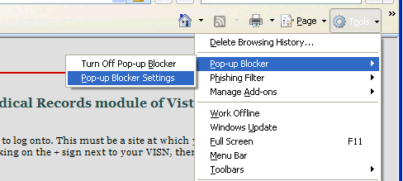
Some links found in this user manual go to sites or pages found on the VA intranet. These sites or pages are not accessible from outside the VA network.

What’s New with VistAWeb Release 16.1?
If you are already familiar with VistAWeb, read this section of the manual to find out what is new in this release. If you are not familiar with VistAWeb, you may want to start with Accessing VistAWeb and then come back to this section to find out what’s new.
VistAWeb Version 16.1 (WEBV*1*26) incorporates changes to comply with section 508 standards and regulations. VistAWeb is removing the detailed display column on the grid domain reports. Columns have been rearranged so that now the first column in the grid will be the column that specifies the type of data from a clinician’s perspective, e.g. Medication Name, Title of Note, Lab Test name, etc. The items in this column will have a hyperlink added to them that will provide detailed display information to the user. A few reports where this change can be seen are the Consults and Procedures, Chem & Hematology, Microbiology, Current Orders, All Outpatient Pharmacy, Progress Notes, and Radiology Reports.
VistAWeb Version 16.1.5 (WEBV*1*31) incorporates multiple changes needed for the proper display of VLER data on VistAWeb pages for: 'Immunization Name' data, Source data for Allergy and Problem List as well as Provider Name data in the Problem List section.
VistAWeb Version 16.1.6 (WEBV*1*32) incorporates changes which corrects a copy to clipboard problem with allergies, updates acronyms as suggested by the VLER team for display of NON-VA data, corrects several displays issues with C32 and stylesheet corrections. In addition, this patch also makes several updates to this VistAWeb User Manual.
VistAWeb Version 16.1.8.2 (WEBV*1*34) incorporates changes which include the display of C-CDA structured documents and displays C-CDA unstructured documents. Provides support for additional mime types for C-CDA unstructured document and Aggregated data from C-CDA document.

Accessing VistAWeb
There are three ways to access patient data using VistAWeb.
- VistAWeb can be made available by adding it to the CPRS Tools Menu.
- CPRS users also have direct “one-click” access to VistaWeb from a VistaWeb button located on the CPRS Toolbar.
These two methods are referred to as CPRS-spawned versions of VistAWeb. They are compliant with the Clinical Context Object Workgroup (CCOW) standards and, therefore, maintain context with the patient selected in CPRS.
- As a third option, VistAWeb can be accessed in a standalone mode by entering the URL link (REDACTED) in the IE address bar.
These methods of accessing VistAWeb are discussed in more detail in later sections of this manual.

VistAWeb under the CPRS Tools Menu
To access VistAWeb, you must first log into CPRS using your access/verify codes, select a patient, and select VistAWeb from the Tools menu. VistAWeb will maintain context with the selected patient and retrieve data for that patient from all sites where the patient has records. When you select a different patient from the CPRS File menu, VistAWeb will maintain context with the new selection. This is described in Patient Context in CPRS-Spawned VistAWeb.
Figure 2: VistAWeb Access from the CPRS Tools Menu
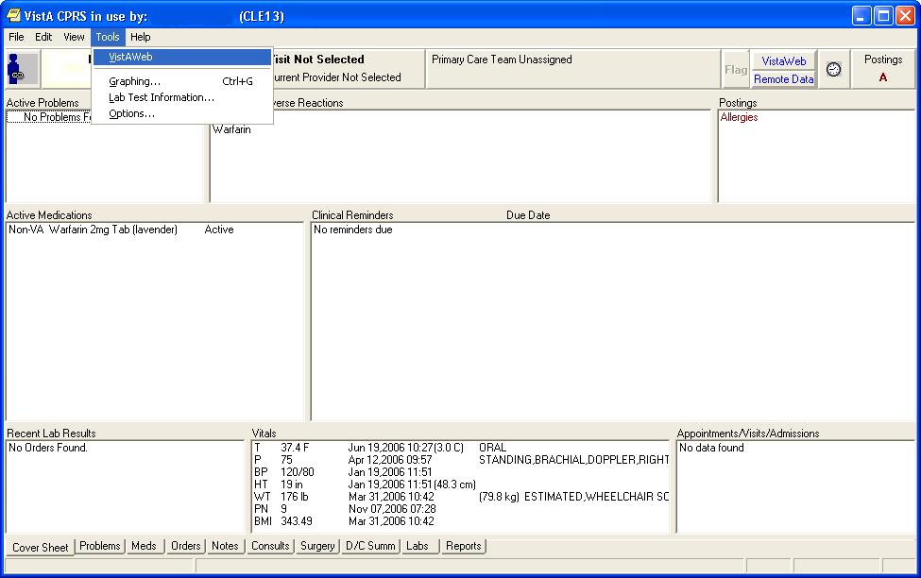
The first time you launch VistAWeb from CPRS, a login (using the same access and verify codes as for CPRS) is required. Subsequent uses of VistAWeb do not require a second login.
Figure 3: Initial Launch Using CPRS Access and Verify Codes
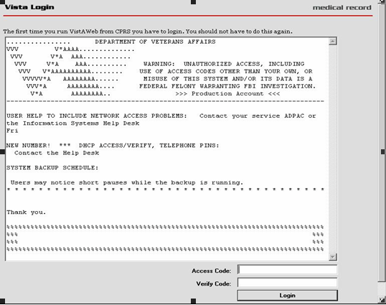

Access to VistAWeb from CPRS VistaWeb Button
A VistAWeb button is available next to the Remote Data Available button; when you click this button, CPRS will launch VistAWeb for you. Additionally, when VistAWeb is launched by CPRS, patient context is maintained. This means that VistAWeb will change patients whenever you do a patient selection in CPRS.
Figure 4: VistAWeb from the VistaWeb Button

Patient Context in CPRS-Spawned VistAWeb
VistAWeb is a CCOW-compliant application and, therefore, maintains context with the patient who was selected in CPRS. When you spawn VistAWeb from CPRS, VistAWeb presents you with a screen that confirms the patient identity, the sites where there is patient data, and gives you the option to proceed or cancel. If you select Proceed, VistAWeb displays the Sites & Notices screen for the new patient along with a menu of reports that are available in VistAWeb. If you select Cancel, VistAWeb forces you to close the session. When using VistAWeb through the CPRS Tools menu, you will not be able to select a new patient from within the VistAWeb application; however, you can return to CPRS to select a new patient and the VistAWeb connection process will begin again.
Figure 5: VistAWeb Maintains Context with the CPRS Patient
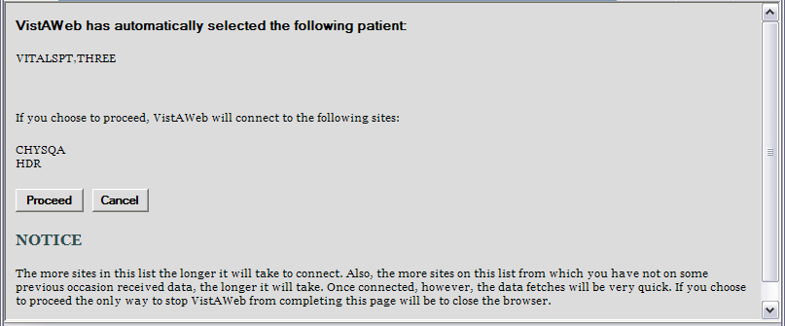
To avoid potential patient safety problems, VistAWeb will not open from a CPRS session that is not in context. This can occur when multiple CPRS sessions are open on the desktop. In the following example, two CPRS sessions are open. One session is in context, as indicated by the icon with a blue person and a connected chain link. The other CPRS session is not participating in patient context, as indicated by the icon with red and blue people and a broken chain. The VistAWeb warning message is the result of attempting to launch VistAWeb from the CPRS session that is not in context. VistAWeb forces the user to exit the attempted connection.
Figure 6: Two CPRS Sessions: One in Context, One Not in Context
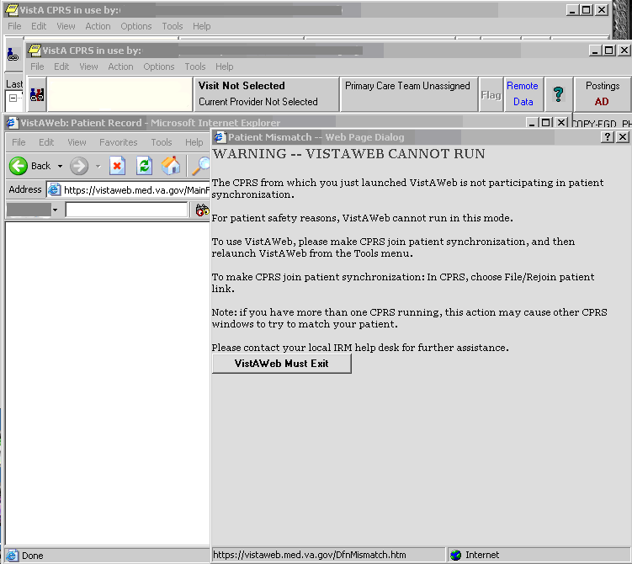

VistAWeb Directly from Internet Explorer (IE) (“Standalone” VistAWeb)
VistAWeb can also be accessed directly from IE by entering REDACTED in the IE address bar. Users must select their local site for login, then log in using their CPRS/VistA access and verify code pair.
Some links found in this user manual go to sites or pages found on the VA intranet. These sites or pages are not accessible from outside the VA network.
Once you have made your login site selection, you may want to save the URL in the IE “Favorites” menu for future ease of access.
Users who regularly only use the standalone version of VistAWeb will be required to update their verify codes periodically, just as they would if logging into CPRS. When this happens, the login screen will display the message, “User must enter a new Verify code at this time”.
By default, users will be able to look up only those patients who are in their local VistA site. Data for those patients will be retrieved from all other sites the patients have visited. Some users (researchers or referral coordinators, for example) may need to look up patients who are not in the local VistA. VistAWeb requires that these users be granted Special User access. Special Users and Requesting Special User Access are discussed in more detail later in this manual
An exception to the VistA/CPRS account requirement is made for properly credentialed Special Users, who do not have clinical VistA accounts. For those users, access can be obtained by logging in through the “100. Central Office Claims System,” as shown at the bottom of the sites menu in the figure below.
Figure 7: VistAWeb Home Page
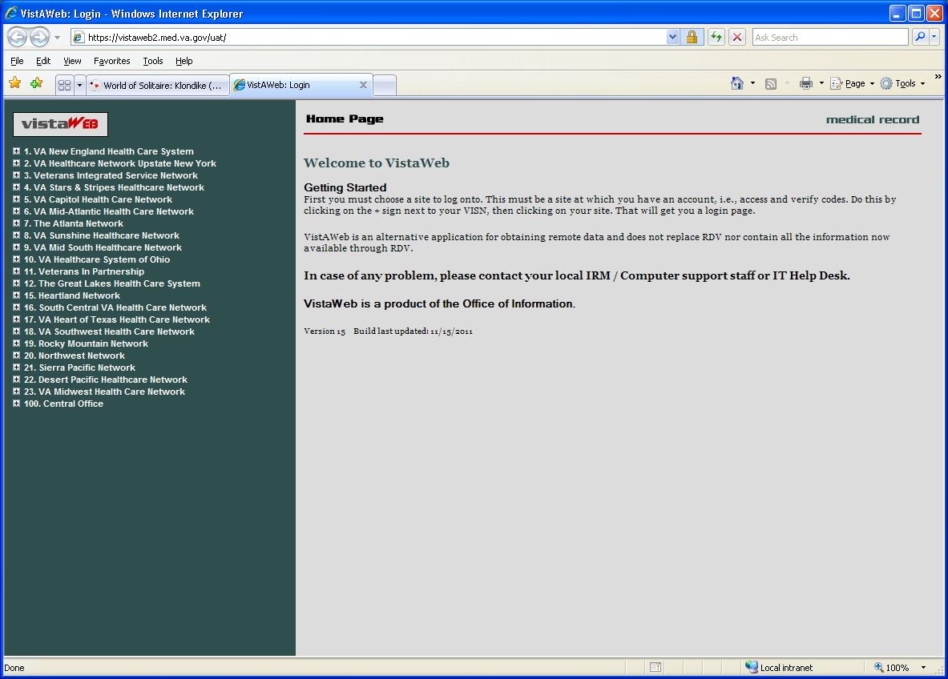
To log into VistAWeb, select the site where you have an account from the list of sites on the left side of the page. The VistA login page for that site will appear. You should enter your access/verify codes the same way you would enter them in CPRS.
Figure 8: VistAWeb – VistA Site-Login Screen
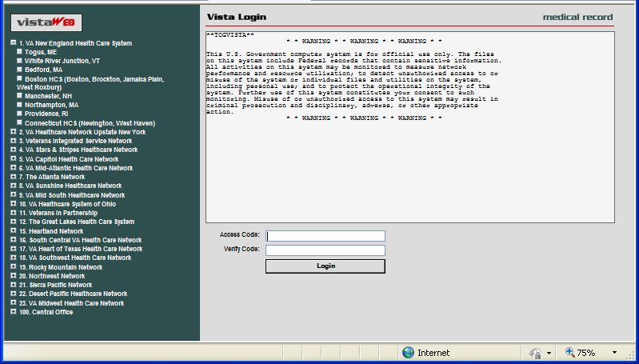a
After you log into VistAWeb, the Patient Selection screen appears. If you have Special User access, a list of sites for patient selection will be present on the left side of the screen. Special Users may select a site other than their login site for patient selection. All other users will be limited to patient selection from their login site only. In either case, data for the selected patient will be automatically retrieved from all sites where that patient has data.

Patient Selection
In standalone VistAWeb, patient selection can be performed in much the same way as in CPRS. You can enter the patient’s name, part of the patient’s last name, social security number, or the five-digit identifier (first letter of patient’s last name plus the last four digits of the patient’s social security number). After entering one of these identifiers, click your mouse button on the FIND button or press the Enter key on the keyboard. A list of potential matching patients appears in the box below. If there are more names available than shown in the scroll box, click the “More names…” button to see them. Once you have identified the desired patient, click your mouse button on the patient name, and click the mouse again on the OK button or press the Enter key on the keyboard.
Figure 9: Using the Patient Selection Screen to “Find” a Patient
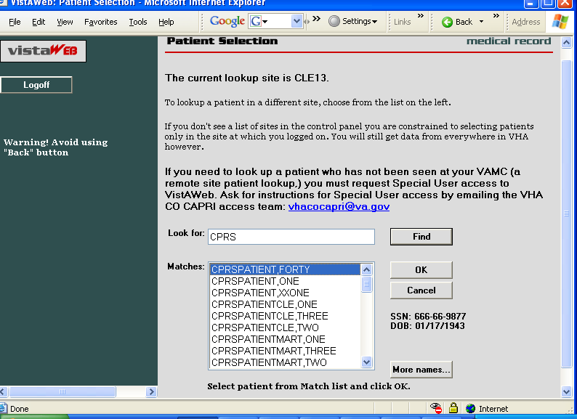
In the example above, the user does not have Special User access, so patient selection is limited to the local site where the user first logged in. There is no list of alternate patient selection sites on the left side of the VistAWeb Patient Selection screen.

Special Users
By default, users of VistAWeb are permitted to select patients that are in the local VistA system where the user logs in. VistAWeb will retrieve data for these patients from all sites where the patients have records. Some users (researchers or referral coordinators, for example) may need to select patients that are not in the local VistA. These users will require Special User access, which can be granted for one site in addition to the login site, several sites, an entire Veteran’s Integrated Service Network (VISN), or all sites nationally.
After logging in to VistAWeb, Special Users will see the Patient Selection screen, with a list of sites accessible for patient selection.
Figure 10: Special User Multiple Site and Patient Selection
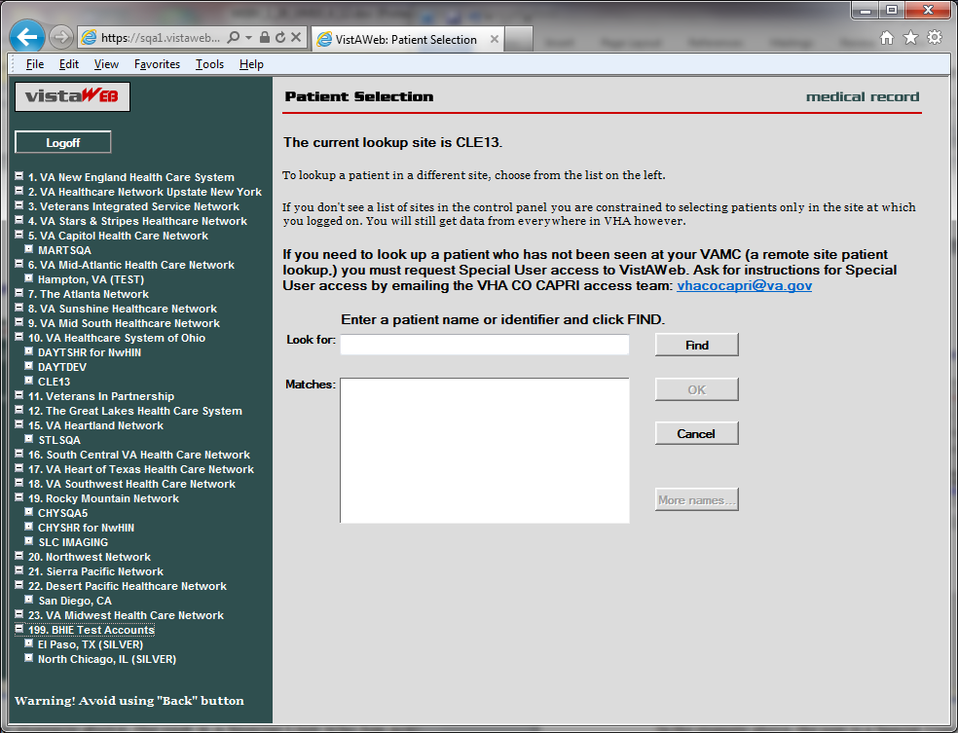
In the example above, the user is a Special User who has access to perform patient selection at several sites, which are listed on the left side of the screen. To select a patient from a site other than the login site, you must first click on the desired site on the left side of the screen and then perform patient selection.

Requesting Special User Access
Requests for Special User access fall into one of three categories.
- National Programs requiring “Special User” access, such as Blind Rehab, Transplant, War Related Illnesses, and so forth
- VA Researchers requiring “Special User” access for the purpose of approved research projects
- All Others, for example, local users, requiring “Special User” access to multiple VA sites for the purpose of clinical opinions, referral coordination, and so forth.
All users requesting Special User access will be required to verify completion of the annual VHA Privacy Policy Training and VA Information Security Awareness Course and to sign the Rules of Behavior (ROB) prior to approval of the request.
Individuals requesting Special User access to VistAWeb should request instructions by visiting this website: REDACTED.

Sensitive Patient Warning
Similar to CPRS, standalone VistAWeb displays a warning to you if you select a patient who has been flagged or designated as a Sensitive Patient. VistAWeb differs from CPRS in that it will display the warning message to you if the patient is sensitive in ANY of the sites from where the sensitive data will be retrieved. If you elect to proceed, notification will be sent to the Information Security Officer (ISO) at any and all sites where the patient data is marked sensitive. Both standalone and CPRS-spawned versions of VistAWeb also display the sensitivity status on the Sites & Notices screen.
Figure 11: Restricted Record Warning
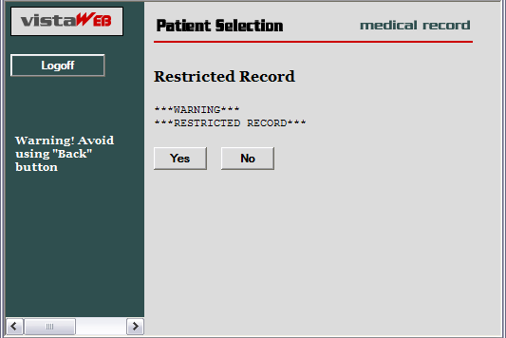

Refresh Patient Data
A Refresh Patient Data button has been added to VistAWeb that allows you to update reports without having to log off and back into a VistAWeb session when new data is added to the patient’s record in CPRS. Clicking on the Refresh Patient Data button returns you to the Sites & Notices screen from which you can navigate back to the appropriate report to see the new data.
Figure 12: Refresh Patient Data Button
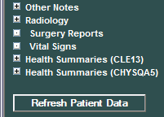

Category I Patient Record Flags
Category I Patient Record Flags are now displayed in standalone sessions of VistAWeb before the user is permitted to “Continue to Patient Record”. The Category I flags are also displayed in both standalone and spawned versions of VistAWeb on the Sites & Notices screen below.
Figure 13: Example Category I Patient Record Flag in Standalone VistAWeb
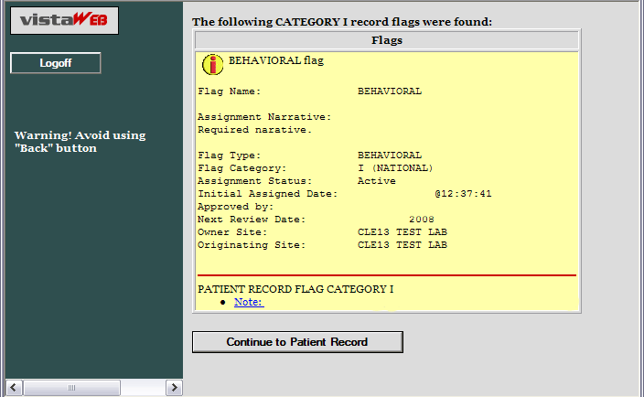
Figure 14: Example Category I Patient Record Flag on the Sites & Notices Screen
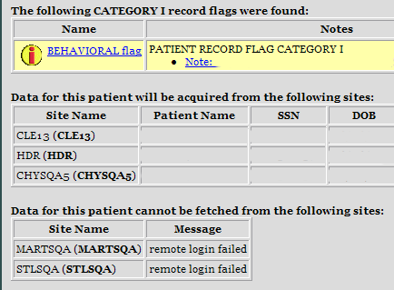

Using VistAWeb
After the Patient Selection page, all VistAWeb functionality for a Special User is the same as for other users, except that there is no clinical context management as described earlier in Patient Context in CPRS-Spawned VistAWeb.

Automatic Retrieval of Data from Multiple Sites
When the patient is first selected, VistAWeb determines how many sites the patient has visited and displays a message similar to the following to let you know that VistAWeb is establishing connections to those systems.
Figure 15: Please Wait…Message
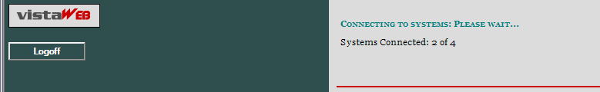
The Sites and Notices page is then displayed, which includes a list of sites where data for that patient will be retrieved. In the following example, VistAWeb will attempt to retrieve data from all available sites listed in the patient’s treating facility list. In this example, MARTSQA, STLSQA, and DAYTSHR are three examples of sites in the patient’s treating facility list to which VistAWeb has been able to make a connection. If VistAWeb cannot connect to some of the systems (sites) where the patient has been seen, that information is supplied in table format below the sites that are connected. The Last Seen field in the tables is only populated when the Master Patient Index (MPI) has that information to report.
On the left side of the screen, there is a list of reports for which VistAWeb is able to retrieve patient data. It is important to note that just because a site is listed doesn’t mean there will be data available from that site in all domains. For more detail regarding the type of reports, refer to the Expanded List of All Reports section of this manual.
Figure 16: Patient Data Available at Multiple Sites
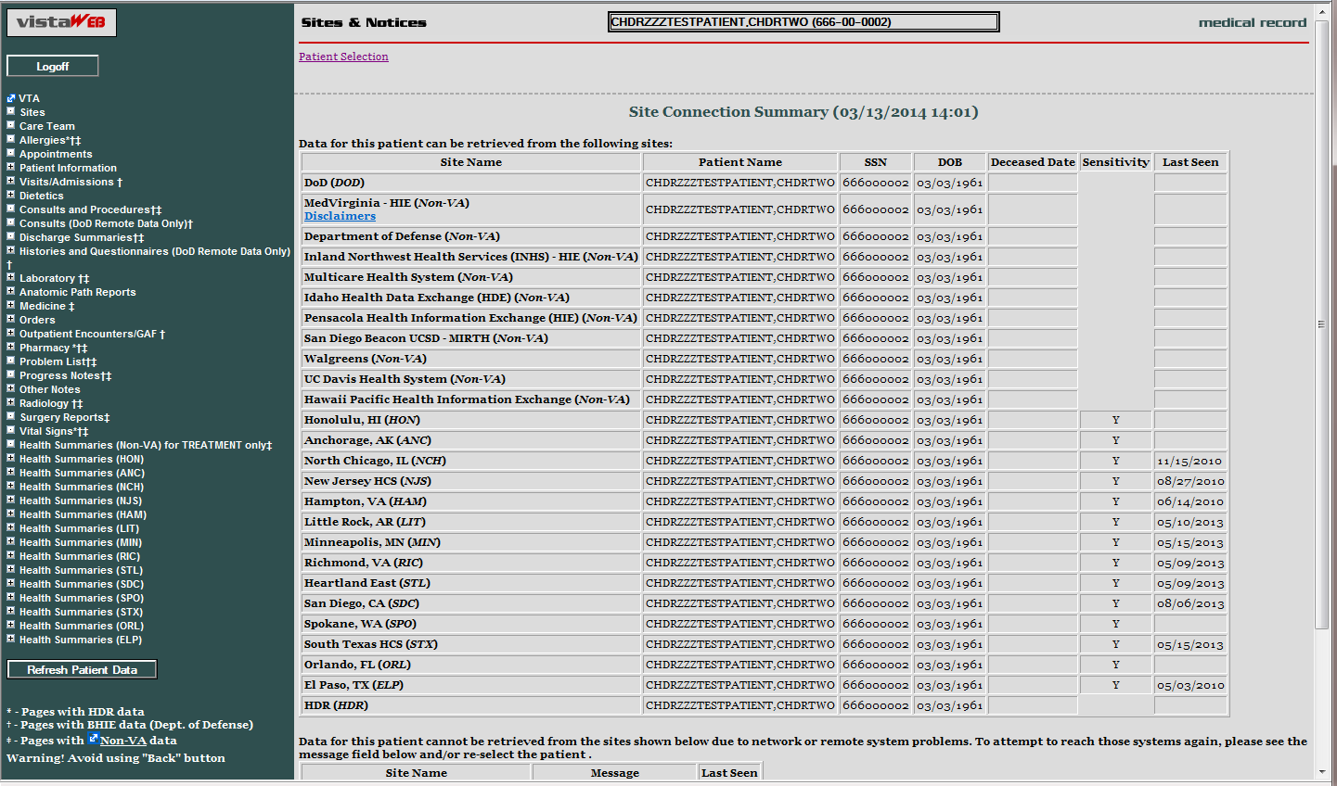
Reports/”domains” that have data from non-VAMCs are indicated with the appropriate icon from the legend; these reports/domains show the data in an “aggregated view”, which means that all sources provide that data for the specific report/domain.
Figure 17: Aggregated View

Expanded List of All Reports
Entries preceded by a plus sign (+) can be expanded to show sub-reports by clicking the mouse on the plus sign (+). Expanded lists can be collapsed by clicking the mouse on the minus sign (). Figure 18 is a fully expanded list of reports retrieved by VistAWeb. In addition to National and local VistA health summaries, VISN level health summaries are available. Consequently, the list of available summaries can be quite long and will vary depending on the user’s login site. The list of health summaries is similar to the Health Summary list available from the Reports tab in CPRS.
Figure 18: Expanded List of VistAWeb Reports

Report Examples
There are over 80 different reports available in VistAWeb. A representative sampling is presented here to demonstrate the different types of reports and formatting options.

Text Reports
Text reports are the most basic of all reports available to users. Text is displayed in a non-interactive mode and is very similar to the corresponding reports found in CPRS from the Reports tab. One example of a Text report is the Patient Inquiry report. All site data is retrieved for the selected report, and the patient’s data for the associated site is placed within the tab from where the data was retrieved. In the example below, there are four tabs: MARTSQA, CLE13, STLSQA, and CHYSQA5. To view data retrieved from MARTSQA for the selected patient, click the mouse on the MARTSQA tab. If any particular report is not available from a site where the patient has been seen, or if there is no data for a specified date range, then that site’s report tab will return the statement “No Data Found”.
Figure 19: Patient Inquiry Text Report
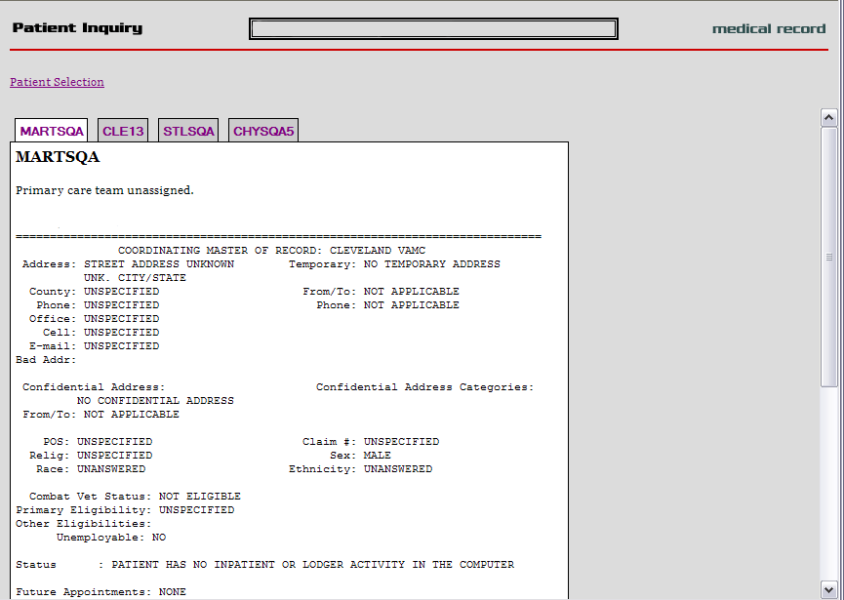

Text Report with Date Range Option
In report screens where date ranges can be typed, two digits can be entered for years, and dashes can be entered instead of slashes. VistAWeb will reformat to the dd/mm/yyyy format for the user, e.g., 12-11-05 will be reformatted to 12/11/2005 automatically. Typing in a date range clears any set radio button. Likewise, setting a radio button for one of the available time periods will clear dates previously typed into the From/To fields. The following composed sequence demonstrates that VistAWeb corrects the date format and then shows that clicking the All Results button clears the To/From date fields.
Figure 20: Date Range Entry and Radio Button Selection
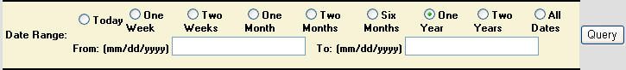
When these reports are generated they are presented in table format, which typically can be sorted and can contain data from multiple sites, as with Allergies, Outpatient Pharmacy, and Vital Signs reports. In the following example report of Progress Notes or Chem & Hematology, the initial default query is performed automatically for a one-year time period, and the maximum number of items per site to return is defaulted to 50. You can type in a different number or click in the All Data box to retrieve all the items for the specified period. You can select a different time period or enter a From/To date range, and you can specify a different maximum number of items to return. Click the mouse on the Query button to run the report for the new time period or date range and number of items. Note that, if the default number is deleted, either a minimum of 1 item must be requested or All Data must be checked for the specified time period. Otherwise, an error message is displayed.
Figure 21: Progress Notes Report showing AWIV column, Date Range, Author, Location, and Site
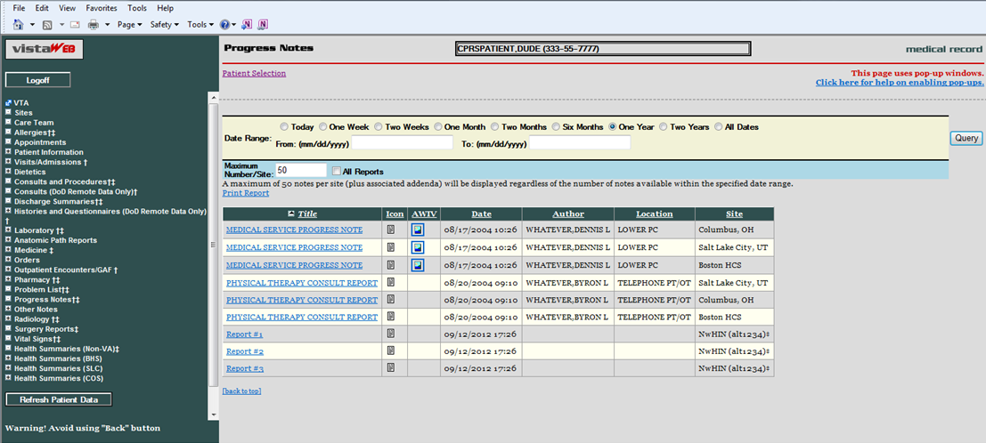
Figure 22: Progress Notes Report with Chem & Hematology
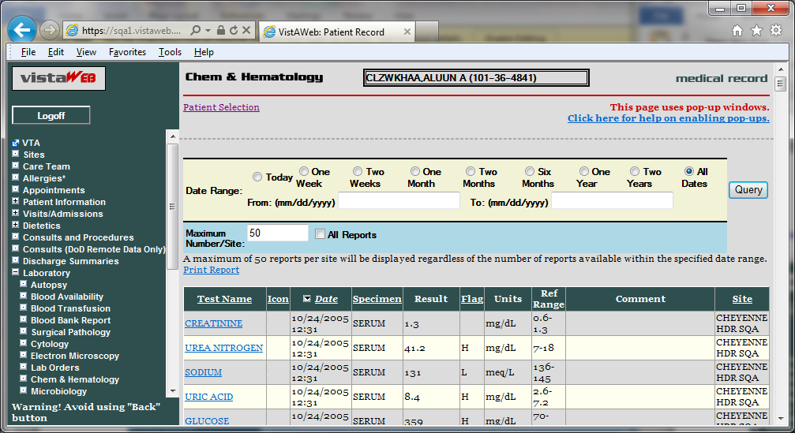

Predefined Filtering and Date Range
The Pharmacy – All Outpatient report often contains a large number of entries, depending on the patient’s history of outpatient prescriptions. Providing shorter date ranges allows for the quicker retrieval of data. For this report, the Date Range selection criteria default to 15 Months. You can select 2 Years or All Results by clicking on their radio buttons and then clicking the Query button.
Figure 23: Date Range Selection Criteria for All Outpatient Pharmacy Report
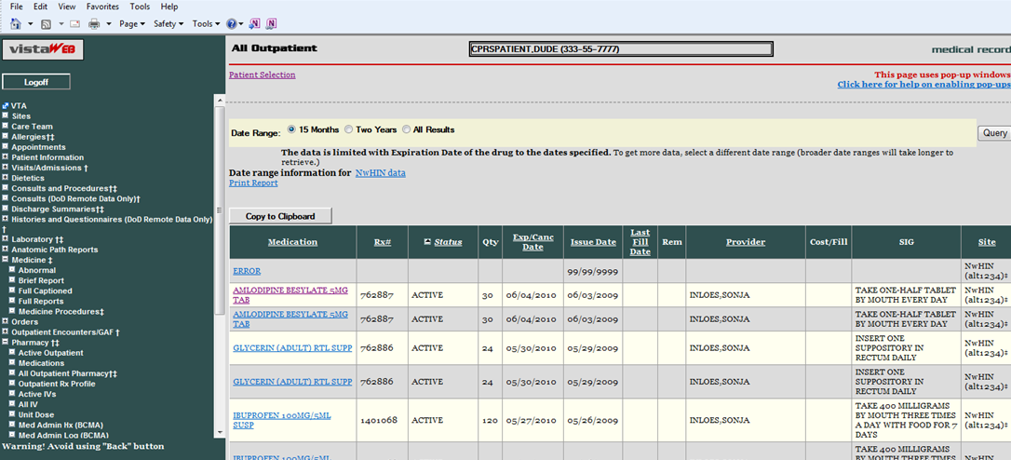
Some reports require you to enter the date range before the report will appear. This is the case for queries that have the potential to return very large amounts of data or where filtering the data lends usability to the report. Summaries, such as Discharge, Lab, some Order summaries, and both of the Med Admin Hx and Med Admin Log reports, tend to generate large volumes of data. Narrowing the date range for a report for a patient’s summary data may improve the speed of the data retrieval.
Some reports that do not require a date range include the following: Sites, Care Team, Allergies, Appointments, Patient Inquiry, Patient Demographics, Patient Insurance, Dietetics Profile, Blood Bank, Daily Order Summary, Medications, Outpatient Rx Profile, All IV, and Imaging.
Figure 24: Date Range for Lab and Other Large Volume Reports
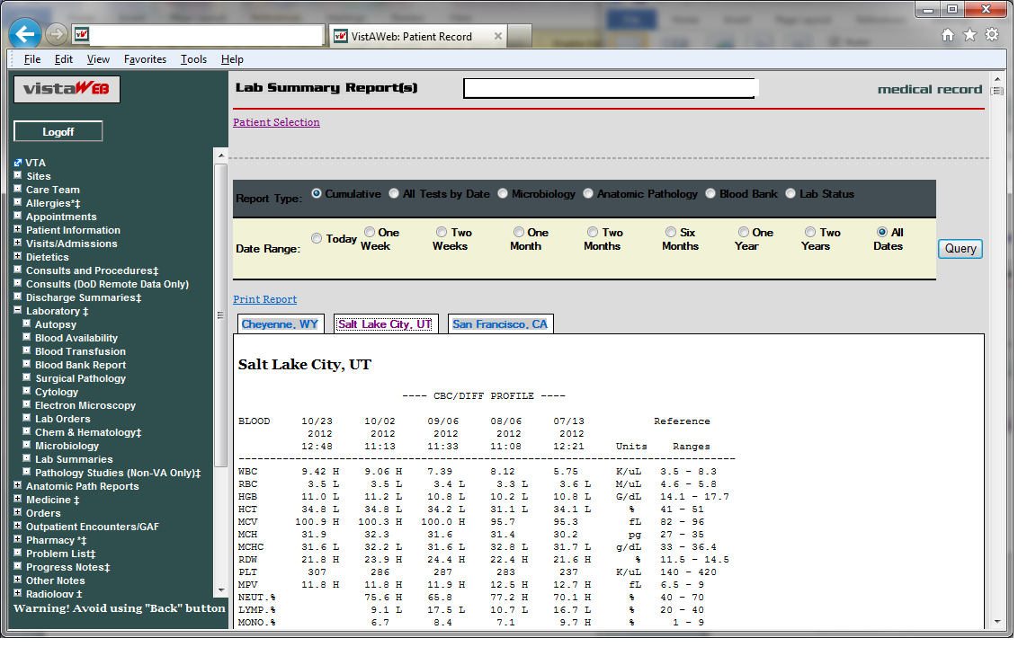

Data Grid Style of Report
The data grid style of report presents data in the form of a grid or table, with the data being retrieved and displayed according to a specified date range. The data for most of the tables can then be sorted in multiple ways. The underlined column headers indicate which columns may be used for sorting. Report data is generally retrieved and presented with the most recent date at the top, descending to the earliest date at the bottom. For some reports, Vitals for example, data from multiple sites is presented strictly by date, without consideration for the site. For some other reports, Problem List for example, the problems from multiple sites are displayed by status (active first) and then in descending date order for one site and then descending order for the next site, and so on. Then inactive problems are listed if there are any. In most of the reports that have a date column, clicking the date won’t change the sorting of that column unless some other sort, alphabetical, for example, had been done which upset the descending date order.

Data Grid with Additional Details
The data grid permits you to view additional details about a selected item in a row. In this example, Progress Notes titles are listed in VistAWeb. To view the actual text of the note, click on the Title link for the note of interest.
Figure 25: Progress Notes
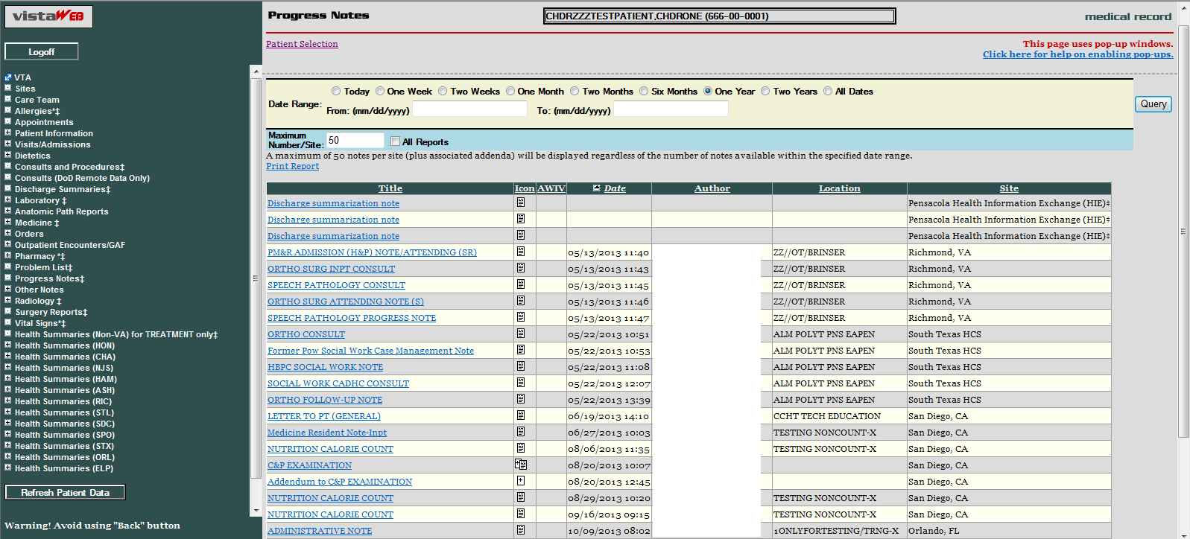
When you click on the Title link, the detail of the selected note appears in a pop-up box, represented in the example below. Click on the Print or Close buttons to effect the desired action.
Figure 26: Progress Note Title link (AWIV – Imaging details)
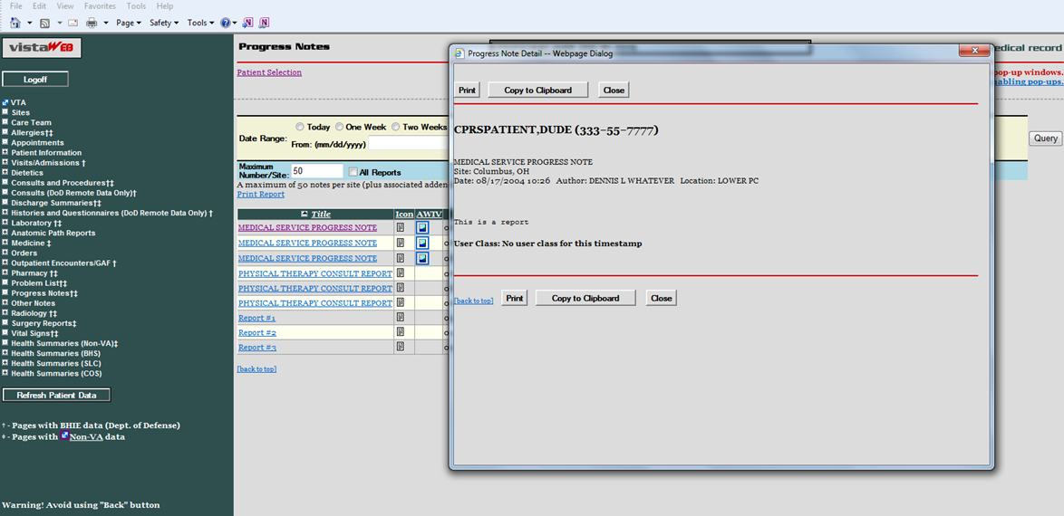
Figure 27: Imaging Report
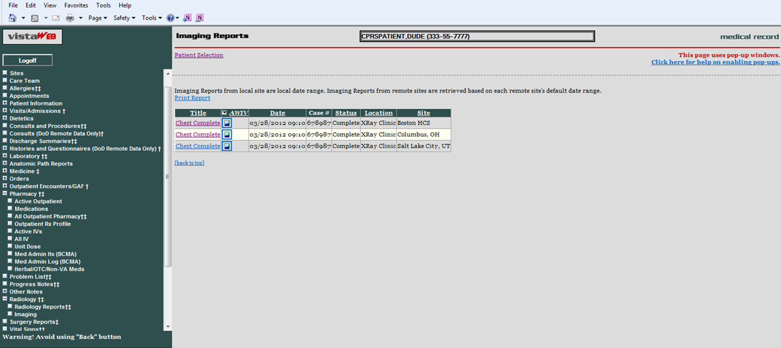
Figure 28: Imaging Report Details
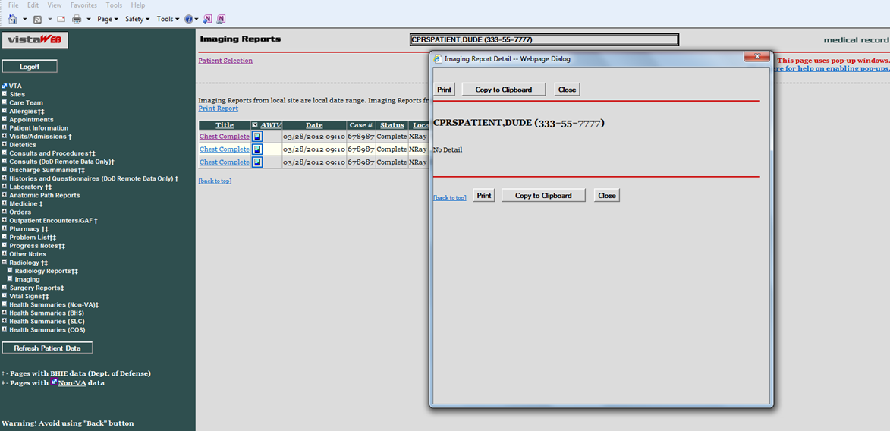

Vital Signs Report
In the following Vital Signs example report, note that three of the Site column listings display Home Telehealth (HT) as the site where the vitals were taken. The HT indicates the data was supplied through the HT interface.
Figure 29: Vital Sign Report Presented as Table
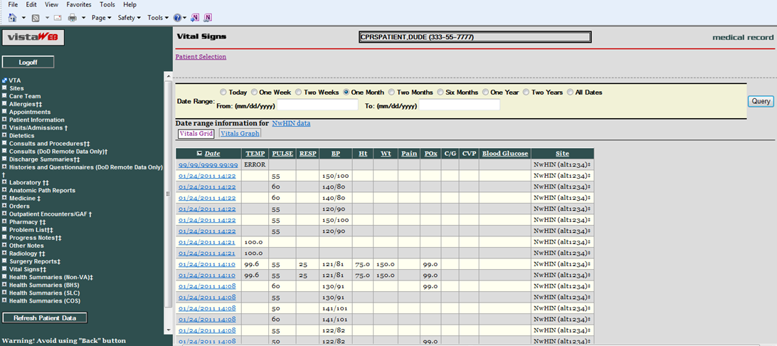
When you select the Date link of an HT site from the Vital Signs screen, additional information is provided about the method of data entry, qualifiers, vitals measuring devices, and that data standardization has been accomplished for this vital sign record.
Figure 30: Details of HT Standardized Vitals
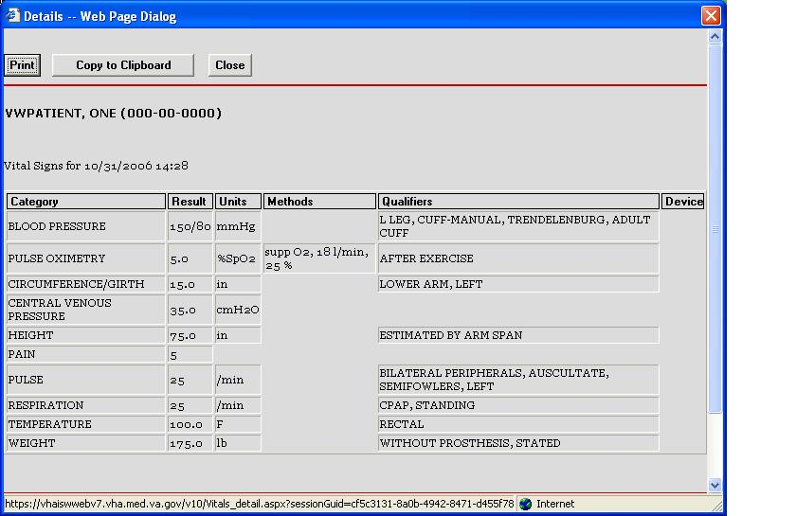
If the vitals data is coming from the Health Data Repository – Interim Messaging Solution (HDR-IMS) repository, but was not entered through the HT interface, the Details – Web Page Dialog will show the letter S in the Standardized column and any other data that was entered through the Vitals package that maps to other column headings. In the following example, the Methods and Qualifiers for supplemental oxygen that was delivered to the patient are shown.
Figure 31: Details of Non-HT Standardized Vitals
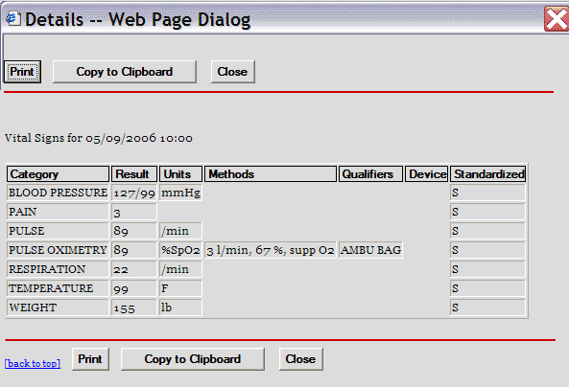
If the vitals data is coming from the HDR-Historical database or a VistA site, the Standardized column does not display the letter S and no data is supplied for Units, Methods, Qualifiers, or Device. If for some reason the HDR databases are inaccessible, VistAWeb still polls the VistA sites where the patient has been seen and will return any available requested data for display.
Figure 32: Details of Non-Standardized Vitals
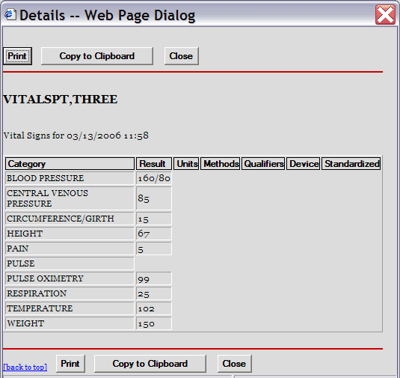
Figure 33: Vitals Graphing
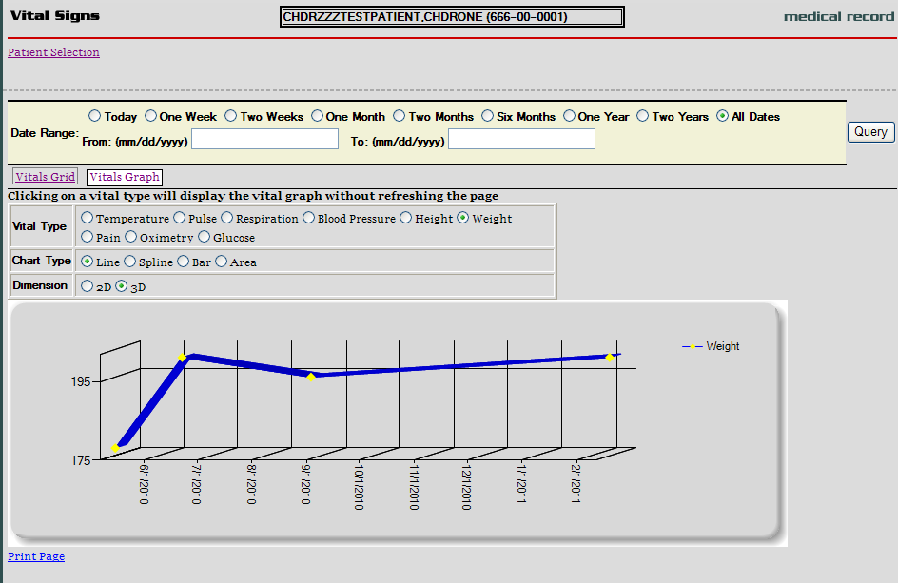

Data Grid with Copy to Clipboard Option
The following example of a Medications report lists a variety of medications and their statuses, along with Copy to Clipboard button. Providers often find it useful to copy lists of active and suspended medications to a patient note. When you click the mouse on the Copy to Clipboard button, the list of Active and Suspended medications is automatically copied to the clipboard and grouped by Status. Discontinued and expired medications are not copied.
When you do a copy to clipboard, this data is available to other web pages, which poses a patient safety issue, since patient information can be seen by other web pages
In V8, users can set up an option that does not allow the clipboard data to be available to other web pages.
Figure 34: Copy to Clipboard
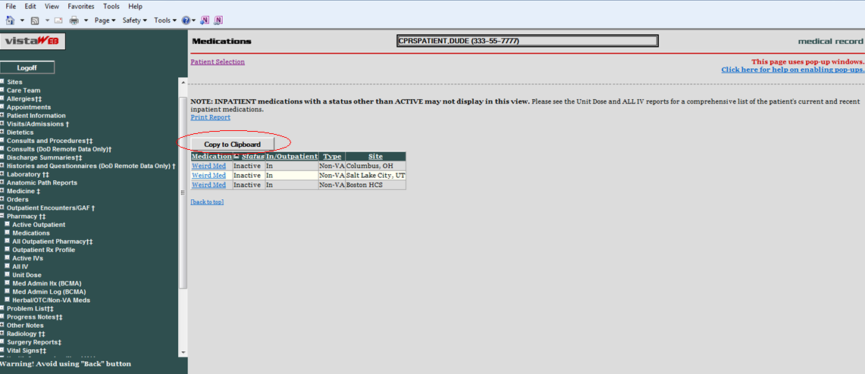
The list can be pasted into another document or a Progress Note within CPRS.
Figure 35: Medications from VistAWeb Pasted into CPRS Progress Note
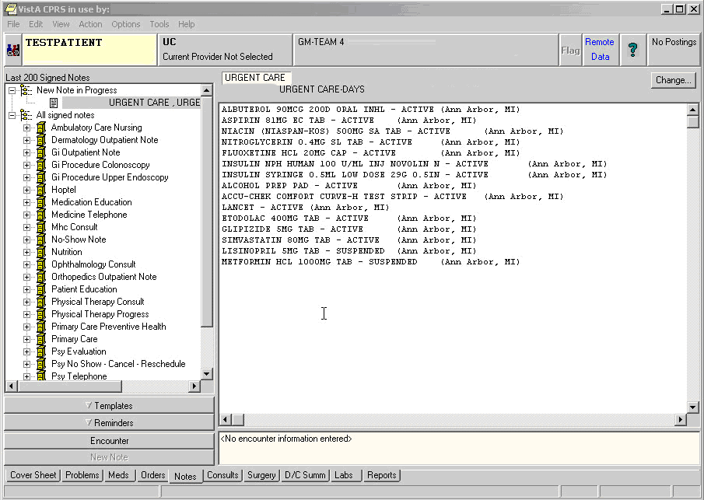
VistAWeb displays Non-VA and Herbal/OTC medications if applicable. In the following screen capture of a Medication report, the Type field has one medication listed as Non-VA.
Figure 36: Non-VA Medications
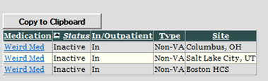

Department of Defense Reports
VistAWeb version10 added the following.
1. Detailed display for DoD data for the Outpatient Pharmacy report. The following fields are displayed in the detailed display.
Medication
Start Date/ Time
Stop Date/ Time
Current Status
Order #
Medication Instructions
Sig
Days Supply
Quantity
Refills
Pick Up
Dispense Comments.
Figure 37: Outpatient Pharmacy detailed display
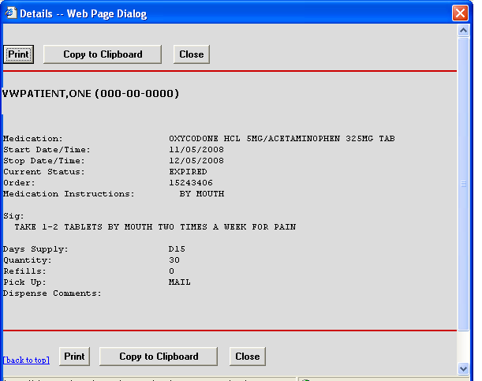
Three new reports under Pharmacy:
- Active Outpatient
- Active IV report
- Herbal/OTC/Non-VA Meds.
Figure 38: Active Outpatient Medications - Grid
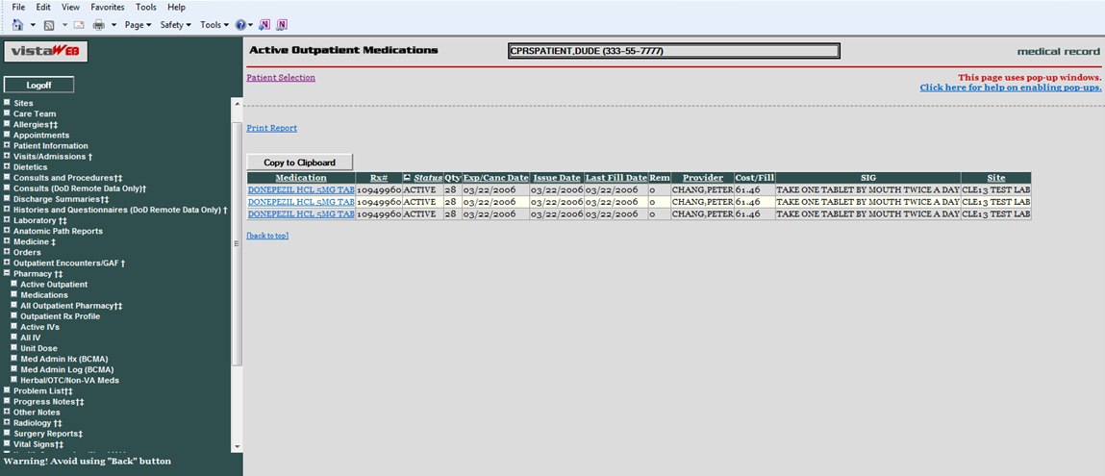
Figure 39: Active Outpatient Medications - Details
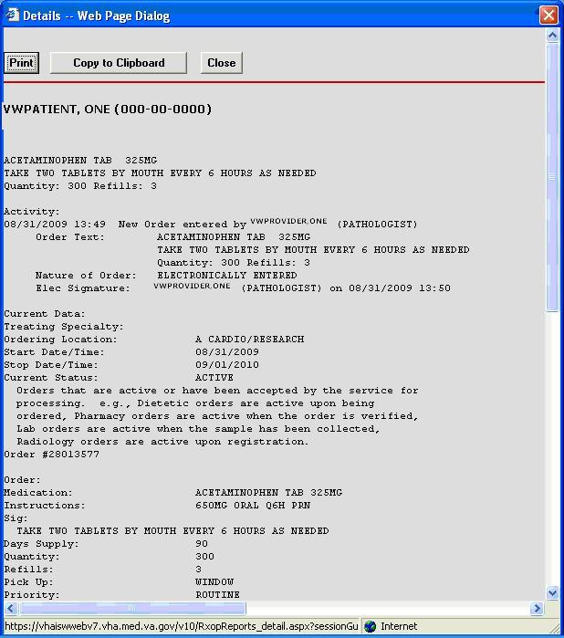
Figure 40: Active IV
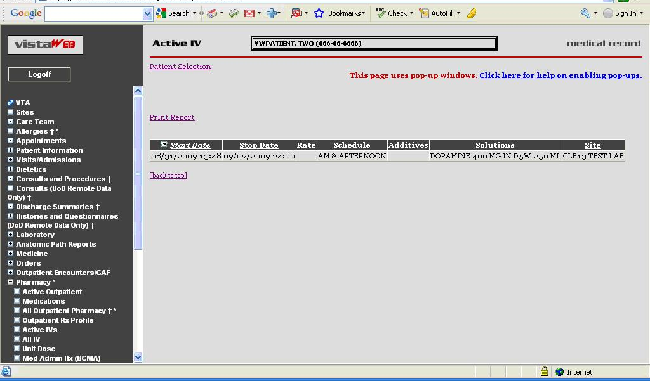
Figure 41: Herbal / OTC / Non-VA Meds
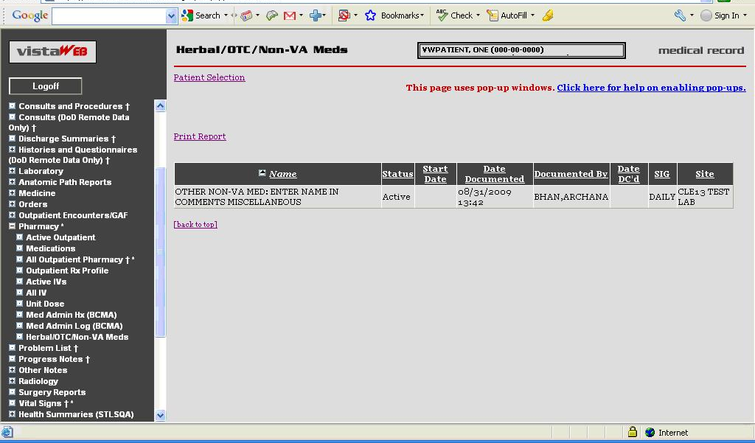

- In response to PSPO 832:
Added a new centered heading "Site Connection Summary” followed by the date and time in parenthesis.
Example: “Site Connection Summary (12/19/2008 10:06AM)”
Added the following two notes above the tables that display a list of the sites that VistAWeb could / could not connect to:
  - Data for this patient can be retrieved from the following sites.
  - Data for this patient cannot be retrieved from the sites shown below due to network or remote system problems. To attempt to reach those systems again, please see the message field below and/or re-select the patient".
VistAWeb version 9 added reports to retrieve and display data received through the BHIE Framework from DoD for the following.
- Family Histories
- Social Histories
- Other Histories
- Questionnaires.
Users can select a date range and specify the number of observations, and the BHIE real-time DoD data and DoD pre-separation data within these parameters are displayed in VistAWeb for the above mentioned reports.
Figure 42: Dept of Defense Reports – Social Histories
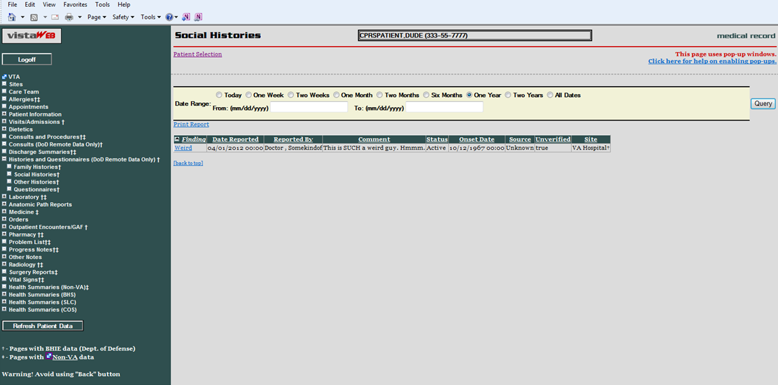
When the “Finding” window is clicked, a new window with details pops up.
Figure 43: Dept of Defense Reports – Details
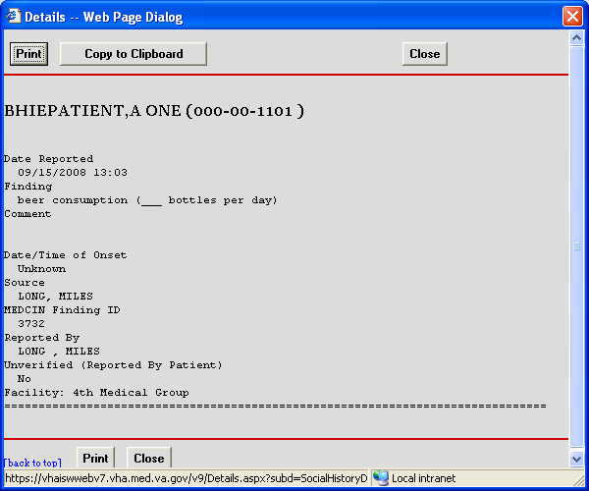
Figure 44: Dept of Defense Reports – Other Histories
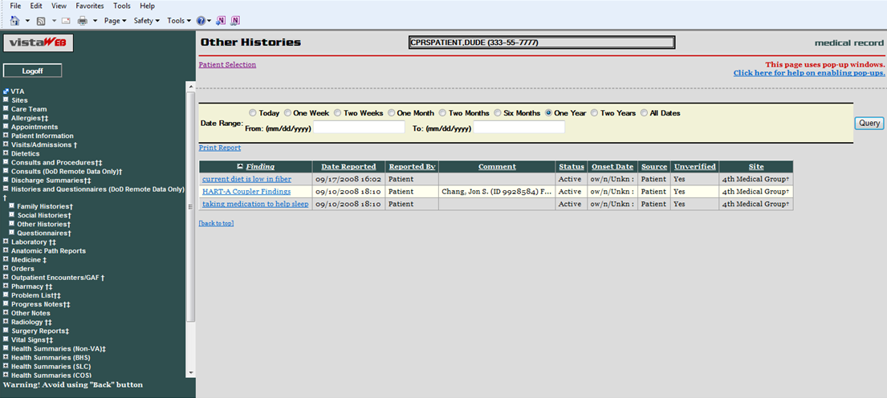
Figure 45: Dept of Defense Reports – Other Histories Details
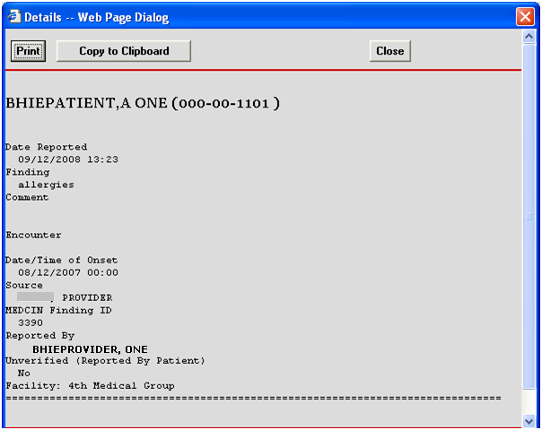
Figure 46: Dept of Defense Reports – Questionnaires
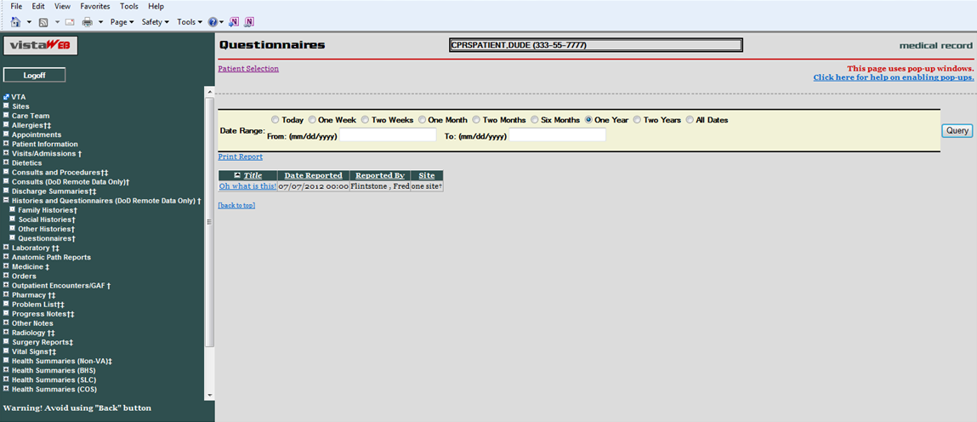
Figure 47: Dept of Defense Reports – Questionnaires Details
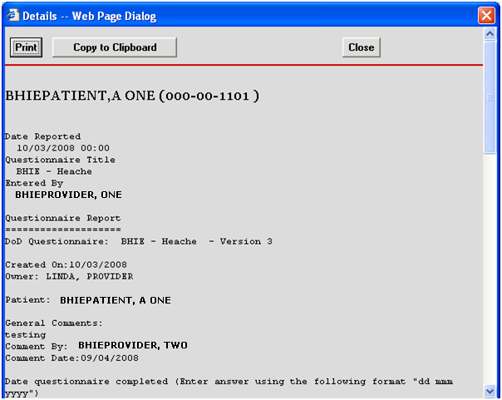

Other Past Medical Histories report from DoD

HART Report from Department of Defense
The report referenced by the HART Health Assessment Review Tool (HART) Report is comprised of answers, “findings”, to a health assessment questionnaire (health indicator data including physical activity, overweight and obesity, substance abuse, etc.). Although this is originally entered in a question and answer format, the report is stored and displayed simply as “findings” (no longer associated with questions). The report is displayed in VistAWeb as “Other Past Medical Histories”.
Data displayed on the HART report was not truncated in the Comment column, so the entire report appeared making the row unreasonably tall.
The report will now have similar truncating for HART data as is done in CPRS. This will reduce the size of the report and make it easier for the user to read. The entire text of the comment field will be available in the detailed display window.
The display of the “Comment” field will be restricted to 30 characters in the grid view of the “Other Past Medical Histories” report in VistAWeb.
Figure 48: Comment Field
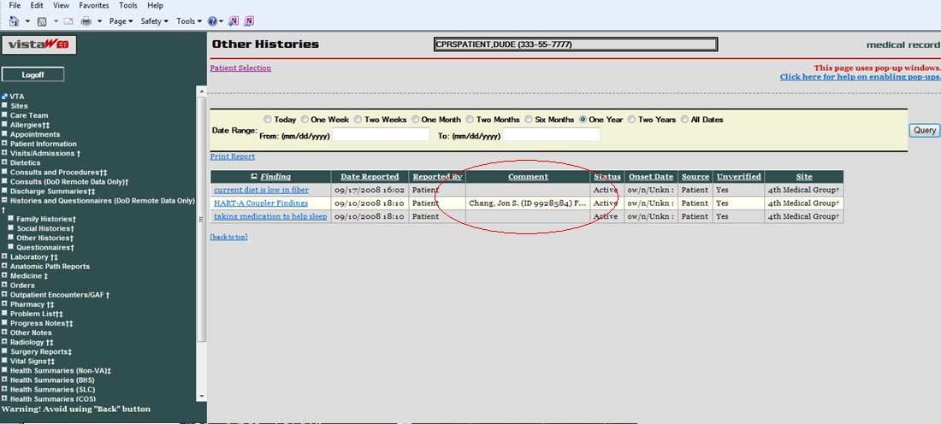

Figure 49: Detailed Display
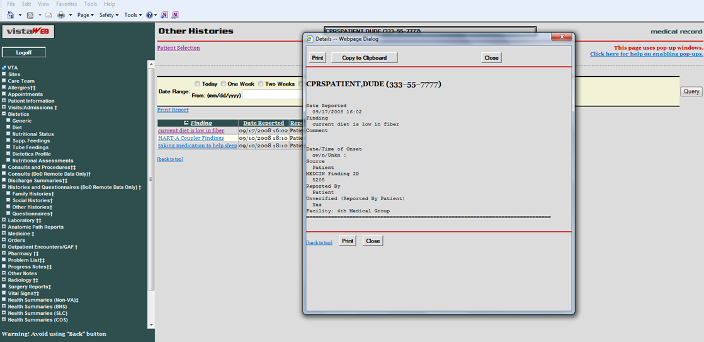

Non-VA Health Summaries
Non-VA Health Summaries are clinical summary documents retrieved from non-VA Healthcare Providers via the eHealth Exchange. These documents provide a summary of the care a patient has received through a non-VA health care system.
To access a patient’s Non-VA Health Summaries click on the Health Summaries (Non-VA) for TREATMENT only menu item on the VistaWeb menu (Figure 51). This menu item is only displayed when there is Non-VA data available for the patient. Click this menu item to open the Non-VA Health Summaries screen (Figure 52).
Figure 50: Accessing Non-VA Health Summaries
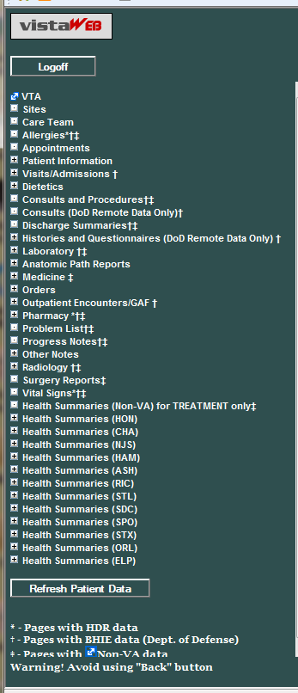
Figure 51: Available Non-VA Health Summaries
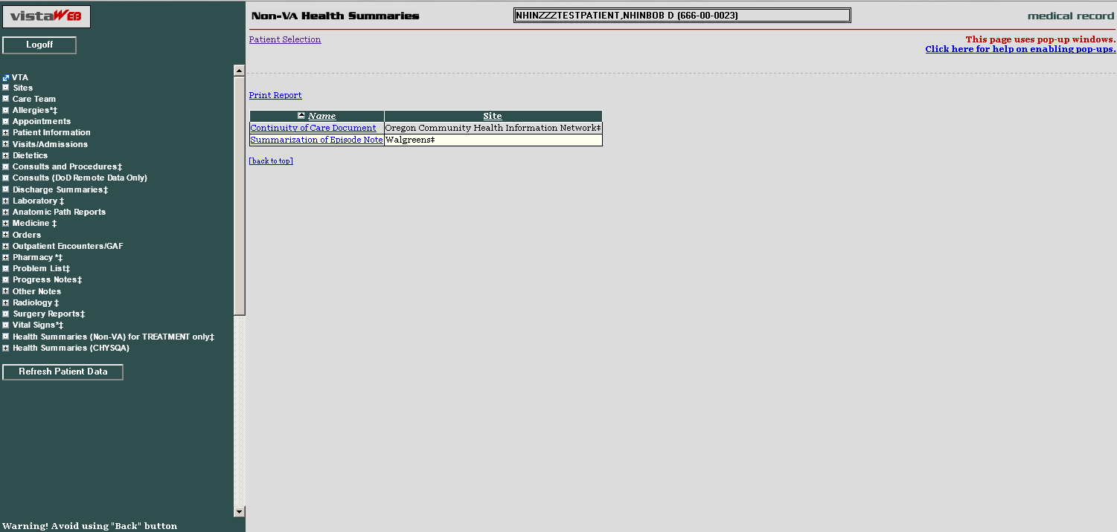

Viewing a Non-VA Health Summary
To open a Non-VA Health Care Summary document click on the hyperlink in the Name column of the table on the Non-VA Health Summaries screen.
Non-VA Health Summary documents have a variety of names (as defined by the sending organization). Most commonly they are called “Continuity of Care Document” or “Summarization of Episode Note”. Figure 52 above shows a patient who has non-VA Health Summary documents available from two eHealth Exchange Partners. While it is technically possible for a patient to have care summary documents available from multiple partners, most patients will have one or two.
Figure 52: Display of a Non-VA Health Summary – C32 format
If the document received from external clinical partner is in C32 format, the following display format is used.
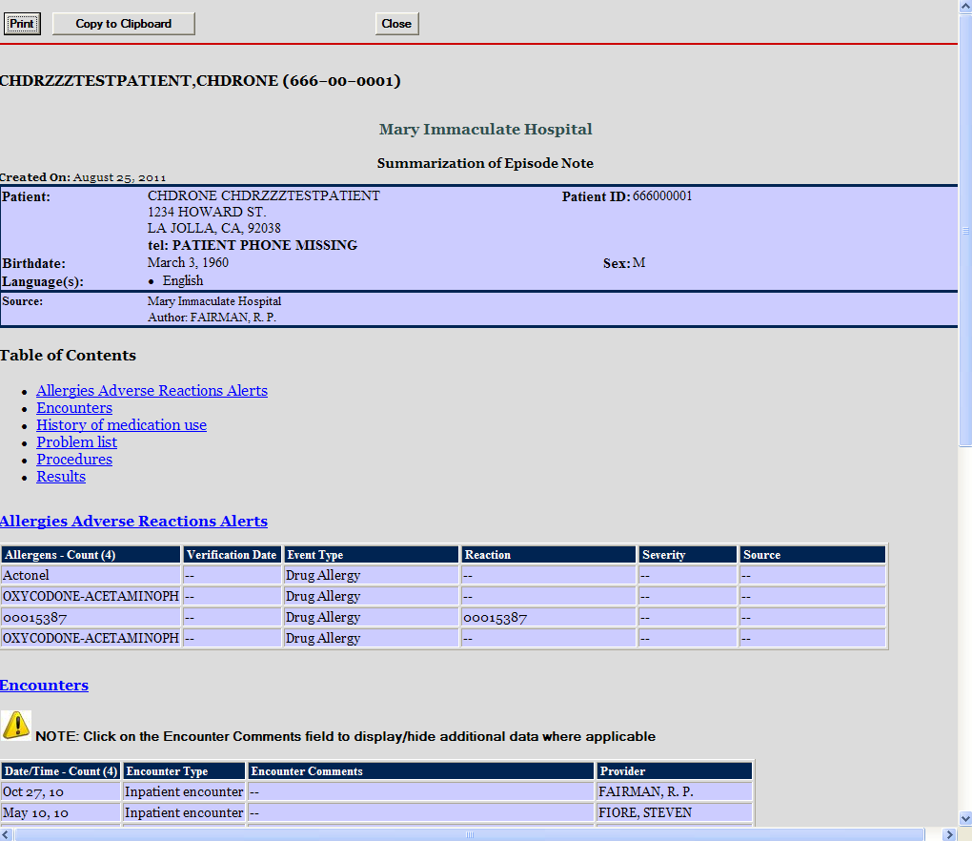
Figure 53: Hover Over Capability
Most columns have a "hover over" capability that will display the complete contents of a cell when the content exceeds the column width.
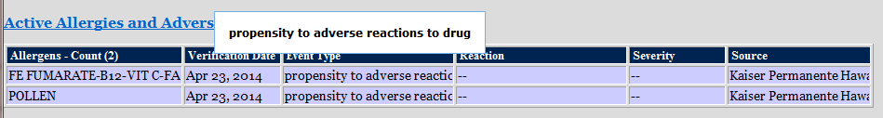
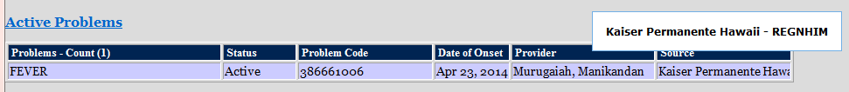
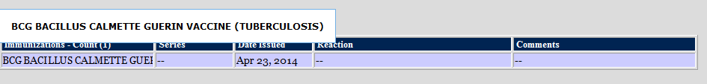
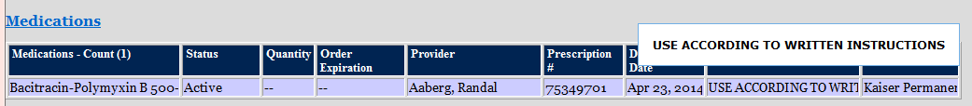

Figure 54: Display of a Non-VA Health Summary – C-CDA format
If the document received from external clinical partner is in C-CDA format, the following display format is used.
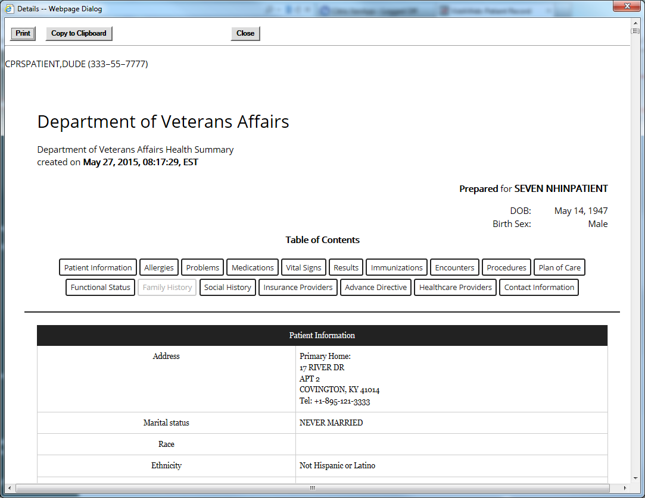

.

Aggregated Data
Some of the data that is visible in a Non-VA Health Summary (for both C32 and C-CDA document formats) is also available in an aggregated view with data from other sources, such as VA Medical Centers and other Non-VA partners. This data can be found by selecting Allergies, Laboratory->Chem and Hem, Pharmacy->All Outpatient Pharmacy, Problem List, and Vital Signs, as shown in Figure below.
Figure 64: Viewing Aggregate Data
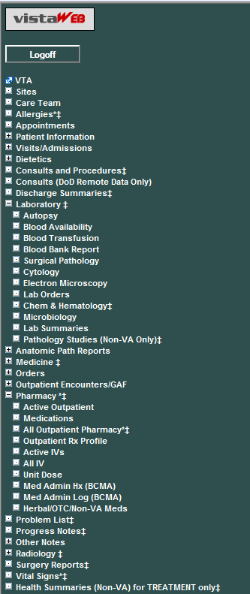
Figure 65: Allergies Aggregated View
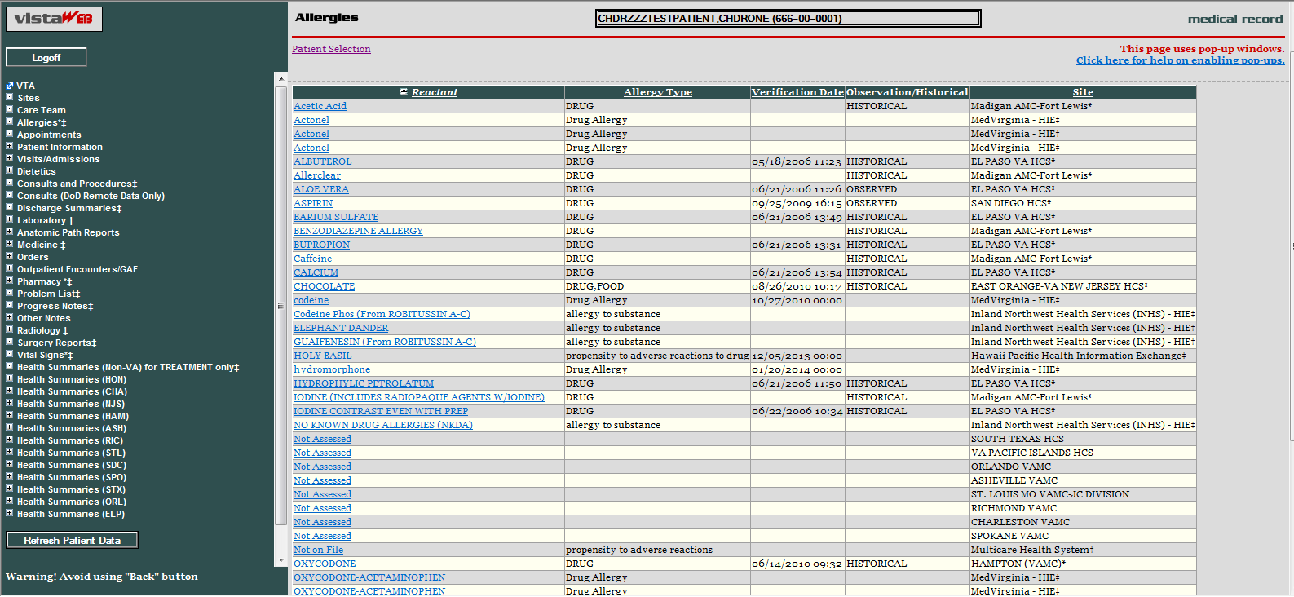

Figure 66: Chemistry and Hematology Grid-style report
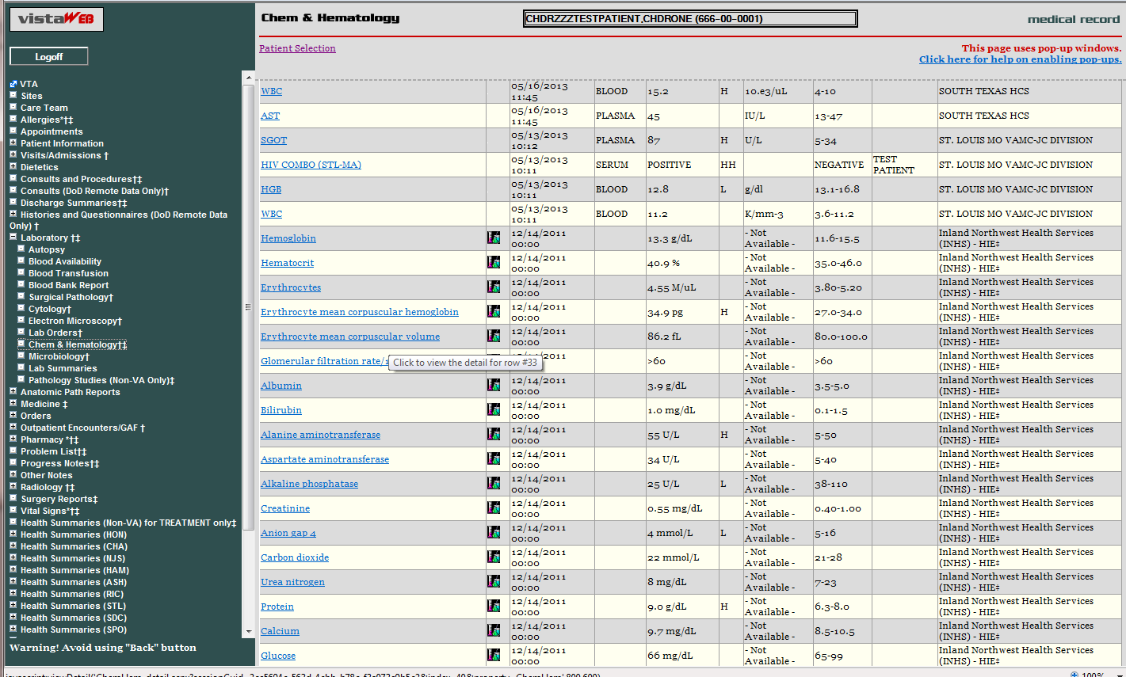

Figure 67: ALL OUTPATIENT PHARMACY PROFILE
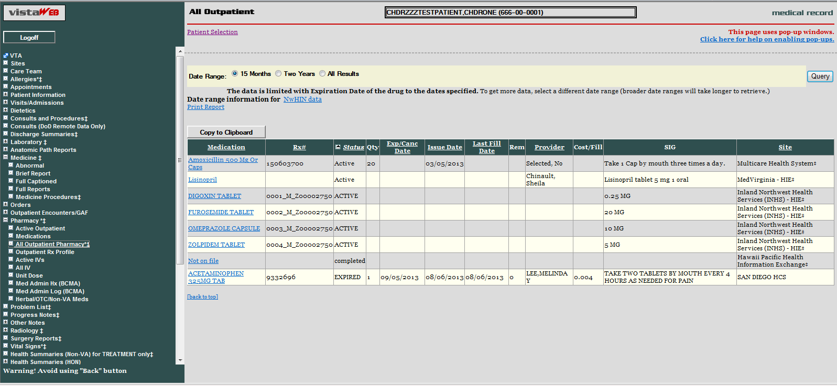

Non-VA Clinical Notes
Some Non-VA partners also send clinical notes to VA. These notes can be found in the VistaWeb menu under Consults and Procedures, Discharge Summaries, Medicine->Medicine Procedures, Progress Notes, Radiology, and Surgery Reports.
Figure 68: Non-VA Clinical Notes
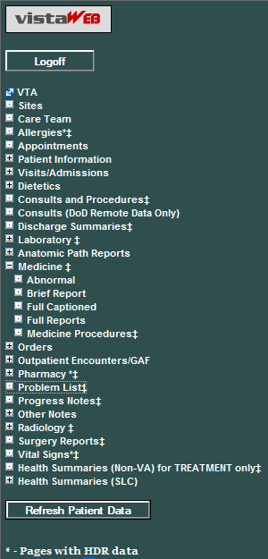
Figure 69: Procedures Notes
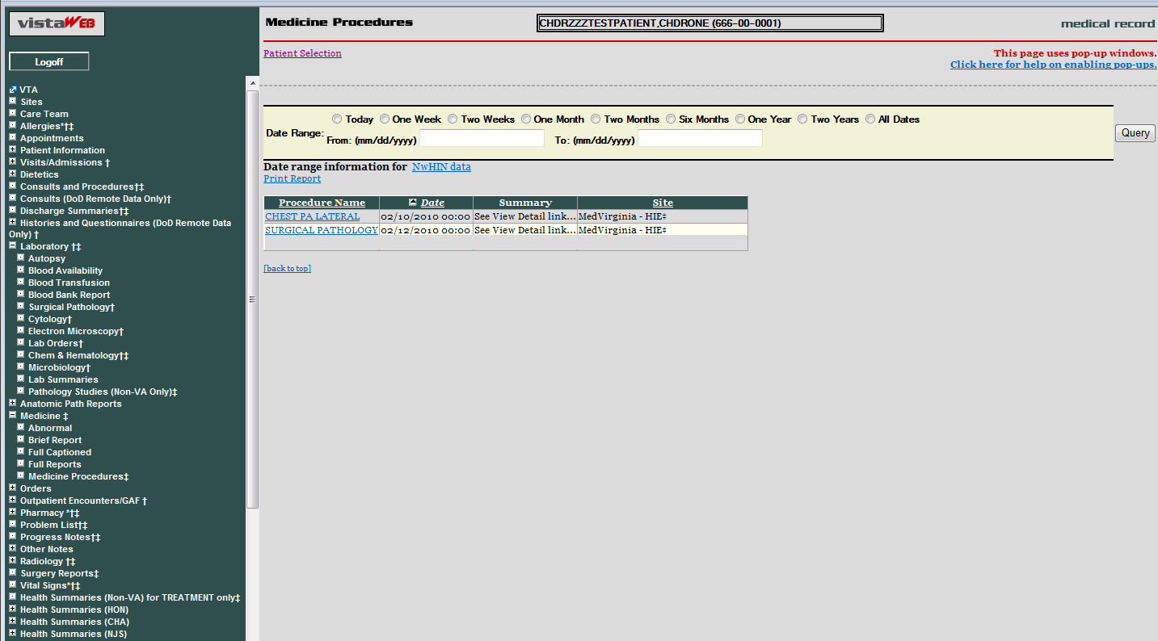

VistAWeb Timeout
VistAWeb has a 15-minute inactivity timeout, which disconnects you from the current session if you don’t respond to the 2-minute Web Page Dialog Countdown. Click the Don’t close VistAWeb button to reset the timer to 15 minutes. Click the Close VistAWeb button to exit VistAWeb immediately.
Figure 70: VistAWeb Timeout Dialog Box
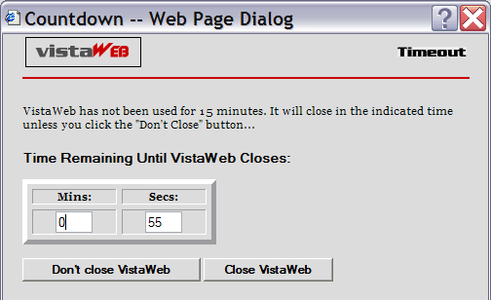
If you allow VistAWeb to timeout, the following IE dialog box is displayed telling you that VistAWeb is trying to close the window. If you click the No button, an empty IE window will remain. If you want to continue to use VistAWeb, you will have to reestablish your connection, and since VistAWeb will bring up the new session in a new window anyway, you should click the Yes button to eliminate this empty window.
Figure 71: IE Close Dialog
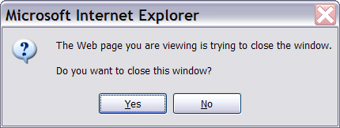
Under some circumstances, VistAWeb will cease operations. This is usually related to running a standalone session and a spawned session of VistAWeb at the same time. When this occurs, you will be presented one of the following messages indicating an appropriate course of action for you to pursue.
Figure 72: Empty Session Message – Rerun VistAWeb
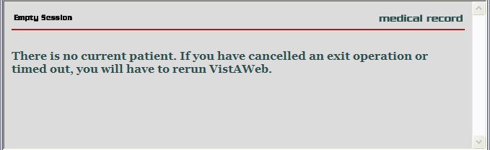
Figure 73: Empty Session Message – Use a Different Browser Window
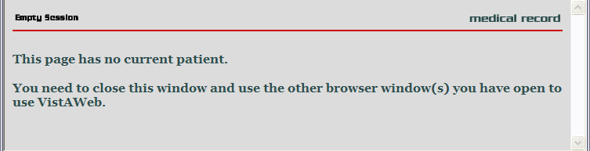

Glossary: Acronyms, Abbreviations, and Definitions

Term | Definition
AWIV | Advanced Windows Imaging Viewer
BHIE | Bidirectional Health Information Exchange
CCOW | Clinical Context Object Workgroup
CPRS | Computerized Patient Record System
DoD | Department of Defense
FHIE | Federal Health Information Exchange
HDR | Health Data Repository
HDR II | Health Data Repository II – final stage of project to develop and deploy an HDR
HDR-IMS | Health Data Repository-Interim Messaging Solution
HITSP | Healthcare Information Technology Standards Panel
HL7 | Health Level 7
HT | Home Telehealth
IE | Internet Explorer (Microsoft)
IHS | Indian Health Service
IRM | Information Resource Management
ISO | Information Security Officer
LHR | Legal Health Record
MPI | Master Patient Index
RDV | Remote Data View
RPC | Remote Procedure Call
URL | Uniform Resource Locator (internet address)
VA | Department of Veterans Affairs
VAMC | Department of Veterans Affairs Medical Center
VHA | Veterans Health Administration
VISN | Veterans Integrated Service Network
VistA | Veterans (Health) Information Systems and Technology Architecture

Definitions
http://vaww.oed.wss.va.gov/process/Library/master_glossary/masterglossary.htm
Term | Definition
Application Coordinator | Designated individuals responsible for user-level management and maintenance of an application package, such as CPRS or Laboratory. Also abbreviated as ADPAC (Automated Data Processing Application Coordinator) or CAC (Clinical Application Coordinator)
Austin Information Technology Center (AITC) | The AITC (a.k.a. Austin Automation Center (AAC)) provides comprehensive e-government solutions to match the critical needs of VA and other federal agency customers, from managing data to automating business processes. The AITC supports over 100 customer applications that provide mission critical data for financial management, payroll, human resources, logistics, medical records, eligibility benefits and supply functions.
Business Owner | A key stakeholder (individual or entity) that is accountable for the business outcomes for a particular existing or new Information Technology (IT) system and has the final authority on project scope, deliverables, quality, risks, and change management processes.
Computerized Patient Record System | The Computerized Patient Record System (CPRS) is a VistA application that enables users to enter, review, and continuously update all the information connected with any patient. In addition, CPRS supports clinical decision-making, with order-checking, alerts, clinical reminders, and patient record flags.
Data Standardization Program | The development, adoption, implementation, and verification of standard terminology within VA software applications to promote interoperability of patient record data between VA and non-VA healthcare providers and to ensure that clinical decisions are based on each patient's entire medical record. Program scope includes standard clinical and administrative terminologies for both current and future VA software applications. (Also see data standardization.)
Domain | Medical areas such as Allergies, Consults, Notes, Laboratory, Medical Procedures, etc. An area of knowledge or activity characterized by a family of related systems. An area of knowledge or activity characterized by a set of concepts and terminology understood by practitioners in that area.
Double dagger (‡) | The double dagger is a symbol that is displayed next to VistAWeb domains to indicate that eHealth Exchange (non-VA) data is available.
Enterprise System Engineering (ESE) | ESE replaces Testing Service, IVV, and Enterprise Infrastructure Engineering (EIE)
Federal Health Information Exchange (FHIE) | The Federal Health Information Exchange (FHIE) Program is a Federal IT health care initiative that facilitates the secure electronic one-way exchange of patient medical information between Government health organizations. The project participants are the Department of Defense (DoD) and the Department of Veterans Affairs (VA).
Healthcare Information Technology Standards Panel (HITSP) | The Healthcare Information Technology Standards Panel is a cooperative partnership between the public and private sectors. The Panel was formed for the purpose of harmonizing and integrating standards that will meet clinical and business needs for sharing information among organizations and systems.
Health Data Repository | A repository of clinical information normally residing on one or more independent platforms for use by clinicians and other personnel in support of patient-centric care. The data is retrieved from heritage, transaction-oriented systems and is organized in a format to support clinical decision-making in support of patient care. Formerly known as Clinical Data Repository.
HL7 | Health Level Seven is one of several American National Standards Institute (ANSI) -accredited Standards Developing Organizations (SDOs) operating in the healthcare arena.
Initial Operating Capability (IOC) Testing | Initial Operating Capability (IOC) Testing (formerly known as field testing) is when a product/system that has been modified/enhanced is placed into a limited production (live) environment, which includes a minimum of three test sites of varying size/complexity, in order to test the new features and functionality of the product/system and to ascertain if the features and functionality perform as expected and do not adversely affect the existing functionality of the product/system.
Requirements | User needs that trigger the development of a program, system, or project. Requirements may be business, functional, and/or system needs. They are documented in detail in the Requirements Specifications Document (RSD) document.
Subject Matter Experts (SME) | Persons representing application development/functional requirements.
User Acceptance Testing (UAT) | UAT is a type of acceptance test that involves end-users as testers. User Acceptance Test (1) exercises the functionality of the application using test data in a controlled test environment and (2) evaluates the usability of a component or system. The Program Manager may invite Product Support to participate in this evaluation.
Veterans Health Administration (VHA) | VHA facilities are divided into geographical regions called VISNs. In the 1990s VHA organized into 22 administrative VISN regions. VISN 20 services veterans in Alaska, Idaho, Oregon, and Washington. However each individual facility continued to maintain its own clinical database (VISTA); the databases were not integrated as a VISN. In 1997-98 VISN 20 began an initiative called CHIPS, to develop a VISN wide information system for decision support, performance measuring and population studies.
VHA Health Information Model (VHIM) | VHIM is an enterprise-wide initiative developed to guide the re-engineering of VHA systems. It is a UML-based model that classifies and represents data elements, including their relationships and constraints. The VHIM mitigates risk of project failure by creating standardized service payloads that all systems will understand. It is a computationally independent model, meaning it can be transformed to different implementations – such as XML, Java, Delphi, etc. It is the authoritative source for semantics and information structure for VHA.
Veterans Health Information Systems And Technology Architecture (VISTA) | A term used to describe the VA’s health care information system. It encompasses in-house developed applications developed by VA staff (see Decentralized Hospital Computer Program), office automation applications, locally developed applications, and commercial-off-the-shelf applications.  VISTA is the largest healthcare system in the world and is extremely complex. The majority of the historical VISTA documentation is out of date and does not provide the detailed information needed by development teams. The development of the current VISTA environment occurred by evolution and was triggered by needs; it was not designed as a whole system. Therefore, the software code, relationships, data structure, and infrastructure were developed incrementally, in individual applications and functions, and are very interdependent.

