VistA Imaging Exchange (VIX) Viewer Improvements

MAG*3.0*303

Enhanced Image Viewer User Guide



November 2022

Version 21.0

Department of Veterans Affairs (VA)

Office of Information and Technology (OIT)

**Revision History**

| Date | Revision | Description | Author |
| --- | --- | --- | --- |
| 11/01/2022 | 21.0 | Updated for MAG*3.0*303 | VA IT VistA Imaging Technical team |
| 04/05/2022 | 20.2 | Updates for MAG*3.0*269 T4 | VA IT VistA Imaging Technical team |
| 02/18/2022 | 20.1 | Updates for MAG*3.0*269 name | VA IT VistA Imaging Technical team |
| 10/18/2021 | 20.0 | Updated for MAG*3.0*269 | VA IT VistA Imaging Technical team |
| 05/21/2021 | 19.0 | Updated for MAG*3.0*284 | REDACTED |
| 07/27/2020 | 18.0 | Updated for MAG*3.0*254 | VA IT VistA Imaging Technical team |
| 06/19/2019 | 17.1 | Updated title page for MAG*3*230 remaining content is the same | REDACTED |
| 05/24/2019 | 17.0 | Updated screenshots with captions | REDACTED |
| 11/15/2018 | 16.0 | Additional MAG*3.0*221 Updates | REDACTED |
| 10/03/2018 | 15.0 | Updated for MAG*3.0*221 | REDACTED |
| 08/22/2018 | 14.0 | Updated for MAG*3.0*201 | REDACTED |
| 07/11/2018 | 13.0 | Additional MAG*3.0*197 Updates | REDACTED |
| 03/26/2018 | 12.0 | Updated for MAG*3.0*197 | REDACTED |
| 11/06/2017 | 11.0 | Additional MAG*3.0*185 Updates | REDACTED |
| 10/12/2017 | 10.0 | Initial MAG*3.0*185 Updates and Incorporated comments from reviewers. | REDACTED |
| 10/04/2017 | 9.0 | Removed ECG references. Date Updates | REDACTED |
| 09/06/2017 | 8.0 | Date Updates | REDACTED |
| 06/27/2017 | 7.0 | Updated for MAG*3.0*177 | REDACTED |
| 04/18/2017 | 6.0 | Formatting updates | REDACTED |
| 04/13/2017 | 5.0 | Formatting and screenshot updates | REDACTED |
| 04/06/2017 | 4.0 | Updated for MAG*3.0*170 | REDACTED |
| 03/24/2017 | 3.0 | Date Updates | REDACTED |
| 02/14/17 | 2.0 | Formatting updates and added  reference to Enhanced Image Viewer. Removed Radiology Viewer section | REDACTED |
| 09/29/16 | 1.0 | Initial Draft | REDACTED |

Table of Contents

1. Introduction 8

1.1. Purpose 8

1.2. Document Orientation 8

1.2.1. Organization of the Manual 8

1.2.2. Assumptions 9

1.2.3. Coordination 9

1.2.4. Disclaimers 9

1.2.4.1. Software Disclaimer 9

1.2.4.2. Documentation Disclaimer 10

1.2.5. Documentation Conventions 10

1.2.6. References and Resources 10

1.3. Enterprise Service Desk and Organizational Contacts 10

2. System Summary 11

2.1. System Configuration 11

2.2. Data Flows 11

2.3. User Access Levels 11

2.4. Continuity of Operation 12

3. Getting Started 13

3.1. Logging On 13

3.2. System Menu 14

3.3. Exit System 15

3.4. Caveats and Exceptions 15

4. Using the Software 16

4.1. Launching the Viewer 16

4.2. Loading Images 17

4.3. Working with Images 18

4.3.1. Viewing Images and Manipulating View Layout 18

4.3.2. Viewing Stacked Images 19

4.3.3. Using the Image Navigation Toolbar 19

4.3.4. Document Viewer 20

4.3.5. Printing an Image 21

4.3.6. Exporting an Image 22

4.3.7. External Links 22

4.3.7.1. Release of Information (ROI) Print Queue Status and ROI Submission 23

4.4. Using the Viewer Toolbar 24

4.4.1. Viewing Information on an Image 26

4.4.2. Changing the Settings of an Image 27

4.4.3. Changing the Study Layout 32

4.4.4. Presentation State 32

4.4.5. Using the Measurements Tools 32

4.4.6. Using the RGB Tool 34

4.5. Closing the Viewer 34

4.6. Image Quality Assurance (QA) 35

4.6.1. Image Information 37

4.6.1.1. Image QA 38

4.6.2. Viewing and Setting Image Status 42

4.6.3. Image QA Report 44

5. Troubleshooting 46

5.1. Special Instructions for Error Correction 46

6. Acronyms and Abbreviations 47

**Table of Figures**

Figure 1: Image Viewer System Summary 11

Figure 2: Main Viewer Page 14

Figure 3: Loading Screen 16

Figure 4: Images Not Loading 17

Figure 5: Main Viewer Page with Thumbnail Panel 17

Figure 6: Main Viewer Page with Images Loaded 19

Figure 7: Navigation Toolbar 19

Figure 8: Frame Count 20

Figure 9: Main Viewer Page with a Document Loaded 20

Figure 10: Print Menu 21

Figure 11: Print Menu - Device Selection 21

Figure 12: Exporting an Image 22

Figure 13: External Links Button in the Top Right Corner 22

Figure 14: External Links Menu 22

Figure 15: ROI Print Queue Status 23

Figure 16: Print Queue 23

Figure 17: Disabled Toolbar Button 24

Figure 18: Toolbar 24

Figure 19: DICOM Attributes 26

Figure 20: Image Metadata 26

Figure 21: Settings Menu 27

Figure 22: Annotations Preferences 27

Figure 23: Measurement Preferences 28

Figure 24: Ellipse and Rectangle Preferences 28

Figure 25: Label Preferences 29

Figure 26: Annotation Preferences 29

Figure 27: Cine Preferences 30

Figure 28: Layout Preferences 30

Figure 29: Layout Preference Choices 31

Figure 30: Copy Attributes Preferences 31

Figure 31: Layout Attribute Preference Choices 32

Figure 32: Presentation State Button 32

Figure 33: Presentation State Menu 32

Figure 34: Measurement Tool View 1 33

Figure 35: Measurement Tool View 2 33

Figure 36: Measurement Tool View 3 33

Figure 37: 2D Length Calibration 33

Figure 38: Hounsfield Measurement Tools 34

Figure 39: RGB Tool Button 34

Figure 40: Viewer Close Button 34

Figure 41: Main Viewer Page with Image Loaded 35

Figure 42: External Links Menu on Main Viewer Page 36

Figure 43: Image Information 37

Figure 44: Image Editor 38

Figure 45: QA Review Page 38

Figure 46: QA Filters and Date Range 39

Figure 47: Search Filter Details 39

Figure 48: QA Status Choices 40

Figure 49: Percentage of Images to Display 40

Figure 50: Saved Filters 41

Figure 51: QA Filter Results 42

Figure 52: QA Filter Results and Image Information 42

Figure 53: QA Thumbnail 43

Figure 54: QA Review Status Update Menus 43

Figure 55: QA Statistics Reports Page 44

Figure 56: Run QA Report 44

Figure 57: View QA Report 45

Figure 58: Viewer Version Number 46

Figure 59: Viewer Information Dialog 46

**Table of Tables**

Table 1: Viewing Images and Manipulating View Layout 18

Table 2: Functions and Uses of the Toolbar 19

Table 3: Toolbar Icons- Names, Functions, and Descriptions 24

# Introduction

## Purpose

This manual describes the "Viewer" web application which is also known as the:

* Enhanced Image Viewer
* Image Viewer
* VistA Imaging Exchange (VIX) Viewer
* VistA Imaging Viewer

The Viewer displays and provides tools for clinical and medical media in web hosting applications like the Joint Legacy Viewer (JLV). The media can be images, documents, data, and videos. The images are Digital Imaging and Communications in Medicine (DICOM) and non-DICOM images. The documents are typically medical reports. To keep things simple, henceforth in this document, we use the term images to identify all media types unless a specific type is applicable.

This manual assumes you are familiar with web applications. This manual also assumes you are using the Viewer with the latest release level. The release level appears on the cover page and at the top of the Revision History page. Section 5 describes how to see the complete release number.

## Document Orientation

### Organization of the Manual

This document contains the following sections to assist you in using the Viewer:

* **Section 1 – Introduction**  
  Describes the document and helps you to follow the document.
* **Section 2 – System Summary**  
  Describes a summary of the Viewer.
* **Section 3 – Getting Started**  
  Describes how the Viewer works. Explains the main Viewer page and how the Viewer handles images.
* **Section 4 – Using the Software**Describes how to use the Viewer. References the image manipulation toolbars and explains how to close the Viewer. Describes how to use the Quality Assurance features of the Viewer.
* **Section 5 – Troubleshooting**Describes how to access some of the information contained in the Viewer. The information assists you in troubleshooting some issues that might occur when using the Viewer.
* **Section 6 - Acronyms**Defines the Acronyms and Terms used and referenced in this document.

### Assumptions

The user has been provided the appropriate active roles, menus, and security keys required for the VIX Viewer. Also, the user has basic knowledge of the use of a web browser, menu options, and navigation tools.

### Coordination

Use of the Viewer is subject to the following provisions:

**Caution:** Federal law restricts this device to use by or on the order of either a licensed practitioner or persons lawfully engaged in the manufacture or distribution of the product.

The Viewer is not intended for the primary interpretation of radiology exams. When the Viewer installs on approved and properly maintained hardware, primary interpretation of other image types is permissible by licensed practitioners at their discretion.

The Food and Drug Administration (FDA) classifies VistA Imaging and the Viewer (as a component of VistA Imaging) as a medical device. Unauthorized modification to VistA Imaging, including the Viewer, such as installing unapproved software, adulterates the medical device. The use of an adulterated medical device violates US federal law (21CFR820).

### Disclaimers

This is a controlled document. No changes to this document may be made without the express written consent of the VistA Imaging Office of Enterprise Development group.

While every effort has been made to assure the accuracy of the information provided, this document might include technical inaccuracies and/or typographical errors. Changes are periodically made to the information herein and incorporated into new editions of this document. Product names mentioned in this document might be trademarks or registered trademarks of their respective companies and are hereby acknowledged.

* VistA Imaging Office of Enterprise Development Department of Veterans Affairs
* Internet: <http://www.va.gov/imaging>
* Imaging VistA Imaging SharePoint: REDACTED

#### Software Disclaimer

This software was developed at the Department of Veterans Affairs by employees of the Federal Government in their official duties. Pursuant to Title 17 Section 105 of the United States Code, this software is not subject to copyright protection and is in the public domain. VA assumes no responsibility whatsoever for its use by other parties and makes no guarantees, expressed or implied, about its quality, reliability, or any other characteristic. We would appreciate acknowledgment if the software is used. This software can be redistributed and/or modified freely if any derivative works bear some notice that they are derived from it, and any modified versions bear some notice that they have been modified.

#### Documentation Disclaimer

The appearance of external hyperlink references in this manual does not constitute an endorsement by the VA of the website or the information, products, or services contained therein. The VA does not exercise any editorial control over the information you may find at these locations. Such links are provided and are consistent with the stated purpose of the VA.

### Documentation Conventions

This document uses the following conventions:

* Controls, options, and button names are shown in **Bold.**
* A vertical bar is used to separate menu choices. For example: "Click **File | Open"** means: "Click the **File** menu, then click the **Open** option." Keyboard key names are shown in bold and in brackets.
* Sample output is shown in monospace.
* When this document is used online, hyperlinks are indicated by blue text.
* Useful or supplementary information is shown in a **Tip.** Important or required information is shown in a **NOTE.**
* Critical information is indicated by: 

### References and Resources

Additional information about VistA Imaging can be found at:

* VistA Imaging: <http://www.va.gov/vdl/application.asp?appid=105>

## 1.3. Enterprise Service Desk and Organizational Contacts

If you encounter any problems using the Viewer, contact your local Imaging Coordinator or support staff. If the problem cannot be resolved locally, use YourIT Service Desk Manager to place a service request, or contact the Enterprise Service Desk at REDACTED.

# System Summary

Web hosting applications, such as the JLV, embed the Image Viewer (Figure 1) in the host application's web page. The Image Viewer communicates with the CVIX/VIX application. The web hosting application might also directly communicate with the CVIX/VIX application. The Image Viewer operates inside the VA network. VistA Imaging provides formal authorization to a web hosting application to embed the Image Viewer. Users of an authorized web hosting application are automatically authorized to use the Image Viewer.

Figure 1: Image Viewer System Summary

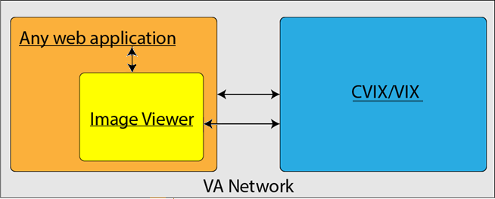

## System Configuration

The Viewer adds image display capabilities to web hosting applications in a similar way as the Clinical Display desktop application adds image display capabilities to the Computerized Patient Record System (CPRS).

The Viewer is a web-based application that provides a subset of features of Clinical Display. This means it does not supply all features that Clinical Display offers.

## Data Flows

The Viewer is a web application that enables you to access patient images using VA approved versions of Chrome or Edge.

The Viewer allows users to locate and display any patient images available to the VA from VistA Imaging, including Department of Defense (DoD) images.

## User Access Levels

Users use a service account in VistA with the DICOM VISA [MAG DICOM VISA] and CPRSChart [OR CPRS GUI CHART] secondary menu options, at a minimum, to access the Image Viewer through the web hosting application.

## Continuity of Operation

Since the Viewer is embedded in another application, the Viewer relies on the other application's continuity of operation.

# Getting Started

After logging into the web hosted application and selecting a patient study, the Viewer's main page displays the study. Section 3.2 describes the main page.

## Logging On

To access the Viewer and authenticate, the user logs on through the web hosted application. The web hosted application logs in users to authenticate their credentials by getting a security token. This token is used throughout the Viewer's web pages.

## System Menu

The image below (Figure 2) shows the main Viewer page and its components.

Figure 2: Main Viewer Page

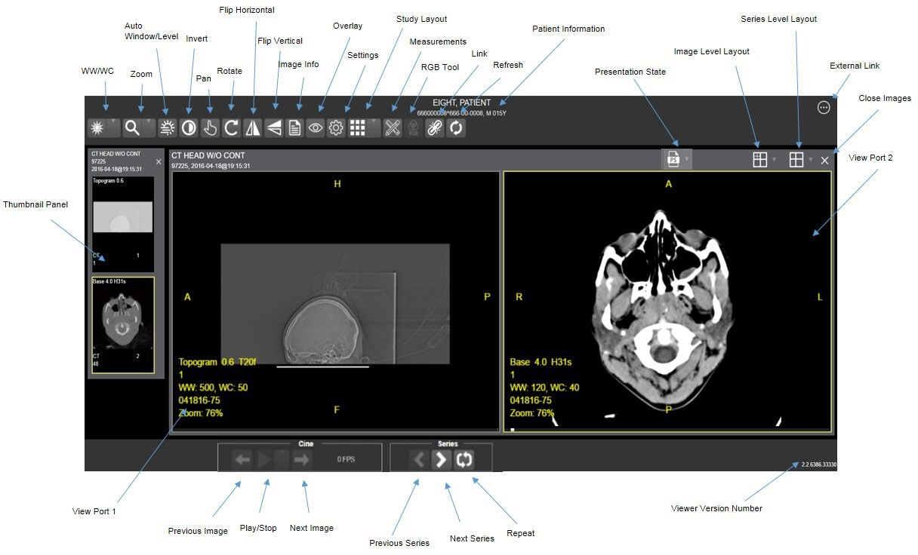

## Exit System

To exit the system, close the Viewer's web pages that are open in web browser tabs and exit the web hosted application.

## Caveats and Exceptions

If encountering issues, clear the cache in the web browser for the Viewer.

# Using the Software

## Launching the Viewer

Upon launching the Viewer, the following loading screen (Figure 3) displays while the Viewer loads the study's images:

Figure 3: Loading Screen



**NOTE:** The VA's and your network's bandwidth dictate the amount of time it takes to transfer the images. Some images can be very large which usually means they take a while to load, sometimes even minutes. The faster the bandwidth, the faster the computer can transfer data.

The first time a study launches, the Viewer pre-processes the study's images and loads them into a cache on the VIX server. Caching images reduces the load time for subsequent study views.

If there is trouble loading one or more images, the following screen displays (Figure 4) with the option to either proceed or empty the cache and try again. If you select proceed, the study loads without the problem images. If you choose to empty the cache and retry, the Viewer attempts to re-process all the images for the study.

Figure 4: Images Not Loading

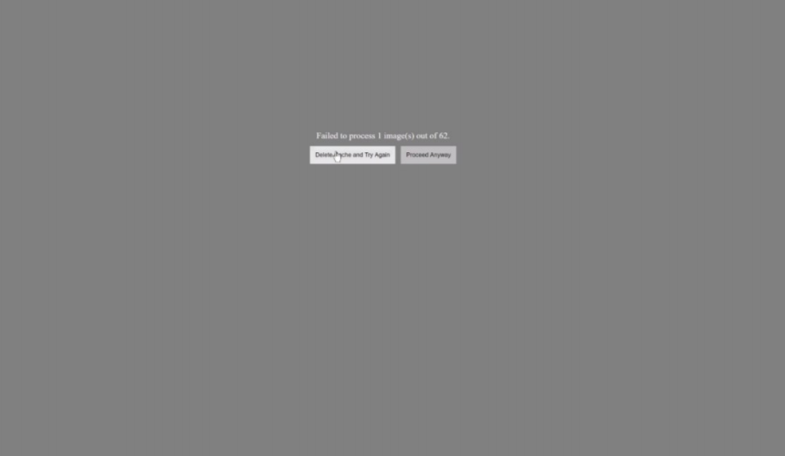

## Loading Images

When the Viewer main page opens, it displays thumbnail placeholders until the thumbnails themselves are retrieved. See Table 1 for an example of a thumbnail.

To display images associated with thumbnails:

1. On the left side of the Viewer main page, locate the thumbnail for the desired image.
2. Click the desired **thumbnail**. A progress page displays as shown below (Figure 5) until the loading of the image completes.

Figure 5: Main Viewer Page with Thumbnail Panel

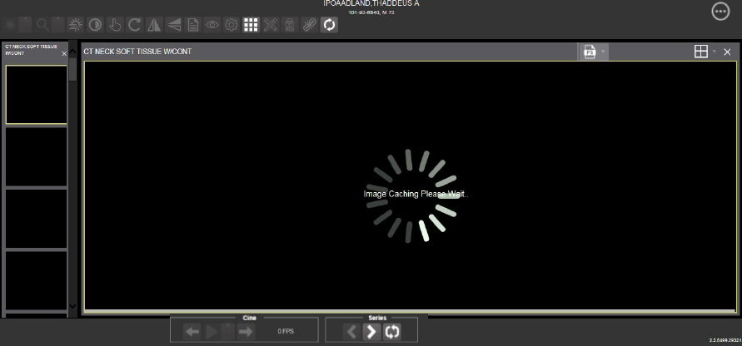

## Working with Images

The functions described below change how the images display.

**NOTE**: Any changes made to the images as described below apply only to the current session and not to subsequent sessions.

### Viewing Images and Manipulating View Layout

Table 1: Viewing Images and Manipulating View Layout

| Button Icon | Button Name and Function | Description |
| --- | --- | --- |
| Image Level Layout | Image Level Layout | The Image Level Layout button allows users to select how many images within each series display within the viewport for each series. |
| Series Level Layout | Series Level Layout | The Series Level Layout button manipulates how many series within the study display on the viewport. |
| Close Images | Close Images | The Close Images button closes the currently selected image from the viewport. |
| Thumbnail | Thumbnail | The title of the series appears at the top left of the thumbnail. The image type appears at the bottom left, with the number of images in the series directly below that. The series number displays on the bottom right of the thumbnail. For DICOM images, the modality code appears on the bottom left. |
| Thumbnail Panel | Thumbnail Panel | To adjust the size of the thumbnail panel, click and drag the right edge of the panel to the left or right. This affects how many thumbnails are shown per row within the panel but does not alter the size of the thumbnails. When hovering over the viewport and viewing non-stacked images, use the mouse wheel to scroll between the different series displayed in the thumbnail panel. Use drag-and-drop to drag thumbnails to the viewport. A yellow outline appears around the thumbnail that currently shows in the viewport. |

### Viewing Stacked Images

When viewing a stacked image series, use the mouse wheel to scroll between the images in the stack. Upon scrolling, if multiple series display in the viewport, scout lines appear on the images of the other series in a different plane to indicate what part of the body the series is displaying. See Figure 6 below.

Figure 6: Main Viewer Page with Images Loaded

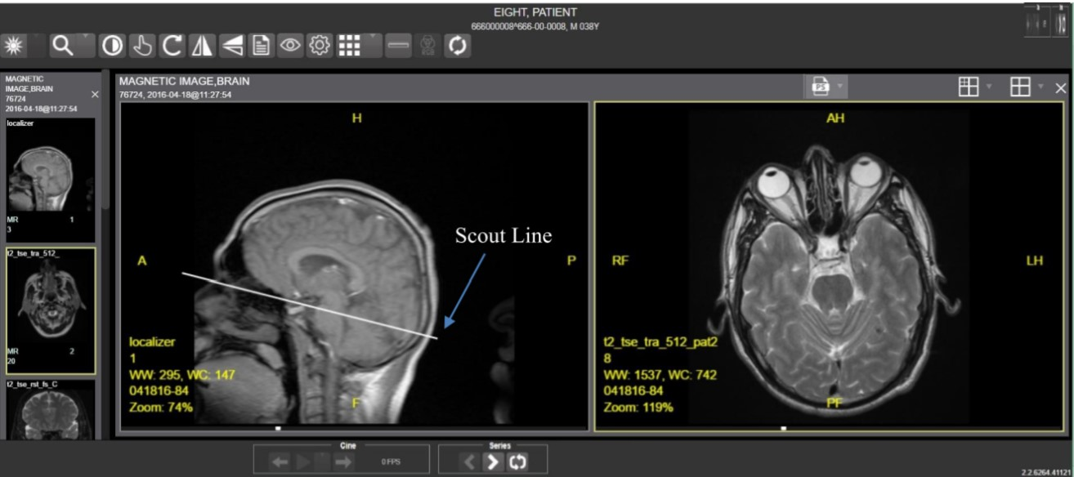

### Using the Image Navigation Toolbar

The navigation toolbar appears automatically when the Viewer determines it applies to the displayed image. See Figure 7 below:

Figure 7: Navigation Toolbar

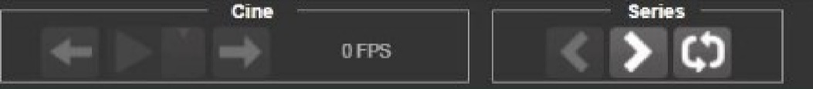

Table 2 describes the functions and uses of each button in the navigation toolbar*.*

Table 2: Functions and Uses of the Toolbar

| Button Icon | Button Name and Function | Description |
| --- | --- | --- |
| Previous Series Next Series | Previous Series and Next Series | The Previous Series and Next Series buttons help you toggle between the image series in the study. |
| Previous Image Next Image | Previous Image and Next Image | The Previous Image and Next Image buttons help you scroll through the images within the currently selected series. |
| Play  Stop | Play and Stop | The Play and Stop buttons begin and end playing through a cine image scene. |
| Repeat | Repeat | When you select the Repeat series button, the current series repeats. When you deselect the button, all the series play through before repeating the current series. |

While a series is playing, a number appears next to the image navigation toolbar. The number is the frame rate the series is currently playing. See Figure 8 below.

Figure 8: Frame Count

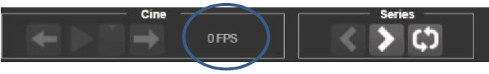

* **NOTE:** The first time a series plays, it might play slower while caching the images. Once the images are cached, the series plays faster.

### Document Viewer

When viewing a document, the document viewer loads and the image viewer toolbars hide. See Figure 9 below for an example of the document viewer.

Figure 9: Main Viewer Page with a Document Loaded

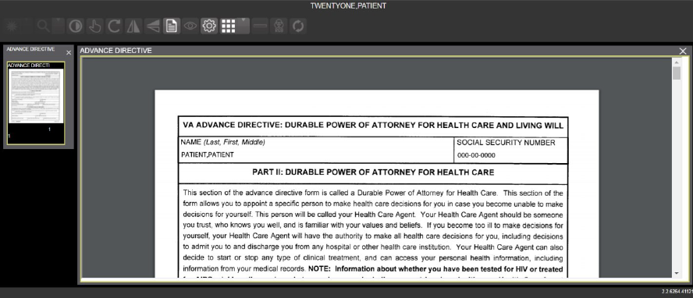

### Printing an Image

To print an image, right-click on the image to display a context menu. See Figure 10 below for an example.

Figure 10: Print Menu

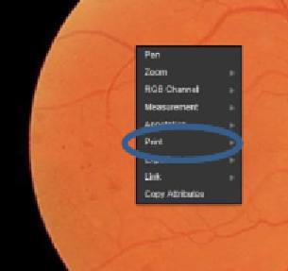

After selecting the print option, you can select print options. You must select a print reason and enter your digital signature. After selecting the print options, the image opens in a new tab in a printable form. You can now print the image by selecting **File** | **Print**, or **Ctrl+P**. See Figure 11 below for an example.

Figure 11: Print Menu - Device Selection

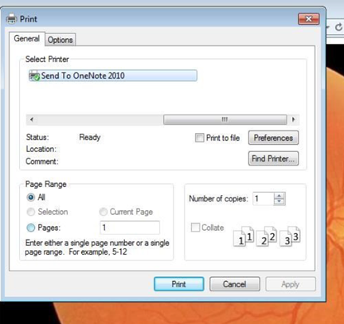

### Exporting an Image

To export an image, right-click on the image to display a context menu. See Figure 12 for an example.

Figure 12: Exporting an Image

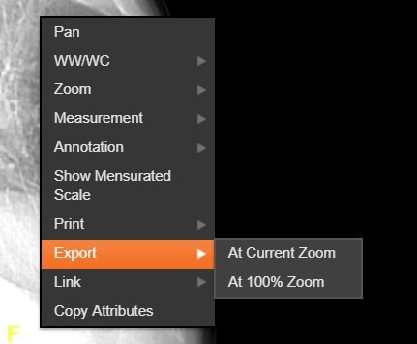

After selecting the desired zoom, you must enter the digital signature before the image exports.

### External Links

Click the button in the top right corner (Figure 13) of the Viewer page to view the **External Links** menu (Figure 14).

Figure 13: External Links Button in the Top Right Corner

External Links Button in the Top Right Corner 

Figure 14: External Links Menu

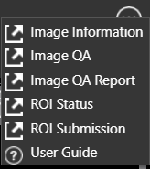

#### Release of Information (ROI) Print Queue Status and ROI Submission

To view the ROI Print Queue Status, click **ROI Status** on the **External Links** menu, and the following screen displays (Figure 15).

Figure 15: ROI Print Queue Status

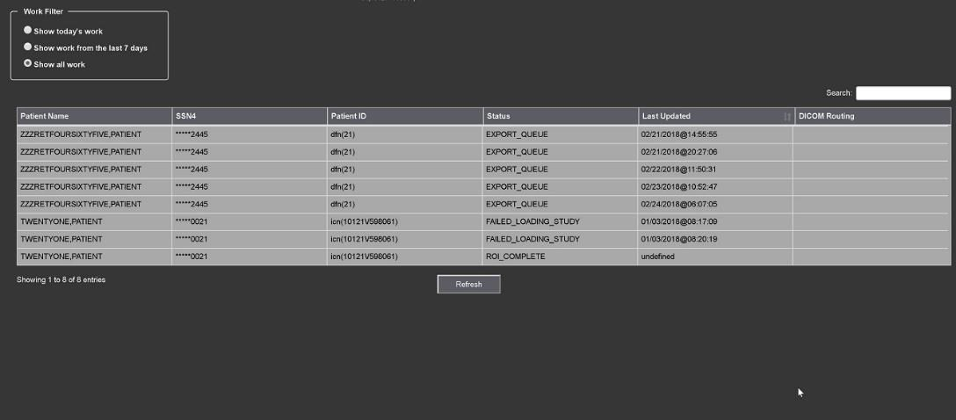

To perform ROI Submissions, click **ROI Submission** on the **External Links** menu and the following screen displays (Figure 16).

Figure 16: Print Queue

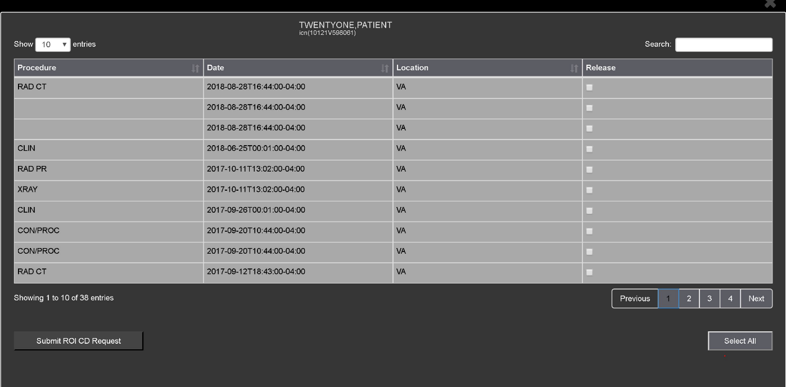

To print:

* Select one or more items and click **Submit** ROI CD Request, where CD stands for Compact Disc.
* Choose the target printer or CD (for DICOM images only) and the reason for printing.
* Enter the electronic signature. The selected items print to the chosen target.

## Using the Viewer Toolbar

The toolbar provides buttons to access the Viewer features while viewing an image. The Viewer enables and disables (grays them out) the buttons depending on the image type. See Figure 17 for an example of a grayed-out toolbar button. See Figure 18 for an image of the toolbar.

Figure 17: Disabled Toolbar Button

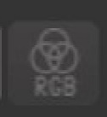

Figure 18: Toolbar



Table 3 describes the functions and uses of each button in the toolbar are described below*.*

Table 3: Toolbar Icons- Names, Functions, and Descriptions

| Button Icon | Button Name and Function | Description |
| --- | --- | --- |
| Window/Level | WW/WC (Window Level) | Provides the ability to set the WW/WC (Window Level) View. When you select the WW/WC button, click, and drag on the desired image to alter the grayscale value of the image. For Computerized Tomography (CT) images, a preset menu displays with the following options: Default, Abdomen, Bone, Brain, Head/Neck, Lung, and Customize. |
| Zoom | Zoom | Provides the ability to resize the image to 100%, or Fit to Window, or Fit Width to Window, or Fit Height to Window, or to Customize the sizing. When you select the Zoom button, click, and drag the image to zoom in and out. |
| Auto Window /Level | Auto Window Level | Provides the ability to click and drag on the selected image to adjust the window level. |
| Invert | Invert | Inverts the image. |
| Pan | Pan | After selecting this button, click, and drag the image to pan and view the desired area. |
| Rotate | Rotate | Rotates the Image 90 degrees counterclockwise. |
| Flip Horizontal | Flip Horizontal | Flips the Image horizontally. |
| Flip Vertical | Flip Vertical | Flips the Image vertically. |
| View Image Info | View Image Info | Displays the image's DICOM attributes and metadata. |
| Overlay | Overlay | The Overlay option toggles the overlay on and off. The Cross Reference Line option toggles the scout lines on and off. The Hide Annotation/Measurement option toggles the annotations and measurements you have created on the image. |
| Settings | Settings | Provides the ability to set the Annotation, Cine, and Layout Preferences. For more information on the settings, see section 4.4.2 below. |
| Study Level | Study Level | Provides the ability to set the Study Level to lxl, lx2, lx3, 2xl,2x2, 2x3, 3xl, or 3x3. |
| Measurements | Measurements | Provides the ability to access the 2D Length, the Angle Tool, 2D Point, 2D Length Calibration, or Delete All. For more information on the measurement options, see section 4.4.5 below. |
| Red Green Blue (RGB) Tool | Red Green Blue (RGB) Tool | Accesses the RGB Tool. For more information on the RGB tool, see section 4.4.6 below. |
| Link | Link | Allows you to select two image stacks and scroll. |
| Refresh | Refresh | Provides the ability to refresh the image to its original settings. |

### Viewing Information on an Image

To view the image's information, select the **View Image Info** button. To view the DICOM information, select **DICOM Header**, and the screen shows the DICOM attributes as shown below (Figure 19).

Figure 19: DICOM Attributes

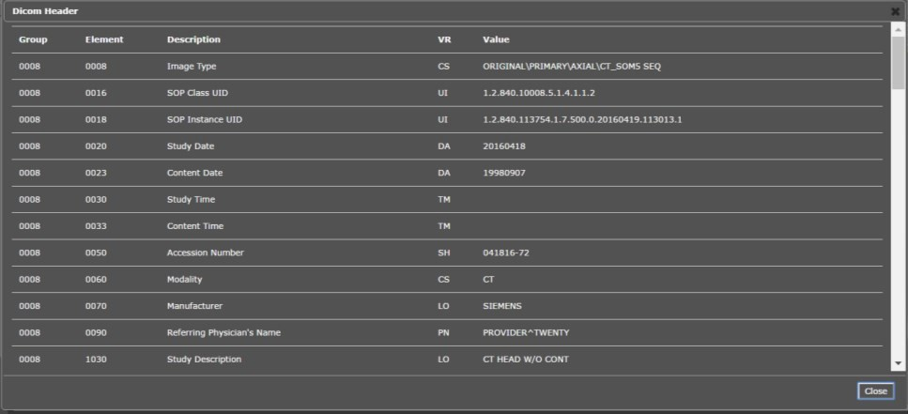

To view the Imaging Data for the Image, select the **Imaging Data** option, and the screen displays the image's metadata as shown below (Figure 20):

Figure 20: Image Metadata

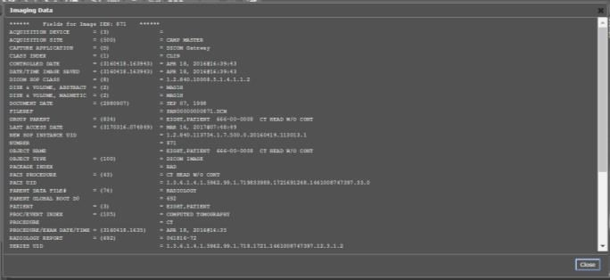

### Changing the Settings of an Image

Select the **Settings** button to view or update the settings options (Figure 21).

Figure 21: Settings Menu

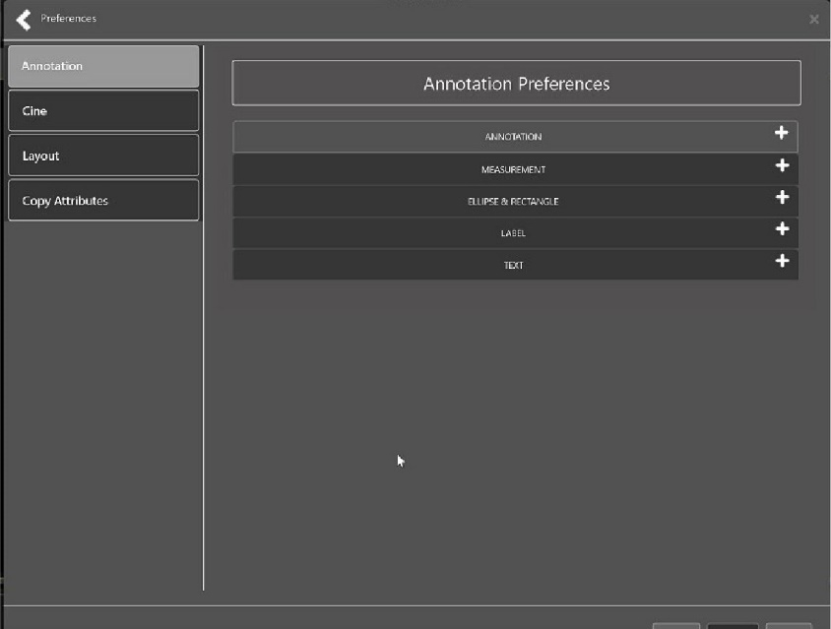

Click **Annotation**, and the following screen displays (Figure 22).

Figure 22: Annotations Preferences

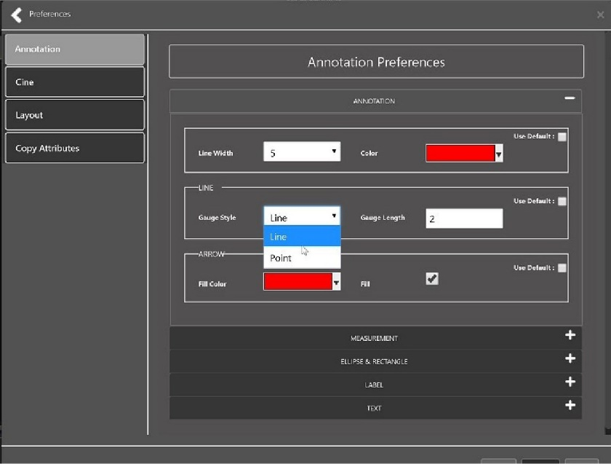

Click **Measurement**, and the following screen displays (Figure 23).

Figure 23: Measurement Preferences

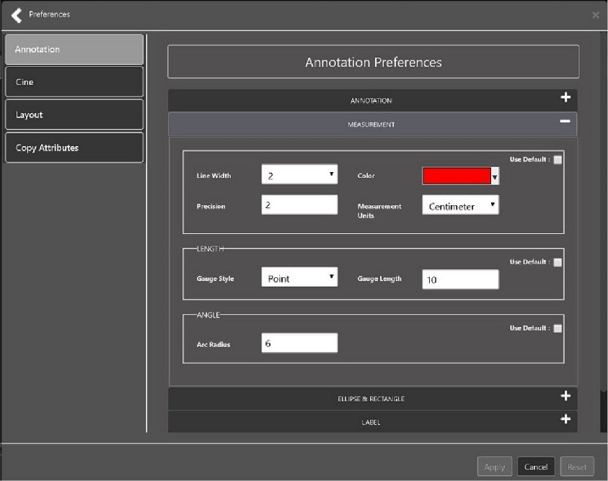

Click **Ellipse and Rectangle**, and the following screen displays (Figure 24):

Figure 24: Ellipse and Rectangle Preferences

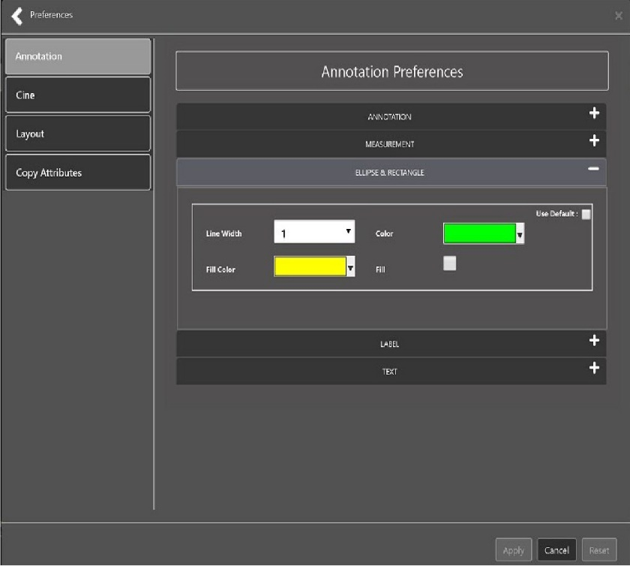

Click **Label**, and the following screen displays (Figure 25):

Figure 25: Label Preferences

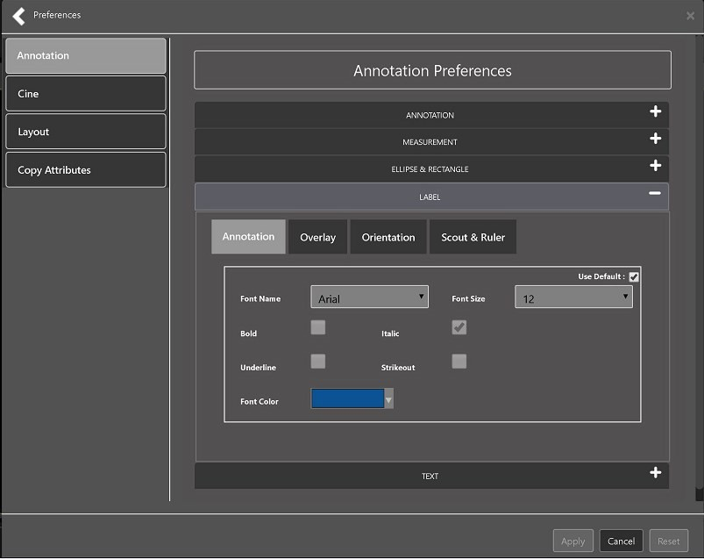

Under Label preferences, choose Annotation, Overlay, Orientation, or Scout & Ruler. Click **Text**, and the following screen displays (Figure 26):

Figure 26: Annotation Preferences

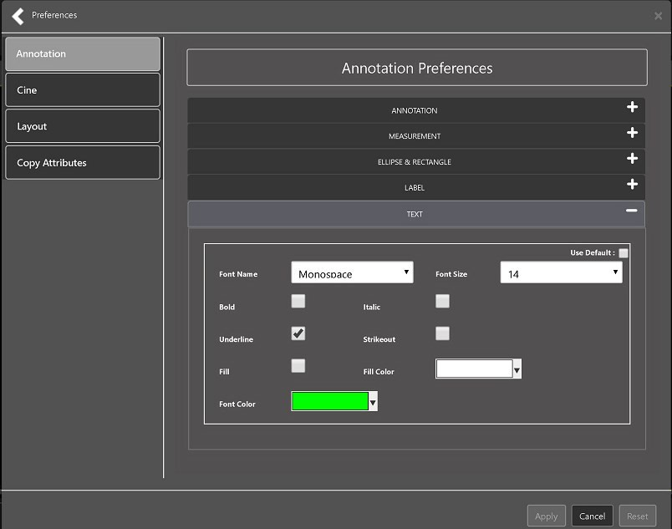

To view or update the Cine Settings, select the **Cine Preference** and the following screen displays (Figure 27):

Figure 27: Cine Preferences

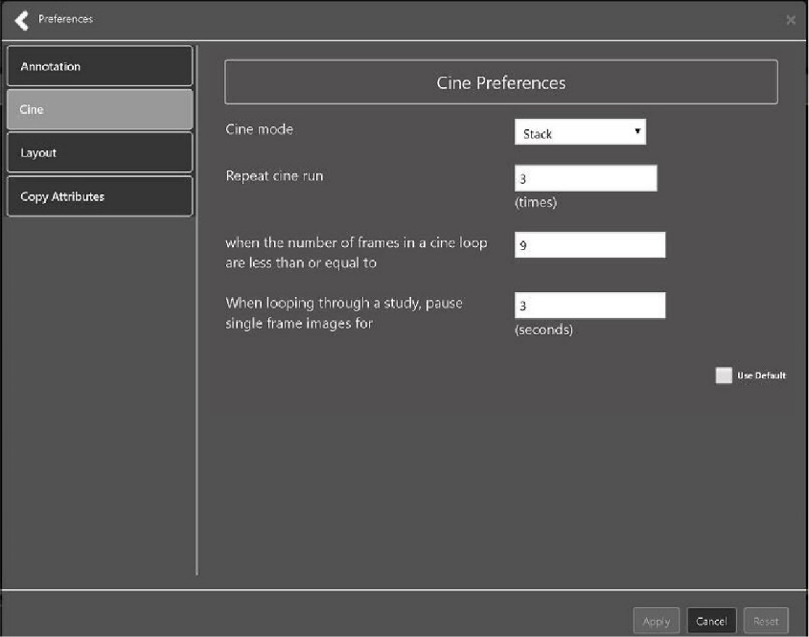

To view the Layout settings, select the **Layout Preference** to display the following screen (Figure 28):

Figure 28: Layout Preferences

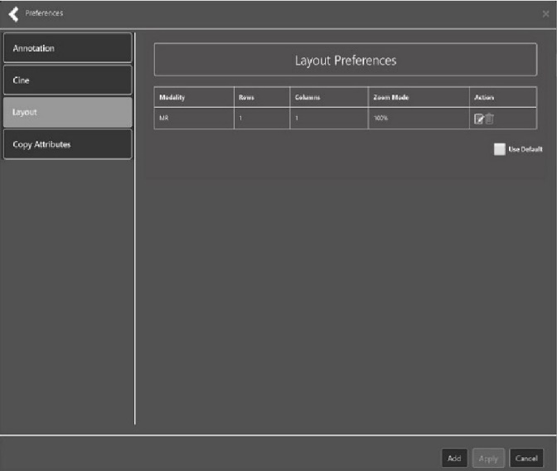

Click **Add** in the bottom right of the page to add a new layout preference (Figure 29).

Figure 29: Layout Preference Choices

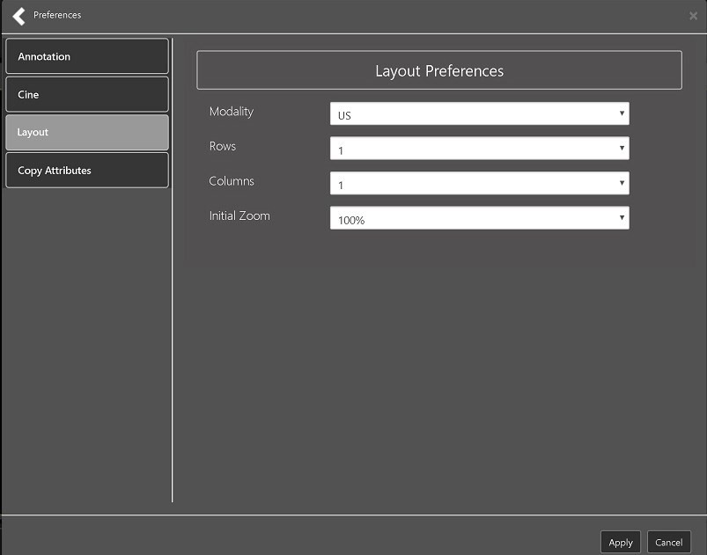

To view the Copy Attributes settings, select the **Copy Attributes Preference**, and the following screen displays (Figure 30):

Figure 30: Copy Attributes Preferences

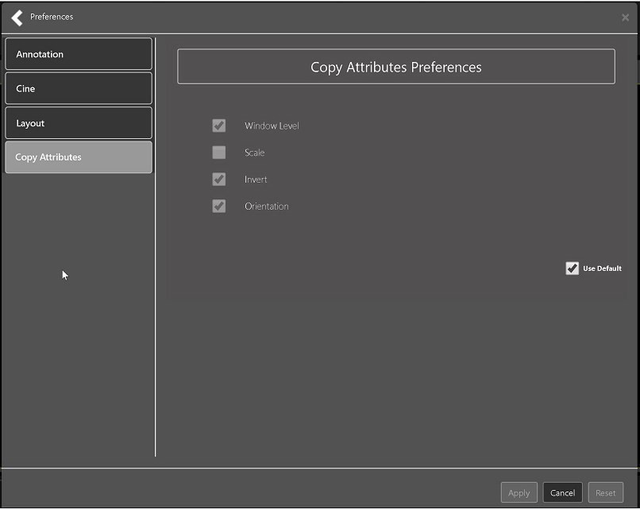

### Changing the Study Layout

To change the study layout, select the **Study Layout Button**, and the following screen displays (Figure 31):

Figure 31: Layout Attribute Preference Choices

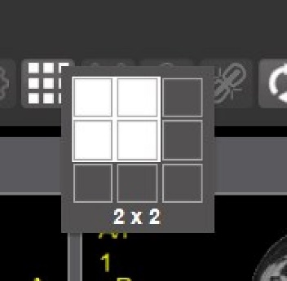

Select the **study level** that best suits your purpose.

### Presentation State

To view presentation state options, click the **PS Icon** (Figure 32),and the following menu appears (Figure 33).

Figure 32: Presentation State Button

Presentation State button

Figure 33: Presentation State Menu

Presentation State Menu

The presentation state icon is available only if there are presentation states associated with the study and there is an annotation drawn on the image. The bottom of the context menu displays all the saved presentation states associated with the study. To view additional information about a specific presentation state, hover over it in the context menu.

### Using the Measurements Tools

To use the various measurement tools, select the **Measurements** button, and the following screens display depending on the option you choose (Figure 34, Figure 35, and Figure 36):

Figure 34: Measurement Tool View 1

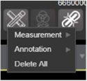

Figure 35: Measurement Tool View 2

Measurement Tool View 2

Figure 36: Measurement Tool View 3

Measurement Tool View 3

The **2D Length** option draws the necessary line(s) to obtain the desired measurements.

The **Angle Tool** draws the necessary line(s) to measure the desired angle.

The **2D Point** tool places the necessary dots to obtain the desired measurements. Use this option for ultrasound studies to measure velocity.

The **2D Length Calibration** option calibrates measurements to ensure accurate data. Images with DICOM info use the DICOM info to inform measurement calibration, but images without this data need calibration to show accurate data. See Figure 37 below.

Figure 37: 2D Length Calibration

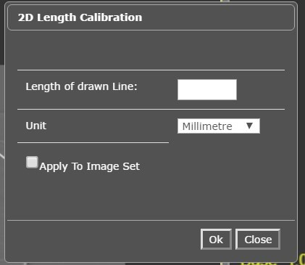

The **Hounsfield** tool takes circular and rectangular density measurements. See Figure 38 below.

Figure 38: Hounsfield Measurement Tools

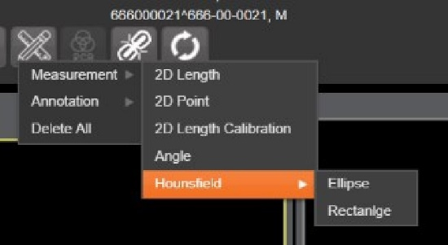

The **Text** tool creates text boxes on the image.

The **Line** tool draws straight lines on the image.

The **Arrow** tool draws straight arrows on the image.

The **Ellipse** tool draws ellipses on the image.

The **Rectangle** tool draws rectangles on the image.

The **Free Hand** tool connects points that you have specified to create any desired shape.

To delete all the measurements and markings you made on the current image, select the **Delete All** option.

### Using the RGB Tool

The **RGB Tool** button filters the image for certain color channels to allow for various observations. When selected, a context menu (Figure 39) appears that allows you to select the desired color channel.

Figure 39: RGB Tool Button



## Closing the Viewer

To close the Viewer page, click the "**X**" on the browser tab. See Figure 40 below.

Figure 40: Viewer Close Button

Viewer Close Button

**NOTE:** Depending on the hosting application the Viewer page might automatically close when you select a different patient.

## Image Quality Assurance (QA)

To use the image quality assurance features, load an image in the Viewer (Figure 41).

Figure 41: Main Viewer Page with Image Loaded

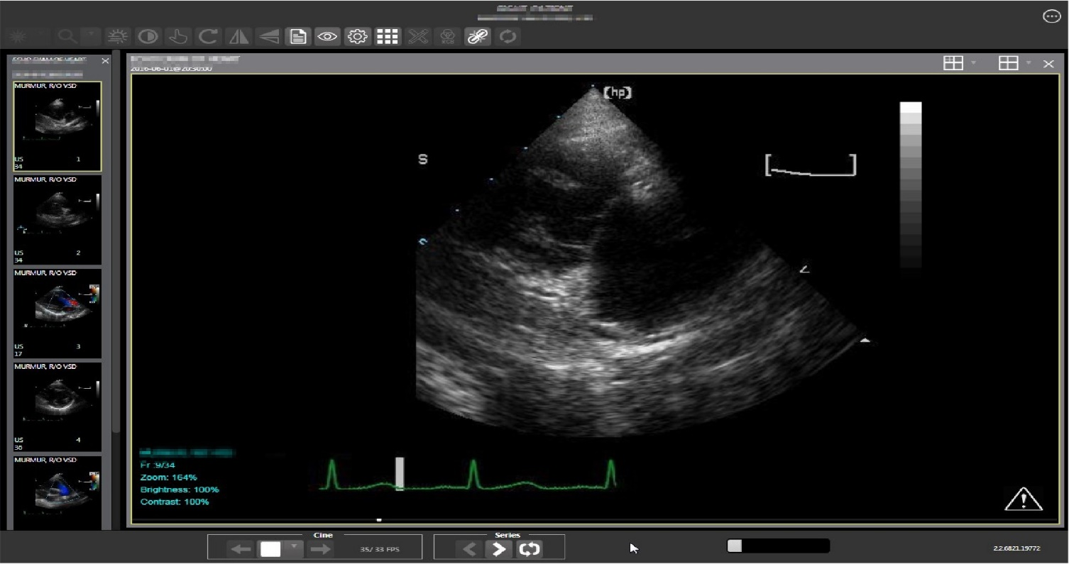

Click the **External Links** button on the Viewer page and a drop-down menu (Figure 42) appears.

Figure 42: External Links Menu on Main Viewer Page

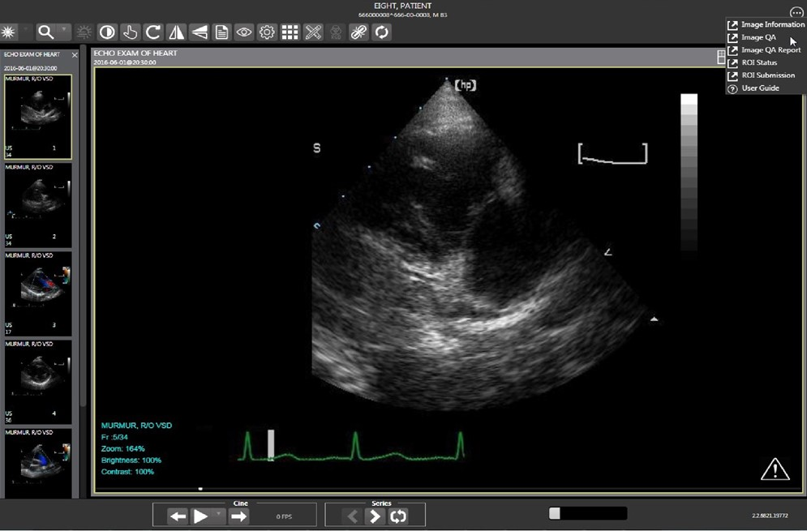

### Image Information

Select the **Image Information** link from the menu. The image information page (Figure 43) displays.

Figure 43: Image Information

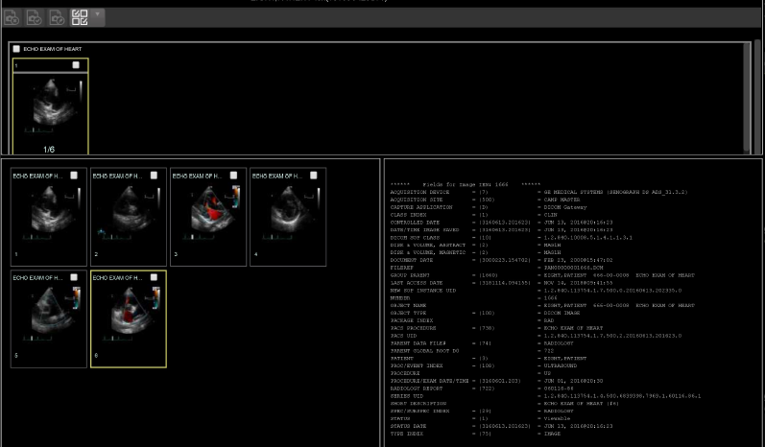Select any image, then click the **Image Edit** button on the toolbar. The image editor dialog (Figure 44) opens. To edit a field, click on the **checkbox** to the left to enable the dropdown control or the textbox. Click **Save** to save the image index fields.

Figure 44: Image Editor

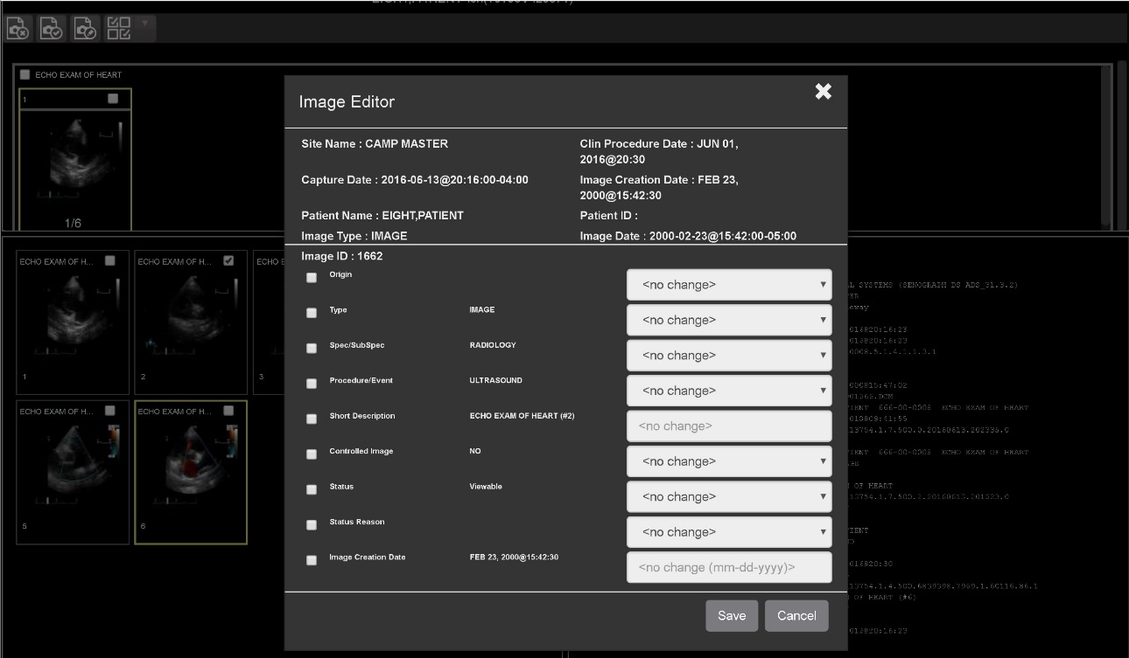

#### Image QA

Select **Image QA** from the **External Links** menu to open the QA review page (Figure 45)*.*

Figure 45: QA Review Page

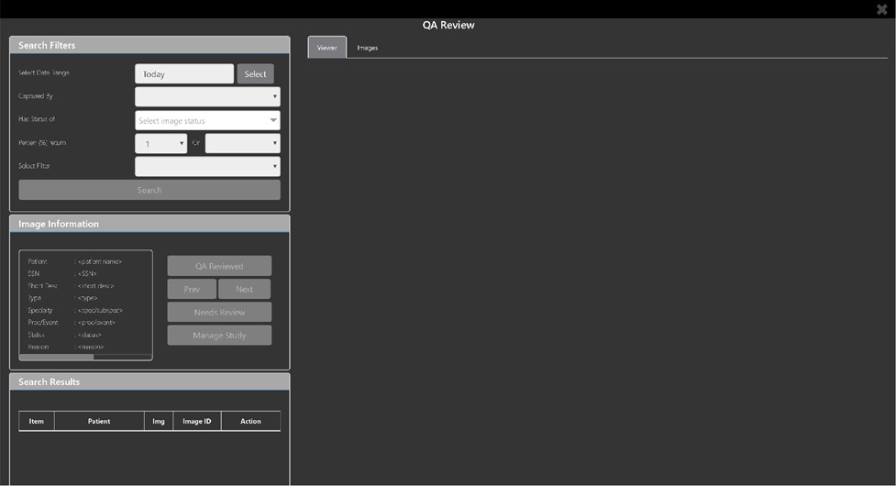

Click the **Select** button from the **Search Filters** group to open the **Select Date Range** pop-up (Figure 46). Select a date range**.**

Figure 46: QA Filters and Date Range

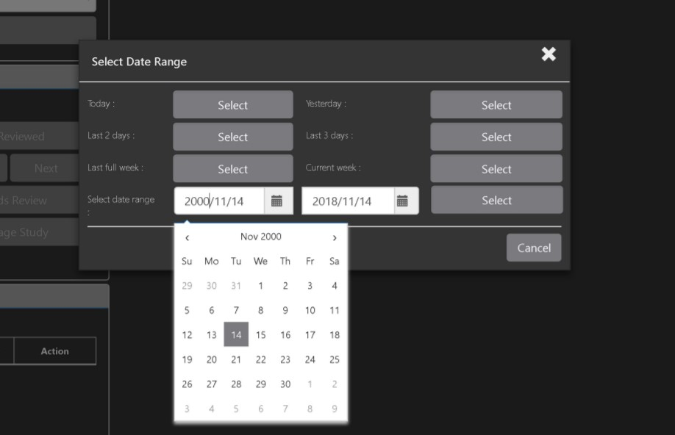

The **Captured By** dropdown populates with a list of valid users for the date range (Figure 47).

Figure 47: Search Filter Details

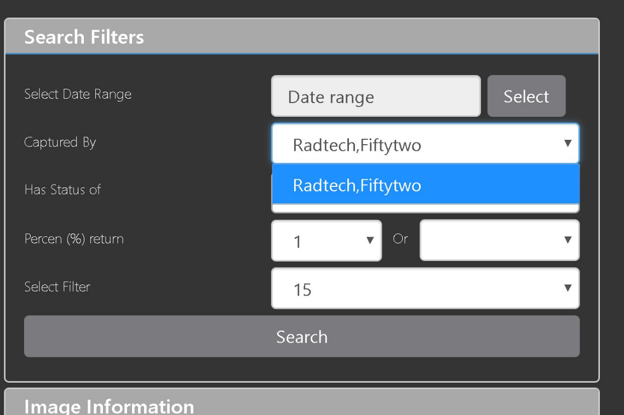

Click the **Has Status of** dropdown, and choose one or more images to choose the status (Figure 48).

Figure 48: QA Status Choices

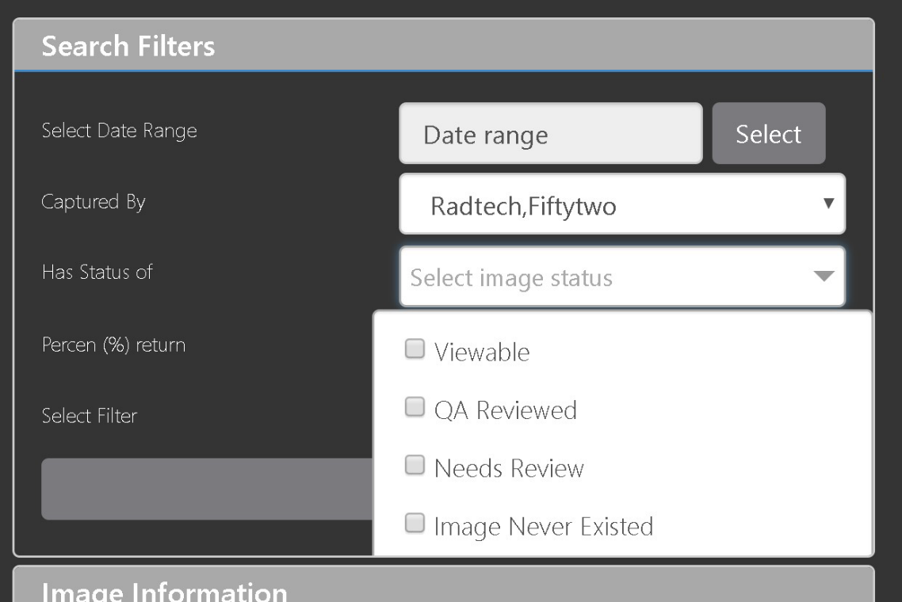

Restrict the study count in the search results using the % **return** dropdowns (Figure 49). The left dropdown is in the percentage of study items to display. The right dropdown is the maximum number of items to display.

Figure 49: Percentage of Images to Display

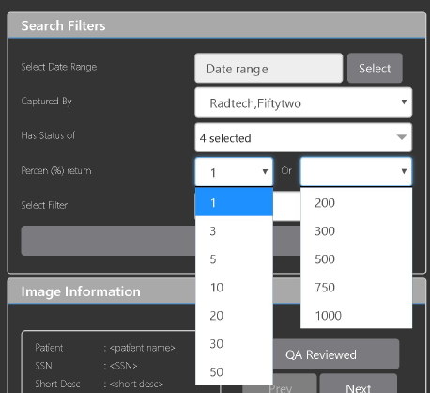

Choose a filter using the **Select Filter** dropdown (Figure 50).

Figure 50: Saved Filters

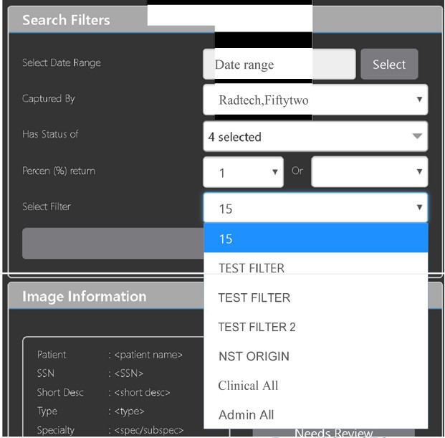

Click **Search** to search for studies. The first study in the list of studies found displays automatically on the right. Click on the **Viewer** icon (circled in red, Figure 51) to display the study. Click on the **Images** icon (circled in yellow, Figure 51) to display the images tab for the study.

Figure 51: QA Filter Results

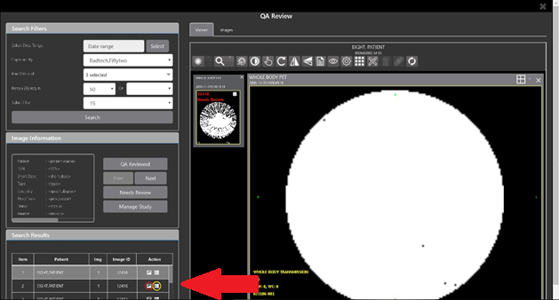

You can click on the **Images** tab at the top after displaying the study (Figure 52).

Figure 52: QA Filter Results and Image Information

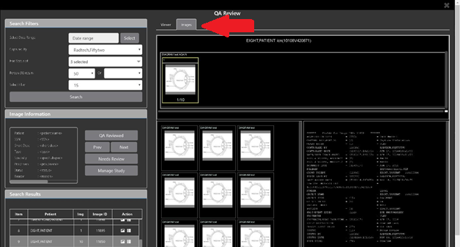

### Viewing and Setting Image Status

Click on a thumbnail. Its image information, including the view status, displays in a panel on the left (highlighted in blue, Figure 53).

Figure 53: QA Thumbnail

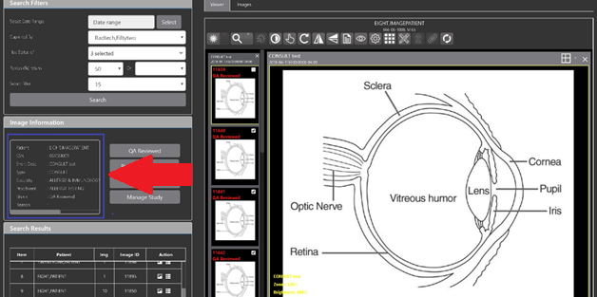

Click on an **image thumbnail** to display the corresponding image. More than one thumbnail can be selected using the shift key.

**NOTE:** The user's VistA account requires the MAG EDIT and MAG QA REVIEW keys to edit/set this information.

Click the **QA Reviewed** or **Needs Review** button to set the corresponding image status. You can also right-click on the image or the image thumbnail to set the image status (Figure 54).

Figure 54: QA Review Status Update Menus

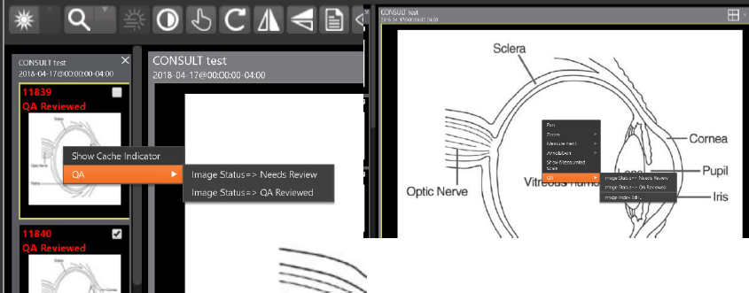

You can invoke the Image Index Editor page by clicking on the **Image Index Edit** menu item.

Use the **Prev** and **Next** buttons to traverse the search results.

Click the **Manage Study** button to display the **Images** tab for the study.

### Image QA Report

Select the **Image QA report** from the Viewer page's **External Links** menu to open the QA Statistics Reports page (Figure 55).

Figure 55: QA Statistics Reports Page

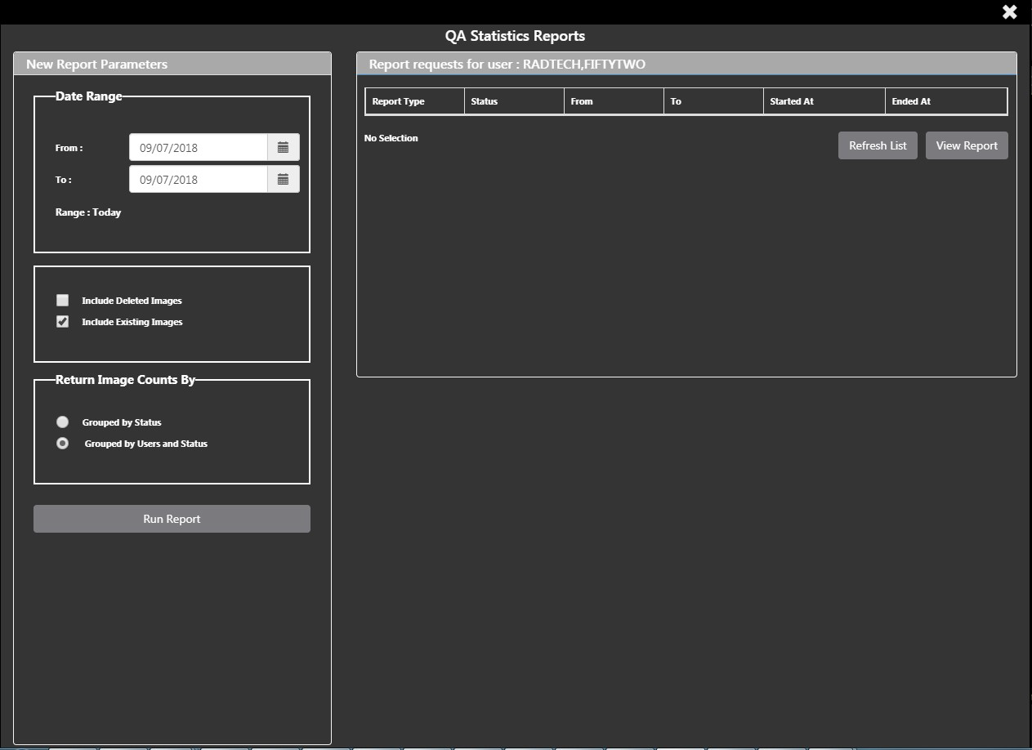

Fill in the report parameters fields and click the **Run Report** button (Figure 56).

Figure 56: Run QA Report

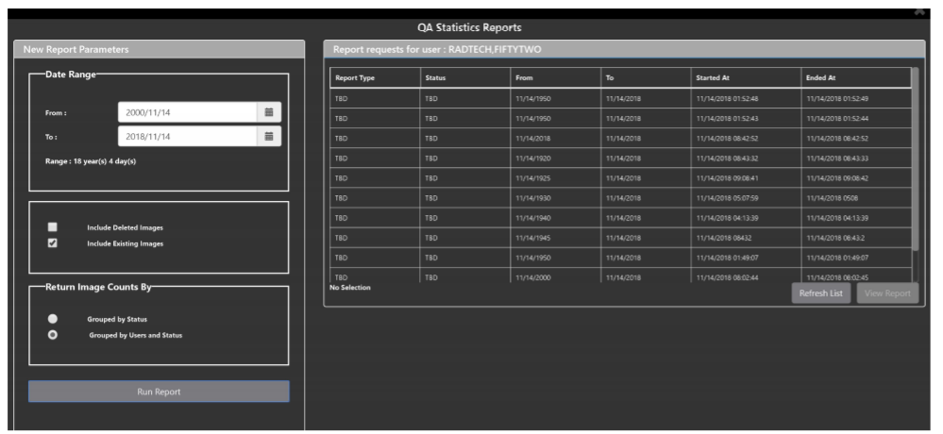

Select any item, and click **View Report** button, then the selected image report statistics load (Figure 57).

Figure 57: View QA Report

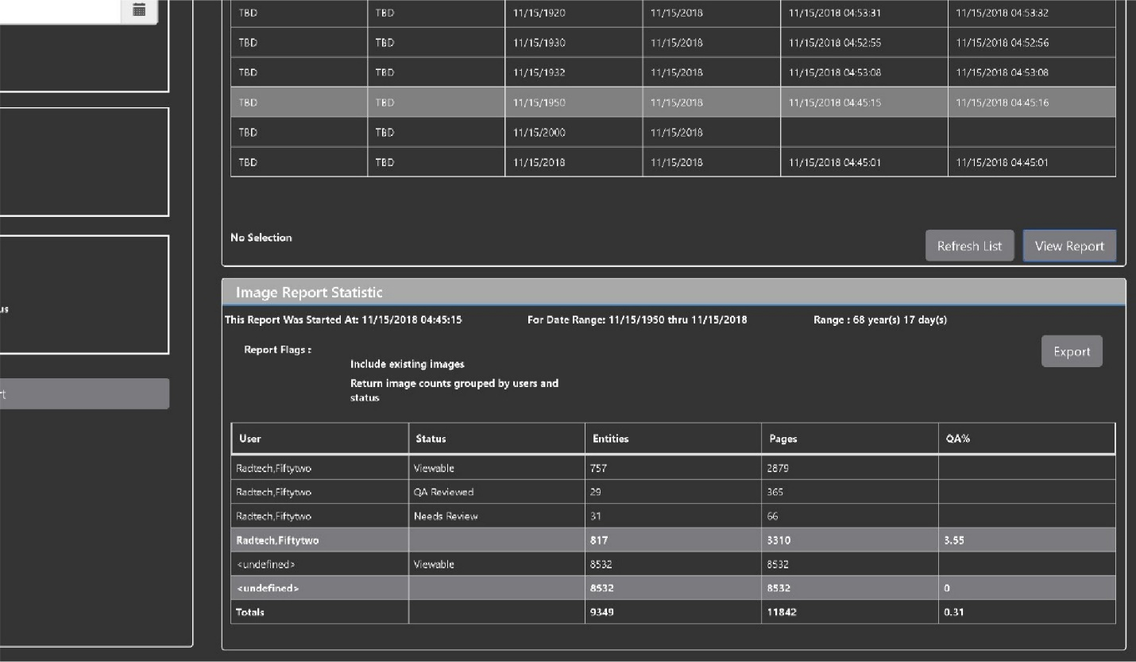

Click **Export** to generate a .csv file using the results.

# Troubleshooting

The **View Image Info** toolbar button can offer data to help you troubleshoot. See section 4.4.1 for more information.

To display version information and message history about the Viewer, first click the **Viewer Version Number** located in the lower right corner of the Viewer main page. See Figure 58 below.

Figure 58: Viewer Version Number

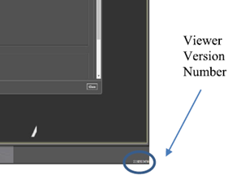

In the Viewer Information dialog (Figure 59) that opens, click on **Version History** to display version release information or click on **Message History** to display message history items.

Figure 59: Viewer Information Dialog

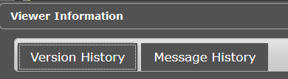

## Special Instructions for Error Correction

Please refer to the VIX Overview - View Image Viewer – Troubleshooting section in [MAG3_0P303_VIX_ADMIN_GUIDE.PDF.](https://www.va.gov/vdl/application.asp?appid=105)

# Acronyms and Abbreviations

| Acronym/Term | Definition |
| --- | --- |
| Cache | A temporary storage place allowing faster access to data. |
| CD | Compact Disc |
| CPRS | Computerized Patient Record System |
| CT | Computerized Tomography |
| DICOM | Digital Imaging and Communications in Medicine |
| DoD | Department of Defense |
| Viewer | Enhanced Image Viewer |
| FDA | Food and Drug Administration |
| JLV | Joint Legacy Viewer |
| OIT | Office of Information and Technology |
| QA | Quality Assurance |
| RGB | Red Green Blue |
| ROI | Release of Information |
| VA | Department of Veteran Affairs |
| VistA | Veterans Health Information System and Technology Architecture |
| VIX | VistA Imaging Exchange Services |
| WW/WC | Window Level |