VistA Imaging Exchange (VIX) Viewer Improvements

MAG*3.0*303

VIX Installation Guide



November 2022

**Version 44.7**

Department of Veterans Affairs

Office of Information Technology (OIT)

.

**Property of the US Government**

This is a controlled document. No changes to this document may be made without the express written consent of the VistA Imaging development group.

While every effort has been made to assure the accuracy of the information provided, this document may include technical inaccuracies and/or typographical errors. Changes are periodically made to the information herein and incorporated into new editions of this document.

Product names mentioned in this document may be trademarks or registered trademarks of their respective companies and are hereby acknowledged.

VistA Imaging Product Development  
Department of Veterans Affairs  
Internet: <https://www.va.gov/health/imaging/>  
VA intranet: REDACTED

Revision History

|  |  |  |  |
| --- | --- | --- | --- |
| Date | Version | Description | Author |
| 11/03/2022 | 44.7 | Updates to Updating an Existing VIX, Post-Installation for New VIX Installations and Updating Existing VIX Installations, and Troubleshooting/Reconfiguration. | VA IT VistA Imaging Technical team |
| 10/27/2022 | 44.6 | Updates to Updating an Existing VIX and SQL Server Removal. | VA IT VistA Imaging Technical team |
| 10/07/2022 | 44.5 | Updates to Installing a New VIX. | VA IT VistA Imaging Technical team |
| 10/06/2022 | 44.4 | Updates to Installing a New VIX, Updating an Existing VIX, and Post-Installation for New VIX Installations and Updating Existing VIX Installations. | VA IT VistA Imaging Technical team |
| 10/05/2022 | 44.3 | Updates to Post-Installation for New VIX Installations and Updating Existing VIX Installations. | VA IT VistA Imaging Technical team |
| 09/19/2022 | 44.2 | Revisions to Preparing for a New VIX Installation. | VA IT VistA Imaging Technical team |
| 09/16/2022 | 44.1 | Updates for MAG*3.0*303 based on review. | VA IT VistA Imaging Technical team |
| 08/25/2022 | 44.0 | Initial draft for MAG*3.0*303. | VA IT VistA Imaging Technical team |
| 06/07/2022 | 43.4 | Revisions to Service Account Settings Appendix. | VA IT VistA Imaging Technical team |
| 06/03/2022 | 43.3 | Updates for MAG*3.0*269 release date. | VA IT VistA Imaging Technical team |
| 05/26/2022 | 43.2 | Revisions to Installing a New VIX, Updating an Existing VIX, Post Installation Instructions, Troubleshooting, and Service Account Settings Appendix. | VA IT VistA Imaging Technical team |
| 05/12/2022 | 43.1 | Revisions to Installing a New VIX, Updating an Existing VIX, Post Installation Instructions, and Troubleshooting. | VA IT VistA Imaging Technical team |
| 05/11/2022 | 43.0 | Revisions to Service Account Settings Appendix. | VA IT VistA Imaging Technical team |
| 05/10/2022 | 42.9 | Revisions to Installing a New VIX, Updating an Existing VIX, and Post Installation Instructions. | VA IT VistA Imaging Technical team |
| 04/20/2022 | 42.8 | Revisions to Installing a New VIX and Updating an Existing VIX. | VA IT VistA Imaging Technical team |
| 03/18/2022 | 42.7 | Revisions to Updating an Existing VIX, and Post Installation Instructions. | VA IT VistA Imaging Technical team |
| 02/22/2022 | 42.6 | Revisions to Updating an Existing VIX, and Post Installation Instructions. | VA IT VistA Imaging Technical team |
| 02/10/2022 | 42.5 | Revisions to Updating an Existing VIX, and Post Installation Instructions. | VA IT VistA Imaging Technical team |
| 02/04/2022 | 42.4 | Revisions to Installing a New VIX and Updating an Existing VIX, and Back Out/Uninstall Scenarios. | VA IT VistA Imaging Technical team |
| 01/03/2022 | 42.3 | Revisions to Installing a New VIX and Updating an Existing VIX. | VA IT VistA Imaging Technical team |
| 12/10/2021 | 42.2 | Revisions to Installing a New VIX and Updating an Existing VIX. | VA IT VistA Imaging Technical team |
| 11/16/2021 | 42.1 | Incorporated comments from reviewers for MAG*3.0*269, Revisions to Installing a New VIX, Updating an Existing VIX, Back Out/Uninstall Scenarios, & Appendices. Reduced image file sizes. | VA IT VistA Imaging Technical team |
| 09/03/2021 | 42.0 | Update for MAG*3.0*269, Revisions to Installing a New VIX and Updating an Existing VIX. | VA IT VistA Imaging Technical team |
| 09/02/2021 | 41.0 | Updates for MAG*3.0*284 | REDACTED |
| 04/06/2021 | 40.4 | Additional Updates for MAG*3.0*254, Revisions to Installing a New VIX, Updating an Existing VIX, Post-Installation for New VIX Installations and Updating Existing VIX Installations. | VA IT Vista Imaging Technical team |
| 03/17/2021 | 40.3 | Additional Updates for MAG*3.0*254, Post-Installation for New VIX Installations and Updating Existing VIX Installations. | VA IT VistA Imaging Technical team |
| 03/11/2021 | 40.2 | Additional Updates for MAG*3.0*254, Back Out/Uninstall Scenarios. | VA IT VistA Imaging Technical team |
| 02/24/2021 | 40.1 | Additional Updates for MAG*3.0*254, Post-Installation for New VIX Installations and Updating Existing VIX Installations, & Appendices. | VA IT VistA Imaging Technical team |
| 01/28/2021 | 40.0 | Additional Updates for MAG*3.0*254, Revisions to Installing a New VIX, Updating an Existing VIX, Post-Installation for New VIX Installations and Updating Existing VIX Installations, & Appendices. | VA IT VistA Imaging Technical team |
| 01/20/2021 | 39.0 | Update for MAG*3.0*254, Revisions to Installing a New VIX, Updating an Existing VIX, Post-Installation for New VIX Installations and Updating Existing VIX Installations, & Appendix A. | VA IT VistA Imaging Technical team |
| 05/29/2020 | 38.0 | Update for MAG *3.0*249, Addition of PowerShell Verification section, Revisions to Pre-Installation Configuration - Backup Copies and Tomcat User Permissions section. | REDACTED |
| 05/26/2020 | 37.0 | Revisions for Zip/Unzip, Manual restart sections, Figure headings, Post-Installation for New VIX Installations and Updating Existing VIX Installations & Appendix A. | REDACTED |
| 03/16/2020 | 36.0 | Update for MAG*3.0*249, 508 compliant. | REDACTED |
| 08/16/2019 | 35.5 | Update for T3 Build. | REDACTED |
| 08/02/2019 | 35.0 | Update for MAG*3.0*230. | REDACTED |
| 05/20/2019 | 34.0 | Update to save VIX configuration settings. | REDACTED |
| 04/29/2019 | 33.0 | Update to save VIX configuration settings. | REDACTED |
| 04/05/2019 | 32.0 | Updated for MAG*3.0 221 T5 Updates. | REDACTED |
| 03/22/2019 | 31.0 | Updated for MAG*3.0 221 T4. | REDACTED |
| 03/01/2019 | 30.0 | Updated for MAG*3.0 221 T4. | REDACTED |
| 02/22/2019 | 29.0 | Updated for MAG*3.0 221. | REDACTED |
| 02/01/2019 | 28.0 | Updated for MAG*3.0 201 T9. | REDACTED |
| 11/19/2018 | 27.0 | Updated for MAG*3.0*201. | REDACTED |
| 09/27/2018 | 26.0 | Additional MAG*3.0*197 Updates. | REDACTED |
| 08/21/2018 | 25.0 | Additional MAG*3.0*197 Updates. | REDACTED |
| 08/14/2018 | 24.0 | Additional MAG*3.0*197 Updates. | REDACTED |
| 07/26/2018 | 23.0 | Additional MAG*3.0*197 Updates. | REDACTED |
| 07/06/2018 | 22.0 | Updated for MAG*3.0*197. | REDACTED |
| 06/21/2018 | 21.0 | Additional MAG*3.0*197 Updates. | REDACTED |
| 05/25/2018 | 20.0 | Additional MAG*3.0*197 Updates. | REDACTED |
| 03/13/2018 | 19.0 | Additional MAG*3.0*197 Updates. | REDACTED |
| 01/26/2018 | 18.0 | Updated for MAG*3.0*197. | REDACTED |
| 01/25/2018 | 17.0 | Additional MAG*3.0*185 Updates. | REDACTED |
| 01/11/2018 | 16.0 | Additional MAG*3.0*185 updates. | REDACTED |
| 12/05/2017 | 15.0 | Updated MAG*3.0*185 build numbers. | REDACTED |
| 11/14/2017 | 14.0 | Incorporated comments from reviewers regarding MAG*3.0*185. | REDACTED |
| 10/25/2017 | 13.0 | MAG*3.0*185 Updates. | REDACTED |
| 10/03/2017 | 12.0 | MAG*3.0*177 Updates. | REDACTED |
| 08/01/2017 | 11.0 | MAG*3.0*177 Updates. | REDACTED |
| 07/26/2017 | 10.0 | MAG*3.0*170 Updates. | REDACTED |
| 07/05/2017 | 9.0 | MAG*3.0*170 Installer Updates. | REDACTED |
| 04/27/2017 | 8.0 | Updated port information. | REDACTED |
| 03/24/2017 | 7.0 | Date updates. | REDACTED |
| 02/14/2017 | 6.0 | Updated for MAG 3.0*170. | REDACTED |
| 05/10/2016 | 5.0 | Updated for MAG*3.0*162. | REDACTED |
| 09/09/2013 | 4.0 | Updated for MAG*3.0*130. | REDACTED |
| 07/25/2013 | 3.0 | Updated for MAG*3.0*034/116/118, MAG*3.0*119, MAG*3.0*127, MAG*3.0*129. | REDACTED |
| 05/07/2012 | 2.0 | Updated for MAG*3.0*122. | REDACTED |
| 10/14/2011 | 1.0 | Created for MAG*3.0*104. WPR complete Aug 31; labeled for release Oct 14. | REDACTED |

Table of Contents

1. Introduction 14

1.1. Intended Audience 14

1.2. Document Conventions 14

1.3. Terms of Use 14

1.4. Related Information 14

2. Installing a New VIX 15

2.1. Preparing for a New VIX Installation 15

2.1.1. Setting up VistA 15

2.1.2. Selecting and Validating the VIX Server 15

2.1.2.1. FDA Requirements 16

2.1.2.2. Operating System and Hardware Requirements 16

2.1.2.3. Port Requirements 17

2.1.2.4. Environment Requirements 17

2.1.3. Getting VIX Component Licenses 19

2.1.3.1. Laurel Bridge DCF Toolkit 19

2.1.3.2. Aware JPEG2000 Toolkit License 20

2.1.4. Getting a VIX Security Certificate 20

2.1.5. PowerShell Version Verification 20

2.1.6. Java Version Verification 23

2.1.7. LibreOffice Verification 24

2.2. New VIX Server Installation 24

2.3. Preparing Passwords, Activating Components, and Staging Files 24

2.3.1. VIX Server Installation 25

2.3.1.1. To install the VIX Server 25

2.4. Activating a New VIX 44

2.4.1. To Register the VIX 45

3. Updating an Existing VIX 46

3.1. Preparing for a VIX Update 46

3.1.1. VistA Software Dependencies 46

3.1.2. Scheduling Downtown and Impact of a VIX Update 46

3.2. Preparing Service Account and Passwords 48

3.3. Performing a VIX Server Update 48

4. Post-Installation for New VIX Installations and Updating Existing VIX Installations 72

4.1. McAfee Exclusions 72

4.2. Verifying Installation/Upgrade is Complete 73

4.3. Verifying VIX Operations 75

4.3.1. Verifying Access to the VIX Tools and VIX Transaction Log 75

4.3.2. Spot-Checking VIX Image Delivery 76

4.4. DICOM SCP Configuration 77

5. Troubleshooting/Reconfiguration 78

5.1. Resuming an Interrupted VIX Installation 78

5.1.1. Resuming Installation (single server VIX) 78

5.2. Using the VIX Service Installation Wizard to Reconfigure the VIX 79

5.2.1. Reconfiguring a VIX Server 80

5.3. Tomcat Permissions 84

5.4. VIX Support 84

6. Back Out/Uninstall 85

6.1. Stopping the VIX Services 85

6.2. Back Out/Uninstall Scenarios 85

6.2.1. Uninstall/Restore as part of Troubleshooting 86

6.2.2. Relocating a VIX onto a New Server 86

6.2.3. Decommissioning a VIX 87

6.3. Uninstalling the VIX 87

6.3.1. Remove VIX related applications, accounts, directories, and variables 87

6.4. Rollback and Back Out of MAG*3.0*303 89

6.4.1. Rollback Verification Procedure 92

7. Appendix A: Enable MUSE Functionality 94

8. Appendix B: DICOM SCP Configuration 99

8.1. AE Titles Configuration 99

8.1.1. Laurel Bridge AE Titles Configuration on VIX/CVIX 99

8.1.2. AE Titles Configuration on DICOM SCU 101

8.2. Tomcat/ Laurel Bridge DICOM SCP Configuration 101

9. Appendix C: Restart Script 105

10. Appendix D: SQL Server Removal 107

10.1. Script SQL Server Removal 107

10.2. Manual SQL Server Removal 110

11. Appendix E: Tomcat Permissions 111

12. Appendix F: Service Account Settings 113

13. Appendix G: VIX Install Checklist 124

13.1. VIX Install Checklist 124

14. Acronyms 126

**Table of Figures**

Figure 1: RECOMMENDED VIX Settings 16

Figure 2: Add Roles and Features Wizard 17

Figure 3: .NET Framework Missing 18

Figure 4: Registry Editor .NET Framework Key 18

Figure 5: NET Framework Setup Dialogs 19

Figure 6: Execute Windows PowerShell 21

Figure 7: PowerShell Version 4.0 Check 21

Figure 8: PowerShell Setup Dialogs 22

Figure 9: PowerShell Version 5.1 Check 23

Figure 10: PowerShell Script Error 23

Figure 11: Java and LibreOffice Version Check 23

Figure 12: User Account Control - VIX Service Installation Wizard 25

Figure 13: Run the VIX Service Installation Wizard 26

Figure 14: User Account Control - VIX Installer 26

Figure 15: VIX Service Installation Wizard 30.303.X.XXXX 27

Figure 16: VIX Prerequisites - Tomcat Not Installed 28

Figure 17: VIX Prerequisites - Laurel Bridge Not Installed 29

Figure 18: VIX Prerequisites - Service Account not Created 30

Figure 19: VIX Prerequisites - VIX Security Certificate not Installed 31

Figure 20: VIX Prerequisites - LibreOffice not Installed 32

Figure 21: VIX Service Installation Wizard Prerequisites Complete 32

Figure 22: VIX Cache and Configuration Folder Creation 33

Figure 23: VistA and Email Configuration - Confirm 34

Figure 24: VistA and Email Configuration - Next 35

Figure 25: Specify the MUSE Configuration - Before Confirm 36

Figure 26: Specify the MUSE Configuration - After Confirm 37

Figure 27: Local DoD Connection for Images Configuration 38

Figure 28: Begin the VIX and VIX Viewer/Render Services Install 39

Figure 29: VIX Viewer/Render Info Dialog 39

Figure 30: PowerShell Pop-up Script Top Portion 41

Figure 31: PowerShell Pop-up Script Middle Portion 42

Figure 32: PowerShell Pop-up Script Bottom Portion 43

Figure 33: VIX Install Complete 44

Figure 34: User Account Control - Vix Service Installation Wizard 49

Figure 35: Run the VIX Service Installation Wizard 50

Figure 36: User Account Control - VixInstaller 50

Figure 37: Update VIX Components 51

Figure 38: Update VIX Components PowerShell Pop-up Script 52

Figure 39: SQL Server Uninstall Dialog 53

Figure 40: Select SQL Server Setup ZIP file 53

Figure 41: Remove SQL Server Select Instance 54

Figure 42: Remove SQL Server Select Features 54

Figure 43: Remove SQL Server 2017 Complete 55

Figure 44: VIX Service Installation Wizard 56

Figure 45: VIX Prerequisites - Java Not Installed 57

Figure 46: VIX Prerequisites - Tomcat Not Installed 58

Figure 47: Apache Tomcat Service Account Password 59

Figure 48: VIX Prerequisites - LibreOffice Not Installed 60

Figure 49: All VIX Prerequisites Installed or Configured 60

Figure 50: VIX Cache and Configuration Folder Creation 61

Figure 51: Specify the VistA and Email Configuration - Before Confirm 62

Figure 52: Specify the VistA and Email Configuration - After Confirm 62

Figure 53: Specify the MUSE Configuration - Before Confirm 63

Figure 54: Specify the MUSE Configuration - After Confirm 64

Figure 55: Configure Local DoD connection 65

Figure 56: Begin the VIX and VIX Viewer/Render Services Install 66

Figure 57: VIX Viewer/Render Info Dialog Screenshot 66

Figure 58: Save/Configuration Button 67

Figure 59: PowerShell Pop-up Script Top Portion 68

Figure 60: PowerShell Pop-up Script Middle Portion 69

Figure 61: PowerShell Pop-up Script Bottom Portion 70

Figure 62: VIX Installation Complete 71

Figure 63: Set Exclusions Dialog 72

Figure 64: VISA Version Verification 73

Figure 65: VIX Viewer and Render Services Running 73

Figure 66: Listener Running 74

Figure 67: 10 Hydra IX Processor and 5 Hydra VistA Worker Processes Running 74

Figure 68: Login Page 75

Figure 69: VIX Tools Page 76

Figure 70: Run the VIX Service Installation Wizard 79

Figure 71: Run the VIX Service Installation Wizard 80

Figure 72: SQL Server Uninstall Dialog 81

Figure 73: Select SQL Server Setup ZIP file 81

Figure 74: Remove SQL Server Select Instance 82

Figure 75: Remove SQL Server Select Features 82

Figure 76: Remove SQL Server 2017 Complete 83

Figure 77: Stopping VIX Viewer Service 85

Figure 78: Select the SQLEXPRESS_X64-14_0_1000_169.ZIP dialog 91

Figure 79: SQL Server Setup 91

Figure 80: Verify SQL Server Service 93

Figure 81:Specify the MUSE configuration Enable and configure MUSE pre-populated 94

Figure 82: Sample MuseDataSource-1.0.Config File for One Server (MUSE ENABLED FOR JLV VIX Image Viewer) 95

Figure 83: Background Processor Queue Processor 96

Figure 84: EKG Tab in Network Location Manager in Background Processor Queue Processor 97

Figure 85: Network Location Properties in Background Processor Queue Processor 98

Figure 86: Sample AE Titles Configuration File 100

Figure 87: Example AE Titles Configuration File 100

Figure 88: Sample AE Titles configuration File with Multiple DICOM SCP Clients 101

Figure 89: Sample DICOM SCP Configuration File 102

Figure 90: Example ScpConfiguration Configuration File 103

Figure 91: Execute Windows PowerShell 105

Figure 92: Windows PowerShell Restart Script 106

Figure 93: Execute Windows PowerShell 107

Figure 94: Remove SQL Server Select Instance 108

Figure 95: Remove SQL Server Select Features 109

Figure 96: Remove SQL Server 2017 Complete 109

Figure 97: Microsoft SQL Removal 110

Figure 98: Execute Windows PowerShell 111

Figure 99: FileMan File Entry 200 122

**Table of Tables**

Table 1: Functions Affected by VIX Updates 47

Table 2: VIX Site’s User Profile SSN, Service Account on Local VistA, and Suggested Service Account on Local VistA 115

Table 3: VIX Install Checklist 124

# Introduction

This document explains how to install the VistA Imaging Exchange (VIX) service. Please follow the install checklist in *Appendix G: VIX Install Checklist* at the same time as you follow the main sections of this document*.* To do that, most people open two copies of this document at once.

## Intended Audience

This document is intended for VA staff responsible for managing a local VIX, called *the VIX server* for the remainder of this document.

This document presumes a working knowledge of the VistA environment, VistA Imaging components and workflow, and Windows administration.

## Document Conventions

This document uses the following conventions:

Controls, options, and button names are displayed in **Bold**.

A vertical bar is used to separate successive menu choices. For example: “Click **File** | **Open**” means: “Click the **File** menu; then click the **Open** option.”

Keyboard key names are displayed in bold and in brackets.

Sample output is displayed in monospace.

Helpful information is denoted by a **TIP**.

Important or required information is displayed in a **NOTE**.

Critical information is indicated by: Warning icon

## Terms of Use

The VIX is a component of VistA Imaging and is regulated as a medical device by the Food and Drug Administration (FDA). Use of the VIX is subject to the following provisions:

Warning iconThe FDA classifies VistA Imaging, and the VIX (as VistA Imaging component) as a medical device. **Unauthorized modifications to VistA Imaging, including the VIX, such as installing unapproved software, adulterates the medical device.** The use of an adulterated medical device violates US federal law (21CFR820).

Warning iconBecause software distribution/inventory management tools can install inappropriate or unapproved software without a local administrator’s knowledge, sites must exclude the VIX server from such systems.

## Related Information

In addition to this manual, the following document contains information about the VIX:

[VistA Image Exchange (VIX) Administrator’s Guide](https://www.va.gov/vdl/application.asp?appid=105)

# Installing a New VIX

This section explains how to implement a new VIX. The installation checklist in *Appendix G: VIX Install Checklist* summarizes the process.

**TIP**: If you are updating an existing VIX, do not use this section; instead, use the *Updating an Existing VIX* section.

## Preparing for a New VIX Installation

Preparing to install a new VIX involves:

* Configuring the MUSE interface. This requires the MUSE username and MUSE password for the site’s online MUSE server. If the MUSE username and password are not documented in existing site VistA Imaging documentation, please contact the local BioMed team or MUSE administrator for the information.
* Acquiring Installation File. Copy MAG3_0P303_VIX_SETUP.msi to C:\temp. (Download if required. See the patch description of the patch for the download location.)
* Setting up VistA: Install the VistA KIDs package, see *Setting up VistA*.
* Selecting and validating the server where the VIX gets installed, see *Selecting and Validating the VIX Server*.
* Getting VIX component licenses, see *Getting VIX Component Licenses*.
* Getting a VIX security certificate, see *Getting a VIX Security Certificate*.
* PowerShell Version Verification, see *PowerShell Version Verification*.
* Java Version Verification, see *Java Version Verification*.
* LibreOffice Verification, see *LibreOffice Verification*.

**NOTE**: Please ensure you have scheduled a downtime of VIX services. It may take 1-2 hours to complete.

**NOTE**: It is strongly suggested to restart the VIX Server prior to installing a new VIX.

Specifics are covered in the following sections.

### Setting up VistA

You must install the compatible KIDS package on the VistA system before installing the VIX server software. For information about installing the KIDS package, see the patch description of the patch you are installing.

* If you are implementing a VIX for the first time, the MAG VIX ADMIN key must be assigned to the VistA accounts of administrators who need access to the VIX transaction log.

### Selecting and Validating the VIX Server

The VIX server must meet the FDA, hardware, and environmental requirements specified in the following sections.

#### FDA Requirements

The VIX is a component of VistA Imaging and is therefore regulated as a medical device by the FDA. Use of the VIX is subject to the terms of use listed in the introduction.

#### Operating System and Hardware Requirements

VIX hardware requirements:

* Installation must be done on a 64-bit OS machine. Minimum: Windows Server 2012 R2. Maximum: Windows Server 2016.
* The VIX Install requires at least 2 GB of free disk space.
* The VIX servers run with recommend settings (Figure 1) of at least 4 CPUs, 32 GB of RAM, and a dedicated local drive for the VIX cache with 500 GB of disk space.
* Slow performance may occur with VIX servers running under the recommended settings.
* The VIX requires a 1 gigabit Ethernet connection.

Figure 1: RECOMMENDED VIX Settings

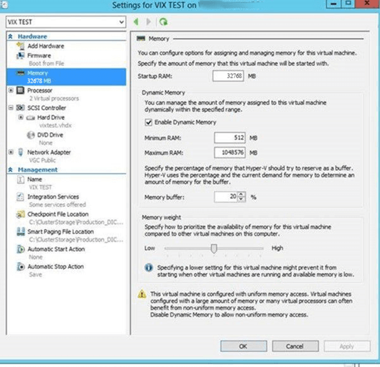

#### Port Requirements

On the VIX server, verify that ports REDACTED, REDACTED, REDACTED, REDACTED, REDACTED, REDACTED, REDACTED, and REDACTED are accessible to VA wide area network IP addresses (10.x.x.x).

**NOTE:** Port REDACTED was new with MAG*3.0*249 and required for communication with the site’s MUSE server.

#### Environment Requirements

The VIX environment requirements include:

* Verify Visual C++ 2010 Redistributable Package (x64) is installed by viewing Programs and Features in the Control Panel. If Visual C++ 2010 Redistributable Package (x64) is not installed, download it, and install it.

**NOTE**: Microsoft Visual C++ 2010 Redistributable Package (x64) can be directly downloaded from <https://www.microsoft.com/en-us/download/details.aspx?id=14632>

* Verify .NET 3.5 features are enabled from Add Roles and Features (Figure 2) from the Server Manager option, with the Features Wizard (required for VIX install). Alternatively, to discover if .NET 3.5 framework is installed, find .NET Framework versions in the registry by doing the following:

1. On the Start menu, select **Run.**
2. In the Open box, enter regedit.exe. You must have administrative credentials to run regedit.exe.
3. In the Registry Editor, open the following subkey: Software\Microsoft\NET Framework Setup\NDP\v3.5.
4. Ensure the Install REG_DWORD equals 1.

Figure 2: Add Roles and Features Wizard

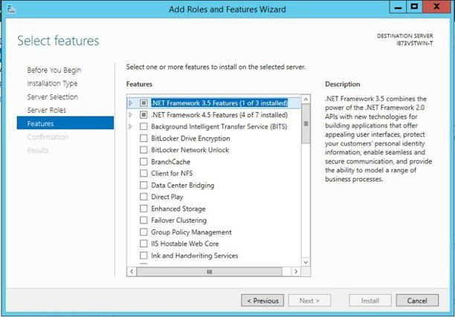

* If running Windows Server 2012 R2, verify .NET 4.7.2 or .NET 4.8 framework. If running Windows Server 2016, verify .NET 4.8 framework is installed. If one of these frameworks is not installed, the installer displays an error message and asks to install the .NET Framework (Figure 3).

Figure 3: .NET Framework Missing

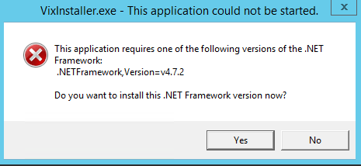

To discover if you have .NET 4.7.2 or .NET 4.8 framework installed, find .NET Framework versions in the registry, do the following:

1. On the Start menu, select **Run.**
2. In the Open box, enter regedit.exe. You must have administrative credentials to run regedit.exe.
3. In the Registry Editor, open the following subkey: HKEY_LOCAL_MACHINE\SOFTWARE\Microsoft\NET Framework Setup\NDP\v4\Full (Figure 4).
4. Ensure the Release REG_DWORD is greater than or equal to 461808 (for .NET 4.7.2) or greater than or equal to 528040 (for .NET 4.8).

**NOTE**: Release REG_DWORD is equal to 461814 (for .NET 4.7.2) or 528049 (for .NET 4.8) at the time this install documentation was last updated.

**NOTE**: Additional details on determining .NET Framework versions installed is available at <https://docs.microsoft.com/en-us/dotnet/framework/migration-guide/how-to-determine-which-versions-are-installed>.

Figure 4: Registry Editor .NET Framework Key

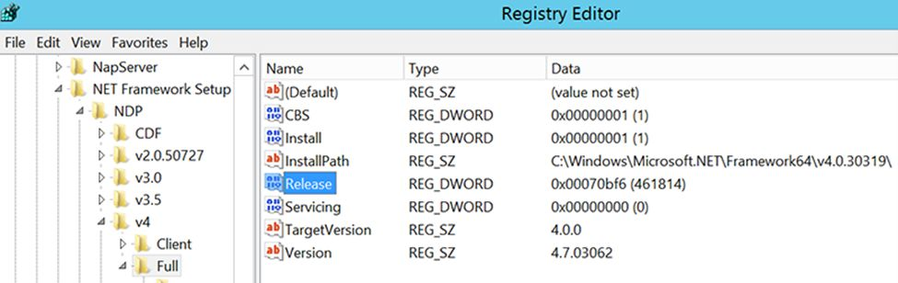

If either .NET 4.7.2 or .NET 4.8 framework is not installed, download it, install it, and then restart the server (Figure 5).

**NOTE**: .NET 4.7.2 software can be found on the download site, i.e.: NDP472-KB4054530-x86-x64-AllOS-ENU.exe, or directly download from the URL - <https://support.microsoft.com/en-us/help/4054530/microsoft-net-framework-4-7-2-offline-installer-for-windows>.

**NOTE**: .NET 4.8 software can be found on the download site, i.e. ndp48-x86-x64-allos-enu.exe, or directly downloaded from the URL for Windows Server 2012 R2 - <https://support.microsoft.com/en-us/help/4486081/microsoft-net-framework-4-8-for-windows-server-2012> or for Windows Server 2016 <https://support.microsoft.com/en-us/topic/microsoft-net-framework-4-8-offline-installer-for-windows-9d23f658-3b97-68ab-d013-aa3c3e7495e0>.

Figure 5: NET Framework Setup Dialogs

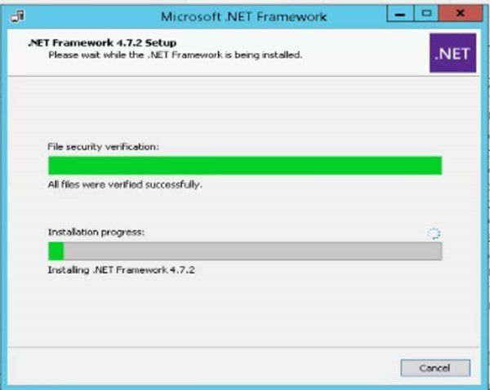

### Getting VIX Component Licenses

Two toolkits used by the VIX require third-party licenses.

#### Laurel Bridge DCF Toolkit

The Laurel Bridge DICOM Connectivity Framework (DCF) toolkit is a third-party toolkit used by the VIX to convert images to and from DICOM format.

The VA has purchased an enterprise-wide license for this toolkit. If you do not have a site-specific serial number for this license, do the following:

1. From the VIX server, attempt to access the Laurel Bridge activation code server at <https://laurelbridge.com>. (A login page displays if you can access the site.)

Warning icon **If you cannot access this site, enter a ticket and indicate that your site ACL (access control list) needs to be modified to access** **REDACTED over HTTPS port REDACTED**.

1. Contact the REDACTED mail group to obtain a request form and instructions for completing the form.

The VIX installation process generates an activation code using the serial number information provided. The activation code allows the Laurel Bridge DCF toolkit to be installed and used.

The Laurel Bridge activation code links to the hardware of the server where the toolkit is installed. If you must replace the licensed server, email the contacts listed previously to arrange to get the serial number(s) transferred as well.

#### Aware JPEG2000 Toolkit License

The Aware JPEG2000 toolkit is a third-party toolkit used for DICOM-to-JPEG2000 image conversion by the VIX.

Sites that implement the VIX must purchase a one-time permanent license for the latest version of the Aware JPEG2000 toolkit from Aware for each server where the VIX is used.

**NOTE**: Do not install the Aware JPEG2000 toolkit before you run the VIX installer. The VIX installer installs the version of the Aware JPEG2000 toolkit with which the VIX has been tested. If you install the Aware JPEG2000 toolkit before running the VIX installer, this interferes with the installation process.

### Getting a VIX Security Certificate

Each server that hosts the VIX must request a security certificate. To receive a security certificate, send an email to REDACTED and include the following:

* The Fully Qualified Domain Name (FQDN) of the VIX server.
* Contact information for the primary and backup administrators of the VIX.

Requests typically process within five business days, after which the security certificate (one per server) is securely transmitted to the requesting site POC for install on the site VIX. The security certificate includes the following files:

* A federation.zip file containing federation.truststore and federation.keystore.
* A LocalAdmin.jks file.

After receiving the security certificate, copy the contents to the temporary folder in C:\temp on the local server where the VIX software is installed. The VIX Service Installation Wizard prompts you to provide the federation.zip file from the security certificate during the installation process.

### PowerShell Version Verification

Before beginning the VIX install, validate the installed Windows PowerShell version. If PowerShell 4.0 is the current installed version, you must install PowerShell 5.1 on your server to replace version 4.0. If PowerShell 5.1 or later is not installed, the post-installation script fails. To determine the PowerShell version:

1. Choose **Start**, type PowerShell, then right-click on **Windows PowerShell** and **run** as an administrator (Figure 6).

Figure 6: Execute Windows PowerShell

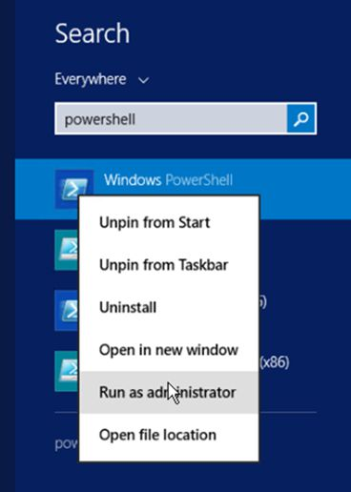

1. Once PowerShell launches, type the command:

Get-Host | Select-Object Version

Press **[ENTER]** to display the PowerShell version.

1. Notice the first two numbers that appear under Version, then close PowerShell. If the first two numbers under Version are **4.0** (Figure 7), proceed with the next step to install PowerShell 5.1.

Figure 7: PowerShell Version 4.0 Check

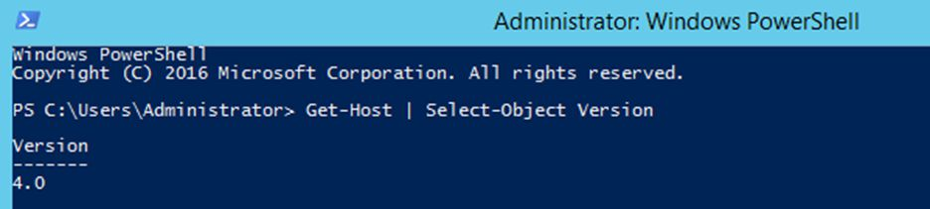

PowerShell 5.1 software can be found in the file Win8.1AndW2K12R2-KB3191564-x64.msu, with direct download available from <https://www.microsoft.com/en-us/download/details.aspx?id=54616>. To install PowerShell:

1. Follow the on-screen instructions (Figure 8).

Figure 8: PowerShell Setup Dialogs

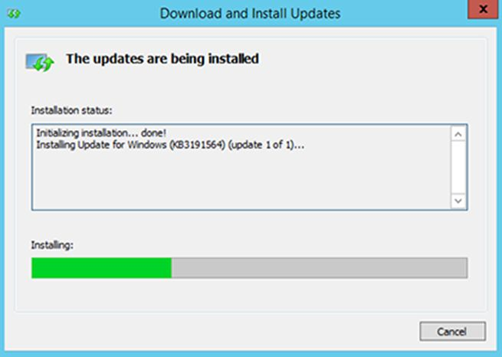

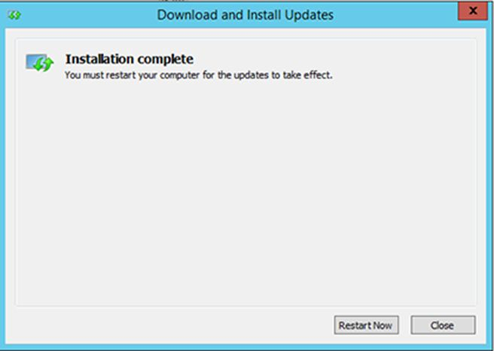

1. After PowerShell 5.1 is installed, a reboot of your server is REQUIRED.

To verify the successful installation of PowerShell:

1. Choose **Start**, type PowerShell, then right-click on **Windows PowerShell** and **run** as an administrator (Figure 6).
2. Once PowerShell launches, type the command:

Get-Host | Select-Object Version

Press **[ENTER]** to display the PowerShell version.

1. Notice the first two numbers that appear under Version, then close PowerShell. The first two numbers under Version should display **5.1** (Figure 9) if PowerShell 5.1 installation was successful.

Figure 9: PowerShell Version 5.1 Check

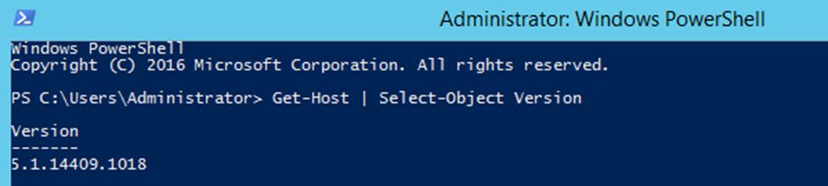

**NOTE**: PowerShell must be configured to allow scripts to run. An error may occur (Figure 10) that prevents scripts from running.

Figure 10: PowerShell Script Error

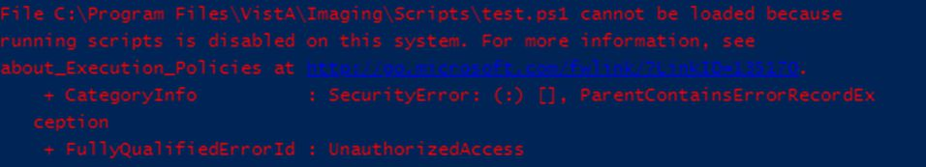

To fix the above PowerShell script error:

1. Choose **Start**, type PowerShell, then right-click on **Windows PowerShell** and **run** as an administrator (Figure 6).
2. Once PowerShell launches, type the command:

Set-ExecutionPolicy RemoteSigned -Force

Press **[ENTER]** to set the policy to allow scripts to run, then close PowerShell.

### Java Version Verification

Before beginning the VIX install, validate any Java version installed. MAG*3.0*303 VIX installer uninstalls Java 8.0.291, if installed, and installs Java 8.0.331. If the Java version installed is older than Java 8.0. 291, you must uninstall manually. The current Java version can be checked using the Control Panel (Figure 11). Reboot your server after Java uninstall.

Figure 11: Java and LibreOffice Version Check

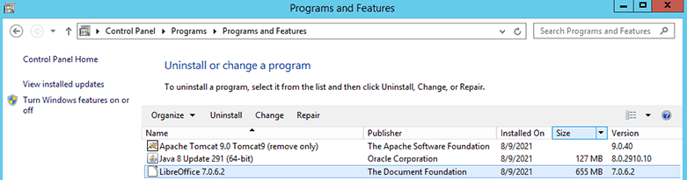

### LibreOffice Verification

Before beginning the VIX install, validate any LibreOffice version installed. MAG*3.0*303 VIX installer uninstalls LibreOffice 7.0.6 and installs LibreOffice 7.2.5. If the LibreOffice version installed is not 7.0.6, it must be uninstalled manually. The current LibreOffice version can be checked using the Control Panel (Figure 11).

## New VIX Server Installation

The following steps are used to install a VIX on a server for the first time. Installation should take less than 30 minutes if all preparation steps in the previous sections are complete.

**NOTE**: Only perform the steps in this section if you are installing the VIX on a single server.

## Preparing Passwords, Activating Components, and Staging Files

**NOTE:** Use proper safeguards to securely store passwords.

Before starting the VIX installation process, do the following:

1. As already stated in Section 2.1, configuring the MUSE interface requires the MUSE username and MUSE password for the site’s online MUSE server. If the MUSE username and password are not documented in existing site VistA Imaging documentation, please contact the local BioMed team or MUSE administrator for the information.
2. Prepare a password to be used for the Apache Tomcat administrator account created as part of the VIX installation process.

* The password is case sensitive, must contain at least **fourteen (14) alphanumeric characters**, and must contain at least one capital letter and one number.

1. Prepare a password for the Windows account that the VIX installation process creates.

* The system uses this Windows account, named “apachetomcat” when it is created by the VIX installer, to run the VIX in the Tomcat environment. This account is limited to only the functions it needs to run the VIX.
* The password is case sensitive, must contain at least **fourteen (14) alphanumeric characters**, and must contain at least one capital letter and one number.

1. To use the Release of Information (ROI) and DICOM Query Retrieve Service Class Provider (SCP), set up a local VistA service account as specified in as specified in *Appendix F: Service Account Settings*.
2. Determine the email address or addresses for notification about invalid ROI periodic processing credentials. The VIX sends an email notification to the email address or addresses if the ROI periodic processing credentials are invalid or have expired. You must specify this address when you install the VIX. You can set up a new email account for this purpose or use an existing one.
3. Copy the contents of the VIX security certificate received to the temporary folder in C:\temp on the local VIX server.

### VIX Server Installation

VIX installation involves running two processes back-to-back. The first short process installs the VIX Service Installation Wizard. The second, longer process involves using the VIX Service Installation Wizard to install the actual VIX.

**NOTE**: These steps presume you have already obtained a serial number for the Laurel Bridge DCF toolkit. These steps also presume the VIX can access the Laurel Bridge license server via the internet.

#### To install the VIX Server

1. Use an administrator-level account to log onto the VIX server.
2. If you did not already do this, copy the latest VIX installer (MAG3_0P303_VIX_SETUP.msi) to C:\temp.
3. Do the following to prepare the VIX Service Installation Wizard:
4. Right-click the MAG3_0P303_VIX_SETUP.msi file and click on Install.
5. If prompted with “Do you want to allow the following program from a verified publisher to make changes to this computer?”, click **Yes** (Figure 12).

Figure 12: User Account Control - VIX Service Installation Wizard

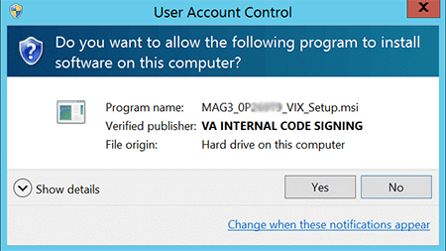

1. When the Welcome page displays, click **Next**.
2. When the Confirm Installation page displays, click **Next**.
3. When the Installation Complete screen displays, click **Close**.
4. Run the VIX Service Installation Wizard as an administrator (Figure 13).
5. **R**ight-click **Start**.
6. **L**eft-click **Search**.
7. Type **VIX**.
8. **R**ight-click **VIX Service Installation Wizard**.
9. **L**eft-click **Run as administrator**.

Figure 13: Run the VIX Service Installation Wizard

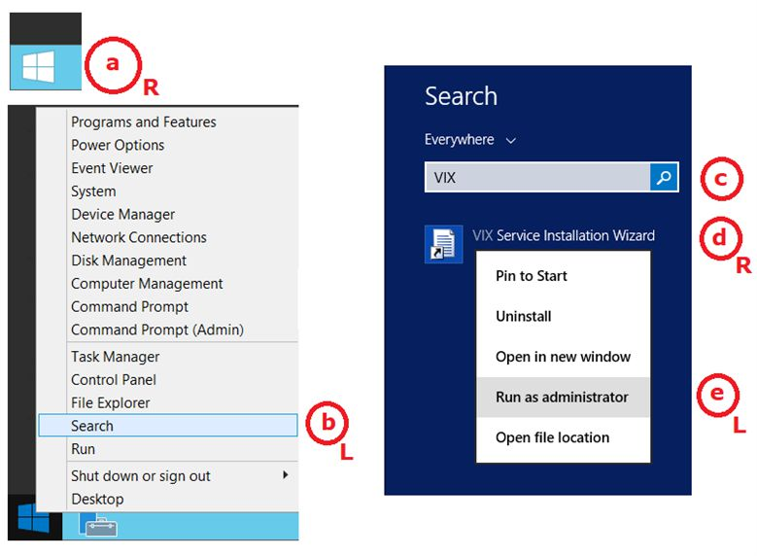

**NOTE**: If the VIX Service Installation Wizard does not appear in the Search bar as in Figure 13, open Windows Explorer and navigate to the **C:\Program Files (x86)\Vista\Imaging\VixInstaller** folder, **r**ight-click **VixInstaller.exe** and **l**eft-click **Run as administrator**.

1. If prompted with “Do you want to allow the following program from an unknown publisher to make changes to this computer?”, click **Yes** (Figure 14).

Figure 14: User Account Control - VIX Installer

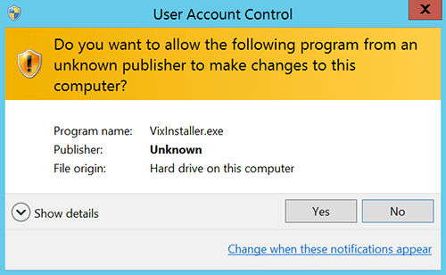

1. When the Welcome page for the VIX Service Installation Wizard displays, click **Next**.
2. In the **Site Number** field of the Specify the VA site... page, enter the STATION NUMBER (field (#99) in the INSTITUTION file (#4) of your site, the information is in FileMan in VistA). Then, click **Lookup Server Addresses**.
3. Verify the site-related information retrieved by the lookup is correct. Then, click **Next**.

**NOTE**: The VIX server hostname is blank, and the port number is 0; these values are populated automatically once the VIX is registered with the VistA site service.

1. Please be patient for the VIX Prerequisites page to appear, as it may take a while. When the Install the VIX Prerequisites page displays, verify that the icons for the first two items on the page areCheckmark icon.
2. ***account* has Administrator role** – This line indicates if an administrative account is being used. If not, cancel the installation and restart it using a Windows administrator account.
3. **Current operating system** – This line indicates if the proper operating system is present. If a non-supported operating system is identified, the installation cannot continue.
4. On the same page, read the line that indicates the state of the Java Runtime Environment. If Checkmark icon displays, skip to the next step. If Install needed icon displays (Figure 15), do the following:
5. Click **Install**.
6. Wait until the status icon for the Java Runtime Environment changes to Checkmark icon. This install of Java may take over five minutes to complete. Please be patient, as this step may take a while to complete.

Figure 15: VIX Service Installation Wizard 30.303.X.XXXX

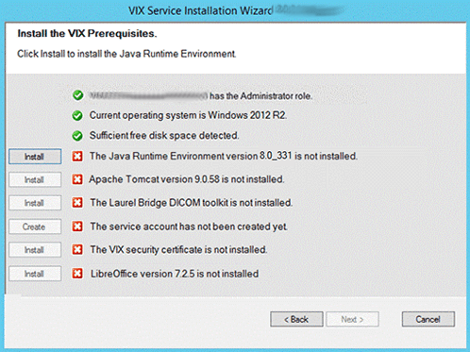

**NOTE:** The person installing the VIX software does not need to be in the VHAMASTER domain. The installer’s domain should appear with their name. This (and subsequent screenshots) is just an example of what the installer sees.

1. On the same page, read the line that indicates the state of the Apache Tomcat installation. Since you may have reached this page by clicking the **Back** button on a subsequent page, if Checkmark icon displays, skip to the next step. If Install needed icon displays (Figure 16), do the following:
2. Click **Install**.
3. In the dialog box that displays, enter and confirm the Apache Tomcat password that you previously prepared as described in *Preparing Passwords, Activating Components, and Staging Files*. Then, click **OK**.
4. Wait until the status icon for Apache Tomcat changes to Checkmark icon. This install of Tomcat may take over five minutes to complete. Please be patient, as this step may take a while to complete.

Figure 16: VIX Prerequisites - Tomcat Not Installed

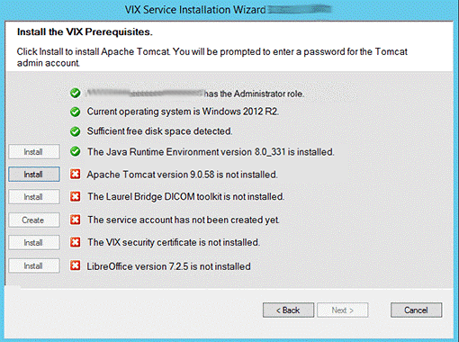

1. On the same page, read the line that indicates the state of the Laurel Bridge toolkit. Since you may have reached this page by clicking the **Back** button on a subsequent page, if Checkmark icon displays, skip to the next step. If Install needed icon displays (Figure 17), do the following:
2. Click the **Install** button next to the Laurel Bridge item. After a brief delay, the Activate DCF License window opens.

**TIP:** The system automatically selects the Network Activation tab and pre-populates about half of the boxes in the window.

1. Enter all the following information in the Network Activation tab:

**NOTE:** The system disables the Activate button if any of the following boxes are left blank.

* + 1. **Product Serial Number** – the new Laurel Bridge DCF serial number (include dashes).
    2. **Site** – the name of your site.
    3. **CPUs** – the number of CPUs on the server hosting the VIX.
    4. **Contact name** and **Contact email** – the administrator of your local VistA Imaging system

1. Near the bottom of the window, click **Activate**. After a brief delay, the **Status** box displays a green “Success” message.
2. Click **Exit with success**. The Activate DCF License window closes and the updated Laurel Bridge toolkit installs in only a second or two.

Figure 17: VIX Prerequisites - Laurel Bridge Not Installed

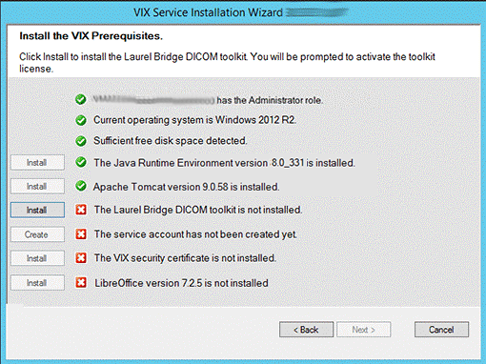

1. On the same page, read the line that indicates the state of the service account. Since you may have reached this page by clicking the **Back** button on a subsequent page, if Checkmark icon displays, skip to the next step. If Install needed icon displays (Figure 18), do the following:
2. Click **Create**.
3. In the dialog box that displays, enter the Windows service account password that you prepared in *Preparing Passwords, Activating Components, and Staging Files*, previously. Then, click **OK**.
4. Wait until the status icon for the service account changes to Checkmark icon.

Figure 18: VIX Prerequisites - Service Account not Created

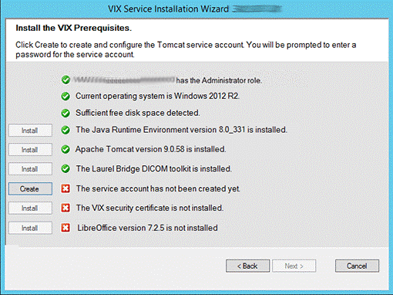

1. On the same page, check the line that indicates the state of VIX security certificate. Since you may have reached this page by clicking the **Back** button on a subsequent page, if Checkmark icon displays, skip to the next step. If Install needed icon displays (Figure 19), do the following:
2. Click **Install**.
3. In the dialog box that displays, click **Select**.
4. Specify the location of the federation.zip file from the security certificate contents in C:\temp on the local VIX server. Then, click **OK**.

Figure 19: VIX Prerequisites - VIX Security Certificate not Installed

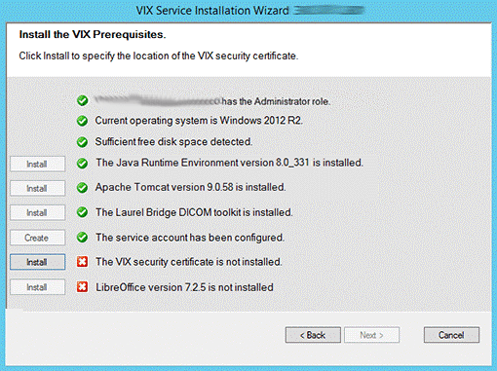

1. On the same page, read the line that indicates the state of the LibreOffice installation. If Checkmark icon displays, skip to the next step. If Install needed icon displays (Figure 20), do the following:
2. Click **Install**.
3. Wait until the status icon for LibreOffice changes to Checkmark icon. (This install of LibreOffice may take several minutes to complete. Please be patient, as this step may take a while to complete.)

Figure 20: VIX Prerequisites - LibreOffice not Installed

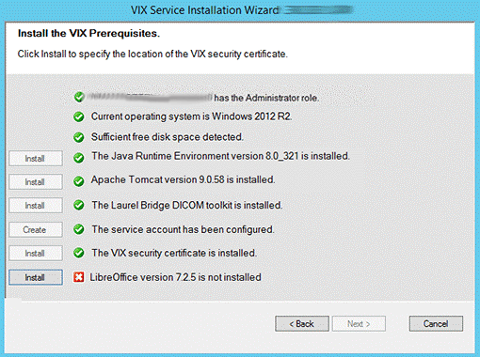

1. In the Install the VIX Prerequisites page, confirm that all the icons are Checkmark icon. Then, click **Next** (Figure 21).

Figure 21: VIX Service Installation Wizard Prerequisites Complete

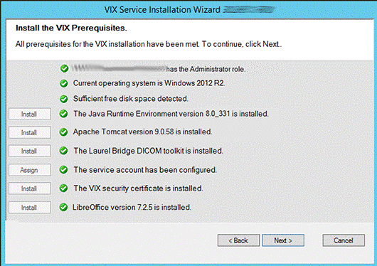

1. In the Specify the location page, select the drive for the VIX configuration files to reside. Then, click **Create**.
2. On the same page, select the drive where to create the VIX cache. Select the “C:\” drive for the VixConfig folder and the appropriate VixCache drive for your site (D: is displayed as an example in Figure 22). Click each **Create** button to create the folders.

Figure 22: VIX Cache and Configuration Folder Creation

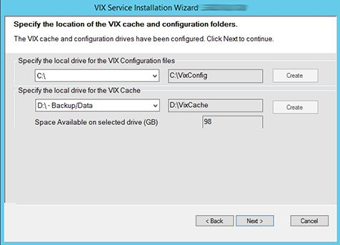

1. Click **Next**.
2. In the VistA and Email Configuration (Figure 24), perform the following:
3. Specify the access and verify codes for the account with the VistA credentials. The VIX uses this account for periodic processing of ROI disclosure requests and DICOM SCP query retrieve requests. The account must be valid VistA credentials with the settings specified in *Appendix F: Service Account Settings*.

**NOTE**: Hidden/asterisk and plain text forms of the access and verify codes can by toggled. Click **Show** to show the plain text forms and click **Hide** to show the hidden/asterisk forms.

1. Specify the email address that gets notifications for invalid credentials. The VIX sends an email notification to the address or addresses specified in this field if the ROI periodic processing credentials are expired or invalid. You can enter several addresses, separated by a comma.
2. Click **Confirm** (Figure 23).

Figure 23: VistA and Email Configuration - Confirm

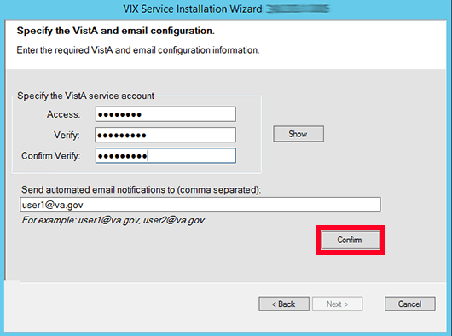

The VIX installation program checks the information. If it detects an error, it displays a tooltip with information about the error. When it confirms the configuration, Next becomes available. Click **Next** (Figure 24).

Figure 24: VistA and Email Configuration - Next

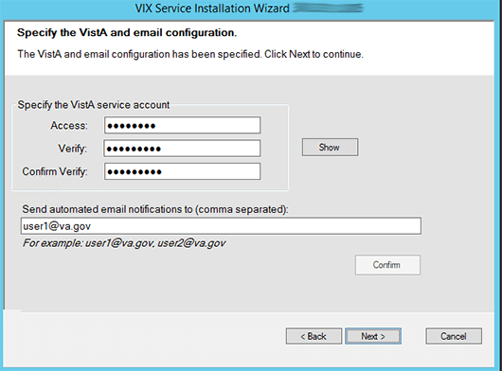

1. **New with MAG*3.0*303**: In the Specify the MUSE Configuration, if enabling the MUSE, **check** Enable and configure MUSE. Specify the MUSE site number, server host, username, and password. Please refer to *Appendix A: Enable* MUSE Functionalityfor additional information to assist with the MUSE configuration. Click **Confirm** (Figure 25).

**NOTE**: Hidden/asterisk and plain text forms of the username and password can by toggled. Click **Show** to show the plain text forms and click **Hide** to show the hidden/asterisk forms.

**NOTE**: It is expected that the site administrator is aware of all needed entries in the MUSE configuration, including the MUSE site number, host, username, and password if changes are needed. One method to obtain the values is from the Background processor discussed in *Appendix A: Enable MUSE Functionality*. If the password is not documented in existing site VistA Imaging documentation or if not available, please contact the local BioMed team or MUSE administrator.

Figure 25: Specify the MUSE Configuration - Before Confirm

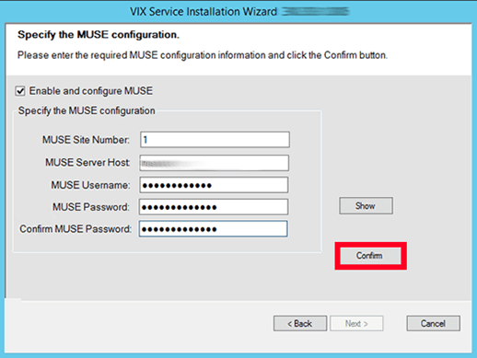

1. In the Specify the MUSE Configuration, after it confirms the configuration, Next becomes available. Click **Next** (Figure 26).

**NOTE**: During MUSE Configuration validation, the VIX installation program checks the information. If the installation program detects an error, it displays a tooltip with information about the error.

Figure 26: Specify the MUSE Configuration - After Confirm

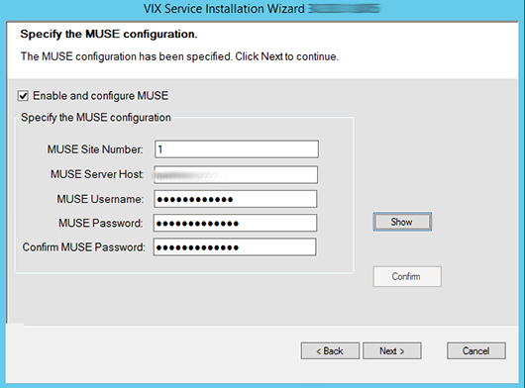

1. In the Configure Local DoD connection page (Figure 27), complete one of the following:
2. If your site has no local network connection to a DoD facility, click **Next** (this is the case at most VA sites).
3. If your site has a local network connection to a DoD facility, enter connection information for the DoD’s Integrator server. After entering the connection information, click **Confirm** to test the connection. Then, click **Next.**

Figure 27: Local DoD Connection for Images Configuration

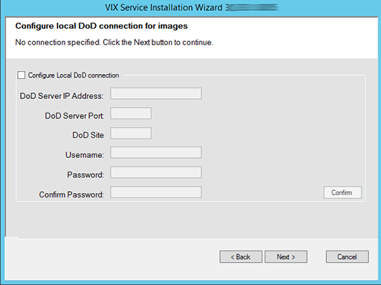

1. On the Install the VIX page (Figure 28), click **Install**. (The information on this page is saved in C:\Program Files (x86)\VistA\Imaging\VIXInstaller for future reference or troubleshooting.) This starts the installation process. This starts the installation process of the VIX and the VIX Viewer/Render Services.

Figure 28: Begin the VIX and VIX Viewer/Render Services Install

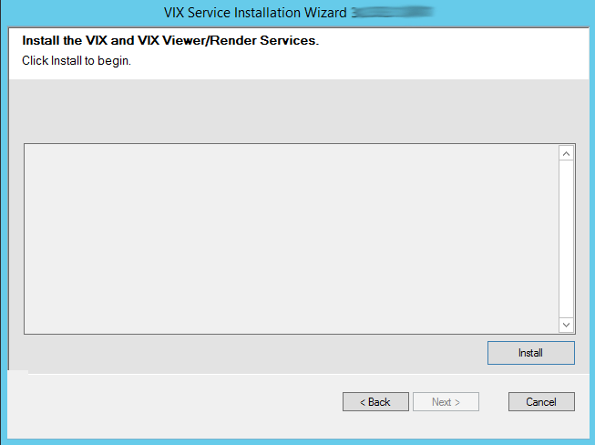

1. Wait a moment and then click **Configure Viewer/Render** (Figure 29).

Figure 29: VIX Viewer/Render Info Dialog

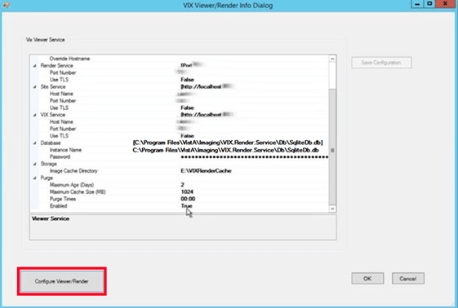

1. Verify the following settings:
2. Verify the viewer port number is REDACTED.
3. Verify the trusted client port is REDACTED.
4. Verify Site Service hostname is localhost.
5. Verify Site Service port is REDACTED.
6. Verify VIX Service hostname is localhost.
7. Verify instance name is C:\Program Files\VistA\Imaging\VIX.Render.Service\Db\SQLiteDb.db.
8. Edit image cache directory drive to the dedicated VIX cache drive. (i.e. “E:\VIXRenderCache”)
9. If setting values were modified, click the **Save Configuration** button in the top right corner.
10. Click **OK**.
11. The installation updates the VIX Viewer/Render Services in the background. Then the VIX installation will finish. This takes up to over five minutes to complete.
12. During the final install, a PowerShell script utility pops up (Figure 30, Figure 31, Figure 32) to perform additional install tasks and closes when complete.

**NOTE**: The PowerShell pop-up performs various configuration and certificate tasks and executes patch specific post-scripts.

**NOTE**: If the MUSE service is not enabled, the PowerShell pop-up may display a red error message in the MUSE check section. See Figure 30.

Figure 30: PowerShell Pop-up Script Top Portion

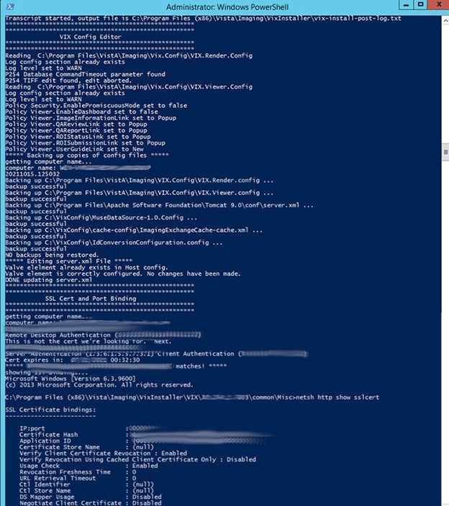

Figure 31: PowerShell Pop-up Script Middle Portion

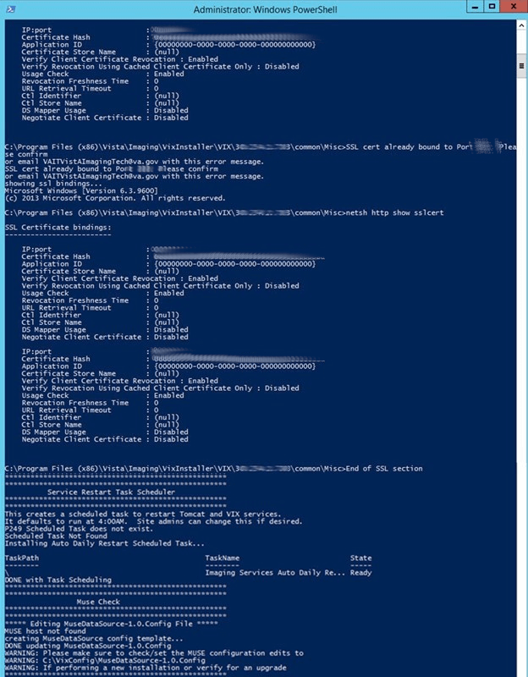

Figure 32: PowerShell Pop-up Script Bottom Portion

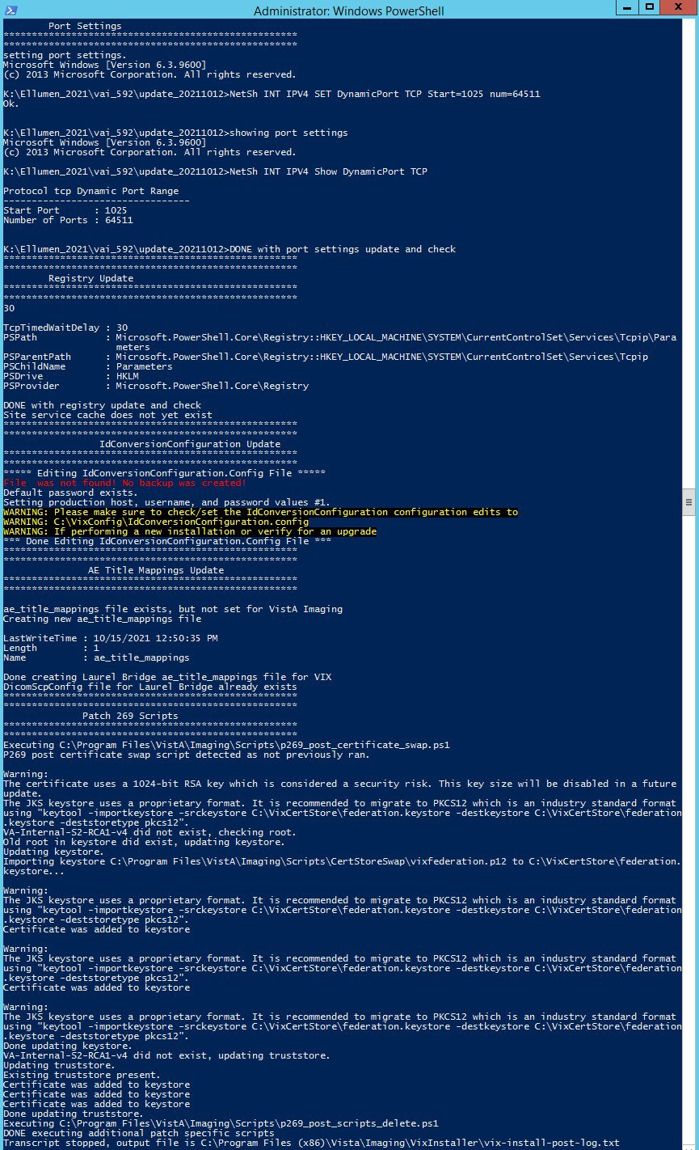

1. The VIX starts automatically (Tomcat and Viewer/Render services) when the installation is complete. When the installation is complete, click **Finish** to exit the wizard (Figure 33). The VIX Service Installation Wizard closes.

Figure 33: VIX Install Complete

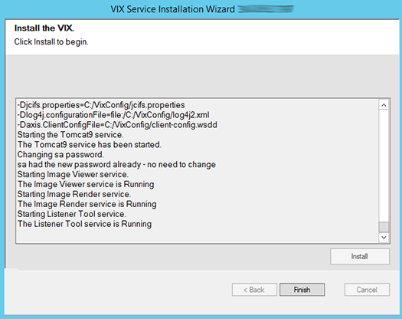

**New with MAG*3.0*303:** Perform the following additional steps to fully setup the VIX security certificate:

1. Using File Explorer, navigate to the C:\VixCertStore folder. Copy the LocalAdmin.jks file from the security certificate contents in C:\temp and paste into the C:\VixCertStore folder (to replace the LocalAdmin.jks that already exists).
2. Execute the restart script (Restart_VIX_Services.ps1) to restart the Apache Tomcat service, VIX Viewer and VIX Render services, and Listener Tool, see *Appendix C: Restart Script*.

The VIX starts automatically but cannot be used until it is activated and registered with the VistA Site Service. See the next section for details.

## Activating a New VIX

After the VIX is installed, it is inactive until it is registered with the VistA Site Service. Clinical Display workstations and VistARad workstations use the site service to determine if local and remote VIX servers are available.

After the VIX is registered in the site service, the VIX begins to be actively used, both by clinicians at your site and remote VA sites for access to locally stored images.

**NOTE**: Do not register the VIX with the site service until after it is installed. Registering the VIX before it is installed causes errors and timeout issues for Clinical Display users.

### To Register the VIX

1. Gather the following information:

* Primary contact name, phone, and email:
* Backup contact name, phone, and email:
* Site name:
* STATION NUMBER (field #99) from INSTITUTION file (#4):
* Network Name defined for Imaging Resources group:

1. Enter a National ticket to the Health, Clinical Services Diagnostics Team (previously known as Clin 3, the group name is SPM.Health.ClinSvs.Diag) for a site service update.
2. Paste the lines in the preceding step into the ticket.
3. Include “Add VIX server to Site Service database.”
4. The Health Clinical Services Diagnostics Team notifies you, typically within five business days, when the site service registration is complete.
5. Continue to *Post-Installation for New VIX Installations and Updating Existing VIX Installations**.*

# Updating an Existing VIX

This chapter explains how to update an existing VIX server. An installation checklist that summarizes this process can be found in *Appendix G: VIX Install Checklist*.

## Preparing for a VIX Update

Preparing for a VIX update involves:

* Configuring the MUSE interface. This requires the MUSE username and MUSE password for the site’s online MUSE server. If the MUSE username and password are not documented in existing site VistA Imaging documentation, please contact the local BioMed team or MUSE administrator for the information.
* Acquiring Installation File.
* Acquiring Installation Files. Copy MAG3_0P303_VIX_SETUP.msi and SQLEXPRESS_X64-14_0_1000_169.ZIP (SQL 2017) to C:\temp. (Download if required. See the patch description of the patch for the download location.)  
  **NOTE**: There is a new version of SQLEXPRESS_X64-14_0_1000_169.ZIP released for MAG3*0*303.
* Copy the MAG3_0P269_VIX_SETUP.msi to C:\temp for the backup plan if not already present.
* Verify the MAG*3.0*303 VistA KIDs package has been installed, see *VistA Software Dependencies.*
* Ensure downtime has been scheduled to install the VIX service. Local administrations of the applications and services impacted by an offline VIX should be contacted prior to installing the MAG3_0P303_VIX_SETUP.msi. The installation needs to be coordinated to avoid any disruption of services. This communication should be done in advance of the VIX update, see *Scheduling Downtown and Impact of a VIX Update.*

**TIP**: VIX-specific account passwords and security key assignments established for older VIX systems automatically carry over to new VIX systems.

**NOTE**: It is strongly suggested to restart the VIX Server prior to updating an existing VIX.

### VistA Software Dependencies

The VIX server software requires that a compatible Imaging KIDS package be installed on VistA. For details about the compatible KIDS package and installing it, see the patch description of the specific patch.

### Scheduling Downtown and Impact of a VIX Update

You need to schedule downtime with appropriate personnel for the duration of the VIX installation. Schedule 1 to 2 hours for the downtime and notify users of the impact of the VIX update.

While the VIX server is being updated, VIX assisted functions are unavailable. The list of known applications and services impacted by a local offline VIX includes:

* Clinical Display access to remote images may be temporarily inaccessible.
* VistARad access to remote images and other teleradiology features.
* DICOM Importer client.
* Local Joint Legacy Viewer (JLV) user display of images (local or remote).
* Signed Informed Consent ability to store new consents.
* Any new Ingest consuming application.
* Integrated Visualization System (IVS) mobile application access to local images.
* Enterprise DICOM Q/R functionality.
* Access to DoD images or artifacts.
* Access to VA Cerner images or artifacts.
* Any other external application calling a local VIX service directly.

Table 1 summarizes how a VIX outage affects clinicians.

Table 1: Functions Affected by VIX Updates

| Clinical Group | Impact |
| --- | --- |
| Local Clinical Display Users | DoD images are inaccessible for the duration of the VIX shutdown.  Remote VA images may be temporarily inaccessible. Clinical Display attempts to revert to pre-VIX remote image views, but users may have to disconnect from and reconnect to remote sites, or in some cases, restart Clinical Display.  Clinicians may notice longer retrieval times for remote images for the duration of the VIX shutdown.  After the VIX is restarted, restart Clinical Display to ensure that Clinical Display is no longer using pre-VIX remote image views for remote sites. |
| Local VistARad Users | Remote exam data and images and monitored exam lists are unavailable. For additional information, refer to the documentation for VistARad. |
| Remote VA or DoD Clinicians requesting Images or Artifacts | Remote clinicians may experience transitory application errors if the VIX is shut down while it is in the middle of processing a request; the clinician may have to repeat the request.  Remote VA clinicians issuing new requests may notice longer retrieval times for the duration of the VIX shutdown.  Remote DoD clinicians are unable to retrieve locally stored images for the duration of the VIX shutdown. |
| Local DICOM Importer Users | The DICOM importer client cannot log into VistA and process imports for the duration that the VIX is down. |
| VIX Image Viewer/JLV Users | Clinical users of JLV cannot access images or artifacts (local or remote) using the VIX image viewer. |
| iMedConsent Users | Patients’ consent forms are unavailable. Currently, this results in multiple unsigned Text Integration Utility (TIU) notes in Computerized Patient Record System (CPRS) due to CVIX and iMedConsent Web (ICW) deficiencies until the necessary corrective action(s) can be deployed by both the CVIX and ICW development teams. |
| IVS Mobile Application Users | IVS mobile application users cannot access local images. |

## Preparing Service Account and Passwords

Before starting the VIX server update process, identify your DICOM/ Release of Information (ROI) periodic processing VistA Imaging VistA service account. It is suggested to update the name of the VistA service account as described in *Appendix F: Service Account Settings*. To ensure DICOM query retrieve/ROI periodic processing functionality, update the SSN of the service account and verify it has the security keys, secondary menu options, a value for the INITIAL field, and additional options as described in *Appendix F: Service Account Settings*.

Locate the current password used for the Apache Tomcat administrator account and DICOM query retrieve/ROI periodic processing VistA Imaging VistA service account credentials.

* The Apache Tomcat administrator password is case sensitive, must contain at least **fourteen (14) alphanumeric characters**, and must contain at least one capital letter and one number.

## Performing a VIX Server Update

Use the following steps to update a VIX server.

**NOTE**: You do not have to stop any currently running services because this install process automatically stops them for you.

1. Use an administrator-level account to log onto the VIX server.
2. If you did not already do so in Section 3.1, copy the VIX installation file MAG3_0P303_VIX_SETUP.msi to C:\temp on the VIX server. (Download if required, see the patch description of the patch for the download location).
3. Go into Control Panel/Programs/Programs and Features, and remove the prior VIX Service Installation Wizard by right-clicking on it and choosing Uninstall.
4. To Install the VIX Service Installation Wizard perform the following steps:
5. Right-click the **VIX installation** file (MAG3_0P303_VIX_SETUP.msi) and click on Install.
6. If prompted with “Do you want to allow the following program from a verified publisher to make changes to this computer?”, click **Yes** (Figure 34)

Figure 34: User Account Control - Vix Service Installation Wizard



1. When the Welcome page displays, click **Next**.
2. When the Confirm Installation page displays, click **Next**.
3. When the Installation Complete screen displays, click **Close**.
4. Run the VIX Service Installation Wizard as an administrator (Figure 35).
5. **R**ight-click **Start**.
6. **L**eft-click **Search**.
7. Type **VIX**.
8. **R**ight-click VIX Service Installation Wizard.
9. **L**eft-click Run as administrator.

**NOTE**: If the VIX Service Installation Wizard does not appear in the Search bar as in Figure 35, open Windows Explorer and navigate to the **C:\Program Files (x86)\Vista\Imaging\VixInstaller** folder, **r**ight-click **VixInstaller.exe** and **l**eft-click **Run as administrator**.

Figure 35: Run the VIX Service Installation Wizard



1. If prompted with “Do you want to allow the following program from an unknown publisher to make changes to this computer?”, click **Yes** (Figure 36).

Figure 36: User Account Control - VixInstaller



1. When the Welcome page for the VIX Service Installation Wizard displays, click **Next.**
2. **Click** on the button labeled **Uninstall version 30.269.5.7925** to uninstall (Figure 37) the pre-existing VIX software. (If it is not already stopped, the wizard gracefully stops the VIX service before performing the uninstall.)

Figure 37: Update VIX Components

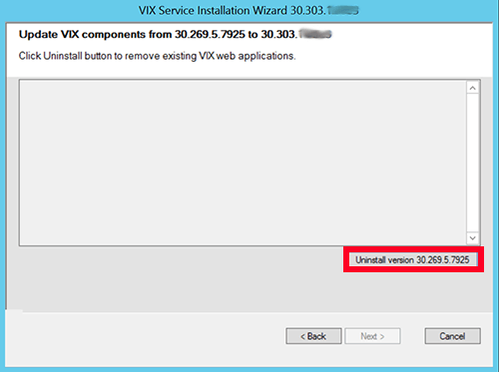

1. During the uninstall, a PowerShell script utility pops up (Figure 38) to perform back-ups of prior configuration files and, if present, execute any patch-specific pre-scripts. The PowerShell window closes when complete.

Figure 38: Update VIX Components PowerShell Pop-up Script

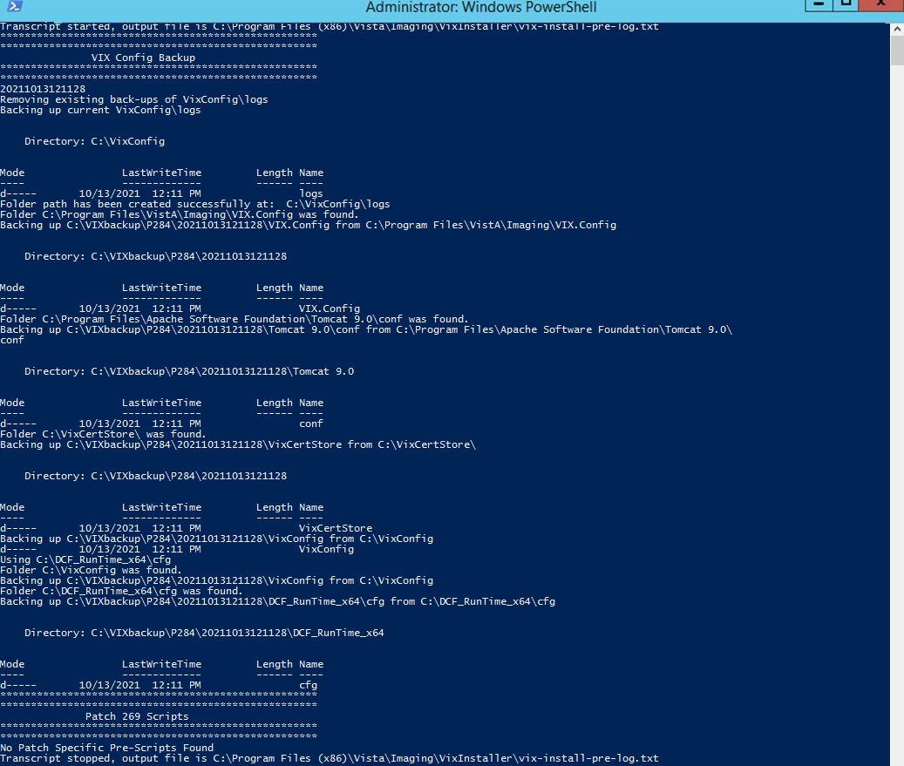

1. **New with MAG*3.0*303:** During the uninstall, a SQL Server dialog box appears to ask to uninstall SQL Server.
2. **Click** Yes, unless directed to Click No.

**NOTE**: If clicking **Yes**, please wait until the PowerShell script is done executing and the PowerShell window has closed.

**NOTE**: If clicking **No**, please follow Appendix D: SQL Server Removal to remove SQL Server at a later time after VIX installation.

Figure 39: SQL Server Uninstall Dialog

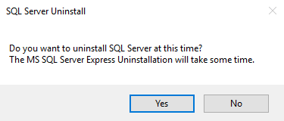

1. Select (Figure 40) the SQLEXPRESS_X64-14_0_1000_169.ZIP file in the temporary folder in C:\temp and Click **OK**.

**NOTE**: There is a new version of SQLEXPRESS_X64-14_0_1000_169.ZIP released for MAG3*0*303.

Figure 40: Select SQL Server Setup ZIP file

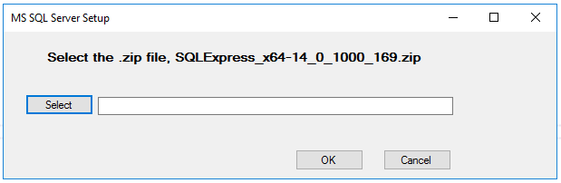

1. A Remove SQL Server 2017 window appears. On the Select Instance page click **Next** (Figure 41).

Figure 41: Remove SQL Server Select Instance

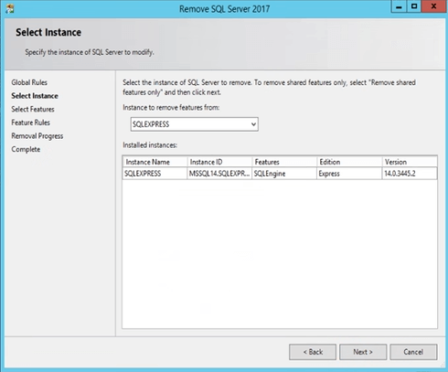

1. On the Select Features page click **Select All**, then click **Next** (Figure 42). Wait for the uninstall of SQL Server to complete. This can take about seven to ten minutes.

Figure 42: Remove SQL Server Select Features

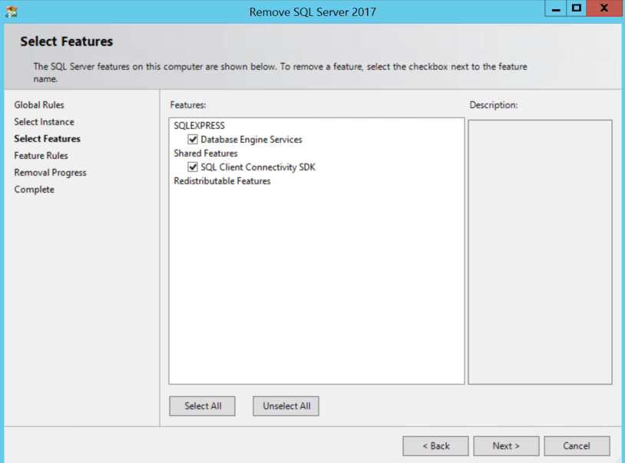

1. On the Complete page click **Close** (Figure 43).

Figure 43: Remove SQL Server 2017 Complete

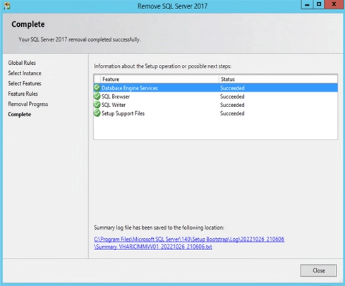

1. When the Uninstall is complete, **Press Next to continue** displays in the VIX Service Installation Wizard, click **Next.**
2. In the **Site Number** field of the “Specify the VA Site the VIX will service” page, verify that the **Site Number** box shows your STATION NUMBER (field (#99) in the INSTITUTION file (#4) of your site, the information is in FileMan in VistA).
3. Confirm the connection by clicking **Lookup Server Address**. Then click **Next** (Figure 44).

Figure 44: VIX Service Installation Wizard

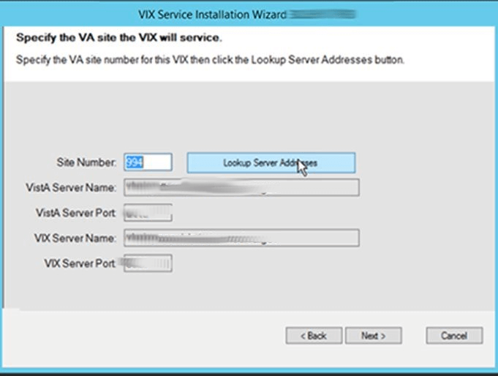

1. Please be patient for the VIX Prerequisites page to appear, as it may take a while. When the Install the VIX Prerequisites page displays, read the line that indicates the state of the Java Runtime Environment. If Checkmark icon displays, skip to the next step. If Install needed icon displays (Figure 45), do the following:
2. Click Install.
3. Wait until the status icon for the Java Runtime Environment changes to Checkmark icon. (This install of Java may take over five minutes to complete. Please be patient, as this step may take a while to complete.)

Figure 45: VIX Prerequisites - Java Not Installed

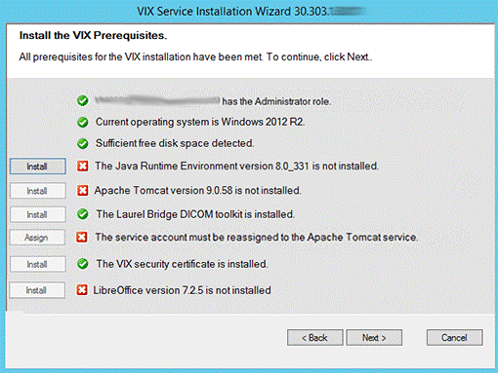

**NOTE:** The person installing the VIX software does not need to be in the VHAMASTER domain. The installer’s domain should appear with their name. This (and subsequent screenshots) is just an example of what the installer sees.

1. On the same page, read the line that indicates the state of the Apache Tomcat installation. If Checkmark icon displays, skip to the next step. If Install needed icon displays (Figure 46), do the following:
2. Click **Install**.
3. Wait until the status icon for Apache Tomcat changes to Checkmark icon. (This install of Tomcat may take over five minutes complete. Please be patient, as this step may take a while to complete.)

Figure 46: VIX Prerequisites - Tomcat Not Installed

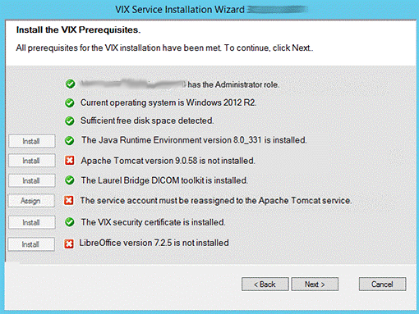

1. On the same page, check the line that indicates the state of the Laurel Bridge toolkit. Verify Checkmark icon displays. If Install needed icon displays, refer to the *Laurel Bridge DCF Toolkit* instructions to obtain an updated serial number and activation code.
2. On the same page, read the line that indicates the state of the service account. If Checkmark icon displays, skip to the next step. If Install needed icon displays, do the following:
3. Click **Assign** (Figure 47).

Figure 47: Apache Tomcat Service Account Password

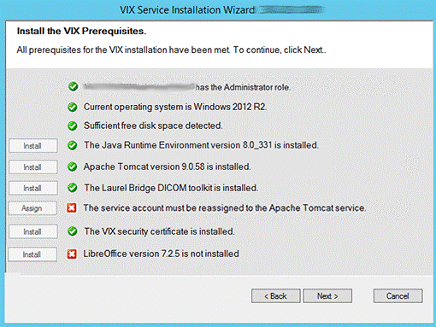

1. In the dialog box that displays enter the Windows service account password that you previously prepared in *Preparing Passwords, Activating Components, and Staging Files.* Then click **OK**.

* The password is case sensitive, must contain at least **fourteen (14) alphanumeric characters,** and must contain at least one capital letter and one number.

1. Wait until the status icon for the service account changes to Checkmark icon.
2. On the same page, check the line that indicates the state of VIX security certificate. Verify Checkmark icon displays.
3. On the same page, read the line that indicates the state of the LibreOffice installation. If Checkmark icon displays, skip to the next step. If Install needed icon displays (Figure 48), do the following:
4. Click **Install**.
5. Wait until the status icon for LibreOffice changes to Checkmark icon. (This install of LibreOffice may take several minutes to complete. Please be patient, as this step may take a while to complete.)

Figure 48: VIX Prerequisites - LibreOffice Not Installed

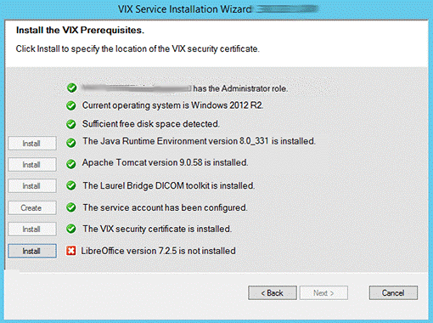

1. Once LibreOffice is installed, the Install the VIX Prerequisites page will update with a Checkmark icon icon. Confirm that all the icons are Checkmark icon and click **Next** (Figure 49).

Figure 49: All VIX Prerequisites Installed or Configured

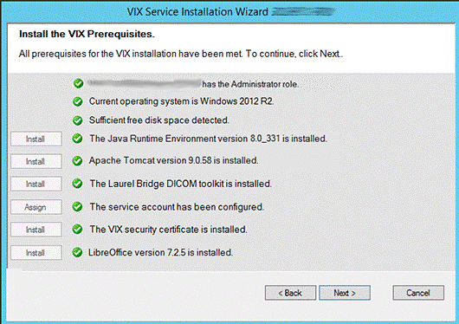

1. In the Specify the location page, if you want to keep your existing locations, click **Next**. If you want to change them, select the “C:\” drive for VixConfig folder and the dedicated VIX cache drive for the VixCache folder for your site. Ensure the dedicated VIX cache drive correctly points to the drive letter that is currently being used, for example, “D:\VIXCache” as displayed in Figure 50. For each folder, click **Create** to confirm and create the folders.

Figure 50: VIX Cache and Configuration Folder Creation

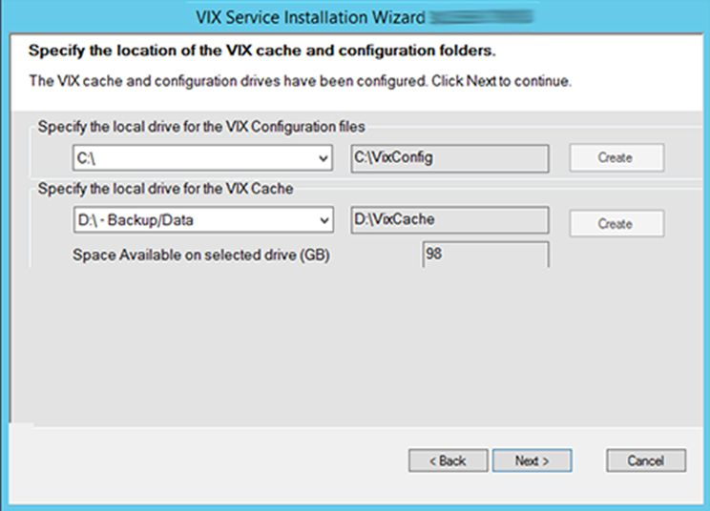

1. In the Specify the VistA and Email Configuration, specify the access and verify codes for the account with the VistA credentials. If the email address(es) has changed, specify the email address(es) that gets notifications for invalid credentials. You can enter several email addresses, separated by a comma. Click **Confirm** (Figure 51).

**NOTE**: Hidden/asterisk and plain text forms of the access and verify codes can by toggled. Click **Show** to show the plain text forms and click **Hide** to show the hidden/asterisk forms.

**NOTE**: The VIX uses this account for periodic processing of ROI disclosure requests and DICOM SCP query retrieve requests. The account must be valid VistA credentials with the settings described in *Appendix F: Service Account Settings*.

**NOTE**: The VIX sends an email notification to the address or addresses specified if the ROI periodic processing credentials are expired or invalid.

1. In the Specify the VistA and Email Configuration, after it confirms the configuration, **Next** becomes available. Click **Next** (Figure 52).

**NOTE**: During VistA Configuration validation, the VIX installation program checks the information. If the installation program detects an error, it displays a tooltip with information about the error.

Figure 51: Specify the VistA and Email Configuration - Before Confirm



Figure 52: Specify the VistA and Email Configuration - After Confirm



1. **New with MAG*3.0*303**: In the Specify the MUSE Configuration, verify if the MUSE settings have not changed since the prior installation and you want to keep the existing values. If changes are needed, if enabling the MUSE, **check** Enable and configure MUSE. Specify the MUSE site number, server host, username, and password. If changes are needed, please refer to *Appendix A: Enable* MUSE Functionality for additional information to assist with the MUSE configuration. Click **Confirm** (Figure 53).

**NOTE**: Hidden/asterisk and plain text forms of the username and password can by toggled. Click **Show** to show the plain text forms and click **Hide** to show the hidden/asterisk forms.

**NOTE**: It is expected that the site administrator is aware of all needed entries in the MUSE configuration, including the MUSE site number, host, username, and password if changes are needed. One method to obtain the values is from the Background processor discussed in *Appendix A: Enable* MUSE Functionality. If the password is not documented in existing site VistA Imaging documentation or if not available, please contact the local BioMed team or MUSE administrator.

Figure 53: Specify the MUSE Configuration - Before Confirm

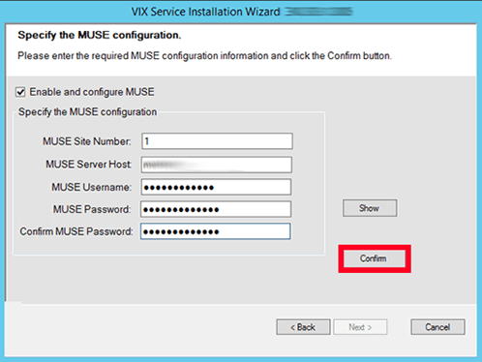

1. In the Specify the MUSE Configuration, after it confirms the configuration, Next becomes available. Click **Next** (Figure 54).

**NOTE**: During MUSE Configuration validation, the VIX installation program checks the information. If the installation program detects an error, it displays a tooltip with information about the error.

Figure 54: Specify the MUSE Configuration - After Confirm

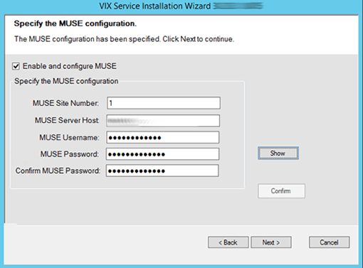

1. In the Configure Local DoD connection page (Figure 55), if the DoD connection information has not changed since the last time you ran the installer and you want to keep the existing values, click **Next.**

If you want to change the DoD connection information, perform the following:

1. If your site has no local network connection to a DoD facility, click **Next**. This is the case at most VA sites.
2. If your site has a local network connection to a DoD facility, enter connection information for the DoD’s Integrator server. After entering the connection information, click **Confirm** to test the connection. Then, click **Next**.

Figure 55: Configure Local DoD connection



1. On the Install the VIX page (Figure 56), click **Install.** (The information on this page is saved in C:\Program Files (x86)\VistA\Imaging\VIXInstaller for future reference or troubleshooting.) This starts the installation process of the VIX and the VIX Viewer/Render Services.

Figure 56: Begin the VIX and VIX Viewer/Render Services Install



1. Wait a moment and then click **Configure Viewer/Render** (Figure 57).

Figure 57: VIX Viewer/Render Info Dialog Screenshot



1. **New with MAG*3.0*303:** Verify Database > Instance Name is set to the following:   
   C:\Program Files\VistA\Imaging\VIX.Render.Service\Db\SQLiteDb.db.
2. Verify the following settings:
3. Verify the viewer port number is REDACTED.
4. Verify the trusted client port is REDACTED.
5. Verify Site Service > Host Name is localhost.
6. Verify Site Service > Port Number is REDACTED.
7. Verify VIX Service > Host Name is localhost.
8. Verify the image cache directory drive is the dedicated VIX cache drive. (i.e. “E:\VIXRenderCache").
9. Click the **Save Configuration** button in the top right corner.

**NOTE**: The ‘Save Configuration’ button does not activate unless you changed the configuration (Figure 58).

Figure 58: Save/Configuration Button

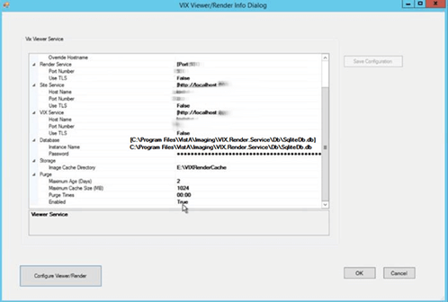

1. Click **OK**.
2. The installation updates the VIX Viewer/Render Services will be updated in the background. Then the VIX installation finishes. This takes up to over five minutes to complete.
3. During the final install, a PowerShell script utility pops up (Figure 59, Figure 60, and Figure 61) to perform additional install tasks and closes when complete.

**NOTE**: The PowerShell pop-up performs various configuration and certificate tasks and executes patch specific post-scripts.

**NOTE**: If the MUSE service is not enabled, the PowerShell pop-up may display a red error message in the MUSE check section. See *Appendix A: Enable MUSE Functionality*.

Figure 59: PowerShell Pop-up Script Top Portion

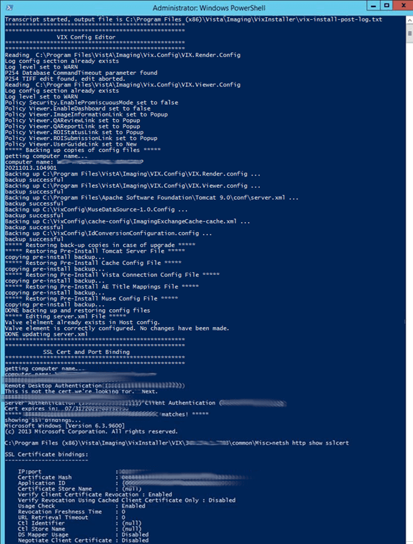

Figure 60: PowerShell Pop-up Script Middle Portion



Figure 61: PowerShell Pop-up Script Bottom Portion

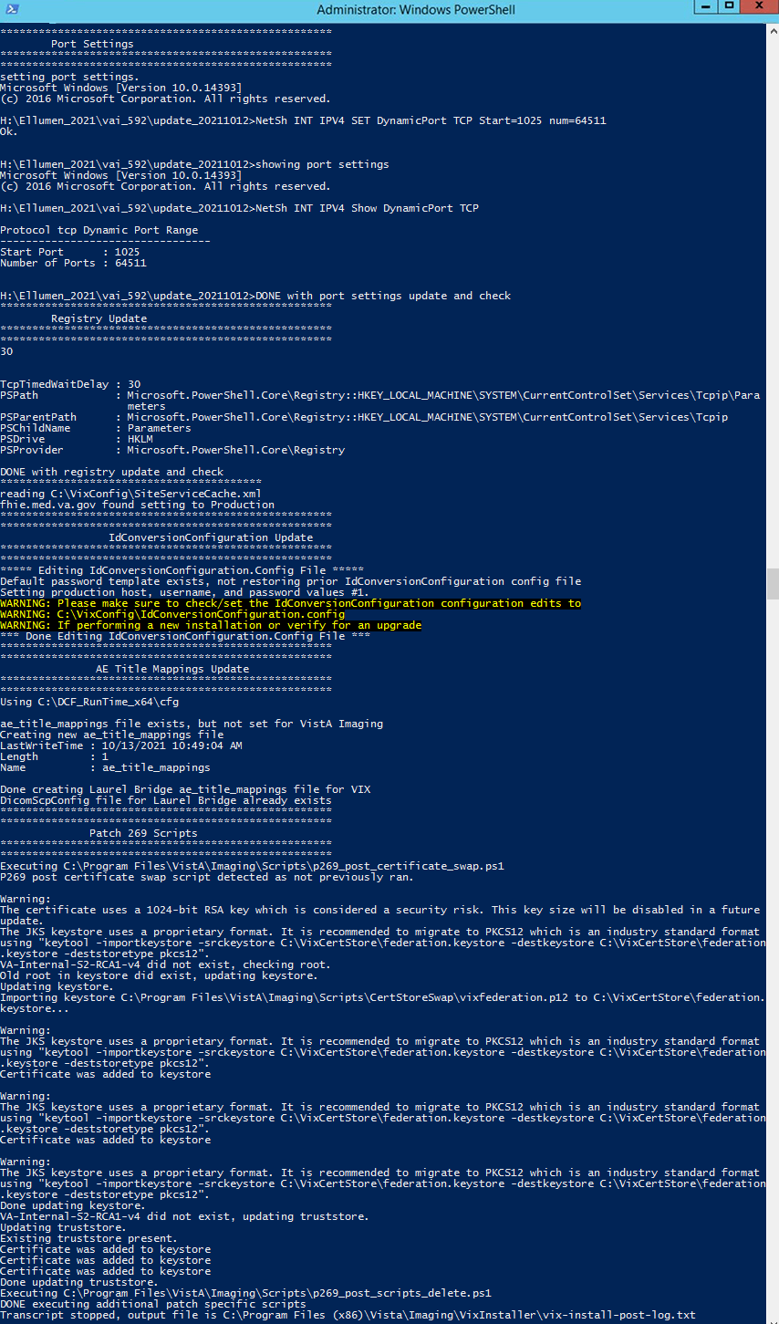

1. When the installation completes, the VIX automatically starts the Tomcat, Viewer/Render, and Listener Tool services. Click **Finish** to exit the wizard (Figure 62). The VIX Service Installation Wizard closes.

Figure 62: VIX Installation Complete

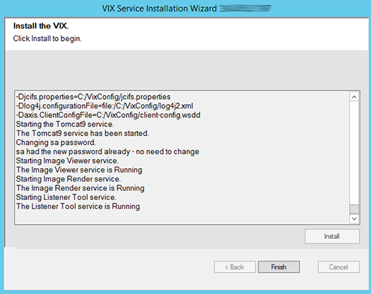

1. Restart the VIX server after the VIX Installation completes.
2. Continue to *Post-Installation for New VIX Installations and Updating Existing VIX Installations**.*

# Post-Installation for New VIX Installations and Updating Existing VIX Installations

## McAfee Exclusions

Exclude the following directories using McAfee On-Access Scan Properties (Figure 63). Make sure “Also exclude subfolders” is checked, so subfolders are excluded as well:

* C:\Program Files\Java\**\*\**lib\
* C:\Program Files\Apache Software Foundation\Tomcat*\lib\
* C:\Program Files\Apache Software Foundation\Tomcat*\logs\
* C:\Program Files\VistA\Imaging\VIX.Render.Service\log\
* C:\Program Files\VistA\Imaging\VIX.Viewer.Service\log\
* C:\VixConfig\logs\
* ?:\VixCache\
* ?:\VIXRenderCache\

**NOTE**: The wildcards, * and ? for the java, tomcat, and cache folder exclusions respectively, are new with **MAG*3.0*303.**

**NOTE**:The wildcard * can replace the wildcard ? for the cache folder exclusions, if desired.

Figure 63: Set Exclusions Dialog

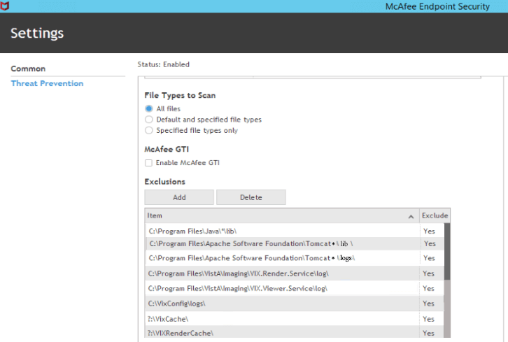

Click **OK** in the Set Exclusions window. Then click **OK** in the McAfee On-Access Scan Properties window.

## Verifying Installation/Upgrade is Complete

Verify that your installation is complete by obtaining the current version (Figure 64). Follow these steps:

1. Go to the VIX homepage: **http://*FQDN of VIX server*:REDACTED/**
2. The current version is listed in the format XX.XXX.X.X. The first two digits represent Version 3.0 of the VistA Imaging system. The next three digits are the number of the latest patch that has affected the VIX. This patch number should match the number of the VIX component you have most recently installed.

Figure 64: VISA Version Verification

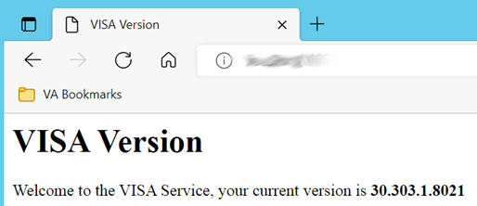

1. Verify VIX Viewer and VIX Render services are running (Figure 65).

Figure 65: VIX Viewer and Render Services Running

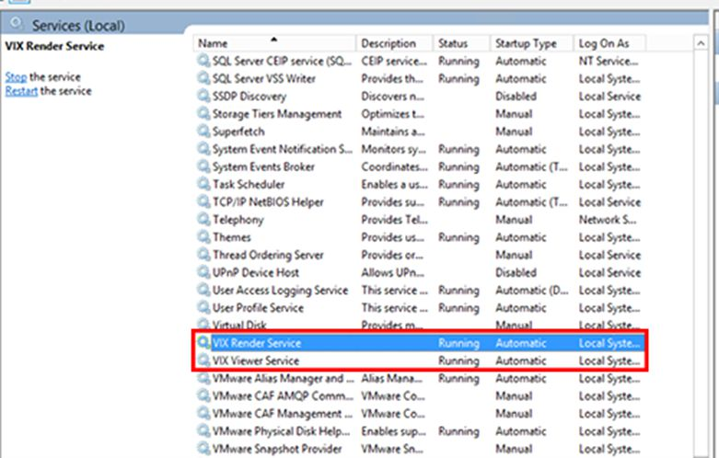

1. Verify the ListenerTool is running (Figure 66).

Figure 66: Listener Running

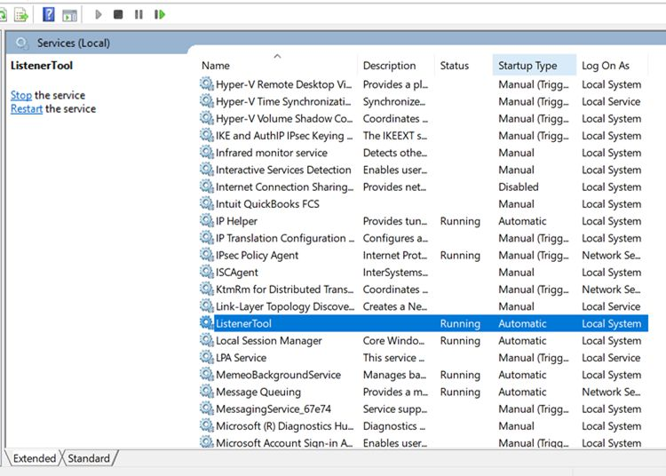

1. Verify that you have 10 Hydra IX Processor and 5 Hydra VistA Worker processes running (Figure 67):

Figure 67: 10 Hydra IX Processor and 5 Hydra VistA Worker Processes Running

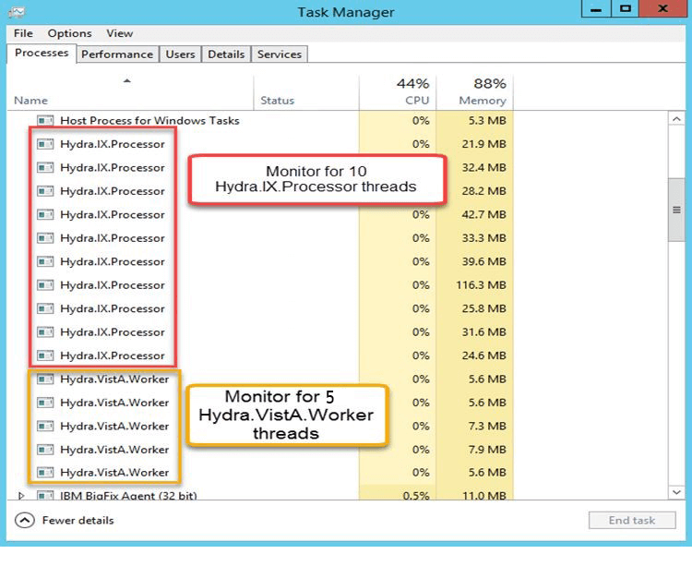

## Verifying VIX Operations

After a VIX is installed and is registered with the Image Exchange Service (not needed if VIX is only being updated), Clinical Display (MAG*3.0*258 or later) and VistARad (MAG*3.0*199 or later) workstations automatically start using the VIX.

* Clinical Display begins sending requests for remote data to the VIX immediately. No configuration changes are required for Clinical Display to start using the VIX.
* VistARad needs some local configuration changes to enable some of its VIX-supported capabilities; refer to the VistARad documentation for details.
* JLV Image Viewing does not require any additional configuration changes. The Image Viewer should launch without issue and be able to display MUSE images.

**NOTE**: Please use either Chrome or Edge on your Government Furnished Equipment (GFE) or VIX server to verify and perform VIX Operations.

### Verifying Access to the VIX Tools and VIX Transaction Log

VIX administrators can use the VIX Tools as described in the *VIX Administrator’s Guide* with a listing of available tools in Appendix B: VIX Tools of the VIX Administrator’s Guide.

To access the VIX Tools, navigate to [REDACTED/vix/viewer/tools](https://example.vha.med.va.gov:343/vix/viewer/tools) to be prompted to login (Figure 68). Use a VistA account with the MAG VIX ADMIN security key and INITIAL to log in.

Figure 68: Login Page

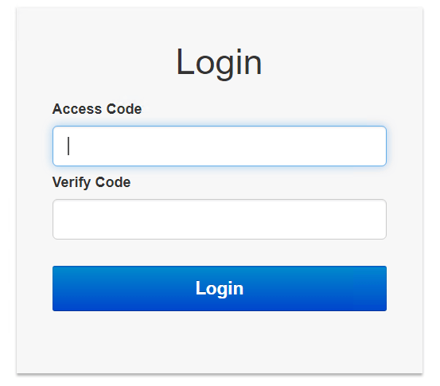

The VIX transaction log can be used to monitor VIX activities. Once logged in to the VIX Tools page, access to the transaction log at **http://*FQDN*:REDACTED/Vix/secure/VixLog.jsp** is available  
(where *FQDN* is the fully qualified domain name of the VIX server) (Figure 69).

Figure 69: VIX Tools Page

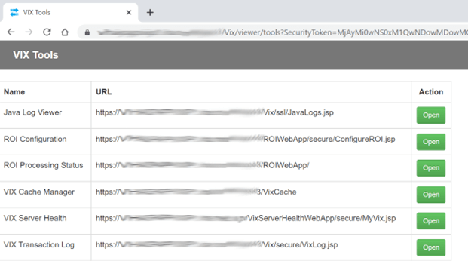

If you cannot access the transaction log, verify that the VIX service is running.

If the VIX is running, but you cannot access the transaction log, ensure that ports REDACTED, REDACTED, and REDACTED on the VIX server are not blocked. Possible culprits of a blocked port include antivirus firewalls and modifications to ACLs (Access Control Lists).

For detailed information about the transaction log contents, refer to the [*VIX Administrator’s Guide.*](https://www.va.gov/vdl/application.asp?appid=105)

### Spot-Checking VIX Image Delivery

This section shows different ways you can spot-check displaying remote images.

1. Using JLV:
   1. Select an image with a camera icon, and launch the Image Viewer to display the selected image.
   2. Select the “Cardiology Studies VA MUSE Only” widget, and view a MUSE EKG image by selecting the camera icon. This launches the Image Viewer to display the selected MUSE EKG image.
   3. Turn on the Display DOD Image User Preference in JLV. View a DoD image by selecting the camera icon. This launches the Image Viewer to display the selected DoD image.
2. On the Clinical Display workstation:
   1. Select a patient with remote images.
   2. If it is not visible already, display the Abstracts area to display an abstract for one of the remote images.
   3. Right-click the abstract for the remote image, and open the Image Information Advanced window.
   4. In the Image Information Advanced window, check the IEN (Internal Entry Number) value or Image Number. If the value starts with “urn”, the remote image was retrieved by the VIX.

## DICOM SCP Configuration

Please refer to *Appendix B: DICOM SCP Configuration* to configure the DICOM SCP.

**New with MAG*3.0*303:** The installer automatically generates a default blacklist consisting of site codes that configured DICOM SCUs do not receive data from. Your local site code and the site codes of your Veterans Integrated Service Network (VISN) appear in the <siteCodeBlackList> section in the file ScpConfiguration.config located in the C:\VixConfig folder. If you want your site’s data to be available to the configured DICOM SCU, ensure your local site code is not in the <siteCodeBlackList> section in the ScpConfiguration.config.

# Troubleshooting/Reconfiguration

## Resuming an Interrupted VIX Installation

If you have had to interrupt or cancel an in-progress VIX installation, you can resume the installation.

**NOTE**: If you re-run MAG3_0P***number***_VIX_SETUP.msi, you are repeating the installation of the VIX Service Installation Wizard software, not the installation of the VIX itself. If you do this, click **Cancel**, choose **Yes** when prompted for confirmation, and then exit the installer. Then restart the VIX installation following the steps below.

### Resuming Installation (single server VIX)

1. Log onto the VIX server as an administrator.
2. Run the VIX Service Installation Wizard as an administrator (Figure 70).
3. **R**ight-click **Start**.
4. **L**eft-click **Search**.
5. Type **VIX**.
6. **R**ight-click VIX Service Installation Wizard.
7. **L**eft-click Run as administrator.

Figure 70: Run the VIX Service Installation Wizard



1. If prompted with “Do you want to allow the following program from an unknown publisher to make changes to this computer?”, click **Yes.**
2. Follow the steps for a new VIX installation, see *New VIX Server Installation* section, or for updating a VIX, see *Updating an Existing VIX* section.

## Using the VIX Service Installation Wizard to Reconfigure the VIX

You must re-execute the VIX Service Installation Wizard if you need to:

* Change the drive where the VixCache or VixConfig folders are located. It is recommended that these folders reside on the same shared drive.
* Change the VIX configuration to use a different local VistA hostname or port number.

Using the VIX Service Installation Wizard to reconfigure VIX is like the steps for updating a VIX, except the process is much faster since no actual software is being installed.

**TIP**: Changing a VIX cache location or local connection information should take about 5 minutes.

### Reconfiguring a VIX Server

1. Review the information in the *Scheduling Downtown and Impact of a VIX Update* section, and schedule downtime and notify appropriate groups of the downtime.
2. Run the VIX Service Installation Wizard as an administrator (Figure 71).
3. **R**ight-click **Start**.
4. **L**eft-click **Search**.
5. Type **VIX**.
6. **R**ight-click VIX Service Installation Wizard.
7. **L**eft-click Run as administrator.

Figure 71: Run the VIX Service Installation Wizard



1. If prompted with “Do you want to allow the following program from an unknown publisher to make changes to this computer?”, click **Yes**.
2. When the Welcome page displays, verify that the screen displays “This wizard will guide you through the installation of the Vista Imaging Patch MAG*3.0*303 VIX” and click **Next**.
3. Then, when prompted to do so, click Uninstall version 30.303.xxx. (The wizard gracefully stops the VIX service before performing the uninstall.).
4. If a SQL Server dialog box appears to ask to uninstall SQL Server (Figure 72) perform the following:
5. **Click** Yes, unless directed to Click No.

**NOTE**: If clicking **Yes**, please wait until the PowerShell script is done executing and the PowerShell window has closed.

**NOTE**: If clicking **No**, please follow Appendix D: SQL Server Removal to remove SQL Server at a later time after VIX installation.

Figure 72: SQL Server Uninstall Dialog



1. Select (Figure 73) the SQLEXPRESS_X64-14_0_1000_169.ZIP file in the temporary folder in C:\temp and Click **OK**.

**NOTE**: There is a new version of SQLEXPRESS_X64-14_0_1000_169.ZIP released for MAG3*0*303.

Figure 73: Select SQL Server Setup ZIP file



1. A Remove SQL Server 2017 window appears. On the Select Instance page click **Next** (Figure 74).

Figure 74: Remove SQL Server Select Instance



1. On the Select Features page click **Select All**, then click **Next** (Figure 75). Wait for the uninstall of SQL Server to complete. This can take about seven to ten minutes.

Figure 75: Remove SQL Server Select Features



1. On the Complete page click **Close** (Figure 76).

Figure 76: Remove SQL Server 2017 Complete



1. When the Uninstall is complete, **Press Next to continue** displays in the VIX Service Installation Wizard, click **Next.**
2. Click **Next** until the “Specify the VA Site the VIX will service” page displays.
3. On this page, verify that the **Site Number** box shows your STATION NUMBER (field (#99) in the INSTITUTION file (#4) of your site, the information is in FileMan in VistA). Then, click the **Lookup Server Address**.
4. Verify the correct hostname and port number for the local VistA system displays. Then, click **Next**.
5. When the Install the VIX Prerequisites page displays, click **Next**. (All prerequisites are installed already.)
6. On the “Specify the VA Site the VIX will service” page, do one of the following:
7. If you are changing the location of the VIX cache and configuration files, select the new drive for each. Click **Create**. Then, click **Next**.
8. If you are NOT changing the location of the VIX cache and configuration files, click **Next**.
9. In the Specify the VistA and email Configuration, do the following:
10. Enter the access and verify codes. If you are changing the email address or addresses enter them. Click **Confirm**.
11. Click **Next**.
12. In the “Specify the MUSE Configuration” page do one of the following:
13. If you are changing the MUSE configuration, enter the configuration settings. Click **Confirm**. Then click **Next**.
14. If you are NOT changing the MUSE configuration, click **Next**.
15. In the Configure local DoD connection page, click **Next**.
16. In the Install the VIX page, click **Install**.
17. Wait a moment and then click **Configure Viewer/Render**.
18. If you are changing the Viewer/Render configuration, enter the configuration settings. Click **Save Configuration**. Then click **OK**.
19. If you are NOT changing the Viewer/Render configuration, click **OK**.
20. Wait until the installation is complete and click **Finish**.
21. Restart the VIX server after the VIX Installation completes.
22. Re-execute the Post-Installation instructions, see *Post-Installation for New VIX Installations and Updating Existing VIX Installations* section.

## Tomcat Permissions

If encountering file system access errors after VIX Installation, please refer to *Appendix E: Tomcat Permissions,* i.e.: ...error denying access to apachetomcat account.

## VIX Support

If you encounter problems installing the VIX, please call the Enterprise Service Desk at REDACTED.

# Back Out/Uninstall

## Stopping the VIX Services

This section describes stopping any currently running services to assist with the back out/uninstall for complete VIX removal.

For Server 2012 R2 or 2016 (Server Manager | Tools | Component Services | Services (Local), or Task Manager | Services | Open Services), sort the Name column, and stop each VIX service shown below by selecting **Stop** (Figure 77).

* ListenerTool
* Tomcat9
* VIX Render Service
* VIX Viewer Service

Always use the Window ‘Task Manager’ to monitor the processing tasks as needed.

Figure 77: Stopping VIX Viewer Service

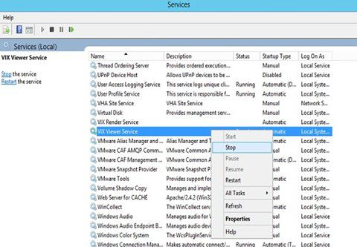

## Back Out/Uninstall Scenarios

The information in this section addresses three possible cases that involve uninstalling a VIX:

* Troubleshooting
* Relocation onto a different server
* Decommission

Each of these scenarios is outlined in the following sections.

### Uninstall/Restore as part of Troubleshooting

If you need to remove and then immediately reinstall the VIX on the same server for troubleshooting purposes, you need to do the following:

1. Locate the product serial number for the Laurel Bridge software that is bundled with the VIX. This number is in the license paperwork that was provided by REDACTED when the VIX was set up.

**NOTE**: You need to re-enter this serial number as a part of the VIX installation process.

1. Run the VIX Service Installation Wizard as an administrator.
2. **R**ight-click **Start**.
3. **L**eft-click **Search**.
4. Type **VIX**.
5. **R**ight-click VIX Service Installation Wizard.
6. **L**eft-click Run as administrator.
7. When the Welcome page displays, verify that the screen displays “This wizard will guide you through the installation of the Vista Imaging Patch MAG*3.0*303 VIX” and click **Next**.
8. Then, when prompted to do so, click **Uninstall version 30.303.xxx**. (The wizard gracefully stops the VIX service before performing the uninstall.)
9. When the Uninstall completes, "Press Next to continue" displays in the VIX Service Installation Wizard, click **Cancel**. Click **Yes** in the dialog box that displays "Do you really want to quit the VIX Service Installation Wizard?"
10. Go to the Control Panel, choose **Add/Remove Programs**, and remove the MAG*3.0*303 VIX Service Installation Wizard.
11. Re-execute the VIX installation as if for a new VIX, see *New VIX Server Installation* section.
12. Re-execute the Post-Installation instructions, see *Post-Installation for New VIX Installations and Updating Existing VIX Installations* section.

### Relocating a VIX onto a New Server

If you need to remove all traces of the VIX from the old server and set up the VIX on a new server, you need to do the following:

1. Contact the REDACTED mail group and arrange to have the existing Laurel Bridge DCF toolkit licenses transferred to a new server.
2. Validate the new VIX server as described in the *Selecting and Validating the VIX Server* section.
3. Manually remove the VIX as described in the *Uninstalling the VIX* section below.
4. Re-execute the VIX installation as if for a new VIX, see *New VIX Server Installation* section.

### Decommissioning a VIX

If you need to completely decommission a VIX and not replace it by another VIX, do the following:

1. Notify the REDACTED mail group that the Laurel Bridge license seats used by your site are no longer being used.
2. Contact REDACTED mail group to have the VIX security certificate retired and the VIX removed from the site service.
3. Manually remove the VIX as described in the *Uninstalling the VIX* section below.
4. In VistA, remove the MAG VIX ADMIN security key from the accounts that have this key assigned.

## Uninstalling the VIX

The following steps explain how to completely remove a VIX and all its supporting components (toolkits, runtime environments, etc.) from the server where the VIX is installed:

Warning iconThese steps remove the VIX and permanently delete the VIX cache.

Depending on the VIX server configuration and operating system, the specifics of removing the VIX vary, but the general process is as follows:

1. Stop the VIX service. See Section 6.1.
2. Remove VIX-related applications, accounts, directories, and variables.

These steps do not require a server reboot and can be performed while the rest of the Imaging system is active.

### Remove VIX related applications, accounts, directories, and variables

After stopping (and/or removing) the VIX services as described in the previous sections, you need to remove VIX software and settings.

These steps presume you are already logged in as an administrator on the server where the VIX service used to reside.

These steps cover all supported VIX configurations.

1. Use Windows Explorer to navigate to the drive where the VIXCache is located, and delete the following folders:

***shared drive letter***:\VixCache

1. Delete the VixRenderCache folder, which is usually on that same drive.
2. Use Windows Explorer to delete the following directories:

C:\ DCF_RunTime  
C:\Program Files\Java\jre1.8.0_331

1. If you are removing the VIX permanently, also delete the following folders:

Warning icon SKIP THIS STEP if you are uninstalling and reinstalling the VIX on the same server for troubleshooting purposes. If you delete these folders, you need to recreate the VIX configuration and request new VIX security certificates.

C:\VixBackup

C:\VixConfig  
C:\VixCertStore

1. Open the window used to remove programs.
2. On Windows, click **Start | Control Panel**. Under the Programs item, click **Uninstall** a program.
3. Remove these four programs (no reboot required):

* Apache Tomcat 9.0.58
* Java (TM) 1.8.0. Update 331
* LibreOffice 7.2.5
* VIX Service Installation Wizard

1. In Windows Explorer, right-click the Local Disk (C:) folder, select Properties. Then, select the **Security** tab.
2. Select the apachetomcat user and click **Remove**.
3. Click **OK** to close the Properties dialog box and click **Yes** when asked if you want to continue.

**NOTE**: If one or more “Error applying security” messages display, click Continue until they are all closed.

1. Open the Computer Management/Server Manager window.
2. On Windows, right-click **Computer** on the desktop. Then, click **Manage**.
3. In the tree on the left side of the window, navigate to Users.
4. On Windows, go to Server Manager/Configuration/ Local Users and Groups/Users.
5. On the right side of the window, right-click the apachetomcat user, click **Delete**, and click **Yes** when you are asked for confirmation.
6. Open the System Properties dialog box.
7. On Windows, right-click **Computer** on the desktop. Then, click **Properties**. Then on the left side of the System window, click **Advanced** system settings.
8. In the Advanced tab, click **Environment Variables**.
9. In the System variables list near the bottom of the dialog, delete the following variables:

CATALINA_HOME DCF_USER_CLASSES  
DCF_BIN DCF_USER_LIB  
DCF_CFG DCF_USER_ROOT  
DCF_CLASSES LD_LIBRARY_PATH  
DCF_LIB OMNI_BIN  
DCF_LOG OMNI_LIB  
DCF_PLATFORM OMNI_ROOT  
DCF_ROOT vixcache  
DCF_TMP vixconfig  
DCF_USER_BIN

1. In the System variables list, select the Path system variable. Then, click Edit.
   1. In the Variable value box, delete the following substrings:
   2. C:\DCF (if present)  
      C:\DCF_Runtime\bin  
      C:\DCF_Runtime\lib  
      C:\Program Files\Java\jre1.8.0_331\bin
   3. NOTE: It is recommended that after deleting each substring you delete any extra semicolon characters.
   4. After removing the substrings, click OK. Then click OK twice more to close the Environment Variables and System Properties dialog boxes.
2. VIX removal is complete.

## Rollback and Back Out of MAG*3.0*303

If it is necessary to uninstall the MAG*3.0*303 VIX and back out the VIX to a prior version perform the following steps:

1. Run the MAG*3.0*303 VIX Service Installation Wizard as an administrator.
2. **R**ight-click **Start**.
3. **L**eft-click **Search**.
4. Type **VIX**.
5. **R**ight-click VIX Service Installation Wizard.
6. **L**eft-click Run as administrator.

**NOTE**: If the VIX Service Installation Wizard does not appear in the Search bar, open Windows Explorer and navigate to the **C:\Program Files (x86)\Vista\Imaging\VixInstaller** folder, **r**ight-click **VixInstaller.exe** and **l**eft-click **Run as administrator**.

1. When the Welcome page displays, verify that the screen displays “This wizard will guide you through the installation of the Vista Imaging Patch MAG*3.0*303 VIX” and click **Next**.
2. Then, when prompted to do so, click **Uninstall version 30.303.xxx**. (The wizard gracefully stops the VIX service before performing the uninstall.)
3. When the Uninstall completes, "Press Next to continue" displays in the VIX Service Installation Wizard, click **Cancel**. Click **Yes** in the dialog box that displays "Do you really want to quit the VIX Service Installation Wizard?"
4. Go to the Control Panel, choose **Add/Remove Programs**, and remove the MAG*3.0*303 VIX Service Installation Wizard.
5. Verify backup copies of critical configuration file folders exist within C:\VIXBackup\P269\YYYYMMDDHHMMSS. Where YYYYMMDDHHMMSS is the latest version of the folder that contains the backups (most current date).

**NOTE**: Backups exist of the following:

* C:\DCF_RunTime_x64\cfg
* C:\Program Files\Apache Software Foundation\Tomcat 9.0\conf
* C:\Program Files\VistA\Imaging\VIX.Config
* C:\VixConfig
* C:\VixCertStore

1. Stop each VIX service: ListenerTool, Tomcat9, VIX Render Service, and VIX Viewer Service by opening Windows Services and then selecting **Stop** for each service (Figure 77) as described in Section 6.1.
2. Install the previous version of VIX, which was included in MAG*3.0*269 (find it on the VA SFTP site or from a local backup folder). Do the following to prepare the VIX Service Installation Wizard:
3. Right-click the MAG3_0P269_VIX_SETUP.msi file and click on Install.
4. When the Welcome page displays, click **Next**.
5. When the Confirm Installation page displays, click **Next**.
6. When the Installation Complete screen displays, click **Close**.
7. Run the MAG*3.0*269 VIX Service Installation Wizard as an administrator.
8. **R**ight-click **Start**.
9. **L**eft-click **Search**.
10. Type **VIX**.
11. **R**ight-click **VIX Service Installation Wizard**.
12. **L**eft-click **Run as administrator**.

**NOTE**: If the VIX Service Installation Wizard does not appear in the Search bar, open Windows Explorer and navigate to the **C:\Program Files (x86)\Vista\Imaging\VixInstaller** folder, **r**ight-click **VixInstaller.exe** and **l**eft-click **Run as administrator**.

1. Once the MAG*3.0*269 VIX Service Installation Wizard is running, click **Next** and continue with the installation steps described in detail in the *MAG*3.0*269 VIX Installation Guide* as if it is an upgrade MAG*3.0*269 install, *except* also perform the following steps regarding SQL Server installation. During the upgrade install, prior to clicking Next on the Install the VIX Prerequisites page, install SQL Server if prompted, by performing the following:
2. Click **OK** and select (Figure 78) the SQLEXPRESS_X64-14_0_1000_169.ZIP file in the temporary folder in C:\temp. Depending on your system, this step may take up to twenty minutes (Figure 79).

Figure 78: Select the SQLEXPRESS_X64-14_0_1000_169.ZIP dialog

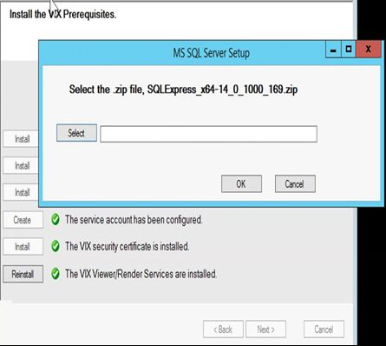

Figure 79: SQL Server Setup

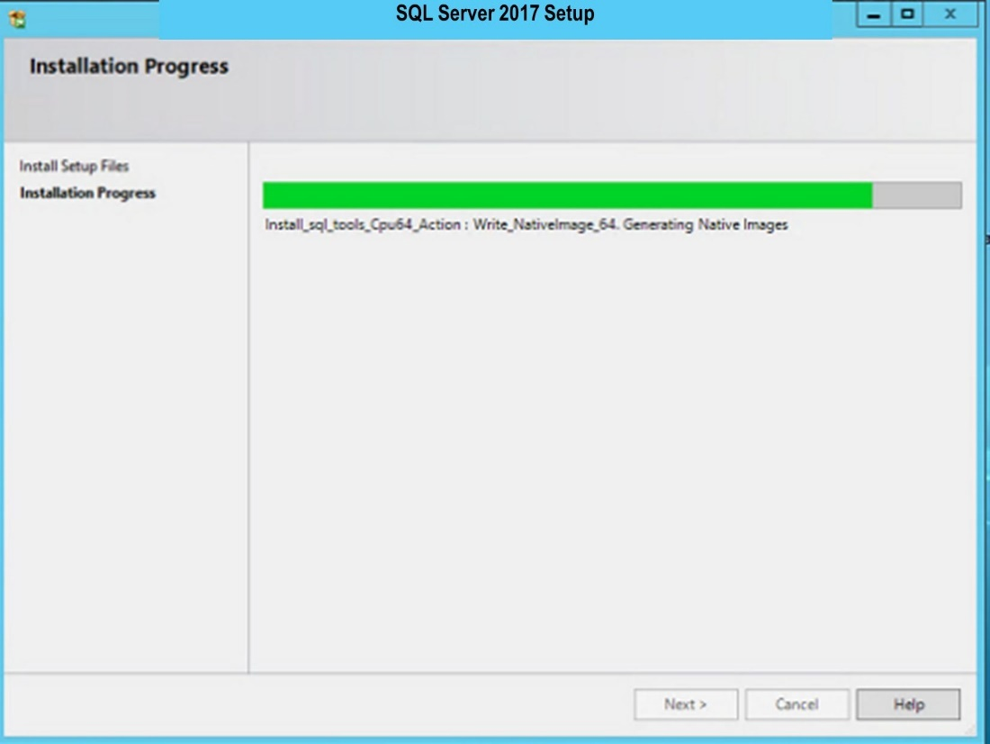

1. Once SQL Server is installed, in the Install the VIX Prerequisites page, confirm that all the icons are Checkmark icon. Then, click Next. Then proceed with the remaining installation steps described in detail in the *MAG*3.0*269 VIX Installation Guide* as if it is an upgrade MAG*3.0*269 install.
2. Upon completion of the installation, if necessary, configuration files in C:\VIXBackup\P269\YYYYMMDDHHMMSS\VixConfig can be copied to C:\VixConfig as needed (e.g. MuseDataSource-1.0.Config) to restore the prior version. Where YYYYMMDDHHMMSS is the latest version of the folder that contains the backups (most current date).

**NOTE**: Encryption support for many configuration files was added in MAG*3.0*303. If any potential issues arise with configuration files, it is suggested to copy the files IdConversionConfiguration.config, FederationDataSource-1.0.config, ExchangeDataSource-1.0.config, MuseDataSource-1.0.config in C:\VIXBackup\P269\YYYYMMDDHHMMSS\VixConfig to C:\VixConfig and replace over the existing IdConversionConfiguration.config, FederationDataSource-1.0.config, ExchangeDataSource-1.0.config, MuseDataSource-1.0.config files. Where YYYYMMDDHHMMSS is the latest version of the folder that contains the backups (most current date).

If configuration files are to be restored, first stop each VIX service: ListenerTool, Tomcat9, VIX Render Service, and VIX Viewer Service by opening Windows Services and then selecting **Stop** for each service.

1. Apply the McAfee Exclusions after MAG*3.0*269 install as discussed in the *MAG*3.0*269 VIX Installation Guide*.
2. Reboot your server.

### Rollback Verification Procedure

1. Verify the version of Java after reinstalling MAG*3.0*269 by running Windows ‘Programs and Feature’, is Java 8.0.291
2. Verify the version of Tomcat after reinstalling MAG*3.0*269 by running Windows ‘Programs and Features’, is Tomcat 9.0.40
3. Verify the version of the VIX by going to the VIX homepage **http://*FQDN of VIX server*:REDACTED/** using a browser e.g.: Chrome or Edge.
4. Verify the SQL Server services are running. For Server 2012 R2 or 2016 (Server Manager | Tools | Component Services | Services (Local), or Task Manager | Services | Open Services), sort the Name column, and verify SQL Server (SQLEXPRESS) is running (Figure 80).

**NOTE**: If the SQL Server (SQLEXPRESS) service in the Windows Services is not running or disabled, please enable the SQL Server (SQLEXPRESS) service and start it.

Figure 80: Verify SQL Server Service

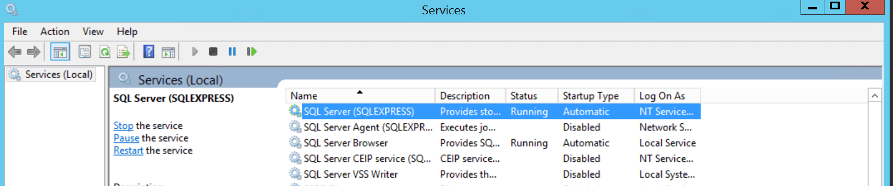

# Appendix A: Enable MUSE Functionality

**New with MAG*3.0*303**: The MUSE configuration is specified during VIX Installation in the Specify the MUSE Configuration page. On this page, set or update if needed, the value for the MUSE site number of the MUSE server that contains EKGs for your facility, the value of the MUSE host, the value of the MUSE username, and the password for the MUSE obtained from existing site VistA Imaging documentation (if not available, please contact the local BioMed team or MUSE administrator for the password).

Enabling the MUSE functionality is only needed to be performed if this is a new installation, or in the case of an upgrade installation, it is determined it is not enabled by following *Has the MUSE functionality already been configured to be enabled?*

**Has the MUSE functionality already been configured to be enabled?**

* To determine if MUSE functionality is already configured, observe the behavior when the MUSE Configuration page loads during VIX Installation.
* **No, it is not enabled**. A checkbox does **not** appear next to Enable and configure MUSE. Continue with this Appendix to perform the steps to enable MUSE functionality.
* **Yes, it is enabled.** A checkbox appears next to Enable and configure MUSE and values for a real MUSE site number, host, username, and password are pre-populated and present for each entry on the page (Figure 81). The MUSE functionality is already enabled. There is no reason to perform the steps in this Appendix unless reconfiguring.

Figure 81:Specify the MUSE configuration Enable and configure MUSE pre-populated

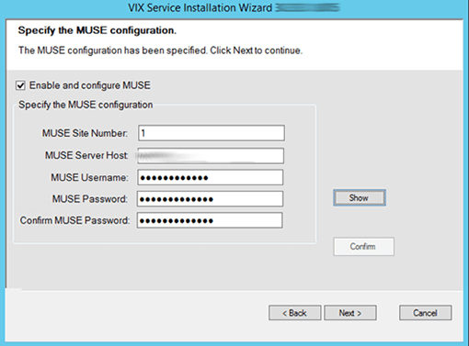

* Alternatively, a manual check of the MuseDataSource-1.0.Config file may be used to determine if MUSE functionality is already configured. Open the MuseDataSource-1.0.Config file located in C:\VixConfig. Run Notepad, Notepad++, or WordPad as an administrator and then open the file.
* **No, it is not enabled**. If the MuseDataSource-1.0.Config file located in C:\VixConfig is like the template displayed in Figure 82, continue with this Appendix to perform the steps to enable MUSE functionality.
* **Yes, it is enabled.** If the MuseDataSource-1.0.Config file located in C:\VixConfig is not like the template displayed in Figure 82 (i.e. a real MUSE site number, host, username, and password are present), the MUSE functionality is already enabled. There is no reason to perform the steps in this Appendix unless reconfiguring.

**NOTE**: Due to encryption changes in MuseDataSource-1.0.Config with MAG*3.0*303, a manual check of the MuseDataSource-1.0.Config may not always be reliable and it is preferred to now use the MUSE Configuration page during VIX Installation to determine if MUSE functionality is already configured.

Figure 82: Sample MuseDataSource-1.0.Config File for One Server (MUSE ENABLED FOR JLV VIX Image Viewer)

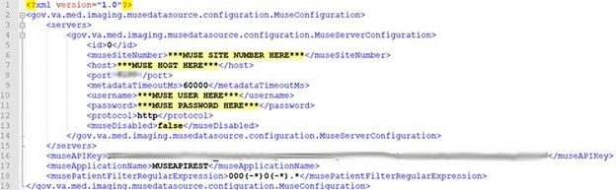

One of the methods identified to obtain the values of the MUSE site number, host, and username is from the Background Processor (BP) Queue Processor. For more information on the Background Processor, please see the [*VistA Imaging System Background Processor User Manual*](https://www.va.gov/VDL/application.asp?appid=105). If the site is running the BP Queue processor, use the below steps to obtain the values of the MUSE site number, host, and username.

1. From the Background Processor Queue Processor (Figure 83) menu bar, select **Edit** > **Network Location Manager** to open the Network Location Manager window.

Figure 83: Background Processor Queue Processor

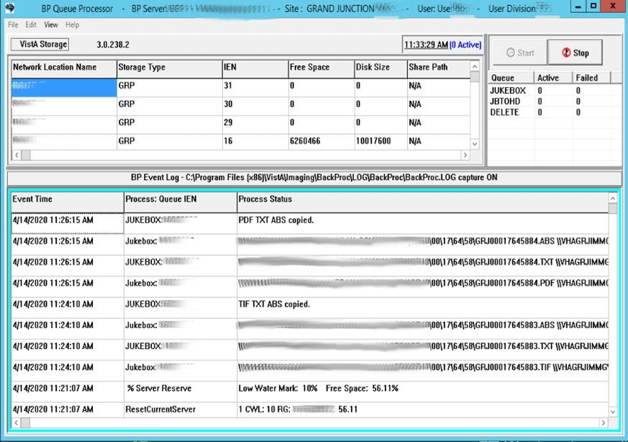

1. Click on the EKG tab in the Network Location Manager window. A listing of the network location of available MUSE servers appears (Figure 84).

**NOTE**: Pay attention to the Operational Status of available MUSE servers. Only add the MUSE server that is **On-Line and contains EKGs of the local site.**

Figure 84: EKG Tab in Network Location Manager in Background Processor Queue Processor

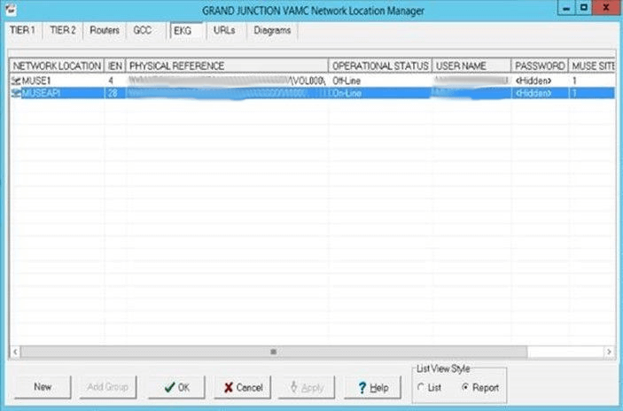

1. To obtain details for a MUSE server, right-click on the server and run **Properties** to launch Network Location Properties. The network share and username for that MUSE server displays (Figure 85).
2. Use the details from the Network Location Properties for the MUSE server that is On-Line to obtain the MUSE site number, host, and username. The MUSE site number is listed under “Site Number” under “MUSE”. The Fully Qualified Domain Name of the Server for the host entry is listed under “Network Share” between \\ and \ (Figure 85). The MUSE site username for the username entry displays under “User Name” under “Network Credentials Security”.

Figure 85: Network Location Properties in Background Processor Queue Processor

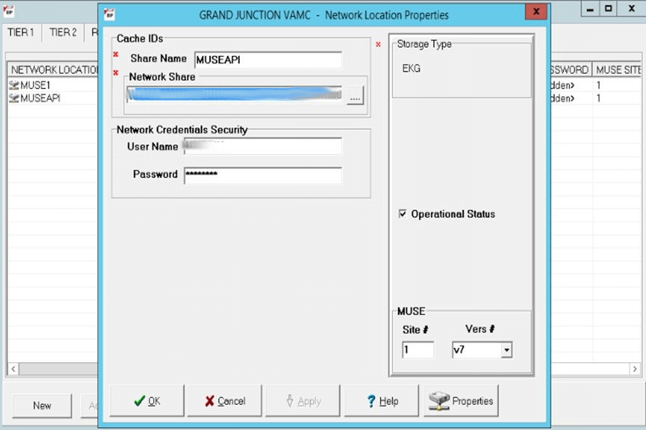

Note the entries for the MUSE site number, host, and username for the MUSE server that is On-Line. This is obtained from the Network Location Manager Properties tab in the Background Processor Queue Processor. The MUSE site password can be obtained from the existing site VistA Imaging documentation (if not available, obtain your MUSE site password from the local BioMed team or MUSE administrator).

# Appendix B: DICOM SCP Configuration

**NOTE: Perform this step as part of the *Post-Installation for New VIX Installations and Updating Existing VIX Installations.***

The DICOM SCP enables Commercial Picture Archive and Communication System (PACS) and various query retrieve devices at VA facilities to get remote VistA images through the use of DICOM C-FIND and C-MOVE.

Henceforth, this Appendix refers to the Commercial PACS and query retrieve devices as a DICOM SCP client.

You need to configure the DICOM SCP if this is a new installation, or in the case of an upgrade installation, you determine it is not yet configured by following *Has the DICOM SCP functionality already been configured?*

**Has the DICOM SCP functionality already been configured?**

* To determine if DICOM SCP functionality is already configured, open the ae_title_mappings file located in the folder cfg\dicom within the Laurel Bridge installation directory (C:\DCF_RunTime_x64\cfg\dicom by default). Run, Notepad, Notepad++ or WordPad as an administrator and then open the file.
* **No, it is not configured**. If the ae_title_mappings file located in the folder cfg\dicom within the Laurel Bridge installation directory (C:\DCF_RunTime_x64\cfg\dicom by default) is like the template displayed in Figure 86, continue with this Appendix to perform the steps to configure DICOM SCP functionality.
* **Yes, it is configured.** If the ae_title_mappings file located in in the folder cfg\dicom within the Laurel Bridge installation directory (C:\DCF_RunTime_x64\cfg\dicom by default) is not like the template displayed in Figure 86 (i.e. a real DICOM SCP host IP, port, and AE Title are present), the DICOM SCP functionality is already configured. There is no reason to perform the steps in this Appendix unless reconfiguring.

Additional details on the DICOM SCP Configuration are provided in the “*Configure DICOM SCP Functionality*” section in the [*VIX Administrator’s Guide*](https://www.va.gov/vdl/application.asp?appid=105).

## AE Titles Configuration

This section describes both the calling and called Application Entities (AE) Titles that must both be configured for DICOM SCP to work. It is necessary to configure both the AE Titles on the VIX server with those of the DICOM SCP client and also to configure the AE Titles on the DICOM SCP client with those of the VIX server.

**NOTE**: The port for the host for DICOM SCP must be configured as a bi-directional open port in any firewall.

### Laurel Bridge AE Titles Configuration on VIX/CVIX

This section describes how to configure the AE Titles configuration file ae_title_mappings located in the folders cfg\dicom within the Laurel Bridge installation directory (C:\DCF_RunTime_x64\cfg\dicom by default). Open the ae_title_mappings file to perform edits. Run, Notepad, Notepad++, or WordPad as an administrator and then open the file.

For each DICOM SCP client, the AE Title name and its host/port attributes must be set. For each DICOM SCP client, update the following entries for the AE Titles configuration file (see Figure 86):

1. Set the IP address for the host for the DICOM SCP client, (after host = line 11).
2. Set the port for the DICOM SCP client where the DICOM SCP is used for the C-STORE operation, (after port = line 12).
3. Set the AE Title the DICOM SCP client is using to communicate with the DICOM SCP (calling AE) (inside [ ] on line 10 and after ae_title = line 13).

Ensure that each of these lines is uncommented (i.e. remove the # at the front of the line if present). Save the ae_title_mappings file after updating the entries.

Figure 86: Sample AE Titles Configuration File

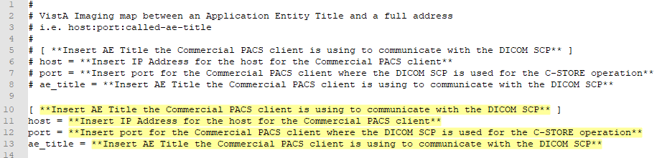

An example of the ae_title_mappings file updated for one DICOM SCP client is shown in Figure 87.

**NOTE**: The example in Figure 87 for configuration of one DICOM SCP client is not how an actual VIX site’s ae_title_mappings file is to be configured. This example is for illustrative purposes only.

Figure 87: Example AE Titles Configuration File

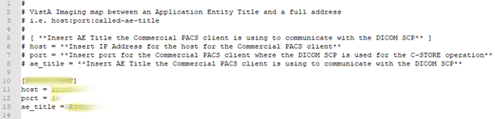

For each additional DICOM SCP client, similarly add lines for the host, port, and ae_title with the correct values as new lines below the prior lines for the prior DICOM SCP client (Figure 88). Save the ae_title_mappings file after updating the entries.

Figure 88: Sample AE Titles configuration File with Multiple DICOM SCP Clients

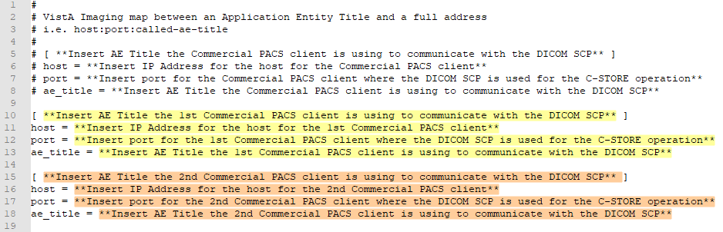

After updating the ae_title_mappings file, as described above, execute the restart script (Restart_VIX_Services.ps1) to restart the Apache Tomcat service, VIX Viewer and VIX Render services, and Listener Tool, see

### AE Titles Configuration on DICOM SCU

This section describes the AE Titles configuration on the DICOM SCU. Installation/administration personnel on the VIX server might not be able to perform this configuration and, in which case, must provide the necessary information to the DICOM SCU administration personnel to perform.

The following three pieces of information are needed for the configuration of the DICOM SCU: 1) the IP address for the host for the VIX server, 2) the port of DICOM SCP on the VIX server, and 3) the AE Title of DICOM SCP (called AE).

Many different DICOM SCU vendors exist and each of these systems has their own distinct approach for configuration. If additional information regarding specifics of configuring the DICOM SCU is needed, please reach out to its vendor or consult its documentation.

## Tomcat/ Laurel Bridge DICOM SCP Configuration

The VIX install performs some of the configuration for the DICOM SCP automatically with reasonable defaults and predefined entries. Update two entries in the ScpConfiguration.Config file located in C:\VixConfig to configure the DICOM SCP. Run Notepad, Notepad++, or WordPad as an administrator and then open the file.

Update the following entries for the DICOM SCP functionality (see Figure 89):

1. Set the DICOM SCU calling AE title, inside opening and closing aeTitle tags (inside <aeTitle> </aeTitle> - line 18). Change the value from the default setting of ALL.
2. Set the DICOM SCU IP address inside the opening and closing callingAeIp tags (inside < callingAeIp> </callingAeIp> - line 19). Change the value from the default setting of 0.0.0.0.

Figure 89: Sample DICOM SCP Configuration File

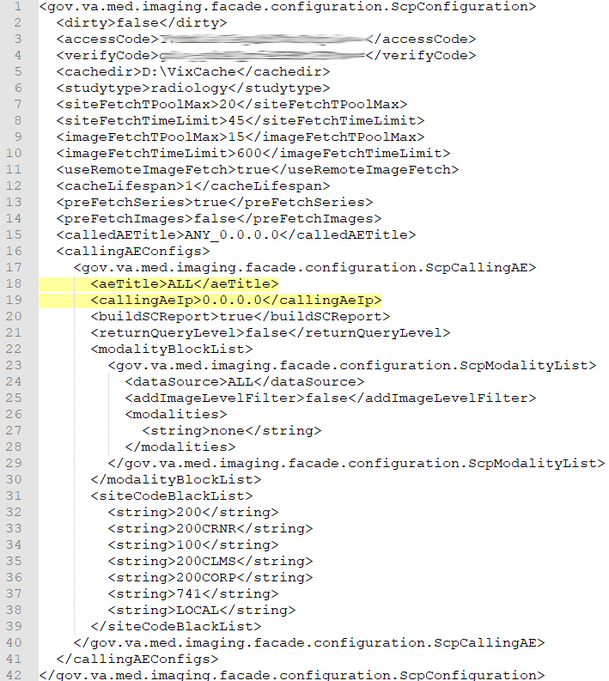

An example of the ScpConfiguration.Config file updated for one DICOM SCP client is shown in Figure 90.

**NOTE**: The example in Figure 90 for configuration of the aeTitle and callingAeIp is not how an actual VIX site’s ScpConfiguration.Config file is to be configured. This example is for illustrative purposes only.

Figure 90: Example ScpConfiguration Configuration File

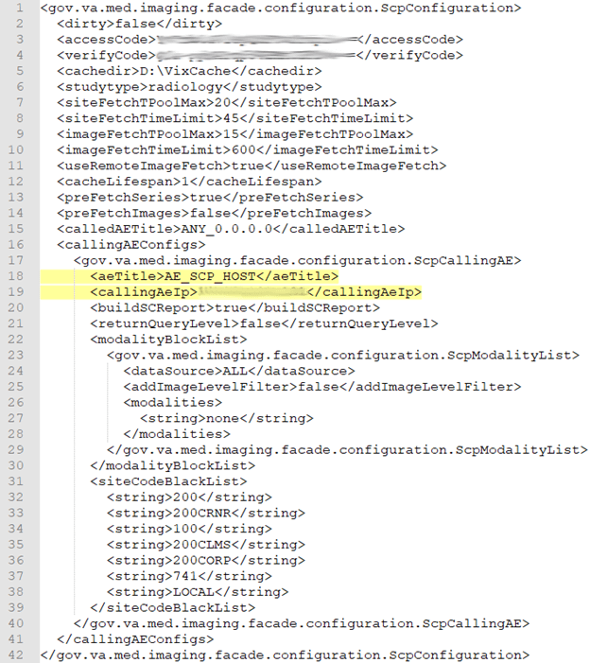

If additional changes to the defaults for the Tomcat DICOM SCP Configuration and/or Laurel Bridge DICOM SCP Configuration are desired, see the [*VIX Administrator’s Guide*](https://www.va.gov/vdl/application.asp?appid=105) for details.

**NOTE**: For each additional DICOM SCP client, insert an additional block of code containing the elements from lines 17 to 40 before current line 41 (Figure 90), as described in the [*VIX Administrator’s Guide*](https://www.va.gov/vdl/application.asp?appid=105)*.*

**NOTE**: If additional updates are needed to the encrypted access and verify codes in the ScpConfiguration.Config file, refer to lines 3 and 4 in Figure 90, for the account with VistA credentials see the section “Modifying the ROI Processing and DICOM Query/Retrieve Parameters of the VIX” in the [*VIX Administrator’s Guide*](https://www.va.gov/vdl/application.asp?appid=105) to update (preferred) or see the section “*Reconfiguring a VIX Server*,” in this VIX Installation Guide to perform a reconfigure installation.

# Appendix C: Restart Script

This appendix describes how to execute the restart script (Restart_VIX_Services.ps1) to restart the Apache Tomcat service, VIX Viewer and VIX Render services, and Listener Tool.

Perform the following:

1. Run PowerShell as an administrator (Figure 91).
   1. Right-click **Start**.
   2. Left-click **Search**.
   3. Type **powershell**.
   4. Right-click **Windows PowerShell**.
   5. Left-click Run as administrator.

Figure 91: Execute Windows PowerShell

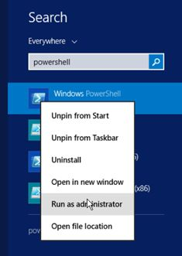

1. If prompted with “Do you want to allow the following program from an unknown publisher to make changes to this computer?”, click **Yes**.
2. Once PowerShell launches, **type** the command:

cd "C:\Program Files\VistA\Imaging\Scripts"

Then press **[ENTER]** to change the working directory to the Scripts folder.

1. Then **type** the command:

.\Restart_VIX_Services.ps1

And press **[ENTER]** to execute the restart script. Wait for the script to complete (Figure 92).

Figure 92: Windows PowerShell Restart Script

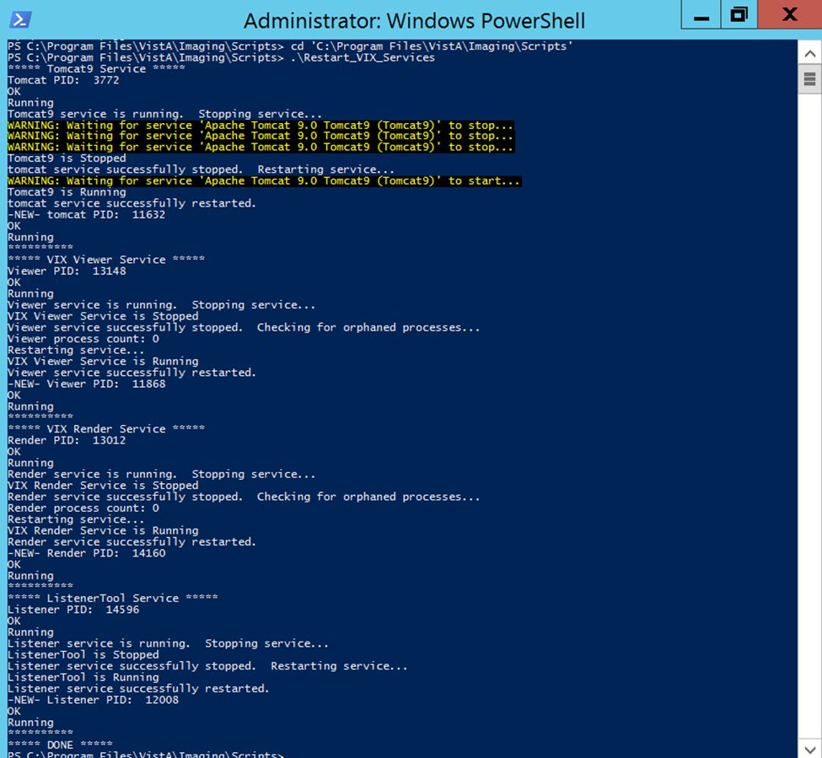

1. Close PowerShell.

# Appendix D: SQL Server Removal

After successfully installing MAG*3.0*303 and verifying operation, SQL Server can be removed if this is an upgrade installation and SQL Server was not removed during the uninstall portion of the install of MAG*3.0*303.

Two methods are provided to remove SQL Server outside of MAG*3.0*303 installation: using a PowerShell script (preferred) or manual.

## Script SQL Server Removal

1. If not already present, acquire SQLEXPRESS_X64-14_0_1000_169.ZIP (SQL 2017) and copy to C:\temp. (Download if required. See the patch description of the patch for the download location.)
2. Run PowerShell as an administrator (Figure 93).
   1. Right-click **Start**.
   2. Left-click **Search**.
   3. Type **powershell**.
   4. Right-click **Windows PowerShell**.
   5. Left-click Run as administrator.

Figure 93: Execute Windows PowerShell



1. If prompted with “Do you want to allow the following program from an unknown publisher to make changes to this computer?”, click **Yes**.
2. Once PowerShell launches, **type** the command:

cd "C:\Program Files\VistA\Imaging\Scripts"

Then press **[ENTER]** to change the working directory to the Scripts folder.

1. Then **type** the command:

.\uninstall_install_sql_server.ps1

And press **[ENTER]** to execute the script.

1. When prompted with “Please enter the full path of the SQLEXPRESS_X64-14_0_1000_169.ZIP file” enter C:\temp and press **[ENTER]**.
2. When prompted with “Please choose Deployment Option (1 to Uninstall, 2 to Install, or Q to Quit)” enter 1 and press **[ENTER]**.
3. When prompted with “Confirm you want to uninstall SQL Server Express (Y/N?)” enter Y and press **[ENTER]**.
4. A Remove SQL Server 2017 window appears. On the Select Instance page click **Next** (Figure 94).

Figure 94: Remove SQL Server Select Instance



1. On the Select Features page click **Select All**, then click **Next** (Figure 95). Wait for the uninstall of SQL Server to complete. This can take about seven to ten minutes.

Figure 95: Remove SQL Server Select Features



1. On the Complete page click **Close** (Figure 96).

Figure 96: Remove SQL Server 2017 Complete



1. Close PowerShell.
2. Restart the server after uninstalling SQL Server*.*

## Manual SQL Server Removal

1. Stop the Apache Tomcat Service if it is installed and running.
2. Uninstall MS-SQL programs for 2017 (**Control Panel – Programs – Programs and Features – Uninstall**) (Figure 97).
3. Remove/Delete the folder C:\Program Files\Microsoft SQL Server (include data files if any exist).
4. Restart the server after uninstalling SQL Server*.*

Figure 97: Microsoft SQL Removal

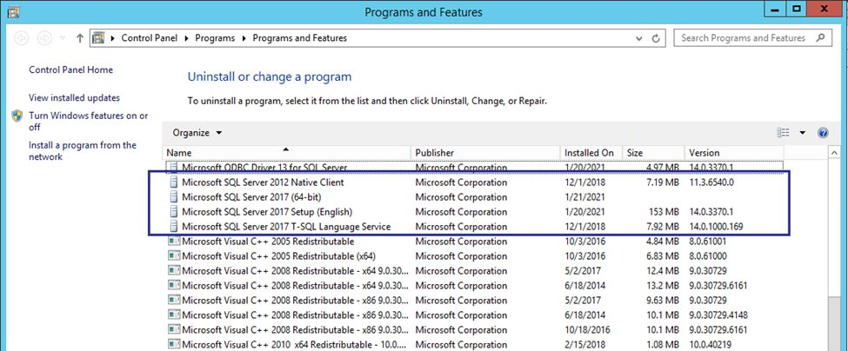

# Appendix E: Tomcat Permissions

Due to the VA group policy restriction or rules, there may be an issue found while the VIX installer wizard is setting file system access rules - i.e.: ...error denying access to apachetomcat account to c:\...

To resolve this, after the VIX Installation, run the tomcat permissions script (permission_fixer.ps1).

Perform the following:

1. Run PowerShell as an administrator (Figure 98).
   1. Right-click **Start**.
   2. Left-click **Search**.
   3. Type **powershell**.
   4. Right-click **Windows PowerShell**.
   5. Left-click Run as administrator.

Figure 98: Execute Windows PowerShell



1. If prompted with “Do you want to allow the following program from an unknown publisher to make changes to this computer?”, click **Yes**.
2. Once PowerShell launches, **type** the command:

cd "C:\Program Files\VistA\Imaging\Scripts"

Then press **[ENTER]** to change the working directory to the Scripts folder.

1. Then **type** the command:

.\permission_fixer.ps1

And press **[ENTER]** to execute the permission fixer script. Wait for the script to complete.

1. Close PowerShell.
2. Follow the steps in *Appendix C: Restart Script* to execute the restart script.

**NOTE**: The permission fixer script updates the Apache Tomcat account [apachetomcat] permissions on the following folders

* C:\Program Files\Apache Software Foundation\Tomcat 9.0\
* C:\Program Files\java\Jre...
* C:\DCF_Run Time_x64
* C:\Vixconfig
* C:\VixCertStore
* YOUR_DRIVE_LETTER:\VixCache

**NOTE**: The permission fixer script does not update apachetomcat permissions on YOUR_DRIVE_LETTER:\VixRenderCache as this is no longer needed.

# Appendix F: Service Account Settings

The VIX uses a service account on the local VistA for periodic processing of ROI disclosure requests and DICOM query retrieve SCP requests. The service account may be the same one used by the DICOM Gateway and the Hybrid DICOM Gateway (HDIG). You may also use it to log into the VIX Tools page described in the *Verifying Access to the VIX Tools and VIX Transaction Log* section.

Table 2 lists each VIX site’s current and suggested local VistA service account. The Designated User (DUZ) identifies the service account. The suggested service account enables each site to have a unique name.

The VIX’s service account on its local VistA must have the following SSN format, security keys, secondary menus, a value for the INITIAL field, RAD/NUC med classification, CPRS TAB, and authorized to write med orders. If any setting is missing, update the service account.

**NOTE**: If unable to update the service account on the local VistA yourself, please create a ticket assigned to the ESD Tier 1 group to update the service account on the local VistA. Example text for the ticket appears after the table.

Verify the SNN of the service account on the local VistA is as specified in Table 2. All SSNs begin with 9 to avoid possible collisions with a real SSN issued by the Social Security Administration.

Verify the service account on the local VistA has the following security keys:

* MAG SYSTEM
* MAG VIX ADMIN
* MAG DOD FIX
* RA MGR
* RA VERIFY
* RA ALLOC

Verify the service account on the local VistA has the following secondary menus:

* MAG WINDOWS (All MAG* RPC's)
* MAG DICOM VISA (DICOM VISA)
* OR CPRS GUI CHART (CPRSChart version x.xx.xxx.x)
* MAG DICOM GATEWAY FULL
* MAG DICOM QUERY RETRIEVE

Verify the service account on the local VistA has a value for the INITIAL field.

Verify the service account on the local VistA has the following RAD/NUC med classification:

* 1      staff
* 4      technologist

Verify the service account on the local VistA has the following CPRS TAB:

* CPRS TAB: COR
* EFFECTIVE DATE: <TODAY

Verify the service account on the local VistA has the following authorized to write med orders:

* YES

**NOTE**: To verify the service account on the local VistA has a value for the INITIAL field perform the following:

1. Access VA FileMan [DIUSER] in your VistA instance.
2. Select Inquire to File Entries [DIINQUIRE], then choose the NEW PERSON file (#200).
3. When prompted "Select NEW PERSON NAME", select your VistA Imaging service account.
4. Either answer Yes to Standard Captioned Output (followed by No in "Include COMPUTED fields"), or answer No, and then choose the INITIAL field (#1).
5. The latter just shows the INITIAL field, the former shows all fields. Either way, verify that the results include a value for the account's initials.

If the service account on the local VistA does not have a value for the INITIAL field set one:

1. Access VA FileMan [DIUSER] in your VistA instance.
2. Select Enter or Edit File Entries [DIEDIT], then choose the New Person file (#200). When prompted "EDIT WHICH FIELD", choose INITIAL (#1).
3. When prompted "Select NEW PERSON NAME", choose your VistA Imaging service account.
4. Finally, when you see the "INITIAL" prompt, enter the initials for the user. Enter any appropriate value, such as VSA

Table 2: VIX Site’s User Profile SSN, Service Account on Local VistA, and Suggested Service Account on Local VistA

|  |  |  |  |  |
| --- | --- | --- | --- | --- |
| Site Name | Site Number | VIX User Profile SSN | VIX's Service Account on Local VistA | Suggested VIX's Service Account on Local VistA |
| Manila, PI | 358 | REDACTED |  | REDACTED |
| Togus, ME | 402 | REDACTED | REDACTED | REDACTED |
| White River Junction, VT | 405 | REDACTED | REDACTED | REDACTED |
| Montana HCS | 436 | REDACTED | REDACTED | REDACTED |
| Fargo, ND | 437 | REDACTED | REDACTED | REDACTED |
| Sioux Falls, SD | 438 | REDACTED | REDACTED | REDACTED |
| Cheyenne, WY | 442 | REDACTED | REDACTED | REDACTED |
| Honolulu, HI | 459 | REDACTED | REDACTED | REDACTED |
| Wilmington, DE | 460 | REDACTED | REDACTED | REDACTED |
| Anchorage, AK | 463 | REDACTED | REDACTED | REDACTED |
| Albuquerque, NM | 501 | REDACTED | REDACTED | REDACTED |
| Alexandria, LA | 502 | REDACTED | REDACTED | REDACTED |
| Altoona, PA | 503 | REDACTED | REDACTED | REDACTED |
| Amarillo, TX | 504 | REDACTED | REDACTED | REDACTED |
| Ann Arbor, MI | 506 | REDACTED | REDACTED | REDACTED |
| Atlanta, GA | 508 | REDACTED | REDACTED | REDACTED |
| Augusta, GA | 509 | REDACTED | REDACTED | REDACTED |
| Maryland HCS | 512 | REDACTED | REDACTED | REDACTED |
| Battle Creek, MI | 515 | REDACTED | REDACTED | REDACTED |
| Bay Pines, FL | 516 | REDACTED | REDACTED | REDACTED |
| Beckley, WV | 517 | REDACTED | REDACTED | REDACTED |
| Bedford, MA | 518 | REDACTED | REDACTED | REDACTED |
| Big Spring, TX | 519 | REDACTED | REDACTED | REDACTED |
| Biloxi, MS | 520 | REDACTED | REDACTED | REDACTED |
| Birmingham, AL | 521 | REDACTED | REDACTED | REDACTED |
| Boston HCS | 523 | REDACTED | REDACTED | REDACTED |
| Bronx, NY | 526 | REDACTED | REDACTED | REDACTED |
| Upstate NY HCS | 528 | REDACTED | REDACTED | REDACTED |
| Butler, PA | 529 | REDACTED | REDACTED | REDACTED |
| Boise, ID | 531 | REDACTED | REDACTED | REDACTED |
| Charleston, SC | 534 | REDACTED | REDACTED | REDACTED |
| Chicago, IL (Westside) | 537 | REDACTED | REDACTED | REDACTED |
| Chillicothe, OH | 538 | REDACTED | REDACTED | REDACTED |
| Cincinnati, OH | 539 | REDACTED | REDACTED | REDACTED |
| Clarksburg, WV | 540 | REDACTED | REDACTED | REDACTED |
| Cleveland, OH | 541 | REDACTED | REDACTED | REDACTED |
| Coatesville, PA | 542 | REDACTED | REDACTED | REDACTED |
| Columbia, SC | 544 | REDACTED | REDACTED | REDACTED |
| Miami, FL | 546 | REDACTED | REDACTED | REDACTED |
| West Palm Beach, FL | 548 | REDACTED | REDACTED | REDACTED |
| North Texas HCS | 549 | REDACTED | REDACTED | REDACTED |
| Danville, IL | 550 | REDACTED | REDACTED | REDACTED |
| Dayton, OH | 552 | REDACTED | REDACTED | REDACTED |
| Detroit, MI | 553 | REDACTED | REDACTED | REDACTED |
| Eastern Colorado HCS | 554 | REDACTED | REDACTED | REDACTED |
| North Chicago, IL | 556 | REDACTED | REDACTED | REDACTED |
| Dublin, GA | 557 | REDACTED | REDACTED | REDACTED |
| Durham, NC | 558 | REDACTED | REDACTED | REDACTED |
| New Jersey HCS | 561 | REDACTED | REDACTED | REDACTED |
| Erie, PA | 562 | REDACTED | REDACTED | REDACTED |
| Fayetteville, AR | 564 | REDACTED | REDACTED | REDACTED |
| Fayetteville, NC | 565 | REDACTED | REDACTED | REDACTED |
| Black Hills HCS | 568 | REDACTED | REDACTED | REDACTED |
| Fresno, CA | 570 | REDACTED | REDACTED | REDACTED |
| N. Florida/S. Georgia HCS | 573 | REDACTED | REDACTED | REDACTED |
| Grand Junction, CO | 575 | REDACTED | REDACTED | REDACTED |
| Hines, IL | 578 | REDACTED | REDACTED | REDACTED |
| Houston, TX | 580 | REDACTED | REDACTED | REDACTED |
| Huntington, WV | 581 | REDACTED | REDACTED | REDACTED |
| Indianapolis, IN | 583 | REDACTED | REDACTED | REDACTED |
| Iron Mountain, MI | 585 | REDACTED | REDACTED | REDACTED |
| Jackson, MS | 586 | REDACTED | REDACTED | REDACTED |
| Kansas City, MO | 589 | REDACTED | REDACTED | REDACTED |
| Hampton, VA | 590 | REDACTED | REDACTED | REDACTED |
| Las Vegas, NV | 593 | REDACTED | REDACTED | REDACTED |
| Lebanon, PA | 595 | REDACTED | REDACTED | REDACTED |
| Lexington, KY | 596 | REDACTED | REDACTED | REDACTED |
| Little Rock, AR | 598 | REDACTED | REDACTED | REDACTED |
| Long Beach, CA | 600 | REDACTED | REDACTED | REDACTED |
| Louisville, KY | 603 | REDACTED | REDACTED | REDACTED |
| Loma Linda, CA | 605 | REDACTED | REDACTED | REDACTED |
| Madison, WI | 607 | REDACTED | REDACTED | REDACTED |
| Manchester, NH | 608 | REDACTED | REDACTED | REDACTED |
| Northern Indiana HCS | 610 | REDACTED | REDACTED | REDACTED |
| Northern California HCS | 612 | REDACTED | REDACTED | REDACTED |
| Martinsburg, WV | 613 | REDACTED | REDACTED | REDACTED |
| Memphis, TN | 614 | REDACTED | REDACTED | REDACTED |
| Minneapolis, MN | 618 | REDACTED | REDACTED | REDACTED |
| Central Alabama HCS | 619 | REDACTED | REDACTED | REDACTED |
| Hudson Valley HCS | 620 | REDACTED | REDACTED | REDACTED |
| Mountain Home, TN | 621 | REDACTED | REDACTED | REDACTED |
| Muskogee, OK | 623 | REDACTED | REDACTED | REDACTED |
| Tennessee Valley HCS | 626 | REDACTED | REDACTED | REDACTED |
| New Orleans, LA | 629 | REDACTED | REDACTED | REDACTED |
| NY HCS | 630 | REDACTED | REDACTED | REDACTED |
| Northampton, MA | 631 | REDACTED | REDACTED | REDACTED |
| Northport, NY | 632 | REDACTED | REDACTED | REDACTED |
| Oklahoma City, OK | 635 | REDACTED | REDACTED | REDACTED |
| Central Plains HCS | 636 | REDACTED | REDACTED | REDACTED |
| Asheville, NC | 637 | REDACTED | REDACTED | REDACTED |
| Palo Alto HCS | 640 | REDACTED |  | REDACTED |
| Philadelphia, PA | 642 | REDACTED | REDACTED | REDACTED |
| Phoenix, AZ | 644 | REDACTED | REDACTED | REDACTED |
| Pittsburgh HCS | 646 | REDACTED | REDACTED | REDACTED |
| Portland, OR | 648 | REDACTED | REDACTED | REDACTED |
| Prescott, AZ | 649 | REDACTED | REDACTED | REDACTED |
| Providence, RI | 650 | REDACTED | REDACTED | REDACTED |
| Richmond, VA | 652 | REDACTED | REDACTED | REDACTED |
| Roseburg, OR | 653 | REDACTED | REDACTED | REDACTED |
| Reno, NV | 654 | REDACTED | REDACTED | REDACTED |
| Saginaw, MI | 655 | REDACTED | REDACTED | REDACTED |
| St. Cloud, MN | 656 | REDACTED | REDACTED | REDACTED |
| St. Louis, MO | 657 | REDACTED | REDACTED | REDACTED |
| Salem, VA | 658 | REDACTED | REDACTED | REDACTED |
| Salisbury, NC | 659 | REDACTED |  | REDACTED |
| Salt Lake City, UT | 660 | REDACTED | REDACTED | REDACTED |
| San Francisco, CA | 662 | REDACTED |  | REDACTED |
| Puget Sound HCS | 663 | REDACTED | REDACTED | REDACTED |
| San Diego, CA | 664 | REDACTED | REDACTED | REDACTED |
| Sheridan, WY | 666 | REDACTED | REDACTED | REDACTED |
| Shreveport, LA | 667 | REDACTED | REDACTED | REDACTED |
| Spokane, WA | 668 | REDACTED | REDACTED | REDACTED |
| South Texas HCS | 671 | REDACTED | REDACTED | REDACTED |
| San Juan, PR | 672 | REDACTED | REDACTED | REDACTED |
| Tampa, FL | 673 | REDACTED | REDACTED | REDACTED |
| Central Texas HCS | 674 | REDACTED | REDACTED | REDACTED |
| Orlando, FL | 675 | REDACTED | REDACTED | REDACTED |
| Tomah, WI | 676 | REDACTED | REDACTED | REDACTED |
| Tucson, AZ | 678 | REDACTED | REDACTED | REDACTED |
| Tuscaloosa, AL | 679 | REDACTED | REDACTED | REDACTED |
| Walla Walla, WA | 687 | REDACTED | REDACTED | REDACTED |
| Washington, DC | 688 | REDACTED | REDACTED | REDACTED |
| Connecticut HCS | 689 | REDACTED | REDACTED | REDACTED |
| West Los Angeles, CA | 691 | REDACTED | REDACTED | REDACTED |
| White City OR | 692 | REDACTED | REDACTED | REDACTED |
| Wilkes Barre, PA | 693 | REDACTED | REDACTED | REDACTED |
| Milwaukee, WI | 695 | REDACTED |  | REDACTED |
| Valley Coastal Bend HCS | 740 | REDACTED | REDACTED | REDACTED |
| El Paso, TX | 756 | REDACTED | REDACTED | REDACTED |
| Columbus, OH | 757 | REDACTED | REDACTED | REDACTED |
| Billings, MT CBOC | 436GH | REDACTED | REDACTED | REDACTED |
| Pensacola, FL | 520BZ | REDACTED | REDACTED | REDACTED |
| Canandaigua, NY | 528A5 | REDACTED | REDACTED | REDACTED |
| Bath, NY | 528A6 | REDACTED | REDACTED | REDACTED |
| Syracuse, NY | 528A7 | REDACTED | REDACTED | REDACTED |
| Albany, NY | 528A8 | REDACTED | REDACTED | REDACTED |
| Lake City VA Medical Center | 573A4 | REDACTED | REDACTED | REDACTED |
| Columbia, MO | 589A4 | REDACTED | REDACTED | REDACTED |
| Topeka, KS | 589A5 | REDACTED | REDACTED | REDACTED |
| Leavenworth, KS | 589A6 | REDACTED | REDACTED | REDACTED |
| Wichita, KS | 589A7 | REDACTED | REDACTED | REDACTED |
| Lexington, KY -CDD | 596A4 | REDACTED | REDACTED | REDACTED |
| Grand Island, NE | 636A4 | REDACTED | REDACTED | REDACTED |
| Lincoln, NE | 636A5 | REDACTED | REDACTED | REDACTED |
| Central Iowa HCS | 636A6 | REDACTED | REDACTED | REDACTED |
| Iowa City, IA | 636A8 | REDACTED | REDACTED | REDACTED |
| Poplar Bluff, MO | 657A4 | REDACTED | REDACTED | REDACTED |
| Marion, IL | 657A5 | REDACTED | REDACTED | REDACTED |

**NOTE**: For several sites, the VIX service accounts in Table 2 are missing because they expired at the time of this publication.

**NOTE:** Sites can find the DUZ corresponding to their VIX service account on the local VistA by following the steps below:

1. In FileMan, choose the option to Inquire to File Entries, choose the New Person file (#200), and then enter the name of your VIX’s service account on its local VistA.
2. Accept the defaults for Standard Captioned Output, when asked "Include COMPUTED fields", answer either B or R, as you need to view the record number.
3. If multiple results are returned based on the name you entered, you will need to view each of them to determine which is your local service account and which are visitor accounts. Select one of the accounts.
4. In the data listed for each account, check for the presence of the DATE VERIFY CODE LAST CHANGED field (refer to the red highlighted field in Figure 97). If the DATE VERIFY CODE LAST CHANGED field is not present return to step 2 and select a different account upon reaching step 4, otherwise continue to the next step.

Figure 99: FileMan File Entry 200

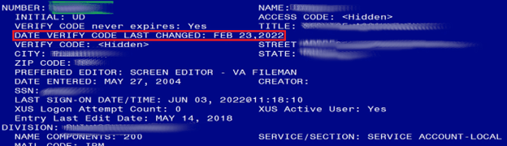

1. If the field is present, it is the local service account. If it is not, it is a visitor account and should not be edited. The number printed in the NUMBER field is the DUZ of the VIX’s service account on the local VistA (refer to the green highlighted field in Figure 99). Record the DUZ of the VIX’s service account on the local VistA. (Consider documenting the DUZ of the service account on the local VistA in your Master Site Profile.)

**NOTE**: Once the DUZ is obtained, follow the steps below to update the corresponding VIX service account:

1. To view a record once you have its DUZ value, access VA FileMan [DIUSER] and select Inquire to File Entries [DIINQUIRE].
2. When prompted "Output from what File", select NEW PERSON (#200).
3. When asked to "Select NEW PERSON NAME", enter a back-tick (`) followed by the DUZ for the account. Select whichever view options you want (the defaults are fine), and then view the account's record to determine the details and make any necessary adjustments.

**NOTE**: If you are unable to perform the above steps, please create a support ticket with VistA Apps for assistance.

Below is an example of the information to provide in a ticket to update the VIX’s service account on the local VistA. The example shows specifying the access code of the VIX’s service account on the local VistA, the name of the VIX’s service account on the local VistA, the suggested name of the VIX’s service account on the local VistA, the SSN of the VIX’s service account on the local VistA, and any missing VistA menus, keys, and other settings to add. Be sure to copy and paste the security keys, secondary menus, INITIAL, and RAD/NUC information shown before Table 2 into the ticket as needed.

Assignment group: ESD Tier 1

Category: Service

Subcategory: Access

Please use the ***SITE_SERVICE_ACCOUNT_ACCESS_CODE_HERE*** to look up the DUZ for the ***SITE_SERVICE_ACCOUNT_NAME_HERE*** service account in ***SITE_VISTA_NAME_HERE*** VistA and then update the service account with the following:

Change service account name to: ***IMAGINGSVC,SITE_ABBREVIATION_HERE***

Add SSN: ***SITE_SERVICE_ACCOUNT_SSN_HERE***

Add keys: MAG DOD FIX, RA ALLOC

Add secondary menus: MAG WINDOWS, MAG DICOM QUERY RETRIEVE

Add INITIAL field: VSA

Add RAD/NUC med classification: RAD/NUC MED CLASSIFICATION

1 staff

4 technologist

Add CPRS TAB: CPRS TAB: COR

EFFECTIVE DATE: <TODAY

Add AUTHORIZED TO WRITE MED ORDERS: YES

**NOTE**: This is a false SSN, which was not generated by, and will not conflict with, a real SSN issued by the Social Security Administration, but meets the requirements for VistA Broker Security Exchange (BSE) authentication between sites. These changes are required for Enterprise DICOM query retrieve with MAG*3.0*269.

# Appendix G: VIX Install Checklist

Table 3 summarizes the VIX installation process.

## VIX Install Checklist

Table 3: VIX Install Checklist

|  | Requirement | Location in VIX Installation Guide | Action |
| --- | --- | --- | --- |
|  | Install patch MAG*3.0*303 KIDS in VistA | See Installation Prerequisites | Perform steps in MAG*3.0*303 Patch Description Document |
|  | Verify VIX server meets minimum hardware specifications | See *Operating System and Hardware Requirements* | Allocate more CPU cores/RAM as needed to meet the minimum or recommended specifications |
|  | Verify Microsoft Visual C++ 2010 Redistributable Package (x64) is installed | See *Environment Requirements* | If required, download and install Microsoft Visual C++ 2010 Redistributable Package (x64) |
|  | Verify .NET 3.5 is installed and enabled | See *Environment Requirements* | Install and enable .NET 3.5 if required |
|  | Verify .NET 4.7.2 or 4.8 is installed and enabled | See *Environment Requirements* | If required, download and install .NET 4.7.2 or 4.8 |
|  | Verify PowerShell 5.1 is installed | See *PowerShell Version Verification* | If required, download and install PowerShell 5.1 |
|  | Verify MUSE configuration information needed for installation, if any | See *Appendix A: Enable* MUSE Functionality | Verify MUSE site number, MUSE server name, MUSE username, and MUSE password |
|  | If an upgrade install, verify you have SQL 2017 Express zip file SQLExpress_x64-14.0.1000.169 | See Installation Instructions | Download from SFTP site, if required, but do not install since the VIX Service Installation Wizard does it |
|  | Initiate the installation of the VIX MAG3_0P303_VIX_SETUP.msi | See Installation Instructions | Perform steps in Installation Instructions |
|  | Verify that McAfee Exclusions are updated | See *McAfee Exclusions* | Perform steps in McAfee Exclusions |
|  | Verify VIX install is complete | See *Verifying Installation/Upgrade is Complete* | Perform steps in Verifying Installation/Upgrade is Complete |
|  | Verify that VIX is running | See *Verifying Installation/Upgrade is Complete* | Verify VIX is running |
|  | Verify that VIX Viewer and VIX Render services running | See *Verifying Installation/Upgrade is Complete* | Verify VIX Viewer and VIX Render services are running |
|  | Verify ListenerTool service is running | See *Verifying Installation/Upgrade is Complete* | Verify ListenerTool service is running |
|  | Request Site Service update to your facility if needed | See *To Register the VIX* | Create a national ticket to the Health, Clinical Services Diagnostics Team (previously known as Clin 3, the group name is SPM.Health.ClinSvs.Diag) to update your site service entry to include the new viewer (Port REDACTED for HTTPS) |
|  | Verify that images, including MUSE EKGs and DoD images, can be viewed via zero-footprint Image Viewer. | See *Spot-Checking VIX Image Delivery*. | Verify JLV utilizing zero-footprint viewer. If unable to view an image including MUSE EKGs and DoD images, enter a support ticket for assistance |

# Acronyms

|  |  |
| --- | --- |
| Term | Definition |
| AE | Application Entities |
| BP | Background Processor |
| CPRS | Computerized Patient Record System |
| DCF | DICOM Connectivity Framework |
| DUZ | Designated User |
| FDA | Food and Drug Administration |
| FQDN | Fully Qualified Domain Number |
| HDIG | Hybrid DICOM Gateway |
| ICW | IMedConsent Web |
| IEN | Internal Entry Number |
| IVS | Integrated Visualization System |
| JLV | Joint Legacy Viewer |
| PACS | Picture Archive and Communication System |
| ROI | Release of Information |
| SCP | Service Class Provider |
| SSN | Social Security Number |
| TIU | Text Integration Utility |
| VIX | VistA Imaging Exchange |