VistA Imaging System

Advanced Web Image Viewer (AWIV) User Guide

March 2013 – Revision 2.0

Department of Veterans Affairs Office of Enterprise Development Health Provider Systems

Advanced Web Image Viewer (AWIV) User Guide
VistA Imaging MAG*3.0*124 March 2013

Property of the US Government
This is a controlled document. No changes to this document may be made without the express written consent of the VistA Imaging Office of Enterprise Development group.
While every effort has been made to assure the accuracy of the information provided, this document may include technical inaccuracies and/or typographical errors. Changes are periodically made to the information herein and incorporated into new editions of this document.
Product names mentioned in this document may be trademarks or registered trademarks of their respective companies, and are hereby acknowledged.
VistA Imaging Office of Enterprise Development Department of Veterans Affairs
Internet: REDACTED
VA intranet: REDACTED

Revision History

Date | Rev | Notes
Mar 2013 | 2.0 | Added Web Application section and DoD abstract info. REDACTED . Updated for Patch 124. Added section on AWIV Web Application; added Print button and images of toolbars; copyedited. REDACTED
Oct 2010 | 1.0 | Updated per WPR. REDACTED
Sept 2010 | .9 | Initial draft; WPR complete. REDACTED

Contents

Preface v
Terms of Use v
Conventions v
Related Information vi
Getting Help vi
AWIV Overview 1
How the AWIV Works 1
Main AWIV Window 2
How the AWIV Handles Images 3
AWIV Web Application 3
Getting to the AWIV 5
Launching the AWIV Using VistAWeb 5
Launching the AWIV Using the AWIV Web Application 6
Viewing Images Using Abstracts 7
Loading Images 7
Viewing a Study Report 7
DoD Image Abstracts 7
Working with Abstracts 7
Resizing Abstracts 7
Changing Font Size 8
Using the Abstracts Toolbar 9
Arranging the Abstracts Horizontally 9
Using the Full Resolution Viewer 11
Changing Image Orientation 11
Changing Image Size 11
Panning Images 13
Adjusting Brightness/ Contrast 13
Inverting an Image 13
Printing an Image 13
Working with Multi-Page Images 13
Working with Multiple Images 14
To Change Layout 14
Using Viewer Pages 14
To apply actions to all images 14
Resetting an Image 15
Refreshing an Image 15
Removing Images 15
Using the Radiology Viewer 17
Images Available in a Study 17
Choosing a Series to View 17
Changing Image Orientation 18
Changing Image Size 18
Printing an Image 19
Getting Diagnostic Quality Images 19
Changing Window/Level 19
Using the Protractor to Measure Angles 20
Using the Ruler Tool 21
Panning Images 22
Resetting an Image 22
Inverting an Image 22
Scrolling Through Images 23
Using the Cine Viewer 23
Using Other Viewers 25
Viewing Documents 25
Viewing Movie Files 25
Closing the AWIV 27
Troubleshooting 29
About the AWIV 29
Message Log 30
Glossary 31
Appendix A - Supported File Extensions 33
Appendix B – AWIV Toolbars 35
Full Resolution Viewer Toolbars 35
Radiology Viewer Toolbars 37

Preface

This manual describes the VistA Imaging Advanced Web Image Viewer (AWIV). It is intended for clinicians who use VistAWeb and need access to images. This manual assumes that a current version of the AWIV is installed and that users are familiar with the Microsoft Windows environment.

Terms of Use
Use of the AWIV is subject to the following provisions:

Caution: Federal law restricts this device to use by or on the order of either a licensed practitioner or persons lawfully engaged in the manufacture or distribution of the product.
The AWIV is not intended for the primary interpretation of radiology exams. When the AWIV is installed on approved and properly maintained hardware, primary interpretation of other image types is permissible by licensed practitioners at their discretion.
The FDA classifies VistA Imaging, and the AWIV (as a component of VistA Imaging) as a medical device. Unauthorized modifications to VistA Imaging, including the AWIV, such as the installation of unapproved software, will adulterate the medical device. The use of an adulterated medical device violates US federal law (21CFR820).

Conventions
This document uses the following conventions:

- Controls, options, and button names are shown in Bold.

- A vertical bar is used to separate menu choices. For example: “Click File | Open” means: “Click the File menu, then click the Open option.”

- Keyboard key names are shown in bold and in brackets.

- Sample output is shown in monospace.

- When this document is used online, hyperlinks are indicated by blue text.

- Useful or supplementary information is shown in a Tip.

- Important or required information is shown in a NOTE.

- Critical information is indicated by:

Related Information
Additional information about VistA Imaging and VistAWeb can be found at:
- VistAWeb: http://www.va.gov/vdl/application.asp?appid=147
- VistA Imaging: REDACTED

Getting Help
If you encounter any problems using the AWIV, contact your local Imaging Coordinator or support staff. If the problem cannot be resolved locally, use Remedy to place a service request, or contact the National Help Desk at 1-888-596-4357.

AWIV Overview

How the AWIV Works
The VistA Imaging Advanced Web Image Viewer (AWIV) adds image display capabilities to VistAWeb in much the same way that the Clinical Display application adds image display capabilities to the Computerized Patient Record System (CPRS). The AWIV is a Web-based application and hence provides a subset of the features of Clinical Display.
With the AWIV, a user can display images associated with progress notes or radiology reports within the VistAWeb application.

The VistA Imaging AWIV can be launched either from the VistAWeb in a VA-approved version of Microsoft Internet Explorer or from within the AWIV Web Application.
VistAWeb (version 13 or later) displays an image icon to allow the user to launch the AWIV. Whereas, double-clicking any study from within the AWIV Web Application launches the AWIV.

The AWIV retrieves information and images from across the VA WAN. This may affect the performance of the AWIV in displaying images.

Note that certain Clinical Display features (such as filters) and image types (such as EKG images stored on MUSE servers) are not available in the AWIV.

NOTE: Turn off pop-up blockers on your computer to allow opening the AWIV component in a new browser window. The AWIV Web Application is hosted on the CVIX and enables use of the AWIV via Microsoft Internet Explorer, independent of VistAWeb. When the AWIV Web Application is used, workstations do not require access to VistAWeb or access to VistA Imaging Clinical Display. Images will be available in a Web-based interface, making it easier for users to access the images. Users can view images available in VistA Imaging and the Department of Defense (DoD), including Neurocognitive Assessment Tool (NCAT) reports, and radiology images and artifacts stored in Healthcare Artifact and Image Management Solution (HAIMS) using AWIV through Microsoft Internet Explorer 7, 8, or 9. For more information on using the AWIV Web Application, see the VistA Imaging AWIV Web Application User Guide.
NOTE: The NCAT system must be online and available in order for AWIV users to view NCAT reports.

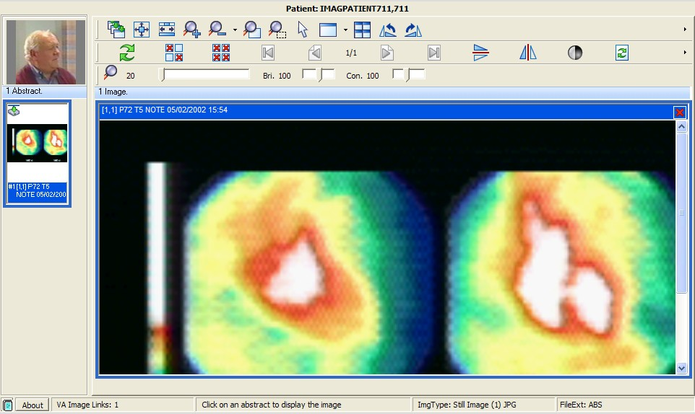
Image Manipulation Toolbars
Patient Photo
Abstracts Area
Main Image Display area
Status Bar

Main AWIV Window
The image below shows the main AWIV window and the various components of this window.

AWIV Overview

How the AWIV Handles Images
Most images handled by the AWIV are shown in one of two primary viewers, the Full Resolution style viewer, or the Radiology style viewer. These two viewers incorporate many of the controls available in the similarly named viewers in Clinical Display. In general, images associated with progress notes are shown in the Full Resolution Viewer, and images associated with radiology are shown in the Radiology Viewer. However, there are exceptions to this.
The AWIV uses outside viewers to handle certain types of images and non-image objects. For example, Word documents are opened in Microsoft Word if Word is available. For a detailed list of image types and the viewer associated with each type, see Appendix A - Supported File Extensions.

AWIV Web Application
The VistA Imaging AWIV Web Application enables users to access patient images using VA approved versions of Internet Explorer independent of VistAWeb and VistA Imaging Clinical Display, similar to the way that VistAWeb currently does. The AWIV Web Application can be accessed using the URL: REDACTED

The AWIV Web Application allows users to locate and display any patient images available to the VA from VistA Imaging, the DoD, including NCAT reports, and radiology images and artifacts stored in HAIMS.
NOTE: The NCAT system must be online and available in order for AWIV users to view NCAT reports.
For more information on AWIV Web Application, see the VistA Imaging AWIV Web Application User Guide.

This page is intentionally blank.

Getting to the AWIV

Launching the AWIV Using VistAWeb
The AWIV can be launched from within VistAWeb. To launch the AWIV and display images, you will first need to select the patient and record that is associated with the remote images you want to view.
The following steps summarize how this is done when VistAWeb is launched in a standalone mode directly from a browser.
NOTE: Turn off pop-up blockers on your computer to allow opening the AWIV component in a new browser window.
- Start VistAWeb.
- In VistAWeb, select the site that you want to access.
- Log in to the site when you are prompted to do so.
- Select a patient.
- Use the list on the left side of the page to view the progress notes or radiology reports for the selected patient.
- Use the controls at the top of the page to query for the records you want to view. A list of records is displayed.
- Records with associated images display an image icon in the AWIV column. Click the icon to launch the AWIV.

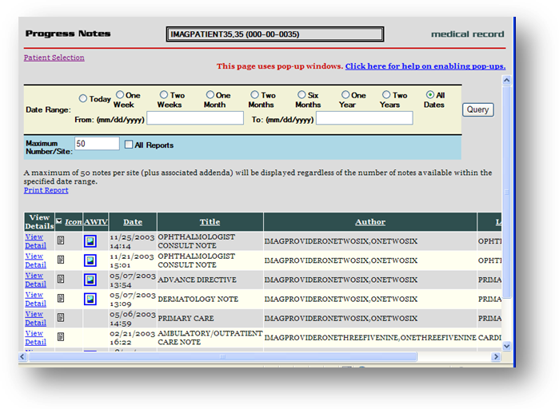
- The AWIV window opens and images are presented as abstracts on the left side of the window. To view images, click abstracts as described in the following section.

If you launch VistAWeb from the CPRS, the specific steps you use will vary.
For specific information on how to launch VistAWeb from CPRS, see the VistAWeb User Guide at http://www.va.gov/vdl/application.asp?appid=147.

Launching the AWIV Using the AWIV Web Application
To display images using the AWIV Web Application,
- Go to the URL REDACTED using a VA approved version of Internet Explorer.
- Select a site (to which the user has credentials) to log into.
- Select a patient.
- Select one or more sites that the patient has been seen at in the site information bar, to display studies from that site(s).
- Click on a study to open images in the AWIV.
- Review and manipulate images as needed, using the AWIV.
For more details on how to use the VistA Imaging AWIV Web Application, refer to the
AWIV Web Application User Guide.

Viewing Images Using Abstracts

Loading Images
When the AWIV window opens, it displays abstract placeholders until the abstracts themselves are retrieved.

NOTE: You can click abstracts and work with them while they are being retrieved. The abstracts do not have to be fully loaded.

To display images associated with abstracts,

- On the left side of the AWIV window, locate the abstract for the image you want to load.

- Click the desired abstract. A progress icon with a yellow arrow image is being retrieved.
indicates that the

- Wait until the progress icon turns green image display area.

Viewing a Study Report

. At this point the image is loaded in the main

To view the associated progress note or study report, right-click an abstract and click
Study Report. The report or progress note will display in the Study Report window.

DoD Image Abstracts
When you select a DoD artifact, the AWIV window opens with all image abstracts automatically loaded in the abstracts area, and the selected abstract displayed in the main AWIV viewer or in an external viewer (depending on the image type).

NOTE: This only applies to DoD NCAT and non-radiology artifacts from HAIMS selected from within the AWIV Web Application.

Working with Abstracts
You can use the functions described below to change how abstracts are displayed.

NOTE: Any changes made to the abstracts as described below apply only to the current session. They will not be saved for subsequent sessions.

Resizing Abstracts
To resize abstracts,

- Right-click any abstract.

- Click Resize the abstracts… A message box displays.
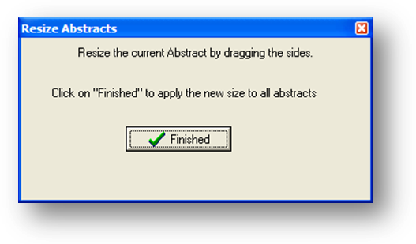
NOTE: Do not click Finished until after you have completed resizing images.
- Resize the abstract by dragging the highlighted edges or a corner of the abstract to desired size, as shown in the image below.
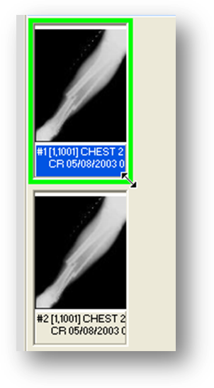
- Click Finished in the pop-up window when you have finished resizing the abstract. All abstracts in the study selected will be resized.

Changing Font Size
To change the size of the image title font displayed,

- Right-click an abstract.

Viewing Images Using Abstracts

- Click Font Size.
- Select one of the available font sizes. The font will be resized.

Using the Abstracts Toolbar
To show the abstracts toolbar, right-click an abstract and click Toolbar.
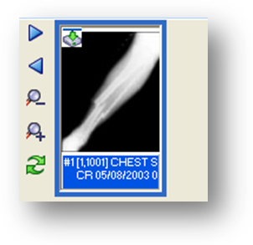
Using the abstracts toolbar, you can:

  - Navigate abstracts using Previous and Next .
  - Resize abstracts using Zoom In and Zoom Out .
  - Refresh abstracts using Refresh.
Arranging the Abstracts Horizontally
In the AWIV window, abstracts are arranged vertically by default. To temporarily display abstracts horizontally, right-click an abstract, and click Scroll | Horizontal.

This page is intentionally blank.

Using the Full Resolution Viewer

The AWIV uses the Full Resolution Viewer for most non-DICOM images. The Full Resolution Viewer can be recognized by three image manipulation toolbars displayed at the top of the image area. (The Radiology Viewer has two toolbars at the top and one at the side).

The following sections explain how to work with images in the Full Resolution Viewer using the buttons in the image manipulation toolbars.

For information about the Radiology Viewer, see page 16.

Changing Image Orientation
To change the orientation of an image,

  - To flip the image vertically, click Flip Vertical .
  - To flip the image horizontally, click Flip Horizontal .
  - To rotate the image counter clockwise, click Rotate Counter Clockwise 90 .
  - To rotate the image clockwise, click Rotate Clockwise 90 .

Changing Image Size
Changing an image size in the Full Resolution Viewer includes resizing an image, zooming, using the mouse magnifier and resetting the image. Below are instructions on how to use each of these functions.

To resize an image

  - To fit the image in the window, click Fit Image to Window .
  - To fit the entire image width in the window, click Fit Image Width button .

To zoom in or out incrementally

  - To zoom in on an image, click Zoom In .
  - To zoom out from an image, click Zoom Out .

March 2013 VistA Imaging v 3.0 11

To zoom to a specified value

- Click the arrow on the Zoom Out/Zoom Menu .
- Choose one of the available settings.
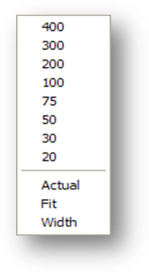

To use the Zoom Slider

- Click the Zoom Slider .
- Drag the bar until desired zoom level is reached for the image.
- Alternatively, click the arrows on the left and right of the slider bar.

To use the Zoom In on Selected Area Tool

- Click Zoom In on Selected Area on the toolbar.
- Drag the mouse to define a rectangular area that contains the image feature you want to magnify.
- Release the left mouse button. The selected area will be enlarged to fit the available display area.

To use the Mouse Magnifier Tool

- Click Mouse Magnifier.
- Point to an area in the image and drag the mouse. A magnification area will display and will move as you drag the mouse.

- Release the left mouse button. The magnified area will disappear on its own.

Panning Images
To pan an image that is larger than the display area, left-click in the image and drag to view the desired part.

Adjusting Brightness/ Contrast
- To adjust the brightness of an image, click the brightness slider and drag to achieve desired brightness level.

- To adjust the contrast of an image, click the contrast slider and drag to achieve desired contrast level.

Inverting an Image
To invert an image, click Invert Image on the toolbar.

Printing an Image
To print an image, click Print Image on the toolbar.

Working with Multi-Page Images
When multiple pages are available in a single image, the scroll buttons in the middle image manipulation toolbar are enabled. To scroll through multiple pages, use the scroll buttons on the toolbar.
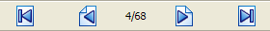

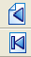
- Click to go to the next page.
- Click to go to the previous page.
- Click to go to the first page.
- Click to go to the last page.

Working with Multiple Images
When multiple images are available, you can choose to display one or all of the available images in the main image display area by clicking the abstracts. There are several other AWIV functions multiple images, which are described below.

To Change Layout
- To tile images currently displayed in the main image display area, click Tile Images
on the toolbar.
- To maximize an image, click the arrow on the Maximize Image (Layout utils.) on the toolbar, and click Maximize Image.
- To control how many images are displayed at one time in the main image display area, click the arrow on the Maximize Image (Layout utils.) and then choose one of the available layouts.
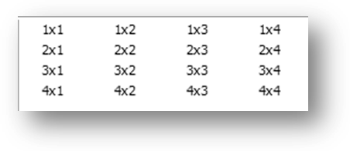
Using Viewer Pages
If images are laid out across multiple pages, use the Previous Viewer Page and the Next Viewer Page options in the Maximize Image menu to switch between pages.
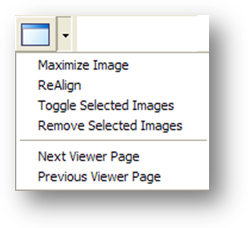
To apply actions to all images
To apply selected actions to all images currently displayed in the main image display area,

- Click Apply Actions to all Images on the toolbar.
- Select an action from one of the toolbar options, to apply that action to all images currently displayed in the main image display area.

Resetting an Image
To undo any changes made to an image, click Reset .

Refreshing an Image
To refresh/reload an image, click Refresh on the toolbar.

Removing Images

To remove some or all images from the main image display area

- To remove a single image, click in the upper right corner of the image.
- To remove multiple images CTRL-Click the images to remove and then click Remove Selected Images on the toolbar.
- To remove all images, click Remove All Images on the toolbar.

This page intentionally left blank.

Using the Radiology Viewer

While the AWIV Web Application allows access to other types of images, the AWIV uses the Radiology Viewer to view and manipulate DICOM radiology images. The Radiology Viewer can be recognized by two toolbars at the top and side of the image display area. (The Full Resolution Viewer has three toolbars.)
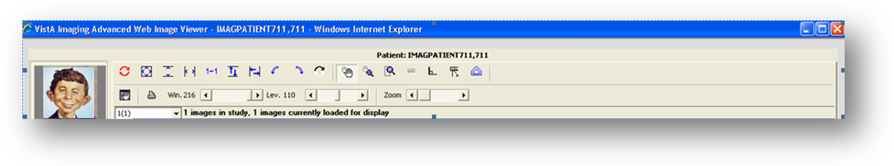
The following sections explain how to work with images in the Radiology Viewer. For information about the Full Resolution Viewer, see page 11.

Images Available in a Study
If there are multiple images, the information bar above the image displays, the number of images available in that study as shown in the image below.

Choosing a Series to View
To view a particular series of images, use the dropdown menu in the information bar above the image to select the series.
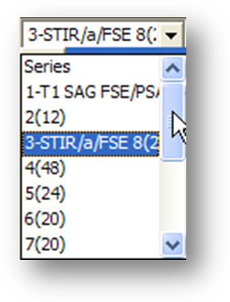

March 2013 VistA Imaging v 3.0 17

Changing Image Orientation
To change the orientation of an image, use toolbar buttons as follows,

- To flip the image vertically, click Flip Vertical .
- To flip the image horizontally, click Flip Horizontal .
- To rotate the image to the left, click Rotate Left .
- To rotate the image to the right, click on Rotate Right .

Changing Image Size
You can resize an image, zoom, use the mouse magnifier, and reset images to their original viewing size, as follows,

To resize an image

- To fit the image in the window, click Fit Image to Window .
- To fit the entire image height in the window, click Fit Image Height .
- To fit the entire image width in the window, click Fit Image width .
- To view the image in its original size, click Actual Size .

To use the Zoom Slider

- Click the Zoom slider .
- Drag the bar until desired zoom level is reached for the image.
- Alternatively, click the arrows on the left and right of the slider bar.

To use the Zoom In on Selected Area tool

- Click Zoom In on Selected Area on the toolbar.
- Drag the mouse to define a rectangular area that contains the image feature you want to magnify.

- Release the left mouse button. The selected area will be enlarged to fit the available display area.

To use the Mouse Magnifier tool

- Click Mouse Magnifier on the toolbar.
- Point to an area in the image and drag the mouse. A magnification area will display and will move as you drag the mouse.
- Release the left mouse button. The magnified area will disappear on its own.

Printing an Image
To print an image, click Print Image on the toolbar.

Getting Diagnostic Quality Images
If there are both reference and diagnostic quality versions of an image available, the AWIV will display the reference quality image by default. This is done to reduce the time needed for images to load across the VistA Imaging WAN.

When reference-quality images are displayed in the main image window, the yellow bar displayed near the bottom of the window indicates that this is a reference quality image with the phrase “Reduced size – Reference quality image.”

To retrieve the diagnostic quality image,

- Right-click an abstract.

- Select “Get Diagnostic Image.” A progress icon with a yellow arrow image is being retrieved.
- Wait for the diagnostic image to display.

Changing Window/Level
indicates that the

You can change the window/level of an image using the mouse. You can also use the auto-window/level tool to base window/level values on a selected area in an image.

To change window/level with the mouse

- Point to the image you want to adjust and drag using the right mouse button.
- Drag up or down to change window (window width) values.

- Drag left or right to change level (window center) values.

To use the Auto Window/ Level tool

- Click Auto Window/Level in the toolbar near the top of the window.
- In the image you want to adjust, drag the mouse to define a rectangular area that includes the tissue you want to base the window/level on.
- When the drag is completed, the new window/level values will be applied to the entire image.
- Continue using the Auto-Window/Level tool, or disable it by choosing another tool.

To change window/level using toolbar sliders

You can also click Win. / Lev. 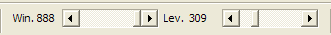 on
the toolbar and change window/level by dragging with the left mouse button or by using the slider.

Using the Protractor to Measure Angles

To measure an angle
- To enable the option, click Protractor .
- Once the option is selected, click the mouse on the image, to begin measuring the angle.
- Drag mouse to stop point and click once again to draw the line.
- Select desired area and draw an angled line to measure angle. The angle between the lines is displayed on the image, as shown below.

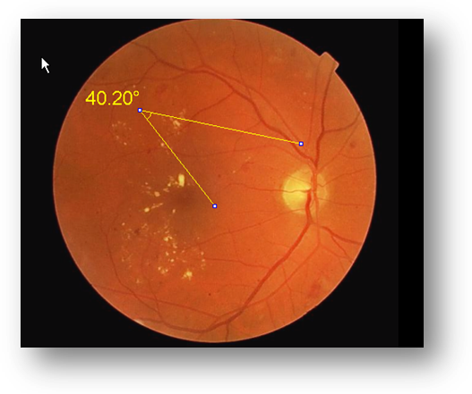

To change the angle after making an angle selection

- Click the Use Protractor Ruler Pointer .
- Select the line to extend in the angle.
- Drag the line to desired location.
- Re-measure angle.
NOTE: You can delete an angle measurement by clicking the Reset Image button.

Using the Ruler Tool
To measure a feature in an image,

- Click Ruler on the toolbar.
- Click on the image to start measuring.
- Drag to desired area to get a measurement. The length is displayed on the image, as shown below.

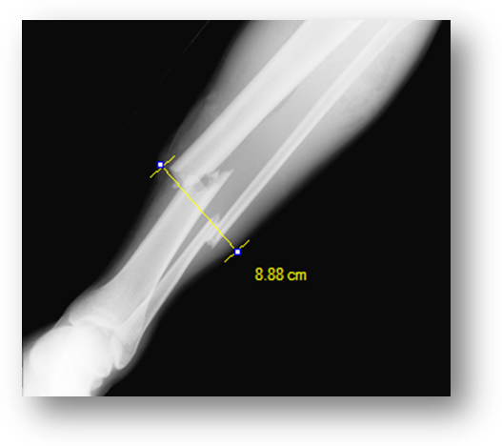

NOTE: The ruler is available only if the applicable sizing information is available in the DICOM image header.

Panning Images

To pan an image with the mouse

To pan an image that is larger than the display area, left click and drag to view desired part of the image.

To use the pan window

To pan an image using a pan window,

- Click Pan Window in the tool bar above the image.
- Click and drag the rectangular box that appears in the pan window to move to the desired area in the image.

Resetting an Image
To undo any changes made to an image click Reset to restore the original image.

Inverting an Image
To invert an image, click Invert Image on the toolbar.

Scrolling Through Images
If multiple images are available in the study, you can scroll through these images by using the scroll tools available to the left of the image.

- Click to go to next image.
- Click to go to previous image.
- Click to go to the first image in the study.
- Click to go to the last image in the study
- Click to play the images as a slide show.
- To change the speed of the slide show, drag the smaller slider at the bottom of the scroll tools. Speed increases as you drag from top to bottom.
You can also scroll through images using the long vertical slider bar. Drag the slider from top to bottom to go to the next image.

Using the Cine Viewer
When DICOM multi-frame images are loaded in the Radiology Viewer, a special toolbar displays automatically. You can use this to work with multi-frame images as described below.

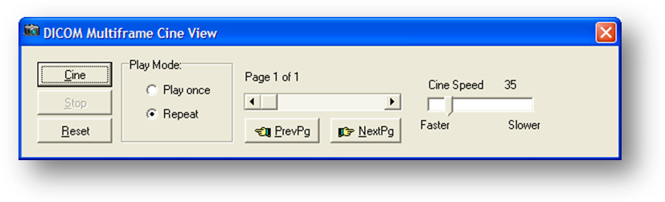

  - To play the study, click Cine.
  - To stop playing the study, click Stop.
  - To returns to the first page in the study, click Reset.
  - To repeat play, select the Repeat option in the Play Mode area.
  - To play once, select the Play once option in the Play Mode area.
  - To change the play speed, click and drag the Cine Speed slider.
  - To go to the previous page in the study, click PrevPg. Alternatively, use the page slider.

  - To go to the next page in the study, click NextPg. Alternatively, use the page slider.

Using Other Viewers

Viewing Documents
If a progress note or radiology report has a Word .doc file or .avi movie file associated with it, the AWIV launches the appropriate outside viewer when abstracts for these files are selected.

Clicking Word documents will open the document in a Microsoft Word window.

If you close the AWIV and select another patient in VistAWeb, the .doc file with information for the previous patient remains displayed.

Viewing Movie Files
If a selected patient image is a motion video clip, it will open in the Video Player window, as shown below.
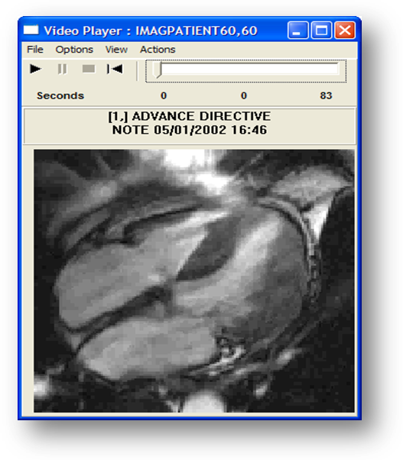
- Click to play.
- Click to pause play.

- Click to stop playing.
- Click to rewind.
- Click and drag the slider to browse the video clip, frame by frame.
- Click View | Set Start Point to set start point.
- Click View | Set End Point to set end point.
- Click Options | Video Loop to continuously play all or part of the file.
- You can choose to display or hide the progress bar in the video player, by clicking

Options | Show Progress Bar.

With the progress bar,
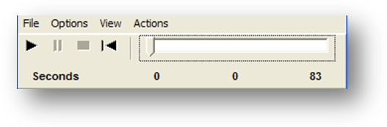
Without the progress bar,
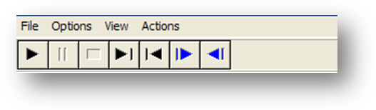

Closing the AWIV

To close the AWIV window, click in the upper right hand corner of the AWIV Window or click either of the Close buttons at the top and bottom of the AWIV window.

NOTE: The AWIV closes automatically when a different patient is selected in either VistAWeb or in the AWIV Web Application.

This page is intentionally blank.

Troubleshooting

About the AWIV
To display version and memory usage information about the AWIV, click the About
button located in the lower left corner of the AWIV window.
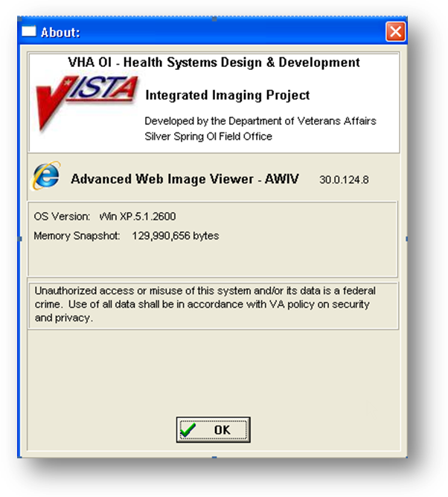

Message Log
The Message History window is used to view system messages for debugging purposes. To open this window, click Message History in the lower left corner of the AWIV window to view message history as shown in the image below.
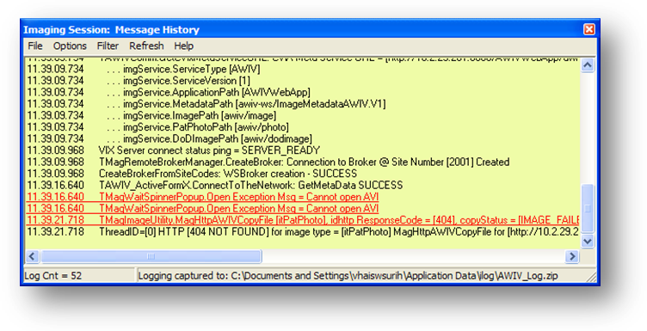
To exit the message history window, click in the top right corner of the Message History window or click File | Exit.

Acronym /Term | Definition
AWIV | Advanced Web Image Viewer
CPRS | Computerized Patient Record System
DICOM | Digital Imaging and Communications in Medicine
EKG | Electrocardiogram
FAQ | Frequently Asked Questions
FDA | Food and Drug Administration
HIMS ROI | Health Information Management Services Release of Information (department)
ID | Identifier or Identification
Multi-frame | A DICOM image that contains multiple two-dimensional pixel planes in a single file. When the file is displayed, each plane (frame) is presented as a separate image. This separation is automatically handled in the Radiology Viewer.
MUSE | A third party cardiology information system used to store and manage ECG/EKG (electrocardiogram) images. If a VA facility stores their ECG images in MUSE, they will not be accessible to the AWIV.
TGA | Targa (image type)
US | United States
VA | Veteran Affairs
VistA | Veterans Health Information System and Technology Architecture
VistAWeb | VistAWeb is an intranet web application used to review remote stored VistA and Health Data Repository (HDR) patient information; see REDACTED for details about VistAWeb

This page is intentionally left blank.

Extension | Description | Associated Viewer
756 | Historical 756 | Radiology Viewer or Full Resolution Viewer depending on image type.
ABS | Abstract file | Abstract area
ASC | ASCII text file | Not Supported
AVI | Motion video | Video Player
BIG | X-ray file 2000K | Radiology Viewer
BMP | Bitmap | Full Resolution Viewer
BW | Black and white | Radiology Viewer or Full Resolution Viewer depending on image type.
DCM | DICOM | Radiology Viewer
DOC | MS Word document | Microsoft Word
DOCX | MS Word document | Microsoft Word
HTM | Web HTM document | Not Supported
HTML | Web HTML document | Not Supported
JPG | JPEG full color | Full Resolution Viewer
MHT | MIME HTML web page archive | Not Supported
MHTML | MIME HTML web page archive | Not Supported
MP3 | Motion video MPEG-3 | Not Supported
MP4 | Motion video MPEG-4 | Not Supported
MPEG | Motion video MPG | Not Supported
MPG | Motion video MPG | Not Supported
PAC | X-ray PAC image | Radiology Viewer
PDF | Adobe PDF | Full Resolution Viewer
RTF | Rich text format | MS Word
TGA | TARGA image | Radiology Viewer
TIF | Tagged Image File Format | Full Resolution Viewer
WAV | Audio wave file | Not Supported
This page intentionally left blank.

Appendix B – AWIV Toolbars

Full Resolution Viewer Toolbars
The Full Resolution Viewer has three toolbars. Each toolbar is shown below with a description of each button on the toolbar.

 | Apply | Applies the actions to all images.
 | Fit Image to Window | Resizes the image to fit in the viewing window.
 | Width | Fits the image to the width of the viewing window.
 | Zoom In | Incrementally magnifies the image.
 | Zoom Out | Decreases image magnification with each click.
 | Mouse Magnifier | Allows the user to select a portion of the image to magnify using a mouse click.
 | Zoom (Selected Area) | Allows the user to click an area to zoom in on the image. The image point selected zooms in or out with the movement of the mouse.
 | Pointer | Changes the mouse back to a pointer.
 | Image Layout | Allows the user to specify the image size and layout. A drop down list appears when selected with options for the user to select.
 | Tile Images | Tiles the images.
 | Rotate Image Counter Clockwise | Rotates the Image 90 degrees counterclockwise.
 | Rotate Image Clockwise | Rotates the Image 90 degrees clockwise.
 | Refresh Images | Refreshes current image.
 | Remove Selected Images | Removes the selected image from the Full

 |  | Resolution Viewer pane.
 | Remove all images | Removes all of the images from Full Resolution Viewer pane.
 | Print Image | Prints the image.
 | Flip Vertical | Flips the image vertically.
 | Flip Horizontal | Flips the image horizontally.
 | Invert Image | Inverts the image.
 | Reset Image | Adjusts the image to its original size.
 |  | Increases or decreases magnification.
 |  | Increases or decreases brightness.
 |  | Increases or decreases contrast.

Appendix B – AWIV Toolbars

Radiology Viewer Toolbars
The Radiology Viewer has two toolbars that can be used to manipulate images. Each toolbar is shown below with a description of each button on the toolbar.

 | Reset Images | Resets the image to its original settings.
 | Fit Image to Window | Resizes image to fit to the window.
 | Fit Image to height. | Resizes image to fit to the height of the window.
 | Fit Image to width. | Resizes image to fit to the width of the window.
 | Actual Size | Resets the image to the actual size.
 | Flip Vertical | Flips the image vertically.
 | Flip Horizontal | Flips the image horizontally.
 | Rotate Left | Rotates the image to the left.
 | Rotate right | Rotates the image to the right.
 | Invert Image | Inverts the image.
 | Pan Image with mouse. | Pans image on mouse click.
 | Mouse Magnifier | Magnifies image on mouse click.
 | Zoom | Zooms in on the selected area.
 | Ruler | Measures on mouse click.
 | Protractor | Measures angle on mouse click.
 | Ruler/Protractor pointer | Moves lines drawn.
 | Auto Window Level | Window control.

 | Pan Window | Opens the pan window.
 | Print Image | Prints the image.
 |  | Changes Window/ Level values of the image.
 |  | Zooms in or out of the image.

