VistA Imaging Exchange (VIX) Query Retrieve

MAG*3.0*269

Enhanced Image Viewer User Guide



April 2022

Version 20.2

Department of Veterans Affairs

Office of Information and Technology (OIT)

**Revision History**

**NOTE:** The revision history cycle begins once changes or enhancements are requested after the document has been baselined.

| Date | Revision | Description | Author |
| --- | --- | --- | --- |
| 04/05/2022 | 20.2 | Updates for MAG*3.0*269 T4 | VA IT VistA Imaging Technical team |
| 02/18/2022 | 20.1 | Updates for MAG*3.0*269 name | VA IT VistA Imaging Technical team |
| 10/18/2021 | 20.0 | Updated for MAG*3.0*269 | VA IT VistA Imaging Technical team |
| 05/21/2021 | 19.0 | Updated for MAG*3.0*284 | REDACTED |
| 07/27/2020 | 18.0 | Updated for MAG*3.0*254 | VA IT VistA Imaging Technical team |
| 06/19/2019 | 17.1 | Updated title page for MAG*3*230 remaining content is the same | REDACTED |
| 05/24/2019 | 17.0 | Updated screenshots with captions | REDACTED |
| 11/15/2018 | 16.0 | Additional MAG*3.0*221 Updates | REDACTED |
| 10/03/2018 | 15.0 | Updated for MAG*3.0*221 | REDACTED |
| 08/22/2018 | 14.0 | Updated for MAG*3.0*201 | REDACTED |
| 07/11/2018 | 13.0 | Additional MAG*3.0*197 Updates | REDACTED |
| 03/26/2018 | 12.0 | Updated for MAG*3.0*197 | REDACTED |
| 11/06/2017 | 11.0 | Additional MAG*3.0*185 Updates | REDACTED |
| 10/12/2017 | 10.0 | Initial MAG*3.0*185 Updates and Incorporated comments from reviewers. | REDACTED |
| 10/04/2017 | 9.0 | Removed ECG references. Date Updates | REDACTED |
| 09/06/2017 | 8.0 | Date Updates | REDACTED |
| 06/27/2017 | 7.0 | Updated for MAG*3.0*177 | REDACTED |
| 04/18/2017 | 6.0 | Formatting updates | REDACTED |
| 04/13/2017 | 5.0 | Formatting and screenshot updates | REDACTED |
| 04/06/2017 | 4.0 | Updated for MAG*3.0*170 | REDACTED |
| 03/24/2017 | 3.0 | Date Updates | REDACTED |
| 02/14/17 | 2.0 | Formatting updates and added  reference to Enhanced Image Viewer. Removed Radiology Viewer section | REDACTED |
| 09/29/16 | 1.0 | Initial Draft | REDACTED |

Table of Contents

1. Introduction 1

1.1. Purpose 1

1.2. Document Orientation 1

1.2.1. Organization of the Manual 1

1.2.2. Coordination 1

1.2.3. Disclaimers 2

1.2.3.1. Software Disclaimer 2

1.2.3.2. Documentation Disclaimer 2

1.2.4. Documentation Conventions 2

1.2.5. References and Resources 3

1.3. Enterprise Service Desk and Organizational Contacts 3

2. Enhanced Image Viewer Overview 4

2.1. How the Enhanced Image Viewer Works 4

2.2. Enhanced Image Viewer Web-Based Application 4

2.3. Main Enhanced Image Viewer Window 5

3. Viewing Images 6

3.1. Launching the Enhanced Image Viewer 6

3.2. Loading Images 7

3.3. Working with Images 7

3.3.1. Viewing Images and Manipulating View Layout 7

3.3.2. Viewing Stacked Images 8

3.3.3. Using the Image Navigation Toolbar 9

3.3.4. Document Viewer 10

3.3.5. Printing an Image 11

3.3.6. Exporting an Image 12

3.3.7. External Links 12

3.3.7.1. Release of Information (ROI) Print Queue Status and ROI Submission 13

3.4. Using the Enhanced Image Viewer Toolbar 14

3.4.1. Viewing Information on an Image 16

3.4.2. Changing the Settings of an Image 17

3.4.3. Changing the Study Layout 22

3.4.4. Presentation State 22

3.4.5. Using the Measurements Tools 22

3.4.6. Using the RGB Tool 24

3.5. Closing the Enhanced Image Viewer 24

4. Image Quality Assurance (QA) 25

4.1. Image Information 27

4.1.1. Image QA 28

4.2. Viewing and Setting Image Status 32

4.3. Image QA Report 33

5. Troubleshooting 35

6. Acronyms 36

**Table of Figures**

Figure 1: Main Enhanced Image Viewer window 5

Figure 2: Loading Screen 6

Figure 3: Images Not Loading 6

Figure 4: Main Enhanced Image Viewer window with thumbnail panel 7

Figure 5: Main Enhanced Image Viewer window with images loaded 9

Figure 6: Navigation Toolbar 9

Figure 7: Frame Count 10

Figure 8: Main Enhanced Image Viewer Window with a document loaded 10

Figure 9: Print menu 11

Figure 10: Print Menu - Device Selection 11

Figure 11: Exporting an Image 12

Figure 12: External Links Options 12

Figure 13: Button in the Top Right Corner 12

Figure 14: ROI Print Queue Status 13

Figure 15: Print Queue 13

Figure 16: Grayed out toolbar button 14

Figure 17: Toolbar 14

Figure 18: DICOM Attributes 16

Figure 19: Image Metadata 16

Figure 20: Settings Menu 17

Figure 21: Annotations Preferences 17

Figure 22: Measurement Preferences 18

Figure 23: Ellipse and Rectangle Preferences 18

Figure 24: Label Preferences 19

Figure 25: Annotation Preferences 19

Figure 26: Cine Preferences 20

Figure 27: Layout Preferences 20

Figure 28: Layout Preference Choices 21

Figure 29: Copy Attributes Preferences 21

Figure 30: Layout Attribute Preference Choices 22

Figure 31: Presentation State button 22

Figure 32: Presentation State Menu 22

Figure 33: Measurement Tool View 1 23

Figure 34: Measurement Tool View 2 23

Figure 35: Measurement Tool View 3 23

Figure 36: 2D Length Calibration 23

Figure 37: Hounsfield Measurement Tools 24

Figure 38: RGB Tool button 24

Figure 39: Enhanced Image Viewer Close Button 24

Figure 40: Main Enhanced Image Viewer Window with Image loaded 25

Figure 41: External Link with Drop Down Menu 26

Figure 42: Image Information 27

Figure 43: Image Editor 28

Figure 44: QA Review Page 28

Figure 45: QA Filters and Date Range 29

Figure 46: Search Filter Details 29

Figure 47: QA Status Choices 30

Figure 48: Percentage of Images to display 30

Figure 49: Saved Filters 31

Figure 50: QA Filter Results 31

Figure 51: QA Filter Results and Image Information 32

Figure 52: QA Thumbnail 32

Figure 53: QA Review Status Update Menus 33

Figure 54: QA Statistics Reports Page 33

Figure 55: Run QA Report 34

Figure 56: View QA Report 34

Figure 57: Enhanced Image Viewer Version Number 35

Figure 58: Viewer Information Dialog 35

**Table of Tables**

Table 1: Viewing Images and Manipulating View Layout 7

Table 2: Functions and Uses of the Toolbar 9

Table 3: Toolbar Icons- Names, Functions, and Descriptions 14

# Introduction

## Purpose

This manual describes the Enhanced Image Viewer. It is intended for clinicians who use hosting applications such as Joint Legacy Viewer (JLV) and need access to images. This manual assumes that a current version of the Enhanced Image Viewer is installed and that users are familiar with the Microsoft Windows environment.

## Document Orientation

### Organization of the Manual

This document contains the following sections to assist in walking the reader through accessing and using the Enhanced Image Viewer application:

* **Section 1 – Introduction**  
  Describes the document and is designed to aid the reader in how best to follow the document.
* **Section 2 − Enhanced Image Viewer Overview**  
  Describes how the Enhanced Image Viewer works. Explains the main Enhanced Image Viewer Window and how the Enhanced Image Viewer handles images.
* **Section 3 − Viewing Images**Describes how to use the Enhanced Image Viewer. References the image manipulation toolbars and explains how to close the Enhanced Image Viewer.
* **Section 4 – Image Quality Assurance (QA)**  
  Describes how to use the Quality Assurance features of the Enhanced Image Viewer.
* **Section 5 – Troubleshooting**Describes how to access some of the information contained in the Enhanced Image Viewer that will assist the user in troubleshooting some issues that may occur when using the application.
* **Section 6 - Acronyms**  
  Defines the Acronyms and Terms used and referenced in this document.

### Coordination

Use of the Enhanced Image Viewer is subject to the following provision:

**Caution:** Federal law restricts this device to use by or on the order of either a licensed practitioner or persons lawfully engaged in the manufacture or distribution of the product.

The Enhanced Image Viewer is not intended for the primary interpretation of radiology exams. When the Enhanced Image Viewer is installed on approved and properly maintained hardware, primary interpretation of other image types is permissible by licensed practitioners at their discretion.

The Food and Drug Administration (FDA) classifies VistA Imaging and the Enhanced Image Viewer (as a component of VistA Imaging) as a medical device. Unauthorized modification to VistA Imaging, including the Enhanced Image Viewer, such as installing unapproved software, will adulterate the medical device. The use of an adulterated medical device violates US federal law (21CFR820).

### Disclaimers

This is a controlled document. No changes to this document may be made without the express written consent of the VistA Imaging Office of Enterprise Development group.

While every effort has been made to assure the accuracy of the information provided, this document may include technical inaccuracies and/or typographical errors. Changes are periodically made to the information herein and incorporated into new editions of this document. Product names mentioned in this document may be trademarks or registered trademarks of their respective companies and are hereby acknowledged.

* VistA Imaging Office of Enterprise Development Department of Veterans Affairs
* Internet: <http://www.va.gov/imaging>
* Imaging VI SharePoint: REDACTED

#### Software Disclaimer

This software was developed at the Department of Veterans Affairs (VA) by employees of the Federal Government in their official duties. Pursuant to Title 17 Section 105 of the United States Code, this software is not subject to copyright protection and is in the public domain. VA assumes no responsibility whatsoever for its use by other parties and makes no guarantees, expressed or implied, about its quality, reliability, or any other characteristic. We would appreciate acknowledgment if the software is used. This software can be redistributed and/or modified freely if any derivative works bear some notice that they are derived from it, and any modified versions bear some notice that they have been modified.

#### Documentation Disclaimer

The appearance of external hyperlink references in this manual does not constitute an endorsement by the VA of this Web site or the information, products, or services contained therein. The VA does not exercise any editorial control over the information you may find at these locations. Such links are provided and are consistent with the stated purpose of the VA.

### Documentation Conventions

This document uses the following conventions:

* Controls, options, and button names are shown in **Bold.**
* A vertical bar is used to separate menu choices. For example: "Click **File | Open"** means: "Click the **File** menu, then click the **Open** option." Keyboard key names are shown in bold and in brackets.
* Sample output is shown in monospace.
* When this document is used online, hyperlinks are indicated by blue text.
* Useful or supplementary information is shown in a **Tip.** Important or required information is shown in a **NOTE.**
* Critical information is indicated by: 

### References and Resources

Additional information about VistA Imaging can be found at:

* VistA Imaging: <http://www.va.gov/vdl/application.asp?appid=105>

## 1.3. Enterprise Service Desk and Organizational Contacts

If you encounter any problems using the Enhanced Image Viewer, contact your local Imaging Coordinator or support staff. If the problem cannot be resolved locally, use YourIT Service Desk Manager to place a service request, or contact the Enterprise Service Desk at REDACTED.

# Enhanced Image Viewer Overview

## How the Enhanced Image Viewer Works

The Enhanced Image Viewer adds image display capabilities to hosting applications in a similar way as the Clinical Display desktop application adds image display capabilities to the Computerized Patient Record System (CPRS).

The Enhanced Image Viewer is a web-based application that provides a subset of features of Clinical Display. This means it does not supply all features that Clinical Display offers.

With the Enhanced Image Viewer, a user can display images associated with progress notes or radiology reports.

## Enhanced Image Viewer Web-Based Application

The Enhanced Image Viewer is a web application that enables users to access patient images using VA approved versions of Edge and Chrome. The Enhanced Image Viewer launches from a hosting application such as JLV.

The Enhanced Image Viewer allows users to locate and display any patient images available to the VA from VistA Imaging, including Department of Defense (DoD) images.

## Main Enhanced Image Viewer Window

The image below (Figure 1) shows the main Enhanced Image Viewer window and its components.

Figure 1: Main Enhanced Image Viewer window

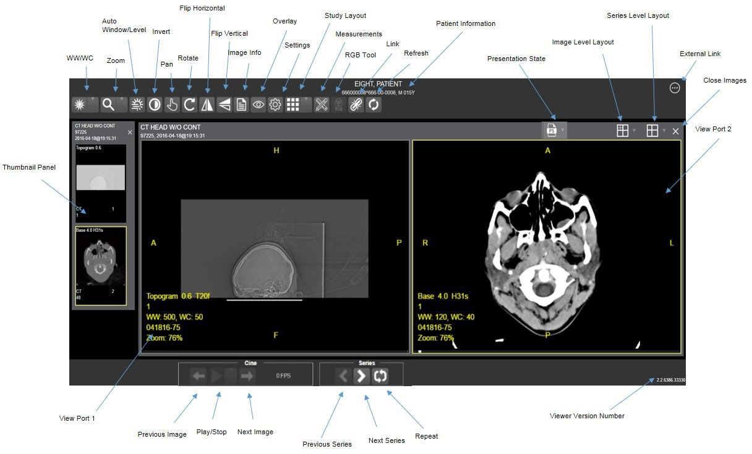

# Viewing Images

## Launching the Enhanced Image Viewer

Upon launching the Enhanced Image Viewer, the following loading screen (Figure 2) displays:

Figure 2: Loading Screen



The first time a study launches, the Enhanced Image Viewer pre-processes the study's images and loads them into a cache on the VistA Imaging Exchange Servers (VIX) server. Caching images reduces the load time for subsequent study views.

If there is trouble loading one or more images, the following screen displays (Figure 3) with the option to either proceed or empty the cache and try again. If the user selects proceed, the study loads without the problem images. If the user chooses to empty the cache and retry, the Enhanced Image Viewer attempts to re-process all the images for the study.

Figure 3: Images Not Loading

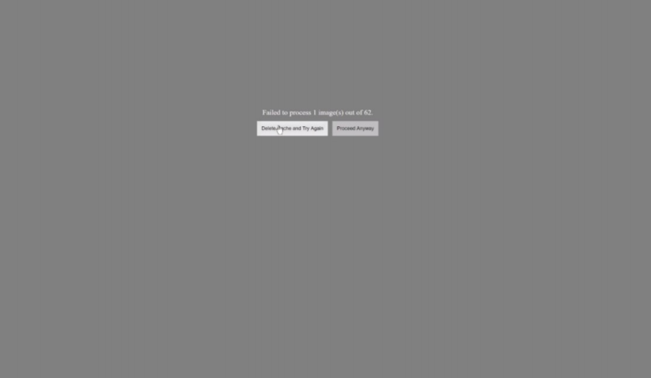

## Loading Images

When the Enhanced Image Viewer window opens, it displays thumbnail placeholders until the thumbnails themselves are retrieved. See Table 1 for an example of a thumbnail.

To display images associated with thumbnails:

1. On the left side of the Enhanced Image Viewer window, locate the thumbnail for the desired image.
2. Click the desired **thumbnail**. A progress window displays as shown below (Figure 4) until the loading of the image completes.

Figure 4: Main Enhanced Image Viewer window with thumbnail panel

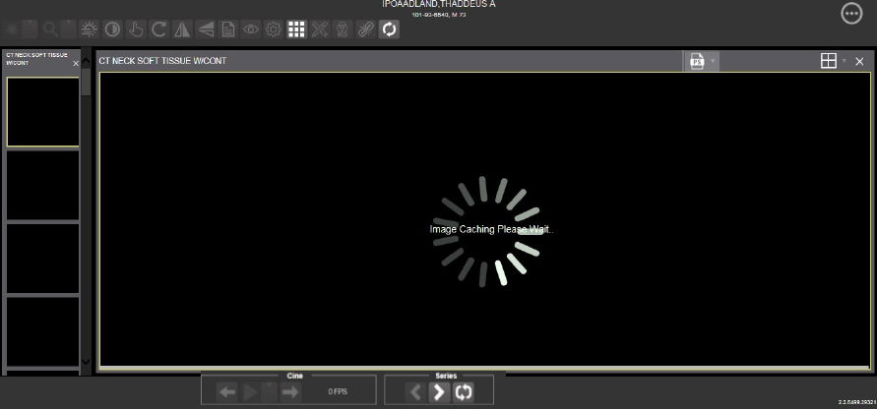

## Working with Images

The functions described below change how the images are displayed.

**NOTE**: Any changes made to the images as described below apply only to the current session and not to subsequent sessions.

### Viewing Images and Manipulating View Layout

Table 1: Viewing Images and Manipulating View Layout

| Button Icon | Button Name and Function | Description |
| --- | --- | --- |
| Image Level Layout | Image Level Layout | The image-level layout button allows users to select how many images within each series display within the viewport for each series. |
| Series Level Layout | Series Level Layout | The image series layout button manipulates how many series within the study will display on the viewport. |
| Close Images | Close Images | The close images button closes the currently selected image from the viewport. |
| Thumbnail | Thumbnail | The title of the series appears at the top left of the thumbnail. The image type appears at the bottom left, with the number of images in the series directly below that. The series number displays on the bottom right of the thumbnail. For Digital Imaging and Communications in Medicine (DICOM) images, the modality code appears on the bottom left. |
| Thumbnail Panel | Thumbnail Panel | To adjust the size of the thumbnail panel, click and drag the right edge of the panel. This affects how many thumbnails are shown per row within the panel but does not alter the size of the thumbnails. When hovering over the viewport and viewing non-stacked images, use the mouse wheel to scroll between the different series displayed in the thumbnail panel. Use drag-and-drop to drag thumbnails to the viewport. A yellow outline appears around the thumbnail that currently shows in the viewport. |

### Viewing Stacked Images

When viewing a stacked image series, use the mouse wheel to scroll between the images in the stack. Upon scrolling, if multiple series display in the viewport, scout lines appear on the images of the other series in a different plane to indicate what part of the body the series is displaying. See Figure 5 below.

Figure 5: Main Enhanced Image Viewer window with images loaded

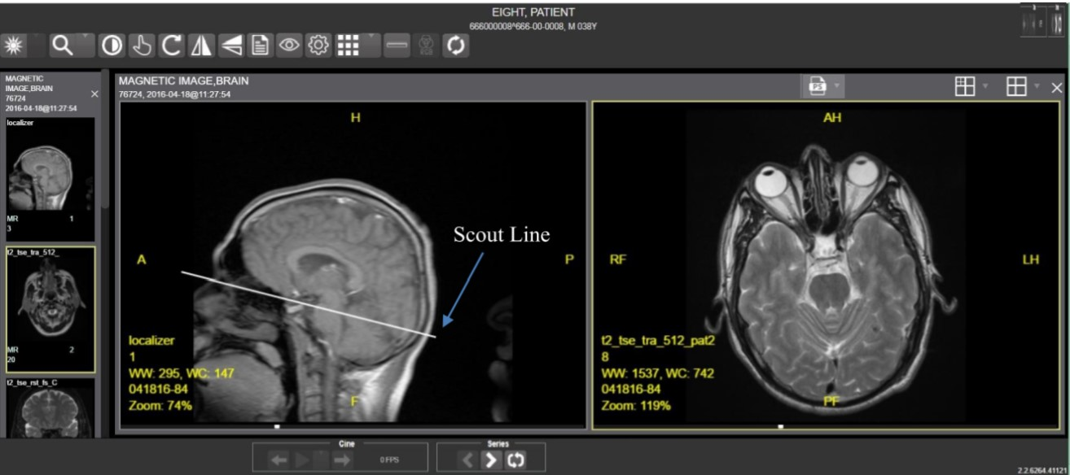

### Using the Image Navigation Toolbar

The navigation toolbar appears automatically when the Enhanced Image Viewer determines it applies to the displayed image. See Figure 6 below:

Figure 6: Navigation Toolbar

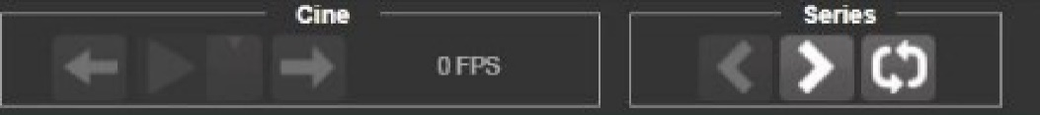

Table 2 describes the functions and uses of each button in the navigation toolbar*.*

Table 2: Functions and Uses of the Toolbar

| Button Icon | Button Name and Function | Description |
| --- | --- | --- |
| Previous Series Next Series | Previous Series and Next Series | The previous and next series buttons allow users to toggle between the various image series in the study. |
| Previous Image Next Image | Previous Image and Next Image | The previous and next image buttons allow users to scroll through the images within the currently selected series. |
| Play  Stop | Play and Stop | The play and stop buttons begin and end playing through a cine image scene. |
| Repeat | Repeat | When the user selects the repeat series button, the current series repeats. When the user deselects the button, all the series play through before repeating the current series. |

While a series is playing, a number appears next to the image navigation toolbar. The first number is the frame rate the series is currently playing, and the second number is the frame rate used when recording the series. See Figure 7 below.

Figure 7: Frame Count

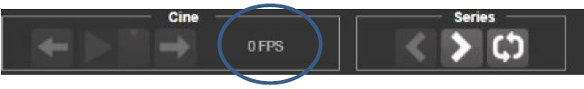

* **NOTE:** The first time a series plays, it might play slower while caching the images. Once the images are cached, the series plays faster.

### Document Viewer

When viewing a document, the document viewer loads and the image viewer toolbars hide. See Figure 8 below for an example of the document viewer.

Figure 8: Main Enhanced Image Viewer Window with a document loaded

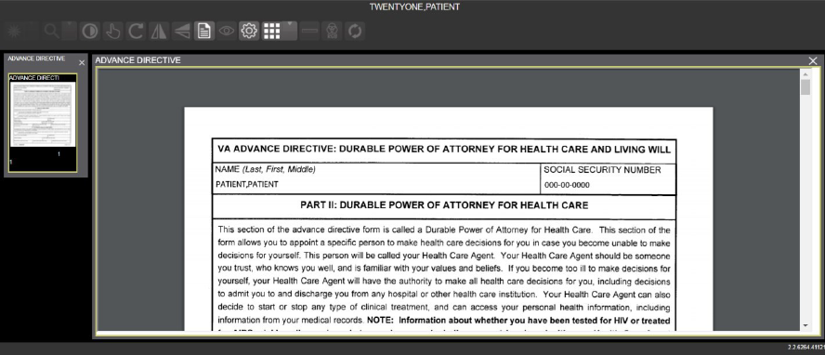

### Printing an Image

To print an image, right-click on the image to display a context menu. See Figure 9 below for an example.

Figure 9: Print menu

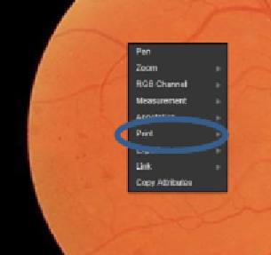

After selecting the print option, the user can select print options. The user must select a print reason and enter their digital signature. After selecting the print options, the image opens in a new tab in a printable form. The user can now print the image by selecting **File** | **Print**, or **Ctrl+P**. See Figure 10 below for an example.

Figure 10: Print Menu - Device Selection

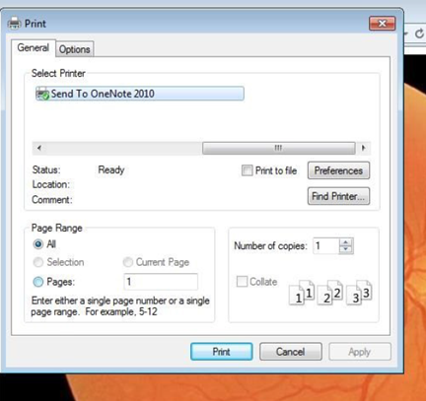

### Exporting an Image

To export an image, right-click on the image to display a context menu. See Figure 11 for an example.

Figure 11: Exporting an Image

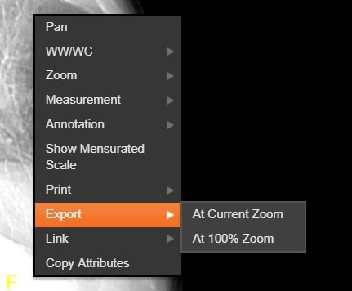

After selecting the desired zoom, the user must enter the digital signature before the image exports.

### External Links

Click the button in the top right corner (Figure 13) of the Enhanced Image Viewer to view the External Links options (Figure 12).

Figure 12: External Links Options

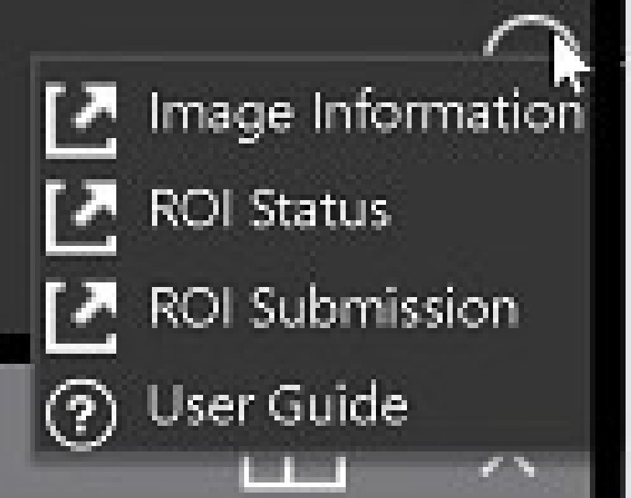

Figure 13: Button in the Top Right Corner



#### Release of Information (ROI) Print Queue Status and ROI Submission

To view the ROI Print Queue Status, click **ROI Status** on the External Links menu and the following screen displays (Figure 14).

Figure 14: ROI Print Queue Status

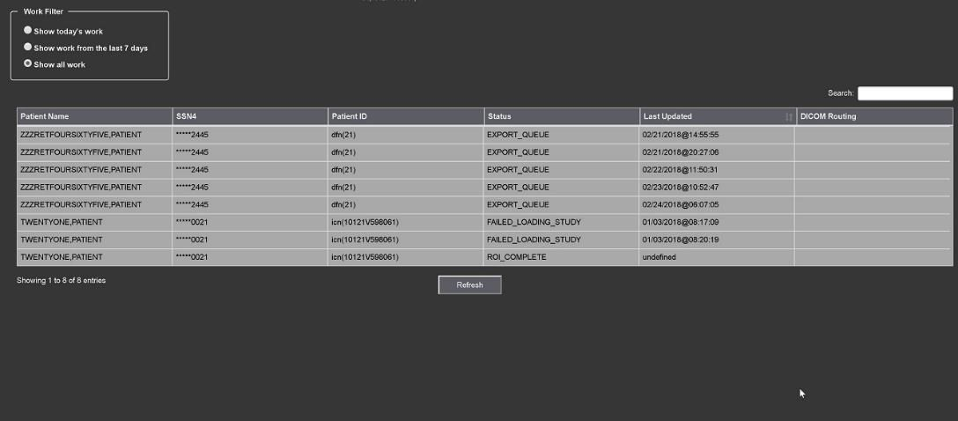

To perform ROI Submissions, click **ROI Submission** on the External Links menu and the following screen displays (Figure 15).

Figure 15: Print Queue

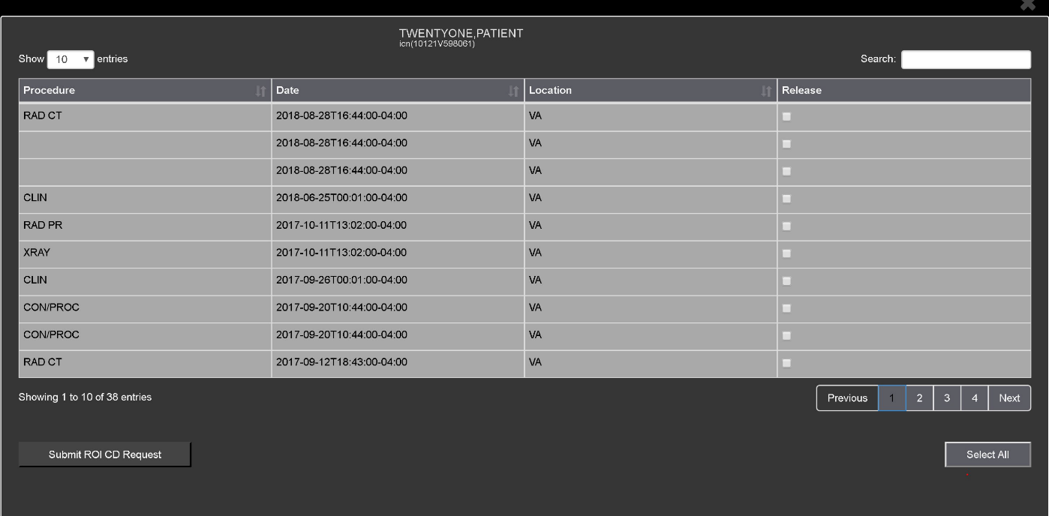

To print:

* Select one or more items and click **Submit** ROI CD Request, where CD stands for Compact Disc.
* Choose the target printer or CD (for DICOM images only) and the reason for printing.
* Enter the electronic signature. The selected items print to the chosen target.

## Using the Enhanced Image Viewer Toolbar

The toolbar provides buttons to access the Enhanced Image Viewer features while viewing an image. The Enhanced Image Viewer enables and disables (grays them out) the buttons depending on the image type. See Figure 16 for an example of a grayed-out toolbar button. See Figure 17 for an image of the toolbar.

Figure 16: Grayed out toolbar button

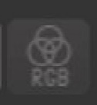

Figure 17: Toolbar



Table 3 describes the functions and uses of each button in the toolbar are described below*.*

Table 3: Toolbar Icons- Names, Functions, and Descriptions

| Button Icon | Button Name and Function | Description |
| --- | --- | --- |
| Window/Level | WW/WC (Window/Level) | Provides the ability to set the WW/WC (Window/Level) View. When you select the WW/WC button, click, and drag on the desired image to alter the grayscale value of the image. For Computerized Tomography (CT) images, a CT preset menu displays with the following options: Default, the Abdomen, the Bone, the Brain, the Head/Neck, the Lung, or to Customize. |
| Zoom | Zoom | Provides the ability to resize the image to 100%, or Fit to Window, or Fit Width to Window, or Fit Height to Window, or to Customize the sizing. When you select the Zoom button, click, and drag the image to zoom in and out. |
| Auto Window /Level | Auto Window /Level | Provides the ability to click and drag on the selected image to adjust the window/level. |
| Invert | Invert | Inverts the image. |
| Pan | Pan | After selecting this button, click, and drag the image to pan and view the desired area. |
| Rotate | Rotate | Rotates the Image 90 degrees counterclockwise. |
| Flip Horizontal | Flip Horizontal | Flips the Image horizontally. |
| Flip Vertical | Flip Vertical | Flips the Image vertically. |
| View Image Info | View Image Info | Displays the DICOM Attributes and Metadata for the Image. |
| Overlay | Overlay | The Overlay option toggles the overlay on and off. The Cross Reference Line option toggles the scout lines on and off. The Hide Annotation/Measurement option toggles the annotations and measurements the user has created on the image. |
| Settings | Settings | Provides the ability to set the Annotation, Cine, and Layout Preferences. For more information on the settings, see section 3.4.2 below. |
| Study Level | Study Level | Provides the ability to set the Study Level to lxl, lx2, lx3, 2xl,2x2, 2x3, 3xl, or 3x3. |
| Measurements | Measurements | Provides the ability to access the 2D Length, the Angle Tool, 2D Point, 2D Length Calibration, or Delete All. For more information on the measurement options, see section 3.4.5 below. |
| Red Green Blue (RGB) Tool | Red Green Blue (RGB) Tool | Accesses the RGB Tool. For more information on the RGB tool, see section 3.4.6 below. |
| Link | Link | Allows the user to select two image stacks and scroll. |
| Refresh | Refresh | Provides the ability to refresh the image to its original settings. |

### Viewing Information on an Image

To view images information, select the **Image Info Button**. To view the Digital Imaging and Communications in Medicine (DICOM) information, select **DICOM Header**, and a screen showing the DICOM Attributes displays as shown below (Figure 18).

Figure 18: DICOM Attributes

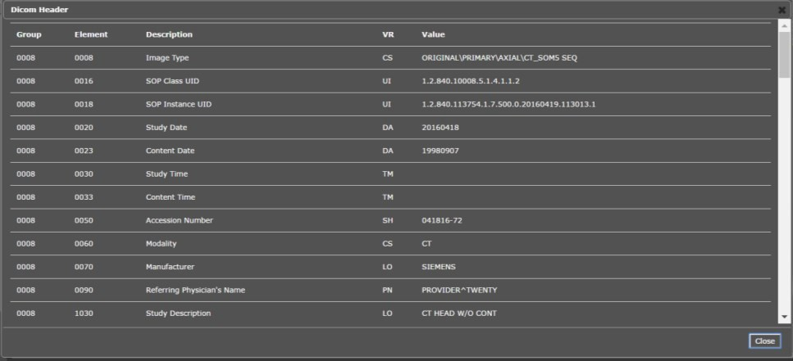

To view the Imaging Data for the Image, select the **Imaging Data option**, and a screen showing the Image Metadata displays as shown below (Figure 19):

Figure 19: Image Metadata

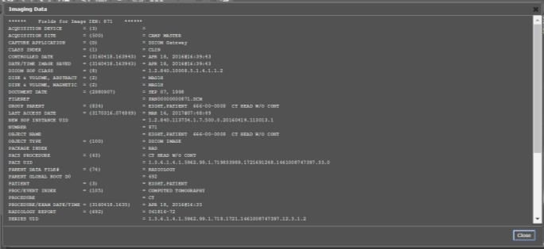

### Changing the Settings of an Image

Select the **Settings button** to view or update the settings options (Figure 20).

Figure 20: Settings Menu

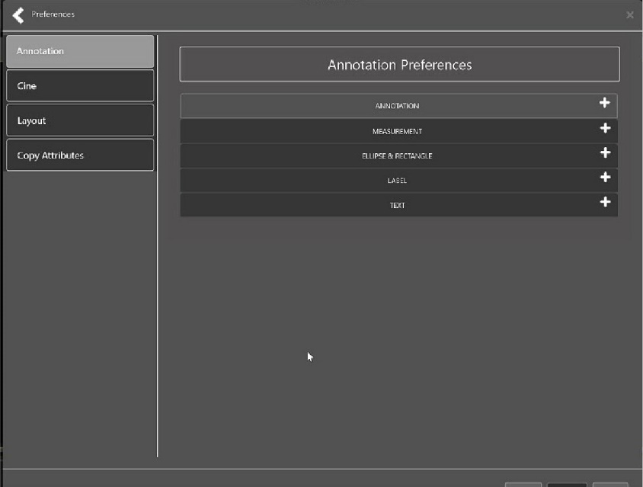

Click **Annotation**, and the following screen displays (Figure 21).

Figure 21: Annotations Preferences

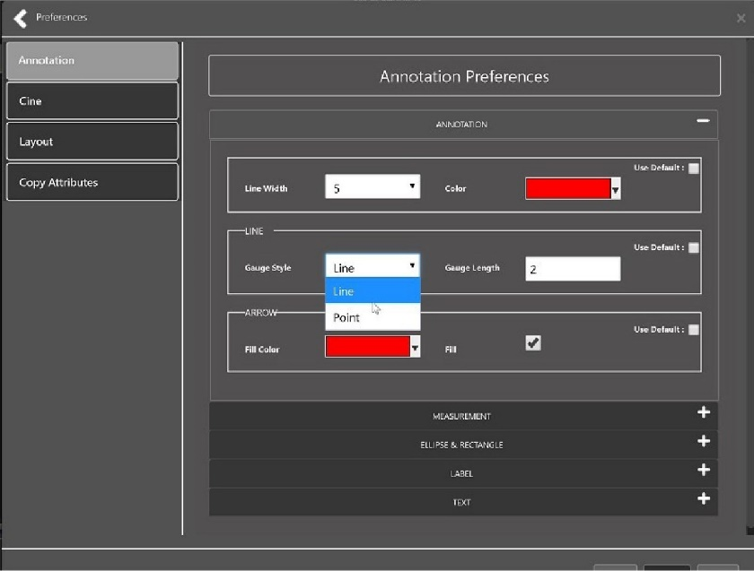

Click **Measurement**, and the following screen displays (Figure 22).

Figure 22: Measurement Preferences

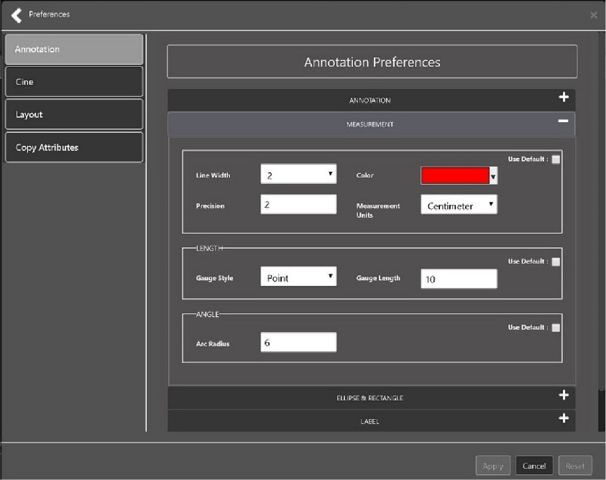

Click **Ellipse and Rectangle**, and the following screen displays (Figure 23):

Figure 23: Ellipse and Rectangle Preferences

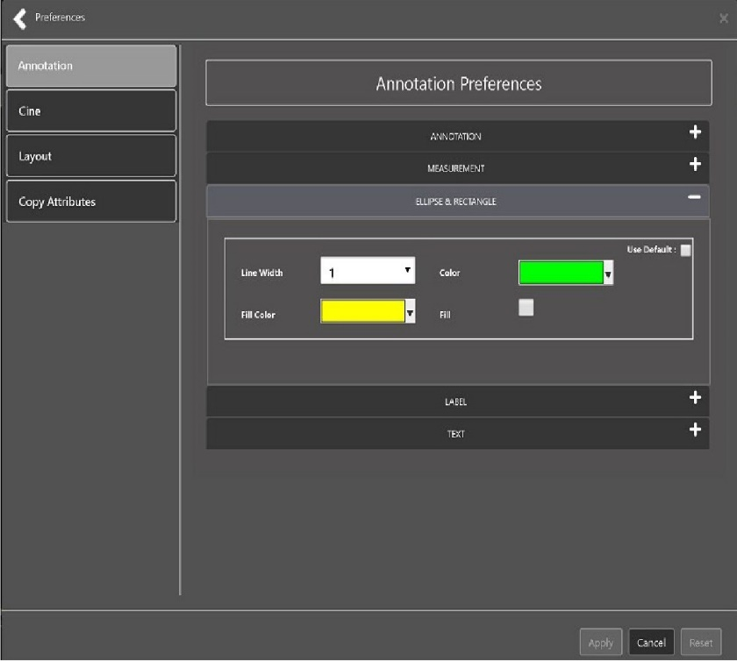

Click **Label**, and the following screen displays (Figure 24):

Figure 24: Label Preferences

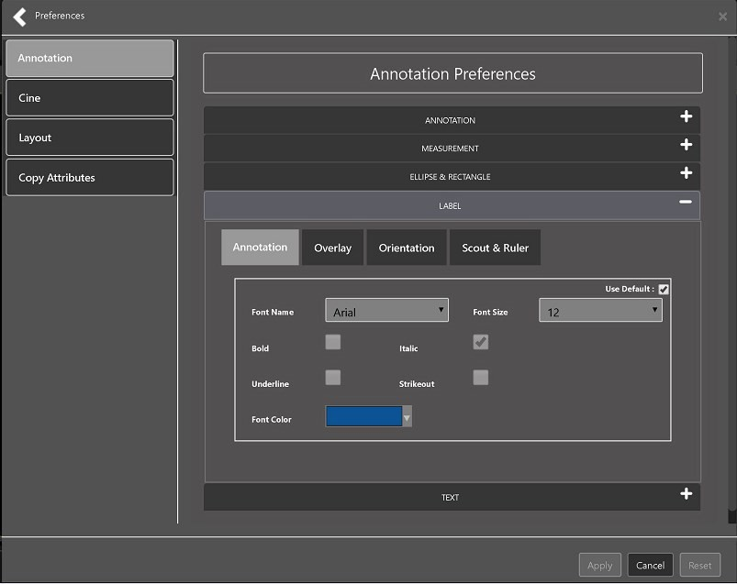

Under Label preferences, choose Annotation, Overlay, Orientation, or Scout & Ruler. Click **Text**, and the following screen displays (Figure 25):

Figure 25: Annotation Preferences

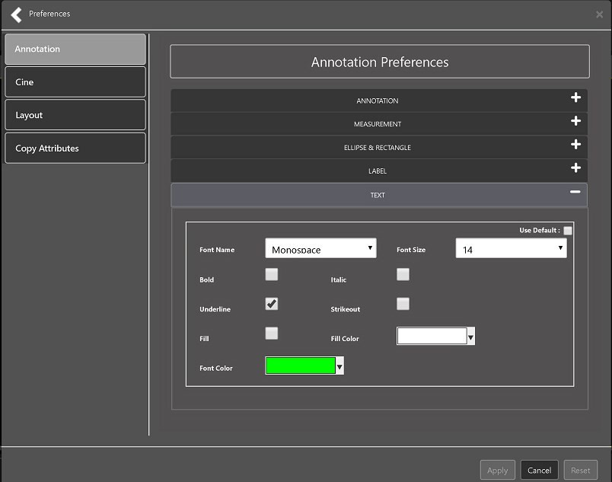

To view or update the Cine Settings, select the **Cine Preference** and the following screen displays (Figure 26):

Figure 26: Cine Preferences

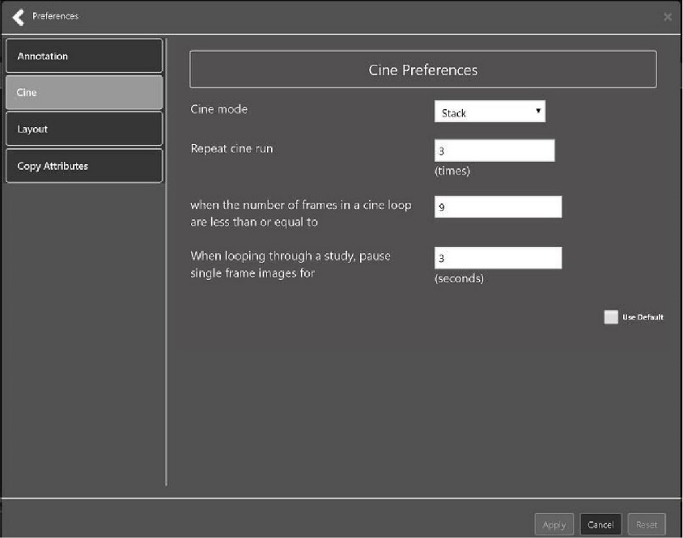

To view the Layout settings, select the **Layout Preference** to display the following screen (Figure 27):

Figure 27: Layout Preferences

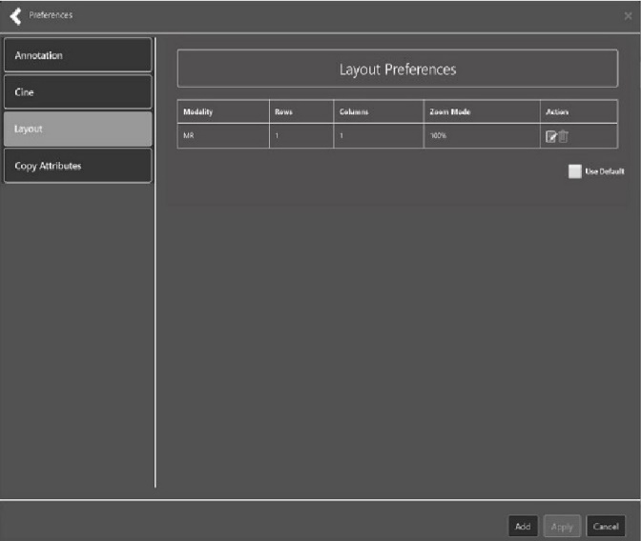

Click **Add** in the bottom right of the window to add a new layout preference (Figure 28).

Figure 28: Layout Preference Choices

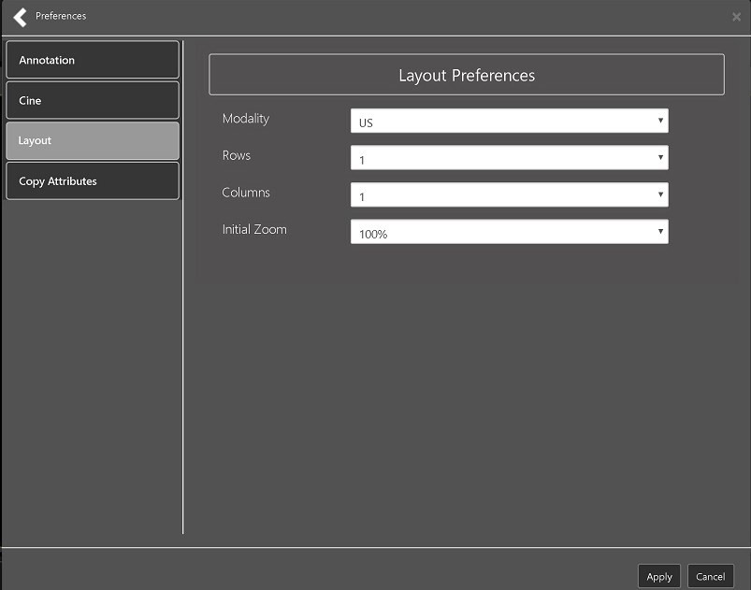

To view the Copy Attributes settings, select the **Copy Attributes Preference**, and the following screen displays (Figure 29):

Figure 29: Copy Attributes Preferences

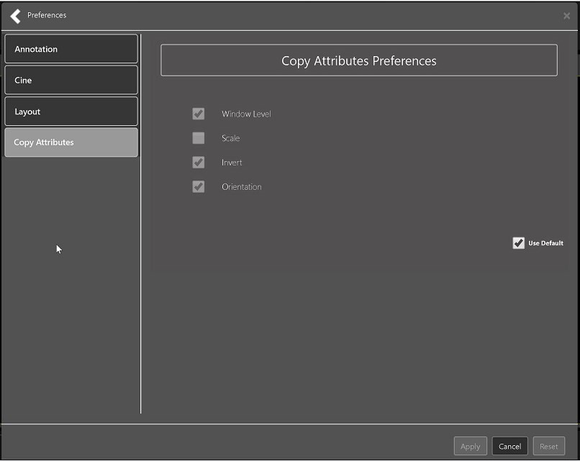

### Changing the Study Layout

To change the study layout, select the **Study Layout Button**, and the following screen displays (Figure 30):

Figure 30: Layout Attribute Preference Choices

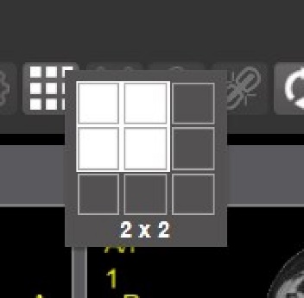

* Select the **study level** that best suits your purpose.

### Presentation State

To view presentation state options, click the **PS Icon** (Figure 31),and the following menu appears (Figure 32).

Figure 31: Presentation State button

Presentation State button

Figure 32: Presentation State Menu

Presentation State Menu

The presentation state icon is available only if there are presentation states associated with the study and there is an annotation drawn on the image. The bottom of the context menu displays all the saved presentation states associated with the study. To view additional information about a specific presentation state, hover over it in the context menu.

### Using the Measurements Tools

To use the various measurement tools, select the Measurements Button, and the following screens display (Figure 33, Figure 34, and Figure 35):

Figure 33: Measurement Tool View 1

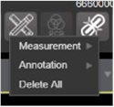

Figure 34: Measurement Tool View 2

Measurement Tool View 2

Figure 35: Measurement Tool View 3

Measurement Tool View 3

The **2D Length** option draws the necessary line(s) to obtain the desired measurements.

The **Angle Tool** draws the necessary line(s) to measure the desired angle.

The **2D Point** tool places the necessary dots to obtain the desired measurements. Use this option for ultrasound studies to measure velocity.

The **2D Length Calibration** option calibrates measurements to ensure accurate data. Images with DICOM info use the DICOM info to inform measurement calibration, but images without this data need calibration to show accurate data. See Figure 36 below.

Figure 36: 2D Length Calibration

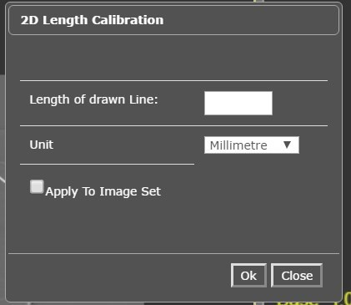

The **Hounsfield** tool takes circular and rectangular density measurements. See Figure 37 below.

Figure 37: Hounsfield Measurement Tools

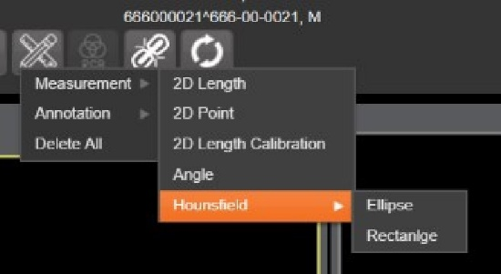

The **Text** tool creates text boxes on the image.

The **Line** tool draws straight lines on the image.

The **Arrow** tool draws straight arrows on the image.

The **Ellipse** tool draws ellipses on the image.

The **Rectangle** tool draws rectangles on the image.

The **Free Hand** tool connects points that have been specified by the user to create any desired shape.

To delete all the measurements and markings you made on the current image, select the **Delete All** option.

### Using the RGB Tool

The **RGB Tool** button filters the image for certain color channels to allow for various observations. When selected, a context menu (Figure 38) appears that allows you to select the desired color channel.

Figure 38: RGB Tool button

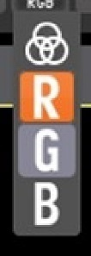

## Closing the Enhanced Image Viewer

To close the Enhanced Image Viewer window, click the "**X**" on the browser tab. See Figure 39 below.

Figure 39: Enhanced Image Viewer Close Button

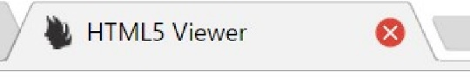

**NOTE:** The Enhanced Image Viewer closes automatically with a different patient selection.

# Image Quality Assurance (QA)

To use the image quality assurance features, load an image in the Enhanced Image Viewer (Figure 40).

Figure 40: Main Enhanced Image Viewer Window with Image loaded

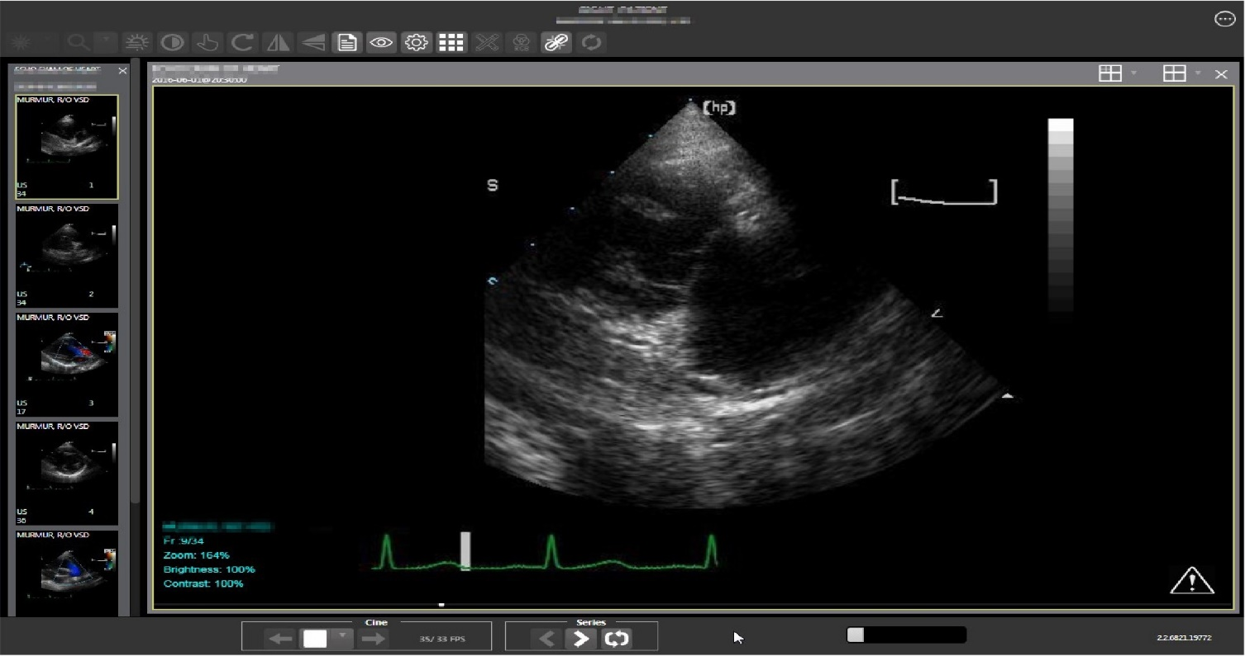

Click the **External Link button** on the Enhanced Image Viewer page and a drop-down menu (Figure 41) appears.

Figure 41: External Link with Drop Down Menu

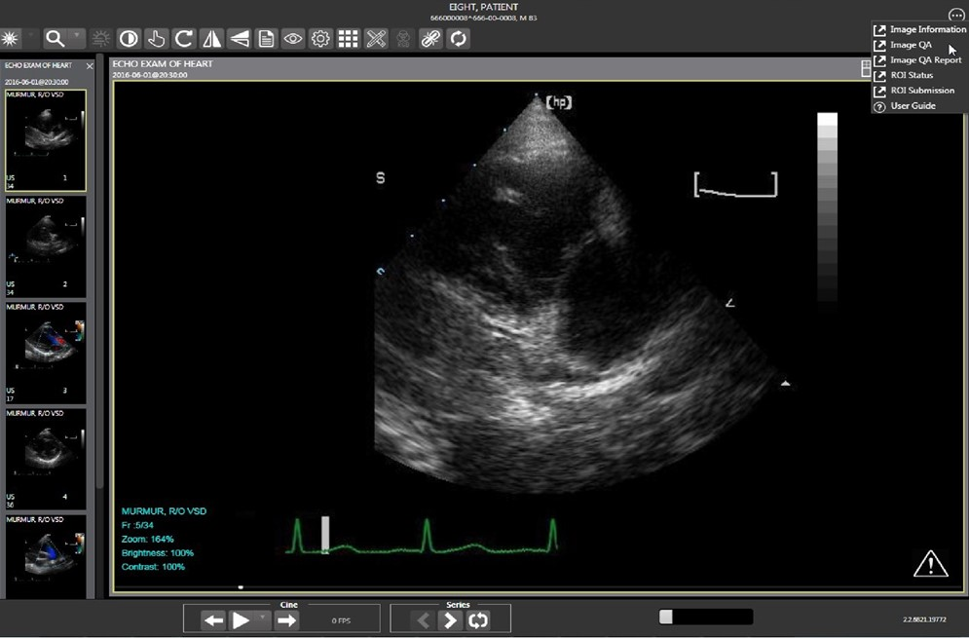

## Image Information

Select the **Image Information** link from the menu. The image information page (Figure 42) loads.

Figure 42: Image Information

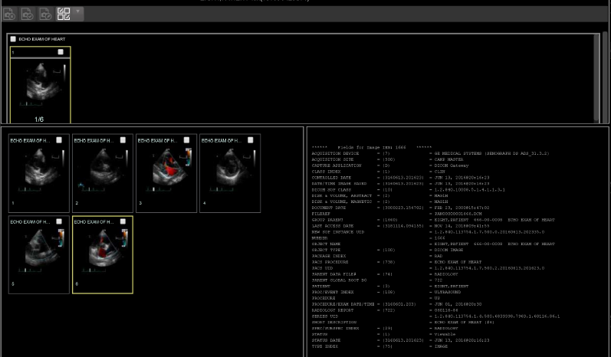

Select any image, then click **Image Edit** button on the toolbar. The image editor dialog (Figure 43) opens. To edit a field, click on the **checkbox** to the left to enable the dropdown control or the textbox. Click **Save** to save the image index fields. Figure 43 shows this.

Figure 43: Image Editor

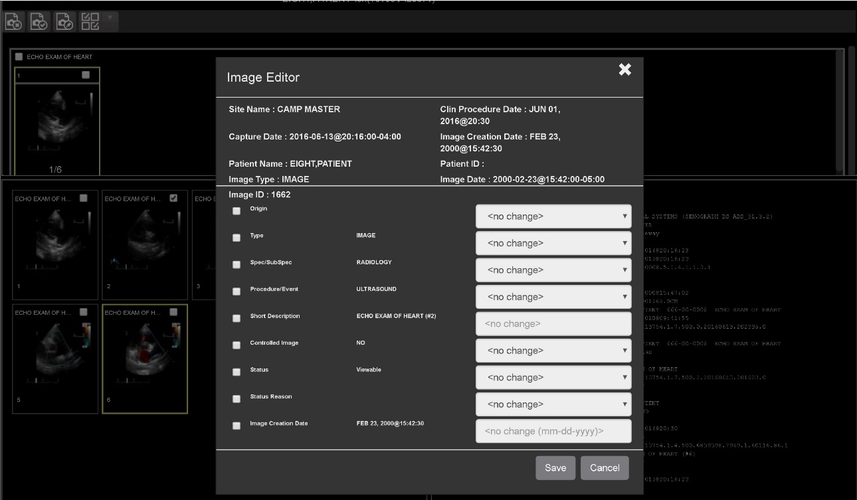

### Image QA

Select the **Image QA** from the external link to open the QA review page (Figure 44)*.*

Figure 44: QA Review Page

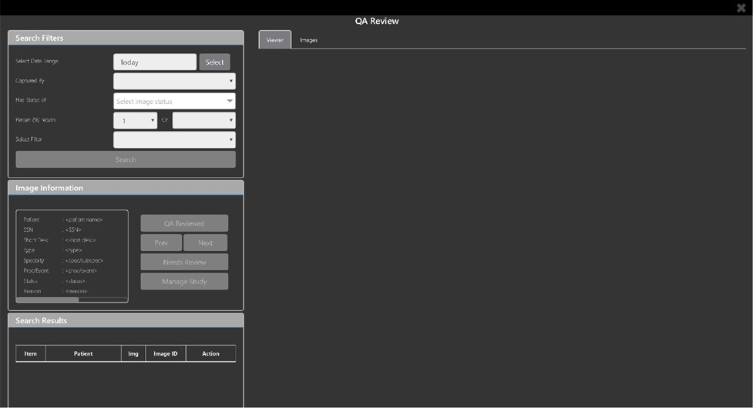

Click the **Select** button from the **Search Filters** group to open the **Select Date Range** window (Figure 45). Select a date range**.**

Figure 45: QA Filters and Date Range

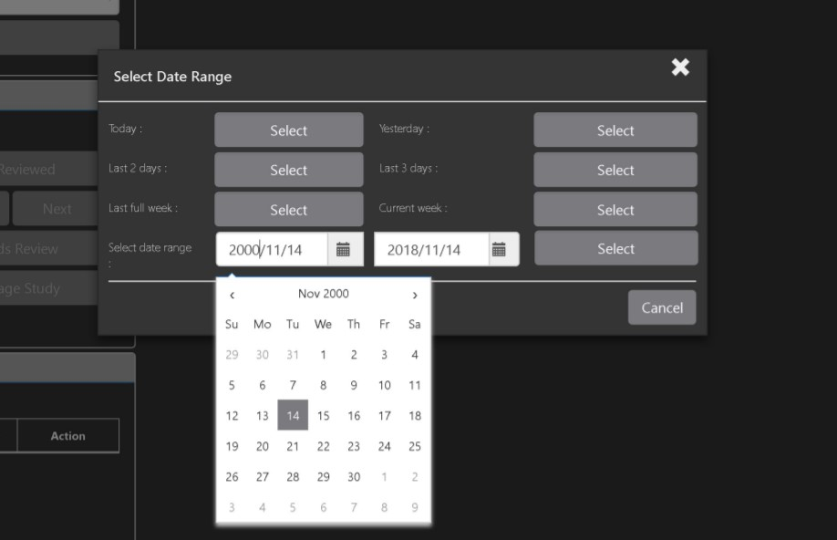

The **Captured By** dropdown populates with a list of valid users for the date range (Figure 46).

Figure 46: Search Filter Details

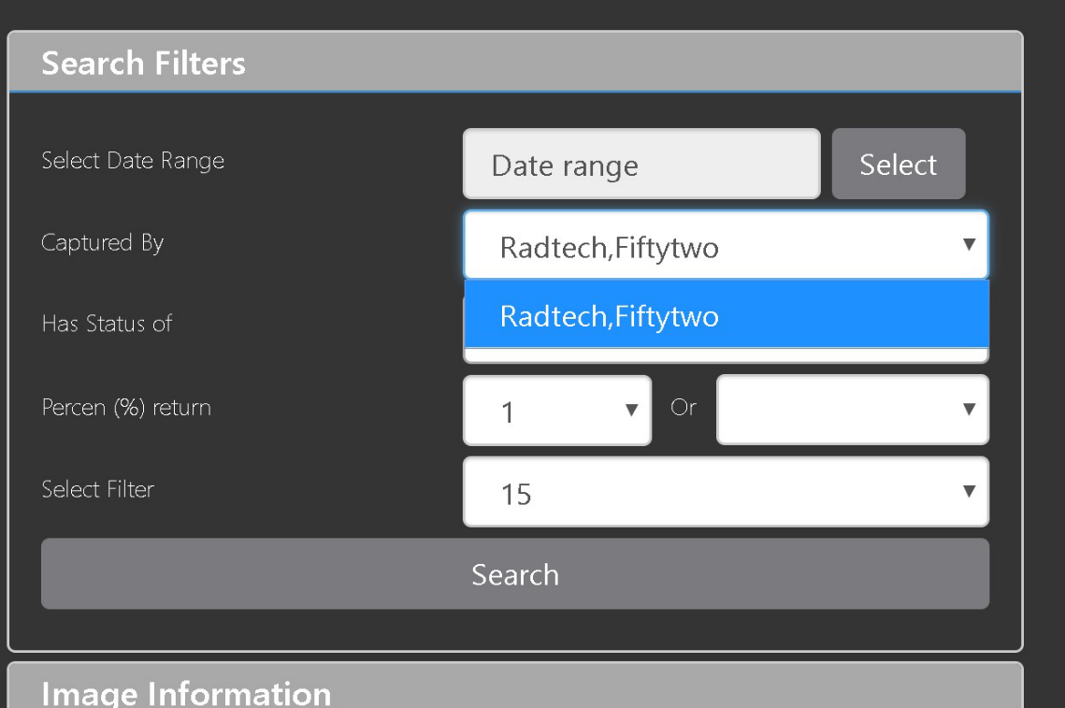

Click the **Has Status of** dropdown, and choose one or more images to choose the status (Figure 47).

Figure 47: QA Status Choices

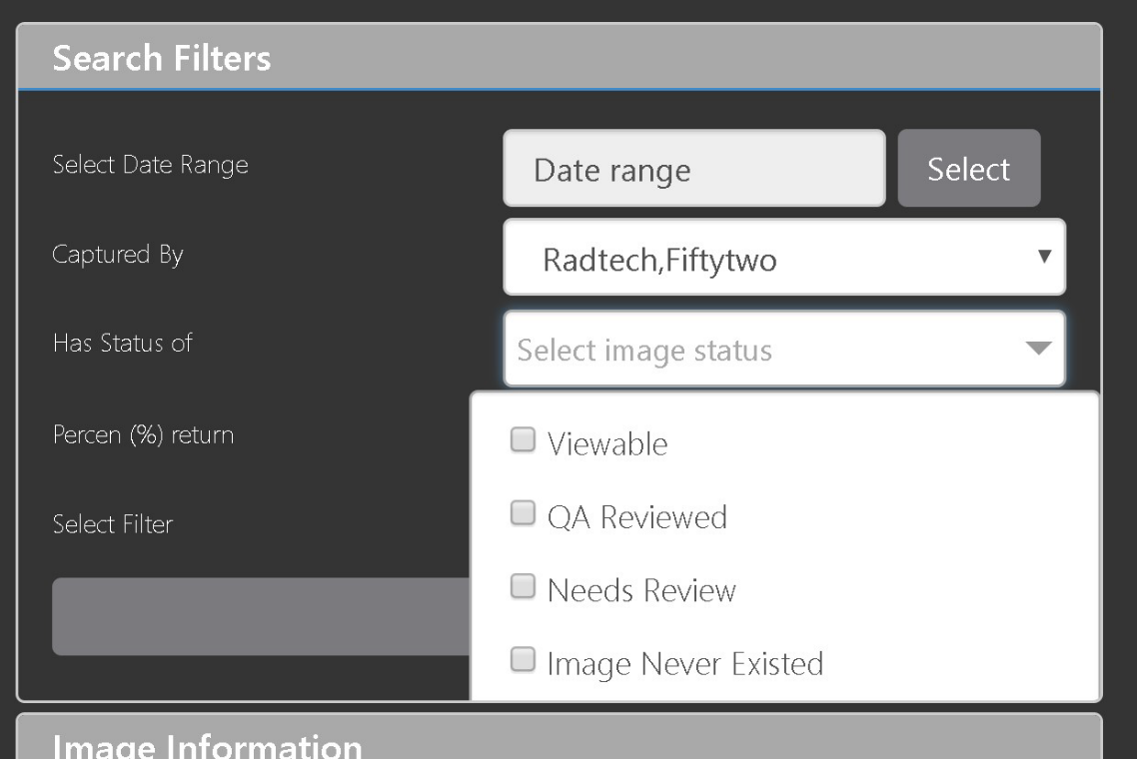

Restrict the study count in the search results using the % **return** dropdowns (Figure 48). The left dropdown is in the percentage of study items to display. The right dropdown is the maximum number of items to display.

Figure 48: Percentage of Images to display

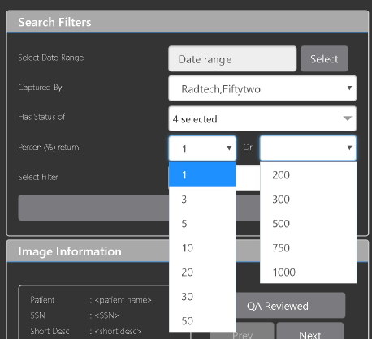

Choose a filter using the **Select Filter** dropdown (Figure 49).

Figure 49: Saved Filters

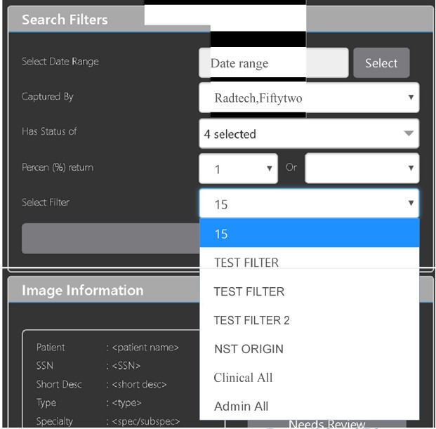

Click **Search** to search for studies. The first study in the list of studies found displays automatically on the right. Click on the **Viewer** icon (circled in red, Figure 50) to display the study. Click on the **Images** icon (circled in yellow, Figure 50) to display the images tab for the study.

Figure 50: QA Filter Results

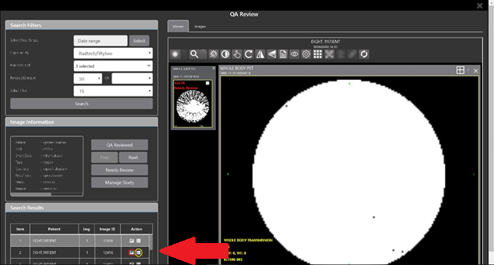

You can click on the **Images tab** at the top after displaying the study (Figure 51).

Figure 51: QA Filter Results and Image Information

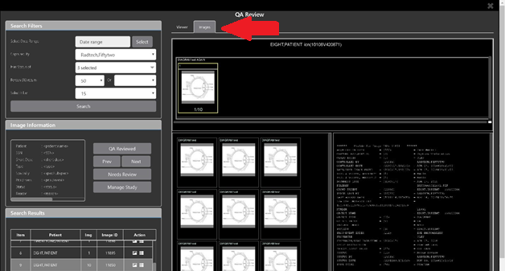

## Viewing and Setting Image Status

Click on an **image** in the thumbnail panel. Its image information, including the view status, displays in a panel on the left (highlighted in blue, Figure 52).

Figure 52: QA Thumbnail

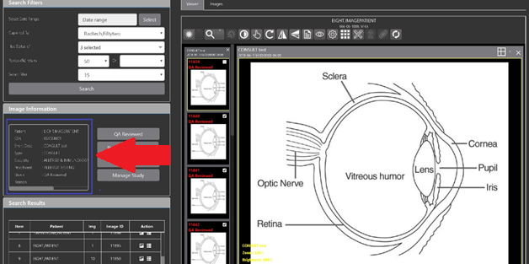

Click on an **image thumbnail** to display the corresponding image. More than one thumbnail can be selected using the shift key.

Click the **QA Reviewed** or **Needs Review** button to set the corresponding image status. You can also right-click on the image or the image thumbnail to set the image status (Figure 53).

Figure 53: QA Review Status Update Menus

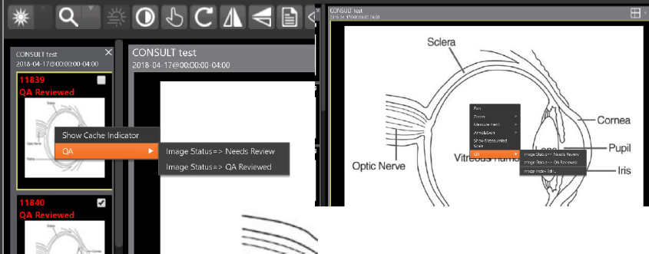

You can invoke the Image Index Editor window by clicking on the **Image Index Edit** menu item.

Use the **Prev** and **Next** buttons to traverse the search results.

Click the **Manage Study** button to display the **Images** tab for the study.

## Image QA Report

Select the **Image QA report** from the Enhanced Image Viewer page external link to open the QA Statistics Reports page (Figure 54).

Figure 54: QA Statistics Reports Page

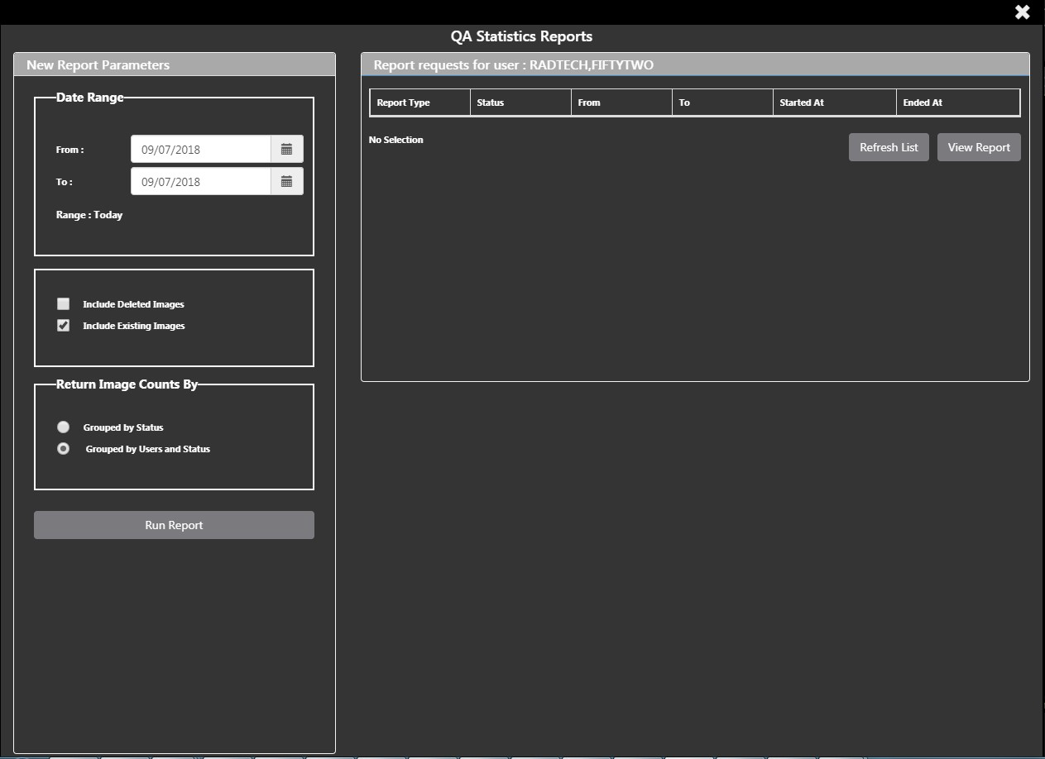

Fill the required fields in the report parameters and click the **Run Report** button (Figure 55).

Figure 55: Run QA Report

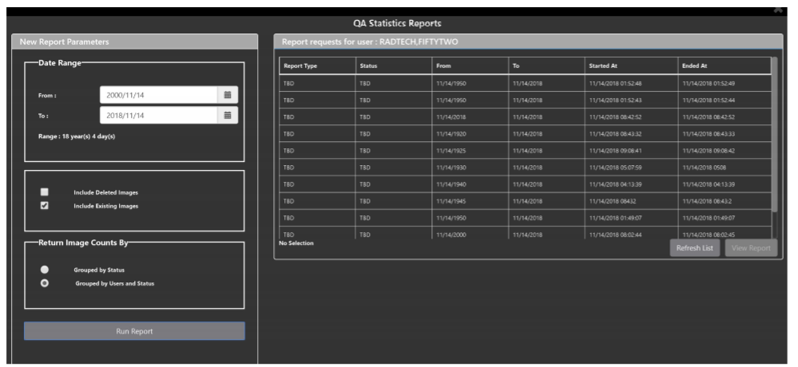

Select any item, and click **View Report button**, then the selected image report statistic loads (Figure 56).

Figure 56: View QA Report

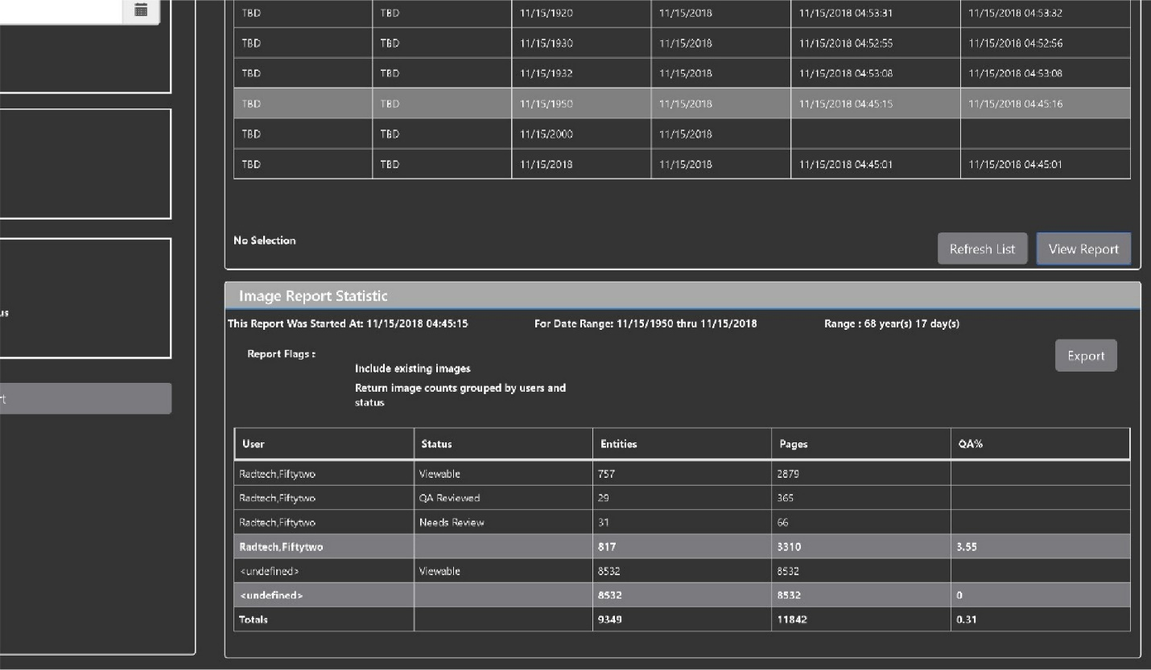

Click **Export** to generate a .csv file using the results.

# Troubleshooting

To display version information and message history about the Enhanced Image Viewer, first click the **Viewer Version Number** located in the lower right corner of the Enhanced Image Viewer window. See Figure 57 below.

Figure 57: Enhanced Image Viewer Version Number

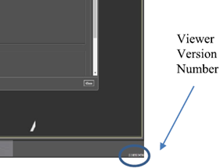

In the Viewer Information dialog (Figure 58) that opens, click on **Version History** to display version release information or click on **Message History** to display message history items.

Figure 58: Viewer Information Dialog

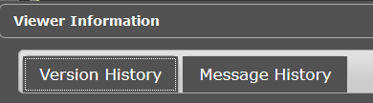

The **Imaging Info** found in the top toolbar can also be used for troubleshooting. See section 3.4.1 for more info.

# Acronyms

| Acronym/Term | Definition |
| --- | --- |
| Cache | A temporary storage place allowing fast access to data. |
| CD | Compact Disc |
| CPRS | Computerized Patient Record System |
| CT | Computerized Tomography |
| DICOM | Digital Imaging and Communications in Medicine |
| DoD | Department of Defense |
| Enhanced Image Viewer | Enhanced Image Viewer |
| FDA | Food and Drug Administration |
| ID | Identifier or Identification |
| JLV | Joint Legacy Viewer |
| QA | Quality Assurance |
| RGB | Red Green Blue |
| ROI | Release of Information |
| VA | Department of Veteran Affairs |
| VistA | Veterans Health Information System and Technology Architecture |
| VIX | VistA Imaging Exchange Services |
| WW/WC | Window Level |