VistA Imaging Exchange (VIX) STS Token Support

MAG*3.0*329

Enhanced Image Viewer User Guide



May 2023

Version 22.0

Department of Veterans Affairs (VA)

Office of Information and Technology (OIT)

**Revision History**

| Date | Revision | Description | Author |
| --- | --- | --- | --- |
| 05/01/2023 | 22.0 | Updated for MAG*3.0*329. Added multi-page TIFF imaging. | VA IT VistA Imaging Technical team |
| 11/01/2022 | 21.0 | Updated for MAG*3.0*303 | VA IT VistA Imaging Technical team |
| 04/05/2022 | 20.2 | Updates for MAG*3.0*269 T4 | VA IT VistA Imaging Technical team |
| 02/18/2022 | 20.1 | Updates for MAG*3.0*269 name | VA IT VistA Imaging Technical team |
| 10/18/2021 | 20.0 | Updated for MAG*3.0*269 | VA IT VistA Imaging Technical team |
| 05/21/2021 | 19.0 | Updated for MAG*3.0*284 | REDACTED |
| 07/27/2020 | 18.0 | Updated for MAG*3.0*254 | VA IT VistA Imaging Technical team |
| 06/19/2019 | 17.1 | Updated title page for MAG*3*230 remaining content is the same | REDACTED |
| 05/24/2019 | 17.0 | Updated screenshots with captions | REDACTED |
| 11/15/2018 | 16.0 | Additional MAG*3.0*221 Updates | REDACTED |
| 10/03/2018 | 15.0 | Updated for MAG*3.0*221 | REDACTED |
| 08/22/2018 | 14.0 | Updated for MAG*3.0*201 | REDACTED |
| 07/11/2018 | 13.0 | Additional MAG*3.0*197 Updates | REDACTED |
| 03/26/2018 | 12.0 | Updated for MAG*3.0*197 | REDACTED |
| 11/06/2017 | 11.0 | Additional MAG*3.0*185 Updates | REDACTED |
| 10/12/2017 | 10.0 | Initial MAG*3.0*185 Updates and Incorporated comments from reviewers. | REDACTED |
| 10/04/2017 | 9.0 | Removed ECG references. Date Updates | REDACTED |
| 09/06/2017 | 8.0 | Date Updates | REDACTED |
| 06/27/2017 | 7.0 | Updated for MAG*3.0*177 | REDACTED |
| 04/18/2017 | 6.0 | Formatting updates | REDACTED |
| 04/13/2017 | 5.0 | Formatting and screenshot updates | REDACTED |
| 04/06/2017 | 4.0 | Updated for MAG*3.0*170 | REDACTED |
| 03/24/2017 | 3.0 | Date Updates | REDACTED |
| 02/14/17 | 2.0 | Formatting updates and added  reference to Enhanced Image Viewer. Removed Radiology Viewer Section | REDACTED |
| 09/29/16 | 1.0 | Initial Draft | REDACTED |

Table of Contents

1. Introduction 8

1.1. Purpose 8

1.2. Document Orientation 8

1.2.1. Organization of the Manual 8

1.2.2. Assumptions 9

1.2.3. Coordination 9

1.2.4. Disclaimers 9

1.2.4.1. Software Disclaimer 10

1.2.4.2. Documentation Disclaimer 10

1.2.5. Documentation Conventions 10

1.2.6. References and Resources 10

1.3. Enterprise Service Desk and Organizational Contacts 11

2. System Summary 12

2.1. System Configuration 12

2.2. Data Flows 12

2.3. User Access Levels 12

2.4. Continuity of Operation 13

3. Getting Started 14

3.1. Logging On 14

3.2. System Menu and Main Viewer Page 15

3.3. Exit System 16

3.4. Caveats and Exceptions 16

4. Using the Software 17

4.1. Launching the Viewer 17

4.2. The Main Viewer Page 19

4.2.1. The Main Toolbar 20

4.2.2. Thumbnails and Image Loading 22

4.2.3. The Image Navigation Toolbars 24

4.3. Working with Images 25

4.3.1. Manipulating View Layout 25

4.3.2. Viewing DICOM Images 25

4.3.2.1. Viewing Stacked Images 25

4.3.3. Viewing Multi-Page TIFF Images 26

4.3.4. Viewing Normal Web Images 26

4.3.5. Viewing Documents 27

4.3.6. Printing an Image 27

4.3.7. Exporting an Image 28

4.3.8. External Links 29

4.3.8.1. Release of Information (ROI) Print Queue Status and ROI Submission 30

4.3.9. Viewing Information in an Image 31

4.3.10. Changing the Settings of an Image 32

4.3.11. Changing the Study Layout 37

4.3.12. Presentation State 37

4.3.13. Using the Measurements Tools 38

4.3.14. Using the RGB Tool 40

4.3.15. Conditions for Image Viewer Functions 40

4.4. Image Quality Assurance (QA) 41

4.4.1. Image Information 43

4.4.2. Image QA 44

4.4.3. Viewing and Setting Image Status 49

4.4.4. Image QA Report 50

4.5. Closing the Viewer 52

5. Troubleshooting 53

5.1. Special Instructions for Error Correction 53

6. Acronyms and Abbreviations 54

**Table of Figures**

Figure 1: Image Viewer System Summary 12

Figure 2: Main Viewer Page Snapshot 15

Figure 3: Loading Page 17

Figure 4: Images Not Loading 18

Figure 5: Main Viewer Page 19

Figure 6: Main Toolbar 20

Figure 7: Sample Disabled Toolbar Button 20

Figure 8: Main Viewer Page with Thumbnail Panel 22

Figure 9: Sample Image Navigation Toolbars 24

Figure 10: Frame Rate 24

Figure 11: Main Viewer Page with Images Loaded 26

Figure 12: PDF is Not Ready Status in the Lower Right Corner 26

Figure 13: PDF is Ready Status in the Lower Right Corner 26

Figure 14: Main Viewer Page with a Document Loaded 27

Figure 15: Print Menu 27

Figure 16: Print Menu - Device Selection 28

Figure 17: Exporting an Image 29

Figure 18: External Links Button in the Top Right Corner 29

Figure 19: External Links Menu 29

Figure 20: ROI Print Queue Status 30

Figure 21: Print Queue 30

Figure 22: DICOM Attributes 31

Figure 23: Image Metadata 31

Figure 24: Settings Menu 32

Figure 25: Annotations Preferences 32

Figure 26: Measurement Preferences 33

Figure 27: Ellipse and Rectangle Preferences 33

Figure 28: Label Preferences 34

Figure 29: Annotation Preferences 34

Figure 30: Cine Preferences 35

Figure 31: Layout Preferences 35

Figure 32: Layout Preference Choices 36

Figure 33: Copy Attributes Preferences 36

Figure 34: Layout Attribute Preference Choices 37

Figure 35: Presentation State Button 37

Figure 36: Presentation State Menu 37

Figure 37: Measurement Tool View 1 38

Figure 38: Measurement Tool View 2 38

Figure 39: Measurement Tool View 3 38

Figure 40: 2D Length Calibration 39

Figure 41: Hounsfield Measurement Tools 39

Figure 42: RGB Tool Button 40

Figure 43: Main Viewer Page with Image Loaded 41

Figure 44: External Links Menu on Main Viewer Page 42

Figure 45: Image Information 43

Figure 46: Image Editor 44

Figure 47: QA Review Page 44

Figure 48: QA Filters and Date Range 45

Figure 49: Search Filter Details 45

Figure 50: QA Status Choices 46

Figure 51: Percentage of Images to Display 46

Figure 52: Saved Filters 47

Figure 53: QA Filter Results 48

Figure 54: QA Filter Results and Image Information 48

Figure 55: QA Thumbnail 49

Figure 56: QA Review Status Update Menus 49

Figure 57: QA Statistics Reports Page 50

Figure 58: Run QA Report 51

Figure 59: View QA Report 51

Figure 60: Viewer Close Button 52

Figure 61: Viewer Version Number 53

Figure 62: Viewer Information Dialog 53

**Table of Tables**

Table 1: Toolbar Icons - Names, Functions, and Descriptions 20

Table 2: Thumbnail Elements, Names, Functions, and Descriptions 23

Table 3: Functions and Uses of the Image Navigation Toolbar Buttons 24

Table 4: Viewing Images and Manipulating View Layout 25

Table 5: Conditional Image Viewer Functions 40

# Introduction

## Purpose

This manual describes the "Viewer" web application which is also known as the:

* Central VistA Imaging Exchange (CVIX) Viewer
* Enhanced Image Viewer
* Image Viewer
* VistA Imaging Exchange (VIX) Viewer
* VistA Imaging Viewer

The Viewer displays and provides tools for clinical and medical media in web applications like the Joint Legacy Viewer (JLV). The media can be:

* Audios
* Data
* Documents (typically medical reports, with extensions of DOC, PDF, RTF, and TXT)
* Images
  + Digital Imaging and Communications in Medicine (DICOM)
  + Non-DICOM, such as Joint Photographic Experts Group (JPEG) and Tag Image File Format (TIFF)
* Videos

To keep things simple, henceforth in this document, we use the term images to identify all media types unless a specific type is applicable. We also use the term VIX to mean CVIX or VIX.

This manual assumes you are familiar with web applications. This manual also assumes you are using the Viewer with the latest release level. The release level appears on this document's cover page and at the top of its Revision History page. Section 5 describes how to see the complete release number on the main Viewer page.

## Document Orientation

### Organization of the Manual

This document contains the following sections to assist you in using the Viewer:

* **Section 1 – Introduction**  
  Describes the document and helps you to follow the document.
* **Section 2 – System Summary**  
  Describes a summary of the Viewer.
* **Section 3 – Getting Started**  
  Describes a quick overview to start using the Viewer.
* **Section 4 – Using the Software**Describes in-depth instructions how to use the Viewer. References the main and image navigation toolbars and buttons and explains how to close the Viewer. Describes how to use the Quality Assurance features of the Viewer.
* **Section 5 – Troubleshooting**Describes how to access some of the information contained in the Viewer. The information assists you in troubleshooting some issues that might occur when using the Viewer.
* **Section 6 - Acronyms**Defines the Acronyms and Terms used and referenced in this document.

### Assumptions

The user has been provided the appropriate active roles, menus, and security keys required for the VIX Viewer. Also, the user has basic knowledge of the use of a web browser, menu options, and navigation tools.

### Coordination

Use of the Viewer is subject to the following provisions:

**Caution:** Federal law restricts this device to use by or on the order of either a licensed practitioner or persons lawfully engaged in the manufacture or distribution of the product.

The Viewer is not intended for the primary interpretation of radiology exams. When the Viewer installs on approved and properly maintained hardware, primary interpretation of other image types is permissible by licensed practitioners at their discretion.

The Food and Drug Administration (FDA) classifies VistA Imaging and the Viewer (as a component of VistA Imaging) as a medical device. Unauthorized modification to VistA Imaging, including the Viewer, such as installing unapproved software, adulterates the medical device. The use of an adulterated medical device violates US federal law (21CFR820).

### Disclaimers

This is a controlled document. No changes to this document may be made without the express written consent of the VistA Imaging Office of Enterprise Development group.

While every effort has been made to assure the accuracy of the information provided, this document might include technical inaccuracies and/or typographical errors. Changes are periodically made to the information herein and incorporated into new editions of this document. Product names mentioned in this document might be trademarks or registered trademarks of their respective companies and are hereby acknowledged.

* VistA Imaging Office of Enterprise Development Department of Veterans Affairs
* Internet: <http://www.va.gov/imaging>
* Imaging VistA Imaging SharePoint: REDACTED

#### Software Disclaimer

This software was developed at the Department of Veterans Affairs by employees of the Federal Government in their official duties. Pursuant to Title 17 Section 105 of the United States Code, this software is not subject to copyright protection and is in the public domain. VA assumes no responsibility whatsoever for its use by other parties and makes no guarantees, expressed or implied, about its quality, reliability, or any other characteristic. We would appreciate acknowledgment if the software is used. This software can be redistributed and/or modified freely if any derivative works bear some notice that they are derived from it, and any modified versions bear some notice that they have been modified.

#### Documentation Disclaimer

The appearance of external hyperlink references in this manual does not constitute an endorsement by the VA of the website or the information, products, or services contained therein. The VA does not exercise any editorial control over the information you may find at these locations. Such links are provided and are consistent with the stated purpose of the VA.

### Documentation Conventions

This document uses the following conventions:

* Button names, menu names, and menu option names are shown in **Bold.**
* A vertical bar is used to separate menu choices. For example: "Click **File | Open"** means: "Click the **File** menu, then click the **Open** option."
* Keyboard shortcuts are shown like **Ctrl+C** which means to press the control (Ctrl) key on your keyboard, keep it pressed, and press the C key.
* When this document is used online, hyperlinks are indicated by blue text.
* Useful or supplementary information is shown in a **Tip.** Important or required information is shown in a **NOTE.**
* Critical information is indicated by: 

### References and Resources

Additional information about VistA Imaging can be found at:

* VistA Imaging: <http://www.va.gov/vdl/application.asp?appid=105>

## Enterprise Service Desk and Organizational Contacts

If you encounter any problems using the Viewer, contact your local Imaging Coordinator or support staff. If the problem cannot be resolved locally, use YourIT Service Desk Manager to place a service request, or contact the Enterprise Service Desk at REDACTED.

# System Summary

VistA Imaging provides formal authorization to a web application to embed, or host, the Image Viewer. The web-hosting application authorizes users to use its own functions as well as the functions in the Image Viewer.

Web-hosting applications, such as the JLV, embed the Image Viewer (Figure 1) in the host application's web page. The Image Viewer communicates with the CVIX/VIX application. The host application might also directly communicate with the CVIX/VIX application. The Image Viewer operates inside the VA network.

Figure 1: Image Viewer System Summary

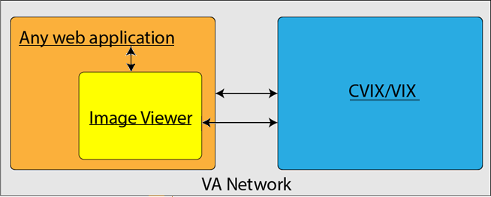

## System Configuration

The Viewer adds image display capabilities to web applications in a similar way as the Clinical Display desktop application adds image display capabilities to the Computerized Patient Record System (CPRS).

The Viewer is a web-based application that provides a subset of features of Clinical Display. This means it does not supply all features that Clinical Display offers.

## Data Flows

The Viewer is a web application that enables you to access patient images using VA approved versions of Chrome or Edge.

The Viewer allows users to locate and display any patient images available to the VA from VistA Imaging, including Department of Defense (DoD) images.

## User Access Levels

Users use a service account in VistA with the DICOM VISA [MAG DICOM VISA] and CPRSChart [OR CPRS GUI CHART] secondary menu options, at a minimum, to access the Image Viewer through the web application.

## Continuity of Operation

Since the Viewer is embedded in another application, the Viewer relies on the other application's continuity of operation.

# Getting Started

After logging into the web-hosting application and selecting a patient study, the hosting application launches the Viewer to display the study on its main page (Section 3.2).

## Logging On

To access the Viewer and authenticate, the user logs on through the web-hosting application. The hosting application logs in users to authenticate their credentials by getting a security token. This token is used throughout the Viewer's web pages.

## System Menu and Main Viewer Page

The image below (Figure 2) is a quick snapshot of the main Viewer page. Section 4.2 provides a complete description.

Figure 2: Main Viewer Page Snapshot

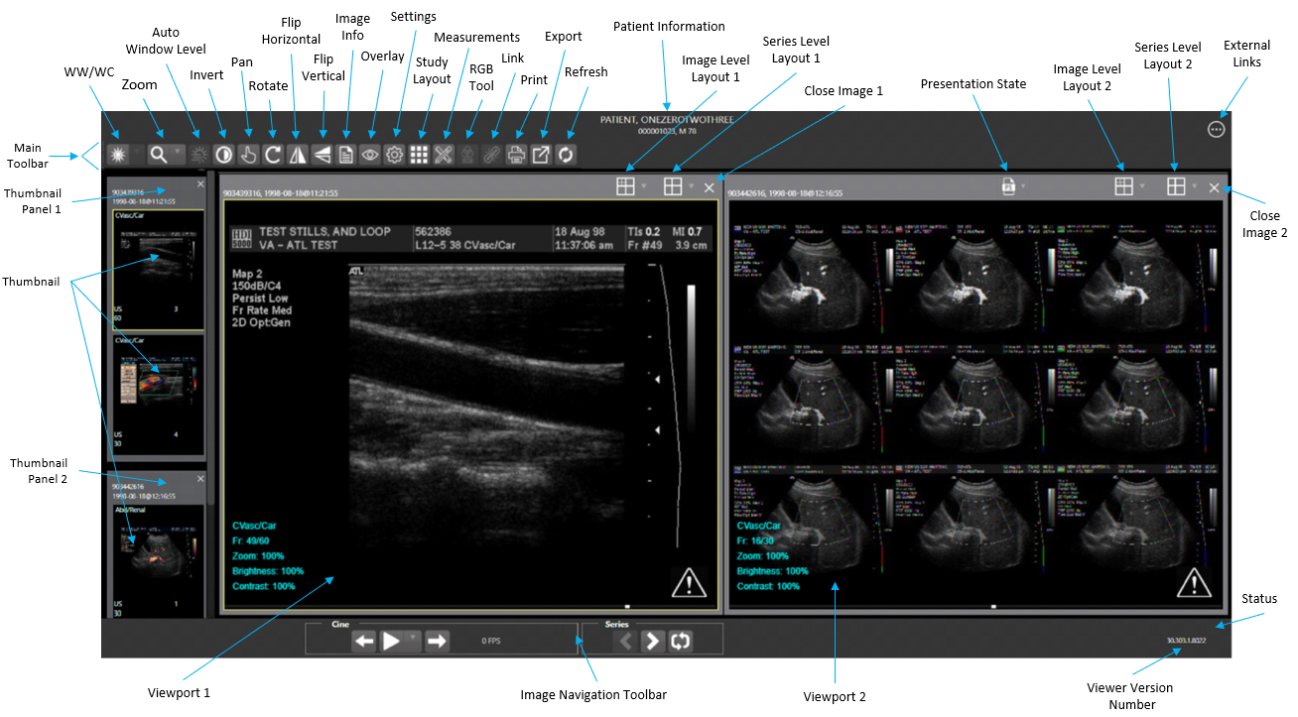

## Exit System

To exit the system, close the Viewer's web pages that are open in the web browser tab(s).

## Caveats and Exceptions

If encountering issues, clear the cache in the web browser for the Viewer, and refresh the page.

# Using the Software

This section describes how to use the Viewer web application.

## Launching the Viewer

Upon launching the Viewer, the following loading page (Figure 3) displays while the Viewer loads the study's images:

Figure 3: Loading Page



**NOTE:** The VA's and your network's bandwidth dictate the amount of time it takes to transfer the images. Some images can be very large which usually means they take a while to load, sometimes even minutes. The faster the bandwidth, the faster the computer can transfer data.

The first time a study launches, the Viewer pre-processes the study's images and loads them into a cache on the VIX server. Caching images reduces the load time for subsequent study views.

If there is trouble loading one or more images, the following page displays (Figure 4) with the option to either proceed or empty the cache and try again. If you select proceed, the study loads without the problem images. If you choose to empty the cache and retry, the Viewer attempts to re-process all the images for the study.

Figure 4: Images Not Loading

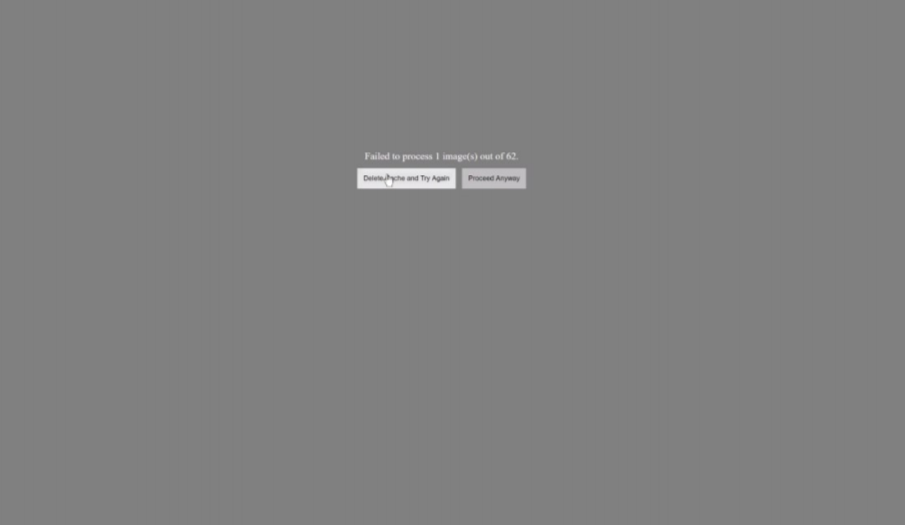

## The Main Viewer Page

When the main Viewer page opens, it shows the patient information, main toolbar, external links button, thumbnail panel(s), viewport(s), image navigation toolbar (Section 4.2.2), status, and Viewer version number (Figure 5). The Viewer displays thumbnail placeholders until the thumbnails are retrieved, then displays the images in the viewport(s). Section 4.3.15 describes the components that appear and are enabled according to the active viewport's image as indicated by a yellow outline.

Figure 5: Main Viewer Page



### The Main Toolbar

The main toolbar (Figure 6) provides buttons to access the Viewer functions while viewing an image. The Viewer enables (brightens) and disables (grays out, Figure 7) the buttons depending on the image type in the active viewport. See Figure 6 for an image of the toolbar.

Figure 6: Main Toolbar



Figure 7: Sample Disabled Toolbar Button

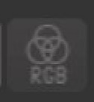

Table 1 describes the functions and uses of each button in the toolbar*.*

Table 1: Toolbar Icons - Names, Functions, and Descriptions

| Button Icon | Button Name and Function | Description |
| --- | --- | --- |
| Window/Level | **WW/WC** (Window Level) | Manually click and drag an image to make the Viewer alter the grayscale value of the image. For Computerized Tomography (CT) images, a preset dropdown menu displays with the following options: Default (the image as initially loaded and displayed), Abdomen, Bone, Brain, Head/Neck, Lung, and Customize. |
| Zoom | **Zoom** | Click and drag on an image to zoom in and out. A preset dropdown menu provides the options to resize the image to 100%, or Fit to Window, or Fit Width to Window, or Fit Height to Window, or to Customize the sizing. |
| Auto Window /Level | **Auto Window Level** | Click and drag a rectangular area on an image to adjust the window level based on the image's minimum pixel value. |
| Invert | **Invert** | Invert an image so that dark is light, and light is dark. |
| Pan | **Pan** | Click and drag an image to move its viewing area. |
| Rotate | **Rotate** | Rotate an image 90 degrees clockwise. |
| Flip Horizontal | **Flip Horizontal** | Flip an image horizontally. |
| Flip Vertical | **Flip Vertical** | Flip an image vertically. |
| View Image Info | **View Image Info** | Display an image's DICOM attributes and metadata. |
| Overlay | **Overlay** | Toggle the overlay on and off. The **Cross Reference Line** option toggles the scout lines on and off. The **Hide Annotation/Measurement** option toggles the annotations and measurements on the image. The **6000 Overlay** option appears when the image contains a 6000 Overlay and toggles its display on and off. |
| Settings | **Settings** | Set the Annotation, Cine, and Layout Preferences. For more information on the settings, see Section 4.3.10 below. |
| Study Level | **Study Level Layout** | Set the layout for displaying the study's viewports to lxl, lx2, lx3, 2xl, 2x2, 2x3, 3xl, 3x2, or 3x3 tiles. |
| Measurements | **Measurements** | Measure the 2D Length, the Angle Tool, 2D Point, 2D Length Calibration, or Delete All according to Section 4.3.13. |
| Red Green Blue (RGB) Tool | **RGB Tool** | Access the Red Green Blue (RGB) Tool as described in Section 4.3.14. |
| Link | **Link** | Select two image stacks and scroll. |
| Print | **Print** | Access the Print Tool as described in Section 4.3.6. |
| Export | **Export** | Access the Export Tool as described in Section 4.3.7. |
| Refresh | **Refresh** | Refresh the page to the original settings without reloading the images from the server. |

### Thumbnails and Image Loading

The following describes the steps that occur when the main Viewer page displays:

1. The thumbnail panel(s) display on the left side of the page.
2. The Viewer selects the first thumbnail, indicated by a yellow outline.
3. The Viewer displays the loading progress (Figure 8).
4. The Viewer displays the loaded image associated with the thumbnail in the viewport.
5. After the above steps are complete, you can click the thumbnail for your desired image if it isn't already selected, and its image displays in the viewport. Section 4.3 describes how to work with images.

Figure 8: Main Viewer Page with Thumbnail Panel

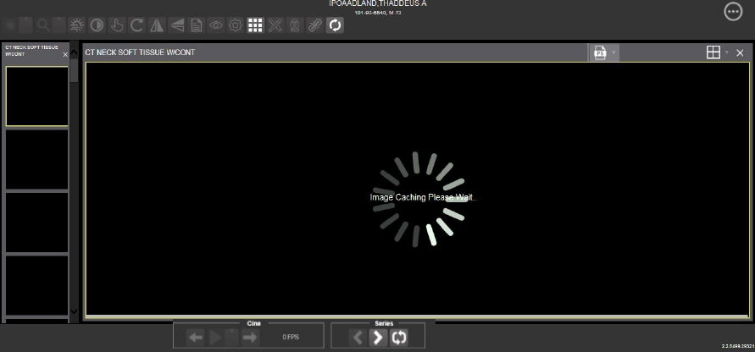

Table 2 describes the thumbnail elements.

Table 2: Thumbnail Elements, Names, Functions, and Descriptions

| Web Page Element | Element Name and Function | Description |
| --- | --- | --- |
| Thumbnail | **Thumbnail** | The title of the series appears at the top left of the thumbnail. The image type appears at the bottom left, with the number of images in the series directly below that. The series number displays on the bottom right of the thumbnail. For DICOM images, the modality code appears on the bottom left. |
| Thumbnail Panel | **Thumbnail Panel** | To adjust the size of the thumbnail panel, click and drag the right edge of the panel to the left or right. This affects how many thumbnails are shown per row within the panel but does not alter the size of the thumbnails. When hovering over the panel with stacked images, if you have a mouse wheel, you can use it to scroll between the different series thumbnails. Use drag-and-drop to drag thumbnails to the viewport. A yellow outline appears around the thumbnail that currently shows in the viewport. |

### The Image Navigation Toolbars

An image navigation toolbar appears automatically when the Viewer determines it applies to the image displayed in the active viewport. Figure 9 shows samples of these toolbars.

Figure 9: Sample Image Navigation Toolbars

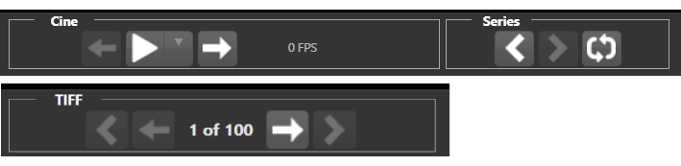

Table 3 describes the functions and uses of each button in the image navigation toolbar*.*

Table 3: Functions and Uses of the Image Navigation Toolbar Buttons

| Button Icon | Button Name and Function | Description |
| --- | --- | --- |
| Previous Series Next Series | **Previous Series and Next Series** | Navigate through the study's series. Alternatively, you can click the thumbnail for the series to view. |
| Previous Image Next Image | **Previous Image and Next Image** | Navigate through the active series' or TIFF's images. If you have a mouse wheel, you can also use it to scroll through the frames when you hover over the viewport. |
| Play  Stop | **Play and Stop** | Begin and end playing through a cine image scene. The down arrow changes forward or backward direction. |
| Repeat | **Repeat** | Select to repeat the series. Deselect to play through the series before repeating the series. |

While a series plays, a number (Figure 10) appears in the navigation toolbar. The number is the frame rate the series is currently playing.

Figure 10: Frame Rate

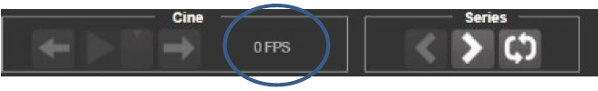

* **NOTE:** The first time a series plays, it might play slower while caching the images. Once the images are cached, the series plays faster.

## Working with Images

If the image in the active viewport is not the one you desire, you can:

* Click another viewport, if any.
* Click the thumbnail for your desired image, and its image displays in the viewport.

The remainder of this section explains how to work with images.

### Manipulating View Layout

Table 4 describes the buttons and functions to change how the images display in the viewport.

Table 4: Viewing Images and Manipulating View Layout

| Button Icon | Button Name and Function | Description |
| --- | --- | --- |
| Image Level Layout | **Image Level Layout** | Manipulates the number and position of the series' images that can display on the viewport. |
| Series Level Layout | **Series Level Layout** | Manipulates the number and position of the study's series that can display on the viewport. |
| Close Images | **Close Image** | Closes the currently selected image from the viewport. |

### Viewing DICOM Images

The Viewer displays DICOM images by simulating Picture Archiving and Communication System (PACS) functionality. For example, when a CT scan displays, you can manipulate its window level, zoom, annotate, and so on as described in Sections 4.2.1 and 4.2.3. You can work with other modalities in a similar fashion, but they do not support window leveling.

#### Viewing Stacked Images

Stacked images (such as for the CT, MR, and US modalities) represent a series, each with its own thumbnail in the thumbnail panel. When viewing a stacked image series and you have a mouse wheel, you can use it to scroll between the images in the stack when hovering over the thumbnail panel. You can also scroll through the stack by clicking the **Series** buttons described in Section 4.2.2.

Upon scrolling, if multiple series display in the viewport, scout lines appear on the images of the other series in a different plane to indicate what part of the body the series displays as shown in Figure 11 below.

Figure 11: Main Viewer Page with Images Loaded

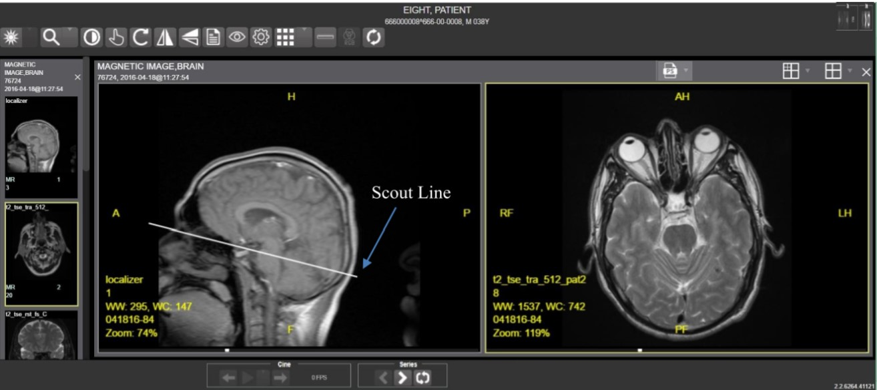

### Viewing Multi-Page TIFF Images

When an image is in the TIFF format and contains multiple pages, the Viewer converts each page to the JPEG format to display it easily and quickly in the browser. Meanwhile, behind the scenes, the Viewer converts the entire TIFF file to PDF, sets the statusto indicate the PDF is not yet ready (Figure 12), and disables the **Print** and **Export** main toolbar icons.

Figure 12: PDF is Not Ready Status in the Lower Right Corner

PDF is Not Ready Status in the Lower Right Corner

When the PDF is ready, the Viewer updates the status (Figure 13), enables the **Print** and **Export** main toolbar icons, and displays **Print** and **Export** options on the context menu as described in Sections 4.3.6 and 4.3.7.

Figure 13: PDF is Ready Status in the Lower Right Corner

PDF is Ready Status in the Lower Right Corner

You can use the **Next Image** and **Previous Image** navigation toolbar icons to move the displayed images forward and backward as described in Section 4.2.3.

### Viewing Normal Web Images

The Viewer enables most main toolbar icons when displaying normal web images such as JPEG and single-page TIFFs. Window leveling, however, does not apply.

### Viewing Documents

When viewing a document, the document viewport displays (Figure 14), and the Viewer disables most of the main toolbar icons. The display might look different than shown depending on the browser.

Figure 14: Main Viewer Page with a Document Loaded

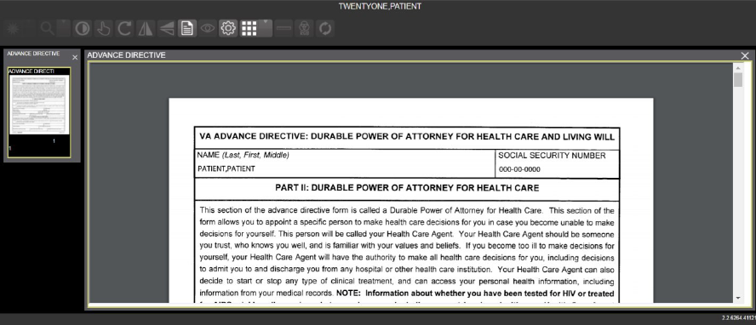

### Printing an Image

To print an image, do one of the following:

* Click the **Print** main toolbar icon.
* Right-click on the image to display a context menu. See Figure 15 below for an example.

**NOTE:** For non-Claims users, their VistA account requires the MAG ROI or MAG SYSTEM keys to print an image. Claims users have special permission to print.

Figure 15: Print Menu

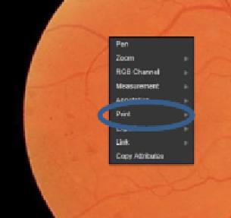

After selecting the print option, you can select print options. You must select a print reason and enter your digital signature. After selecting the print options, the image opens in a new tab in a printable form. You can now print the image by selecting **File** | **Print**, or **Ctrl+P**. See Figure 16 below for an example.

Figure 16: Print Menu - Device Selection

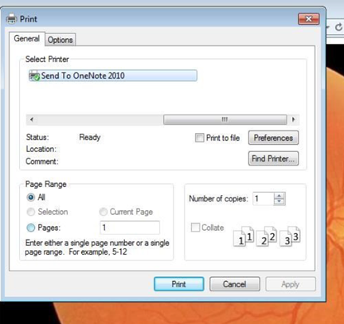

### Exporting an Image

To export an image, do one of the following:

* Click the **Export** main toolbar icon.
* Right-click on the image to display a context menu. See Figure 17 for an example.

**NOTE:** For non-Claims users, their VistA account requires the MAG ROI or MAG SYSTEM keys to export an image. Claims users have special permission to export.

Figure 17: Exporting an Image

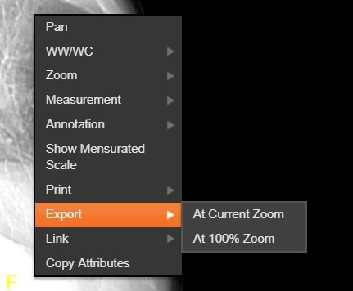

After selecting the desired zoom, you must enter the digital signature before the image exports.

### External Links

Click the button in the top right corner (Figure 18) of the Viewer page to view the **External Links** menu (Figure 19).

Figure 18: External Links Button in the Top Right Corner

External Links Button in the Top Right Corner 

Figure 19: External Links Menu

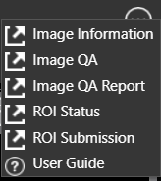

#### Release of Information (ROI) Print Queue Status and ROI Submission

To view the ROI Print Queue Status, click **ROI Status** on the **External Links** menu, and the following screen displays (Figure 20).

Figure 20: ROI Print Queue Status

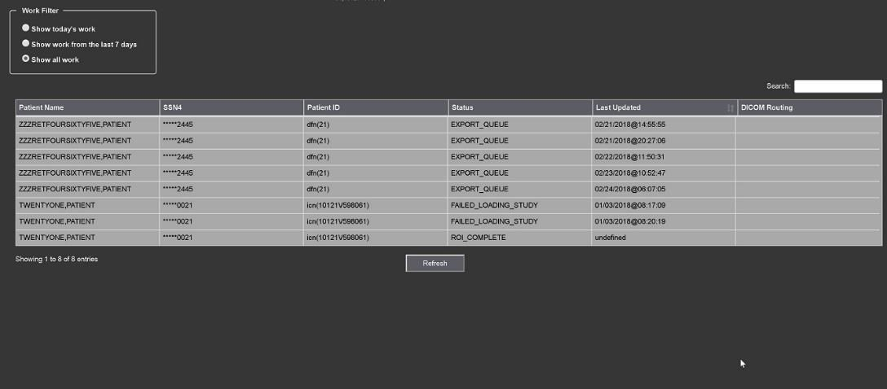

To perform ROI Submissions, click **ROI Submission** on the **External Links** menu and the following screen displays (Figure 21).

Figure 21: Print Queue

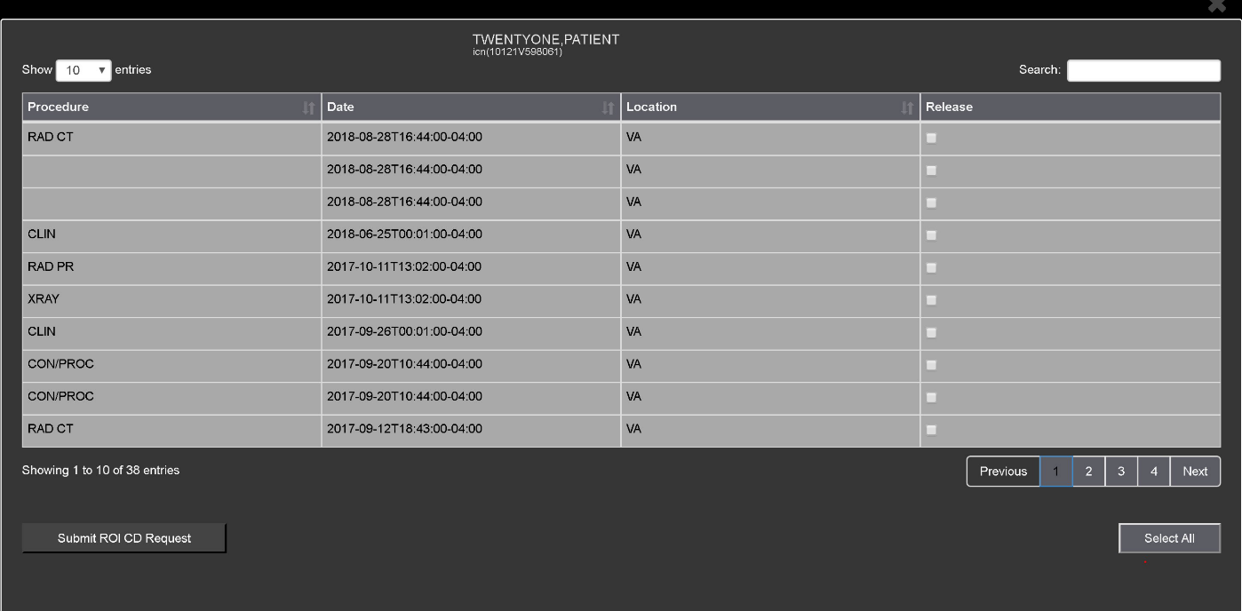

To print:

* Select one or more items and click **Submit** ROI CD Request, where CD stands for Compact Disc.
* Choose the target printer or CD (for DICOM images only) and the reason for printing.
* Enter the electronic signature. The selected items print to the chosen target.

### Viewing Information in an Image

To view the image's information, select the **View Image Info** button. To view the DICOM information, select **DICOM Header**, and the screen shows the DICOM attributes as shown below (Figure 22).

Figure 22: DICOM Attributes

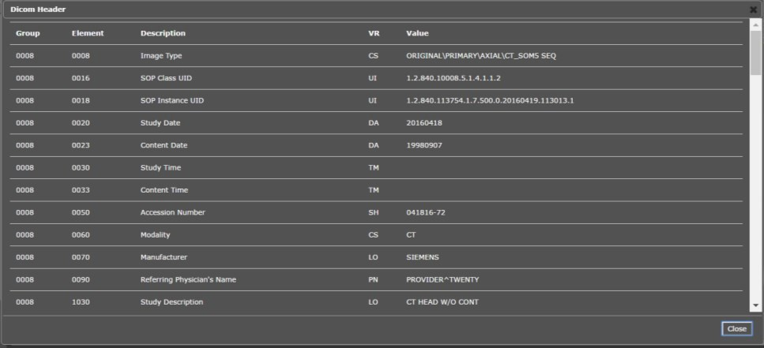

To view the Imaging Data for the Image, select the **Imaging Data** option, and the screen displays the image's metadata as shown below (Figure 23).

Figure 23: Image Metadata

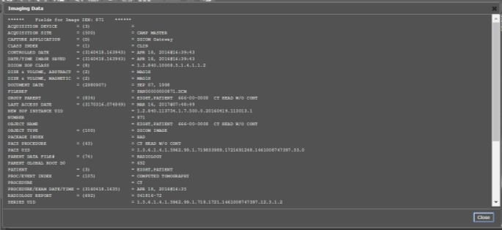

### Changing the Settings of an Image

Select the **Settings** button to view or update the settings options (Figure 24).

Figure 24: Settings Menu

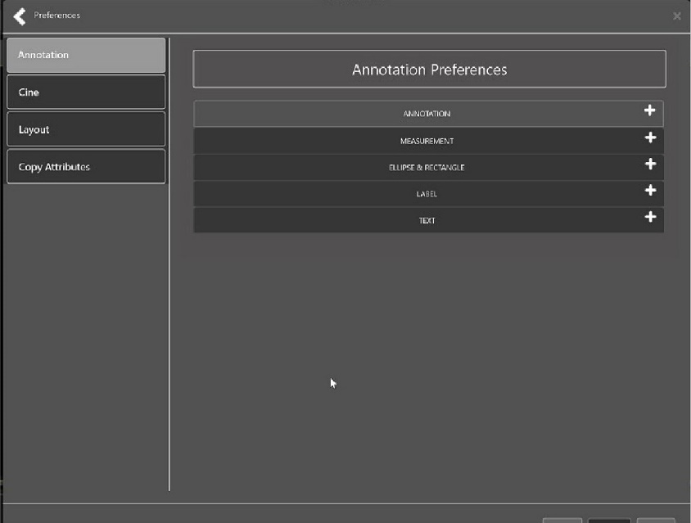

Click **Annotation**, and the following screen displays (Figure 25).

Figure 25: Annotations Preferences

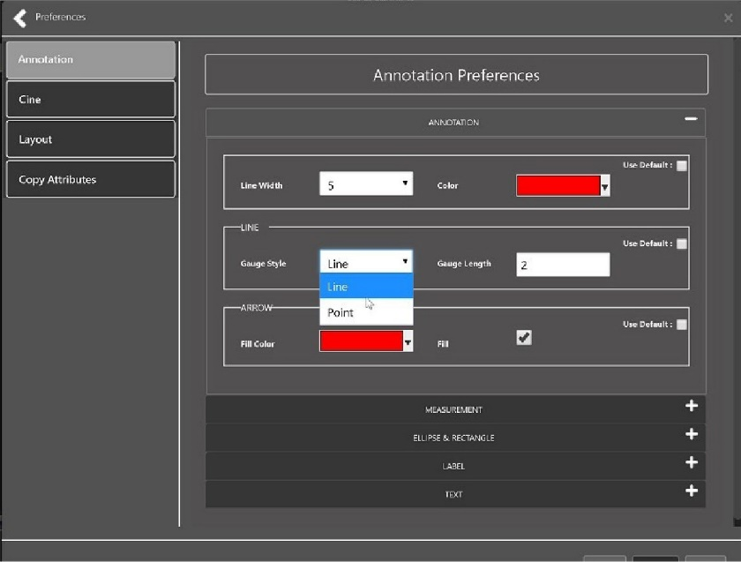

Click **Measurement**, and the following screen displays (Figure 26).

Figure 26: Measurement Preferences

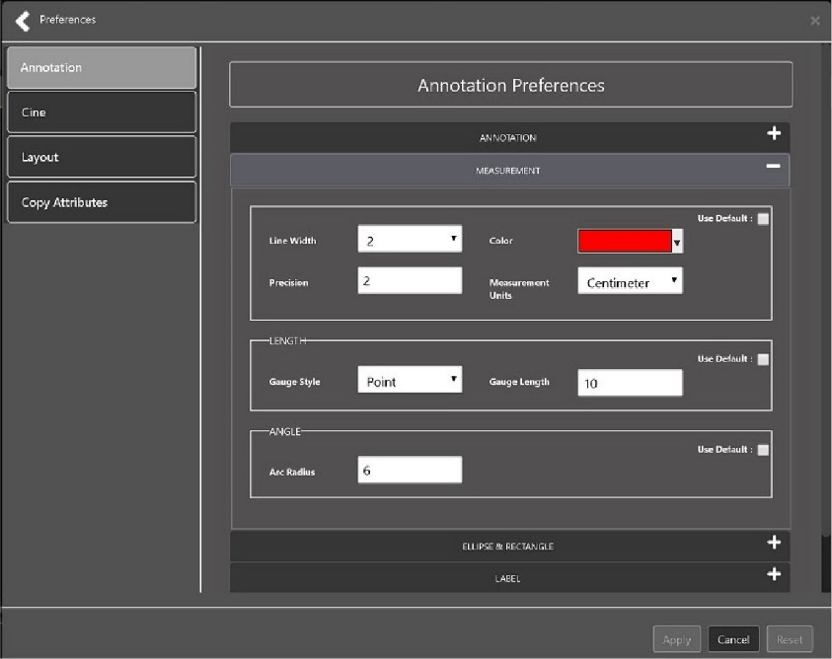

Click **Ellipse and Rectangle**, and the following screen displays (Figure 27).

Figure 27: Ellipse and Rectangle Preferences

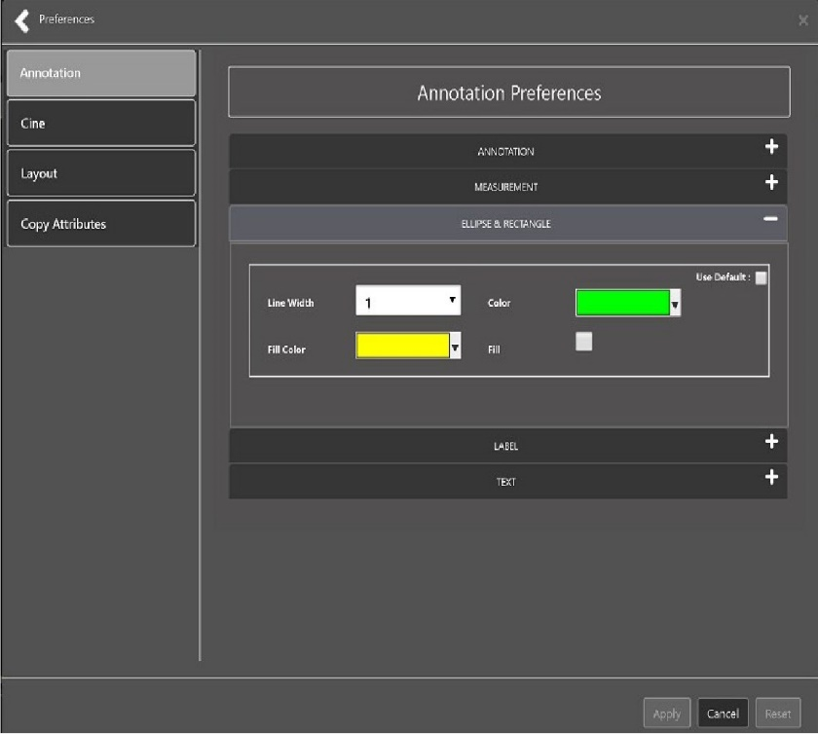

Click **Label**, and the following screen displays (Figure 28).

Figure 28: Label Preferences

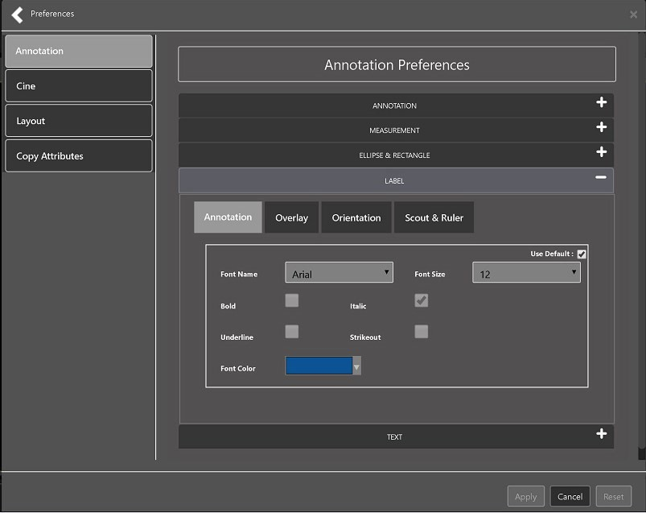

Under Label preferences, choose Annotation, Overlay, Orientation, or Scout & Ruler. Click **Text**, and the following screen displays (Figure 29).

Figure 29: Annotation Preferences

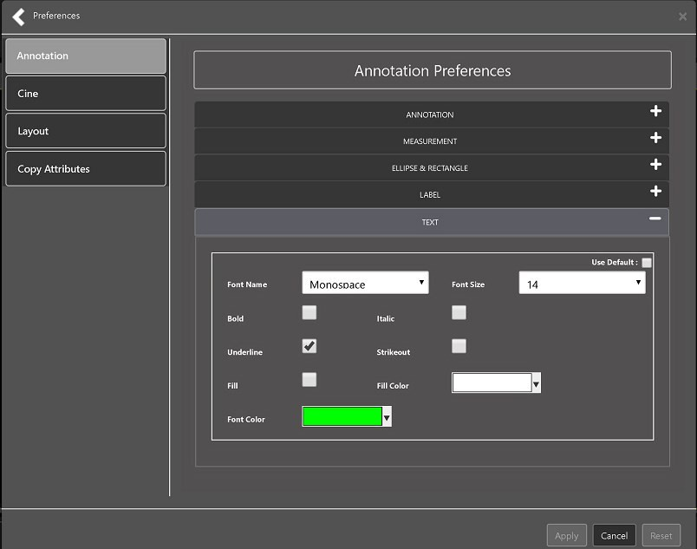

To view or update the Cine Settings, select the **Cine Preference** and the following screen displays (Figure 30).

Figure 30: Cine Preferences

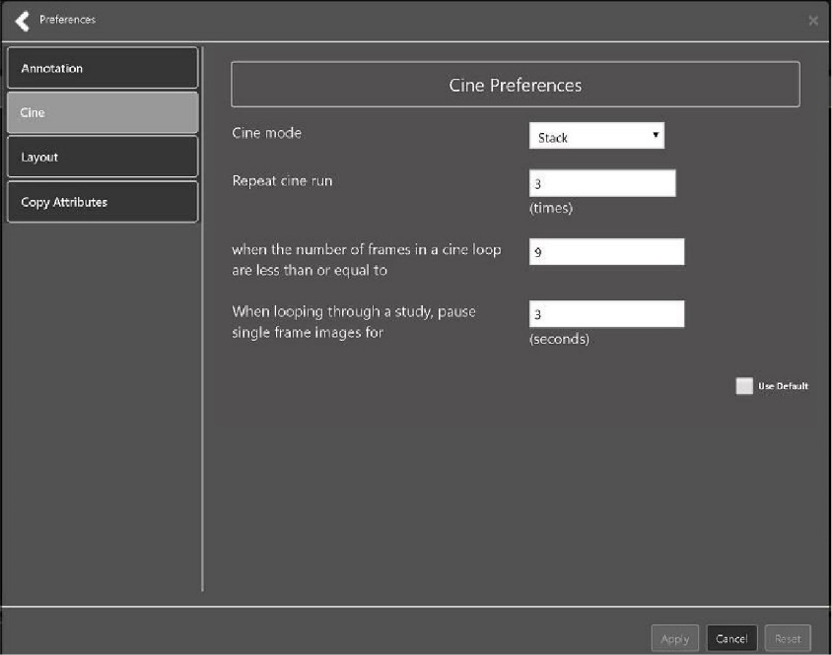

To view the Layout settings, select the **Layout Preference** to display the following screen (Figure 31).

Figure 31: Layout Preferences

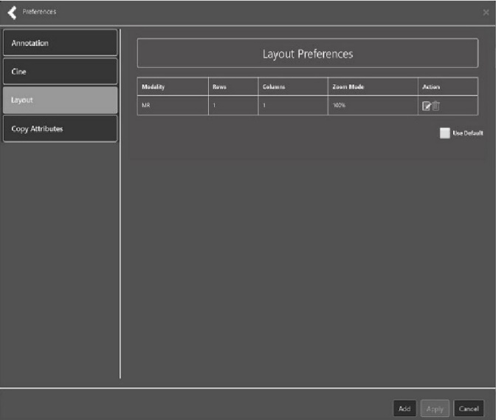

Click **Add** in the bottom right of the page to add a new layout preference (Figure 32).

Figure 32: Layout Preference Choices

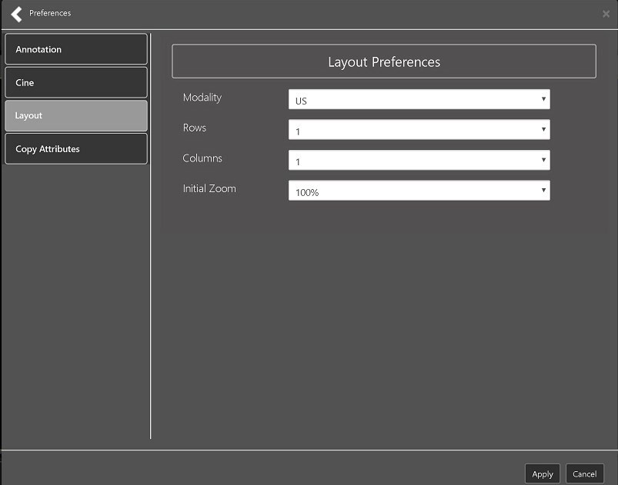

To view the Copy Attributes settings, select the **Copy Attributes Preference**, and the following screen displays (Figure 33).

Figure 33: Copy Attributes Preferences

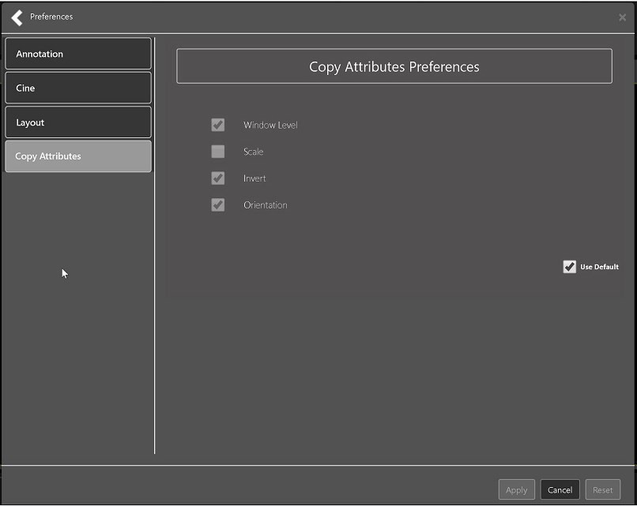

### Changing the Study Layout

To change the study layout, select the **Study Layout Button**, and the following screen displays (Figure 34).

Figure 34: Layout Attribute Preference Choices

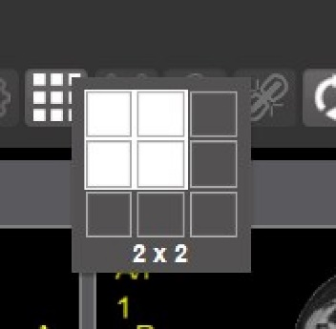

Select the **study level** that best suits your purpose.

### Presentation State

To view presentation state options, click the **PS Icon** (Figure 35),and the following menu appears (Figure 36).

Figure 35: Presentation State Button

Presentation State button

Figure 36: Presentation State Menu

Presentation State Menu

The presentation state icon is available only if there are presentation states associated with the study and there is an annotation drawn on the image. The bottom of the context menu displays all the saved presentation states associated with the study. To view additional information about a specific presentation state, hover over it in the context menu.

### Using the Measurements Tools

To use the various measurement tools, select the **Measurements** button, and the following screens display depending on the option you choose (Figure 37, Figure 38, and Figure 39).

Figure 37: Measurement Tool View 1

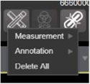

Figure 38: Measurement Tool View 2

Measurement Tool View 2

Figure 39: Measurement Tool View 3

Measurement Tool View 3

The **2D Length** option draws the necessary line(s) to obtain the desired measurements.

The **Angle Tool** draws the necessary line(s) to measure the desired angle.

The **2D Point** tool places the necessary dots to obtain the desired measurements. Use this option for ultrasound studies to measure velocity.

The **2D Length Calibration** option calibrates measurements to ensure accurate data. Images with DICOM info use the DICOM info to inform measurement calibration, but images without this data need calibration to show accurate data. See Figure 40 below.

Figure 40: 2D Length Calibration

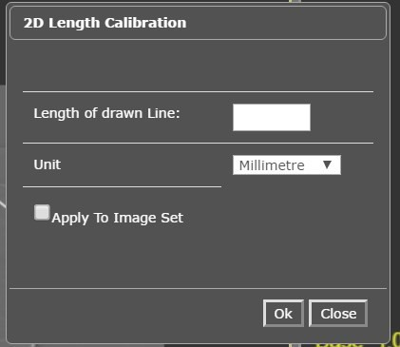

The **Hounsfield** tool takes circular and rectangular density measurements. See Figure 41 below.

Figure 41: Hounsfield Measurement Tools

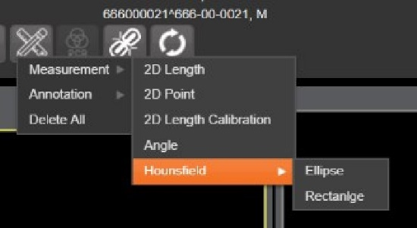

The **Text** tool creates text boxes on the image.

The **Line** tool draws straight lines on the image.

The **Arrow** tool draws straight arrows on the image.

The **Ellipse** tool draws ellipses on the image.

The **Rectangle** tool draws rectangles on the image.

The **Free Hand** tool connects points that you have specified to create any desired shape.

To delete all the measurements and markings you made on the current image, select the **Delete All** option.

### Using the RGB Tool

The **RGB Tool** button filters the image for certain color channels to allow for various observations. When selected, a context menu (Figure 42) appears that allows you to select the desired color channel.

Figure 42: RGB Tool Button



### Conditions for Image Viewer Functions

Table 5 describes the Viewer functions dependent on certain conditions.

Table 5: Conditional Image Viewer Functions

| Function | Section Reference | MAG Keys |
| --- | --- | --- |
| Delete an image | Not applicable at this time | MAG DELETE or MAG SYSTEM |
| Edit an image | 4.4.3 | MAG EDIT, or MAG QA REVIEW, or MAG SYSTEM |
| Image navigation toolbar | 4.2.2 | Not applicable |
| Main toolbar buttons | 4.2.1 | Not applicable |
| Print and Export an image | 4.3.6 and 4.3.7 | For non-Claims users, their VistA account requires the MAG ROI or MAG SYSTEM keys to print and export an image. Claims users have special permission to print and export. |
| Status | 4.3.3 | Not applicable |

## Image Quality Assurance (QA)

To use the image quality assurance features, load an image in the Viewer (Figure 43).

Figure 43: Main Viewer Page with Image Loaded

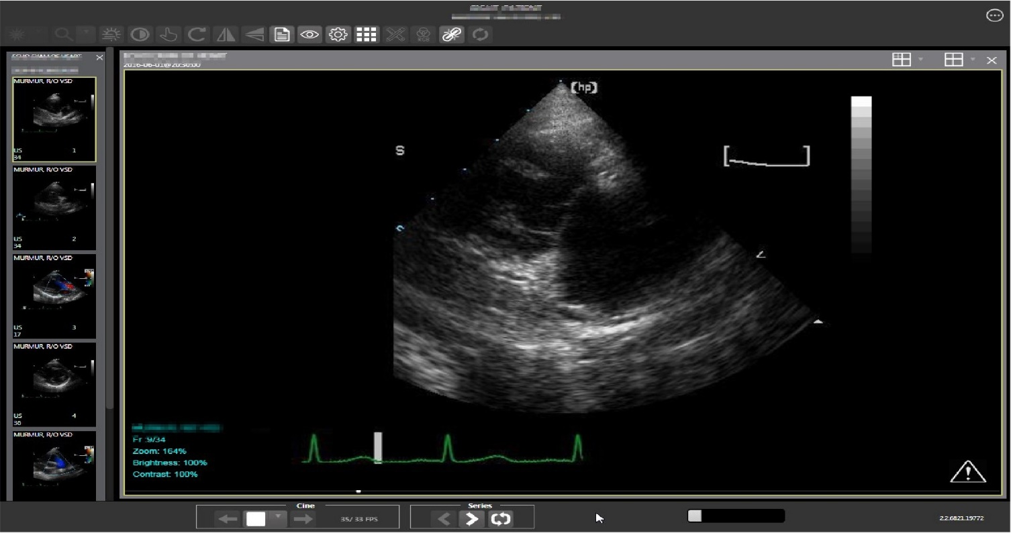

Click the **External Links** button on the Viewer page and a drop-down menu (Figure 44) appears.

Figure 44: External Links Menu on Main Viewer Page

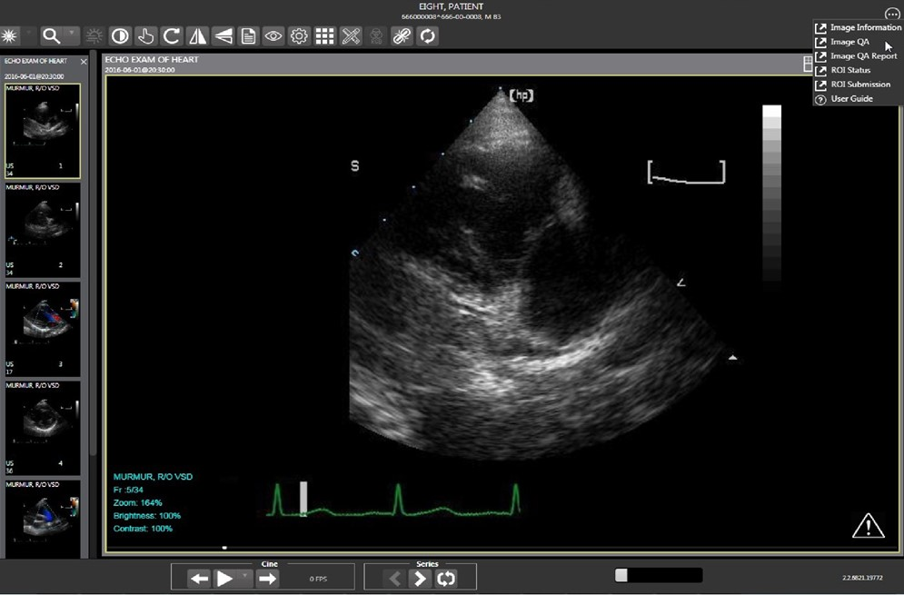

### Image Information

Select the **Image Information** link from the menu. The image information page (Figure 45) displays.

Figure 45: Image Information

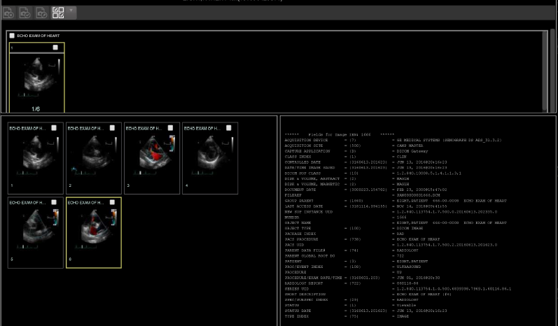

Select any image, then click the **Image Edit** main toolbar button. The image editor dialog (Figure 46) opens. To edit a field, click on the **checkbox** to the left to enable the dropdown control or the textbox. Click **Save** to save the image index fields.

Figure 46: Image Editor

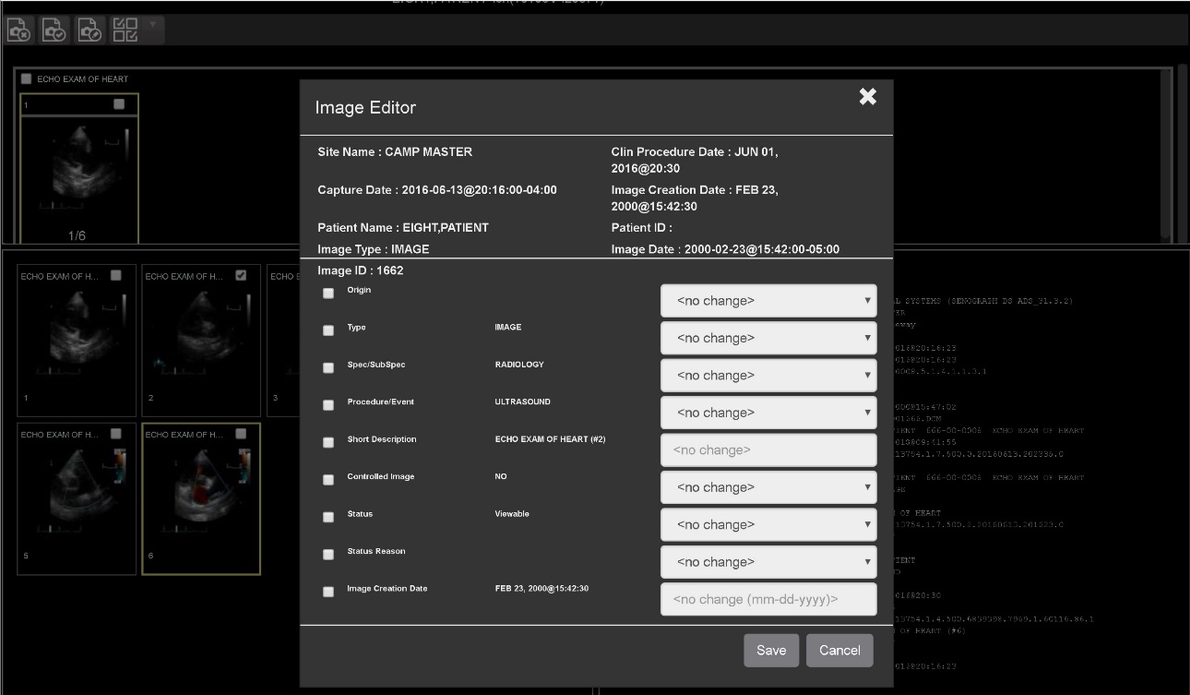

### Image QA

Select **Image QA** from the **External Links** menu to open the QA review page (Figure 47)*.*

Figure 47: QA Review Page

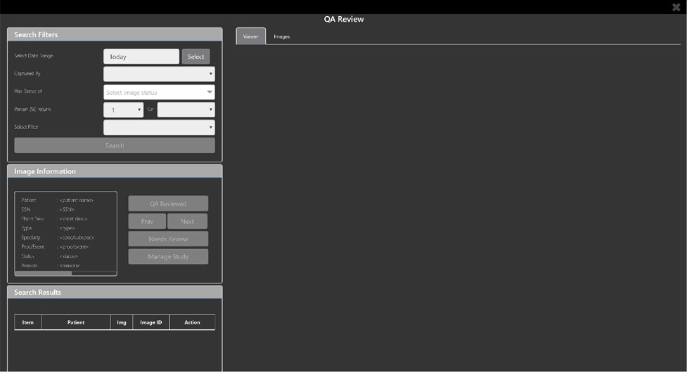

Click the **Select** button from the **Search Filters** group to open the **Select Date Range** pop-up (Figure 48). Select a date range**.**

Figure 48: QA Filters and Date Range

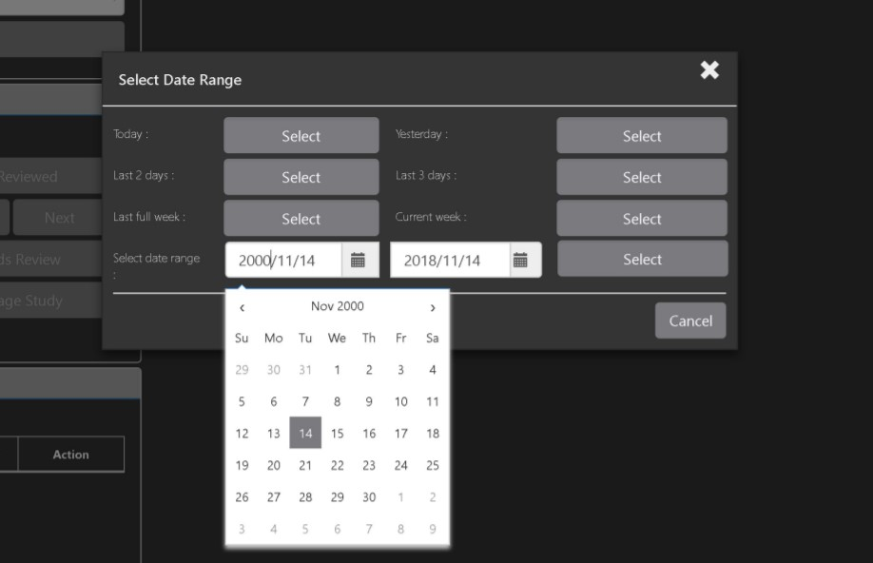

The **Captured By** dropdown populates with a list of valid users for the date range (Figure 49).

Figure 49: Search Filter Details

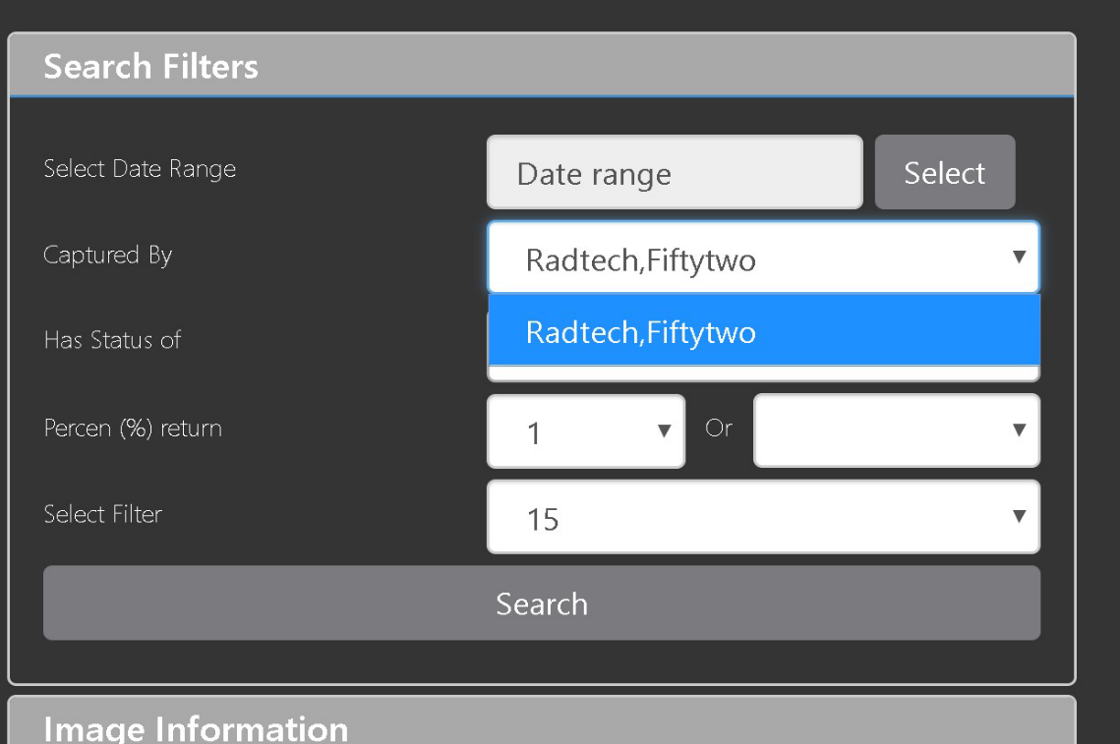

Click the **Has Status of** dropdown, and choose one or more images to choose the status (Figure 50).

Figure 50: QA Status Choices

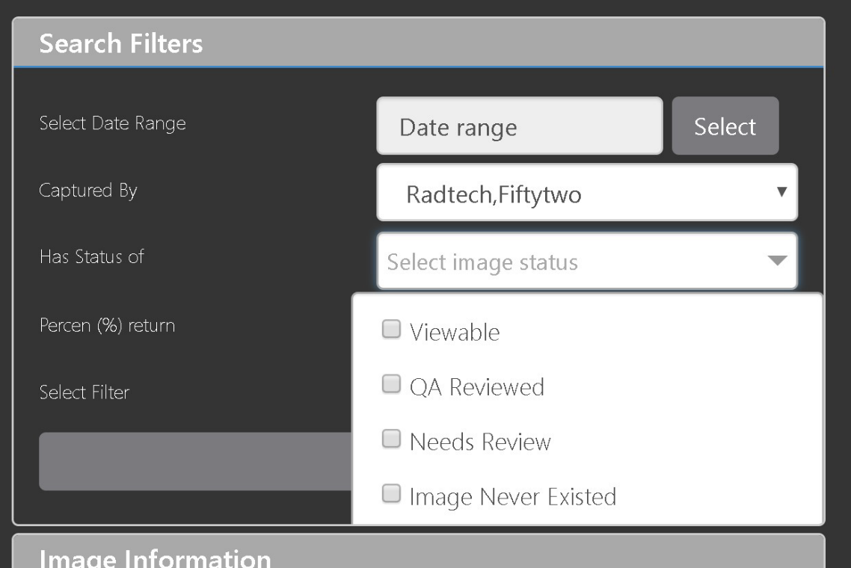

Restrict the study count in the search results using the % **return** dropdowns (Figure 51). The left dropdown is in the percentage of study items to display. The right dropdown is the maximum number of items to display.

Figure 51: Percentage of Images to Display

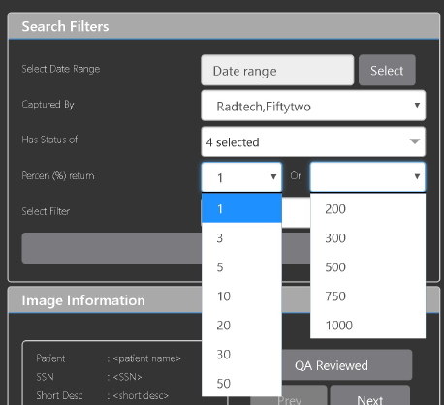

Choose a filter using the **Select Filter** dropdown (Figure 52).

Figure 52: Saved Filters

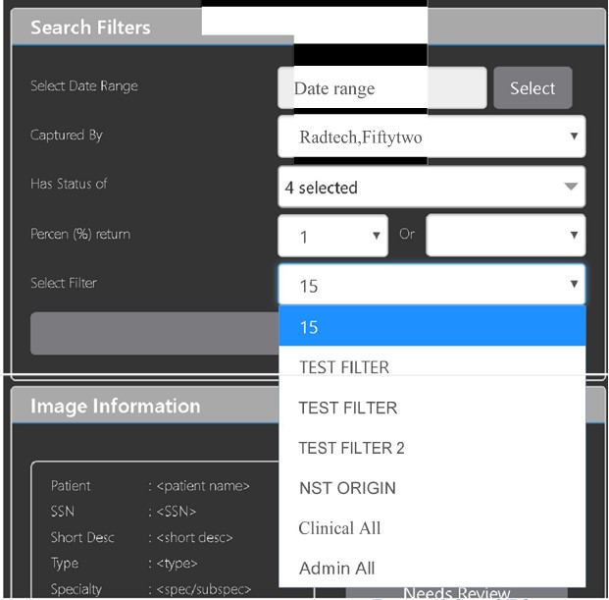

Click **Search** to search for studies. The first study in the list of studies found displays automatically on the right. Click on the **Viewer** icon (circled in red, Figure 53) to display the study. Click on the **Images** icon (circled in yellow, Figure 53) to display the images tab for the study.

Figure 53: QA Filter Results

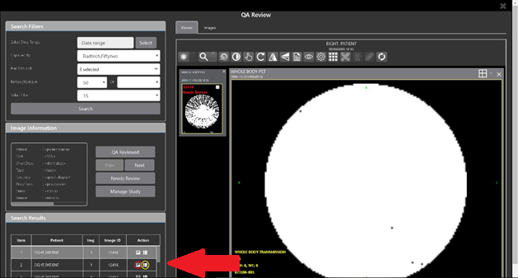

You can click on the **Images** tab at the top after displaying the study (Figure 54).

Figure 54: QA Filter Results and Image Information

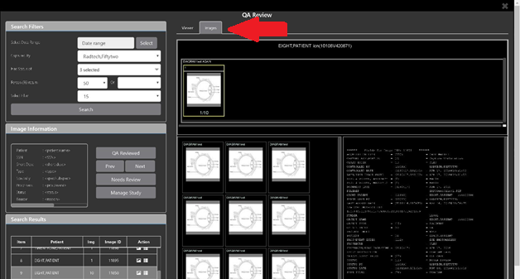

### Viewing and Setting Image Status

Click on a thumbnail. Its image information, including the view status, displays in a panel on the left (highlighted in blue, Figure 55).

Figure 55: QA Thumbnail

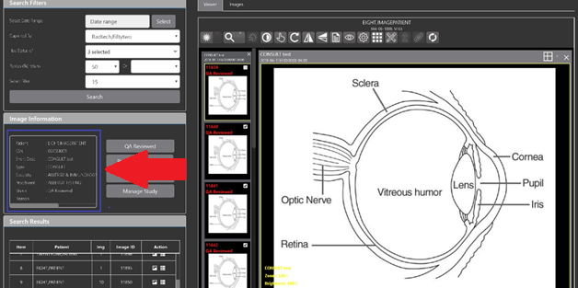

Click on an **image thumbnail** to display the corresponding image. More than one thumbnail can be selected using the shift key.

**NOTE:** The user's VistA account requires the MAG EDIT or MAG QA REVIEW keys to edit/set this information.

Click the **QA Reviewed** or **Needs Review** button to set the corresponding image status. You can also right-click on the image or the image thumbnail to set the image status (Figure 56).

Figure 56: QA Review Status Update Menus

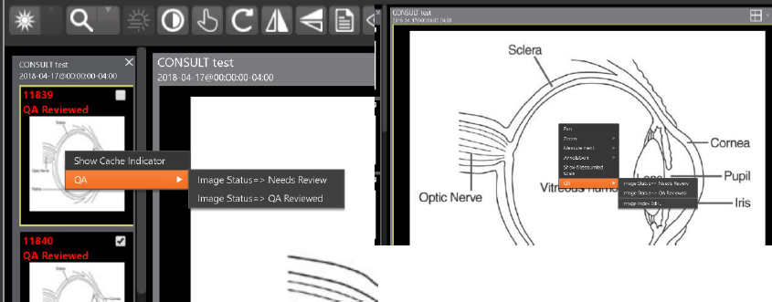

You can invoke the Image Index Editor page by clicking on the **Image Index Edit** menu item.

Use the **Prev** and **Next** buttons to traverse the search results.

Click the **Manage Study** button to display the **Images** tab for the study.

### Image QA Report

Select the **Image QA report** from the Viewer page's **External Links** menu to open the QA Statistics Reports page (Figure 57).

Figure 57: QA Statistics Reports Page

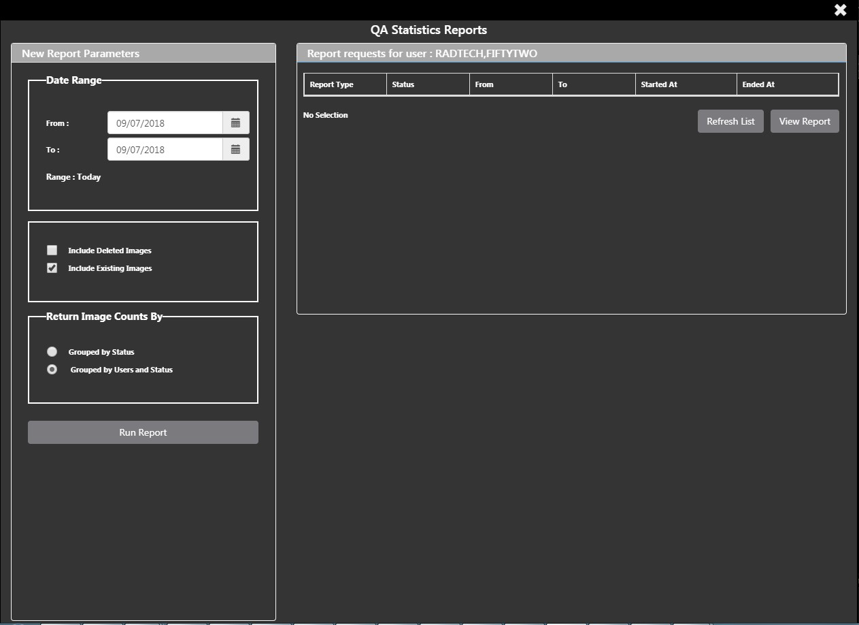

Fill in the report parameters fields and click the **Run Report** button (Figure 58).

Figure 58: Run QA Report

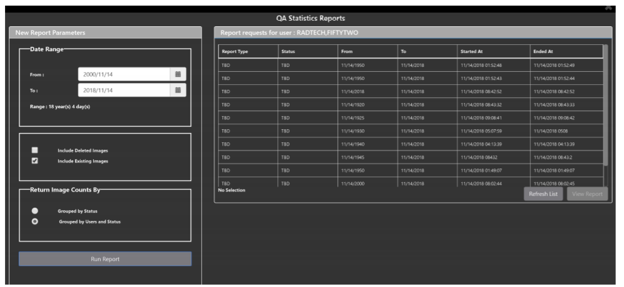

Select any item, and click **View Report** button, then the selected image report statistics load (Figure 59).

Figure 59: View QA Report

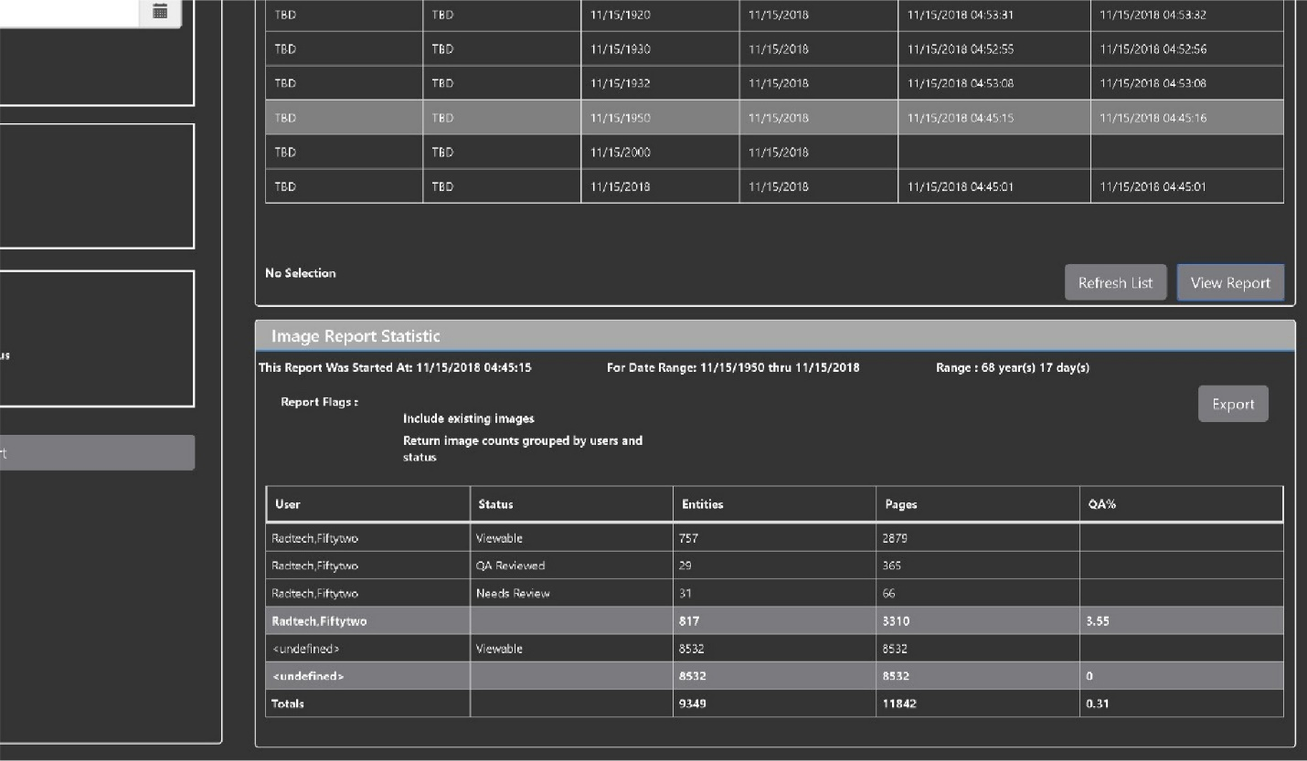

Click **Export** to generate a .csv file using the results.

## Closing the Viewer

To close the Viewer page, click the "**X**" on the browser tab. See Figure 60 below.

Figure 60: Viewer Close Button

Viewer Close Button

**NOTE:** Depending on the hosting application, the Viewer page might automatically close when you select a different patient.

# Troubleshooting

The **View Image Info** main toolbar button can offer data to help you troubleshoot. See Section 4.3.9 for more information.

To display version information and message history about the Viewer, first click the **Viewer Version Number** located in the lower right corner of the Viewer main page (Figure 61).

Figure 61: Viewer Version Number

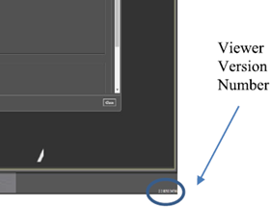

In the Viewer Information dialog (Figure 62) that opens, click on **Version History** to display version release information or click on **Message History** to display message history items.

Figure 62: Viewer Information Dialog

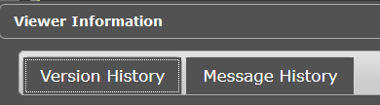

If encountering issues, clear the cache in the web browser for the Viewer, and refresh the page.

## Special Instructions for Error Correction

Please refer to the VIX Overview - View Image Viewer – Troubleshooting Section in [MAG3_0P329_VIX_ADMIN_GUIDE.PDF.](https://www.va.gov/vdl/application.asp?appid=105)

# Acronyms and Abbreviations

| Acronym/Term | Definition |
| --- | --- |
| Cache | A temporary storage place allowing faster access to data. |
| CD | Compact Disc |
| CPRS | Computerized Patient Record System |
| CT | Computerized Tomography |
| CVIX | Central Vista Imaging Exchange |
| DICOM | Digital Imaging and Communications in Medicine |
| DoD | Department of Defense |
| Viewer | Enhanced Image Viewer |
| FDA | Food and Drug Administration |
| JLV | Joint Legacy Viewer |
| JPEG | Joint Photographic Experts Group |
| OIT | Office of Information and Technology |
| PACS | Picture Archiving and Communication System |
| PDF | Portable Document Format |
| QA | Quality Assurance |
| RGB | Red Green Blue |
| ROI | Release of Information |
| TIFF | Tag Image File Format |
| VA | Department of Veteran Affairs |
| VistA | Veterans Health Information System and Technology Architecture |
| VIX | VistA Imaging Exchange Services |
| WW/WC | Window Level |