VITALS/MEASUREMENTS INSTALLATION GUIDE

Version 5.0
October 2002

Department of Veterans Affairs
VISTA System Design & Development

Revision History

Date | Revision | Description | Author
1/16/2002 | 5.1 | Added Revision History | REDACTED
2/6/2002 | 5.2 | Update install guide | REDACTED
2/13/2002 | 5.3 | The following sections were updated: Overview  Example - Vitals Server Installation Post Initialization Tasks  File Security | REDACTED
3/6/2002 | 5.4 | The following sections were updated: Disk Storage  Example - Vitals Server Installation  Post Installation Tasks | REDACTED
5/13/2002 | 5.5 | The following sections were updated: Overview  Example - Vitals Server Installation  Post Initialization Tasks | REDACTED
5/14/2002 | 5.6 | Took out screen capture of setup screen in install shield example as instructed by  David. | REDACTED
5/15/2002 | 5.7 | Took out screen capture of self-extracting zip file, and changed Setup.exe to Vitals.exe as instructed by  David. | REDACTED
5/21/2002 | 5.8 | Added REDACTEDchanges to the Install  Guide. | REDACTED
6/21/2002 | 5.9 | Added REDACTEDchanges to the Install  Guide. | REDACTED
9/10/2002 | 6.0 | Added REDACTEDchanges to the Install  Guide for T31. | REDACTED
9/19/2002 | 6.1 | Changed release date to October 2002. | REDACTED
10/17/2002 | 6.2 | Added REDACTEDchanges to the Install  Guide for T32. | REDACTED
10/23/2002 | 6.3 | Added REDACTED changes to the Install  Guide for T32. | REDACTED

Table of Contents
Installation Guide 1
Overview 1
Vitals/Measurements V. 5.0 Installation (M Server) 3
Pre-installation instructions: 3
Installation Instructions: 3
M Server Installation – Example Screen Listing 5
Vitals/Measurements V. 5.0 Installation (Client Installation) 9
Post Installation Tasks on the M Server 16
Customizing the Client Installation 17
Server Based Installation 20

Table of Contents

Installation Guide

Overview

- In the Package (#9.4) file, this application is known as Gen. Med. Rec. - Vitals. The package namespaces are GMRV and GMV. Version 5 is exporting only GMV namespaced code which provides a GUI interface. The existing roll’n’scroll options (i.e., GMRV namespace) still exist, but are not sent out with Version 5. The roll’n’scroll and GUI versions can both be used.

Contents of this package can be found in the VISTA Documentation Library (VDL).

The Vitals/Measurements package is comprised of two parts, the M Server and the Client workstation. This guide addresses both the installation of the KIDS build on the M Server and the executable on the workstation.

The post installation routine GMVXPST deletes 4 obsolete data dictionary fields and any data that may remain. It does not send a mail message when done. The post installation should take no longer than 10 minutes to complete. It also updates the Parameters (#8989.5) file with the current version of executable files and the weblink for the Vitals/Measurements package.

- Requirements for M Server installation:

The M Server (disk) storage requirements for this package are:

Globals | Type of Data | Size
DDs | Data Dictionaries | 40 k
GMR | Patient data for the Text Generator, Vitals/Measurements,  Intake and Output, Adverse Reaction Tracking and Consult/ Request Tracking Modules | 25-75 k/  patient
GMRD | Static data for the Text Generator, Vitals/Measurements and Intake and Output Modules | 10 k depending on the global efficiency

Installation Guide

The following packages and patches must be installed and fully patched for the installation environment for Version 5.0 of the Vitals/Measurements package on the M Server:

  - VA FileMan V. 22 or greater
  - Kernel V. 8.0 or greater
  - Kernel Toolkit V. 7.3 or greater
  - Kernel RPC Broker V. 1.1 or greater
  - PIMS V. 5.3 or greater
  - Intake and Output V. 4.0
  - Health Summary V. 2.7 or greater
  - Nursing V. 4.0 or greater

- Requirements for VISTA Client installation: The client (disk) storage requirements are:
Type of Data Size

Application (user) 1356.5 k Application (manager) 811.5 k

Help Files (user) 460 k Help Files (manager) 175.678 k

The following describes the installation environment for the Vitals/Measurements package on the VISTA client workstation:

- Workstations must be running under Windows NT (V4 or later) or Windows 2000.
- The workstation must be connected to the local area network.
- Twelve (12) megabytes of available disc space is needed to run the program.
- RPC Broker Workstation can be installed (Optional).

Installation Guide

Vitals/Measurements V. 5.0 Installation (M Server)

Note: The server installation must be done before the client installation. Pre-installation instructions:
- Coordinate the installation with the CAC, package ADPAC and IRMS.
- If not already on system, create, place, and set the journaling option for the globals ^GMR and ^GMRD on the volume set.

Installation Instructions:

INSTALLATION FILES:

The following software and documentation files are released as parts of Vitals 5.0

File Name | Contents | Retrieval Format
VITL5.KID | Vitals 5.0 M code | ASCII
NUR*4*37
GMRY*4*5
VITL5_IG.PDF | Vitals 5.0 Installation Guide | Binary
VITL5_RN.PDF | Vitals 5.0 Release Notes | Binary
VITL5_TM.PDF | Vitals 5.0 Technical | Binary
VITL5_UM.PDF | Vitals 5.0 User Manual | Binary
VITL5.EXE | Vitals 5.0 Executable | Binary
VITL5_SRC.xxx | Vitals 5.0 GUI Source Code | Binary

Note: The NUR*4*37 KIDS build contains one routine, NURAPI. The GMRY*4*5 KIDS build contains only one routine, GMRYAPI. Both routines contain utilities used by the Vitals/Measurements package.

The files listed above may be obtained via FTP. The preferred method is to FTP the files from: REDACTED This transmits the files from the first available FTP server. Sites may also elect to retrieve software directly from a specific server as follows:

CIO FIELD OFFICE |  | FTP ADDRESS |  | DIRECTORY
REDACTED |  | REDACTED |  | REDACTED

Installation Guide

Users should copy the VITL5.KID file to an area where it can be loaded into the M account by the KIDS utility. Also, the VITL5.EXE file should be copied into a sharable directory where it can be reached for the client installation.

INSTALLATION:

- Users may remain on the system at the time of installation. The software should be installed when use of the Vitals software is minimal.
- On the VISTA system, set the variables DUZ and DUZ(0) by executing the command D
^XUP. Verify DUZ(0) = @.
- Mapping is not recommended for any Vitals routines.
- Use the Kernel Installation & Distribution System menu [XPD MAIN] and select Installation and then Load a Distribution. When prompted to enter a host file, enter VITL5.kid.
- From this menu, run the option Verify Checksums in Transport global to verify that all routines have the correct checksum.
- Use the KIDS installation menu option [XPD MAIN] and select Installation and then Install Package(s) and select the package GEN. MED. REC. – VITALS. Refer to the following Installation example in this manual for additional information.

Installation Guide

M Server Installation – Example Screen Listing

> D ^XUP

Setting up programmer environment Terminal Type set to: C-VT100

Select OPTION NAME: XPD MAIN Kernel Installation & Distribution System

Edits and Distribution ... Utilities ...
KIDS Installation ...

Select Kernel Installation & Distribution System Option: INSTALLation

- Load a Distribution
- Verify Checksums in Transport Global
- Print Transport Global
- Compare Transport Global to Current System
- Backup a Transport Global
- Install Package(s)
Restart Install of Package(s) Unload a Distribution

Select Installation
Option:
1 Load a Distribution

Enter a Host File: VITL5.KID

KIDS Distribution saved on Feb 06, 2002@11:03:08 Comment: VITALS v5, NUR*4*37 and GMRY*4*5

This Distribution contains Transport Globals for the following Package(s): GEN. MED. REC. - VITALS 5.0
NUR*4.0*37 GMRY*4.0*5
Distribution OK!

Want to Continue with Load? YES// <RET>
Loading Distribution...

Build GEN. MED. REC. - VITALS 5.0 has an Enviromental Check Routine Want to RUN the Environment Check Routine? YES// <RET>
GEN. MED. REC. - VITALS 5.0
Will first run the Environment Check Routine, GMVXENV

NUR*4.0*37 GMRY*4.0*5
Use INSTALL NAME: GEN. MED. REC. - VITALS 5.0 to install this Distribution.

- Load a Distribution
- Verify Checksums in Transport Global
- Print Transport Global
- Compare Transport Global to Current System
- Backup a Transport Global
- Install Package(s)

Installation Guide

Restart Install of Package(s) Unload a Distribution

Select Installation Option: 6 Install Package(s)
Select INSTALL NAME: GEN. MED. REC. - VITALS 5.0 Loaded from
Distribution 2/6/02@11:11:36
=> VITALS v5, NUR*4*37 and GMRY*4*5 ;Created on Feb 06, 2002@11:03:08

This Distribution was loaded on Feb 06, 2002@11:11:36 with header of VITALS v5, NUR*4*37 and GMRY*4*5 ;Created on Feb 06, 2002@11:03:08 It consisted of the following Install(s):
GEN. MED. REC. - VITALS 5.0 NUR*4.0*37 GMRY*4.0*5
Checking Install for Package GEN. MED. REC. - VITALS 5.0 Will first run the Environment Check Routine, GMVXENV

Install Questions for GEN. MED. REC. - VITALS 5.0 Incoming Files:

120.5 GMRV VITAL MEASUREMENT
Note: You already have the 'GMRV VITAL MEASUREMENT' File.

  - GMRV VITAL TYPE (including data) Note: You already have the 'GMRV VITAL TYPE' File. Data will NOT be added.

  - GMRV VITAL QUALIFIER (including data) Note: You already have the 'GMRV VITAL QUALIFIER' File. Data will NOT be added.

  - GMRV VITAL CATEGORY (including data) Note: You already have the 'GMRV VITAL CATEGORY' File. Data will NOT be added.

120.57 GMRV VITALS PARAMETERS (including data) Note: You already have the 'GMRV VITALS PARAMETERS' File. Data will NOT be added.

Want KIDS to Rebuild Menu Trees Upon Completion of Install? YES// NO

NOTE: The decision to rebuild menus is left up to each facility, ‘No’ was used for this example. Please follow whatever policy your facility uses for rebuilding menus when installing software.
Checking Install for Package NUR*4.0*37 Install Questions for NUR*4.0*37

Checking Install for Package GMRY*4.0*5 Install Questions for GMRY*4.0*5

Installation Guide

Want KIDS to INHIBIT LOGONs during the install? YES// NO
Want to DISABLE Scheduled Options, Menu Options, and Protocols? YES// NO

Enter the Device you want to print the Install messages.
You can queue the install by enter a 'Q' at the device prompt. Enter a '^' to abort the install.

DEVICE: HOME// <RET> TELNET

Install Started for GEN. MED. REC. - VITALS 5.0 : Feb 06, 2002@11:12:20
Build Distribution Date: Feb 06, 2002 Installing Routines:
Feb 06, 2002@11:12:27
Installing Data Dictionaries:
Feb 06, 2002@11:12:30
Installing Data:
Feb 06, 2002@11:12:30
Installing PACKAGE COMPONENTS: Installing SECURITY KEY Installing REMOTE PROCEDURE Installing OPTION
Feb 06, 2002@11:12:34
Installing PARAMETER DEFINITION
Feb 06, 2002@11:12:36
Running Post-Install Routine: ^GMVXPST Updating system parameters.
Will queue data cleanup as a background job. Task #: 330472

Updating Routine file... Updating KIDS files...
GEN. MED. REC. - VITALS 5.0 Installed.
Feb 06, 2002@11:12:38
Not a production UCI
NO Install Message sent
Install Started for NUR*4.0*37 :
Feb 06, 2002@11:12:38
Build Distribution Date: Feb 06, 2002 Installing Routines:
Feb 06, 2002@11:12:38

Installation Guide

Updating Routine file... Updating KIDS files...
NUR*4.0*37 Installed.
Feb 06, 2002@11:12:39
Not a production UCI
NO Install Message sent
GMRY*4.0*5
Install Started for GMRY*4.0*5 :
Feb 06, 2002@11:12:39
Build Distribution Date: Feb 06, 2002 Installing Routines:
Feb 06, 2002@11:12:39
Updating Routine file... Updating KIDS files...
GMRY*4.0*5 Installed.
Feb 06, 2002@11:12:39
Not a production UCI
NO Install Message sent
+------------------------------------------------------------+ 100% ¦ 25 50 75 ¦ Complete +------------------------------------------------------------+

Install Completed

Installation Guide

Vitals/Measurements V. 5.0 Installation (Client Installation)

The Vitals application utilizes the RPC Broker connection to the VISTA server for operation. Before installing the application, insure that the workstation has connectivity to the required server via the RPC Broker. For help in setting up the RPC Broker on the workstation refer to the Kernel RPC Broker documentation.

Run VITL5.exe from the sharable directory where you placed it, and follow the installation steps that will be presented to the user.
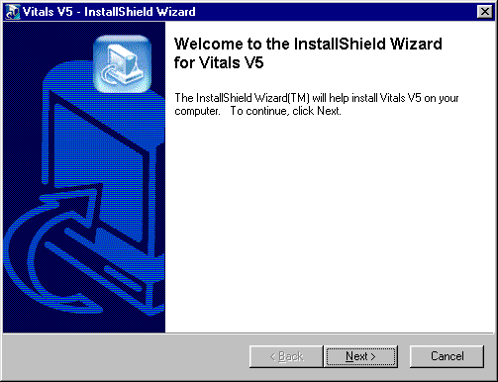
Fig. 1

- Your first screen is a welcome screen. Press the Next button to begin the installation process of Vitals/Measurements (Fig. 1).
- You will then see an Extracting Files window and then another Install Shield window.

Installation Guide

- When the extracting process completes, you will see the following welcome screen (Fig. 2):
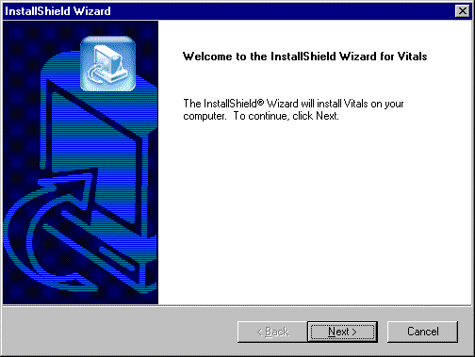
Fig. 2

Installation Guide

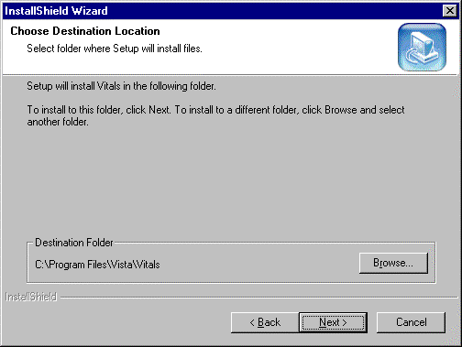
Fig. 3

- Select the location (i.e., Destination Folder in Fig. 3) on the client where the application is to be installed. By default the installation will be placed in the system directory of:

C:\Program Files\Vista\Vitals\…

It is recommended that you use this default as it is in compliance with the GUI SACC guidelines for the location of GUI application installations. The application will operate correctly if placed elsewhere on the client workstation but this is not recommended. Use Browse button to select another destination folder or directory.

Installation Guide

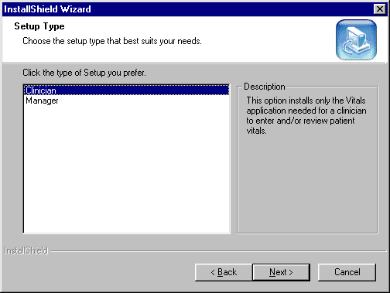
Fig. 4

- Select the setup you prefer by clicking on it and then clicking the Next button (Fig. 4).

Clinician only installs Vitals, Vitals Manager is not installed.
Manager installs both the Vitals and Vitals Manager applications.

Clinical Application Coordinators, package coordinators, and Information Resource Management Service (IRMS) staff should get the Manager setup.

Clinical staff should get the Clinician setup.

Installation Guide

- The Install wizard will now start copying files upon verification of the settings (Fig. 5).
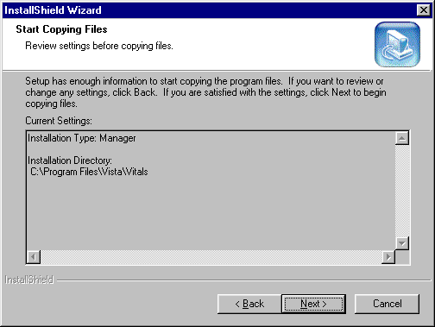
Fig. 5

Installation Guide

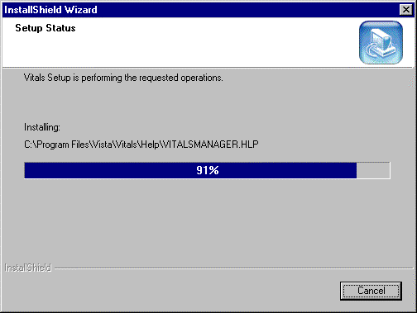
Fig. 6

- Once all steps are completed the installation will begin and show the progress as it installs (Fig. 6). If the installation files are located on the client PC, the install screen should complete in less than one minute. Server and network connectivity for installations over the network may cause the installation time to increase.

Installation Guide

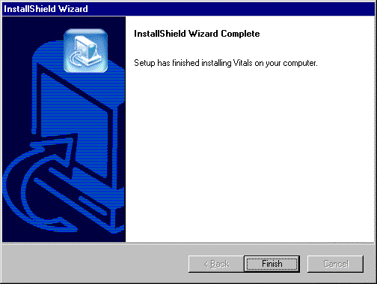
Fig. 7

- Upon completion of the installation this screen will be presented to the user and the installation can be finalized by pressing the Finish button (Fig. 7).

Installation Guide

Post Installation Tasks on the M Server

- There is one security key in this application, it is GMV MANAGER. This new key controls access to the Vitals Manager module. This key should be assigned to the package coordinator.
- There are no routines to be mapped in the Vitals/Measurements software as of this release.
- All users should be assigned the GMV V/M GUI option.
- Verify that the following globals are journaled and place them in the UCI translation table for each CPU: ^GMR and ^GMRD.
- Verify that the file security is correct for the following files:

NUMBER | NAME |  | GLOBAL NAME | DD ACC | RD ACC | WR ACC | DEL ACC | LAY AUD  ACC ACC
120.5 | GMRV | VITAL MEASUREMENT | ^GMR(120.5, | @ |  | @ | @ | @
120.51 | GMRV | VITAL TYPE | ^GMRD(120.51, | @ |  | @ | @ | @
120.52 | GMRV | VITAL QUALIFIER | ^GMRD(120.52, | @ |  | @ | @ | @
120.53 | GMRV | VITAL CATEGORY | ^GMRD(120.53, | @ |  | @ | @ | @
120.57 | GMRV | VITALS PARAMETERS | ^GMRD(120.57, | @ |  | @ | @ | @

Installation Guide

Customizing the Client Installation

The client installation by default installs and builds the icons and program folder items without any command line switches. Vitals/Measurements utilizes the ServerList utility of the RPC Broker for selecting a server to connect to if it is configured on the client workstation.
Instructions for configuration and utilization of the ServerList utility can be found in the RPC Broker documentation located on the VDL. If the ServerList utility has not been configured on the client, the applications by default will attempt to connect to the server identified in the users HOSTS file as BROKERSERVER on Listener Port 9200. Adding command line parameters to the shortcuts as shown below by right clicking the appropriate Vitals/Measurements application icon and selecting the Properties menu item can easily override these parameters.
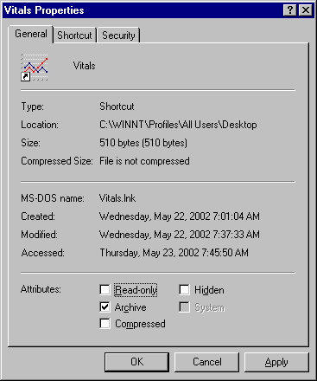
Fig. 8

The above (Fig. 8) is a standard properties view of the Vitals icon as displayed when right clicking the icon. Select the Shortcut tab to proceed with customization.

Installation Guide

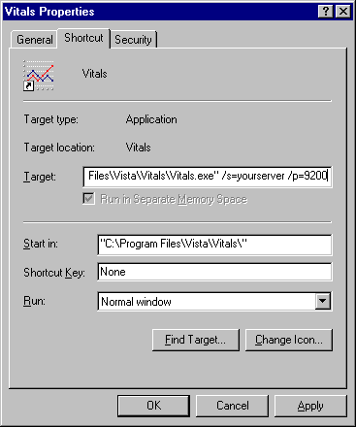
Fig. 9

This example (Fig. 9) will attempt to connect the application to the server identified in your HOSTS file as yourserver and will use listener port 9200.

Vitals/Measurements V. 5.0 command line parameters available from the command prompt or within Windows shortcut definitions are:

Vitals.exe [/server=servername] [/port=listenerport]
[/tempdir=temporarydirectory] [/helpdir=helpdirectory] [/debug={on|off}] [/brokertimeout=seconds]

VitalsManager.exe [/server=servername] [/port=listenerport] [/helpdir=helpdirectory] [/debug={on|off}] [/brokertimeout=seconds]

Installation Guide

Switches | Description | Example
/server | Specifies an alternate server to connect to. The server must be defined in the clients hosts. file.  Default Hosts. file locations: NT 4.0/W2K =  c:\winnt\system32\drivers\etc\hosts. Windows 9x = c:\windows\hosts.  Default = BROKERSERVER | /server=vista
/port | Specifies an alternate listener port on the selected server. This is the TCP/IP port that the broker is running on VISTA server.  Default = 9200 | /port=9200
/tempdir | Location accessible to the client workstation and current user for storage of temporary scratch files.  Default = application_directory\temp | /tempdir=C:\temp
/helpdir | Location of the Vitals/Measurements windows help files.  Default = application_directory\help | /helpdir=C: \help
/debug | Set the debug mode for both the RPC Broker and the Vitals/Measurements application.  Default = Off. | /debug=On
/brokertimeout | Overrides the timeout for the RPC Broker when executing a Remote Procedure.  Default = 30. | /brokertimeout=60
/nonsharedbroker | Force application to use nonshared version of RPC  Broker | /nonsharedbroker

Installation Guide

Server Based Installation

The Vitals/Measurements package may be installed on a shared server and accessed via shortcuts on the user’s desktop to minimize the impact of patching and installation. To do this simply perform a complete install of the application on a workstation and verify that the installation is working. Next, copy all files and sub directories from the target directory (default C:\Program Files\vista\Vitals\…’) to the shared server. On each individual workstation all that needs to be done is the creation of a shortcut pointing to the Vitals.exe and/or VitalsManager.exe applications on the server. These shortcuts can be customized as shown above in the Customizing the Client Installation section. This allows for updates to occur on the single copy of the application on the server and does not require IRM going to each individual workstation to apply updates. As the VA moves towards utilizing Microsoft SMS, Vitals/Measurements will be updated to support this method of client installation.

List of all files that need to be copied to the server share for server based installations: C:\Program Files\vista\Vitals\Vitals.exe
C:\Program Files\vista\Vitals\VitalsManager.exe C:\Program Files\vista\Vitals\Help\Vitals.hlp C:\Program Files\vista\Vitals\Help\Vitals.cnt C:\Program Files\vista\Vitals\Help\VitalsManager.hlp C:\Program Files\vista\Vitals\Help\VitalsManager.cnt C:\Program Files\vista\Vitals\Help\Roboex32.dll

