Bed Management Solution (BMS) v2.4

Deployment, Installation, Rollback, and Back-Out Guide

January 2020 v1.3

Department of Veterans Affairs
Office of Information and Technology (OI&T)

Revision History

Date | Version | Description | Author
11/06/2019 | 1.0 | Updated wth BMS v2.4 | Technatomy
12/16/2019 | 1.1 | Updated Schedule and Deployment Instructions | Technatomy
1/13/2020 | 1.2 | Updated Schedule | Technatomy
1/15/2020 | 1.3 | Updated Installation Instructions | Technatomy

Artifact Rationale

This document describes the Deployment, Installation, Back-out, and Rollback Plan for new products going into the VA Enterprise. The plan includes information about system support, issue tracking, escalation processes, and roles and responsibilities involved in all those activities. Its purpose is to provide clients, stakeholders, and support personnel with a smooth transition to the new product or software, and should be structured appropriately, to reflect particulars of these procedures at a single or at multiple locations.
Per the Veteran-focused Integrated Process (VIP) Guide, the Deployment, Installation, Back-out, and Rollback Plan is required to be completed prior to Critical Decision Point #2 (CD #2), with the expectation that it will be updated throughout the lifecycle of the project for each build, as needed.

Table of Contents
- Introduction 2
- Purpose 2
- Dependencies 2
Constraints 3
- Roles and Responsibilities 3
- Deployment 4
Timeline 4
Site Readiness Assessment 5
Application Architecture 5
    - Deployment Topology (Targeted Architecture) 6
    - Site Information (Locations, Deployment Recipients) 6
    - Site Preparation 6
    - Resources 6
      - Facility Specifics 6
      - Hardware 6
      - Software 6
      - Communications 6
      - Deployment/Installation/Back-Out Checklist 7
- Installation 7
Pre-installation and System Requirements 7
6.1.1 Pre-installation Activities: 7
Database Server 7
Application Servers 8
Web Server 9
Report Server 9
Post-installation and Smoke Testing 10
    - Post-installation Activities 10
    - Smoke Testing 10
- Rollback/ Back-Out Plan 10

Table of Figures
Figure 1: BMS Overview 2
Figure 2: BMS Architecture Diagram 5

List of Tables
Table 1: Deployment, Installation, Back-out, and Rollback Roles and Responsibilities 4
Table 2: Deployment Timeline 4
Table 3: Deployment/Installation/Back-Out Checklist 7

BMS v2.4

Introduction
This document describes how to deploy and install the various components of the software for the Bed Management Solution (BMS) v2.4 project, as well as how to back-out the product and rollback to a previous version or data set. This document is a companion to the project charter and management plan for this effort. In cases where a non-developed Commercial Off-the-Shelf (COTS) product is being installed, the vendor provided User and Installation Guide may be used, but the Back-Out Recovery strategy still needs to be included in this document.
BMS is a real-time, user-friendly web-based Veterans Health Information Systems and Technology Architecture (VistA) interface for tracking patient movement, bed status and bed availability within the VA system. It provides performance information that can be used to measure and improve patient flow as it occurs within and between VAMCs. BMS enhances safety, quality of care, patient/staff satisfaction and improves patient flow for process and outcome improvements. BMS, the automated Bed Management Solution, allows administrative and clinical staff to record, manage and report on the planning, patient-movement, patient occupancy, and other activities related to management of beds. All patient admission, discharge, and transfer movements are pulled directly from VistA to BMS resulting in minimal manual data entry.

Purpose
The purpose of this plan is to provide a single, common document that describes how, when, where, and to whom the BMS application will be deployed and installed, as well as how it is to be backed out and rolled back, if necessary. The plan also identifies resources, communications plan, and rollout schedule. Specific instructions for installation, back-out, and rollback are included in this document.

Dependencies
BMS communicates with VistA to capture bed, patient, admission, transfer, and discharge information. BMS also interfaces with National Utilization Management Integration (NUMI) to retrieve information regarding NUMI reviews.
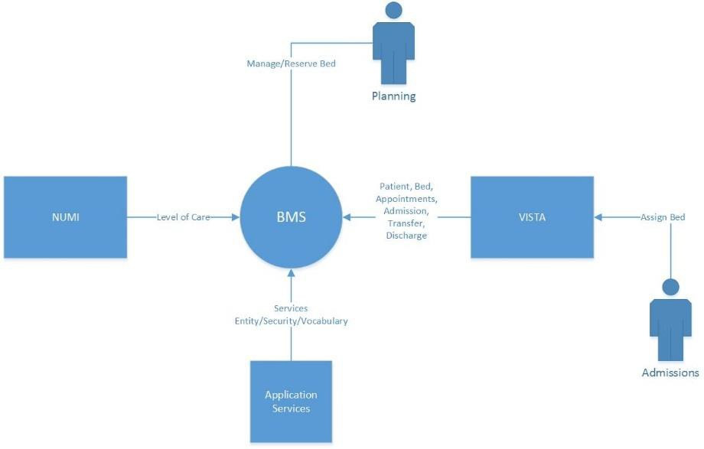
Figure 1: BMS Overview

Constraints
The software needs to address system-related issues associated with the currently deployed BMS v.2.3.1 product, while continuing to meet functional business needs and requirements of the business owner.
The objective of the second increment of the intended solution is to enhance the current BMS functionality identified in the Init8_BMS_RSD Inc2 as part of the nationally supported Class I solution, while complying with all previously established VA national release criteria. This version will be integrated with VistA and NUMI.

Specific functionalities to be deployed in the second increment of BMS v2.4 will enhance functionalities of the following components of the system:
Whiteboard integration and management Icon Library management
Event Notifications management Patient waitlist management

BMS v2.4 will be a single code base system supporting all VAMCs and Veterans Integrated Service Networks (VISNs).

BMS v2.4 will be hosted in a browser-controlled environment.

BMS v2.4 design will support the server configurations deployed at the Austin Information Technology Center (AITC) that hosts BMS v.2.3.1.

Roles and Responsibilities
This section outlines the roles and responsibilities for managing the deployment of the BMS 2.4 application. The BMS 2.4 Development Team will produce the deployment artifacts (RFC’s, DB Scripts, executables, etc.) and work directly with the AITC personnel to plan the actual deployment.

Table 1: Deployment, Installation, Back-out, and Rollback Roles and Responsibilities
ID | Team | Phase / Role | Tasks | Project Phase (See Schedule)
1 | FO, EO, NDCP or Product Development (depending upon project ownership) | Deployment | Plan and schedule deployment (including orchestration with vendors). | Deployment
2 | FO, EO, NDCP or Product Development (depending upon project ownership) | Deployment | Determine and document the roles and responsibilities of those involved in the deployment. | Design/Build
3 | FO, EO, or NDCP | Deployment | Test for operational readiness. | Design/Build
4 | FO, EO, or NDCP | Deployment | Execute deployment. | Design/Build
5 | FO, EO, or NDCP | Installation | Plan and schedule installation. | Deployment
6 | Regional PM/ Field Implementation Services (FIS)/ Office of Policy and Planning (OPP) PM | Installation | Ensure authority to operate and that certificate authority security documentation is in place. | Design/Build
7 | Regional PM/FIS/OPP PM/ Nat’l Education & Training | Installations | Coordinate training. | Deployment
8 | FO, EO, NDCP or Product Development (depending upon project ownership) | Back-out | Confirm availability of back-out instructions and back-out strategy (what are the criteria that trigger a back-out). | Deployment
9 | FO, EO, NDCP or Product Development (depending upon project ownership) | Post Deployment | Hardware, Software and System Support. | Maintenance

Deployment
The deployment and installation is scheduled to run as depicted in the BMS v2.4 development master schedule.

Timeline
The deployment and installations timelines are depicted in the Deployment Timeline Schedule below.
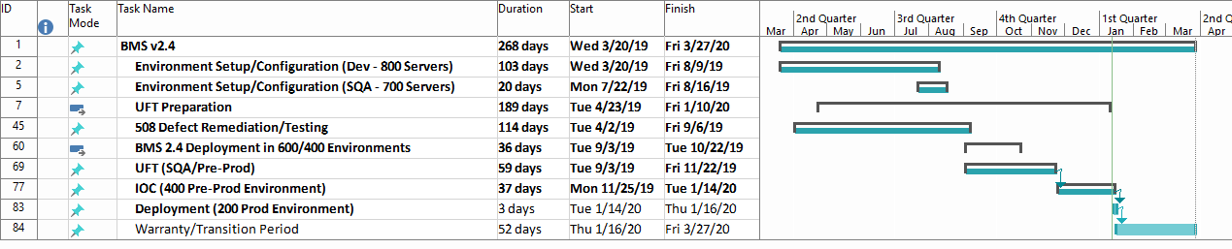
Table 2: Deployment Timeline

Site Readiness Assessment
The product will be released by the BMS Development Team to the AITC Build Manager via a Change Order. The AITC Build Manager will follow the installation steps in Section 0 to complete the product’s activation at AITC. The Implementation Manager has assured site readiness by assessing the readiness of the receiving site to deploy the product. AITC, under contract, will provide the product dependencies, power, equipment, space, manpower, etc., to ensure the successful activation of this product.

Application Architecture
The following diagram represents the high-level architecture for the BMS application. BMS is a national application deployed at the AITC data center. The application is accessed at VA medical centers using approved web browser software. BMS reads data from VistA systems associated with each site’s VistA instance.

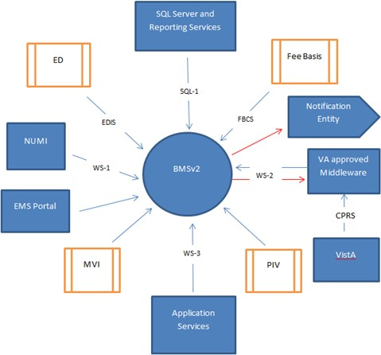

Figure 2: BMS Architecture Diagram

Deployment Topology (Targeted Architecture)
This product will be released to AITC. The AITC, under contract, will house and secure this product on its Pre-Production and Production servers. The BMS system will be available to VA users on a continuous basis (excluding scheduled maintenance activities).

Site Information (Locations, Deployment Recipients)
AITC will host the web and application servers for the BMS system.

Site Preparation
BMS will be supported on VA equipment that currently runs the existing BMS 2.3.1 system; therefore, no site preparatiohn activites are required.

Resources
This section describes the hardware, software, and communications for the deployment of BMS, where applicable.

Facility Specifics
No facility-specific features are required for this deployment.

Hardware
As middleware, BMS 2.4 requires no hardware to install. BMS 2.4 will be supported on existing VA equipment.

Software
BMS 2.4 will be installed as an upgrade to the existing BMS 2.3.1 system running in production. Other than changes to the application files and database objects, no new COTS software or database/operating system updates are required.
The software components and database change scripts will be staged at the following location:
REDACTED

Communications
This section outlines the communications to be distributed to the business user community:
        - Communication between the development team, AITC, and the Sustainment team will occur via email and conference calls scheduled through Microsoft Lync.
        - Notification of scheduled maintenance periods that require the service to be offline or that may degrade system performance will be disseminated to the business user community a minimum of 48 hours prior to the scheduled event.

        - Notification to VA users for unscheduled system outages or other events that impact the response time will be distributed within 30 minutes of the occurrence.

Deployment/Installation/Back-Out Checklist
The table below outlines the coordination effort and documents the day/time/individual when each activity (deploy, install, back-out) is completed for BMS 2.4. The table will be populated once the activities are completed.
Table 3: Deployment/Installation/Back-Out Checklist
Activity | Day | Time | Individual who completed task
Deploy | TBD
Install | TBD
Back-Out | TBD

Installation
This section outlines the backup and installation steps for the various BMS 2.4 components.

Pre-installation and System Requirements
This section outlines the minimum requirements for the product to be installed, as well as the recommended hardware and software system requirements. BMS 2.4 is being deployed as an upgrade to the current BMS 2.3.1 application. As an upgrade, there are no changes to the existing hardware and software system components. The only changes are to the BMS application and database objects - to support the BMS 2.4 functionality.

6.1.1 Pre-installation Activities:
  - Backup the existing BMS v2.3.1 databases from vaaussqlbms210
  - Shut down the BMS v2.3.1 application on the web server and the two app servers
    - Web Server 210 - vaauswebbms210
    - Application Server 210 – vaausappbms210
    - Application Server 211 – vaausappbms211
  - Stop all vaaussqlbms210 database services/jobs, including the replication services

Database Server
This section outlines the installation steps for the various BMS v2.4 database components on vaaussqlbms210.
- Apply BMS 2.4 database change scripts
  - Download the BMS_2.4_db_210.zip file from
REDACTED

  - Unzip BMS_2.4_db_210.zip to vaaussqlbms210 B:\BMS_2.4_db_210
  - Execute the change scripts within the directory – in order

Application Servers
This section outlines the installation steps for the BMS components on the two application servers – vaausappbms210 and vaausappbms211.
- Copy existing Services directory to backup location on the App Servers
  - On vaausappbms210, copy D:\Services to D:\Services_2.3.1_app_210_<yyyymmdd>
  - On vaausappbms211, copy D:\Services to D:\Services_2.3.1_app_211_<yyyymmdd>
- Download deployment files
  - Download the BMS.Prod.Service210 - 2.4.zip file from
REDACTED
  - Download the BMS.Prod.VIService211 - 2.4.zip file from
REDACTED
- Replace BMS 2.4 Services\BMS directories on App Servers
  - Unzip BMS.Prod.Service210 - 2.4.zip to vaausappbms210 D:\BMS.Prod.Service210
  - Replace all files in D:\Services\BMS with files from D:\BMS.Prod.Service210
  - Unzip BMS.Prod.VIService211 - 2.4.zip to vaausappbms211 D:\BMS.Prod.VIService211
  - Replace all files in D:\Services\BMS with files from D:\ BMS.Prod.VIService211
- Update report operations via Policy Manager
  - On vaausappbms210, execute D:\ Services\Consoles\PolicyManager\PolicyManager.exe, log into the policy manager using the appropriate BMS Service account.
  - In the Left Navigation pane, expand Policy Manager > Definitions, click on Operation Definitions.
  - Scroll down the Operation Definitions list, add the following if they do not already exist:
    - Click “Add Operation”, Name: “WardWhiteboard, Write" (then properties -> Check Place & Organization)
    - Click “Add Operation”, Name: “rep, UserAccess” Description: “User Access Report”
    - Click “Add Operation”, Name: “rep, Discharge Order Difference Report” Description: “Discharge Order Difference Report”
    - Click “Add Operation”, Name: “rep, Facility Diversion Report” Description: “Facility Diversion Report”
    - Click “Add Operation”, Name: “rep, PPBP By Date Range Report” Description: “PPBP By Date Range Report”
    - Click “Add Operation”, Name: “rep, VISN Diversion Report” Description: “VISN Diversion Report”
    - Click “Add Operation”, Name: “rep, VISN Emergency Management Report” Description: “VISN Emergency Management Report”
  - In the Operation Definitions list, double click “WardWhiteboard, Write":

    - Check: Place, Organization, click “OK”
  - In the Left Navigation pane, expand Policy Manager > Definitions, click on Task Definitions.
  - In the Right List pane, double click on “Reporting Services, Fetch”
  - Under the Definition tab, click the “Add …” button, and scroll down the Operation Definitions list, check the following if they exist:
    - rep, UserAccess Report
    - rep, Discharge Order Difference Report
    - rep, Facility Diversion Report
    - rep, PPBP By Date Range Report
    - rep, VISN Diversion Report
    - rep, VISN Emergency Management Report
  - Click Okay on the “Add Definitions” dialogue, click “OK” on the “Task Definition Properties” dialogue and close the PolicyManager.

Web Server
This section outlines the installation steps for the BMS components on the web server – vaauswebbms210.
- Copy existing BMSWeb directory to backup directory on the Web Server
  - On vaauswebbms210, copy D:\BMSWeb to D:\BMSWeb_2.3.1_web_210_<yyyymmdd>
- Download deployment file
  - Download the BMS.Prod.Web210 - 2.4.zip file from
REDACTED
- Replace BMS 2.4 BMSWeb directory on the Web Server
  - Unzip BMS.Prod.Web210 - 2.4.zip to vaauswebbms210 D:\BMS.Prod.Web210
  - Replace all files in D:\BMSWeb with files from D:\BMS.Prod.Web210

Report Server
This section outlines the installation steps for the BMS components on the report server – vaaussqlbms211.
- Backup existing BMS 2.3.1 report files
  - Create a backup directory named D:\BMS_2.3.1_backup_<yyyymmdd>
  - Copy all directories/files from http://vaaussqlbms211/Reports to the backup directory
- Download deployment file
  - Download the BMS_2.4_reports_211.zip file from
REDACTED
- Create BMS 2.4 Report Definitions directory on the Report Server
  - Unzip BMS_2.4_reports_211.zip to vaaussqlbms211 D:\BMS_2.4_reports_211

- Update Reports on Report Server
  - On vaaussqlbms211, open IE, navigate to: http://vaaussqlbms211/Reports
  - Add or update each report that is located in D:\BMS_2.4_reports_211\

Post-installation and Smoke Testing
This section outlines the post-installation activities and the minimum BMS 2.4 functionality to smoke test.

Post-installation Activities
- Start up the BMS v2.4 application on the web server and the two app servers
  - Application Server 210 – vaausappbms210
  - Application Server 211 – vaausappbms211
  - Web Server 210 - vaauswebbms210
- Start all vaaussqlbms210 database services/jobs, including the replication services

Smoke Testing
- Perform Smoke Testing
  - White Boards
  - BMS 2.4 UI and Reports
  - Background Processes

Rollback/ Back-Out Plan
The BMSv2.4 rollback/back-out plan is relatively straightforward since a complete backup of the database was performed prior to the install; and backup directories were created on each of the upgraded servers.
  - Following the procedures in sections 6.1 and 6.2, the first activity in a rollback to BMS v2.3.1 is to shut down all of the services/jobs across the servers; and then restore the database on vaaussqlbms210.
  - Next, back-out the Services directories on the two app servers to (vaausappbms210 and vaausappbms211) and the BMSWeb directory on the web server (vaaussqlbms211) from the backup directories – by renaming them. See sections 6.3 and 6.4 for the directory names.
  - The next step is to restore the BMS v2.3.1 report files on the report server (vaaussqlbms211) by following the steps in section 6.5 to re-apply the original BMS v.2.3.1 report definitions.
  - The last steps are to following the instructions in section 6.6 to restart the BMS v.2.3.1 application and smoke test the functionality.

