Bed Management Solution (BMS) v2.4 (WEBB*2*18)

Deployment, Installation, Rollback, and Back-Out Guide

December 2020 v1.4

Department of Veterans Affairs
Office of Information and Technology (OI&T)

Revision History

Date | Version | Description | Author
12/04/2020 | 1.3 | Updates for WEBB*2*18 BMS Release | S. Davidson
10/06/2020 | 1.2 | Updates for WEBB*2*17 BMS Release | David Horn
07/21/2020 | 1.1 | Updated for WEBB*2*17 BMS Release | S. Davidson
05/29/2020 | 1.0 | Updated for WEBB*2*16 BMS Patch | David Horn

Artifact Rationale

This document describes the Deployment, Installation, Back-out, and Rollback Plan for new products going into the VA Enterprise. The plan includes information about system support, issue tracking, escalation processes, and roles and responsibilities involved in all those activities. Its purpose is to provide clients, stakeholders, and support personnel with a smooth transition to the new product or software, and should be structured appropriately, to reflect particulars of these procedures at a single or at multiple locations.
Per the Veteran-focused Integrated Process (VIP) Guide, the Deployment, Installation, Back-out, and Rollback Plan is required to be completed prior to Critical Decision Point #2 (CD #2), with the expectation that it will be updated throughout the lifecycle of the project for each build, as needed.

Table of Contents
Contents
Bed Management Solution (BMS) v2.4 1
May 2020 v1.0 1
Table of Contents 3
List of Tables 4
1. Introduction 2
2. Purpose 2
3. Dependencies 2
Constraints 3
4. Roles and Responsibilities 3
5. Deployment 4
Site Readiness Assessment 4
Application Architecture 4
5.3.1 Deployment Topology (Targeted Architecture) 6
5.3.2 Site Information (Locations, Deployment Recipients) 6
5.3.3 Site Preparation 6
5.3.4 Resources 6
6. Installation 7
Pre-installation and System Requirements 7
6.1.1 Pre-installation Activities: 7
Database Server 7
Web Server 7
Post-installation and Smoke Testing 8
6.6.1 Post-installation Activities 8
6.6.2 Smoke Testing 8
7. Rollback/ Back-Out Plan 8

Table of Figures
Figure 1: BMS Overview 2
Figure 2: BMS Architecture Diagram 5

List of Tables
Table 1: Deployment, Installation, Back-out, and Rollback Roles and Responsibilities 4
Table 2: Deployment Timeline 4
Table 3: Deployment/Installation/Back-Out Checklist 7

BMS v2.4

Introduction
This document describes how to deploy and install the various components of the software for the Bed Management Solution (BMS) v2.4 project, as well as how to back-out the product and rollback to a previous version or data set. This document is a companion to the project charter and management plan for this effort. In cases where a non-developed Commercial Off-the-Shelf (COTS) product is being installed, the vendor provided User and Installation Guide may be used, but the Back-Out Recovery strategy still needs to be included in this document.
BMS is a real-time, user-friendly web-based Veterans Health Information Systems and Technology Architecture (VistA) interface for tracking patient movement, bed status and bed availability within the VA system. It provides performance information that can be used to measure and improve patient flow as it occurs within and between VAMCs. BMS enhances safety, quality of care, patient/staff satisfaction and improves patient flow for process and outcome improvements. BMS, the automated Bed Management Solution, allows administrative and clinical staff to record, manage and report on the planning, patient-movement, patient occupancy, and other activities related to management of beds. All patient admission, discharge, and transfer movements are pulled directly from VistA to BMS resulting in minimal manual data entry.

Purpose
The purpose of this plan is to provide a single, common document that describes how, when, where, and to whom the BMS application will be deployed and installed, as well as how it is to be backed out and rolled back, if necessary. The plan also identifies resources, communications plan, and rollout schedule. Specific instructions for installation, back-out, and rollback are included in this document.

Dependencies
BMS communicates with VistA to capture bed, patient, admission, transfer, and discharge information. BMS also interfaces with National Utilization Management Integration (NUMI) to retrieve information regarding NUMI reviews.
Figure 1: BMS Overview
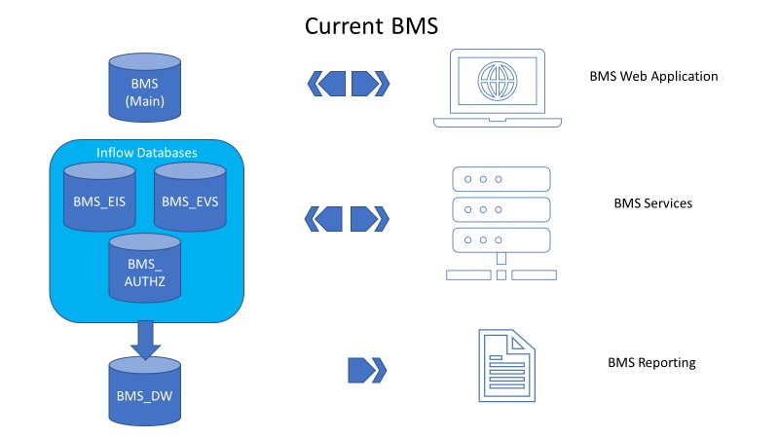

Constraints
The software needs to address system-related issues associated with the currently deployed BMS v.2.4.10 product, while continuing to meet functional business needs and requirements of the business owner.
The objective of this software release is to enhance the current BMS functionality as part of the nationally supported Class I solution, while complying with all previously established VA national release criteria.

Specific functionalities to be deployed in this release of BMS v2.4 will enhance functionalities of the following components of the system:
- Redeployment of repaired Bulk Add/Edit User
- Email Alert for Patients added to the National Wait List
- Census Category fix to display “N/A” for Wards not configured
- Bulk Bed Processing enhancements – bed management, return to service, evacuation icon
- Hover feature for patients who are Opt-Out
- Correct defect with CLC column not filtering when populated on facility PPBP list
- Provide clearer guidance for users on Whiteboard Bed Edit Page
- Evacuation patient logic enhancement

BMS v2.4 will be a single code base system supporting all VAMCs and Veterans Integrated Service Networks (VISNs).

BMS v2.4 will be hosted in a browser-controlled environment.

BMS v2.4 design will support the server configurations deployed at the Austin Information Technology Center (AITC) that hosts BMS v.2.4.

Roles and Responsibilities
This section outlines the roles and responsibilities for managing the deployment of the BMS 2.4 application. The BMS Development Team will produce the deployment artifacts (RFC’s, DB Scripts, executables, etc.) and work directly with the AITC personnel to plan the actual deployment.

Table 1: Deployment, Installation, Back-out, and Rollback Roles and Responsibilities
ID | Team | Phase / Role | Tasks | Project Phase (See Schedule)
1 | FO, EO, NDCP or Product Development (depending upon project ownership) | Deployment | Plan and schedule deployment (including orchestration with vendors). | Deployment
2 | FO, EO, NDCP or Product Development (depending upon project ownership) | Deployment | Determine and document the roles and responsibilities of those involved in the deployment. | Design/Build
3 | FO, EO, or NDCP | Deployment | Test for operational readiness. | Design/Build
4 | FO, EO, or NDCP | Deployment | Execute deployment. | Design/Build
5 | FO, EO, or NDCP | Installation | Plan and schedule installation. | Deployment
6 | Regional PM/ Field Implementation Services (FIS)/ Office of Policy and Planning (OPP) PM | Installation | Ensure authority to operate and that certificate authority security documentation is in place. | Design/Build
7 | Regional PM/FIS/OPP PM/ Nat’l Education & Training | Installations | Coordinate training. | Deployment
8 | FO, EO, NDCP or Product Development (depending upon project ownership) | Back-out | Confirm availability of back-out instructions and back-out strategy (what are the criteria that trigger a back-out). | Deployment
9 | FO, EO, NDCP or Product Development (depending upon project ownership) | Post Deployment | Hardware, Software and System Support. | Maintenance

Deployment
The deployment and installation is scheduled to run as depicted in the BMS v2.4 development master schedule.

Site Readiness Assessment
The product will be released by the BMS Development Team to the AITC Build Manager via a Change Order. The AITC Build Manager will follow the installation steps in Section 0 to complete the product’s activation at AITC. The Implementation Manager has assured site readiness by assessing the readiness of the receiving site to deploy the product. AITC, under contract, will provide the product dependencies, power, equipment, space, manpower, etc., to ensure the successful activation of this product.

Application Architecture
The following diagram represents the high-level architecture for the BMS application. BMS is a national application deployed at the AITC data center. The application is accessed at VA medical centers using approved web browser software. BMS reads data from VistA systems associated with each site’s VistA instance.

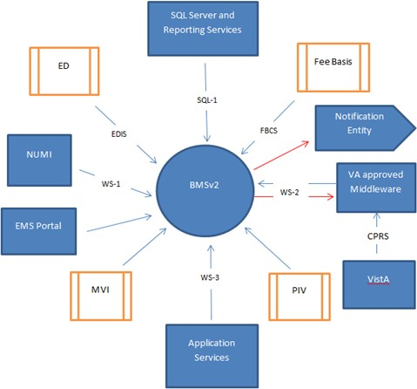

Figure 2: BMS Architecture Diagram

Deployment Topology (Targeted Architecture)
This product will be released to AITC. The AITC, under contract, will house and secure this product on its Pre-Production and Production servers. The BMS system will be available to VA users on a continuous basis (excluding scheduled maintenance activities).

Site Information (Locations, Deployment Recipients)
AITC will host the web and application servers for the BMS system.

Site Preparation
BMS will be supported on VA equipment that currently runs the existing BMS 2.3.1 system; therefore, no site preparatiohn activites are required.

Resources
This section describes the hardware, software, and communications for the deployment of BMS, where applicable.

Facility Specifics
No facility-specific features are required for this deployment.

Hardware
As middleware, BMS 2.4 requires no hardware to install. BMS 2.4 will be supported on existing VA equipment.

Software
BMS 2.4 will be updating the system to implement a patch to fix post-deployment defect fixes. Other than changes to the application files and database objects, no new COTS software or database/operating system updates are required.
The software components and database change scripts will be staged at the following location:
\\vaaussqlbms801.aac.dva.va.gov\bms_team\prod_deployment\patches

Communications
This section outlines the communications to be distributed to the business user community:
        - Communication between the development team, AITC, and the Sustainment team will occur via email and conference calls scheduled through Microsoft Lync.
        - Notification of scheduled maintenance periods that require the service to be offline or that may degrade system performance will be disseminated to the business user community a minimum of 48 hours prior to the scheduled event.

        - Notification to VA users for unscheduled system outages or other events that impact the response time will be distributed within 30 minutes of the occurrence.

Deployment/Installation/Back-Out Checklist
The table below outlines the coordination effort and documents the day/time/individual when each activity (deploy, install, back-out) is completed for BMS 2.4. The table will be populated once the activities are completed.
Table 3: Deployment/Installation/Back-Out Checklist
Activity | Day | Time | Individual who completed task
Deploy | TBD
Install | TBD
Back-Out | TBD

Installation
This section outlines the backup and installation steps for the various BMS 2.4 components.

Pre-installation and System Requirements
This section outlines the minimum requirements for the product to be installed, as well as the recommended hardware and software system requirements. BMS 2.4 is being deployed to fix post deployment defects. As an upgrade, there are no changes to the existing hardware and software system components. The only changes are to the BMS application and database objects
- to support the BMS 2.4 functionality.

6.1.1 Pre-installation Activities:

Download the .zip files from the following directory and unzip on the applicable servers
\\vaaussqlbms801\bms_team\Release 2 2020\Prod\BMS.Services.zip
\\vaaussqlbms801\bms_team\Release 2 2020\Pre-Prod\SQL.zip
\\vaaussqlbms801\bms_team\Release 2 2020\Pre-Prod\Web.zip

Database Server
This section outlines the installation steps for the various BMS v2.4 database components on vaaussqlbms210.
  - Execute the database scripts located in the \\vaaussqlbms801\bms_team\Release 2 2020\ Prod\SQL.zip

Web Server
This section outlines the installation steps for the BMS components on the web server – vaauswebbms210.
- Backup affected web dll’s from D:\BMSWeb\
- Install modified web dll’s on the web server in the D:\BMSWeb\ directory, which will restart the web services and update cache

App Servers
This section outlines the installation steps for the BMS components on the web server – vaausappbms210 and vaaausappbms211.
- Backup affected app dll’s from D:\Services\BMS both on VAAUSAPPBMS200 and VAAUSAPPBMS201.
- Stop the following Services on VAAUSAPPBMS200 and VAAUSAPP201, in order as listed: VAAUSAPPBMS200: (BMS.BedManagerService, BMS.SecurityHost, BMS.ServiceHost) VAAUSAPPBMS201: (BMS.VI.ServiceHost, BMS.ServiceHost)
- Install modified app dll’s on the app servers in the D:\Services\BMS directories on VAAUSAPPBMS200 and VAAUSAPPBMS201, which will restart the web services and update cache
- Start the following Services on VAAUSAPPBMS200 (in order as listed): BMS.ServiceHost, BMS.SecurityHost, BMS.BedManagerService and VAAUSAPPBMS201 (in order as listed): BMS.ServiceHost, BMS.VI.ServiceHost

Post-installation and Smoke Testing
This section outlines the post-installation activities and the minimum BMS 2.4 functionality to smoke test.

Post-installation Activities
Log into the BMS Web Application

Smoke Testing
- Perform Smoke Testing
  - Ensure the BMS Application allows login, navigation, report execution, as well as other functionality that would be included as part of regression testing efforts.
  - Ensure tht the activation and deactivation of sites as well as addition of new sites is available via the BMS application (Do NOT recommend testing this unless support teams are scheduled and available).
  - Ensure EDIS auto-remove dropdown is available from the facility PPBP list.
  - Ensure that the Virtual Ward column on Bed Board Ward confirmation page is renamed to Combined Ward.
  - Ensure the Return to Service Checkbox on Bulk Bed Management page appears correctly on the Bulk Bed Management Page.
  - Ensure the SVC (Service Connected Percentage) appears properly on the Facility PPBP List.
  - Ensure that the PPBL Status report are showing the proper number of pages. The previous version within the application only displayed a maximum of one page.

Rollback/ Back-Out Plan
The BMSv2.4 rollback/back-out plan is relatively straightforward since backup directories were created on each of the upgraded servers.
  - VAAUSSQLBMS210
    - Restore and Compile the backup stored procedures
  - VAAUSWEBBMS210
    - Shutdown the web service
    - Restore the backup web dll’s
    - Restart the web service
  - VAAUSAPPBMS210/VAAUSAPP211
    - Shutdown the services
    - Restore the backup app dll’s
    - Restart the services.
  - Perform Smoke Testing

