Compensation and Pension Records Interchange (CAPRI)

Release Notes
DVBA*2.7*209
March 2019
Department of Veterans Affairs
Office of Information and Technology (OI&T)

Table of Contents
1. Introduction 1
1.1. Description 1
2. Purpose 2
3. Audience 2
4. This Release 2
4.1. Enhancements 2
N/A 2
4.2. New Features and Functions Added 2
N/A 2
4.3. Modifications to Existing Functionality 2
4.3.1. Pre Post Discharge Flag 2
4.3.2. Virtual VA Transmission Status 4
4.3.3. Error Message displayed for GUI version of CAPRI 5
4.4. Known Issues 6
4.5. Defects 6
4.5.1. I7798288FY16 / 553087 CAPRI - C&P Exam Requests missing RO value: 6
4.5.2. I9127673FY16 / 553089 CAPRI - Copying with CTRL C causes CAPRI to crash 6
4.5.3. I15864002FY17 / 588679 CAPRI: inconsistent routing locations on 7131 requests 7
4.5.4. I18426774FY18 / 894638 CAPRI 7131 requests automatically closing in AMIE: 7
4.5.5. I12188347FY17 / 553078 CAPRI exams not closing out properly when a DBQ is cancelled 7
4.5.6. I13232280FY17 / 553080 CAPRI "Validate Remote Connections" problem 8
4.5.7. I7855778FY16 / 553084 CAPRI is unable to access Upstate New York HCS using Enterprise 8
4.5.8. I11409458FY17 / 553076 CAPRI: Enterprise Search Issue 8
4.5.9. I13483878FY17 / 894644 CAPRI Enterprise Search Concern: 8
4.5.10. I18189589FY18 / 894652 CAPRI - Enterprise Search does not work from-to Portland: 9
4.5.11. INC0629993 / 894656 A CAPRI bug has been identified where the mouse cursor changes to an hourglass, then never changes back: 9
4.5.12. INC3159682 / 867183 CAPRI GUI-Your Client software is older than the server on Vista 9
4.5.13. 876380 Update RPC logger code to improve CAPRI Performance 10
4.5.14. INC2749812 / 876380 ERIE - DVBA C Check 2507 Integrity Report findings 10
4.5.15. INC2754318 / 876379 CAPRI - Portland cannot see exams transferred from R01 10
4.5.16. INC3221099 / 876378 New C&P Divisions being set to active 10
4.5.17. INC1885947 / 941346 CAPRI C&P template bug with keyboard navigation 11
4.5.18. INC1315324 / 951874 CAPRI edit exam list parameters MAS option - bug allows all divisions to be displayed 11
4.5.19. INC2498456 / 894659 CAPRI - cannot cosign templates/exams 11
5. Product Documentation 12

Introduction
The main purpose of this patch is to release a new version of the Compensation & Pension Record Interchange (CAPRI) Graphical User Interface (GUI) that includes defect fixes to the user interface to support user interface modifications.
CAPRI GUI 209 and VistA patch 209 provide defect fixes for the CAPRI GUI and the Automated Medical Information Exchange (AMIE) package.

Description
The Separation Health Assessment (SHA) is a comprehensive medical examination conducted by either the Veterans Affairs (VA) or Department of Defense (DoD) for Separating Service Members (SSMs) who file pre-discharge claims under the Benefits Delivery at Discharge (BDD) Program. The SHA is used by both the Veterans Benefits Administration (VBA) and DoD to evaluate a SSM’s disability(ies) and determine benefits eligibility according to a common standard. The VA and DoD need the ability to share the SHA results as soon as it they become available (on or prior to the Release from Active Duty [RAD] date). To avoid duplication of health assessments between the two departments, VA assessments are used by DoD. Software changes were made to CAPRI to facilitate the transfer of SSMs Veterans Health Administration (VHA) completed Disability Benefits Questionnaires (DBQs) to the DoD’s Healthcare Artifact and Image Management Solution (HAIMS) electronic Servicemember (SM) treatment record. The VHA completed DBQs for SSMs include SHA DBQs and supplemental DBQs completed while the SSM is on active duty.
Patch DVBA*2.7*209 will also fix the following issues:
- 2507 Request without Regional Office (RO) values
- Copy and Paste crash issues
- Inconsistent routing locations on 7131 requests
- 7131 requests automatically closing in AMIE
- 2507 Requests not closing out properly when an exam is cancelled
- "Validate Remote Connections" validation issues
- Enterprise search issues with validating the "Connect To" site
- Enterprise search allowing search without all required data
- Enterprise search results may include non VAMC entities that are not Accessible.
- Enterprise search identifying user as being connected as a "Treating Facility" and attempts to "Connect to Site" user is continuously prompted to select a site
- A delay between mouse cursor loading symbol changing back to pointer
- Capri GUI not recognizing version control
- GUI logger code default status change to improve performance
- C&P exams not transferring if patient is not registered at new receiving site
- DVBA C Check 2507 Integrity Report findings listing all exams
- New C&P Divisions being set to active automatically
- CAPRI C&P Template bug with keyboard navigation
- CAPRI Edit exam list parameters MAS Option-Bug allows all divisions to be displayed
- Co-Signing templates encounters an undefined error during signature process

Purpose
These CAPRI Release Notes cover the application updates for CAPRI Patch DVBA*2.7*209.

Audience
This document targets users and administrators of CAPRI Patch DVBA*2.7*209 and the corresponding client (GUI) application and applies to the changes made between this release and any previous release for this software.

This Release
The following sections provide a summary of the modifications to the existing software, and any known issue for CAPRI Patch DVBA*2.7*209.

Enhancements

N/A

New Features and Functions Added

N/A

Modifications to Existing Functionality
The following are modifications to existing functionality:

Pre Post Discharge Flag
CAPRI will update the GUI “Signature Validation” screen to include a new drop-down menu that will require the C&P Clinician to select whether or not the completed DBQs are Pre or Post Discharge.
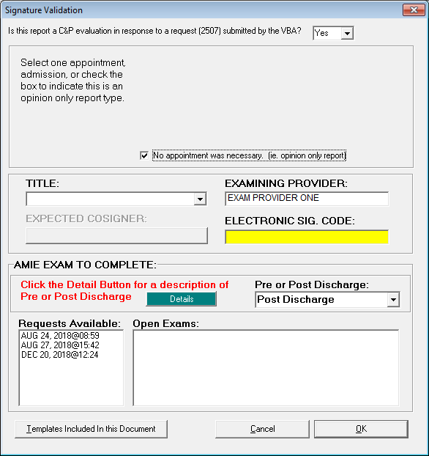
Figure 1. Signature Validation Screen.
PRE or POST DISCHARGE: From the drop-down menu, select Pre Discharge or Post Discharge:
- Select Pre Discharge if the patient’s proposed date of separation from active service is ON or AFTER the date of the examination being performed.
- Select Post Discharge if the patient’s last date of separation from active service was BEFORE the date of the examination being performed.
NOTE: The CAPRI Signature Validation screen will automatically default to the Post-Discharge status. The clinician MUST change the selection to Pre-Discharge when applicable.
Click the Details button for a description of Pre or Post Discharge.
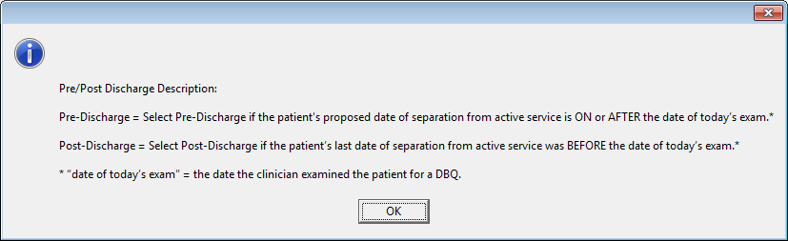
Figure 2. Description of Pre or Post Discharge.

DAS sends to DoD any DBQ flagged as Pre-Discharge that has an EDIPI and is either received in DAS on, or before, the date that is populated in the RAD field, or that has no date populated in the RAD field.

Virtual VA Transmission Status
If transmission fails between CAPRI and DAS, the user will be able to retransmit up to 5 times before being prompted to contact the national help desk.
When an examiner completes an exam from the signature validation screen it will automatically be transmitted to Virtual VA (Figure 33.). The examiner will need to acknowledge the Virtual VA Transmission Status window as shown below by clicking the “Close” button.
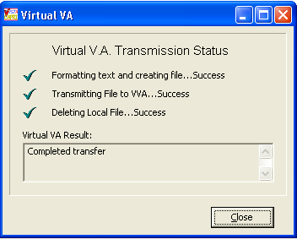
Figure 3. Virtual VA Transmission Status.
Step 7 - When an examiner completes an exam from the signature validation screen it will automatically be transmitted to VLER DAS. The user will “not” have to acknowledge transmission; however, if transmissions to VLER DAS fails the following message “Transmission to VLER failed, do you want to retransmit?” will be displayed to the user and give the opportunity to retransmit the failed DBQ(s) five times. (Figure 4.). If the user selects “No” or after the fifth failed attempt to transmit, the user is prompted to contact the National Service Desk. (Figure 5).
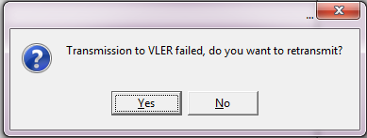
Figure 4. VLER Transmission Failed Alert.
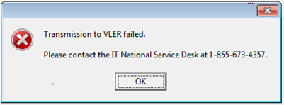
Figure 5. Contact National Service Desk.

Error Message displayed for GUI version of CAPRI
An error message is displays for the GUI version of CAPRI that does not match the current version of the VistA patch.
CAPRI VistA and GUI Enhancements – Software Versioning Messages
For GUI versions of the CAPRI application that do not match the current version of the VistA patch, a message displays that the software does not match what is running on the Vista server and a seven (7)-day grace period is in effect for the user to update the client software:
Example Message:
Your client software does not match the server on VistA. Please contact IRM for assistance. VistA is running DVBA*2.7*209*1
Your access using this version will be denied after 11/18/2019 [example 7-day grace period date]
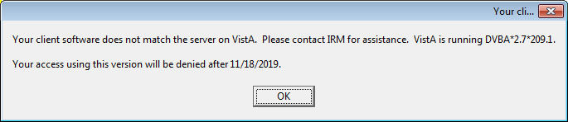
Figure 6. Software Version Error Message 1
If the user fails to update the client software within the seven (7)-day grace period, message below displays:
Example Message:
Your client software does not match the server on VistA. Please contact IRM for assistance. VistA is running DVBA*2.7*209*1
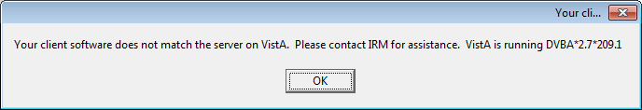
Figure 7. Software Version Error Message 2
Pressing OK at the screen above will display the message below:

Example Message:
Versions of CAPRI prior to DVBA*2.7*209*1 will not run from this server. You are currently running DVBA*2.7*193.12*
Example of Message Displayed in the GUI
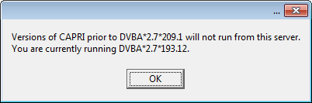
Figure 8. Software Version Error Message 3

Known Issues
TBD

Defects

I7798288FY16 / 553087 CAPRI - C&P Exam Requests missing RO value:
Problem:
When marking a 2507 Exam as insufficient, when creating the new request, if the Regional office has more than one match in the VAMC by name, the update will fail to populate the Regional Office because it cannot find a unique value based on the name.

Resolution:
Rather than using the name to identify the Regional Office, CAPRI will now pass the internal entry number of the Institution File record as there will be only one entry for each internal value.

I9127673FY16 / 553089 CAPRI - Copying with CTRL C causes CAPRI to crash
duplicate: I10983321FY17
duplicate: I11270080FY17
duplicate: I11995613FY17
duplicate: I9127811FY16
Problem:
Attempting to copy or paste from the exam "Cancel Comments" box on the "Exam Details" screen of CAPRI using CTRL C or CTRL V causes a fatal crash of CAPRI. Using the mouse right-click menu to copy/paste does not cause this failure.

Attempting to copy from the "Routing Location Information" box on the "Add New C&P Exam" screen of CAPRI using CTRL C causes a fatal crash of CAPRI. Using the mouse right-click menu to copy does not cause this failure.

Resolution:
The code in CAPRI that handles the CopyToClipboard, CutToClipboard, and PasteFromClipboard has been changed to set the current Edit Box or Memo Box as the ActiveControl. This tells the Windows API which control to copy/cut/paste to or from.

I15864002FY17 / 588679 CAPRI: inconsistent routing locations on 7131 requests
Problem:
When a user creates a new 7131 request using the 7131 requests tab in CAPRI, the list of routing locations available is identical to what is set to active under the "edit exam list parameters (MAS)" utility in CAPRI. However, if the user goes back into the 7131 request, CAPRI displays every routing location (both active and inactive) as options to the user.

Resolution:
When populating the list or routing locations on a 7131 Edit, CAPRI will now filter out inactive locations.

I18426774FY18 / 894638 CAPRI 7131 requests automatically closing in AMIE:
Problem:
CAPRI currently allows a 7131 to be submitted without checking any of the checkboxes on the "New 7131 Request" form. The FORM 7131 (#396) records are created, but because there are not any items identified by checkboxes the request is auto finalized (essentially closed) without any data returned. An additional request came in to force users to also enter "Comments" when submitting a 7131.

Resolution:
Prior to allowing a user to submit a 7131 request, CAPRI will check and force at least one checkbox to be marked and data entered into the "Comments" memo box.

I12188347FY17 / 553078 CAPRI exams not closing out properly when a DBQ is cancelled
Problem:
If a 2507 Request has multiple exams and the exams have a mixed bag of completed/canceled statuses AND the last exam satisfied is canceled, the corresponding 2507 Exam Status is not updated and the 2507 is not released even though all exams have been satisfied.

Resolution:
When canceling a 2507 Exam, CAPRI will now check to see if there are any remaining open exams on the 2507 Request. If there are not, it will update the status and release the exam.

I13232280FY17 / 553080 CAPRI "Validate Remote Connections" problem
Problem:
When on the "Validate Remote Connections" screen and checking connections for multiple entries, there is potential for one entry to fail and provide incorrect results for the subsequent tests automatically. This happens when a connection timeout occurs and CAPRI does not handle the failed attempt correctly resulting in subsequent failures.

Resolution:
When connection timeouts occur, CAPRI will reset the broker variables which will allow it to truly test each subsequent record.

I7855778FY16 / 553084 CAPRI is unable to access Upstate New York HCS using Enterprise
Problem:
When using the Enterprise Search functionality, CAPRI can indicate a user is unable to access certain sites due to issues with how CAPRI evaluates permissions.

Resolution:
When evaluating permissions, rather than using the selected entries site number to validate, CAPRI will now use the full facility name to compare with the site list the user has access to so that it will be able to appropriately grant access (or deny).

I11409458FY17 / 553076 CAPRI: Enterprise Search Issue
Problem:
After performing an "Enterprise Search" in CAPRI, the results returned may include non VAMC entities that are not accessible. If the user tries to connect to one of these entries they are presented with an error indicating they do not have access to the site or some other issue occurred preventing the connection. This causes confusion for VBA users who are tasked with collecting all relevant health information.

Resolution:
Now, after selecting a non VAMC entity to connect to, a message will display indicating the entry selected is not a VA treatment facility containing patient records.

I13483878FY17 / 894644 CAPRI Enterprise Search Concern:
Problem:
According to the CAPRI user manual, Enterprise Search is supposed to require First Name, Last Name, SSN, and Date of Birth. However, CAPRI is not physically requiring the Date of Birth field to be completed before allowing searches.

Resolution:
CAPRI GUI code modified to review and validate the DOB field. DOB is now a required field.

I18189589FY18 / 894652 CAPRI - Enterprise Search does not work from-to Portland:
Problem:
If a CAPRI user is connected to a site and does an "Enterprise Search" and the search identifies the site the user is currently connected to as a "Treating Facility," and if the user attempts to “Connect to Site," there is a potential to get into an endless loop where the end user is continuously prompted for a select to site.

Resolution:
CAPRI will now compare the "connect to" site with the currently connected site and if they are the same, present the user with a message/error indicating they are already connected to the site and to use the "Patient Selector" to select the patient in question.

INC0629993 / 894656 A CAPRI bug has been identified where the mouse cursor changes to an hourglass, then never changes back:
Problem:
When the user presses "OK" on the Preview Window, the mouse cursor will change to the loading symbol (a wheel or potentially an hour glass) for an extended duration of time, before returning to the default cursor pointer.

Resolution:
A line of code was added at the end of SaveExamsToMemory which returns the cursor to its default state after the user presses "OK" on the Preview Window and SaveExamsToMemory finishes executing.

INC3159682 / 867183 CAPRI GUI-Your Client software is older than the server on Vista
Problem:
Patch 193.12 introduced version control for the GUI to confirm that the user was using the latest version after a deadline date. Users were receiving an error after the deadline even if they were using the most current GUI version.

Resolution:
If the patch number check fails it falls back to a date located in the PARAMETERS file. We found a problem in the code that is failing the patch number check which appears to have been hard coded sometime prior to patch 193.10. This hardcoded code is being removed and corrected.

876380 Update RPC logger code to improve CAPRI Performance
Problem:
CAPRI Patch 193 included an update to create an RPC log that could be used to better identify errors received in the field. The logger was set to store 3 days’ worth of logs that could be used for debugging.

Resolution:
Change of the RPC logger’s default status to OFF and create a new parameter that will allow the logger to be turned ON when needed by a member of the IT support team.

INC2749812 / 876380 ERIE - DVBA C Check 2507 Integrity Report findings
Problem:
The report includes two entries. Both patients have cancelled exams. Two exams found on one patient, one from 1995, the other 2014. The second patient has one entry from 1995.

Resolution:
Patch 193.12 changed the screening process for this report. Routine DVBCCHKR is being reverted back to previous screening logic.

INC2754318 / 876379 CAPRI - Portland cannot see exams transferred from R01
Problem:
C&P exams are not being transferred to sites if the patient is not registered at the receiving site. Routine DVBCXFRC is expecting data parameters not being set in the bulletin receiving routine.

Resolution:
Routine DVBCXFRB is being modified to set the necessary variables required to enter the new patient information into the receiving sites file.

INC3221099 / 876378 New C&P Divisions being set to active
Problem:
New Divisions being added to the MEDICAL CENTER DIVISION File (#40.8), and then being added to CAPRI DIVISION EXAM LIST File (#396.15) are being marked as active if the Disable All Exams? field is left null.

Resolution:
DISABLE ALL EXAMS? field (#4) of DIVISION EXAM LIST File (#396.15) has a name change to DISABLE ALL C&P EXAMS? and will be made a required field. Additionally, a more exact verbiage will be added to the help text for this field. A post-install routine will review existing entries and if Null, will set the status to "No."

INC1885947 / 941346 CAPRI C&P template bug with keyboard navigation
Problem:
When using the keyboard to navigate the templates listed in the "Available Templates" or "Selected Templates" lists in CAPRI, the "Description" text does not update. This text only updates when a template is selected via a mouse click.

Resolution:
Modify ListBoxTemplatesChange and ListBoxSelectedTemplatesChange to update FMCommentsMemo when a new template is selected. This will allow the "Description" text to be accurate when using keyboard navigation.

INC1315324 / 951874 CAPRI edit exam list parameters MAS option - bug allows all divisions to be displayed
Problem:
If all Divisions are disabled in CAPRI DIVISION EXAM LIST File (#396.15), then CAPRI will allow all routing locations as selectable when Adding a New Request. This could lead to misrouted requests and claims processing delays.

Resolution:
Prevent all Divisions from being disabled in CAPRI to avoid these situations. If all CAPRI DIVISION EXAM LIST File (#396.15) Division's DISABLE ALL EXAMS? field (#4) are set to "YES," display no routing location options on the Add New C&P Exam form.

INC2498456 / 894659 CAPRI - cannot cosign templates/exams
Problem:
An error occurs during the co-signature process due to expected CAPRI TEMPLATE values being undefined during the signature process causing the save process to fail while updating the 2507 Exam file (#396.4).

Resolution:
The CAPRI code has been modified to identify the relevant data regardless of the signature process so the records are able to file correctly.

Product Documentation
The following documents apply to this release:
- CAPRI User Manual DVBA*2.7*
- CAPRI GUI Installation Supplemental Guide
- CAPRI System Administration and Technical Guide
- CAPRI Release Notes DVBA*2.7*
- CAPRI Deployment, Installation, Back-Out, and Rollback Guide DVBA*2.7*
All CAPRI documents are available at the VA (Software) Documentation Library (VDL) web site at the following CAPRI link: https://www.va.gov/vdl/application.asp?appid=133
This website is usually updated within 1-3 days of the patch release date.

