Compensation and Pension Records Interchange (CAPRI)

Release Notes
DVBA*2.7*193
September 2018
Department of Veterans Affairs
Office of Information and Technology (OI&T)

Table of Contents
1. Introduction 1
2. Purpose 1
3. Audience 1
4. This Release 1
4.1. Enhancements 1
4.1.1. Edit Exam List Parameters 1
4.1.2. DoD Records Tab has been removed from CAPRI 3
4.1.3. Error Message displayed for GUI version of CAPRI 3
4.1.4. Request Status by Date Range 5
4.1.4.1. VocRehab Tab Functionality 6
4.2. New Features and Functions Added 6
4.2.1. Joint Legacy Viewer (JLV) Tab 6
4.3. Modifications to Existing Functionality 7
4.4. Known Issues 7
4.5. Defects 7
4.5.1. CA SDM I9147004FY16 CAPRI - Authorized Patient: 7
4.5.2. CA SDM I9130238FY16 CAPRI - Other: 2507 e-mails erroneous 8
4.5.3. CA SDM I6482663FY16 CAPRI - Other: 8
4.5.4. CA SDM I9148176FY16 CAPRI - DBQs/Worksheets: 8
4.5.5. CA SDM I9127755FY16 - Other: clinical documents search issue 8
4.5.6. CA SDM I7698322FY16 CAPRI - Other: 2507s not closing out correctly 9
4.5.7. CA SDM I6587267FY16 CAPRI: patching the provider signature function 9
4.5.8. CA SDM I8233197FY16 CAPRI freezing: 9
4.5.9. CA SDM I9000823FY16 CAPRI - cannot close exams on one patient: 9
4.5.10. I18872737FY18 CAPRI - VistAWeb link will not connect to JLV service: 10
5. Product Documentation 10

Introduction
The main purpose of this patch is to release a new version of the Compensation & Pension Record Interchange (CAPRI) Graphical User Interface (GUI) that includes defect fixes to the user interface to support user interface modifications.
CAPRI GUI 193.12 and VistA patch 193.12 provide defect fixes for the CAPRI GUI and the Automated Medical Information Exchange (AMIE) package.

Purpose
These CAPRI Release Notes cover the changes to CAPRI Patch DVBA*2.7*193.12 for this release.

Audience
This document targets users and administrators of CAPRI Patch DVBA*2.7*193.12 and the corresponding client (GUI) application and applies to the changes made between this release and any previous release for this software.

This Release
The following sections provide a summary of the modifications to the existing software, and any known issue for CAPRI Patch DVBA*2.7*193.12.

Enhancements
The following are the enhancements added to the CAPRI Patch DVBA*2.7*193.12 release.

Edit Exam List Parameters
- New C&P routing locations added to the VistA Division file will now default to inactive in CAPRI. The CAPRI “Edit Exam List Parameters (MAS)” option will be used to manually activate new C&P routing locations in the VistA Division file.
(See CAPRI User Manual (UM) Section 2.13.1)
The menu option Edit Exam List Parameter (MAS) is under Tools on the CAPRI menu bar. Exam List Parameter (MAS) is a tool used by sites to define which exams are performed at a division. When an exam request is made via the C&P exams tab, the exam list displays exams as performed or not performed in a division according to this definition. See Figure 2-208 below.
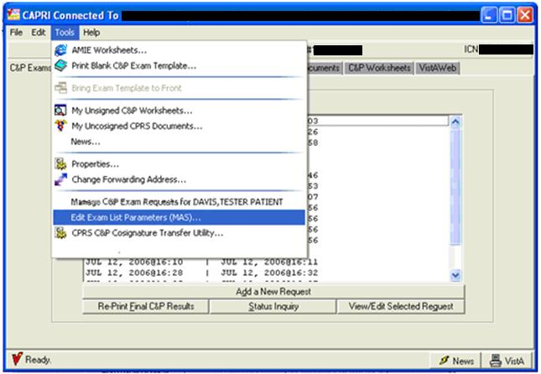
Figure 2-208 CAPRI Tools Menu—Edit Exam List Parameters.
If a new division(s) has/have been added, the next time a user uses this option it sets the new division(s) to inactive by default. CAPRI users can manually activate the new division(s) by unchecking the ‘Completely Inactive this Division’s checkbox.
To turn off a division so it is not available for user selection, the user selects the division on the left of the screen then selects the box labeled Completely Inactivate this Division in the Edit Exam List Parameters (MAS) window as shown in (Figure 2-209). A textbox is provided for <comments relating to a specific division.
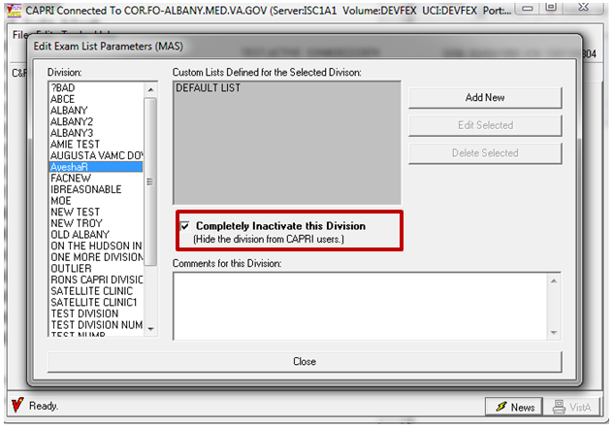
Figure 4-1 Edit Exam List Parameters Screen.

DoD Records Tab has been removed from CAPRI
DoD Records Tab has been removed from CAPRI.

Error Message displayed for GUI version of CAPRI
- Modifications have been made to CAPRI so that when a VistA patch is installed, CAPRI users will be unable to run the older version of the GUI.
(See CAPRI User Manual (UM) Section 3.10)
An error message is displayed for GUI version of CAPRI that does not match the current version of the VistA patch.
When running the GUI version of CAPRI that does not match the current version of the VistA patch, the message shown below (Error! Reference source not found.) will display on the screen.
"Your Client Software is older than the server on VistA. Please contact IRM for assistance. VistA is running CAPRI GUI v2.7*193*1*A.”

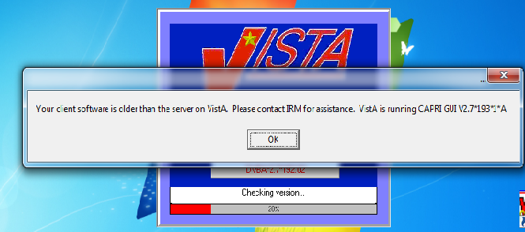
Figure 4-2. Incompatible CAPRI GUI Version Alert.

After the user clicks on the ‘OK’ button displayed above, a second message will display in the GUI:
“Versions of CAPRI prior to DVBA*2.7*193 will not run from this server. You are currently running DVBA*2.7*192.”
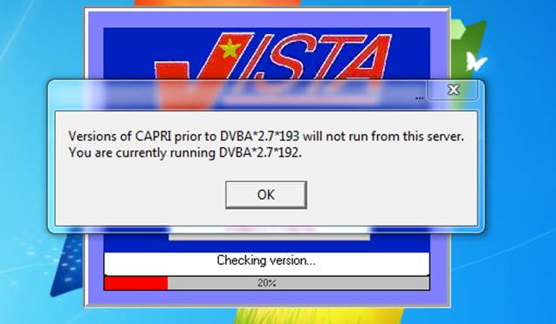
Figure 4-3. Incompatible CAPRI GUI Version Second Alert.
After the user clicks on the OK button displayed above, CAPRI will be disabled and will not run

Request Status by Date Range
- The CAPRI ‘Request Status by Date Range Report’ has been Modified for the Cancellation Reason and Cancellation Comment fields. When viewing the report in the CSV format, the Cancellation Reason and Cancellation Comment fields will be truncated to 40 characters displayed by an asterisks (*) in front of the comments.
(See CAPRI User Manual (UM) Section 2.5.1.8)
The report in (Figure 4-4 CAPRI Reports—Request Status by Date Range) generates a simple list of exam requests by Request Status entered within the specified date range. In addition, the statuses of New; Pending, Reported; and Released to RO, Not Printed may be run for a blank date range by choosing Yes to Blank Date Range. The following fields are reported: SSN, Patient Name, Request Date, Date Released, Date Printed, Status, Date Cancelled, VBA Requesting Station, Claim Type, Special Consideration(s), Cancellation Reason, and Cancellation Comments.
When viewing the report in CSV format, the Cancellation Reason and Cancellation Comments fields are truncated to 40 characters displayed by an asterisk (*) in front of the comments.
The report is sorted by the date of the last request status change. When a blank date range is used for New; Pending, Reported; or Released to RO the report is sorted by request date. The report was created primarily to assist VBA to better track exam requests as they are processed.
Request Status by Date Range allows the following status filters:
- All Statuses
- New
- Pending, Reported
- Canceled by MAS
- Canceled by RO
- Released to RO, Not Printed
- Completed, Printed by RO

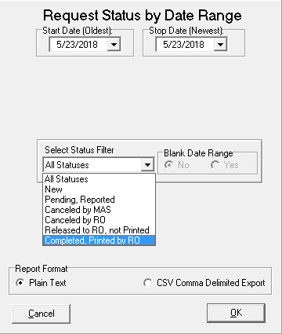
Figure 4-4 CAPRI Reports—Request Status by Date Range

VocRehab Tab Functionality
- VocRehab Tab has been modified to not appear inactive by color.
(See CAPRI User Manual (UM) Section 2.11.3)
For the user, there are no visible changes to the VocRehab Tab.

New Features and Functions Added
The following are the new features and functions added to the CAPRI Patch DVBA*2.7*193.12 release.

Joint Legacy Viewer (JLV) Tab
- JLV tab replaces the VistAWeb Tab.
(See CAPRI User Manual (UM) Section 2.13.2)
The Joint Legacy Viewer (JLV) tab has replaced the VistAWeb as part of the GUI 193.12 update, in preparation of the VistAWeb end of lifecycle. The JLV provides an integrated read-only view of health data from all VA and VA community partner sites where the Veteran or Service member has received care.
The JLV tab is viewable only from CAPRI clients that operate on the DVBA*2.7*193.12 framework (GUI 193.12 and VistA Patch 205)
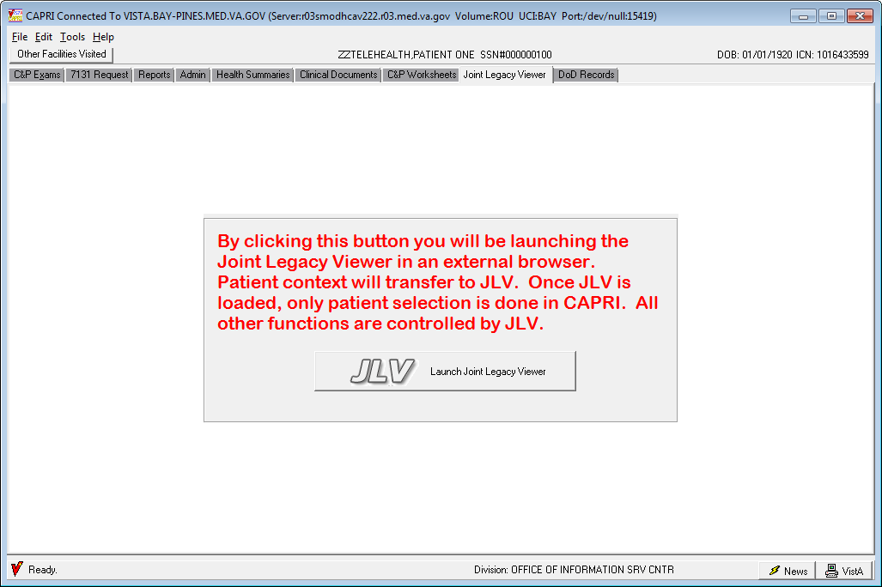
Figure 4-5. Joint Legacy Viewer (JLV) Launching Button
NOTE: To maintain patient context between CAPRI and Joint Legacy Viewer, CAPRI will close the JLV bowser each time a patient or site is changed.

Modifications to Existing Functionality
The following is a modification to existing functionality:
CAPRI GUI V2.7 193.12 requires a Version Control check against VistA patch DVBA*2.7*193.12 Version Control file that will ensure that all VA Sites and CAPRI Users will be operating under CAPRI GUI v2.7. 193.12 after DVBA*2.7*193.12 has been installed.
The above statement has also been noted in the CAPRI 193 Deployment, Installation, Back-Out, and Rollback Guide (Section 3 Deployment) and in the CAPRI 193 GUI Installation Supplemental Guide (Section 3 CAPRI Installation Procedures).

Known Issues
There are no known issues for this patch (CAPRI GUI v2.7. 193.12).

Defects

CA SDM I9147004FY16 CAPRI - Authorized Patient:
Problem:
This particular issue happens because the low internal number of the patient in the PATIENT file (example 719). This becomes problematic during a call to retrieve the patient’s exam requests because it passes the ien and looks for PARTIAL matches. Because of this it returns all requests and tries to return all the requests for every patient ien that contains 719. Assuming there 719,000 patients it tries to return exams for ien 719000-719999.

Resolution:
This is controlled by the "NUMBER" property for the FMExamRequestLister1 component which is currently "*." The “*” tells the FileMan call to retrieve every match This has been changed to retrieve only the first 250 matches.

CA SDM I9130238FY16 CAPRI - Other: 2507 e-mails erroneous
Problem:
CAPRI sends Outlook notification e-mails to end users notifying them when a 2507 is released, individual exams are released, or exams are cancelled. Users have identified an issue where in the right circumstances, some exams on a 2507 can be cancelled, other exams on the same 2507 can be completed/released, and the only e-mail the end users receives is a message stating that all exams on the 2507 are cancelled. This is an erroneous and misleading e-mail.

Resolution:
When a mix of canceled or completed exams lead to the release of a 2507 request, the email will reflect that both actions led to the release.

CA SDM I6482663FY16 CAPRI - Other:
Problem:
When signing off on CAPRI templates and selecting a "TITLE," if there are two options that have matching text CAPRI can potentially select the incorrect TIU DOCUMENT DEFINITION when creating the TIU DOCUMENT.

Resolution:
Change the matching process so that it no longer allows partial matching and fully evaluates the entire name of the "TITLE" being selected.

CA SDM I9148176FY16 CAPRI - DBQs/Worksheets:
Problem:
While in a 2507 Request, users are able to add a duplicate/existing exam type on the same 2507 Request if the preceding 2507 Exam is no longer open even though two of the same exam types on a single 2507 Exam are not supposed to be allowed.

Resolution:
Filter out existing exam types on that 2507 Request when presenting the user exam type options when they are adding additional exams to that 2507 Request.

CA SDM I9127755FY16 - Other: clinical documents search issue
Problem:
The issue occurs because regardless of the report criteria selected (Date Range, # Records, All), the code unconditionally passes the last selected “max number” value to the Remote procedure code - 'TIU DOCUMENTS BY CONTEXT' which restricts the number of returned records regardless of the report format specified.

Resolution:
Only restrict the number of records if those criteria are selected when running the Report.

CA SDM I7698322FY16 CAPRI - Other: 2507s not closing out correctly
Problem:
If a user cancels the only exam on a request, and then exits the "View C&P Exam" form by clicking the "X" in the upper right hand corner rather than utilizing the "Close Window" button, the code to update the 2507 record is not executed and the status is not updated.

Resolution:
Remove the ability to click the "X" and force the user to close the form/window using the available "Close Window."

CA SDM I6587267FY16 CAPRI: patching the provider signature function
Problem:
When signing off on a CAPRI template and linking it to a 2507 Exam, CAPRI fails to populate the CAPRI TEMPLATE ID field (#1) in the 2507 EXAM file (#396.4).

Resolution:
Add logic so that when the 2507 EXAM record is being updated, it also updates the CAPRI TEMPLATE ID field (#1).

CA SDM I8233197FY16 CAPRI freezing:
Problem:
When signing off on a CAPRI template and if the main form is pushed off the screen, then when the "Virtual VA" transmission form displays, it displays at the center of the form that is currently pushed off the screen and, since that is the active screen and the user is unable to manipulate it (click buttons etc.), it gives the impression that CAPRI has frozen.

Resolution:
Rather than displaying the "Virtual VA" transmission form in the center of the main form, it displays in the middle of the screen so the user can always respond and complete the signature process.

CA SDM I9000823FY16 CAPRI - cannot close exams on one patient:
Problem:
While opening the "Manage C&P Request" form for a patient, the application makes a call to retrieve all partial matches by patient for all 2507 requests using the patient internal entry number. This could potentially lead to thousands of irrelevant records being returned which also causes CAPRI to freeze while processing the extra records.

Resolution:
Rather than pulling all partial matches, the number of results is limited to 150.

I18872737FY18 CAPRI - VistAWeb link will not connect to JLV service:
Problem:
VistA Web application is to be decommissioned. The CAPRI GUI client link to VistA Web must be replaced by link to the replacement Joint Legacy Viewer (JLV).

Resolution:
The CAPRI GUI client has been updated to replace the VistA Web integration (VistA Web tab) with the JLV tab. This tab will contain a button that will launch JLV in an external browser while keeping patient context.

INC0731818 - C&P Exam Button
Problem:
In reference to the C&P Exam screen, current placement of the ‘Add An Insufficient Exam Request’ and ‘Close Window’ buttons cover checkboxes and other items at the end of the screen, so users are unable to select these items.

Resolution:
The CAPRI GUI client has been updated with a new C&P Exam screen (Figure 2-58) to display the new placement of the ‘Add An Insufficient Exam Request’ and ‘Close Window’ buttons. Both buttons have been moved to the top of the form and made static.

Product Documentation
The following documents apply to this release:
- CAPRI User Manual DVBA*2.7*193
- CAPRI GUI Installation Supplemental Guide
- CAPRI System Administration and Technical Guide
- CAPRI Release Notes DVBA*2.7*193.12
- CAPRI Deployment, Installation, Back-Out, and Rollback Guide DVBA*2.7*193
All of the CAPRI documents are available VA (Software) Documentation Library (VDL) web site at the following CAPRI link: https://www.va.gov/vdl/application.asp?appid=133
This website is usually updated within 1-3 days of the patch release date.

