Compensation and Pension Record Interchange (CAPRI)
(CAPRI GUI v. DVBA_27_187_12)

Release Notes

Patch DVBA*2.7*187

December 2014

Department of Veterans Affairs
Office of Enterprise Development

Preface
Purpose of the Release Notes
The Release Notes document describes the enhancements and/or defects addressed in Patch DVBA*2.7*187.
Reference Numbering System
This document uses a numbering system to organize its topics into sections and show the reader how these topics relate to each other. For example, section 1.3 means this is the main topic for the third section of Chapter 1. If there were two subsections to this topic, they would be numbered 1.3.1 and 1.3.2. A section numbered 2.3.5.4.7 would be the seventh subsection of the fourth subsection of the fifth subsection of the third topic of Chapter 2. This numbering system tool allows the reader to more easily follow the logic of sections that contain several subsections.

Table of Contents
1 Overview 1
2 Customer – Veteran Health Administration (VHA) and/or Veterans Benefits Administration (VBA) 1
2.1 Enhancements 1
2.1.1 Add “DBQ Medical SHA” to the AMIE Exam File 1
2.1.2 Rename DBQ Medical Opinion 1 to DBQ Medical Opinion in the AMIE Exam File 1
2.1.3 Inactivate entries in the AMIE Exam File 2
2.1.4 New Security key for Get Docs from Virtual VA (VVA) 2
2.1.5 Get Docs from DAS – On the file menu 2
3 Customer – Veteran Health Administration (VHA) 4
3.1 Enhancements 4
3.1.1 Notify DAS of vendor exam requests for CAPRI Contract Referral (CCR) 4
3.1.2 New “CAPRI Alert” for CAPRI Contract Referral (CCR) pending under review exams 5
3.1.3 CAPRI Contract Referral (CCR) – Retrieve exam results with status of pending under review from DAS 6
3.1.4 DBQ transmission failure to DAS 9
3.1.5 Separate current merged PDF exam results into a separate PDF for each exam transmitted to DAS 10
4 Customer – Veteran Health Administration (VHA) and/or Veterans Benefits Administration (VBA) 10
4.1 Defects with remedy tickets 10
4.1.1 INC000000998063 – Transmit to Virtual VA (VVA) bug. 10
4.1.2 INC000000970009 – Wrong exam comments on 2507 screen 10
4.1.3 INC000000938270 – Requestor without email address receives error when completing templates 11
4.1.4 INC000000959449 – Wrong patient data in footer when print functionality utilized from “My Unsigned C&P Worksheets” menu 11
4.1.5 INC000000919417 – ONEEMAIL+15^DVBAB1A error 11
4.1.6 INC000000819092 – CAPRI News Items not saving read/clear status 12
4.1.7 INC0000001005379 – New patient entry fails if space at end 12
5 Software and Documentation Retrieval 12
5.1 VistA Patch DVBA*2.7*187 12
5.2 CAPRI GUI v187 Client Software & User Documentation 13
5.3 Related Documents 14

Overview
The main purpose of this patch is to release a new version of the Compensation & Pension Record Interchange (CAPRI) Graphical User Interface (GUI) that includes defect fixes and enhancements to the user interface to support user interface modifications.
CAPRI GUI v187 and patch (DVBA*2.7*187) provide defect fixes and enhancements for the CAPRI GUI and the Automated Medical Information Exchange (AMIE) package.
The information contained in this document is not intended to replace the CAPRI GUI User Manual. The software defects and enhancements are briefly discussed so that readers are aware of high level functional changes. The CAPRI GUI User Manual should be used to obtain detailed information regarding specific functionality.

Customer – Veteran Health Administration (VHA) and/or Veterans Benefits Administration (VBA)

Enhancements

Add “DBQ Medical SHA” to the AMIE Exam File

A new entry is being added to the AMIE EXAM File (#396.6). The exam type will be available as a selectable exam under C&P Exams tab, Add New C&P Exam window, List of Exams.

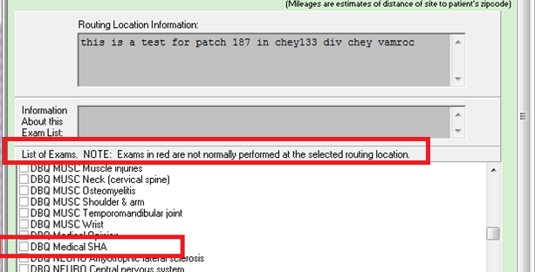

Rename DBQ Medical Opinion 1 to DBQ Medical Opinion in the AMIE Exam File

DBQ Medical Opinion 1 has been renamed to DBQ Medical Opinion, per the DBQ Governance Group, in the AMIE EXAM File (#396.6). The exam type will be available as a selectable exam under C&P Exams tab, Add New C&P Exam window, List of Exams.

Inactivate entries in the AMIE Exam File

The following entries have been inactivated, per the DBQ Governance Group, in the AMIE EXAM File (#396.6). These exam types will no longer be available as a selectable exam under C&P Exams tab, Add New C&P Exam window, List of Exams.

Entry Number EXAM NAME
438 DBQ Medical Opinion 2
439 DBQ Medical Opinion 3
440 DBQ Medical Opinion 4
441 DBQ Medical Opinion 5
433 DBQ CARDIO Ischemic heart disease
416 DBQ MUSC Flatfoot (pes planus)

New Security key for Get Docs from Virtual VA (VVA)
For CAPRI users that once had the security key "DVBA CAPRI DENY_GETVBADOCS" applied to their user accounts, to deny access to the "Get Docs from Virtual VA" functionality, the business now requires the security key to be replaced. The new security key DVBA CAPRI GETVBADOCS will be added to CAPRI. The old key denied access, the new one grants access.

NOTE: All current users that did not have the DVBA CAPRI DENY_GETVBADOCS security key will automatically receive the new security key when VistA patch DVBA*2.7*187 is installed. Any new CAPRI users, that should have access to Get Docs from Virtual VA menu option, will have to be given the DVBA CAPRI GETVBA DOCS security key.***

Get Docs from DAS – On the file menu

FILE|GET DOCS FROM DAS has been created to allow CAPRI VHA users to retrieve and view documents from central data store Data Access Service (DAS), formerly known as VLER DAS. The user MUST hold the DVBA CAPRI GETDOCSFROMVLER security key to access this functionality.

To access the GET DOCS FROM DAS:
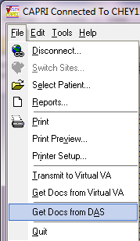

The “RETRIEVE EXAM” window will be displayed and allow the CAPRI user to enter exam search criteria for documents to be retrieved. The following search criteria are acceptable. Note** all queries must have a Date Range and at least one other search criteria.

- Patient SSN (must be 9 digits or 9 digits +P for Pseudo SSN) and Date Range
- VA Facility ID (exact match) and Date Range
- Physician (Not case sensitive and can be a partial match) and Date Range
- Exam Status (completed or rejected only) and Date Range
- Or multiple selection of the above and Date Range

Once the search criteria have been chosen click the “Search” button:
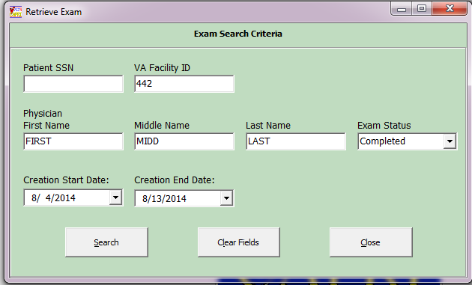

The “Retrieve Documents from DAS” window will be displayed with results from search criteria selected and allow the CAPRI user to open documents for the selected veteran, by clicking on document and choosing “View Selected Document” button or by double clicking on the document. This window allows the user to sort by column and view the sort in Ascending or Descending order.

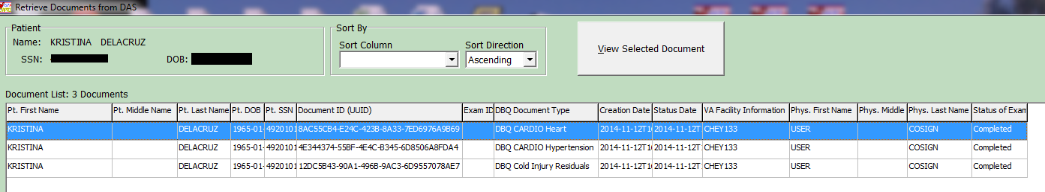

Customer – Veteran Health Administration (VHA)

Enhancements

Notify DAS of vendor exam requests for CAPRI Contract Referral (CCR)

CAPRI (CCR) has been modified to notify DAS that a new 2507 Exam Request has been submitted for a DAS enabled vendor, currently those vendors are Logistics Health Incorporated (LHI) and Medical Services of Los Angeles (MSLA). The VHA user may assign one or many exams from the 2507 Exam Request to a vendor.

If a 2507 exam request is assigned in part to one vendor and in part to another vendor, then each such assignment is a separate notification to DAS. Each assignment is intended for one and only one vendor. An exam request notification to the vendor will only include the exams specifically assigned by a VHA user to the vendor and will not include any other exams that are part of the 2507 Exam Request. DAS will then notify the appropriate vendor that a new exam request is available for retrieval.

****NOTE: C & P Users must complete training on use of CCR prior to implementing the application functionality. Once trained, the DEM Program Office will authorize the keys be provided to allow for functionality.

DEM Program Office POC: REDACTED

New “CAPRI Alert” for CAPRI Contract Referral (CCR) pending under review exams

When CAPRI users, that have access to CAPRI Contract Referral (CCR), log into CAPRI, any exam results from a vendor that are in a status of pending review will display in the alerts screen as “You have # vendor exam requests pending review”.

Note: pending under review exams will only be displayed for vendors that utilize DAS for sending and receiving exams results.

The user may select Continue to bypass the alerts and go to the Patient Selector screen and access the Tools|CAPRI Contract Referral menu to perform CCR tasks needed to review, approve, or mark the exam insufficient from the Vendor.

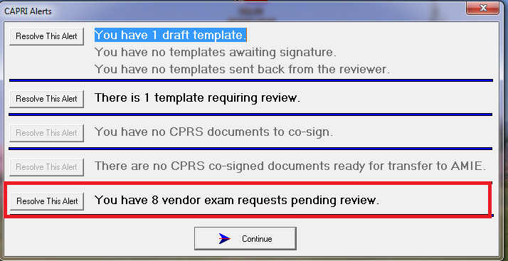

The user clicks the Resolve This Alert button to be taken to the Manifests Pending Under Review window where the alert can be resolved. The user will choose the patient and then click on the CAPRI Contract Referral (CCR) button, which will open CCR functionality and allow the user to perform CCR tasks needed to review, approve, or mark the exam insufficient from the vendor.
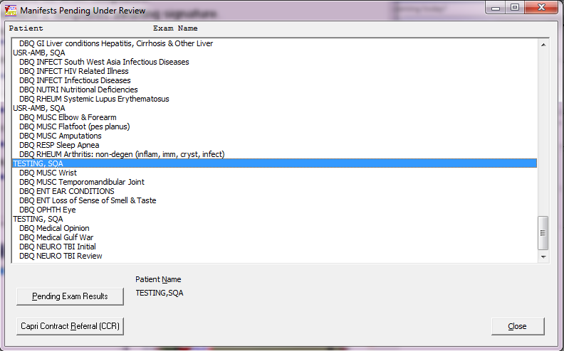

CAPRI Contract Referral (CCR) – Retrieve exam results with status of pending under review from DAS

To retrieve exam results from DAS, from a DAS enabled vendor, with a status of pending under review, the user will click “Download Exam Results” button. Once the results have been downloaded the exams will be removed from the “Contracted 2507 Requests and Exams” window with a referral status of “Pending Referrals”.

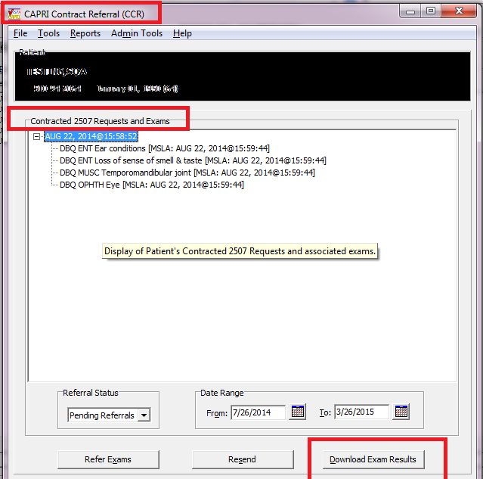

To review the downloaded results the user will access Tools|Manage Patient’s C&P Exam Requests from the CAPRI Contract Referral (CCR) screen and perform the following from the CCR-C&P Exam Request Report Management screen:

- Choose the exam request from the C&P Exam Requests section
- Choose the exam to review from the Exams section
- Click “View Exam Attachments” to review the exam results in PDF format. *Note: vendors may send other supporting documentation, which will also be displayed.

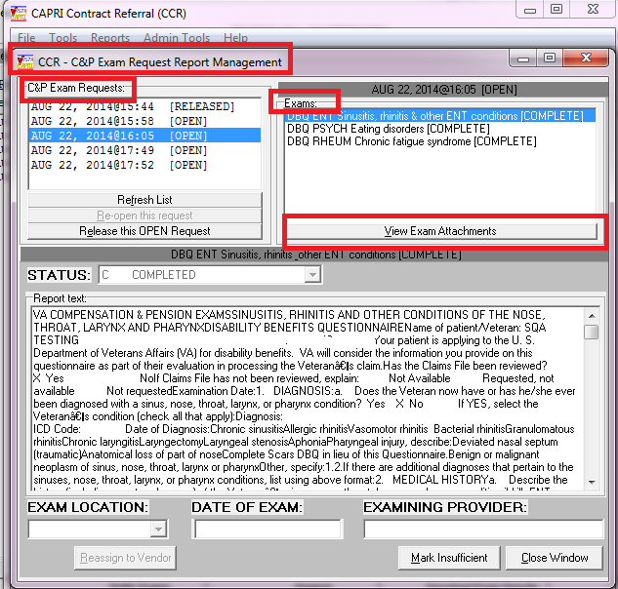

- After clicking View Exam Attachments, the Retrieve Documents from DAS window will be displayed.

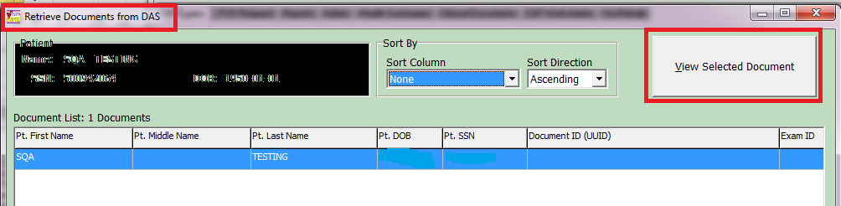

- The user will click “View Selected Document” or double click on the document and the exam result will be displayed in PDF format to user for review.

Note: If it is determined that the exam will need to be “marked insufficient” and sent back to the vendor it is hightly recommended that you save the PDF document for reference during the mark insufficient process as the PDF (or any other supporting documents) will be closed when the user closes the “Retrieve Documents from DAS” window.

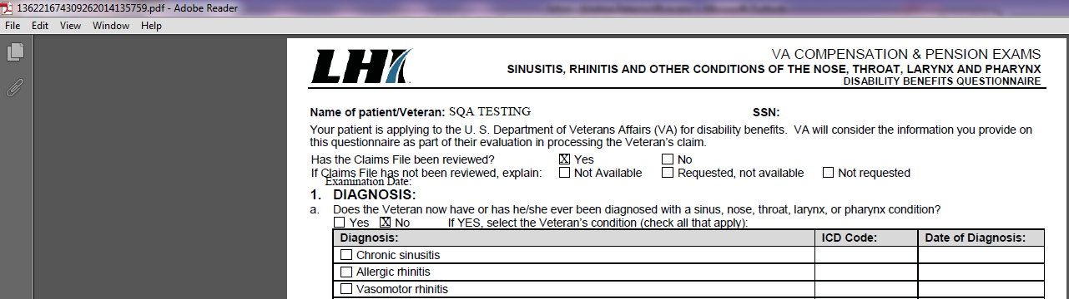

- Once the Retrieve Documents from DAS window as been closed the user will be taken back to the CCR-C&P Exam Request Report Management screen.
- If the exam results are considered complete the user will choose Release this Open Exam Request and DAS will be notified that the exam request is complete.
- If the exam result for 1 or more of the exams in the request is “insufficient” the user will perform the following:
  - Choose the exam to mark insufficient
  - Click “Mark Insufficient”
  - Update the word document with disapproved changes, click save and close the word document
  - Click Reassign to Vendor button
Note: If multiple exams within the request are insufficient, each exam must be re-assigned individually. *You must CLICK the Reassign to Vendor button for each exam**

- After the user re-assigns the exam to the vendor, CAPRI will send a notification to DAS of the rejected exam and attach the word document.
- DAS will notify the appropriate vendor of the rejected exam.

DBQ transmission failure to DAS

When an examiner completes a DBQ from the signature validation screen it will automatically be transmitted to DAS. The user will “not” have to acknowledge transmission; however, if transmission to DAS fails the user will have the opportunity to retransmit the failed DBQ(s) one time only.

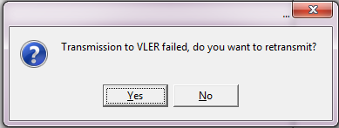

Separate current merged PDF exam results into a separate PDF for each exam transmitted to DAS

When an examiner signs and completes multiple templates that have been merged together, CAPRI will now separate the current merged/concatenated exam report back into single exams for the purpose of PDF file creation and transmit to DAS with the following exceptions:

- Co-signed exams will not be unmerged
- Co-signed exams in CPRS will only be stored in VistA as text and not shared with other systems
- Exams transmitted to Virtual VA will still be merged

Customer – Veteran Health Administration (VHA) and/or Veterans Benefits Administration (VBA)

Defects with remedy tickets

INC000000998063 – Transmit to Virtual VA (VVA) bug.

Issue
After a user selects “Transmit to Virtual VA”, after the attempt is complete, the status caption indicates the application is in a “sending…” state.

Solution
After the Virtual VA transmission attempt is complete, the status caption will be reset to “Ready”.

INC000000970009 – Wrong exam comments on 2507 screen

Issue
When adding a 2507 Exam Request the “Routing Location Information” is populated prior to the “Routing Location” being chosen.

Solution
Prior to displaying the form to add a 2507 Exam request, the “Routing Location Information” will be set to null until a “Routing Location” is selected.

INC000000938270 – Requestor without email address receives error when completing templates

Issue
When completing a template examiners would get the following message if the “requestor” of the 2507 Request did not have an email address defined.
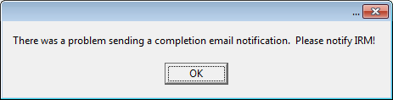

Solution
Prior to sending an email notification the process will verify that the “requestor” has an email address. If not, the notification attempt will not proceed.

INC000000959449 – Wrong patient data in footer when print functionality utilized from “My Unsigned C&P Worksheets” menu

Issue
If a user accesses a template/worksheet via the "My Unsigned C&P Worksheets" option, the patient info is different than what is displayed and stored on the main screen so when the print functionality is utilized it pulls the data from the main screen rather than the newly opened template/worksheet and populates the footer with the wrong patient data.

Solution
If the print functionality is triggered from within the worksheet module the patient info will be pulled from the template header rather than from the main form. The footer information will now accurately indicate the correct patient information.

INC000000919417 – ONEEMAIL+15^DVBAB1A error
Issue
While in a 2507 Request, if a user (other than the initial requestor) edits the request, the “Requestor” value will reflect the name of the user who edited the request and not the user who submitted the initial 2507 Request.

Solution
CAPRI has been modified so that the user editing the request is no longer being passed to Vista to be updated as the new "Requestor".

INC000000819092 – CAPRI News Items not saving read/clear status

Issue
When determining if a user has read the “news items”, the code looks for the existence of the CAPRINewsReadInfo.txt file in the users “Temp” directory, but with the migration to Windows 7, it
is VA policy that this directory be purged upon every restart therefore the flag/file is removed after every restart.

Solution
Store and point to a different directory, that is not purged, when determining if the “News Items” have been read.

INC0000001005379 – New patient entry fails if space at end

Issue
While entering a new patient through CAPRI, if either the first or last name contain leading or trailing spaces an error will occur while trying to lookup existing potential matches.

Solution
Prior to searching for potential matches, the leading and trailing spaces will be removed. Error will no longer occur.

Software and Documentation Retrieval

VistA Patch DVBA*2.7*187
                - The VistA server software is being distributed as a PackMan patch message through the National Patch Module (NPM). The KIDS build for this patch is DVBA*2.7*187.

CAPRI GUI v187 Client Software & User Documentation
                - The CAPRI GUI v187 client software is being distributed as executable CAPRI.exe contained in the zip file [DVBA_27_P187_12.ZIP]. The installed executable for this patch is client version 187.12 with a size of 14.4 MB.
                - The CAPRI GUI v187 client software and documentation for this patch may be retrieved directly using FTP. The preferred method is to FTP the files from:
REDACTED
                - This transmits the files from the first available FTP server. Sites may also elect to retrieve software directly from a specific server as follows:
OI&T Field Office | FTP Address | Directory
Albany | REDACTED | [anonymous.software]
Hines | REDACTED | [anonymous.software]
Salt Lake City | REDACTED | [anonymous.software]

                - The following files will be available:

File Name | Retrieval Format | Contents
DVBA_27_P187_12.zip | Binary | File(s) indented below:  - CAPRI.exe - CAPRI v187 executable  - VACAPRIVVA.dll – Virtual VA dynamically linked library  - CAPRI_Help.chm  - CAPRI.map - CAPRI error map  - CAPRISession.r2w - Reflections session configuration  - ssh_config - Secure Shell configuration  - CAPRI_GUI_ISG.doc - CAPRI GUI Installation Supplemental Guide  - Libeay32.dll - VLER /DAS dynamically linked library  - Ssleay32.dll - VLER /DAS dynamically linked library  - QPDF.exe - Support PDF compression and Linearization  - QPDF13.dll - Support PDF compression and Linearization  - LIBGCC_S_DW2-1.dll - Support PDF compression and Linearization  - LIBSTDC++-6.dll - Support PDF compression and Linearization
DVBA_27_P187_RN.PDF | Binary | Patch Release Notes (This document)
DVBA_27_P187_UM.PDF | Binary | Updated CAPRI GUI User Manual
CAPRI_SYSADMINTECH GUIDE_DVBA_27_TM.PDF | Binary | Updated CAPRI System Administration  And Technical Guide

Related Documents
The VA (Software) Documentation Library (VDL) web site will also contain the DVBA*2.7*187 Release Notes and updated CAPRI GUI User Manual. This website is usually updated within 1-3 days of the patch release date.
The VDL web address for CAPRI documentation is: http://www.va.gov/vdl/application.asp?appid=133

