Event Capture System 2.0

Graphical User Interface

Technical Manual
April 2024
Department of Veterans Affairs
Office of Information and Technology

Revision History
Date | Revision | Description | Author
04/2024 | 2.6 | Updated for Patch EC*2.0*165  Updated patch number and release date throughout document | Booz Allen Hamilton
10/2023 | 2.5 | Updated for Patch EC*2.0*164  Updated patch number and release date throughout document | Booz Allen Hamilton
06/2023 | 2.4 | Updated for Patch EC*2.0*159  Updated patch number and release date throughout document  Added data pieces, number 8 and 9, to RPC EC GETPRBLST  Updated Figure 6 Reports Menu Screen without ECMGR Option, and Figure 7 Reports Menu Screen with ECMGR Options to reflect new report names  Updated language in section 12.1 for error correction | Booz Allen Hamilton
11/2022 | 2.3 | Updated for Patch EC*2.0*161  Updated patch number and release date throughout document | Booz Allen Hamilton
07/2022 | 2.2 | Updated for Patch EC*2.0*158  Updated patch number and release date throughout document | Booz Allen Hamilton
02/01/2022 | 2.1 | Updated for Patch EC*2.0*156  Updated patch number and release date throughout document  Removed heading for “Namespace” under 2.1  Renamed section 5.2 from “Menu Outline” to “Main Menu Options”  Renamed section 5.3 from “Menu Diagram” to “Submenu Options”  Moved former section 12.1 (“Online Help”) to section 12, General Troubleshooting bullet items  Updated Figure 6 and Figure 7 to reflect new report (Procedure Summary)  Added content to section 7.1 - Integration Control Registrations  Added content to 7.3 - Remote Procedure Calls | Booz Allen Hamilton
03/22/2021 | 2.0 | Document Updated for Patch 152  New Content Added as per Latest Template | Liberty IT Solutions
04/13/2020 | 1.1 | Document Updated for Patch 148 | Liberty IT Solutions
11/21/2018 | 1.0 | Initial Document Release | TeamSMS/Leidos

Table of Contents
1 Introduction 1
1.1 Purpose 1
1.2 System Overview 1
1.2.1 Functions of the Software 2
1.3 Document Orientation 2
1.3.1 Disclaimers 2
1.3.1.1 Software Disclaimer 2
1.3.1.2 Documentation Disclaimer 2
1.3.2 References 3
2 Implementation and Maintenance 3
2.1 System Requirements 3
2.1.1 Hardware Requirements 3
2.1.2 Software Requirements 3
2.1.3 Database Requirements 4
2.2 System Setup and Configuration 4
3 Files 4
3.1 Global Placement 4
3.2 File List 5
3.2.1 List File Attributes 5
3.3 Templates and File Flow 6
4 Routines 6
4.1 XINDEX 7
4.2 Callable Routines 7
4.3 Routine List 7
5 Exported Options 8
5.1 Event Capture Security Keys 8
5.2 Main Menu Options 9
5.3 Submenu Options 10
6 Mail Groups, Alerts, and Bulletins 12
7 Public Interfaces 13
7.1 Integration Control Registrations 13
7.2 Application Programming Interfaces 15
7.3 Remote Procedure Calls 15
7.4 HL7 Messaging 35
7.5 Web Services 35
8 Standards and Conventions Exemptions 35
8.1 Internal Relationships 35
8.2 Software-wide Variables 35
9 Security 36
9.1 Security Menus and Options 36
9.2 Security Keys and Roles 36
9.3 File Security 36
9.3.1 VA FileMan Access Codes 36
9.4 Electronic Signatures 37
9.5 Secure Data Transmission 37
10 Archiving 38
11 Non-Standard Cross-References 38
12 Troubleshooting 38
12.1 Special Instructions for Error Correction 38
12.2 National Service Desk and Organizational Contacts 38
Appendix A Acronyms A-1
Appendix B Glossary B-1

Table of Figures
Figure 1 Grant Access to DSS Units by User 8
Figure 2 Event Capture Main Menu 9
Figure 3 Event Capture Main Menu for Users with ECACCESS Key 9
Figure 4 Data Entry Menu Screen 10
Figure 5 Spreadsheet Menu Screen 10
Figure 6 Reports Menu Screen without ECMGR Option 11
Figure 7 Reports Menu Screen with ECMGR Options 11
Figure 8 Management Menu Screen 12

Table of Tables
Table 1 Required VistA Software Products 3
Table 2 FORUM Steps 4
Table 3 File Export 5
Table 4 Mapping File Flow 6
Table 5 VA FileMan Access Codes 36
Table 6 Acronyms A-1
Table 7 Glossary of Terms B-1

Introduction
The Event Capture System (ECS) is a Veterans Health Information Systems and Technology Architecture (VistA) Class I workload reporting system supporting operations of the Department of Veterans Affairs (VA) Managerial Cost Accounting Office (MCAO). There are several Veterans Health Administration (VHA) national programs mandating using ECS instead of, or to augment other workload capture information systems. For example, ECS is used when programs cannot report workload in the form of Current Procedural Terminology (CPT) codes. ECS also allows for more precise workload capture and reporting than otherwise possible through other VistA systems.

Purpose
The Event Capture Technical Manual serves a dual purpose:
- Provides technical information to aid the Office of Information and Technology (OIT) staff with implementing and maintaining the software
- Provides security information for Information Security Officers (ISO)

System Overview
ECS captures basic resource utilization data which are reported in VistA and fed to the Decision Support System (DSS) in the DSS ECS monthly extract. The Event Capture software provides a mechanism to track and account for procedures and delivered services that other VistA packages do not handle. The procedures and services tracked through Event Capture are associated with the following:
- The patient to whom they were delivered
- The provider requesting the service or procedure
- The DSS Unit responsible for delivering the service
Information entered into ECS will then be sent electronically to DSS, Patient Care Encounter (PCE), and billing offices for processing which will in turn facilitate workload analysis, cost analysis and transmission of billing.
DSS Units typically represent the smallest identifiable work unit in a clinical service at a medical center. Veterans Affairs Medical Centers (VAMC) define the DSS Units. A DSS Unit can represent any of the following:
- An entire service
- A section of a service
- A small section within a section
- A medical equipment item used in patient procedures
The user must define the following items for every DSS Unit:
- Service: The service associated with the DSS Unit
- Cost Center: The fiscal identifier for the service using the particular DSS Unit
- Medical Specialty: The specialty section associated with the DSS Unit

Functions of the Software
Event Capture with all patches installed provides the following functions:
- Allows each VAMC to utilize the software for its own resource/costing needs
- Implements DSS Units
- Assigns user access to the DSS Units
- Allows single and batch data entry for patient procedures
- Generates reports for workload and other statistical tracking
- Provides a Graphical User Interface (GUI) to the ECS application
- Allows the user to upload patient encounter data to Event Capture from a spreadsheet
- Allows the user to switch between Computerized Patient Record System (CPRS) and ECS without having to log back into the ECS GUI application

Document Orientation
- Audience – Advanced users and support personnel for Event Capture.
- Assumptions – This document assumes a sound fundamental knowledge of VistA and Event Capture.

Disclaimers

Software Disclaimer
This software was developed at the Department of Veterans Affairs (VA) by employees of the Federal Government in the course of their official duties. Pursuant to title 17 Section 105 of the United States Code this software is not subject to copyright protection and is in the public domain. VA assumes no responsibility whatsoever for its use by other parties, and makes no guarantees, expressed or implied, about its quality, reliability, or any other characteristic. We would appreciate acknowledgement if the software is used. This software can be redistributed and/or modified freely provided that any derivative works bear some notice that they are derived from it, and any modified versions bear some notice that they have been modified.

Documentation Disclaimer
The appearance of external hyperlink references in this manual does not constitute endorsement by the Department of Veterans Affairs (VA) of this Web site or the information, products, or services contained therein. The VA does not exercise any editorial control over the information you may find at these locations. Such links are provided and are consistent with the stated purpose of the VA.

References
Documentation and additional information for this product—including the Event Capture User Guide (UG), and the Event Capture Deployment, Installation, Back-out, and Rollback Guide (DIBR)—can be found on the VA Software Document Library (VDL).
Online technical documentation pertaining to the Event Capture software, in addition to documentation found in the help topics, may be generated through utilization of several Kernel options. These include XINDEX and VA FileMan List File Attributes. Further information about other utilities that supply online technical documentation may be found in the Kernel Reference Manual.

Implementation and Maintenance
The namespace for Event Capture is EC. The excluded namespaces are ECT, ECW, ECX, and EC1.

System Requirements
There are approximately 250 Event Capture routines that take up approximately 997KB of disk space (including pre-initialization and post-initialization routines).

Hardware Requirements
N/A

Software Requirements
Event Capture is part of a larger integrated medical records system and relies on data from other packages to perform its functions.
Table 1 lists the VistA software products that must be installed before installing Event Capture.
Table 1 Required VistA Software Products
Product Name | Minimum Version
CPT/Healthcare Common Procedure Coding System (HCPCS) Codes | 6.0
Diagnosis Related Group (DRG) Grouper | 18
Kernel | 8.0
MailMan | 8.0
Patient Care Encounter (PCE) | 1.0
Patient Information Management Service (PIMS) | 5.3
Registration | 5.2
Remote Procedure Call (RPC) Broker | XWB*1.1*71
ToolKit | 7.3
VA FileMan | 22.2

Database Requirements
Table 2 lists the steps in FORUM from the Software Services Primary Menu.
Table 2 FORUM Steps
Step | Custodial Package | Subscriber Package
1 | DBA MENU | DBA MENU
2 | INTEGRATION CONTROL REGISTRATIONS | INTEGRATION CONTROL REGISTRATIONS
3 | Custodial Package Menu | Subscriber Package Menu
4 | ACTIVE ICRs by Custodial Package | Print ACTIVE by Subscribing Package
5 | Select PACKAGE NAME: EC | START WITH SUBSCRIBING PACKAGE: RA// EVENT CAPTURE
6 | DEVICE HOME// <Enter> | GO TO SUBSCRIBING PACKAGE: LAST// EVENT CAPTURE
7 | This step blank on purpose | DEVICE: <Enter>

System Setup and Configuration
Event Capture does not require site parameters.

Files
This section contains information related to files used by the ECS application. It identifies files exported and describes the steps necessary to obtain a list of templates and map the file flow relationships for Event Capture. Event Capture uses a series of FileMan files to store data related to workload entered via the ECS GUI.

Global Placement
Event Capture with all patches installed creates the following global files: ^EC, ^ECC, ^ECD, ^ECH, ^ECJ, ^ECL, and ^ECR. Global protection and placement should be made on all of them. It is possible that one or more of these global files already exist on your system.

File List
Table 3 lists the Event Capture files with all exported patches installed. VA Directive 6402 Modifications to Standardized National Software, 8/28/2013 governs these files, and can be found at the Department of Veterans Affairs Directives web site (VA Publications).
Use the List File Attributes option in VA FileMan to print the Data Dictionary (DD).
Table 3 File Export
File Number | File Name
720.1 | EVENT CAPTURE LOG
720.3 | EC EVENT CODE SCREENS
720.4 | EC PROCEDURE REASON
720.5 | EC EVENT CODE SCREENS/PROC REASON LINK
721 | EVENT CAPTURE PATIENT
722 | EVENT CAPTURE PROVIDER
723 | MEDICAL SPECIALTY
724 | DSS UNIT
725 | EC NATIONAL PROCEDURE
726 | EVENT CAPTURE CATEGORY

List File Attributes
This VA FileMan option allows the user to generate documentation pertaining to files and file structure. Utilization of this option via the "Standard" format will yield the following Data Dictionary information for a specified file(s): file name and description, identifiers, cross-references, files pointed to by the file specified, files which point to the file specified, input templates, print templates, and sort templates. In addition, the following applicable data are supplied for each field in the file: field name, number, title, global location, description, help prompt, cross-reference(s), input transform, date last edited, and notes.
Using the "Global Map" format of this option generates output which lists all cross-references for the file selected, global location of each field in the file, input templates, print templates, and sort templates.

Templates and File Flow
Table 4 lists the steps from the VistA Systems Manager Menu to obtain the templates and to map the file flow relationships for Event Capture with all patches installed.
Table 4 Mapping File Flow
Steps | Templates | File Flow  (Relationships between Files)
1 | VA FileMan | VA FileMan
2 | Print File Entries | Data Dictionary Utilities
3 | OUTPUT FROM WHAT FILE:  Print Template or Sort Template | Map Pointer Relations
4 | SORT BY: Name// Name | Select PACKAGE NAME: Event Capture
5 | START WITH NAME: FIRST//EC<Enter> | Remove FILE: <Enter>
6 | GO TO NAME: ECW// <Enter> | Add FILE: (Enter name or file number for files you want to include in the output. This prompt will repeat until the next step.)
7 | WITHIN NAME, SORT BY: <Enter> | Add FILE: <Enter>
8 | FIRST PRINT FIELD: Name | Enter name of file group for optional graph header: EVENT CAPTURE// <Enter>
9 | THEN PRINT FIELD: <Enter> | DEVICE: HOME// <Enter> HOME (CRT)
10 | Heading (S/C):  PRINT TEMPLATE LIST// <Enter>
11 | START AT PAGE: 1 <Enter>
12 | DEVICE: <Enter> HOME (CRT) Right Margin: 80// <Enter>

Routines
This section contains relevant information for ECS GUI application software routines and describes the actions to perform in order to obtain a list of routines supporting ECS that are implemented in the back-end Massachusetts General Hospital Utility Multi-Programming System (MUMPS) environment. Event Capture is comprised of a number of MUMPS routines that enable entering, editing, and deleting of data, as well as producing reports. These routines are used to accomplish user-initiated tasks through the ECS GUI component.

XINDEX
This option analyzes the structure of a routine(s) to determine in part if the routine(s) adheres to VistA Programming Standards. The XINDEX output may include the following components: list of compiling errors and warnings, routine listing, local variables, global variables, naked global references, label references, and external references. By running XINDEX for a specified set of routines, the user is afforded the opportunity to discover any deviations from VistA Programming Standards that exist in the selected routines, and to see how routines interact with one another. That is, which routines call or are called by other routines.
To run XINDEX for the Event Capture software, specify the following namespace at the "Routine:" prompt: EC*. Event Capture initialization routines that reside in the User Class Identifier (UCI) in which XINDEX is being run, as well as compiled template routines found within the Event Capture namespace, should be omitted at the "Routine:" prompt. To omit routines from selection, preface the namespace with a tick mark ( ‘ ).

Callable Routines
The Event Capture software uses Integration Agreement 4460 to call the Application Programmer Interface (API) to store and retrieve data for the PROVIDER MULTIPLE field (#42) in the EVENT CAPTURE PATIENT file (#721).

Routine List
Perform the following steps from the VistA Systems Manager Menu to obtain the MUMPS routines contained in the Event Capture software:
- Programmer Options
- Routine Tools
- First Line Routine Print
- All Routines? No => <Enter>
- Routine: EC*
- Routine: ‘ECT*
- Routine: ‘ECW*
- Routine: ‘ECX*
- Routine: ‘EC1*
- Routine: <Enter>
- (A)lpha, (D)ate, (P)atched, OR (S)ize ORDER: A//<Enter>
- Include line (2), Include lines 2&(3), (N)one: None//<Enter>
- DEVICE: HOME// <Enter>SSH VIRTUAL TERMINALRight Margin: 80// <Enter>
Steps 6 through 9 are to exclude those routines from appearing in the list.

Exported Options
This section provides an overview of the main menu and submenus available in the ECS GUI application. The user must hold the appropriate security keys in order to access all options.

Event Capture Security Keys
Security keys are assigned in VistA using the menu option Key Management, and then choosing the submenu Allocation of Security Keys.
- ECMGR: Gives a user access to the ECS Management Menu. This key is intended to be used only for Event Capture Managers.
- ECACCESS: Gives a user the ability to grant or remove DSS Unit access. Note that if the user also has the ECMGR key, ECACCESS will not have any effect.
- ECALLU: Gives a user access to all DSS Units (super user). This should be assigned only to those managing the software (i.e., holders of the ECMGR key).
- ECNORPT: Restricts the user from access to the Event Capture Reports.
- ECSPSH: Gives a user access to upload data from a spreadsheet.

- When granting access to DSS Units by user (Figure 1), if the desired name is unavailable, confirm the following:
- The user has an active CPRS TAB in the NEW PERSON file (#200).
- The user has the OR CPRS GUI CHART option in their secondary menu option.
- The user is not DISusered.
- The user has the "AUSER" cross-reference in the NEW PERSON file (#200); all active users should already have this.
Figure 1 Grant Access to DSS Units by User
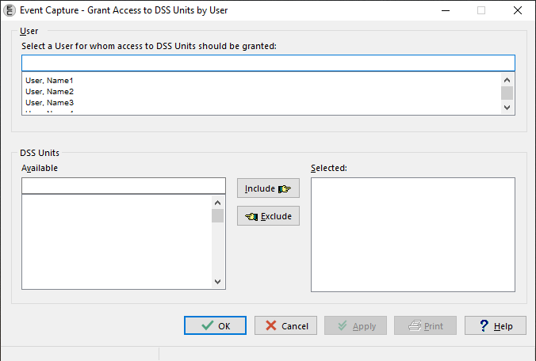

Main Menu Options
The Event Capture software contains the Data Entry, Spreadsheet, Reports, and Management Menu options. Figure 2 shows these major menu options as they appear in the ECS GUI.
Figure 2 Event Capture Main Menu
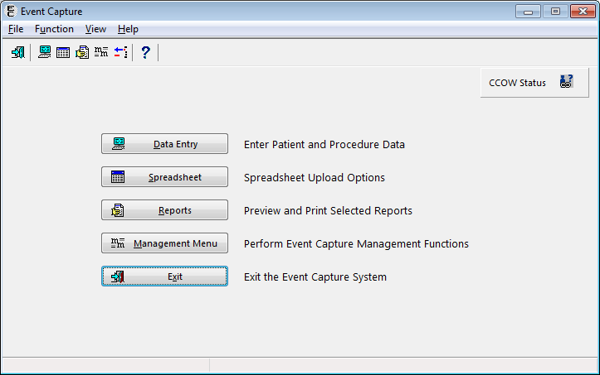
In cases where the user has the ECACCESS key, the menu will have an Access by User option in place of the Management Menu option, as shown in Figure 3.
Figure 3 Event Capture Main Menu for Users with ECACCESS Key
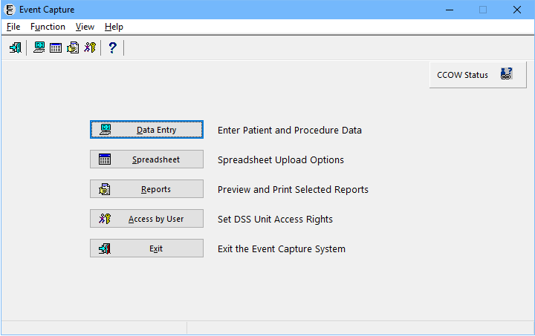

Submenu Options
Figure 4 shows the submenu items that are available when the Data Entry option is selected from the Main Menu.
Figure 4 Data Entry Menu Screen
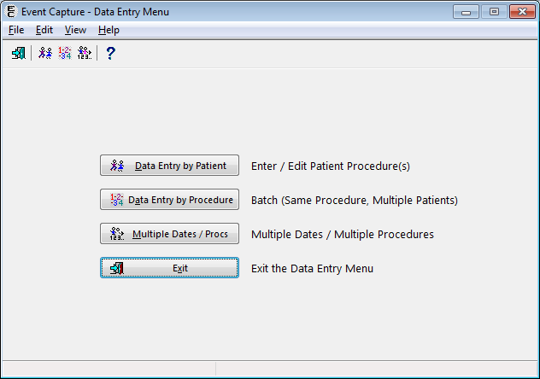
Figure 5 shows the Spreadsheet Upload form that becomes active when the Spreadsheet option is selected from the Main Menu. The user must hold the ECSPSH security key in order to access this screen.
Figure 5 Spreadsheet Menu Screen
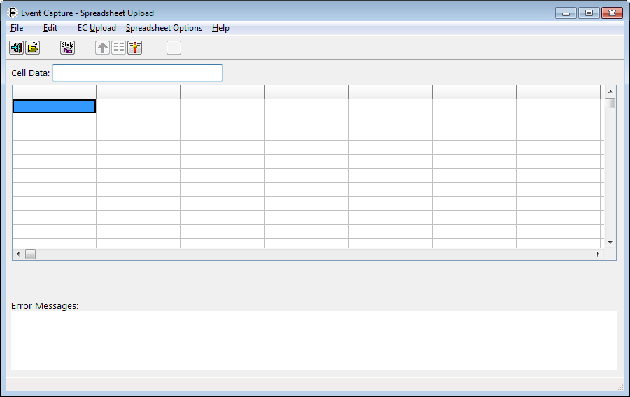
Figure 6 shows the submenu items that are available when the Reports option is selected from the Main Menu and the user does not hold the ECMGR security key.
Figure 6 Reports Menu Screen without ECMGR Option
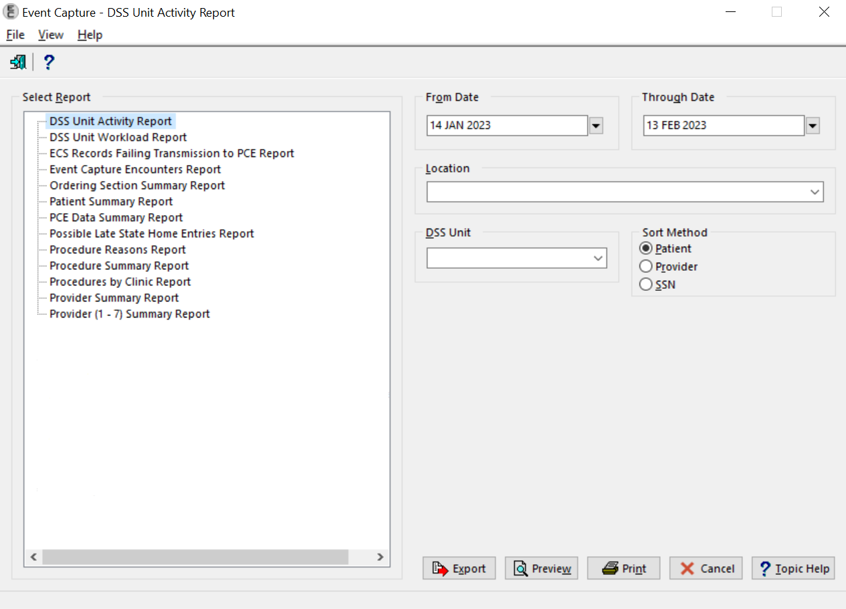
Figure 7 shows the submenu items that are available when the Reports option is selected from the Main Menu and the user holds the ECMGR security key.
Figure 7 Reports Menu Screen with ECMGR Options
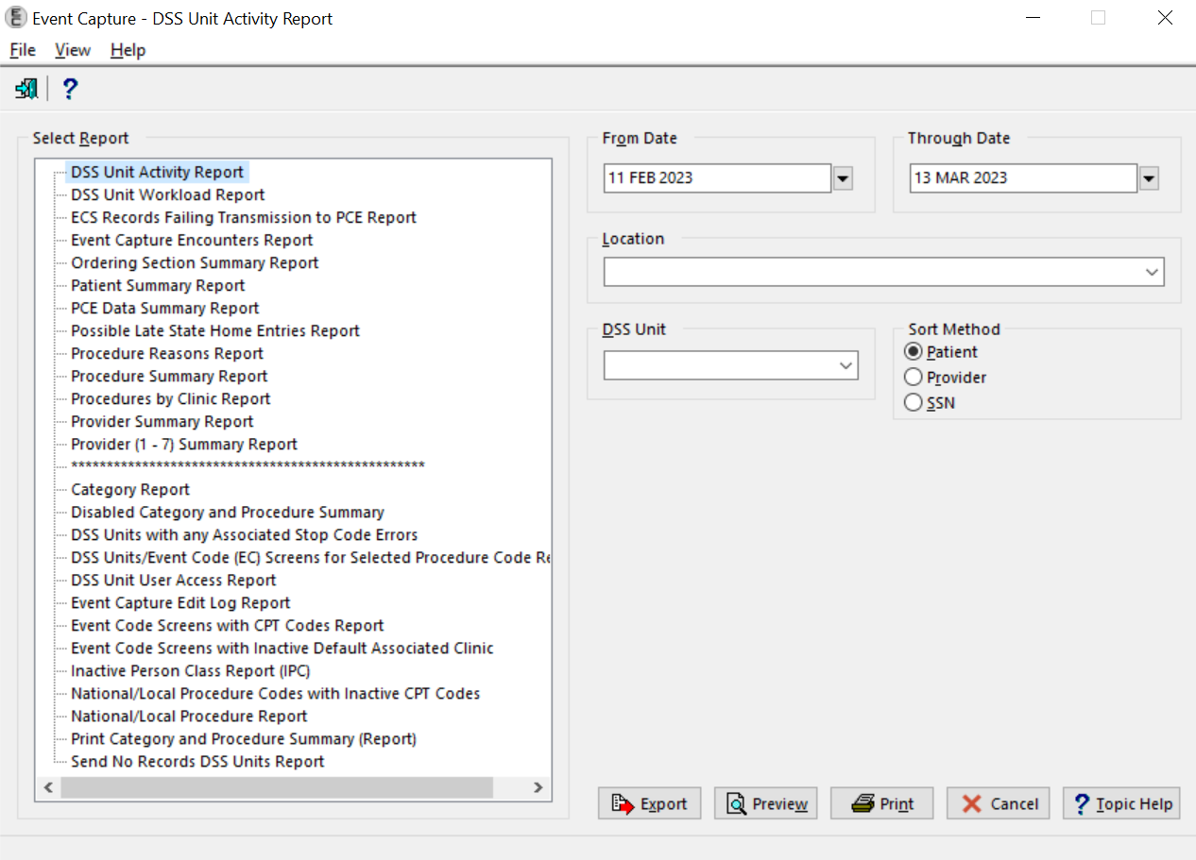
Figure 8 shows the submenu items that are available when the Management Menu option is selected from the Main Menu. The user must hold the ECMGR security key in order to access this menu.
Figure 8 Management Menu Screen
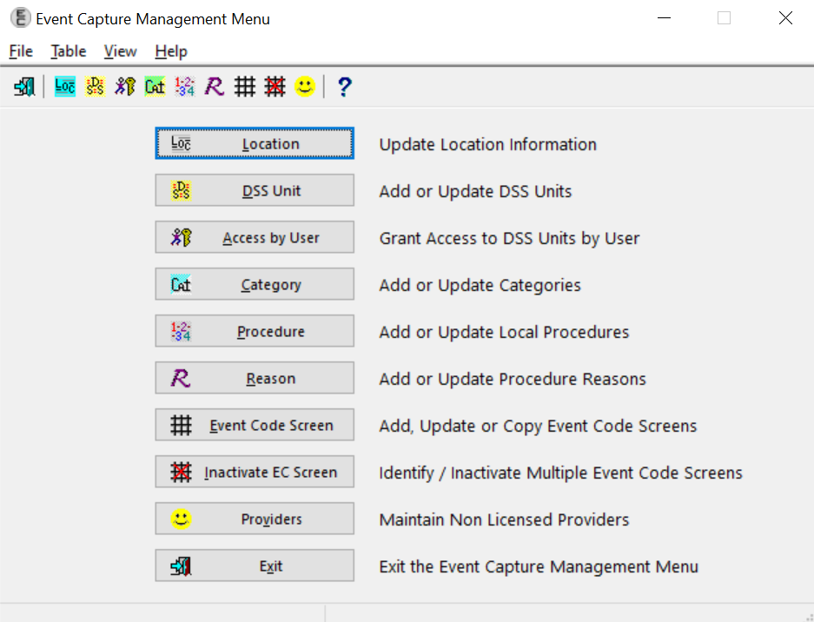

Mail Groups, Alerts, and Bulletins
Users can set up an ECS mail group in VistA to receive relevant ECS notifications. Contact IT to set up a VistA ECS Mail Group so more than one person receives ECS administrative messages.
More information regarding current ECS package administrative email messages can be obtained from the ECS User Guide, which can be found on the VDL.

Public Interfaces

Integration Control Registrations
This section lists the Integration Control Registrations (ICRs) created and/or used by ECS. They are categorized by the custodian or subscriber relationship to the software. No private ICRs are documented below.
Custodian:

ICR #96
Type: File
File #730
Root: ECC(730,
ICR #97
Type: File.
File #730
Root: ECC(730,
ICR #205
Type: File
Root: ECC(723,
ICR #249
Type: Other
ICR #1561
Type: File
File #724
Root: ECD(
ICR #1869
Type: File
File #720
Root: ECP(
ICR #1870
Type: File
File #720.1
Root: EC(720.1,
ICR #1872
Type: File
File #720.3
Root: ECJ(
ICR #1873
Type: File
File #721
Root: ECH(
ICR #1874
Type: File
File #725
Root: EC(725,
ICR #1875
Type: File
File #726
Root: EC(726,
ICR #4131
Type: Routine
Routine: ECRRPC
ICR #4460
Type: Routine
Routine: ECPRVMUT
ICR #6009
Type: File
File #720.3
Root: ECJ(
ICR #6010
Type: Routine
Routine: ECUERPC
ICR #6011
Type: Routine
Routine: ECUERPC1
ICR #6012
Type: Routine
Routine: ECFLRPC
ICR #6013
Type: File
File #724
Root: ECD(
ICR #6016
Type: Routine
Routine: ECUMRPC1
ICR #6155
Type: File
File #200
Root: VA(200,D0,EC
ICR #10100
Type: File
File #730
Root: ECC(730

Subscriber:

ICR #322 – DBIA322
Custodial Package: REGISTRATION
Usage: Controlled Subscription
Type: File
File #45.7
Root: DIC(45.7,
ICR #406 – DBIA406
Custodial Package: SCHEDULING
Usage: Controlled Subscription
Type: Routine
Routine: SDCO21
ICR #427 – DBIA427
Custodial Package: REGISTRATION
Usage: Controlled Subscription
Type: File
File #8
Root: DIC(8,
ICR # 432 — DBIA432
Custodial Package: KERNEL
Usage: Controlled Subscription
Type: File
File #49
Root: DIC(49,
ICR #491 – DBIA491
Custodial Package: KERNEL
Usage: Controlled Subscription
Type: File
File #7
Root: DIC(7,
ICR #492 – DBIA492
Custodial Package: IFCAP
Usage: Controlled Subscription
Type: File
File #420.1
Root: PRCD(420.1,
ICR #510 – DISV
Custodial Package: VA FILEMAN
Usage: Controlled Subscription
Type: File
File #
Root: DISV(
ICR #954 – DBIA954
Custodial Package: IFCAP
Usage: Controlled Subscription
Type: Routine
Routine: PRCSREC2
ICR # 1531 — DBIA1531
Custodial Package: DSS - DECISION SUPPORT SYSTEM EXTRACT
Usage: Controlled Subscription
Type: File
File #727.815
Root: ECX(727.815,
ICR #1579 – SCHEDULING CLASSIFICATION
Custodial Package: SCHEDULING
Usage: Controlled Subscription
Type: Routine
Routine: SDCO22
ICR #1623 – SCDXUAPI - OCCASION OF SERVICE ENTRY
Custodial Package: SCHEDULING
Usage: Controlled Subscription
Type: Routine
Routine: SCDXUAPI
ICR #1889 – ADD/EDIT/DELETE PCE DATA SILENTLY
Custodial Package: PCE PATIENT CARE ENCOUNTER
Usage: Controlled Subscription
Type: Routine
Routine: PXAPI
ICR #1890 – DBIA1889-B
Custodial Package: PCE PATIENT CARE ENCOUNTER
Usage: Controlled Subscription
Type: Routine
Routine: PXAPI
ICR #1902 – DBIA1900-C
Custodial Package: PCE PATIENT CARE ENCOUNTER
Usage: Controlled Subscription
Type: Routine
Routine: VSIT
ICR #1905 – RETURN SELECTED VISITS FROM VSIT
Custodial Package: PCE PATIENT CARE ENCOUNTER
Usage: Controlled Subscription
Type: Routine
Routine: VSIT
ICR #2058 — PACKAGE FILE LOOKUP
Custodial Package: KERNEL
Usage: Controlled Subscription
Type: File
File #9.4
Root: DIC(9.4,
ICR #2251 – DBIA-2251
Custodial Package: KERNEL
Usage: Controlled Subscription
Type: File
File #4
Root: DIC(4,
ICR #2741 – OE/RR calls to GMPLUTL2
Custodial Package: PROBLEM LIST
Usage: Controlled Subscription
Type: Routine
Routine: GMPLUTL2
ICR #3371 – ORWU HASKEY
Custodial Package: ORDER ENTRY/RESULTS REPORTING
Usage: Controlled Subscription
Type: Remote Procedure
ICR #3834 — CSL Cost Center table update
Custodial Package: COMMUNICATIONS SERVICE LIBRARY
Usage: Controlled Subscription
Type: Routine
Routine: CSLEC
ICR # 3852 — CSL Cost Center file 536.3
Custodial Package: COMMUNICATIONS SERVICE LIBRARY
Usage: Controlled Subscription
Type: File
File #536.3
Root: CSLCC(
ICR #3859 – APPOINTMENT DATA BY PATIENT
Custodial Package: SCHEDULING
Usage: Controlled Subscription
Type: Routine
Routine: SDAMA201
ICR #4069 — HL7 MESSAGE TEXT FILE (#772)
Custodial Package: HEALTH LEVEL SEVEN
Usage: Controlled Subscription
Type: File
File #772
Root: ECX(772,
ICR #4255 — CSL REFERENCING PARAMETERS
Custodial Package: COMMUNICATIONS SERVICE LIBRARY
Usage: Controlled Subscription
Type: Other
ICR #4652 – CLNCHK - SDUTL2 (RESTRICTING STOP CODE)
Custodial Package: SCHEDULING
Usage: Supported
Type: Routine
Routine: SDUTL2
ICR #5747 — ICD Data Extraction
Custodial Package: DRG GROUPER
Usage: Controlled Subscription
Type: Routine
Routine: ICDEX

Application Programming Interfaces
N/A

Remote Procedure Calls
This section describes the 49 Remote Procedure Call (RPC) entry points and parameters created and/or used by ECS. Click any of the RPCs below to see details.

- EC CLASHELP
- EC DELETE FILE ENTRY
- EC DELETE TEST PATIENT DATA
- EC DIEDON
- EC DSSCATCHECK
- EC FILER
- EC GET DEFAULT PROVIDER
- EC GETBATPROCS
- EC GETCAT
- EC GETCPTLST
- EC GETDATE
- EC GETDSSECS
- EC GETDSSUNIT
- EC GETDSSUNITUSRS
- EC GETECLOC
- EC GETECSCATS
- EC GETECSCREEN
- EC GETECSDETAIL
- EC GETECSPROCS
- EC GETENCDXS
- EC GETIEN
- EC GETLIST
- EC GETLOC
- EC GETNATPX
- EC GETPATCH
- EC GETPATCLASTAT
- EC GETPATELIG
- EC GETPATINFO
- EC GETPATPROCS
- EC GETPRBLST
- EC GETPRODEFS
- EC GETPROVIDER
- EC GETPXLST
- EC GETPXMODIFIER
- EC GETPXREASON
- EC GETSCNHELP
- EC GETUSRDSSUNIT
- EC GETVERSION
- EC GETVISITINFO
- EC ICD10IMPLEMEN-TATIONDATE
- EC RECENT VISITS
- EC REPORTS
- EC SPACEBAR
- EC VALIDATE SPREADSHEET DATA
- ORWU DEVICE
- ORWU HASKEY
- ORWU NEWPERS
- ORWU USERINFO
- SC PATIENT LOOKUP

- EC CLASHELP — Returns the service-connected and related disabilities information for the selected patient.
TAG: CLHLP
ROUTINE: ECUERPC2
RETURN VALUE TYPE: GLOBAL ARRAY
AVAILABILITY: RESTRICTED
DESCRIPTION: RPC Broker entry point for classification help
INPUT PARAMETER: ECARY
PARAMETER TYPE: LITERAL
DESCRIPTION: Input key ECARY consists of the following pieces -
ECDFN — Patient DFN from file (#2)
ECKY — Key to provide help on. Example ECKY='SC' provides help on service connection.
RETURN PARAMETER DESCRIPTION: Array of help text for classification.
- EC DELETE FILE ENTRY - A general purpose for deletion of entry in ECS files which uses parameters to determine which file and entry to delete.
TAG: ECDEL
ROUTINE: ECUMRPC2
RETURN VALUE TYPE: GLOBAL ARRAY
DESCRIPTION: A general purpose Event Capture routine for deletion of entry in ECS files.
INPUT PARAMETER: ECARY
PARAMETER TYPE: LIST
DESCRIPTION: The input array ECARY contains the file number and the IEN number of the entry to be deleted.
ECARY("ECFILE") — the file number where the entry to be deleted
ECARY("IEN") — the entry number to be deleted
ECFILE | Option
720.3 | EC Event Code Screens
724 | DSS Unit
RETURN PARAMETER DESCRIPTION: Returns a flag of success or failure and error message.
- EC DELETE TEST PATIENT DATA — Delete test patient data from the EVENT CAPTURE PATIENT file (#721).
TAG: DTPD
ROUTINE: ECUMRPC1
RETURN VALUE TYPE: GLOBAL ARRAY
AVAILABILITY: RESTRICTED
DESCRIPTION: This RPC is used to delete any test patient data from the EVENT CAPTURE PATIENT file (#721).
If the patient is identified as a test patient and the procedure associated with the test patient record is not in the range of CH103 to CH109 then the record will be deleted. If the procedure is in this range for a test patient, the record will not be deleted. Test patients, with procedures in this range, are allowed for recording Chaplain workload.
This RPC can be invoked in two modes. The first mode, "I" is for gathering information about the account, the date/time of the last deletion, the user who ran the deletion and the status of the deletion process. The second mode, "D", is for deleting patient records as defined above.
Care should be used when running this RPC as the data cannot be restored once deleted. In addition, this process could take a while to complete. The amount of time needed will vary based on the total number of records to be reviewed and the total number of records to be deleted.
INPUT PARAMETER: ECARY
PARAMETER TYPE: LITERAL
DESCRIPTION: This will hold the mode in which you want to run the RPC. The two possible modes are "I"nformation or "D"elete.
RETURN PARAMETER DESCRIPTION: Depending on the mode, the return results will vary.
For the "I"nformational mode, the return value will be account type (test or production)^network name^date/time deletion last completed^user who last ran the deletion^status of the deletion (0 not running/1 running).
For the "D"eletion mode, the return value will be 0 if the task couldn't be queued to run in the background or 1 to indicate that it was successfully tasked to the background.
- EC DIEDON — Get the date of death for the patient.
TAG: ECDOD
ROUTINE: ECUERPC2
RETURN VALUE TYPE: SINGLE VALUE
AVAILABILITY: RESTRICTED
DESCRIPTION: This RPC returns a patient's date of death.
INPUT PARAMETER: ECARY
PARAMETER TYPE: LITERAL
DESCRIPTION: The input variable ECARY contains the patient's DFN.
RETURN PARAMETER DESCRIPTION: The RPC returns either of the following pieces of data as output:
1. 0^Patient DFN is not defined
2. DOD internal FileMan format^message when patient died
3. ^ [if patient is not dead]
- EC DSSCATCHECK — Check whether the Category is used in an Event Code Screen.
TAG: CATCHK
ROUTINE: ECUMRPC1
RETURN VALUE TYPE: SINGLE VALUE
AVAILABILITY: RESTRICTED
DESCRIPTION: Checks whether category is used in an Event Code Screen.
INPUT PARAMETER: ECARY
PARAMETER TYPE: LITERAL
DESCRIPTION: Variable ECARY contains the DSS Unit IEN (file #724) that will be checked to determine if category exists.
RETURN PARAMETER DESCRIPTION: Returns a value of 1 or 0 indicating whether category is used in Event Code Screen, 1-Yes or 0-No.
- EC FILER — A general purpose filer which uses parameters to determine which file and field to update.
TAG: FILE
ROUTINE: ECFLRPC
RETURN VALUE TYPE: GLOBAL ARRAY
AVAILABILITY: RESTRICTED
DESCRIPTION: A general purpose Event Capture routine used when filing data into ECS files.
INPUT PARAMETER: ECARY
PARAMETER TYPE: LIST
DESCRIPTION: The input array ECARY defines all the fields and values needed for a particular file. The variable ECARY("ECFILE") must always be set to the file number where data will be saved. The following are the options and files available:
ECFILE | Option
4 | Event Capture Locations
200 | Allocate/Deallocate users to Unit
200A | Allocate/Deallocate Units to user
721 | Event Capture Patient File
722 | Event Capture Provider File (Non Licensed Providers)
724 | DSS Unit
720.3 | EC Event Code Screens
720.4 | Event Code Reasons
725 | EC Local Procedure
726 | Event Capture Category
RETURN PARAMETER DESCRIPTION: Returns a flag of success or failure, or a list of error codes.
- EC GET DEFAULT PROVIDER — Get the default provider based on the DSS Unit and the data entry user.
TAG: ECDEFPRV
ROUTINE: ECUERPC2
RETURN VALUE TYPE: SINGLE VALUE
AVAILABILITY: RESTRICTED
DESCRIPTION: This remote procedure will return the default provider based on the DSS Unit and the user entering data into Event Capture.
If the user is an active provider then they will be the default regardless of the DSS unit's send to PCE setting.
If the user is not an active provider then a check is made to see the last person they referenced in the NEW PERSON file (#200). If that person is an active provider then they will be the default.
If the DSS unit's send to PCE setting is set to send no records then the user will be the default if they are found in the EVENT CAPTURE PROVIDER file (#722). If the user is not identified as an event capture provider then a check is made to see the last person they referenced in the NEW PERSON file (#200). If that person is in the EVENT CAPTURE PROVIDER file (#722) then they will be the default.
If none of the checks produces a provider then there will be no default identified.
INPUT PARAMETER: ECARY
PARAMETER TYPE: LITERAL
DESCRIPTION: The input variable ECARY contains the IEN of the DSS unit concatenated with the date/time of the procedure. If a date/time isn't sent, today's date will be assumed.
RETURN PARAMETER DESCRIPTION: The RESULTS variable will contain either the IEN^User Name or -1 if no default is found.
- EC GETBATPROCS — Get patient procedures based on the search parameters.
TAG: PROCBAT
ROUTINE: ECUERPC1
RETURN VALUE TYPE: GLOBAL ARRAY
AVAILABILITY: RESTRICTED
DESCRIPTION: Returns an array with entries from EVENT CAPTURE PATIENT FILE #721 for patients for a specific procedure.
INPUT PARAMETER: ECARY
PARAMETER TYPE: LITERAL
DESCRIPTION: Input variable ECARY contains the following values separated by up-arrows:
1. ECLOC — Location IEN
2. ECUNT — DSS unit IEN
3. ECC — Category IEN
4. ECP — Procedure IEN
5. ECSD — Start Date
6. ECED — End Date
RETURN PARAMETER DESCRIPTION: Returns an array of Event Capture Patients with the following data:
1. 721 IEN
2. Patient name
3. Procedure Date and Time
4. Primary Diagnosis
5. Ordering Section
6. Associated Clinic
- EC GETCAT — Get all Category records from the EVENT CAPTURE CATEGORY file (#726).
TAG: CAT
ROUTINE: ECUMRPC1
RETURN VALUE TYPE: GLOBAL ARRAY
AVAILABILITY: AGREEMENT
DESCRIPTION: Returns a list of active and/or inactive categories from file #726.
INPUT PARAMETER: ECARY
PARAMETER TYPE: LITERAL
DESCRIPTION: Status of A-ctive, I-nactive or B-oth.
RETURN PARAMETER DESCRIPTION: Returns an array with categories. Data pieces as follows:
1. IEN of Category
2. Name of Category
3. Creation Date
4. Inactive Date
- EC GETCPTLST — Get all CPT codes from the CPT file (#81) that match the search string.
TAG: CPTFND
ROUTINE: ECUMRPC2
RETURN VALUE TYPE: GLOBAL ARRAY
AVAILABILITY: SUBSCRIPTION
DESCRIPTION: Performs a search on a CPT string and returns an array list of matches from file #81.
INPUT PARAMETER: ECARY
PARAMETER TYPE: LITERAL
DESCRIPTION: CPT search string.
RETURN PARAMETER DESCRIPTION: Returns a global array with CPT IEN, code and name respectively.
- EC GETDATE — Get the user-entered date in FileMan date format.
TAG: ECDATE
ROUTINE: ECUURPC
RETURN VALUE TYPE: SINGLE VALUE
AVAILABILITY: SUBSCRIPTION
DESCRIPTION: Broker call returns the client date as a Fileman internal and external date format.
INPUT PARAMETER: ECARY
PARAMETER TYPE: LITERAL
DESCRIPTION: Client entered date and date flag passed in variable ECARY:
DTSTR — Date String, eg N, T@800, 4/15@1205
FLG — Date Flag, eg R means time is required
RETURN PARAMETER DESCRIPTION: Returns in variable RETURN:- Fileman internal date^External date format. If date is invalid, returns 0^Invalid Date/Time.
- EC GETDSSECS — Get a list of Event Code Screens from the EC EVENT CODE SCREENS file (#720.3) based on a DSS Unit.
TAG: DSSECS
ROUTINE: ECUMRPC
RETURN VALUE TYPE: GLOBAL ARRAY
AVAILABILITY: RESTRICTED
DESCRIPTION: Returns a list of Event Code Screen from EC EVENT CODE CREENS FILE #720.3 based on a DSS Unit and location.
INPUT PARAMETER: ECARY
PARAMETER TYPE: LITERAL
DESCRIPTION: Input variable ECARY contains the value for DSS Unit
ECD — DSS Unit IEN
ECL — Location
RETURN PARAMETER DESCRIPTION: Returns an array with data Event Code screens as follows:
1. 720.3 IEN
2. Procedure 5 digit code and description
3. Location
4. Status (active, inactive)
5. Category description
6. Synonym
- EC GETDSSUNIT — Get the DSS Units from the DSS UNIT file (#724) based on the input parameters.
TAG: DSSUNT
ROUTINE: ECUMRPC1
RETURN VALUE TYPE: GLOBAL ARRAY
AVAILABILITY: AGREEMENT
DESCRIPTION: Returns array with active and/or inactive DSS units from file 724.
INPUT PARAMETER: ECARY
PARAMETER TYPE: LITERAL
DESCRIPTION: Optional input variable ECARY containing the following ^ delimited pieces:
Piece 1 - Active or inactive DSS Units (optional). A-ctive (default), I-nactive, B-oth
Piece 2 - Specific DSS Unit name (optional)
Piece 3 - Specific DSS IEN (optional)
Piece 4 - Specific DSS Unit number (optional)
RETURN PARAMETER DESCRIPTION: The results array contains data for DSS units as follows:
1. IEN of DSS Unit
2. Name of DSS Unit
3. IEN of DSS Unit (repeated)
4. Inactive Flag
5. Send to PCE
6. Unit Number
7. Service
8. Medical Specialty
9. Cost Center
10. Associated Stop Code (if OOS or send no records PCE setting)
11. Category flag
12. Default date entry
13. Credit Stop Code (only if PCE setting is send no records)
14. CHAR4 code (only if PCE setting is send no records)
15. Allow duplicate record filing on spreadsheet upload
- EC GETDSSUNITUSRS — Get the users who have access to the specified DSS Unit.
TAG: ECUSR
ROUTINE: ECUMRPC
RETURN VALUE TYPE: GLOBAL ARRAY
AVAILABILITY: AGREEMENT
DESCRIPTION: Returns an array of users with access to a particular DSS unit. User access to a DSS unit is determined from the NEW PERSON file (#200).
INPUT PARAMETER: ECARY
PARAMETER TYPE: LITERAL
MAXIMUM DATA LENGTH: 30
DESCRIPTION: DSS unit IEN must be passed in as input parameter.
RETURN PARAMETER DESCRIPTION: Returns an array list with user name and IEN from the NEW PERSON file (#200).
- EC GETECLOC — Get the Event Capture Locations from the INSTITUTION file (#4).
TAG: ECLOC
ROUTINE: ECUMRPC
RETURN VALUE TYPE: GLOBAL ARRAY
AVAILABILITY: AGREEMENT
DESCRIPTION: Returns an array with all active Event Capture locations from the INSTITUTION file (#4).
RETURN PARAMETER DESCRIPTION: Returns array with value set to location and location IEN respectively.
- EC GETECSCATS — Get the Category for an Event Code Screen based on the Location and DSS Unit.
TAG: CAT
ROUTINE: ECUERPC
RETURN VALUE TYPE: GLOBAL ARRAY
AVAILABILITY: AGREEMENT
DESCRIPTION: Returns an array of categories for an Event Code screen based on a specific location and DSS unit.
INPUT PARAMETER: ECARY
PARAMETER TYPE: LITERAL
DESCRIPTION: Input variable ECARY contains the following values separated by up-arrow.
1. ECL — Location IEN
2. ECD — DSS Unit IEN
3. ECCSTA — Category status, A-ctive (default), I-nactive, B-oth
RETURN PARAMETER DESCRIPTION: Returns an array of categories with data pieces as follows:
1. Category IEN
2. Category description
- EC GETECSCREEN — Get the records from the EC EVENT CODE SCREENS file (#720.3).
TAG: ECSCN
ROUTINE: ECUMRPC
RETURN VALUE TYPE: GLOBAL ARRAY
AVAILABILITY: AGREEMENT
DESCRIPTION: Returns a list active, inactive or both of Event Code Screens from EC EVENT CODE SCREENS file (#720.3).
INPUT PARAMETER: ECARY
PARAMETER TYPE: LITERAL
DESCRIPTION: Input variable ECARY can contains the following elements separated by up-arrow.
STAT — Active and/or inactive Event Code Screens [A-ctive (default), I-nactive, B-oth]
LOCIEN — Location IEN (optional)
DSSIEN — DSS IEN (optional)
If no parameters are passed, a status of active is assumed as well as all locations.
If an LOC IEN is passed, then only the event codes screens associated with that location are returned.
If a DSS IEN is passed then only the event code screens associated with that DSS Unit are returned.
RETURN PARAMETER DESCRIPTION: The result array contains the following data separated by up-arrow.
1. 720.3 IEN
2. Location description
3. DSS Unit description
4. Category Description
5. Procedure 5-digit code and description
- EC GETECSDETAIL - Get detailed information for the selected record from the EC EVENT CODE SCREENS file (#720.3).
TAG: ECSDTLS
ROUTINE: ECUMRPC
RETURN VALUE TYPE: SINGLE VALUE
AVAILABILITY: AGREEMENT
DESCRIPTION: Returns details on a specific Event Code Screen from the EC EVENT CODE SCREENS FILE #720.3.
INPUT PARAMETER: ECARY
PARAMETER TYPE: LITERAL
DESCRIPTION: The input parameter ECARY contains the Event code screen IEN.
RETURN PARAMETER DESCRIPTION: The return variable contains the following data separated by up-arrows.
1. 720.3 IEN
2. Event Code Screen name
3. Synonym
4. Volume
5. Associated Clinic
6. Procedure Reason indicator
7. Status
8. Send to PCE status - 1 if sent, 0 if not
- EC GETECSPROCS - Get the procedures for an Event Code Screen based on the Location, DSS Unit and Category.
TAG: PROC
ROUTINE: ECUERPC
RETURN VALUE TYPE: GLOBAL ARRAY
AVAILABILITY: RESTRICTED
DESCRIPTION: Returns an array of procedures for an Event Code screen (file #720.3). Event code screens are based on location, DSS unit and Category.
INPUT PARAMETER: ECARY
PARAMETER TYPE: LITERAL
DESCRIPTION: Input variable ECARY contains the following values separated by up-arrow.
1. ECL — Location IEN
2. ECD — DSS Unit IEN
3. ECC — Category IEN
RETURN PARAMETER DESCRIPTION: Returns an array of procedures. Data pieces as follows:
1. EC National Number SPACE Procedure Name SPACE [Synonym]
2. Procedure Code
3. CPT Code
4. Default Volume
5. Event Code Screen IEN
- EC GETENCDXS - Get the primary diagnosis and any secondary diagnoses for a patient encounter.
TAG: ENCDXS
ROUTINE: ECUERPC1
RETURN VALUE TYPE: GLOBAL ARRAY
AVAILABILITY: RESTRICTED
DESCRIPTION: Returns a patient encounter primary and secondary diagnosis codes from the Event Capture Patient file (#721).
INPUT PARAMETER: ECARY
PARAMETER TYPE: LITERAL
DESCRIPTION: Input variable ECARY has the following pieces of data separated by up-arrows.
1. ECDFN — Patient IEN (#200)
2. ECDT — Procedure date and time (FileMan format)
3. ECL — Location IEN
4. EC4 — Clinic IEN
RETURN PARAMETER DESCRIPTION: Returns an array with patient encounter diagnosis information.
1. Primary/secondary flag (1-primary, 0-secondary)
2. Diagnosis IEN
3. Diagnosis code and description
- EC GETIEN — Get the Internal Entry Number (IEN) for a record.
TAG: FNDIEN
ROUTINE: ECUURPC
RETURN VALUE TYPE: SINGLE VALUE
AVAILABILITY: AGREEMENT
DESCRIPTION: Returns the IEN from a file.
INPUT PARAMETER: ECARY
PARAMETER TYPE: LITERAL
DESCRIPTION: Input variable ECARY contains the following elements
1. FIL — File number
2. TXT — .01 description
RETURN PARAMETER DESCRIPTION: Returns a file IEN.
- EC GETLIST — Get records from the associated file which match the search criteria entered.
TAG: SRCLST
ROUTINE: ECUMRPC1
RETURN VALUE TYPE: GLOBAL ARRAY
AVAILABILITY: RESTRICTED
DESCRIPTION: This call is used to perform a search on a file based on a search string.
INPUT PARAMETER: ECARY
PARAMETER TYPE: LITERAL
DESCRIPTION: The input string ECARY contains six pieces separated by "^"
ECFIL — File to search
ECSTR — Search string
ECDIR — Search order
ECNUM — (Optional) Number of records to return [DEFAULT: 44]
ECADT — (Optional) date to determine clinic status (active/inactive)
ECLOC — (Optional) location (IEN) to filter associated clinic list
ECTYPE — (Optional) primary or secondary stop codes desired
ECOOS — (Optional) Set to "OOS" to only see "OOS" related
RETURN PARAMETER DESCRIPTION: Returns a list of values based on the search criteria.
- EC GETLOC — Get all Locations from the INSTITUTION file (#4).
TAG: GLOC
ROUTINE: ECUMRPC2
RETURN VALUE TYPE: GLOBAL ARRAY
AVAILABILITY: AGREEMENT
DESCRIPTION: This broker entry point returns all active, inactive or both locations from file #4.
INPUT PARAMETER: ECARY
PARAMETER TYPE: LITERAL
DESCRIPTION: Input variable ECARY contains the following values:
STAT — Active, inactive or both (optional)
RETURN PARAMETER DESCRIPTION: Results array contain the following values:
1. Location IEN
2. Location description
3. State
4. Current Location Flag
5. Facility Type
6. Station Number
- EC GETNATPX — Get the Procedures, both local and national, from the EC NATIONAL PROCEDURE file (#725).
TAG: ECNATPX
ROUTINE: ECUMRPC
RETURN VALUE TYPE: GLOBAL ARRAY
AVAILABILITY: AGREEMENT
DESCRIPTION: Returns an array of active, inactive or both of Event Capture national and local Procedures from file #725.
INPUT PARAMETER: ECARY
PARAMETER TYPE: LITERAL
DESCRIPTION: Input variable ECARY contains the following subscripted elements:
ECPX — Procedures to output; L- local, N- National, B- Both
STAT — Active or inactive EC Nat Codes; A-ctive (default), I-nactive, B-oth
If no values are passed in it defaults to Local and Active.
RETURN PARAMETER DESCRIPTION: Returns an array of EC local/national procedures with the following pieces of data separated by an up-arrow.
1. File #725 IEN
2. Name
3. National Number
4. Inactive Date
5. Synonym
6. CPT IEN
7. CPT Code
8. CPT Short Name
- EC GETPATCH — Indicates whether the specified patch has been installed.
TAG: PATCH
ROUTINE: ECUURPC
RETURN VALUE TYPE: SINGLE VALUE
AVAILABILITY: RESTRICTED
DESCRIPTION: Broker call checks to see if a patch has been installed. Returns 1 if patch is installed.
INPUT PARAMETER: ECARY
PARAMETER TYPE: LITERAL
DESCRIPTION: Input a patch number, ex. EC*2.0*28.
RETURN PARAMETER DESCRIPTION: Returns a 1 if patch has been installed, otherwise returns a 0.
- EC GETPATCLASTAT — Get the patient's classification status based on the date/time of the procedure.
TAG: PATCLAST
ROUTINE: ECUERPC1
RETURN VALUE TYPE: SINGLE VALUE
AVAILABILITY: RESTRICTED
DESCRIPTION: Returns a patient's in/out status and classifications.
Classifications are: Agent Orange, Ionizing Radiation, SC Condition, Environmental Contaminants, Military Sexual Trauma, Head/Neck Cancer, Combat Veteran, and Project 112/SHAD.
INPUT PARAMETER: ECARY
PARAMETER TYPE: LITERAL
DESCRIPTION: Input variable ECARY contains the following values separated by up-arrow.
1. ECDFN — Patient IEN (#2)
2. ECD — DSS Unit IEN (#724)
3. ECDT — Procedure date and time (FileMan format)
RETURN PARAMETER DESCRIPTION: Returns a single line with values for a patient's status and classifications.
Data are delimited by (^) and '~'. Values after the '~' refer to those classifications that must be asked for when the answer to the service-connected classification is 'No'.
Pieces delimited by '^' are:
1. Patient Status: I for inpatient or O for outpatient
2-9. Classification:
2. Agent Orange
3. Ionizing Radiation
4. SC Condition
5. Environmental Contaminants
6. Military Sexual Trauma
7. Head/Neck Cancer
8. Combat Veteran
9. Project 112/SHAD
Data delimited by '~' follow those of '^'. Pieces as follows:
1. Agent Orange
2. Ionizing Radiation
3. Environmental Contaminants
- EC GETPATELIG — Get a list of the patient's eligibilities.
TAG: ELIG
ROUTINE: ECUERPC
RETURN VALUE TYPE: GLOBAL ARRAY
AVAILABILITY: AGREEMENT
DESCRIPTION: Returns a list of patient eligibilities.
INPUT PARAMETER: ECARY
PARAMETER TYPE: LITERAL
DESCRIPTION: Input variable, ECARY contains the patient IEN (#2).
RETURN PARAMETER DESCRIPTION: Returns an array of patient eligibilities as follows:
1. Primary/secondary Elig flag (Flag 1-primary, 0-secondary)
2. Eligibility IEN
3. Eligibility description
- EC GETPATINFO — Get specific patient information from the EVENT CAPTURE PATIENT file (#721) based on the input parameter.
TAG: PATINF
ROUTINE: ECUERPC1
RETURN VALUE TYPE: GLOBAL ARRAY
AVAILABILITY: RESTRICTED
DESCRIPTION: This is a general purpose call that provides segments of the patient data from the Event Capture Patient File #721.
INPUT PARAMETER: ECARY
PARAMETER TYPE: LITERAL
DESCRIPTION: The input variable ECARY contains the following values:
ECIEN — Event Capture Patient ien (#2)
ECTYP — Data type to return. Types are:
DXS — primary and secondary diagnosis codes
MOD — modifiers
CLASS — classification data
OTH — other type data
RETURN PARAMETER DESCRIPTION: Based on the type data requested, returns one of the following:
DXS — primary and secondary diagnosis codes
MOD — modifiers
CLASS — classification data
OTH — other type data
- EC GETPATPROCS — Get patient procedures from the EVENT CAPTURE PATIENT file (#721) based on the input criteria.
TAG: PATPROC
ROUTINE: ECUERPC
RETURN VALUE TYPE: GLOBAL ARRAY
AVAILABILITY: RESTRICTED
DESCRIPTION: Returns an array of patient entries from EVENT CAPTURE PATIENT FILE #721 that matches a location, DSS unit, patient DFN, start date and end date.
INPUT PARAMETER: ECARY
PARAMETER TYPE: LITERAL
DESCRIPTION: Input variable ECARY contains the following values separated by up-arrows:
1. ECLOC — Location IEN
2. ECPAT — Patient DFN (IEN)
3. ECUNT — DSS Unit IEN
4. ECSD — Start Date
5. ECED — End Date
RETURN PARAMETER DESCRIPTION: Returns an array with Event Capture Patient entries with the following data:
1. 721 IEN
2. Procedure date and time
3. Category
4. Procedure
5. Volume
6. Provider
7. Ordering Section
8. Associated Clinic
9. Primary Diagnoses
10. Provider IEN
- EC GETPRBLST — List all problems for an Event Capture patient from the PROBLEM file (#9000011).
TAG: GETPLST
ROUTINE: ECUERPC2
RETURN VALUE TYPE: GLOBAL ARRAY
AVAILABILITY: SUBSCRIPTION
DESCRIPTION: Returns a problem list for an Event Capture patient.
INPUT PARAMETER: ECARY
PARAMETER TYPE: LITERAL
DESCRIPTION: Input value, ECARY, contains the following values separated by "^"
ECIEN - Event Capture Patient IEN.
ECSTAT - The status of the problems to retrieve.
A = Active problems only.
I = Inactive problems only.
"" or undefined = all problems regardless of status.
RETURN PARAMETER DESCRIPTION: Returns an array of problem list for an Event Capture patient. Data pieces are:
1. Problem Status
2. ICD Code
3. ICD Code Description
4. Onset Date
5. Date of Last Modified
6. Provider
7. Service
8. Current Coding System Flag(1: Current Coding System, 0: If not)
9. ICD Code IEN
- EC GETPRODEFS - Get the default Associated Clinic and the default Medical Specialty for the patient procedure.
TAG: PRDEFS
ROUTINE: ECUERPC
RETURN VALUE TYPE: SINGLE VALUE
AVAILABILITY: RESTRICTED
DESCRIPTION: This broker entry point returns the defaults for procedure data entry.
INPUT PARAMETER: ECARY
PARAMETER TYPE: LITERAL
DESCRIPTION: Input value, ECARY, contains the following values separated by "^"
ECL — Location IEN
ECD — DSS Unit IEN
ECC — Category IEN
ECP — Procedure IEN
RETURN PARAMETER DESCRIPTION: Output value, RESULTS, contain the data pieces as follows:
1 — Associated Clinic IEN
2 — Associated Clinic
3 — Medical Speciality IEN
4 — Medical Speciality
- EC GETPROVIDER — Get the list of providers who were valid on the date of the procedure.
TAG: PRVDER
ROUTINE: ECUERPC
RETURN VALUE TYPE: GLOBAL ARRAY
AVAILABILITY: AGREEMENT
DESCRIPTION: Returns an array of valid providers based on a procedure date.
INPUT PARAMETER: ECARY
PARAMETER TYPE: LITERAL
DESCRIPTION: Input variable ECARY contains the procedure date.
RETURN PARAMETER DESCRIPTION: Returns an array of active providers. Data pieces are as follows:
1. IEN of file #200
2. Provider Name
3. Occupation
4. Speciality
5. Subspecialty
- EC GETPXLST — Get records from either the CPT file (#81) or the EC NATIONAL PROCEDURE file (#725) which match the search string.
TAG: PXFND
ROUTINE: ECUMRPC2
RETURN VALUE TYPE: GLOBAL ARRAY
AVAILABILITY: AGREEMENT
DESCRIPTION: Performs a search on a procedure string and returns an array list of matches from file #81 and/or #725.
User can type:
1. "A.search string" to search file #81.
2. "B.search string" to search file #725.
3. "search string" to search both files.
INPUT PARAMETER: ECARY
PARAMETER TYPE: LITERAL
DESCRIPTION: Procedure search string.
RETURN PARAMETER DESCRIPTION: Returns a global array with:
1. Procedure IEN
2. Procedure Code and Name.
- EC GETPXMODIFIER — Get the CPT modifiers for a procedure based on the procedure date.
TAG: ECPXMOD
ROUTINE: ECUERPC
RETURN VALUE TYPE: GLOBAL ARRAY
AVAILABILITY: AGREEMENT
DESCRIPTION: Returns CPT modifier entries for a CPT Procedure based on procedure date.
INPUT PARAMETER: ECARY
PARAMETER TYPE: LITERAL
DESCRIPTION: Input variable ECARY contains the following values separated by up-arrows:
1. ECCPT — CPT Code IEN (file #81)
2. ECDT — Procedure date and time (FileMan format)
RETURN PARAMETER DESCRIPTION: Returns an array of CPT procedure modifiers as follows:
1. 2-character Modifier
2. Modifier Name
3. Modifier IEN (#81.3)
- EC GETPXREASON — Get the procedure Reasons linked to an Event Code Screen.
TAG: ECPXRS
ROUTINE: ECUMRPC
RETURN VALUE TYPE: GLOBAL ARRAY
AVAILABILITY: AGREEMENT
DESCRIPTION: Return array entries with Procedure reasons linked to an Event Code screen.
INPUT PARAMETER: ECARY
PARAMETER TYPE: LITERAL
DESCRIPTION: The Event Code screen IEN from file #720.3.
RETURN PARAMETER DESCRIPTION: Returns an array with data containing
1. Procedure Reason
2. Procedure Reason IEN from file #720.4
3. Event Code Screens / Procedure Reason Link IEN from file #720.5
- EC GETSCNHELP — Get the information for the topic help from the HELP FRAME file (#9.2).
TAG: ECHELP
ROUTINE: ECUURPC
RETURN VALUE TYPE: GLOBAL ARRAY
AVAILABILITY: PUBLIC
DESCRIPTION: Returns the text from the HELP FRAME file (#9.2) based on a help frame.
INPUT PARAMETER: ECARY
PARAMETER TYPE: LITERAL
DESCRIPTION: Input variable ECARY contains the name of the help frame.
RETURN PARAMETER DESCRIPTION: Returns an array with help text from the HELP FRAME File (#9.2).
- EC GETUSRDSSUNIT — Get the DSS Units for which the user has access.
TAG: USRUNT
ROUTINE: ECUERPC
RETURN VALUE TYPE: GLOBAL ARRAY
AVAILABILITY: RESTRICTED
DESCRIPTION: Returns an array of DSS units for which the user has access.
INPUT PARAMETER: ECARY
PARAMETER TYPE: LITERAL
DESCRIPTION: The input variable ECARY contain the following '^' delimited values.
1. ECL — Location IEN from INSTITUTION file (#4); if defined, gives User's DSS units for a location
2. ECDUZ — IEN from NEW PERSON file (#200); if defined, gives list of DSS Units available to user
3. ECSUMUSR — Set if getting DSS units for the 'Print Category and Procedure Summary Report' (optional)
4. ECDUST — DSS Unit Status (Active/Inactive/Both) if getting units for the 'Print Category and Procedure Summary Report' (optional)
RETURN PARAMETER DESCRIPTION: Returns an array of DSS Units. Data pieces separated by an up-arrow as follows:
1. IEN of DSS UNIT file (#724)
2. Name of DSS Unit
3. Send to PCE Flag
4. Data entry date/time default
- EC GETVERSION — Get the version number of the Event Capture software that is present on the server.
TAG: VERSRV
ROUTINE: ECUURPC
RETURN VALUE TYPE: SINGLE VALUE
AVAILABILITY: RESTRICTED
DESCRIPTION: Returns the server version of a particular option. This is used by ECS GUI to determine the current server version of the software.
INPUT PARAMETER: ECARY
PARAMETER TYPE: LITERAL
DESCRIPTION: ECARY contains the option name and client version of the software.
RETURN PARAMETER DESCRIPTION: Returns the server version of the software.
- EC GETVISITINFO — Get patient information related to a visit.
TAG: VISINFO
ROUTINE: ECUERPC2
RETURN VALUE TYPE: SINGLE VALUE
AVAILABILITY: RESTRICTED
DESCRIPTION: This broker call returns specific EC patient visit data (location, DSS Unit, patient IEN, etc.) based on a Visit Number.
INPUT PARAMETER: ECARY
PARAMETER TYPE: LITERAL
DESCRIPTION: The value ECARY contains the Visit Number IEN (ECVSN) from the VISIT file (#9000010).
RETURN PARAMETER DESCRIPTION: This call returns the following EC patient values separated by an up-arrow (^):
1. Location IEN
2. Location Name
3. DSS Unit IEN
4. DSS Unit Name
5. Send to PCE value
6. Procedure Date/Time FileMan format
7. Procedure Date/Time human readable format
8. Patient DFN
or (if error):
1. 0
2. Error Message
- EC ICD10IMPLEMENTATIONDATE — Get the date the ICD-10 code set was implemented for Event Capture.
TAG: ICD10
ROUTINE: ECVICDDT
RETURN VALUE TYPE: GLOBAL ARRAY
AVAILABILITY: RESTRICTED
DESCRIPTION: The EC ICD10IMPLEMENTATIONDATE RPC returns the Implementation Date of ICD-10 Code Set in MM/DD/YYYY format OR -1^Error Message.
- EC RECENT VISITS — Get the recent visits for a selected patient.
TAG: RCNTVST
ROUTINE: ECUTL1
RETURN VALUE TYPE: ARRAY
DESCRIPTION: Returns the 60 most recent visits/appointments for a selected patient for the selected location.
INPUT PARAMETER: ECARY
PARAMETER TYPE: LITERAL
DESCRIPTION: ECARY will be sent with two delimited pieces of information.
DFN — patient's IEN
LOC — (optional) IEN of the location to filter visits/appts
RETURN PARAMETER DESCRIPTION: Return parameter is an array containing:
Piece 1 — Date of visit, internal FileMan date
Piece 2 — Date of Visit (readable) and Clinic Name
Piece 3 — Date of Visit (readable)
Piece 4 — Clinic Name
- EC REPORTS — The RPC Broker entry point for EC reports. The input parameter indicates where the output is to be sent - a printer, a device, a queue, or an export file. Some screens (e.g. the Event Code Screens Table) use this RPC to populate the rows of a table.
TAG: RPTEN
ROUTINE: ECRRPC
RETURN VALUE TYPE: GLOBAL ARRAY
AVAILABILITY: RESTRICTED
DESCRIPTION: This call is used by all Event Capture GUI reports. Produces report based on option selected from the Delphi application.
INPUT PARAMETER: ECARY
PARAMETER TYPE: LIST
DESCRIPTION: The input array ECARY will be defined based on the report to be generated. The report handle or type must be defined. It is also necessary to specify whether the report will be printed to a device or displayed. The following is an example of the variables defined for 'Patient Summary Report':
ECARY("ECDFN")=170
ECARY("ECED")=3010430
ECARY("ECHNDL")="ECPAT"
ECARY("ECPTYP")="D"
ECARY("ECRY")=Y
ECARY("ECSD")=3010401
RETURN PARAMETER DESCRIPTION: Returns the report, or the task number if queued.
- EC SPACEBAR — Returns the equivalent to the "Spacebar / Return" feature in VistA, retrieving the last record accessed for the specified file.
TAG: ECDEF
ROUTINE: ECUERPC1
RETURN VALUE TYPE: SINGLE VALUE
AVAILABILITY: RESTRICTED
DESCRIPTION: This RPC would return the value equivalent to when the 'Spacebar and Return' keys are entering in the VISTA package.
INPUT PARAMETER: ECARY
PARAMETER TYPE: LITERAL
DESCRIPTION: The input variable ECARY contains the value of the file to obtain the VISTA equivalent of 'spacebar return'.
RETURN PARAMETER DESCRIPTION: The RESULTS variable contains the IEN and the .01 field description.
- EC VALIDATE SPREADSHEET DATA — Perform validation checks for all fields represented by a row in the spreadsheet.
TAG: IN
ROUTINE: ECV1RPC
RETURN VALUE TYPE: ARRAY
AVAILABILITY: PUBLIC
DESCRIPTION: This RPC validates EC spreadsheet data and returns an array containing error messages
INPUT PARAMETER: ECDATA
PARAMETER TYPE: LITERAL
DESCRIPTION: This is a row of data in the spreadsheet
RETURN PARAMETER DESCRIPTION: This is a list of error codes and messages
- ORWU DEVICE — Get a list of print devices which are registered in VistA.
TAG: DEVICE
ROUTINE: ORWU
RETURN VALUE TYPE: ARRAY
AVAILABILITY: SUBSCRIPTION
APP PROXY ALLOWED: Yes
DESCRIPTION: Returns a list of print devices.
- ORWU HASKEY — Determine whether the user has a specified security key.
TAG: HASKEY
ROUTINE: ORWU
RETURN VALUE TYPE: SINGLE VALUE
DESCRIPTION: Returns 1 if a user holds a security key, otherwise 0.
- ORWU NEWPERS — Get a group of records from the NEW PERSON file (#200) for use in populating a list box.
TAG: NEWPERS
ROUTINE: ORWU
RETURN VALUE TYPE: ARRAY
APP PROXY ALLOWED: Yes
DESCRIPTION: Returns a set of NEW PERSON file (#200) entries for use in a long list box.
- ORWU USERINFO — Get relevant information for the current user.
TAG: USERINFO
ROUTINE: ORWU
RETURN VALUE TYPE: SINGLE VALUE
APP PROXY ALLOWED: Yes
DESCRIPTION: Returns preferences for the current user.
- SC PATIENT LOOKUP — Get records from the PATIENT file (#2) matching the search criteria.
TAG: FINDP
ROUTINE: SCUTBK11
RETURN VALUE TYPE: GLOBAL ARRAY
AVAILABILITY: RESTRICTED
DESCRIPTION: Patient lookup.
This is intended as a temporary RPC until a VA or FileMan component is available. Does a Multiple index lookup on the PATIENT file (#2). This does not invoke DPTLK. Given lookup value, this returns a list of the form DFN^patient name^DOB^PID.
Only the first 500 records that match the value are returned.
INPUT PARAMETER: LIST ATTRIBUTES
PARAMETER TYPE: LIST

HL7 Messaging
N/A

Web Services
N/A

Standards and Conventions Exemptions
N/A

Internal Relationships
All Event Capture options are designed to stand alone. Each option can be independently invoked.

Software-wide Variables
N/A

Security
This section identifies security measures that must be in place for normal operation of the ECS application. Event Capture security is maintained through the use of security keys, file protection, and option assignment in addition to standard VistA logon security.

Security Menus and Options
N/A

Security Keys and Roles
Take the following steps from the VistA Systems Manager Menu to obtain information about the security keys contained in the Event Capture software:
- VA FileMan
- Print File Entries
- OUTPUT FROM WHAT FILE: PRINT TEMPLATE// Security Key
- SORT BY: NAME// <Enter>
- START WITH NAME: FIRST// EC
- GO TO NAME: LAST// ECX
- WITHIN NAME, SORT BY: <Enter>
- FIRST PRINT FIELD: Name
- THEN PRINT FIELD: Description
- THEN PRINT FIELD: <Enter>
- Heading (S/C): SECURITY KEY LIST// <Enter>
- START AT PAGE: 1// <Enter>
- DEVICE: <Enter> HOME (CRT) Right Margin: 80// <Enter>

File Security

VA FileMan Access Codes
Table 5 lists the recommended VA FileMan Access Codes for the ECS GUI Software.
Table 5 VA FileMan Access Codes
File Number | File Name | Data Dictionary (DD) Access | Read (RD) Access | Write (WR) Access | Delete (DEL) Access | Learn-As-You-Go (LAYGO) Access
720.1 | EVENT CAPTURE LOG | @
720.3 | EC EVENT CODE SCREENS | @
720.4 | EC PROCEDURE REASON | @ | @ | @ | @ | @
720.5 | EC EVENT CODE SCREENS/PROC REASON LINK | @ | @ | @ | @ | @
721 | EVENT CAPTURE PATIENT | @
722 | EVENT CAPTURE PROVIDER
723 | MEDICAL SPECIALTY | @
724 | DSS UNIT | @
725 | EC NATIONAL PROCEDURE | @
726 | EVENT CAPTURE CATEGORY | @
Entries in the MEDICAL SPECIALTY file (#723) are set by the MCAO or its designee. Any additions, deletions, or modifications will be distributed nationally through the release of the Event Capture software.
Entries in the EC NATIONAL PROCEDURE file (#725) are also set by the MCAO or its designee. The Event Capture Management Menu provides the option to add locally recognized procedures to this file. Each entry in a file is assigned an Internal Entry Number (IEN) or record number. When the site adds a local entry, the software forces the IEN to be 90000 or higher.

Electronic Signatures
N/A

Secure Data Transmission
N/A

Archiving
The Event Capture software does not provide for the archiving or purging of its data.

Non-Standard Cross-References
N/A

Troubleshooting
Sites should have a backup emergency plan in place in the event the system goes down. Technical users of the ECS software should ensure that a local contingency plan is used in the event of application problems in a live environment. The plan should identify the procedure(s) for maintaining the functionality in the event of a system outage. Field Station ISOs can get assistance from the Regional ISO.
General Troubleshooting Tips:
- Throughout the ECS GUI application, click the question mark button (located on the toolbar or at the bottom right corner of the screen) to obtain online information for any screen.
- To obtain online information for a field, select that field and press <F1>.

Special Instructions for Error Correction
A back-out of the software should only be performed in response to severe system impairment and there is no other option available. Specific back-out guidance is provided in the EC*2.0*165 DIBR, which can be found on the VA Software Documentation Library (VDL).
Please use the VA YourIT service portal to enter a ticket for additional assistance.

National Service Desk and Organizational Contacts
The Enterprise Service Desk (ESD) Provides critical IT support to Veterans Affairs. Contact information can be found online at the VA YourIT service portal.

Acronyms
Table 6 lists the acronyms used throughout the ECS Technical Manual and their appropriate descriptions.
Table 6 Acronyms
Acronym | Description
API | Application Programming Interface
CPRS | Computerized Patient Record System
CPT | Current Procedural Terminology
DD | Data Dictionary
DRG | Diagnosis Related Group
DSS | Decision Support System
EC | Event Code
ECS | Event Capture System
ESD | Enterprise Service Desk
GUI | Graphical User Interface
HCPCS | Healthcare Common Procedure Coding System
IEN | Internal Entry Number
ICR | Integration Control Registrations
ISO | Information Security Officer
LAYGO | Learn-As-You-Go
MCAO | Managerial Cost Accounting Office
MUMPS | Massachusetts General Hospital Utility Multi-Programming System
OIT | Office of Information and Technology
PCE | Patient Care Encounter
PIMS | Patient Information Management Service
RD | Read Access
RPC | Remote Procedure Call
UCI | User Class Identifier
VA | Department of Veterans Affairs
VAMC | Veterans Affairs Medical Center
VDL | VA Software Documentation Library
VHA | Veterans Health Administration
VistA | Veterans Health Information Systems and Technology Architecture
WR | Write Access

Glossary
Table 7 lists terms used throughout the ECS Technical Manual.
Table 7 Glossary of Terms
Term | Definition
Category | Provides a common level to group associated procedures. Multiple procedures can be defined for each category.
Cost Center | Reveals which service is using the specified DSS Unit. Cost centers are defined in the Fiscal Service cost manuals.
DSS Unit | Defines the lowest level segment used for tracking hospital resources. These units can be a small work unit within a service, or a large division within a service. Management at each facility is responsible for tailoring the DSS Units to fit its resource/cost reporting needs.
DSS Unit Number | Four- to seven-character Department Cost Manager (DCM) department code. MCAO will be providing guidance to VAMCs regarding what they should enter.
Event Capture | Software designed to provide management tools necessary to track procedures not tracked by other VistA software.
Event Code Screen | Unique combination of location, DSS Unit, category and procedure that defines patient procedures.
FileMan | This system implements the VistA database engine and is the basis for several patient safety controls, as well as fiscal integrity controls. It implements security, confidentiality, and privacy controls, and is a critical component in meeting the requirements of Enterprise Architecture.
Kernel | This system implements security, confidentiality, and privacy controls for VistA, including user authentication algorithms. It provides many tools for the safe construction of local software, and it implements many national control files, to include, but not limited to, New Person, Institution, State, etc. This system is a critical component in meeting the requirements of Enterprise Architecture.
Location | Facility or division name as it appears in the INSTITUTION file (#4).
Procedure | A specific function performed on, or service provided to, a patient.
Provider | The person performing the procedure.
Remote Procedure Call (RPC) | This system supports client and/or server messaging used by CPRS, Bar Code Medication Administration (BCMA), and others, to access the MUMPS database through APIs. It provides a development kit for local development, and it implements security, confidentiality, and privacy controls. This system is a critical component in meeting the requirements of Enterprise Architecture.

