Revision History

Date | Revision | Description | Author
12/20/2018 | 0.2 | VA Tech Edit Review:  - Renamed document file.  - Added a Revision History section to track edits to this document.  - Updated Introductory text to explain this document and how it will be incorporated in to the Master POM.  - Updated styles and formatting to match the Master POM.  - Modified content throughout to refer to figures and tables as appropriate.  - Added alternate text to all images and verified document is Section 508 conformant.  - Some questions/comments remain, and Approval section is incomplete. | VA Tech Writer: REDACTED
12/19/2018 | 0.1 | Initial document. | Halfaker and Associates: REDACTED

This document contains content specific to the Electronic Contract Management System (eCMS) application that is currently migrating messaging from the Vitria Interface Engine (VIE) to InterSystems HL7 Health Connect (HealthShare).
Section 6.3 in this document will be added as a sub-section entry to Section 6, “Appendix A— Products Migrating from VIE to HL7 Health Connect” in the FileMan 24 (FM24) project Master Production Operations Manual (POM):

HC-HL7_Messaging_POM-Master.docx
The “Pharmacy Automated Dispensing Equipment (PADE)” content is found in Section 6.1 in the FM24 project Master POM (HC-HL7_Messaging_POM-Master.docx).
The Outpatient Pharmacy Automation Interface (OPAI) content is found in Section 6.2 in the FM24 project Master POM (HC-HL7_Messaging_POM-Master.docx).

  - Electronic Contract Management System (eCMS)
This section contains content specific to the Electronic Contract Management System (eCMS). It describes how to maintain the components of the Health Level Seven (HL7) Health Connect Production as well as how to troubleshoot problems that might occur with eCMS in production. The intended audience for this document is the Office of Information and Technology (OIT) teams responsible for hosting and maintaining the eCMS system after production release.

Review eCMS System Default Settings
This section describes how to access the eCMS system default settings and review the current settings. At the time of production deployment, these settings will be configured and should not change. Post-production, they should be used for possible troubleshooting. For example, if a Veterans Health Information Systems and Technology Architecture (VistA) site Internet Protocol (IP) address is changed for some reason, the setting in the table in Figure 2 will need to be adjusted and reapplied to the settings for the outbound Operation.
To access the “System Default Settings” page, do the following:

Management Portal → Ensemble → Configure → System Default Settings
The System Default Settings maps an outbound business Operation to the domain name (FQDN) or IP address to which the message will be sent. These values are used to apply the default values to the IP address on the business Operation settings. On the Enterprise instance, there will be an entry for each Regional instance and the enterprise eCMS production instance. On a Regional instance, there will be a full list of VistA instances in the region, and one entry for the Enterprise HC instance labeled as eCMS Enterprise. The full mapping of outbound Operations to FQDNs or IP Addresses for each Health Connect instance are stored in a secure SharePoint location, accessible to production operations staff.
Figure 1: System Default Settings—Enterprise HC

REDACTED
Figure 2: System Default Settings—Regional HC
REDACTED

Review eCMS Router Lookup Settings
The eCMS router lookup settings map a destination facility identification from an HL7 message to an outbound business Operation. Figure 3 and Figure 4 are samples of appropriate entries used by eCMS routers on the Enterprise and Regional Health Connect instances, respectively. The full mapping of destination facilities to outbound Operations for each Health Connect instance are stored in a secure SharePoint location, accessible to production operations staff.
To review the eCMS router lookup settings, do the following:
Use the Management Portal (MP) to navigate to the “Data Lookup Tables” page:

Management Portal → Ensemble → Configure → Data Lookup Tables
Select the following:

Open → InboundRouter → eCMS
Select the OK button.
On the Enterprise Health Connect instance, the router pulls the destination facility identifier (segment 6.2 in the message header) to determine the name of the outbound Operation. On the Enterprise instance, all possible destination facilities must be listed, and are routed to their assigned Regional Health Connect instance, see Figure 3 for a sample for illustration.

Figure 3: Lookup Tables—Enterprise
REDACTED

On the Regional Health Connect instance, a message received from the Enterprise Health Connect instance contains a destination facility identifier in segment MSH-6.2 of the message header. The router maps that identifier to the key in Figure 4, and uses the value to determine the outbound Operation that routes the message to the appropriate VistA instance.
Figure 4: Lookup Tables—Regional

REDACTED

eCMS Troubleshooting
For troubleshooting eCMS:
      - Enter an Incident or Request ticket in ITSM ServiceNow system.
      - Contact Tier 2 or the VA Enterprise Service Desk (ESD)
      - Contact InterSystems Support

6.3.3.1 eCMS Common Issues and Resolutions
Table 1: eCMS—Common Issues and Resolutions

Issue | Common Resolution | Support Contact
VistA instances are not able to send messages to eCMS. | Check the ensure the Regional Health Connect instance for the VistA systems has the production started, and inbound services enabled. | HC Operations
eCMS is not receiving messages. | Ensure the Enterprise Health Connect instance has the eCMS production started, and all services, operations, and processes are enabled. | HC Operations
VistA systems are not receiving messages from eCMS, but they are able to send messages. | Ensure all outbound Operations “ToVista*” are enabled in both the Enterprise and Regional Health Connect instances. | HC Operations
Isolated VistA instances are not  receiving messages from eCMS. | Ensure that the FQDN for the outbound Operation in the System Default settings for the subject VistA is correct  Ensure the outbound Operation for the subject VistA is enabled.  Ensure the Lookup Table entry for the subject destination facility is correct in both the Regional and Enterprise HC instances. | HC Operations
What is the contingency plan if Health Connect goes down? | For all of the applications that are supported by Health Connect (HC), if a site has an issue they think is related to HC, they can open a YourIT (ServiceNow) ticket.  In the case of eCMS, they should open a High Priority YourIT (ServiceNow) ticket by calling the VA Enterprise Service Desk (ESD).  Request that the help desk get a member of the HC National Admin | Health Connect Support (HSH EO HealthShare Administration) — Submit YourIT (ServiceNow) Ticket

Issue | Common Resolution | Support Contact
 | team on the phone 24/7. eCMS is supported in the same way as OPAI.

eCMS Rollback Procedures
For back-out and rollback procedures, see the eCMS Deployment, Installation, Back-Out, and Roll Back Guide (HC_eCMS_DIBRG.docx) document.

eCMS Enterprise Business Process Logic (BPL)
Workflow logic to route HL7 messages from the Enterprise HC to the Regional HC based on Receiving Facility ID:
- Get Receiving Facility. Assign the MSH:ReceivingFacility.universalID, which is piece
6.2 from the MSH header, to receivingSystem.
- Look up Business Operation. A sql statement Lookup Business Operation gets the receivingBusinessOperation value from the InboundRouter table based on the receivingSystem value from the prior step (6.3.5 step 1). This will return the Business Operation of the Regional HC instance for the VistA to which the message is addressed.
Figure 5: Sample SQL Statement
SELECT DataValue into :context.receivingBusinessOperation FROM Ens_Util.LookupTable WHERE TableName = 'HCM.InboundRouter.Ecms' and KeyName = :context.receivingSystem

- If the condition to check receivingBusinessOperation value is empty:
  - If receivingBusinessOperation is NULL, send an alert to the support group (OIT EPMO TRS EPS HSH HealthConnect Administration).
  - Move the message to the BadMessageHandler.
  - The support group needs to check the MSH segment of the message and verify that an entry for the Universal Id in the MSH segment exists in the Outbound Router Table and maps to a corresponding Operation value (see Figure 3).
If condition to check the Operation value in Outbound Router is Enabled:
- If Operation is not Enabled send out an alert to the support group, to enable the Operation and continue to step 5.
- If Operation is Enabled continue to step 5.
Send to Outbound Operator. Send the HL7 message to the Configured Business Operation.

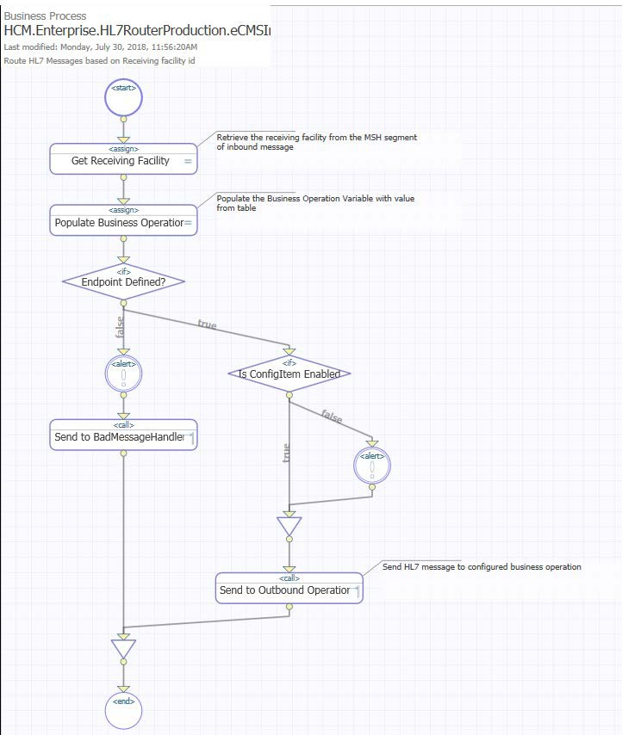
Figure 6: Business Process Logic—Enterprise

eCMS Regional Business Process Logic (BPL)
Workflow logic to route HL7 messages on a Regional HC server based on Receiving Facility ID: Get Receiving Facility. Assign the MSH:ReceivingFacility.universalID, which is piece
6.2 from the MSH header, to receivingSystem.
Look up Business Operation. A sql statement Lookup Business Operation gets the receivingBusinessoperation value from the InboundRouter table based on the receivingSystem value from step 1. This returns the Business Operation of the VistA instance to which the message is addressed.
Figure 7: Sample SQL Statement
SELECT DataValue into :context.receivingBusinessOperation FROM Ens_Util.LookupTable WHERE TableName = 'HCM.InboundRouter.Table' and KeyName = :context.receivingSystem

If condition to check receivingBusinessOperation value is empty:
- If receivingBusinessOperation is NULL, send an alert to the support group (OIT EPMO TRS EPS HSH HealthConnect Administration) and move the message to the BadMessageHandler. The support group needs to check the MSH segment of the message and verify that an entry for the Universal Id in the MSH segment exists in the Outbound Router Table and maps to a corresponding Operation value (see Figure 4).
- If receivingBusinessOperation is not empty continue to step 4.
If condition to check the Operation value in Outbound Router is Enabled:
- If Operation is not Enabled send out an alert to the support group, to enable the Operation and continue to step 5.
- If Operation is Enabled continue to step 5.
Send to Outbound Operator. Send the HL7 message to the Configured Business Operation.

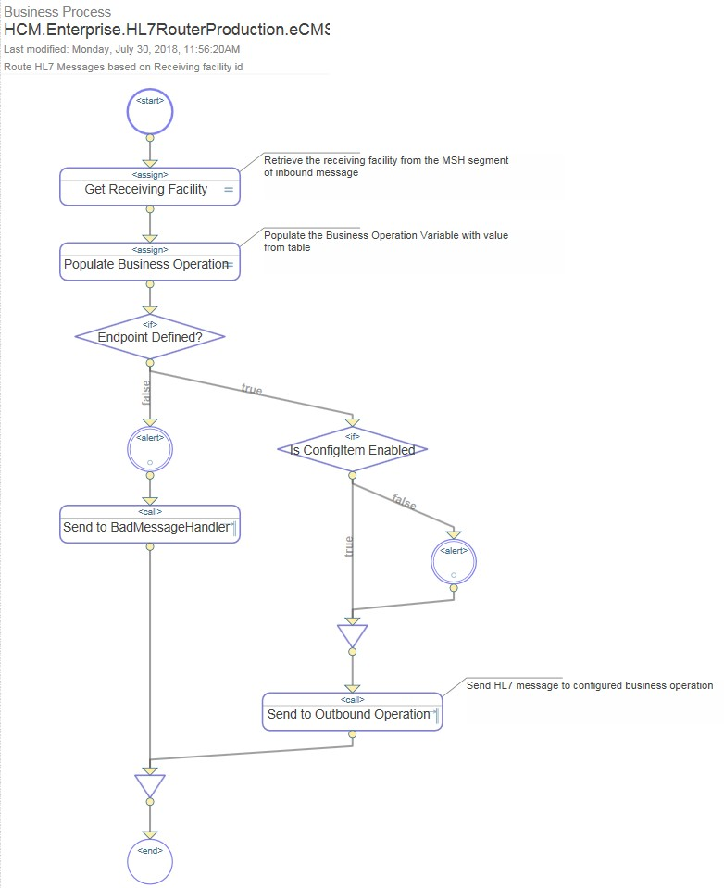
Figure 8: Business Process Logic—Regional

eCMS Message Samples
Figure 9: eCMS—Message Sample to eCMS from VistA
MSH|^~\&|PRCHJ_IFCAP_2237_SEND|999^HL7.ANYSITE.MED.VA.GOV:5632^DNS|PRCHJ_ ECMS_2237_SEND|200^:9450^DNS|20180802133512-0400||OMN^O07^OMN_O07|999
740296|T^|2.5|||AL|AL| NTE|1|P|OTTA HAVE THEM |RJ ORC|NW|999-16-3-044-
0005|||ST||||20160428||999936434^EMPLOYEE^EXAMPLE^L^^^^^^^^^^^^^^^201604281813
05-0400^^SYSTEMS ANALYST|999936432^EXAMPLE
NAME^EMPLOYEE^L^^^^^^^^^^^^^^^^^|||||999-MED SURG^MED||999936432^EXAMPLE NAME^EMPLOYEE^L^^^^^^^^^^^^^^^20160428181144-0400^^||FISCAL^^999^^^^^&|BLD 3 RM 4|||||20160523||4
RQD|1|^^^^|33938YI||12|PR^PAIR^^|820100 Medical|2660 Operating Supplies and Ma
RQ1|45.98|||12433^ABBEY HEALTH CARE^^^
ZA1||||||||
NTE|1|P|SHOES , BLACK, RUBBER-SOLED, |LD
ZZ1|PO BOX 1823||||ANYCITY|NE|00001||308-534-7733| ZZ2||308 534-7733|PO BOX 1823||||ANYCITY|NE|00001|||||| ZZ3|20160428|551.76|551.76|3660160|010020100||044 90 MED/SURG SUPPLIES|E|2016

Figure 10: eCMS—Message Sample to VistA from eCMS
MSH|^~\&|PRCHJ_ECMS_2237_SEND|200^:9450^DNS|PRCHJ_IFCAP_2237_SEND|442^HL7. ANYSITE.MED.VA.GOV:5632^DNS|20180824065525- 05:00||ORN^O08^ORN_O08|76331677020180824065525-723|T|2.5|||AL|NE MSA|AA|999 740299|999-19-1-064-0003*189654
ORC|OK|999-19-1-064-0003|189654 RQD|1|324627

eCMS Alerts

Table 2: eCMS—Alerts

Alert | Description
Automatically Resend HL7 Message | Health Connect shall place the HL7 message in a queue and automatically resend the message for the system configured time period until an Accept Acknowledgment commit response is received:  - CA—Commit Accept  - CE—Commit Error  - CR—Commit Reject  This setting can be found on the business operation by going to  Settings tab and updating Failure Timeout.  In this situation, the business operation should turn purple (see Figure 11).

Alert | Description
Send Email Alert(s) that System or Device Offline | Health Connect sends designated operations support personnel email alert(s) identifying the system or device that is offline based on the configured system parameter for frequency to send email alerts.
Send Email Alert Message Queue Size Exceeded | Health Connect sends an email alert to designated Health Connect operations support personnel when the message send queue exceeds the configurable message queue limit. This setting can be found on the business operation by going to settings tab and updating Queue Count Alert.
Send Email Alert When Commit Reject Message Received | Health Connect sends an email alert to designated Health Connect operations support personnel when it receives a commit reject message in response to sending an HL7 message. This setting can be found on the business operation by going to settings tab and updating Reply Code Actions.
Send Email Alert When Commit Error Message Received | Health Connect sends an email alert to designated Health Connect operations support personnel when it receives a commit error message in response to sending an HL7 message. This setting can be found on the business operation by going to settings tab and updating Reply Code Actions.

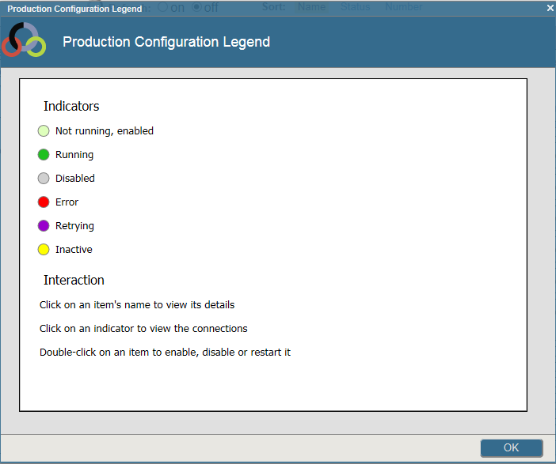
Figure 11: HL7 Health Connect—Production Configuration Legend: Status Indicators

eCMS Approval Signatures
The signatures in this section indicate the approval of the HL7 InterSystems Health Connect Production Operations Manual (POM) for the Electronic Contract Management System (eCMS) application.

NOTE: Digital signatures will only be added to the PDF version of the Microsoft® Word document (i.e., HC-HL7_Messaging_POM-eCMS-Signed.pdf).

REDACTED

REDACTED

REDACTED

