Integrated Funds Distribution, Control Point Activity, Accounting and Procurement
(IFCAP)

Version 5.1

Logistics Data Query Tool USER MANUAL

May 2007

Department of Veterans Affairs
Office of Information and Technology (OI&T) Management, Enrollment, and Financial Systems

Revision History
This manual documents the Logistics Data Query Tool application. Functionality is fully documented elsewhere in this document. For future releases, information will be included here on changes and new features.

Date | Revision | Description | Author(s)
5/31/2007 | 1.0 | Initial issue | REDACTED

THIS PAGE INTENTIONALLY LEFT BLANK

Table of Contents

Revision History iii
Table of Contents v
Chapter 1. Introduction. 1-1
  - Background: IFCAP, Prosthetics, VistA and MUMPS 1-1
  - Purpose of the User Manual 1-1
  - Related Documents 1-1
  - Target Audience 1-2
  - Assumptions About the Audience 1-2
  - The Graphical User Interface 1-3
  - What’s the Query Tool All About? 1-4
  - How Does the Query Tool Work? 1-4
  - Information Displayed by the Query Tool 1-4
Chapter 2. Orientation 2-1
  - Reference Numbering System 2-1
  - Special Usage Conventions in this Manual 2-1
  - Icons Used in Boxed Notes 2-1
  - Hypertext and Hyperlinks 2-2
Chapter 3. Navigating the Program 3-1
  - Pressing and Clicking 3-1
    - Specific Query Tool Shortcut Keys 3-2
    - Clicks and Shortcut Keys: Windows versus Query Tool 3-3
  - Assistive Technology 3-5
    - Maximizing the Screen 3-6
    - Windows Accessibility Shortcuts 3-6
    - Setting the “Focus” on the Detail Display Screen 3-9
    - Tab Order on Detail Display Screen 3-9
    - Activating Pull-Down Lists 3-10
    - Navigating the Date Picker Calendar Pop-ups 3-10
  - Determining the Query Tool Version 3-11
Chapter 4. Using the Logistics Data Query Tool 4-1
  - Associated Files and Their Locations 4-1
  - Start the Program 4-2
  - Sign-On to Vista 4-4
    - Specify VistA Server 4-6
    - Enter Access and Verify Codes 4-8
    - Changing Your VistA Sign-On Identity 4-9
    - Changing Your Verify Code 4-10
  - Open the Logistics Detail Display 4-12
  - Display Screen 4-13
  - Maximize the Screen. 4-14
  - Selecting Data 4-14
    - Select Beginning Date 4-14
    - Select Ending Date 4-16
    - Select Custom Data 4-17
  - Retrieve and Display the Data 4-21
  - Data Display Grids 4-22
    - Main Grid Data 4-22
    - Main Grid Display 4-26
    - Detail Grid Data 4-26
    - Too Many Items to Display 4-28
    - Detail Grid Display 4-29
    - No Data Found 4-30
    - Limit on Number of Items Displayed 4-31
    - Altering Column Width 4-32
    - Moving Columns 4-33
    - Sorting Data by Column 4-34
    - Toggling Between Grids 4-37
  - Using Excel 4-38
    - Exporting Data 4-38
    - Security Reminder 4-38
    - Specifying Storage Location 4-39
    - Viewing the Data in Excel 4-41
    - Saving the Excel File 4-43
    - Save as Excel Workbook 4-44
    - Assign a Filename and Directory 4-45
  - Exiting the Display 4-47
  - Exiting the Query Tool 4-47
Chapter 5. Using the Online Help Feature 5-1
  - Getting Online Help 5-1
  - Special Usage and Conventions in the Help File 5-1
    - Hyperlinks 5-1
    - Keys and Buttons 5-1
    - Tips and Messages 5-1
    - Using Help Topics 5-2
  - Help File Glossary 5-10
Chapter 6. The Remote Procedure Call Broker 6-1
Chapter 7. Error Messages 7-1
Chapter 8. Other Messages 8-1
Chapter 9. Glossary 9-1
Chapter 10. Technical Summary 10-1
  - Associated Files 10-1
  - Data Sources 10-2
  - PRCHL GUI Option 10-2
  - IFCAP Routines 10-2
Index xi
Tables:
Table 2-1 - Icons Used in Boxed Notes 2-2
Table 3-1 - Pressing and Clicking 3-1
Table 3-2 - Application-Specific Shortcut Keys 3-2
Table 3-3 - Clicks and Shortcut Keys: Windows versus the Query Tool 3-4
Table 4-1 - Query Tool Files 4-1
Table 4-2 - Server List Files 4-1
Table 4-3 - Display Screen Areas 4-13
Table 4-4 - Custom Data Choices 4-18
Table 4-5 Main Grid Data 4-22
Table 4-6 Detail Grid Data 4-26
Table 7-1 Error: Connection to Broker Server Cancelled 7-2
Table 7-2 Error: Problem Encountered Getting Broker Information 7-2
Table 7-3 Error: Sign-On Was Not Completed 7-3
Table 7-4 Error: WSAECONNABORTED 7-4
Table 7-5 Error: WSAECONNREFUSED 7-5
Table 7-6 Error: WSAECONNRESET 7-6
Table 7-7 Error: WSAETIMEDOUT 7-7
Table 7-8 Error: Not a Valid ACCESS CODE/VERIFY CODE Pair 7-8
Table 7-9 Error: Please Sign-On First 7-8
Table 7-10 Error: Multiple Sign-Ons Not Allowed 7-9
Table 7-11 Error: Error with Date Selected 7-9
Table 7-12 Error: Maximum Date Range Exceeded. 7-10
Table 7-13 Error: No Date Range 7-10
Table 7-14 Error: No Data to Export 7-11
Table 7-15 Error: Can’t Write to File 7-11
Table 7-16 Error: Error in Help File 7-12
Table 7-17 Error: This Topic Does Not Exist 7-12
Table 7-18 Error: Your VERIFY Code Was Not Changed (Content or Formatting) 7-13
Table 7-19 Error: VERIFY Code Was Not Changed (Same Code) 7-14
Table 8-1 Confidentiality Warning 8-2
Table 8-2 Excel Export Security Reminder 8-2
Table 8-3 You Are About to Log Off and Log On Again 8-3
Table 8-4 No Data Found 8-3
Table 8-5 Too Many Items 8-4
Table 8-6 No Browser Detected 8-4
Table 10-1 Query Tool Files 10-1

Figures:
Figure 3-1 Maximizing via the Keyboard 3-6
Figure 3-2 Turning on StickyKeys 3-7
Figure 3-3 Turning on FilterKeys 3-7
Figure 3-4 Turning on ToggleKeys 3-8
Figure 3-5 Turning on MouseKeys 3-8
Figure 3-6 Turning on HighContrast 3-9
Figure 3-7 Display Screen Tab Order 3-10
Figure 3-8 The “About” Pane 3-11
Figure 4-1 VistA Splash Screen 4-3
Figure 4-2 Query Tool Home Screen. 4-4
Figure 4-3 Selecting Server 4-6
Figure 4-4 Connection Cancelled 4-7
Figure 4-5 Entering Access and Verify Codes: 4-8
Figure 4-6 Confirming VistA Sign-Off/On 4-10
Figure 4-7 OK or Cancel New Verify Code 4-11
Figure 4-8 Confidentiality Warning. 4-12
Figure 4-9 Display Screen 4-13
Figure 4-10 Selection Area 4-14
Figure 4-11 Selecting Beginning Date 4-15
Figure 4-12 Changing Calendar Month 4-15
Figure 4-13 Selecting Custom Data 4-17
Figure 4-14 Retrieving (Displaying) Data 4-22
Figure 4-15 P Lines and I Lines 4-24
Figure 4-16 Shipping and Handling Charges. 4-25
Figure 4-17 Main Grid 4-26
Figure 4-18. “Too Many Items” Notice 4-29
Figure 4-19 Item Detail Grid Display 4-30
Figure 4-20: No Data Found 4-31
Figure 4-21 More Than 80 Items 4-32
Figure 4-22 BOC Column Being Adjusted 4-32
Figure 4-23 Moving Columns (Step 1) 4-33
Figure 4-24 Moving Columns (Step 2) 4-34
Figure 4-25 Default Display 4-35
Figure 4-26 Display Sorted by Status 4-36
Figure 4-27 Purchase Order Item Sort 4-37
Figure 4-28 Excel Export Security Reminder Message 4-39
Figure 4-29 Select Directory Dialog 4-40
Figure 4-30 Select Directory Dialog, Showing Drive List 4-40
Figure 4-31 “No Directory” Error Message. 4-41
Figure 4-32 Excel “CSV“ Sheet as Exported from Query Tool 4-42

Figure 4-33 Excel Sheet Showing Detail Records 4-43
Figure 4-34 Excel “Save As” Step 1 4-44
Figure 4-35 Excel “Save As” Step 2 4-45
Figure 4-36 Default Filename 4-46
Figure 5-1 Tips, Error and Other Messages 5-2
Figure 5-2 Help Topics Pane 5-3
Figure 5-3 Help File “Bars” 5-3
Figure 5-4 Help Topics Button 5-4
Figure 5-5 Help Topics Contents Tab Displayed 5-4
Figure 5-6 Help Topics Tabs 5-5
Figure 5-7 Help Topics Index 5-5
Figure 5-8 Multiple Index Entries. 5-6
Figure 5-9 Help Topics Contents 5-7
Figure 5-10 Help Topics Search 5-8
Figure 5-11 Find Setup Wizard. 5-9
Figure 5-12 Opening Topic (Contents) 5-10
Figure 5-13 Sample Pop-up Glossary Entry 5-11
Figure 6-1 Client Agent Status 6-2
Figure 6-2 Client Agent Information Pop-Up 6-2
Figure 6-3. Using Task Manager to Determine Status of Client Agent. 6-3

May 2007 Logistics Data Query Tool User Manual ix

THIS PAGE INTENTIONALLY LEFT BLANK

Chapter 1. Introduction

This manual is available online at…
http://www.va.gov/vdl/application.asp?appid=42.

See paragraph 2.4 for information about online documents and the use of hyperlinks in this document.

Background: IFCAP, Prosthetics, VistA and MUMPS
Financial and logistics functions for most Department of Veterans Affairs (VA) facilities are handled by the Integrated Funds Distribution, Control Point Activity, Accounting and Procurement (IFCAP) software. The National Prosthetics Patient Database (NPPD) contains information, among other things, about prosthetics items purchased for patients. Both IFCAP and NPPD are part of the Veterans Health Information Systems and Technology Architecture (VistA).
MUMPS is the Massachusetts General Hospital Utility Multi-Programming System, also known simply as M. IFCAP is written in M. While M is a very powerful language, viewing information usually requires use of the utility known as VA FileMan (FM). FM can be used to display and manipulate the data stored within M “globals.” While FM is very powerful, effective use of the program requires training and access to the files. This has proven to be a significant constraint for site staff.

Purpose of the User Manual
This User Manual explains the fundamentals of how to use the new Logistics Data Query Tool, more simply known as the Query Tool. You can use the Query Tool to quickly access, analyze and verify IFCAP and Prosthetics procurement data and display it using a graphical user interface to the VistA data. You can sign-on to VistA, find data, view the data, or easily move the data into a Microsoft® Excel® spreadsheet.
This manual does not, as a general rule, address how to use IFCAP, nor does it define IFCAP terminology—although it does list the data fields from which IFCAP data is extracted for display. See 1.3 below for IFCAP documents that may be of use.
Throughout this document, any references to “User Manual,” “Manual,” “the Manual,” or “this Manual” should be interpreted to mean the Logistics Data Query Tool User Manual (this document).

Related Documents
All of the following documents are available at:

http://www.va.gov/vdl/application.asp?appid=42
- A series of role-based IFCAP User Guides provides information on how IFCAP operates at a site
- The Logistics Data Query Tool Installation Guide provides instructions about installing the required IFCAP option as well as the Query Tool itself
- The IFCAP Technical Manual contains information that assists programmers, site managers, and Information Resources Management (IRM) technical personnel to operate, maintain, and troubleshoot IFCAP software

Target Audience
Expected users of the Query Tool and of this manual include Chief Logistics Officers; Materiel Managers; Purchasing Agents; and members of the Facility Logistics Staff (including Inventory Managers; Supply, Processing, and Distribution (SPD) Technicians; Management Analysts; Warehouse Clerks; or Supply System Analysts).
The local Information Resources Management (IRM) staff members will also be involved.
Information about the roles associated with many of these titles may be found online in the VistA Documentation Library at:
http://www.va.gov/vdl/application.asp?appid=42

Assumptions About the Audience
This manual assumes that persons using the manual are at least somewhat familiar with the following software and/or concepts:
    - The VistA (specifically, IFCAP) computing environment. This manual makes no attempt to explain how IFCAP itself works; this is documented elsewhere (e.g., in the various IFCAP User Guides).
    - The Microsoft Windows operating system (at least Windows fundamentals, including how to operate the keyboard and mouse in the Windows environment).
    - The Microsoft Excel computer spreadsheet application.
If you are not familiar with any of the above, please contact your supervisor for the necessary training.

The Graphical User Interface
A user interface is the means by which you (the user) interact with a computer program. The interface provides one or more means of input (which allows you to manipulate the system) and output (which allows the program to respond to your input).
An interface may be strictly text-based (as in the traditional roll-and-scroll character-based VistA interface), or it may use both text and graphics.
A graphical user interface is one which uses graphics, or graphics with text, rather than pure text. We refer to this as a GUI, often pronounced “gooey.” A GUI takes advantage of the computer's graphics capabilities to make the program easier to use, and includes so-called “controls” which enable you to interact with a program. Controls may include buttons, pull-down menus, scroll bars, check boxes, text entry boxes, etc.
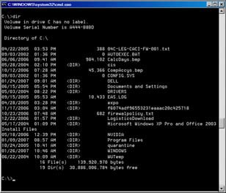
The first interactive computer user interfaces were text- and keyboard-oriented, usually consisting of typed commands which you had to remember, and computer responses that were infamously brief. The command interface of the DOS operating system (shown at right, and which you can still access from your Windows operating system) is an example of the typical user-computer interface before GUIs arrived.

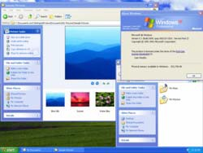
Today's major computer operating systems (including Microsoft Windows XP, shown at left) provide a GUI. Software applications typically use those elements of the GUI that come with the operating system and add their own graphical user interface elements and ideas. A GUI sometimes uses one or more metaphors for objects familiar in real life, such as the desktop, the view through a window, or the physical layout in a building. Elements of a GUI include controls, which are interface elements enabling a user to interact with a computer.
Buttons, pull-down menus, scroll bars, check boxes, and text entry boxes are typical controls. Controls are sometimes qualified as virtual to distinguish them from their physical counterparts; e.g., virtual buttons that can be clicked with a mouse cursor, versus physical buttons that can be pressed with a finger.
Even the most basic of windows has some elements of a GUI. Consider, for example, the Microsoft Internet Explorer® browser, a portion of which is shown at right. In a window that has been maximized— that is, one which
has been expanded to fill the screen— the upper right corner has three controls that can be used to modify the window:

Minimizes the window

Returns the window to its “normal” or default size Closes the window
When the window is not maximized, the “normal” button is replaced by the Maximize button.
A well-designed GUI, which uses graphical images and controls in addition to text to represent the information and actions available to the user, can free the user from learning complex command languages. Usually the interactions with the program are performed through direct manipulation of these graphical elements (like “clicking” an icon with a computer mouse). If you are reading this document on your computer, you are probably using the GUI of your particular web browser or word processor.

What’s the Query Tool All About?
The Query Tool is a Windows software application that acts as a “front-end” to enable you to more easily find, display, and export VistA data. The Query Tool is a specialized tool which looks for a pre-determined list of specific data fields in the VistA and Prosthetics databases. Although you can specify additional data fields for your search, Query Tool is not an all-purpose tool for examining the MUMPS globals (files) which store the data. The Query Tool enables you to…
    - Search for data and display data by a range of dates
    - Sort and rearrange the view of the data; display the data in a custom view
    - Export the data into a Microsoft Excel spreadsheet file
You’ll learn more about what the Query Tool can do in the chapters which follow.

How Does the Query Tool Work?
The Query Tool, which runs on your computer workstation, uses a protocol known as a Remote Procedure Call (RPC). An RPC enables the Query Tool to communicate directly with VistA to find and display data stored on another computer (for more information, see: Chapter 6 below).
You must already have been assigned the PRCHL GUI, a special kind of IFCAP option (called a B-type option), on your primary or secondary IFCAP menu in order to use the Query Tool.
If you don’t know whether or not you have this option assigned, please contact your supervisor.

Information Displayed by the Query Tool
The Query Tool display screen has a Selection Area (which allows you to select data to be displayed) and two “grids,” each with columns and rows of information. The Main Grid shows order-level information, and the Detail Grid shows the details (line items) associated with each selected order.

These three areas of the screen, as well as the data displayed, are discussed in more detail starting at paragraph 4.5 below.

THIS PAGE INTENTIONALLY LEFT BLANK

Chapter 2. Orientation

Reference Numbering System
This document uses a numbering system to organize topics into sections that show you how the topics relate. For example, section 1.3 means this is the main topic for the third section of Chapter 1. If there were two subsections to this topic, they would be numbered 1.3.1 and 1.3.2. A section numbered 2.3.5.4.7 would be the seventh subsection of the fourth subsection of the fifth subsection of the third topic of Chapter 2. This numbering system tool allows you to more easily follow the logic of sections that contain several subsections.

Special Usage Conventions in this Manual
Please note the following special usage conventions found in this manual. Also note the differences between the images and link styles used in this Manual and those in the Help File (see 5.2).
- Windows vs. windows: The term “Windows” (capitalized) refers to the Microsoft® Windows® family of operating systems. The terms “window“ and “windows“ (not capitalized) refer to a visual area of a computer screen, usually rectangular in shape, containing some kind of user interface and displaying the output of and allowing input for one of a number of simultaneously running computer processes. Most windows have some kind of a “menu bar“ across the top that lists the options available to you from that window.
- Keys: In the Help File as well as in this printed documentation, computer keys that you press are represented inside <angle brackets> (examples: <Alt>, <L>, <Alt>+<L>).
- Buttons: Buttons that are part of the Query Tool interface or that are displayed in the Help File appear inside [square brackets] (example: [ Button ]).
- Menu choices: Following the Microsoft convention, references to any window menu bar choice use the Microsoft Sans Serif typeface, with the <Alt> key character underlined (example: File).
- Window or section names: Likewise, names of specific windows in the application, or of defined parts of a window, are also shown in the Microsoft Sans Serif typeface (examples: Home Screen, Main Grid).
- File and Field Names: Names of files and database fields are shown in Courier New
typeface, boldfaced (example: IFCAP Item Master).

Icons Used in Boxed Notes
Whenever you need to be aware of something important or informative, the Manual will display a boxed note with an icon to alert you; icons are shown in Table 2-1. Look for these icons in the left and right margins of the document.

Table 2-1 - Icons Used in Boxed Notes
Icon | Meaning | Icon
 | Warning: Something that could adversely affect your use of the Query Tool or of the material available in the IFCAP databases.
 | Tip: Advice on how to more easily navigate or use the Guide or the software.
 | Information: or Note: Additional information that might be helpful to you or something you need to know about, but which is not critical to understanding or use of the software.
 | Technical Note: Information primarily of interest to software developers, IRM or Enterprise Product Support (EPS) personnel. Most users can usually safely ignore such notes.
 | Question: A question that might come to your mind (hopefully, followed by an Answer!)

These symbols are also used in the Help File for similar purposes (see 5.2.3 below).

Hypertext and Hyperlinks
This document contains “hypertext” that provides links to other parts of this document or to other related documents. Hypertext is a computer-based text retrieval system that enables you to access particular locations in electronic documents by clicking on hyperlinks in those documents. If you are viewing this document on your computer screen (as opposed to reading a printed copy), you will find certain hyperlinked words or phrases.
- An internal or “cross-reference” hyperlink allows you to “jump” to another part of this document. If you have the Web toolbar enabled in your copy of Word, just click the back ( ) icon on the toolbar to return to where you jumped from. Typically, these hyperlinks
will be imbedded in sentences like “See the IFCAP Glossary in Chapter 9.” Although such internal cross-references may not be shown in blue, if you move your mouse over such phrases, a pop-up box will display the link, like this:
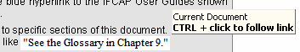

- Another kind of internal hyperlink uses “bookmarks” to direct you to other locations in this document. These are presented in a blue font. Again, click the back ( ) icon on the toolbar to return to the point where you jumped from.

Chapter 2. Orientation

- Links to web pages or Internet sites should open in your web browser (typically Internet Explorer®). Normally, such links will be preceded by the shortcut graphic ( ). Use the browser’s “back” button to return to this document. Since Internet Explorer and Word are both Microsoft products, do not close the browser window, since this may (under certain circumstances) also close this document.
- Links to some external documents (for example, other Word documents) may (depending on your system settings) open in Word. Such links are presented in a blue font. For example, note the shortcut graphic with blue hyperlink to the other online documents shown in the boxed note below. Again, use the back ( ) icon on the menu bar to return to where you were.
In either case, you may click (or, as shown above and depending on your computer’s operating system or software version, you may have to hold down the <Ctrl> key while clicking) on the link to see the other document or move to the specified place in this document.

If your copy of this document has been downloaded to a local file:

Please make certain your copy is current. Compare the revision history of your copy (see
Revision History on page iii) with that of the original at

http://www.va.gov/vdl/application.asp?appid=42

THIS PAGE INTENTIONALLY LEFT BLANK

Chapter 3. Navigating the Program
For most required interaction with the Query Tool, you may use mouse clicks, pull-down menus, or keyboard shortcuts. See 3.1.1 and 3.1.2 below for more information about keyboard shortcuts.
Note to Those Using Microsoft Wheel Mouse: Under certain circumstances not yet fully defined, touching the wheel can cause the Query Tool application to lock up. At this point, neither a cause nor a solution is known.

Pressing and Clicking
When you are using the Query Tool, you may be told to “press” one or more keys, or to “click” an icon, link, or button on the screen.

Table 3-1 - Pressing and Clicking
When this manual tells you to… | it means:
Press a key | Press the indicated key on the computer keyboard.
Press <Alt> , <?>  (where <?> may be any other key) | Press the <Alt> key, then the other indicated key (this is useful for those who may have difficulty in holding down one key while pressing another).
Press <Ctrl> or <Alt> plus some other key (like <Ctrl> +<L> or  <Alt>+<L>) | While holding down the <Ctrl> or <Alt> key, press the other key(s) indicated on the computer keyboard. You do not have to depress both keys simultaneously—but you do have to press and hold the  <Ctrl> or <Alt> key first, since it modifies the normal action of the other key.  In all known instances in the current Query Tool application, using the <Alt> key with a letter has the same effect as using the <Ctrl> key with a letter. In many cases, using just the letter key by itself will also work.
Press <F1>  (or another function key) | Press the indicated function key one time only. Function keys are usually found across the top of the keyboard.
Click | After placing the mouse cursor over an icon, a hyperlink, or something similar, press the left mouse button once.
Click [ OK ]  (or another button) | After placing the mouse cursor over an on-screen button, press the left mouse button once.
Double-click | After placing the mouse cursor over an icon or something similar, press the left mouse button twice in rapid succession without moving the mouse.
Right-click | After placing the mouse cursor over an icon, a hyperlink, or something similar, press the right mouse button once. Usually, this will display a list of options from which to select. As a practical matter, the Query Tool application does not currently offer any opportunities for this usage.

Specific Query Tool Shortcut Keys
The Query Tool offers several shortcut keys or combinations. In cases where different screens (or different parts of a screen) produce different effects, the screens are identified as follows in the Action column:
- Home = the opening Home Screen (menu)
- LDD = the Logistics Detail Display screen
- Main = the Main Grid on the Logistics Detail Display screen
- Detail = the Detail Grid on the Logistics Detail Display screen

See also 3.2 for specific keys useful to those who require assistive technology.

Table 3-2 - Application-Specific Shortcut Keys
Option | Shortcut | Action
Home Screen: File Menu (File)
Close [see fourth item] Closes everything (and signs off VistA)

Logistics Detail Display <Ctrl>+<L>,
<Alt>+<L>, <L>

Opens Logistics Detail Display

_{VistA} _{Sign-On} <Alt>+<S>, <S> Opens VistA sign-on dialog; select server to connect to,
then enter Access Code and Verify Code
[not listed on menu] <Alt>+<F4> Closes everything (and signs off VistA)
Home Screen: Help Menu (Help)
About <Ctrl>+<A> Displays current version number, warnings, etc.

Contents and Help <F1> Opens online Help File (when available)
Logistics Detail Display: File Menu (File)
Close <Ctrl>+<C> LDD: Closes Logistics Detail Display, returns to Home
Screen (does not terminate application, does not sign-off VistA)
Home: No effect

Display <Ctrl>+<D>,
<Alt>+<D>, <D>
Excel <Ctrl>+<X>,
<Alt>+<X>,<X>
Displays items for selected date range

Opens Excel, exports selected data to new sheet

_{Get} _{Started} Opens beginning date “date picker” calendar with current date as default
<Ctrl>+<B>

_{Select} _{Beginning} _{Date} Opens beginning date “date picker” calendar with current date as default
<Ctrl>+<B>

_{Select} _{Ending} _{Date} Opens ending date “date picker” calendar with current date as default
<Ctrl>+<E>

Option | Shortcut | Action
[not listed on menu] <Alt>+<F4> Closes Logistics Detail Display, returns to Home Screen
(does not terminate application, does not sign-off VistA)
Logistics Detail Display: View Menu (View)
_{Custom} _{Data} ₁ <Ctrl>+<H> Shifts focus to first custom data selection (#1 under
Select custom data…)
_{Custom} _{Data} ₂ <Ctrl>+<I> Shifts focus to second custom data selection (#2 under
Select custom data…)
_{Custom} _{Data} ₃ <Ctrl>+<J> Shifts focus to third custom data selection (#3 under
Select custom data…)
_{Item} _{Detail} _{Grid} <Ctrl>+<L> Shifts focus to Item Detail (List) Grid with first item
detail record selected
Main Grid <Ctrl>+<G> Shifts focus to Main Grid
Help Menu (Help)
About <Ctrl>+<A> Displays current version number, warnings, etc.
Contents and Help <F1> Opens online Help File

User Manual <Ctrl>+<U> Opens user manual (not yet available via this method)
Buttons

[ Display ] <Alt>+<D>,
<Ctrl>+<D>,<D>
[ Excel ] <Alt>+<X>,
<Ctrl>+<X>,<X>
[ Logistics Detail Display ] <Alt>+<L>,
<Ctrl>+<L>, <L>
[ VISTA Sign-On ] <Alt>+<S>,
<Ctrl>+<S>, <S>
LDD: Retrieves and displays data in the grids

LDD: Opens Excel, exports selected data to new sheet

Home: Opens the Logistics Detail Display (only after sign-on completed)

Home: Opens the VistA sign-on dialog

[ _{Close} ] <Ctrl>+<C> LDD: Closes display, returns to Home Screen (does not
terminate application, does not sign-off VistA)

[ Get Started by Selecting a Beginning Date ]
<Ctrl>+<B> Opens beginning date calendar with current date as
default

[ Select Ending Date ] <Ctrl>+<E> Opens ending date calendar with current date as default

Clicks and Shortcut Keys: Windows versus Query Tool
If you are accustomed to using shortcut keys in Windows, you should be aware that some shortcut keys or combinations may provide the same effect, a different effect, or no effect when you are working in the Query Tool. Sometimes the effect of key combinations is different, depending on which screen or grid you are using within the Query Tool. The similarities and differences are laid out in Table 3-3. In cases where different screens (or different parts of a screen) produce different effects, the screens are identified in the right-hand column as follows:

      - Home = the opening Home Screen (menu)
      - LDD = the Logistics Display screen (see 4.5 below)
      - Selection = the Selection Area on the Logistics Display screen (see 4.7 below)
      - Main = the Main Grid on the Logistics Display screen (see 4.9.1 below)
      - Detail = the Detail Grid on the Logistics Display screen (see 4.9.3 below)

Table 3-3 - Clicks and Shortcut Keys: Windows versus the Query Tool
Click/Keys | Shortcut | Action
Working with Text: In Windows… In the Query Tool…
<Ctrl>+<A> Select Select all the text in a document Displays the About pane
<Ctrl>+<B> Bold Bold the selected text LDD: Displays Beginning Date
calendar
Home: No effect
<Ctrl>+<C> Copy Copy the selected text or objects LDD: Closes the Logistics
Detail Display screen, returns to Home Screen (does not terminate application, does not sign-off VistA)
Home: No effect
<Ctrl>+<I> Italics Italicize the selected text Selection: Shifts focus to second
custom sort criterion (#2 under Select custom data…)

<Ctrl>+<X> Cut Cut the selected text or objects LDD: Creates Excel file

<Shift>+<↑>
<Shift>+<↓>

Select Row Select text, one row at a time,
from the cursor up or down
Selection: Changes Ending Date by one month (increase or decrease)
Main: Selects order record (same as up or down arrow alone).
Detail: Selects item record (same as up or down arrow alone).

<Ctrl>+<↑>
<Ctrl>+<↓>
Current Paragraph Next Paragraph
Moves cursor to top of the current (Up arrow) or next (Down arrow) paragraph
Main: Leaves currently-selected record selected, but “slides” the main grid window up or down to display records above or below the currently-selected record (similar to using the vertical scroll button).
Detail: No effect

<Ctrl>+<←> Previous Word
Next Word
Moves cursor to previous (Left arrow) or next (Right arrow)
Home: Moves from one button to the other: [ VISTA Sign-On ] to

Click/Keys | Shortcut | Action
<Ctrl>+<→> word [ Logistics Detail Display ]
Working with Files/Documents: In Windows… In the Query Tool…
<Ctrl>+<W> Close Close the document No effect

<Ctrl>+<F6> Switch Switch between open (non- minimized) documents
No effect on application itself, but Windows will respond by moving to next open application window

Assistive Technology
Some of the current features of the Query Tool navigation may not be intuitive if you are using assistive technology (for example, a screen reader like JAWS¹). The development staff is aware of this and is working toward an alternate method of navigating the Detail Display screen in a future release of the Query Tool. Each function may also be selected by using keystrokes; these keystrokes are identified in the discussion for the function. Generally, the keystrokes include:
- Press <Alt>+<F> or <F10> followed immediately by <↓>, then choose the function
- Press <Alt> followed immediately by <F>, then choose the function
- Press <Ctrl> + a letter that represents the function (for example, <Ctrl>+<B> chooses the “Select Beginning Date” function)
- Press <Alt> + a letter that represents the function

¹ JAWS is an acronym for Job Access with Speech, and refers to a software product for visually impaired users produced by the Blind and Low Vision Group at Freedom Scientific. See http://en.wikipedia.org/wiki/JAWS_%28screen_reader%29 and http://www.freedomscientific.com/fs_products/software_jaws.asp.

Maximizing the Screen
Instead of clicking the Maximize button, you can press <Alt>+<space> and select Maximize:

Figure 3-1 Maximizing via the Keyboard
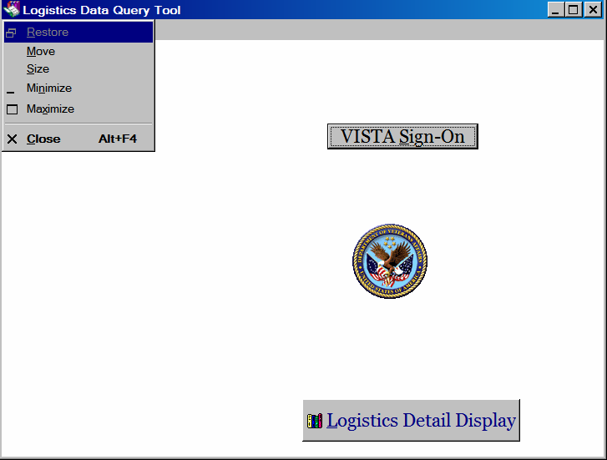

Windows Accessibility Shortcuts
The Windows operating system offers a number of accessibility shortcuts which can be useful.

StickyKeys
Press <Shift> five times to toggle StickyKeys on and off:

Figure 3-2 Turning on StickyKeys
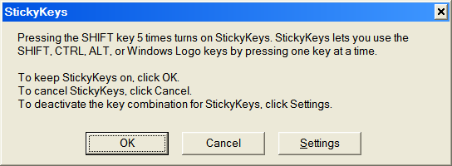

StickyKeys lets you use the <Shift>, <Ctrl> or <Alt> keys by pressing one key at a time, rather than having to press these keys in conjunction with another key.

FilterKeys
Press down and hold the right-hand <Shift> key for eight seconds to toggle FilterKeys on and off:

Figure 3-3 Turning on FilterKeys
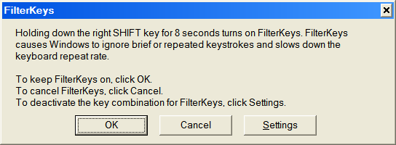

FilterKeys causes Windows to ignore brief or repeated keystrokes and slows down the keyboard repeat rate.

      - ToggleKeys
Press down and hold the <Num Lock> key for five seconds to turn ToggleKeys on and off:

Figure 3-4 Turning on ToggleKeys
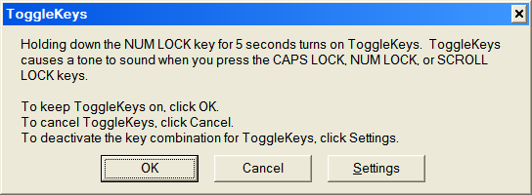

ToggleKeys causes a tone to sound when you press the <Caps Lock>, <Num Lock>, or
<Scroll Lock> keys.

      - MouseKeys
Press the left-hand <Alt> key plus the left-hand <Shift> key plus the <Num Lock> key to toggle
MouseKeys on and off:

Figure 3-5 Turning on MouseKeys
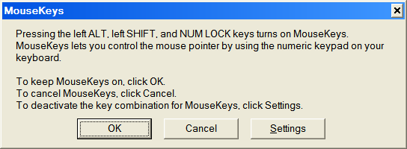

MouseKeys lets you control the mouse pointer by using the numeric keypad on your keyboard.

HighContrast
Press the left-hand <Shift> key plus the left-hand <Alt> key plus the <Print Screen> key to toggle
HighContrast on and off:

Figure 3-6 Turning on HighContrast
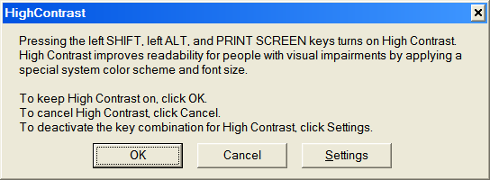

HighContrast improves readability for people with visual impairments by applying a special system color scheme and font size.

Setting the “Focus” on the Detail Display Screen
When you open or return to the Detail Display screen, the cursor position (or “focus”) may not be readily apparent. Any time that you open or return to this screen, you should immediately press the <Tab> key to set the focus.
If you have been on the Detail Display screen, leave the screen, and then return, the focus remains where you left it. If you do not remember where that was, press <Tab> followed by
<Back>+<Tab> to return to that focus; your screen reader (if any) should then read the focus field.

Tab Order on Detail Display Screen
On the Detail Display screen, the tab order (that is, the order in which screen elements are selected when you press the <Tab> key) is as follows and as shown in Figure 3-7. Tab position “0” is where the cursor rests when the screen first opens. Note that in the figure below, the term “None-” is highlighted to help show the cursor location. This term may or may not be highlighted in the Query Tool itself.

- Select custom data 1: None- (none selected by default)
- [ Get Started by Selecting a Beginning Date ] button
- [ Select Ending Date ] button
- [ Display ] button
- [ Excel ] button
- Select custom data 1: pull-down list
- Select custom data 2: pull-down list

- Select custom data 3: pull-down list
Figure 3-7 Display Screen Tab Order
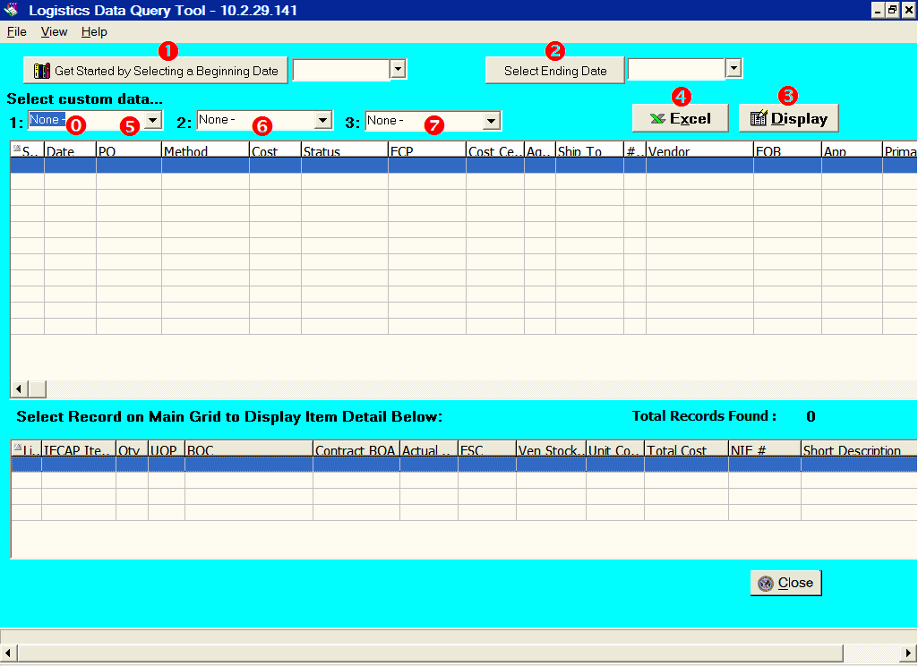

Activating Pull-Down Lists
You can activate pull-down lists from the keyboard. Simply tab to the pull-down list field and press <F4> or <Alt>+<↓>.

Navigating the Date Picker Calendar Pop-ups
Using the date selection pop-up calendars (known as “date pickers”) may be somewhat problematic for those using screen readers. The pop-up date picker calendar is essentially a graphic, rather than text, feature. The following keys can be used to navigate on the calendar pop-ups:
- <Page Up> displays the previous month.

- <Page Down> displays the following month.
- <Arrow> keys (left, right, up, down) change the day of the month. If you continue to arrow up, down, left or right, the month will eventually change accordingly.
- <Enter> selects date chosen and closes the pop-up.
- <Esc> closes the pop-up without making a selection (but remember that you must make a selection before you can proceed to the next step).

Determining the Query Tool Version
From almost any screen where you see Help available on the menu bar, you can determine the version of your Query Tool application by any of these methods:
- Click Help in the menu bar, then select the About option
- Press <Alt>+<H>, then select the About option.
- Press <Alt>,<H>, then select the About option
- Press <Ctrl>+<A>
You’ll then see the current “About” pane, which should look similar to the one below. The software version number, shown on the third line, reflects the IFCAP version ("5.1"); IFCAP patch number ("103"); and the Query Tool executable iteration ("01"). The IFCAP patch number is also shown on the fifth line: “PRC*5.1*103.”

Figure 3-8 The “About” Pane
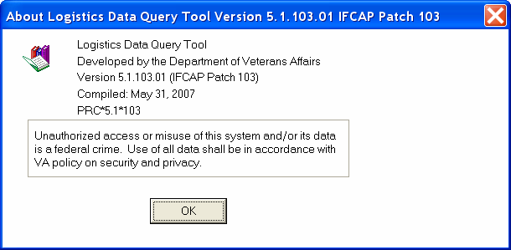

Click the [ OK ] button to close the “About” pane and return to the previous screen.

THIS PAGE INTENTIONALLY LEFT BLANK

Chapter 4. Using the Logistics Data Query Tool

Associated Files and Their Locations
The Query Tool uses a number of files, each of which are essential to the proper running of the application. Each must be in a specific directory.
CAUTION: Do not delete, rename, or move any of these files to a different physical or logical drive, folder or directory. If any of these files are missing, renamed or moved, the Query Tool may not work correctly.

The Query Tool application and its associated files are stored in the directory C:\Program Files\VISTA\IFCAP\. This directory is created by InstallShield® when the Query Tool is first installed on the workstation. Although you should never have occasion to move or alter these files, the list is provided here so that you will know which files you should not alter, delete or move.
The files directly related to the Query Tool are:

Table 4-1 - Query Tool Files
Filename | Purpose/Explanation
PRCLogisticsTools.exe | The compiled executable (program) file
PRCLogisticsTools.hlp | The online help file
PRCLogisticsTools.cnt | The online help “contents” file
PRCLogisticsTools.gid | The online help “index” file. This is the only file which can be safely deleted (the help system will rebuild it the next time it’s needed); there should, however, normally not be  any need to delete it.
RoboEx32.dll  InetWH32.dll | Dynamic link libraries needed for proper operation of the  Help File.

Other files may also be required to assist in setting up user workstations. The following applications are also found in the C:\Program Files\VISTA\IFCAP\ directory:

Table 4-2 - Server List Files
Filename | Purpose/Explanation
ServerList.exe | The “Edit Broker Servers” program, needed to specify which  servers are available to use in Query Tool
xwb1_1ws.exe | Program needed to set up the RPC Broker Client on the workstation. See  http://www.va.gov/vdl/documents/Infrastructure/Remote_Proc_Call_Broker_(RPC)/xwb1_  1p40ig.pdf.

Start the Program

Tip: You must already have access to VistA data, have been assigned the IFCAP GUI option on your menu, and have been assigned an Access Code and Verify Code for your site before attempting to use the Query Tool. If you do not have access or don’t know your codes, please contact your supervisor.
Tip: You should already have a shortcut icon on your Windows desktop allowing you to access the Query Tool. It should look something like the one shown at right. If you don’t have such an icon, please contact your IRM Service.

Start the Query Tool application by double-clicking the icon on your workstation desktop. You should first see the VistA “splash” logo, superimposed over the application’s Home Screen:

Figure 4-1 VistA Splash Screen
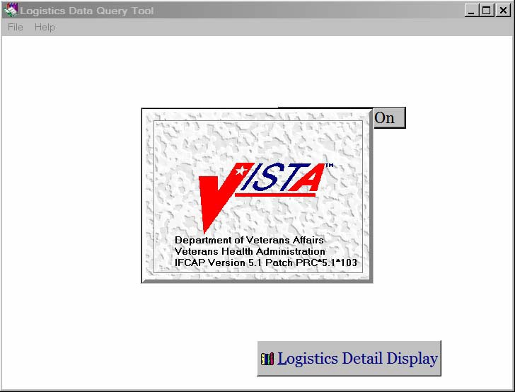

After a few seconds, the VistA logo will vanish, and you’ll see the Query Tool Home Screen:

Figure 4-2 Query Tool Home Screen
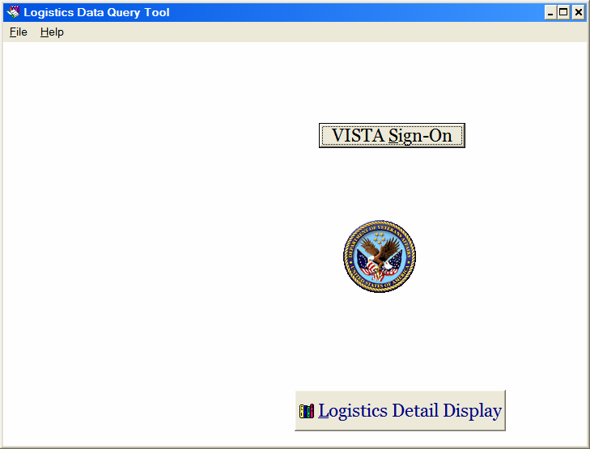

Sign-On to Vista
Before you can use the Query Tool features, you must sign-on to VistA through the Query Tool.

Can I sign-on using the Query Tool if I’m already signed-on to VistA?
If your VistA user profile allows multiple sign-on— and you have not used up your “quota” of sign- ons— then you may use the Query Tool to initiate another session.

If this is not allowed in your profile, and you attempt to sign-on using the Query Tool, you will receive an error message:
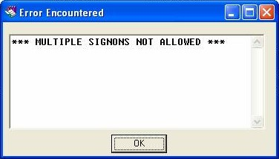

Click [ OK ] to dismiss the error pop-up. Sign off your current “standard” VistA session, and then sign-on through the Query Tool.

How would you know if you have already signed-on to VistA through the Query Tool? Look at the title bar (the top bar) of the Home Screen:
- If it says “Logistics Data Query Tool” followed by the Internet Protocol (IP) address or server name: then you have already signed-on to VistA.
- If it says “ Logistics Data Query Tool ” with nothing following, then you must sign on.
- If it says “ You are not logged on ” then you must sign-on to VistA before you may
continue.
From the Home Screen, start the VistA sign-on process using any of these methods:
- Click the [ VISTA Sign-On ] button
- Click File in the menu bar, then select VISTA Sign-On
- Press <Alt>+<F>, then select VISTA Sign-On
- Press <Alt>,<F>, then select VISTA Sign-On
- Press <Alt>+<S>, <Ctrl>+<S>, or <S>

See: Chapter 8 for other messages and warnings you may encounter during the sign-on process.

Specify VistA Server
You will first see a dialog box, where you’ll be asked to select a server. Click the pull-down arrow to see the list of servers available to you.

Figure 4-3 Selecting Server
REDACTED

Highlight the server you want, and then click the [ ✓ OK ] button.
Tip: When the Connect To dialog pops up, rather than clicking with the mouse, you can use the <↓> or <↑> arrow keys to display your choices, then just press <Enter> to select the server.

If you don’t know which server to select (or if none appear to be available to you), click the
[ x Cancel ] button. You should then see a message like this:

Figure 4-4 Connection Cancelled
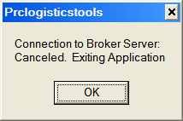

Click the [ OK ] button to terminate the Query Tool application, and then contact your supervisor or your IRM Service for assistance.

Enter Access and Verify Codes
Once you successfully select a server, you’ll see the pop-up VistA Sign-on dialog box, where you’ll see information about the server. Enter your Access Code and Verify Code in the boxes provided:

Figure 4-5 Entering Access and Verify Codes:
REDACTED

Tip: Don’t use <Enter> to move from the Access Code field to the Verify Code field. Use
<Tab> instead. Using <Enter> will result in an error!

After entering your codes, click [ ✓ OK ]. Assuming your codes are accepted, you’ll return to the Home Screen, ready to open the display. When you see the Home Screen, note that the

window caption has changed from “ You are not logged on ” to “ Logistics Data Query Tool -
XX.X.XX.XXX ” (where the name or IP address of the server appears in place of the X’s).

Tip: If you intend to use the Query Tool display throughout the day, you can leave the application running in the background. If you terminate the application after each use, you’ll have to go through this process again each time you use it.

However… Your site may enforce inactivity timeout rules which will make this inappropriate. Leaving the application running also consumes some of your computing resources!
See: Chapter 8 for messages and warnings you may encounter during the sign-on process.

Changing Your VistA Sign-On Identity
In some cases, you may need to sign-on to VistA using a different Access Code and Verify Code. In such a case, return to the Home Screen and then re-select the VistA Sign-On option (see paragraph 4.3 above). You will be asked to verify the fact that you wish to log off and log on again:

Figure 4-6 Confirming VistA Sign-Off/On
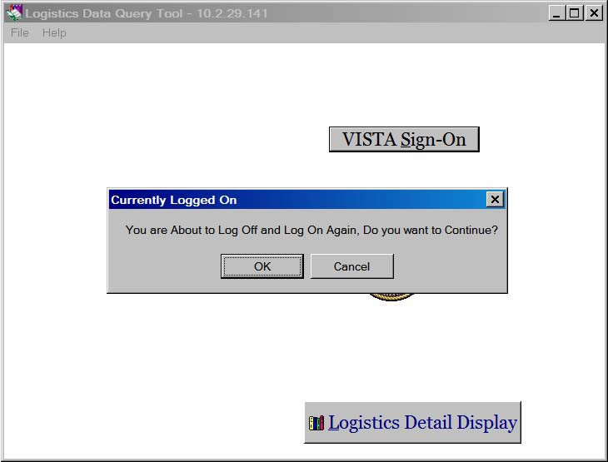

To re-log on to VistA using a different user ID, click the [ OK|] button to continue to the VistA Sign-On screen. If you have gotten here by mistake, click the [ Cancel ] button to return to the Home Screen.

Changing Your Verify Code
The current version of the RPC Broker also includes a Change VistA Verify Code dialog box for the client workstation. If your Verify Code is found to have expired when you start to sign-on to the server, the dialog box shown below will be automatically presented. You will then be required to input and confirm your new Verify Code.

Figure 4-7 OK or Cancel New Verify Code
REDACTED

Enter your old and new Verify Code and click [ ✓ OK ]. Note that you may have to use the horizontal slider bar (or expand the dialog box) to see the response buttons.
If you are not prepared to enter your new code, or want to stop this process for any reason, click [  Cancel ]. You will return to the Home Screen. You will not be able to use the Query Tool until you change your Verify Code.
If you get any other error or advisory message during this process, see Chapter 7.
Note: At some sites, you can use the Query Tool to change your Verify Code at any time. If this is not true at your site and you attempt to do that, you may get an error message. If that happens, you can use the Edit User Characteristics option in the VistA roll-and-scroll environment.

Tip: You cannot re-enter your existing Verify Code as the “new” Verify Code. If you do, you will get an error message (see Chapter 7).

Open the Logistics Detail Display
Once you have signed on to VistA, you will be able to find and display VistA data onscreen. From the Home Screen, open the display by using one of these methods:
- Click the [ Logistics Detail Display ] button
- Click File in the menu bar, then select Logistics Detail Display
- Press <Alt>+<F>, then select Logistics Detail Display
- Press <Alt>, <F>, then select Logistics Detail Display
- Press <Ctrl>+<L>, <Alt>+<L>, or <L>

You’ll then see the confidentiality warning:

Figure 4-8 Confidentiality Warning
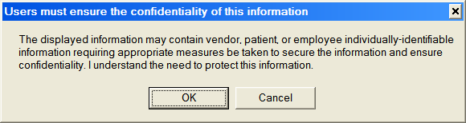

Click the [ OK ] button to indicate that you understand the warning and restrictions. This will allow you to use the display. You cannot use the display until you click the [ OK ] button; if you click the [ Cancel ] button, you’ll simply return to the Home Screen.

Display Screen
The Query Tool display screen has a Selection Area and two “grids,” each with columns and rows of information (see Figure 4-9). The three areas of the screen are indicated by the key letters – in the screen shot below. These areas are identified in Table 4-3.

Figure 4-9 Display Screen
REDACTED

Table 4-3 - Display Screen Areas
Key | Section | Purpose
 | Selection Area | Allows you to select data using a date range and other criteria.
 | Main Grid | Displays the orders that meet your selection criteria.
 | Detail Grid | Displays item level detail about one selected order.
More information on the screen elements and the data they display will be found starting at paragraph
4.9 below.

Maximize the Screen
If you have not already done so, you might want to consider maximizing the screen. This will make viewing the data displays much easier.
Click the maximize button in the top right corner of the window. Or, press <Alt>+<Space>
and select Maximize.

Tip: When you access the Display Screen, the Home Screen is still resident in the background. If you then minimize the Display Screen, the Home Screen will remain on your monitor, and you will not be able to minimize, maximize or “touch” it in any way.

We strongly suggest that if you need to minimize the application, you first exit the Display Screen (via the [ Home ] button or by using the menu options). Any data that you have retrieved and displayed will remain on the Display Screen, and will be available when you return to the Display Screen.

Selecting Data
Use the controls in the Selection Area to find and display data that meet your criteria. You must specify a date range by selecting a Beginning Date and an Ending Date. Most of the data elements to be displayed are predetermined, but you may also specify up to three data elements to be displayed in addition to the standard set of data.

Figure 4-10 Selection Area
REDACTED

Select Beginning Date
As the button indicates, you Get Started by Selecting a Beginning Date using any of the following methods:
- Click the [ Get Started by Selecting a Beginning Date ] button

- Click File in the menu bar, then choose Select Beginning Date
- Press <Alt>+<F>, then choose Select Beginning Date
- Press <Alt>, <F>, then choose Select Beginning Date
- Press <Ctrl>+<B>

Any of these methods will show you a pop-up calendar, called the date picker, from which you can select the beginning date. By default, the current date (as currently stored on your workstation) is offered and is shown circled. You can accept that date by simply pressing the
<Enter> key, by clicking on the circled date, or by clicking on the “today” tag at the bottom of the calendar. If you wish a different date in the same month, click on that date.

Figure 4-11 Selecting Beginning Date
REDACTED

To choose month earlier than the current month, click on the left arrow ( date picker:

Figure 4-12 Changing Calendar Month
) at the top of the

You may also click on the right-hand arrow to see data for a future month. This can be useful, for example, if your site “preloads” purchase orders with future order dates in preparation for the upcoming fiscal year. This may be done because it's known that certain goods and services will be needed, even though they will be purchased with “future money.”

Tip: You cannot enter a date by typing it directly into the box, nor can you paste text from your computer’s clipboard.
Tip: If you use assistive technology, please see 3.2 for alternate methods of using the date picker.
NOTE that your workstation’s date is used to determine the default calendars that are displayed; the Query Tool does not consult with the VistA system to determine the current date. If your system date is incorrect, you may not see all the relevant data.

Select Ending Date
Once you have selected the Beginning Date, the current date is displayed in the ending date field. You can accept this, or you may select a different Ending Date using any of the following methods:
- Click the [ Select Ending Date ] button
- Click File in the menu bar, then choose Select Ending Date
- Press <Alt>+<F>, then choose Select Ending Date
- Press <Alt>, <F>, then choose Select Ending Date
- Press <Ctrl>+<E>
Any of these methods will show you another date picker from which you can select the Ending Date, using the methods shown in paragraph 4.7.1 above. As with the Beginning Date calendar, the current date is offered as the default and is shown circled. You can accept or change the date using the same methods as for the Beginning Date. As with the Beginning Date, remember:
  - You cannot enter a date by typing it directly into the text box
  - You cannot paste text from your computer clipboard

Tip: The maximum date range is 100 days. If you select dates that will exceed this range— and, yes, the date picker will allow you to do that— expect to receive an error message!
Tip: If you use assistive technology, please see 3.2 for alternate methods of using the date picker.

Tip: You must select both a Beginning Date and an Ending Date; if you do not, you’ll receive an error message when you attempt to display data.

Select Custom Data
The data elements displayed are set for most of the display columns, but there are three “custom data” fields that you can select in addition to the standard ones; these fields display in the three variable-content columns to the right of the Liq Amount (Liquidated Amount) column. Click the pull-down arrow to select one data element for the first of the three boxes, located just below the label “Select custom data…” and identified with the “1:” label. Note that you cannot select more than one element from the list, and you may have to use the vertical scroll button to see all the available choices. Repeat the process, if desired, for the other two boxes. A complete list of fields available is shown in Table 4-4 below.

Figure 4-13 Selecting Custom Data
REDACTED

Table 4-4 shows the current choices for the Custom Data selections (these are subject to change in the future). On the pull-down list, each choice gives the field description, followed by a dash, followed by the field number. Except for the ITEM DETAIL – ITM (which appears first), the choices are arranged numerically by the field number.

Tip: You can activate pull-down lists from the keyboard. Simply tab to the pull-down list field and press <F4>. See 3.2 for other keyboard shortcuts.

Tip: If you wish to view or export item level data, you must select ITEM DETAIL – ITM in one of the custom data fields.

Table 4-4 - Custom Data Choices
Field Description | Field Number
ITEM DETAIL | ITM
SPECIAL FUND CONTROL POINT | .03
INVOICE ADDRESS | .04
PRIORITY OF 2237 | .06
ESTIMATED ORDER? | .08
DEPOT VOUCHER NO. | .09
EMERGENCY ORDER? | .2
LOCAL PROCUREMENT REASON CODE | .25
EXPENDABLE/NONEXPENDABLE | .3
SUPPLY STATUS | .5
SUPPLY STATUS ORDER | .7
FISCAL STATUS ORDER | .8
APPROPRIATION | 1.4
SUBACCOUNT1 | 3
SUBAMOUNT1 | 3.4
SUBACCOUNT2 | 4
SUBAMOUNT2 | 4.4
VENDOR | 5
DEBTOR | 5.1
REQUESTING SERVICE | 5.2
SHIP TO | 5.4
DELIVERY LOCATION | 5.6
VERBAL PURCHASE ORDER | 6
CONFIRMATION COPY | 6.2
F.O.B. POINT | 6.4
ORIGINAL DELIVERY DATE | 6.9
DELIVERY DATE | 7
ESTIMATED COST | 7.2
SOURCE CODE | 8
ASTR. FOR SOURCE CODE | 8.1
PROPOSAL | 8.2
EST. SHIPPING AND/OR HANDLING | 13
EST. SHIPPING BOC | 13.05

Field Number
Field Description
EST. SHIPPING LINE ITEM NO. 13.1
GOV’T B/L NO. 13.2
SHIP VIA 13.3
GBL P.O. NUMBER 13.4
LINE ITEM COUNT 15
PA/PPM/AUTHORIZED BUYER 16
PO PRINTED TIME 18
NEED SPECIAL HANDLING? 18.6
TYPE OF SPECIAL HANDLING 18.7
AGENT ASSIGNED P.O. 19
DATE P.O. ASSIGNED 19.2
MONTH 21
QUARTER 22
LAST DIGIT OF FISCAL YEAR 23
BBFY 26
OLD PO RECORD 27
NEW PO RECORD 28
END DATE FOR SERVICE ORDER 29
AUTO ACCRUE 30
SUBSTATION 31
RFQ NBR 42
DISPUTED 44
DELIVERY ORDER 47
TYPE OF ORDER 48
SORT GROUP 51
CLASSIFICATION OF REQUEST 52
PCDO VENDOR 53
RECEIVING REQUIRED? 54
PURCHASE CARD USER 56
APPROVE RECONCILIATION USER 57
DATE RECONCILED 58
PURCHASE COST 60
PURCHASE CARD HOLDER 61
PCDO 2237 62
PROCESSING REQUIRED IN FISCAL 63
FREE TEXT VENDOR 64
INTERFACE PACKAGE PREFIX 65
DEPARTMENT NUMBER 70
DOCUMENT IDENTIFIER CODE 71
ROUTING INDENTIFIER [sic] CODE 72

Field Description |  |  |  |  |  | Field Number
ACTIVITY ADDRESS CODE |  |  |  |  |  | 72.4
DEPT. DESIGNATION |  |  |  |  |  | 73
SPECIAL CODE |  |  |  |  |  | 73.4
SIGNAL CODE |  |  |  |  |  | 74
FUND CODE |  |  |  |  |  | 75
DISTRIBUTION CODE |  |  |  |  |  | 76
PROJECT CODE |  |  |  |  |  | 77
PRIORITY CODE |  |  |  |  |  | 78
ADVICE CODE |  |  |  |  |  | 79
MEDIA & STATUS CODE |  |  |  |  |  | 80
REASON CODE |  |  |  |  |  | 83
TOTAL AMOUNT |  |  |  |  |  | 91
NET AMOUNT |  |  |  |  |  | 92
LIQUIDATED AMOUNT |  |  |  |  |  | 93
ACTUAL 1358 BALANCE |  |  |  |  |  | 94
FISCAL 1358 BALANCE |  |  |  |  |  | 95
ESTIMATED 1358 BALANCE |  |  |  |  |  | 96
CONVERTED 1358 |  |  |  |  |  | 96.5
AUTH. AMOUNT REMAINING |  |  |  |  |  | 96.6
BULLETIN SENT |  |  |  |  |  | 96.7
PROMPT PAY TYPE |  |  |  |  |  | 97
PAYABLE CODE |  |  |  |  |  | 101
DOCUMENT IDENTIFIER/COMMON |  |  |  |  | NO. | 102
REQUISITION NO. |  |  |  |  |  | 102.4
ISSUE VOUCHER NO. |  |  |  |  |  | 102.5
ISSUE VOUCHER NO. |  |  |  |  |  | 102.6
LOG BATCH NO. |  |  |  |  |  | 103
LOG | ACQ. | CODE | SHEETS | DONE? | 103.5
LOG CODE SHEETS SENT BY 104
LOG CODE SH. VALIDATION CODE | 105
LOG CS VALIDATION VERSION | 105.5
DATE SIGNED | 106
SUPPLY FUND ORDER OBLIGATION? | 106.4
RELEASING FACILITY NUMBER | 197
CASCA PROJECT NO. | 108
CASCA TRANS TYPE | 109
ISMS BATCH NO. | 111
ISMS CODE SHEETS DONE? | 112
ISMS CODE SHEETS SENT BY | 113
ISMS VALIDATION VERSION | 114.5

Field Number
Field Description
ISMS DATE SIGNED 115
DO YOU WANT TO SEND THIS EDI? 116
BILL # 500.01
CERTIFIED P.O. 501
REASON NOT COMPLETED 117
NUMBER OF OFFERS 118
PRE AWARD SYNOPSIS 119
ALTERNATIVE ADVERTISING 120
SOLICITATION PROCEDURE 121
EVALUATED PREFERENCE 122
FUNDING AGENCY CODE 123
FUNDING AGENCY OFFICE CODE 124
MULTIYEAR 125
EPA DESIGNATED PRODUCT 126
CONTRACT BUNDLING 127
EXTENT COMPLETED 128
PERF. BASED SERVICE CONTRACT 129
CLINGER COHEN 130
PLACE OF PERF. THIS STATION? 131
PLACE OF PERFORMANCE 132
SEND TO FPDS? 133

Retrieve and Display the Data
Once you have specified the date range and the kind of data you want in the “custom” fields, click the [ Display ] button (far right side) to retrieve and display the data by using any of these methods:
- Click the [ Display ] button (far right side)
- Click File in the menu bar, then select Display
- Press <Alt>+<F>, then select Display
- Press <Alt>, <F>, then select Display
- Press <Alt>+<D>, <Ctrl>+<D> or <D>

Figure 4-14 Retrieving (Displaying) Data
REDACTED

If there are no records available that match your date range, you simply won’t see any records displayed when you click the [ Display ] button. There is no warning or advice in this situation. Adjust your criteria and try again.
If your connection to the server is slow, you may notice that the [ Display ] button momentarily changes during the search to show [ Searching ]. This is normal; the button will revert to its normal appearance once the search is complete.
Assuming that your selections resulted in one or more records being found, the records will be displayed in the Main Grid, one of the two grids used. Both grids are explained in 4.9 below.

Data Display Grids
The retrieved data will be displayed in the two grids. See paragraph 4.9.7 below for information on how to temporarily adjust the display grids for easier reading, or paragraph 4.9.10 below on how to sort the data by the various columns.

Main Grid Data
The data displayed in the Main Grid includes the information shown below. See the Glossary for unfamiliar terms.

Table 4-5 Main Grid Data
Column # & Heading |  | Data Presented / Explanation
0 | STN | Station Number

Column # & Heading |  | Data Presented / Explanation
1 | Date | Suspense entry date
2 | PO | Purchase Order number (for the order record). See 4.9.1.1 below for additional information.
3 | Method | This entry may be the method of purchase (e.g., Purchase Card).  It may also be the Prosthetics HCPCS code or the Item Master File number plus the National Item File number.
4 | Cost | Total cost for the order
5 | Status | Order status (e.g., Ordered, Cancelled Order)
6 | FCP | Fund Control Point
7 | Cost Center | Cost Center. This entry may also be the Budget Object Code (BOC) or the Contract number.
8 | Agent Assigned PO | Name of person handling the order
9 | Ship To | Place to where the order is to be shipped
10 | # Line Item | Number of detail (item) lines on the order
11 | Vendor | Vendor name or Vendor stock number.
12 | FOB | Freight on Board (typically Origin or Destination)
13 | App | Appropriation
14 | Primary 2237 | Primary 2237 number for the order
Note: There are two horizontal sliders: one which affects only the Main Grid (at the bottom of the Main Grid) and (if detail information is displayed) one which affects only the Detail Grid (at the bottom of that grid). Use the grid slider button(s) to see all the information displayed. Even if none of the columns have been expanded (see 4.9.7 below), the elements shown below this row can usually be seen only by sliding the button to the right. Depending on the size of your window, there may also be a third slider at the bottom of the window, which affects everything in that window.
15 | Purchase Card Holder | Name of Purchase Card User
16 | Liq Amount | The Liquidated Amount
17  18  19 | [varies] [varies] [varies] | Data in these columns comes from IFCAP File 442 (IFCAP orders) and/or from File 664 (Prosthetics orders). The data displayed depends on the custom data elements you picked in the Selection Area: Custom data element #1 appears in column 17, #2 in column 18, and #3 in column 19.
20 | IEN 442 | The Internal Entry Number (IEN) from IFCAP File 442.

P Lines and I Lines
If you selected ITEM DETAIL – ITM as one of the custom data elements, you will see item-level lines displayed in the PO column of the Main Grid, displayed immediately following the order- level line.

For example, in Figure 4-15 below, consider the highlighted row (purchase order 695-U62544) and the two rows which follow.

The row immediately below the highlighted row shows detail-level information from the BILLING ITEM multiple of the Prosthetics 1358 (#664) file entry. This entry is associated (linked) with an entry in the Procurement and Accounting Transactions (#442) file. In the PO column, you see 695-U62544-P 1. This is a “P line.”

The second row below the highlighted one also shows line detail, but in this case it’s from the
ITEM multiple of the #442 file entry for the order: 695-U62544-I 1. This is an “I line.”

Figure 4-15 P Lines and I Lines
REDACTED

Detail Grid Entries for P Lines and I Lines
Now consider the Detail Grid in Figure 4-15 above. Note the entry “V2229” that appears in the IFCAP Item # column. This corresponds to the value that appeared in the Main Grid in the Method column: “HCPCS: V2229.”

In the Detail Grid, the detail for Line # (U62544-P 1) is being pulled from the Prosthetics file, while the detail for Line # (U62544-I 1) comes from the IFCAP file. The value “V2299” in the IFCAP Item # column is a Prosthetics HCPCS code. In the Main Grid, that HCPCS code value is prefixed with the string “HCPCS:” and is displayed in the Method column. There is only one line item, but two detail line items to show the data separately according to source file.

Shipping and Handling Charges
Now look at purchase order 695-U62540 (highlighted row) in Figure 4-16 below. There are two P lines and a single I line. In the Prosthetics 1358 (#664) file, shipping charges are stored at the header level, just as in the IFCAP Procurement & Accounting Transaction (#442) file. The Query Tool design displays these shipping charges as the second P line (Line # P2) in the Detail Grid

Figure 4-16 Shipping and Handling Charges
REDACTED

Main Grid Display
The Main Grid displays the orders which fall within the date range you specified:

Figure 4-17 Main Grid
REDACTED

Detail Grid Data
The data displayed in the Detail Grid includes the information shown in Table 4-6. See the Glossary for unfamiliar terms.

Table 4-6 Detail Grid Data
Column # & Heading |  | Data Presented / Explanation
0 | (N/A) | (“Zero” is not displayed in this grid and can be ignored.)
1 | Line # | Line number for items in the order highlighted in the Main Grid.
2 | IFCAP Item # | This entry may be the Item Number from the Item Master file; the Prosthetics Healthcare Common Procedure Coding System (HCPCS) Code; or the word SHIPPING. This entry uniquely identifies a specific inventory item (like L2795, 83). Currently, these numbers are locally—not nationally— assigned.

Column # & Heading |  | Data Presented / Explanation
3 | Qty | Quantity (for the line item)
4 | UOP | Unit of Purchase for the line item (like EA, BX). This describes the quantity/packaging combination in which the vendor sells the item; it may be different from the Unit of Issue used to actually issue the item to the end user.
5 | BOC | Budget Object Code
6 | Contract BOA | Basic Ordering Agreement (like DEVELOPMENT06, V797P 5615M)
7 | Actual Unit Cost | Cost per unit under terms of the contract/order
8 | FSC | Federal Stock Classification
9 | Vendor Stock # | The stock number assigned by the vendor to the item
10 | Unit Con | Unit Conversion Factor
11 | Total Cost | Cost per unit times quantity, adjusted by any discounts or add-ons
12 | NIF # | National Item File Number
Note: The horizontal slider that affects the application screen as a whole (at the bottom of the screen) can be used to see the far right-hand side of the display if needed. If you need to see the entire Short Description column, however, your only choice may be to collapse several of the earlier columns, then expand the Short Description column (see 4.9.7 below). See the second example immediately below, which shows the Short Description column after expansion.
13 | Short Description | The basis of the information displayed here is the Item Master (#441) file Short Description field (.05).  What actually displays here will be either a combination of the IFCAP Short Description and the first line of the word processing text, or any combination of the two depending on what is populated in the IFCAP and Prosthetics files.  If the order does not have an IFCAP Item Master file entry, but does have word processing text: The tag “1st Line:” will be displayed, followed by the first line of the word processing text. For example:  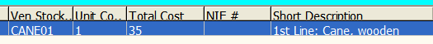  If the item does have an IFCAP Item Master file entry,

Column # & Heading |  | Data Presented / Explanation
 |  | this field will display a combination of both the IFCAP Short Description, the tag “1st Line:”, and the first line of the word processing text. For example:

CAUTION: Because all or part of the word processing field may be displayed, there is a distinct possibility that patient information may be displayed. Particular care must be taken to avoid breaching confidentiality and privacy rules, especially when saving the data to Excel, and later, when displaying the data in Excel or printing from Excel.

Too Many Items to Display
A limit of 80 line items per order has been established for display purposes. If an order has more than 80 line items, the Main Grid will display-- in the # Line Item column on the row following the order itself— the message “<** More than 80 Line Items **>“. Note that in the illustration below, the # Line Item field on the row following the order (circled) shows this message. If you select that order on the Main Grid, you’ll see a pop-up message telling you that there are too many line items to display. This means that you can see how much money was spent on the order, but you cannot tell which items were purchased.

Figure 4-18. “Too Many Items” Notice
REDACTED

Click [|OK ] (or just press <Enter>) to return to the Main Grid and continue.

Detail Grid Display
Once you select an order (by clicking on a row or otherwise highlighting the row in the Main Grid), line-level detail information for that order is displayed in the Detail Grid.

Figure 4-19 Item Detail Grid Display
REDACTED

For example, the illustration above shows details for PO #688-4F058 (which is highlighted in the Main Grid). Note that the Main Grid shows, in the # Line Item (displayed as #... if the column has not been expanded) column, the number “3,” meaning that there are three items for this order; those three item records are displayed in the Detail Grid.

No Data Found
If you select an order in the Main Grid, and there are no item records associated with that order, you’ll see a notice telling you that there is no item data associated with that order. Note that in the illustration below, the # Line Item (#...) field (circled) is empty for that order:

Figure 4-20: No Data Found
REDACTED

Click [ OK ] (or just press <Enter>) to return to the Main Grid and continue.

Limit on Number of Items Displayed
A limit of 80 line items per order has been established for Query Tool displays. If an order has more than 80 items, the Main Grid will, in the #Line Item column on the row following the order itself, display the message “<** More Than 80 Line Items **>.” Note that in the illustration below, the #Line Item field on the row following the order (circled) shows this message. If you select that order in the Main Grid, you’ll get a pop-up message telling you there are too many items to display. In such case, you can see how much money was spent on the order, but you cannot tell what items were purchased.

Figure 4-21 More Than 80 Items
REDACTED

Altering Column Width
You will note that not all the column headings, nor all of the information shown in the columns, can always be easily read. You can temporarily alter the way data is displayed in the grids to make specific data easier to read. Place the mouse pointer at the boundary to the right of the column to be adjusted.
The pointer should change to the “adjust width” (or “double arrow”) pointer: .
Hold down the left mouse button and move the pointer left or right to adjust the width.
The screen shot “close-up” in Figure 4-22 shows the Detail Grid BOC column (the column to the left of the cursor) being adjusted.

Figure 4-22 BOC Column Being Adjusted

Note: You cannot alter the row height.

Moving Columns
You can also change the order in which the data is displayed, by moving columns from their default locations. Click and hold the heading for the column you want to move, and then drag the column to the location you wish. In the sample below, the column Cost Center has been selected for the move. Note how the left-hand border has changed to a highlight:

Figure 4-23 Moving Columns (Step 1)
REDACTED

Drag the column to its new location (in this case, immediately following the Cost column). The left-hand border will move as you drag the column. When the desired location is reached, just drop the column in its new position by releasing the mouse button. Note that the Cost Center column is now immediately to the right of the Cost column:

Figure 4-24 Moving Columns (Step 2)
REDACTED

Sorting Data by Column
You can sort the data displayed by any one of the column headings. Just click on the column header to sort by the data in that column. Note that once you have done a sort, a small up- or down-arrow appears in the column header. You can change the sort order from ascending to descending (or vice versa) by clicking on the column header tab again; the arrow will change direction to show you the sort order. Or, you can use left- and right-clicks to do the sort: a left- click on the column header sorts the data in ascending order; while a right-click sorts in descending order.
To illustrate, here is a “default” display, sorted by STN:

Figure 4-25 Default Display
REDACTED

Note the small arrow to the left of the title in the first column (enlarged here for clarity): .
The first time the Detail Display Screen is accessed, the small arrow appears in the STN column header, but the data is sorted by IEN 442, visible only by scrolling to the right.
You can sort, for example, by Status. Click on the header tab, and the records will be sorted by status. The ascending sort marker will appear in the header tab, to the left of the column label: . Note that the arrow points up, meaning this is an ascending sort.
After you click the column header, Query Tool will redisplay the data, sorted by Status:

Figure 4-26 Display Sorted by Status
REDACTED

If you prefer, you can click on the header tab again to change to a descending sort. The arrow in the header now reverses to show this is a descending sort: .

About PO Item Number Sorting: Because the sorting mechanism treats all record cells as though they were character strings, the order sorting of the PO column may not be what you might expect. For example, a PO with items numbered from 1 through 24 will sort 1, 10, 11… then 2, 20, 21, followed by 3, 4… 9. See Figure 4-27 below, which shows the records after they have been exported to Excel.

Figure 4-27 Purchase Order Item Sort

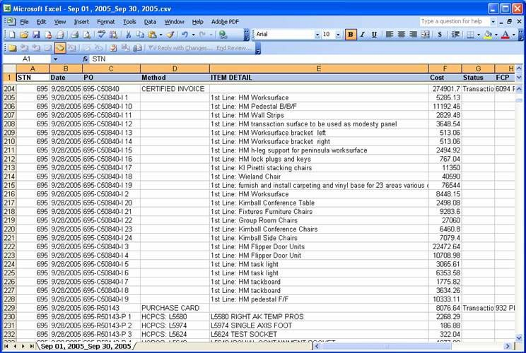

Technical Note: Sorting in the Query Tool is done by use of a module called
TSortGrid. If you really want to know more about this module, see Chapter 9.

Toggling Between Grids
You can toggle between the Main Grid and the Detail Grid by using either the mouse or “hot keys.” When you toggle to a different grid, this is also called “shifting the focus.”
- To shift focus to the Main Grid, press <Ctrl> + <G>. Within the grid, you can use the keyboard up and down arrow keys (<↑> and <↓>) to move up or down and select records. Or, you can click anywhere on a row in the Main Grid to shift the focus and select that order.
- Once you have selected a record in the main grid and wish to shift focus to the Detail Grid, press <Ctrl> +<L> or click on any row in the Detail Grid.
Using only the keyboard, you can quickly navigate between the grids to review records. For more keyboard shortcuts, please see paragraph 3.1.1.

Using Excel
Once you have the data displayed, you can export the data to Microsoft Excel. Note that you cannot export individual line item records, and you cannot select individual orders to export. Whenever you export from the Query Tool application, all the order records that are currently displayed along with their associated detail records are exported to the spreadsheet. Also note that any sorts done in the Query Tool (see paragraph 4.9.10 above) will not be carried over to Excel.
Obviously, you must have Excel installed on your computer in order for this option to work… but you do not need to have Excel running; the Query Tool application will automatically open Excel and create the new spreadsheet.

Exporting Data
From either the Main Grid or the Detail Grid, you can export the data currently being displayed using any of these methods:
- Click the [ Excel ] button
- Click File in the menu bar, then choose Excel
- Press <Alt>+<F>, then select Excel
- Press <Alt>, <F>, then select Excel
- Press <Alt>+<X>, <Ctrl>+<X>, or <X>

Security Reminder
Because you may be exporting individually-identifiable sensitive data, you must make a conscious decision about where you store the exported data.
When you click the [ Excel ] button, the Query Tool application will first display a security reminder message:

Figure 4-28 Excel Export Security Reminder Message
REDACTED

Click [ OK ] to acknowledge the message and continue.

Specifying Storage Location
Query Tool will then ask you to specify a directory or folder where you wish to store the Excel CSV file that’s about to be created. “CSV” stands for “comma-separated values,” which is a type of text data file that Excel can use to create a spreadsheet.

Figure 4-29 Select Directory Dialog
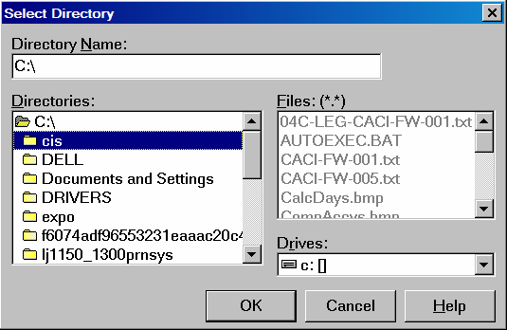

You may enter the drive\directory name directly in the Directory Name: box, or use the pull- down list provided under Drives to browse to the desired drive/directory:

Figure 4-30 Select Directory Dialog, Showing Drive List
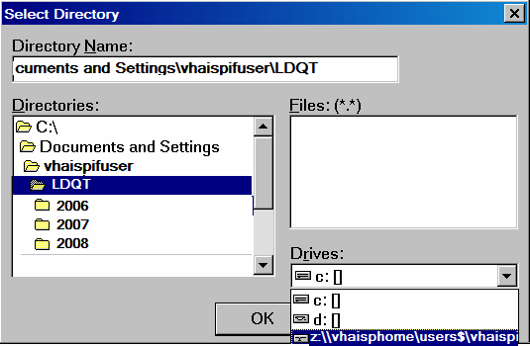

Select the drive letter, and a list of folders on that drive will be displayed in the Directories: list. Select the folder, then click [ OK ].

Information: This feature is a departure from earlier test versions of the Query Tool, and was added in response to security concerns about storing potentially sensitive data on the workstation hard disk drive. You must make a conscious decision about the storage location, based on local conditions. The recommended storage location is a secure network drive. For example, many users have a “z:\\” drive assigned, as shown above.
Note: If you do choose a network drive, you may expect a delay in saving the file, particularly if you are working via a Virtual Private Network (VPN). Please allow time for this operation to complete, and do not click the [ Excel ] button again.

You must select a directory. If you click [|Cancel|] or the Windows [|X|] button, or if you press the <Esc> key, you’ll see this notice:
Figure 4-31 “No Directory” Error Message
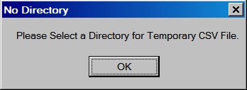

Once you have selected a directory, Query Tool will open Excel, create a CSV file, and then display the records in Excel.

Viewing the Data in Excel
Once you have the records in Excel, you can manipulate them as you wish for viewing or printing. Here’s what a typical file looks like immediately after it’s been opened in Excel. Note that the filename still has the .CSV extension at this point:

Figure 4-32 Excel “CSV“ Sheet as Exported from Query Tool
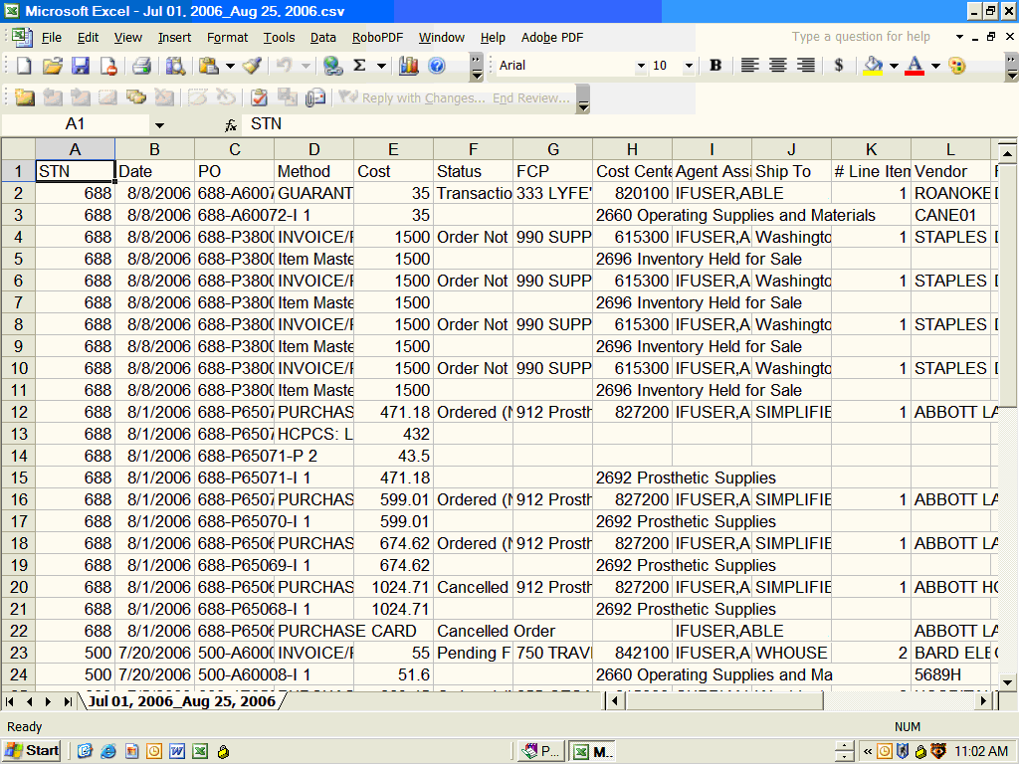

Note that any item detail records for each order are displayed immediately following the order record. In the sample below, row 9 is an order, while rows 10 – 12 are items associated with that order:

Figure 4-33 Excel Sheet Showing Detail Records
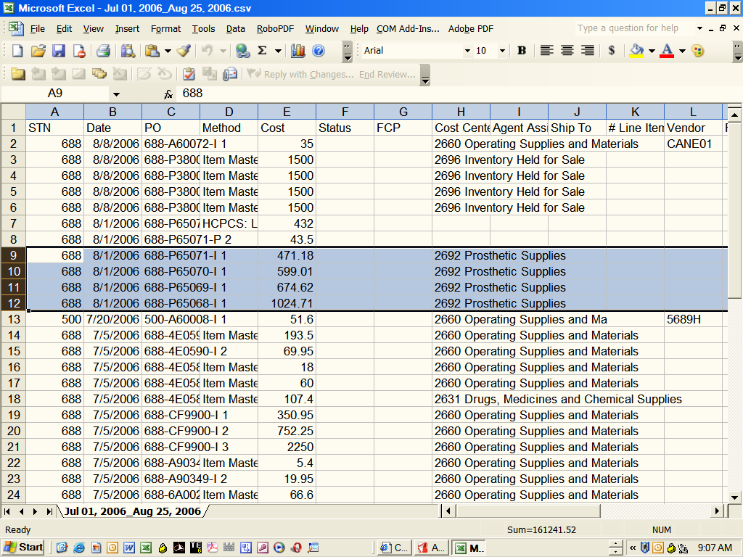

Saving the Excel File
The Query Tool application automatically saves the original (source) .CSV file in the directory you select (see 4.10.1 above). The .CSV filename extension is also automatically assigned, and cannot be changed within the application—but you can, and should, use Excel to save the file under a different name.

CAUTION: The .CSV file stored in your selected download directory is automatically deleted when you exit the Query Tool application. If you have not saved the file with a different filename extension, the file will be lost.

Start this process by doing a “save as” from the Excel File menu:

Figure 4-34 Excel “Save As” Step 1
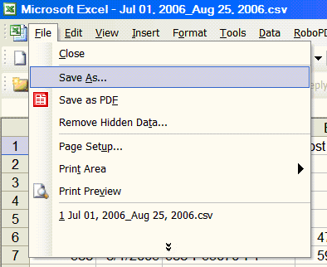

Save as Excel Workbook
You will almost certainly want to save the file as an Excel file with the .XLS file suffix. Select the “Save as type” Microsoft Excel 97- Excel 2003 & 5.0/95 Workbook (*.xls), or the closest equivalent you can find on your system, as shown in Figure 4-35.

Figure 4-35 Excel “Save As” Step 2
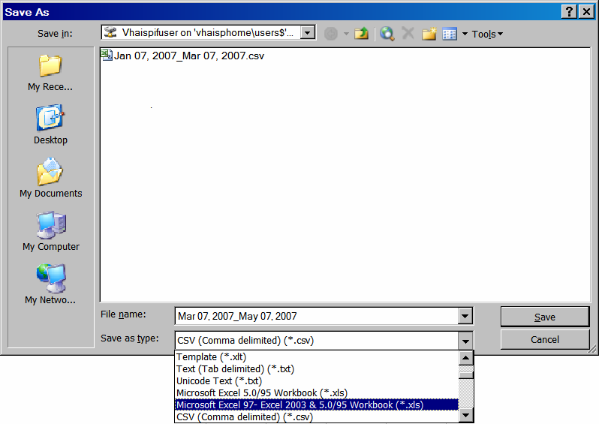

Assign a Filename and Directory
After you specify the file type, you’ll want to assign a filename. Note that the drive and directory you specified earlier is now shown as the default location:

Figure 4-36 Default Filename
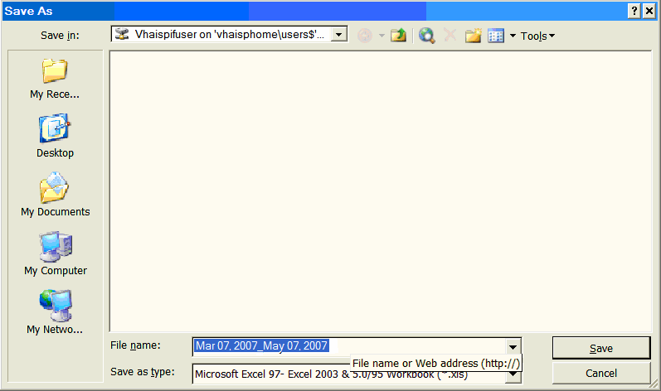

You can accept the filename offered (as shown above, the default filename offered consists simply of the date range), or you can substitute a filename that is more meaningful to you.

CAUTION: Any .CSV files which use the default date range filename (like Jul 01, 2006_Aug 25, 2006.csv), regardless of where you store them, are automatically deleted when you next click the [ Excel ] button, or when you exit the Query Tool application. If you have not saved the file with a different filename extension, the file will be lost.

If, for some reason, you do want to save a CSV file, you will need to rename it to change the filename in some way.
Once you have the data saved in an Excel workbook, you can change column widths, sort data, and create printouts to meet your needs.

CAUTION: Changes to the content or format of the records in Excel will not be reflected in the original IFCAP database. You cannot use the Excel spreadsheet to

import changes back to IFCAP. If you create printed reports from Excel, the data displayed may be different from what you and others will see in IFCAP or in the Query Tool application.

Exiting the Display
Once you’re through examining your data, from either the Main Grid or the Detail Grid, you can return to the Home Screen using any of these methods:
- Click the [ Close ] button
- Click File in the menu bar, then choose Home
- Press <Alt>+<F>, then select Home
- Press <Alt>, <F>, then select Home
- Press <Ctrl>+<C>
This has the effect of leaving you signed on to VistA and ready to examine more data later.

Tip: Your data display is not cleared or otherwise changed by returning to the Home Screen. From Home, you can simply click the [ Logistics Detail Display ] button again and immediately return to your data.
Tip: When you access the Display Screen, the Home Screen is still resident in the background. If you then minimize the Display Screen, the Home Screen will remain on your monitor, and you will not be able to minimize, maximize or “touch” it in any way.

We strongly suggest that if you need to minimize the application, you first exit the Display Screen (via the [|Close ] button or by using the menu options). Any data that you have retrieved and displayed will remain on the Display Screen, and will be available when you return to the Display Screen.

Exiting the Query Tool
From the Home Screen, you can exit the Query Tool application using any of these methods:
- Click the Windows [ X ] button
- Click File in the menu bar, then choose Close
- Press <Alt>+<F>, then select Close
- Press <Alt>, <F>, then select Close
- Press <Alt>+<F4>

This also has the effect of logging you off from VistA and of clearing out any data that you had earlier retrieved. When you reopen the application, you will be required to sign-on to VistA again.
Tip: If you intend to use the Query Tool display throughout the day, you may leave the application running in the background. If you terminate the application after use, you will have to go through this process again each time you use it.

However… Your site may enforce inactivity timeout rules which will make this inappropriate. Leaving the application running also consumes some of your computing resources!

THIS PAGE INTENTIONALLY LEFT BLANK

Chapter 5. Using the Online Help Feature

Getting Online Help
Much of the material in this manual is also available, in somewhat abbreviated form, via the Query Tool application’s built-in help functions. When running the Query Tool application, you can access the Help File by any of these methods:
- Click [ ? Help ] if available
- Click Help in the menu bar, then select Contents and help
- Press <Alt>+<H>, then select Contents and help
- Press <Alt>,<H>, then select Contents and help
- Press <F1>
Some context-sensitive help is available. For example, if you click the [|? Help ] button during the VISTA Sign-on process, you will see help about how to use the Connect To dialog.

Special Usage and Conventions in the Help File

Hyperlinks
In the Help File, you can click an internal hyperlink (note the difference from the way hyperlinks appear in this Manual) to jump to another part of the Help File. After using such a hyperlink, you can click the [ Back ] button on the menu bar to return to where you were.
On the other hand, an Internet hyperlink will take you to a website, web page, or other external source. Such links are either preceded by the “shortcut” graphic ( ) and/or begin with “http://.” Just click the [|Back ] button on the Help File menu bar to return to where you were.

Keys and Buttons
As in this manual, the Help File shows keys inside <angle brackets>, while buttons that are part of the Query Tool interface appear inside [ square brackets ].

Tips and Messages
Throughout the Help File, you may see tips about how the program works, or about the Help File itself. While using the program, you may encounter various messages, either resulting from an error or just to keep you informed. The images used are the same as in the Manual, but link styles are different from those used in the Manual (see 2.2).

Figure 5-1 Tips, Error and Other Messages
Tip: From time to time, you may see informative tips about how to handle a given situation or advice on how the program works.
Technical Note: Information primarily of interest to software developers, IRM or Enterprise Product Support (EPS) personnel. Most users can usually safely ignore such notes.
Did you get an error message? There will usually be a link to the list of Error Messages.

Just click on the link to find out more about the error and how to fix the problem. Or, click on any ERROR MESSAGES link to see the list of error messages.
You may also see other informational messages.
Click on any OTHER MESSAGES link to see a list and explanation of these informational messages.

Using Help Topics
The Help File is organized as a series of related topics, which can be thought of as similar to chapters in a book. The first “chapter” displayed when you open the Help File is a list of contents, like the table of contents in a book. Each major and many minor topics are displayed as hyperlinks, so you can click on any topic of interest and immediately jump to the part of the Help File where that subject is discussed.

Using Built-In Topics Aids
When you first open the Help File, you should see the CONTENTS, INDEX AND SEARCH topic displayed, as shown in Figure 5-2. To use the built-in contents, index and search features of the Help File, first check to make sure that the Help Topics pane (as indicated by the yellow- highlighted portion of the illustration below) is displayed; your screen should look something like Figure 5-2.

Figure 5-2 Help Topics Pane
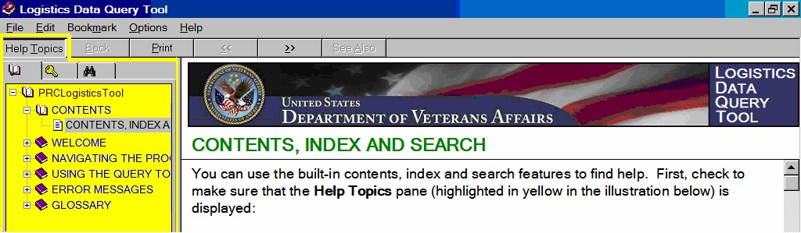

If you don’t see the Help Topics pane displayed at the left of your screen, first take a moment to familiarize yourself with the Help File “bars” at the top of the screen.
Figure 5-3 Help File “Bars”
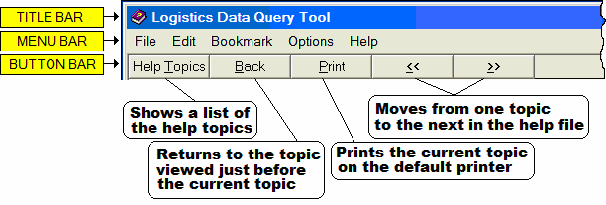

To display the Help Topics pane, click Help Topics in the Help File button bar. Note that before you click the button, it is shown at the same “level” as the other buttons—that is, it is not “depressed”— and a single pane is displayed in the Help File.

Figure 5-4 Help Topics Button
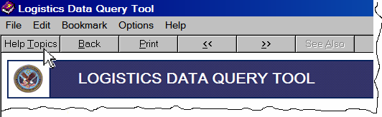

Clicking the [ Help Topics ] button will display the Help Topics pane, from which you can usually find the topic you’re looking for. Note that there are three different “tabs” available in the Help Topics pane. Normally, the default tab displayed is the Contents ( ) tab, as shown below.

Figure 5-5 Help Topics Contents Tab Displayed
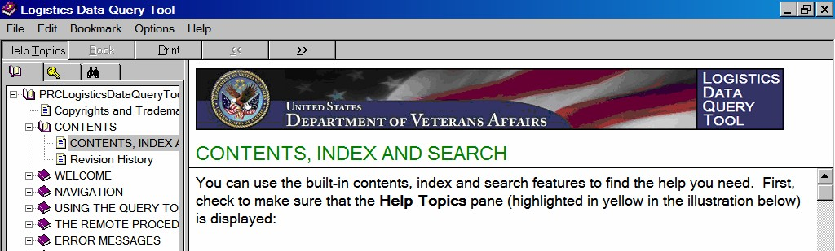

Figure 5-5 shows the Contents tab displayed. Note that after you click the [ Help Topics ]
button, it is shown “depressed”— and that there are now two panes displayed in the Help File.
Once the left pane is displayed, you can display any of the three tabs, depending on which method you wish to use. Just click on the tab header:

Figure 5-6 Help Topics Tabs

Note: If you don’t see the Contents or Index tab, then one or more files may be missing from your system. Contact IRM for assistance.

Using the Help Topics Index
When the Help File is created, an index of terms and concepts is also created. You can use this index to help find information on how the Query Tool works. Click on the Index tab, from which you may select the term you’re interested in:

Figure 5-7 Help Topics Index
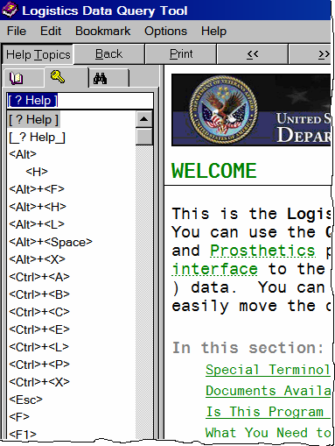

        - Click on the term to see the first topic containing that term, or start typing the text you’re looking for in the entry box to jump to the first matching entry.
        - Use the [|Back ] button in the button bar to return to the last topic you visited.
        - Use the [|>> ] and [|<< ] buttons in the button bar to move forward or backward in the help text, one topic at a time.

Depending on the number of places that the term appears in the Help File, you may see a pop-up “pick list” when you click on an indexed term.

Figure 5-8 Multiple Index Entries
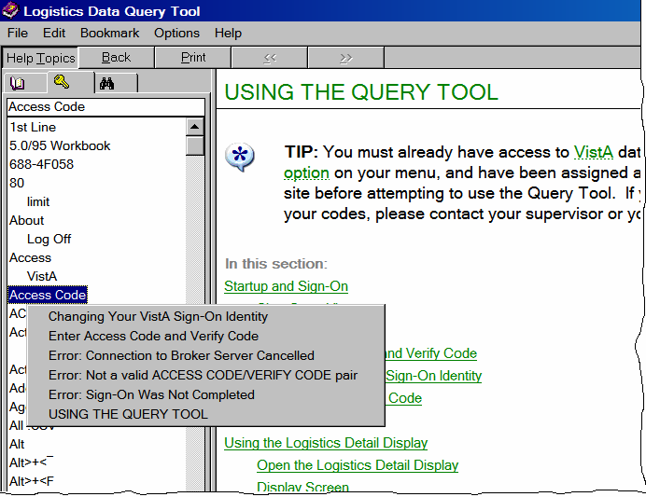

Choose from the list of entries by left-clicking in the pop-up pick list.

Using the Help Topics Contents
The Help Topics tab displays all the topics in the Help File. If necessary, click on [ Help Topics ] in the button bar to display the Help Topics pane. Click on the Contents tab, from which you may select the topic you’re interested in:

Figure 5-9 Help Topics Contents
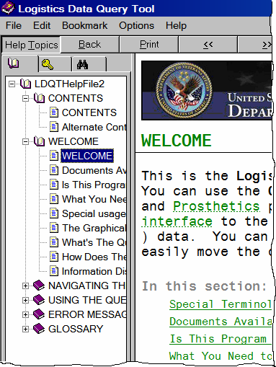

Major topic headings (sections) appear in ALL CAPS. When the Contents tab is first opened, the topic headings are all “compressed” (as indicated by the expand icon ). You can expand and collapse the contents listing to suit your needs.

        - Click on the topic title to see the topic text.
        - Click on the expand icon (if necessary), to see the subtopics under a main topic.
        - If the expanded topic gets in your way, click on the collapse icon to see only the major topic heading.

Tip: You can toggle the Help Topics pane on or off at any time; simply click the [ Help Topics ] button. Toggling the pane “off” will provide a wider pane to display help information. Or, you can adjust the width of the Help Topics pane by left-clicking, holding and dragging the right-hand edge of the pane.

Using the Help Topics Search
Finally, you can do a text search of the Help File for a term you’re interested in. If necessary, click the [ Help Topics ] button to display the Help Topics pane. Click on the Search tab, from which you may search for the topic you’re interested in:

Figure 5-10 Help Topics Search
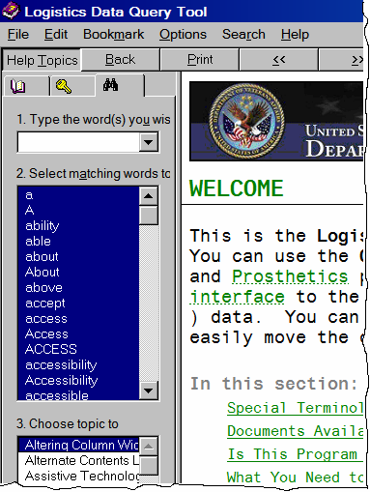

Tip: The first time you select the Search option, the Find Setup Wizard, as shown in Figure 5-11, will be displayed. Click [ Next> ], then [ Finish> ]. A “book” icon may be briefly displayed while setup is running. After a short while (exactly how long depends on your computer system), the Search pane will be displayed, as shown below. After the first time, the Search pane should appear immediately after you select it.

Figure 5-11 Find Setup Wizard
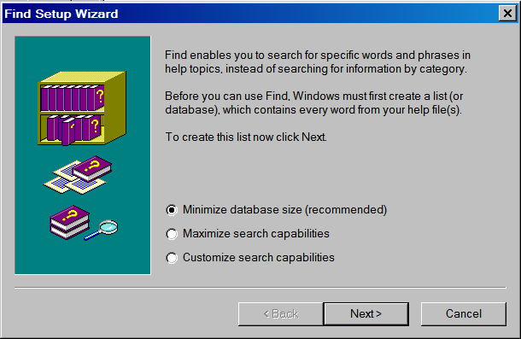

Using Text CONTENTS Links
In addition to the Help contents, index and search features, there are also text hyperlinks that take you to major topics. For example, on the main Welcome page, there are hyperlinks like those shown in Figure 5-12.

Figure 5-12 Opening Topic (Contents)
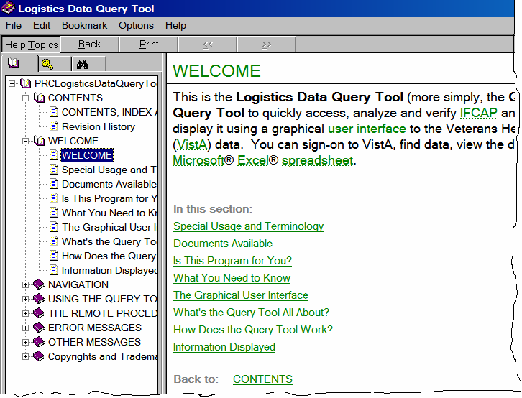

Each major and many minor topics are displayed as hyperlinks, so you can click on any topic of interest and immediately jump to the part of the Help File where that subject is discussed. If you wish, you can use this feature as a kind of tutorial to familiarize yourself with the Query Tool.

Help File Glossary
The Help File has a built-in glossary. If you see a link like this (green text with dotted underlining), just click it to see a glossary “pop-up” definition or explanation; click anywhere

outside the pop-up (or press <Esc>) to close it. A sample glossary pop-up is shown in Figure 5-13.

Figure 5-13 Sample Pop-up Glossary Entry
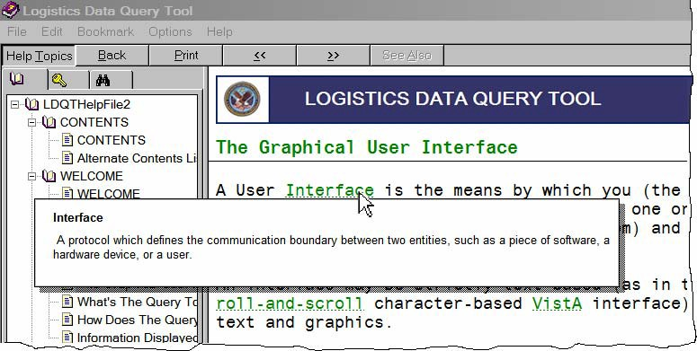

A complete Glossary showing all terms used in this application is also available in Chapter 9.

THIS PAGE INTENTIONALLY LEFT BLANK

Chapter 6. The Remote Procedure Call Broker

The Query Tool, which runs on your computer workstation, uses a protocol known as a remote procedure call (RPC). An RPC enables the Query Tool to use your computer to communicate directly with (“call”) VistA to find and display data stored on another computer (the VistA server). In order to use the Query Tool, you must have a special kind of IFCAP option (called a B-type option) assigned on your secondary IFCAP menu.
Specifically, the Query Tool uses the VistA RPC Broker utility, version 1.1, in order to sign-on as the user, open globals, and extract data.

- This enhanced version of the RPC Broker software supports a single sign-on (also called “auto sign-on”) point from a client workstation to the server. You need only sign on once when accessing a VistA roll-and-scroll (e.g., Lab, Pharmacy) and/or a VistA client/server GUI-based application (e.g., PCMM, CPRS, or the Query Tool) on the same workstation, regardless of which application is started first. Once logged into the server, you should normally not be asked to enter your Access and Verify codes for any subsequent VistA applications you may start.

- In addition, if you have opened both a VistA roll-and-scroll session and a client/server application on the same workstation and the roll-and-scroll session times out, the user will still be logged on via the client/server application.

- You log into VistA by responding to screen prompts displayed by the Query Tool, and you are then able to access both IFCAP and Prosthetics data through a B-type option. The RPC Broker component (TRPCBroker) wraps the functionality of the Broker into a Delphi component resulting in a more modularized and orderly interface. All properties and methods of the Broker are in one component.
Since the RPC Broker software is essential to the operation of the Query Tool, you need to know how to determine if it is working properly.
CLAGENT.EXE, the RPC Broker Client Agent program, runs in support of the single sign-on process. This program automatically and continuously runs in the background on the client workstation and normally should not be closed or shut down by the user. An icon (the “satellite dish”) will be displayed in the System Tray indicating the Broker Client Agent is running.
Locate the Client Agent icon ( ) in the Windows system tray (right side) and place your mouse pointer over the icon. After you hover over the icon for a second or two, a pop-up will show information about your connection:

Figure 6-1 Client Agent Status
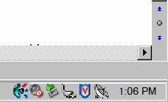   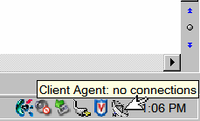

You can also tell quickly whether you have a connection by noting the appearance of the icon in the system tray:
No connections.
At least one connection is available.
For more information about the connection, double-click the icon. You’ll see this pop-up dialog:
Figure 6-2 Client Agent Information Pop-Up
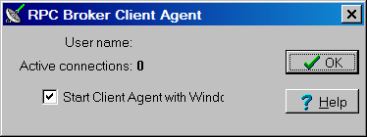

Tip: The Start Client with Windows box is checked (selected) by default, which means that the client agent starts automatically whenever Windows starts.

The client agent documentation recommends keeping this setting. If this box is not checked, click in the checkbox so the checkmark appears, and then click [ ✓ OK ]. Results may be unpredictable if this option is not checked!

However... Having the client agent running all the time does consume some of your computing resources. If this proves to be a problem, you might wish to consider turning off the auto-start option.
Tip: For help on starting and using the agent, click [ ? Help ]. This opens the Help File for the RPC Broker Client, which is different from the Query Tool Help File. The RPC Broker Client Help File offers valuable information about options and choices you can set that will take effect each time it runs.

Chapter 6. The Remote Procedure Call Broker

Tip: Although the Client Agent pop-up dialog (as shown above) is supposed to report whether or not there is an active connection, experience indicates that CA may report “Active connections: 0” even when a connection does exist. You can use the Windows Task Manager to see if the Client Agent process is running, as shown in Figure 6-3 below.

Figure 6-3. Using Task Manager to Determine Status of Client Agent
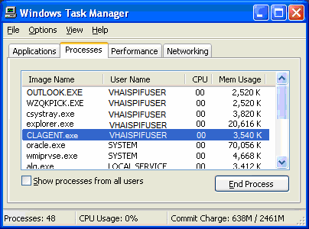

If you have other problems with the RPC Broker software, contact your supervisor or your IRM Service.

Chapter 7. Error Messages

In using the Query Tool, you may from time to time encounter error messages, usually in the form of pop-up panes. Some errors will be seen as the familiar Windows error pop-up, while others may be seen in a text window. In some cases, you may have to resize the window or use the horizontal or vertical scroll button (or both) to see the entire message or to see the response buttons.
Regardless of the type, each error pop-up should have an [ OK ] button or the equivalent. If it does not, use the Windows [ X ] button to close the pop-up. Please make a note of any pop-up that does not have an [ OK ] button and report it to your supervisor.
The list of known error messages is shown below. Click on an error name to see an explanation of that error. In addition to the graphic reproduction of the error message, the text of all messages is also included here. If you are viewing this document on your screen (for example, in Word or in a web browser), you can also “find” the message by pressing <Ctrl>+<F> and entering part of the message text that appeared.
Note that the appearance of the error message may vary, depending on your computer’s operating system and default color scheme.
At the end of each explanation, use the link to return to this page.
Back to: Error Messages
Remember that there are also other, non-error, messages. If you don’t find the message you got listed here, check Other Messages.

Connection/Sign-On Errors | Data Search/Display/Export Errors
Table 7-1 Error: Connection to Broker Server Cancelled  Table 7-2 Error: Problem Encountered Getting Broker Information Table 7-3 Error: Sign-On Was Not Completed  Table 7-4 Error: WSAECONNABORTED Table 7-5 Error: WSAECONNREFUSED Table 7-6 Error: WSAECONNRESET  Table 7-7 Error: WSAETIMEDOUT  Table 7-8 Error: Not a Valid ACCESS CODE/VERIFY CODE Pair Table 7-9 Error: Please Sign-On First  Table 7-10 Error: Multiple Sign-Ons Not Allowed  Table 7-18 Error: Your VERIFY Code Was Not Changed (Content or Formatting)  Table 7-19 Error: VERIFY Code Was Not Changed (Same Code) | Table 7-11 Error: Error with Date Selected  Table 7-12 Error: Maximum Date Range Exceeded Table 7-13 Error: No Date Range  Table 7-14 Error: No Data to Export Table 7-15 Error: Can’t Write to File
 | Help File Errors
Table 7-16 Error: Error in Help File
Table 7-17 Error: This Topic Does Not Exist

Table 7-1 Error: Connection to Broker Server Cancelled
Name: | Error: Connection to Broker Server Cancelled
Error message / display: | Prclogisticstools |  | 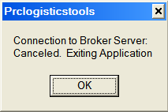
 | Connection to Broker Server: Canceled. Exiting Application.
Possible cause: | - You entered an incorrect Access Code or Verify Code  - You attempted to change your Verify Code and an unspecified error occurred  - No connection is available
Action to  take: | Click the [ OK ] button to terminate the Query Tool application, and then contact your supervisor for assistance.
Back to: Error Messages

Table 7-2 Error: Problem Encountered Getting Broker Information
Name: | Error: Problem Encountered Getting Broker Information
Error message / display: | Prclogisticstools |  | 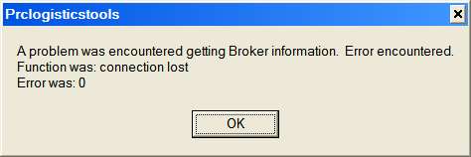
A problem was encountered getting Broker information. Error encountered. Function was: connection lost
Error was: 0
Possible cause: | Connection to the server was lost or never made. This may happen, for example, if you have  not yet signed on to the server and attempt to change your Verify Code, or if your connection gets “dropped” while you are using the Query Tool.
Action to  take: | Click [ OK ]. You will probably see a different error, telling you that the connection attempt was aborted. This is normal:  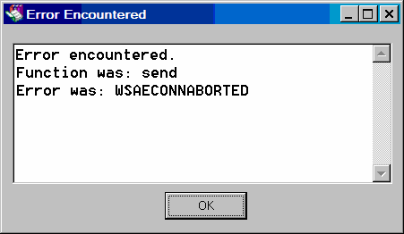  Click [ OK ] once again to return to the Home Screen and sign-on again.
Back to: Error Messages

Table 7-3 Error: Sign-On Was Not Completed
Name: | Error: Sign-On Was Not Completed
Error message / display: | Error Encountered |  | 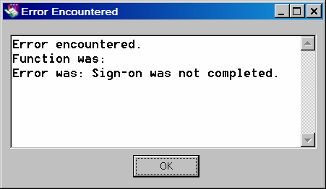
Error encountered. Function was:
Error was: Sign-on was not completed
Possible cause: | - You entered an incorrect Access Code or Verify Code  - You attempted to change your Verify Code and an unspecified error occurred  - No connection is available
Action to  take: | - Click [ OK ] to return to the Home Screen and continue.  - Check to see if you have a Client Agent connection (see Chapter 6).  - If you continue to have problems, contact your supervisor.
Back to: Error Messages

Table 7-4 Error: WSAECONNABORTED
Name: | Error: WSAECONNABORTED
Error message / display: | Error Encountered
Error encountered. Function was: send
Error was: WSAECONNABORTED
Possible cause: | An attempt to send information to the server was made, but no connection was available. This may happen, for example, if you have not yet signed on to the server and attempt to change your Verify Code Or, if you are using a virtual private network (VPN), this error may occur if the VPN connection is lost.  Note: This error message is generated by the RPC Broker (see Chapter 6 above); the Broker documentation’s explanation for this error message is “Software caused connection abort.  An established connection was aborted by the software in your host machine, possibly due to a data transmission time-out or protocol error.”
Action to  take: | - Click [ OK ] to return to the Home Screen and sign on again.  - Check to see if you have a Client Agent connection (see Chapter 6).  - If you continue to have problems, contact your IRM Service.
Back to: Error Messages

Table 7-5 Error: WSAECONNREFUSED
Name: | Error: WSAECONNREFUSED
Error message / display: | Error Encountered |  | 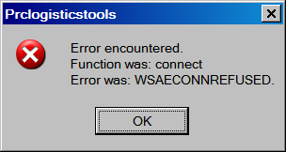
Error encountered. Function was: connect
Error was: WSAECONNREFUSED
Possible cause: | You attempted to connect to a server that is not available, or to which you do not have access. This may also happen if you attempt to sign-on to the BROKER SERVER.  Note: This error message is generated by the RPC Broker (see Chapter 6 above); the Broker documentation’s explanation for this error message is “Connection refused. No connection could be made because the target machine actively refused it. This usually results from trying to connect to a service that is inactive on the foreign host - i.e. one with no server application running.”
Action to  take: | - Click [ OK ] to return to the Home Screen and sign on again. Be sure to select a server to which you have access, and do not try to connect to the BROKER SERVER.  - Check to see if you have a Client Agent connection (see Chapter 6).  - If you continue to have problems, contact your IRM Service.
Back to: Error Messages

Table 7-6 Error: WSAECONNRESET
Name: | Error: WSAECONNRESET
Error message / display: | Error Encountered |  | 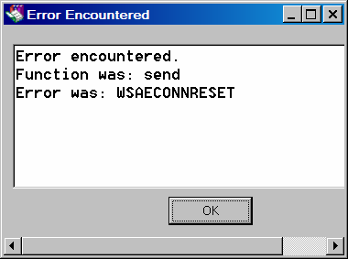
Error encountered.
Function was: connect / send Error was: WSAECONNRESET
Possible cause: | Your connection to the server was reset. This may happen, for example, if the VistA server is shut down or restarted.  Note: This error message is generated by the RPC Broker (see Chapter 6 above); the Broker documentation’s explanation for this error message is “Connection reset by peer. An existing connection was forcibly closed by the remote host. This normally results if the peer application on the remote host is suddenly stopped, the host is rebooted, or the remote host  used a ‘hard close’… on the remote socket.”
Action to  take: | - Click [ OK ] to return to the Home Screen and sign on again. Be sure to select a server to which you have access.  - Check to see if you have a Client Agent connection (see Chapter 6 above).  - If you continue to have problems, contact your IRM Service.
Back to: Error Messages

Table 7-7 Error: WSAETIMEDOUT
Name: | Error: WSAETIMEDOUT
Error message / display: | Error Encountered |  |  | 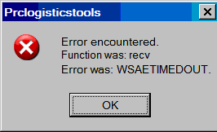
Error encountered.
Function was: connect / recv Error was: WSAETIMEDOUT
Possible cause: | The connection to the server you selected could not be made within the time allowed. This may be because the server is not available, or your connection may be too slow or not available. Or, the time allotted for a “send” or “receive” operation to or from the server may have been exceeded. Finally, this may occur if your server connection is lost while you are logged on.  Note: This error message is generated by the RPC Broker (see Chapter 6 above); the Broker documentation’s explanation for this error message is “Connection timed out. A connection attempt failed because the connected party did not properly respond after a period of time, or  established connection failed because connected host has failed to respond.”
Action to  take: | - Click [ OK ] to return to the Home Screen and sign on again. Be sure to select a server to which you have access.  - Check your VPN connection.  - Check to see if you have a Client Agent connection (see Chapter 6).  - If you continue to have problems, contact your supervisor.  You may also see a second message, reporting an “access violation.” This is normal:  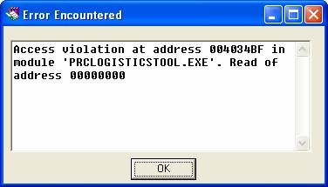  - Click [ OK ] to return to the Home Screen and sign on again. Be sure to select a server to which you have access.  - Check your VPN connection.  - Check to see if you have a Client Agent connection (see Chapter 6).  - If you continue to have problems, contact your IRM Service.
Back to: Error Messages

Table 7-8 Error: Not a Valid ACCESS CODE/VERIFY CODE Pair
Name: | Error: Not a Valid ACCESS CODE/VERIFY CODE Pair
Error message / display: | Error Encountered |  | 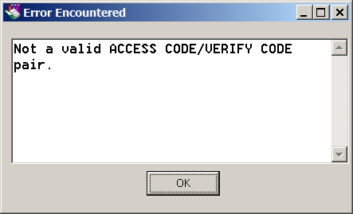
 | Not a valid ACCESS CODE/VERIFY CODE pair.
Possible cause: | - The Access Code and Verify Code you provided could not be validated against one another (one or both may be incorrect).  - You left one or both of these fields blank during the sign-on process.  - You left both these fields blank when attempting to change your Verify Code.
Action to  take: | Click [ OK ] to return to the VISTA Sign-on dialog and try again. If you continue to have problems, please notify your supervisor.
Back to: Error Messages

Table 7-9 Error: Please Sign-On First
Name: | Error: Please Sign-On First
Error message / display: | Not Logged On
 | Please Sign On first
Possible cause: | You attempted to open the Logistics Detail Display, but had not yet signed-on to VistA.
Action to  take: | Click [ OK ].  See 4.3 for information about signing-on.
Back to: Error Messages

Table 7-10 Error: Multiple Sign-Ons Not Allowed
Name: | Error: Multiple Sign-Ons Not Allowed
Error message / display: | Error Encountered
 | *** MULTIPLE SIGN-ONS NOT ALLOWED ***
Possible cause: | You attempted to sign-on to Vista using the Query Tool, but you are already signed-on through some other means (usually a direct, “normal” VistA sign-on).
Action to  take: | Click [ OK ] to dismiss the error pop-up. Sign off your current “standard” VistA session, and then sign-on through the Query Tool.  See 4.3 for information about signing-on.
Back to: Error Messages

Table 7-11 Error: Error with Date Selected
Name: | Error: Error with Date Selected
Error message / display: | Error with Date Selected |  | 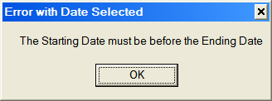
 | The Starting Date must be before the Ending Date
Possible cause: | You entered an Ending Date that precedes the Beginning Date.
Action to  take: | - Click [ OK ] to return to the Selection Area; correct one or both dates and continue.  - If you continue to have problems, contact your supervisor.
Back to: Error Messages

Table 7-12 Error: Maximum Date Range Exceeded
Name: | Error: Maximum Date Range Exceeded
Error message / display: | Over Limit |  | 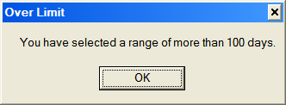
 | You have selected a range of more than 100 days.
Possible cause: | You entered Beginning and Ending Dates creating a range of more than 100 days.
Action to  take: | - Click [ OK ] to return to the Selection Area; correct one or both dates and continue.  - If you continue to have problems, contact your supervisor.
Back to: Error Messages

Table 7-13 Error: No Date Range
Name: | Error: No Date Range
Error message / display: | No Date Range |  | 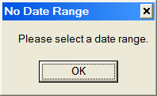
 | Please select a date range.
Possible cause: | You entered Beginning and Ending Dates creating a range of more than 100 days. You entered an incomplete date range (missing Beginning Date, Ending Date, or  both).
Action to  take: | - Click [ OK ] to return to the Selection Area; provide a valid date range and continue.  - Check to make sure that both dates are valid dates (for example, don’t specify a date of February 31!).  - If you continue to have problems, contact your supervisor.
Back to: Error Messages

Table 7-14 Error: No Data to Export
Name: | Error: No Data to Export
Error message / display: | No Data |  | 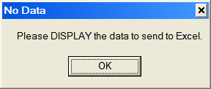
 | Please DISPLAY the data to send to Excel.
Possible cause: | You indicated that you wished to export (send) data to Excel from the Display Screen (for example, by clicking the [ X Excel ] button), but you have not yet displayed (retrieved) any data.
Action to  take: | Click [ OK ] to return to the Display Screen.  If you don’t know how to specify display data, please see 4.4.
Back to: Error Messages

Table 7-15 Error: Can’t Write to File
Name: | Error: Can’t Write to File
Error message / display: | Error |  | 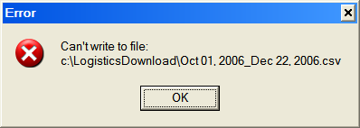
 | Can’t write to file: c:\LogisticsDownloads\*.csv
Possible cause: | You attempted to export a .CSV file with the same name as one that is currently open in Excel.
Action to  take: | - Click [ OK ] to return to the file save dialog.  - Change the name of the file you are trying to save (note that the default filename is simply the date range you specified).  - If you want to replace the existing file that has the same name, close the file in Excel, then retry the export operation.  - If you continue to have problems, contact your supervisor.
Back to: Error Messages

Table 7-16 Error: Error in Help File
Name: | Error: Error in Help File
Error message / display: | Windows Help |  | 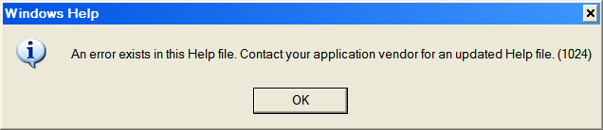
 | An error exists in this Help file. Contact your application vendor for an updated Help file.
Possible cause: | You clicked on a help topic (button or link), and there is some kind of a problem with that topic (probably an error in coding of the Help File itself).
Action to  take: | Click [ OK ] to return to the previous screen. Please make a note of the topic you clicked on, and then notify your supervisor of the problem.  You can also try finding the topic using Using Help Topics (5.2.4 above).
Back to: Error Messages

Table 7-17 Error: This Topic Does Not Exist
Name: | Error: This Topic Does Not Exist
Error | Windows Help |  | 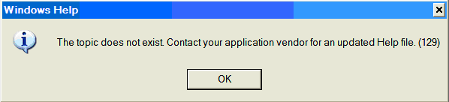
message / display:
 | This topic does not exist. Contact your
 | application vendor for
 | an updated Help file.
 | (129)
Possible cause: | You clicked on a help topic (button or link) which was inadvertently left out of the Help File, or for which the link was incorrectly coded in the Help File.
Action to  take: | Click [ OK ] to return to the previous screen. Please make a note of the topic you clicked on, and then notify your supervisor of the problem.  You can also try finding the topic, or related ones; see Using Help Topics (5.2.4 above).  If you use these alternate methods and still cannot find the topic, please make a note of the topic you clicked on, and then notify your supervisor of the problem.
Back to: Error Messages

Table 7-18 Error: Your VERIFY Code Was Not Changed (Content or Formatting)
Name: | Error: Your VERIFY Code Was Not Changed (Content or Formatting)
Error | Prclogisticstools |  | 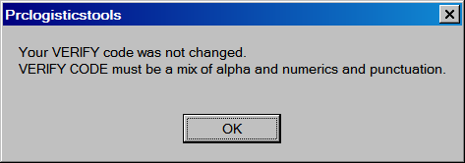
message / display:
 | Your VERIFY code was not changed.
 | VERIFY CODE must
 | be a mix of alpha and
 | numerics and
 | punctuation.
or: | Your VERIFY code was not changed. Enter 8-20 characters mixed alphanumeric and punctuation (except ‘^’, ‘;’, ‘:’). |  | 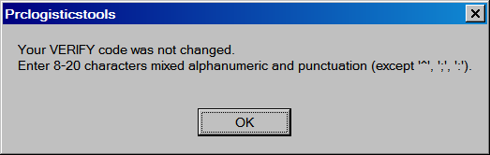
Possible cause: | You indicated that you wished to change your Verify Code, but the new code you entered did not conform to the content or formatting rules.
Action to  take: | Click [ OK ] to return to the Change VERIFY Code dialog and then:  - Try again.
 | - Click [ x Cancel ] to return to the Home Screen.
 | - Click [ ? Help ] to see hints for composing a new code.
Back to: Error Messages

Table 7-19 Error: VERIFY Code Was Not Changed (Same Code)
Name: | Error: VERIFY Code Was Not Changed (Same Code)
Error message / display: | Prclogisticstools
 | Your VERIFY Code was not changed. The new code is the same as the current one.
Possible cause: | You indicated that you wished to change your Verify Code, but the new code you entered was the same as your current code.
Action to  take: | Click [ OK ] to return to the Change VERIFY Code dialog and then:  - Try again.
 | - Click [ x Cancel ] to return to the Home Screen.
 | - Click [ ? Help ] to see hints for composing a new code.
Back to: Error Messages

Chapter 8. Other Messages

In addition to error messages, you may also encounter other informative messages from time to time. As with error messages, you may sometimes have to resize the message box or use the horizontal or vertical scroll button (or both) to see the entire message or to see the response buttons.
Regardless of the type, each message should have a button (usually an [ OK|] button) that will close the message box. If it does not, use the Windows [ X ] button to close the pop-up.
Please make a note of any pop-up that does not have an [ OK|] or equivalent button and report it to your supervisor.
The list of known information messages is shown below. Click on a message name to see an explanation. In addition to the graphic reproduction of the message, the text of all messages is also included here. If you are viewing this document on your screen (for example, in Word or in a web browser), you can also “find” the message by pressing <Ctrl>+<F> and entering part of the message text that appeared.
Note that the appearance of the message may vary, depending on your computer’s operating system and default color scheme.
At the end of each explanation, use the link to return here.
Back to: Other Messages
Remember that there are also error messages. If you don’t find the message you got listed here, check Error Messages.

Other Messages
Table 8-1 Confidentiality Warning
Table 8-2 Excel Export Security Reminder
Table 8-3 You Are About to Log Off and Log On Again
Table 8-4 No Data Found
Table 8-5 Too Many Items
Table 8-6 No Browser Detected

Table 8-1 Confidentiality Warning
Name: | Confidentiality Warning
Message / display: | Users must ensure the confidentiality of this information
 | The following displayed information may contain vendor, patient, or employee individually-identifiable information requiring appropriate measures be taken to secure the information and ensure the confidentiality. I understand the need to protect this information.
Reason for  message: | Under certain circumstances, information may be displayed that reveals individually-  identifiable information.
How to respond: | Click [ OK ]. This is your acknowledgment of your responsibility to safeguard this type of information. You will then be allowed to continue using the Query Tool.
For more information: | See Open the Logistics Detail Display.
Back to: Other Messages

Table 8-2 Excel Export Security Reminder
Name: | Security Reminder
Message / display: | Security Reminder |  | 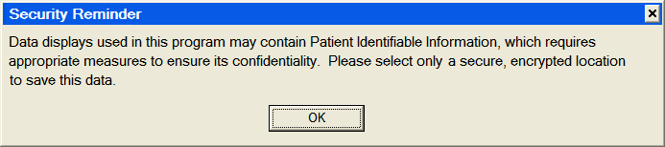
Data displays used in this program may contain Patient Identifiable Information, which requires appropriate measures to ensure its confidentiality. Please select only a
secure, encrypted location to save this data.
Reason for message: | Under certain circumstances, information may be displayed that reveals individually- identifiable information. This message reminds you that data exported to Excel should be stored in a secure, encrypted location.
How to respond: | Click [ OK ]. This is your acknowledgment of your responsibility to safeguard this type of information. You will then be allowed to continue the export. Any other response, including pressing <Esc> or closing the message box by clicking [ X ], will still cause the directory selection dialog to appear, and you will be reminded that you must select a storage location for your file. You cannot export data without choosing a location.
For more information: | See Security Reminder and Specifying Storage Location.
Back to: Other Messages

Chapter 8. Other Messages

Table 8-3 You Are About to Log Off and Log On Again
Name: | You are About to Log Off and Log On Again
Message / display: | Currently Logged On |  | 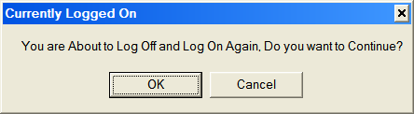
 | You are About to Log Off and Log On Again. Do you want to continue?
Reason for message: | See 4.3.3 above.
How to respond: | Click [ OK ] or [ Cancel ].
Back to: Other Messages

Table 8-4 No Data Found
Name: | No Data Found
Message / display: | Information
 | No data found.
Possible cause: | This may indicate, for example, that an order once existed, but has since been cancelled.
Action to  take: | Since this message indicates that the data is missing or otherwise unavailable, there is not a way to “fix” this from within the Query Tool. If you believe the message is erroneous, or if you continue to have problems, contact your supervisor.  Click [ OK ] to return to the Main Grid.
Back to: Other Messages

Table 8-5 Too Many Items
Name: | Too Many Items
Message / display: | Information
 | More Than 80 lines found for this PO, too many to display.
Possible cause: | A limit of 80 line items per order has been established for displays. If an order has more than 80 line items, the Main Grid will, in the # Line Item column on the row following the order itself, display the message “<** More than 80 Line Items >**.” If you  select that order in the Main Grid, you’ll see the above pop-up message.
Action to  take: | This is a design feature. If you believe the message is erroneous, or if you continue to have problems, contact your supervisor or IFCAP Application Coordinator.  Click [ OK ] to return to the Main Grid.
Back to: Other Messages

Table 8-6 No Browser Detected
Name: | No Browser Detected
Message / display: | This is not the usual pop-up error message. It’s seen only when you are using the Help File, and will appear in a help file window.
Possible cause: | You apparently requested (by clicking on a link or something similar) a web page, document, or other source on the Internet or on a computer network which requires a web browser program… but no browser application was found on this computer.
Action to  take: | This is a design feature. If you believe the message is erroneous, or if you continue to have problems, contact your supervisor or IFCAP Application Coordinator.  Click [ Back ] to return to your last location in the Help File.
Back to: Other Messages

Chapter 9. Glossary

The following glossary defines terms and acronyms that may be encountered in using this manual or the Query Tool application. Since users of the Query Tool are presumed to be familiar with VistA, no attempt is made to define VistA terms unless the definition bears directly on use of the Query Tool. See the glossaries in any of the IFCAP User Guides for VistA definitions not included here. VistA acronyms are listed here with their complete text.
You can jump to the beginning of an alphabetical section by clicking on a letter below (if a letter is grayed out, it means there are no terms beginning with that letter).

At the end of each section, you may use the link to return to this page.
Back to: Glossary

— A —
Term | Definition
Access Code | With each sign-on to VistA, the user must enter two codes to be recognized and allowed to proceed: the Access Code and Verify Code. The Access Code is assigned by IRM Service and is used by the computer to recognize the user. Each user has a unique access code. The only way this code can be changed is for the IRM Service to edit it.  When the code is established by IRM, it is encrypted; that is, it is “scrambled” according to a cipher. The code is stored in the computer only in this encrypted form. Thus, even if the access code is viewed, the viewer cannot determine what the user actually types to tell the computer this code. See also Verify Code.
API | See Application Programming Interface.
Application Programming Interface (API) | The interface provided by one application which permits other applications to make requests for services and to allow data to be exchanged between the two applications. In this case, the IFCAP API allows the Query Tool application to retrieve and display data.
Assistive Technology (AT) | A generic term that includes assistive, adaptive, and rehabilitative devices and the process used in selecting, locating, and using them. AT promotes greater independence for people with disabilities by enabling them to perform tasks that they were formerly unable to accomplish, or had great difficulty accomplishing, by providing enhancements to or changed methods of interacting with the technology needed to accomplish such tasks.
Back to: Glossary
— B —

Term | Definition
BOA | Basic Ordering Agreement.
BOC | Budget Object Code
B-type Option | In VistA, an option designed to be run only by the RPC Broker, and which cannot be run from the menu system.
Browser | A browser is a software application that enables a user to display and interact with text, images, and other information typically located on a web page at a website on the World Wide Web or on a local area network.
Back to: Glossary

— C —
Term | Definition
Client | A client is a computer system that accesses a (remote) service on another computer by some kind of network. The term was first applied to devices that were not capable of running their own stand-alone programs, but could interact with remote computers via a network.  These dumb terminals were clients of the time-sharing mainframe computer.  In terms of the Query Tool, the computer workstation is the client which interacts with the distant IFCAP server.  See also: Remote Procedure Call Broker.
Comma-Separated Values (CSV) | “Separated” or “delimited” data files use specific characters (delimiters) to separate its values. Most database and spreadsheet programs are able to read or save data in a delimited format. The comma-separated values file format is a delimited data format that has fields separated by the comma character and records separated by newlines. Excel can import such a file and create a spreadsheet from it.
Component | A term describing the “building blocks” of software applications; a component is a software object that generally contains data and code. A component may or may not be visible. These components interact with other components on a form to create the Query Tool user application interface.
CP | Control Point
CSV | See Comma-Separated Values.
Back to: Glossary

— D —
Term | Definition
Delphi Pascal® | A high-level, compiled, strongly typed programming language that supports structured and object-oriented design. This is the language used for the Query Tool. Also known as Object Pascal. See also Delphi.

— D —
Term | Definition
Delphi® | Borland® Delphi® is a software development package that allows creation of applications which allow manipulation of live data from a database. Among other things, Delphi is an object-oriented, visual programming environment used to develop 32-bit applications for deployment in the Windows environment. This is the software that was used to produce the Query Tool application.  See also http://www.borland.com/us/products/delphi/index.html.
DOS | The term DOS (originally, the disk operating system) commonly refers to the family of closely related operating systems which dominated the IBM personal computer compatible market between 1981 and 1995 (or until about 2000, if Windows versions 95, 98, and M.E. are included). MS-DOS from Microsoft was the most widely used.
Detail Grid | The part of the Query Tool display which shows the line items for orders that meet selection criteria entered by the user. The data displayed in this grid is drawn from IFCAP File 442 purchase order line item details and from Prosthetics order details. See also Main Grid.
Back to: Glossary

— E —
Term | Definition
Excel | A spreadsheet program from Microsoft.
Back to: Glossary

— F —
Term | Definition
FCP | Fund Control Point
FileMan | VA FileMan is a set of user and programming utilities written in MUMPS (M) by the Department of Veterans Affairs (formerly Veterans Administration) for defining database files, implementing file and field level security, updating the database and writing ad hoc and production reports. Its development began in the late 1970’s and it has been continually enhanced since that time. While file access was initially controlled via FileMan security codes associated with files and fields and issued to users based on their user functions, the VA Kernel now controls the menu system and security structure in VistA. VA Kernel’s  File Access Security scheme now also controls file level access of users at many VistA installations.
FMS | Financial Management System
FOB | Freight on Board
FSC | Federal Supply Classification

— F —
Term | Definition
Function | In the Query Tool, a function is a software routine that returns a value.  See also Function key.
Function key | A key on a computer or terminal keyboard which can be programmed so as to cause an operating system command interpreter or application program to perform certain actions. On some keyboards/computers, function keys may have default actions, accessible on power-on. For example, <F1> is traditionally the function key used to activate a help system.
Back to: Glossary

— G —
Term | Definition
Globals | Globals are variables which are automatically and transparently stored on disk and persist beyond program, routine, or process completion.  Globals are used exactly like ordinary variables, but with the caret character prefixed to the variable name.  Globals are stored in highly structured data files by MUMPS, and accessed only as MUMPS globals. VistA file definitions and data are both stored in globals.
Graphical User Interface (GUI) | A graphical user interface (or GUI, often pronounced “gooey”) is a graphical (rather than purely textual) user interface to a computer. A GUI is a particular case of user interface for interacting with a computer which employs graphical images and widgets in addition to text to represent the information and actions available to the user. Usually the actions are performed through direct manipulation of the graphical elements. A GUI takes advantage of the computer’s graphics capabilities to make the program easier to use.  Source: http://en.wikipedia.org/wiki/GUI  See also User Interface.
GUI | See Graphical User Interface.
Back to: Glossary

— I —
Term | Definition
IEN | See Internal Entry Number.
Information Resources Management (IRM) | The service which is involved in planning, budgeting, procurement and management-in-use of VA's information technology investments.
Input | Any parameter received by a function as part of a message and used to complete the process invoked.
Interface | An interface defines the communication boundary between two entities,

— I —
Term | Definition
 | such as a piece of software, a hardware device, or a user.
Internal Entry Number (IEN) | The number which uniquely identifies each item in the IFCAP database.
IRM | See Information Resources Management.
Back to: Glossary

— J —
Term | Definition
JAWS | JAWS is an acronym for Job Access with Speech, and refers to a software product for visually impaired users produced by the Blind and Low Vision Group at Freedom Scientific. See http://en.wikipedia.org/wiki/JAWS_%28screen_reader%29 and http://www.freedomscientific.com/fs_products/software_jaws.asp.
Back to: Glossary

— L —
Term | Definition
Logic | Programming languages, like human languages, are defined through the use of rules to determine both structure and meaning. A computer program consists of a set of axioms and rules. The steps that a program performs and the decisions made by the program in response to a set of instructions provided (or conditions found) are referred to as the program’s logic.
Back to: Glossary

— M —
Term | Definition
M | The Massachusetts General Hospital Utility Multi-Programming System, or alternatively M, is a programming language originally created for use in the healthcare industry. M is designed to make writing database- driven applications easy while simultaneously making efficient use of computing resources. The most outstanding, and unusual, design feature of M is that database interaction is transparently built into the language. Many parts of VistA are written in M.
MailMan | MailMan, the Department of Veterans Affairs electronic mail system, is a communications tool that provides electronic communication among users sharing computing facilities. A communications link can be made with cables, telephone lines, or satellite connections.

— M —
Term | Definition
Main Grid | The part of the Query Tool display which shows the orders that meet selection criteria entered by the user. See also Detail Grid.
Massachusetts General Hospital Utility Multi- Programming System | See M.
Microsoft | The Microsoft Corporation, commonly known as just Microsoft, publishes software products such as the Microsoft Windows operating system and the Microsoft Office suite of productivity software, each of which has achieved near-ubiquity in the desktop computer market.
MUMPS | See M.
Back to: Glossary

— N —
Term | Definition
Namespace | As used in this document, this term refers to a method of specifying prefixes for software package component names to prevent “collision” and possible overwriting of one package’s software by another. Hence the names of IFCAP routines, data globals, options, templates, etc. must begin with the letters “PRC.” The fourth character indicates a particular function (for example, “PRCA” belongs to Accounts Receivable and “PRCN” belongs to Equipment/Turn-In Request). Within the IFCAP’s “PRC” namespaces, sub-namespaces have been established for different modules. The PRCHL namespace, for example is designed for use by PCLO-sponsored packages like the Consolidated Logistics Report Server (CLRS) and the Query Tool. Similarly, “PRCS” is used for control point, “PRCH” for purchasing, “PRCF” for accounting and “PRCP” for GIP.
National Prosthetics Patient Database (NPPD) | Until 1997, national comprehensive databases containing patient- specific information on the disabled population’s use of prosthetic, orthotic, or sensory aids were not available. In 1997, the Prosthetic Software Package became operational. One of its major products is the National Prosthetics Patient Database, a national database with potential to enhance quality, reduce costs, and improve efficiency. The NPPD is a roll-up of all prosthetic data recorded at each VHA facility, providing patient information by unique social security number about patient eligibility, prosthetic treatment, date of provision, cost, and vendor. The Query Tool can retrieve data from the NPPD as well as from IFCAP.
NPPD | See National Prosthetics Patient Database.
Back to: Glossary

— O —

Term | Definition
Operating system | An operating system is a software program that manages the hardware and software resources of a computer. A key component of system software, the operating system performs basic tasks, such as controlling and allocating memory, prioritizing the processing of instructions, controlling input and output devices, facilitating networking, and managing files (source: http://en.wikipedia.org/wiki/Operating_system).  Microsoft Windows is an operating system.
Option | A Vista option is an application component defined in VA Kernel to control user and remote server access to VistA applications. Options can appear on menu “trees” of options, through which the user navigates to execute application software. Types of options include menu (to allow grouping of options); edit (to edit application files via VA FileMan); inquire (to query the database via VA FileMan); print (to execute reports via VA FileMan); run routine (to execute custom application software); server (to process remote procedure calls via MailMan); and Broker (to process GUI remote procedure calls via Kernel Broker).  See also B-type Option.
Output | The process of transmitting information by an object (verb usage); may also be used as a noun for information transmitted by a source (object). Output allows the application to produce the effects of the users’ manipulation. Also: Any parameter returned by a function to the invoking process upon completion of that function.
Back to: Glossary

— P —
Term | Definition
PCLO | See Prosthetics and Clinical Logistics Office.
PO | Purchase Order
PRCHL | The PRCHL namespace, used for both the Query Tool and the Consolidated Logistics Report Server (CLRS).
PRCHL GUI | A B-type option, placed on the user’s primary or secondary menu, which allows use of the Query Tool.
Procedure | A procedure is a routine that does not return a value. See also Routine  and Function.
Prosthetics and Clinical Logistics Office (PCLO) | The Office of Prosthetics and Clinical Logistics at VHA.
Protocol | A protocol is a computing convention or standard that controls or enables communication and data transfer. In its simplest form, a protocol can be thought of as the rules governing the syntax, semantics, and synchronization of communication. In VistA, protocols complement options by controlling the invocation of a VistA application. They can be linked to a menu tree in the same manner as can options.

— P —
Term | Definition
Back to: Glossary

— R —
Term | Definition
Remote Procedure Call (RPC) | A protocol that one program can use to request a service from a program located on another computer network. Essentially, M code can take optional parameters to do some work and then return either a single value or an array back to the client application.  See also Remote Procedure Call (RPC) Broker.
Remote Procedure Call (RPC) Broker | A piece of middleware software that allows programmers to make program calls from one computer to another, via a network. The RPC Broker establishes a common and consistent foundation for client/server applications being written under the VistA umbrella. The RPC Broker acts as a bridge connecting the client application front-end on the workstation (in this case, the Delphi Query Tool application) to the M - based data and business rules on the server. It serves as the communications medium for messaging between VistA client/server applications. Upon receipt, the message is decoded, the requested remote procedure call is activated, and the results are returned to the calling application. Thus, the RPC Broker helps bridge the gap between the traditionally proprietary VA software and other types of software.  See also Remote Procedure Call (RPC).
Requirement | A condition or capability to which the system being built must conform.
Roll-and-scroll, roll’n’scroll | In non-GUI VistA displays, scrolling is often used to show large amounts of data that could not fit on the screen all at the same time. The term “scroll” is derived from the way in which people read scrolls of paper, by rolling up the top of the page and allowing objects lower on the page to move up. Each new line is introduced below the prior line which appears to shift up. As the screen fills up, older lines disappear from view at the top of the screen. The cursor and the user’s focus are on the bottom line, as contrast to the user navigating between fields on a stationary form.
Routine | Generally, a set of programming instructions designed to perform a specific limited task. In Delphi, this may be a function or a procedure. In MUMPS, a routine is a named segment of software that is swapped into the memory partition when invoked, and then swapped out when no longer needed to make room for subsequently invoked code segments, thereby more effectively using available memory.
RPC | See Remote Procedure Call.
RPC Broker | See Remote Procedure Call Broker.
Back to: Glossary

— S —
Term | Definition
Section 508 | Section 508 of the Rehabilitation Act as amended, 29 U.S.C. Section 794(d), requires that when Federal agencies develop, procure, maintain, or use electronic and information technology, they shall ensure that this technology is accessible to people with disabilities. Agencies must ensure that this technology is accessible to employees and members of the public with disabilities to the extent it does not pose an “undue burden.” Section 508 speaks to various means for disseminating information, including computers, software, and electronic office equipment.
Selection Area | That part of the Detail Display Screen which allows the user to select data using a date range and other criteria.
Server | In information technology, a server is a computer system that provides services to other computing systems—called clients—over a network. The server is where VistA M-based data and Business Rules reside, making these resources available to the requesting server.
Spreadsheet | A rectangular table (or grid) of information, originally financial information. The word came from “spread” in the sense of a newspaper or magazine item that covered two facing pages, extending across the center fold and treating the two pages as one large one. The compound word “spread-sheet” came to mean the format used to present bookkeeping ledgers—with columns for categories of expenditures across the top, invoices listed down the left margin, and the amount of each payment in the cell where its row and column intersect—which were traditionally a “spread” across facing pages of a bound ledger (book for keeping accounting records) or on oversized sheets of paper ruled into rows and columns in that format and approximately twice as wide as ordinary paper. Spreadsheets today are used to present a wide variety of information.
SRS | See Software Requirements Specification.
STN | Station Number
Back to: Glossary

— T —
Term | Definition
Technical Services Project Repository (TSPR) | The TSPR is the central data repository and database for VA Health IT (VHIT) project information.  See REDACTED
Toggle | To “toggle” means to alternate between two or more computer-related options, usually by the operation of a single switch or keystroke. For example, you can toggle back and forth between the two data display grids on the screen.

— T —
Term | Definition
TSPR | See Technical Services Project Repository.
Back to: Glossary

— U —
Term | Definition
User Interface | A user interface is the means by which people (the users) interact with a particular machine, device, computer program or other complex tool (the system).  The user interface provides one or more means of:  - Input, which allows the users to manipulate the system  - Output, which allows the system to produce the effects of the users’ manipulation  The interface may be based strictly on text (as in the traditional “roll and scroll” IFCAP interface), or on both text and graphics.  In computer science and human-computer interaction, the user interface (of a computer program) refers to the graphical, textual and auditory information the program presents to the user, and the control sequences (such as keystrokes with the computer keyboard and movements of the computer mouse) the user employs to control the program.  See also Graphical User Interface.
Back to: Glossary

— V —
Term | Definition
Verify Code | With each sign-on to VistA, the user must enter two codes to be recognized and allowed to proceed: the Access Code and Verify Code. Like the Access Code, the Verify Code is also generally assigned by IRM Service and is also encrypted. This code is used by the computer to verify that the person entering the access code can also enter a second code correctly. Thus, this code is used to determine if users can verify who they are. See also Access Code.
Veterans Health Information Systems and Technology Architecture (VistA) | VistA is a comprehensive, integrated health care information system composed of numerous software modules (see http://www.va.gov/vista_monograph/docs/vista_monograph2005_06.doc ).
VHA | Veterans Health Administration
VISN | Veterans Integrated Service Network
VistA | See Veterans Health Information Systems and Technology Architecture.

— V —
Term | Definition
Back to: Glossary

— W —
Term | Definition
web browser | A web browser is a software program enabling a user to display and interact with text, images, and other information typically located on a web page at a website on the World Wide Web or in a document. Text and images in a document can contain hyperlinks to other topics in the same document or at a website.
Windows | Windows® is a family of operating systems by Microsoft. These systems can run on several types of platforms such as servers, embedded devices and, most typically, on personal computers.  Windows XP is the current (as of May 2007) operating system for use on general-purpose computer systems, including home and business desktops, notebook computers, and media centers. The letters “XP” stand for experience. Source: http://en.wikipedia.org/wiki/Windows_xp
Windows Internet Explorer (IE) | Windows Internet Explorer® is a proprietary graphical web browser developed by Microsoft and included as part of the Microsoft Windows line of operating systems. It has been the most widely-used web browser since 1999.
Back to: Glossary

THIS PAGE INTENTIONALLY LEFT BLANK

Chapter 10. Technical Summary

Information: Information like that found in this chapter might normally be included in the IFCAP Technical Manual. This chapter, however, addresses the internal workings of the Query Tool itself, while the Technical Manual is designed to show technical information about IFCAP itself. For this reason, it seemed better to record these details here. It’s likely that this material will be of interest only to IRM Service personnel; all others can safely ignore it.
Source code for the Delphi units associated with the Query Tool should not be needed during use of the Query Tool. These files are not distributed with the Query Tool; they are discussed in this document for information purposes only and are subject to change as needed. In the unlikely event that a question arises, the source code may be found in the Query Tool Software Design Document (SDD), available in the Technical Service Project Repository (TSPR):
REDACTED

Associated Files
The Query Tool application and its associated files are stored in the directory C:\Program Files\VISTA\IFCAP\. This directory is created by the Query Tool InstallShield executable PRCLogisticsTools.exe. The files directly related to the Query Tool are:

Table 10-1 Query Tool Files
Filename | Purpose/Explanation
PRCLogisticsTools.exe | The compiled executable (program) file
PRCLogisticsTools.hlp | The online help file
PRCLogisticsTools.cnt | The online help “contents” file
PRCLogisticsTools.gid | The online help “index” file. This is the only file which can be safely deleted (the help system will rebuild it the  next time it’s needed); there should, however, normally not be any need to delete it.
RoboEx32.dll  InetWH32.dll | Dynamic link libraries needed for proper operation of the  Help File.

CAUTION: Do not delete or rename any of the above files. Do not move any of these files to a different physical or logical drive, folder or directory. The folders and files must be located on the C:\ drive in the directory C:\Program Files\VISTA\IFCAP\. If any of these files are missing or renamed, the Query Tool may not work correctly.

In Delphi (the language in which the Query Tool is written), procedures which use outside files like this are case-sensitive, so do not change the case in the filename.

Data Sources
The Query Tool reads order data from the IFCAP Procurement & Accounting Transaction (#442) file and from the Prosthetics 1358 (#664) file. The IFCAP code also points to File #441 for item detail. When the data is retrieved, Query Tool displays it on two grids. The data can then be examined on screen or exported to be analyzed using Excel. See
4.9.1 and 4.9.3 for information on the data presented.

PRCHL GUI Option
PRCHL GUI is a B-type option used only by the RPC Broker. It does not appear on any user menu, but it must be placed on the user’s secondary menu. Under normal circumstances, it cannot itself be used as a primary menu (only if the person’s sole use of IFCAP is via the Query Tool should this option appear on the primary menu). This option allows the RPC Broker access to the routines which gather data and pass it back through the RPC Broker to the Query Tool.

IFCAP Routines
There are several IFCAP options and routines which support the Query Tool. More information about these routines and the data retrieval process is available in the Logistics Data Query Tool System Design Document.

When the user provides a date range (and, optionally, custom data fields to be selected) and clicks the [ Display ] button in the Query Tool, the RPC Broker asks permission to retrieve data on behalf of the user (identified by the DUZ).

Routine PRCHL4 checks to see if the user has the required PRCHL GUI option on the primary or secondary menu. If so, and if options PRCHL LIST and PRCHL LIST X allow, permission is granted to the Broker and the data retrieval process begins:

    - Using option PRCHL LIST, Routine PRCHL4 then looks at the IFCAP Procurement & Accounting Transaction (#442) file and at the Prosthetics 1358 (#664) file to find purchase order header data (order-level records) that fall within the date range specified for the query. It follows a pointer to File 441 to get item detail.

Chapter 10. Technical Summary

    - Routine PRCHL4 finds the “standard” data elements for display in the Main Grid and loads it into a TMP (temporary) global for handoff to the Broker to display in the Query Tool. PRCHL4 also notifies the RPC Broker of the global’s location.
    - Routine PRCHL5 loads into a temporary global the list of “custom” (optional) fields available for extraction and display by the Query Tool.
    - For each of the orders found by Routine PRCHL4, Routine PRCHL6 extracts Purchase Order line item detail data from IFCAP File #442 and from Prosthetics File #664, and then loads the data into a RESULTS array for handoff to the Broker to display in the Query Tool Main Grid and Detail Grid.

THIS PAGE INTENTIONALLY LEFT BLANK

Index
[ ? Help ], 5-1
[ Button ], 2-1
[ Cancel ], 4-6
[✓ OK ], 4-6

<↓>, 3-5
<?>, 3-1
<Alt>, 2-1, 3-1
<Alt>, <F>, 3-5, 4-5, 4-21
<Alt>, <H>, 3-11, 5-1
<Alt>+, 3-5
<Alt>+<↓>, 3-10
<Alt>+<D>, 3-2
<Alt>+<F>, 3-5, 4-5, 4-21
<Alt>+<F4>, 3-2, 3-3, 4-47
<Alt>+<H>, 3-11, 5-1
<Alt>+<L>, 3-1, 4-5, 4-12
<Alt>+<S>, 3-2
<Alt>+<Space>, 4-14
<Alt>+<X>, 3-2, 3-3, 4-38
<arrow>, 3-11
<Back>+<Tab>, 3-9
<Ctrl>, 3-1, 3-5
<Ctrl>+, 3-1
<Ctrl>+<A>, 3-2, 3-3, 3-4, 3-11
<Ctrl>+<B>, 3-2, 3-3, 3-4, 3-5, 4-15
<Ctrl>+<C>, 3-2, 3-3, 3-4, 4-47
<Ctrl>+<D>, 3-2, 4-21
<Ctrl>+<E, 3-2, 3-3, 4-16
<Ctrl>+<E>, 3-2
<Ctrl>+<G>, 3-2, 3-3
<Ctrl>+<H>, 3-2, 3-3
<Ctrl>+<I>, 3-3, 3-4
<Ctrl>+<J>, 3-2, 3-3
<Ctrl>+<L>, 3-3, 4-5, 4-12
<Ctrl>+<U>, 3-2, 3-3
<Ctrl>+<X>, 3-2, 3-3, 3-4, 4-38
<Enter>, 3-11
<Esc>, 3-11
<F1>, 3-1, 3-3, 5-1
<F10>, 3-5
<F4>, 3-10

<Left Alt>+<Left Shift>+<PrintScreen>, 3- 8
<Page Down>, 3-11
<Page Up>, 3-10
<Tab>, 3-9

1:, 3-9, 4-17
100 days, 4-16

2:, 3-9, 4-17

3:, 3-10, 4-17

Access Code, 4-8, 4-9, 9-1, 9-10
Accessibility shortcuts, 3-6
acronyms, 9-1 application
exiting, 4-47
leave running, 4-9
Application Coordinator, 1-2, 4-7
assistive technology, 3-2, 3-5
audience assumptions, 1-2

bar
scroll, 1-3
Beginning Date, 7-9, 7-10, 7-11 box
text entry, 1-3 broker
Remote Procedure Code, 4-10 RPC, 4-10
Broker Server, 7-5, 7-6, 7-7, 7-8, 7-9, 7-10,
7-11, 7-12, 7-13, 7-14, 8-2, 8-3, 8-4
button, 3-1
[ Cancel ], 4-6
[ OK ], 4-7
Close, 7-1
Display, 3-9, 4-21, 5-7
Excel, 3-9, 4-38
Get Started…, 3-9
Logistics Detail Display, 4-12 maximize, 4-14

OK, 3-1
response, 7-1
Select Ending Date, 3-9 VISTA Sign-On, 4-5
buttons, 1-3, 5-1
[  Cancel ], 7-13, 7-14
[  Cancel ], 4-11
[ OK ], 3-1
[ Cancel ], 4-10
[ No ], 4-12
[|OK|], 3-11, 4-31
[ Yes ], 4-10, 4-12
Get Started by Selecting…, 4-14 response, 4-11
Select Ending Date, 4-16

calendar, 3-10
default, 4-16
Change Verify Code, 4-10
click, 2-3, 3-1, 4-6, 4-8, 4-10, 4-11, 4-12, 4-
15, 4-21, 4-22, 4-36, 4-37, 5-1
double-, 3-1 Client Agent
connection, 7-3, 7-4, 7-5, 7-6, 7-7
icon, 7-3, 7-4, 7-5, 7-6, 7-7
code
Verify, 7-4
Virtual Public Network, 7-4, 7-5, 7-6, 7-7,
7-8, 7-9, 7-10, 7-11, 7-12, 7-13, 7-14,
8-2, 8-3, 8-4
VPN, 7-4, 7-5, 7-6, 7-7, 7-8, 7-9, 7-10, 7-
11, 7-12, 7-13, 7-14, 8-2, 8-3, 8-4
confidentiality warning, 4-12 Connection to Broker Server
Cancelled, 4-7 contents
table of, v control
select custom data, 3-9 controls, 1-3, 1-4, 4-14 criteria
selection, 4-13 custom data field, 4-17

data

criteria, 4-17, 4-26
custom, 4-17
displaying, 4-21
elements, 4-17
export, 4-38
exporting, 4-38
in Excel, 4-41
no item detail, 4-31 select, 1-4
select custom, 3-9
selecting, 4-17
sorting, 4-35 date
accept current, 4-15
beginning, 3-2, 3-3, 4-14, 4-15 Changing Calendar Month, 4-15 ending, 3-2, 3-3, 4-16
maximum range, 4-16
workstation, 4-16
date picker, 3-10, 4-15
date range, 4-13 days
100, 4-16
detail grid, 4-26
Detail Grid, 4-13, 4-26, 4-37, 4-38, 4-47, 9-
3, 9-6
dialog
Connect To, 5-1 display
alter column width, 4-32 column width, 4-32, 4-33
exiting, 4-47
Display, 4-21
Display button, 3-9
Display Screen, 4-13 documents
available, 2-2
related, 1-2 Documents
related, 1-2
double-click, 3-1

Edit User Characteristics option, 4-41 Ending Date, 7-10, 7-11
Ending Date button, 3-9

error
Connection Lost, 7-2, 7-3, 7-4, 7-5, 7-6,
7-7, 7-8, 7-9, 7-10, 7-11, 7-12, 7-13, 7-
14, 8-2, 8-3, 8-4
connection/sign-on, 7-1
display/search, 7-1
Ending Date, 7-9, 7-10, 7-11
help file, 7-1
messages, 4-6, 4-8, 4-9
error messages, 7-1
Excel, 1-2, 1-4, 3-2, 3-3, 3-4, 4-28, 4-38, 4-
41, 4-42, 4-43, 4-46, 9-3
save as, 4-44, 4-45
Excel button, 3-9 exit
application, 4-47
display, 4-47

figures
list of, viii file
Comma Separated Value, 4-43 Comma Separated Values, 4-41 CSV, 4-41, 4-42, 4-43
name, 4-45
Save as type, 4-44 save CSV, 4-43
XLS, 4-44
filename, 4-45
focus, 3-9
return to, 3-9
shift, 4-37

Get Started button, 3-9
Get Started by Selecting… button, 4-14 glossary, 5-10, 9-1
link, 5-10 graphic
shortcut, 5-1
grid, 4-37, 9-3, 9-9
detail, 3-2, 4-26
Detail, 1-4, 4-13, 4-32, 4-37
main, 3-2
Main, 1-4, 4-13, 4-22, 4-37
toggling, 4-37

grids, 1-4, 3-3, 4-13
Detail, 3-3, 3-4, 4-29, 4-30
Main, 2-1, 3-3, 3-4, 4-22, 4-26, 4-30
shift focus, 4-37
GUI, 1-3, 1-4, 9-8

height
row, 4-32 help
online, 5-1
Help, 3-2, 3-3, 3-11, 5-1, 6-2, 7-13, 7-14
High Contrast, 3-8
Home Screen, 2-1, 3-2, 3-4, 4-2, 4-3, 4-4, 4-
8, 4-9, 4-10, 4-12, 4-47, 7-13, 7-14
hyperlink, 3-1
internal, 2-2, 5-1
hyperlinks, 2-2

icon, 1-4, 2-1, 3-1, 4-2
Information, 2-2
Technical Note, 2-2
Tip, 2-2
Warnings, 2-2 icons
for boxed notes, 2-2, 3-1, 3-2, 3-4, 4-1, 4-
13, 4-18
IFCAP, 1-2, 2-1, 2-2, 4-2, 4-12, 4-26, 9-3
B-type option, 1-4, 6-1
option, 1-4, 6-1
user guides, 1-2
User Guides, 1-2
IFCAP Application Coordinator, 1-2 IFCAP menu, 1-4, 6-1
index
as alternate contents method, 5-5
input, 2-1
interface, 1-3
controls, 1-3
user, 1-3, 2-1
item #, 4-26
item level detail, 4-13 item number, 4-26

key

function, 3-1
hot, 4-37
shortcut, 3-2, 4-37
keyboard, 1-2, 1-3, 3-1, 4-37
keys, 5-1
press, 3-1
shortcut, 3-2, 3-3

LDD, 3-2, 3-9
Liquidated Amount, 4-17 list
activate, 3-10
pull-down, 3-10
Logistics Data Query Tool, iii, 1-1 Logistics Data Query Tool -, 4-5 Logistics Detail Display, 3-2, 3-9 Logistics Detail Display button, 4-12

M (software language), 1-1, 9-5, 9-6, 9-8
Main Grid, 4-13, 4-22, 4-26, 4-29, 4-37, 4-
38, 4-47, 9-3, 9-6
manual
numbering system, 2-1
online, 1-1
purpose of, 1-1
special usage conventions, 2-1 Manual, 1-1, 2-1, 2-2, 3-3, 9-1
maximize, 1-3, 4-14
maximize screen, 4-14 maximizing the screen, 3-6 maximum date range, 4-16 menu
IFCAP, 1-4, 6-1
pull-down, 1-3, 3-1, 4-6, 4-17
menu bar, 2-1, 3-11, 4-12, 4-15, 4-16, 4-38,
4-47, 5-1
message, 5-1
error, 5-1
other, 5-1, 5-2 messages
other, 8-1
Microsoft, 1-3, 1-4, 2-1, 4-38, 4-44, 9-3, 9-
6, 9-7, 9-11
minimize, 1-3
mouse, 1-2, 1-3, 1-4, 3-1, 4-32, 4-37

MouseKeys, 3-8
MUMPS, 9-6

names
fields, 2-1
file, 2-1
navigating, 3-1
navigation, 3-5, 3-10 note
boxed, 2-1

OK, 3-1, 7-1
operating system, 1-3, 2-3, 9-6, 9-7
option
About, 3-11
B-type, 1-4, 6-1
Contents and Help, 3-2, 3-3, 5-1 Edit User Characteristics, 4-41 IFCAP, 1-4, 6-1
Logistics Detail Display, 4-12 select beginning date, 4-15 Select Ending Date, 4-16
Start Client with Windows, 6-2 order, 1-4, 4-13
tab, 3-9
other messages, 8-1
output, 2-1, 9-7

picker
date, 3-10, 4-15
pointer
adjust width, 4-32
double-arrow, 4-32
prerequisites, 1-2
press, 3-1
privacy warning, 4-12

Query Tool, 1-1, 1-4, 2-2, 3-1, 3-3, 3-11, 4-
2, 4-3, 4-4, 4-7, 4-9, 4-13, 4-16, 4-38, 4-
39, 4-40, 4-41, 4-42, 4-47, 5-1, 9-1, 9-3,
9-6

reader
screen, 3-5, 3-10 records

none available, 4-22
Remote Procedure Call, 1-4, 6-1 Revision History, iii
right-click, 3-1
roll-and-scroll, 4-41
row height, 4-32
RPC, 1-4, 6-1
RPC Broker, 4-10

screen
display, 1-4, 3-4
focus, 3-9
high contrast, 3-8
maximize, 1-4, 3-6, 4-14
reader, 3-5, 3-10
tab order, 3-9
scroll, 7-1
scroll bar, 1-3
Searching, 4-22
Section 508, 3-2, 3-5 Select custom data, 3-9 Select custom data…, 4-17 select orders, 4-13
Selecting Beginning Date button, 4-14 Selection Area, 1-4, 3-2, 3-4, 4-13, 4-14
selection criteria, 4-13
server, 4-10, 7-4
select, 4-6, 4-8
select using arrow keys, 4-6 shift focus, 4-37
shortcut, 3-2, 4-2
shortcuts, 4-37
signed on, 4-47 sign-on
already signed on, 4-5 change identity, 4-9
to VistA, 4-5
spreadsheet, 1-1, 1-2, 1-4, 4-38, 9-3
symbols, 2-2

tab order, 3-9 tables
list of, vii text
pasting, 4-16
text window, 7-1
tips, 5-1
Tips, 5-2
toggling between grids, 4-37 training, 1-2

user guides IFCAP, 1-2

VDL, 1-2
Verify code change, 4-10
Verify Code, 4-8, 4-9, 4-10, 4-11, 7-4
new, 4-10 versions, iii
VistA, 1-1, 1-2, 1-4, 3-2, 3-3, 3-4, 4-2, 4-3,
4-4, 4-8, 4-9, 4-10, 4-12, 4-16, 4-47, 4-48,
5-1, 6-1, 9-8, 9-10
Documentation Library, 1-2
sign-off, 3-2

warning
confidentiality, 4-12
privacy, 4-12
window, 1-3, 1-4, 2-1, 3-4, 3-5
resize, 7-1
text, 7-1
windows, 1-3, 2-1
Windows, 1-2, 1-4, 3-3, 3-4, 3-5, 4-1, 4-2, 4-
47, 7-1, 9-6, 9-7, 9-11
accessibility shortcuts, 3-6
system tray, 6-1

You are not logged on, 4-5

THIS PAGE INTENTIONALLY LEFT BLANK

