Veteran Health Identification Card (VHIC 4.27)

User Guide
Volume 2 - Reports

December 2023

Department of Veterans Affairs
Office of Information and Technology (OIT)

Revision History
NOTE: The revision history cycle begins once changes or enhancements are requested after the document has been baselined.
Date | Revision | Description | Author
12/14/2023 | 14.2 | No functionality changes for VIP 27 updated date and version number | REDACTED
09/18/2023 | 14 | Updated to reflect changes to functionality during VIP 26 and help desk option | REDACTED
06/17/2023 | 13 | Updated to reflect changes to functionality during VIP 25, removed duplicate information and added links | REDACTED
03/18/2023 | 12 | Updated to reflect changes to functionality during VIP 24 | REDACTED
12/17/2022 | 11 | Updated to reflect changes to functionality during VIP 23 | REDACTED
09/18/2022 | 10.1 | No functionality changes for VIP 22 updated date and version number | REDACTED
06/18/2022 | 10 | Updated to reflect changes to functionality during VIP 21 | REDACTED
4/18/2022 | 9 | Updated to reflect VIP 20 Changes | REDACTED
09/18/2021 | 8.1 | No functional changes, screenshots updated | REDACTED
06/20/21 | 8 | Updated to reflect changes during VIP 17 | REDACTED
03/20/21 | 7.1 | No functionality changes for VIP 16 updated date and version number | REDACTED
12/19/2020 | 7 | Updated to reflect VIP 15 changes | REDACTED
06/20/2020 | 6 | Updated to reflect changes to the functionality during VIP 13 | REDACTED
02/15/2020 | 5 | Updated to reflect changes in application during VIP 12 release | REDACTED
11/01/2019 | 4 | Updated to reflect the changes in application for VIP 10- Validation for ICN input fields on all search screens and usage tips, default search date updated, no records found message updated, report formats updated | REDACTED
09/03/2019 | 3 | Updated to reflect changes to VHIC Application (4.9) VIP 1 | REDACTED
03/18/19 | 2.2 | Updated to reflect changes to Swipe/Scan Reporting | REDACTED
01/22/2018 | 2.1 | Accepted all changes as approved on anomaly logs, re-paginated document, re-ran TOCs, and created Section 508 compliant PDF for uploading, with Word document, to RTC Jazz Tools as well as SharePoint. | REDACTED
01/19/2018 | 2.1 | Re-paginated document. Readied document for creating Section 508 compliant PDF. | REDACTED
01/02/2018 | 2.1 | Applied changes from first anomaly log dated 010418 as well as some additional internal anomalies identified by the VHIC Product Development Team. | REDACTED
12/22/2017 | 2.1 | Updated Section 2.3 Proper Navigation of the VHIC Application with “Skip to Content” information. Updated document images to include “Skip to Content” link where necessary. Added new Section entitled “Card Destruction.” Updated Section 8.4 Auditing Report to include new functionality. Revised images where necessary to show the “Destruction” tab under the “Card” tab. Updated Appendix entitled “VHIC Roles.” | REDACTED
08/14/2017 | 2.0 | Checked Alt text for all images and figures. Added Alt text to figures without it. Removed extra figure number from Figure 7-82 caption entitled, “On Hold Status Report query screen – Supervisor.” Re-ran TOCs and fixed content/figure pagination issues in the Word document. Document converted to Section 508 compliant PDF as part of VHIC 4.8. Updated document name to match VA naming conventions by replacing spaces in Word document name with underscores. | REDACTED
08/01/2017 | 2.0 | Updated to reflect changes for VHIC 4.8 | REDACTED
08/15/2016 | 1.6 | Completed technical writer review of document. Ran Spelling and Grammar, added Alt text to all images, and re-ran TOCs. Created a footer and page numbering for document. Changed cover date from “August 2016” to match footer date of “September 2016” to match other Volumes. | REDACTED
08/04/2016 | 1.6 | Updated content | REDACTED
01/06/2015 | 1.5 | Updated content and Images | REDACTED
07/07/2015 | 1.4 | Updated content and Images | REDACTED
07/07/2015 | 1.3 | Rebuilt to capture content overhaul to VHIC System and divided this guide into three separate parts | REDACTED
05/20/2015 | 1.2 | Updated Content and Images to reflect the Maintenance Releases | REDACTED
1/13/2015 | 1.1 | Updated content and Images | REDACTED
9/18/2014 | 1.0 | Rebuilt to capture content overhaul to VHIC System | REDACTED

Table of Contents
1. Introduction 1
1.1. Purpose 1
1.2. Document Orientation 1
1.2.1. Organization of the Manual 1
1.2.2. Assumptions 1
1.2.3. Disclaimers 2
1.2.3.1. Software Disclaimer 2
1.2.3.2. Documentation Disclaimer 2
1.2.4. Documentation Conventions 2
1.3. Enterprise Service Desk and Organizational Contacts 2
2. Accessing the VHIC Application 3
2.1. Browser 3
2.1.1. Browser Incompatibility Issue 3
2.2. System Menu 3
2.3. Proper Navigation of the VHIC Application 3
2.4. Roles within VHIC 4
2.4.1. VHIC Administrator 5
2.4.2. VHIC Associate and Supervisor 5
2.4.3. VHIC Auditor and Read-Only User 6
3. VHIC Reporting 6
3.1. Veteran Detail Report (Direct Search) 11
3.2. Card Request Totals Report 16
3.3. Card Status Report 20
3.3.1. MPI (Master Person Index) Status Option 21
3.3.2. Card Status Option 25
3.3.3. Print Release Status Option 28
3.4. Multiple Card Requests Report 33
3.5. Card History Report 36
3.6. Card Replacement Report 40
3.7. Card Expiration Report 46
3.8. Card Request Progress Report 50
3.9. Card Swipe/Scan Report 53
3.10. Card On Hold Report 56
3.11. Card Destruction Report 61
3.12. Print Services – Processing Report 70
3.13. Print Services – Batch Error Report 73
3.13.1. Sent Not Acknowledged 74
3.13.2. Acknowledged Not Confirmed 77
3.13.3. Pending Not Sent 79
3.14. Auditing Report 83
3.15. Card Requests Report 84
3.16. No EDIPI Report 89
3.17. Self-Service Card Request Reports 93
3.17.1. Self-Service Activity Report 94
3.17.2. Self-Service Audit Log 96
3.17.3. Self-Service Manual Review Activity Report 99
3.17.4. Self-Service Expiring Requests Report 102
3.17.5. Self-Service Review Status Report 104
3.17.6. Self-Service Requests Awaiting Review 106
4. Troubleshooting 108

Table of Figures
Figure 1: VHIC Navigation Buttons 3
Figure 2: VHIC Administrator 4
Figure 3: VHIC Associate and VHIC Supervisor menu 4
Figure 4: VHIC Auditor and VHIC Read-Only User menu 4
Figure 5: VHIC Administrator 5
Figure 6. VHIC Associate and VHIC Supervisor Home screen 6
Figure 7: VHIC Auditor and VHIC Read-Only User Home screen 6
Figure 8: Report Tabular Structure for the Administrator, Technical Administrator Tier 3, and the Auditor 8
Figure 9: Report Tabular Structure for the Supervisor 9
Figure 10: Report Tabular Structure for the Associate 10
Figure 11: Report Tabular Structure for the Read-Only user 11
Figure 12: Veteran Report Query Fields 12
Figure 13: Veteran Report Search Results 12
Figure 14: Card ID Error Message 13
Figure 15: VHIC Veteran Detail Report 14
Figure 16: Veteran Detail Report with Preferred Name Listed. 15
Figure 17: Card Number and Person ID links on Veteran Detail report 15
Figure 18: Card Request Totals Report query screen as seen by Administrators 16
Figure 19: VHIC Card Request National Report 17
Figure 20: Card Request Total PDF Creation 17
Figure 21: VHIC Card Request Total Create XLS 18
Figure 22: VHIC Card Request Totals Spreadsheet 18
Figure 23: Card Request Totals Report by VISN 19
Figure 24: VHIC Card Request Totals report – VISN 19
Figure 25: Card Status Report query screen as seen by Administrator 20
Figure 26: Card Status Report MPI Status drop-down options displayed 21
Figure 27: MPI Status Report PDF Generated 22
Figure 28: VHIC MPI Status National Summary Report – Active 22
Figure 29: VHIC MPI Status VISN Summary Report – Active 23
Figure 30: VHIC MPI Status Facility Summary Report – Active 23
Figure 31: VHIC MPI Status Facility Detail Report – Active 24
Figure 32: Veteran Detail Report from Link 24
Figure 33: VHIC MPI Status Facility Detail Report Exported to XLS 25
Figure 34: VHIC MPI Status Facility Detail Report Spreadsheet 25
Figure 35: Card Status Report query screen with Card Status drop-down menu options displayed 26
Figure 36: VHIC Card Status National Summary Report – Requested 27
Figure 37: VHIC Card Status VISN Summary Report – Requested 27
Figure 38: VHIC Card Status Facility Summary Report – Requested 28
Figure 39: VHIC Card Status Facility Detail Report – Requested 28
Figure 40: Card Status Report : Print Release Status drop-down menu options displayed 29
Figure 41: Print Release Status Report PDF Generated 29
Figure 42: VHIC Print Status National Summary Report – Mailed 30
Figure 43: VHIC Print Release Status Summary Report - VISN – Mailed 31
Figure 44: VHIC Print Status Detail Report - Facility – Mailed 31
Figure 45: Print Release Status Report XLS Generated 32
Figure 46: Print Release Status Report Spreadsheet 32
Figure 47: Multiple Card Requests Report query screen – Administrator 34
Figure 48: VHIC National Summary Report for Number of Cards Requested 34
Figure 49: VHIC VISN Summary Report for Number of Cards Requested 35
Figure 50: VHIC Facility Summary Report for Number of Cards Requested 35
Figure 51: VHIC Facility Detail Report for Number of Cards Requested 36
Figure 52: Card History Report query screen as seen by Administrators and Auditors 36
Figure 53: VHIC Card History by Card ID Report 37
Figure 54: Card History by Person ID Report 38
Figure 55: Card History Report Status History 40
Figure 56: VHIC Card Replacement Report query screen seen by Administrators 41
Figure 57: Card Replacement Report PDF Generated 41
Figure 58: VHIC Card Replacement Summary Report – National 42
Figure 59: VHIC Card Replacement VISN Summary Report 42
Figure 60: VHIC Card Replacement Facility Report – Summary 43
Figure 61: No Matching Data Message 43
Figure 62: VHIC Card Replacement Facility Sub Reason Report – Summary 44
Figure 63: VHIC Card Replacement Facility Sub Reason Detail report 44
Figure 64: VHIC Card Replacement XLS Generated 45
Figure 65: VHIC Card Replacement Details Spreadsheet 45
Figure 66: Card Expiration Report query screen Administrator View 46
Figure 67: VHIC Card Expiration Report PDF Generated 47
Figure 68: VHIC Card Expiration National Summary Report 47
Figure 69: VHIC Card Expiration VISN Summary Report 48
Figure 70: VHIC Card Expiration Facility Summary Report 48
Figure 71: VHIC Card Expiration Facility Detail Report 49
Figure 72: VHIC Card Expiration Report XLS Generated 49
Figure 73: VHIC Card Expiration Report Spreadsheet 50
Figure 74: Card Request Progress Report query screen - Administrators 51
Figure 75: VHIC Card Request Progress National Summary Report 51
Figure 76: VHIC Card Request Progress VISN Summary Report 52
Figure 77: VHIC Card Request Progress Facility Summary Report 52
Figure 78: VHIC Card Request Progress Facility Detail Report 53
Figure 79: VHIC Card Swipe/Scan Report query screen - Administrators and Auditors 53
Figure 80: VHIC Swipe Scan Report results 54
Figure 81: Create Swipe Scan PDF 54
Figure 82: VHIC Swipe Scan Report results PDF 55
Figure 83: Card Swipe/Scan Report 55
Figure 84: On Hold Status Report query screen – Administrator 56
Figure 85: On Hold Status Report Generate PDF 57
Figure 86: VHIC On Hold Card Status National Summary Report 57
Figure 87: VHIC On Hold Card Status VISN Summary Report 58
Figure 88: VHIC On Hold Card Status Facility Summary Report 58
Figure 89: VHIC On Hold Card Status Facility Detail Report 59
Figure 90: VHIC Veteran Detail Report 59
Figure 91: VHIC Card History by Card ID 60
Figure 92: VHIC On Hold Card Status Report XLS Generated 60
Figure 93: VHIC On Hold Card Status Report Detailed Spreadsheet 61
Figure 94: Card Destruction Report Pending Destruction – Administrator View 62
Figure 95: Card Destruction Report Pending Destruction PDF Generated 62
Figure 96: Card Destruction Report – Pending Destruction – Last Name Hyperlink 63
Figure 97: Veteran Detail Report 63
Figure 98: Card Destruction Report – Pending Destruction – Card ID Hyperlink 64
Figure 99: VHIC Card History by Card ID Report 64
Figure 100: Card Destruction Pending Report XLS Generated 65
Figure 101: Card Destruction Pending Report Spreadsheet 65
Figure 102: Card Destruction Destroyed Report Query 66
Figure 103: Card Destruction Destroyed Report PDF Generated 66
Figure 104: Card Destruction Destroyed Report XLS Generated 67
Figure 105: Card Destroyed Report Spreadsheet 67
Figure 106: VHIC Card Destroyed Report 68
Figure 107: Veteran Detail Report 68
Figure 108: VHIC Card Destruction Report - Destroyed - Card ID Hyperlink 69
Figure 109: VHIC Card History by Card ID Report 69
Figure 110: VHIC Print Services Processing Status Summary Report as seen by Administrators 70
Figure 111: VHIC Print Services Processing Status Summary Report 71
Figure 112: VHIC Print Services Processing Status VISN Summary Report 71
Figure 113: VHIC Print Services Processing Status Facility Summary Report 72
Figure 114: VHIC Print Services Processing Status Facility Detail Report 72
Figure 115: Print Services – Print Error Status Report query screen – Administrator View 74
Figure 116: VHIC Print Error Status Facility Summary Report – Sent Not Acknowledged 75
Figure 117: VHIC Print Error Status National Summary Report – Sent Not Acknowledged 75
Figure 118: VHIC Print Error Status VISN Summary Report – Sent Not Acknowledged 76
Figure 119: VHIC Print Error Status Facility Summary Report – Sent Not Acknowledged 76
Figure 120: VHIC Batch File Processing Error Status Detail Report - Not Acknowledged 77
Figure 121: VHIC Print Error Status Facility Detail Report – Acknowledged Not Confirmed 77
Figure 122: VHIC Print Error Status National Summary Report – Acknowledged Not Confirmed 78
Figure 123: VHIC Print Error Status VISN Summary Report – Acknowledged Not Confirmed 78
Figure 124: VHIC Print Error Status Facility Detail Report – Acknowledged Not Confirmed 79
Figure 125: VHIC Print Error Status Facility Detail Report – Acknowledged Not Confirmed 79
Figure 126: VHIC Print Error Status National Summary Report – Pending Not Sent 80
Figure 127: VHIC Print Error Status National Summary Report – Pending Not Sent 80
Figure 128: VHIC Print Error Status VISN Summary Report – Pending Not Sent 81
Figure 129: VHIC Batch File Processing Error Status Summary Report – Facility 82
Figure 130: VHIC Print Error Status Facility Detail Report – Pending Not Sent 83
Figure 131: Audit Report query screen – Administrators and Auditors 83
Figure 132: VHIC Auditing Report 83
Figure 133: Card Requests query screen – Administrators and Auditors Only 84
Figure 134: VHIC Card Requests by User Summary Report – National 86
Figure 135: VHIC Card Requests by User VISN Summary Report 86
Figure 136: VHIC Card Requests by User Facility Summary Report 87
Figure 137: VHIC Card Requests by User Detail Report – Last Name Hyperlink 87
Figure 138: Veteran Detail Report 88
Figure 139: VHIC Card Requests by User Detail Report – Card ID Hyperlink 88
Figure 140: VHIC Card History by Card ID Report 89
Figure 141: VHIC Cards Printed No EDIPI Report Query Screen 90
Figure 142: VHIC Cards Printed No EDIPI National Summary Report Results 90
Figure 143: VHIC Cards Printed No EDIPI VISN Summary Report 91
Figure 144: VHIC Cards Printed No EDIPI Facility Summary Report 92
Figure 145: VHIC Cards Printed No EDIPI VISN Facility Detail Report 92
Figure 146: VHIC Card History by Card ID Report screen 93
Figure 147: VHIC Card History by Person ID Report screen 93
Figure 148. Self-Service Activity Summary Report 94
Figure 149. VHIC Self-Service Activity Summary Report 95
Figure 150. VHIC Self-Service Activity Detail Report 95
Figure 151. VHIC Card History by Card ID Report 96
Figure 152. Self-Service Audit Log Field Entry 97
Figure 153. Self-Service Audit Log Results 97
Figure 154. Status Messages and HTTP Responses Highlighted 98
Figure 155. Self-Service Audit Log No Match Message 98
Figure 156. VHIC Self-Service Requests National Summary Report 99
Figure 157. VHIC Self-Service Requests National Summary Report Results 100
Figure 158. VHIC Self-Service Requests VISN Summary Report Results 100
Figure 159. Self-Service Facility Summary Report Results 101
Figure 160. Self-Service Facility Detail Report 101
Figure 161. Figure Self-Service Facility Report Exported to .PDF 102
Figure 162. VHIC Self-Service Requests Expiring Report 103
Figure 163. VHIC Self-Service Requests Expiring Report Results 103
Figure 164. VHIC Self-Service Requests Expiring Report Exported Spreadsheet 104
Figure 165. Self-Service Review Status Report 105
Figure 166. Self-Service Review Status Report Results 105
Figure 167. Self-Service Review Status Report Results Exported to Spreadsheet 106
Figure 168. Self-Service Requests Awaiting Review By VISN Report Page 107
Figure 169. Self-Service Requests Awaiting Review By VISN Report Results 107
Figure 170. Self-Service Requests Awaiting Review By VISN Report Exported 108

Table of Tables
Table 1: Enterprise Service Desk Contact Information 2
Table 2: Veteran Report at a Glance 11
Table 3: Card Request Totals Report at a Glance 16
Table 4: Card Status Report at a Glance 20
Table 5: Multiple Request Report at a Glance 33
Table 6: Card History Report at a Glance 36
Table 7: Card Replacement Report at a Glance 40
Table 8: Card Expiration Report at a Glance 46
Table 9: Card Request Progress Report at a Glance 50
Table 10: Card Swipe/Scan Report at a Glance 53
Table 11: On Hold Status Report at a Glance 56
Table 12: Card Destruction Report at a Glance 61
Table 13: Batch Summary Report at a Glance 70
Table 14: Batch Error Report at a Glance 73
Table 15: Audit Report at a Glance 83
Table 16: Card Request Report at a Glance 84
Table 17. VHIC Cards Printed No EDIPI Report at a Glance 89
Table 18. Self-Service Activity Report at a Glance 94
Table 19. Self-Service Audit Log at a Glance 96
Table 20. Self-Service Manual Activity Report at a Glance 99
Table 21. Self-Service Expiring Requests Report 102
Table 22. Self-Service Review Status Report 104
Table 23. Self-Service Requests Awaiting Review By VISN Report 106

Introduction

Purpose
The purpose of this User Guide is to provide general system information, as well accessibility and user roles with the VHIC application and the reporting capability of the different roles and access levels.

Document Orientation

Organization of the Manual
This User Guide is divided into sections to allow you to quickly obtain the information you need.
The first section will provide an overview of what the various user roles and their accessibility within the VHIC application. Available reports and report details will vary depending on role and access level.
The next section will provide information on the different reports available to VHIC Associates and the types of metrics that can be obtained. There are five tabs for each of the reports that can be generated:
- Veteran – direct report to search for a Veteran
- Card – includes Request Totals, Status, Multiple Requests, History, Replacement, Expiration, Request Progress, Swipe/Scan, and On Hold
- Print Services – includes Processing, No Member ID, and Error
- Auditing – provides information on all User’s activity in the system
- Self Service – provides information on requests submitted thru VHIC Self Service portal by the veteran
Reports can be exported in PDF and/or XLS formats, and there are a variety of search criteria available for each report.

Assumptions
This guide was written with the following assumed experience/skills of the audience:
- User has basic knowledge of the operating system (such as the use of commands, menu options, and navigation tools).
- User has been provided the appropriate active roles, menus, and security keys required for the VHIC application.
- User is using Google Chrome or Microsoft Edge to do their job of either Creating VHIC Card Requests, Running Reports, or Deactivating VHICs depending on user roles.
- User has validated access to the VHIC application.
- User has completed any prerequisite training.

Disclaimers

Software Disclaimer
This software was developed at the Department of Veterans Affairs (VA) by employees of the Federal Government in the course of their official duties. Pursuant to title 17 Section 105 of the United States Code this software is not subject to copyright protection and is in the public domain. VA assumes no responsibility whatsoever for its use by other parties, and makes no guarantees, expressed or implied, about its quality, reliability, or any other characteristic. We would appreciate acknowledgement if the software is used. This software can be redistributed and/or modified freely provided that any derivative works bear some notice that they are derived from it, and any modified versions bear some notice that they have been modified.

Documentation Disclaimer
The appearance of external hyperlink references in this manual does not constitute endorsement by the Department of Veterans Affairs (VA) of this Web site or the information, products, or services contained therein. The VA does not exercise any editorial control over the information you may find at these locations. Such links are provided and are consistent with the stated purpose of the VA.

Documentation Conventions
This manual uses several methods to highlight different aspects of the material.
- Descriptive text is presented in a proportional font (as represented by this font).
- “Screenshots” of computer online displays (i.e., character-based screen captures/dialogs) and are shown in a non-proportional font and enclosed within a box. Also included are Graphical User Interface (GUI) Microsoft Windows images (i.e., dialogs or forms).
- User's responses to online prompts (e.g., manual entry, taps, clicks, etc.) will be [boldface] type and enclosed in brackets.

Enterprise Service Desk and Organizational Contacts
The support contact information documented herein are intended to restore normal service operation as quickly as possible and minimize the adverse impact on business operations, ensuring that the best possible levels of service quality and availability are maintained.

The following table lists the contact information needed by site users for troubleshooting purposes. Support contacts are listed by description of the incident escalation and contact information (phone number and options to select).
Table 1: Enterprise Service Desk Contact Information
Issue | Contact Info
For Provisioning Issues | Contact the Enterprise Service Desk at, option 2.  When contacted by a support specialist, be ready to supply the employee’s full name, VA user ID and email address.
For Proofing Issues | Contact the Enterprise Service Desk at REDACTED, option 2.  When contacted by a support specialist, be ready to supply the Veterans' full name, full SSN, and DOB.
For All Other VHIC System Issues | Contact the Enterprise Service Desk at REDACTED, option 2. When contacted by a support specialist, be ready to supply the Veterans' full name, full SSN, and DOB.

Accessing the VHIC Application

Browser
VHIC is a web-based application which users will access via a web browser. The recommended browser is Google Chrome or Microsoft Edge.
The VHIC URL is REDACTED and is case sensitive – it must be entered exactly as shown. After successfully logging in to the VHIC application, users should bookmark this site for easy access in the future.

Browser Incompatibility Issue
In some instances, users may experience image misplacement or misalignment. This is most likely due to the current browser compatibility settings. You will want to ensure that the browser is not set to Compatibility View. This process is explained in the Veteran Health Identification Card User Guide - Volume 4 - Troubleshooting document.

System Menu
Depending on the VHIC users’ role, they will be presented different Home screens upon logging to the VHIC application.

Proper Navigation of the VHIC Application
The correct way to navigate through the VHIC application is to use the [Back] and [Next] buttons that are located at the bottom of each screen instead of using the Browser’s built in Back button. Please do NOT use the [Back] button at the top of your browser window to navigate back to a previous screen; this will cause errors to occur.

Figure 1: VHIC Navigation Buttons

The VHIC user can also navigate to the different features within the VHIC application by clicking on one of the navigation links located in the header near the top left of the screen. The user’s assigned role will determine which links are available as seen below. To see the full home screens for each user role, refer to REDACTED
Figure 2: VHIC Administrator
Figure 3: VHIC Associate and VHIC Supervisor menu
Figure 4: VHIC Auditor and VHIC Read-Only User menu

NOTE: The [Skip To Content] link is a Section 508 compliance feature that skips repetitive navigation links so that page content can be quickly accessed.

Roles within VHIC
The VHIC application is built to accommodate a specific set of pre-established user roles. During the provisioning process, the VHIC user will have a role assigned to them, which will determine what aspects of the VHIC application are available to them. The following breaks down the specific roles and the areas of access that accompany each role.

If, while utilizing the VHIC application, a user finds they do not have access to items they feel they should have access to or find that they have access to items they should not, based on the definitions listed below, the VHIC user should report this information to their VHIC Supervisor. The VHIC Supervisor should then verify that the proper role has been assigned.
For a detailed list of Roles and corresponding Access levels please refer to the VHIC Roles and Access document.

VHIC Administrator
The VHIC Administrator will be presented with three menu options: Card Requests, Reports and Card Management. They can navigate to each of these application modules by either clicking on one of the links located in the header at the top left of the screen or by clicking on one of the icon buttons in the middle of the screen.
Figure 5: VHIC Administrator
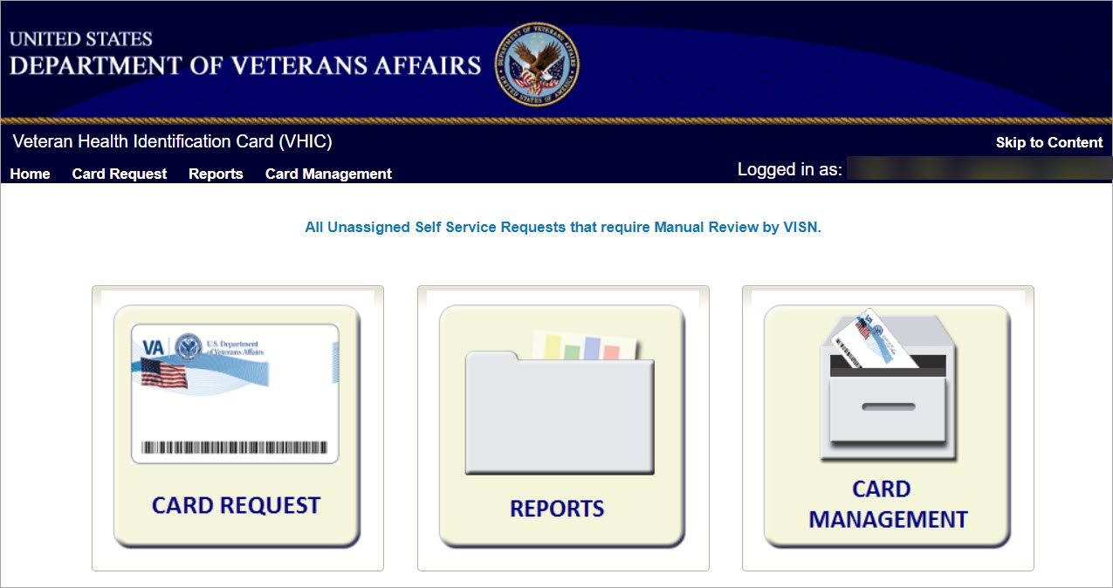

VHIC Associate and Supervisor
The VHIC Associate and VHIC Supervisor users will be presented with two menu options: Card Requests and Reports. They can navigate to each of these application modules by either clicking on one of the links located in the header at the top left of the screen or by clicking on one of the icon buttons in the middle of the screen.

Figure 6. VHIC Associate and VHIC Supervisor Home screen
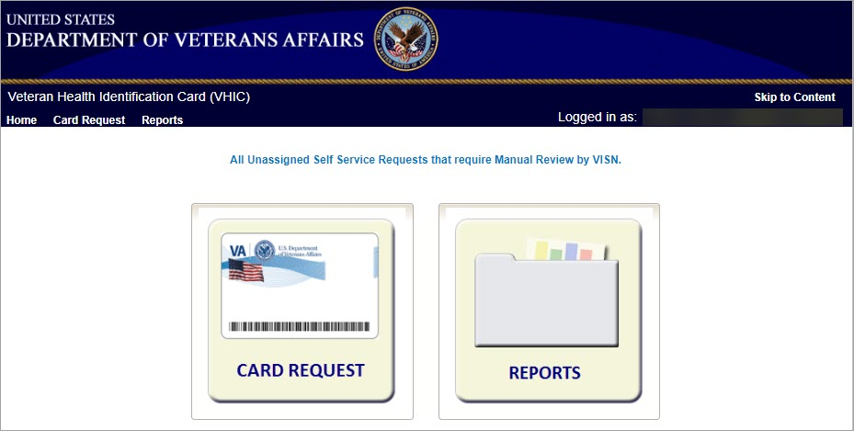

VHIC Auditor and Read-Only User
The VHIC Auditor and VHIC Read-Only users will be presented with the Reports menu option. They can navigate to Reports by clicking on the icon button in the middle of the screen.
Figure 7: VHIC Auditor and VHIC Read-Only User Home screen
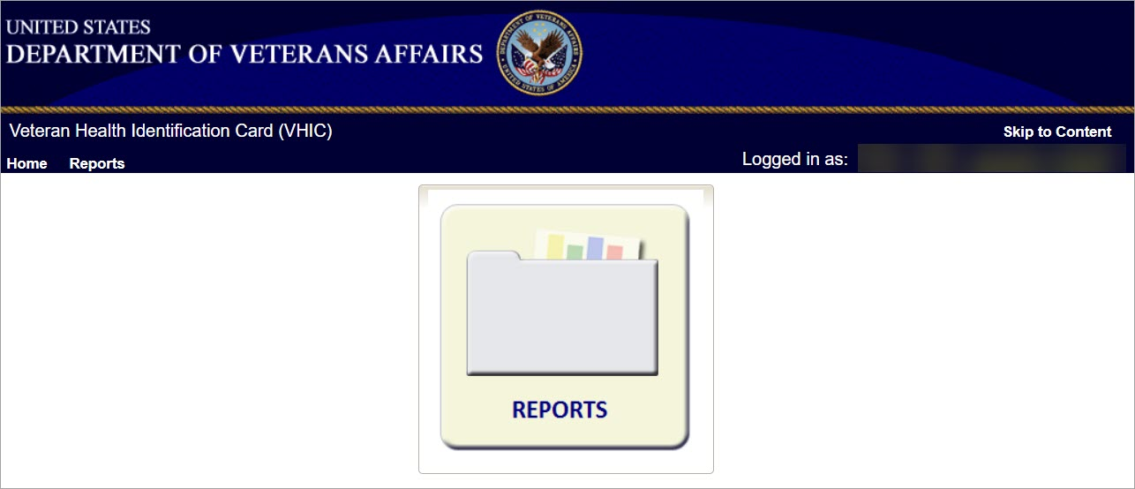

VHIC Reporting
The VHIC application offers a variety of reporting options divided into five main reporting tabs. Certain tabs may contain sub-tabs. Not all VHIC user roles have access to all reports, or all of the available functionality of certain reports (i.e., national option or multi-select option).
The National search option returns results, which includes every available VISN and Facility. This option, triggered by selecting the National checkbox, is only available to those user roles with authorization to use this feature. Since the results returned consist of all VISNs/Facilities, checking the National checkbox removes any available VISN and/or Facility options.
The ability to Multi-select is available on certain reports that have VISN and/or Facility selection criteria and is available to Administrators, and Tech Admin (Tier 3) roles. This feature works by holding down the [Control] button (Ctrl) on the keyboard and single clicking on each desired list items.
Most reports give the user the option to select either [Report], [Create PDF], or [Create XLS] once they have entered their search criteria. Clicking the [Report] button will generate the query results in a new tab. This allows the user to return to the original query tab in order to modify their search criteria if needed. Keep in mind, while date ranges may be generous, results are limited to 3000 lines.
The user selects the desired reporting option by clicking on the appropriate tab or sub-tab. A tab highlighted in blue, lets the user know which report they are viewing. Once they select a report, the user will need to provide certain search criteria based on the specific requirements of the report selected.
Some reports contain Hyperlinks. Clicking the hyperlinks (indicated by blue font) allow the VHIC user to access more detailed information. For instance, if the user wants to keep the Summary Report for a VISN open while reviewing the Detail Report for a specific Facility, they can hold down the [Control] button (Ctrl) on the keyboard while clicking on the hyperlink for the Facility they wish to view. This opens the Facility Detail Report in another browser window allowing the user to view both reports and have the ability to select another Facility in which to view.

NOTE: All report examples in this User Guide will be shown from the Administrator role view as it provides the most options. Other roles will see appropriate options and details as assigned to their workgroup.

The following graphic represents the VHIC tabular report structure for the Administrator, Technical Administrator Tier 3, and the Auditor:
Figure 8: Report Tabular Structure for the Administrator, Technical Administrator Tier 3, and the Auditor
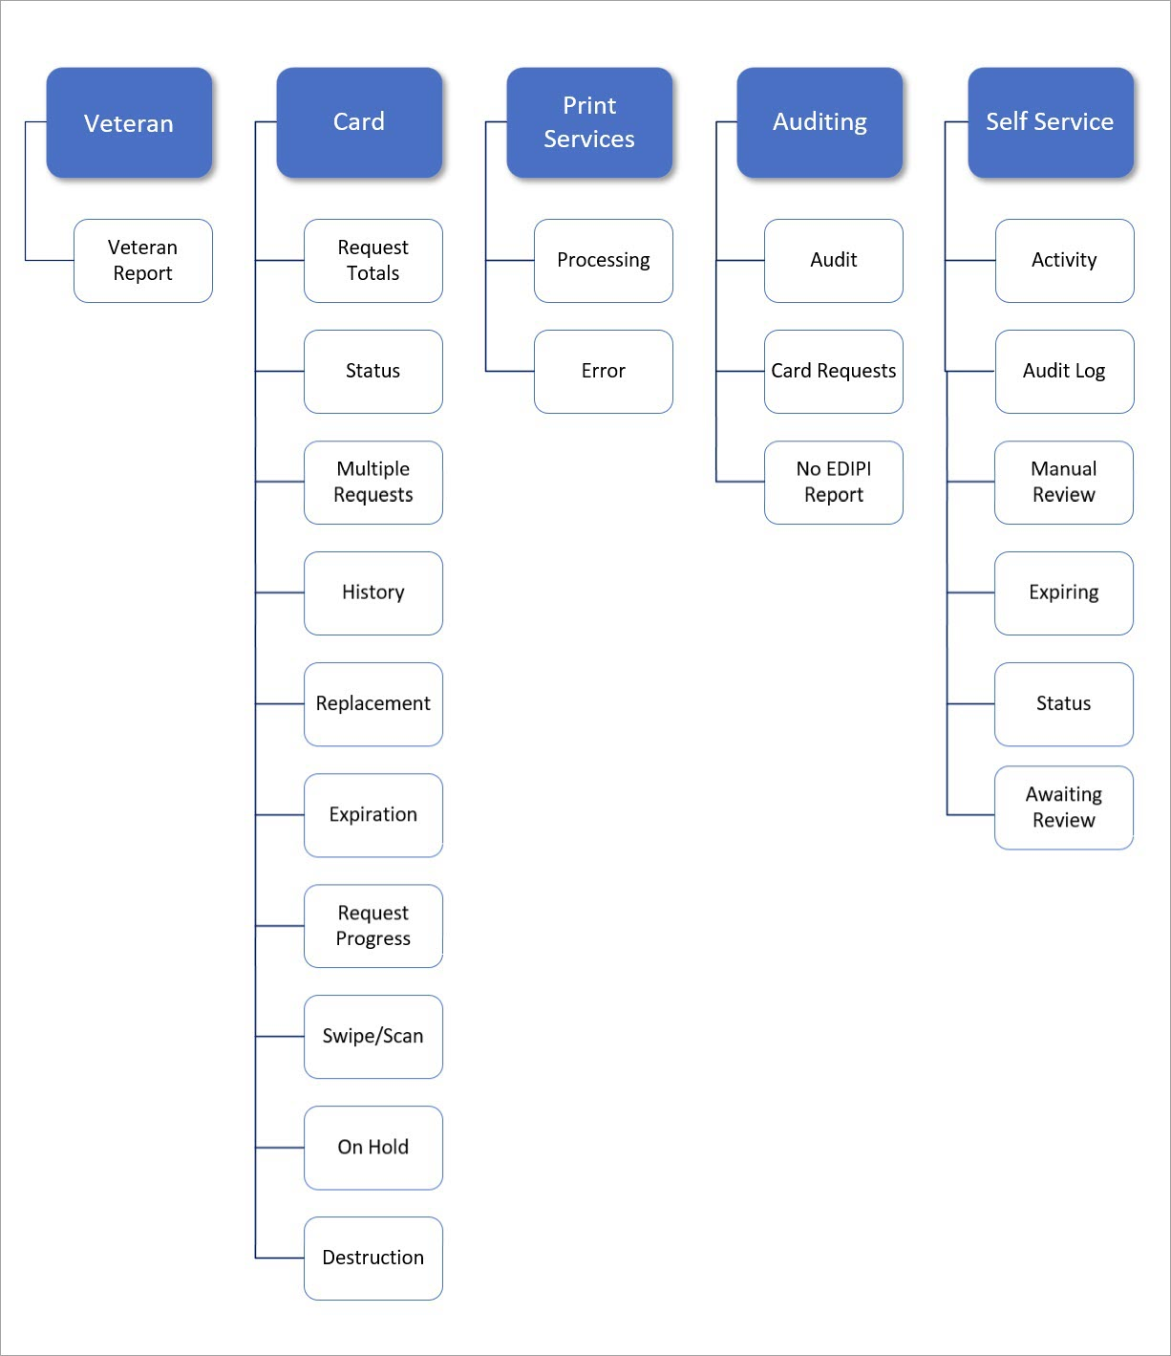

The following graphic represents the VHIC tabular report structure for the Supervisor user:
Figure 9: Report Tabular Structure for the Supervisor
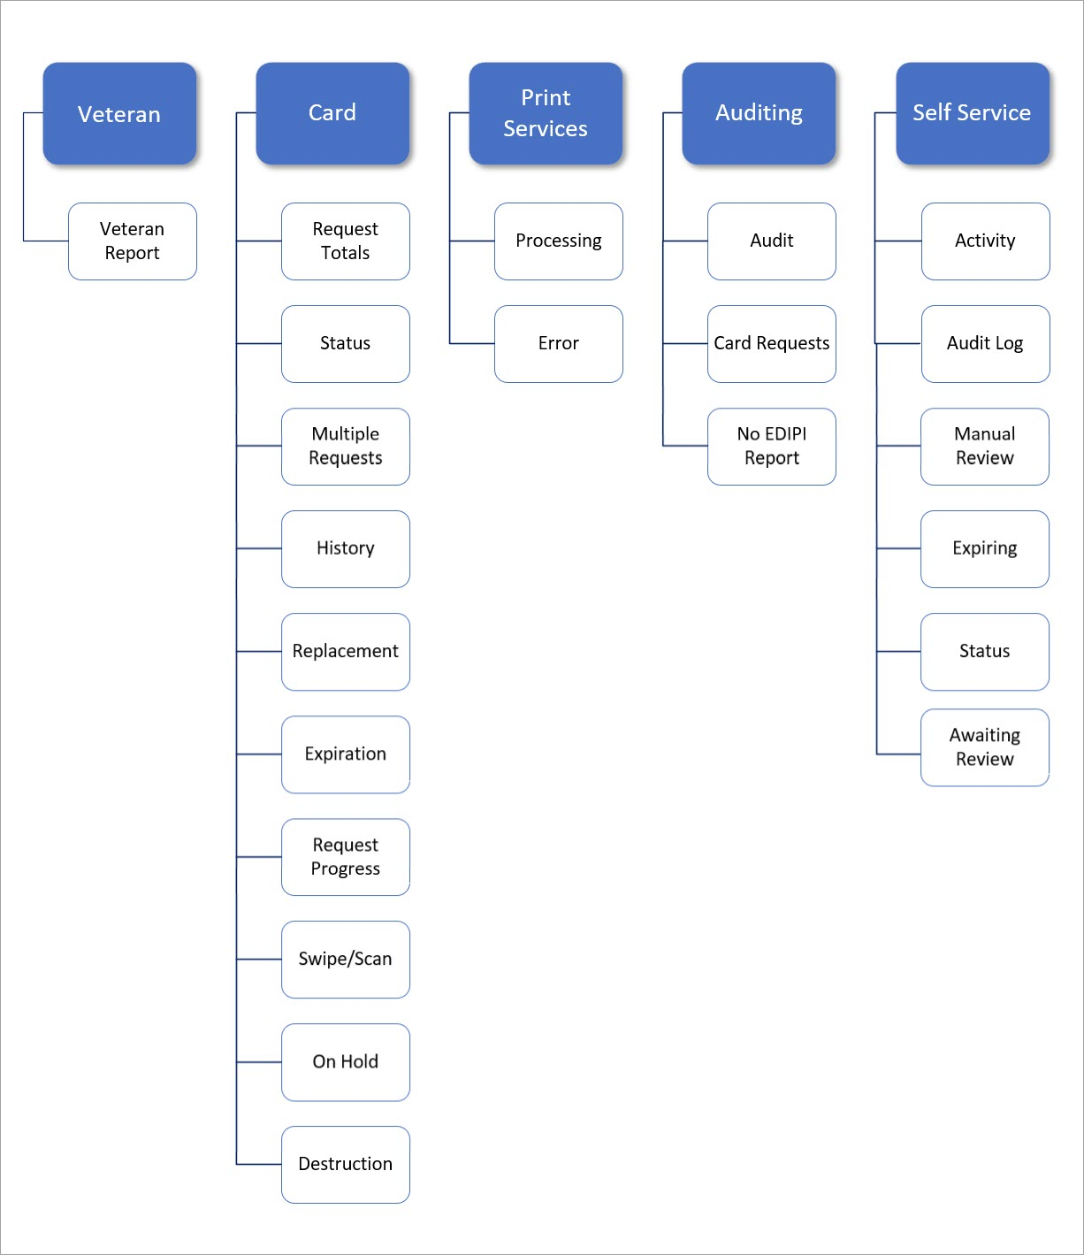

The following graphic represents the VHIC tabular report structure for the Associate user:
Figure 10: Report Tabular Structure for the Associate
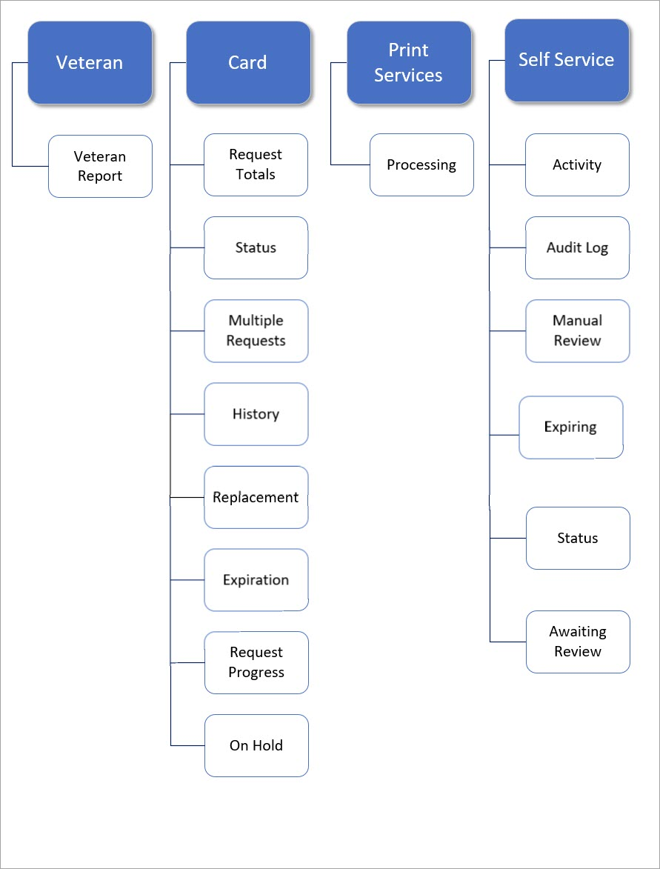

The following graphic represents the VHIC tabular report structure for the Read-Only user:
Figure 11: Report Tabular Structure for the Read-Only user
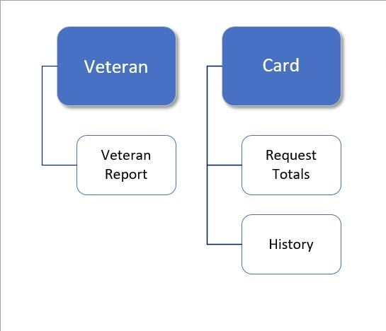

Veteran Detail Report (Direct Search)
Table 2: Veteran Report at a Glance
At a Glance…
Who can access this report? | Administrator, Supervisor, Associate, Tech Admin (Tier 3), Auditor, Read-Only
Who can access National version? | N/A
Date Range Allowed | N/A
Search Criteria Available | Last Name, First Name, Date of Birth, Last four of SSN, ICN, Member ID, Card ID, Person ID

The Veteran Report (a.k.a. Direct Search or Veteran Detail Report) is the first report query screen presented to the VHIC user when accessing the reporting section of VHIC. This report provides a comprehensive overview of all of the information the VHIC application has on a particular Veteran, including their photo.

Figure 12: Veteran Report Query Fields
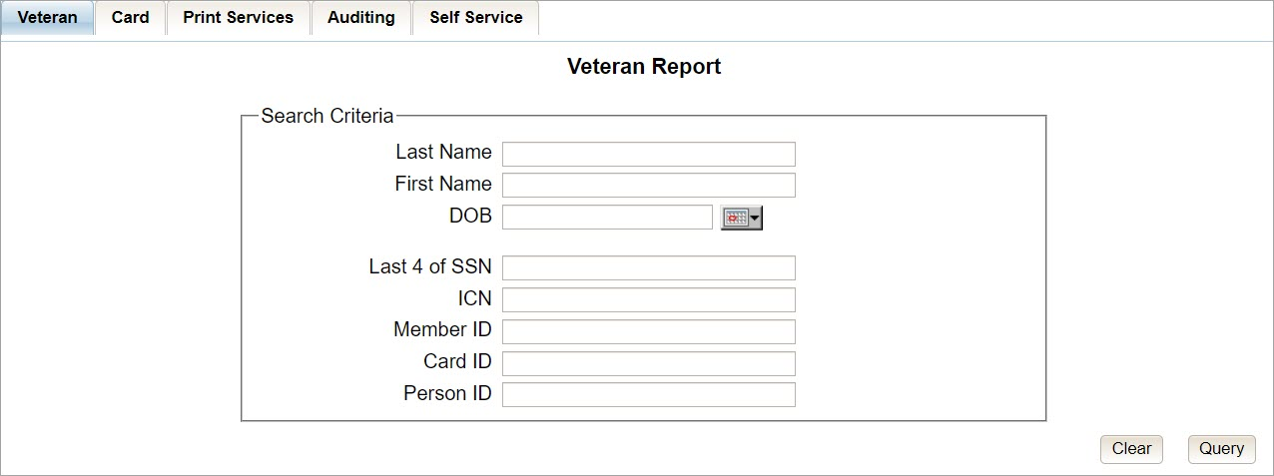

After entering the appropriate search traits and clicking the [Query] button, a screen will appear with a summary listing of potential matches.
Figure 13: Veteran Report Search Results
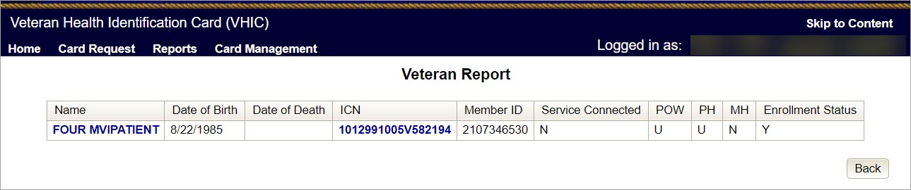

The query result displays a summary view of Veteran information consisting of:
- Name
  - Hyperlink to the Veteran Detail Report
- Date of Birth
- Date of Death
- ICN
  - Hyperlink to the Veteran Detail Report
- Member ID
- Service Connected
- POW – Prisoner of War
- PH – Purple Heart
- MH – Medal of Honor
- Enrollment Status

NOTE: Entering an Invalid ICN, Card ID, or Veteran ID will result in an error message such as the one seen below. Examples of errors include:
- Invalid ICN. ICN must be 17 characters
- Invalid ICN. ICN must not contain special characters
- Invalid ICN format. Please enter valid ICN format, 17 chars (10 digits + V + 6 digits)
- Veteran ID must be an integer value
- Card ID: Please enter a valid number between 0 and 2147483647
Figure 14: Card ID Error Message
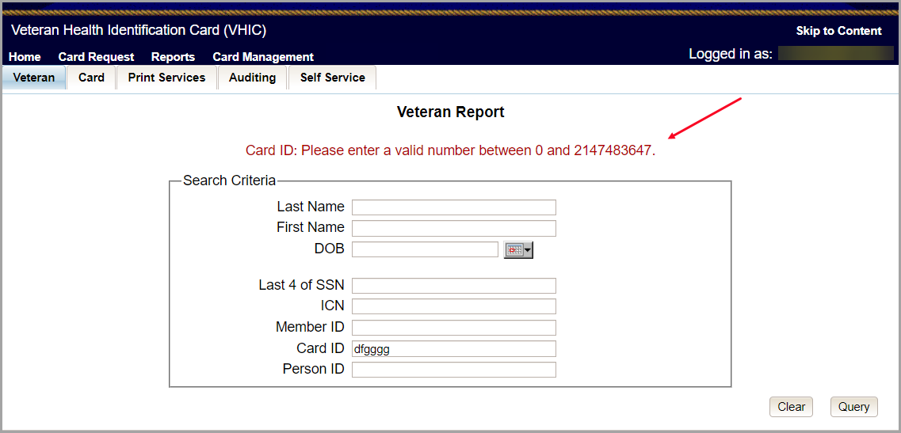

Clicking on the Veteran’s name, or on their ICN, displays a comprehensive level of this report, a.k.a. the VHIC Veteran Detail Report.

Figure 15: VHIC Veteran Detail Report
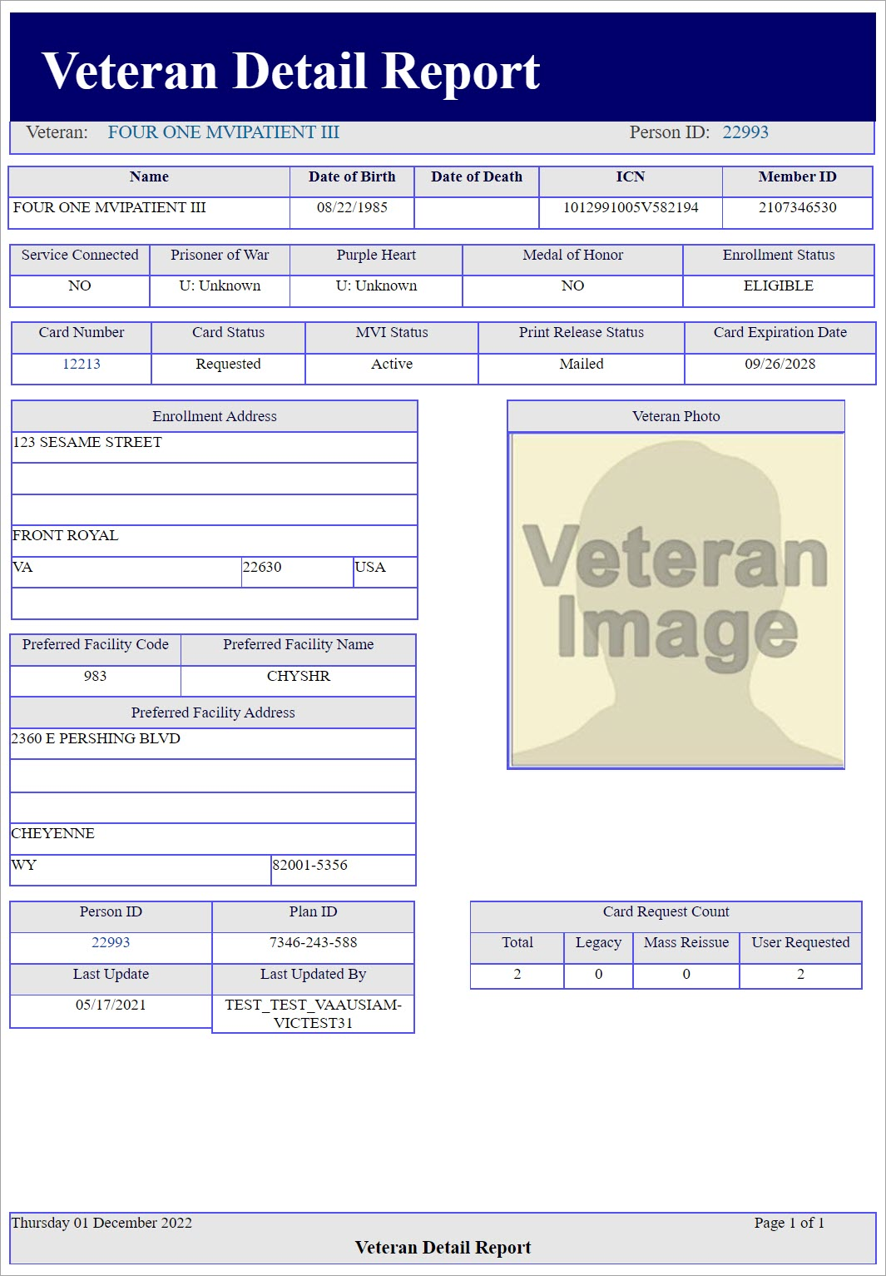

NOTE: If the Veteran has a Preferred Name registered in the system it will appear on the Veteran Detail Report within parenthesis where the Full Name appears as seen below.
Figure 16: Veteran Detail Report with Preferred Name Listed.
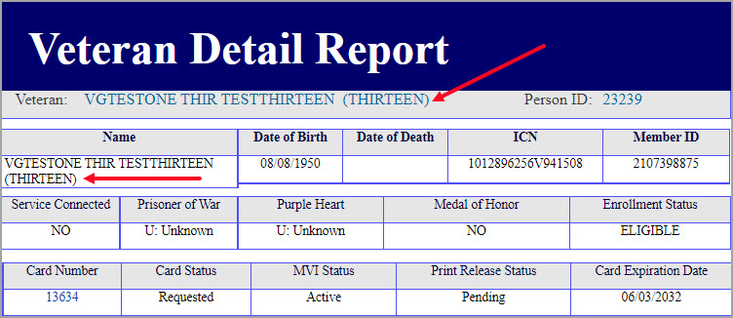

The VHIC Veteran Report contains a hyperlink in the Card Number and Person ID Number areas. Clicking these hyperlinks take the user to the VHIC Card History by Card ID report and VHIC Card History by Person ID Reports, respectively. This user guide covers Card History Reports in section.

Figure 17: Card Number and Person ID links on Veteran Detail report
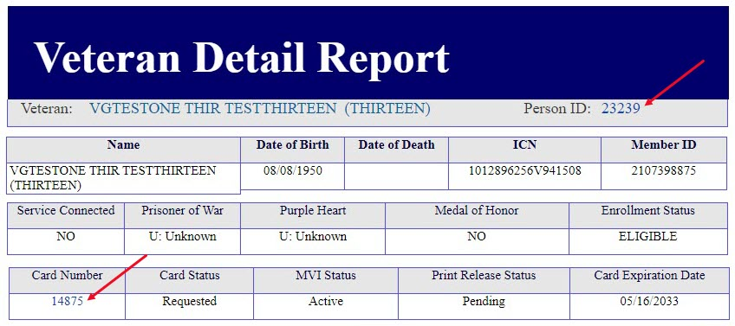

Card Request Totals Report
Table 3: Card Request Totals Report at a Glance
At a Glance…
Who can access this report? | Administrator, Supervisor, Associate, Tech Admin (Tier 3), Auditor, Read-Only
Who can access National version? | Administrator, Tech Admin (Tier 3), Auditor
Date Range Allowed | Admins, Tech Admin (Tier 3), Auditor – unlimited  Supervisor, Associate, Read-Only – one (1) year or less from date report is being run
Search Criteria Available (may vary by role) | VISN, Facility, Start Date, End Date
The Card Request Totals Report gives the user exactly that – the total card requests by selected VISN and/or Facility, in a tabular format within a designated period of time. By default, the "End Date" is set to the current date and the "Start Date" is set to a month prior. The Selecting the National checkbox, if available, returns results for all VISNs and Facilities. Selecting either the [VISN] or the [Facility] radio button will update the list of available options accordingly.

The Card Request Totals Report can be viewed by clicking the [Report] button or using the [Create PDF] button to generate a pdf of the results for Details can be viewed on an Excel Spreadsheet by selecting [Create XLS].
Figure 18: Card Request Totals Report query screen as seen by Administrators
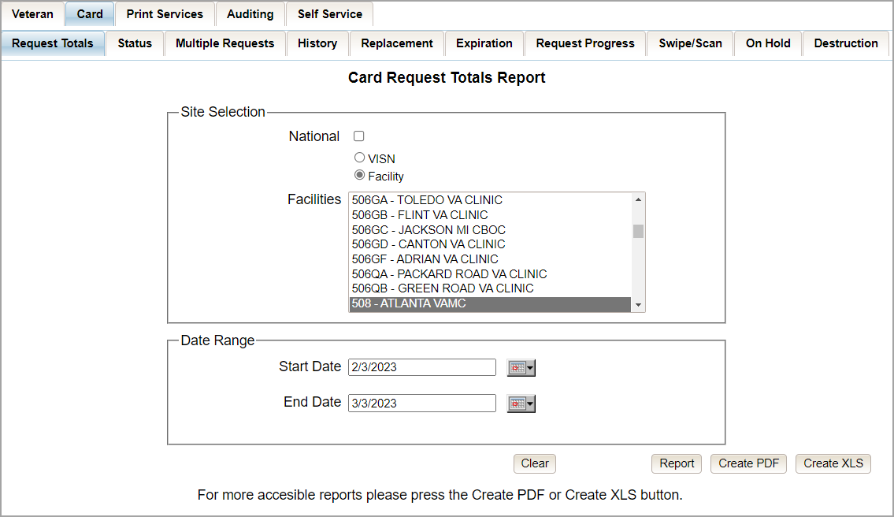

Figure 19: VHIC Card Request National Report
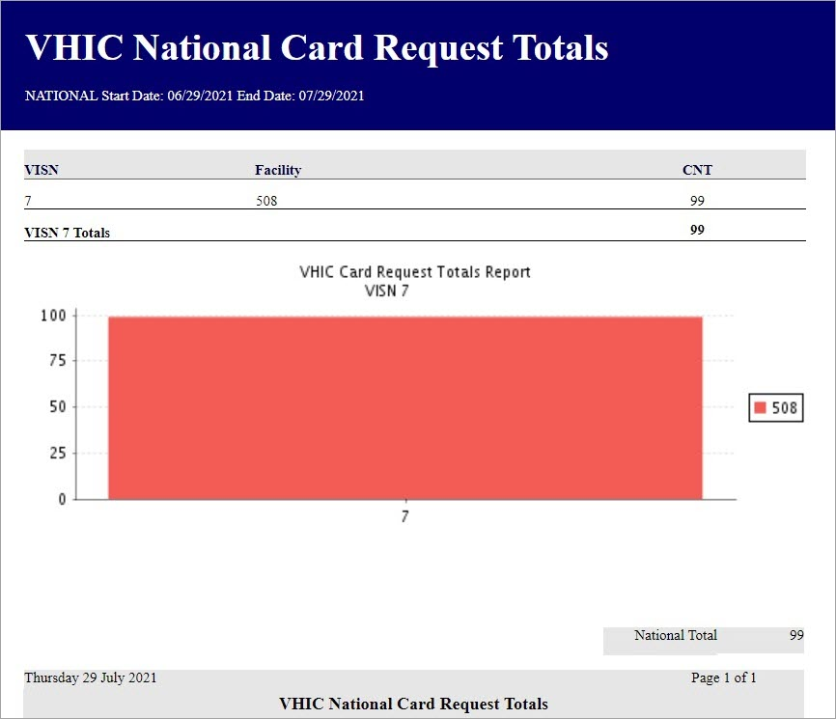

Figure 20: Card Request Total PDF Creation
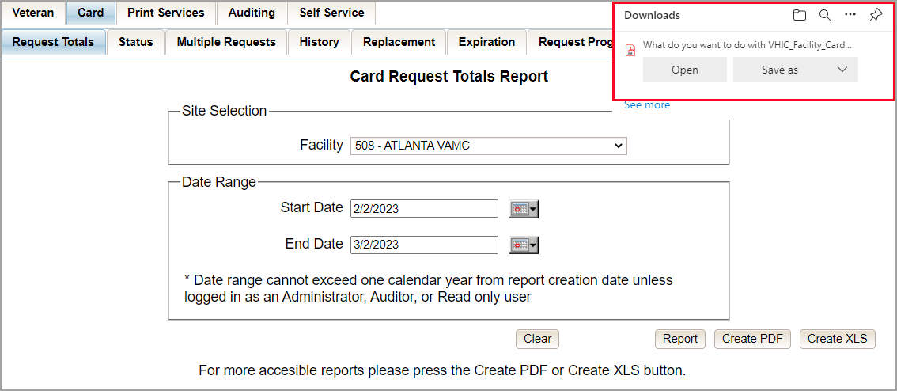

Selecting the [Create XLS] button will generate the report and export it to an Excel spreadsheet. The exported Excel spreadsheet contains the detailed data used to produce the report. An example can be found in Figure 22: VHIC Card Request Totals Spreadsheet.
Figure 21: VHIC Card Request Total Create XLS
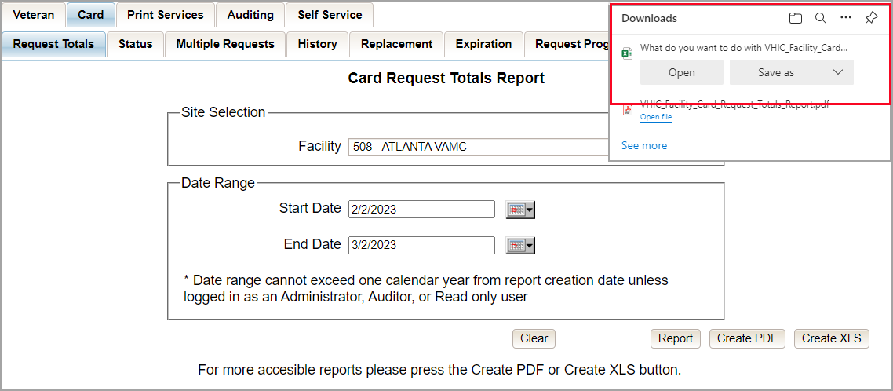

Figure 22: VHIC Card Request Totals Spreadsheet
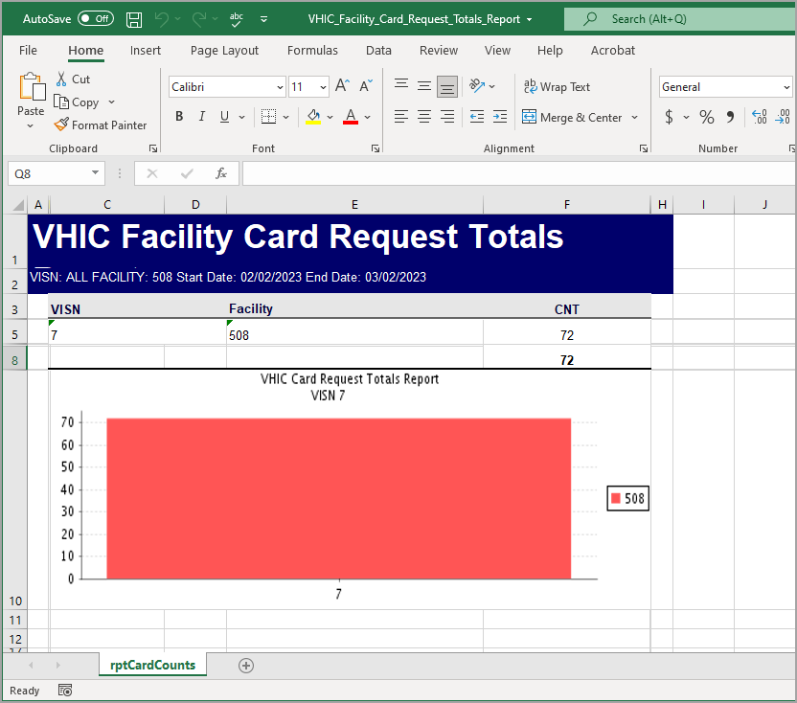

The Card Request Totals report does not contain links to move between Site Selection options. For example, in order to view VISN Card Request Totals after running the National Totals, the user will need to navigate back to the report screen and submit a new query.
Figure 23: Card Request Totals Report by VISN
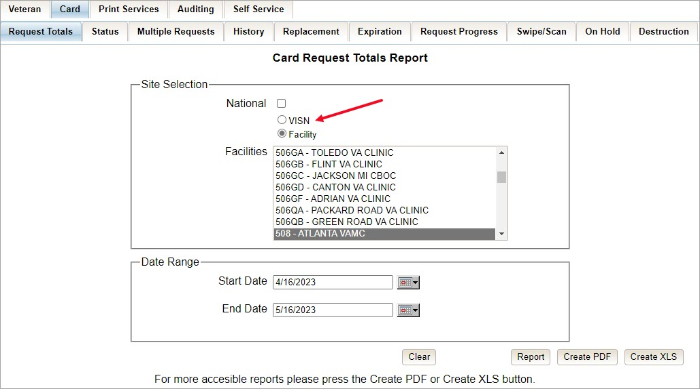

Figure 24: VHIC Card Request Totals report – VISN
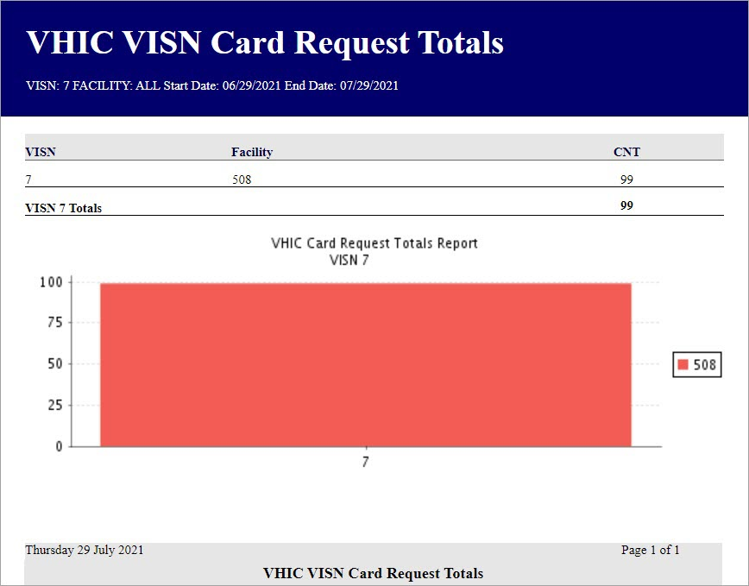

Card Status Report
Table 4: Card Status Report at a Glance
At a Glance…
Who can access this report? | Administrator, Supervisor, Associate, Tech Admin (Tier 3), Auditor
Who can access National version? | Administrator, Tech Admin (Tier 3), Auditor
Date Range Allowed | Admins, Tech Admin (Tier 3), Auditor – unlimited  Supervisor, Associate, Read-Only – one (1) year or less from date report is being run
Search Criteria Available (may vary by role) | VISN, Facility, MPI Status, Card Status, Print Release Status (which includes a drop-down list), Start Date, End Date
The Card Status Report contains three unique categories: MPI Status, Card Status, and Print Release Status. This report has the usual search criteria options such as VISN or Facility, Start Date, and End Date. Along with those, the user must choose one of the three (3) options: MPI Status, Card Status, or Print Release Status. Each one of these options contains their own drop- down-list of items. The user must select one item from the corresponding list prior to running the desired report. The following sections list the options available for each status’ selection. As with all reports, access to report categories, statuses, and options will depend on the role and access level of the user.
Figure 25: Card Status Report query screen as seen by Administrator
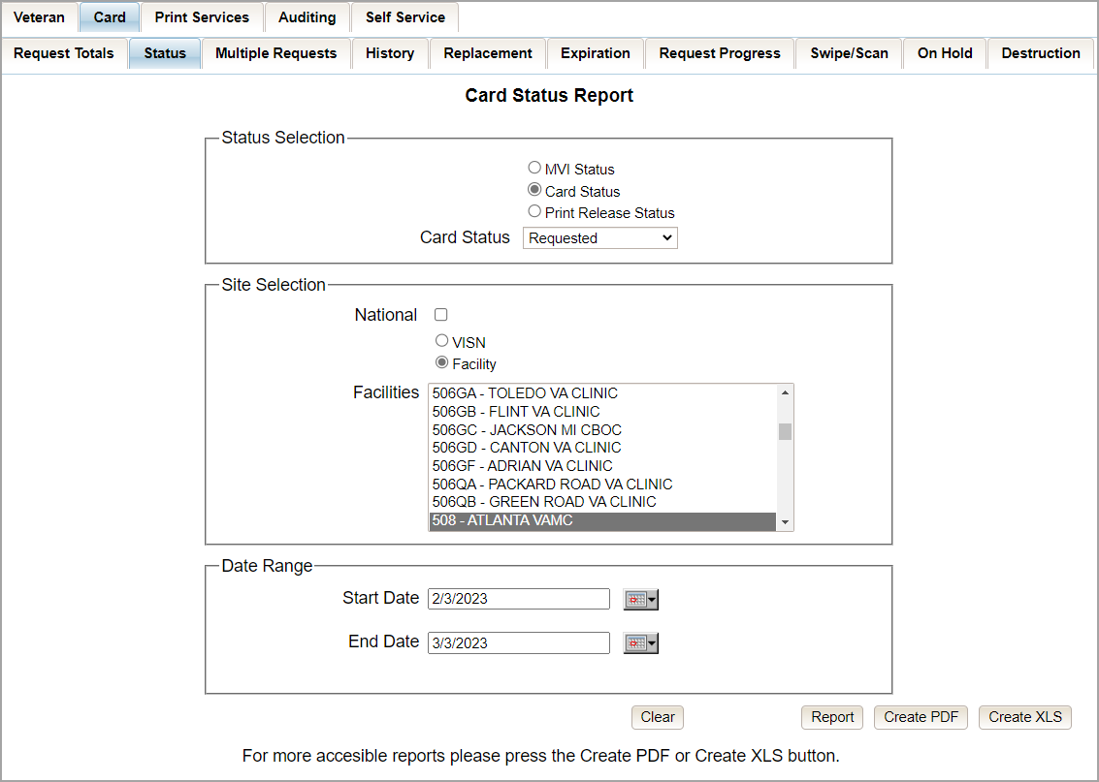

MPI (Master Person Index) Status Option
Clicking the [MPI Status] radio button provides the following report options:
- Active*
- Not Correlated
- Rejected
- Unlinked
NOTE: The starred (*) item is the default for that status.

Once the user selects one of the drop-down list options, chooses a site, and inputs a date range, they will click [Report]. Clicking [Report] will display the VHIC MPI Status Summary Report.
Figure 26: Card Status Report MPI Status drop-down options displayed
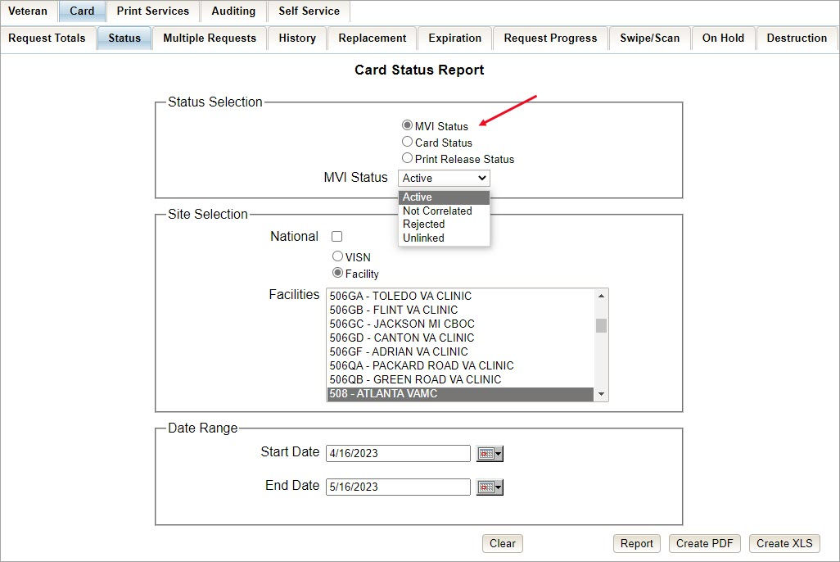

Clicking [PDF] will generate VHIC MPI Status Summary Report in a .pdf.
Figure 27: MPI Status Report PDF Generated
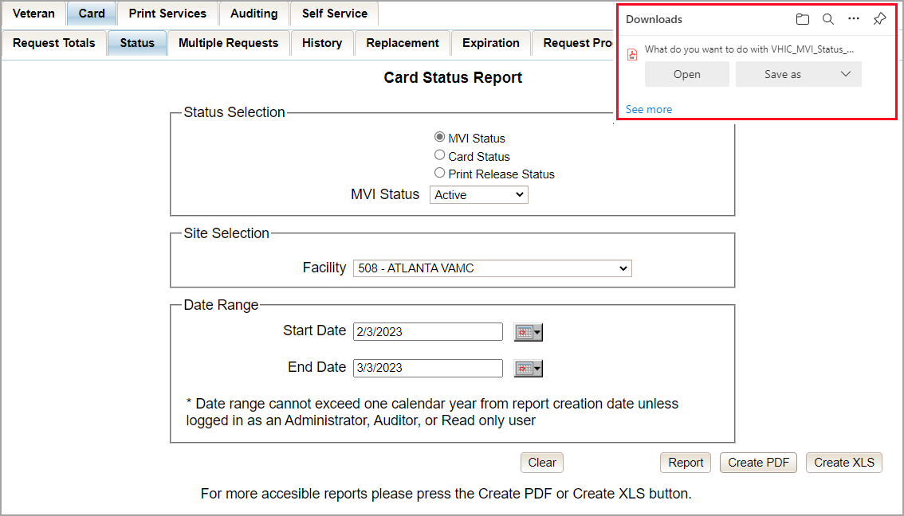

The VHIC MPI Status Summary Report contains hyperlinks (the number in the column relating to the selection made from the drop-down menu). Clicking a hyperlink will open the next report. The hyperlink in the VHIC MPI Status National Summary Report will take you to the VHIC MPI Status VISN Summary Report.
Figure 28: VHIC MPI Status National Summary Report – Active
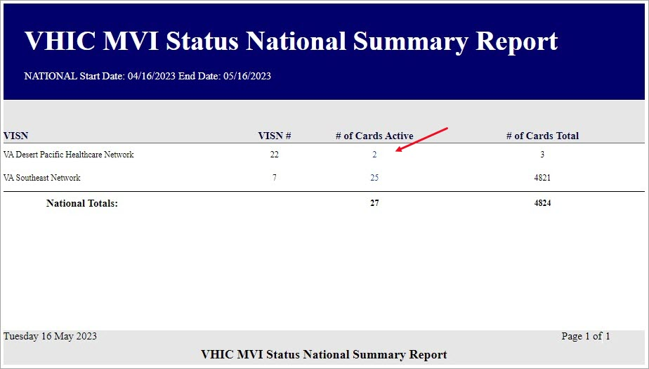

Clicking on the hyperlink in the VISN Summary Report will take you to the VHIC MPI Status Facility Detail Report with results broken down by Veteran.
Figure 29: VHIC MPI Status VISN Summary Report – Active
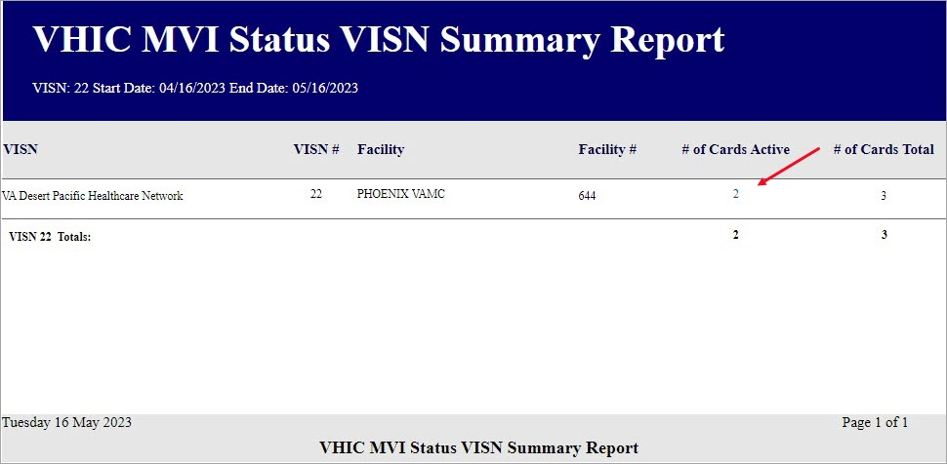

If you searched by Facility, you would be given the VHIC MPI Status Facility Summary Report and would click on the hyperlink to be taken to the VHIC MPI Status Facility Detail Report.
Figure 30: VHIC MPI Status Facility Summary Report – Active
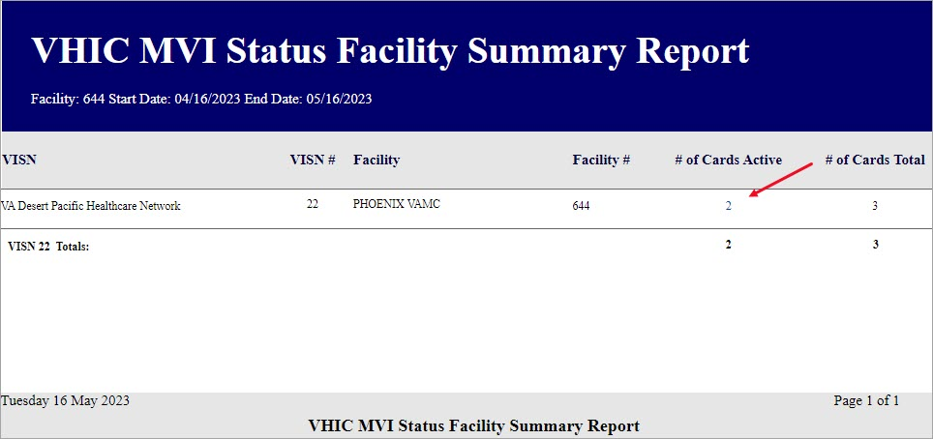

From the VHIC MPI Status Facility Detail Report, the user can click on any of the Veteran Name Hyperlinks to view the Veteran Detail Report of the selected veteran.
Figure 31: VHIC MPI Status Facility Detail Report – Active
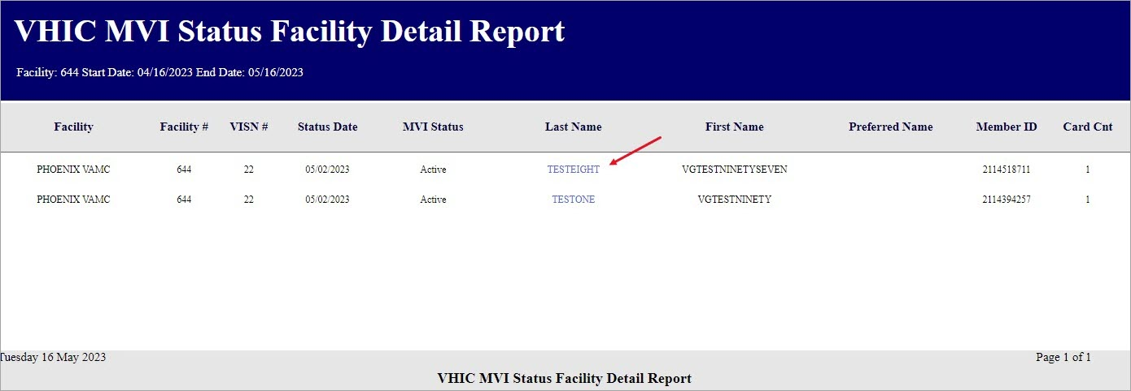

Figure 32: Veteran Detail Report from Link
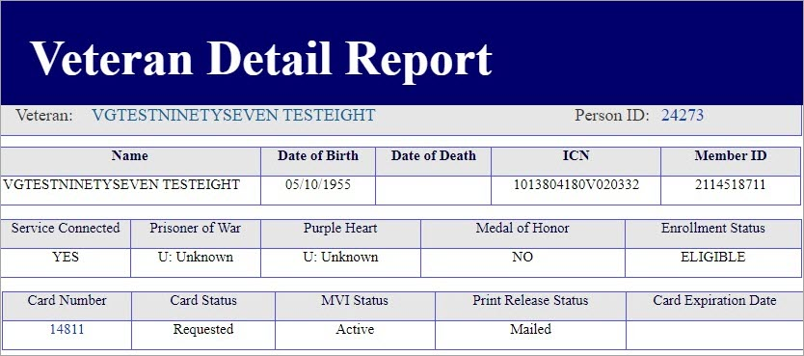

Selecting the [Create XLS] button will generate the report and export it to an Excel spreadsheet. The exported Excel spreadsheet contains the detailed data used to produce the report. An example can be found in Figure 34: VHIC MPI Status Facility Detail Report Spreadsheet.

Figure 33: VHIC MPI Status Facility Detail Report Exported to XLS
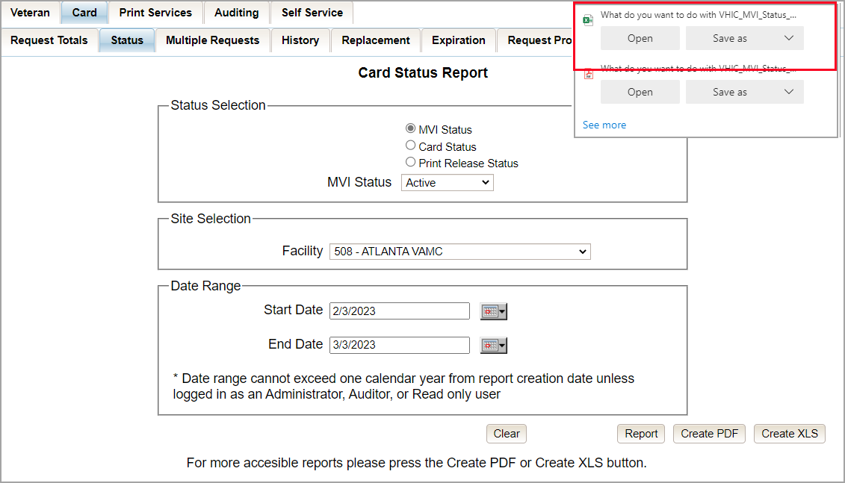

Figure 34: VHIC MPI Status Facility Detail Report Spreadsheet
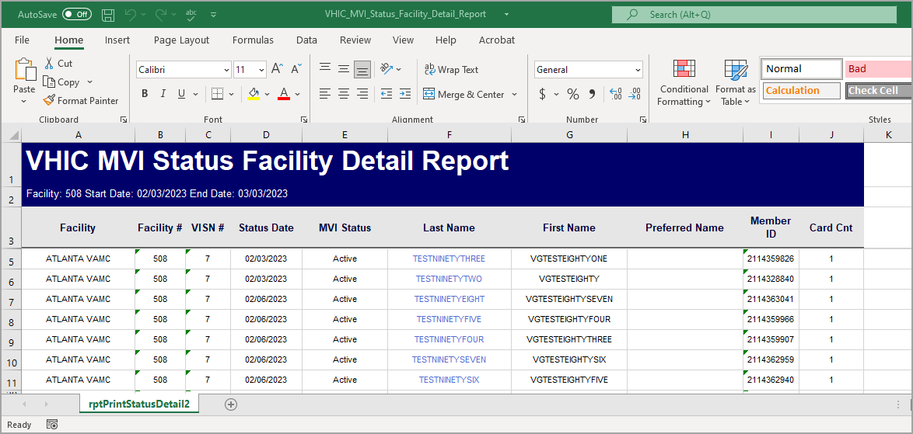

Card Status Option
Clicking the [Card Status] radio button provides the following report options:
- Replaced
- Deactivated
- Expired
- On Hold
- Pending
- Requested*
- Defunct
- Pending Destruction
- Destroyed
NOTE: The starred (*) item is the default for that status.

Once the user selects one of the drop-down list options, chooses a site, and inputs a date range, they will click the [Report] button. Clicking [Report] will display the VHIC Card Status Report.
Figure 35: Card Status Report query screen with Card Status drop-down menu options displayed
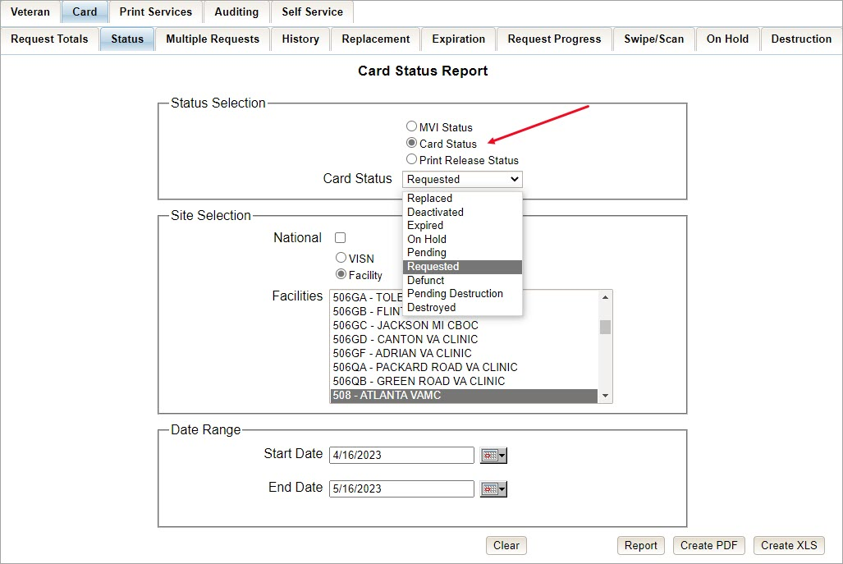

The VHIC Card Status Report contains hyperlinks (the number in the column relating to the selection made from the drop-down menu). Clicking a hyperlink will open the next report. The hyperlink in the VHIC Card Status National Report will take you to the VHIC Card Status VISN Report.

Figure 36: VHIC Card Status National Summary Report – Requested
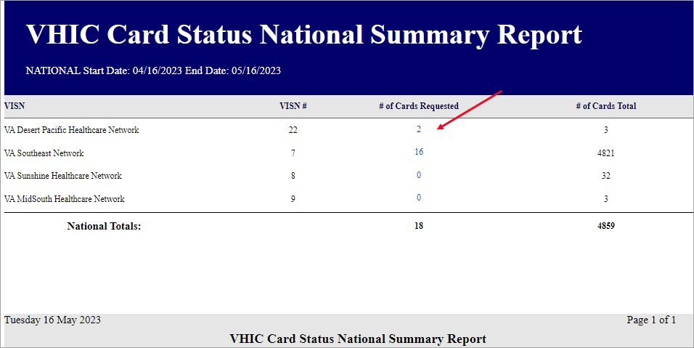

Clicking on the hyperlink in the VISN Summary Report will take you to the VHIC Card Status Detail Report with results broken down by Veteran.
Figure 37: VHIC Card Status VISN Summary Report – Requested
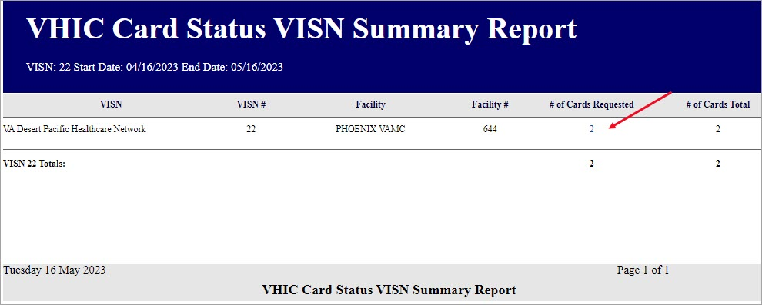

If you searched by Facility, you would be given the VHIC Card Status Facility Report and would click on the hyperlink to be taken to the VHIC Card Status Detail Report.

Figure 38: VHIC Card Status Facility Summary Report – Requested
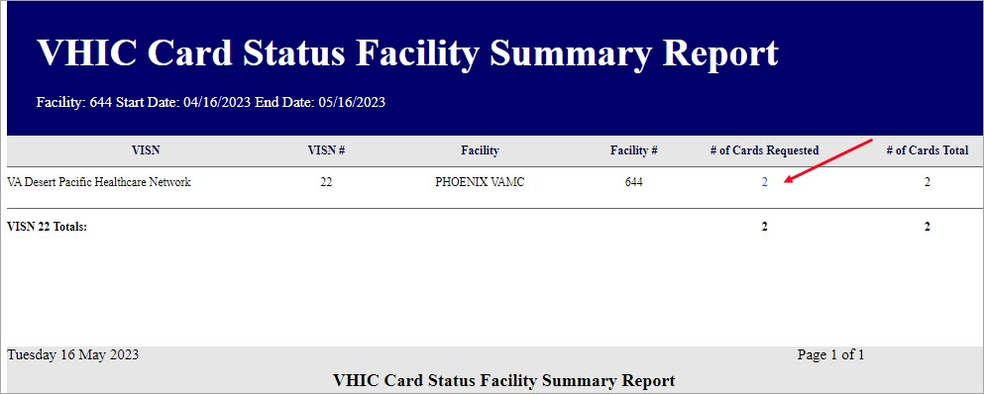

From the Facility Detail Report users can select a Veteran Name link to view their Veteran Detail Report.
Figure 39: VHIC Card Status Facility Detail Report – Requested
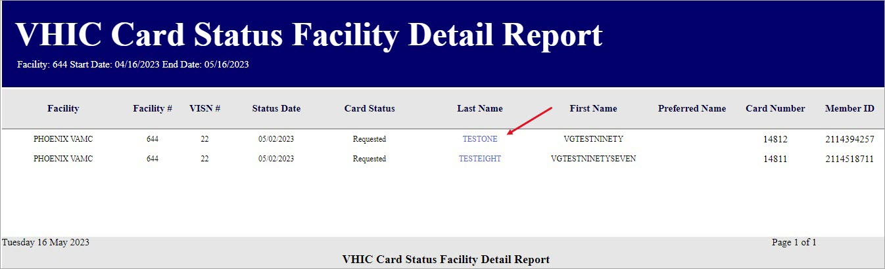

Print Release Status Option
Clicking the [Print Release Status] radio button provides the following report options:
- Cancelled
- Error
- Mailed*
- Not Started
- Pending
- Received
- Rejected
- Sent

NOTE: The starred (*) item is the default for that status.

Once the user selects one of the drop-down list options, chooses a site, and inputs a date range, they will click the [Report] button. Clicking [Report] will display the VHIC Print Status Summary Report.
Figure 40: Card Status Report : Print Release Status drop-down menu options displayed
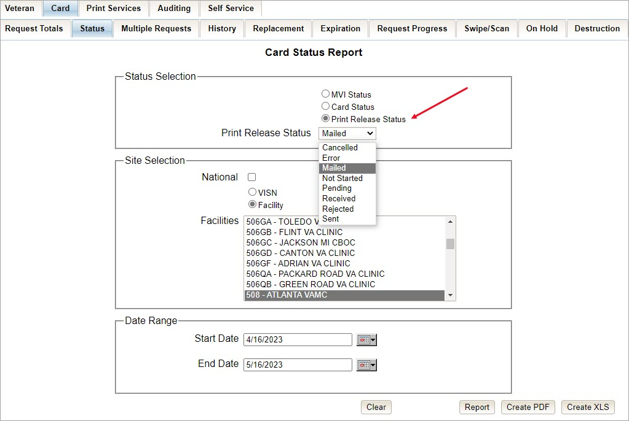

Clicking [PDF] will generate VHIC MPI Status Summary Report in a .pdf format as in.
Figure 41: Print Release Status Report PDF Generated
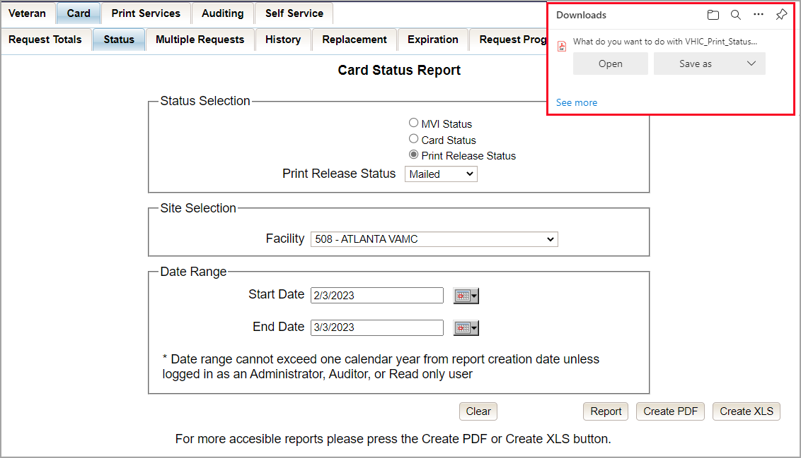

The VHIC Print Status Report contains hyperlinks (the number in the column relating to the selection made from the drop-down menu). Clicking a hyperlink will open the next report. The hyperlink in the VHIC Print Status National Report will take you to the VHIC Print Status VISN Summary Report.
Figure 42: VHIC Print Status National Summary Report – Mailed
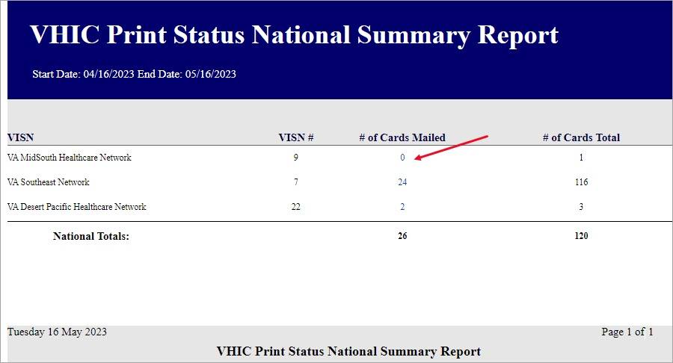

Clicking on the hyperlink in the VISN Summary Report will take you to the VHIC Print Status Detail Report with results broken down by Veteran.
Figure 43: VHIC Print Release Status Summary Report - VISN – Mailed
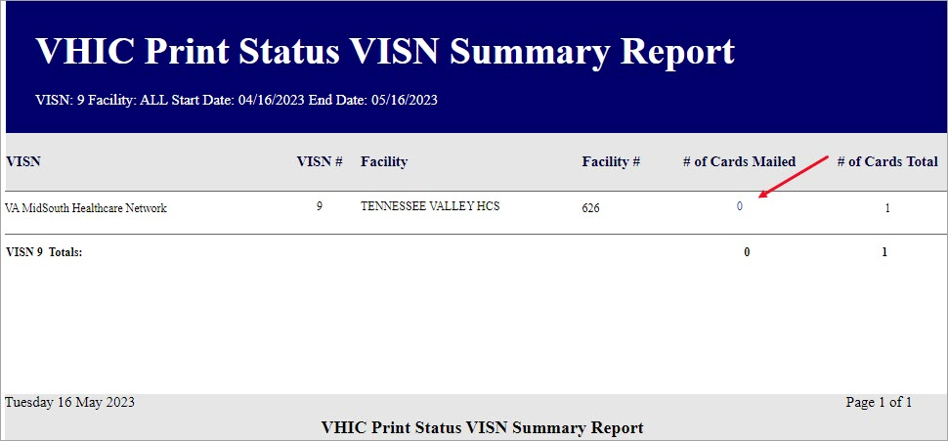

If you searched by Facility, you would be given the VHIC Print Status Facility Report and would click on the hyperlink to be taken to the VHIC Print Status Detail Report.
Figure 44: VHIC Print Status Detail Report - Facility – Mailed
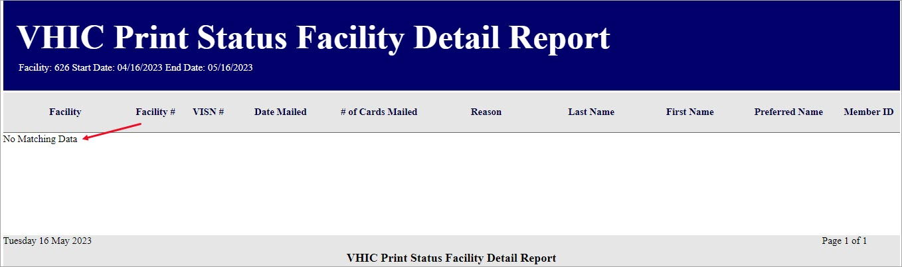

Selecting the [Create XLS] button will generate the report and export it to an Excel spreadsheet The exported Excel spreadsheet contains the detailed data used to produce the report. An example can be found in Figure 46: Print Release Status Report Spreadsheet.
Figure 45: Print Release Status Report XLS Generated
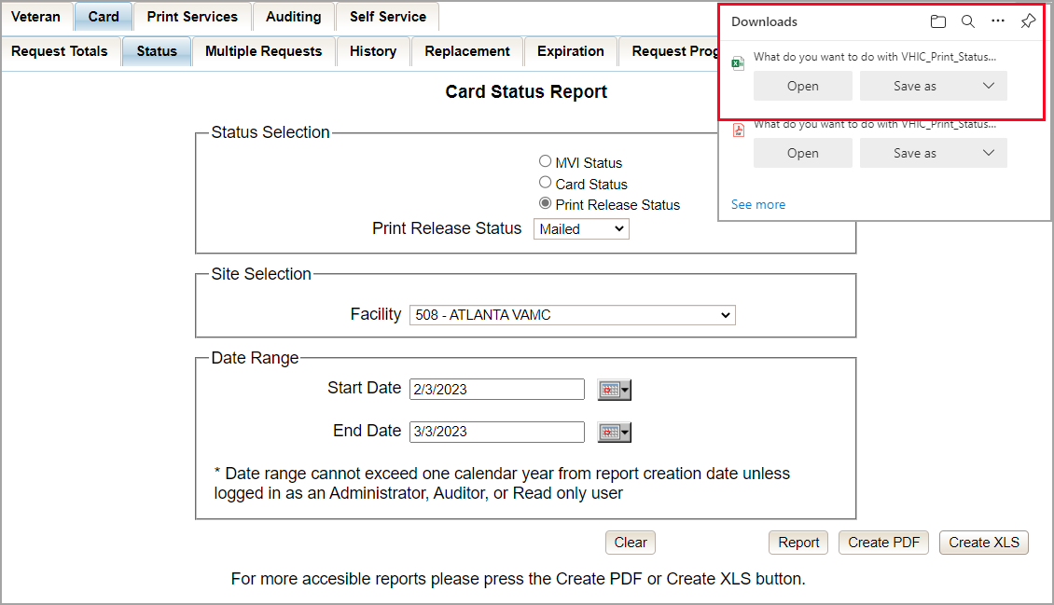

Figure 46: Print Release Status Report Spreadsheet
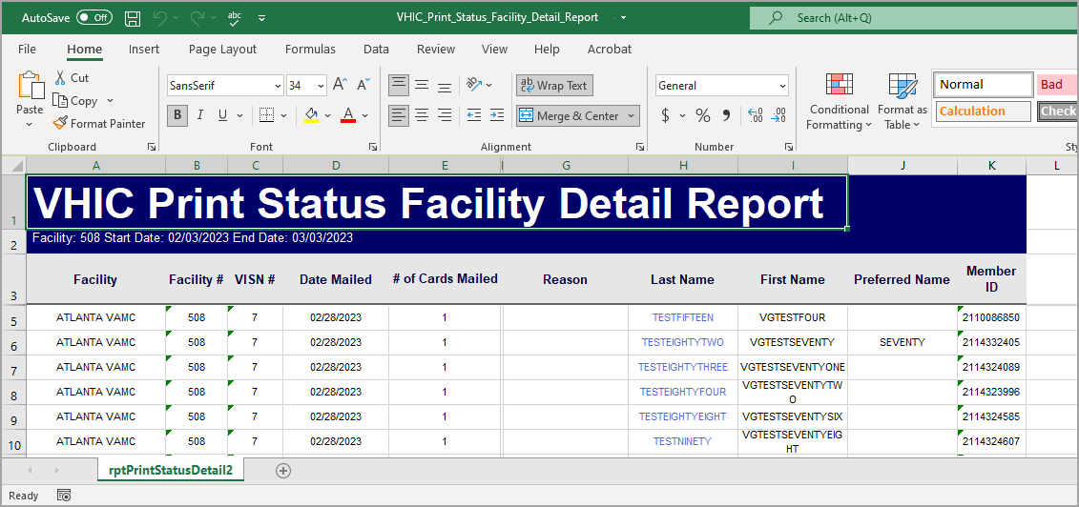

Multiple Card Requests Report
Table 5: Multiple Request Report at a Glance
At a Glance…
Who can access this report? | Administrator, Supervisor, Tech Admin (Tier 3), Auditor
Who can access National version? | Administrator, Tech Admin (Tier 3), Auditor
Date Range Allowed | Admins, Tech Admin (Tier 3), Auditor – unlimited  Supervisor, Associate, Read-Only – one (1) year or less from date report is being run
Search Criteria Available (may vary by role) | Card Requests (#), VISN, Facility, Cards Requested, Cards Mailed, Start Date, End Date

The Multiple Card Requests Report provides a summary of either multiple cards requested for a Veteran or multiple cards mailed to a Veteran. The user must select the radio button corresponding to the desired report. This report is customizable and will return multiples based on specific numeric criteria entered into the Card Requests field (the default is two (2)).

Once the user specifies a number of cards requested or mailed, chooses a site, and inputs a date range, they will click the [Report] button. Clicking [Report] will display the VHIC Detailed Report for Number of Cards Requested/Mailed.

Figure 47: Multiple Card Requests Report query screen – Administrator
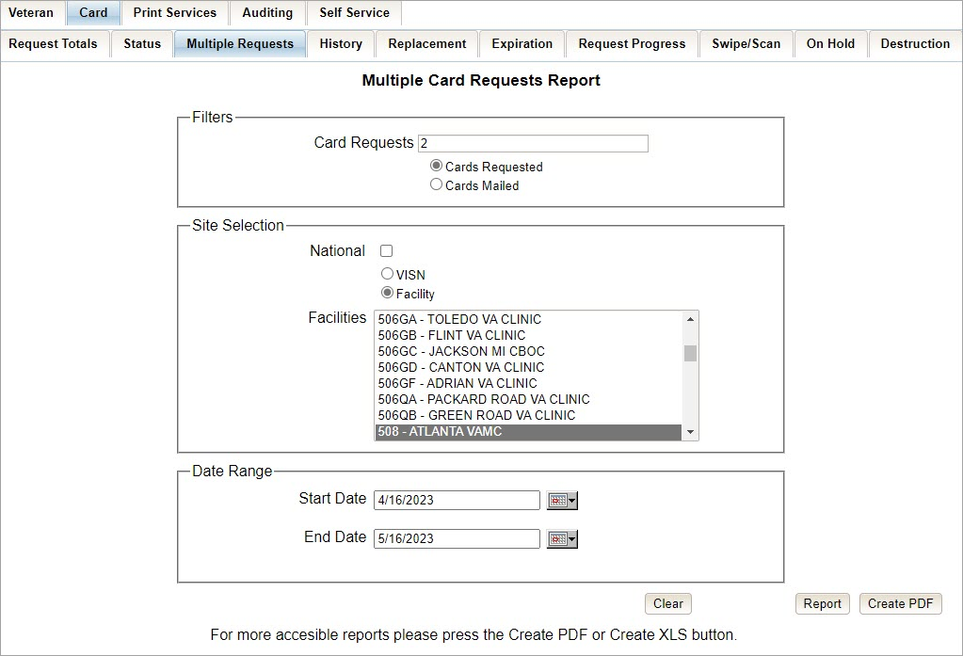

The VHIC Summary Report for Number of Cards Requested/Mailed - National lists all the VISNs and contains a hyperlink in the VISN # column. Clicking the hyperlink takes the user to the VHIC Detailed Report for Number of Cards Requested/Mailed - VISN report.
Figure 48: VHIC National Summary Report for Number of Cards Requested
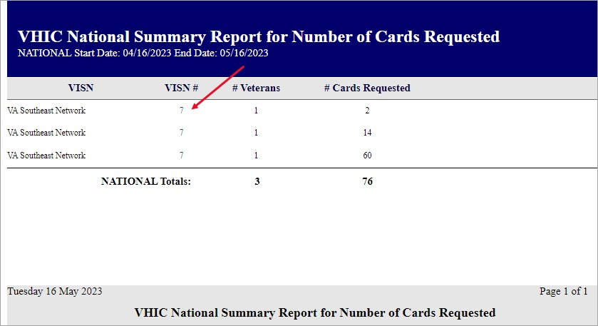

The VHIC Detail Report for Number of Cards Requested/Mailed - VISN lists all the Facilities for the selected VISN and contains a hyperlink in the Facility # column. Clicking the hyperlink takes the user to the VHIC Facility Detailed Report for Number of Cards Requested/Mailed report.
Figure 49: VHIC VISN Summary Report for Number of Cards Requested
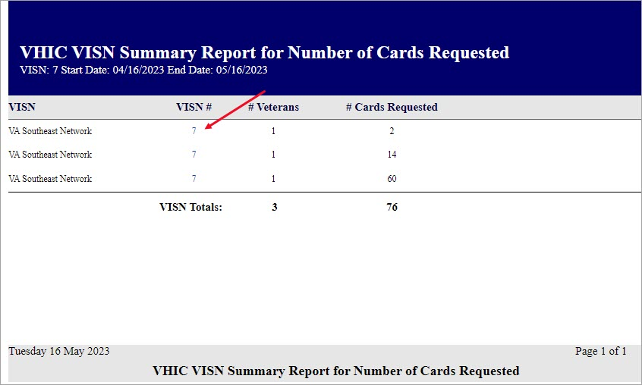

When the user searches by Facility, the VHIC Detailed Report for Number of Cards Requested/Mailed - Facility lists all the VISNs and contains a hyperlink in the Facility # column. Clicking on the facility number will drill down further to show a breakdown by Veteran.
Figure 50: VHIC Facility Summary Report for Number of Cards Requested
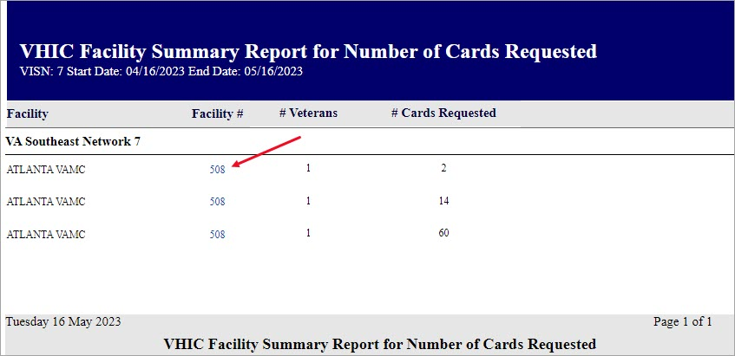

The VHIC Facility Detailed Report for Number of Cards Requested/Mailed report includes the Veteran’s Name, Member ID (if available), and number of Cards Requested/Mailed.
Figure 51: VHIC Facility Detail Report for Number of Cards Requested
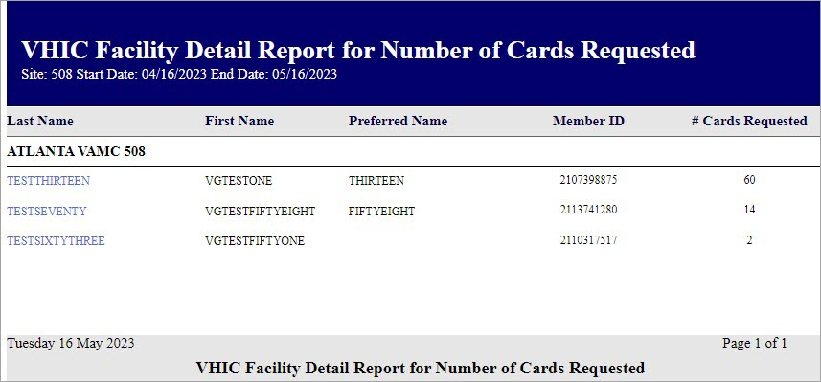

Card History Report
Table 6: Card History Report at a Glance
At a Glance…
Who can access this report? | Administrator, Supervisor, Associate, Tech Admin (Tier 3), Auditor, Read-Only
Who can access National version? | N/A
Date Range Allowed | N/A
Search Criteria Available | Card ID, Person ID

The Card History Report provides the user with a breakdown of requested cards. To access these reports, enter a Card ID number or a Person ID number of the Veteran.
Figure 52: Card History Report query screen as seen by Administrators and Auditors
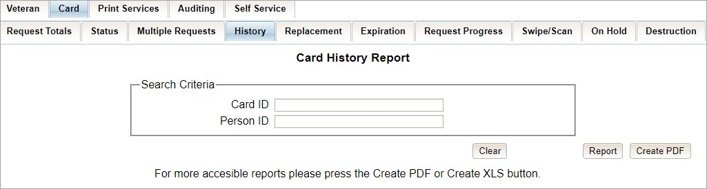

Searching by Card ID (found in the Veteran Detail Report) returns a single result for that specific card number, referred to as the Card History by Card ID Report.
NOTE: The example below is a card history report featuring a Veteran with a foreign mailing address.
Figure 53: VHIC Card History by Card ID Report
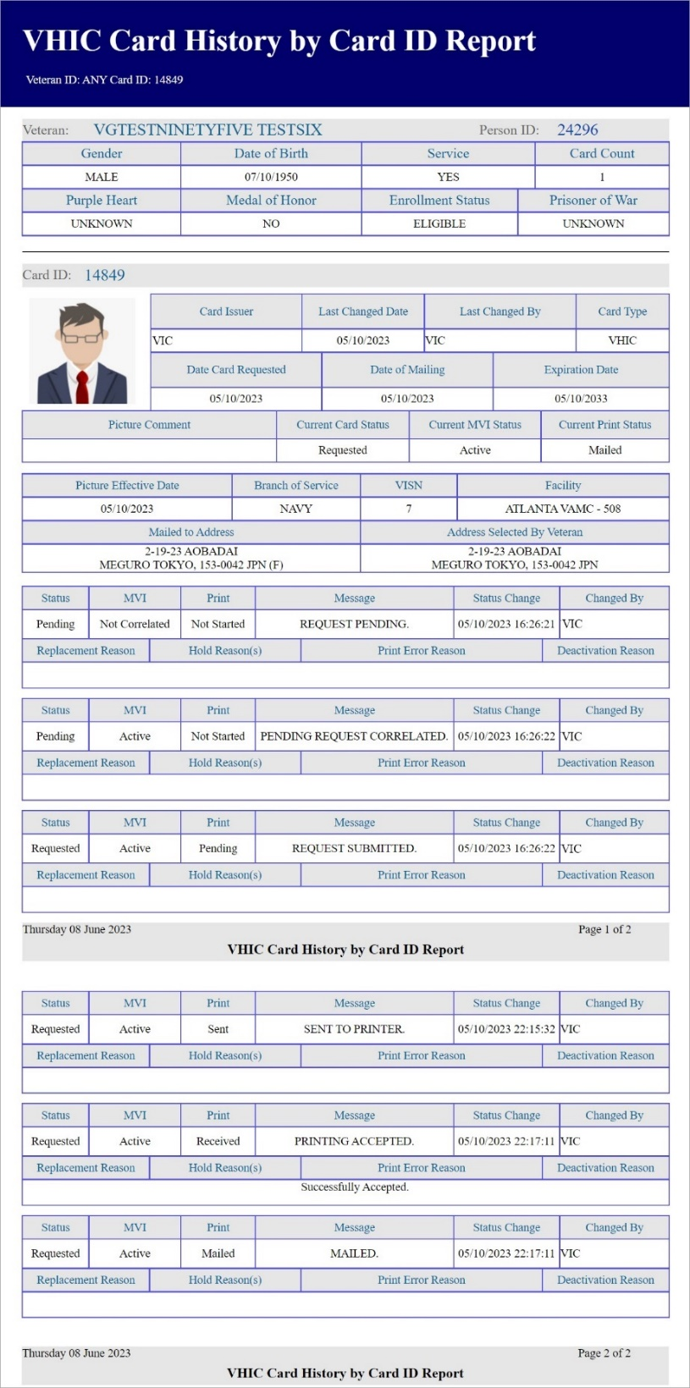

Searching by Person ID (found in the Veteran report) returns all of the cards requested for that Veteran, referred to as the Card History by Person ID Report.
Figure 54: Card History by Person ID Report
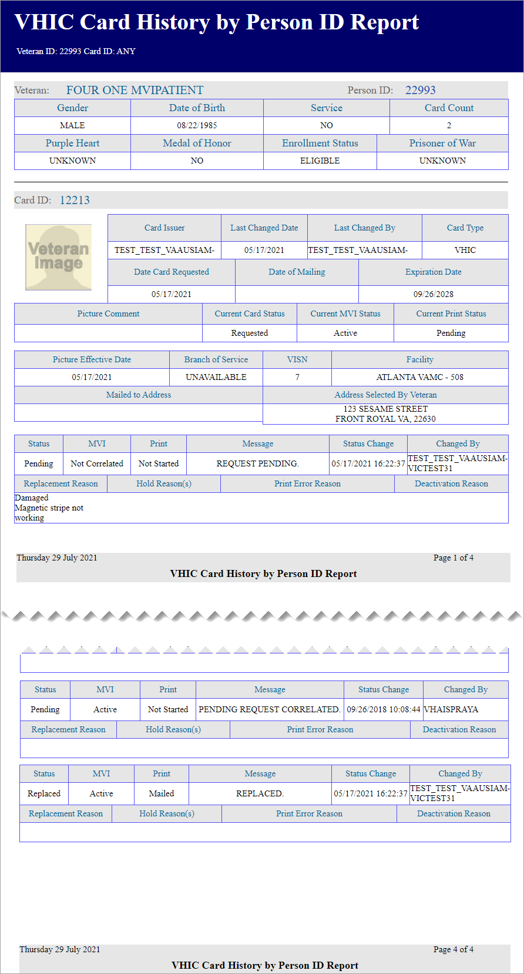

Both reports, Card History by Card ID, and Card History by Person ID, provide the user with the following information tied to that particular card:
- Veteran’s name
- Person ID
- Gender
- Date of Birth
- Service status
- Card Count
- Purple Heart status
- Medal of Honor status
- Enrollment Status
- Prisoner of War status
- Card ID
- Card Issuer
- Last Changed Date
- Last Changed By
- Card Type
- Date Card Requested
- Date of Mailing
- Expiration Date
- Picture Comment
- Current Card Status
- Current MPI Status
- Current Print status
- Picture Effective Date
- Branch of Service
- VISN
- Facility
- Replacement Reason (If any)
- Hold Reason(s) (If any)
- Print Error Reason (If any)
- Deactivation Reason (If any)

A history of the three statuses is also available. This allows reviewers to monitor and verify the various stages the card request has gone through as well as its final status at the time of the report.
Figure 55: Card History Report Status History
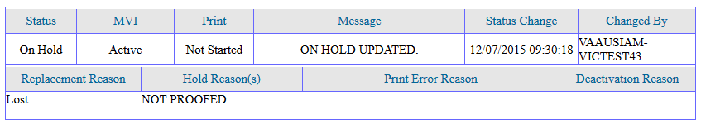

Card Replacement Report
Table 7: Card Replacement Report at a Glance
At a Glance…
Who can access this report? | Administrator, Supervisor, Associate, Tech Admin (Tier 3), Auditor
Who can access National version? | Administrator, Tech Admin (Tier 3), Auditor
Date Range Allowed | Administrator, Tech Admin (Tier 3), Auditor – unlimited  Supervisor, Associate – one (1) year or less from date report is being run
Search Criteria Available | VISN, Facility, Start Date, End Date
Each Card Replacement Report gives the user a breakdown, in a tabular format, of the requested replacement cards. The report, sorted by the replacement reasons and by the selected VISN and/or Facility, displays the number of Cards Replaced for each specific reason, and provides a hyperlinked number. Clicking a hyperlink takes the user to reports that are more detailed.

Selecting the [National] checkbox (if available) will return results for all VISNs and Facilities. Selecting either the [VISN] or the [Facility] radio button will update the list of available options accordingly (based on a user’s role).

Figure 56: VHIC Card Replacement Report query screen seen by Administrators
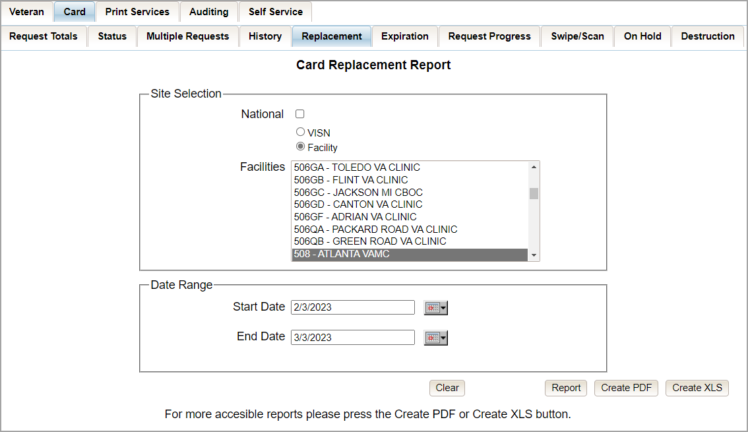

Clicking [PDF] will generate VHIC MPI Status Summary Report in a .pdf format as in.
Figure 57: Card Replacement Report PDF Generated
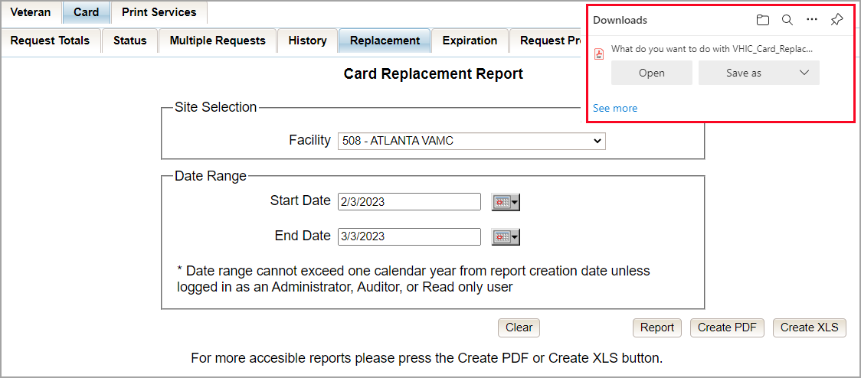

The VHIC Card Replacement National Report lists the VISNs and contains a hyperlink in the VISN # column. Clicking the hyperlink takes the user to the VHIC Card Replacement VISN Summary Report.

Figure 58: VHIC Card Replacement Summary Report – National
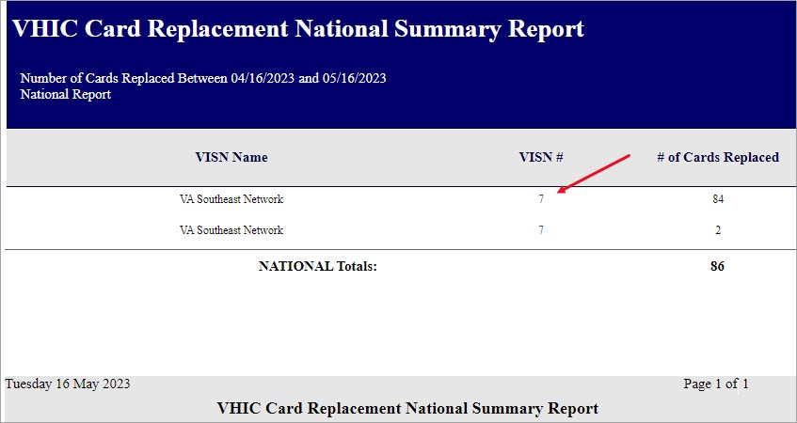

The VHIC Card Replacement VISN Summary Report lists all the Facilities for the selected VISN and contains a hyperlink in the Facility # column. Clicking the hyperlink takes the user to the VHIC Card Replacement Facility Summary report.
Figure 59: VHIC Card Replacement VISN Summary Report
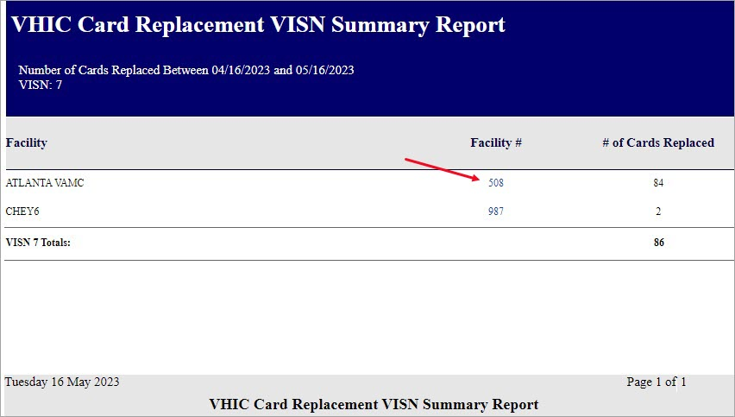

The VHIC Card Replacement Facility Report lists the Replacement Reasons and contains a hyperlink in the # of Cards Replaced column. Clicking the hyperlink takes the user to the VHIC Card Replacement Facility Sub-Reason Report.
Figure 60: VHIC Card Replacement Facility Report – Summary
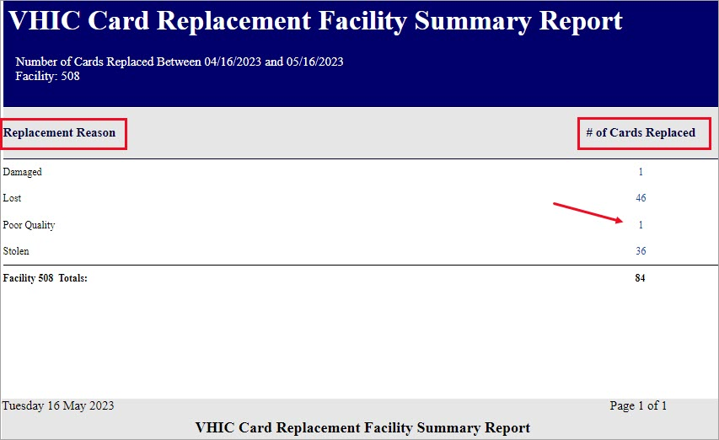

NOTE: The "No Matching Data" message will show when no records are returned to be consistent with the other summary level reports for this option.
Figure 61: No Matching Data Message
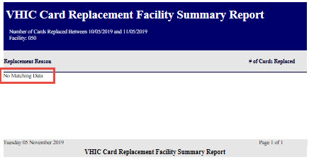

The VHIC Card Replacement Facility Sub-Reason Report contains a hyperlink in the # of Cards Replaced column. Clicking the hyperlink opens up a detailed breakdown report by Veteran.
Figure 62: VHIC Card Replacement Facility Sub Reason Report – Summary
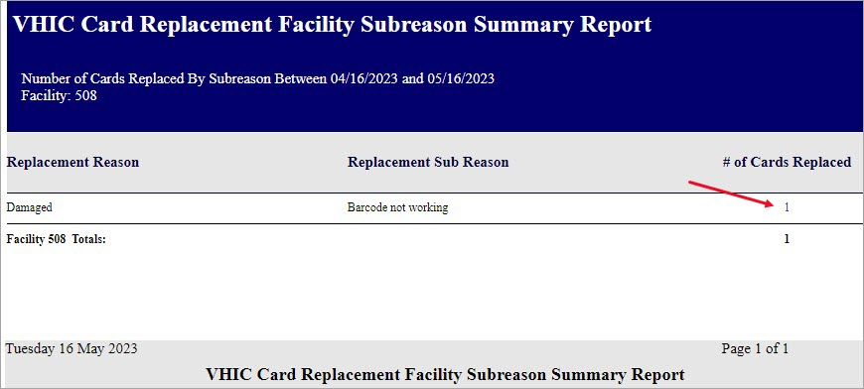

The VHIC Card Replacement Sub-Reason Detail contains hyperlinks in both the Card Number column and the Last 4 SSN column. Clicking the hyperlink under Card Number will take the user to the Card History Report for that Card ID and clicking on the hyperlink under the Last 4 SSN takes the user to the Veteran Detail Report for the Veteran selected.
Figure 63: VHIC Card Replacement Facility Sub Reason Detail report
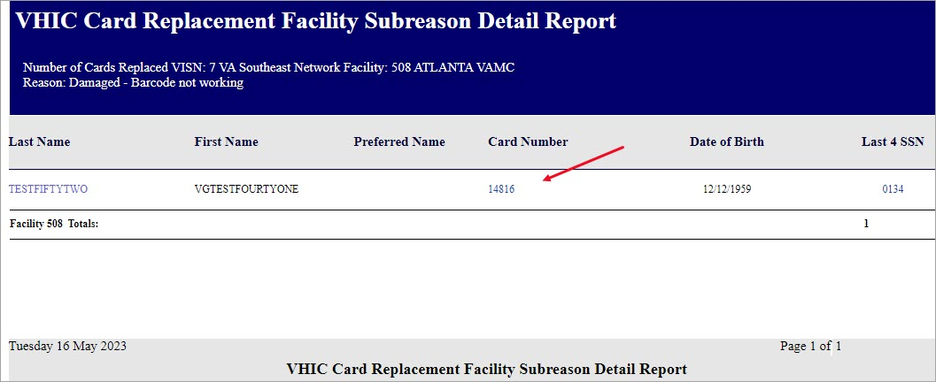

Selecting the [Create XLS] button will generate the report and export it to an Excel spreadsheet. The exported Excel spreadsheet contains the detailed data used to produce the report. An example can be found in Figure 65: VHIC Card Replacement Details Spreadsheet.
Figure 64: VHIC Card Replacement XLS Generated
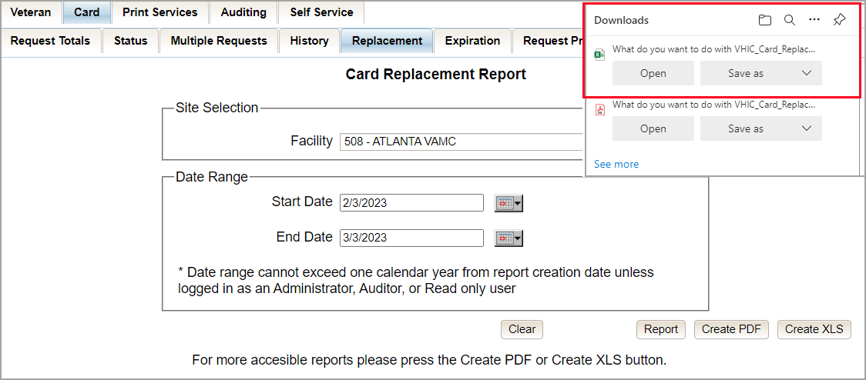

Figure 65: VHIC Card Replacement Details Spreadsheet
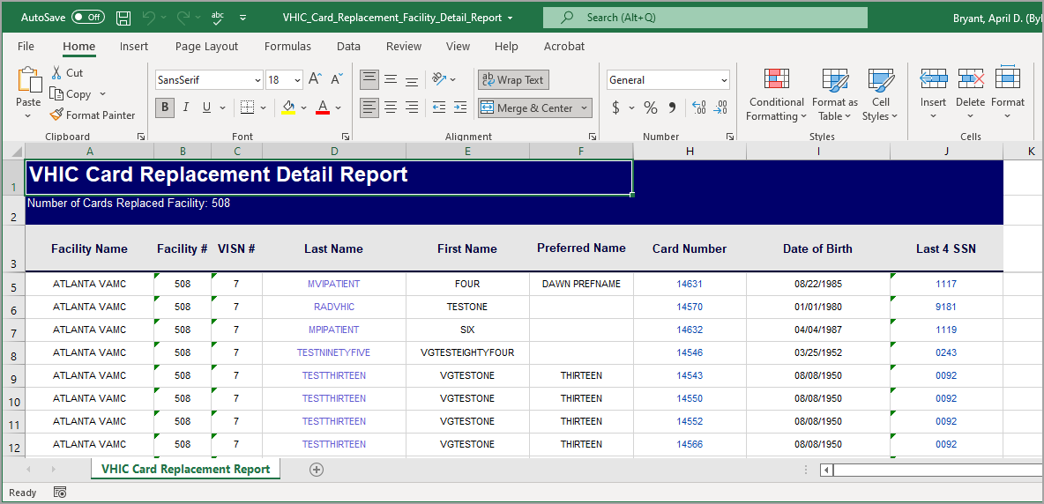

Card Expiration Report
Table 8: Card Expiration Report at a Glance
At a Glance…
Who can access this report? | Administrator, Supervisor, Associate, Tech Admin (Tier 3), Auditor
Who can access National version? | Administrator, Tech Admin (Tier 3), Auditor
Date Range Allowed | Administrator, Tech Admin (Tier 3), Auditor – unlimited  Supervisor, Associate – one (1) year or less from date report is being run
Search Criteria Available | VISN, Facility, Start Date, End Date
The Card Expiration Report allows the user to view information pertaining to VHICs that have expired. From the Card Expiration Report screen, the user can query expired cards by National, VISN, or Facility, depending on their role.

NOTE: The user can also find VHICs set to expire by selecting future start and end dates.

Figure 66: Card Expiration Report query screen Administrator View
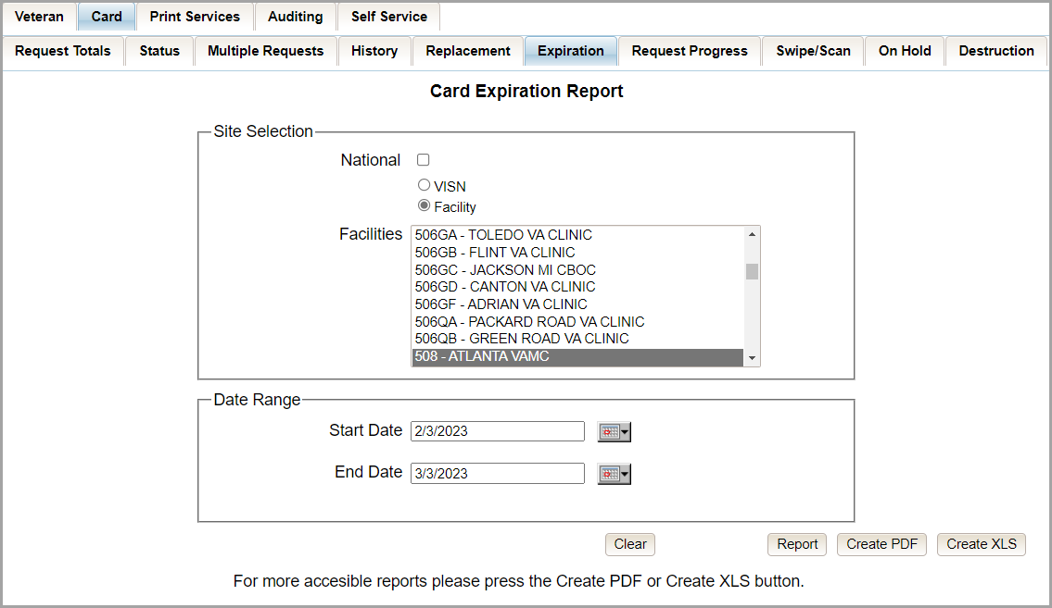

Clicking [PDF] will generate VHIC MPI Status Summary Report in a .pdf format as shown below.

Figure 67: VHIC Card Expiration Report PDF Generated
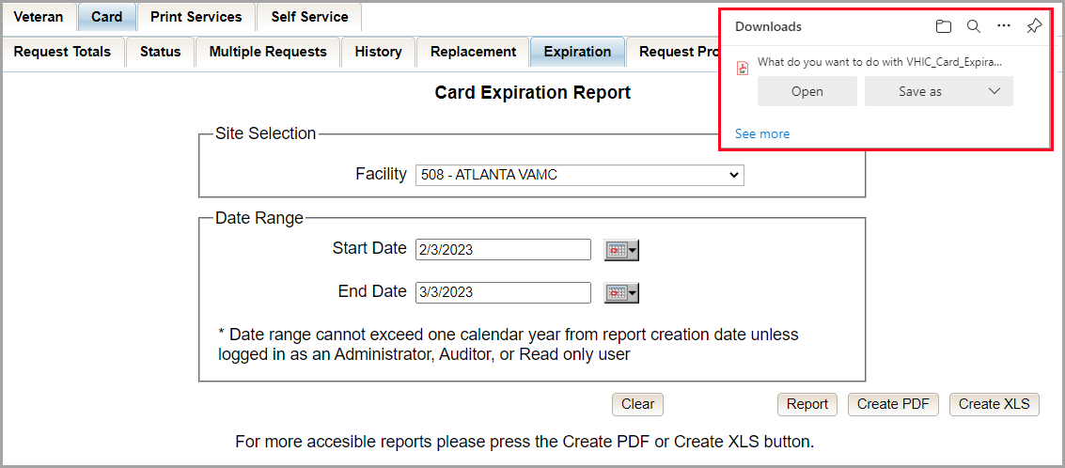

The VHIC Card Expiration Summary Report - National lists the VISNs and Facilities and contains a hyperlink in the VISN Number column. Clicking the hyperlink takes the user to the VHIC Card Replacement Site Report – VISN.
Figure 68: VHIC Card Expiration National Summary Report
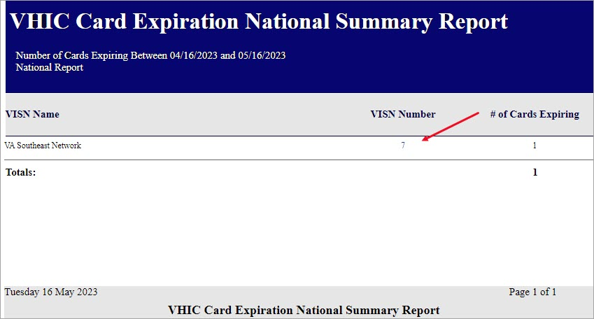

The VHIC Card Expiration Site Report - VISN contains a hyperlink in the Facility Number column. Clicking the hyperlink opens up a detailed breakdown report by Veteran.
Figure 69: VHIC Card Expiration VISN Summary Report
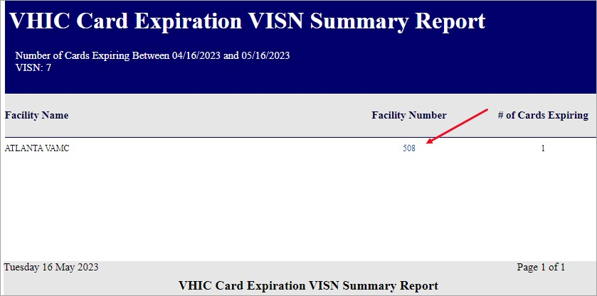

In addition, when searching my Facility on the query screen, the VHIC user will be taken to VHIC Card Expiration Site Report – Facility. The VHIC Card Expiration Site Report - Facility contains a hyperlink in the Facility Number column. Clicking the hyperlink opens up a detailed breakdown report by Veteran.
Figure 70: VHIC Card Expiration Facility Summary Report
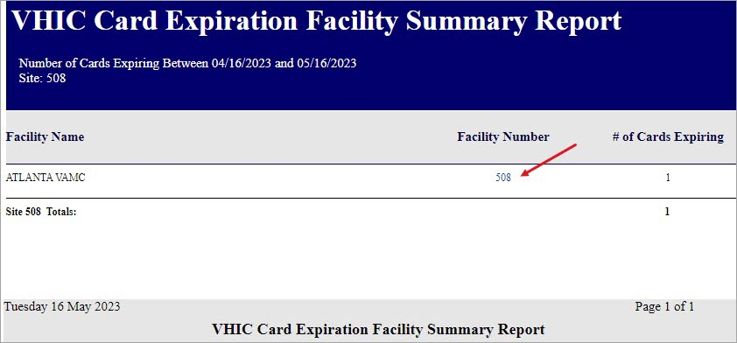

The VHIC Card Expiration Detail Report contains hyperlinks in both the Card Number column and the Last 4 SSN column. Clicking the hyperlink under Card Number will take the user to the Card History Report for that Card ID and clicking on the hyperlink under the Last 4 SSN takes the user to the Veteran Detail Report for the Veteran selected.
Figure 71: VHIC Card Expiration Facility Detail Report

Selecting the [Create XLS] button will generate the report and export it to an Excel spreadsheet. The exported Excel spreadsheet contains the detailed data used to produce the report. An example can be found in Figure 73: VHIC Card Expiration Report Spreadsheet.
Figure 72: VHIC Card Expiration Report XLS Generated
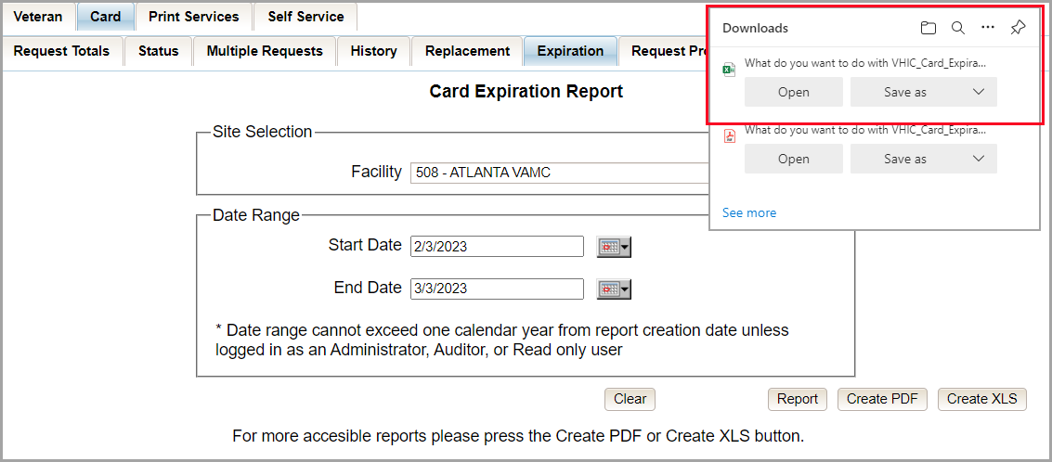

Figure 73: VHIC Card Expiration Report Spreadsheet
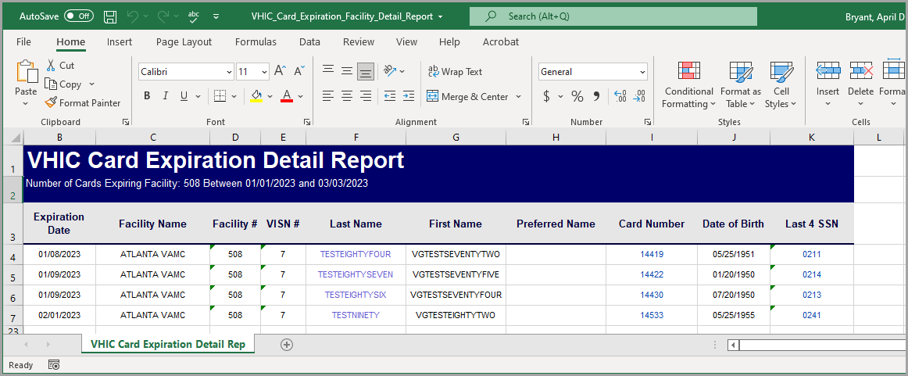

Card Request Progress Report
Table 9: Card Request Progress Report at a Glance
At a Glance…
Who can access this report? | Administrator, Supervisor, Associate, Tech Admin (Tier 3), Auditor
Who can access National version? | Administrator, Tech Admin (Tier 3), Auditor
Date Range Allowed | Administrator, Tech Admin (Tier 3), Auditor – unlimited  Supervisor, Associate – one (1) year or less from date report is being run
Search Criteria Available | VISN, Facility, Start Date, End Date
There are many stages that a VHIC (card) goes through once the user clicks either the [Submit] button or the [Hold] button.
The Card Request Progress report allows the user to see how many cards are currently at each step of the Card Request lifecycle starting from the time the VHIC user clicks on either the [Submit] button or the [Hold] button, all the way through the mailed confirmation for a given VISN, Facility and Nationally, during a set time period.
The card request stages that are displayed on this report are: Pending, Request Submitted, On Hold, Defunct, Sent to Printer, Acknowledged, Rejected, and Confirmed Mailed.
This would allow the user to keep an eye on potential areas of trouble (i.e., Cards On-Hold or timing out and becoming Defunct) and be able to track down what is happening at each stage much easier.

Figure 74: Card Request Progress Report query screen - Administrators
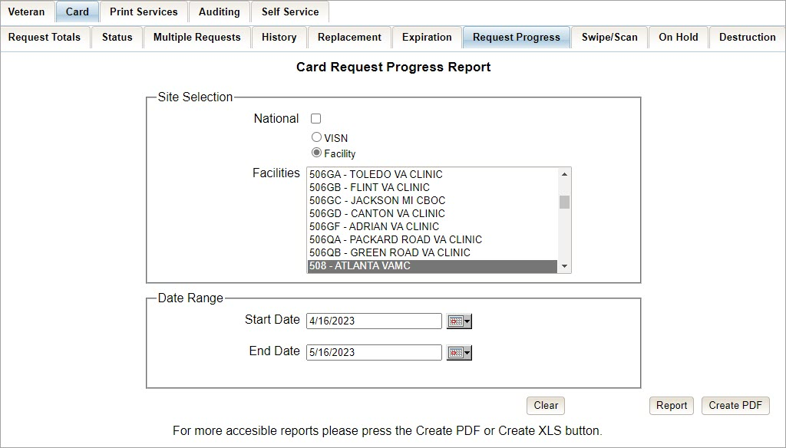

The VHIC Card Request Progress National Summary Report lists all of the VISNs and contains a hyperlink in the VISN # column. Clicking the hyperlink takes the user to the VHIC Card Request Progress VISN Summary Report.
Figure 75: VHIC Card Request Progress National Summary Report
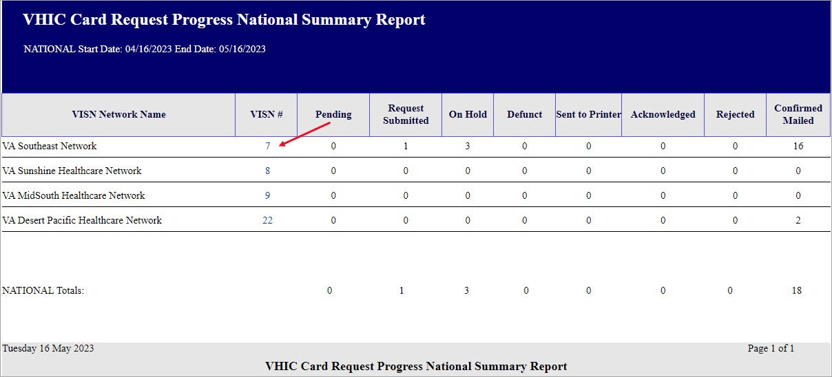

The VHIC Card Request Progress VISN Summary Report lists all of the Facilities included in the selected VISN and contains a hyperlink in the Facility # column. Clicking the hyperlink takes the user to the VHIC Card Request Progress Facility Summary Report.

Figure 76: VHIC Card Request Progress VISN Summary Report
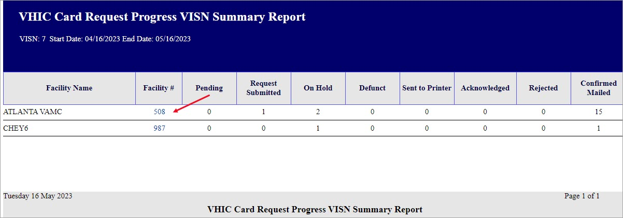

The VHIC Card Request Progress Facility Summary Report contains a hyperlink on the number displayed for each progress status column. Clicking the hyperlink takes the user to the VHIC Card Request Progress Facility Detail Report for the selected progress status.
Figure 77: VHIC Card Request Progress Facility Summary Report
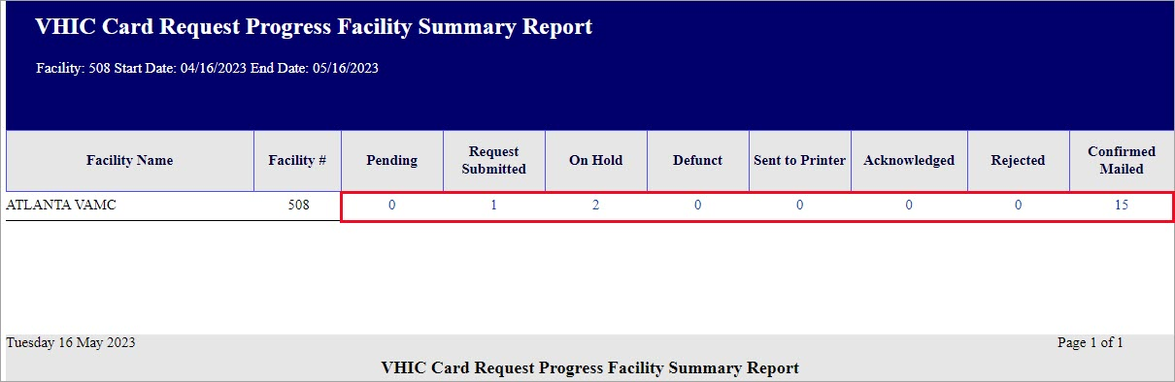

The VHIC Card Request Progress Facility Detail Report will provide a detailed list of all the cards that have the selected status. The user will be able to see the Status Date, Veteran’s Name, Card ID, and Member ID (if available).

The VHIC Card Request Progress Facility Detail Report contains hyperlinks in both the Card Number column and the Last Name column. Clicking the hyperlink under Card Number will take the user to the Card History Report for that Card ID and clicking on the hyperlink under the Last Name takes the user to the Veteran Detail Report for the Veteran selected.

Figure 78: VHIC Card Request Progress Facility Detail Report
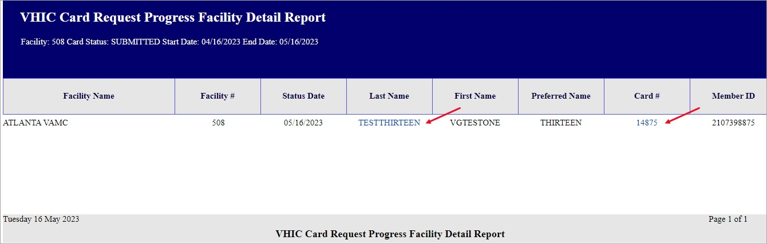

Card Swipe/Scan Report
Table 10: Card Swipe/Scan Report at a Glance
At a Glance…
Who can access this report? | Administrator, Tech Admin (Tier 3), Auditor
Who can access National version? | N/A
Date Range Allowed | N/A
Search Criteria Available | Card ID

The Card Swipe/Scan Report allows the Administrator, Tech Admin (Tier 3) and the Auditor to look up information for a given card ID indicating the location and time where the card has been swiped or scanned .
After entering the Card ID number, select the [Report] button to view the results.
Figure 79: VHIC Card Swipe/Scan Report query screen - Administrators and Auditors
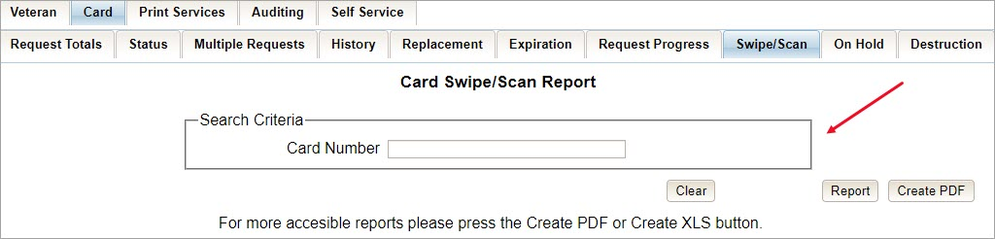

The VHIC Card Swipe Scan Report displays the Facility Name, Facility Number, Vista Option (whether the card was Swiped or Scanned), and the Date and Time the VHIC was Swiped or Scanned in the yyyy-MM-dd hhmmss format.
Figure 80: VHIC Swipe Scan Report results
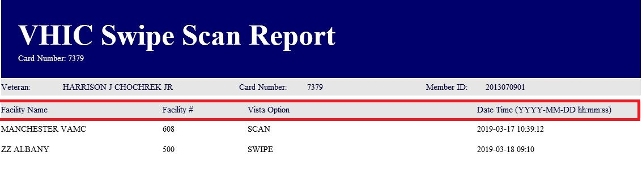

After selecting the [Create PDF] button, a pop-up window will appear asking if you want to open the PDF or save it to your computer.
Figure 81: Create Swipe Scan PDF
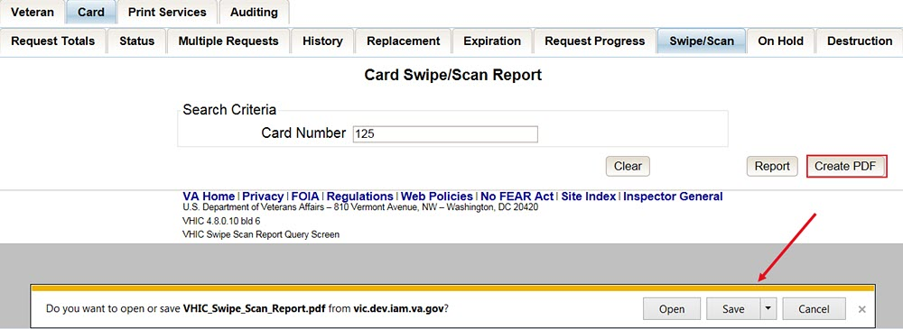

A PDF version of the VHIC Swipe Scan Report results will be generated.
Figure 82: VHIC Swipe Scan Report results PDF
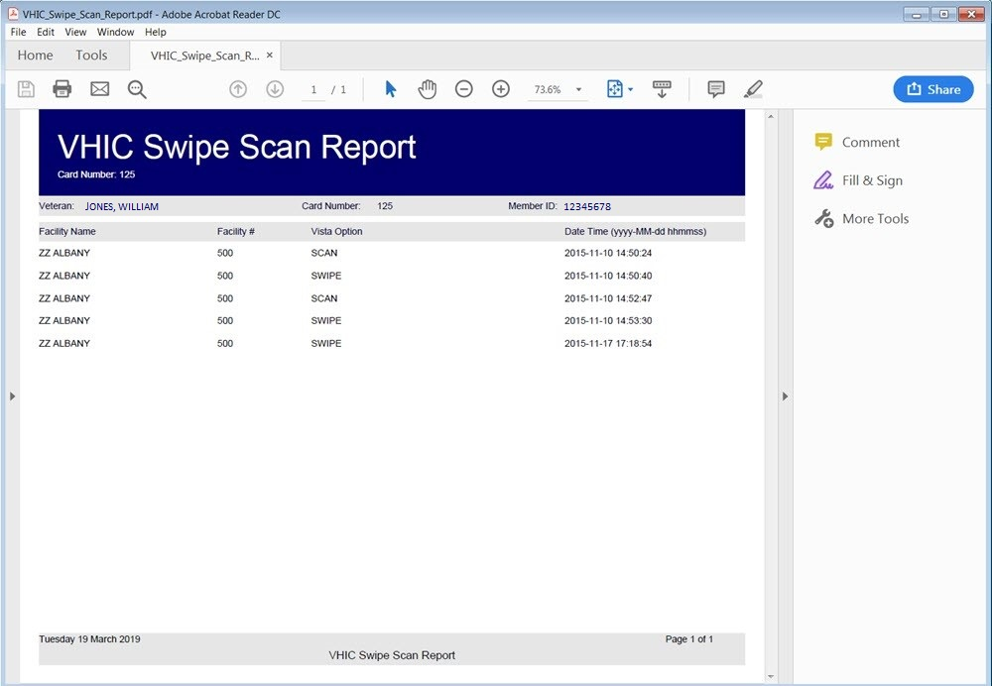

Clicking the [Clear] button will reset the query for a new Card Number.
Figure 83: Card Swipe/Scan Report
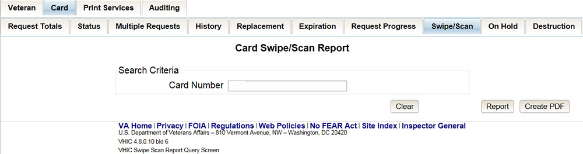

Card On Hold Report
Table 11: On Hold Status Report at a Glance
At a Glance…
Who can access this report? | Administrator, Tech Admin (Tier 3), Supervisor, Associate, Auditor
Who can access National version? | Administrator, Tech Admin (Tier 3), Auditor
Date Range Allowed | Admins, Tech Admin (Tier 3), Auditor – unlimited  Supervisor, Associate – one (1) year or less from date report is being run
Search Criteria Available | VISN, Facility, Start Date, End Date

The On Hold Status Report contains one category: On Hold Status. This report has the usual search criteria options such as National, VISN or Facility, Start Date, and End Date. Along with those, the user must select one of ten On Hold Status options: All, Not Proofed, Eligibility Pending, Enrollment Services Unavailable, Not Correlated, No Photo, No EDIPI, Invalid Date of Birth, Manual Review Required, No Facility Address, and Bad Data.
Figure 84: On Hold Status Report query screen – Administrator
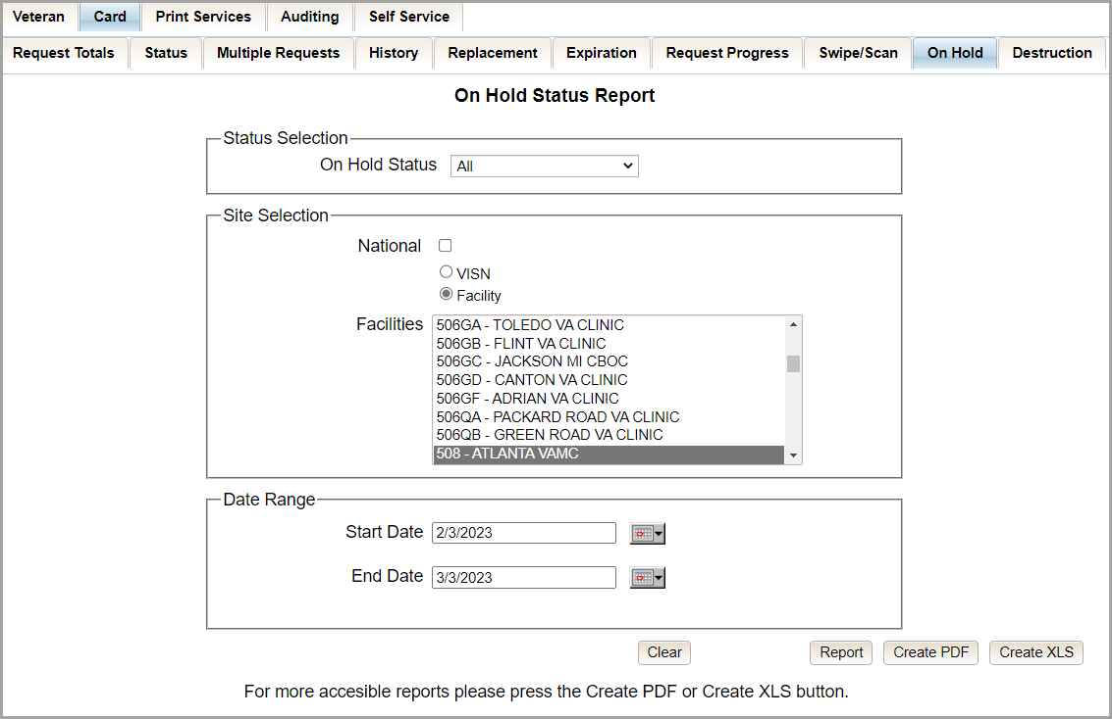

Clicking [PDF] will generate VHIC MPI Status Summary Report in a .pdf.
Figure 85: On Hold Status Report Generate PDF
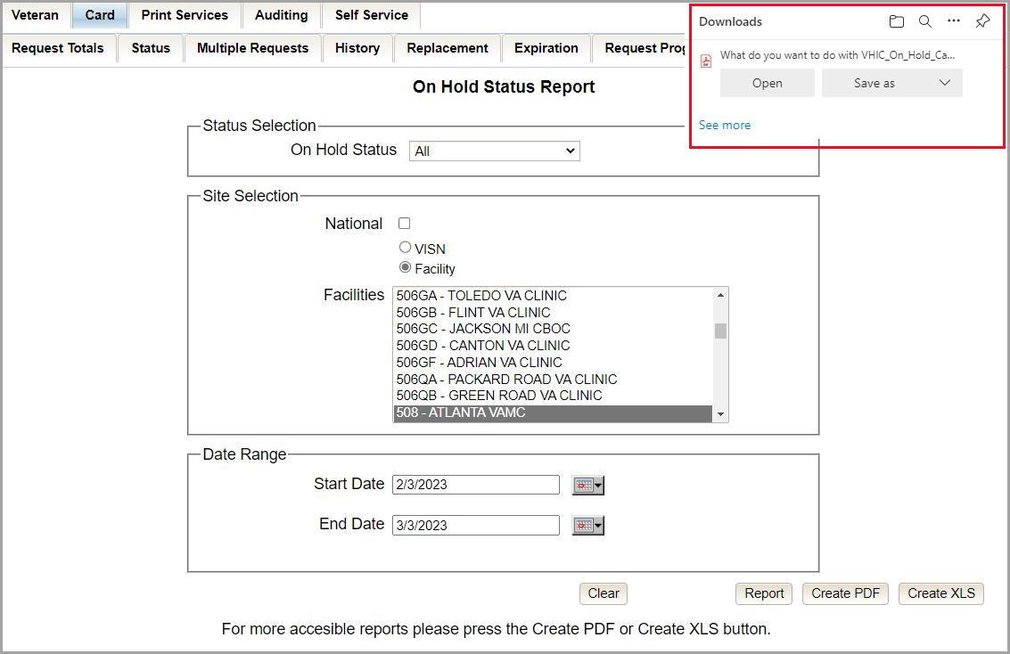

The VHIC On Hold Card Status National Summary Report lists all of the VISNs and contains a hyperlink in the VISN # column. Clicking the hyperlink takes the user to the VHIC On Hold Card Status VISN Summary Report.
Figure 86: VHIC On Hold Card Status National Summary Report
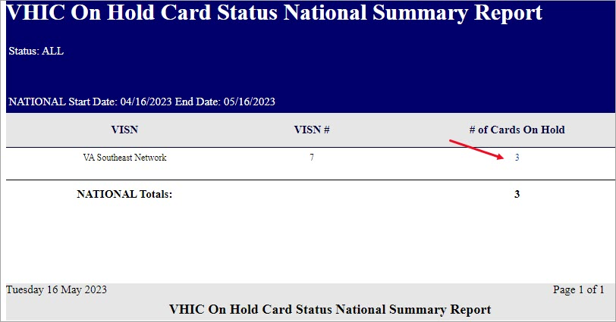

The VHIC On Hold Card Status VISN Summary Report lists all of the Facilities pertaining to the selected VISN and contains a hyperlink in the Facility # column. Clicking the hyperlink takes the user to the VHIC On Hold Card Status Facility Summary Report.
Figure 87: VHIC On Hold Card Status VISN Summary Report
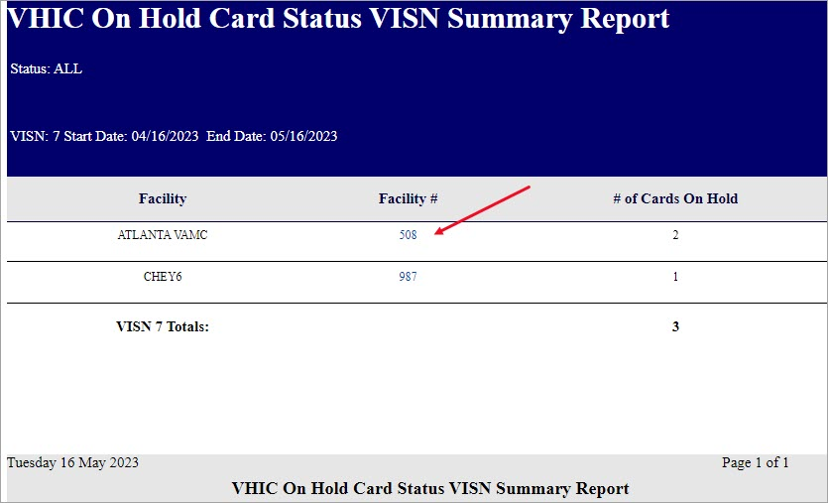

The VHIC On Hold Card Status Facility Summary Report displays the total number of cards On Hold for the selected Facility VISN and contains a hyperlink in the Facility # column. Clicking the hyperlink takes the user to the VHIC On Hold Card Status Facility Detail Report.
Figure 88: VHIC On Hold Card Status Facility Summary Report
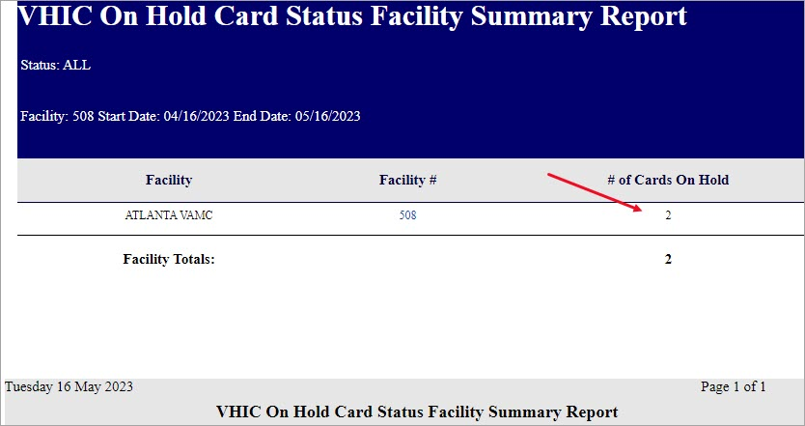

The VHIC On Hold Card Status Facility Detail Report contains several columns: Facility Name, Facility #, On Hold Date, On Hold Reason, Card Issuer, Last Name, and Card Id. The purpose of this report is to provide detailed information in regard to cards that are, or have been, placed on hold. There are hyperlinks in the Last Name and Card ID columns.
- Clicking on the hyperlinked Last Name will take the user to the VHIC Veteran Detail Report
- Clicking the hyperlinked Card ID will take the user to the VHIC Card History Report

Figure 89: VHIC On Hold Card Status Facility Detail Report
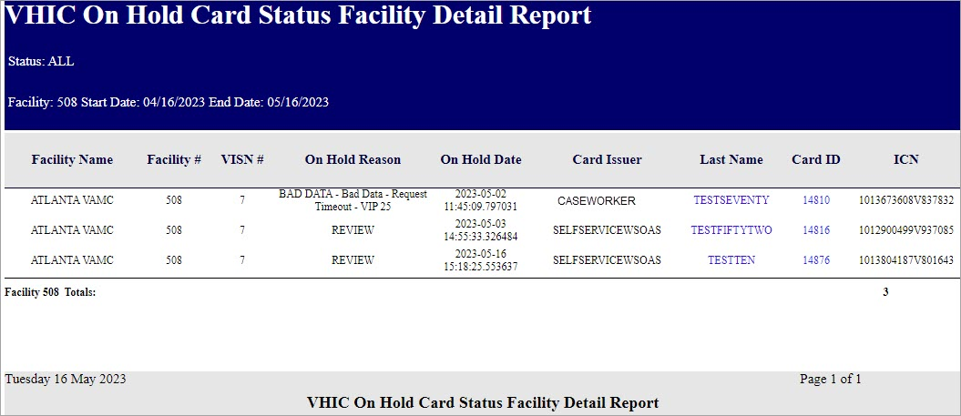

Figure 90: VHIC Veteran Detail Report
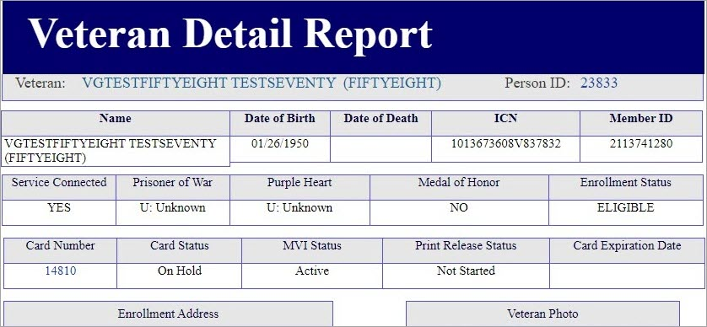

Figure 91: VHIC Card History by Card ID
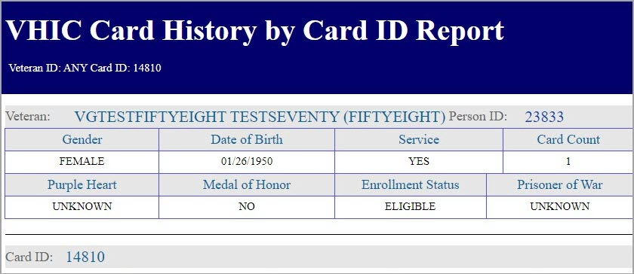

Selecting the [Create XLS] button will generate the report and export it to an Excel spreadsheet. The exported Excel spreadsheet contains the detailed data used to produce the report. An example can be found in Error! Not a valid bookmark self-reference..
Figure 92: VHIC On Hold Card Status Report XLS Generated
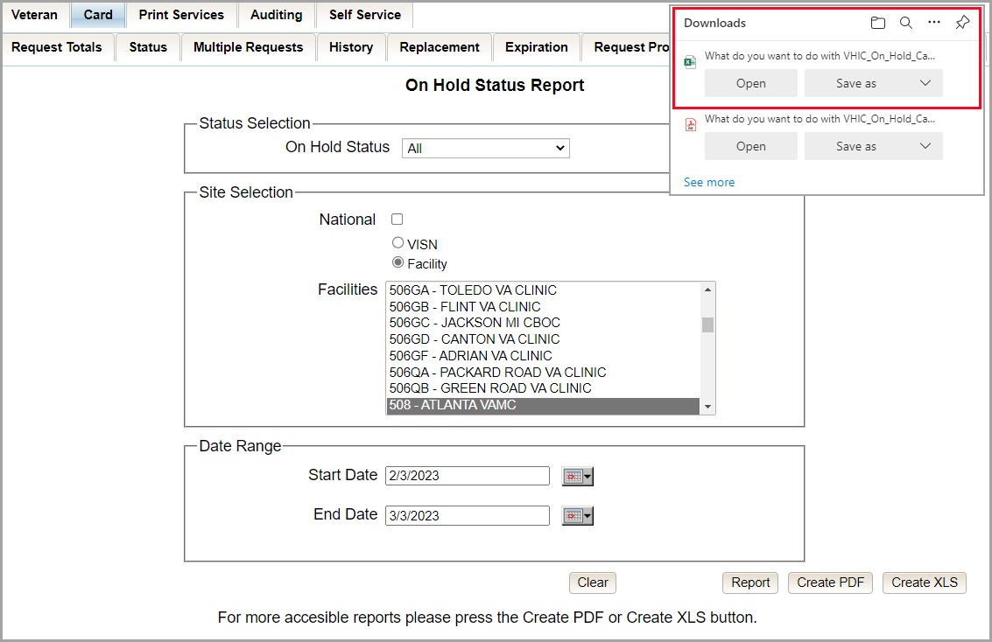

Figure 93: VHIC On Hold Card Status Report Detailed Spreadsheet
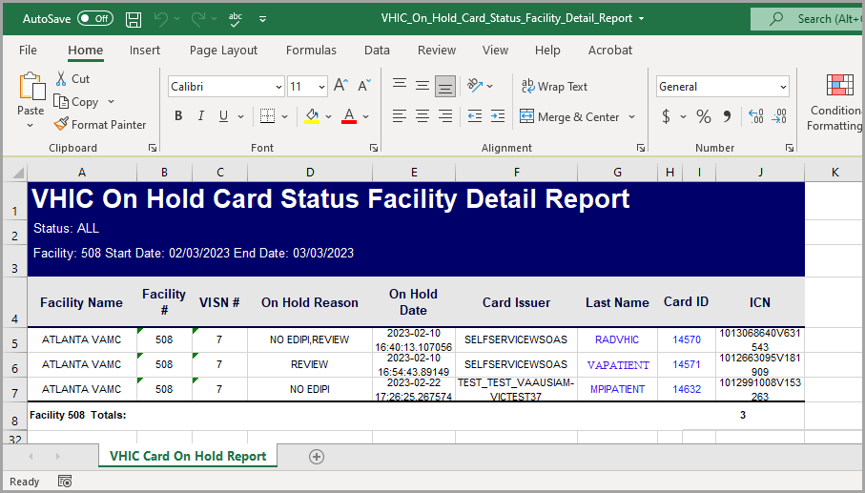

Card Destruction Report
Table 12: Card Destruction Report at a Glance
At a Glance…
Who can access this report? | Administrator, Tech Admin (Tier 3), Auditor
Who can access National version? | N/A
Date Range Allowed | Admins, Tech Admin (Tier 3), Auditor – unlimited
Search Criteria Available | Pending Destruction, Destroyed, Card Type, Start Date, End Date
The Card Destruction Report contains two categories: Pending Destruction and Destroyed. The user must also a select one of four Card Type options: All, Legacy, Mass Reissuance, and VHIC. As with other searches, the user must specify a Start Date and End Date range for the search.

Figure 94: Card Destruction Report Pending Destruction – Administrator View
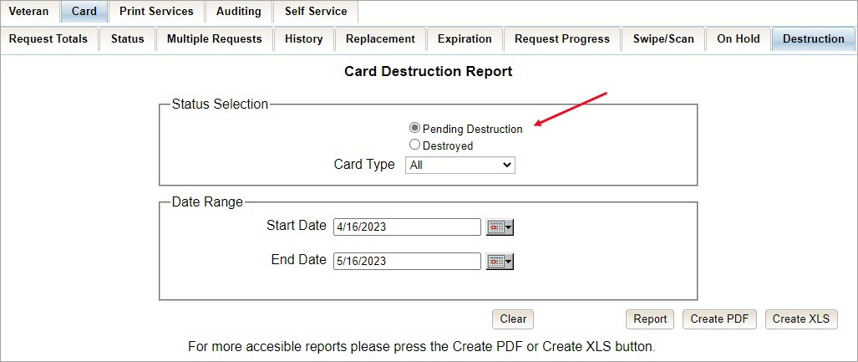

Clicking [PDF] will generate VHIC MPI Status Summary Report in a .pdf format.
Figure 95: Card Destruction Report Pending Destruction PDF Generated
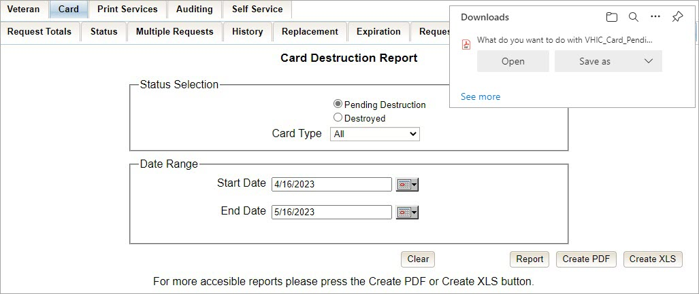

Choosing Pending Destruction and Card Type All, users receive the VHIC Card Destruction Report – Pending Destruction report. Click the Last Name hyperlink highlighted below.

Figure 96: Card Destruction Report – Pending Destruction – Last Name Hyperlink
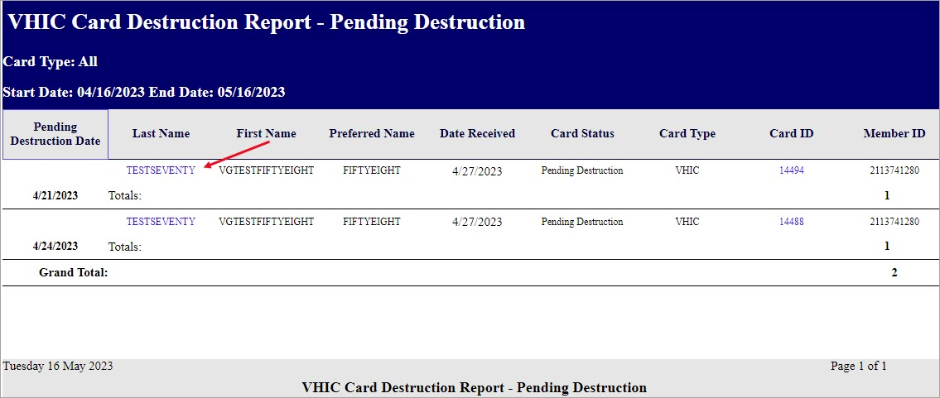

This returns the Veteran Detail Report.
Figure 97: Veteran Detail Report

Click the Card ID hyperlink highlighted below.
Figure 98: Card Destruction Report – Pending Destruction – Card ID Hyperlink
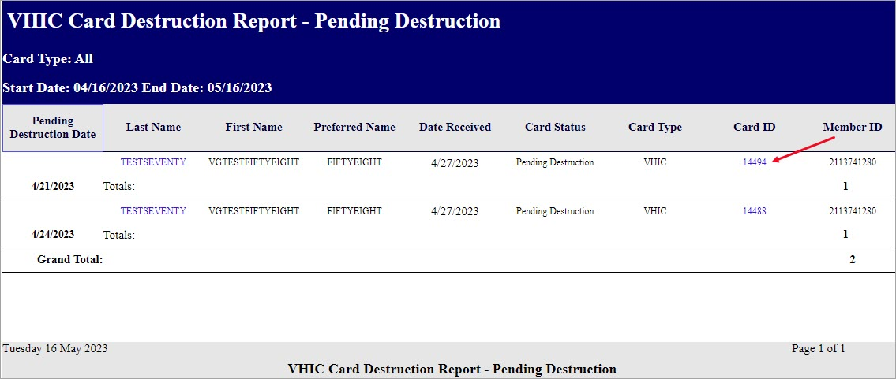

The Card ID hyperlink opens the VHIC Card History by Card ID Report.
Figure 99: VHIC Card History by Card ID Report

NOTE: Clicking the Person ID hyperlink, in the upper right-hand corner of the VHIC Card History by Card ID Report, opens the Veteran Detail Report.

Selecting the [Create XLS] button will generate the report and export it to an Excel spreadsheet. The exported Excel spreadsheet contains the detailed data used to produce the report.
Figure 100: Card Destruction Pending Report XLS Generated
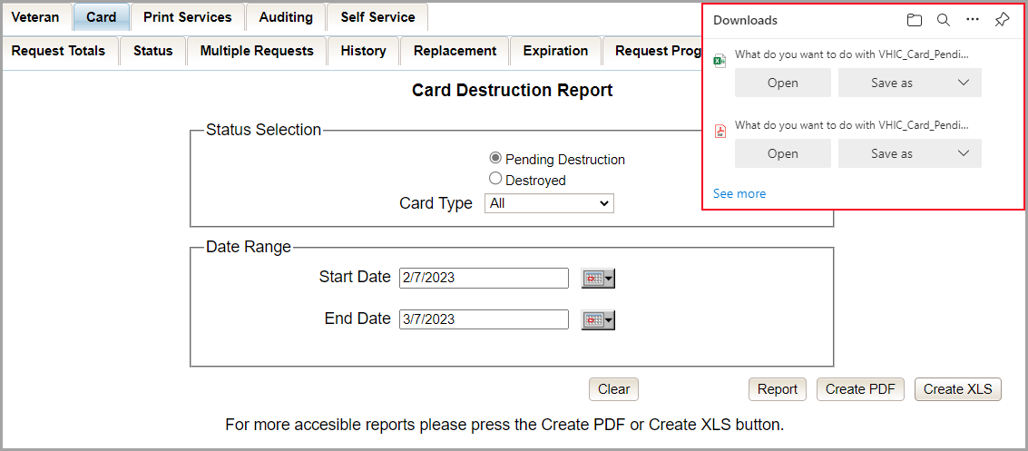

Figure 101: Card Destruction Pending Report Spreadsheet
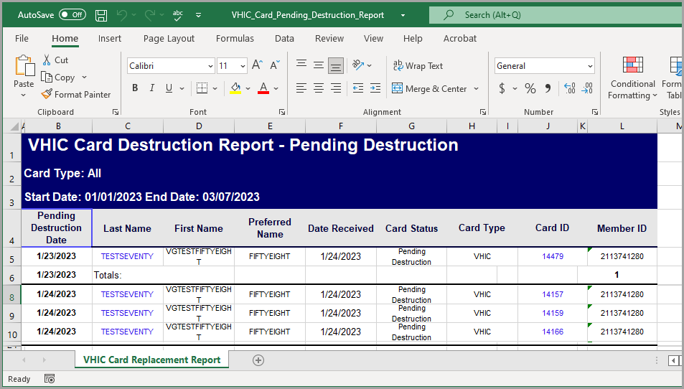

Choosing Destroyed and Card Type All the user receives a report of the cards destroyed within a specified date range.

Figure 102: Card Destruction Destroyed Report Query
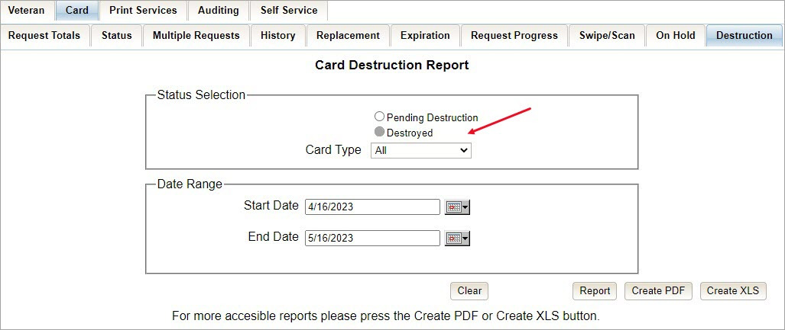

Clicking [PDF] will generate VHIC MPI Status Summary Report in a .pdf format.
Figure 103: Card Destruction Destroyed Report PDF Generated
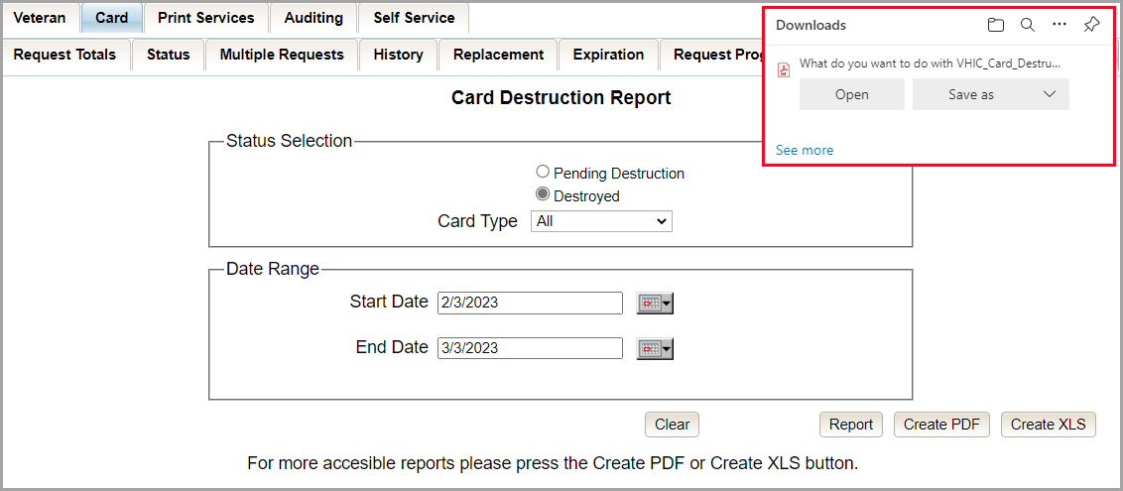

Selecting the [Create XLS] button will generate the report and export it to an Excel spreadsheet.
Figure 104: Card Destruction Destroyed Report XLS Generated
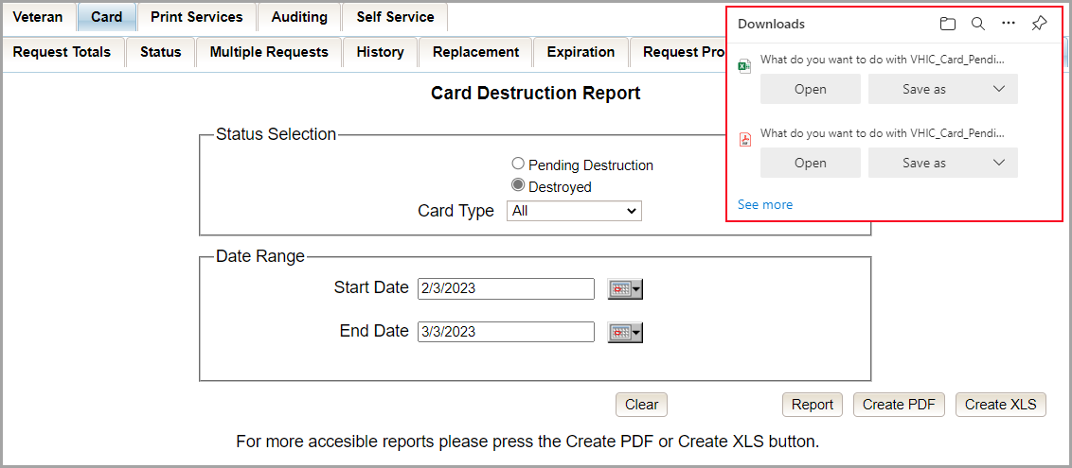

The exported Excel spreadsheet contains the detailed data used to produce the report. An example can be found below.
Figure 105: Card Destroyed Report Spreadsheet
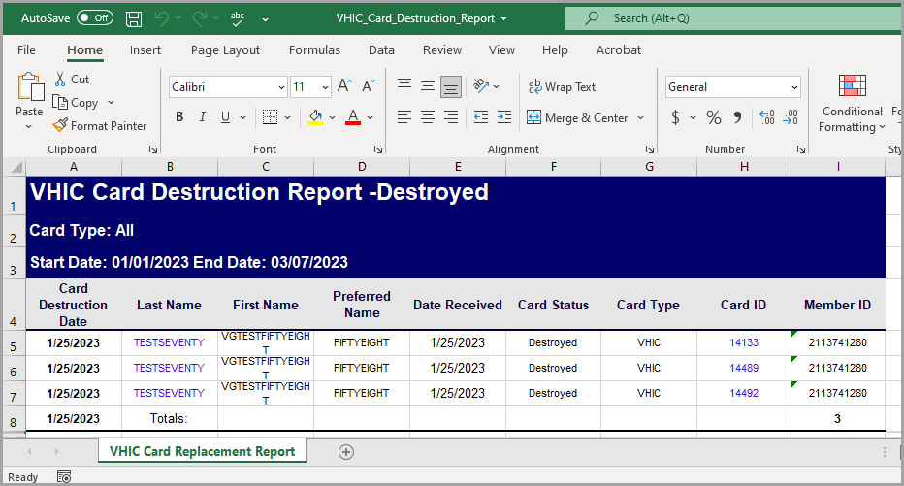

Figure 106: VHIC Card Destroyed Report
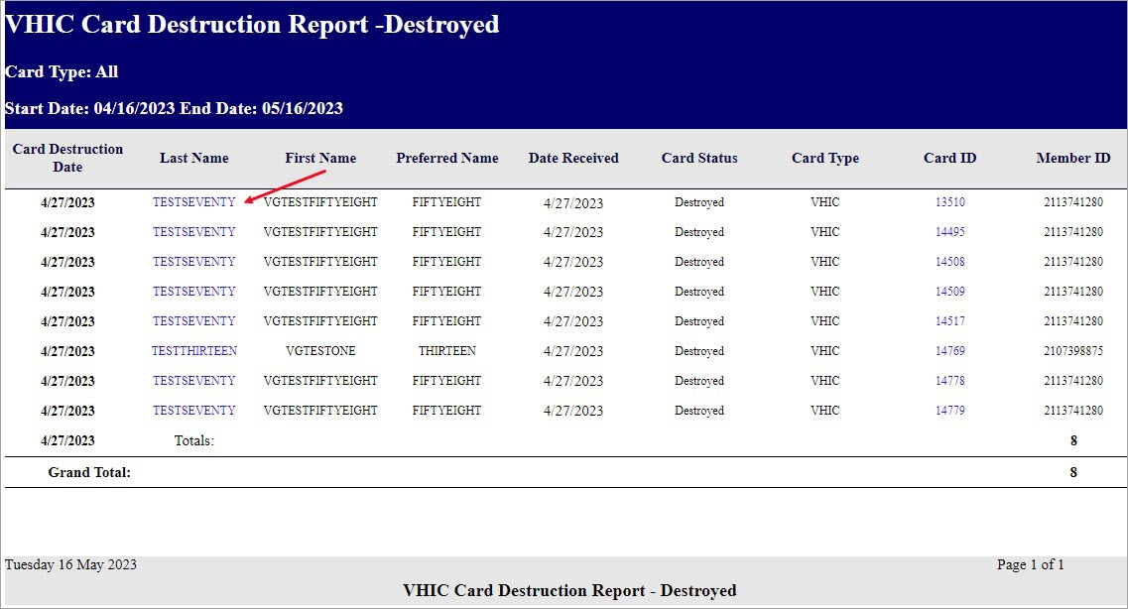

Clicking on the Veteran Last Name hyper link will direct you to the Veteran Detail Report.
Figure 107: Veteran Detail Report

Clicking the Card ID hyperlink will direct you to the Card History by ID Report as seen below.

Figure 108: VHIC Card Destruction Report - Destroyed - Card ID Hyperlink
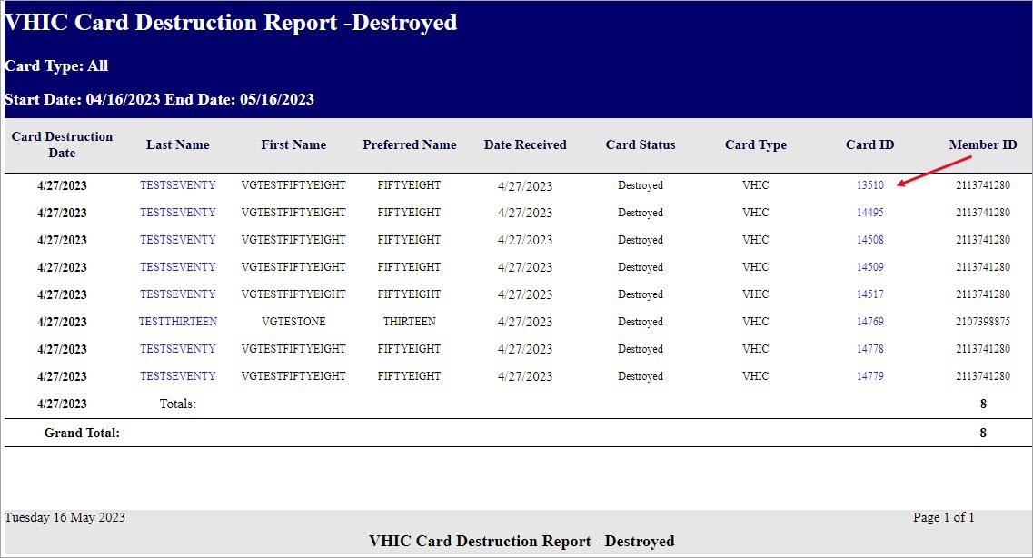

Figure 109: VHIC Card History by Card ID Report

NOTE: Clicking the Person ID hyperlink, in the upper right-hand corner of the VHIC Card History by Card ID Report, opens the Veteran Detail Report.

Print Services – Processing Report
Table 13: Batch Summary Report at a Glance
At a Glance…
Who can access this report? | Administrator, Supervisor, Tech Admin (Tier 3), Auditor
Who can access National version? | Administrator, Tech Admin (Tier 3), Auditor
Date Range Allowed | Admins, Tech Admin (Tier 3), Auditor – unlimited  Supervisor, Associate – one (1) year or less from date report is being run
Search Criteria Available | VISN, Facility, Start Date, End Date
Clicking [Submit] on step 6 of the Card Request process does not immediately transmit a card request to the print vendor. The card requests from all sites are stored throughout the day, then bundled and transmitted to the print vendor in one batch file. When the print vendor receives the batch file, they send back an acknowledgement file for every request specifying success or failure in card printing. The number in the report comes from the data updated by the confirmation and acknowledgement files received from the print vendor.

The Print Services Processing Status Summary Report date fields are not auto populated like most of the other reports. The user must populate them prior to running the report.
Figure 110: VHIC Print Services Processing Status Summary Report as seen by Administrators
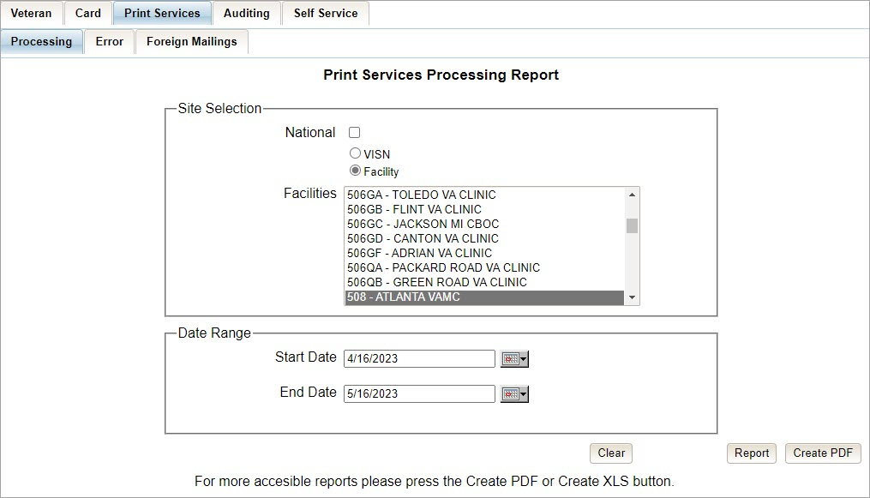

The VHIC Batch File Processing Status Summary Report provides a high-level count of Accepted, Error, Sent, Mailed, and Rejected card requests. The VHIC Batch File Processing Status National Summary Report has a hyperlink in the VISN number column that will take you to the VHIC Batch File Processing Status Summary Report – VISN.
Figure 111: VHIC Print Services Processing Status Summary Report
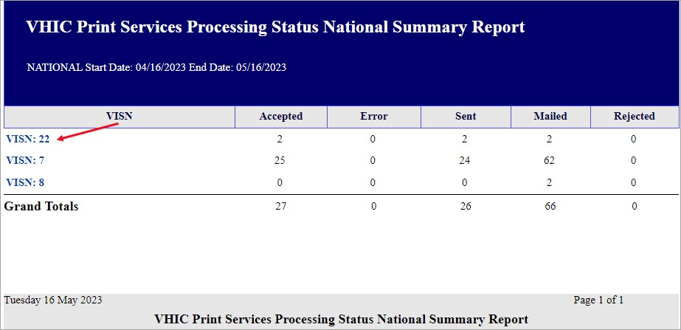

The VHIC Batch File Processing Status Summary Report – VISN has a hyperlink in the Facility Code column that will take you to the VHIC Batch File Processing Status Summary Report – Facility.
Figure 112: VHIC Print Services Processing Status VISN Summary Report
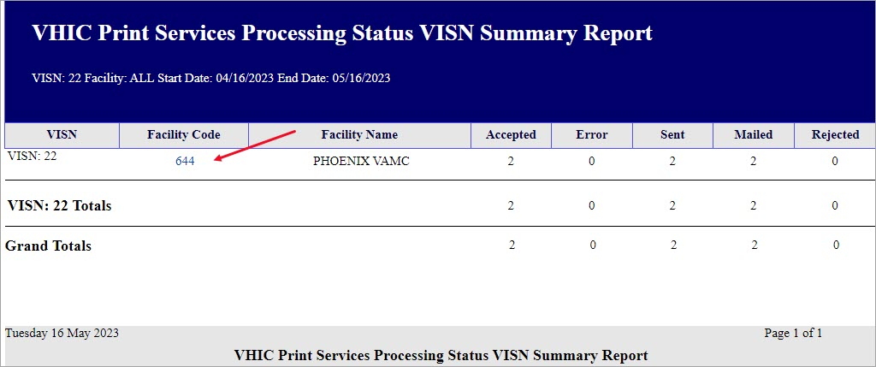

The VHIC Batch File Processing Status Summary Report – Facility has a hyperlink in the Facility Code column that will take you to the VHIC Batch File Processing Status Detail Report.

Figure 113: VHIC Print Services Processing Status Facility Summary Report
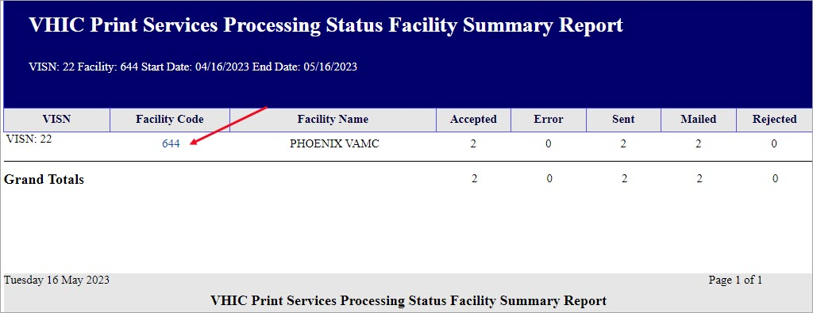

Figure 114: VHIC Print Services Processing Status Facility Detail Report
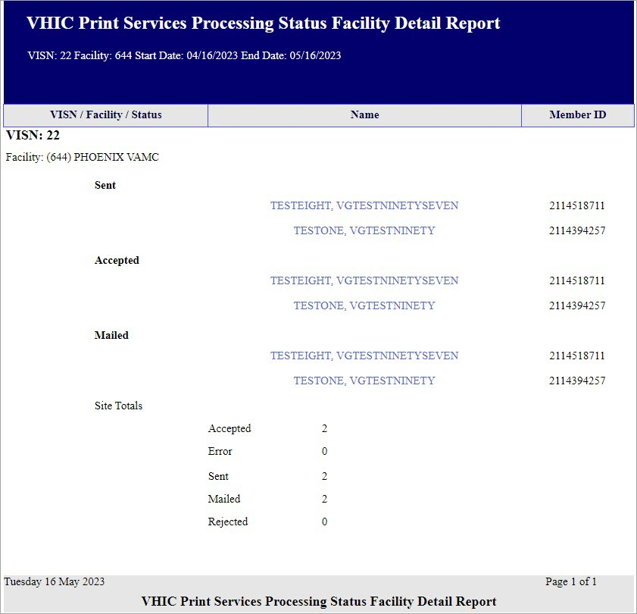

Print Services – Batch Error Report
Table 14: Batch Error Report at a Glance
At a Glance…
Who can access this report? | Administrator, Supervisor, Tech Admin (Tier 3), Auditor
Who can access National version? | Administrator, Tech Admin (Tier 3), Auditor
Date Range Allowed | Admins, Tech Admin (Tier 3), Auditor – unlimited  Supervisor – one (1) year or less from date report is being run
Search Criteria Available | VISN, Facility, Not Acknowledged, Acknowledged Not Confirmed, Pending Not Sent (which includes configurable Number of Days field), Start Date, End Date
The VHIC Print Error Status Summary Report – Sent Not Acknowledged allows the user to find out how many cards have not been acknowledged with an acknowledgement file or cards that have been acknowledged but have received no confirmation of being mailed (Acknowledged Not Mailed) within a given date range. The user will also be able to see how many cards are still sitting in a Pending state and have not been sent to the print vendor (Pending Not Sent).

The user would be able to select the number of days to configure the query. How many days after being sent to the printer before looking for an Acknowledgement file, how many days after getting the Acknowledgement file before receiving Confirmation of it being mailed, or how many days has the card been sitting at a Pending status but has not been sent to the print vendor.

The user would be able to select between National, VISN, and Facility depending on their role.

Figure 115: Print Services – Print Error Status Report query screen – Administrator View
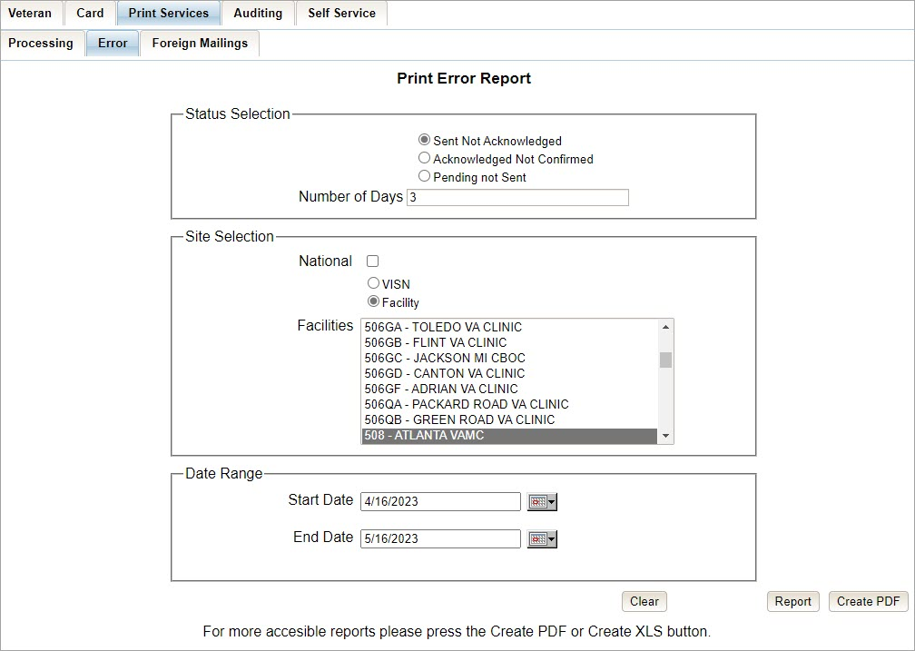

Sent Not Acknowledged
By selecting the [Not Acknowledged] radio button, the VHIC user will be able to see how many cards have not been acknowledged as received within the entered Number of Days (the default is three (3) days) after being sent to the print vendor during the selected Date Range.

Figure 116: VHIC Print Error Status Facility Summary Report – Sent Not Acknowledged
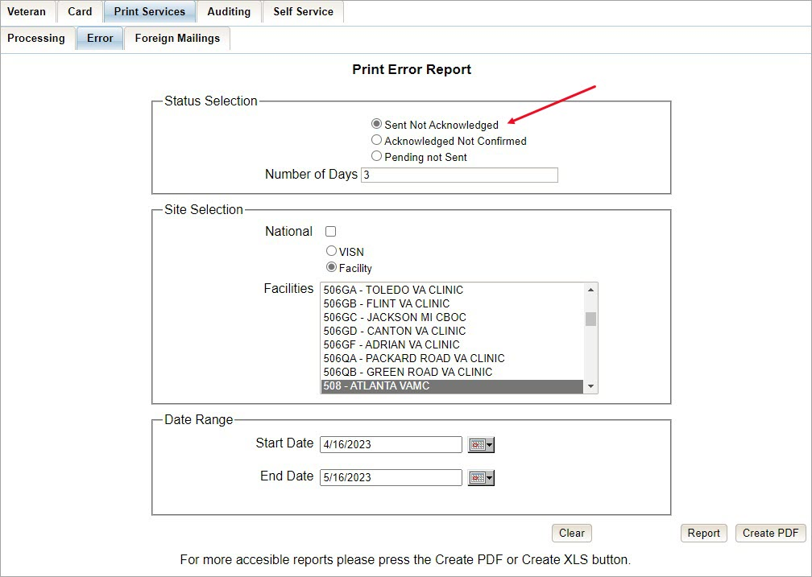

The National Error Summary report lists all of the VISNs and the VISN # is a hyperlink to the VISN Error Summary Report.
Figure 117: VHIC Print Error Status National Summary Report – Sent Not Acknowledged
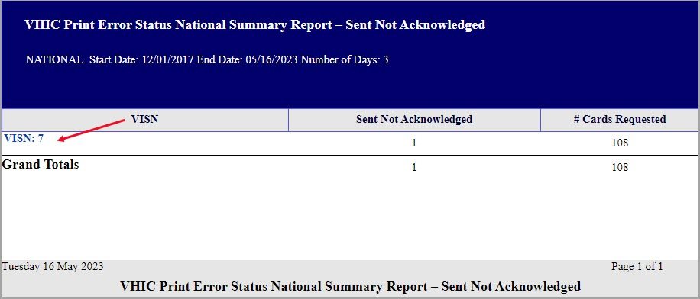

The VISN Error Summary Report lists all of the Facilities for the selected VISN. The Facility # is a hyperlink to the Facility Error Summary Report.
Figure 118: VHIC Print Error Status VISN Summary Report – Sent Not Acknowledged
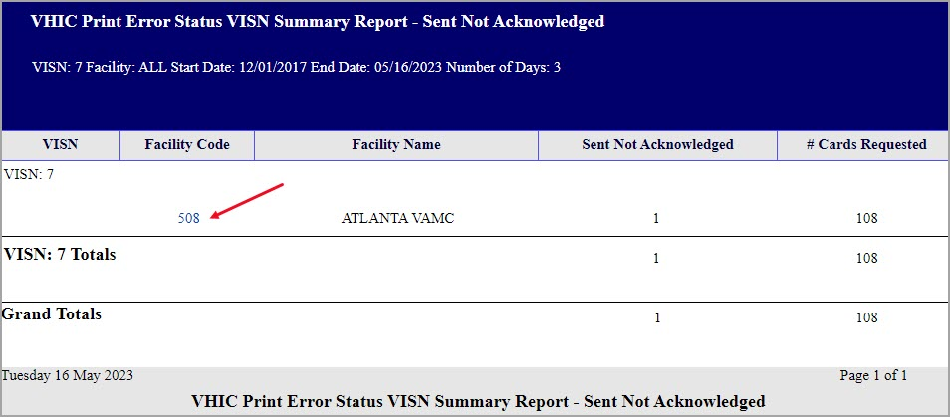

The Facility Error Summary Report shows the totals for the selected Facility. The Facility # is a hyperlink to the Facility Error Detail Report.
Figure 119: VHIC Print Error Status Facility Summary Report – Sent Not Acknowledged
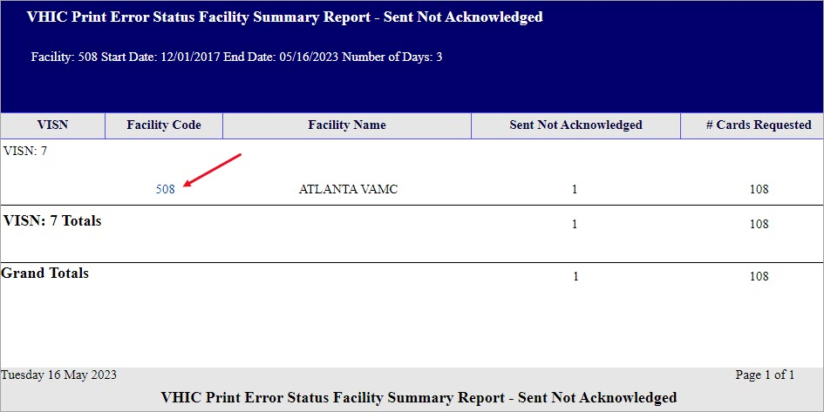

The Facility Error Detail Report would give a list of all of the cards that have NOT been Acknowled by the print vendor and will display the Veteran’s Name, Card ID, and the Card Request File name.
Figure 120: VHIC Batch File Processing Error Status Detail Report - Not Acknowledged
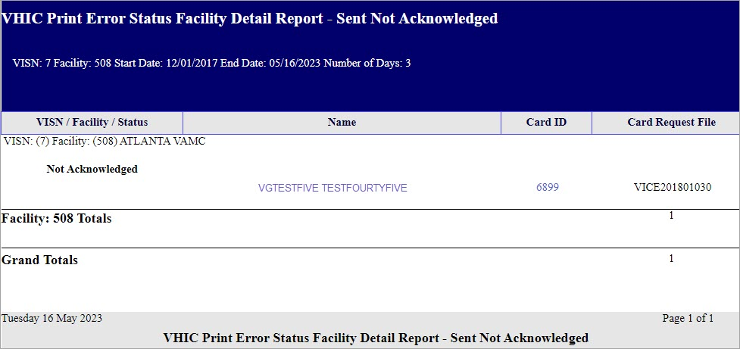

Acknowledged Not Confirmed
By selecting the [Acknowledged Not Confirmed] radio button, the VHIC user will be able to see how many cards have been acknowledged as received but have NOT been confirmed as mailed within the entered Number of Days (the default is seven (7) days) after receiving the acknowledgement file from the print vendor during the selected Date Range.

Figure 121: VHIC Print Error Status Facility Detail Report – Acknowledged Not Confirmed
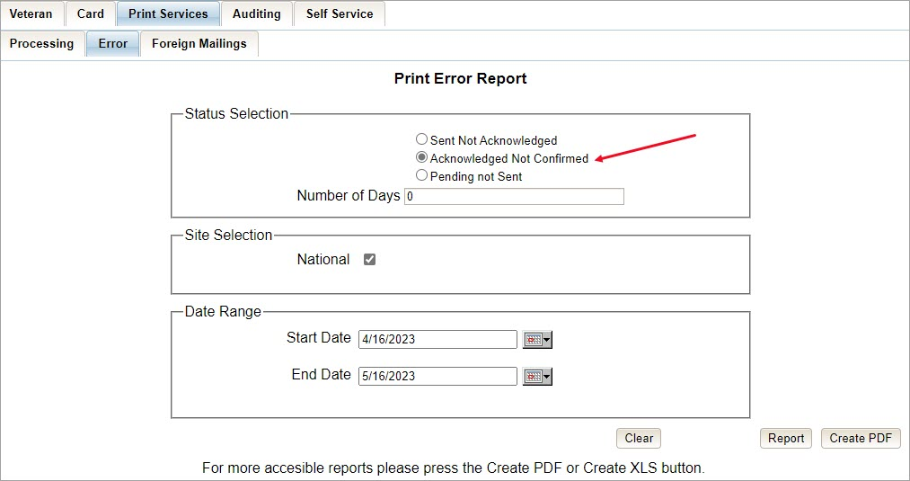

The National Error Summary report lists all of the VISNs and the VISN # is a hyperlink to the VISN Error Summary Report.
Figure 122: VHIC Print Error Status National Summary Report – Acknowledged Not Confirmed
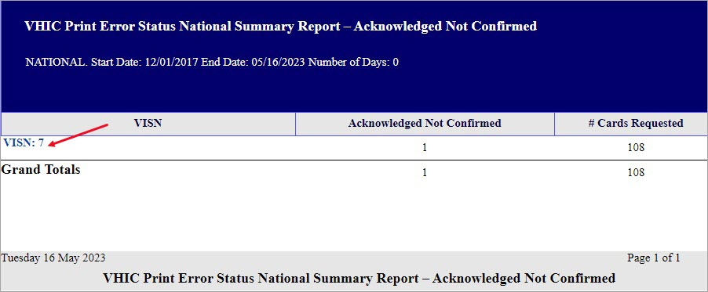

The VISN Error Summary Report lists all of the Facilities for the selected VISN. The Facility # is a hyperlink to the Facility Error Summary Report.
Figure 123: VHIC Print Error Status VISN Summary Report – Acknowledged Not Confirmed
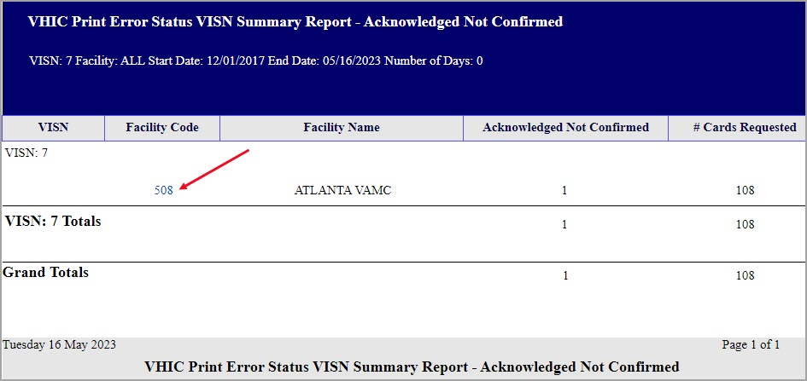

The Facility Error Summary report shows the totals for the selected Facility. The Facility # is a hyperlink to the Facility Error Detail Report.

Figure 124: VHIC Print Error Status Facility Detail Report – Acknowledged Not Confirmed
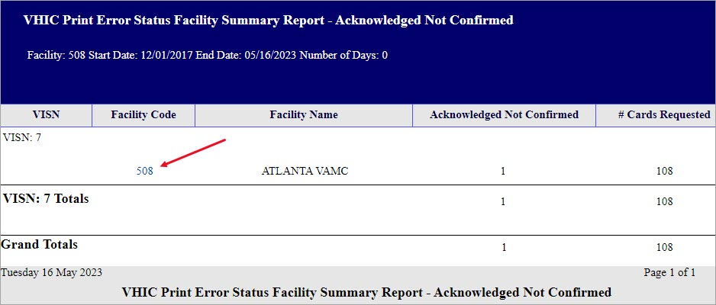

The Facility Error Detail Report would give a list of all of the cards that have NOT been confirmed as Mailed by the print vendor and will display the Veteran’s Name, Card ID, and the Acknowledgement File name.

Figure 125: VHIC Print Error Status Facility Detail Report – Acknowledged Not Confirmed
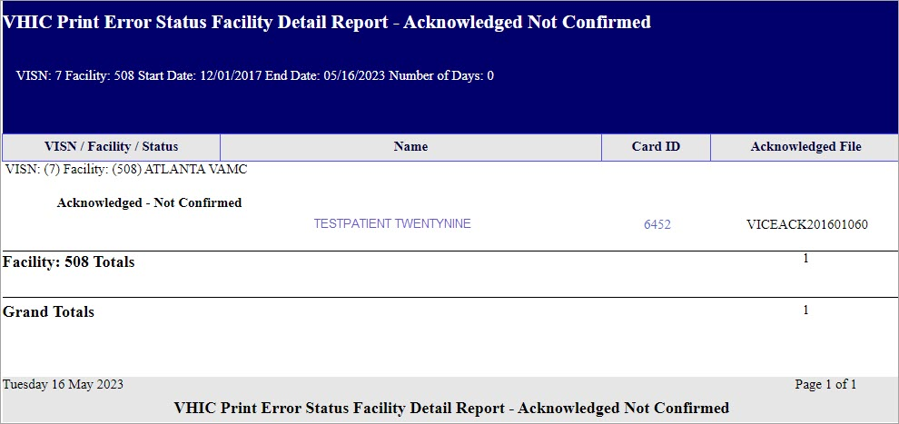

Pending Not Sent
By selecting the [Pending Not Sent] radio button, the VHIC user will be able to see how many cards are sitting in the Pending Card Status state and have not been sent to the print vendor within the entered Number of Days (the default is three (3) days) after the card request has been submitted by the VHIC User within the selected Date Range.

Figure 126: VHIC Print Error Status National Summary Report – Pending Not Sent
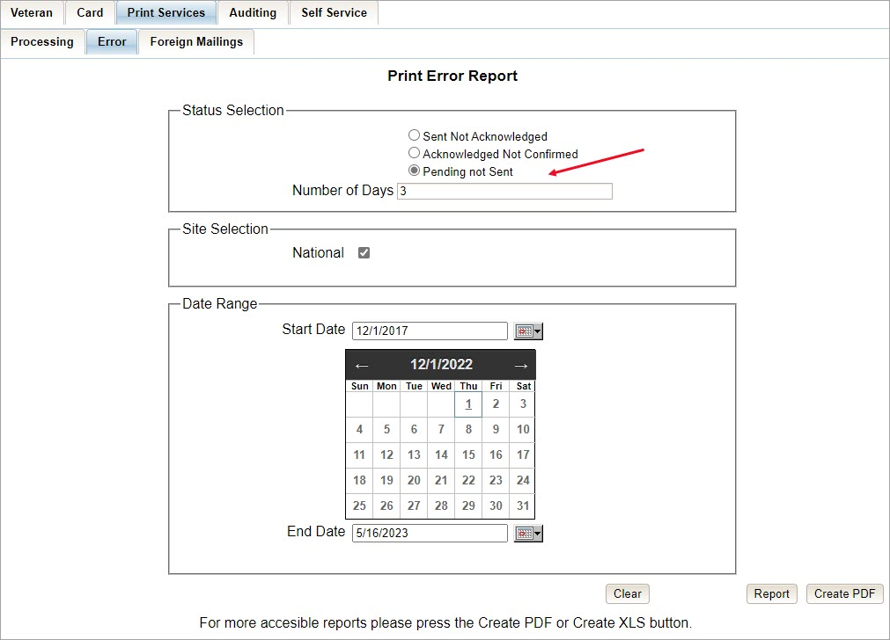

The National Error Summary Report lists all of the VISNs and the VISN # is a hyperlink to the VISN Error Summary Report.
Figure 127: VHIC Print Error Status National Summary Report – Pending Not Sent
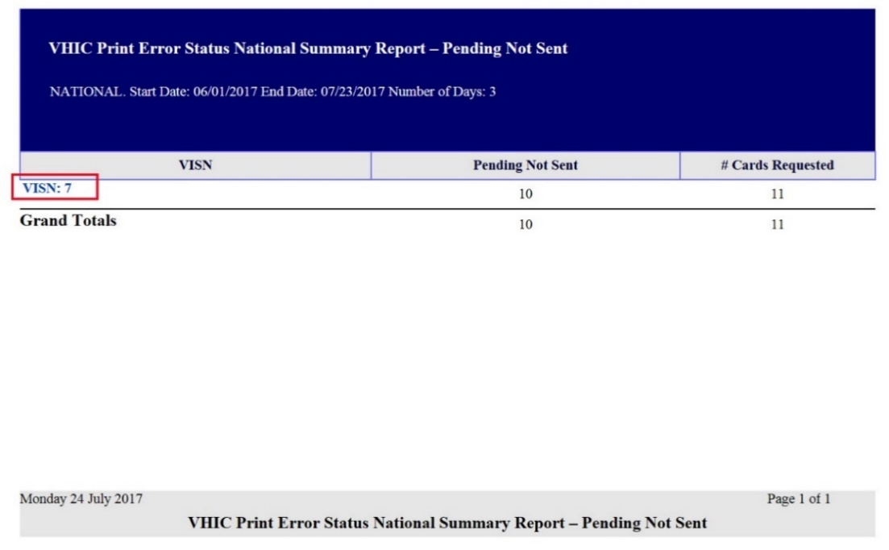

The VISN Error Summary Report lists all of the Facilities for the selected VISN. The Facility # is a hyperlink to the Facility Error Summary Report.

Figure 128: VHIC Print Error Status VISN Summary Report – Pending Not Sent
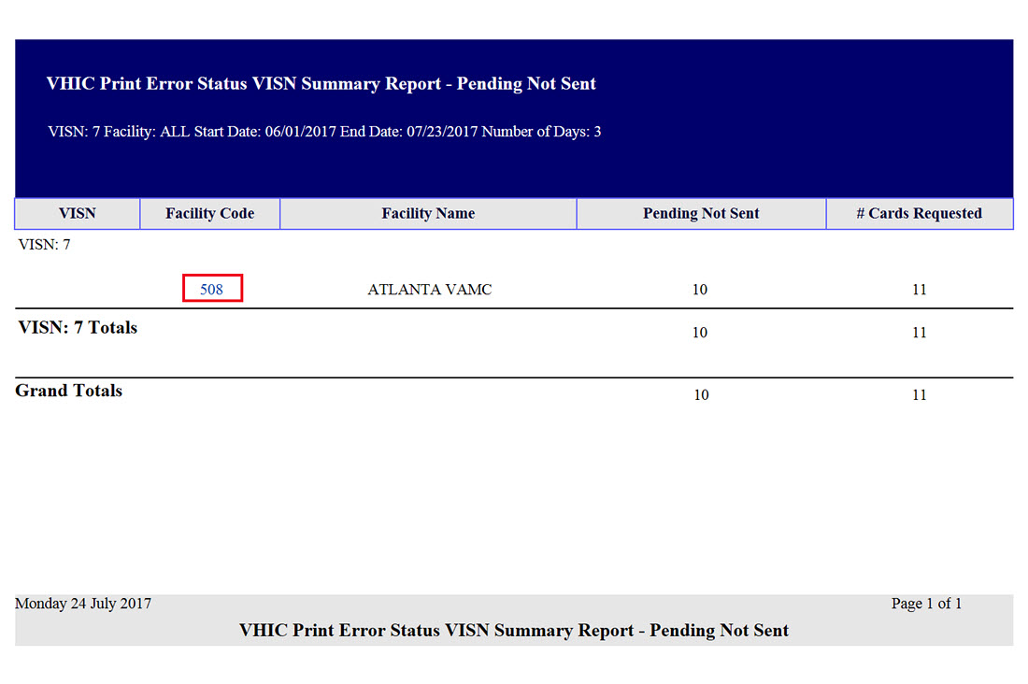

The Facility Error Summary report shows the totals for the selected Facility. The Facility # is a hyperlink to the Facility Error Detail Report.

Figure 129: VHIC Batch File Processing Error Status Summary Report – Facility
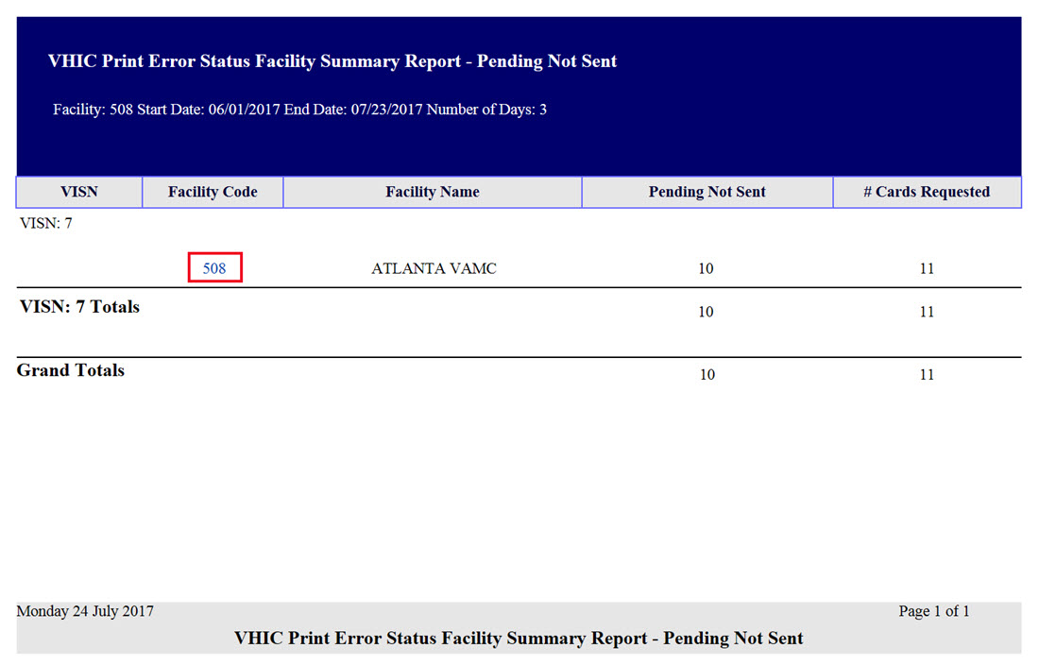

The Facility Error Detail Report gives a list of all of the cards that have NOT been sent to the print vendor will display the Veteran’s Name and Card ID.

Figure 130: VHIC Print Error Status Facility Detail Report – Pending Not Sent
REDACTED

Auditing Report
Table 15: Audit Report at a Glance
At a Glance…
Who can access this report? | Administrator, Supervisor, Tech Admin (Tier 3), Auditor
Who can access National version? | N/A
Date Range Allowed | Admins, Tech Admin (Tier 3), Auditor – unlimited  Supervisor – one (1) year or less from date report is being run
Search Criteria Available | Login, Start Date, End Date
The Auditing Report provides a way to track all activity for individual users within the VHIC system. To run this report, the user must enter the login name/ID for the user being audited. The resulting report returns the following fields of information: Date/Time, Audit ID, Action, Person ID, Member ID, Card ID, and Query String. The query string shows all of the information that was entered into various fields and/or submitted by the associate. Items in the audit report are listed in order of the Date/Time stamp.
Figure 131: Audit Report query screen – Administrators and Auditors
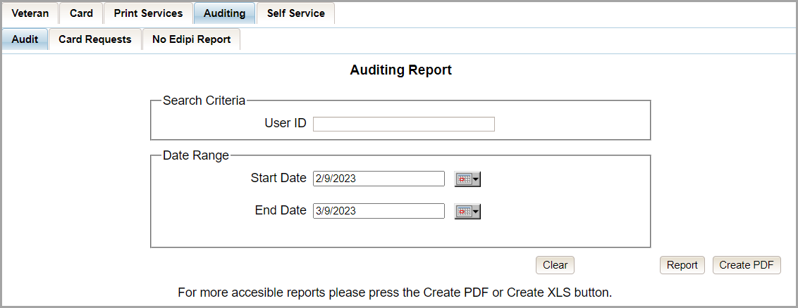

Figure 132: VHIC Auditing Report
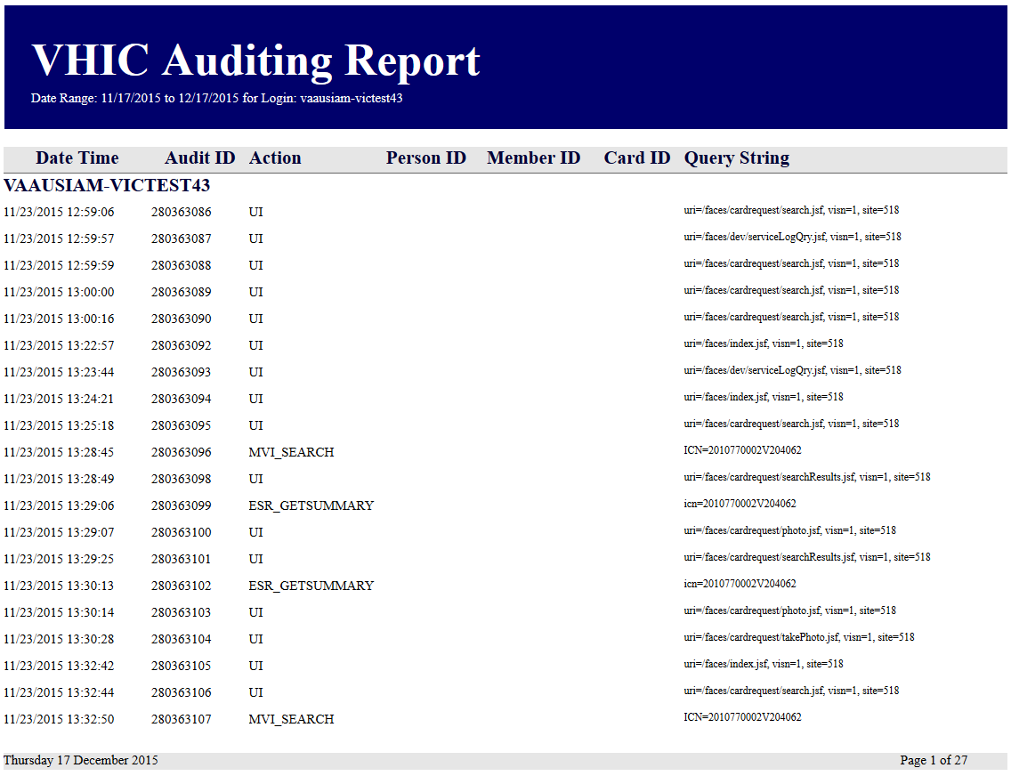

Card Requests Report
Table 16: Card Request Report at a Glance
At a Glance…
Who can access this report? | Administrator, Supervisor, Tech Admin (Tier 3), Auditor
Who can access National version? | N/A
Date Range Allowed | Admins, Tech Admin (Tier 3) – unlimited  Supervisor – one (1) year or less from date report is being run
Search Criteria Available | Login, Start Date, End Date
The Card Requests Report provides the VHIC card requests by user for the selected VISN and/or Facility. Selecting either the [VISN] or the [Facility] radio button will update the list of available options accordingly (based on a user’s role). Selecting the National checkbox, if available, returns results for all VISNs and Facilities.

Figure 133: Card Requests query screen – Administrators and Auditors Only
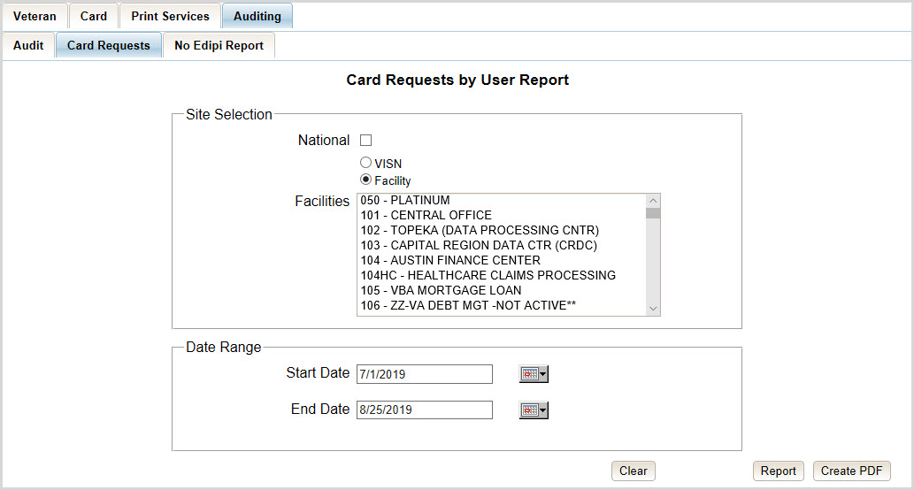

The Card Requests Report provides results by user. Each report contains links that open additional reports. The following example illustrates those reports using a Site Selection of [National]. This search returns data under the columns of VISN Name, VISN Number, and # of Card Requests. Click the VISN Number hyperlink to open the next report.

Figure 134: VHIC Card Requests by User Summary Report – National
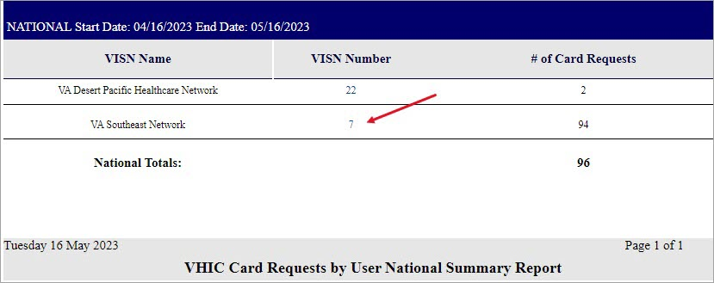

The VHIC Card Requests by User VISN Summary Report opens. This search returns data under the columns of Facility, Facility Number, and # of Card Requests. Click the Facility Number hyperlink to open the next report.
Figure 135: VHIC Card Requests by User VISN Summary Report
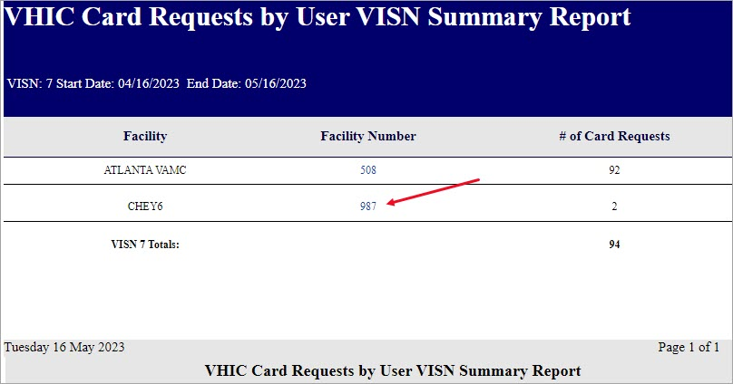

The VHIC Card Requests by User Facility Summary Report opens. This search returns data under the columns of Facility Name, Facility Number, User ID, and 3 of Card Requests. Click the User ID hyperlink to open the next report.

Figure 136: VHIC Card Requests by User Facility Summary Report
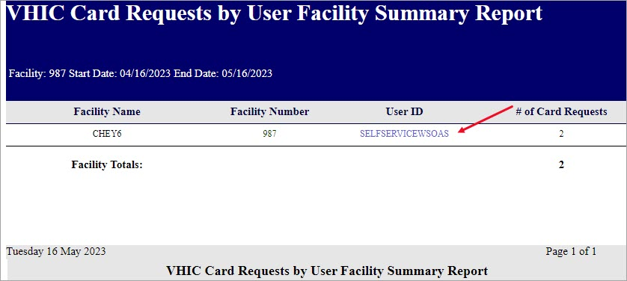

The VHIC Card Requests by User Detail Report opens. This search returns data under the columns of Facility Name, Facility Number, User ID, Card Status, Last Name and Card ID. Both the Last Name column and the Card ID column offer hyperlinks to additional reports. Click the Last Name hyperlink to open the next report.
Figure 137: VHIC Card Requests by User Detail Report – Last Name Hyperlink
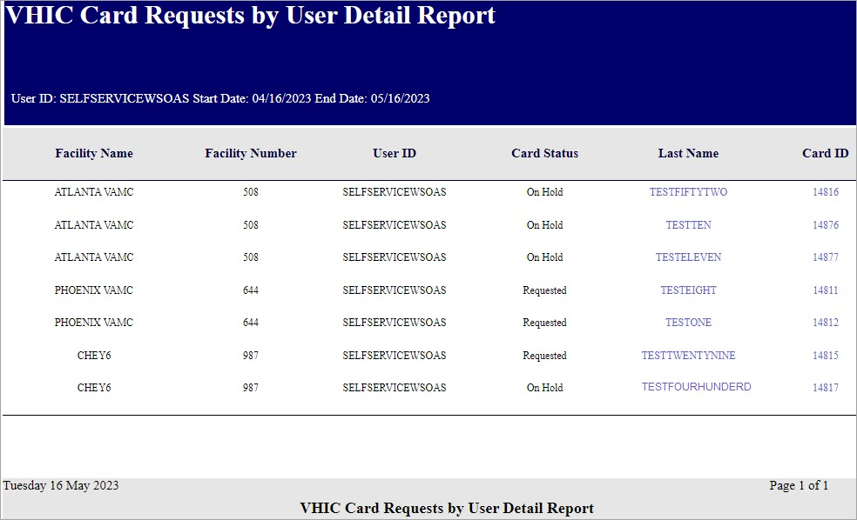

The Veteran Detail Report opens. This search returns specific information relating to the last name clicked from the previous report.
Figure 138: Veteran Detail Report

The VHIC Card Requests by User Detail Report also contains a hyperlink for Card ID. Click the Card ID hyperlink to open the next report.
Figure 139: VHIC Card Requests by User Detail Report – Card ID Hyperlink
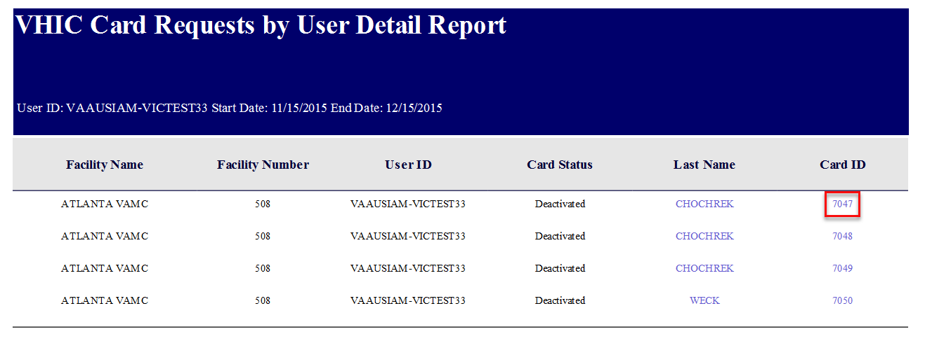

The VHIC Card History by Card ID Report opens. This search returns specific information relating to the Card ID clicked from the previous report.
Figure 140: VHIC Card History by Card ID Report

No EDIPI Report
Table 17. VHIC Cards Printed No EDIPI Report at a Glance
At a Glance…
Who can access this report? | Administrator, Supervisor, Tech Admin (Tier 3), Auditor
Who can access National version? | Administrator and Tech Admin (Tier 3)
Date Range Allowed | Admins, Tech Admin (Tier 3) – unlimited  Supervisor – one (1) year or less from date report is being run
Search Criteria Available | Site Selection, Start Date, End Date
The VHIC Cards Printed No EDIPI Report provides the number(s) of VHIC cards printed with no EDIPI by VISN and/or Facility. Selecting either the [VISN] or the [Facility] radio button will update the list of available options accordingly (based on a user’s role). Selecting the [National] checkbox, if available, returns results for all VISNs and Facilities.

Figure 141: VHIC Cards Printed No EDIPI Report Query Screen
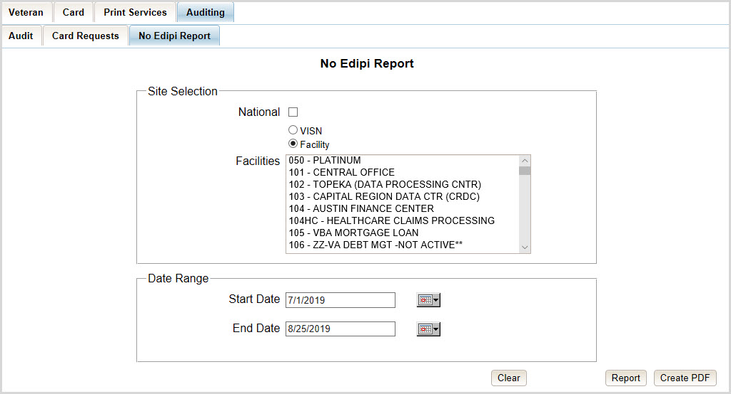

Once the user selects a site, and inputs a date range, they will click [Report] or [Create PDF]. Selecting the [National] check box will display the VHIC Cards Printed No EDIPI National Summary Report displaying the following information:
- VISN Description
- VISN Number
- Number of Cards Total

Figure 142: VHIC Cards Printed No EDIPI National Summary Report Results
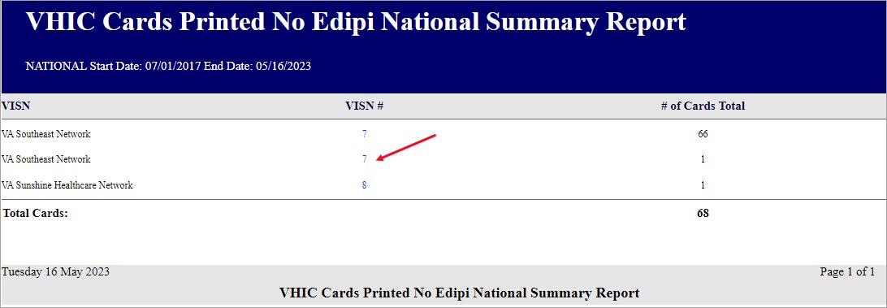

Clicking on the VISN number hyperlink will direct you to the VHIC Cards Printed No EDIPI VISN Summary Report displaying the following
- VISN
- VISN Number
- Facility
- Facility Number
- Number of Cards Total

Figure 143: VHIC Cards Printed No EDIPI VISN Summary Report
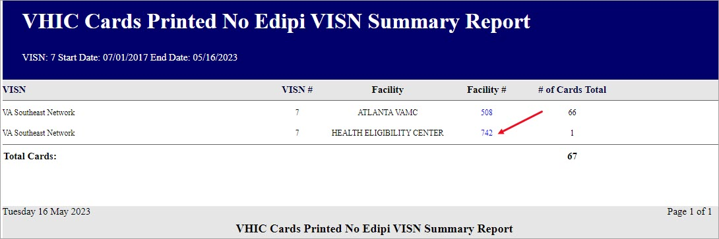

Clicking on the Facility number hyperlink will direct you to the VHIC Cards Printed No EDIPI Facility Summary Report displaying the following fields:
- VISN - SITE
- Card ID (hyperlink)
- Person ID (hyperlink)
- Name
- Last Changed

Figure 144: VHIC Cards Printed No EDIPI Facility Summary Report
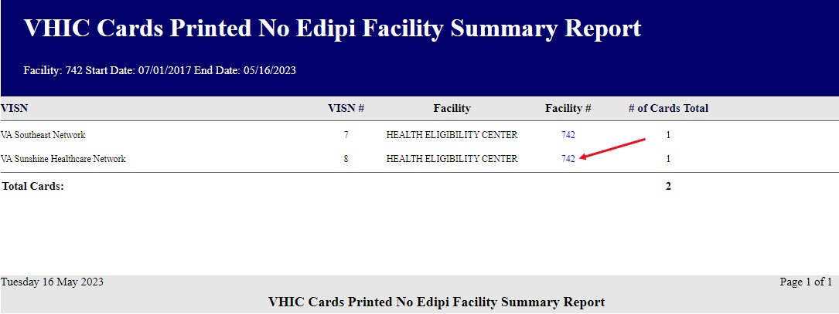

Clicking on the Facility number hyperlink will direct you to the VHIC Cards Printed No EDIPI VISN Facility Detail Report displaying the following:
- VISN – SITE Description
- Card ID (hyperlink)
- Person ID (hyperlink)
- Veteran Name
- Last Changed
Figure 145: VHIC Cards Printed No EDIPI VISN Facility Detail Report
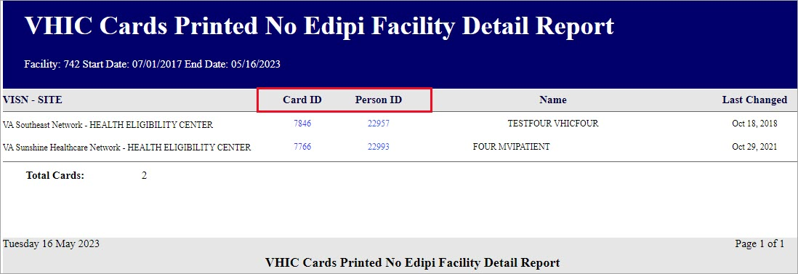

The VHIC Cards Printed No EDIPI VISN Facility Detail Report contain two hyperlinks Card ID and Person ID.
Clicking on the Card ID hyperlink will direct you to the VHIC Card History by Card ID Report screen.

Figure 146: VHIC Card History by Card ID Report screen

Clicking on the Person ID hyperlink will direct you to the VHIC Card History by Person ID Report screen.
Figure 147: VHIC Card History by Person ID Report screen
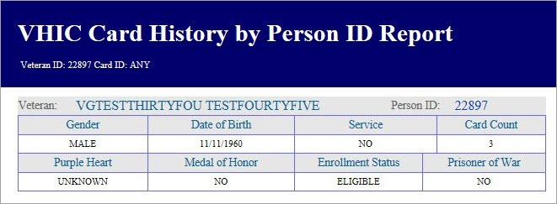

Self-Service Card Request Reports
The VHIC Self-Service Application was created to allow Veterans to request new and replacement VHIC card(s) without having to visit their local facilities offering them convenience and safely limiting exposure to Covid 19. The Self-Service Reports allow the VHIC users to monitor card requests submitted through the Self-Service Tool.

Table 18. Self-Service Activity Report at a Glance
At a Glance…
Who can access this report? | Administrator, Supervisor, Tech Admin (Tier 3), Associate, Auditor
Who can access National version? | N/A
Date Range Allowed | Admins, Tech Admin (Tier 3), Auditor – unlimited  Supervisor, Associate – one (1) year or less from date report is being run
Search Criteria Available | Start Date, End Date

Self-Service Activity Report
The Self-Service Activity Report provides the VHIC user a view of the activity submitted by the VHIC Self-Service Card Request Tool within a specified date range. Using the calendar dropdowns, the user enters the date range desired and select the option to either view the report by clicking the [Report] button or using the [Create PDF] button to generate a pdf of the results for use.

Figure 148. Self-Service Activity Summary Report
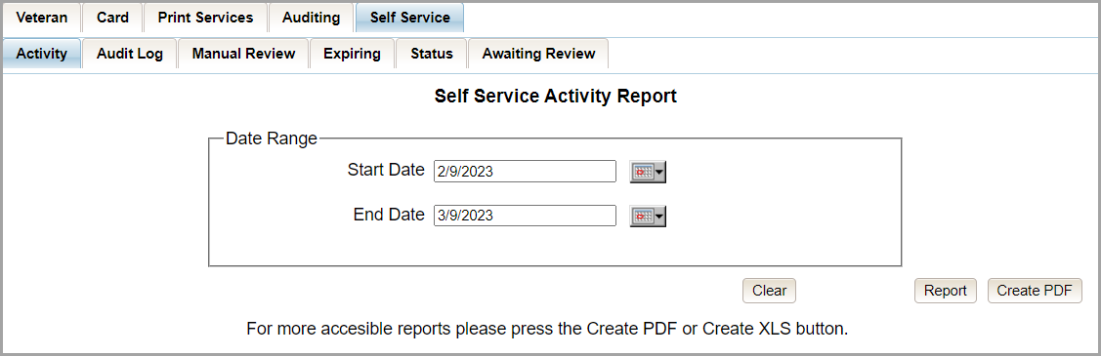

The Report/PDF generated will include the Card Status and number of self-service card requests submitted resulting in that status.

Figure 149. VHIC Self-Service Activity Summary Report
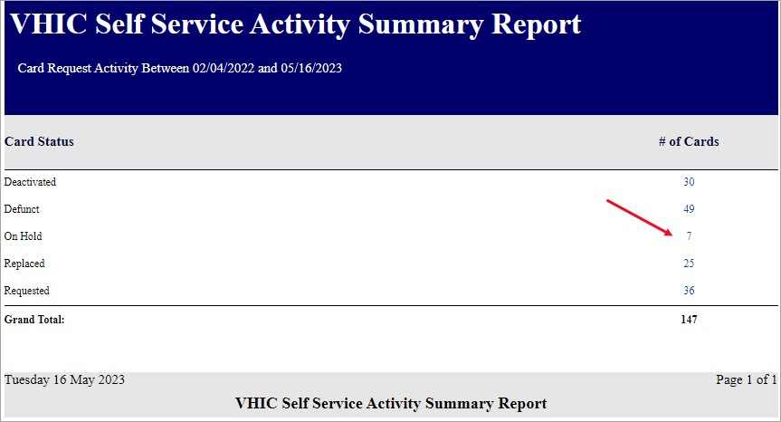

Selecting the # of Cards hyperlink will take you to the Self-Service Activity Detail Report; giving the user the details of the cards with the status selected.
Figure 150. VHIC Self-Service Activity Detail Report
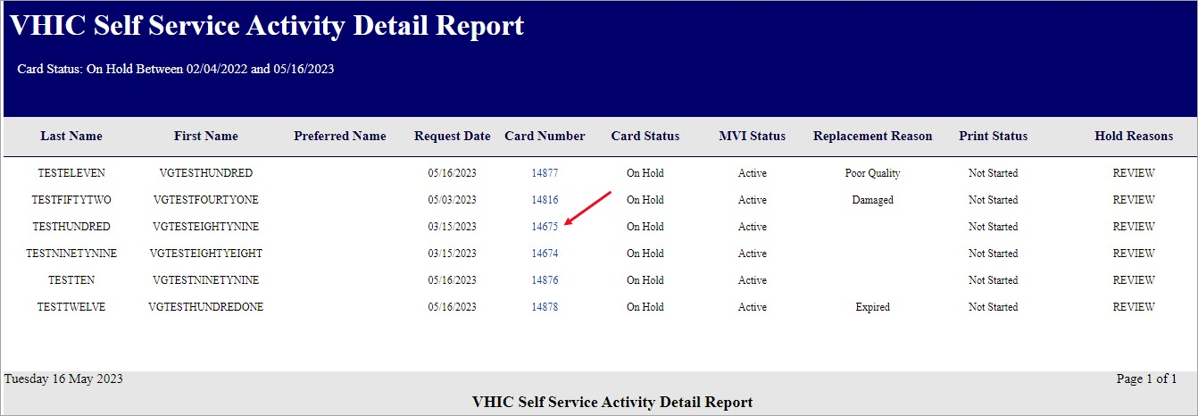

Selecting the Card Number hyperlink in the Detail report will take the user to the Card History by Card ID Report.

Figure 151. VHIC Card History by Card ID Report

Self-Service Audit Log
Table 19. Self-Service Audit Log at a Glance
At a Glance…
Who can access this report? | Administrator, Supervisor, Tech Admin (Tier 3), Associate, Auditor
Who can access National version? | N/A
Date Range Allowed | Admins, Tech Admin (Tier 3), Auditor – unlimited  Supervisor and Associate – one (1) year or less from date report is being run
Search Criteria Available | Login, Start Date, End Date Time of Day

The Self-Service Audit Log provides a way to track all activity for the VHIC Self-Service Tool. The resulting report returns the following fields of information: Date, Action, System, ICN, Card ID, Status Message, and HTTP Response. The query string shows all the information that was entered into various fields and/or submitted by the associate page. Items in the audit report are listed in order of the Date and Time.

Figure 152. Self-Service Audit Log Field Entry
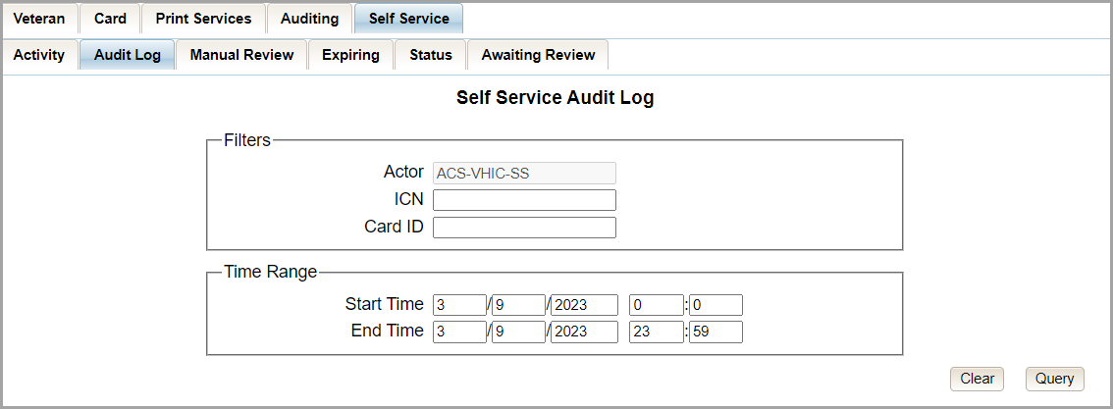

Figure 153. Self-Service Audit Log Results
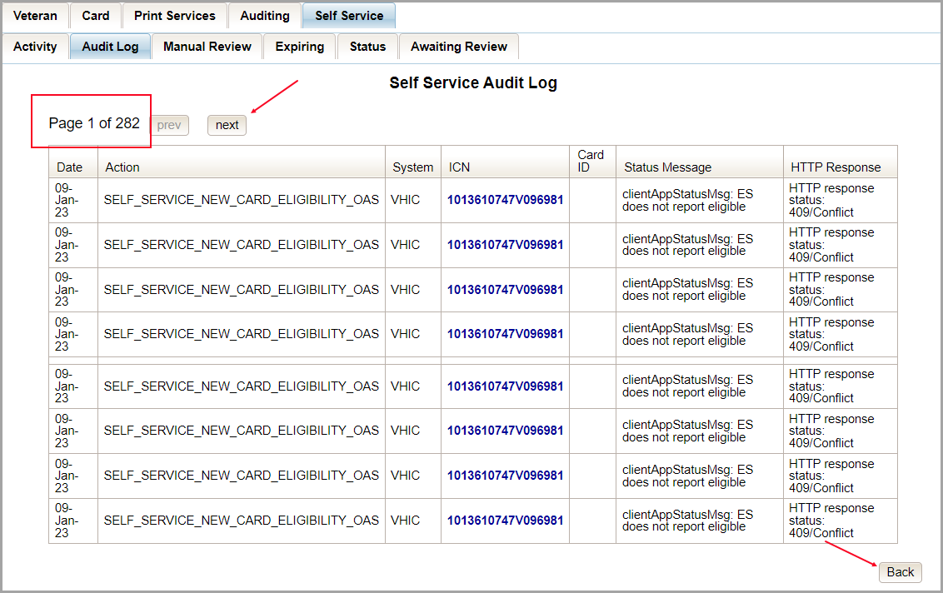

The Status Message and HTTP Response will give the User more details regarding the card request submitted by the veteran using the Self-Service Tool. ICN (hyperlink) will take the user to the Veteran Detail Report and the Card ID (hyperlink) will take the user to Card History by Card ID Report.

Figure 154. Status Messages and HTTP Responses Highlighted
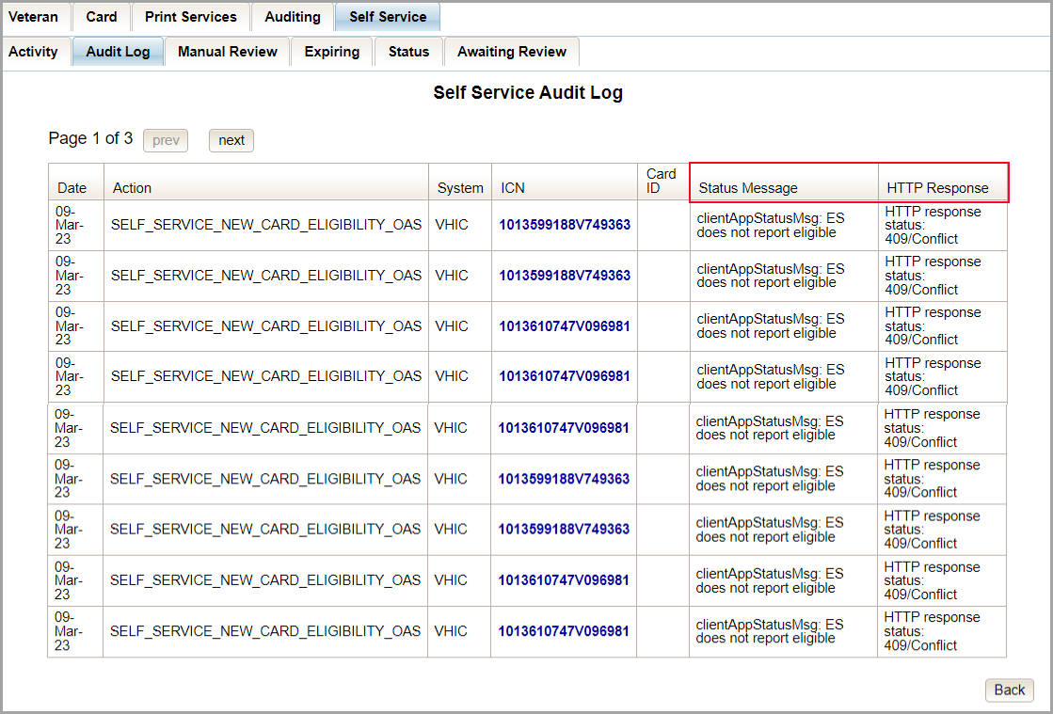

If specific criteria are entered into the Audit Log and the system cannot locate the information a message will appear as in the figure below.
Figure 155. Self-Service Audit Log No Match Message
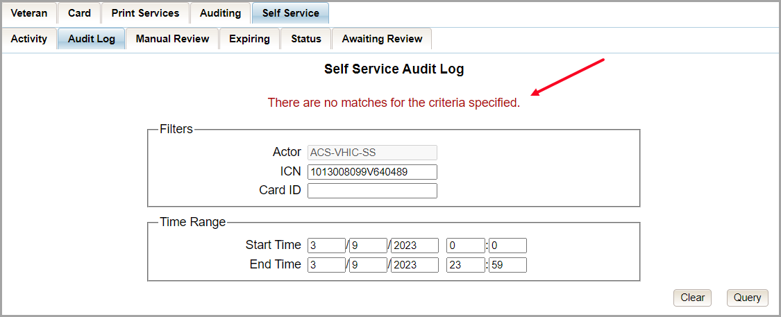

Self-Service Manual Review Activity Report
Table 20. Self-Service Manual Activity Report at a Glance
At a Glance…
Who can access this report? | Administrator, Supervisor, Tech Admin (Tier 3), Associate, Auditor
Who can access National version? | Administrator, Tech Admin (Tier 3), Auditor
Date Range Allowed | Admins, Tech Admin (Tier 3), Auditor, Read-Only – unlimited  Supervisor, Associate – one (1) year or less from date report is being run
Search Criteria Available | Start Date, End Date

The Self-Service Manual Review Activity Report indicates the number of card requests submitted through the Self-Service request process and can be sorted by National Requests, VSN Requests, and Facility Requests, though the report is set to Facility by default. The report can also be exported to .pdf form.
Selecting the National radio button (access permitting) the resulting report returns the following fields of information: VISN, VISN Number, and the Number of Cards submitted.
Figure 156. VHIC Self-Service Requests National Summary Report
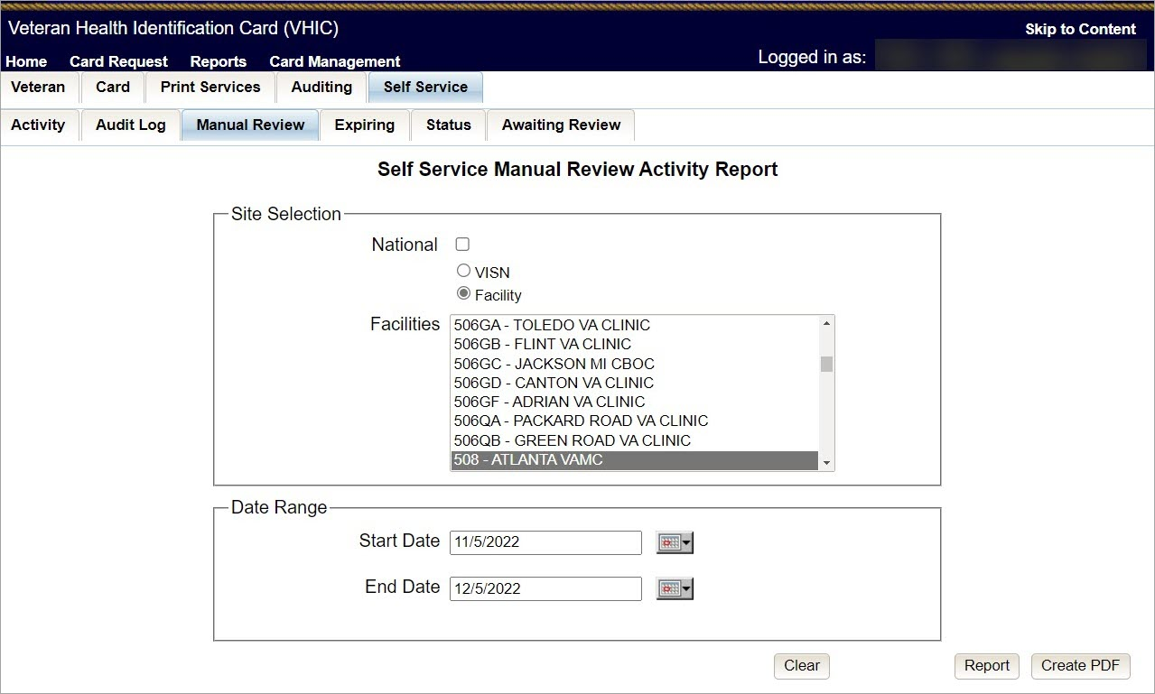

Figure 157. VHIC Self-Service Requests National Summary Report Results
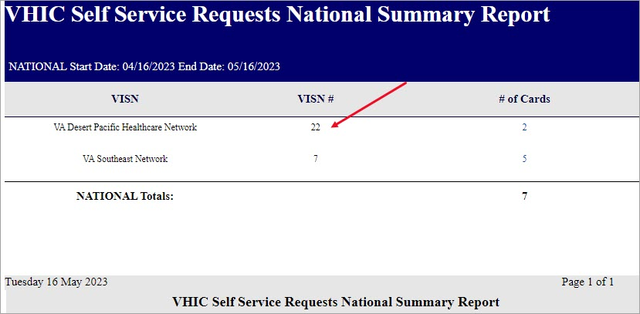

The VISN# is a link to the VISN Summary Report providing Facility, Facility Number, and the Number of Cards submitted for review per Facility within that VISN.
Figure 158. VHIC Self-Service Requests VISN Summary Report Results
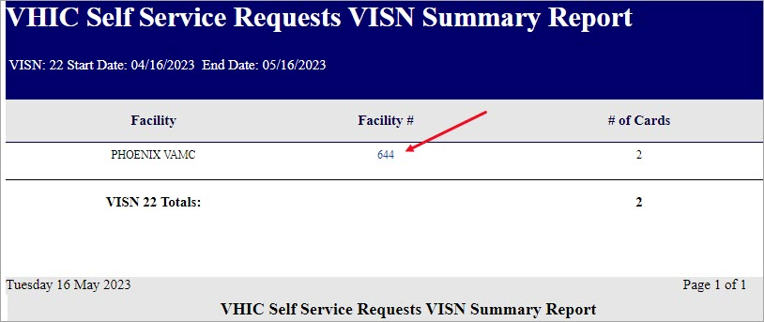

Selecting the facility number link will take the user to the VHIC Self-Service Requests Facility Summary Report providing Facility, Facility Number, and the Number of Cards submitted for review for the specific Facility.
Figure 159. Self-Service Facility Summary Report Results
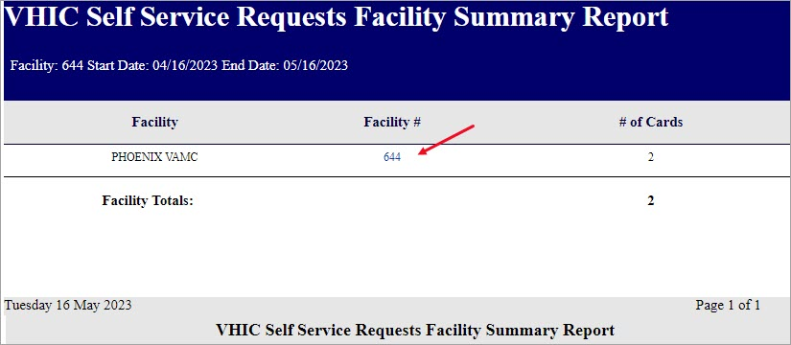

The Facility # link to the Self-Service Facility Detail Report displays the following information:
Facility Name, On Hold Reason, On Hold Date, Card Issuer, Last Name, Card ID, Card Status, Patient ICN, Task Status, and what (if any) POC the request has been Assigned To.

Figure 160. Self-Service Facility Detail Report
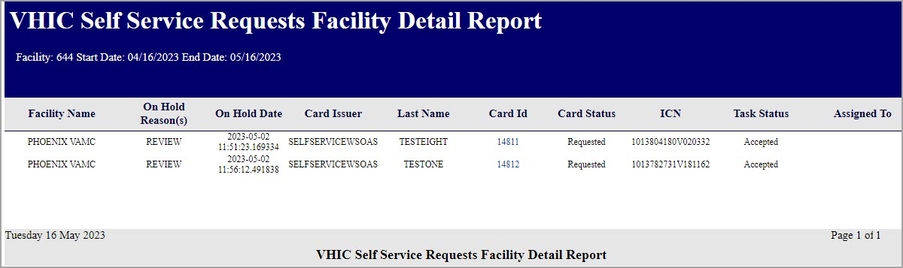

Figure 161. Figure Self-Service Facility Report Exported to .PDF
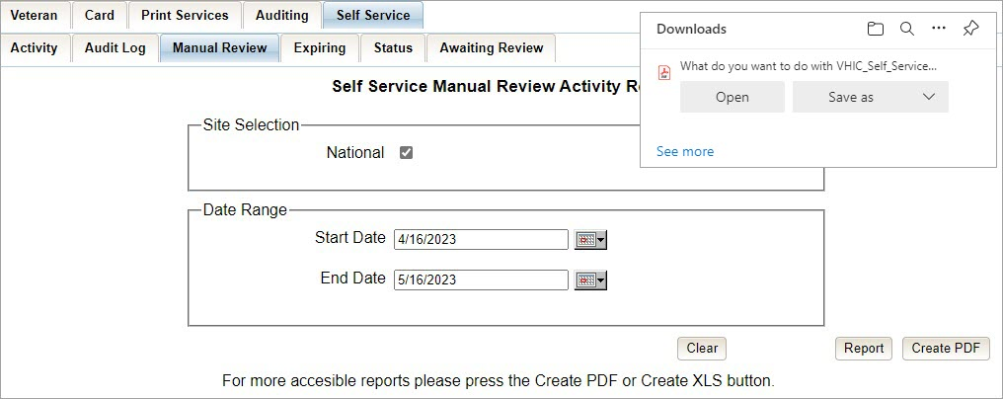

Self-Service Expiring Requests Report

Table 21. Self-Service Expiring Requests Report
At a Glance…
Who can access this report? | Administrator, Supervisor, Tech Admin (Tier 3), Associate, Auditor
Who can access National version? | Administrator, Tech Admin (Tier 3), Auditor
Date Range Allowed | 90 Days
Search Criteria Available | N/A

The Self-Service Expiring Requests Report indicates the number of card requests submitted through Self-Service that have not been processed and are going to expire within the date range specified (maximum of 90 days.) The report can be sorted by National Requests, VSN Requests, and Facility Requests, though the report is set to Facility by default.
Selecting the National radio button (access permitting) the resulting report returns the following fields of information: Card Type, Expiration Status, VISN, VISN Number, Facility Number, Facility Name, City, State, Card ID, Request Date, Number of Days From When the Request was submitted, ICN, Last Name of Veteran, First Name of Veteran, and Preferred Name if available. An example of the report can be seen in Figure 163. VHIC Self-Service Requests Expiring Report Results. The report can be exported to an Excel spreadsheet as in Figure 163. VHIC Self-Service Requests Expiring Report Results Error! Not a valid bookmark self-reference. The exported Excel spreadsheet contains the data used to produce the summary.

Figure 162. VHIC Self-Service Requests Expiring Report
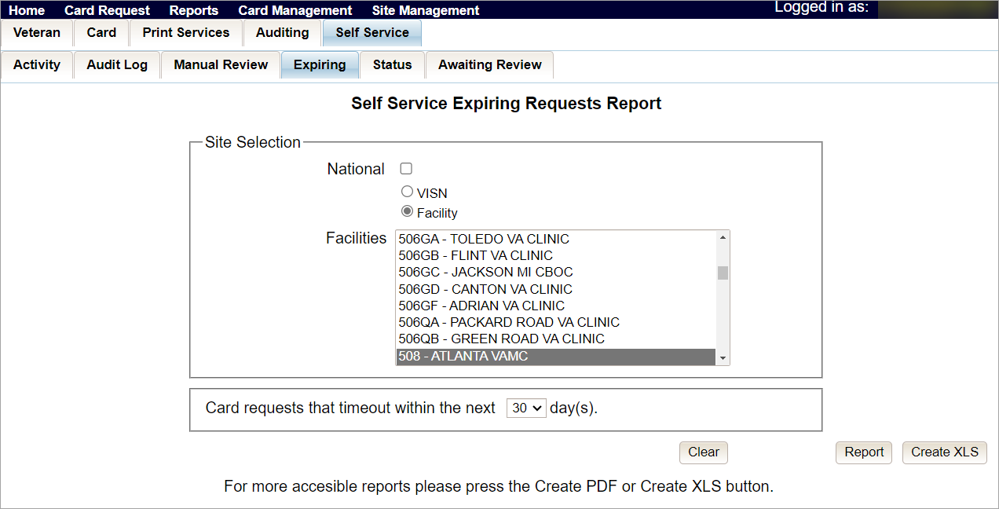

Figure 163. VHIC Self-Service Requests Expiring Report Results
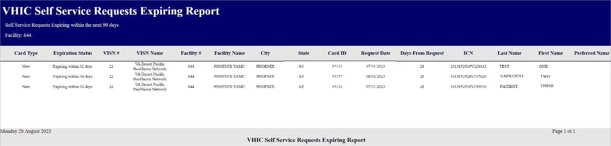

Figure 164. VHIC Self-Service Requests Expiring Report Exported Spreadsheet
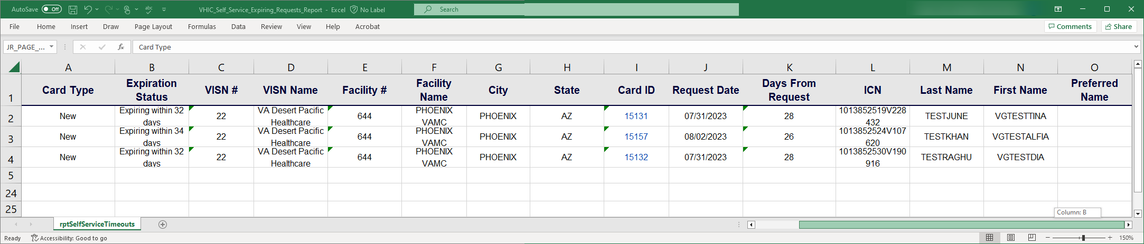

Self-Service Review Status Report

Table 22. Self-Service Review Status Report
At a Glance…
Who can access this report? | Administrator, Supervisor, Tech Admin (Tier 3), Associate, Auditor,
Who can access National version? | Administrator, Tech Admin (Tier 3), Auditor
Date Range Allowed | 30 Days
Search Criteria Available | Start Date, End Date

The Self-Service Review Status Report indicates the number of card requests submitted through Self-Service and their print status (Cancelled, Not started, Pending, Mailed) within a specified date range. The report can be sorted by National Requests, VSN Requests, and Facility Requests, though the report is set to Facility by default.
Selecting the National radio button (access permitting) the resulting report returns the following fields of information: Card Status, Print Status, Month the request was started (within the 30-day period), Total number of card requests as in Figure 164. VHIC Self-Service Requests Expiring Report Exported Spreadsheet. Exporting the report to an Excel spreadsheet will show the detailed data used to produce the summary as seen in Figure 165. Self-Service Review Status Report.

Figure 165. Self-Service Review Status Report
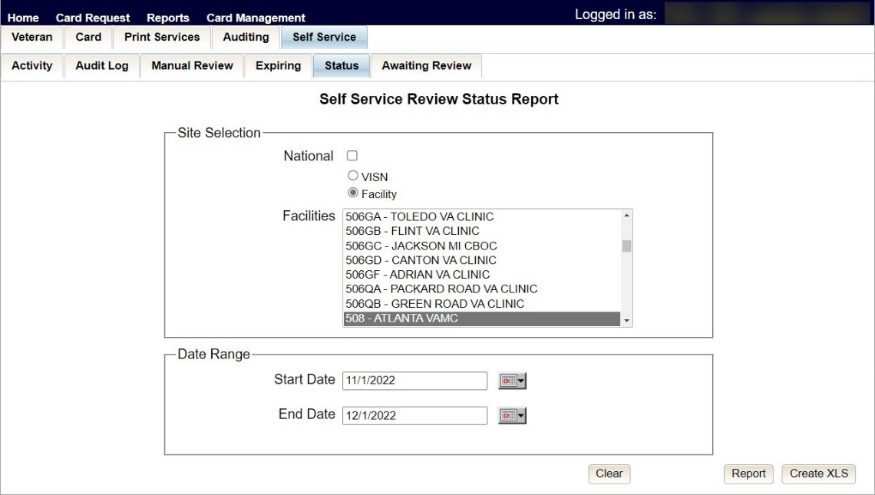

Figure 166. Self-Service Review Status Report Results
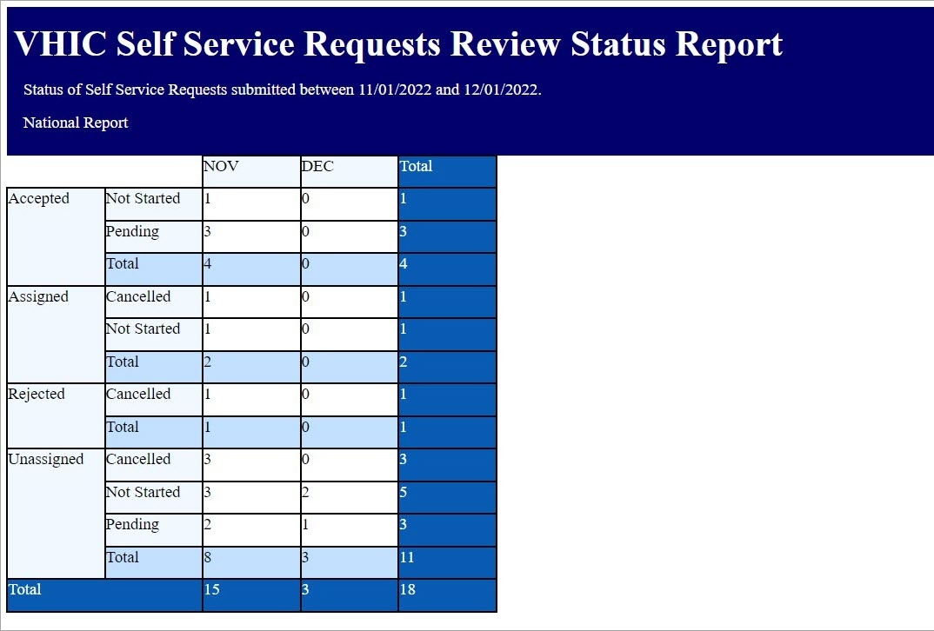

Figure 167. Self-Service Review Status Report Results Exported to Spreadsheet
REDACTED

Self-Service Requests Awaiting Review
Table 23. Self-Service Requests Awaiting Review By VISN Report
At a Glance…
Who can access this report? | Administrator, Supervisor, Tech Admin (Tier 3), Associate, Auditor
Who can access VISN version? | Administrator, Tech Admin (Tier 3), Auditor
Date Range Allowed | 90 days

The Self-Service Requests Awaiting Review By VISN Report. Self-Service Requests Awaiting Review By VISN Report Page indicates the total number of card requests submitted through Self-Service within a VISN within the last 90 days. The results are broken down by Facility within the VISN. An example of the report results can be seen in Figure 168. Self-Service Requests Awaiting Review By VISN Report Page. The report can be exported to an Excel spreadsheet as in Figure 170. Self-Service Requests Awaiting Review By VISN Report Exported. The exported Excel spreadsheet contains the data used to produce the summary.

Figure 168. Self-Service Requests Awaiting Review By VISN Report Page
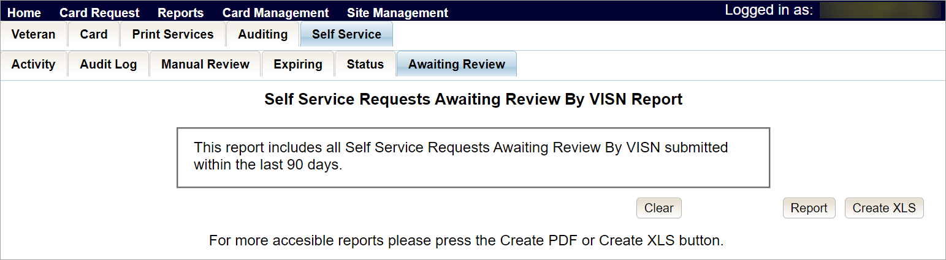

Figure 169. Self-Service Requests Awaiting Review By VISN Report Results
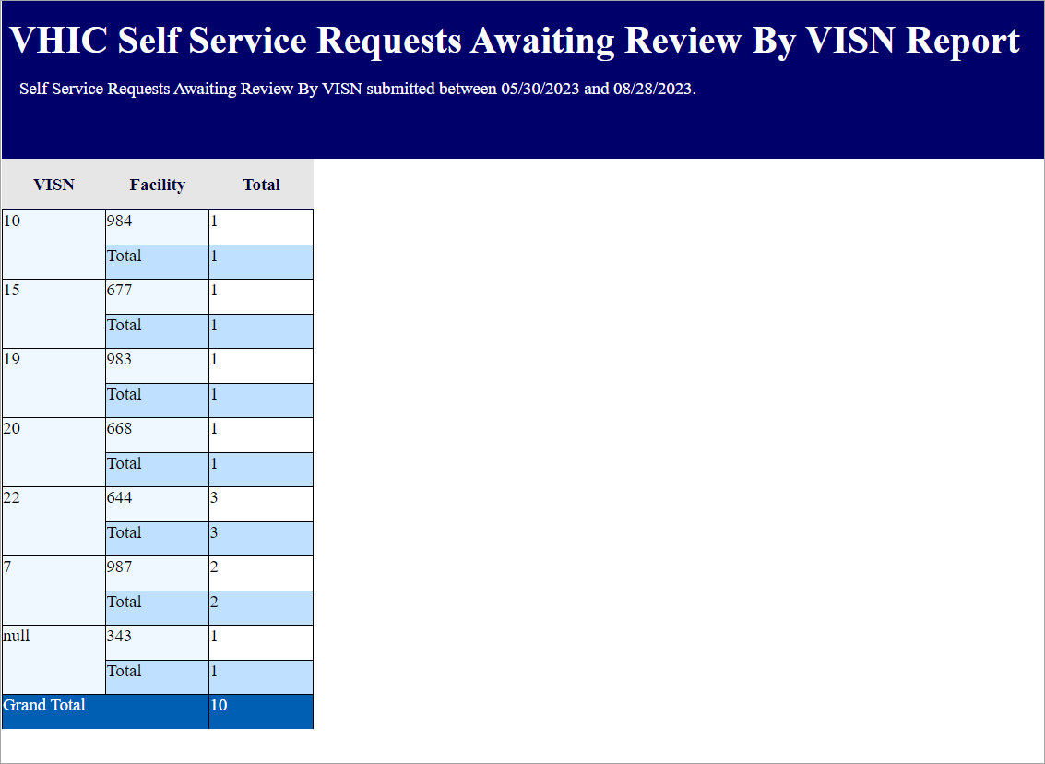

Figure 170. Self-Service Requests Awaiting Review By VISN Report Exported
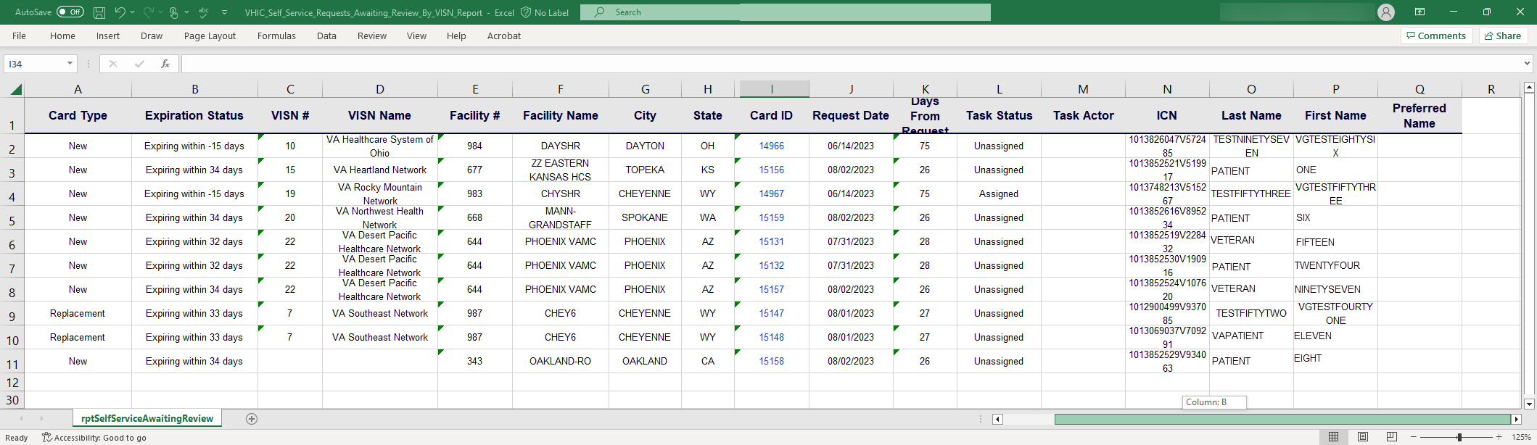

Troubleshooting
For a through set of troubleshooting guidelines, please refer to the Veteran Health Identification Card User Guide - Volume 4 - Troubleshooting document.

