Veteran Health Identification Card (VHIC 4.8)
User Guide

Volume 4 - Troubleshooting

January 2018

Department of Veterans Affairs
Office of Information and Technology (OI&T)

Revision History
NOTE: The revision history cycle begins once changes or enhancements are requested after the document has been baselined.
Date | Revision | Description | Author
01/18/2018 | 2.1 | Accepted all changes as approved on anomaly logs, re-paginated document, re-ran TOCs, and created Section 508 compliant PDF for uploading, with Word document, to RTC Jazz Tools as well as SharePoint. | REDACTED
01/12/2018 | 2.1 | Applied changes from first anomaly log dated 010418. | REDACTED
12/29/2017 | 2.1 | Updated document images to include “Skip to Content” link where necessary. Re-ran TOCs, added Alt Text to all images and figures, and changed document date from “August 2017” to “January 2018.” Updated Appendix entitled “VHIC Roles.” | REDACTED
08/29/2017 | 2.0 | Checked Alt text for all images and figures. Added Alt text to figures without it. Changed name in footer from “Volume 1 Card Requests” to “Volume 4 Troubleshooting.” Fixed figure numbers for Figures 8-1 through 8-21 by removing the duplicate, leading “8.” Edited Figures 8-16 through 8-21 which still used old VHIC application versions of images. Re-ran TOCs and fixed content/figure pagination issues in the Word document. Document converted to Section 508 compliant PDF as part of VHIC 4.8. Updated document name to match VA naming conventions by replacing spaces in Word document name with underscores. | REDACTED
08/15/2017 | 2.0 | Updated for VHIC 4.8 release | REDACTED, REDACTED
08/11/2016 | 1.6 | Completed technical writer review of document. Ran Spelling and Grammar, added Alt text to all images, and re-ran TOCs. Fixed Table of Tables TOC and footer page numbering. Changed cover date from “August 2016” to match footer date of “September 2016.” | REDACTED
08/04/2016 | 1.6 | Updated content | REDACTED
12/28/2015 | 1.5 | Rebuilt to capture content overhaul to VHIC System and divided this guide into four separate parts | REDACTED
01/06/2015 | 1.4 | Rebuilt to capture content overhaul to VHIC System and divided this guide into three separate parts | REDACTED
07/07/2015 | 1.3 | Rebuilt to capture content overhaul to VHIC System and divided this guide into three separate parts | REDACTED
Table of Contents
1. Introduction 1
1.1. Purpose 1
1.2. Document Orientation 1
1.2.1. Organization of the Manual 1
1.2.2. Assumptions 2
1.2.3. Disclaimers 2
1.2.3.1. Software Disclaimer 2
1.2.3.2. Documentation Disclaimer 2
1.2.4. Documentation Conventions 2
1.3. Enterprise Service Desk and Organizational Contacts 3
2. Veteran Health Identification Card – What is it? 4
2.1. Accessing the VHIC Application 4
2.2. Browser 4
2.2.1. Browser Incompatibility Issue 5
2.3. Proper Navigation of the VHIC Application 8
2.4. Roles within VHIC 9
2.4.1. VHIC Associate 9
2.4.2. VHIC Supervisor 10
2.4.3. VHIC Administrator 10
2.4.4. VHIC Technical Administrator (Tier 3) 10
2.4.5. VHIC Auditor 10
2.4.6. VHIC Read-Only User 10
3. Getting Started 11
3.1. Single Sign-On Internal (SSOi) 11
3.2. Logging On 11
3.3. System Menu 12
3.3.1. VHIC Administrator and Technical Administrator Tier 3 12
3.3.2. VHIC Associate and Supervisor 13
3.3.3. VHIC Auditor and Read-Only User 13
3.4. Changing User ID and Password 14
4. Before Requesting a VHIC Card 14
5. Creating a VHIC Card – The Card Request Process 14
6. Deactivating Cards - The Card Management Process 14
7. Reports 14
8. VHIC Troubleshooting (FAQ) 15
8.1. Login Questions 15
8.1.1. Cannot log in to the application 15
8.1.2. Do not have access to required areas/items 15
8.1.3. How to Find VHIC Supervisors 15
8.2. Address Questions 15
8.2.1. Veteran’s Address is Incorrect at the ‘Step 4: Select Mailing Address’ Screen 15
8.2.2. Requesting Facility Address is Incorrect at the ‘Step 4: Select Mailing Address’ Screen 16
8.3. Card Questions 16
8.3.1. What does the VHIC Card Look Like 16
8.3.2. What are the Member ID and the Plan ID on the face of the VHIC card? 16
8.3.3. Member ID is Missing from Card 16
8.4. Photo Questions 17
8.4.1. Image Alignment 17
8.4.2. Photo not saved 20
8.4.3. Adobe Flash Permissions 21
8.5. Information not updating with radio button selection 26
8.6. Error Questions 27
8.6.1. Can I request a card when ‘Bad MVI Address’ is displayed? 27
8.6.2. Can I request a card when ‘Bad Preferred Facility Address’ is displayed? 27
8.6.3. What to do with “Error accessing MVI” messages 27
8.6.4. What to do with “MVI Did Not Return an Enrollment Identifier” messages on Step 2 27
8.7. Photo Error Questions 27
8.7.1. Step 3: Capture Veteran Image 28
8.7.2. Step 5: Save Card Request 30
8.7.3. Wrong Photo on Veteran’s VHIC 31
8.8. Report Questions 32
8.8.1. Report not returning results for selected date range 32
8.9. On Hold Questions 32
8.9.1. Veteran Not Proofed 32
8.9.1.1. User did NOT complete the proofing process using the Identity Management Toolkit application PRIOR to creating a VHIC request 32
8.9.2. Enrollment Services Unavailable 33
8.9.3. Eligibility Pending 34
8.9.4. Bad Data – Other 35
Appendix A: VHIC Roles 36

Table of Figures
Figure 2-1: Example of what the VHIC looks like 4
Figure 2-2: Over-sized icon buttons on the Home Screen 5
Figure 2-3: Words wrapping around the displayed photo on Step 3 5
Figure 2-4: Content on the right of the Step 5 screen is shifted down 5
Figure 2-5: Both the VISN and Facility selection lists are displayed and shifted to the right 5
Figure 2-6: Internet Explorer's Toolbar Menu 6
Figure 2-7: Tools Menu button 6
Figure 2-8: Tools drop-down menu 6
Figure 2-9: Compatibility View Settings screen 7
Figure 2-10: Compatibility View Settings Screen - Close 7
Figure 2-11: VHIC Navigation Buttons 8
Figure 2-12: VHIC Administrator and VHIC Technical Administrator (Tier 3) menu 9
Figure 2-13: VHIC Associate and VHIC Supervisor menu 9
Figure 2-14: VHIC Auditor and VHIC Read-Only User menu 9
Figure 3-1: SSOi Login Screen 11
Figure 3-2: VHIC Administrator and VHIC Technical Administrator (Tier 3) Home screen 12
Figure 3-3: VHIC Associate and VHIC Supervisor Home screen 13
Figure 3-4: VHIC Auditor and VHIC Read-Only User Home screen 13
Figure 8-1: Example of what the VHIC looks like 16
Figure 8-2: Over-sized icon buttons on the Home Screen 17
Figure 8-3: Words wrapping around the displayed photo on Step 3 17
Figure 8-4: Content on the right of the Step 5 screen is shifted down 17
Figure 8-5: Both the VISN and Facility selection lists are displayed and shifted to the right 17
Figure 8-6: Internet Explorer's Tool Bar Menu 18
Figure 8-7: Tools Menu button 18
Figure 8-8: Tools drop-down menu 18
Figure 8-9: Compatibility View Settings screen 19
Figure 8-10: Compatibility View Settings Screen - Close 20
Figure 8-11: Adobe Flash Player Settings - Click Capture Image 21
Figure 8-12: Adobe Flash Player Settings - Right click on Allow 22
Figure 8-13: Adobe Flash Player Settings - select Settings 23
Figure 8-14: Adobe Flash Player Settings - select Settings 24
Figure 8-15: Adobe Flash Player Settings - Reset camera 25
Figure 8-16: Capture Veteran Image screen - Take New Picture 26
Figure 8-17: Step 3: Capture Veteran Image 28
Figure 8-18: Step 3:"Error Saving Picture" error message 29
Figure 8-19: Step 2: Select Veteran screen 29
Figure 8-20: Step 5: Save card Request review screen 30
Figure 8-21: Step 5: "Error accessing VHIC Database. If the error persists, please contact the helpdesk.” error message 31
Figure 8-22: Veteran Not Proofed Warning message on Step 4: Select Mailing Address 32
Figure 8-23: Reason for Hold: Veteran Not Proofed 32
Figure 8-24: Card Request Status: On Hold - Veteran Not Proofed 33
Figure 8-25: Reason for Hold: Enrollment Unavailable 33
Figure 8-26: Reason for Hold: Eligibility Pending 34
Figure 8-27: Reason for Hold: Bad Data - Name Spelled Wrong 35
Figure 8-28: Card Request Status: Replacement on Hold - Bad Data: Name Spelled Wrong 35
Figure 8-29: Reason for Hold: Bad Data Unchecked 35

Table of Tables
Table 1: Documentation Symbols and Descriptions 2
Table 2: Enterprise Service Desk Contact Information 3

Introduction

Purpose
The purpose of this User Guide is to provide general system information, as well accessibility and user roles with the VHIC application. This User Guide will provide a detailed walkthrough of creating Veteran Health Identification Card requests using the VHIC application. This User Guide will also provide the detailed steps on how VHIC Administrators can deactivate all of the VHICs associated to a selected Veteran.

Document Orientation

Organization of the Manual
This User Guide is divided into eight sections to allow you to quickly obtain the information you need.
The first section will provide an overview of what a VHIC is and what the eligibility requirements are, and the various user roles and their accessibility within the VHIC application.
In order to be able to receive a VHIC, a Veteran must meet the following eligibility criteria:
- Be eligible for VA medical benefits
- Be enrolled in the VA Healthcare system
- Be Level 2 proofed at a VA medical facility
- Veteran identity must be recognized in the Master Veteran Index (MVI), which is managed by the Identity and Access Management (IAM) of the VA

NOTE: The level 2 proofing process is a method to verify the identity of Veterans. VA requires Veterans to provide approved identification documents to access Personal Identifiable Information (PII), Personal Health Information (PHI) and request a Veterans Health Identification Card (VHIC).

The second and third sections will walk the user through the steps needed to access the VHIC application, as well as some general guidelines on using the VHIC application.
The fourth section will give the user an overview of what they need to do before starting a card request for a Veteran. The VHIC user must verify the Veteran’s Identity Proofing Level is at Level 2 in the Identity Management Toolkit.
The fifth section explains the process involved with creating a VHIC for a Veteran.
The sixth section covers how to request card deactivation all of the VHICs for a specific Veteran.
The seventh section will provide information on the different reports available to VHIC users and the types of metrics that can be obtained.
The last section covers some troubleshooting issues and solutions that will help the VHIC user to be better able to support the Veteran and ensure that the VHIC requests are processed properly.

Assumptions
This guide was written with the following assumed experience/skills of the audience:
- User has basic knowledge of the operating system (such as the use of commands, menu options, and navigation tools).
- User has been provided the appropriate active roles, menus, and security keys required for the VHIC application.
- User is using Internet Explorer to do their job of either Creating VHIC Card Requests, Running Reports, or Deactivating VHICs depending on user roles.
- User has validated access to the VHIC application.
- User has completed any prerequisite training.

Disclaimers

Software Disclaimer
This software was developed at the Department of Veterans Affairs (VA) by employees of the Federal Government in the course of their official duties. Pursuant to title 17 Section 105 of the United States Code this software is not subject to copyright protection and is in the public domain. VA assumes no responsibility whatsoever for its use by other parties, and makes no guarantees, expressed or implied, about its quality, reliability, or any other characteristic. We would appreciate acknowledgement if the software is used. This software can be redistributed and/or modified freely provided that any derivative works bear some notice that they are derived from it, and any modified versions bear some notice that they have been modified.

Documentation Disclaimer
The appearance of external hyperlink references in this manual does not constitute endorsement by the Department of Veterans Affairs (VA) of this Web site or the information, products, or services contained therein. The VA does not exercise any editorial control over the information you may find at these locations. Such links are provided and are consistent with the stated purpose of the VA.

Documentation Conventions
This manual uses several methods to highlight different aspects of the material.
- Various symbols are used throughout the documentation to alert the reader to special information. The following table gives a description of each of these symbols:
Table 1: Documentation Symbols and Descriptions
Symbol | Description
 | NOTE: Used to inform the reader of general information including references to additional reading material

- Descriptive text is presented in a proportional font (as represented by this font).
- “Screenshots” of computer online displays (i.e., character-based screen captures/dialogs) and are shown in a non-proportional font and enclosed within a box. Also included are Graphical User Interface (GUI) Microsoft Windows images (i.e., dialogs or forms).
- User's responses to online prompts (e.g., manual entry, taps, clicks, etc.) will be [boldface] type and enclosed in brackets.

Enterprise Service Desk and Organizational Contacts
The support contact information documented herein are intended to restore normal service operation as quickly as possible and minimize the adverse impact on business operations, ensuring that the best possible levels of service quality and availability are maintained.
The following table lists the contact information needed by site users for troubleshooting purposes. Support contacts are listed by description of the incident escalation, and contact information (phone number and options to select).
Table 2: Enterprise Service Desk Contact Information
Issue | Contact Info
For Provisioning Issues | Contact the Enterprise Service Desk at REDACTED, option 3 (Applications), then option 1.  When contacted by a support specialist, be ready to supply the employee’s full name, VA user ID and email address.
For Proofing Issues | Contact the Enterprise Service Desk at REDACTED, option 3 (Applications), then option 1.  When contacted by a support specialist, be ready to supply the Veterans' full name, full SSN, and DOB.
For All Other VHIC System Issues | Contact the Enterprise Service Desk at REDACTED, option 3 (Applications), then option 1.  When contacted by a support specialist, be ready to supply the Veterans' full name, full SSN, and DOB.

Veteran Health Identification Card – What is it?
The VHIC serves as an identification mechanism for Veterans that are enrolled in the VA Healthcare system and supports efficiencies at VA medical facilities throughout the United States. Although not required by Veterans to receive medical care at a VA facility, it does enable Veterans to check in for VA appointments more quickly. The VHIC system is a web-based application that VHIC associates use to issue VHICs to enrolled Veterans.
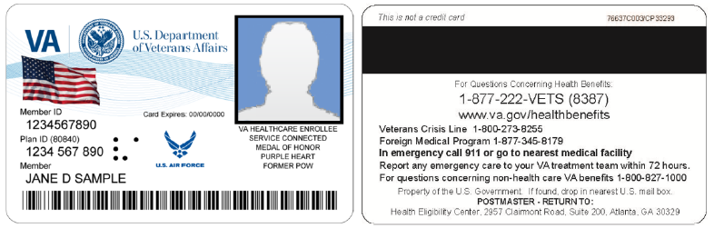
Figure 2-1: Example of what the VHIC looks like

Accessing the VHIC Application
VHIC is a web-based application which users will access via a web browser. The recommended browser is Internet Explorer (currently version 11). The VHIC URL is REDACTED and is case sensitive – it must be entered exactly as shown. After successfully logging in to the VHIC application, users should bookmark this site for easy access in the future. Instructions on how to do just that can be found here: http://windows.microsoft.com/en-us/internet-explorer/add-view-organize-favorites#ie=ie-11-win-7.
The best time to bookmark the site is after the user is in the application itself rather than attempting to bookmark the Login screen.

Browser
Once users are logged into their VA desktop, they will access VHIC using Internet Explorer (IE) by either entering the URL listed above or via the bookmark saved during an earlier session. Please do NOT use the Refresh button at the top of your browser window if you mistype the VHIC URL. The Refresh button will redirect you to the VA website. Please re-enter the VHIC URL and try again.

Browser Incompatibility Issue
In some instances, users may experience image misplacement or misalignment. This is most likely due to the current browser compatibility settings. You will want to ensure that the browser is not set to Compatibility View.
Examples of Image Misplacement and Other Misalignments:
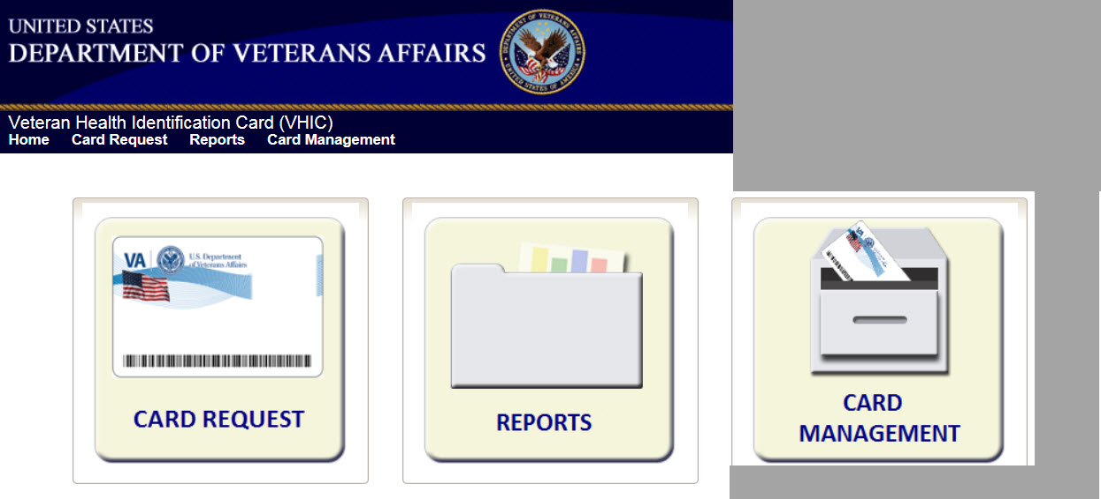
Figure 2-2: Over-sized icon buttons on the Home Screen

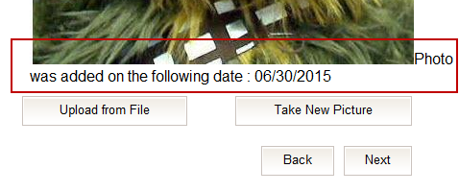
Figure 2-3: Words wrapping around the displayed photo on Step 3

REDACTED
Figure 2-4: Content on the right of the Step 5 screen is shifted down

REDACTED
Figure 2-5: Both the VISN and Facility selection lists are displayed and shifted to the right
If you are experiencing misalignment issues, follow these steps to verify/update your browser compatibility settings:

- With Internet Explorer open, right click in the blue area at the top of the browser window.
- Click on Command Bar to display the Command Tool Bar.
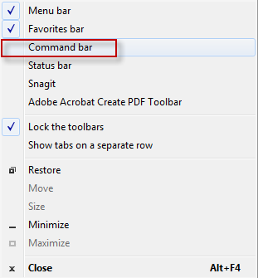
Figure 2-6: Internet Explorer's Toolbar Menu
- Click on the Tools menu button.
Figure 2-7: Tools Menu button
- Click on Compatibility View Settings.
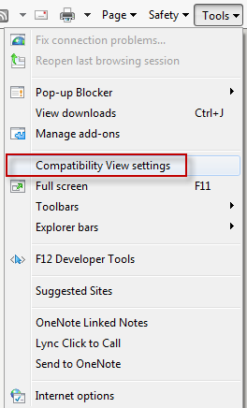
Figure 2-8: Tools drop-down menu
- Uncheck the box next to Display intranet sites in Compatibility View.
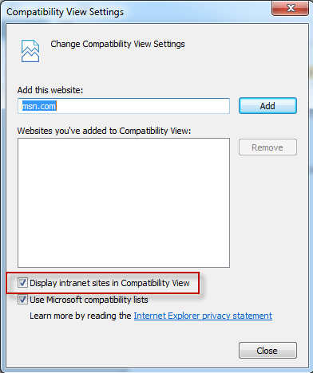
Figure 2-9: Compatibility View Settings screen
- Click the Close button.
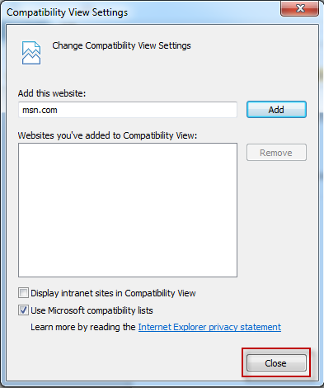
Figure 2-10: Compatibility View Settings Screen - Close

NOTE: Compatibility mode does need to be turned on in order to access other applications such as Notes in NUMI’s CERMe and the Beneficiary Travel Dashboard. You can turn compatibility mode back on by following the above directions and checking the Display intranet sites in Compatibility View checkbox.

Proper Navigation of the VHIC Application
The correct way to navigate through the VHIC application is to use the Back and Next buttons that are located at the bottom of each screen instead of using the Browser’s built in Back button. Please do NOT use the Back button at the top of your browser window to navigate back to a previous screen; this will cause errors to occur.
Figure 2-11: VHIC Navigation Buttons

The VHIC user can also navigate to the different features within the VHIC application by clicking on one of the navigation links located in the header near the top left of the screen. The user’s assigned role will determine which links are available as seen below. To see the full home screens for each user role, refer to Section 3.3.

Figure 2-12: VHIC Administrator and VHIC Technical Administrator (Tier 3) menu

Figure 2-13: VHIC Associate and VHIC Supervisor menu

Figure 2-14: VHIC Auditor and VHIC Read-Only User menu

Roles within VHIC
The VHIC application is built to accommodate a specific set of pre-established user roles. During the provisioning process, the VHIC user will have a role assigned to them, which will determine what aspects of the VHIC application are available to them. The following breaks down the specific roles and the areas of access that accompany each role.
If, while utilizing the VHIC application, a user finds they do not have access to items they feel they should have access to or find that they have access to items they should not, based on the definitions listed below, the VHIC user should report this information to their VHIC Supervisor. The VHIC Supervisor should then verify that the proper role has been assigned.

VHIC Associate
The VHIC Associate role shall be assigned to individuals responsible for processing card requests and resolving card request issues. Associates have the ability to create card requests and have access to a limited number of reports.

VHIC Supervisor
The VHIC Supervisor shall automatically inherit all access and privileges given to the VHIC Associate. The VHIC Supervisor role is allowed to submit a request for user access to the VHIC application. VHIC Supervisors have the ability to create card requests and have access to most available reports (excluding national versions).

VHIC Administrator
The VHIC Administrator role is reserved for the VHIC Business (HEC) team members responsible for the creation and maintenance of all other VHIC accounts/roles. The VHIC Administrator shall automatically inherit privileges given to the VHIC Supervisor. Administrators have the ability to create card requests, deactivate cards, and have access to all available reports.

VHIC Technical Administrator (Tier 3)
The VHIC Technical Administrator (Tier 3) automatically inherits all access and privileges given to the VHIC Administrator. Technical Administrators (Tier 3) have the ability to create card requests and have access to all available reports as well as access to the Administration page.

VHIC Auditor
The VHIC Auditor role shall be assigned to users with read-only access to the VHIC System. The VHIC Auditor does not have the ability to create card requests, but does have access to all available reports.

VHIC Read-Only User
The VHIC Read-Only User role shall be assigned to users with read-only access to the VHIC System. The VHIC Read-Only user does not have the ability to create card requests, but does have access to a limited number of reports.

Getting Started

Single Sign-On Internal (SSOi)
Once users are logged into their VA desktop, they will access VHIC using Internet Explorer (IE) by either entering the URL listed above or via the bookmark saved during an earlier session.
Users will be presented with the Single Sign On – internal (SSOi) login screen (shown below).
Here the VHIC user will need to use their PIV card to log into the VHIC application.
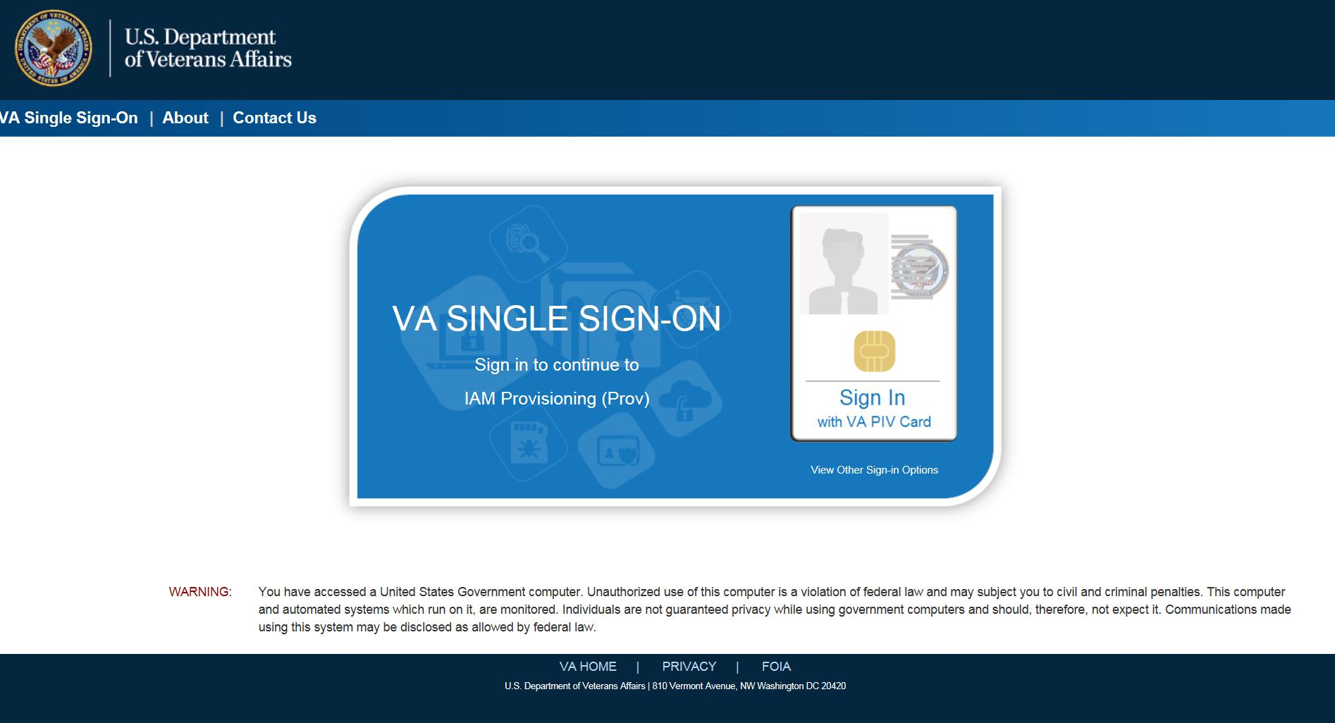
Figure 3-1: SSOi Login Screen

Logging On
The VHIC application is built to accommodate a specific set of pre-established user roles. During the provisioning process, the VHIC user will have a role assigned to them, which will determine what aspects of the VHIC application are available to them. The roles are listed below. For more information on the areas of access that accompanies each role, please refer to section 2.4.
- VHIC Associate
- VHIC Supervisor
- VHIC Administrator
- VHIC Technical Administrator (Tier 3)
- VHIC Auditor
- VHIC Read-Only User

System Menu
Depending on the VHIC users’ role, they will be presented different Home screens upon logging to the VHIC application.

VHIC Administrator and Technical Administrator Tier 3
The VHIC Administrator and VHIC Technical Administrator Tier 3 users will be presented with three menu options: Card Requests, Reports and Card Deactivation. They can navigate to each of these application modules by either clicking on one of the links located in the header at the top left of the screen or by clicking on one of the icon buttons in the middle of the screen.
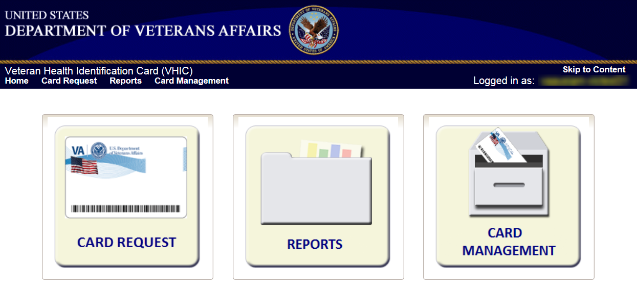
Figure 3-2: VHIC Administrator and VHIC Technical Administrator (Tier 3) Home screen

VHIC Associate and Supervisor
The VHIC Associate and VHIC Supervisor users will be presented with two menu options: Card Requests and Reports. They can navigate to each of these application modules by either clicking on one of the links located in the header at the top left of the screen or by clicking on one of the icon buttons in the middle of the screen.
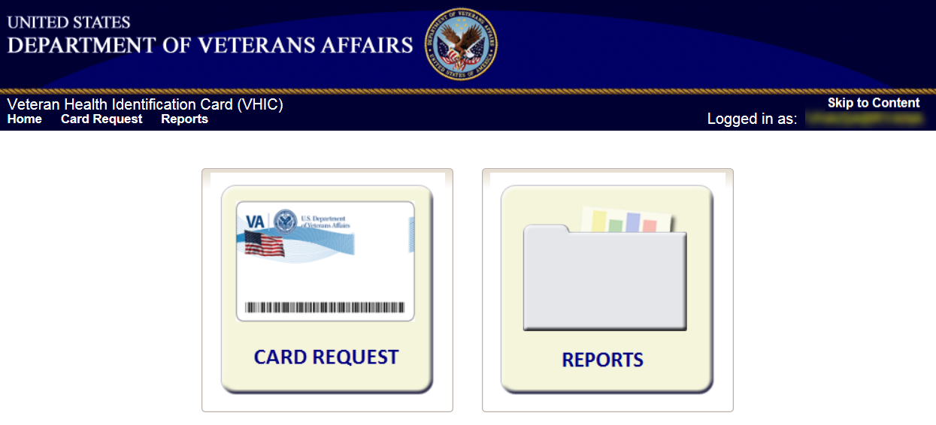
Figure 3-3: VHIC Associate and VHIC Supervisor Home screen

VHIC Auditor and Read-Only User
The VHIC Auditor and VHIC Read-Only users will be presented with the Reports menu option. They can navigate to Reports by clicking on the icon button in the middle of the screen.
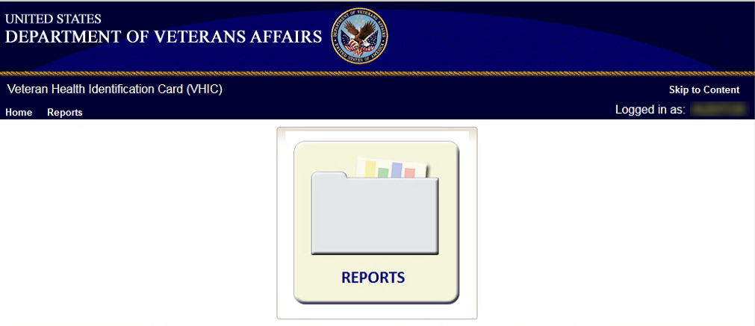
Figure 3-4: VHIC Auditor and VHIC Read-Only User Home screen

Changing User ID and Password
If you have any questions or need help with your User ID or your Password; call the Enterprise Service Desk at REDACTED, option 1 (Account or Password Reset), then option 1.

Before Requesting a VHIC Card
For detailed step-by-step process of how to access and complete the Identity Proofing Verification task in the Identity Management Toolkit application, please refer to section 4 in the Veteran Health Identification Card (VHIC 4.8) User Guide - Volume 1 - Card Requests – All Users document.

Creating a VHIC Card – The Card Request Process
For a step-by-step process on how to navigate through the Card Request screens in the VHIC application and an explanation of the process involved in creating a VHIC for a Veteran, please refer to section 5 in the Veteran Health Identification Card (VHIC 4.8) User Guide - Volume 1 - Card Requests – All Users document.

Deactivating Cards - The Card Management Process
For detailed information that will help the VHIC Administrator navigate through the card deactivation screens in the VHIC application that will allow them to deactivate all of the VHICs for a specific Veteran, please refer to section 6 in the Veteran Health Identification Card (VHIC 4.8) User Guide - Volume 3 - Card Management - Admins document.

Reports
A comprehensive walkthrough of all of the different reports that are available to VHIC users and the types of metrics that can be obtained, as well as an explanation of the user role permissions for accessing the reports are included in the Veteran Health Identification Card (VHIC 4.8) User Guide - Volume 2 - Reports document.

VHIC Troubleshooting (FAQ)
The following section houses some of VHIC’s most frequently asked questions along with the proper guidance on how to remedy or even avoid the issue. Some of the provided steps can be taken as preventative measures to ensure you are less likely to encounter these situations.

Login Questions

Cannot log in to the application
If you are unable to log in to the VHIC application, make sure you are using the correct URL listed in paragraph 2.1.
If you cannot move past the sign on screen, and are given a message stating you don’t have access, please log a ticket requesting help by calling the Contact the Enterprise Service Desk at REDACTED, option 3 (Applications), then option 1.
If you are able to sign on, but are taken to the VA home page or to a non-functioning VHIC screen, please check with your VHIC Supervisor to ensure that you have been properly provisioned and have the necessary authorization that would allow you to access VHIC.

Do not have access to required areas/items
If you log in to VHIC and do not have access to specific areas belonging to your specific role, please check with your VHIC Supervisor to ensure that you have been properly provisioned to access the VHIC application.

How to Find VHIC Supervisors
If you do not know your VHIC provisioning supervisor, log a ticket by contacting the Enterprise Service Desk at REDACTED, option 3 (Applications), then option 1.

Address Questions

Veteran’s Address is Incorrect at the ‘Step 4: Select Mailing Address’ Screen
If the Veteran’s address is incorrect at ‘Step 4: Select Mailing Address’, it must be fixed in the Enrollment System (ES) by someone at your site before card request. After 48 hours, if the address displayed is not correct, call the contacting the Enterprise Service Desk at REDACTED, option 3 (Applications), then option 1 and log a ticket for assistance. Inform the Enterprise Service Desk which screen holds the incorrect address. When contacted by the Admin support team, give them the Veteran’s name, date of birth and social security number for further evaluation.

Requesting Facility Address is Incorrect at the ‘Step 4: Select Mailing Address’ Screen
If the address for the Requesting Facility is not correct, then the VHIC user would need to request help with correcting the address by contacting the Enterprise Service Desk at REDACTED, option 3, option 1. Alternately, send an email message to ESD DEV OPS REDACTED with correction details.

Card Questions

What does the VHIC Card Look Like
Figure 8-1: Example of what the VHIC looks like

What are the Member ID and the Plan ID on the face of the VHIC card?
The Member ID is the unique identifier for the person as established by the Department of Defense (DoD). If the Veteran does not have a unique identifier from the DoD, the “Member ID” label will be printed on the card and the information field will be left blank. The Member ID is also called the Electronic Data Interchange Personal Identifier (EDIPI).
The Plan ID is the unique Health Plan Identifier assigned to the Department of Veterans Affairs (VA) as established by the Centers for Medicare and Medicaid Services. This number is the same for all VHIC cards.

Member ID is Missing from Card
A Service Desk ticket should NOT be created when the Member ID - also called EDIPI - is missing from a VHIC card. There is NO requirement to check for Member ID before printing a VHIC card. Cards missing Member IDs are fully acceptable and usable.
An effort is underway to obtain Member IDs for all Veterans, but it will take some time to complete.

Photo Questions

Image Alignment
If you are experiencing an issue with image misplacement or misalignment, you should verify your browser compatibility settings are properly set.
Examples of Image Misplacement and Other Misalignments:
Figure 8-2: Over-sized icon buttons on the Home Screen

Figure 8-3: Words wrapping around the displayed photo on Step 3

REDACTED
Figure 8-4: Content on the right of the Step 5 screen is shifted down

REDACTED
Figure 8-5: Both the VISN and Facility selection lists are displayed and shifted to the right
If you are experiencing misalignment issues, follow these steps to verify/update your browser compatibility settings:
- With Internet Explorer open, right click in the blue area at the top of the browser window.
- Click on [Command Bar] to display the Command Tool Bar.
Figure 8-6: Internet Explorer's Tool Bar Menu
- Click on the [Tools] menu button.
Figure 8-7: Tools Menu button
- Click on [Compatibility View Settings].
Figure 8-8: Tools drop-down menu
- Uncheck the box next to Display intranet sites in Compatibility View.
Figure 8-9: Compatibility View Settings screen

- Click the [Close] button.
Figure 8-10: Compatibility View Settings Screen - Close

NOTE: Compatibility mode does need to be turned on in order to access other applications such as Notes in NUMI’s CERMe and the Beneficiary Travel Dashboard. You can turn compatibility mode back on by following the above directions and checking the Display intranet sites in Compatibility View checkbox.

Photo not saved
If for any reason you are unable to complete the card request by clicking either the Submit or Hold buttons on Step 5, the VHIC system will not save the photo. You would have to either take a new photo or upload a new photo on Step 3 when you process a new card request for that Veteran.

Adobe Flash Permissions
If you are shown the Adobe Flash Player Setting popup window with the Allow and Deny buttons on Step 3, you will need to perform the following steps.
- Click the [Capture Image] button at the bottom of the screen.
REDACTED

Figure 8-11: Adobe Flash Player Settings - Click Capture Image

- Right click on the [Allow] button.
REDACTED

Figure 8-12: Adobe Flash Player Settings - Right click on Allow

- Click on [Settings].
REDACTED

Figure 8-13: Adobe Flash Player Settings - select Settings

- Set to Allow by clicking on the circle to the immediate left of Allow.
- Set to Remember by clicking on the square to the immediate left of Remember.
- Click the [Close] button.

REDACTED

Figure 8-14: Adobe Flash Player Settings - select Settings

- Click the [Back] button.
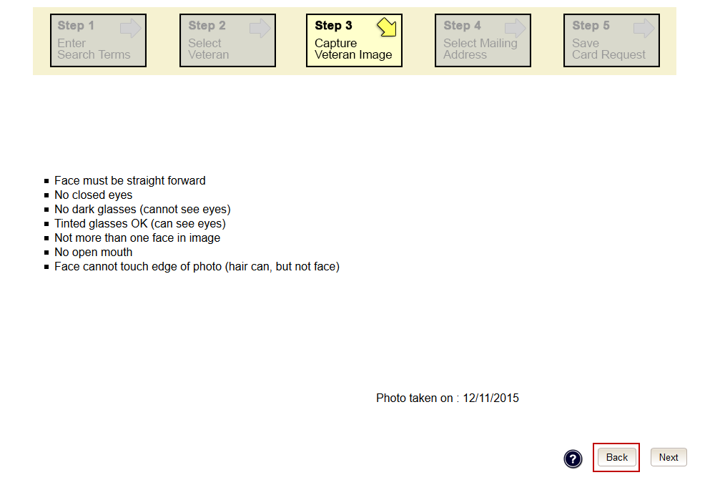
Figure 8-15: Adobe Flash Player Settings - Reset camera

- Click the [Take New Picture] button.
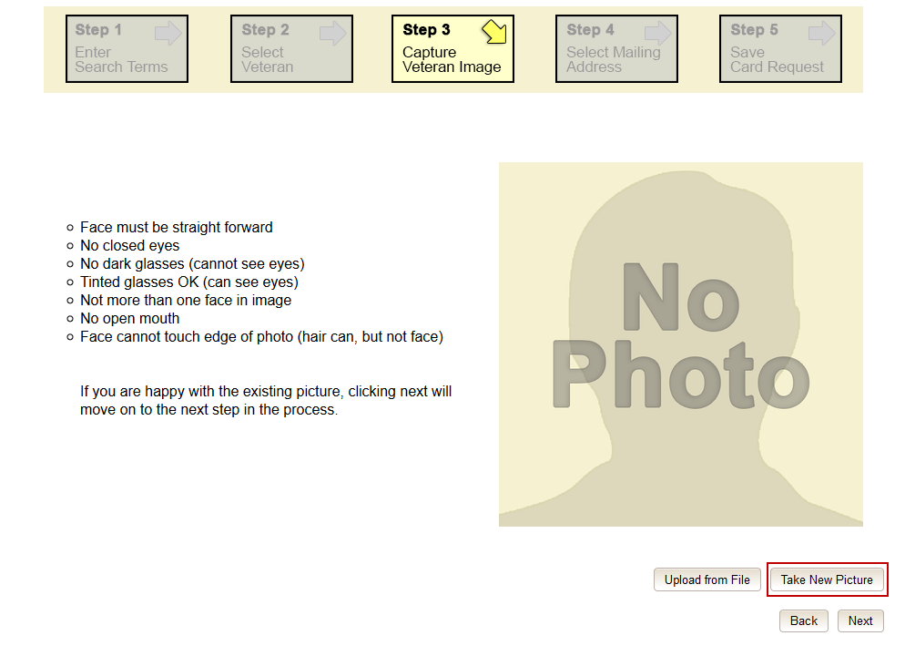
Figure 8-16: Capture Veteran Image screen - Take New Picture
The image silhouette will then return, and the Veteran image will be visible. You can then capture the image and continue with the card request process.

Information not updating with radio button selection
If making certain selections (i.e., check boxes or radio buttons) does not appear to be functioning as expected, this could be due to your browser compatibility settings not being properly set. Follow the steps listed in section 8.4.1 to update these.

Error Questions

Can I request a card when ‘Bad MVI Address’ is displayed?
Home addresses are stored in the Enrollment Services database and in the MVI database. When a valid MVI address is unavailable, the ‘Bad MVI Address’ message is displayed in black letters at the top of the screen. When this occurs, select the Enrollment Services address, the requesting facility address, or the preferred facility address and continue with the card request.

Can I request a card when ‘Bad Preferred Facility Address’ is displayed?
Preferred facilities are sent to VHIC from Enrollment Services. Occasionally, a Veteran will not have a preferred facility associated with their enrollment record. When VHIC does not receive a preferred facility from ES, the VHIC system will display the message ‘Bad Preferred Facility Address’ in red letters at the top of the screen. When this occurs, select the Enrollment Services address, MVI address, or the requesting facility address and continue with the card request.

What to do with “Error accessing MVI” messages
The problem will be forwarded to the Admin support team, and Admin will forward to tier 3 DEV-VIC4 for resolution.
This problem occurs during peak workload times, and is an intermittent problem. Sites experiencing this problem should periodically retry to process VHIC cards.

What to do with “MVI Did Not Return an Enrollment Identifier” messages on Step 2
Enrollment status is obtained by the VHIC system from the Enrollment Services System. Some Veterans have no defined enrollment status in ES (even though they are known to MVI), as indicated by the “No Enrollment Determination” comment.
During card requests for these “no enrollment status” Veterans, at the ‘Step 2 Select Veteran’ screen, a message stating that the “Eligibility could not be determined. MVI did not return an Enrollment [sic] identifier for ICN” is displayed. Inform the Veteran that they will need to have the problem fixed in the Enrollment Services System, (and possibly wait up to 48 hours for the change to become visible to VHIC), and then the card can be requested.

Photo Error Questions
A photo collision is the possibility of two Veteran images getting swapped.
We have implemented several checks at different points of the card request process; Step 3: Capture Veteran Image, Step 5: Save Card Request, and the Card Monitor Job, which is the title of a task run every day in the VHIC system.

Step 3: Capture Veteran Image
The first set of checks happens at Step 3: Capture Veteran Image when the VHIC user clicks the [Next] button after taking a new picture or uploading a photo.
The VHIC system will now check to make sure that the picture being taken or uploaded is not already assigned to another Veteran.
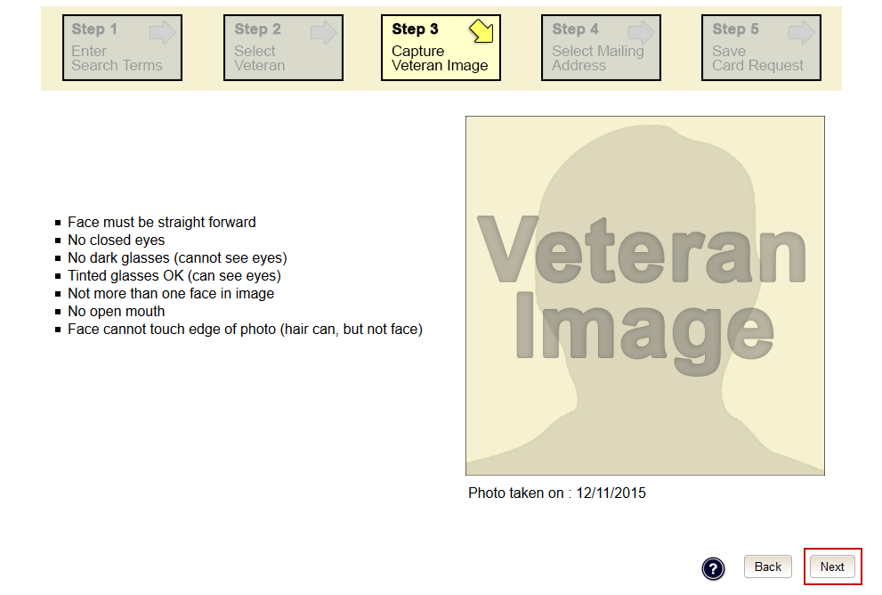
Figure 8-17: Step 3: Capture Veteran Image

If the VHIC application detects a collision, the VHIC user will see the below error show up under the Navigation Bar. If this occurs, then the VHIC user can click the Back button until they get to Step 2: Select Veteran.
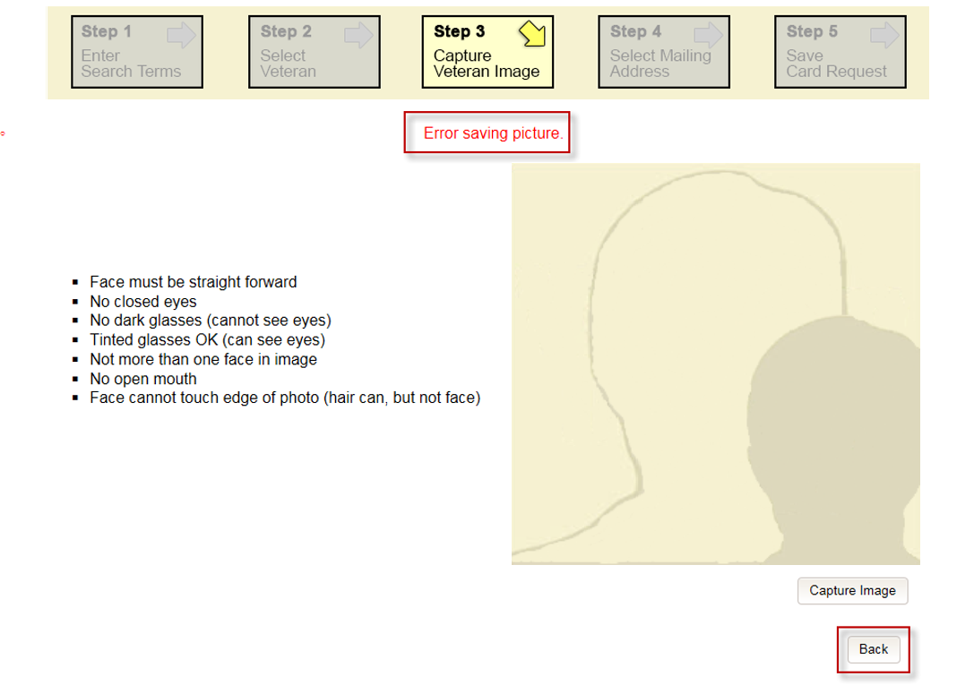
Figure 8-18: Step 3:"Error Saving Picture" error message
Click on the Veteran’s name to be taken to Step 3 again to take a new photo or upload a photo. If using the same photo, you will need to rename the file; i.e. upload1.jpg would be renamed as upload2.jpg. You can then proceed with the card request as normal.
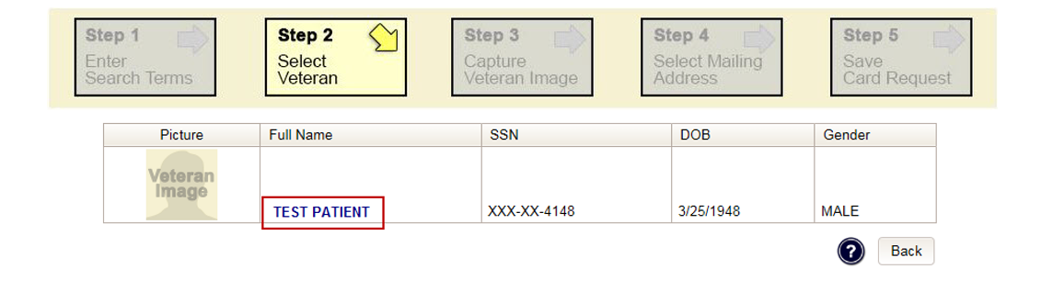
Figure 8-19: Step 2: Select Veteran screen

Step 5: Save Card Request
The second place that the VHIC application checks for possible photo collisions, is on Step 5: Save Card Request when the VHIC user clicks either the [Submit] or [Hold] button.
The VHIC system will then check to make sure that the Veteran’s photo is not associated with any other Veteran.
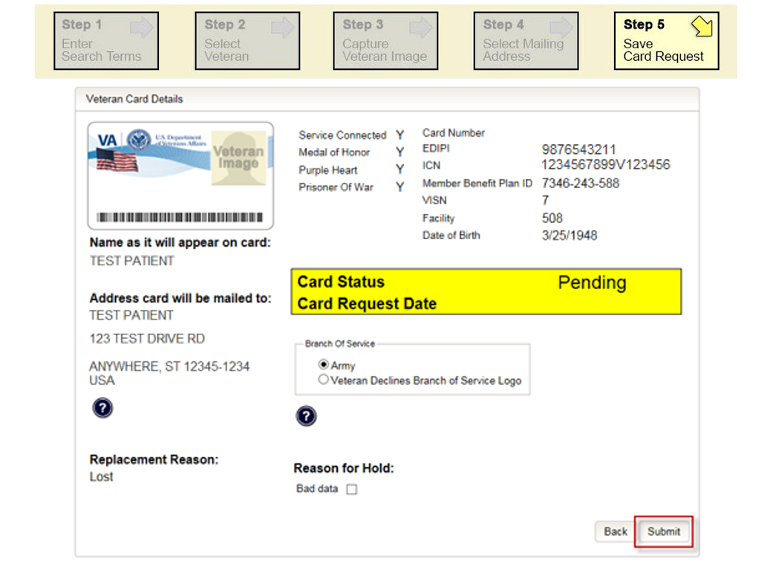
Figure 8-20: Step 5: Save card Request review screen

If the VHIC application detects a collision, the VHIC user will see the below error show up under the Navigation Bar.
When this occurs, the VHIC user MUST start a new Card Request for the Veteran by clicking on the [Card Request] link in the header and take a new photo. If using the same photo, you will need to rename the file; i.e. upload1.jpg would be renamed as upload2.jpg. Since the proofing process was completed at Step 5, there is no need to ID proof the Veteran again.
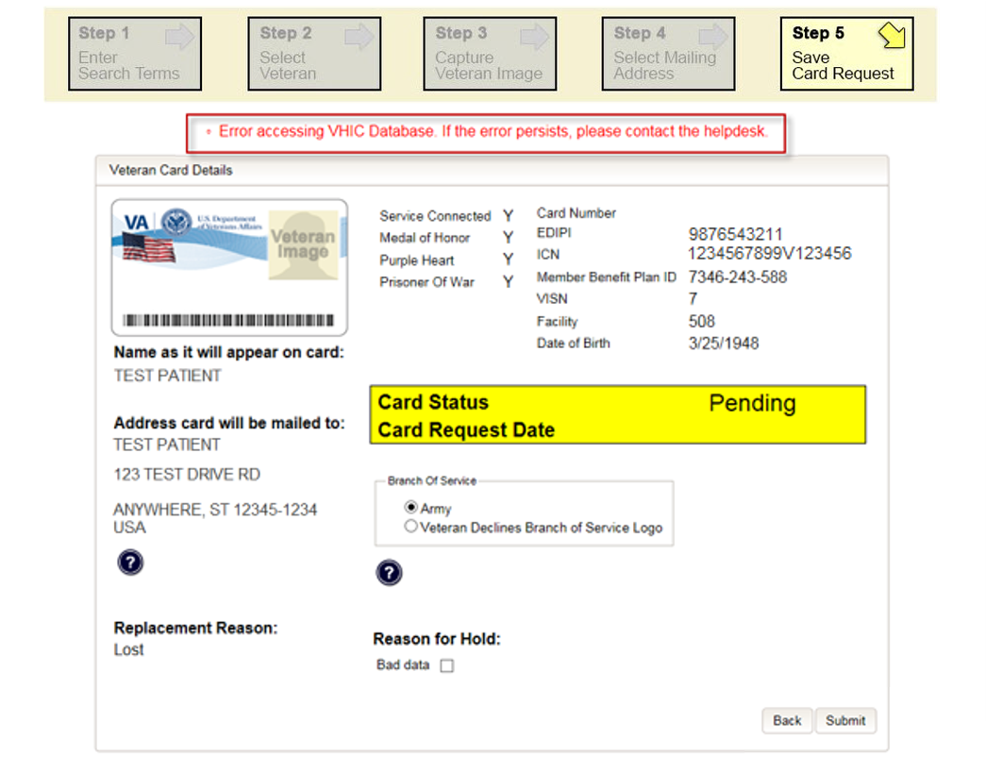
Figure 8-21: Step 5: "Error accessing VHIC Database. If the error persists, please contact the helpdesk.” error message

Wrong Photo on Veteran’s VHIC
If a Veteran brings in a VHIC card that has the wrong photo printed on it, the card will need to be destroyed and the Veteran will need to request a new VHIC.

Report Questions

Report not returning results for selected date range
If you are running a report within a specific date range and find that the results stop well before your end date, this could be a result of having too many results returned. The system limits results to 3000 rows. Any results over this amount will not be returned. Consider modifying the start and end dates for the report in question.
If you specify a large date range, the report might time out and return no results. In that case, retry the report with a smaller date range.

On Hold Questions

Veteran Not Proofed

User did NOT complete the proofing process using the Identity Management Toolkit application PRIOR to creating a VHIC request
If the VHIC user started the VHIC card request BEFORE going into the Identity Management Toolkit application and completing the proofing process, the VHIC application will display the below Warning message on Step 4 of the card request process indicating that the Veteran has NOT been Identity Proofed. The VHIC user will also see “Veteran not proofed” as the Reason for Hold on Step 5. The VHIC application will allow you to save the card request on hold. The card request will be saved for 30 days.
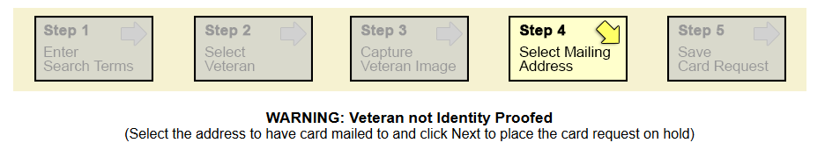
Figure 8-22: Veteran Not Proofed Warning message on Step 4: Select Mailing Address
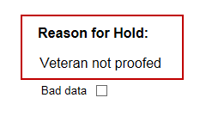
Figure 8-23: Reason for Hold: Veteran Not Proofed

Once the VHIC user completes the Identity Proofing in the Identity Management Toolkit application, they can return to the VHIC application to take the card request off hold. The VHIC user will start a card request as they would normally. The VHIC user will see the On Hold Reason – Veteran Not Proofed displayed on Step 4 of the card request process.
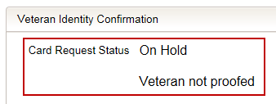
Figure 8-24: Card Request Status: On Hold - Veteran Not Proofed
Continue with the card request process and submit the card request as outlined in section 5.3 Resuming an On-Hold VHIC Request: Veteran NOT Level 2 Proofed Hold Reason in the Veteran Health Identification Card (VHIC 4.8) User Guide - Volume 2 - Reports document.
NOTE: There is a background job that runs every morning at 8:00am Eastern Time that will check the proofing status of any cards placed on hold. As long as there are no other issues with the card request, the job will submit the card request to the print vendor.

Enrollment Services Unavailable
If you get to Step 5 and see the message “Enrollment Unavailable” displayed under Reason for Hold, which means that VHIC is unable to communicate to Enrollment Services at this time, select the Branch of Service (if available) and click on the [Hold] button. This will save the card request for 30 days.
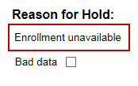
Figure 8-25: Reason for Hold: Enrollment Unavailable
Next, log a ticket by calling the Enterprise Service Desk at REDACTED option #3, option #1 or send an email message to ESD DEV OPS REDACTED to log a trouble ticket.

NOTE: There is a background job that runs every morning at 8:00am Eastern Time that will check the eligibility status of any cards placed on hold.
- If the Eligibility status is confirmed as “Eligible” and there are no other issues with the card request, the job will submit the card request to the print vendor.
- If the Eligibility status is confirmed as “Not Eligible”, the card request will be terminated and no card will be issued.

Eligibility Pending
If you get to Step 5 and see the message “Eligibility Pending” displayed under Reason for Hold, which means that Enrollment Services has returned an eligibility status of “Pending” at this time, select the Branch of Service (if available) and click on the [Hold] button. This will save the card request for seven (7) days.
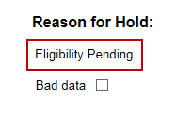
Figure 8-26: Reason for Hold: Eligibility Pending
NOTE: The Veteran should go to Enrollment Services to have the record updated as needed. There is a background job that runs every morning at 8:00am Eastern Time that will check the eligibility status of any cards placed on hold.
- If the Eligibility status is confirmed as “Eligible” and there are no other issues with the card request, the job will submit the card request to the print vendor.
- If the Eligibility status is confirmed as “Not Eligible” or is not updated within Seven (7) days, the card request will be terminated and no card will be issued.

Bad Data – Other
If you get to Step 5: Save Card Request and any information that is displayed on the screen needs to get changed/updated, click the checkbox next to “Bad Data” under Reason for Hold. A Details field will be displayed and you can enter a description on what information needs to be updated. Then select the Branch of Service (if available) and click on the [Hold] button. This will save the card request for 30 days.
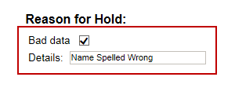
Figure 8-27: Reason for Hold: Bad Data - Name Spelled Wrong
The Veteran should go to Enrollment Services to have the record updated as needed. Card requests that have been placed on hold with “Bad Data” as the Reason for Hold will NOT be updated and submitted by the background job.
The Veteran will need to return to complete the card request after they have had the information updated. You will need to start a card request as you would normally. On Step 4 of the card request process, you will see the On Hold Reason – Bad Data: (reason entered when saved) displayed.
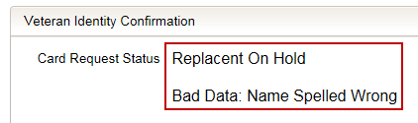
Figure 8-28: Card Request Status: Replacement on Hold - Bad Data: Name Spelled Wrong
Continue with the card request process. When you get to Step 5, you will need to uncheck the checkbox next to “Bad Data” in order to be able to submit the card request.
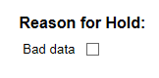
Figure 8-29: Reason for Hold: Bad Data Unchecked

Appendix A: VHIC Roles
 |  |  |  |  |  | VHIC Role
Function/Report Title |  |  | Navigation |  | Selected Status from Drop Down Menu | Administrator | Technical Administrator Tier 3 | Supervisor |  | Associate |  | Auditor | Read-Only User
CARD REQUESTS
Request Cards |  |  | (Card Requests icon on Home Screen/ Card Requests link in top Navigation Bar) |  | N/A | X | X | X |  | X
Deactivate Cards |  |  | (Card Management icon on Home Screen/ Card Management link in top Navigation Bar) |  | N/A | X | X
REPORTS
Veteran (Direct Search) |  |  | (Reports icon on Home Screen/ Reports link in top Navigation Bar)
Basic (no national option)
Veteran Detail Report |  |  | Default view for Reports |  | N/A | X | X |  | X |  | X | X | X
Card Request Totals |  |  | (Card menu tab - Request Totals sub-menu tab)
National
VHIC Card Request Totals |  |  | Click National Checkbox |  | N/A | X | X |  |  |  |  | X
VISN
VHIC Card Request Totals |  |  | Click VISN radio button |  | N/A | X | X |  |  |  |  | X | X
Facility
VHIC Card Request Totals |  |  | Click Facility ration button |  | N/A | X | X |  | X |  | X | X | X
Card Status - MVI Status Report |  |  | (Card menu tab - Status sub-menu tab - MVI Status radio button)
National
VHIC MVI Status National Report |  |  | Click National Checkbox |  | Active | X | X |  |  |  |  | X
 |  |  |  |  | Not Correlated | X | X |  |  |  |  | X
 |  |  |  |  | Rejected | X | X |  |  |  |  | X
 |  |  |  |  | Unlinked | X | X |  |  |  |  | X
VISN
VHIC MVI Status Summary Report |  |  | Click VISN radio button |  | Active | X | X |  |  |  |  | X
 |  |  |  |  | Not Correlated | X | X |  |  |  |  | X
 |  |  |  |  | Rejected | X | X |  |  |  |  | X
 |  |  |  |  | Unlinked | X | X |  |  |  |  | X
Facility
VHIC MVI Status Summary Report |  |  | Click Facility ration button |  | Active | X | X |  | X |  | X | X
 |  |  |  |  | Not Correlated | X | X |  | X |  | X | X
 |  |  |  |  | Rejected | X | X |  | X |  | X | X
 |  |  |  |  | Unlinked | X | X |  | X |  | X | X
Facility Detail
VHIC MVI Status Detail Report |  |  | Click on the Facility Number |  | Active | X | X |  | X |  | X | X
 |  |  |  |  | Not Correlated | X | X |  | X |  | X | X
 |  |  |  |  | Rejected | X | X |  | X |  | X | X
 |  |  |  |  | Unlinked | X | X |  | X |  | X | X
Card Status - Card Status Report |  |  | (Card menu tab - Status sub-menu tab - Card Status radio button)
National
VHIC Card Status National Report |  |  | Click National Checkbox |  | Replaced | X | X |  |  |  |  | X
 |  |  |  |  | Deactivated | X | X |  |  |  |  | X
 |  |  |  |  | Expired | X | X |  |  |  |  | X
 |  |  |  |  | On Hold | X | X |  |  |  |  | X
 |  |  |  |  | Pending | X | X |  |  |  |  | X
 |  |  |  |  | Requested | X | X |  |  |  |  | X
 |  |  |  |  | Defunct | X | X |  |  |  |  | X
 |  |  |  |  | Pending Destruction | X | X |  |  |  |  | X
 |  |  |  |  | Destroyed | X | X |  |  |  |  | X
VISN
VHIC Card Status Summary Report |  |  | Click VISN radio button |  | Replaced | X | X |  |  |  |  | X
 |  |  |  |  | Deactivated | X | X |  |  |  |  | X
 |  |  |  |  | Expired | X | X |  |  |  |  | X
 |  |  |  |  | On Hold | X | X |  |  |  |  | X
 |  |  |  |  | Pending | X | X |  |  |  |  | X
 |  |  |  |  | Requested | X | X |  |  |  |  | X
 |  |  |  |  | Defunct | X | X |  |  |  |  | X
 |  |  |  |  | Pending Destruction | X | X |  |  |  |  | X
 |  |  |  |  | Destroyed | X | X |  |  |  |  | X
Facility
VHIC Card Status Summary Report |  |  | Click Facility ration button |  | Replaced | X | X |  | X |  | X | X
 |  |  |  |  | Deactivated | X | X |  | X |  | X | X
 |  |  |  |  | Expired | X | X |  | X |  | X | X
 |  |  |  |  | On Hold | X | X |  | X |  | X | X
 |  |  |  |  | Pending | X | X |  | X |  | X | X
 |  |  |  |  | Requested | X | X |  | X |  | X | X
 |  |  |  |  | Defunct | X | X |  | X |  | X | X
 |  |  |  |  | Pending Destruction | X | X |  | X |  | X | X
 |  |  |  |  | Destroyed | X | X |  | X |  | X | X
Facility Detail
VHIC Card Status Detail Report |  |  | Click on the Facility Number |  | Replaced | X | X |  | X |  | X | X
 |  |  |  |  | Deactivated | X | X |  | X |  | X | X
 |  |  |  |  | Expired | X | X |  | X |  | X | X
 |  |  |  |  | On Hold | X | X |  | X |  | X | X
 |  |  |  |  | Pending | X | X |  | X |  | X | X
 |  |  |  |  | Requested | X | X |  | X |  | X | X
 |  |  |  |  | Defunct | X | X |  | X |  | X | X
 |  |  |  |  | Pending Destruction | X | X |  | X |  | X | X
 |  |  |  |  | Destroyed | X | X |  | X |  | X | X
Card Status - Print Release Status Report |  |  | (Card menu tab - Status sub-menu tab - Print Status radio button)
National
VHIC Print Status National Report |  |  | Click National Checkbox |  | Cancelled | X | X |  |  |  |  | X
 |  |  |  |  | Error | X | X |  |  |  |  | X
 |  |  |  |  | Mailed | X | X |  |  |  |  | X
 |  |  |  |  | Not Started | X | X |  |  |  |  | X
 |  |  |  |  | Pending | X | X |  |  |  |  | X
 |  |  |  |  | Received | X | X |  |  |  |  | X
 |  |  |  |  | Rejected | X | X |  |  |  |  | X
 |  |  |  |  | Sent | X | X |  |  |  |  | X
VISN
VHIC Print Status Detail Report |  |  | Click VISN radio button |  | Cancelled | X | X |  |  |  |  | X
 |  |  |  |  | Error | X | X |  |  |  |  | X
 |  |  |  |  | Mailed | X | X |  |  |  |  | X
 |  |  |  |  | Not Started | X | X |  |  |  |  | X
 |  |  |  |  | Pending | X | X |  |  |  |  | X
 |  |  |  |  | Received | X | X |  |  |  |  | X
 |  |  |  |  | Rejected | X | X |  |  |  |  | X
 |  |  |  |  | Sent | X | X |  |  |  |  | X
Facility
VHIC Print Status Detail Report |  |  | Click Facility ration button |  | Cancelled | X | X |  | X |  | X | X
 |  |  |  |  | Error | X | X |  | X |  | X | X
 |  |  |  |  | Mailed | X | X |  | X |  | X | X
 |  |  |  |  | Not Started | X | X |  | X |  | X | X
 |  |  |  |  | Pending | X | X |  | X |  | X | X
 |  |  |  |  | Received | X | X |  | X |  | X | X
 |  |  |  |  | Rejected | X | X |  | X |  | X | X
 |  |  |  |  | Sent | X | X |  | X |  | X | X
Facility Detail
VHIC Print Status Detail Report |  |  | Click on the Facility Number |  | Cancelled | X | X |  | X |  | X | X
 |  |  |  |  | Error | X | X |  | X |  | X | X
 |  |  |  |  | Mailed | X | X |  | X |  | X | X
 |  |  |  |  | Not Started | X | X |  | X |  | X | X
 |  |  |  |  | Pending | X | X |  | X |  | X | X
 |  |  |  |  | Received | X | X |  | X |  | X | X
 |  |  |  |  | Rejected | X | X |  | X |  | X | X
 |  |  |  |  | Sent | X | X |  | X |  | X | X
Card Request Progress |  |  | (Card menu tab - Request Progress sub-menu tab)
National
VHIC Card Request Progress National Summary Report |  |  | Click National Checkbox |  | N/A | X | X |  |  |  |  | X
VISN
VHIC Card Request Progress VISN Summary Report |  |  | Click VISN radio button |  | N/A | X | X |  |  |  |  | X
Facility
VHIC Card Request Progress Facility Summary Report |  |  | Click Facility ration button |  | N/A | X | X |  | X |  | X | X
Facility Detail
VHIC Card Request Progress Facility Detail Report |  |  | Click on the Facility Number |  | N/A | X | X |  | X |  | X | X
Multiple Requests |  |  | (Card menu tab - Multiple Requests sub-menu tab)
Cards Requested |  |  | (Cards Requested radio button)
National
VHIC Summary Report for Number of Cards Requested |  |  | Click National Checkbox |  | N/A | X | X |  |  |  |  | X
VISN
VHIC Summary Report for Number of Cards Requested |  |  | Click VISN radio button |  | N/A | X | X |  |  |  |  | X
Facility
VHIC Detailed Report for Number of Cards Requested |  |  | Click Facility ration button |  | N/A | X | X |  | X |  | X | X
Facility Detail
VHIC Facility Detail Report for Number of Cards Requested |  |  | Click on the Facility Number |  | N/A | X | X |  | X |  | X | X
Cards Mailed |  |  | (Cards Mailed radio button)
National
VHIC Summary Report for Number of Cards Requested |  |  | Click National Checkbox |  | N/A | X | X |  |  |  |  | X
VISN
VHIC Summary Report for Number of Cards Requested |  |  | Click VISN radio button |  | N/A | X | X |  |  |  |  | X
Facility
VHIC Detailed Report for Number of Cards Mailed |  |  | Click Facility ration button |  | N/A | X | X |  | X |  | X | X
Facility Detail
VHIC Facility Detail Report for Number of Cards Mailed |  |  | Click on the Facility Number |  | N/A | X | X |  | X |  | X | X
Card History |  |  | (Card menu tab - History sub-menu tab)
Card ID
VHIC Card History |  |  | Enter Veteran's Card ID in the Card ID field |  | N/A | X | X |  | X |  | X | X | X
Person ID
VHIC Card History |  |  | Enter Veteran's Person ID in the Person ID field |  | N/A | X | X |  | X |  | X | X | X
Expiration |  |  | (Card menu tab - Expiration sub-menu tab)
National
VHIC Card Expiration Summary Report |  |  | Click National Checkbox |  | N/A | X | X |  |  |  |  | X
VISN
VHIC Card Expiration Summary Report |  |  | Click VISN radio button |  | N/A | X | X |  |  |  |  | X
Facility
VHIC Card Expiration Site Report |  |  | Click Facility ration button |  | N/A | X | X |  | X |  | X | X
Facility Detail
VHIC Card Expiration Detail Report |  |  | Click on the Facility Number |  | N/A | X | X |  | X |  | X | X
Replacement |  |  | (Card menu tab - Replacement sub-menu tab)
National
VHIC Card Replacement Summary Report |  |  | Click National Checkbox |  | N/A | X | X |  |  |  |  | X
VISN
VHIC Card Replacement Summary Report |  |  | Click VISN radio button |  | N/A | X | X |  |  |  |  | X
Facility
VHIC Card Replacement Facility Report |  |  | Click Facility ration button |  | N/A | X | X |  | X |  | X | X
Facility Sub-Reason Summary
VHIC Card Replacement Facility Subreason Report |  |  | Click # of Cards Replaced |  | N/A | X | X |  | X |  | X | X
Facility Sub-Reason Detail
VHIC Card Replacement Facility Subreason Detail |  |  | Click # of Cards Replaced |  | N/A | X | X |  | X |  | X | X
On Hold |  |  | (Card menu tab - On-Hold sub-menu tab)
National
VHIC On Hold Card Status National Summary Report |  |  | Click National Checkbox |  | Not Proofed | X | X |  |  |  |  | X
 |  |  |  |  | Eligibility Pending | X | X |  |  |  |  | X
 |  |  |  |  | Enrollment Services Unavailable | X | X |  |  |  |  | X
 |  |  |  |  | Bad Data | X | X |  |  |  |  | X
 |  |  |  |  | All | X | X |  |  |  |  | X
VISN
VHIC On Hold Card Status VISN Summary Report |  |  | Click VISN radio button |  | Not Proofed | X | X |  |  |  |  | X
 |  |  |  |  | Eligibility Pending | X | X |  |  |  |  | X
 |  |  |  |  | Enrollment Services Unavailable | X | X |  |  |  |  | X
 |  |  |  |  | Bad Data | X | X |  |  |  |  | X
 |  |  |  |  | All | X | X |  |  |  |  | X
Facility
VHIC On Hold Card Status Facility Summary Report |  |  | Click Facility ration button |  | Not Proofed | X | X |  | X |  | X | X
 |  |  |  |  | Eligibility Pending | X | X |  | X |  | X | X
 |  |  |  |  | Enrollment Services Unavailable | X | X |  | X |  | X | X
 |  |  |  |  | Bad Data | X | X |  | X |  | X | X
 |  |  |  |  | All | X | X |  | X |  | X | X
Facility Detail
VHIC On Hold Card Status Facility Detail Report |  |  | Click on Facility # |  | Not Proofed | X | X |  | X |  | X | X
 |  |  |  |  | Eligibility Pending | X | X |  | X |  | X | X
 |  |  |  |  | Enrollment Services Unavailable | X | X |  | X |  | X | X
 |  |  |  |  | Bad Data | X | X |  | X |  | X | X
 |  |  |  |  | All | X | X |  | X |  | X | X
Card Destruction |  |  | (Card menu tab – Destruction sub-menu tab)
Pending Destruction |  |  | (Pending Destruction radio button)
Basic (no national option)
VHIC Card Destruction Report – Pending Destruction |  |  | Select Status and Date Range |  | All | X | X |  |  |  |  | X
 |  |  |  |  | Legacy | X | X |  |  |  |  | X
 |  |  |  |  | Mass Reissuance | X | X |  |  |  |  | X
 |  |  |  |  | VHIC | X | X |  |  |  |  | X
Destroyed |  |  | (Destroyed radio button)
Basic (no national option)
VHIC Card Destruction Report – Destroyed |  |  | Select Status and Date Range |  | All | X | X |  |  |  |  | X
 |  |  |  |  | Legacy | X | X |  |  |  |  | X
 |  |  |  |  | Mass Reissuance | X | X |  |  |  |  | X
 |  |  |  |  | VHIC | X | X |  |  |  |  | X
Print Services Processing |  |  | (Print Services menu tab - Processing sub-menu tab)
National
VHIC Batch File Processing Status National Report |  |  | Click National Checkbox |  | N/A | X | X |  |  |  |  | X
VISN
VHIC Batch File Processing Status Summary Report |  |  | Click VISN radio button |  | N/A | X | X |  |  |  |  | X
Facility
VHIC Batch File Processing Status Summary Report |  |  | Click Facility ration button |  | N/A | X | X |  | X |  | X | X
Facility Detail
VHIC Batch File Processing Status Detail Report |  |  | Click on the Facility Code |  | N/A | X | X |  | X |  | X | X
Print Error |  |  | (Print Services menu tab - Error sub-menu tab)
Pending Not Sent |  |  | (Pending Not Sent radio button)
National
VHIC Batch File Processing Error Status Summary Report – National |  |  | Click National Checkbox |  | N/A | X | X |  |  |  |  | X
VISN
VHIC Batch File Processing Error Status Summary Report - VISN |  |  | Click VISN radio button |  | N/A | X | X |  |  |  |  | X
Facility
VHIC Batch File Processing Error Status Summary Report - Facility |  |  | Click Facility ration button |  | N/A | X | X |  | X |  |  | X
Facility Detail
VHIC Batch File Processing Error Detail Report - Pending Not Sent |  |  | Click on the Facility Number |  | N/A | X | X |  | X |  |  | X
Sent Not Acknowledged |  |  |  | (Sent Not Acknowledged radio button)
National
VHIC Batch File Processing Error Status Summary Report – National |  |  | Click National Checkbox |  | N/A | X | X |  |  |  |  | X
VISN
VHIC Batch File Processing Error Status Summary Report - VISN |  |  | Click VISN radio button |  | N/A | X | X |  |  |  |  | X
Facility
VHIC Batch File Processing Error Status Summary Report - Facility |  |  | Click Facility ration button |  | N/A | X | X |  | X |  |  | X
Facility Detail
VHIC Batch File Processing Error Detail Report - Not Acknowledged |  |  | Click on the Facility Number |  | N/A | X | X |  | X |  |  | X
Acknowledged Not Confirmed |  |  | (Acknowledged Not Confirmed radio button)
National
VHIC Batch File Processing Error Status Summary Report – National |  |  | Click National Checkbox |  | N/A | X | X |  |  |  |  | X
VISN
VHIC Batch File Processing Error Status Summary Report - VISN |  |  | Click VISN radio button |  | N/A | X | X |  |  |  |  | X
Facility
VHIC Batch File Processing Error Status Summary Report - Facility |  |  | Click Facility ration button |  | N/A | X | X |  | X |  |  | X
Facility Detail
VHIC Batch File Processing Error Detail Report - Acknowledged Not Confirmed |  |  | Click on the Facility Number |  | N/A | X | X |  | X |  |  | X
Cards printed without Member ID |  |  | (Print Services menu tab - No Member ID sub-menu tab)
National
VHIC Cards Printed Without Member ID Report |  |  | Click National Checkbox |  | N/A | X | X |  |  |  |  | X
VISN
VHIC Cards Printed Without Member ID Report |  |  | Click VISN radio button |  | N/A | X | X |  |  |  |  | X
Facility
VHIC Cards Printed Without Member ID Report |  |  | Click Facility ration button |  | N/A | X | X |  | X |  | X | X
Auditing |  |  | (Auditing menu tab)
Basic (no national option)
VHIC Auditing Report |  |  | Default view for Auditing menu tab |  | N/A | X | X |  | X |  |  | X
Card Requests by User |  |  | (Auditing menu tab – Card Requests sub-menu tab)
Card Requests by User
National
VHIC Card Requests by User National Summary Report |  |  | Click National Checkbox |  | N/A | X | X |  |  |  |  | X
VISN
VHIC Card Requests by User VISN Summary Report |  |  | Click VISN radio button |  | N/A | X | X |  |  |  |  | X
Facility
VHIC Card Requests by User Facility Summary Report |  |  | Click Facility ration button |  | N/A | X | X |  | X |  |  | X
User Detail
VHIC Card Requests by User Detail Report |  |  | Click on the User ID |  | N/A | X | X |  | X |  |  | X

Template Revision History
Date | Version | Description | Author
December 2015 | 1.6 | Updated to align with current OI&T Documentation Standards, edited to conform with latest Section 508 guidelines, and remediated with Common Look Office tool | Process Management
June 2015 | 1.5 | Edited to conform with Section 508 guidelines and remediated with Common Look Office tool | Process Management
May 2015 | 1.4 | Reviewed and approved by PMAS Process Improvement Lockdown. Updated instructional test. | Process Management
November 2014 | 1.3 | Updated to conform with latest Section 508 guidelines and remediated with Common Look Office tool | Process Management
April 2014 | 1.2 | Changed title page to clarify that version number refers to software version | Process Management
April 2011 | 1.1 | Formatted to current ProPath documentation standards and edited to conform with latest Alternative Text (Section 508) guidelines | Process Management
June 2009 | 1.0 | Initial Version | PMAS Business Office

Place latest revisions at top of table.
The Template Revision History can be removed or moved to the “Revision History” section at the discretion of the author of the document. If removed, it is recommended that the author indicate the template version used as the baseline for the User Guide in the first entry in the “Document Revision History” table.
The Template Revision History can be removed at the discretion of the author of the document.
Remove blank rows.
ALERT: Delete all Instructional Text before publishing or distributing this document!

