Veteran Health Identification Card (VHIC 4.17)

User Guide
Volume 1 - Card Request – All Users

June 2021

Department of Veterans Affairs
Office of Information and Technology (OI&T)

Revision History
NOTE: The revision history cycle begins once changes or enhancements are requested after the document has been baselined.
Date | Revision | Description | Author
06/20/2021 | 9 | Updated to reflect changes to functionality in VIP 17 | REDACTED
03/04/2021 | 8 | Updated to reflect changes to functionality in VIP 16 | REDACTED
12/19/2020 | 7 | Updated to reflect changes to functionality in VIP 15 | REDACTED
06/20/20 | 6 | Updated to reflect changes to VHIC application during VIP 13 application release | REDACTED
02/15/2020 | 5 | Updated to reflect changes to VHIC application during VIP 12 application | REDACTED
11/01/2019 | 4 | Updated to reflect changes made in the VIP 10 release- validation for ICN input fields on all search screens and added usage tips | REDACTED
09/19/2019 | 3 | Updated to reflect changes to VHIC 4.9 functionality | REDACTED
08/30/2019 | 2.4 | Updated guide to match Style Guide | REDACTED
08/30/2018 | 2.3 | As part of RTC Task# 808827, updated Alt text on four (4) revised images, re-ran TOCs, and checked pagination. Converted this document to a Section 508 compliant PDF. | REDACTED
08/23/2018 | 2.3 | In Section 4, updated Figures 4-20, 4-21, 4-33, and 4-35 to include a message at the bottom of the figure window for how to delete the current MVI Value. This work was completed under RTC Task # 808827. | REDACTED
04/20/2018 | 2.2 | As part of new Section 4, entitled, “Proofing Veteran before Requesting a VHIC Card” added Alt text to all images and figures. Re-ran TOCs and fixed content/figure pagination issues in the Word document. Revision History number set to “2.2” and document converted to Section 508 compliant PDF for uploading, with Word document, to RTC Jazz Tools as well as SharePoint. Completed editing 04/11/2018 for 04/20/2018 delivery. | REDACTED
04/20/2018 | 2.2 | Updated to reflect changes to Proofing process within MVI Toolkit, updated TOCs | REDACTED
01/24/2018 | 2.1 | Accepted all changes as approved on anomaly logs, re-paginated document, re-ran TOCs, and created Section 508 compliant PDF for uploading, with Word document, to RTC Jazz Tools as well as SharePoint. | REDACTED
01/19/2018 | 2.1 | Re-paginated document. Readied document for creating Section 508 compliant PDF. | REDACTED
01/17/2018 | 2.1 | Applied change from third anomaly log dated 011718 and e-mail direction from same date. | REDACTED
01/16/2018 | 2.1 | Applied changes from second anomaly log dated 011618. | REDACTED
01/12/2018 | 2.1 | Applied changes from first anomaly log dated 010418. | REDACTED
12/28/2017 | 2.1 | Updated document images to include “Skip to Content” link where necessary. Re-ran TOCs, added Alt Text to all images and figures, and changed document date from “August 2017” to “January 2018.” Updated Appendix entitled “VHIC Roles.” | REDACTED
08/17/2017 | 2.0 | After receiving documentation updates, re-completed steps from 08/08/17 Revision History entry. Also, fixed figure numbering transition between Figure 2-10 and Figure 2-12. | REDACTED
08/08/2017 | 2.0 | Added Alt text to all images and figures. Accepted all changes remaining in document, re-ran TOCs, and fixed content/figure pagination issues in the Word document. Revision History number set to “2.0” and document converted to Section 508 compliant PDF as part of VHIC 4.8. | REDACTED
07/21/2017 | 2.0 | Updated to include standard image for “Veteran Image.” | REDACTED
07/18/2017 | 2.0 | Updated with content and images for first draft for VHIC 4.8. | REDACTED
04/15/2017 | 1.7 | Updated for VIP 2 Changes | REDACTED
08/12/2016 | 1.6 | Completed technical writer review of document. Ran Spelling and Grammar, added Alt text to all images, and re-ran TOCs. | REDACTED
08/10/2016 | 1.6 | Updated content and Images for VHIC 4.7 | REDACTED
01/06/2016 | 1.5 | Updated content and Images | REDACTED
07/07/2015 | 1.4 | Updated content and Images | REDACTED
07/07/2015 | 1.3 | Rebuilt to capture content overhaul to VHIC System and divided this guide into three separate parts | REDACTED
05/20/2015 | 1.2 | Updated Content and Images to reflect the Maintenance Releases | REDACTED
01/13/2015 | 1.1 | Updated content and Images | REDACTED
09/18/2014 | 1.0 | Rebuilt to capture content overhaul to VHIC System | REDACTED
Table of Contents
1. Introduction 1
1.1. Purpose 1
1.2. Document Orientation 1
1.2.1. Organization of the Manual 1
1.2.2. Assumptions 2
1.2.3. Disclaimers 2
1.2.4. Documentation Conventions 3
1.3. Enterprise Service Desk and Organizational Contacts 3
2. Veteran Health Identification Card – What is it? 4
2.1. Accessing the VHIC Application 4
2.2. Browser 5
2.2.1. Browser Incompatibility Issue 5
2.3. Proper Navigation of the VHIC Application 5
2.4. Roles within VHIC 6
2.4.1. VHIC Associate 6
2.4.2. VHIC Supervisor 6
2.4.3. VHIC Administrator 7
2.4.4. VHIC Technical Administrator (Tier 3) 7
2.4.5. VHIC Auditor 7
2.4.6. VHIC Read-Only User 7
2.4.7. VHIC Card Replacement Enrollment Services Users 7
3. Getting Started 8
3.1. Single Sign-On Internal (SSOi) 8
3.2. Logging On 8
3.3. System Menu 8
3.3.1. VHIC Administrator and Technical Administrator Tier 3 9
3.3.2. VHIC Associate and Supervisor 9
3.3.3. VHIC Auditor and Read-Only User 10
3.4. VHIC System Status Banner 11
3.5. Changing User ID and Password 11
4. Proofing Veteran before Requesting a VHIC Card 12
4.1. Accessing the Identity Management Toolkit 12
4.1.1. Accessing the Identity Management Toolkit Directly 12
4.1.2. Accessing Identity Management Toolkit from within the VHIC Application 13
4.1.3. Logging out of Identity Management Toolkit 15
4.2. Proofing Process and Steps 16
4.2.1. Looking up the Veteran 17
4.2.2. Primary View 21
4.2.3. If Level of Assurance is Level 1 – Complete Proofing 22
4.2.4. If Level of Assurance is Level 2 – Continue to Issue VHIC 33
4.2.5. Proofing Task Opened in Error, Trait Edit Needed 34
5. Creating a VHIC Card – The Card Request Process 38
5.1. New VHIC: Veteran Level 2 Proofed through Identity Management Toolkit 39
5.1.1. Step 1: Enter Search Terms 39
5.1.2. Step 2: Select Veteran 43
5.1.3. Step 3: Capture Veteran Image 43
5.1.4. Step 4: Select Mailing Address 54
5.1.5. Status Section 56
5.1.6. Step 5: Save Card Request 56
5.2. New VHIC: Veteran has NOT been Level 2 Proofed through Identity Management Toolkit 59
5.2.1. Step 1: Enter Search Terms 59
5.2.2. Step 2: Select Veteran 61
5.2.3. Step 3: Capture Veteran Image 62
5.2.4. Step 4: Select Mailing Address 66
5.2.5. Status Section 68
5.2.6. Step 5: Save Card Request 69
5.3. Resuming an On Hold VHIC Request: Veteran NOT Level 2 Proofed Hold Reason 73
5.3.1. Step 1: Enter Search Terms 73
5.3.2. Step 2: Select Veteran 75
5.3.3. Reuse Existing Image 75
5.3.4. Step 4: Select Mailing Address 77
5.3.5. Status Section 79
5.3.6. Step 5: Save Card Request 79
5.4. Replacement VHIC: Veteran Level 2 Proofed through Identity Management Toolkit 84
5.4.1. Step 1: Enter Search Terms 84
5.4.2. Step 2: Select Veteran 86
5.4.3. Step 3: Capture Veteran Image 86
5.4.4. Step 4: Verify Identity Attributes 97
5.4.5. Status Section 99
5.4.6. Step 5: Save Card Request 102
5.5. Placing a Replacement VHIC Request On Hold Manually: Veteran Level 2 Proofed 104
5.5.1. Step 1: Enter Search Terms 104
5.5.2. Step 2: Select Veteran 106
5.5.3. Reuse Existing Image 107
5.5.4. Step 4: Select Mailing Address 109
5.5.5. Status Section 111
5.5.6. Step 5: Save Card Request 114
5.6. On Hold Reasons Explained 116
5.6.1. Veteran Not Proofed 116
5.6.2. Enrollment Services Unavailable 117
5.6.3. Eligibility Pending 118
5.6.4. Bad Data – Other 119
5.6.5. No EDIPI 119
5.7. Resuming an On Hold Replacement VHIC Request: Veteran Level 2 Proofed 122
5.7.1. Step 1: Enter Search Terms 122
5.7.2. Step 2: Select Veteran 124
5.7.3. Reuse Existing Image 125
5.7.4. Step 4: Select Mailing Address 126
5.7.5. Status Section 129
5.7.6. Step 5: Save Card Request 131
5.8. Requesting a VHIC for a Veteran within ten (10) days of a previous VHIC request 134
5.9. Requesting a VHIC for a Veteran with an existing Date of Death 136
6. Card Deactivations 136
7. Reports 137
8. Troubleshooting 137

Table of Figures
Figure 2:1: Example of what the VHIC looks like 4
Figure 2:2: VHIC Navigation Buttons 5
Figure 2:3: VHIC Administrator and VHIC Technical Administrator (Tier 3) menu 6
Figure 2:4: VHIC Associate and VHIC Supervisor menu 6
Figure 2:5: VHIC Auditor and VHIC Read-Only User menu 6
Figure 3:1: SSOi Login Screen 8
Figure 3:2: VHIC Administrator and VHIC Technical Administrator (Tier 3) Home screen 9
Figure 3:3: VHIC Associate and VHIC Supervisor Home screen 10
Figure 3:4: VHIC Auditor and VHIC Read-Only User Home screen 10
Figure 3:5: VHIC System Status Banner 11
Figure 3:6: VHIC Preferred Browser Reminder 11
Figure 4:1: Identity Management Toolkit SSOi Logon Screen 12
Figure 4:2: Step 1: Enter Search Terms with Identity Management Toolkit hyperlink 13
Figure 4:3. Deceased Veteran Search Results 14
Figure 4:4: Step 5 - Save Card Request with Identity Management Toolkit hyperlink 15
Figure 4:5: Log Off link located in the menu bar 15
Figure 4:6: Log Off link located in the Navigation pane 16
Figure 4:7: Identity Management Toolkit Idle message 16
Figure 4:8: Identity Management Toolkit Search Screen 17
Figure 4:9: Identity Management Toolkit Quick Search with Traits 18
Figure 4:10: Identity Management Toolkit Quick Search - MVI Search Results 18
Figure 4:11: Identity Management Toolkit Quick Search with ICN 19
Figure 4:12: Identity Management Toolkit Search Screen; Click Search 19
Figure 4:13: Identity Management Toolkit Search For Person screen 20
Figure 4:14: Identity Management Toolkit Search For Person screen; Click Search 20
Figure 4:15: Identity Management Toolkit Primary View Screen 21
Figure 4:16: Tasks/Requests tab highlighted 22
Figure 4:17: Tasks/Requests screen; click Proofing Tab 22
Figure 4:18: New Proofing Task Button Selected 23
Figure 4:19: Identification Confirmation Message 23
Figure 4:20: Task Details screen; Click Person Verification 23
Figure 4:21: Identity Management Toolkit Person Verification screen 24
Figure 4:22: Data Review Tab Trait Verification 25
Figure 4:23: Data Verification Indicator 25
Figure 4:24: Verification Document Instruction 26
Figure 4:25: Verification Document Section; Enter document details 27
Figure 4:26: Task Complete Pop Up Message 27
Figure 4:27: Person Verification Updated Message 28
Figure 4:28: Refresh View button 28
Figure 4:29: Task/Request Tab; Resolved Tasks 29
Figure 4:30: The Veteran's ICN is highlighted 30
Figure 4:31: SSN Status Not Verified 30
Figure 4:32: Upload Documentation to the Proofing Task 30
Figure 4:33: Figure 160. Enter verification Documents 31
Figure 4:34: Task Saved and Submitted to Hc IdM 32
Figure 4:35: Request Generated 32
Figure 4:36: Step 1: Enter Search Terms - ICN has been entered 33
Figure 4:37: The Veteran's ICN is highlighted 33
Figure 4:38: Step 1: Enter Search Terms - ICN has been entered 34
Figure 4:39: Person Verification Task; Trait Edit Needed 35
Figure 4:40: Processing Error Message 35
Figure 4:41: Person Verification; Task Notes Tab Selection 36
Figure 4:42: Unassign Person Verification Task 37
Figure 5:1: Card Request Navigation Bar 38
Figure 5:2: Navigation Bar Step appearance by state 38
Figure 5:3: Enter Search Terms screen 40
Figure 5:4: Help icon 40
Figure 5:5: Enter Search Terms screen 41
Figure 5:6: Invalid ICN Error Message 42
Figure 5:7. Deceased Veteran Search Results 43
Figure 5:8: Select Veteran screen 43
Figure 5:9: Capture Veteran Image screen 44
Figure 5:10: Capture Veteran Image screen – Take New Picture 45
Figure 5:11: Capture Veteran Image screen – Capture Image 46
Figure 5:12: Capture Veteran Image screen – Accept new photo; click Next 47
Figure 5:13: Capture Veteran Image screen – Upload from File 48
Figure 5:14: Capture Veteran Image screen – Upload photo; click Browse 49
Figure 5:15: Capture Veteran Image screen – Upload photo; click Upload 50
Figure 5:16: Capture Veteran Image screen – Edit photo; click Next 51
Figure 5:17: Capture Veteran Image screen – Reuse Existing Photo; click Next 52
Figure 5:18: Capture Veteran Image screen – Reuse Existing Photo; click OK 53
Figure 5:19: Select Mailing Address screen 54
Figure 5:20: Save Card Request review screen 56
Figure 5:21: Branch of Service Selection 57
Figure 5:22: New Card Request Submitted 58
Figure 5:23: Help icon 59
Figure 5:24: Enter Search Terms screen 60
Figure 5:25: Select Veteran screen 61
Figure 5:26: Step 3 - Capture Veteran Image screen 62
Figure 5:27: Capture Veteran Image screen – Take New Picture 63
Figure 5:28: Capture Veteran Image screen – Capture Image 64
Figure 5:29: Capture Veteran Image screen – Accept new photo; click Next 65
Figure 5:30: Select Mailing Address screen 67
Figure 5:31: Save Card Request review screen 69
Figure 5:32: Branch of Service Selection 70
Figure 5:33: Card Request Saved on Hold – Veteran Not Proofed 72
Figure 5:34: Help icon 73
Figure 5:35: Enter Search Terms screen 74
Figure 5:36: Select Veteran screen 75
Figure 5:37: Capture Veteran Image screen – Reuse Existing Photo; click Next 76
Figure 5:38: Capture Veteran Image screen – Reuse Existing Photo; click OK 76
Figure 5:39: Select Mailing Address screen 78
Figure 5:40: Branch of Service Selection 80
Figure 5:41: Saving a VHIC Card in Hold Status 80
Figure 5:42: On Hold Pop Up Reminder 81
Figure 5:43: Save Card Request review screen; click Submit 82
Figure 5:44: Card Request Submitted 83
Figure 5:45: Help icon 84
Figure 5:46: Enter Search Terms screen 85
Figure 5:47: Select Veteran screen 86
Figure 5:48: Step 3 - Capture Veteran Image screen 87
Figure 5:49: Capture Veteran Image screen – Take New Picture 88
Figure 5:50: Capture Veteran Image screen – Capture Image 89
Figure 5:51: Capture Veteran Image screen – Accept new photo; click Next 90
Figure 5:52: Capture Veteran Image screen – Upload from File 91
Figure 5:53: Capture Veteran Image screen – Upload photo; click Browse 92
Figure 5:54: Capture Veteran Image screen – Upload photo; click Upload 93
Figure 5:55: Capture Veteran Image screen – Edit photo; click Next 94
Figure 5:56: Capture Veteran Image screen – Reuse Existing Photo; click Next 95
Figure 5:57: Capture Veteran Image screen – Reuse Existing Photo; click OK 96
Figure 5:58: Select Mailing address screen 97
Figure 5:59: Card Request Status section 99
Figure 5:60: Replacement Reason drop-down list 100
Figure 5:61: Poor Quality Replacement Reasons 100
Figure 5:62: Damaged Replacement Reasons 100
Figure 5:63: Incorrect Information Replacement Reasons 101
Figure 5:64: Save Card Request review screen 102
Figure 5:65: Branch of Service Selection 103
Figure 5:66: Replacement Card Request Submitted 104
Figure 5:67: Help icon 105
Figure 5:68: Enter Search Terms screen 106
Figure 5:69: Select Veteran screen 107
Figure 5:70: Capture Veteran Image screen – Reuse Existing Photo; click Next 107
Figure 5:71: Capture Veteran Image screen – Reuse Existing Photo; click OK 108
Figure 5:72: Select Mailing Address screen 109
Figure 5:73: Card Request Status section 111
Figure 5:74: Replacement Reason drop-down list 111
Figure 5:75: Poor Quality Replacement Reasons 112
Figure 5:76: Damaged Replacement Reasons 112
Figure 5:77: Incorrect Information Replacement Reasons 113
Figure 5:78: Save Card Request review screen 114
Figure 5:79: Replacement Card Request Saved On Hold 116
Figure 5:80: Veteran Not Proofed Warning message on Step 4: Select Mailing Address 117
Figure 5:81: Reason for Hold: Veteran Not Proofed 117
Figure 5:82: Card Request Status: On Hold - Veteran Not Proofed 117
Figure 5:83: Reason for Hold: Enrollment Unavailable 118
Figure 5:84: Reason for Hold: Eligibility Pending 118
Figure 5:85: Reason for Hold: Bad Data – Name Spelled Wrong 119
Figure 5:86: Card Request Status: Replacement on Hold - Bad Data: Name Spelled Wrong 119
Figure 5:87: Reason for Hold: Bad Data Unchecked 119
Figure 5:88: Reason for Hold: No EDIPI 120
Figure 5:89: On Hold Request Confirmation Box 120
Figure 5:90: HC IdM Request Confirmation 122
Figure 5:91: Help icon 123
Figure 5:92: Enter Search Terms screen 124
Figure 5:93: Select Veteran screen 124
Figure 5:94: Capture Veteran Image screen – Reuse Existing Photo; click Next 125
Figure 5:95: Capture Veteran Image screen – Reuse Existing Photo; click OK 126
Figure 5:96: Select Mailing Address screen 127
Figure 5:97: Card Request Status section 129
Figure 5:98: Replacement Reason drop-down list 130
Figure 5:99: Poor Quality Replacement Reasons 130
Figure 5:100: Damaged Replacement Reasons 130
Figure 5:101: Incorrect Information Replacement Reasons 131
Figure 5:102: Save Card Request review screen; Uncheck Bad Data checkbox 132
Figure 5:103: Save Card Request review screen; click Submit 133
Figure 5:104: Replacement Card Request Submitted 134
Figure 5:105: Replacement Card has been requested within the past 10 days 135
Figure 5:106: Deceased Veteran Notification 136

Table of Tables
Table 1: Documentation Symbols and Descriptions 3
Table 2: Enterprise Service Desk Contact Information 4
Table 3: Who can process a card request? 38

Introduction

Purpose
The purpose of this User Guide is to provide general system information, as well as accessibility and user roles with the VHIC application. This User Guide will provide a detailed walkthrough of creating a Veteran Health Identification Card request using the VHIC application. This User Guide will also provide the detailed steps on how VHIC Administrators can deactivate all of the VHICs associated to a selected Veteran.

Document Orientation

Organization of the Manual
This User Guide is divided into four sections to allow you to quickly obtain the information you need.

The first section will provide an overview of what a VHIC is and what the eligibility requirements are, and the various user roles and their accessibility within the VHIC application.

In order to be able to receive a VHIC, a Veteran must meet the following eligibility criteria:
- Be eligible for VA medical benefits
- Be enrolled in the VA Healthcare system
- Be Level 2 proofed at a VA medical facility
- Veteran identity must be recognized in the Master Veteran Index (MVI), which is managed by the Identity and Access Management (IAM) of the VA

NOTE: The level 2 proofing process is a method to verify the identity of Veterans. VA requires Veterans to provide approved identification documents to access Personal Identifiable Information (PII), Personal Health Information (PHI) and request a Veterans Health Identification Card (VHIC).

The second and third sections will walk the user through the steps needed to access the VHIC application, as well as some general guidelines on using the VHIC application.

The fourth section will give the user step-by-step details of how to complete the Identity Proofing process before starting a card request for a Veteran. The VHIC user must verify the Veteran’s Identity Proofing Level is at Level 2 in the Identity Management Toolkit.

The fifth section explains the process involved with creating a VHIC for a Veteran. A step-by-step process will navigate the VHIC Associate through the screens in the VHIC application. Once all of the required information has been provided, the final step in the process will allow a VHIC request to be submitted for processing.

Each day, these card requests are transmitted from the VHIC system to a vendor to print and mail the cards to the Veterans, the preferred facility, or the requesting facility. Typically, the cards are received in 7-10 business days from date of request. To ensure the VHIC is received at the appropriate address, the VHIC Associate must verify that the correct address is used, and the Print Vendor verifies that the address is valid. If the U.S. Postal Service cannot deliver the card, it is returned to the requesting facility.

The sixth section covers how to request card deactivation all of the VHICs for a specific Veteran.

The seventh section will provide information on the different reports available to VHIC Associates and the types of metrics that can be obtained.

The last section covers some troubleshooting issues and solutions that will help the VHIC user to better able to support the Veteran and ensure that the VHIC requests are processed properly.

Assumptions
This guide has been written with the following assumed experience/skills of the audience:
- User has basic knowledge of the operating system (such as the use of commands, menu options, and navigation tools).
- User has been provided the appropriate active roles required for the VHIC application.
- User is using Google Chrome or Microsoft Edge to do their job of either Creating a VHIC Card Request, Running Reports, or Managing VHICs depending on user roles.
- User has validated access to the VHIC application.
- User has completed any prerequisite training.

Disclaimers

Software Disclaimer
This software was developed at the Department of Veterans Affairs (VA) by employees of the Federal Government in the course of their official duties. Pursuant to title 17 Section 105 of the United States Code this software is not subject to copyright protection and is in the public domain. VA assumes no responsibility whatsoever for its use by other parties, and makes no guarantees, expressed or implied, about its quality, reliability, or any other characteristic. We would appreciate acknowledgement if the software is used. This software can be redistributed and/or modified freely provided that any derivative works bear some notice that they are derived from it, and any modified versions bear some notice that they have been modified.

Documentation Disclaimer
The appearance of external hyperlink references in this manual does not constitute endorsement by the Department of Veterans Affairs (VA) of this Web site or the information, products, or services contained therein. The VA does not exercise any editorial control over the information you may find at these locations. Such links are provided and are consistent with the stated purpose of the VA.

Documentation Conventions
This manual uses several methods to highlight different aspects of the material.
- Various symbols are used throughout the documentation to alert the reader to special information. The following table gives a description of each of these symbols:
Table 1: Documentation Symbols and Descriptions
Symbol | Description
 | NOTE: Used to inform the reader of general information including references to additional reading material

- Descriptive text is presented in a proportional font (as represented by this font).
- “Screenshots” of computer online displays (i.e., character-based screen captures/dialogs) and are shown in a non-proportional font and enclosed within a box. Also included are Graphical User Interface (GUI) Microsoft Windows images (i.e., dialogs or forms).
- User's responses to online prompts (e.g., manual entry, taps, clicks, etc.) will be [boldface] type and enclosed in brackets.

Enterprise Service Desk and Organizational Contacts
The support contact information documented herein is intended to restore normal service operation as quickly as possible and minimize the adverse impact on business operations, ensuring that the best possible levels of service quality and availability are maintained.

The following table lists the contact information needed by site users for troubleshooting purposes. Support contacts are listed by description of the incident escalation and contact information (phone number and options to select).

Table 2: Enterprise Service Desk Contact Information
Issue | Contact Info
For Provisioning Issues | Contact the Enterprise Service Desk at REDACTED, option 3 (Applications), then option 1.  When contacted by a support specialist, be ready to supply the employee’s full name, VA user ID and email address.
For Proofing Issues | Contact the Enterprise Service Desk at REDACTED, option 3 (Applications), then option 1.  When contacted by a support specialist, be ready to supply the Veterans' full name, full SSN, and DOB.
For All Other VHIC System Issues | Contact the Enterprise Service Desk at REDACTED, option 3 (Applications), then option 1  When contacted by a support specialist, be ready to supply the Veterans' full name, full SSN, and DOB.

Veteran Health Identification Card – What is it?
The VHIC serves as an identification mechanism for Veterans that are enrolled in the VA Healthcare system and supports efficiencies at VA medical facilities throughout the United States. Although not required by Veterans to receive medical care at a VA facility, it does enable Veterans to check in for VA appointments more quickly. The VHIC system is a web-based application that VHIC Associates use to issue VHICs to enrolled Veterans.

REDACTED
Figure 2:1: Example of what the VHIC looks like

Accessing the VHIC Application
VHIC is a web-based application that users will access via a web browser. The recommended browser is Google Chrome or Microsoft Edge (currently version 11). The VHIC URL is REDACTED and is case sensitive – it must be entered exactly as shown. After successfully logging in to the VHIC application, users should bookmark this site for easy access in the future. Instructions on how to do just that can be found here: REDACTED

The best time to bookmark the site is after the user is in the application itself rather than attempting to bookmark the Login screen.

Browser
Once users are logged into their VA desktop, they will access VHIC using Google Chrome or Microsoft Edge by either entering the URL listed above or via the bookmark saved during an earlier session. Please do NOT use the Refresh button at the top of your browser window if you mistype the VHIC URL. The Refresh button will redirect you to the VA website. Please re-enter the VHIC URL and try again.

Browser Incompatibility Issue
In some instances, users may experience image misplacement or misalignment. This is most likely due to the current browser compatibility settings. You will want to ensure that the browser is not set to Compatibility View. This process is explained in the Veteran Health Identification Card User Guide - Volume 4 - Troubleshooting document.

Proper Navigation of the VHIC Application
The correct way to navigate through the VHIC application is to use the [Back] and [Next] buttons that are located at the bottom of each screen instead of using the Browser’s built in Back button. Please do NOT use the [Back] button at the top of your browser window to navigate back to a previous screen; this will cause errors to occur.
Figure 2:2: VHIC Navigation Buttons

The VHIC user can also navigate to the different features within the VHIC application by clicking on one of the navigation links located in the header near the top left of the screen. The user’s assigned role will determine which links are available as seen below. To see the full home screens for each user role, refer to the 3.2 System Menu section.

Figure 2:3: VHIC Administrator and VHIC Technical Administrator (Tier 3) menu

Figure 2:4: VHIC Associate and VHIC Supervisor menu

Figure 2:5: VHIC Auditor and VHIC Read-Only User menu

Roles within VHIC
The VHIC application is built to accommodate a specific set of pre-established user roles. During the provisioning process, the VHIC user will have a role assigned to them, which will determine what aspects of the VHIC application are available to them. The following breaks down the specific roles and the areas of access that accompany each role.

If, while utilizing the VHIC application, a user finds they do not have access to items they feel they should have access to or find that they have access to items they should not, based on the definitions listed below, the VHIC user should report this information to their VHIC Supervisor. The VHIC Supervisor should then verify that the proper role has been assigned.

VHIC Associate
The VHIC Associate role shall be assigned to individuals responsible for processing a card request and resolving card request issues. Associates have the ability to create a card request and have access to a limited number of reports.

VHIC Supervisor
The VHIC Supervisor shall automatically inherit all access and privileges given to the VHIC Associate. The VHIC Supervisor role is allowed to submit a request for user access to the VHIC application. VHIC Supervisors have the ability to create a card request and have access to most available reports (excluding national versions).

VHIC Administrator
The VHIC Administrator role is reserved for the VHIC Business (HEC) team members responsible for the creation and maintenance of all other VHIC accounts/roles. The VHIC Administrator shall automatically inherit privileges given to the VHIC Supervisor. Administrators have the ability to create a card request, manage cards, and have access to all available reports.

VHIC Technical Administrator (Tier 3)
The VHIC Technical Administrator (Tier 3) automatically inherits all access and privileges given to the VHIC Administrator. Technical Administrators (Tier 3) have the ability to create a card request and have access to all available reports as well as access to the Administration page.

VHIC Auditor
The VHIC Auditor role shall be assigned to users with read-only access to the VHIC System. The VHIC Auditor does not have the ability to create a card request but does have access to all available reports.

VHIC Read-Only User
The VHIC Read-Only User role shall be assigned to users with read-only access to the VHIC System. The VHIC Read-Only user does not have the ability to create a card request but does have access to a limited number of reports.

VHIC Card Replacement Enrollment Services Users
The VHIC Card Replacement User role shall be assigned to Enrollment System (ES) users with limited access to the VHIC System. The VHIC Card Replacement user does not have the ability to create a new card request but does have access to the Card Replacement functionality.

Detailed information on VHIC Roles and Access levels can be found in the Veteran Health Identification Card (VHIC) Roles and Access Guide document.

Getting Started

Single Sign-On Internal (SSOi)
Once users are logged into their VA desktop, they will access VHIC using Google Chrome or Microsoft Edge (IE) by either entering the URL listed above or via the bookmark saved during an earlier session.
Users will be presented with the Single Sign On – internal (SSOi) login screen (shown below).

Here the VHIC user will need to use their PIV card to log into the VHIC application.

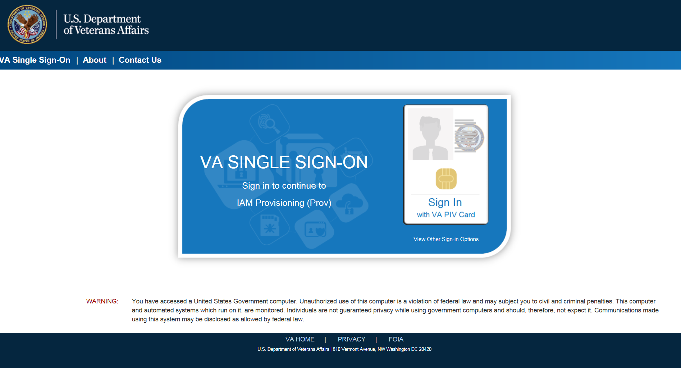
Figure 3:1: SSOi Login Screen

Logging On
The VHIC application is built to accommodate a specific set of pre-established user roles. During the provisioning process, the VHIC user will have a role assigned to them, which will determine what aspects of the VHIC application are available to them. The roles are listed below. For more information on the areas of access that accompanies each role, please refer to VHIC Roles and Access document.

System Menu
Depending on the VHIC users’ role, they will be presented different Home screens upon logging into the VHIC application.

NOTE: Some features of the VHIC application will not function correctly in IE. You will need to copy the URL link and open in Chrome or Edge.

VHIC Administrator and Technical Administrator Tier 3
The VHIC Administrator and VHIC Technical Administrator Tier 3 users will be presented with three menu options: Card Request, Reports and Card Management. They can navigate to each of these application modules by either clicking on one of the links located in the header at the top left of the screen or by clicking on one of the icon buttons in the middle of the screen.
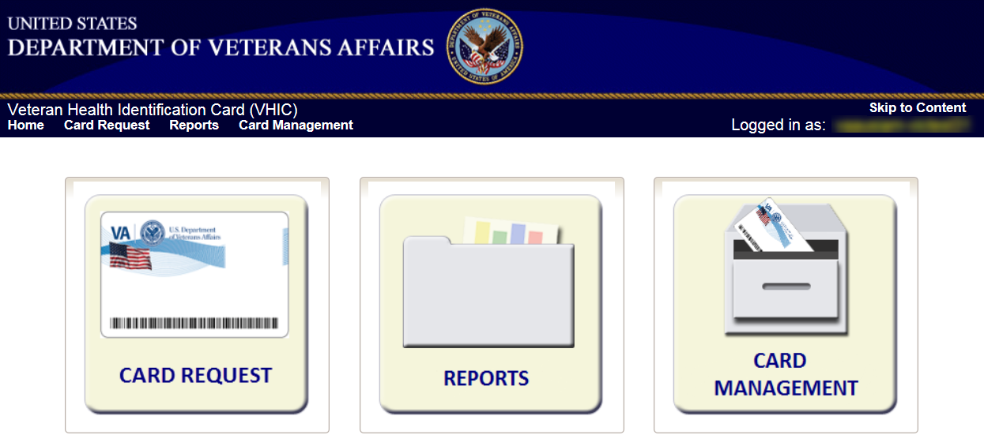
Figure 3:2: VHIC Administrator and VHIC Technical Administrator (Tier 3) Home screen

VHIC Associate and Supervisor
The VHIC Associate and VHIC Supervisor users will be presented with two menu options: Card Request and Reports. They can navigate to each of these application modules by either clicking on one of the links located in the header at the top left of the screen or by clicking on one of the icon buttons in the middle of the screen.

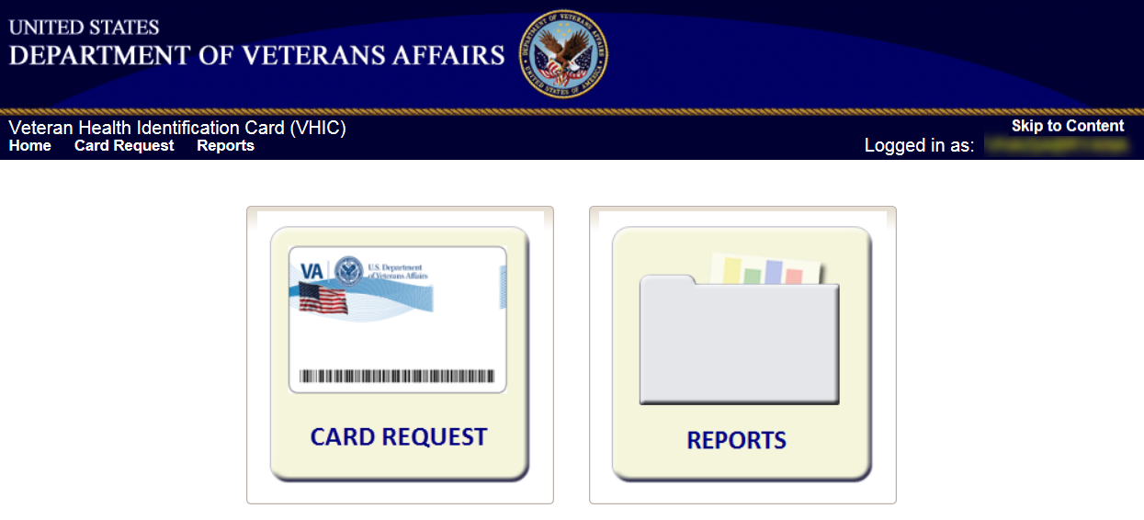
Figure 3:3: VHIC Associate and VHIC Supervisor Home screen

VHIC Auditor and Read-Only User
The VHIC Auditor and VHIC Read-Only users will be presented with the Reports menu option. They can navigate to Reports by clicking on the icon button in the middle of the screen.

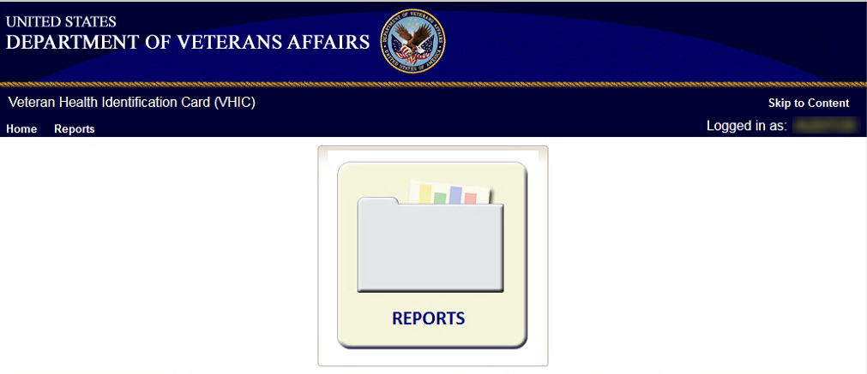
Figure 3:4: VHIC Auditor and VHIC Read-Only User Home screen

VHIC System Status Banner
The VHIC System will display a Status Banner at the top of the screen to notify users of reported issues with the system and/or during maintenance activities that do not require downtime such as high volume or preferred browser reminder.
REDACTED
Figure 3:5: VHIC System Status Banner

REDACTED
Figure 3:6: VHIC Preferred Browser Reminder

Changing User ID and Password
If you have any questions or need help with your User ID or your Password; Contact the Enterprise Service Desk at REDACTED, option 1 (Account or Password Reset), then option 1.

Proofing Veteran before Requesting a VHIC Card

Accessing the Identity Management Toolkit

Accessing the Identity Management Toolkit Directly
The VHIC user will need to go to the Identity Management Toolkit application to look up the Veteran and verify their proofing level and if needed complete the proofing process. The Identity Management Toolkit can be accessed by using the URL in the next section entitled “SSOi.”

SSOi
SSOi:REDACTED
Figure 4:1: Identity Management Toolkit SSOi Logon Screen

The URLs are case sensitive – they must be entered exactly as shown. After successfully logging into the Identity Management Toolkit application, users should bookmark this site for easy access in the future. Instructions on how to do just that can be found here: REDACTED.

The best time to bookmark the site is after the user is in the application itself rather than attempting to bookmark the Login screen.

Accessing Identity Management Toolkit from within the VHIC Application

Step 1 of the VHIC Application
When the VHIC user starts the Card Request process, they will see a message on Step 1: Enter Search Terms. “IMPORTANT: Have you Identity Proofed the Veteran in Identity Management Toolkit? (Click here to open REDACTED in another window)”

The VHIC user can click on the blue words “REDACTED” which is a hyperlink that will take the user to the Identity Management Toolkit application.
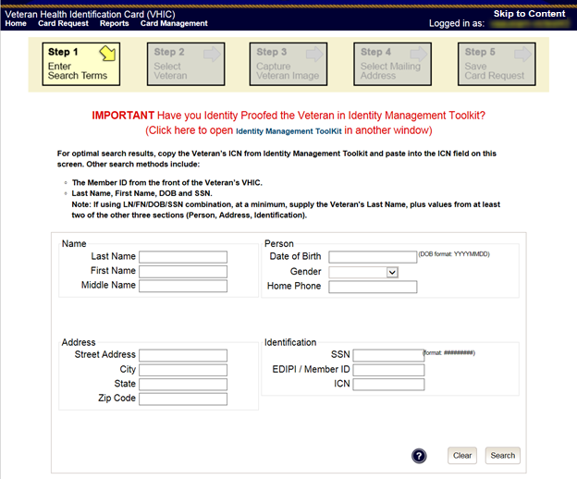
Figure 4:2: Step 1: Enter Search Terms with Identity Management Toolkit hyperlink

NOTE: Should the search result in a deceased Veteran, a message will show at the top of the screen.

REDACTED
Figure 4:3. Deceased Veteran Search Results

Step 5 of the VHIC Application
The VHIC user will also see a message at the bottom of the Step 5: Save Card Request AFTER a card request has been saved on hold due to Veteran Not Proofed.

IMPORTANT: This Veteran still needs to have their Identity Proofing completed.
Follow the steps below:
- Copy the Veteran’s ICN above and click here to open the Identity Management Toolkit in another window.
- Complete Proofing for the Veteran in Identity Management Toolkit.
- Enter the Veteran’s ICN on Step 1 of the VHIC Card Request Process.
- Complete card request process and submit.

The VHIC user can click on the blue words “Identity Management Toolkit” which is a hyperlink that will take the user to the Identity Management Toolkit application.
REDACTED

Figure 4:4: Step 5 - Save Card Request with Identity Management Toolkit hyperlink

Logging out of Identity Management Toolkit
To Log Off:
- Click Log off in the menu bar. You can log off from most of the pages except the logon screen. Logoff is also available from the Navigation Bars.
Figure 4:5: Log Off link located in the menu bar

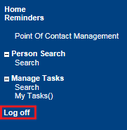
Figure 4:6: Log Off link located in the Navigation pane

- IdM TK has a built-in idle feature. After 60 minutes of inactivity, the idle warning message is displayed as seen in Figure 4:7: Identity Management Toolkit Idle message. Enter your password and click Submit. After you log back on, you are returned to the screen you were previously working on. If you do not have a password, exit the browser and log in through VHIC link/SSOi again.
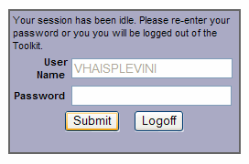
Figure 4:7: Identity Management Toolkit Idle message

Proofing Process and Steps
This section will give the VHIC user the step-by-step details of the proofing process in the Identity Management Toolkit.

Looking up the Veteran
When you first log into the Identity Management Toolkit application, you will be able to search for the Veteran by either entering the Veteran’s ICN or their Identity traits in the Quick Search section. You can also click on the [Search] link on the left side of the screen to be taken to the full identity traits search page to enter more traits as needed.
REDACTED
Figure 4:8: Identity Management Toolkit Search Screen

Quick Search

Quick Search with Identity Traits
Enter the Identity Traits for the Veteran that you want to start an Identity Proofing for. Once you have entered the traits and click the [Search] button.
REDACTED

Figure 4:9: Identity Management Toolkit Quick Search with Traits

MVI requires at least two additional traits other than middle name for a valid search and will take you the Primary View screen for the Veteran located. More details will be provided in the section entitled Primary View.
REDACTED

Figure 4:10: Identity Management Toolkit Quick Search - MVI Search Results

Quick Search with ICN
Enter the Veteran’s ICN in the ICN field then click the [GO] button. This will take you the Primary View screen for the selected Veteran as shown in the section entitled Primary View.
REDACTED

Figure 4:11: Identity Management Toolkit Quick Search with ICN

Person Search
When you are on the Home screen of the Identity Management Toolkit and you want to be able to enter more identity traits to search for the Veteran, click on the Search link on the left side of the screen.
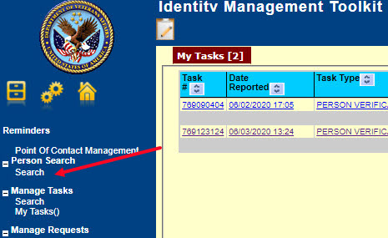
Figure 4:12: Identity Management Toolkit Search Screen; Click Search

This will take you to the Search For Person screen. On this screen you can either enter only the Veteran’s ICN and click the [Search] button, or enter as many of the Veteran’s Identity Traits that you need in order to find the Veteran record that you are looking for and click the [Search] button.
If you are using a criteria-based search, the Last name plus two other fields (not including Middle Name) are required.
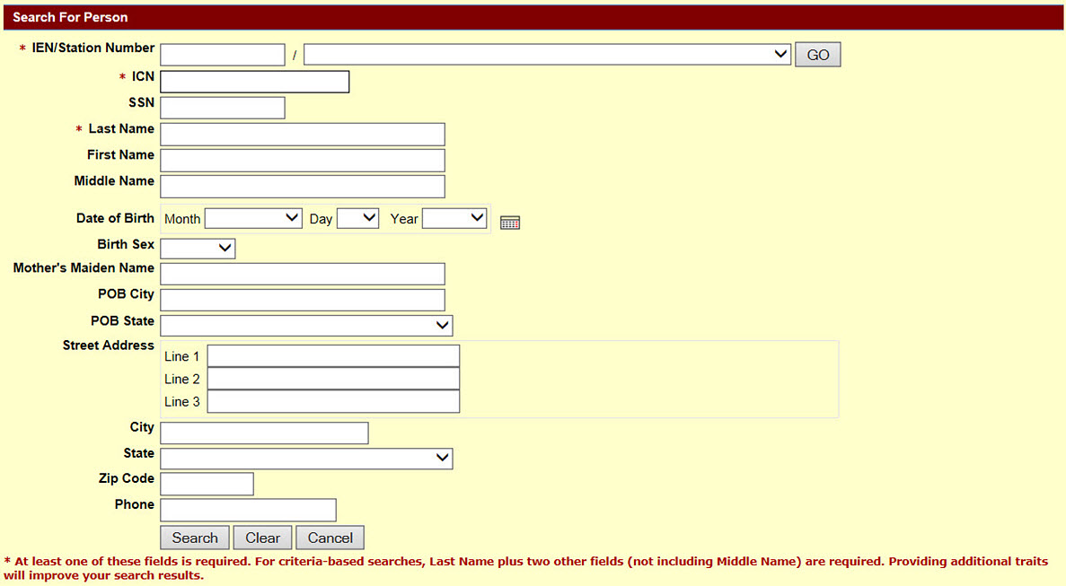
Figure 4:13: Identity Management Toolkit Search For Person screen

Once you have entered the search criteria for the Veteran you are looking for, click the [Search] button. This will take you the Primary View screen for the selected Veteran as shown below in section the section entitled Primary View.
REDACTED

Figure 4:14: Identity Management Toolkit Search For Person screen; Click Search

Primary View
Once you have looked up the Veteran that you are searching for, you will be taken to the Primary View Data screen. Verify the SSN Verification Status and that the traits displayed in the Primary View Data section is correct and take note of the Level of Assurance.
REDACTED

Figure 4:15: Identity Management Toolkit Primary View Screen

If Level of Assurance is Level 1 – Complete Proofing
If the traits in the Primary View are correct and the Level of Assurance is displayed as Level 1, click on the or on the Tasks/Requests tab at the top of the screen to complete the proofing process. Pay attention to the SSN Verification Status, it will be handled slightly differently if the SSN Verification Status for the Veteran is not “Verified”. The person verification will not be completed without HC IdM approval. See 4.2.3.1 Process for Veteran with unverified SSN for the details.
NOTE: You will be verifying identity traits with supporting documentation. Any identity traits that are incorrect or have legally changed need to be updated, see your MVI POC and do not open a Proofing task. If the address needs to be updated, see the Enrollment System POC and do not open a Proofing task.

REDACTED

Figure 4:16: Tasks/Requests tab highlighted

Once you are on the Tasks/Requests screen, click on the Proofing Tab button.
REDACTED

Figure 4:17: Tasks/Requests screen; click Proofing Tab

With the Proofing Tab selected, you will be able to see a list of all Verification Tasks (if any) and a list of Active Tasks for the selected ICN. In order to create a new Proofing Task, select the New Proofing Task button.
REDACTED

Figure 4:18: New Proofing Task Button Selected

The system will inform you that legal documentation is required to complete the task and must be attached if identity trait changes are made.
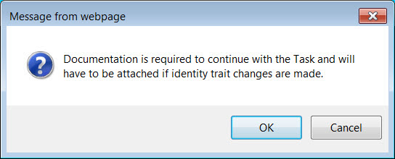
Figure 4:19: Identification Confirmation Message

Selecting “OK” creates a Person Verification Task and takes you to the Task Details screen. Now click on the Person Verification tab at the top of the screen in order to work the Task.
REDACTED

Figure 4:20: Task Details screen; Click Person Verification

When you get to the Person Verification screen, you will see the Veteran’s information from the Primary View screen populated under MVI Value column. Notice that there are multiple tabs on the Person Verification screen. You will need to walk through and complete each tab in order to complete the Person Verification process.
NOTE: If any changes need to be made to the Veteran’s Identity Information, those changes will need to be updated before the proofing process can be completed.

REDACTED

Figure 4:21: Identity Management Toolkit Person Verification screen

Next you will need to verify the information in the MVI Value column with the information on the documents that were submitted for proof of identity.
Select the check box in the Verify column that corresponds to the appropriate trait. The cell in the Verify column will turn green to indicate that they have been authenticated. You do not need to select the verification box if there is no value for a trait in the Primary View such as the Suffix field in the below example. Once the traits are verified, you will have the options to Submit, or Save a Draft of your work.
REDACTED

Figure 4:22: Data Review Tab Trait Verification

Once you click submit, you will be moved to the second tab, Documentation. Please note that the Data Review tab now contains a green check mark. This indicates that the information has been submitted and that you are ready to move on to the next step in the process. You will not be able to Submit or Save Draft on the Documentation tab until the verification on the Data Review tab has been submitted.

Figure 4:23: Data Verification Indicator

On the Documentation tab you will see the verified Identity Traits, a Verification Document(s) Instruction section, and a Verification Document(s) section.
The Verification Document(s) Instruction section lists the documents allowed by the VA for the support of a change, such as Level of Assurance.
REDACTED

Figure 4:24: Verification Document Instruction

Once you have selected the check box indicating the type of Verification Document you reviewed, enter the details of those documents in the fields provided. Note the Green Check in the Allowed Documents box. This is a system check indicating that this is a valid document type for this action. You may Save a Draft at this time or click Submit to move forward with the Identity Proofing.
REDACTED

Figure 4:25: Verification Document Section; Enter document details

After you click the submit button, you will get a pop-up message stating that your Task is complete.
REDACTED
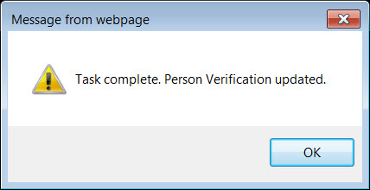
Figure 4:26: Task Complete Pop Up Message

After clicking the OK button, you will be returned to the Primary View screen where you will see a message at the top of the screen saying, “Task complete and resolved” and you can confirm that the Level of Assurance has been updated to 2.

Figure 4:27: Person Verification Updated Message

If for some reason the Level of Assurance is still showing as Level 1, then scroll to the bottom of the Primary View screen and click on the [Refresh View] button. The Level of Assurance should then be updated to Level 2. REDACTED
REDACTED

Figure 4:28: Refresh View button

NOTE: It is possible for an Identity Management Toolkit veteran record to indicate LOA 2 without a precise Date of Birth (MM/DD/YY). Even though the LOA is 2, the card request will be placed into an On Hold status until resolved. See Section 5.6.6 Imprecise Date of Birth for more information
REDACTED

Figure 4:29: Imprecise Date of Birth Reported in Toolkit

Selecting the Tasks/Requests Tab will show the list of Resolved Tasks, you may confirm the resolution of your Person Verification Task here as well.
REDACTED

Figure 4:30: Task/Request Tab; Resolved Tasks

Once the proofing task has been completed and the Level of Assurance has been updated to Level 2, highlight the Veteran’s ICN at the top of the screen and copy it, either by clicking [Ctrl + C] or right clicking on the highlighted number and selecting copy from the menu that displays.
REDACTED

Figure 4:31: The Veteran's ICN is highlighted

Process for Veteran with Unverified SSN
If the SSN Verification Status is blank or states “Unverified”, continue to use the process steps listed above with the following changes:
REDACTED

Figure 4:32: SSN Status Not Verified

- If there is no verified SSN Status attach presented proofing documentation using the tool on the Task Details page.
- REDACTED

Figure 4:33: Upload Documentation to the Proofing Task

- Complete the Data Review, enter the Documentation, and click on [Submit]
- REDACTED

Figure 4:34: Enter verification Documents

After submitting the documentation, you will be returned to the Primary View screen where you will see a message at the top of the screen saying, “Task saved and Request has been submitted to HC IdM for approval” and the Level of Assurance will remain at 1.

REDACTED

Figure 4:35: Task Saved and Submitted to HC IdM

- Returning to the home screen will show you the request generated in the request queue and can be used for tracking purposes.
- REDACTED

Figure 4:36: Request Generated

If the Level of Assurance is confirmed and displayed as Level 2 you will log into the VHIC application and start the card request. On Step 1: Enter Search Terms of the Card Request process; you will paste the Veteran’s ICN that you copied, from the Primary View screen in the Identity Management Toolkit application, into the ICN field in the lower right side of the screen.
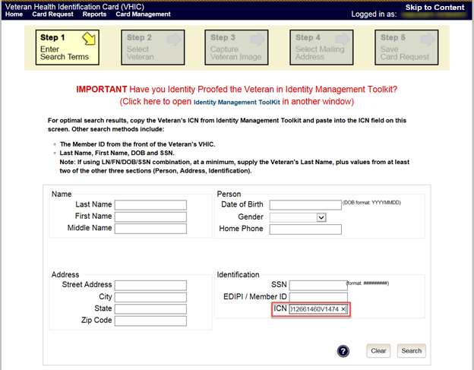
Figure 4:37: Step 1: Enter Search Terms - ICN has been entered

If Level of Assurance is Level 2 – Continue to Issue VHIC
If the Level of Assurance is displayed as Level 2 on the Primary View screen, copy the Veteran’s ICN from the top of the Identity Management Toolkit screen so you can use that to search for the Veteran on Step 1: Enter Search Terms of the Card Request process in the VHIC application.
REDACTED

Figure 4:38: The Veteran's ICN is highlighted

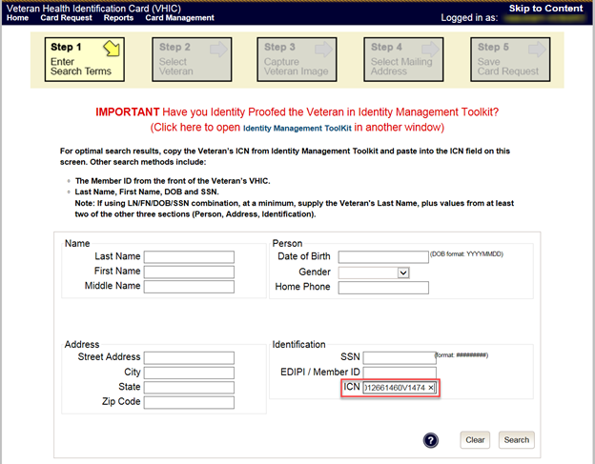
Figure 4:39: Step 1: Enter Search Terms - ICN has been entered

Proofing Task Opened in Error, Trait Edit Needed
VHIC Proofers do not possess the access levels in the MVI Toolkit that are required for making changes to identity traits. If you open a Person Verification Task before verifying the Veteran’s address and identity traits and realize that a Trait Change such as Middle Name correction is needed as shown in the below example, please follow the process below.
Verify the correct information by selecting the corresponding check boxes in the Verify column. Enter the correct information in the New Value column and Save Draft. You will not be able to submit this change.
REDACTED

Figure 4:40: Person Verification Task; Trait Edit Needed

Clicking the Submit button will result in the following Pop-up Message and you will not be able to move forward with completing the Person Verification Task, nor will you be able to close the newly opened Task.
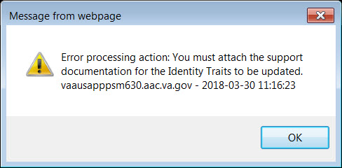
Figure 4:41: Processing Error Message

Selecting “OK” on the Pop-up Message will return you to the Person Verification Tab. Select the Task Notes tab at the top of the screen.
REDACTED

Figure 4:42: Person Verification; Task Notes Tab Selection

On the Task Notes tab, highlight the Task Number at the top of the screen and copy it, either by clicking [Ctrl + C] or right clicking on the highlighted number and selecting copy from the menu that displays. You will need to supply this number to your the appropriate POC (MVI for Identity Trait edits or Enrollment System POC for Address change.) Under New Status, change the status of your Person Verification Task to Unassign and select Save.
REDACTED

Figure 4:43: Unassign Person Verification Task

Contact the appropriate POC. Provide them with the Task Number and details. They will assign the Task to themselves and complete the Trait Edit.

Creating a VHIC Card – The Card Request Process
Table 3: Who can process a card request?
At a Glance…
Who can process a card request? | Administrator, Supervisor, Associate, Tech Admin (Tier 3)

This section will walk the VHIC user through the process of creating a card for a Veteran. During the card request process, issues may arise that will require the card to be put on hold. These cases will be covered in section 5.6 On Hold Reasons Explained.

The card issuance process follows numbered steps shown next.
- Enter Search Terms
- Select Veteran
- Capture Veteran Image
- Select Mailing Address
- Save Card Request

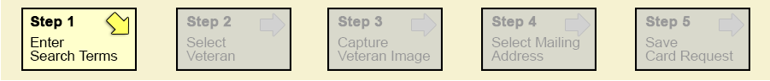
Figure 5:1: Card Request Navigation Bar

NOTE The appearance of the step block will change to indicate the step you are currently working by appearing to be the brightest. See the illustration below.

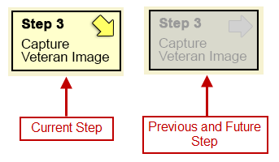
Figure 5:2: Navigation Bar Step appearance by state

These steps are fully explained below. We will now walk through each of the steps required to complete a VHIC card request for New VHICs and Replacement VHICs. We will also go over the steps for placing a card request on hold as well as taking a card request off hold.

New VHIC: Veteran Level 2 Proofed through Identity Management Toolkit

Step 1: Enter Search Terms
The first step in the process is to find the Veteran in the system. This is accomplished by entering enough search criteria to trigger a match within Master Veteran Index (MVI). The top of the screen offers guidance regarding the set of traits recommended to ensure a best match is found. These are guidelines and not necessarily the required set of traits that must be entered.

However, for optimal search results, copy the Veteran’s ICN from the Identity Management Toolkit and paste it into the ICN field on this screen.

Other search methods include:
- The Member ID from the front of the Veteran’s VHIC.
- Last Name, First Name, DOB and SSN.

NOTE: If using LN/FN/DOB/SSN combination, at a minimum, supply the Veteran's Last Name, plus values from at least two of the other three sections (Person, Address, and Identification).

The more traits entered, the more likely a match will be returned.

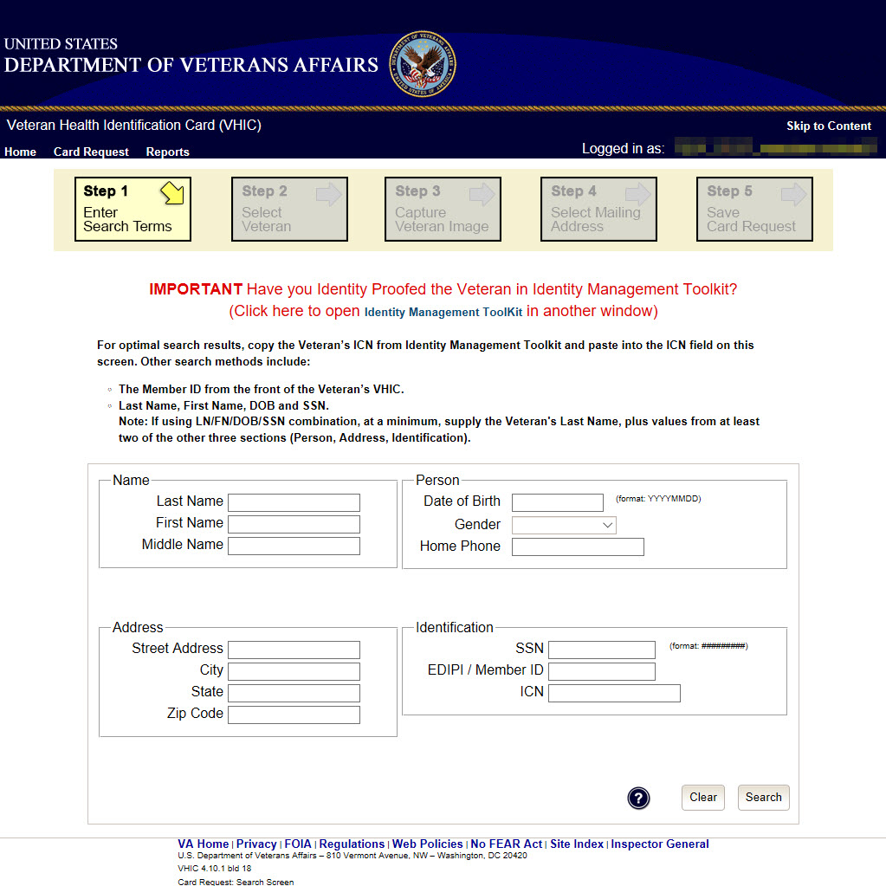
Figure 5:3: Enter Search Terms screen

Additional guidance is also available on-screen by clicking on the blue circle containing a question mark.

Figure 5:4: Help icon

This type of help is available throughout the application and will provide additional detail or clarification for that particular step or section.
Once the information has been entered into the required fields, click on [Search] to proceed to the next step.
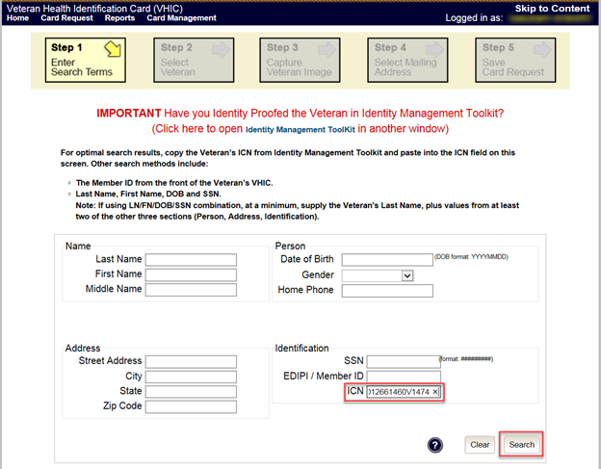
Figure 5:5: Enter Search Terms screen

NOTE:
Entering an Invalid ICN will result in an error message such as the one seen in Figure 5:6: Invalid ICN Error Message. Examples of errors include:
- Invalid ICN. ICN must be 17 characters
- Invalid ICN. ICN must not contain special characters
- Invalid ICN format. Please enter valid ICN format, 17 chars (10 digits + V + 6 digits)

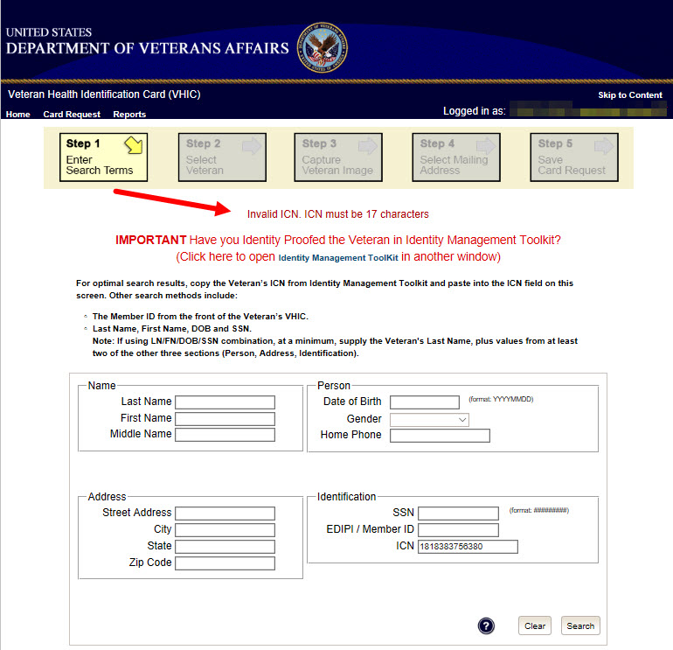
Figure 5:6: Invalid ICN Error Message

NOTE: Should the search result in a deceased Veteran, a message will show at the top of the screen.
REDACTED
Figure 5:7. Deceased Veteran Search Results

Step 2: Select Veteran
Once the search has completed, the results of that search will be displayed on screen. From the list provided (up to 10 matches may be returned), select the appropriate Veteran by clicking on the Veteran’s name which is hyperlinked.

If the correct Veteran is not in the list, click the [Back] button and verify the traits entered are correct. If the traits are correct, try adding additional information to aid in triggering a match.
REDACTED
Figure 5:8: Select Veteran screen

Step 3: Capture Veteran Image
Once a selection has been made, the next step in the process is to capture the Veteran image. VHIC provides several ways to handle this operation: Take New Picture, Upload from file, or Reuse Existing Image.

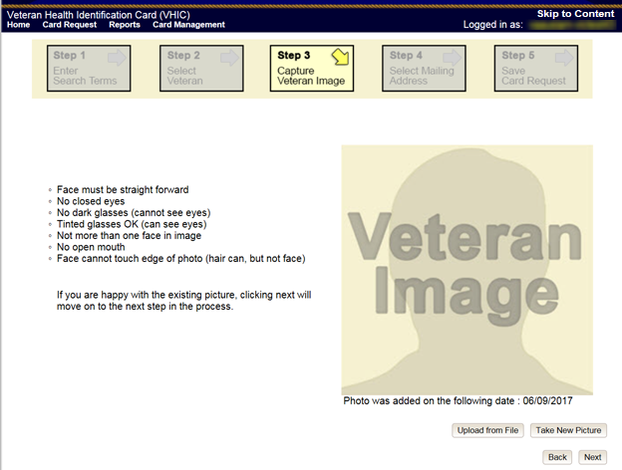
Figure 5:9: Capture Veteran Image screen

Take New Picture
Upon arriving to the Capture Veteran Image page, if there is no useable image for the Veteran already on file, a “No Photo” image will appear in the image capture area. Click [Take New Picture] to capture the Veteran’s image. The camera should become active and the Veteran should be visible in the image capture window.

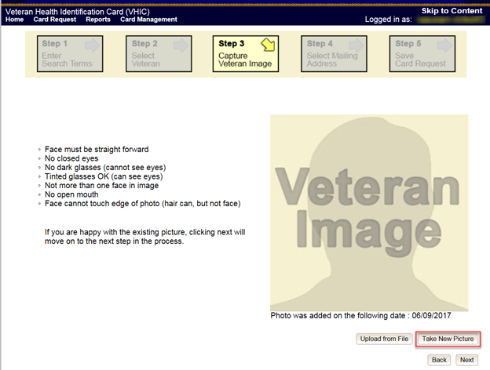
Figure 5:10: Capture Veteran Image screen – Take New Picture

Using the provided silhouette, ensure that that the Veteran is lined up properly. Prior to clicking [Capture Image] ensure the additional image capture guidelines provided on screen are met:
- Face must be straight forward
- No closed eyes
- No dark glasses (cannot see eyes)
- Tinted glasses OK (can see eyes)
- Not more than one face in image
- No open mouth
- Face cannot touch edge of photo (hair can, but not face)

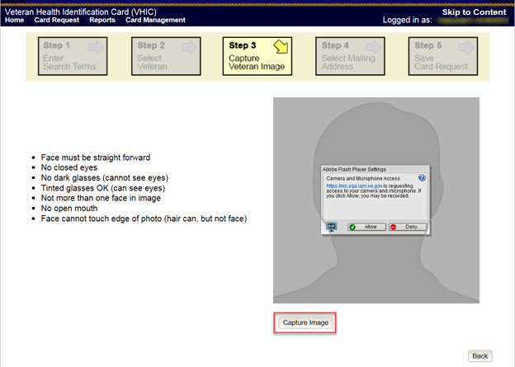
Figure 5:11: Capture Veteran Image screen – Capture Image

Once the image is captured, take a moment to review that the image meets all desired guidelines before proceeding. If the image is acceptable, click [Next] to continue on to the next step.

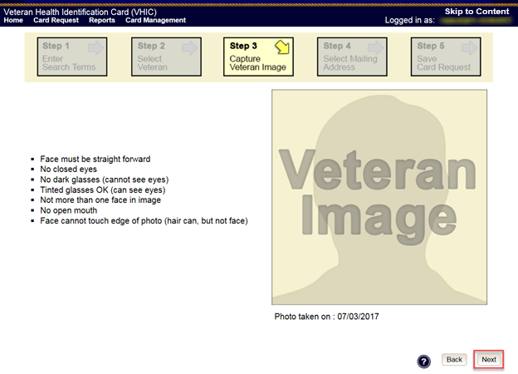
Figure 5:12: Capture Veteran Image screen – Accept new photo; click Next

NOTE: If the image does not meet the guidelines or the Veteran would prefer a new photo be taken or uploaded, this can be done at this point as well by clicking the [Back] button to take a new picture or upload a photo.

Upload from File
In some cases, it may be necessary to upload an image for a Veteran (i.e., they are unable to be present during the card request process due to health issues, etc.) In these cases, VHIC offers the option to upload a photo by selecting the [Upload from File] option.

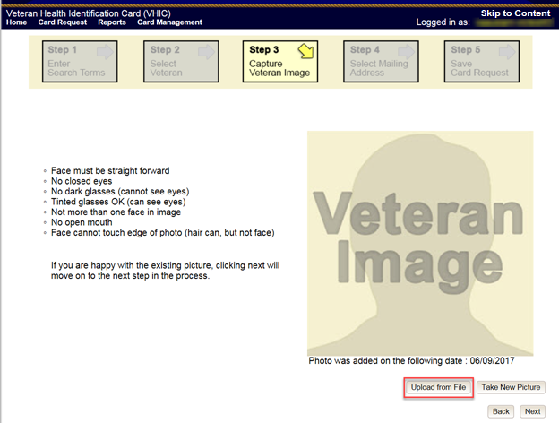
Figure 5:13: Capture Veteran Image screen – Upload from File

Once this option is selected, a [Browse…] button will appear next to a text field. Clicking this button will open up another window to allow for the desired image to be located and selected. The accepted file formats are JPG, GIF, PNG, and BMP. For best results use a 400x400 pixel JPG image. It should also be noted that any adjustments that need to be made to the image to meet the specified guidelines, such as crop and resize, this should be done before the image is uploaded.

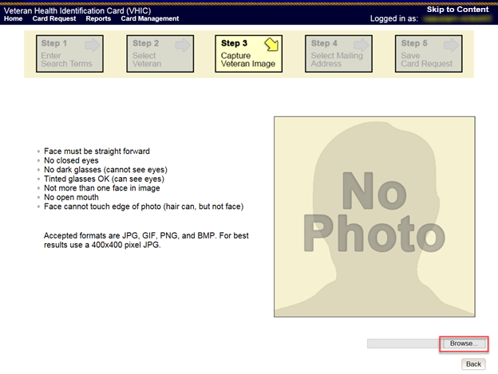
Figure 5:14: Capture Veteran Image screen – Upload photo; click Browse

Once the file has been selected, an [Upload] button will become available. Clicking this will import the image and it will now be visible in the image capture area.

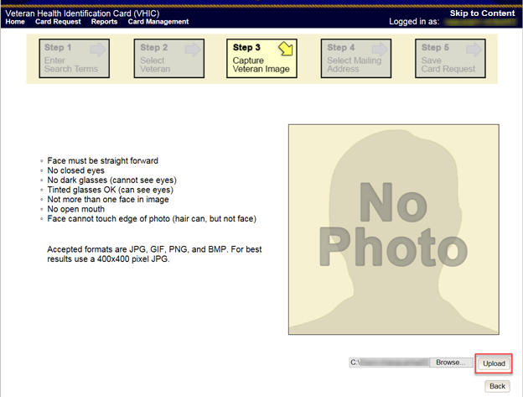
Figure 5:15: Capture Veteran Image screen – Upload photo; click Upload

The user can move the slider below the image window to zoom the image in or out to match the silhouette, the image can also be dragged to line the Veteran’s face inside the silhouette as well.

Once again, be sure to review the image to ensure it meets the specified guidelines before clicking the [Next] button to continue.

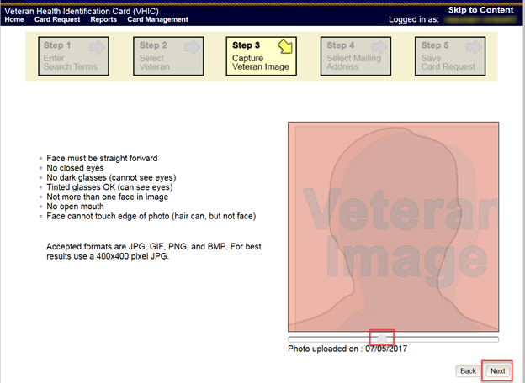
Figure 5:16: Capture Veteran Image screen – Edit photo; click Next

Reuse Existing Image
In the event the Veteran has an existing photo in the system that is less than ten years old, this will appear in the image capture area upon entry to Step 3. If this image meets the required guidelines, it may be reused for the current card request process. Simply click [Next] to continue on to Step 4.

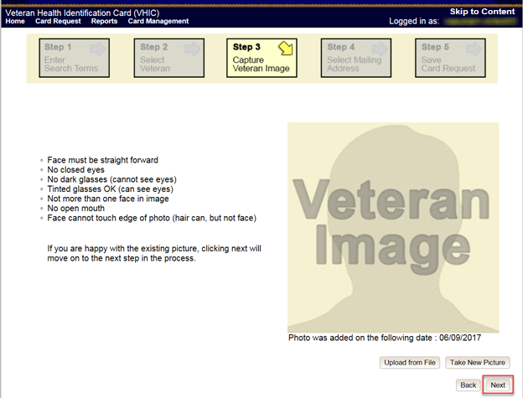
Figure 5:17: Capture Veteran Image screen – Reuse Existing Photo; click Next

The VHIC application will ask the user to confirm that they want to reuse the existing photo for this Veteran. Click the [OK] button to continue to Step 4: Verify Identity Attributes.

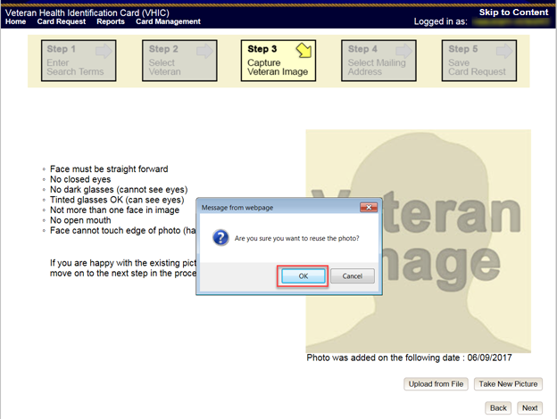
Figure 5:18: Capture Veteran Image screen – Reuse Existing Photo; click OK

NOTE: If the image does not meet the guidelines or the Veteran would prefer a new photo be taken or uploaded, this can be done at this point as well by selecting either [Upload from File] or [Take New Picture].

Step 4: Select Mailing Address
This screen displays the information retrieved from the Master Veteran Index (MVI) and the Enrollment System (ES) for the selected Veteran. The purpose of this screen is to verify the displayed information, and to determine where the Veteran’s card should be mailed.

REDACTED

Figure 5:19: Select Mailing Address screen

This step provides several mailing options for the card:
- Mail to the address received from Enrollment Services
- Mail to the address received from MVI
- Mail to the requesting facility
- Mail to the preferred facility

NOTE: If Enrollment has flagged the Veteran’s address as bad, a message stating why, as well as additional guidance on how to proceed, will be displayed near the top of the screen. At this point, if the Veteran opts to not update their information with ES, the Associate MUST choose one of the remaining viable address options for mailing the card in order to proceed with the card request process.

NOTE: If MVI has flagged the Veteran’s address as bad, a message stating why, as well as additional guidance on how to proceed, will be displayed near the top of the screen. At this point, if the Veteran opts not to update their information with MVI or ES, the Associate MUST choose one of the remaining viable address options for mailing the card in order to proceed with the card request process. Selecting a radio button will automatically update the address information based on the selection. The process cannot continue until the appropriate radio button has been selected.

NOTE: If no preferred facility information has been received from ES or the preferred facility address is flagged as bad, a message stating why, as well as additional guidance on how to proceed, will be displayed near the top of the screen. The Associate MUST choose one of the remaining viable address options for mailing the card in order to proceed with the card request process. Selecting a radio button will automatically update the address information based on the selection. The process cannot continue until the appropriate radio button has been selected.

Selecting a radio button will automatically update the address information based on the selection. The process cannot continue until the appropriate radio button has been selected.

If the address for the Requesting Facility is not correct, then the VHIC user would need to request help with correcting the address by contacting the Enterprise Service Desk at REDACTED, option 3 (Applications), then option 1. Alternately, create a ticket through the [yourIT] shortcut on your desktop with correction details.

If the information on the screen is a correct match, select the [Next] button in the lower right hand to move forward.

Status Section
At the top of the Step 4 screen is the Status section. When going through the card request process, one of the following Card Request Status options will be displayed: New, Replacement, or On Hold. Since this is a new card request the status displayed is New.

Step 5: Save Card Request
Step 5 – Save Card Request – gives the VHIC user and the Veteran one more opportunity to review all of the information on the screen for accuracy.
REDACTED
Figure 5:20: Save Card Request review screen

This screen contains the following information for review:
- Name as it will appear on card
- Address card will be mailed to (this also contains the name as it will appear in the mailing address)
- Replacement reason (if applicable)
- Reason for hold (if applicable)
- Service connected status
- Medal of Honor status
- Purple Heart status
- Prisoner of War status
- Branch of Service selection
- Date of Birth

Other fields that either will be populated or will populate upon final submission are:
- Card Number (populates upon final submission)
- Member ID
- ICN
- Member Benefit Plan ID
- VISN and Facility where request is being processed

Branch of Service
If available, the Veteran’s Branch of Service options will be displayed on screen. The Veteran should be given the opportunity to select which logo they would prefer to appear on their card or if they would like to decline the logo option altogether (default). The appropriate radio button should be selected based upon the Veteran’s preference. Only those branches of service that are listed in the Enrollment System and in which the Veteran has served will be shown. This will need to be chosen before submitting the card request.
NOTE: Only one Branch of Service logo can appear on the card; those with more than one branch will have to select one, or decline to show any logo.

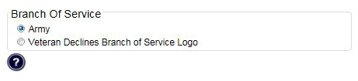
Figure 5:21: Branch of Service Selection

Save Card Request: New
If the card is a new request, meaning the Veteran has never had a VHIC prior to this request; the Replacement Reason section will state the following: Not a replacement card.

Upon submission, a Card Number will be generated as well as an Expiration Date and Card Request Date. The colored field will change from yellow to green and the corresponding Card Status will change from Pending to Submitted.

REDACTED

Figure 5:22: New Card Request Submitted

New VHIC: Veteran has NOT been Level 2 Proofed through Identity Management Toolkit

Step 1: Enter Search Terms
The first step in the process is to find the Veteran in the system. This is accomplished by entering enough search criteria to trigger a match within Master Veteran Index (MVI). The top of the screen offers guidance regarding the set of traits recommended to ensure a best match is found. These are guidelines and not necessarily the required set of traits that must be entered.

However, for optimal search results, copy the Veteran’s ICN from the Identity Management Toolkit and paste it into the ICN field on this screen.

Other search methods include:
- The Member ID from the front of the Veteran’s VHIC.
- Last Name, First Name, DOB and SSN.

NOTE: If using LN/FN/DOB/SSN combination, at a minimum, supply the Veteran's Last Name, plus values from at least two of the other three sections (Person, Address, and Identification).

The more traits entered, the more likely a match will be returned. Additional guidance is also available on-screen by clicking on the blue circle containing a question mark.
Figure 5:23: Help icon

This type of help is available throughout the application and will provide additional detail or clarification for that particular step or section.

Once the information has been entered into the required fields, click on [Search] to proceed to the next step.

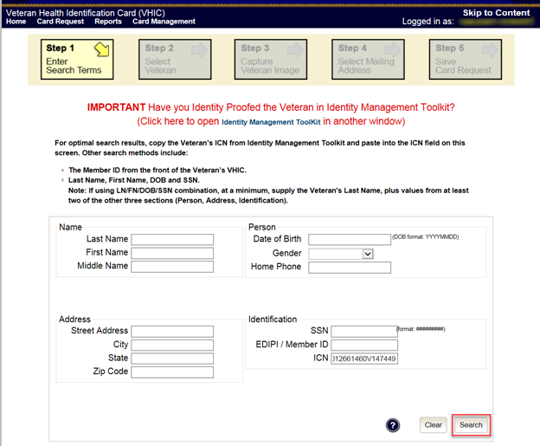
Figure 5:24: Enter Search Terms screen

Step 2: Select Veteran
Once the search has completed, the results of that search will be displayed on screen. From the list provided (up to 10 matches may be returned), select the appropriate Veteran by clicking on the Veteran’s name which is hyperlinked.

If the correct Veteran is not in the list, click the [Back] button and verify the traits entered are correct. If the traits are correct, try adding additional information to aid in triggering a match.

REDACTED
Figure 5:25: Select Veteran screen

Step 3: Capture Veteran Image
Once a selection has been made, the next step in the process is to capture the Veteran image. VHIC provides several ways to handle this operation: Take New Picture, Upload from file, or Reuse Existing Image.

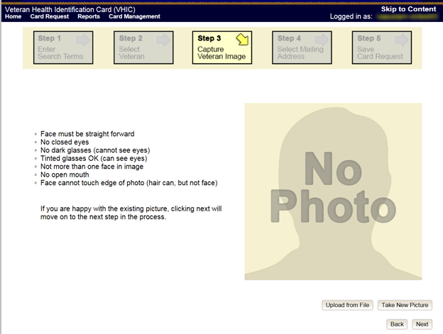
Figure 5:26: Step 3 - Capture Veteran Image screen

Take New Picture
Upon arriving to the Capture Veteran Image page, if there is no useable image for the Veteran already on file, a “No Photo” image will appear in the image capture area. Click [Take New Picture] to capture the Veteran’s image. The camera should become active and the Veteran should be visible in the image capture window.

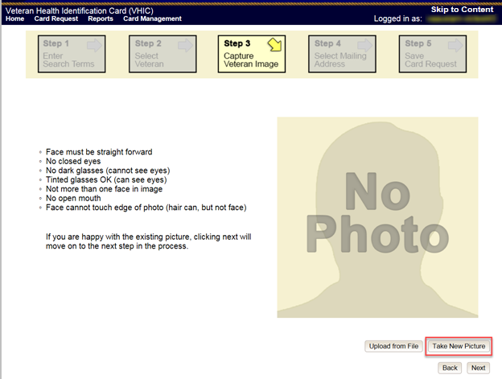
Figure 5:27: Capture Veteran Image screen – Take New Picture

Using the provided silhouette, ensure that that the Veteran is lined up properly. Prior to clicking [Capture Image] ensure the additional image capture guidelines provided on screen are met:
- Face must be straight forward
- No closed eyes
- No dark glasses (cannot see eyes)
- Tinted glasses OK (can see eyes)
- Not more than one face in image
- No open mouth
- Face cannot touch edge of photo (hair can, but not face)

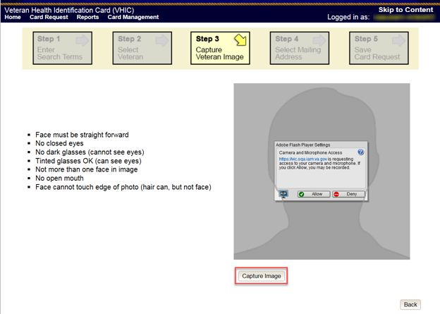
Figure 5:28: Capture Veteran Image screen – Capture Image

Once the image is captured, take a moment to review that the image meets all desired guidelines before proceeding. If the image is acceptable, click [Next] to continue on to the next step.

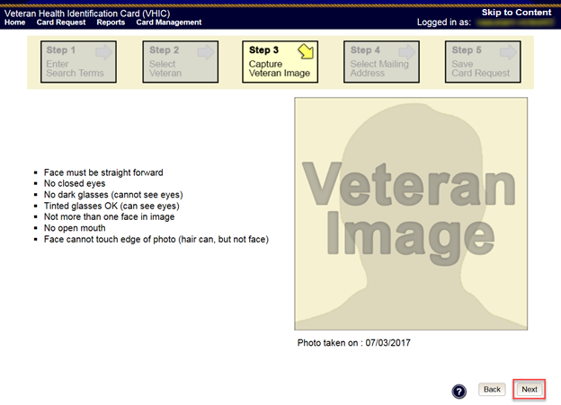
Figure 5:29: Capture Veteran Image screen – Accept new photo; click Next

NOTE: If the image does not meet the guidelines or the Veteran would prefer a new photo be taken or uploaded, this can be done at this point as well by clicking the [Back] button to take a new picture or upload a photo.

Step 4: Select Mailing Address
This screen displays the information retrieved from the Master Veteran Index (MVI) and the Enrollment System (ES) for the selected Veteran. The purpose of this screen is to verify the displayed information, and to determine where the Veteran’s card should be mailed.

If the Veteran was not LOA 2 Proofed through the Identity Management Toolkit before the starting the card request process, the VHIC user will see the message:

“WARNING: Veteran not Identity Proofed”
(Select the address to have the card mailed to and click Next to place the card request on hold.)
The VHIC user will need to select the address to have the card mailed to, click the [Next] button, and save the card request on hold.

REDACTED
Figure 5:30: Select Mailing Address screen

This step provides several mailing options for the card:
- Mail to the address received from Enrollment Services
- Mail to the address received from MVI
- Mail to the requesting facility
- Mail to the preferred facility

NOTE: If Enrollment has flagged the Veteran’s address as bad, a message stating why, as well as additional guidance on how to proceed, will be displayed near the top of the screen. At this point, if the Veteran opts to not update their information with ES, the Associate MUST choose one of the remaining viable address options for mailing the card in order to proceed with the card request process.

NOTE: If MVI has flagged the Veteran’s address as bad, a message stating why, as well as additional guidance on how to proceed, will be displayed near the top of the screen. At this point, if the Veteran opts not to update their information with MVI or ES, the Associate MUST choose one of the remaining viable address options for mailing the card in order to proceed with the card request process. Selecting a radio button will automatically update the address information based on the selection. The process cannot continue until the appropriate radio button has been selected.

NOTE: If no preferred facility information has been received from ES or the preferred facility address is flagged as bad, a message stating why, as well as additional guidance on how to proceed, will be displayed near the top of the screen. The Associate MUST choose one of the remaining viable address options for mailing the card in order to proceed with the card request process. Selecting a radio button will automatically update the address information based on the selection. The process cannot continue until the appropriate radio button has been selected.

Selecting a radio button will automatically update the address information based on the selection. The process cannot continue until the appropriate radio button has been selected.

If the address for the Requesting Facility is not correct, then the VHIC user would need to request help with correcting the address by calling the Enterprise Service Desk at 855-673-4357, option 3, option 3. Alternately create a ticket through the [yourIT] shortcut on your desktop with correction details.

If the information on the screen is a correct match, select the [Next] button in the lower right hand to move forward.

Status Section
At the top of the Step 4 screen is the Status section. When going through the card request process, one of the following Card Request Status options will be displayed: New, Replacement, or On Hold. Since this is a new card request the status displayed is New.

Step 5: Save Card Request
Step 5 – Save Card Request – gives the VHIC user and the Veteran one more opportunity to review all of the information on the screen for accuracy.
REDACTED
Figure 5:31: Save Card Request review screen

This screen contains the following information for review:
- Name as it will appear on card
- Address card will be mailed to (this also contains the name as it will appear in the mailing address)
- Replacement reason (if applicable)
- Reason for hold (if applicable)
- Service connected status
- Medal of Honor status
- Purple Heart status
- Prisoner of War status
- Branch of Service selection
- Date of Birth
Other fields that either will be populated or will populate upon final submission are:
- Card Number (populates upon final submission)
- Member ID
- ICN
- Member Benefit Plan ID
- VISN and Facility where request is being processed

Branch of Service
If available, the Veteran’s Branch of Service options will be displayed on screen. The Veteran should be given the opportunity to select which logo they would prefer to appear on their card or if they would like to decline the logo option altogether (default). The appropriate radio button should be selected based upon the Veteran’s preference. Only those branches of service that are listed in the Enrollment System and in which the Veteran has served will be shown. This will need to be chosen before submitting the card request.
NOTE: Only one Branch of Service logo can appear on the card; those with more than one branch will have to select one, or decline to show any logo.

Figure 5:32: Branch of Service Selection

Save Card Request: New
If the card is a new request, meaning the Veteran has never had a VHIC prior to this request; the Replacement Reason section will state the following: Not a replacement card.

Since this Veteran has NOT had their Identity Proofing completed in the Identity Management Toolkit prior to starting the card request process, the Reason for Hold section will state the following: Veteran Not Proofed. The VHIC user will only be presented with the [Back] and [Hold] buttons.

Upon submission, a Card Number will be generated as well as the Card Request Date. The colored field will change from yellow to orange and the corresponding Card Status will change from Pending to Saved on Hold.

Since the Veteran that this card request was for still needs to be proofed, the VHIC system will display the message below that will include the next steps that the VHIC clerk will need to follow to complete the proofing process.

IMPORTANT: This Veteran still needs to have their Identity Proofing completed.
Follow the steps below:

- Copy the Veteran's ICN above and click here to open the Identity Management Toolkit in another window.
- Complete Proofing for the Veteran in Identity Management Toolkit.
- Enter Veteran's ICN on Step 1 of the VHIC Card Request Process.
- Complete card request process and submit.

The words Identity Management Toolkit are a hyperlink that the VHIC user can click on to be able to open the Identity Management Toolkit application in another browser window.

REDACTED
Figure 5:33: Card Request Saved on Hold – Veteran Not Proofed

Resuming an On Hold VHIC Request: Veteran NOT Level 2 Proofed Hold Reason
When the Associate resumes a card request that has been placed On Hold, they will still be taken through the same steps as though it was a New Card or a Replacement. The Associate won’t be shown that this is an On Hold Request until they get to Step 4.

Step 1: Enter Search Terms
The first step in the process is to find the Veteran in the system. This is accomplished by entering enough search criteria to trigger a match within Master Veteran Index (MVI). The top of the screen offers guidance regarding the set of traits recommended to ensure a best match is found. These are guidelines and not necessarily the required set of traits that must be entered.

However, for optimal search results, copy the Veteran’s ICN from the Identity Management Toolkit and paste it into the ICN field on this screen.

Other search methods include:
- The Member ID from the front of the Veteran’s VHIC.
- Last Name, First Name, DOB and SSN.

NOTE: If using LN/FN/DOB/SSN combination, at a minimum, supply the Veteran's Last Name, plus values from at least two of the other three sections (Person, Address, and Identification).

The more traits entered, the more likely a match will be returned. Additional guidance is also available on-screen by clicking on the blue circle containing a question mark.
Figure 5:34: Help icon

This type of help is available throughout the application and will provide additional detail or clarification for that particular step or section.

Since the VHIC user would have just completed the Identity Proofing process in the Identity Management Toolkit application, the VHIC user can paste the Veteran’s ICN in this screen that was copied from Identity Management Toolkit, then click on [Search] to proceed to the next step.
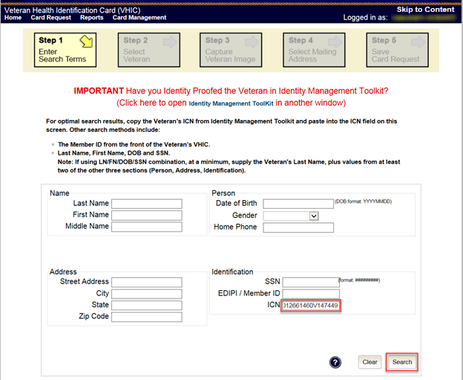
Figure 5:35: Enter Search Terms screen

Step 2: Select Veteran
Once the search has completed, the results of that search will be displayed on screen. From the list provided (up to 10 matches may be returned), select the appropriate Veteran by clicking on the Veteran’s name which is hyperlinked.

If the correct Veteran is not in the list, click the [Back] button and verify the traits entered are correct. If the traits are correct, try adding additional information to aid in triggering a match.
REDACTED
Figure 5:36: Select Veteran screen

Reuse Existing Image
In the event the Veteran has an existing photo in the system that is less than ten years old, this will appear in the image capture area upon entry to Step 3. If this image meets the required guidelines, it may be reused for the current card request process. Simply click [Next] to continue on to Step 4.
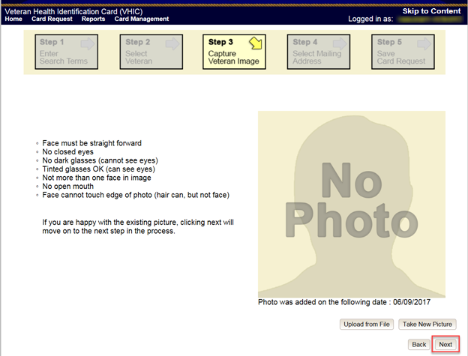
Figure 5:37: Capture Veteran Image screen – Reuse Existing Photo; click Next

VHIC will then ask the user to confirm that they want to reuse the existing photo and then they would click [OK] to continue on to the next step.
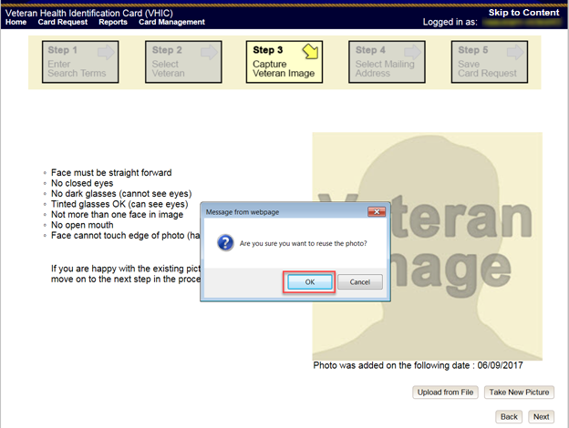
Figure 5:38: Capture Veteran Image screen – Reuse Existing Photo; click OK

Step 4: Select Mailing Address
This screen displays the information retrieved from the Master Veteran Index (MVI) and the Enrollment System (ES) for the selected Veteran. The purpose of this screen is to determine where the Veteran’s card should be mailed.

At the top of the Step 4 screen is the Status section. Since this card request for the Veteran was placed on hold due to Veteran Not Proofed, the status of On Hold will be listed along with the On Hold reason of Veteran Not Proofed. REDACTED

Figure 5:39: Select Mailing Address screen
This step provides several mailing options for the card:
- Mail to the address received from Enrollment Services
- Mail to the address received from MVI
- Mail to the requesting facility
- Mail to the Preferred Facility

NOTE: If Enrollment has flagged the Veteran’s address as bad, a message stating why, as well as additional guidance on how to proceed, will be displayed near the top of the screen. At this point, if the Veteran opts not to update their information with ES, the Associate MUST choose one of the remaining viable address options for mailing the card in order to proceed with the card request process.

NOTE: If MVI has flagged the Veteran’s address as bad, a message stating why, as well as additional guidance on how to proceed, will be displayed near the top of the screen. At this point, if the Veteran opts not to update their information with MVI or ES, the Associate MUST choose one of the remaining viable address options for mailing the card in order to proceed with the card request process. Selecting a radio button will automatically update the address information based on the selection. The process cannot continue until the appropriate radio button has been selected.

NOTE: If no preferred facility information has been received from ES or the preferred facility address is flagged as bad, a message stating why, as well as additional guidance on how to proceed, will be displayed near the top of the screen. The Associate MUST choose one of the remaining viable address options for mailing the card in order to proceed with the card request process. Selecting a radio button will automatically update the address information based on the selection. The process cannot continue until the appropriate radio button has been selected.

Selecting a radio button will automatically update the address information based on the selection. The process cannot continue until the appropriate radio button has been selected.

If the address for the Requesting Facility is not correct, then the VHIC user would need to request help with correcting the address by contacting the Enterprise Service Desk at REDACTED, option 3 (Applications), then option 1. Alternately, create a ticket through the [yourIT] shortcut on your desktop with correction details.

If the information on the screen is a correct match, select the [Next] button in the lower right hand to move forward.

Status Section
At the top of the Step 4 screen is the Status section. Since this card request for the Veteran was placed on hold, the status of On Hold will be listed along with the On Hold reason.

Step 5: Save Card Request
This brings us to Step 5 – Save Card Request. This screen allows the VHIC User to verify all of the information shown on the screen as being correct.

This screen contains the following information for review:
- Name as it will appear on card
- Address card will be mailed to (this also contains the name as it will appear in the mailing address)
- Replacement reason (if applicable)
- Reason for hold (if applicable)
- Service connected status
- Medal of Honor status
- Purple Heart status
- Prisoner of War status
- Branch of Service selection
- Date of Birth

Other fields that either will be populated or will populate upon final submission are:
- Card Number (populates upon final submission)
- Member ID
- ICN
- Member Benefit Plan ID
- VISN and Facility where request is being processed

Branch of Service
If available, the Veteran’s Branch of Service options will be displayed on screen. The Veteran should be given the opportunity to select which logo they would prefer to appear on their card or if they would like to decline the logo option altogether (default). The appropriate radio button should be selected based upon the Veteran’s preference. Only those branches of service that are listed in the Enrollment System and in which the Veteran has served will be shown. This will need to be chosen before submitting the card request.
NOTE: Only one Branch of Service logo can appear on the card; those with more than one branch will have to select one, or decline to show any logo.

Figure 5:40: Branch of Service Selection

If a Branch of Service option is available to the Veteran, the VHIC associate will see that on this screen and will need to ask the Veteran’s preference for which, if any, BoS they would like to appear on the card.

Placing the Card on Hold

Proceeding with the request and placing the card in Hold status, the user would click on the [Hold] button.
REDACTED
Figure 5:41: Saving a VHIC Card in Hold Status

A pop-up message will appear informing the user that a manual release will be required for the card in order to complete the card request process. The user will click the [OK] button to continue to put the card on hold.
REDACTED
Figure 5:42: On Hold Pop Up Reminder

Completing the Card Request

Proceeding with the card request, VHIC user can now click [Submit] to complete the card request.
REDACTED
Figure 5:43: Save Card Request review screen; click Submit

This screen shows that the Card Request was submitted successfully.

If a Branch of Service was selected on the previous screen. The designated choice will appear here, as well as the Expiration Date and the Replacement Reason.

REDACTED
Figure 5:44: Card Request Submitted

Replacement VHIC: Veteran Level 2 Proofed through Identity Management Toolkit

Step 1: Enter Search Terms
The first step in the process is to find the Veteran in the system. This is accomplished by entering enough search criteria to trigger a match within Master Veteran Index (MVI). The top of the screen offers guidance regarding the set of traits recommended to ensure a best match is found. These are guidelines and not necessarily the required set of traits that must be entered.

However, for optimal search results, copy the Veteran’s ICN from the Identity Management Toolkit and paste it into the ICN field on this screen.

Other search methods include:
- The Member ID from the front of the Veteran’s VHIC.
- Last Name, First Name, DOB and SSN.
NOTE: If using LN/FN/DOB/SSN combination, at a minimum, supply the Veteran's Last Name, plus values from at least two of the other three sections (Person, Address, and Identification).
The more traits entered, the more likely a match will be returned. Additional guidance is also available on-screen by clicking on the blue circle containing a question mark.

Figure 5:45: Help icon

This type of help is available throughout the application and will provide additional detail or clarification for that particular step or section.

Once the information has been entered into the required fields, click on [Search] to proceed to the next step.

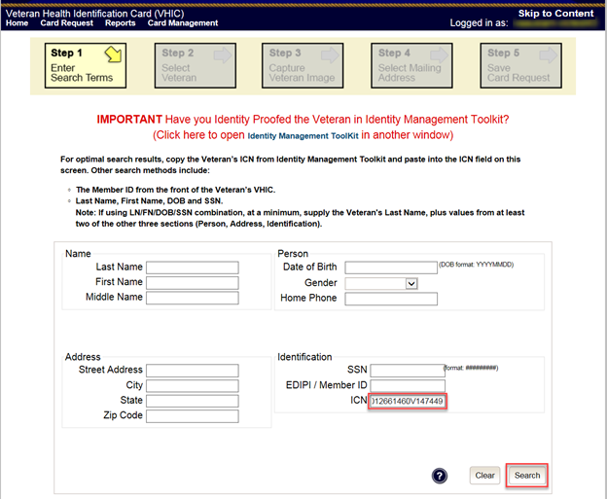
Figure 5:46: Enter Search Terms screen

Step 2: Select Veteran
Once the search has completed, the results of that search will be displayed on screen. From the list provided (up to 10 matches may be returned), select the appropriate Veteran by clicking on the Veteran’s name which is hyperlinked.
If the correct Veteran is not in the list, click the [Back] button and verify the traits entered are correct. If the traits are correct, try adding additional information to aid in triggering a match.

REDACTED
Figure 5:47: Select Veteran screen

Step 3: Capture Veteran Image
Once a selection has been made, the next step in the process is to capture the Veteran image. VHIC provides several ways to handle this operation: Take New Picture, Upload from file, or Reuse Existing Image.

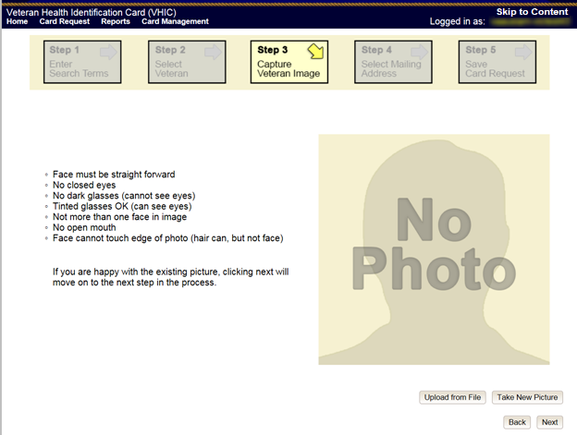
Figure 5:48: Step 3 - Capture Veteran Image screen

Take New Picture
Upon arriving to the Capture Veteran Image page, if there is no useable image for the Veteran already on file, a “No Photo” image will appear in the image capture area. Click [Take New Picture] to capture the Veteran’s image. The camera should become active and the Veteran should be visible in the image capture window.

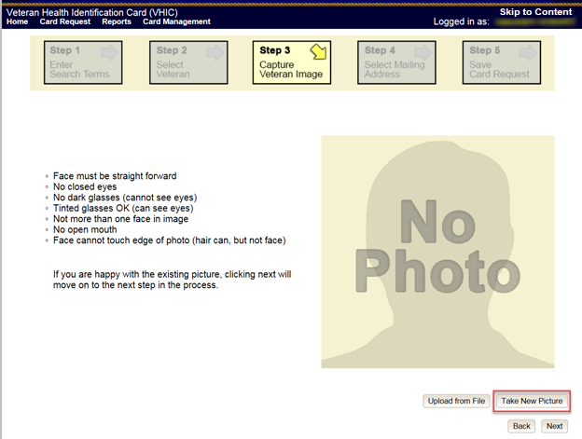
Figure 5:49: Capture Veteran Image screen – Take New Picture

Using the provided silhouette, ensure that that the Veteran is lined up properly. Prior to clicking [Capture Image] ensure the additional image capture guidelines provided on screen are met:
- Face must be straight forward
- No closed eyes
- No dark glasses (cannot see eyes)
- Tinted glasses OK (can see eyes)
- Not more than one face in image
- No open mouth
- Face cannot touch edge of photo (hair can, but not face)

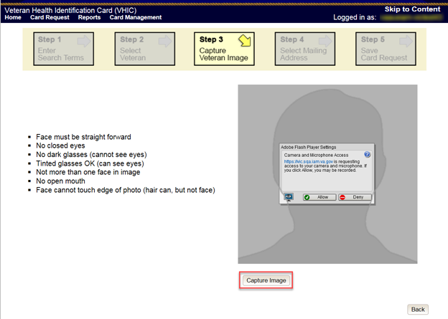
Figure 5:50: Capture Veteran Image screen – Capture Image

Once the image is captured, take a moment to review that the image meets all desired guidelines before proceeding. If the image is acceptable, click [Next] to continue on to the next step.

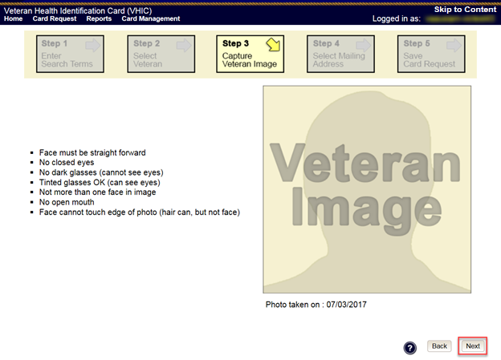
Figure 5:51: Capture Veteran Image screen – Accept new photo; click Next

NOTE: If the image does not meet the guidelines or the Veteran would prefer a new photo be taken or uploaded, this can be done at this point as well by clicking the [Back] button to take a new picture or upload a photo.

Upload from File
In some cases, it may be necessary to upload an image for a Veteran (i.e., they are unable to be present during the card request process due to health issues, etc.) In these cases, VHIC offers the option to upload a photo by selecting the [Upload from File] option.

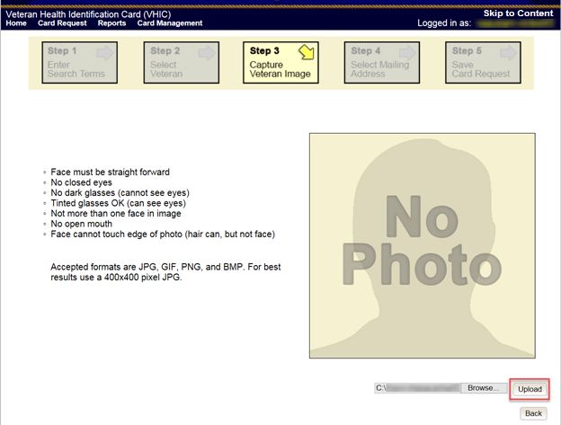
Figure 5:52: Capture Veteran Image screen – Upload from File

Once this option is selected, a [Browse…] button will appear next to a text field. Clicking this button will open up another window to allow for the desired image to be located and selected. The accepted file formats are JPG, GIF, PNG, and BMP. For best results use a 400x400 pixel JPG image. It should also be noted that any adjustments that need to be made to the image to meet the specified guidelines, such as crop and resize, this should be done before the image is uploaded.

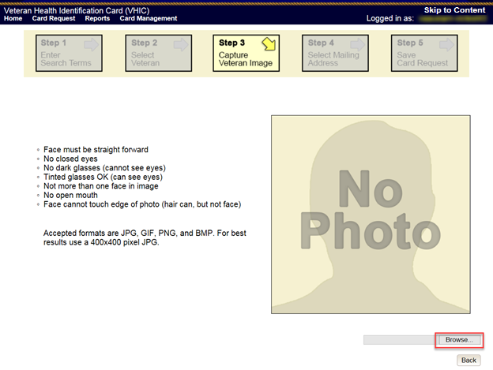
Figure 5:53: Capture Veteran Image screen – Upload photo; click Browse

Once the file has been selected, an [Upload] button will become available. Clicking this will import the image and it will now be visible in the image capture area.

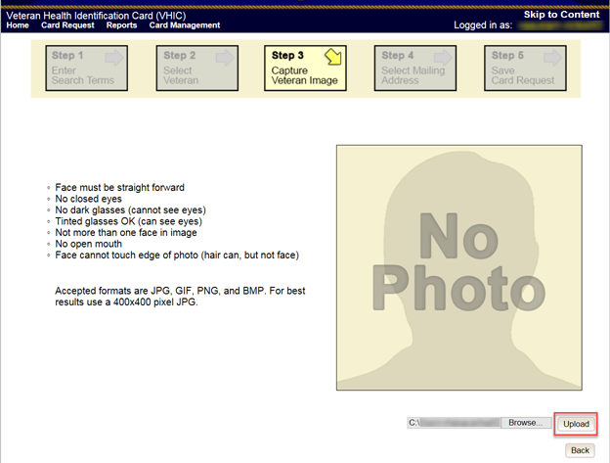
Figure 5:54: Capture Veteran Image screen – Upload photo; click Upload

The user can move the slider below the image window to zoom the image in or out to match the silhouette, the image can also be dragged to line the Veteran’s face inside the silhouette as well.

Once again, be sure to review the image to ensure it meets the specified guidelines before clicking the [Next] button to continue.

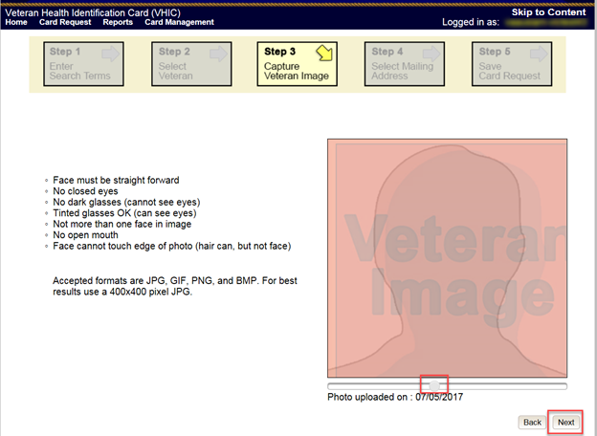
Figure 5:55: Capture Veteran Image screen – Edit photo; click Next

Reuse Existing Image
In the event the Veteran has an existing photo in the system that is less than ten years old, this will appear in the image capture area upon entry to Step 3. If this image meets the required guidelines, it may be reused for the current card request process. Simply click [Next] to continue on to Step 4.

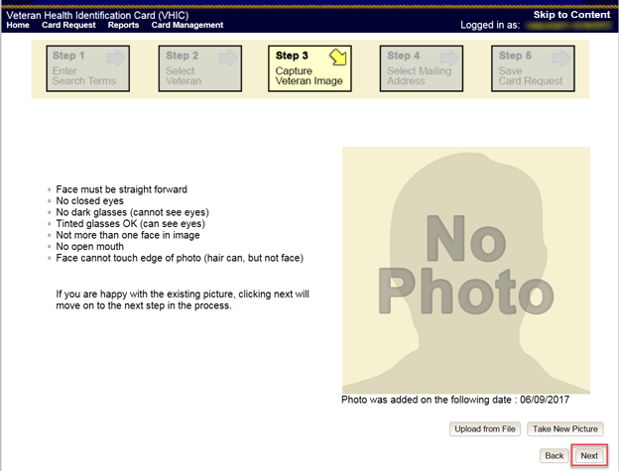
Figure 5:56: Capture Veteran Image screen – Reuse Existing Photo; click Next

The VHIC application will ask the user to confirm that they want to reuse the existing photo for this Veteran. Click the [OK] button to continue to Step 4: Verify Identity Attributes.

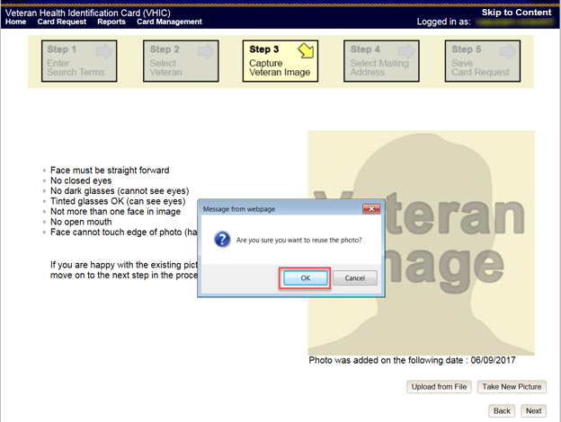
Figure 5:57: Capture Veteran Image screen – Reuse Existing Photo; click OK

NOTE: If the image does not meet the guidelines or the Veteran would prefer a new photo be taken or uploaded, this can be done at this point as well by selecting either [Upload from File] or [Take New Picture].

Step 4: Verify Identity Attributes
This screen displays the information retrieved from the Master Veteran Index (MVI) and the Enrollment System (ES) for the selected Veteran. The purpose of this screen is to determine where the Veteran’s card should be mailed.
REDACTED

Figure 5:58: Select Mailing address screen

This step provides several mailing options for the card:
- Mail to the address received from Enrollment Services
- Mail to the address received from MVI
- Mail to the requesting facility
- Mail to the Preferred Facility

NOTE: If Enrollment has flagged the Veteran’s address as bad, a message stating why, as well as additional guidance on how to proceed, will be displayed near the top of the screen. At this point, if the Veteran opts to not update their information with ES, the Associate MUST choose one of the remaining viable address options for mailing the card in order to proceed with the card request process.

NOTE: If MVI has flagged the Veteran’s address as bad, a message stating why, as well as additional guidance on how to proceed, will be displayed near the top of the screen. At this point, if the Veteran opts not to update their information with MVI or ES, the Associate MUST choose one of the remaining viable address options for mailing the card in order to proceed with the card request process. Selecting a radio button will automatically update the address information based on the selection. The process cannot continue until the appropriate radio button has been selected.

NOTE: If no preferred facility information has been received from ES or the preferred facility address is flagged as bad in the VHIC system, a message stating why, as well as additional guidance on how to proceed, will be displayed near the top of the screen. The Associate MUST choose one of the remaining viable address options for mailing the card in order to proceed with the card request process. Selecting a radio button will automatically update the address information based on the selection. The process cannot continue until the appropriate radio button has been selected.

Selecting a radio button will automatically update the address information based on the selection. The process cannot continue until the appropriate radio button has been selected.

If the address for the Requesting Facility is not correct, then the VHIC user would need to request help with correcting the address by contacting the Enterprise Service Desk at REDACTED, option 3 (Applications), then option 1. Alternately, create a ticket through the [yourIT] shortcut on your desktop with correction details.

If the information on the screen is a correct match, select the [Next] button in the lower right hand to move forward.

Status Section
At the top of the Step 4 screen is the Status section. When going through the card request process, one of the following Card Request Status options will be displayed: New, Replacement, or On Hold. If the card was previously placed on hold, the reason it was placed on hold will be listed here as well. If this is not the first card for the Veteran, the status of Replacement will be listed along with a drop-down list for selecting a Replacement Reason.

Figure 5:59: Card Request Status section

If the Card Request Status is Replacement, a selection must be made from the drop-down list as to why the card is being replaced. The available options are: Damaged, Expired, Incorrect Information, Lost, Poor Quality, or Stolen.

Replacement Options
If the Card Request Status is Replacement, a Replacement Reason will have to be provided before the card request process can continue. Based on the primary replacement reason selected, a secondary reason may need to be provided. The options selected here will appear on the final Step 5 screen under Replacement Reason.

The following are the available primary replacement reasons:
- Damaged
- Deactivated
- Expired
- Incorrect information
- Lost
- Poor Quality
- Stolen

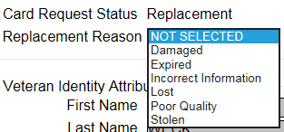
Figure 5:60: Replacement Reason drop-down list

If Poor Quality is selected as a primary replacement reason, one of the following must be selected:
- Photo
- Text
- Other
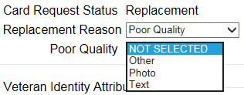
Figure 5:61: Poor Quality Replacement Reasons

If Damaged is selected as a primary replacement reason, one of the following must be selected:
- Barcode not working
- Magnetic stripe not working
- Other physical damage

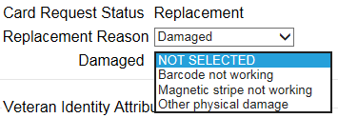
Figure 5:62: Damaged Replacement Reasons

If Incorrect Information is selected as a primary replacement reason, one of the following must be selected:
- Branch of Service
- Date of Birth
- Member ID
- ICN
- Member Benefit Plan ID
- Name
- Photo
- Prisoner of War
- Purple Heart
- Service Connected
- Other
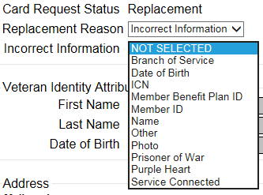
Figure 5:63: Incorrect Information Replacement Reasons

Step 5: Save Card Request
This brings us to Step 5 – Save Card Request. This screen allows the VHIC Admin to verify all of the information shown on the screen as being correct.

REDACTED
Figure 5:64: Save Card Request review screen
This screen contains the following information for review:
- Name as it will appear on card
- Address card will be mailed to (this also contains the name as it will appear in the mailing address)
- Replacement reason (if applicable)
- Reason for hold (if applicable)
- Service connected status
- Medal of Honor status
- Purple Heart status
- Prisoner of War status
- Branch of Service selection
- Date of Birth

Other fields that either will be populated or will populate upon final submission are:
- Card Number (populates upon final submission)
- Member ID
- ICN
- Member Benefit Plan ID
- VISN and Facility where request is being processed

Branch of Service
If available, the Veteran’s Branch of Service options will be displayed on screen. The Veteran should be given the opportunity to select which logo they would prefer to appear on their card or if they would like to decline the logo option altogether (default). The appropriate radio button should be selected based upon the Veteran’s preference. Only those branches of service that are listed in the Enrollment System and in which the Veteran has served will be shown. This will need to be chosen before submitting the card request.
NOTE: Only one Branch of Service logo can appear on the card; those with more than one branch will have to select one, or decline to show any logo.

Figure 5:65: Branch of Service Selection

Save Card Request: Replacement
Saving and submitting a replacement card request is essentially the same as submitting a new card request. The only variation will be the replacement reason. The selections made earlier in Step 4 will be reflected on this screen under the Replacement Reason section.

REDACTED
Figure 5:66: Replacement Card Request Submitted

Placing a Replacement VHIC Request On Hold Manually: Veteran Level 2 Proofed
This section will show how the process flow should go when the VHIC associate enters in a Veteran who is listed in MVI, ES, has a Proofing level of 2 and requesting a new card. During the process the Associate notices some of the Data is not correct.

Step 1: Enter Search Terms
The first step in the process is to find the Veteran in the system. This is accomplished by entering enough search criteria to trigger a match within Master Veteran Index (MVI). The top of the screen offers guidance regarding the set of traits recommended to ensure a best match is found. These are guidelines and not necessarily the required set of traits that must be entered.

However, for optimal search results, copy the Veteran’s ICN from Identity Management Toolkit and paste it into the ICN field on this screen.

Other search methods include:
- The Member ID from the front of the Veteran’s VHIC.
- Last Name, First Name, DOB and SSN.

NOTE: If using LN/FN/DOB/SSN combination, at a minimum, supply the Veteran's Last Name, plus values from at least two of the other three sections (Person, Address, and Identification).

The more traits entered, the more likely a match will be returned. Additional guidance is also available on-screen by clicking on the blue circle containing a question mark.

Figure 5:67: Help icon

This type of help is available throughout the application and will provide additional detail or clarification for that particular step or section.

Once the information has been entered into the required fields, click on [Search] to proceed to the next step.

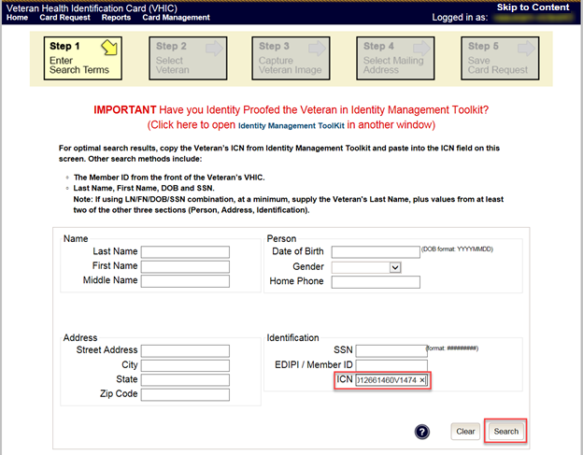
Figure 5:68: Enter Search Terms screen

Step 2: Select Veteran
Once the search has completed, the results of that search will be displayed on screen. From the list provided (up to 10 matches may be returned), select the appropriate Veteran by clicking on the Veteran’s name which is hyperlinked.

If the correct Veteran is not in the list, click the [Back] button and verify the traits entered are correct. If the traits are correct, try adding additional information to aid in triggering a match.
REDACTED
Figure 5:69: Select Veteran screen

Reuse Existing Image
In the event the Veteran has an existing photo in the system that is less than ten years old, this will appear in the image capture area upon entry to Step 3. If this image meets the required guidelines, it may be reused for the current card request process. Simply click [Next] to continue on to Step 4.

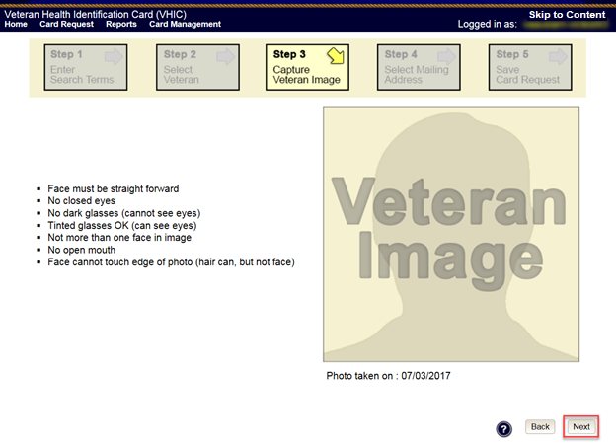
Figure 5:70: Capture Veteran Image screen – Reuse Existing Photo; click Next

VHIC will then ask the user to confirm that they want to reuse the existing photo and then they would click [OK] to continue on to the next step.

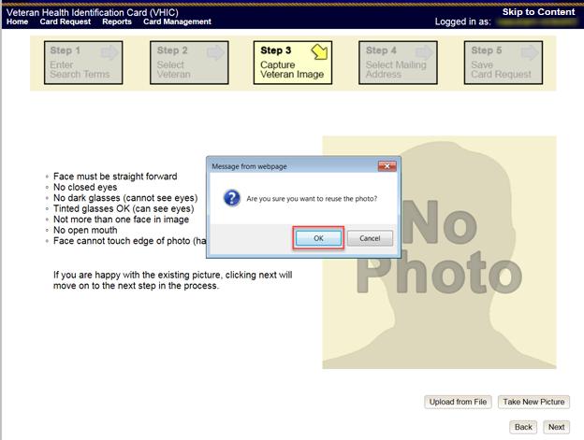
Figure 5:71: Capture Veteran Image screen – Reuse Existing Photo; click OK

Step 4: Select Mailing Address
This screen displays the information retrieved from the Master Veteran Index (MVI) and the Enrollment System (ES) for the selected Veteran. The purpose of this screen is to determine where the Veteran’s card should be mailed.
REDACTED

Figure 5:72: Select Mailing Address screen
This step provides several mailing options for the card:
- Mail to the address received from Enrollment Services
- Mail to the address received from MVI
- Mail to the requesting facility
- Mail to the Preferred Facility

NOTE: If Enrollment has flagged the Veteran’s address as bad, a message stating why, as well as additional guidance on how to proceed, will be displayed near the top of the screen. At this point, if the Veteran opts to not update their information with ES, the Associate MUST choose one of the remaining viable address options for mailing the card in order to proceed with the card request process.

NOTE: If MVI has flagged the Veteran’s address as bad, a message stating why, as well as additional guidance on how to proceed, will be displayed near the top of the screen. At this point, if the Veteran opts not to update their information with MVI or ES, the Associate MUST choose one of the remaining viable address options for mailing the card in order to proceed with the card request process. Selecting a radio button will automatically update the address information based on the selection. The process cannot continue until the appropriate radio button has been selected.
NOTE: If no preferred facility information has been received from ES or the preferred facility address is flagged as bad, a message stating why, as well as additional guidance on how to proceed, will be displayed near the top of the screen. The Associate MUST choose one of the remaining viable address options for mailing the card in order to proceed with the card request process. Selecting a radio button will automatically update the address information based on the selection. The process cannot continue until the appropriate radio button has been selected.

Selecting a radio button will automatically update the address information based on the selection. The process cannot continue until the appropriate radio button has been selected.

If the address for the Requesting Facility is not correct, then the VHIC user would need to request help with correcting the address by contacting the Enterprise Service Desk at REDACTED, option 3 (Applications), then option 1. Alternately, create a ticket through the [yourIT] shortcut on your desktop with correction details.

If the information on the screen is a correct match, select the [Next] button in the lower right hand to move forward.

Status Section
At the top of the Step 4 screen is the Status section. When going through the card request process, one of the following Card Request Status options will be displayed: New, Replacement, or On Hold. If the card was previously placed on hold, the reason it was placed on hold will be listed here as well. If this is not the first card for the Veteran, the status of Replacement will be listed along with a drop-down list for selecting a Replacement Reason.

Figure 5:73: Card Request Status section

If the Card Request Status is Replacement, a selection must be made from the drop-down list as to why the card is being replaced. The available options are: Damaged, Expired, Incorrect Information, Lost, Poor Quality, or Stolen.

Replacement Options
If the Card Request Status should be Replacement, a Replacement Reason will have to be provided before the card request process can continue. Based on the primary replacement reason selected, a secondary reason may need to be provided. The options selected here will appear on the final Step 6 screen under Replacement Reason.

The following are the available primary replacement reasons:
- Damaged
- Deactivated
- Expired
- Incorrect information
- Lost
- Poor Quality
- Stolen
Figure 5:74: Replacement Reason drop-down list

If Poor Quality is selected as a primary replacement reason, one of the following must be selected:
- Photo
- Text
- Other
Figure 5:75: Poor Quality Replacement Reasons

If Damaged is selected as a primary replacement reason, one of the following must be selected:
- Barcode not working
- Magnetic stripe not working
- Other physical damage

Figure 5:76: Damaged Replacement Reasons

If Incorrect Information is selected as a primary replacement reason, one of the following must be selected:
- Branch of Service
- Date of Birth
- Member ID
- ICN
- Member Benefit Plan ID
- Name
- Photo
- Prisoner of War
- Purple Heart
- Service Connected
- Other
Figure 5:77: Incorrect Information Replacement Reasons

Step 5: Save Card Request
This brings us to Step 5 – Save Card Request. This screen allows the VHIC Admin to verify all of the information shown on the screen as being correct.
REDACTED
Figure 5:78: Save Card Request review screen

This screen contains the following information for review:
- Name as it will appear on card
- Address card will be mailed to (this also contains the name as it will appear in the mailing address)
- Replacement reason (if applicable)
- Reason for hold (if applicable)
- Service connected status
- Medal of Honor status
- Purple Heart status
- Prisoner of War status
- Branch of Service selection
- Date of Birth

Other fields that either will be populated or will populate upon final submission are:
- Card Number (populates upon final submission)
- Member ID
- ICN
- Member Benefit Plan ID
- VISN and Facility where request is being processed

If a Branch of Service option is available to the Veteran, the VHIC associate will see that on this screen and will need to ask the Veteran’s preference for which, if any, BoS they would like to appear on the card.

If, after review, the Veteran states that an item is listed incorrectly (i.e., proper Branch of Service is not listed, Medal of Honor status is incorrect, etc.) the VHIC user can check the Bad data checkbox.

When this option is selected, the VHIC user must list the details of the bad data in the provided Details field. This information will be stored in the system and will appear upon submission as well as on Step 4 when this particular request is removed from hold.

The option to Submit is no longer available. Instead the VHIC user will click [Hold] to place the card request on hold.

Save Card Request: Manually saved On Hold
Upon submission, the colored field will change from yellow to orange indicating the card request was placed on hold. A Card Number will be generated as well as the Card Request Date.

The Expiration Date field will now be visible but will not be populated as the card request is not complete at this time. The Card Status is listed as Saved on Hold.
REDACTED
Figure 5:79: Replacement Card Request Saved On Hold

On Hold Reasons Explained

Veteran Not Proofed
User did NOT complete the proofing process using the Identity Management Toolkit application PRIOR to creating a VHIC request

If the VHIC user started the VHIC card request BEFORE going into the Identity Management Toolkit application and completing the proofing process, the VHIC application will display the Warning message on Step 4 of the card request process indicating that the Veteran has NOT been Identity Proofed. The VHIC user will see Veteran not proofed as the Reason for Hold on Step 5. The VHIC application will allow you to save the card request on hold. The card request will be saved for 30 days.
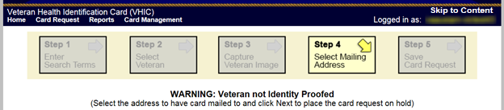
Figure 5:80: Veteran Not Proofed Warning message on Step 4: Select Mailing Address

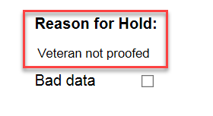
Figure 5:81: Reason for Hold: Veteran Not Proofed

Once the VHIC user completes the Identity Proofing in the Identity Management Toolkit application, they can return to the VHIC application to take the card request off hold. The VHIC user will start a card request as they would normally. The VHIC user will see the On Hold Reason – Veteran Not Proofed displayed on Step 4 of the card request process.
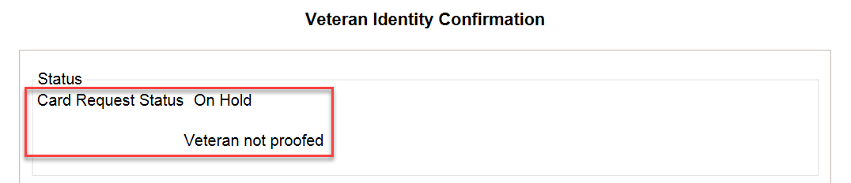
Figure 5:82: Card Request Status: On Hold - Veteran Not Proofed

Continue with the card request process and submit the card request as outlined in section REDACTED

NOTE: There is a background job that runs every morning at 8:00am Eastern Time that will check the proofing status of any cards placed on hold. As long as there are no other issues with the card request, the job will submit the card request to the print vendor.

Enrollment Services Unavailable
If you get to Step 6 and see the message “Enrollment Unavailable” displayed under Reason for Hold, which means that VHIC is unable to communicate to Enrollment Services at this time, select the Branch of Service (if available) and click on the [Hold] button. This will save the card request for 30 days.
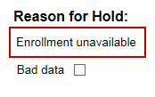
Figure 5:83: Reason for Hold: Enrollment Unavailable

Next, log a ticket by calling the Enterprise Service Desk at REDACTED, option #3 (Applications), then option #1 or create a ticket through the [yourIT] shortcut on your desktop.

NOTE: There is a background job that runs every morning at 8:00am Eastern Time that will check the eligibility status of any cards placed on hold.
- If the Eligibility status is confirmed as “Eligible” and there are no other issues with the card request, the job will submit the card request to the print vendor.
- If the Eligibility status is confirmed as “Not Eligible”, the card request will be terminated, and no card will be issued.

Eligibility Pending
If you get to Step 6 and see the message “Eligibility Pending” displayed under Reason for Hold, which means that Enrollment Services has returned an eligibility status of “Pending” at this time, select the Branch of Service (if available) and click on the [Hold] button. This will save the card request for seven (7) days.
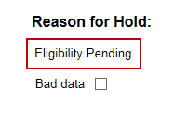
Figure 5:84: Reason for Hold: Eligibility Pending

NOTE: The Veteran should go to Enrollment Services to have the record updated as needed. There is a background job that runs every morning at 8:00am Eastern Time that will check the eligibility status of any cards placed on hold.
- If the Eligibility status is confirmed as “Eligible” and there are no other issues with the card request, the job will submit the card request to the print vendor.
- If the Eligibility status is confirmed as “Not Eligible” or is not updated within Seven (7) days, the card request will be terminated, and no card will be issued.

Bad Data – Other
If you get to Step 6: Save Card Request and any information that is displayed on the screen needs to get changed/updated, click the checkbox next to Bad Data under Reason for Hold. A Details field with be displayed and you can enter a description on what information needs to be updated. Then select the Branch of Service (if available) and click on the [Hold] button. This will save the card request for 30 days.
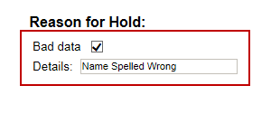
Figure 5:85: Reason for Hold: Bad Data – Name Spelled Wrong

The Veteran should go to Enrollment Services to have the record updated as needed. A card request placed on hold with Bad Data as the Reason for Hold will NOT be updated and submitted by the background job.

The Veteran will need to return to complete the card request after they have had the information updated. You will need to start a card request as you would normally. On Step 4 of the card request process, you will see the On Hold Reason – Bad Data: (reason entered when saved) displayed.
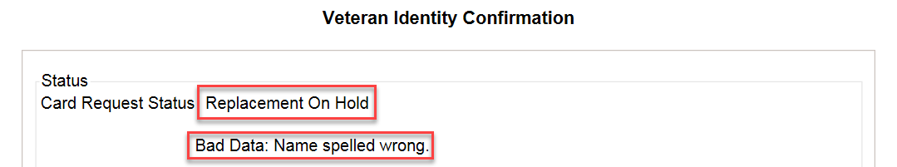
Figure 5:86: Card Request Status: Replacement on Hold - Bad Data: Name Spelled Wrong

Continue with the card request process. When you get to Step 6, you will need to uncheck the checkbox next to Bad Data in order to be able to submit the card request.
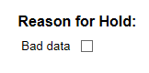
Figure 5:87: Reason for Hold: Bad Data Unchecked

No EDIPI
If you get to Step 6 and see the message “No EDIPI” displayed under Reason for Hold, it means that the VA does not have Defense Enrollment Eligibility Reporting System (DEERS) data for that individual at this time. Select the Branch of Service (if available) and click on the [Hold] button. This will save the card request for thirty (30) days and a request will be generated for HC IdM remediation once you select the hold button.

REDACTED
Figure 5:88: Reason for Hold: No EDIPI

A Confirmation message will appear, select the [OK] button.
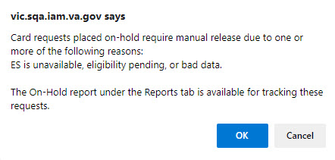
Figure 5:89: On Hold Request Confirmation Box

If a second request is generated before the thirty (30) days the user will get a message indicating that a request is open in the system.
REDACTED
Figure 4:15: Active Request Exists in System Message

Imprecise Date of Birth
If you get to Step 6 and see the message “Invalid Date of Birth” displayed under Reason for Hold, it means that the VA received an imprecise Date of Birth, such as Month/year instead of Month/Date/Year. A request needs to be created for HC IdM remediation. Select the Branch of Service (if available) and click on the [Hold] button. This will save the card request for thirty (30) days and generate the remediation request for HC IdM.

REDACTED
Figure 5:90: Reason for Hold: No EDIPI

A Confirmation request message will appear, select the [OK] button.
Figure 5:91: On Hold Request Confirmation Request

The screen will change showing that the Card Request Status has been updated and saved.
REDACTED
Figure 5:92: Saved on Hold

Resuming an On Hold Replacement VHIC Request: Veteran Level 2 Proofed
When the Associate resumes a card request that has been placed On Hold, they will still be taken through the same steps as though it was a New Card or a Replacement. The Associate won’t be shown that this is an On Hold Request until they get to Step 4.

Step 1: Enter Search Terms
The first step in the process is to find the Veteran in the system. This is accomplished by entering enough search criteria to trigger a match within Master Veteran Index (MVI). The top of the screen offers guidance regarding the set of traits recommended to ensure a best match is found. These are guidelines and not necessarily the required set of traits that must be entered.

However, for optimal search results, copy the Veteran’s ICN from Identity Management Toolkit and paste it into the ICN field on this screen.
Other search methods include:
- The Member ID from the front of the Veteran’s VHIC.
- Last Name, First Name, DOB and SSN.
NOTE: If using LN/FN/DOB/SSN combination, at a minimum, supply the Veteran's Last Name, plus values from at least two of the other three sections (Person, Address, and Identification).

The more traits entered, the more likely a match will be returned. Additional guidance is also available on-screen by clicking on the blue circle containing a question mark.

Figure 5:93: Help icon

This type of help is available throughout the application and will provide additional detail or clarification for that particular step or section.
Once the information has been entered into the required fields, click on [Search] to proceed to the next step.
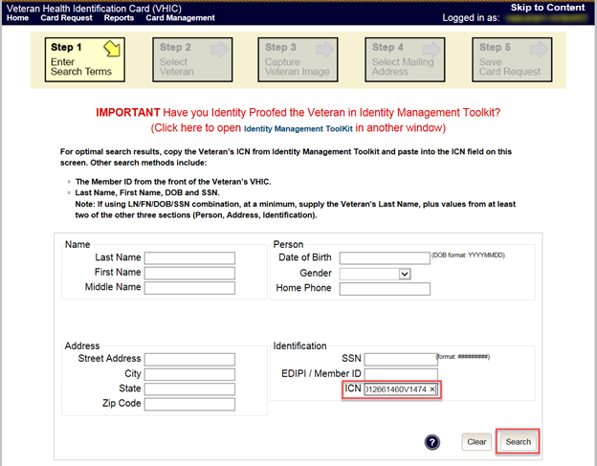
Figure 5:94: Enter Search Terms screen

Step 2: Select Veteran
Once the search has completed, the results of that search will be displayed on screen. From the list provided (up to 10 matches may be returned), select the appropriate Veteran by clicking on the Veteran’s name which is hyperlinked.

If the correct Veteran is not in the list, click the [Back] button and verify the traits entered are correct. If the traits are correct, try adding additional information to aid in triggering a match.
REDACTED
Figure 5:95: Select Veteran screen

Reuse Existing Image
In the event the Veteran has an existing photo in the system that is less than ten years old, this will appear in the image capture area upon entry to Step 3. If this image meets the required guidelines, it may be reused for the current card request process. Simply click [Next] to continue on to Step 4.
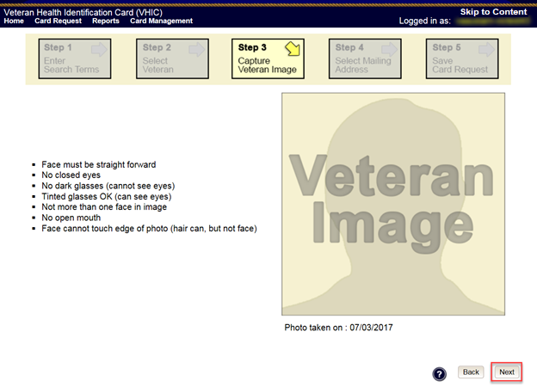
Figure 5:96: Capture Veteran Image screen – Reuse Existing Photo; click Next

VHIC will then ask the user to confirm that they want to reuse the existing photo and then they would click [OK] to continue on to the next step.
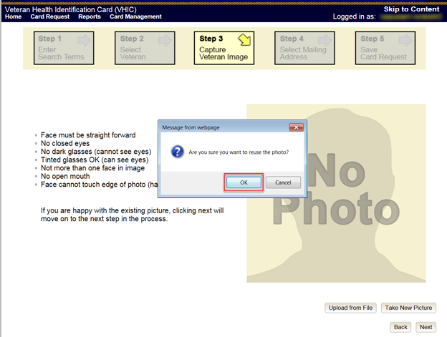
Figure 5:97: Capture Veteran Image screen – Reuse Existing Photo; click OK

Step 4: Select Mailing Address
This screen displays the information retrieved from the Master Veteran Index (MVI) and the Enrollment System (ES) for the selected Veteran. The purpose of this screen is to determine where the Veteran’s card should be mailed.
At the top of the Step 4 screen is the Status section. Since this card request for the Veteran was placed on hold, the status of Replacement On Hold will be listed along with the On Hold reason. There is also a drop-down list for selecting a Replacement Reason.
REDACTED
Figure 5:98: Select Mailing Address screen

This step provides several mailing options for the card:
- Mail to the address received from Enrollment Services
- Mail to the address received from MVI
- Mail to the requesting facility
- Mail to the Preferred Facility
NOTE: If Enrollment has flagged the Veteran’s address as bad, a message stating why, as well as additional guidance on how to proceed, will be displayed near the top of the screen. At this point, if the Veteran opts to not update their information with ES, the Associate MUST choose one of the remaining viable address options for mailing the card in order to proceed with the card request process.

NOTE: If MVI has flagged the Veteran’s address as bad, a message stating why, as well as additional guidance on how to proceed, will be displayed near the top of the screen. At this point, if the Veteran opts not to update their information with MVI or ES, the Associate MUST choose one of the remaining viable address options for mailing the card in order to proceed with the card request process. Selecting a radio button will automatically update the address information based on the selection. The process cannot continue until the appropriate radio button has been selected.

NOTE: If no preferred facility information has been received from ES or the preferred facility address is flagged as bad, a message stating why, as well as additional guidance on how to proceed, will be displayed near the top of the screen. The Associate MUST choose one of the remaining viable address options for mailing the card in order to proceed with the card request process. Selecting a radio button will automatically update the address information based on the selection. The process cannot continue until the appropriate radio button has been selected.

Selecting a radio button will automatically update the address information based on the selection. The process cannot continue until the appropriate radio button has been selected.

If the address for the Requesting Facility is not correct, then VHIC user would need to request help with correcting the address by calling the Enterprise Service Desk at REDACTED, option 3 (Applications), then option 1. Alternately, create a ticket through the [yourIT] shortcut on your desktop with correction details.

If the information on the screen is a correct match, select the [Next] button in the lower right hand to move forward.

Status Section
At the top of the Step 4 screen is the Status section. Since this card request for the Veteran was placed on hold, the status of Replacement On Hold will be listed along with the On Hold reason. There is also a drop-down list for selecting a Replacement Reason.

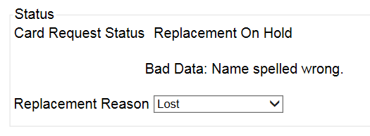
Figure 5:99: Card Request Status section

Since the Card Request Status is Replacement On Hold, a selection must be made from the drop-down list as to why the card is being replaced. The available options are: Damaged, Expired, Incorrect Information, Lost, Poor Quality, or Stolen.

Replacement Options
If the Card Request Status should be Replacement, a Replacement Reason will have to be provided before the card request process can continue. Based on the primary replacement reason selected, a secondary reason may need to be provided. The options selected here will appear on the final Step 6 screen under Replacement Reason.

The following are the available primary replacement reasons:
- Damaged
- Deactivated
- Expired
- Incorrect information
- Lost
- Poor Quality
- Stolen
Figure 5:100: Replacement Reason drop-down list

If Poor Quality is selected as a primary replacement reason, one of the following must be selected:
- Photo
- Text
- Other

Figure 5:101: Poor Quality Replacement Reasons

If Damaged is selected as a primary replacement reason, one of the following must be selected:
- Barcode not working
- Magnetic stripe not working
- Other physical damage

Figure 5:102: Damaged Replacement Reasons

If Incorrect Information is selected as a primary replacement reason, one of the following must be selected:
- Branch of Service
- Date of Birth
- Member ID
- ICN
- Member Benefit Plan ID
- Name
- Photo
- Prisoner of War
- Purple Heart
- Service Connected
- Other
Figure 5:103: Incorrect Information Replacement Reasons

Step 5: Save Card Request
This brings us to Step 5 – Save Card Request. This screen allows the VHIC Admin to verify all of the information shown on the screen as being correct.

If a Branch of Service option is available to the Veteran, the VHIC associate will see that on this screen and will need to ask the Veteran’s preference for which, if any, BoS they would like to appear on the card.

If, after review, the Veteran states that all items are listed correctly now, the VHIC user can uncheck the Bad data checkbox.

When the Bad data checkbox is unchecked, the [Hold] button will change to the [Submit] button.
REDACTED
Figure 5:104: Save Card Request review screen; Uncheck Bad Data checkbox

The VHIC user can now click [Submit] to complete the card request.
REDACTED
Figure 5:105: Save Card Request review screen; click Submit

This screen shows that the Card Request was submitted successfully.

If a Branch of Service was selected on the previous screen. The designated choice will appear here, as well as the Expiration Date and the Replacement Reason.

REDACTED
Figure 5:106: Replacement Card Request Submitted

Requesting a VHIC for a Veteran within ten (10) days of a previous VHIC request
VHIC Users will not be able to request a new VHIC for a Veteran if there has been a previous request made within the past ten (10) days. They will be shown a message on Step 2 of the VHIC card request process stating:
“This Veteran has a recent VHIC request in process. Please remind the Veteran the VHIC should be received with 10 days after the request was submitted.”
REDACTED
Figure 5:107: Replacement Card has been requested within the past 10 days

If for some reason a new VHIC request must be made to include any changes within 10 days of the previous card request, ONLY the VHIC Administrator will be able to submit a new card request. In this instance, the VHIC user will need to submit a request to the VHA HEC VHIC Program Team mail group via an encrypted message to deactivate the submitted card request. Once the VHIC user is notified that their card request has been deactivated, they can submit a new card request with the corrected information
Information to include in the request are listed below:
- Veteran’s First and Last Name
- Member ID and/or Card Number
- Site Point of Contact
- Reason for needing a new card requested within 10 days of the previous request.

NOTE: If the Member ID and/or Card Number are not available, provide the Date of Birth and SSN instead.

Requesting a VHIC for a Veteran with an existing Date of Death
VHIC Users will not be able to request a new VHIC for a Veteran if a Date of Death has been reported for them. They will be shown a message on Step 2 of the VHIC card request process stating:
Card requests for deceased veteran(s) are not allowed. All Cards for deceased veteran(s) have been deactivated in VHIC and unlinked in MVI.

REDACTED
Figure 5:108: Deceased Veteran Notification

The Veteran should referred to Enrollment. This could be to either the facility enrollment department (possibly parent facility), or the HEC Enrollment & Eligibility Division (REDACTED) for assistance.

Card Deactivations
Card deactivations can ONLY be completed by the VHIC Administrator. The VHIC user will need to submit a request to the VHA HEC VHIC Program Team mail group via an encrypted message.
Information to include in the request are listed below:
- Veteran’s First and Last Name
- Member ID and/or Card Number
- Site Point of Contact
- One of the following deactivation reasons:
  - Cancelled/Declined (enrollment)
  - Damaged
  - Deceased
  - Identity Theft
  - Lost
  - Stolen
  - Other – With detailed explanation

NOTE: If the Member ID and/or Card Number are not available, provide the Date of Birth and SSN instead.

NOTE: Once the VHIC user is notified that their card request has been deactivated, they can submit a new card request with the corrected information.

VHIC Administrators can find detailed information on how to deactivate all of the VHICs for a given Veteran in the Veteran Health Identification Card User Guide - Volume 3 – Admins document.

Reports
A comprehensive walkthrough of all of the different reports that are available to VHIC users and the types of metrics that can be obtained, as well as an explanation of the user role permissions for accessing the reports are included in the Veteran Health Identification Card User Guide - Volume 2 - Reports document.

Troubleshooting
For a through set of troubleshooting guidelines, please refer to the Veteran Health Identification Card User Guide - Volume 4 - Troubleshooting document.

