Veteran Health Identification Card (VHIC 4.17)

User Guide

Volume 3 - Card Management and
Administrator Only Tasks

June 2021

Department of Veterans Affairs
Office of Information and Technology (OI&T)

Revision History
NOTE: The revision history cycle begins once changes or enhancements are requested after the document has been baselined.
Date | Revision | Description | Author
06/20/2021 | 7.2 | No Changes in functionality updated date and version number | REDACTED
03/20/21 | 7.1 | No Changes in functionality updated date and version number | REDACTED
12/19/2020 | 7 | Updated for VIP 15 release | REDACTED
06/20/2020 | 6 | Updated to reflect changes to application with VIP 13 | REDACTED
02/15/2020 | 5 | Updated to reflect changes to application with VIP 12 release | REDACTED
11/01/2019 | 4 | Updated to reflect updates to VHIC completed in VIP 10 -Validation for ICN input fields on all search screens and shall add a usage tip | REDACTED
09/04/2019 | 3 | Updated to reflect new functionality for VHIC 4.9 Release (Card Destruction) and updated formatting to comply with OIT Standards | REDACTED
01/21/2018 | 2.1 | Accepted all changes as approved on anomaly logs, re-paginated document, re-ran TOCs, and created Section 508 compliant PDF for uploading, with Word document, to RTC Jazz Tools as well as SharePoint. | REDACTED
01/19/2018 | 2.1 | Re-paginated document. Readied document for creating Section 508 compliant PDF. | REDACTED
01/12/2018 | 2.1 | Applied changes from first anomaly log dated 010418 as well as some additional internal anomalies identified by the VHIC Product Development Team. | REDACTED
12/21/2017 | 2.1 | Updated images to include new “Skip To Content” link. Added Section 8 entitled “Card Destruction.” Updated Appendix entitled “VHIC Roles.”  Checked Alt text for all images and figures. Added Alt text to figures without it. Re-ran TOCs. | REDACTED, REDACTED
08/25/2017 | 2.0 | Checked Alt text for all images and figures. Added Alt text to figures without it. Changed name in footer from “Card Deactivation” to “Card Management.” Re-ran TOCs and fixed content/figure pagination issues in the Word document. Document converted to Section 508 compliant PDF as part of VHIC 4.8. Updated document name to match VA naming conventions by replacing spaces in Word document name with underscores. | REDACTED
08/15/2017 | 2.0 | Updated with content and images for first draft for VHIC 4.8. | REDACTED, REDACTED
08/17/2016 | 1.6 | Completed technical writer review of document. Ran Spelling and Grammar, added Alt text to all images, and re-ran TOCs. Created a footer and page numbering for document Page 1 to match other volumes. Changed cover date from “August 2016” to match footer date of “September 2016” to match other Volumes. | REDACTED
08/04/2016 | 1.6 | Updated content | REDACTED
01/06/2015 | 1.5 | Updated content and Images | REDACTED
07/07/2015 | 1.4 | Updated content and Images | REDACTED
07/07/2015 | 1.3 | Rebuilt to capture content overhaul to VHIC System and divided this guide into three separate parts | REDACTED
05/20/2015 | 1.2 | Updated Content and Images to reflect the Maintenance Releases | REDACTED
01/13/2015 | 1.1 | Updated content and Images | REDACTED
09/18/2014 | 1.0 | Rebuilt to capture content overhaul to VHIC System | REDACTED
Table of Contents
1. Introduction 1
1.1. Purpose 1
1.2. Document Orientation 1
1.2.1. Organization of the Manual 1
1.2.2. Assumptions 2
1.2.3. Disclaimers 2
1.2.3.1. Software Disclaimer 2
1.2.3.2. Documentation Disclaimer 2
1.2.4. Documentation Conventions 3
1.3. Enterprise Service Desk and Organizational Contacts 3
2. Accessing the VHIC Application 4
2.1. Browser 4
2.1.1. Browser Incompatibility Issue 4
2.2. Proper Navigation of the VHIC Application 5
2.3. Roles within VHIC 6
3. Getting Started 6
3.1. Single Sign-On Internal (SSOi) 6
3.2. Logging On 7
3.3. System Menu 7
3.3.1. VHIC Administrator and Technical Administrator Tier 3 7
3.4. VHIC System Status Banner 8
3.5. Changing User ID and Password 8
4. Before Requesting a VHIC Card 8
5. Creating a VHIC Card – The Card Request Process 8
5.1. Requesting a VHIC for a Veteran Within Ten (10) Days of a Previous VHIC Request 9
6. Card Management – The Card Deactivation Process 10
6.1. Cancelled/Declined 12
6.1.1. Accessing Card Deactivation 12
6.1.2. Step 1: Enter Search Terms 12
6.1.3. Step 2: Select Veteran 15
6.1.4. Select Deactivation Reason 15
6.1.5. Confirm Deactivation Request 16
6.1.6. Verifying Card Deactivation 18
6.1.7. Saving a Card Request On-Hold to Retain Picture (For Cancelled/Declined enrollment only) 20
6.2. Damaged 27
6.2.1. Accessing Card Deactivation 27
6.2.2. Step 1: Enter Search Terms 27
6.2.3. Step 2: Select Veteran 29
6.2.4. Select Deactivation Reason 29
6.2.5. Confirm Deactivation Request 30
6.2.6. Request a Replacement Card 31
6.2.7. Verifying Card Deactivation 33
6.3. Deceased 35
6.3.1. Accessing Card Deactivation 35
6.3.2. Step 1: Enter Search Terms 35
6.3.3. Step 2: Select Veteran 37
6.3.4. Select Deactivation Reason 37
6.3.5. Confirm Deactivation Request 38
6.3.6. Verifying Card Deactivation 39
6.4. Identity Theft 41
6.4.1. Accessing Card Management 41
6.4.2. Step 1: Enter Search Terms 41
6.4.3. Step 2: Select Veteran 43
6.4.4. Select Deactivation Reason 43
6.4.5. Confirm Deactivation Request 44
6.4.6. Verifying Card Deactivation 45
6.5. Lost 47
6.5.1. Accessing Card Deactivation 47
6.5.2. Step 1: Enter Search Terms 47
6.5.3. Step 2: Select Veteran 49
6.5.4. Select Deactivation Reason 49
6.5.5. Confirm Deactivation Request 50
6.5.6. Request a Replacement Card 51
6.5.7. Verifying Card Deactivation 52
6.6. Other 54
6.6.1. Accessing Card Deactivation 54
6.6.2. Step 1: Enter Search Terms 54
6.6.3. Step 2: Select Veteran 56
6.6.4. Select Deactivation Reason 57
6.6.5. Confirm Deactivation Request 58
6.6.6. Verifying Card Deactivation 59
6.7. Stolen 61
6.7.1. Accessing Card Deactivation 61
6.7.2. Step 1: Enter Search Terms 61
6.7.3. Step 2: Select Veteran 63
6.7.4. Select Deactivation Reason 63
6.7.5. Confirm Deactivation Request 64
6.7.6. Request a Replacement Card 65
6.7.7. Verifying Card Deactivation 66
7. Card Receiving 68
7.1. Cards Received 68
7.1.1. Accessing Cards Received Screen 68
7.1.2. Step 1: Enter Search Terms 70
7.1.3. Step 2: Card Verification 73
8. Card Destruction 75
8.1. Card Destruction 75
8.1.1. Accessing Card Destruction Screen 75
8.1.2. Step 1: Select Cards for Destruction 77
8.1.3. Select Date of Destruction 79
8.1.4. Card Destruction Status Displayed 80
9. Reports 80
10. Troubleshooting 80

Table of Figures
Figure 2-1: VHIC Navigation Buttons 5
Figure 2-2: VHIC Administrator and VHIC Technical Administrator (Tier 3) menu 5
Figure 2-3: VHIC Associate and VHIC Supervisor menu 5
Figure 2-4: VHIC Auditor and VHIC Read-Only User menu 5
Figure 3-1: SSOi Login Screen 6
Figure 3-2: VHIC Administrator and VHIC Technical Administrator (Tier 3) Home screen 7
Figure 3-3: VHIC System Status Banner 8
Figure 5-1: Replacement Card has been requested within the past 10 days 9
Figure 6-1: Card Deactivation Reasons drop-down menu 11
Figure 6-2: VHIC Administrator Home screen; click Card Management 12
Figure 6-3: Help icon 13
Figure 6-4: Card Management Deactivation Home screen. Enter Search Terms screen 13
Figure 6-5: Enter Search Terms screen - No Match Found error 14
Figure 6-6: Card Deactivation Select Veteran screen 15
Figure 6-7: Select Deactivation Reason screen 15
Figure 6-8: Confirm Deactivation pop-up window 16
Figure 6-9: All Cards Deactivated - Cancelled/Declined 16
Figure 6-10: Card Deactivated Screen with Replace Card Option 17
Figure 6-11: Card Replacement Button Selected 17
Figure 6-12: Card History Report Query Screen 18
Figure 6-13: Card History Report - Cancelled/Declined 19
Figure 6-14: Step 1: Enter Search Terms 20
Figure 6-15: Step 2: Select Veteran 21
Figure 6-16: Step 3: Capture Veteran Image - Reuse Photo, Click Next button 21
Figure 6-17: Step 3: Confirm Reuse of Photo by clicking the OK button 22
Figure 6-18: Step 4: Select Mailing Address - Replacement Reason: Incorrect Information - Other 23
Figure 6-19: Step 5: Save Card Request - Select Bad Data - Details: Retain Picture 24
Figure 6-20: Step 5: Save Card Request - Saved on Hold - Reason for Hold - Bad Data: Retain Picture 25
Figure 6-21: Card History Report Query Screen 25
Figure 6-22: Card History Report - Hold Reason: Bad Data - Retain Picture 26
Figure 6-23: VHIC Administrator Home screen; click Card Management 27
Figure 6-24: Help icon 28
Figure 6-25: Card Deactivation Enter Search Terms screen 28
Figure 6-26: Card Deactivation Select Veteran screen 29
Figure 6-27: Select Deactivation Reason screen 29
Figure 6-28: Confirm Deactivation pop-up window 30
Figure 6-29: All Cards Deactivated – Damaged 30
Figure 6-30: Replace Card 31
Figure 6-31: Step 3 Capture Veteran Image screen 32
Figure 6-32: Card History Report Query Screen 33
Figure 6-33: Card History Report – Damaged 34
Figure 6-34: VHIC Administrator Home screen; click Card Management 35
Figure 6-35: Help icon 36
Figure 6-36: Card Deactivation Enter Search Terms screen 36
Figure 6-37: Card Deactivation Select Veteran screen 37
Figure 6-38: Select Deactivation Reason screen 37
Figure 6-39: Confirm Deactivation pop-up window 38
Figure 6-40: All Cards Deactivated – Deceased 39
Figure 6-41: Card History Report Query Screen 39
Figure 6-42: Card History Report - Deceased 40
Figure 6-43: VHIC Administrator Home screen; click Card Management 41
Figure 6-44: Help icon 42
Figure 6-45: Card Management Enter Search Terms screen 42
Figure 6-46: Card Deactivation Select Veteran screen 43
Figure 6-47: Select Deactivation Reason screen 44
Figure 6-48: Confirm Deactivation pop-up window 44
Figure 6-49: All Cards Deactivated - Identity Theft 45
Figure 6-50: Card History Report Query Screen 45
Figure 6-51: Identity Theft 46
Figure 6-52: VHIC Administrator Home screen; click Card Management 47
Figure 6-53: Help icon 48
Figure 6-54: Card Deactivation Enter Search Terms screen 48
Figure 6-55: Card Deactivation Select Veteran screen 49
Figure 6-56: Select Deactivation Reason screen 49
Figure 6-57: Confirm Deactivation pop-up window 50
Figure 6-58: All Cards Deactivated – Lost 50
Figure 6-59: Replace Card 51
Figure 6-60: Step 3 Capture Veteran Image screen 52
Figure 6-61: Card History Report Query Screen 52
Figure 6-62: Card History Report - Lost 53
Figure 6-63: VHIC Administrator Home screen; click Card Management 54
Figure 6-64: Help icon 55
Figure 6-65: Card Deactivation Enter Search Terms screen 55
Figure 6-66: Card Deactivation Select Veteran screen 56
Figure 6-67: Select Deactivation Reason screen 57
Figure 6-68: Confirm Deactivation pop-up window 58
Figure 6-69: All Cards Deactivated – Other 58
Figure 6-70: Card History Report Query Screen 59
Figure 6-71: Card History Report - Other 60
Figure 6-72: VHIC Administrator Home screen; click Card Deactivation 61
Figure 6-73: Help icon 62
Figure 6-74: Card Deactivation Enter Search Terms screen 62
Figure 6-75: Card Deactivation Select Veteran screen 63
Figure 6-76: Select Deactivation Reason screen 63
Figure 6-77: Confirm Deactivation pop-up window 64
Figure 6-78: All Cards Deactivated - Stolen 64
Figure 6-79: Replace Card 65
Figure 6-80: Step 3 Capture Veteran Image screen 66
Figure 6-81: Card History Report Query Screen 66
Figure 6-82: Card History Report - Stolen 67
Figure 7-1: VHIC Administrator Home screen; click Card Management 68
Figure 7-2: Select Card Receiving Tab 69
Figure 7-3: Card Received Screen 69
Figure 7-4: Card Scanned into system, Card ID populates 70
Figure 7-5: Search by Member ID 71
Figure 7-6: Search by Veteran Name/SSN 72
Figure 7-7: Help icon 72
Figure 7-8: VHIC Card details displayed 73
Figure 7-9: Card status updated - Pending Destruction 73
Figure 7-10: Receiving Search Page 74
Figure 8-1: VHIC Administrator Home screen; click Card Management 75
Figure 8-2: Select Card Destruction Tab 76
Figure 8-3: Card Destruction Screen 77
Figure 8-4: Select Cards by Received Date for Destruction 78
Figure 8-5: Select Date of Destruction 79
Figure 8-6: Card Destruction Confirmation Message 79
Figure 8-7: Card Destruction Status 80

Table of Tables
Table 1: Documentation Symbols and Descriptions 3
Table 2: Enterprise Service Desk Contact Information 3
Table 3: Who can deactivate a card? 10
Table 4: Who can receive a card? 68
Table 5. Who can destroy a card? 75

Introduction

Purpose
The purpose of this User Guide is to provide general system information, as well as accessibility and user roles with the VHIC application. This User Guide will provide a detailed walkthrough of creating Veteran Health Identification Card requests using the VHIC application. This User Guide will also provide the detailed steps on how VHIC Administrators can deactivate all of the VHICs associated to a selected Veteran.

Document Orientation

Organization of the Manual
This User Guide is divided into eight sections, allowing the user to quickly obtain the information needed.
The first section will provide an overview of what a VHIC is and what the eligibility requirements are, and the various user roles and their accessibility within the VHIC application.
In order to be able to receive a VHIC, a Veteran must meet the following eligibility criteria:
- Be eligible for VA medical benefits
- Be enrolled in the VA Healthcare system
- Be Level 2 proofed at a VA medical facility
- Veteran identity must be recognized in the Master Veteran Index (MVI), which is managed by the Identity and Access Management (IAM) of the VA

NOTE: The level 2 proofing process is a method to verify the identity of Veterans. VA requires Veterans to provide approved identification documents to access Personal Identifiable Information (PII), Personal Health Information (PHI) and request a Veterans Health Identification Card (VHIC).

The second and third sections will walk the user through the steps needed to access the VHIC application, as well as some general guidelines on using the VHIC application.
The fourth section will give the user an overview of what they need to do before starting a card request for a Veteran. The VHIC user must verify the Veteran’s Identity Proofing Level is at Level 2 in the Identity Management Toolkit.
The fifth section will provide information for the VHIC Administrator on how to continue with the card request process when the Veteran already has a VHIC requested that falls within the ten (10) day window set aside for mailing.
The sixth section will provide information for the VHIC Administrator on how to deactivate the VHICs for a specific Veteran. A step-by-step process will navigate the VHIC Administrator through the Card Management screens in the VHIC application. Once all of the required information has been provided, the final step in the Card Management process will confirm that the deactivation of all VHICs associated with a Veteran have been deactivated.
The seventh section will provide information on the different reports available to VHIC Associates and the types of metrics that can be obtained.
The last section covers some troubleshooting issues and solutions that will help the VHIC user to better able to support the Veteran and ensure that the VHIC requests are processed properly.

Assumptions
This guide was written with the following assumed experience/skills of the audience:
- User has basic knowledge of the operating system (such as the use of commands, menu options, and navigation tools).
- User has been provided the appropriate active roles required for the VHIC application.
- User is using Google Chrome or Microsoft Edge to do their job of either creating VHIC Card Requests, Running Reports, or Deactivating VHICs depending on user roles.
- User has validated access to the VHIC application.
- User has completed any prerequisite training.

Disclaimers

Software Disclaimer
This software was developed at the Department of Veterans Affairs (VA) by employees of the Federal Government in the course of their official duties. Pursuant to title 17 Section 105 of the United States Code this software is not subject to copyright protection and is in the public domain. VA assumes no responsibility whatsoever for its use by other parties, and makes no guarantees, expressed or implied, about its quality, reliability, or any other characteristic. We would appreciate acknowledgement if the software is used. This software can be redistributed and/or modified freely provided that any derivative works bear some notice that they are derived from it, and any modified versions bear some notice that they have been modified.

Documentation Disclaimer
The appearance of external hyperlink references in this manual does not constitute endorsement by the Department of Veterans Affairs (VA) of this Web site or the information, products, or services contained therein. The VA does not exercise any editorial control over the information you may find at these locations. Such links are provided and are consistent with the stated purpose of the VA.

Documentation Conventions
This manual uses several methods to highlight different aspects of the material.
- Various symbols are used throughout the documentation to alert the reader to special information. The following table gives a description of each of these symbols:
Table 1: Documentation Symbols and Descriptions
Symbol | Description
 | NOTE: Used to inform the reader of general information including references to additional reading material
- Descriptive text is presented in a proportional font (as represented by this font).
- “Screenshots” of computer online displays (i.e., character-based screen captures/dialogs) and are shown in a non-proportional font and enclosed within a box. Also included are Graphical User Interface (GUI) Microsoft Windows images (i.e., dialogs or forms).
- User's responses to online prompts (e.g., manual entry, taps, clicks, etc.) will be [boldface] type and enclosed in brackets.

Enterprise Service Desk and Organizational Contacts
The support contact information documented herein are intended to restore normal service operation as quickly as possible and minimize the adverse impact on business operations, ensuring that the best possible levels of service quality and availability are maintained.
The following table lists the contact information needed by site users for troubleshooting purposes. Support contacts are listed by description of the incident escalation and contact information (phone number and options to select).

Table 2: Enterprise Service Desk Contact Information
Issue | Contact Info
For Provisioning Issues | Contact the Enterprise Service Desk at REDACTED, option 3 (Applications), then option 1.  When contacted by a support specialist, be ready to supply the employee’s full name, VA user ID and email address.
For Proofing Issues | Contact the Enterprise Service Desk at REDACTED, option 3 (Applications), then option 1.  When contacted by a support specialist, be ready to supply the Veterans' full name, full SSN, and DOB.
For All Other VHIC System Issues | Contact the Enterprise Service Desk at REDACTED, option 3 (Applications), then option 1.  When contacted by a support specialist, be ready to supply the Veterans' full name, full SSN, and DOB.

Accessing the VHIC Application

Browser
VHIC is a web-based application which users will access via a web browser. The recommended browser is Google Chrome or Microsoft Edge .
The VHIC URL is REDACTED and is case sensitive – it must be entered exactly as shown. After successfully logging in to the VHIC application, users should bookmark this site for easy access in the future. Instructions on how to do just that can be found here: REDACTED

The best time to bookmark the site is after the user is in the application itself rather than attempting to bookmark the Login screen.

Browser Incompatibility Issue
In some instances, users may experience image misplacement or misalignment. This is most likely due to the current browser compatibility settings. You will want to ensure that the browser is not set to Compatibility View. This process is explained in the Veteran Health Identification Card User Guide - Volume 4 - Troubleshooting document.

Proper Navigation of the VHIC Application
The correct way to navigate through the VHIC application is to use the [Back] and [Next] buttons that are located at the bottom of each screen instead of using the Browser’s built in Back button. Please do NOT use the [Back] button at the top of your browser window to navigate back to a previous screen; this will cause errors to occur.
Figure 2-1: VHIC Navigation Buttons

The VHIC user can also navigate to the different features within the VHIC application by clicking on one of the navigation links located in the header near the top left of the screen. The user’s assigned role will determine which links are available as seen below. To see the full home screens for each user role, refer to Section 3.3 System Menu.

Figure 2-2: VHIC Administrator and VHIC Technical Administrator (Tier 3) menu

Figure 2-3: VHIC Associate and VHIC Supervisor menu

Figure 2-4: VHIC Auditor and VHIC Read-Only User menu
NOTE: The “Skip To Content” link is a Section 508 compliance feature that skips repetitive navigation links so that page content can be quickly accessed.

Roles within VHIC
The VHIC application is built to accommodate a specific set of pre-established user roles. During the provisioning process, the VHIC user will have a role assigned to them, which will determine what aspects of the VHIC application are available to them. The following breaks down the specific roles and the areas of access that accompany each role.

If, while utilizing the VHIC application, a user finds they do not have access to items they feel they should have access to or find that they have access to items they should not, based on the definitions listed below, the VHIC user should report this information to their VHIC Supervisor. The VHIC Supervisor should then verify that the proper role has been assigned.

For a detailed list of Roles and corresponding Access levels please refer to the VHIC Roles and Access document.

Getting Started

Single Sign-On Internal (SSOi)
Once users are logged into their VA desktop, they will access VHIC using Google Chrome or Microsoft Edge by either entering the URL listed above or via the bookmark saved during an earlier session.
Users will be presented with the Single Sign On – internal (SSOi) login screen (shown below).

Here the VHIC user will need to use their PIV card to log into the VHIC application.

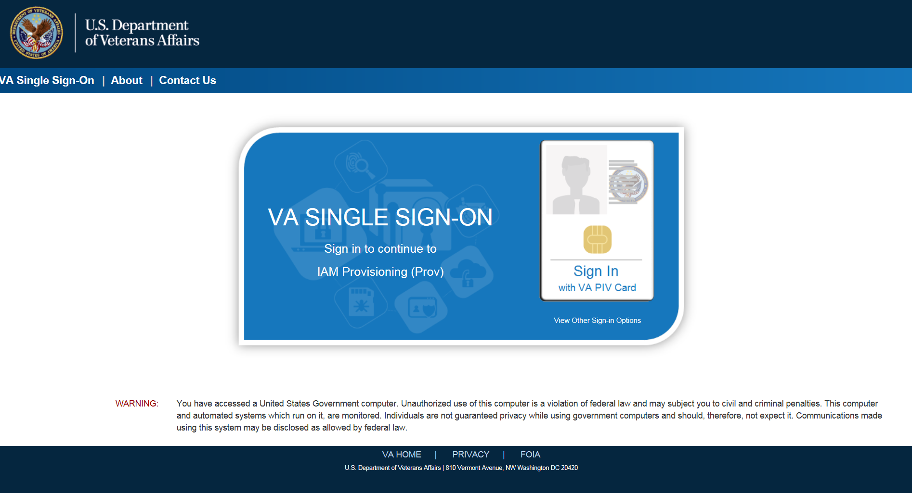
Figure 3-1: SSOi Login Screen

Logging On
The VHIC application is built to accommodate a specific set of pre-established user roles. During the provisioning process, the VHIC user will have a role assigned to them, which will determine what aspects of the VHIC application are available to them. The roles are listed below. For more information on the areas of access that accompanies each role, please refer to VHIC Roles and Access document.

System Menu
Depending on the VHIC users’ role, they will be presented different Home screens upon logging to the VHIC application.

VHIC Administrator and Technical Administrator Tier 3
The VHIC Administrator and VHIC Technical Administrator Tier 3 users will be presented with three menu options: Card Requests, Reports and Card Management. They can navigate to each of these application modules by either clicking on one of the links located in the header at the top left of the screen or by clicking on one of the icon buttons in the middle of the screen.
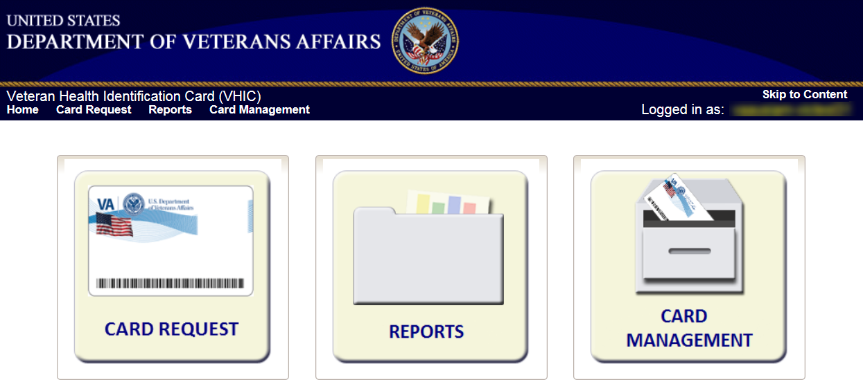
Figure 3-2: VHIC Administrator and VHIC Technical Administrator (Tier 3) Home screen

VHIC System Status Banner
The VHIC System will display a Status Banner at the top of the screen to notify users of reported issues with the system and/or during maintenance activities that do not require downtime.
REDACTED
Figure 3-3: VHIC System Status Banner

Changing User ID and Password
If you have any questions or need help with your User ID or your Password; call the Enterprise Service Desk at REDACATED and then select option 1 (Account or Password Reset), then option 1.

Before Requesting a VHIC Card
For detailed step-by-step process of how to access and complete the Identity Proofing Verification task in the Identity Management Toolkit application, please refer to section 4 in the Veteran Health Identification Card User Guide - Volume 1 - Card Requests – All Users document.

Creating a VHIC Card – The Card Request Process
For a step-by-step process on how to navigate through the Card Request screens in the VHIC application and an explanation of the process involved in creating a VHIC for a Veteran, please refer to section 5 in the Veteran Health Identification Card User Guide - Volume 1 - Card Requests – All Users document.

Requesting a VHIC for a Veteran Within Ten (10) Days of a Previous VHIC Request
VHIC Supervisors and VHIC Associates will not be able to request a new VHIC for a Veteran if there has been a previous request made within the past ten (10) days. They will be shown a message on Step 2 of the VHIC card request process stating:
“This Veteran has a recent VHIC request in process. Please remind the Veteran the VHIC should be received with 10 days after the request was submitted.”

REDACTED
Figure 5-1: Replacement Card has been requested within the past 10 days

If for some reason a new VHIC request must be made to include any changes, ONLY the VHIC Administrator will be able to submit a new card request within 10 days of the previous card request.
In this instance, the VHIC user will need to submit a request to the VHA HEC VHIC Program Team mail group via an encrypted message to deactivate the submitted card request. Once the VHIC user is notified that their card request has been deactivated, they can submit a new card request with the corrected information.
Information to include in the request is listed below:
- Veteran’s First and Last Name
- Member ID and/or Card Number
- Site Point of Contact
Reason for needing a new card requested within 10 days of the previous request.

NOTE: If the Member ID and/or Card Number are not available, provide the Date of Birth and SSN instead.

In virtually all cases, the VHIC user will be able to resubmit their card request with the corrected information. Otherwise, using the information provided in the request sent to the VHA HEC VHIC Program Team, The VHIC Administrator would be able to submit a new card request for the Veteran indicated. The card request will follow the same guidelines and steps as creating a Replacement Card Request that is covered in section 4.4 Replacement VHIC: Veteran Level 2 Proofed through Identity Management Toolkit of the Veteran Health Identification Card User Guide - Volume 1 - Card Requests – All Users document.

Card Management – The Card Deactivation Process
Table 3: Who can deactivate a card?
At a Glance…
Who can deactivate a card? | Administrator, Tech Admin (Tier 3)
This section will walk the VHIC Administrator through the process of deactivating all cards for a Veteran.
The card deactivation process follows numbered steps shown next.
- Enter Search Terms
- Select Veteran
- Select Deactivation Reason
- Confirm Deactivation Request
- Request a Replacement Card (when applicable)
- Verifying Card Deactivation
These steps are fully explained below. We will now walk through the steps required to complete a VHIC card deactivation request for each of the available deactivation reasons.
The following is a list of reasons that are available to the VHIC Administrator for deactivating cards.
- Cancelled/Declined
- Damaged
- Deceased
- Identity Theft
- Lost
- Other
- Stolen
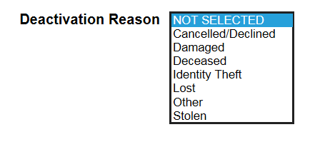
Figure 6-1: Card Deactivation Reasons drop-down menu

The VHIC Administrator will have the option to request a replacement card at the end of the card deactivation process in select instances.
The deactivation reasons that will allow the Administrator to request a new card are:
- Damaged
- Lost
- Stolen

Cancelled/Declined

Accessing Card Deactivation
When the VHIC Administrator logs in to the VHIC application, they are presented with three menu options: Card Request, Reports, and Card Management. The Administrator can click either on the links in the header at the top of the screen or on the icon buttons in the middle of the screen.
To begin the Card Deactivation process, the VHIC Administrator would click on either the Card Management link or the Card Management icon button.
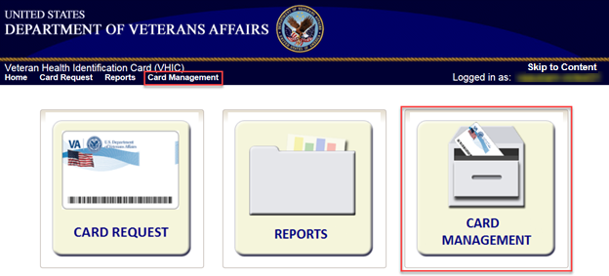
Figure 6-2: VHIC Administrator Home screen; click Card Management

Step 1: Enter Search Terms
The first step in the process is to find the Veteran in the system. This is accomplished by entering enough search criteria to trigger a match within Master Veteran Index (MVI). The top of the screen offers guidance regarding the set of traits recommended to ensure the best match is found. These are guidelines and not necessarily the required set of traits that must be entered.
However, for optimal search results, copy the Veteran’s ICN from Toolkit and paste it into the ICN field on this screen.
Other search methods include:
- The Member ID from the front of the Veteran’s VHIC
- Last Name, First Name, DOB and SSN
- Card ID
NOTES:
- If using LN/FN/DOB/SSN combination, at a minimum, supply the Veteran's Last Name, plus values from at least two of the other three sections (Person, Address, and Identification).
- Entering an Invalid ICN, Card ID, or Veteran ID will result in an error message and usage tip such as “ Invalid ICN. ICN must be 17 characters” More examples can be found in the Veteran Health Identification Card User Guide - Volume 2 – Reports.

The more traits entered, the more likely a match will be returned. Additional guidance is also available on-screen by clicking on the blue circle containing a question mark.
Figure 6-3: Help icon

This type of help is available throughout the application and will provide additional detail or clarification for that particular step or section.
Once the information has been entered into the required fields, click on [Search] to proceed to the next step.
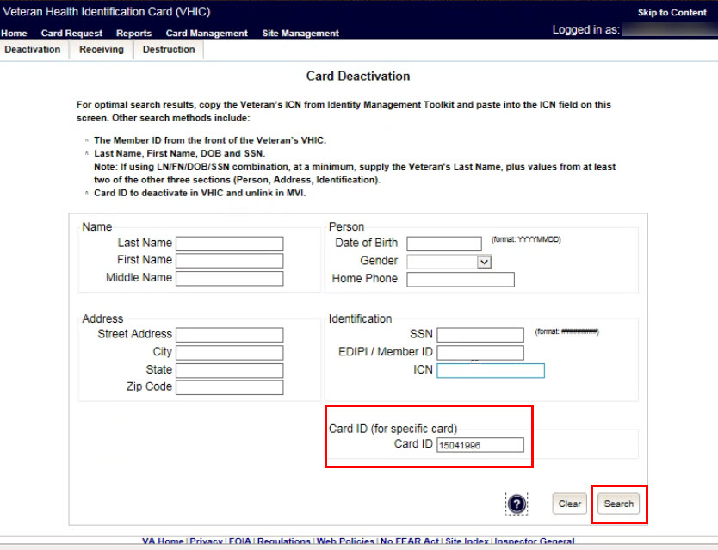
Figure 6-4: Card Management Deactivation Home screen. Enter Search Terms screen

Various error messages can be received throughout the Card Deactivation process. If the search yields no results, a message will be displayed above the search fields.
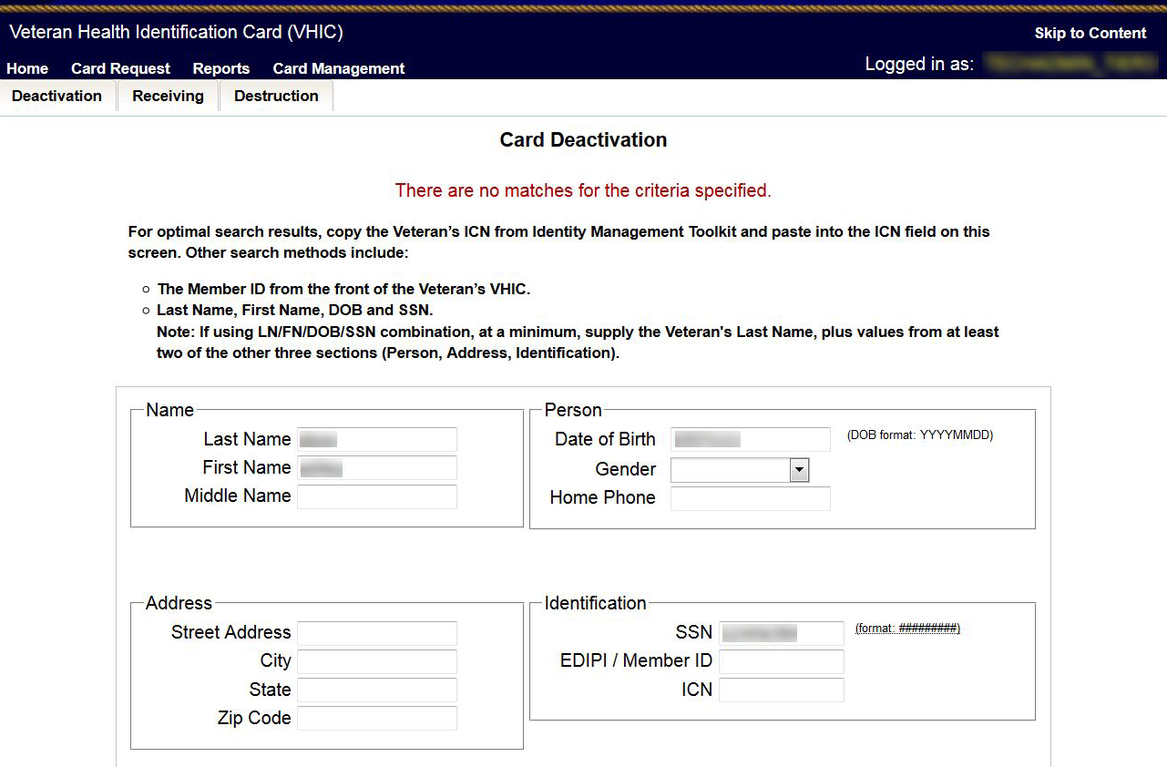
Figure 6-5: Enter Search Terms screen - No Match Found error

The user can then verify that the information entered is correct or make corrections as needed as well as add more information to increase the likelihood of finding a match.

Step 2: Select Veteran
If the search was successful and a possible match has been found, the results of that search will be displayed on screen. From the list provided (up to 10 matches may be returned), select the appropriate Veteran by clicking on the Veteran’s name which is hyperlinked.
If the correct Veteran is not in the list, click the [Back] button and verify the traits entered are correct. If the traits are correct, try adding additional information to aid in triggering a match.
REDACTED
Figure 6-6: Card Deactivation Select Veteran screen

Select Deactivation Reason
Once the Administrator has selected the correct Veteran, the next step in the process is to select the reason for deactivating all the VHIC cards for this Veteran. Choose from one of the several deactivation reasons VHIC provides.
Select the Cancelled/Declined reason for deactivating the VHIC cards for this Veteran from the drop-down menu.
Click on the [Deactivate] button to continue to the next step.
REDACTED
Figure 6-7: Select Deactivation Reason screen

Confirm Deactivation Request
The VHIC application will ask the user to confirm that they really want to deactivate all of the cards for this Veteran.
Click the [OK] button on the pop-up window to continue.
REDACTED
Figure 6-8: Confirm Deactivation pop-up window

This screen shows that the Card Deactivation was completed successfully.
The selected deactivation reason will be displayed on this screen.
Since Cancelled/Declined was the deactivation reason selected, the VHIC Admin is not presented with the option to request a new card for the Veteran.
REDACTED
Figure 6-9: All Cards Deactivated - Cancelled/Declined
When deactivating a single card as in Deactivation by Card ID, a [Replace Card] button will be appear in the bottom right corner. Clicking on the button will redirect the user to the Card Replacement process.
REDACTED
Figure 6-10: Card Deactivated Screen with Replace Card Option

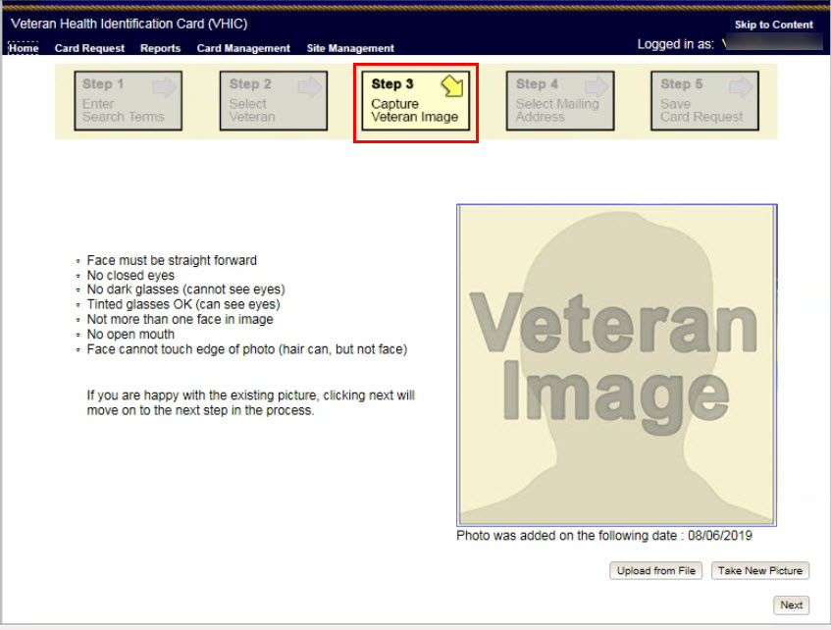
Figure 6-11: Card Replacement Button Selected

Verifying Card Deactivation
The VHIC Administrator can verify that all of the cards for that Veteran have been deactivated by looking at the Card History report. To see all of the cards for a Veteran, search by using the Veteran’s Person ID, which was displayed on the last step of the card deactivation process.
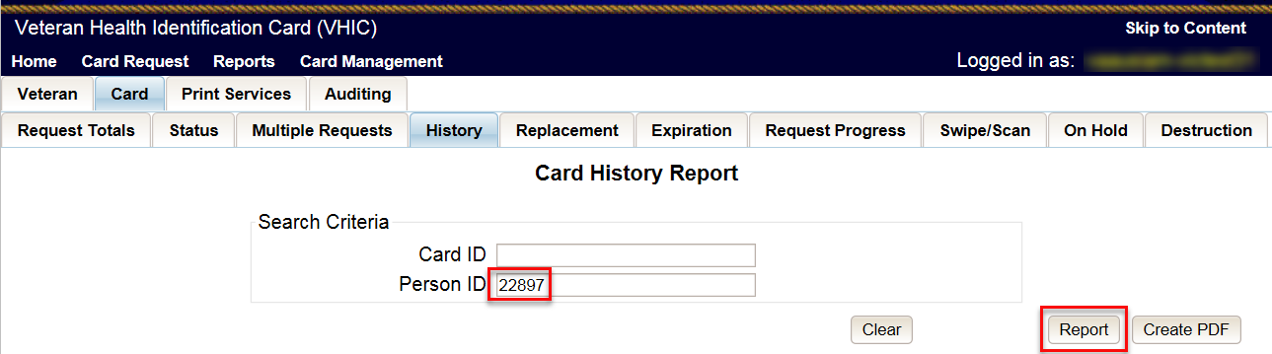
Figure 6-12: Card History Report Query Screen

When looking at the Card History report, the user will see that the Current Card Status has been updated to Deactivated and the Current MVI Status has been updated to Unlinked.
The user will also see the messages for Deactivated and MVI Correlation Unlinked in the Message history section.
The Deactivation Reason field will also be populated with the deactivation reason that was selected during the card deactivation process.
REDACTED
Figure 6-13: Card History Report - Cancelled/Declined

Saving a Card Request On-Hold to Retain Picture (For Cancelled/Declined enrollment only)
The next step in this process is to create a card request and manually save it On-Hold in order to be able to retain the Veteran’s picture in MVI.
On Step 1 of the Card request process, Enter the Veteran’s ICN that was copied from the Card Deactivation Confirmation screen and click the [Search] button.
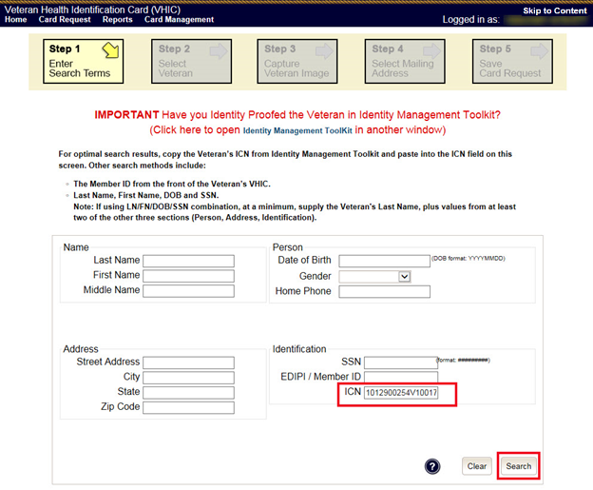
Figure 6-14: Step 1: Enter Search Terms

Select the Veteran you wish to create the card request for by clicking on the Veteran’s Name.
REDACTED
Figure 6-15: Step 2: Select Veteran

Click the [Next] button to reuse the existing photo.
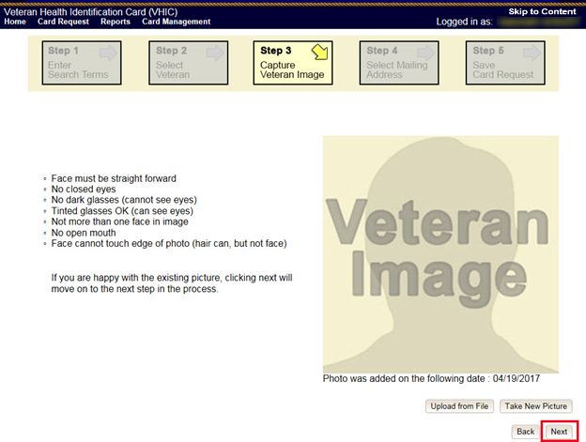
Figure 6-16: Step 3: Capture Veteran Image - Reuse Photo, Click Next button

Confirm that you want to use the existing photo by clicking on the [OK] button.
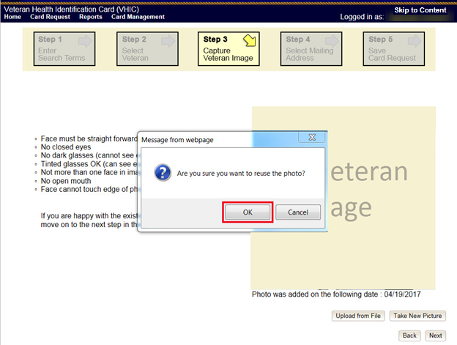
Figure 6-17: Step 3: Confirm Reuse of Photo by clicking the OK button

On the Step 4: Select Mailing Address screen, select “Incorrect Information” from the drop-down menu for Replacement Reason, and “Other” from the drop-down menu that appears for Incorrect Information. Click the [Next] button to continue.
REDACTED
Figure 6-18: Step 4: Select Mailing Address - Replacement Reason: Incorrect Information - Other

On the Step 5: Save Card Request screen, click on the checkbox next to Bad Data and enter “Retain Picture” in the Details text box. Click on the [Hold] button to save the card request.
REDACTED
Figure 6-19: Step 5: Save Card Request - Select Bad Data - Details: Retain Picture

Confirm that the card request has been saved on hold by noting the color bar has gone from yellow to orange, and that the Reason for Hold is displayed as “Bad Data: Retain Picture.”
REDACTED
Figure 6-20: Step 5: Save Card Request - Saved on Hold - Reason for Hold - Bad Data: Retain Picture

The VHIC Administrator can verify that the card just requested for that Veteran has been saved on hold with the Bad Data: Retain Picture hold reason by looking at the Card History report. To see the card history for this card, search by using the Card ID that was displayed on the last step of the card request process.
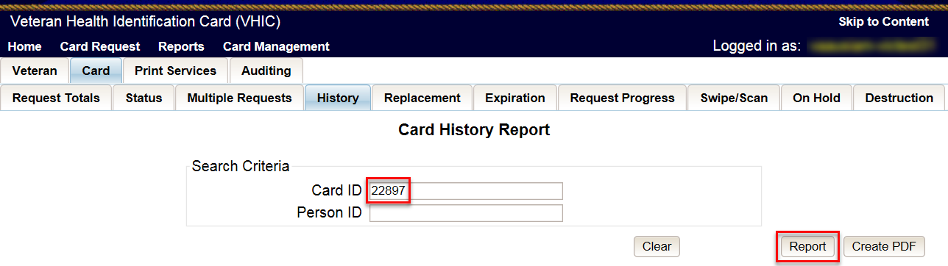
Figure 6-21: Card History Report Query Screen

When looking at the Card History report, the user will see that the Current Card Status has been updated to On Hold and the Current MVI Status has been updated to Active.
The user will also see the Replacement Reason field is now showing “Incorrect Information- Other” and the Hold Reason is listed as “Bad Data – Retain Picture” in the Message history section.
REDACTED
Figure 6-22: Card History Report - Hold Reason: Bad Data - Retain Picture

Damaged

Accessing Card Deactivation
When the VHIC Administrator logs in to the VHIC application, they are presented with three menu options: Card Request, Reports, and Card Management. The Administrator can click either on the links in the header at the top of the screen or on the icon buttons in the middle of the screen.
To begin the Card Management process, the VHIC Administrator would click on either the Card Management link or the Card Management icon button.
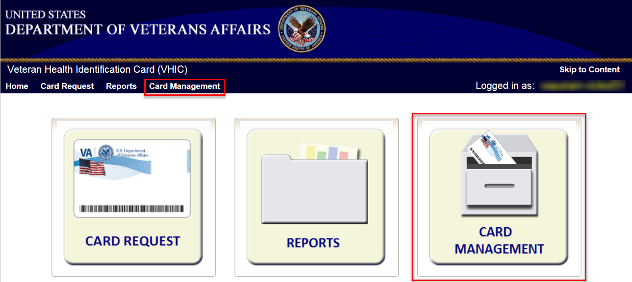
Figure 6-23: VHIC Administrator Home screen; click Card Management

Step 1: Enter Search Terms
The first step in the process is to find the Veteran in the system. This is accomplished by entering enough search criteria to trigger a match within Master Veteran Index (MVI). The top of the screen offers guidance regarding the set of traits recommended to ensure the best match is found. These are guidelines and not necessarily the required set of traits that must be entered.
However, for optimal search results, copy the Veteran’s ICN from Toolkit and paste it into the ICN field on this screen.
Other search methods include:
- The Member ID from the front of the Veteran’s VHIC
- Last Name, First Name, DOB and SSN

NOTE: If using LN/FN/DOB/SSN combination, at a minimum, supply the Veteran's Last Name, plus values from at least two of the other three sections (Person, Address, and Identification).

The more traits entered, the more likely a match will be returned. Additional guidance is also available on-screen by clicking on the blue circle containing a question mark.
Figure 6-24: Help icon

This type of help is available throughout the application and will provide additional detail or clarification for that particular step or section.
Once the information has been entered into the required fields, click on [Search] to proceed to the next step.

REDACTED
Figure 6-25: Card Deactivation Enter Search Terms screen

Step 2: Select Veteran
If the search was successful and a possible match has been found, the results of that search will be displayed on screen. From the list provided (up to 10 matches may be returned), select the appropriate Veteran by clicking on the Veteran’s name which is hyperlinked.
If the correct Veteran is not in the list, click the [Back] button and verify the traits entered are correct. If the traits are correct, try adding additional information to aid in triggering a match.
REDACTED
Figure 6-26: Card Deactivation Select Veteran screen

Select Deactivation Reason
Once the Administrator has selected the correct Veteran, the next step in the process is to select the reason for deactivating all the VHIC cards for this Veteran. Choose from one of the several deactivation reasons VHIC provides.
Select Damaged as the reason for deactivating the VHIC cards for this Veteran from the drop-down menu.
Click on the [Deactivate] button to continue to the next step.
REDACTED
Figure 6-27: Select Deactivation Reason screen

Confirm Deactivation Request
The VHIC application will ask the user to confirm that they really want to deactivate all of the cards for this Veteran.
Click the [OK] button on the pop-up window to continue.
REDACTED
Figure 6-28: Confirm Deactivation pop-up window

This screen shows that the Card Deactivation was completed successfully.
The selected deactivation reason will be displayed on this screen.
REDACTED
Figure 6-29: All Cards Deactivated – Damaged

Request a Replacement Card
The VHIC Administrator will have the option to request a replacement card at the end of the card deactivation process in select instances. Since Damaged was the deactivation reason selected, the VHIC Admin is presented with the option to request a new card for the Veteran.
To request a replacement card, click the [Replace a Card] button.
REDACTED
Figure 6-30: Replace Card

This will take the user to Step 3: Capture Veteran Image of the card request process.
Click [Next] to reuse the existing photo for this Veteran. Then complete the card request process following the current procedures.
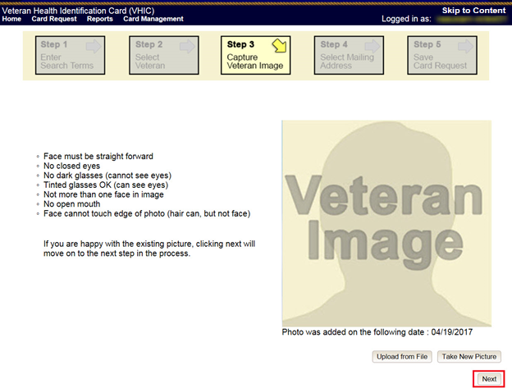
Figure 6-31: Step 3 Capture Veteran Image screen

Verifying Card Deactivation
The VHIC Administrator can verify that all of the cards for that Veteran have been deactivated by looking at the Card History report. To see all of the cards for a Veteran, search by using the Veteran’s Person ID, which was displayed on the last step of the card deactivation process.
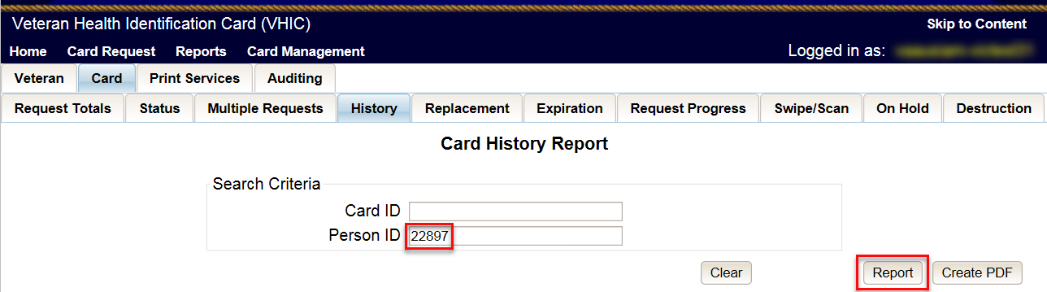
Figure 6-32: Card History Report Query Screen

When looking at the Card History report, the user will see that the Current Card Status has been updated to Deactivated and the Current MVI Status has been updated to Unlinked.
The user will also see the messages for Deactivated and MVI Correlation Unlinked in the Message history section.
The Deactivation Reason field will also be populated with the deactivation reason that was selected during the card deactivation process.
REDACTED
Figure 6-33: Card History Report – Damaged

Deceased

Accessing Card Deactivation
When the VHIC Administrator logs in to the VHIC application, they are presented with three menu options: Card Request, Reports, and Card Management. The Administrator can click either on the links in the header at the top of the screen or on the icon buttons in the middle of the screen.
To begin the Card Management process, the VHIC Administrator would click on either the Card Management link or the Card Management icon button.
Figure 6-34: VHIC Administrator Home screen; click Card Management

Step 1: Enter Search Terms
The first step in the process is to find the Veteran in the system. This is accomplished by entering enough search criteria to trigger a match within Master Veteran Index (MVI). The top of the screen offers guidance regarding the set of traits recommended to ensure the best match is found. These are guidelines and not necessarily the required set of traits that must be entered.

However, for optimal search results, copy the Veteran’s ICN from Toolkit and paste it into the ICN field on this screen.

Other search methods include:
- The Member ID from the front of the Veteran’s VHIC
- Last Name, First Name, DOB and SSN

NOTE: If using LN/FN/DOB/SSN combination, at a minimum, supply the Veteran's Last Name, plus values from at least two of the other three sections (Person, Address, and Identification).

The more traits entered, the more likely a match will be returned. Additional guidance is also available on-screen by clicking on the blue circle containing a question mark.
Figure 6-35: Help icon

This type of help is available throughout the application and will provide additional detail or clarification for that particular step or section.
Once the information has been entered into the required fields, click on [Search] to proceed to the next step.
REDACTED
Figure 6-36: Card Deactivation Enter Search Terms screen

Step 2: Select Veteran
If the search was successful and a possible match has been found, the results of that search will be displayed on screen. From the list provided (up to 10 matches may be returned), select the appropriate Veteran by clicking on the Veteran’s name which is hyperlinked.
If the correct Veteran is not in the list, click the [Back] button and verify the traits entered are correct. If the traits are correct, try adding additional information to aid in triggering a match.
REDACTED
Figure 6-37: Card Deactivation Select Veteran screen

Select Deactivation Reason
Once the Administrator has selected the correct Veteran, the next step in the process is to select the reason for deactivating all the VHIC cards for this Veteran. Choose from one of the several deactivation reasons VHIC provides.
Select the Deceased as the reason for deactivating the VHIC cards for this Veteran from the drop-down menu.
Click on the [Deactivate] button to continue to the next step.
REDACTED
Figure 6-38: Select Deactivation Reason screen

Confirm Deactivation Request
The VHIC application will ask the user to confirm that they really want to deactivate all of the cards for this Veteran.
Click the [OK] button on the pop-up window to continue.
REDACTED

Figure 6-39: Confirm Deactivation pop-up window

This screen shows that the Card Deactivation was completed successfully.
The selected deactivation reason will be displayed on this screen.
Since Deceased was the deactivation reason selected, the VHIC Admin is not presented with the option to request a new card for the Veteran.
REDACTED

Figure 6-40: All Cards Deactivated – Deceased

Verifying Card Deactivation
The VHIC Administrator can verify that all of the cards for that Veteran have been deactivated by looking at the Card History report. To see all of the cards for a Veteran, search by using the Veteran’s Person ID, which was displayed on the last step of the card deactivation process.
Figure 6-41: Card History Report Query Screen

When looking at the Card History report, the user will see that the Current Card Status has been updated to Deactivated and the Current MVI Status has been updated to Unlinked.
The user will also see the messages for Deactivated and MVI Correlation Unlinked in the Message history section.
The Deactivation Reason field will also be populated with the deactivation reason that was selected during the card deactivation process.
REDACTED

Figure 6-42: Card History Report - Deceased

Identity Theft

Accessing Card Management
When the VHIC Administrator logs in to the VHIC application, they are presented with three menu options: Card Request, Reports, and Card Management. The Administrator can click either on the links in the header at the top of the screen or on the icon buttons in the middle of the screen.
To begin the Card Deactivation process, the VHIC Administrator would click on either the Card Management link or the Card Management icon button.
Figure 6-43: VHIC Administrator Home screen; click Card Management

Step 1: Enter Search Terms
The first step in the process is to find the Veteran in the system. This is accomplished by entering enough search criteria to trigger a match within Master Veteran Index (MVI). The top of the screen offers guidance regarding the set of traits recommended to ensure the best match is found. These are guidelines and not necessarily the required set of traits that must be entered.
However, for optimal search results, copy the Veteran’s ICN from Toolkit and paste it into the ICN field on this screen.
Other search methods include:
- The Member ID from the front of the Veteran’s VHIC
- Last Name, First Name, DOB and SSN

NOTE: If using LN/FN/DOB/SSN combination, at a minimum, supply the Veteran's Last Name, plus values from at least two of the other three sections (Person, Address, and Identification).

The more traits entered, the more likely a match will be returned. Additional guidance is also available on-screen by clicking on the blue circle containing a question mark.
Figure 6-44: Help icon

This type of help is available throughout the application and will provide additional detail or clarification for that particular step or section.
Once the information has been entered into the required fields, click on [Search] to proceed to the next step.
REDACTED
Figure 6-45: Card Management Enter Search Terms screen

Step 2: Select Veteran
If the search was successful and a possible match has been found, the results of that search will be displayed on screen. From the list provided (up to 10 matches may be returned), select the appropriate Veteran by clicking on the Veteran’s name which is hyperlinked.
If the correct Veteran is not in the list, click the [Back] button and verify the traits entered are correct. If the traits are correct, try adding additional information to aid in triggering a match.
REDACTED
Figure 6-46: Card Deactivation Select Veteran screen

Select Deactivation Reason
Once the Administrator has selected the correct Veteran, the next step in the process is to select the reason for deactivating all the VHIC cards for this Veteran. Choose from one of the several deactivation reasons VHIC provides.
Select the Identity Theft as the reason for deactivating the VHIC cards for this Veteran from the drop-down menu.
Click on the [Deactivate] button to continue to the next step.
REDACTED
Figure 6-47: Select Deactivation Reason screen

Confirm Deactivation Request
The VHIC application will ask the user to confirm that they really want to deactivate all of the cards for this Veteran.
Click the [OK] button on the pop-up window to continue.
REDACTED
Figure 6-48: Confirm Deactivation pop-up window

This screen shows that the Card Deactivation was completed successfully.
The selected deactivation reason will be displayed on this screen.
Since Identity Theft was the deactivation reason selected, the VHIC Admin is not presented with the option to request a new card for the Veteran.
REDACTED

Figure 6-49: All Cards Deactivated - Identity Theft

Verifying Card Deactiation
The VHIC Administrator can verify that all of the cards for that Veteran have been deactivated by looking at the Card History report. To see all of the cards for a Veteran, search by using the Veteran’s Person ID, which was displayed on the last step of the card deactivation process.
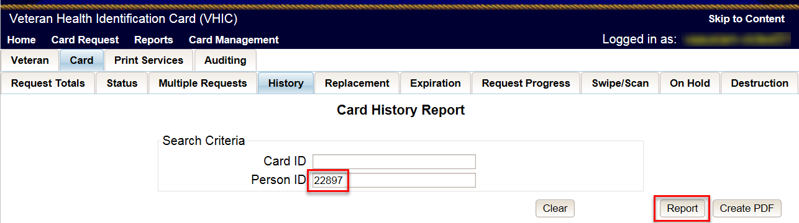
Figure 6-50: Card History Report Query Screen

When looking at the Card History report, the user will see that the Current Card Status has been updated to Deactivated and the Current MVI Status has been updated to Unlinked.
The user will also see the messages for Deactivated and MVI Correlation Unlinked in the Message history section.
The Deactivation Reason field will also be populated with the deactivation reason that was selected during the card deactivation process.
REDACTED
Figure 6-51: Identity Theft

Lost

Accessing Card Deactivation
When the VHIC Administrator logs in to the VHIC application, they are presented with three menu options: Card Request, Reports, and Card Management. The Administrator can click either on the links in the header at the top of the screen or on the icon buttons in the middle of the screen.
To begin the Card Management process, the VHIC Administrator would click on either the Card Management link or the Card Management icon button.
Figure 6-52: VHIC Administrator Home screen; click Card Management

Step 1: Enter Search Terms
The first step in the process is to find the Veteran in the system. This is accomplished by entering enough search criteria to trigger a match within Master Veteran Index (MVI). The top of the screen offers guidance regarding the set of traits recommended to ensure the best match is found. These are guidelines and not necessarily the required set of traits that must be entered.
However, for optimal search results, copy the Veteran’s ICN from Toolkit and paste it into the ICN field on this screen.
Other search methods include:
- The Member ID from the front of the Veteran’s VHIC
- Last Name, First Name, DOB and SSN

NOTE: If using LN/FN/DOB/SSN combination, at a minimum, supply the Veteran's Last Name, plus values from at least two of the other three sections (Person, Address, and Identification).

The more traits entered, the more likely a match will be returned. Additional guidance is also available on-screen by clicking on the blue circle containing a question mark.
Figure 6-53: Help icon

This type of help is available throughout the application and will provide additional detail or clarification for that particular step or section.
Once the information has been entered into the required fields, click on [Search] to proceed to the next step.

Figure 6-54: Card Deactivation Enter Search Terms screen

REDACTED

Step 2: Select Veteran
If the search was successful and a possible match has been found, the results of that search will be displayed on screen. From the list provided (up to 10 matches may be returned), select the appropriate Veteran by clicking on the Veteran’s name which is hyperlinked.
If the correct Veteran is not in the list, click the [Back] button and verify the traits entered are correct. If the traits are correct, try adding additional information to aid in triggering a match.
REDACTED

Figure 6-55: Card Deactivation Select Veteran screen

Select Deactivation Reason
Once the Administrator has selected the correct Veteran, the next step in the process is to select the reason for deactivating all the VHIC cards for this Veteran. Choose from one of the several deactivation reasons VHIC provides.
Select the Lost as the reason for deactivating the VHIC cards for this Veteran from the drop-down menu.
Click on the [Deactivate] button to continue to the next step.
REDACTED

Figure 6-56: Select Deactivation Reason screen

Confirm Deactivation Request
The VHIC application will ask the user to confirm that they really want to deactivate all of the cards for this Veteran.
Click the [OK] button on the pop-up window to continue.
REDACTED

Figure 6-57: Confirm Deactivation pop-up window

This screen shows that the Card Deactivation was completed successfully.
The selected deactivation reason will be displayed on this screen.
REDACTED

Figure 6-58: All Cards Deactivated – Lost

Request a Replacement Card
The VHIC Administrator will have the option to request a replacement card at the end of the Card Management process in select instances. Since Lost was the deactivation reason selected, the VHIC Admin is presented with the option to request a new card for the Veteran.
To request a replacement card, click the [Replace a Card] button.
REDACTED

Figure 6-59: Replace Card

This will take the user to Step 3: Capture Veteran Image of the card request process.
Click [Next] to reuse the existing photo for this Veteran. Then complete the card request process following the current procedures.
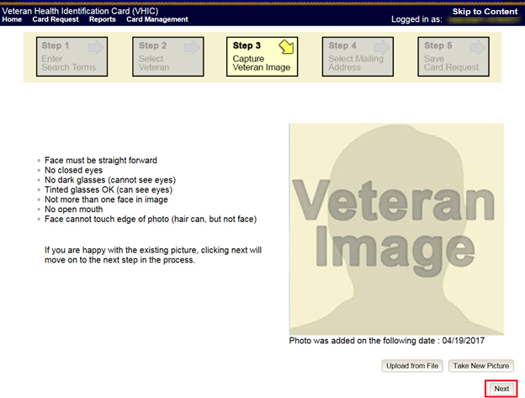
Figure 6-60: Step 3 Capture Veteran Image screen

Verifying Card Deactivation
The VHIC Administrator can verify that all of the cards for that Veteran have been deactivated by looking at the Card History report. To see all of the cards for a Veteran, search by using the Veteran’s Person ID, which was displayed on the last step of the card deactivation process.
Figure 6-61: Card History Report Query Screen

When looking at the Card History report, the user will see that the Current Card Status has been updated to Deactivated and the Current MVI Status has been updated to Unlinked.
The user will also see the messages for Deactivated and MVI Correlation Unlinked in the Message history section.
The Deactivation Reason field will also be populated with the deactivation reason that was selected during the card deactivation process.
REDACTED
Figure 6-62: Card History Report - Lost

Other

Accessing Card Deactivation
When the VHIC Administrator logs in to the VHIC application, they are presented with three menu options: Card Request, Reports, and Card Management. The Administrator can click either on the links in the header at the top of the screen or on the icon buttons in the middle of the screen.
To begin the Card Management process, the VHIC Administrator would click on either the Card Management link or the Card Management icon button.
Figure 6-63: VHIC Administrator Home screen; click Card Management

Step 1: Enter Search Terms
The first step in the process is to find the Veteran in the system. This is accomplished by entering enough search criteria to trigger a match within Master Veteran Index (MVI). The top of the screen offers guidance regarding the set of traits recommended to ensure the best match is found. These are guidelines and not necessarily the required set of traits that must be entered.
However, for optimal search results, copy the Veteran’s ICN from Toolkit and paste it into the ICN field on this screen.
Other search methods include:
- The Member ID from the front of the Veteran’s VHIC
- Last Name, First Name, DOB and SSN

NOTE: If using LN/FN/DOB/SSN combination, at a minimum, supply the Veteran's Last Name, plus values from at least two of the other three sections (Person, Address, and Identification).

The more traits entered, the more likely a match will be returned. Additional guidance is also available on-screen by clicking on the blue circle containing a question mark.
Figure 6-64: Help icon

This type of help is available throughout the application and will provide additional detail or clarification for that particular step or section.
Once the information has been entered into the required fields, click on [Search] to proceed to the next step.
REDACTED
Figure 6-65: Card Deactivation Enter Search Terms screen

Step 2: Select Veteran
If the search was successful and a possible match has been found, the results of that search will be displayed on screen. From the list provided (up to 10 matches may be returned), select the appropriate Veteran by clicking on the Veteran’s name which is hyperlinked.
If the correct Veteran is not in the list, click the [Back] button and verify the traits entered are correct. If the traits are correct, try adding additional information to aid in triggering a match.
REDACTED

Figure 6-66: Card Deactivation Select Veteran screen

Select Deactivation Reason
Once the Administrator has selected the correct Veteran, the next step in the process is to select the reason for deactivating all the VHIC cards for this Veteran. Choose from one of the several deactivation reasons VHIC provides.
Select Other as the reason for deactivating the VHIC cards for this Veteran from the drop-down menu and enter the details as to why the cards for this Veteran need deactivated using up to 50 characters.
Click on the [Deactivate] button to continue to the next step.
REDACTED
Figure 6-67: Select Deactivation Reason screen

Confirm Deactivation Request
The VHIC application will ask the user to confirm that they really want to deactivate all of the cards for this Veteran.
Click the [OK] button on the pop-up window to continue.
REDACTED

Figure 6-68: Confirm Deactivation pop-up window

This screen shows that the Card Deactivation was completed successfully.
The selected deactivation reason will be displayed on this screen.
Since Other was the deactivation reason selected, the VHIC Admin is not presented with the option to request a new card for the Veteran.
REDACTED

Figure 6-69: All Cards Deactivated – Other

Verifying Card Deactivation
The VHIC Administrator can verify that all of the cards for that Veteran have been deactivated by looking at the Card History report. To see all of the cards for a Veteran, search by using the Veteran’s Person ID, which was displayed on the last step of the card deactivation process.
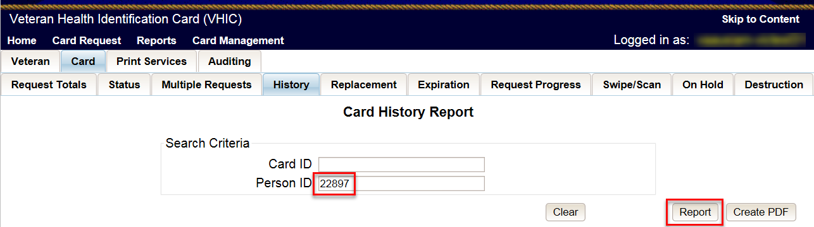
Figure 6-70: Card History Report Query Screen

When looking at the Card History report, the user will see that the Current Card Status has been updated to Deactivated and the Current MVI Status has been updated to Unlinked.
The user will also see the messages for Deactivated and MVI Correlation Unlinked in the Message history section.
The Deactivation Reason field will also be populated with the deactivation reason that was selected during the card deactivation process.
REDACTED
Figure 6-71: Card History Report - Other

Stolen

Accessing Card Deactivation
When the VHIC Administrator logs in to the VHIC application, they are presented with three menu options: Card Request, Reports, and Card Management. The Administrator can click either on the links in the header at the top of the screen or on the icon buttons in the middle of the screen.
To begin the Card Management process, the VHIC Administrator would click on either the Card Management link or the Card Management icon button.
Figure 6-72: VHIC Administrator Home screen; click Card Deactivation

Step 1: Enter Search Terms
The first step in the process is to find the Veteran in the system. This is accomplished by entering enough search criteria to trigger a match within Master Veteran Index (MVI). The top of the screen offers guidance regarding the set of traits recommended to ensure the best match is found. These are guidelines and not necessarily the required set of traits that must be entered.
However, for optimal search results, copy the Veteran’s ICN from Toolkit and paste it into the ICN field on this screen.
Other search methods include:
- The Member ID from the front of the Veteran’s VHIC
- Last Name, First Name, DOB and SSN

NOTE: If using LN/FN/DOB/SSN combination, at a minimum, supply the Veteran's Last Name, plus values from at least two of the other three sections (Person, Address, and Identification).

The more traits entered, the more likely a match will be returned. Additional guidance is also available on-screen by clicking on the blue circle containing a question mark.
Figure 6-73: Help icon

This type of help is available throughout the application and will provide additional detail or clarification for that particular step or section.
Once the information has been entered into the required fields, click on [Search] to proceed to the next step.
REDACTED

Figure 6-74: Card Deactivation Enter Search Terms screen

Step 2: Select Veteran
If the search was successful and a possible match has been found, the results of that search will be displayed on screen. From the list provided (up to 10 matches may be returned), select the appropriate Veteran by clicking on the Veteran’s name which is hyperlinked.
If the correct Veteran is not in the list, click the [Back] button and verify the traits entered are correct. If the traits are correct, try adding additional information to aid in triggering a match.
REDACTED
Figure 6-75: Card Deactivation Select Veteran screen

Select Deactivation Reason
Once the Administrator has selected the correct Veteran, the next step in the process is to select the reason for deactivating all the VHIC cards for this Veteran. Choose from one of the several deactivation reasons VHIC provides.
Select Stolen as the reason for deactivating the VHIC cards for this Veteran from the drop-down menu.
Click on the [Deactivate] button to continue to the next step.
REDACTED
Figure 6-76: Select Deactivation Reason screen

Confirm Deactivation Request
The VHIC application will ask the user to confirm that they really want to deactivate all of the cards for this Veteran.
Click the [OK] button on the pop-up window to continue.
REDACTED
Figure 6-77: Confirm Deactivation pop-up window

This screen shows that the Card Management was completed successfully.
The selected deactivation reason will be displayed on this screen.
REDACTED
Figure 6-78: All Cards Deactivated - Stolen

Request a Replacement Card
The VHIC Administrator will have the option to request a replacement card at the end of the card deactivation process in select instances. Since Stolen was the deactivation reason selected, the VHIC Admin is presented with the option to request a new card for the Veteran.
To request a replacement card, click the [Replace a Card] button.
REDACTED

Figure 6-79: Replace Card

This will take the user to Step 3: Capture Veteran Image of the card request process.
Click [Next] to reuse the existing photo for this Veteran. Then complete the card request process following the current procedures.

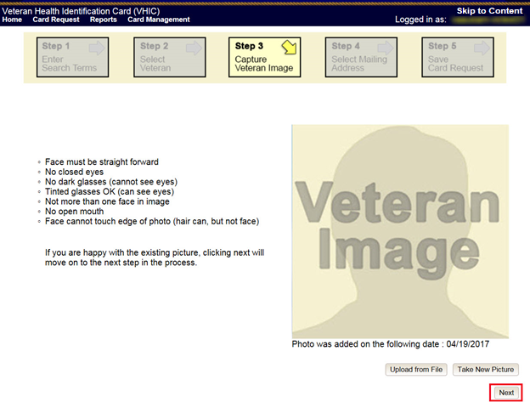
Figure 6-80: Step 3 Capture Veteran Image screen

Verifying Card Deactivation
The VHIC Administrator can verify that all of the cards for that Veteran have been deactivated by looking at the Card History report. To see all of the cards for a Veteran, search by using the Veteran’s Person ID, which was displayed on the last step of the card deactivation process.
Figure 6-81: Card History Report Query Screen

When looking at the Card History report, the user will see that the Current Card Status has been updated to Deactivated and the Current MVI Status has been updated to Unlinked.
The user will also see the messages for Deactivated and MVI Correlation Unlinked in the Message history section.
The Deactivation Reason field will also be populated with the deactivation reason that was selected during the card deactivation process.
REDACTED
Figure 6-82: Card History Report - Stolen

Card Receiving
Table 4: Who can receive a card?
At a Glance…
Who can receive a card? | Administrator, Tech Admin (Tier 3)
Per SOP, the proper disposal of undelivered Veteran Health Identification Cards (VHICs) , Veteran Identification Cards (VICs), Personal Identity Verification (PIV) cards, and other personal items that are returned to the Health Eligibility Center (HEC) require both receiving and destructions logs which will be maintained for six years from the date of document creation, or last effective date, whichever is later.
This section will walk the VHIC Administrator through the process of logging VHIC cards received at the HEC.

Cards Received

Accessing Cards Received Screen
When the VHIC Administrator logs in to the VHIC application, they are presented with three menu options: Card Request, Reports, and Card Management. The Administrator can click either on the links in the header at the top of the screen or on the icon buttons in the middle of the screen.
To begin the Card Management process, the VHIC Administrator would click on either the Card Management link or the Card Management icon button.

Figure 7-1: VHIC Administrator Home screen; click Card Management
The Card Management button will automatically take you to the Card Deactivation Tab. You will need to select Card Receiving by clicking on the Receiving Tab at the top of the page.
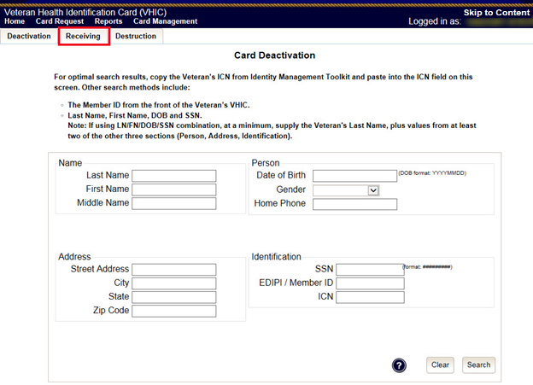
Figure 7-2: Select Card Receiving Tab

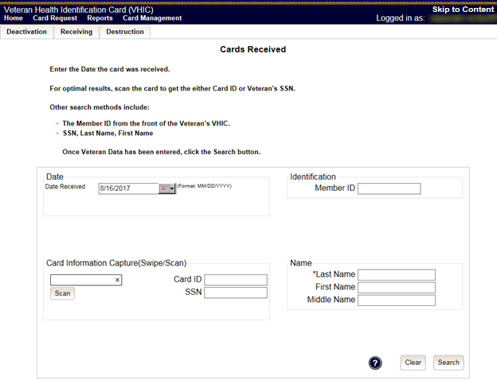
Figure 7-3: Card Received Screen

Step 1: Enter Search Terms
The first step in the process is to find the VHIC Card in the system. For optimal results, this is accomplished by scanning the barcode into the system. Once the barcode is captured, click the Scan button, and the Card ID will populate.
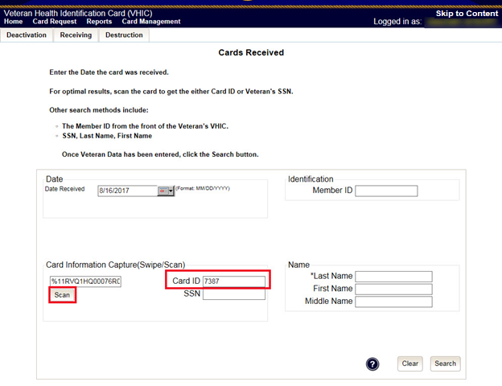
Figure 7-4: Card Scanned into system, Card ID populates

Other search methods include:
- The Member ID from the front of the Veteran’s VHIC
- Last Name, First Name, DOB and SSN

NOTE: If using LN/FN/DOB/SSN combination, at a minimum, supply the Veteran's Last Name, plus values from at least two of the other three sections (Person, Address, and Identification).

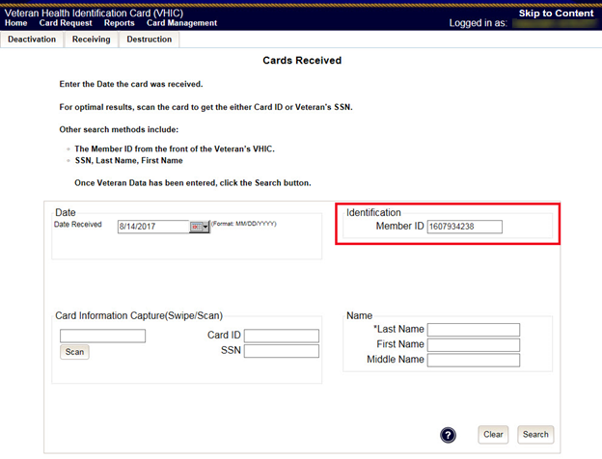
Figure 7-5: Search by Member ID
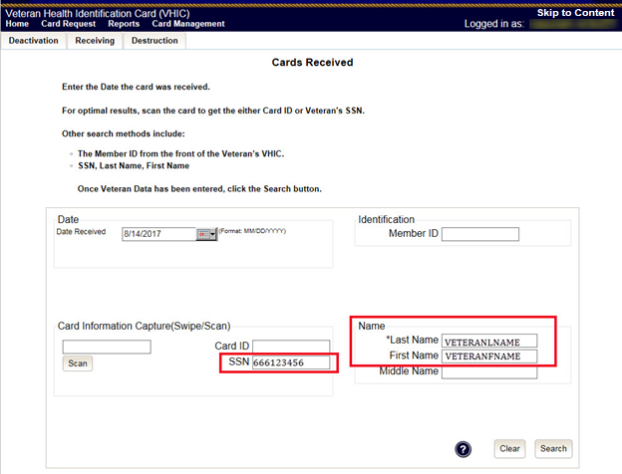
Figure 7-6: Search by Veteran Name/SSN

Additional guidance is also available on-screen by clicking on the blue circle containing a question mark.
Figure 7-7: Help icon

This type of help is available throughout the application and will provide additional detail or clarification for that particular step or section.
Once the information has been entered into the required fields, click on [Search] to proceed to the next step.

Step 2: Card Verification
After search is completed, the system will display the details of the VHIC card scanned. Verify that all information displayed is correct prior to clicking submit.
REDACTED

Figure 7-8: VHIC Card details displayed

Submitting the card information will update the status of the VHIC card and log it into the system as having been received.
REDACTED

Figure 7-9: Card status updated - Pending Destruction

Selecting the Swipe/Scan Another button at the bottom of the screen will bring you back to the Receiving search page.
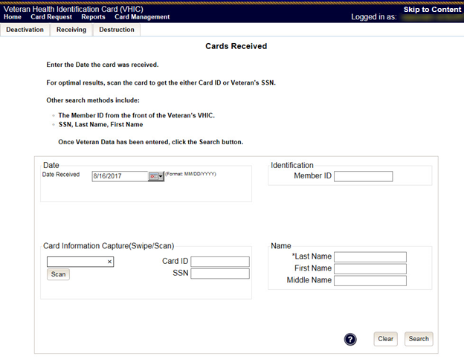
Figure 7-10: Receiving Search Page

Card Destruction
Table 5. Who can destroy a card?
At a Glance…
Who can destroy a card? | Administrator, Tech Admin (Tier 3)
Per SOP, the proper disposal of undelivered Veteran Health Identification Cards (VHICs) , Veteran Identification Cards (VICs), Personal Identity Verification (PIV) cards, and other personal items that are returned to the Health Eligibility Center (HEC) require both receiving and destructions logs which will be maintained for six years from the date of document creation, or last effective date, whichever is later.
This section will walk the VHIC Administrator through the process of destroying VHIC cards received at the HEC. The system will track all VHIC cards received and destroyed, and the logs can be viewed by running the appropriate reports.

Card Destruction

Accessing Card Destruction Screen
When the VHIC Administrator logs in to the VHIC application, they are presented with three menu options: Card Request, Reports, and Card Management. The Administrator can click either on the links in the header at the top of the screen or on the icon buttons in the middle of the screen.
To begin the Card Management process, the VHIC Administrator would click on either the Card Management link or the Card Management icon button.
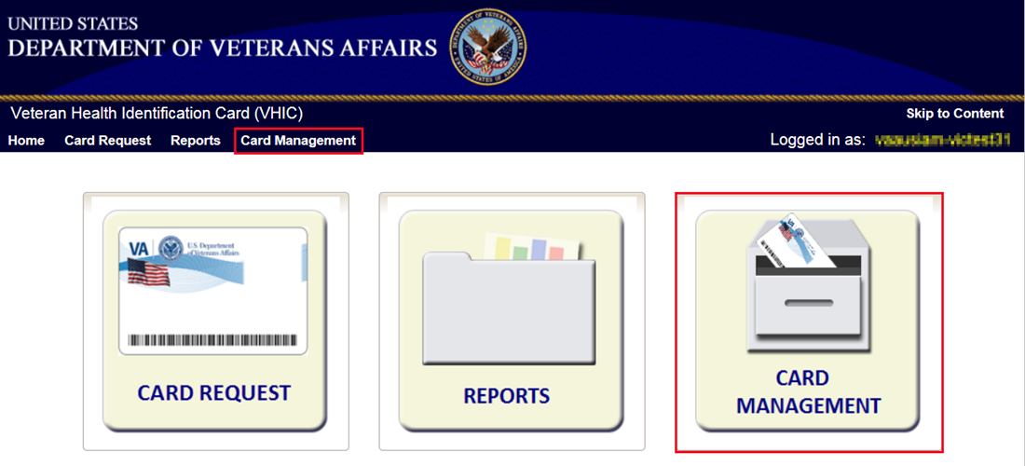
Figure 8-1: VHIC Administrator Home screen; click Card Management

The Card Management button will automatically take you to the Card Deactivation Tab. You will need to select Card Destruction by clicking on the Destruction Tab at the top of the page.
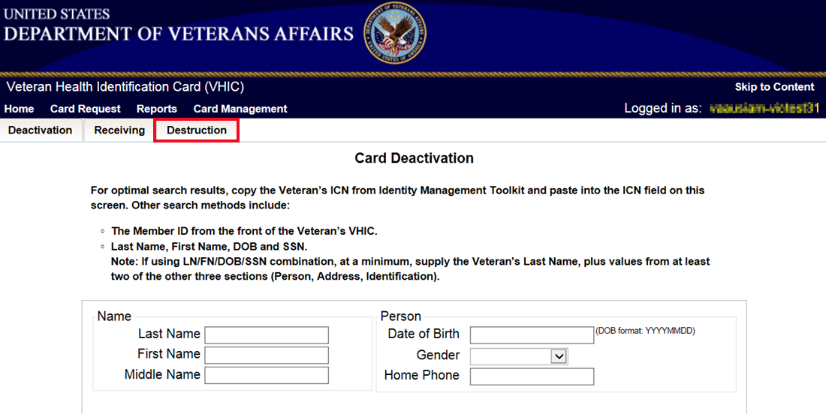
Figure 8-2: Select Card Destruction Tab

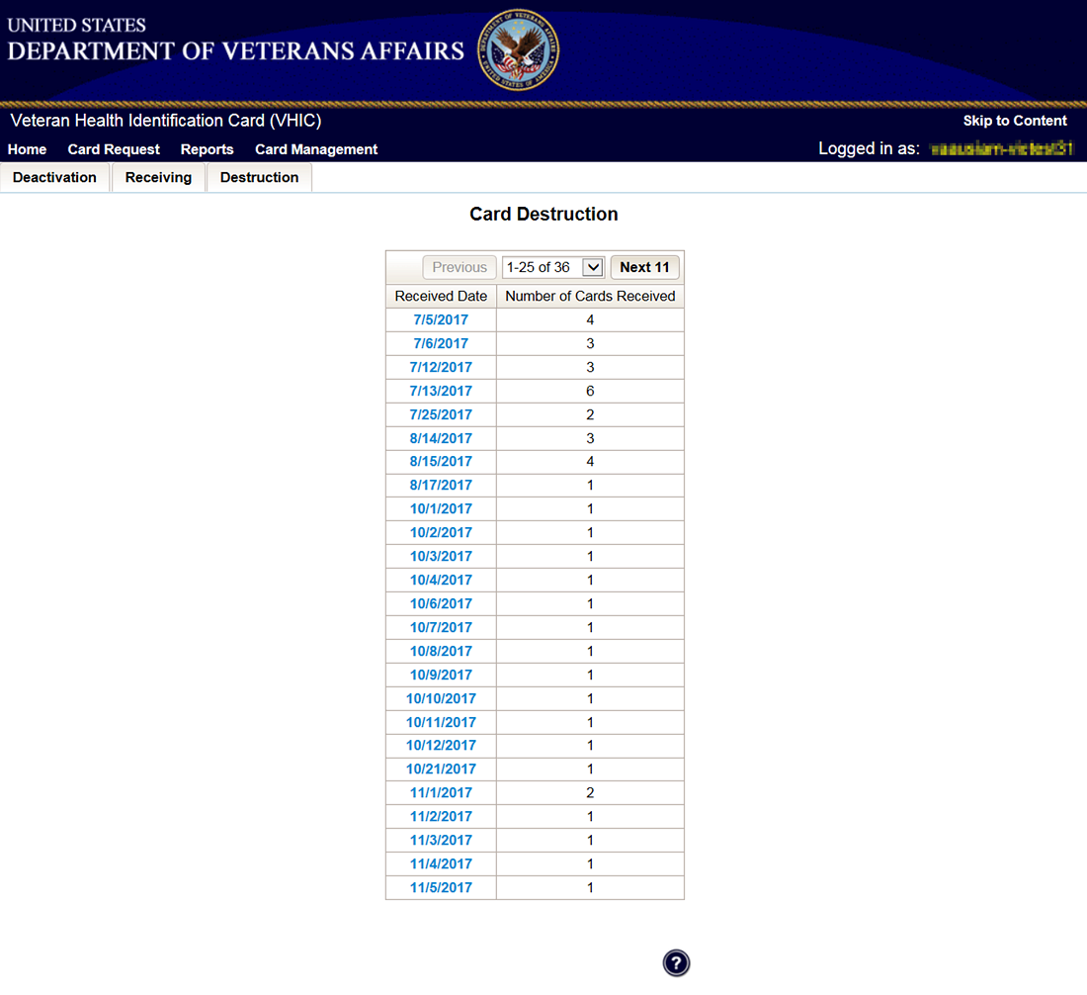
Figure 8-3: Card Destruction Screen

Step 1: Select Cards for Destruction
The Card Destruction screen shows a table of cards received, logged, and ready for destruction. The table indicates the Received Date and Number of Cards Received, allowing for batch destruction as needed. NOTE: To view details of cards received, you will need to run the Card Destruction Report see Veteran Health Identification Card User Guide - Volume 2 – Reports. Select cards for destruction by clicking on the appropriate link found under Received Date.
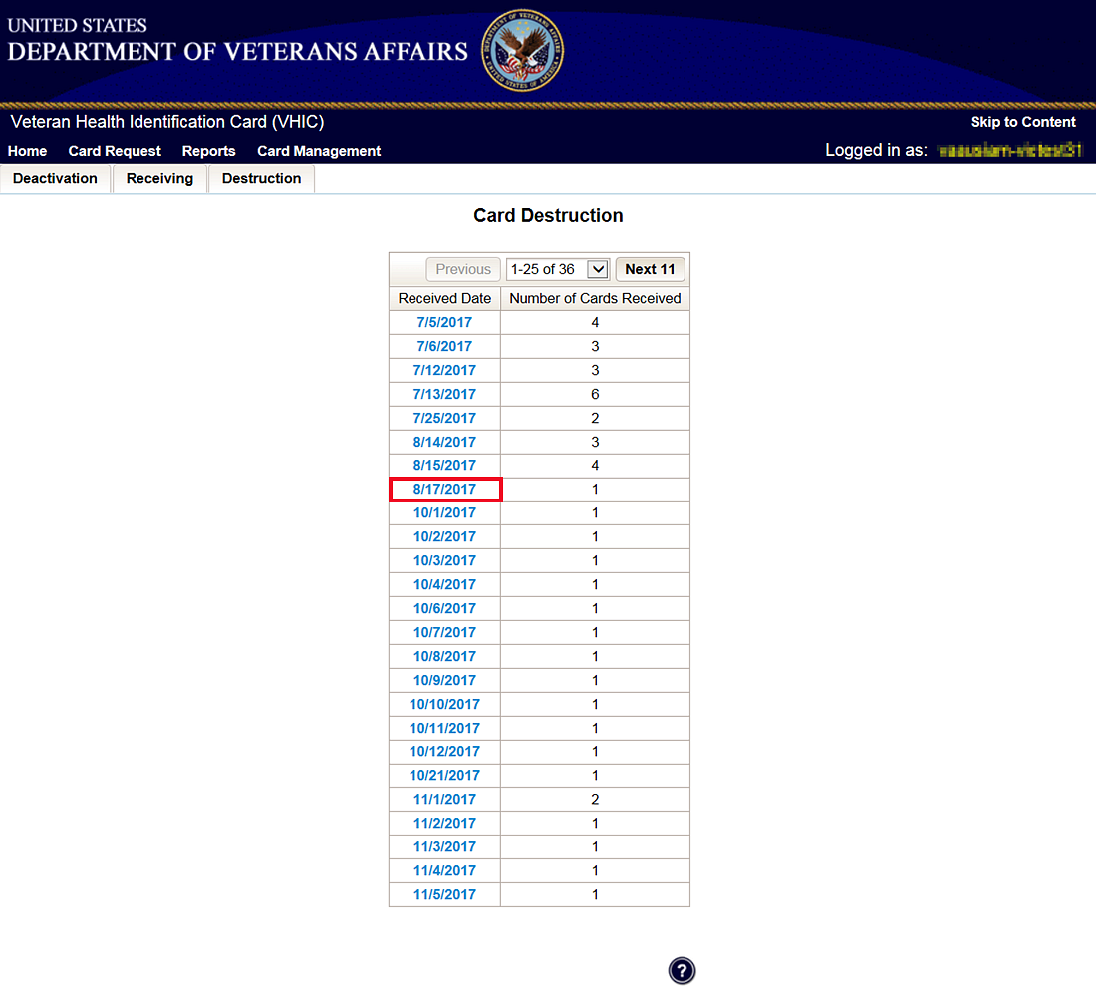
Figure 8-4: Select Cards by Received Date for Destruction

Select Date of Destruction
Once the Received Date has been selected, you will be directed to a new screen for entering the date of destruction. The Date Destroyed will be populated with the current date by default. To provide a different date, you may enter it manually, or select it from the calendar dropdown. You will then click the Submit button.
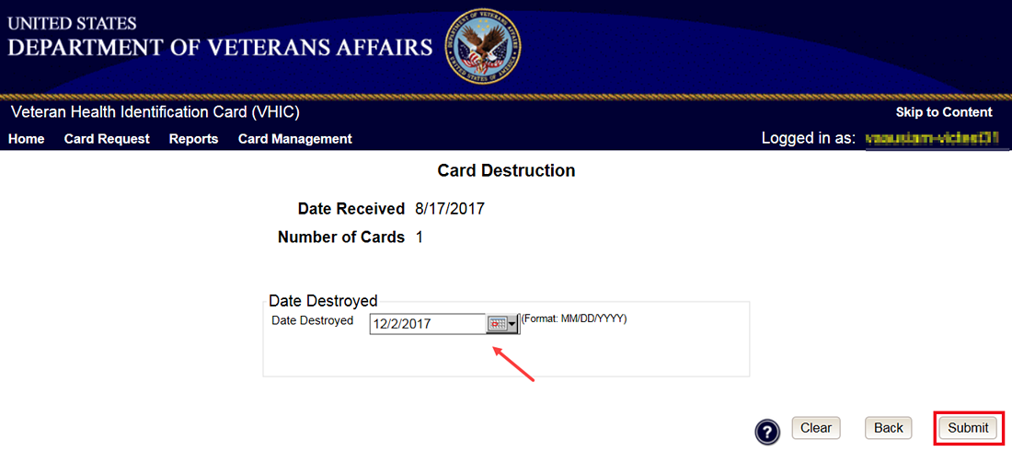
Figure 8-5: Select Date of Destruction

After Clicking submit, a pop-up message will appear to confirm destruction of the selected cards.
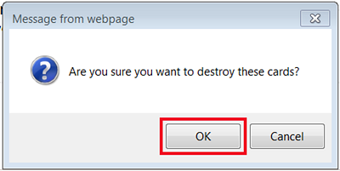
Figure 8-6: Card Destruction Confirmation Message

Card Destruction Status Displayed
Submitting the Card Destruction Date will update the status of the VHIC card(s) and log it into the system as having been destroyed. You will have the options of either exiting the Status Screen or clicking the Destroy Another button to return to the main Card Destruction screen.
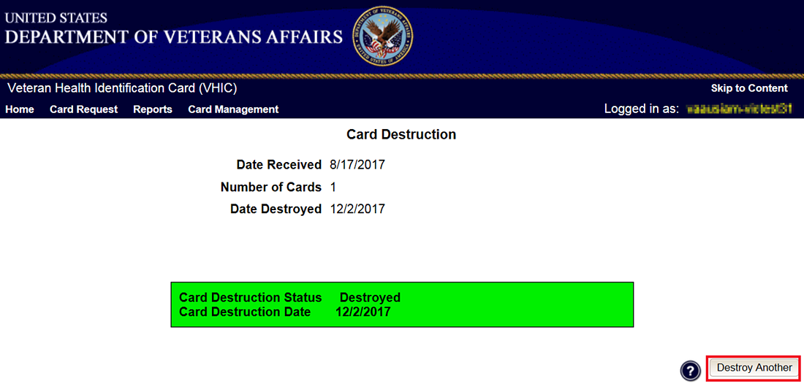
Figure 8-7: Card Destruction Status

Reports
A comprehensive walkthrough of all of the different reports that are available to VHIC users and the types of metrics that can be obtained, as well as an explanation of the user role permissions for accessing the reports are included in the Veteran Health Identification Card User Guide - Volume 2 - Reports document.

Troubleshooting
For a through set of troubleshooting guidelines, please refer to the Veteran Health Identification Card User Guide - Volume 4 - Troubleshooting document.

