Veteran Health Identification Card (VHIC 4.20)

User Guide
Volume 2 - Reports

April 2022

Department of Veterans Affairs
Office of Information and Technology (OIT)

Revision History
NOTE: The revision history cycle begins once changes or enhancements are requested after the document has been baselined.
Date | Revision | Description | Author
4/18/2022 | 9 | Updated to reflect VIP 20 Changes | REDACTED
09/18/2021 | 8.1 | No functional changes, screenshots updated | REDACTED
06/20/21 | 8 | Updated to reflect changes during VIP 17 | REDACTED
03/20/21 | 7.1 | No functionality changes for VIP 16 updated date and version number | REDACTED
12/19/2020 | 7 | Updated to reflect VIP 15 changes | REDACTED
06/20/2020 | 6 | Updated to reflect changes to the functionality during VIP 13 | REDACTED
02/15/2020 | 5 | Updated to reflect changes in application during VIP 12 release | REDACTED
11/01/2019 | 4 | Updated to reflect the changes in application for VIP 10- Validation for ICN input fields on all search screens and usage tips, default search date updated, no records found message updated, report formats updated | REDACTED
09/03/2019 | 3 | Updated to reflect changes to VHIC Application (4.9) VIP 1 | REDACTED
03/18/19 | 2.2 | Updated to reflect changes to Swipe/Scan Reporting | REDACTED
01/22/2018 | 2.1 | Accepted all changes as approved on anomaly logs, re-paginated document, re-ran TOCs, and created Section 508 compliant PDF for uploading, with Word document, to RTC Jazz Tools as well as SharePoint. | REDACTED
01/19/2018 | 2.1 | Re-paginated document. Readied document for creating Section 508 compliant PDF. | REDACTED
01/02/2018 | 2.1 | Applied changes from first anomaly log dated 010418 as well as some additional internal anomalies identified by the VHIC Product Development Team. | REDACTED
12/22/2017 | 2.1 | Updated Section 2.3 Proper Navigation of the VHIC Application with “Skip to Content” information. Updated document images to include “Skip to Content” link where necessary. Added new Section entitled “Card Destruction.” Updated Section 8.4 Auditing Report to include new functionality. Revised images where necessary to show the “Destruction” tab under the “Card” tab. Updated Appendix entitled “VHIC Roles.” | REDACTED
08/14/2017 | 2.0 | Checked Alt text for all images and figures. Added Alt text to figures without it. Removed extra figure number from Figure 7-82 caption entitled, “On Hold Status Report query screen – Supervisor.” Re-ran TOCs and fixed content/figure pagination issues in the Word document. Document converted to Section 508 compliant PDF as part of VHIC 4.8. Updated document name to match VA naming conventions by replacing spaces in Word document name with underscores. | REDACTED
08/01/2017 | 2.0 | Updated to reflect changes for VHIC 4.8 | REDACTED
08/15/2016 | 1.6 | Completed technical writer review of document. Ran Spelling and Grammar, added Alt text to all images, and re-ran TOCs. Created a footer and page numbering for document. Changed cover date from “August 2016” to match footer date of “September 2016” to match other Volumes. | REDACTED
08/04/2016 | 1.6 | Updated content | REDACTED
01/06/2015 | 1.5 | Updated content and Images | REDACTED
07/07/2015 | 1.4 | Updated content and Images | REDACTED
07/07/2015 | 1.3 | Rebuilt to capture content overhaul to VHIC System and divided this guide into three separate parts | REDACTED
05/20/2015 | 1.2 | Updated Content and Images to reflect the Maintenance Releases | REDACTED
1/13/2015 | 1.1 | Updated content and Images | REDACTED
9/18/2014 | 1.0 | Rebuilt to capture content overhaul to VHIC System | REDACTED

Table of Contents

1. Introduction 1
1.1. Purpose 1
1.2. Document Orientation 1
1.2.1. Organization of the Manual 1
1.2.2. Assumptions 2
1.2.3. Disclaimers 2
1.2.3.1. Software Disclaimer 2
1.2.3.2. Documentation Disclaimer 3
1.2.4. Documentation Conventions 3
1.3. Enterprise Service Desk and Organizational Contacts 3
2. Accessing the VHIC Application 4
2.1. Browser 4
2.1.1. Browser Incompatibility Issue 4
2.2. Proper Navigation of the VHIC Application 5
2.3. Roles within VHIC 6
3. Getting Started 6
3.1. Single Sign-On Internal (SSOi) 6
3.2. Logging On 7
3.3. System Menu 7
3.3.1. VHIC Administrator and Technical Administrator Tier 3 7
3.3.2. VHIC Associate and Supervisor 8
3.3.3. VHIC Auditor and Read-Only User 9
3.4. VHIC System Status Banner 9
3.5. Changing User ID and Password 10
4. Before Requesting a VHIC Card 10
5. Creating a VHIC Card – The Card Request Process 10
6. Deactivating Cards – The Card Management Process 10
7. VHIC Reporting 11
7.1. Veteran (Direct Search) Report 15
7.2. Card Request Totals Report 22
7.3. Card Status Report 28
7.3.1. MVI (Master Veteran Index) Status Option 30
7.3.2. Card Status Option 36
7.3.3. Print Release Status Option 40
7.4. Multiple Card Requests Report 45
7.5. Card History Report 51
7.6. Card Replacement Report 59
7.7. Card Expiration Report 66
7.8. Card Request Progress Report 71
7.9. Card Swipe/Scan Report 77
7.10. Card On Hold Report 80
7.11. Card Destruction Report 88
7.12. Print Services – Processing Report 97
7.13. Print Services – Batch Error Report 102
7.13.1. Sent Not Acknowledged 104
7.13.2. Acknowledged Not Confirmed 109
7.13.3. Pending Not Sent 113
7.14. Auditing Report 117
7.15. Card Requests Report 119
7.16. No Edipi Report 124
7.17. Self-Service Card Request Reports 128
7.17.1. Self Service Activity Report 128
7.17.2. Self Service Audit Log 133
7.17.3. Self Service Manual Review Activity Report 136
8. Troubleshooting 138

Table of Figures
Figure 2-1: VHIC Navigation Buttons 5
Figure 2-2: VHIC Administrator and VHIC Technical Administrator (Tier 3) menu 5
Figure 2-3: VHIC Associate and VHIC Supervisor menu 5
Figure 2-4: VHIC Auditor and VHIC Read-Only User menu 5
Figure 3-1: SSOi Login Screen 7
Figure 3-2: VHIC Administrator and VHIC Technical Administrator (Tier 3) Home screen 8
Figure 3-3: VHIC Associate and VHIC Supervisor Home screen 8
Figure 3-4: VHIC Auditor and VHIC Read-Only User Home screen 9
Figure 3-5: VHIC System Status Banner 10
Figure 7-1: Report Tabular Structure for the Administrator, Technical Administrator Tier 3, and the Auditor 12
Figure 7-2: Report Tabular Structure for the Supervisor 13
Figure 7-3: Report Tabular Structure for the Associate 14
Figure 7-4: Report Tabular Structure for the Read-Only user 15
Figure 7-5: Veteran Report Query Fields – Administrator, Tech Admin (Tier 3), Auditor and Supervisor 16
Figure 7-6: Veteran Report Query Fields – Associate 16
Figure 7-7: Veteran Report Query Fields – Read-Only User 17
Figure 7-8: Veteran Report Search Results 17
Figure 7-9: Card ID Error Message 18
Figure 7-10: VHIC Veteran Detail Report 19
Figure 7-11: VHIC Card History by Card ID 20
Figure 7-12: VHIC Card History by Person ID 21
Figure 7-13: Card Request Totals Report query screen – Administrators and Tech Admin (Tier 3) 22
Figure 7-14: Card Request Totals Report query screen – Auditor 23
Figure 7-15: Card Request Totals Report query screen – Supervisor 23
Figure 7-16: Card Request Totals Report query screen – Associate 24
Figure 7-17: Card Request Totals Report query screen – Read-Only User 24
Figure 7-18: VHIC Card Request National Report 25
Figure 7-19: VHIC Card Request Totals report – VISN 26
Figure 7-20: VHIC Card Request Totals report – Facility 27
Figure 7-21: Card Status Report query screen – Administrator and Tech Admin (Tier 3) 28
Figure 7-22: Card Status Report query screen – Auditor 29
Figure 7-23: Card Status Report query screen – Supervisor 29
Figure 7-24: Card Status Report query screen – Associate 30
Figure 7-25: Card Status Report query screen with MVI Status drop-down options displayed 31
Figure 7-26: VHIC MVI Status National Summary Report – Active 32
Figure 7-27: VHIC MVI Status VISN Summary Report – Active 33
Figure 7-28: VHIC MVI Status Facility Summary Report – Active 34
Figure 7-29: VHIC MVI Status Facility Detail Report – Active 35
Figure 7-30: Card Status Report query screen with Card Status drop-down menu options displayed 36
Figure 7-31: VHIC Card Status National Summary Report – Requested 37
Figure 7-32: VHIC Card Status VISN Summary Report – Requested 38
Figure 7-33: VHIC Card Status Facility Summary Report – Requested 39
Figure 7-34: VHIC Card Status Facility Detail Report – Requested 40
Figure 7-35: Card Status Report query screen with Print Release Status drop-down menu options displayed 41
Figure 7-36: VHIC Print Status National Summary Report – Mailed 42
Figure 7-37: VHIC Print Release Status Summary Report - VISN – Mailed 43
Figure 7-38: VHIC Print Release Status Summary Report - Facility – Mailed 43
Figure 7-39: VHIC Print Status Detail Report - Facility – Mailed 44
Figure 7-40: Multiple Card Requests Report query screen – Administrator and Tech Admin (Tier 3) 45
Figure 7-41: Multiple Card Requests Report query screen – Auditor 46
Figure 7-42: Multiple Card Requests Report query screen – Supervisors 46
Figure 7-43: Multiple Card Requests Report query screen – Associate 47
Figure 7-44: VHIC National Summary Report for Number of Cards Requested 48
Figure 7-45: VHIC VISN Summary Report for Number of Cards Requested 49
Figure 7-46: VHIC Facility Summary Report for Number of Cards Requested 50
Figure 7-47: VHIC Facility Detail Report for Number of Cards Requested 51
Figure 7-48: Card History Report query screen – Administrators, Tech Administrator (Tier 3), and Auditors 52
Figure 7-49: Card History Report query screen – Supervisor 52
Figure 7-50: Card History Report query screen – Associate 52
Figure 7-51: Card History Report query screen – Read-Only User 53
Figure 7-52: VHIC Card History by Card ID Report 55
Figure 7-53: Card History by Person ID Report 57
Figure 7-54: Card History Report Status History 59
Figure 7-55: VHIC Card Replacement Report query screen – Administrators and Tech Administrators (Tier 3) 60
Figure 7-56: VHIC Card Replacement Report query screen – Auditors 60
Figure 7-57: Card Replacement Report query screen – Supervisors 61
Figure 7-58: VHIC Card Replacement Report query screen – Associates 61
Figure 7-59: VHIC Card Replacement Summary Report – National 62
Figure 7-60: VHIC Card Replacement Facility Report – Summary 63
Figure 7-61: No Matching Data Message 64
Figure 7-62: VHIC Card Replacement Facility Sub Reason Report – Summary 64
Figure 7-63: VHIC Card Replacement Facility Sub Reason Detail report 65
Figure 7-64: Card Expiration Report query screen – Administrators and Tech Administrators (Tier 3) 66
Figure 7-65: Card Expiration Report query screen – Auditors 67
Figure 7-66: Card Expiration Report query screen – Supervisors 67
Figure 7-67: Card Expiration Report query screen – Associates 68
Figure 7-68: VHIC Card Expiration National Summary Report 68
Figure 7-69: VHIC Card Expiration VISN Summary Report 69
Figure 7-70: VHIC Card Expiration Facility Summary Report 70
Figure 7-71: VHIC Card Expiration Facility Detail Report 70
Figure 7-72: Card Request Progress Report query screen - Administrators and Tech Administrators (Tier 3) 72
Figure 7-73: Card Request Progress Report query screen – Auditors 72
Figure 7-74: Card Request Progress Report query screen – Supervisors 73
Figure 7-75: Card Request Progress Report query screen – Associates 73
Figure 7-76: VHIC Card Request Progress National Summary Report 74
Figure 7-77: VHIC Card Request Progress VISN Summary Report 75
Figure 7-78: VHIC Card Request Progress Facility Summary Report 76
Figure 7-79: VHIC Card Request Progress Facility Detail Report 77
Figure 7-80: VHIC Card Swipe/Scan Report query screen - Administrators, Tech Administrators (Tier 3), and Auditors 78
Figure 7-81: VHIC Swipe Scan Report results 78
Figure 7-82: Create Swipe Scan PDF 79
Figure 7-83: VHIC Swipe Scan Report results PDF 79
Figure 7-84: Card Swipe/Scan Report 80
Figure 7-85: On Hold Status Report query screen – Administrator and Tech Administrator (Tier 3) 81
Figure 7-86: On Hold Status Report query screen – Supervisor 81
Figure 7-87: On Hold Status Report query screen – Associate 82
Figure 7-88: VHIC On Hold Card Status National Summary Report 82
Figure 7-89: VHIC On Hold Card Status VISN Summary Report 83
Figure 7-90: VHIC On Hold Card Status Facility Summary Report 84
Figure 7-91: VHIC On Hold Card Status Facility Detail Report 85
Figure 7-92: VHIC Veteran Detail Report 86
Figure 7-93: VHIC Card History by Card ID 87
Figure 7-94: Card Destruction Report – Administrators and Tech Administrators (Tier 3) 88
Figure 7-95: Card Destruction Report – Auditors 89
Figure 7-96: Card Destruction Report – Pending Destruction – Last Name Hyperlink 89
Figure 7-97: Veteran Detail Report 90
Figure 7-98: Card Destruction Report – Pending Destruction – Last Name Hyperlink 91
Figure 7-99: VHIC Card History by Card ID Report 92
Figure 7-100: VHIC Card History by Card ID Report 93
Figure 7-101: Veteran Detail Report 94
Figure 7-102: VHIC Card Destruction Report - Destroyed - Card ID Hyperlink 95
Figure 7-103: VHIC Card History by Card ID Report 96
Figure 7-104: VHIC Print Services Processing Status Summary Report – Administrators and Tech Administrators (Tier 3) 98
Figure 7-105: VHIC Print Services Processing Status Summary Report – Auditors 98
Figure 7-106: VHIC Print Services Processing Status Summary Report – Supervisors 99
Figure 7-107: VHIC Print Services Processing Status Summary Report query screen – Associates 99
Figure 7-108: VHIC Print Services Processing Status Summary Report 100
Figure 7-109: VHIC Print Services Processing Status VISN Summary Report 100
Figure 7-110: VHIC Print Services Processing Status Facility Summary Report 101
Figure 7-111: VHIC Print Services Processing Status Facility Detail Report 101
Figure 7-112: Print Services – Print Error Status Report query screen – Administrators and Tech Administrators (Tier 3) 103
Figure 7-113: Print Services - Print Error Status Report query screen – Auditors 103
Figure 7-114: Print Services - Print Error Status Report query screen – Supervisors 104
Figure 7-115: VHIC Print Error Status Facility Summary Report – Sent Not Acknowledged 105
Figure 7-116: VHIC Print Error Status National Summary Report – Sent Not Acknowledged 106
Figure 7-117: VHIC Print Error Status VISN Summary Report – Sent Not Acknowledged 107
Figure 7-118: VHIC Print Error Status Facility Summary Report – Sent Not Acknowledged 108
Figure 7-119: VHIC Batch File Processing Error Status Detail Report - Not Acknowledged 109
Figure 7-120: VHIC Print Error Status Facility Detail Report – Acknowledged Not Confirmed 109
Figure 7-121: VHIC Print Error Status National Summary Report – Acknowledged Not Confirmed 110
Figure 7-122: VHIC Print Error Status VISN Summary Report – Acknowledged Not Confirmed 111
Figure 7-123: VHIC Print Error Status Facility Detail Report – Acknowledged Not Confirmed 112
Figure 7-124: VHIC Print Error Status Facility Detail Report – Acknowledged Not Confirmed 113
Figure 7-125: VHIC Print Error Status National Summary Report – Pending Not Sent 113
Figure 7-126: VHIC Print Error Status National Summary Report – Pending Not Sent 114
Figure 7-127: VHIC Print Error Status VISN Summary Report – Pending Not Sent 115
Figure 7-128: VHIC Batch File Processing Error Status Summary Report – Facility 116
Figure 7-129: VHIC Print Error Status Facility Detail Report – Pending Not Sent 117
Figure 7-130: Audit Report query screen – Administrators, Tech Administrators (Tier 3), and Auditors 117
Figure 7-131: Audit Report query screen – Supervisors 118
Figure 7-132: VHIC Auditing Report 118
Figure 7-133: Card Requests query screen – Administrators, Tech Administrators (Tier 3), and Auditors 119
Figure 7-134: Card Requests query screen – Supervisor 120
Figure 7-135: VHIC Card Requests by User Summary Report – National 120
Figure 7-136: VHIC Card Requests by User VISN Summary Report 121
Figure 7-137: VHIC Card Requests by User Facility Summary Report 121
Figure 7-138: VHIC Card Requests by User Detail Report – Last Name Hyperlink 122
Figure 7-139: Veteran Detail Report 122
Figure 7-140: VHIC Card Requests by User Detail Report – Card ID Hyperlink 122
Figure 7-141: VHIC Card History by Card ID Report 123
Figure 7-142: VHIC Cards Printed No Edipi Report Query Screen 124
Figure 7-143: VHIC Cards Printed No Edipi National Summary Report Results 125
Figure 7-144: VHIC Cards Printed No Edipi VISN Summary Report 126
Figure 7-145: VHIC Cards Printed No Edipi Facility Summary Report 127
Figure 7-146: VHIC Cards Printed No Edipi VISN Facility Detail Report 127
Figure 7-147: VHIC Card History by Card ID Report screen 128
Figure 7-148: VHIC Card History by Person ID Report screen 128
Figure 7-149. Self Service Activity Summary Report 129
Figure 7-150. VHIC Self Service Activity Summary Report 130
Figure 7-151. VHIC Self Service Activity Detail Report 131
Figure 7-152. VHIC Card History by Card ID Report 132
Figure 7-153. Self Service Audit Log Field Entry 133
Figure 7-154. Self Service Audit Log Results 134
Figure 7-155. Status Messages and HTTP Responses Highlighted 135
Figure 7-156. Self Service Audit Log No Match Message 135
Figure 7-157. VHIC Self Service Requests National Summary Report 136
Figure 7-158. VHIC Self Service Requests VISN Summary Report 137
Figure 7-159. Self Service Facility Summary Report 137
Figure 7-160. Self Service Facility Detail Report 138

Table of Tables
Table 1 Documentation Symbols and Descriptions 3
Table 2: Enterprise Service Desk Contact Information 4
Table 3: Veteran Report at a Glance 15
Table 4: Card Request Totals Report at a Glance 22
Table 5: Card Status Report at a Glance 28
Table 6: Multiple Request Report at a Glance 45
Table 7: Card History Report at a Glance 51
Table 8: Card Replacement Report at a Glance 59
Table 9: Card Expiration Report at a Glance 66
Table 10: Card Request Progress Report at a Glance 71
Table 11: Card Swipe/Scan Report at a Glance 77
Table 12: On Hold Status Report at a Glance 80
Table 13: Card Destruction Report at a Glance 88
Table 14: Batch Summary Report at a Glance 97
Table 15: Batch Error Report at a Glance 102
Table 16: Audit Report at a Glance 117
Table 17: Card Request Report at a Glance 119
Table 18. VHIC Cards Printed No Edipi Report at a Glance 124
Table 19. Self Service Activity Report at a Glance 128
Table 20. Self Service Audit Log at a Glance 133
Table 21. Self Service Manual Activity Report at a Glance 136

Introduction

Purpose
The purpose of this User Guide is to provide general system information, as well accessibility and user roles with the VHIC application. This User Guide will provide a detailed walkthrough of creating Veteran Health Identification Card requests using the VHIC application. This User Guide will also provide the detailed steps on how VHIC Administrators can deactivate all of the VHICs associated to a selected Veteran.

Document Orientation

Organization of the Manual
This User Guide is divided into eight sections to allow you to quickly obtain the information you need.

The first section will provide an overview of what a VHIC is and what the eligibility requirements are, and the various user roles and their accessibility within the VHIC application.

In order to be able to receive a VHIC, a Veteran must meet the following eligibility criteria:
- Be eligible for VA medical benefits
- Be enrolled in the VA Healthcare system
- Be Level 2 proofed at a VA medical facility
- Veteran identity must be recognized in the Master Veteran Index (MVI), which is managed by the Identity and Access Management (IAM) of the VA

NOTE: The level 2 proofing process is a method to verify the identity of Veterans. VA requires Veterans to provide approved identification documents to access Personal Identifiable Information (PII), Personal Health Information (PHI) and request a Veterans Health Identification Card (VHIC).

The second and third sections will walk the user through the steps needed to access the VHIC application, as well as some general guidelines on using the VHIC application.

The fourth section will give the user an overview of what they need to do before starting a card request for a Veteran. The VHIC user must verify the Veteran’s Identity Proofing Level is at Level 2 in the Identity Management Toolkit.

The fifth section explains the process involved with creating a VHIC for a Veteran.

The sixth section covers how to request card deactivation all of the VHICs for a specific Veteran.

The seventh section will provide information on the different reports available to VHIC Associates and the types of metrics that can be obtained. There are four tabs for each of the reports that can be generated:
- Veteran – direct report to search for a Veteran
- Card – includes Request Totals, Status, Multiple Requests, History, Replacement, Expiration, Request Progress, Swipe/Scan, and On Hold
- Print Services – includes Processing, No Member ID, and Error
- Auditing – provides information on all User’s activity in the system

Reports can be exported in PDF format, and there are a variety of search criteria available for each report.

The last section covers some troubleshooting issues and solutions that will help the VHIC user to be better able to support the Veteran and ensure that the VHIC requests are processed properly.

Assumptions
This guide was written with the following assumed experience/skills of the audience:
- User has basic knowledge of the operating system (such as the use of commands, menu options, and navigation tools).
- User has been provided the appropriate active roles, menus, and security keys required for the VHIC application.
- User is using Google Chrome or Microsoft Edge to do their job of either Creating VHIC Card Requests, Running Reports, or Deactivating VHICs depending on user roles.
- User has validated access to the VHIC application.
- User has completed any prerequisite training.

Disclaimers

Software Disclaimer
This software was developed at the Department of Veterans Affairs (VA) by employees of the Federal Government in the course of their official duties. Pursuant to title 17 Section 105 of the United States Code this software is not subject to copyright protection and is in the public domain. VA assumes no responsibility whatsoever for its use by other parties, and makes no guarantees, expressed or implied, about its quality, reliability, or any other characteristic. We would appreciate acknowledgement if the software is used. This software can be redistributed and/or modified freely provided that any derivative works bear some notice that they are derived from it, and any modified versions bear some notice that they have been modified.

Documentation Disclaimer
The appearance of external hyperlink references in this manual does not constitute endorsement by the Department of Veterans Affairs (VA) of this Web site or the information, products, or services contained therein. The VA does not exercise any editorial control over the information you may find at these locations. Such links are provided and are consistent with the stated purpose of the VA.

Documentation Conventions
This manual uses several methods to highlight different aspects of the material.
- Various symbols are used throughout the documentation to alert the reader to special information. The following table gives a description of each of these symbols:

Table 1 Documentation Symbols and Descriptions
Symbol | Description
 | NOTE: Used to inform the reader of general information including references to additional reading material

- Descriptive text is presented in a proportional font (as represented by this font).
- “Screenshots” of computer online displays (i.e., character-based screen captures/dialogs) and are shown in a non-proportional font and enclosed within a box. Also included are Graphical User Interface (GUI) Microsoft Windows images (i.e., dialogs or forms).
- User's responses to online prompts (e.g., manual entry, taps, clicks, etc.) will be [boldface] type and enclosed in brackets.

Enterprise Service Desk and Organizational Contacts
The support contact information documented herein are intended to restore normal service operation as quickly as possible and minimize the adverse impact on business operations, ensuring that the best possible levels of service quality and availability are maintained.

The following table lists the contact information needed by site users for troubleshooting purposes. Support contacts are listed by description of the incident escalation and contact information (phone number and options to select).

Table 2: Enterprise Service Desk Contact Information
Issue | Contact Info
For Provisioning Issues | Contact the Enterprise Service Desk at REDACTED, option 3 (Applications), then option 1.  When contacted by a support specialist, be ready to supply the employee’s full name, VA user ID and email address.
For Proofing Issues | Contact the Enterprise Service Desk at REDACTED, option 3 (Applications), then option 1.  When contacted by a support specialist, be ready to supply the Veterans' full name, full SSN, and DOB.
For All Other VHIC System Issues | Contact the Enterprise Service Desk at REDACTED, option 3 (Applications), then option 1. When contacted by a support specialist, be ready to supply the Veterans' full name, full SSN, and DOB.

Accessing the VHIC Application

Browser
VHIC is a web based application which users will access via a web browser. The recommended browser is Google Chrome or Microsoft Edge .
The VHIC URL is https://vic.iam.va.gov/VIC/faces/index.jsf and is case sensitive – it must be entered exactly as shown. After successfully logging in to the VHIC application, users should bookmark this site for easy access in the future. Instructions on how to do just that can be found here: http://windows.microsoft.com/en-us/internet-explorer/add-view-organize-favorites#ie=ie-11-win-7.

The best time to bookmark the site is after the user is in the application itself rather than attempting to bookmark the Login screen.

Browser Incompatibility Issue
In some instances, users may experience image misplacement or misalignment. This is most likely due to the current browser compatibility settings. You will want to ensure that the browser is not set to Compatibility View. This process is explained in the Veteran Health Identification Card User Guide - Volume 4 - Troubleshooting document.

Proper Navigation of the VHIC Application
The correct way to navigate through the VHIC application is to use the [Back] and [Next] buttons that are located at the bottom of each screen instead of using the Browser’s built in Back button. Please do NOT use the [Back] button at the top of your browser window to navigate back to a previous screen; this will cause errors to occur.
Figure 2-1: VHIC Navigation Buttons

The VHIC user can also navigate to the different features within the VHIC application by clicking on one of the navigation links located in the header near the top left of the screen. The user’s assigned role will determine which links are available as seen below. To see the full home screens for each user role, refer to Section 3.3 System Menu.

Figure 2-2: VHIC Administrator and VHIC Technical Administrator (Tier 3) menu
Figure 2-3: VHIC Associate and VHIC Supervisor menu
Figure 2-4: VHIC Auditor and VHIC Read-Only User menu

NOTE: The [Skip To Content] link is a Section 508 compliance feature that skips repetitive navigation links so that page content can be quickly accessed.

Roles within VHIC
The VHIC application is built to accommodate a specific set of pre-established user roles. During the provisioning process, the VHIC user will have a role assigned to them, which will determine what aspects of the VHIC application are available to them. The following breaks down the specific roles and the areas of access that accompany each role.

If, while utilizing the VHIC application, a user finds they do not have access to items they feel they should have access to or find that they have access to items they should not, based on the definitions listed below, the VHIC user should report this information to their VHIC Supervisor. The VHIC Supervisor should then verify that the proper role has been assigned.

For a detailed list of Roles and corresponding Access levels please refer to the VHIC Roles and Access document.

Getting Started

Single Sign-On Internal (SSOi)
Once users are logged into their VA desktop, they will access VHIC using Google Chrome or Microsoft Edge by either entering the URL listed above or via the bookmark saved during an earlier session.
Users will be presented with the Single Sign On – internal (SSOi) login screen (shown below).

Here the VHIC user will need to use their PIV card to log into the VHIC application.

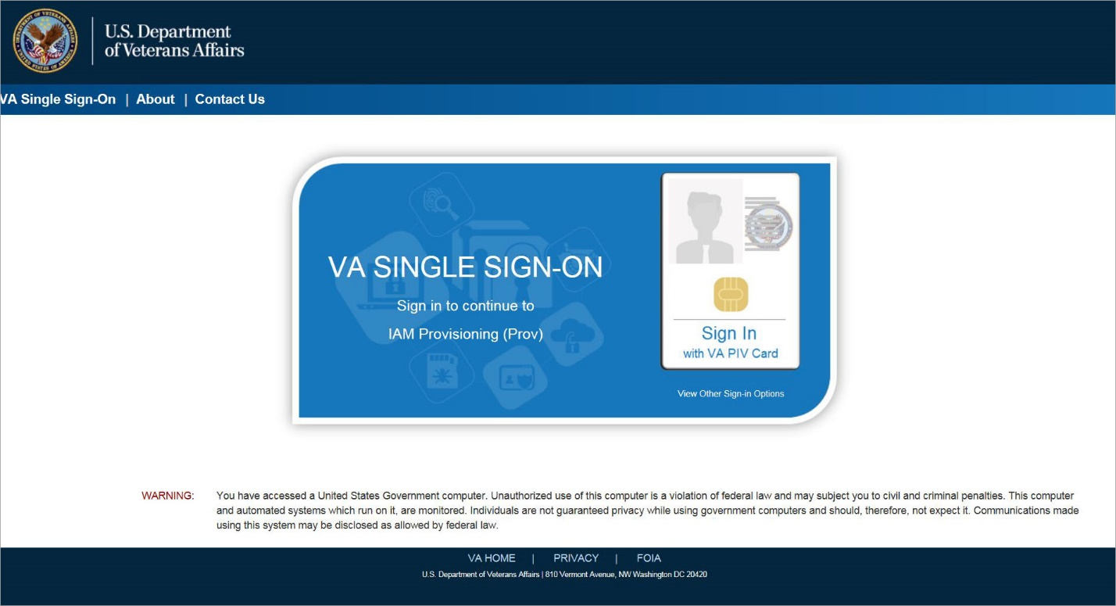
Figure 3-1: SSOi Login Screen

Logging On
The VHIC application is built to accommodate a specific set of pre-established user roles. During the provisioning process, the VHIC user will have a role assigned to them, which will determine what aspects of the VHIC application are available to them. The roles are listed below. For more information on the areas of access that accompanies each role, please refer to VHIC Roles and Access document.

System Menu
Depending on the VHIC users’ role, they will be presented different Home screens upon logging to the VHIC application.

VHIC Administrator and Technical Administrator Tier 3
The VHIC Administrator and VHIC Technical Administrator Tier 3 users will be presented with three menu options: Card Requests, Reports and Card Management. They can navigate to each of these application modules by either clicking on one of the links located in the header at the top left of the screen or by clicking on one of the icon buttons in the middle of the screen.

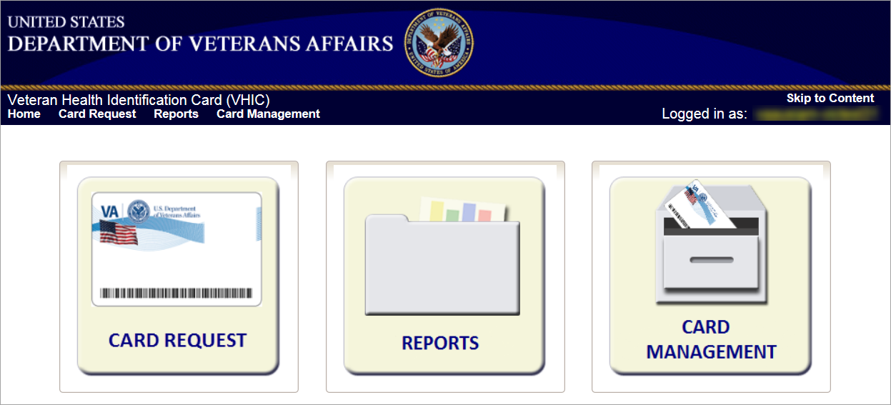
Figure 3-2: VHIC Administrator and VHIC Technical Administrator (Tier 3) Home screen

VHIC Associate and Supervisor
The VHIC Associate and VHIC Supervisor users will be presented with two menu options: Card Requests and Reports. They can navigate to each of these application modules by either clicking on one of the links located in the header at the top left of the screen or by clicking on one of the icon buttons in the middle of the screen.

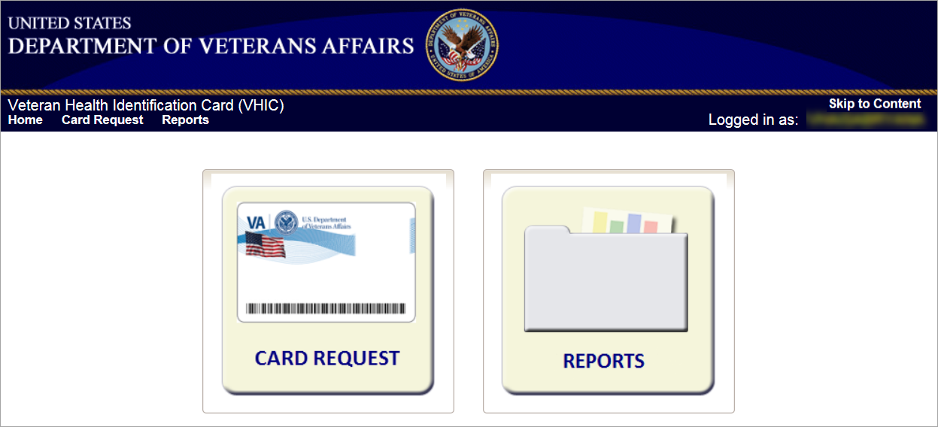
Figure 3-3: VHIC Associate and VHIC Supervisor Home screen

VHIC Auditor and Read-Only User
The VHIC Auditor and VHIC Read-Only users will be presented with the Reports menu option. They can navigate to Reports by clicking on the icon button in the middle of the screen.

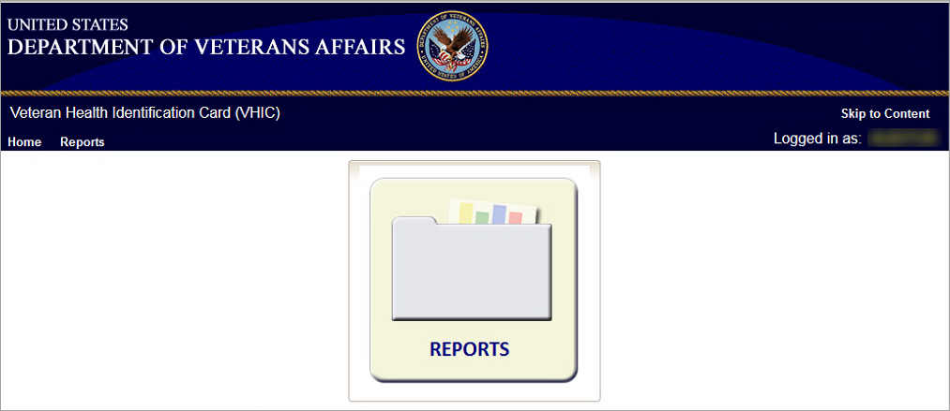
Figure 3-4: VHIC Auditor and VHIC Read-Only User Home screen

VHIC System Status Banner
The VHIC System will display a Status Banner at the top of the screen to notify users of reported issues with the system and/or during maintenance activities that do not require downtime.
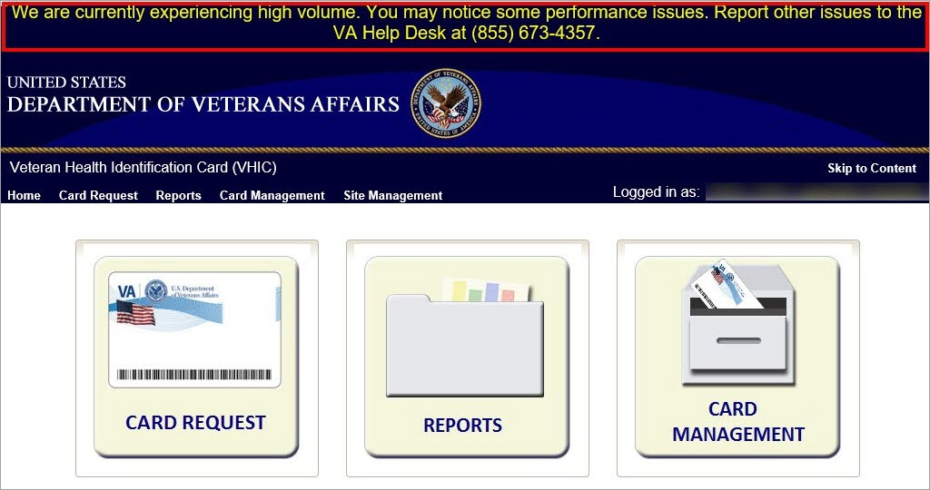
Figure 3-5: VHIC System Status Banner

Changing User ID and Password
If you have any questions or need help with your User ID or your Password; Contact the Enterprise Service Desk at REDACTED, option 1 (Account or Password Reset), then option 1.

Before Requesting a VHIC Card
For detailed step-by-step process of how to access and complete the Identity Proofing Verification task in the Identity Management Toolkit application, please refer to section 4 in the Veteran Health Identification Card User Guide - Volume 1 - Card Requests – All Users document.

Creating a VHIC Card – The Card Request Process
For a step-by-step process on how to navigate through the Card Request screens in the VHIC application and an explanation of the process involved in creating a VHIC for a Veteran, please refer to section 5 in the Veteran Health Identification Card User Guide - Volume 1 - Card Requests – All Users document.

Deactivating Cards – The Card Management Process
For detailed information that will help the VHIC Administrator navigate through the card deactivation screens in the VHIC application that will allow them to deactivate all of the VHICs for a specific Veteran, please refer to section 6 in the Veteran Health Identification Card User Guide - Volume 3 - Card Management - Admins document.

VHIC Reporting
The VHIC application offers a variety of reporting options divided into four main reporting tabs. Certain tabs may contain sub-tabs. Not all VHIC user roles have access to all reports, or all of the available functionality of certain reports (i.e., national option or multi-select option).
The National search option returns results, which includes every available VISN and Facility. This option, triggered by selecting the National checkbox, is only available to those user roles with authorization to use this feature. Since the results returned consist of all VISNs/Facilities, checking the National checkbox removes any available VISN and/or Facility options.
The ability to Multi-select is available on certain reports that have VISN and/or Facility selection criteria and is available to Administrators, and Tech Admin (Tier 3) roles. This feature works by holding down the [Control] button (Ctrl) on the keyboard and single clicking on each desired list items.
All reports, with the exception of the Veteran Detail report, give the user the option to select either [Report] or [Create PDF] once they have entered their search criteria. Clicking the [Report] button will generate the query results in a new tab. This allows the user to return to the original query tab in order to modify their search criteria if needed. Keep in mind, while date ranges may be generous, results are limited to 3000 lines.
The user selects the desired reporting option by clicking on the appropriate tab or sub-tab. A tab highlighted in blue, lets the user know which report they are viewing. Once they select a report, the user will need to provide certain search criteria based on the specific requirements of the report selected.
Some reports contain Hyperlinks. Clicking the hyperlinks (indicated by blue font) allow the VHIC user to access more detailed information. For instance, if the user wants to keep the Summary Report for a VISN open while reviewing the Detail Report for a specific Facility, they can hold down the [Control] button (Ctrl) on the keyboard while clicking on the hyperlink for the Facility they wish to view. This opens the Facility Detail Report in another browser window allowing the user to view both reports and have the ability to select another Facility in which to view.

The following graphic represents the VHIC tabular report structure for the Administrator, Technical Administrator Tier 3, and the Auditor:
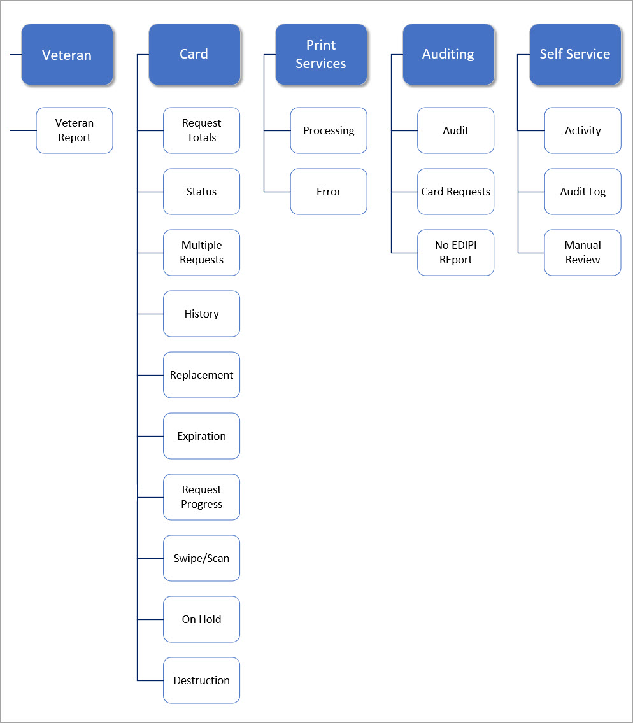
Figure 7-1: Report Tabular Structure for the Administrator, Technical Administrator Tier 3, and the Auditor

The following graphic represents the VHIC tabular report structure for the Supervisor user:
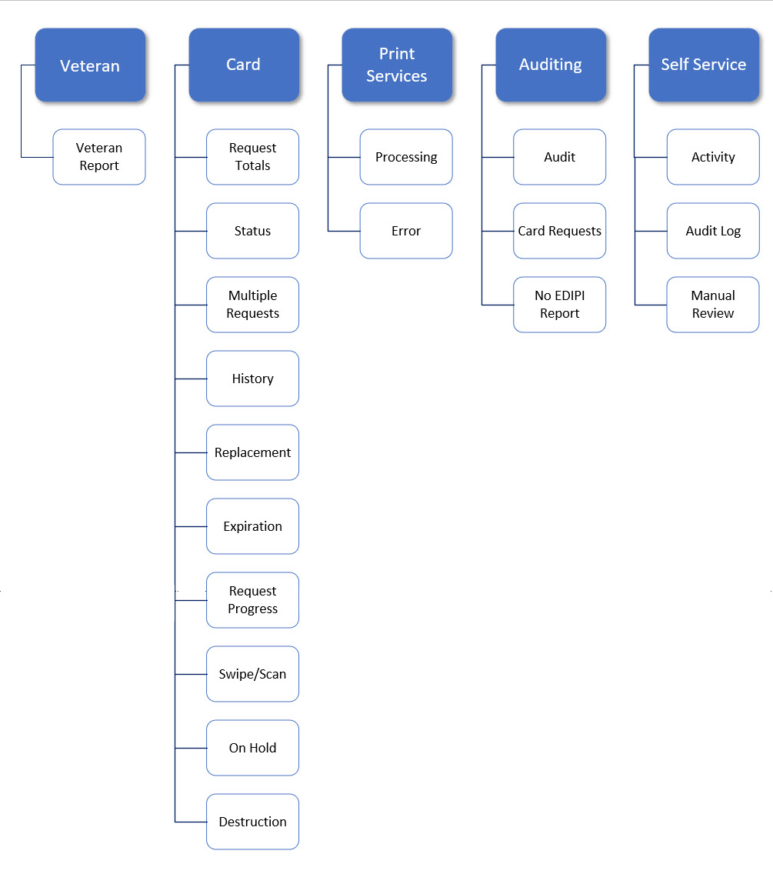
Figure 7-2: Report Tabular Structure for the Supervisor

The following graphic represents the VHIC tabular report structure for the Associate user:
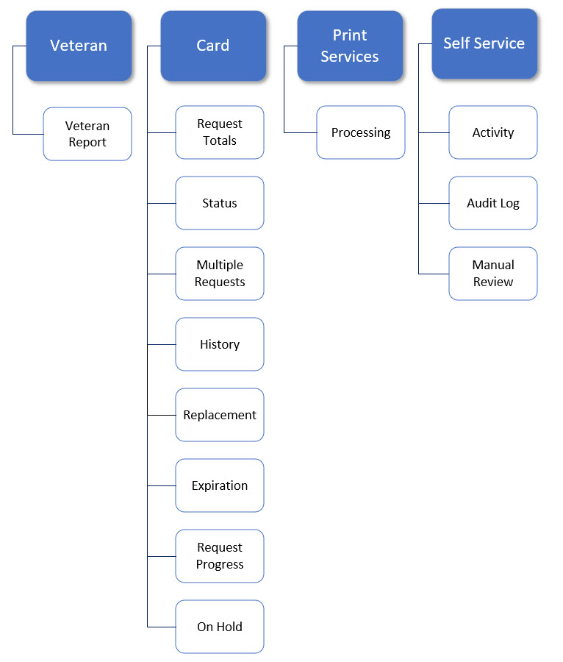
Figure 7-3: Report Tabular Structure for the Associate

The following graphic represents the VHIC tabular report structure for the Read-Only user:
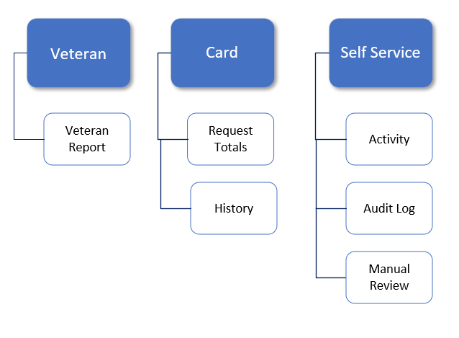
Figure 7-4: Report Tabular Structure for the Read-Only user

Veteran (Direct Search) Report
Table 3: Veteran Report at a Glance
At a Glance…
Who can access this report? | Administrator, Supervisor, Associate, Tech Admin (Tier 3), Auditor, Read-Only
Who can access National version? | N/A
Date Range Allowed | N/A
Search Criteria Available | Last Name, First Name, Date of Birth, Last four of SSN, ICN, Member ID, Card ID, Person ID

The Veteran Report (a.k.a. Direct Search or Veteran Detail Report) is the first report query screen presented to the VHIC user when accessing the reporting section of VHIC. This report provides a comprehensive overview of all of the information the VHIC application has on a particular Veteran, including their photo.

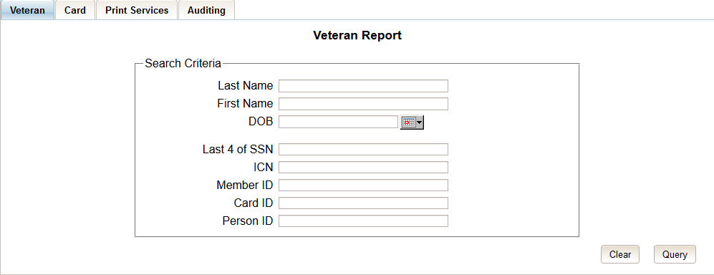
Figure 7-5: Veteran Report Query Fields – Administrator, Tech Admin (Tier 3), Auditor and Supervisor

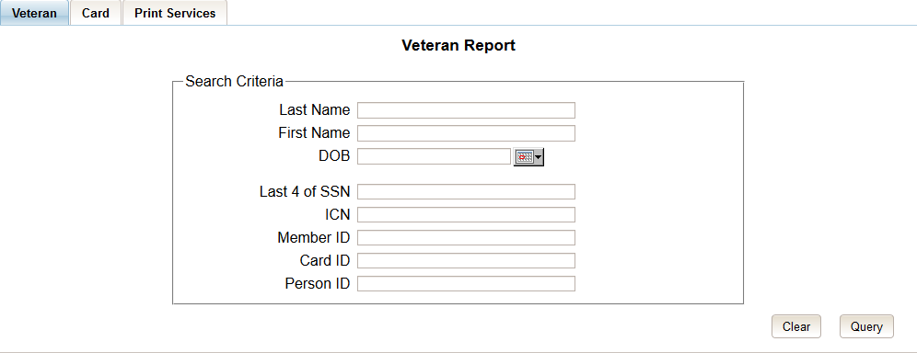
Figure 7-6: Veteran Report Query Fields – Associate

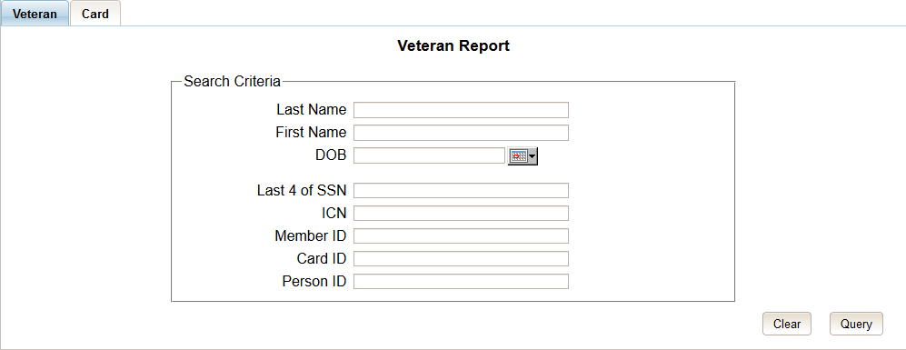
Figure 7-7: Veteran Report Query Fields – Read-Only User

After entering the appropriate search traits and clicking the [Query] button, a screen will appear with a summary listing of potential matches.
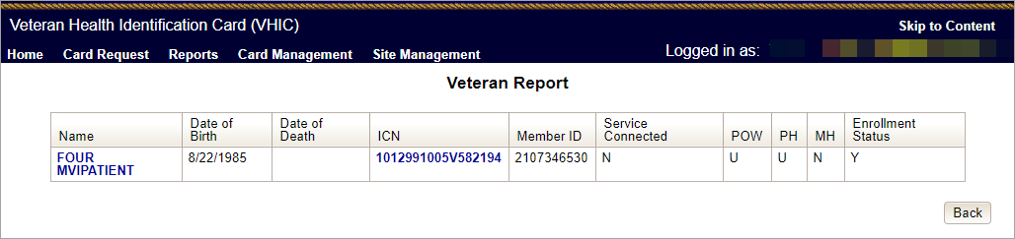
Figure 7-8: Veteran Report Search Results

The query result displays a summary view of Veteran information consisting of:
- Name
  - Hyperlink to the Veteran Detail Report
- Date of Birth
- ICN
  - Hyperlink to the Veteran Detail Report
- Member ID
- Service Connected
- POW – Prisoner of War
- PH – Purple Heart
- MH – Medal of Honor
- Enrollment Status

NOTE:
Entering an Invalid ICN, Card ID, or Veteran ID will result in an error message such as the one seen in Figure 7-9: Card ID Error Message. Examples of errors include:
- Invalid ICN. ICN must be 17 characters
- Invalid ICN. ICN must not contain special characters
- Invalid ICN format. Please enter valid ICN format, 17 chars (10 digits + V + 6 digits)
- Veteran ID must be an integer value
- Card ID: Please enter a valid number between 0 and 2147483647

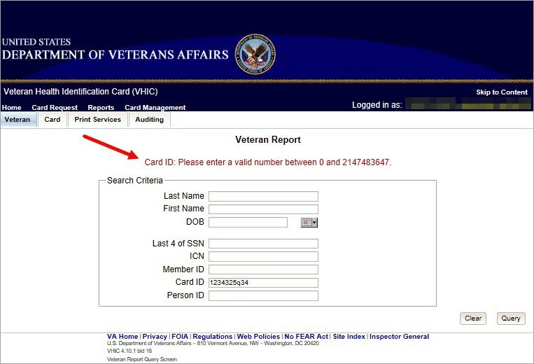
Figure 7-9: Card ID Error Message

Clicking on the Veteran’s name, or on their ICN, displays a comprehensive level of this report, a.k.a. the VHIC Veteran Detail Report.

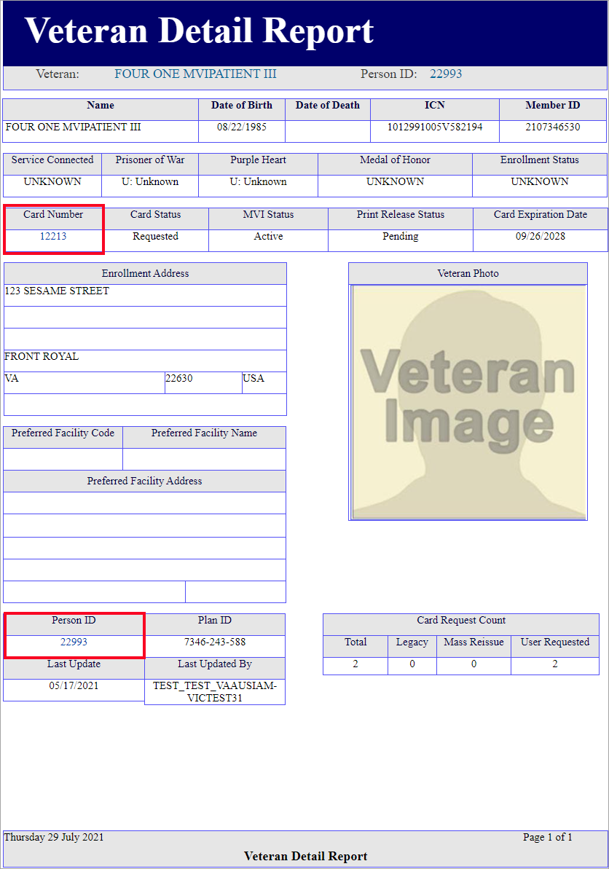
Figure 7-10: VHIC Veteran Detail Report

The VHIC Veteran Report contains a hyperlink in the Card Number area. Clicking this hyperlink takes the user to the VHIC Card History by Card ID report. This user guide covers Card History Reports in section 7.5.

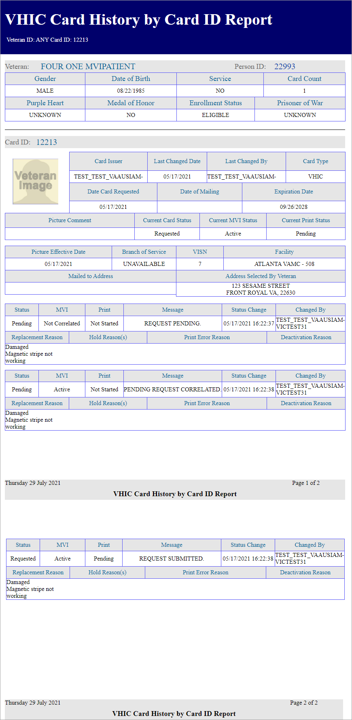
Figure 7-11: VHIC Card History by Card ID

The VHIC Veteran Detail Report also contains a hyperlink in the Person ID area. Clicking this hyperlink takes the user to the VHIC Card History by Person ID Report. This user guide covers Card History Reports in section 7.5.
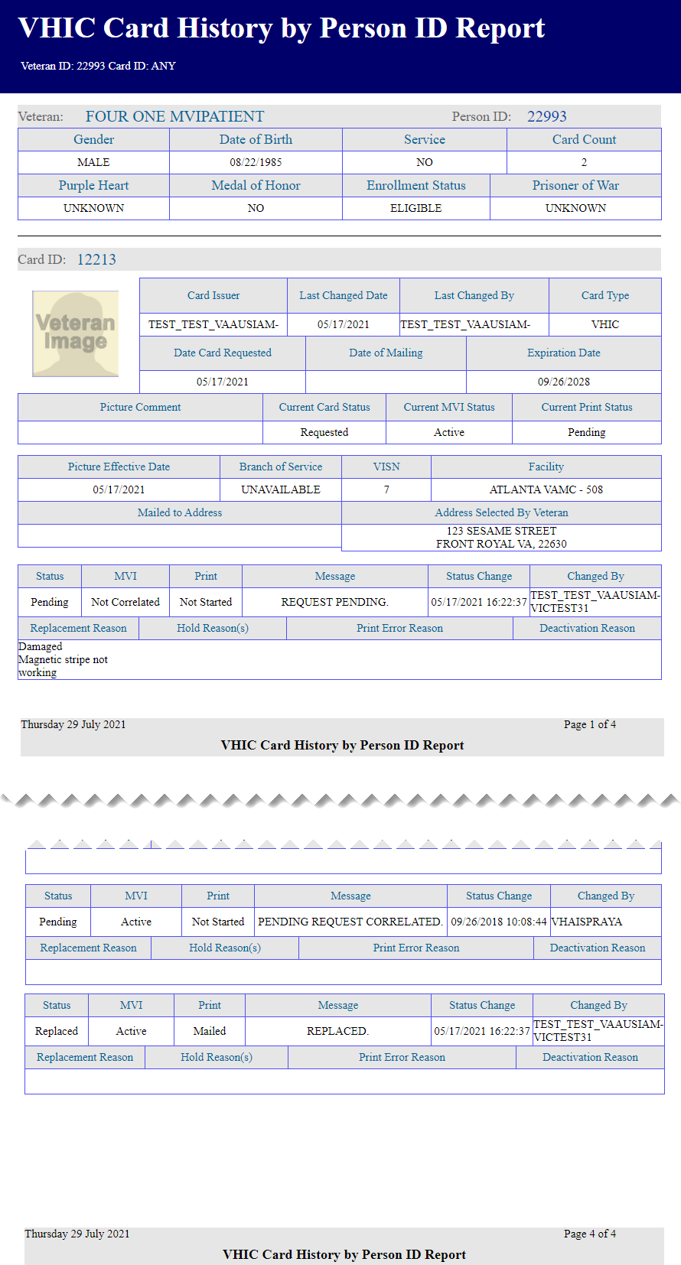
Figure 7-12: VHIC Card History by Person ID

Card Request Totals Report

Table 4: Card Request Totals Report at a Glance
At a Glance…
Who can access this report? | Administrator, Supervisor, Associate, Tech Admin (Tier 3), Auditor, Read-Only
Who can access National version? | Administrator, Tech Admin (Tier 3), Auditor
Date Range Allowed | Admins, Tech Admin (Tier 3), Auditor – unlimited  Supervisor, Associate, Read-Only – one (1) year or less from date report is being run
Search Criteria Available (may vary by role) | VISN, Facility, Start Date, End Date

The Card Request Totals Report gives the user exactly that – the total card requests by selected VISN and/or Facility, in a tabular format within a designated period of time. By default the "End Date" is set to the current date and the "Start Date" is set to a month prior. The Selecting the National checkbox, if available, returns results for all VISNs and Facilities. Selecting either the [VISN] or the [Facility] radio button will update the list of available options accordingly (based on a user’s role).

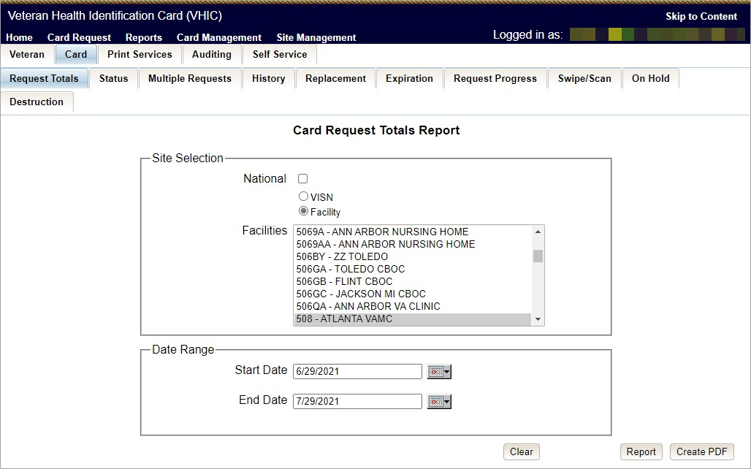
Figure 7-13: Card Request Totals Report query screen – Administrators and Tech Admin (Tier 3)

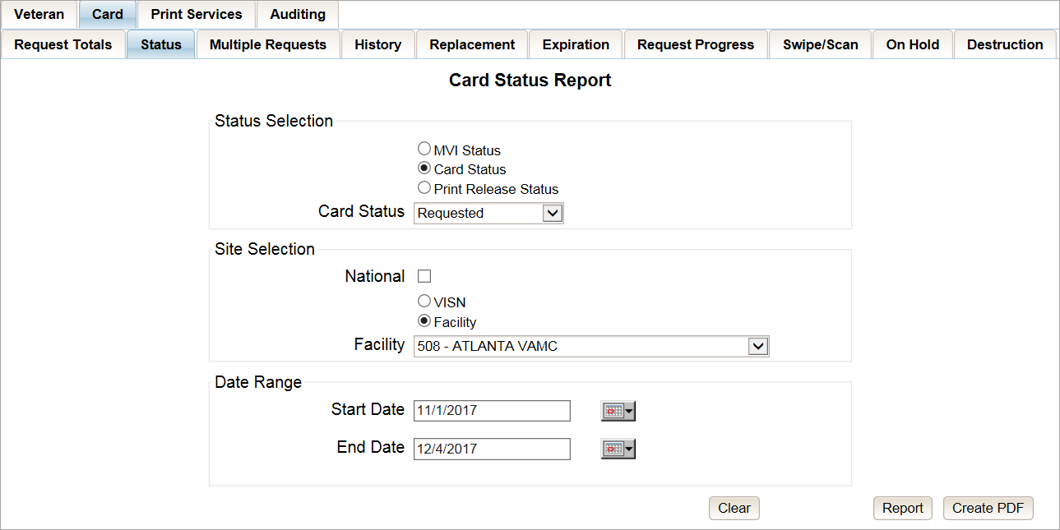
Figure 7-14: Card Request Totals Report query screen – Auditor

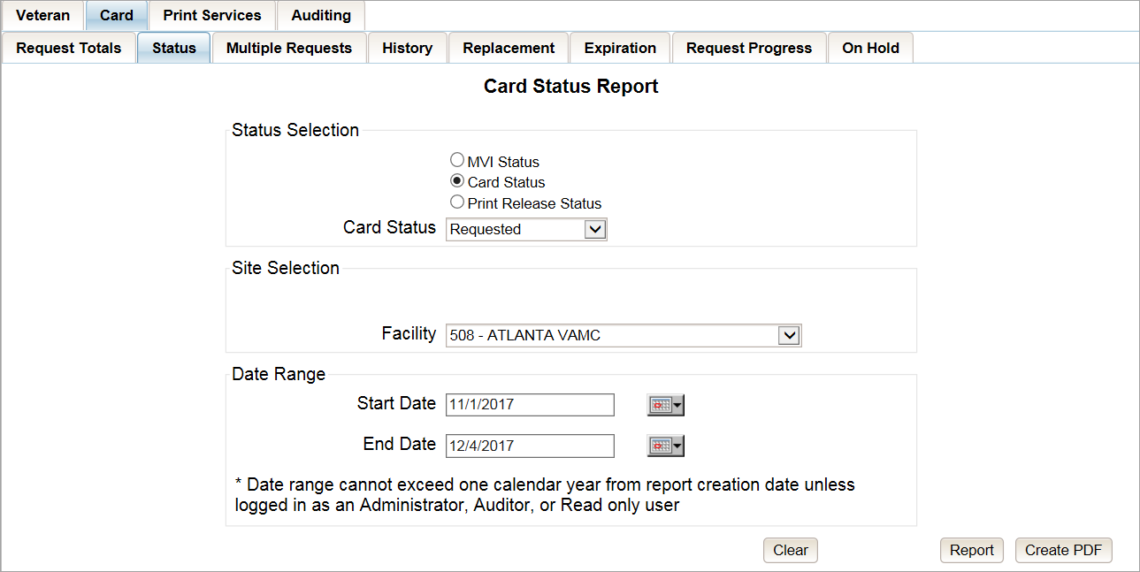
Figure 7-15: Card Request Totals Report query screen – Supervisor

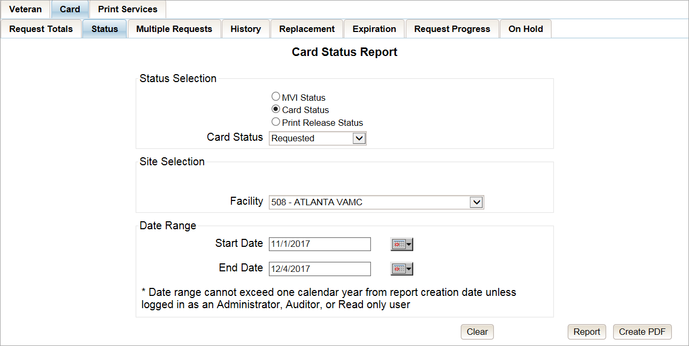
Figure 7-16: Card Request Totals Report query screen – Associate

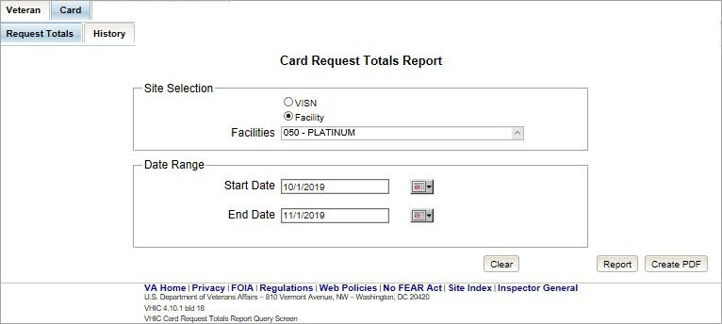
Figure 7-17: Card Request Totals Report query screen – Read-Only User

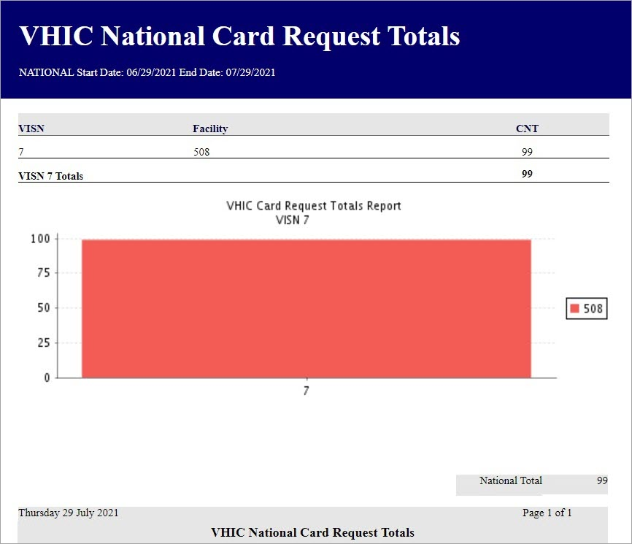
Figure 7-18: VHIC Card Request National Report

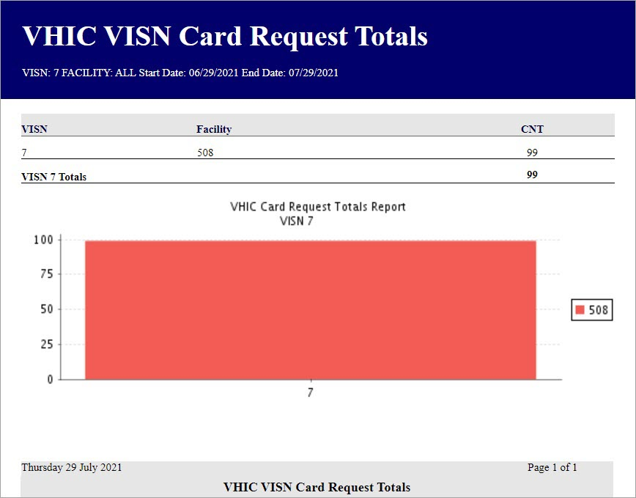
Figure 7-19: VHIC Card Request Totals report – VISN

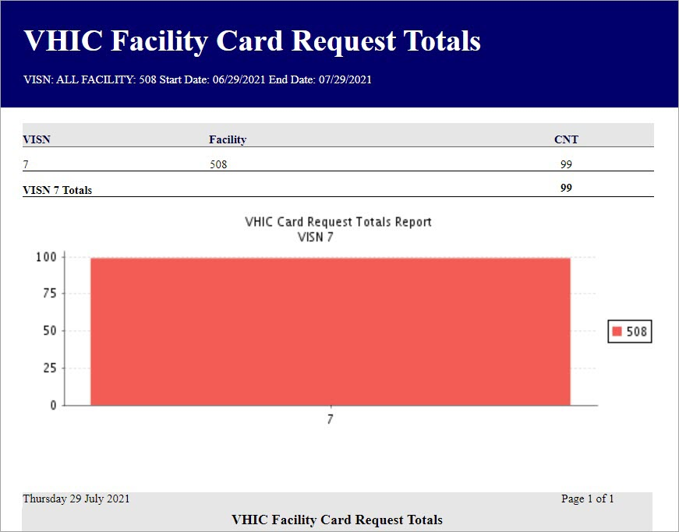
Figure 7-20: VHIC Card Request Totals report – Facility

Card Status Report
Table 5: Card Status Report at a Glance
At a Glance…
Who can access this report? | Administrator, Supervisor, Associate, Tech Admin (Tier 3), Auditor
Who can access National version? | Administrator, Tech Admin (Tier 3), Auditor
Date Range Allowed | Admins, Tech Admin (Tier 3), Auditor – unlimited  Supervisor, Associate, Read-Only – one (1) year or less from date report is being run
Search Criteria Available (may vary by role) | VISN, Facility, MVI Status, Card Status, Print Release Status (which includes a drop down list), Start Date, End Date

The Card Status Report contains three unique categories: MVI Status, Card Status, and Print Release Status. This report has the usual search criterial options such as VISN or Facility, Start Date, and End Date. Along with those, the user must choose one of the three (3) options: MVI Status, Card Status, or Print Release Status. Each one of these options contains their own drop- down-list of items. The user must select one item from the corresponding list prior to running the desired report. The following sections list the options available for each status’ selection.

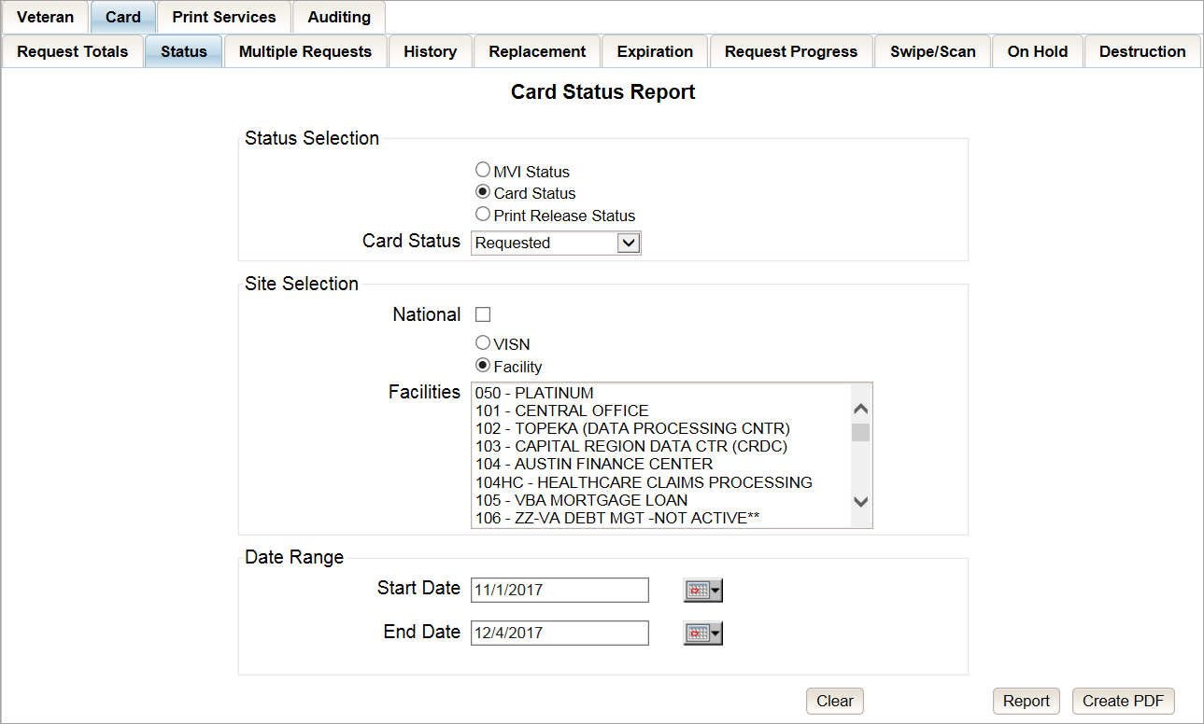
Figure 7-21: Card Status Report query screen – Administrator and Tech Admin (Tier 3)

Figure 7-22: Card Status Report query screen – Auditor

Figure 7-23: Card Status Report query screen – Supervisor
Figure 7-24: Card Status Report query screen – Associate

MVI (Master Veteran Index) Status Option
Clicking the [MVI Status] radio button provides the following report options:
- Active*
- Not Correlated
- Rejected
- Unlinked

NOTE: The starred (*) item is the default for that status.

Once the user selects one of the drop-down list options, chooses a site, and inputs a date range, they will click [Report]. Clicking [Report] will display the VHIC MVI Status Summary Report.

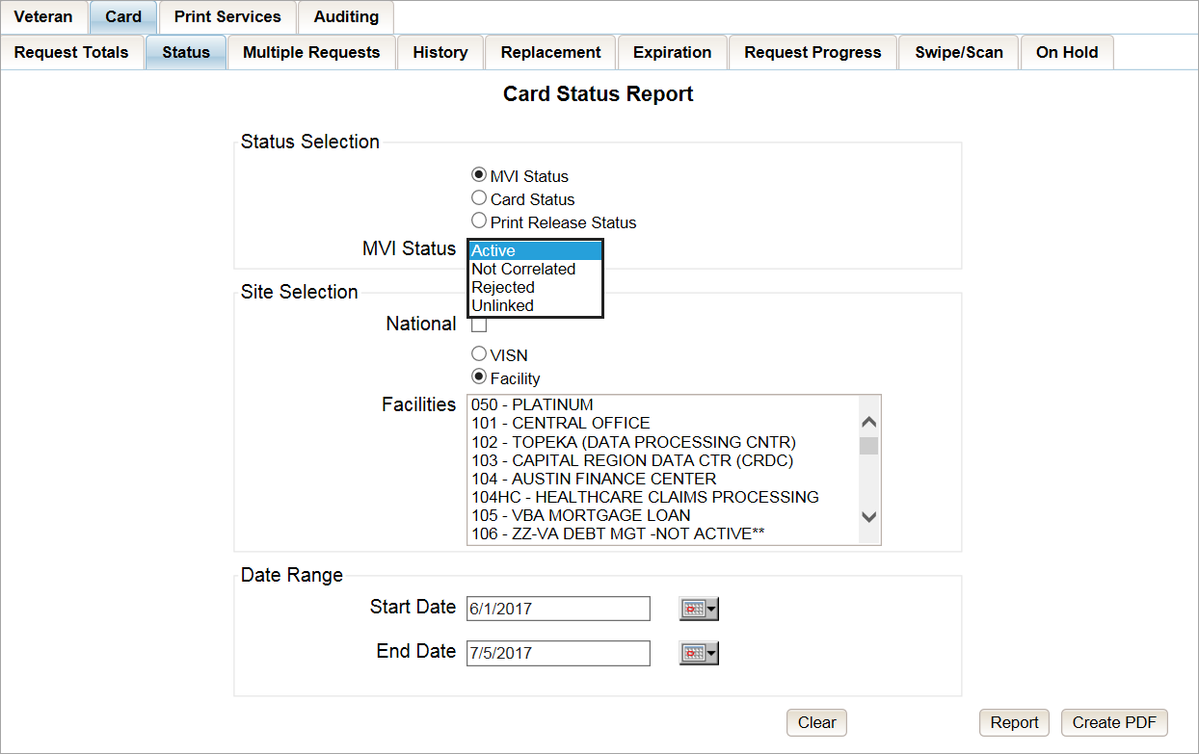
Figure 7-25: Card Status Report query screen with MVI Status drop-down options displayed

The VHIC MVI Status Summary Report contains hyperlinks (the number in the column relating to the selection made from the drop down menu). Clicking a hyperlink will open the next report. The hyperlink in the VHIC MVI Status National Summary Report will take you to the VHIC MVI Status VISN Summary Report.

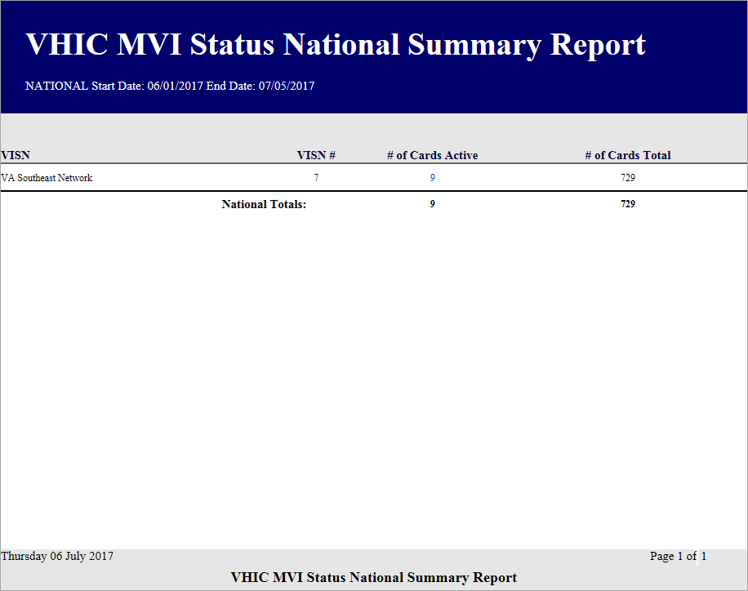
Figure 7-26: VHIC MVI Status National Summary Report – Active

Clicking on the hyperlink in the VISN Summary Report will take you to the VHIC MVI Status Facility Detail Report with results broken down by Veteran.

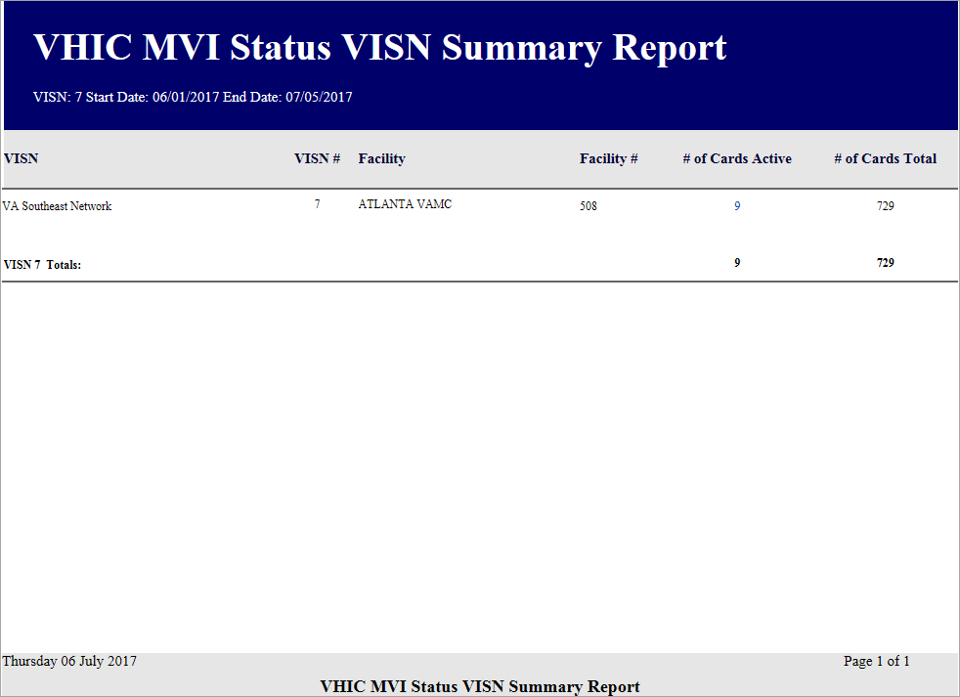
Figure 7-27: VHIC MVI Status VISN Summary Report – Active

If you searched by Facility, you would be given the VHIC MVI Status Facility Summary Report and would click on the hyperlink to be taken to the VHIC MVI Status Facility Detail Report.

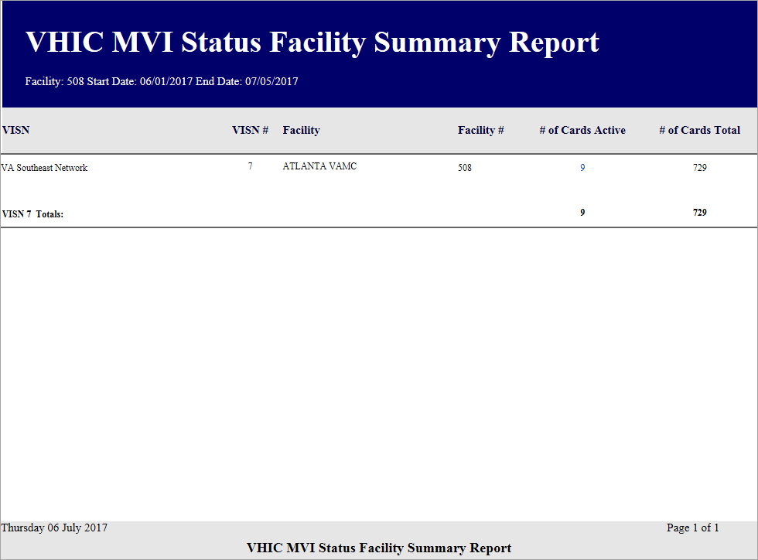
Figure 7-28: VHIC MVI Status Facility Summary Report – Active

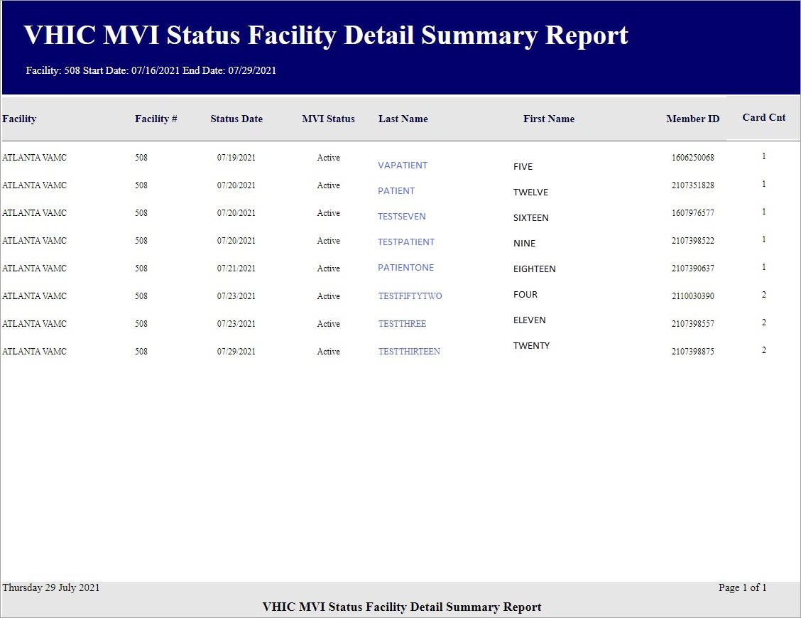
Figure 7-29: VHIC MVI Status Facility Detail Report – Active

Card Status Option
Clicking the [Card Status] radio button provides the following report options:
- Replaced
- Deactivated
- Expired
- On Hold
- Pending
- Requested*
- Defunct
NOTE: The starred (*) item is the default for that status.

Once the user selects one of the drop-down list options, chooses a site, and inputs a date range, they will click the [Report] button. Clicking [Report] will display the VHIC Card Status Report.

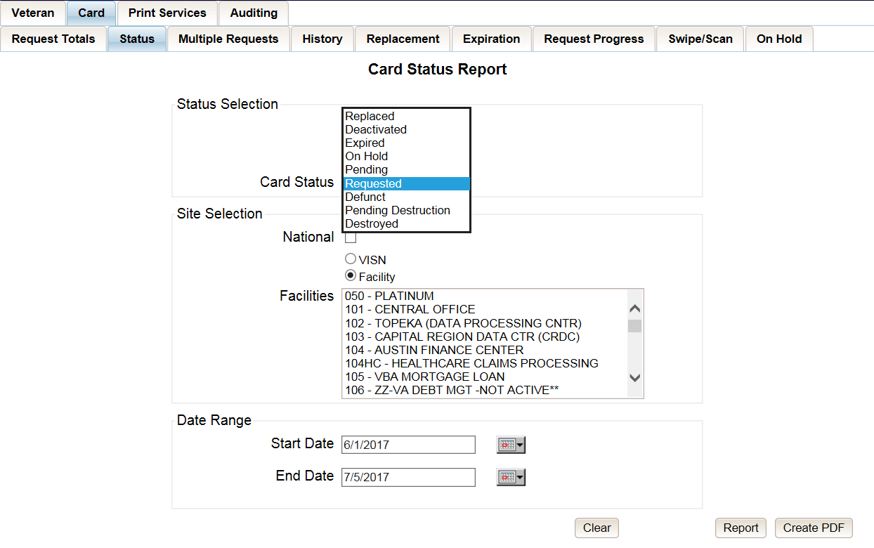
Figure 7-30: Card Status Report query screen with Card Status drop-down menu options displayed

The VHIC Card Status Report contains hyperlinks (the number in the column relating to the selection made from the drop down menu). Clicking a hyperlink will open the next report. The hyperlink in the VHIC Card Status National Report will take you to the VHIC Card Status VISN Report.

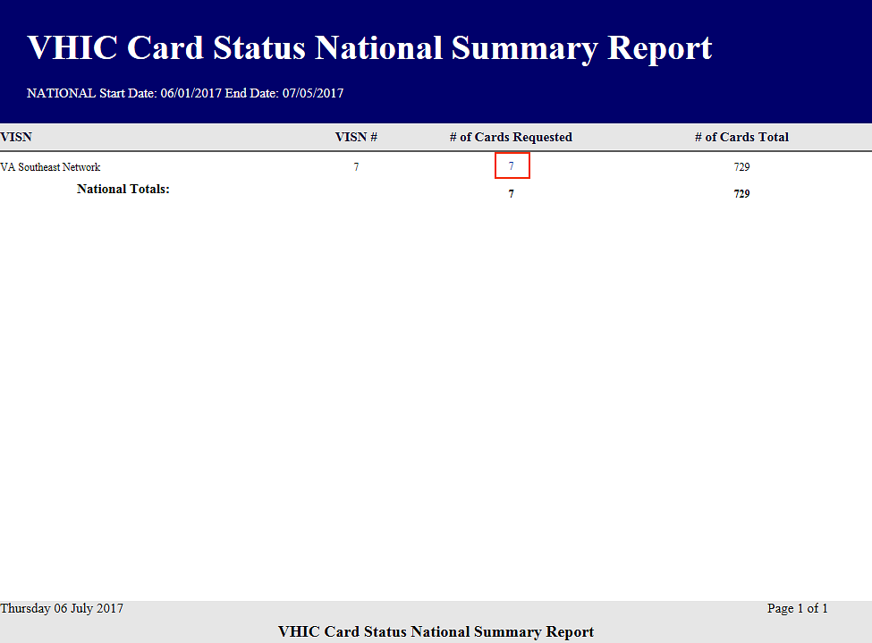
Figure 7-31: VHIC Card Status National Summary Report – Requested

Clicking on the hyperlink in the VISN Summary Report will take you to the VHIC Card Status Detail Report with results broken down by Veteran.

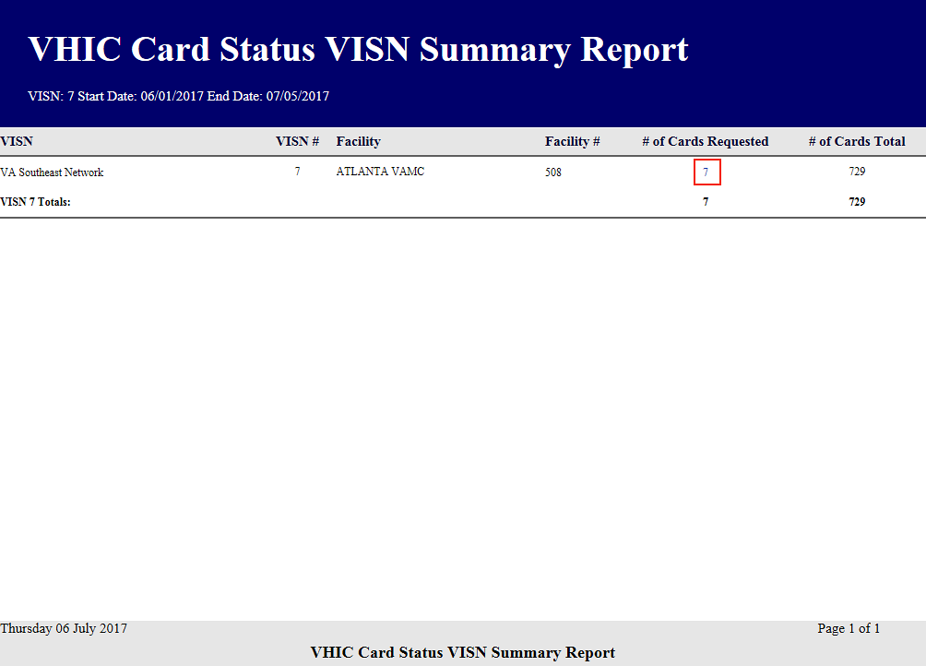
Figure 7-32: VHIC Card Status VISN Summary Report – Requested

If you searched by Facility, you would be given the VHIC Card Status Facility Report and would click on the hyperlink to be taken to the VHIC Card Status Detail Report.

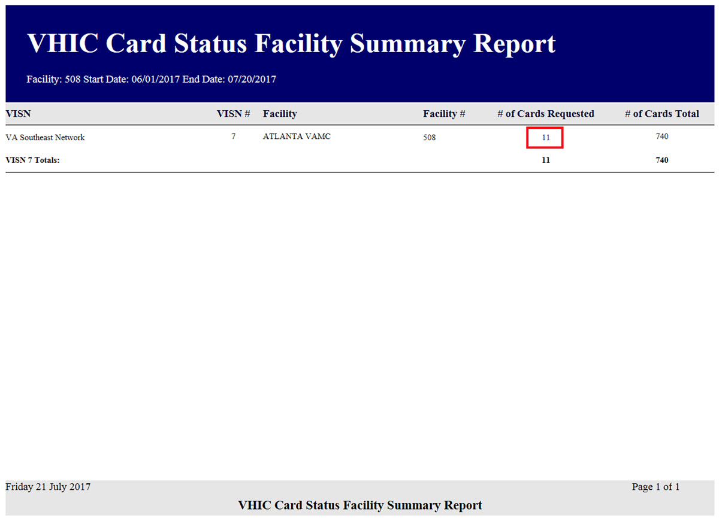
Figure 7-33: VHIC Card Status Facility Summary Report – Requested

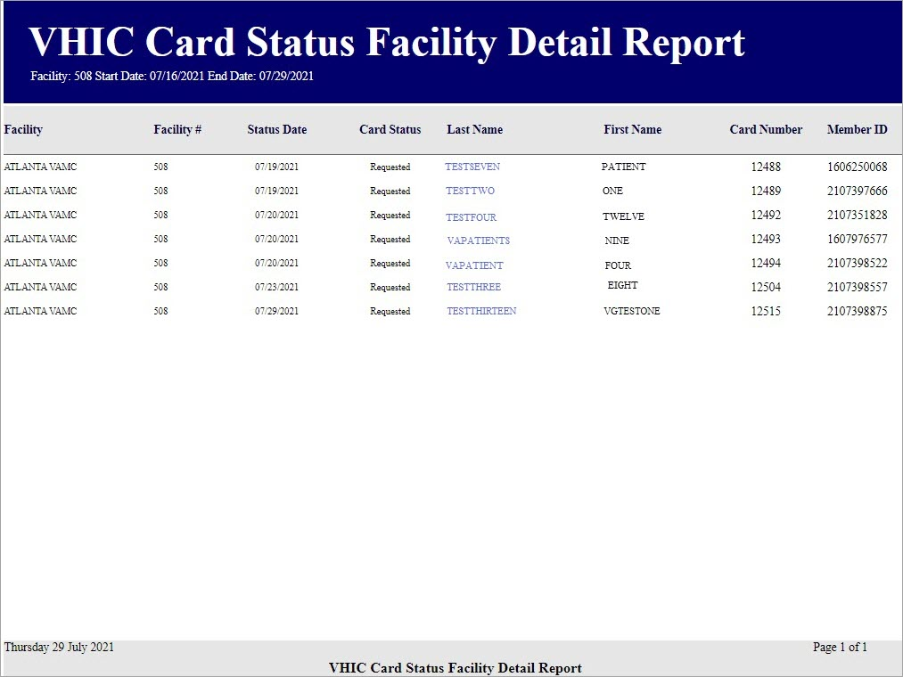
Figure 7-34: VHIC Card Status Facility Detail Report – Requested

Print Release Status Option
Clicking the [Print Release Status] radio button provides the following report options:
- Cancelled
- Error
- Mailed*
- Not Started
- Pending
- Received
- Rejected
- Sent
NOTE: The starred (*) item is the default for that status.

Once the user selects one of the drop-down list options, chooses a site, and inputs a date range, they will click the [Report] button. Clicking [Report] will display the VHIC Print Status Summary Report.

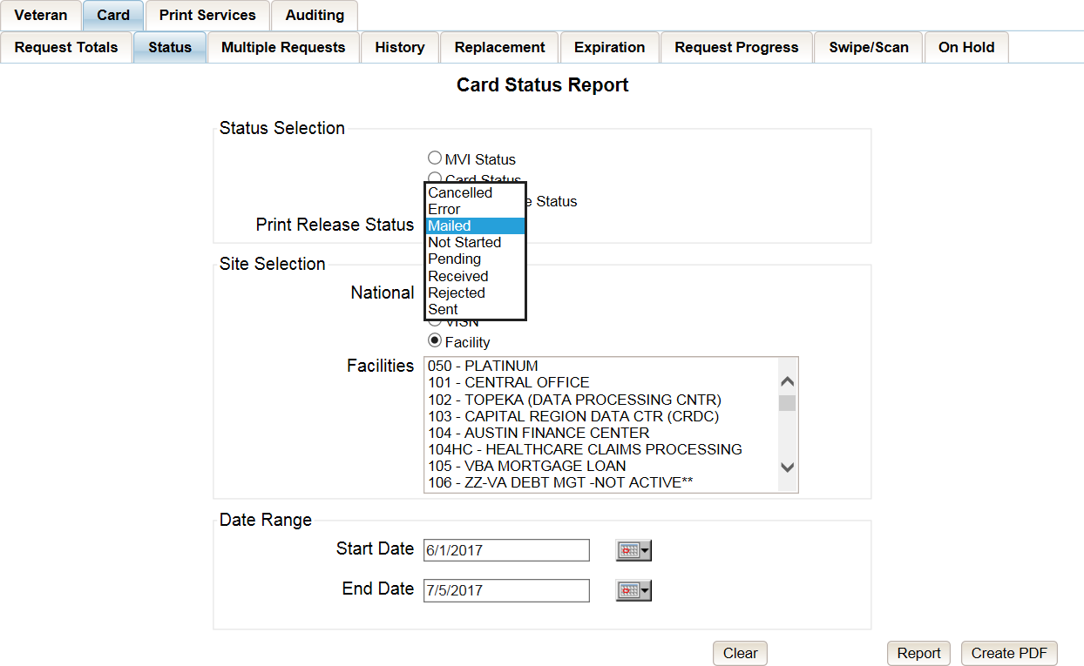
Figure 7-35: Card Status Report query screen with Print Release Status drop-down menu options displayed

The VHIC Print Status Report contains hyperlinks (the number in the column relating to the selection made from the drop down menu). Clicking a hyperlink will open the next report. The hyperlink in the VHIC Print Status National Report will take you to the VHIC Print Status VISN Summary Report.

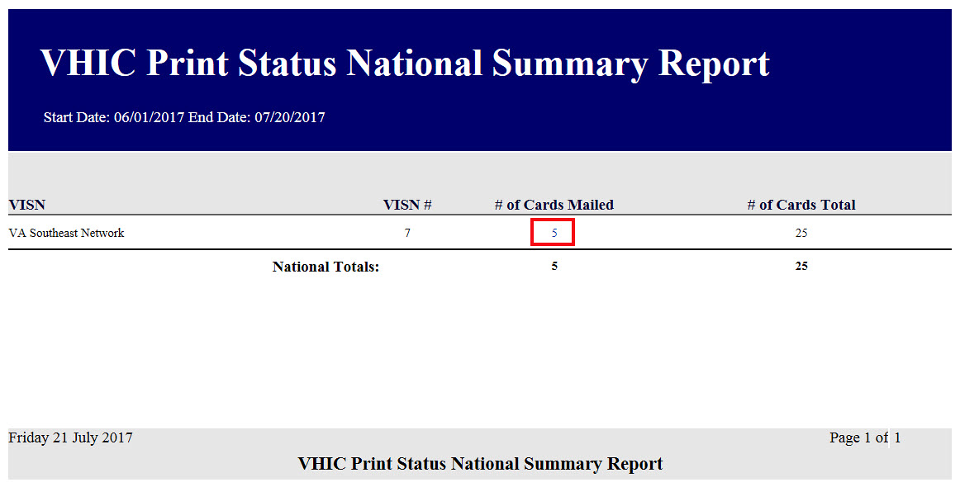
Figure 7-36: VHIC Print Status National Summary Report – Mailed

Clicking on the hyperlink in the VISN Summary Report will take you to the VHIC Print Status Detail Report with results broken down by Veteran.

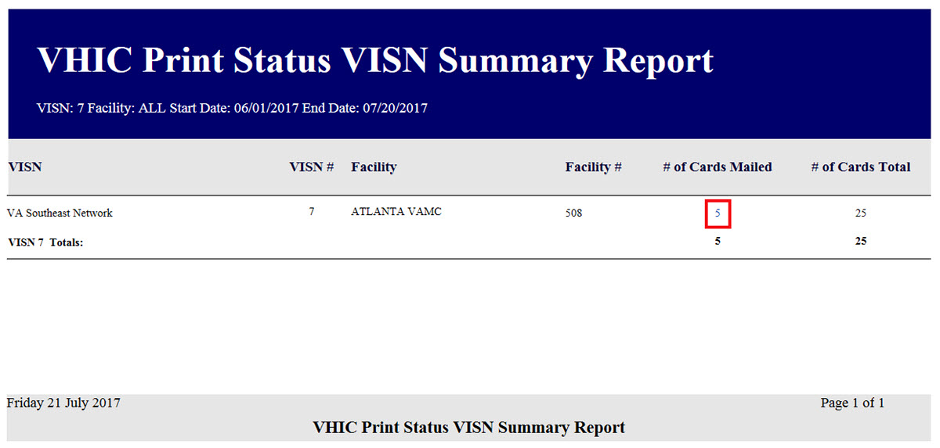
Figure 7-37: VHIC Print Release Status Summary Report - VISN – Mailed

If you searched by Facility, you would be given the VHIC Print Status Facility Report and would click on the hyperlink to be taken to the VHIC Print Status Detail Report.

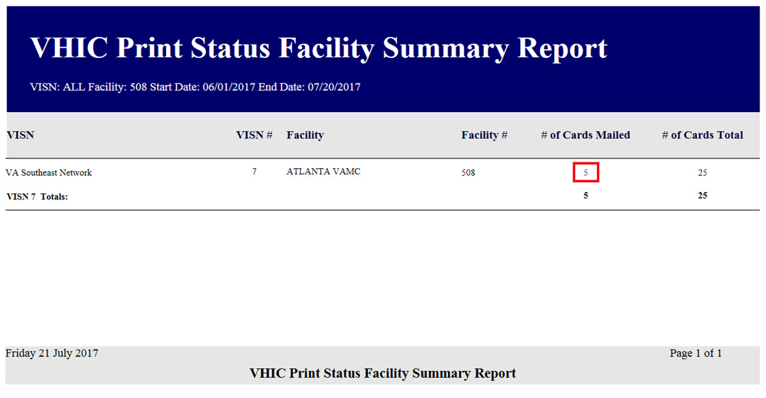
Figure 7-38: VHIC Print Release Status Summary Report - Facility – Mailed

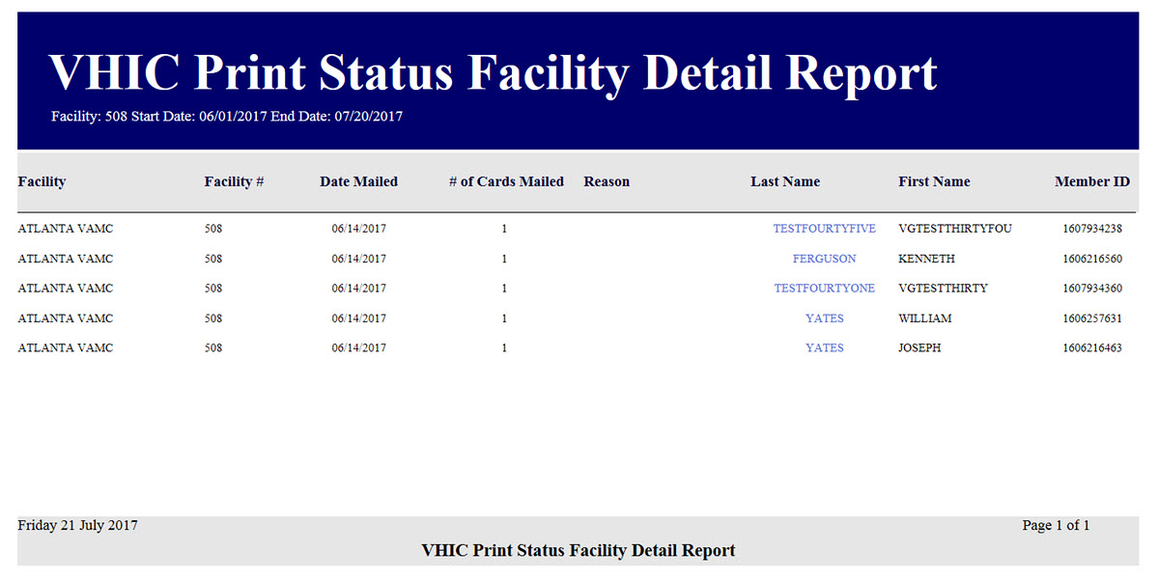
Figure 7-39: VHIC Print Status Detail Report - Facility – Mailed

Multiple Card Requests Report
Table 6: Multiple Request Report at a Glance
At a Glance…
Who can access this report? | Administrator, Supervisor, Tech Admin (Tier 3), Auditor
Who can access National version? | Administrator, Tech Admin (Tier 3), Auditor
Date Range Allowed | Admins, Tech Admin (Tier 3), Auditor – unlimited  Supervisor, Associate, Read-Only – one (1) year or less from date report is being run
Search Criteria Available (may vary by role) | Card Requests (#), VISN, Facility, Cards Requested, Cards Mailed, Start Date, End Date
The Multiple Card Requests Report provides a summary of either multiple cards requested for a Veteran or multiple cards mailed to a Veteran. The user must select the radio button corresponding to the desired report. This report is customizable and will return multiples based on specific numeric criteria entered into the Card Requests field (the default is two (2)).

Once the user specifies a number of cards requested or mailed, chooses a site, and inputs a date range, they will click the [Report] button. Clicking [Report] will display the VHIC Detailed Report for Number of Cards Requested/Mailed.

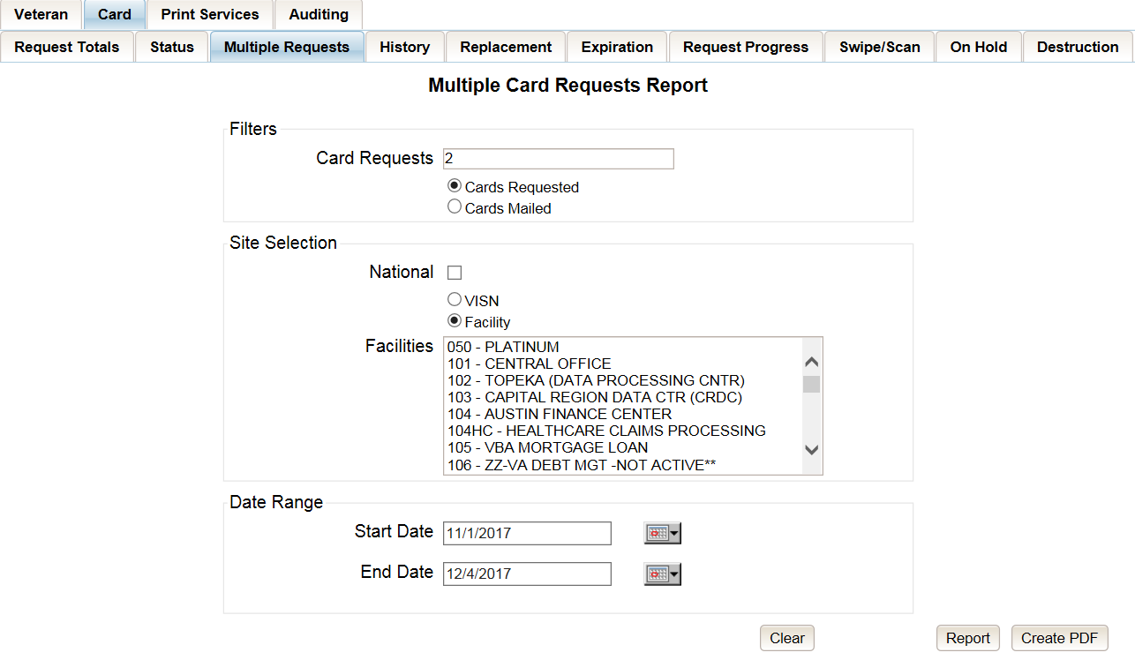
Figure 7-40: Multiple Card Requests Report query screen – Administrator and Tech Admin (Tier 3)
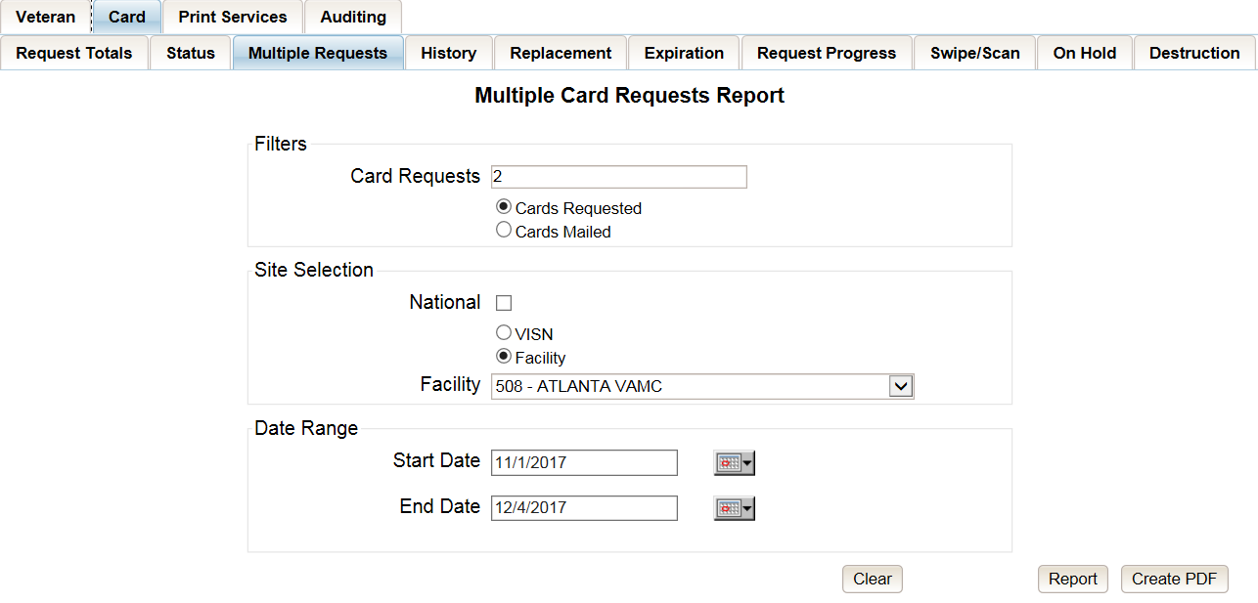
Figure 7-41: Multiple Card Requests Report query screen – Auditor

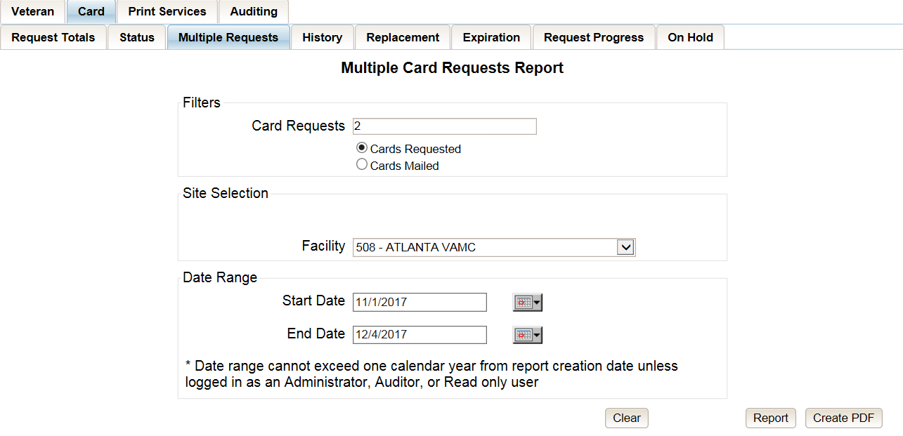
Figure 7-42: Multiple Card Requests Report query screen – Supervisors
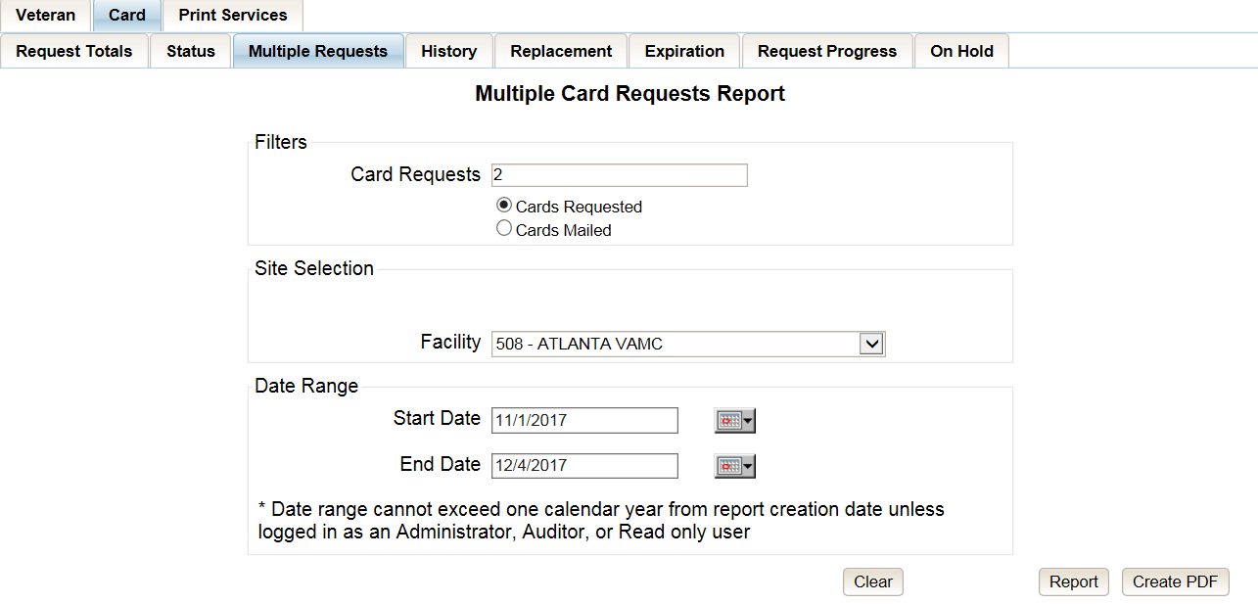
Figure 7-43: Multiple Card Requests Report query screen – Associate

The VHIC Summary Report for Number of Cards Requested/Mailed - National lists all the VISNs and contains a hyperlink in the VISN # column. Clicking the hyperlink takes the user to the VHIC Detailed Report for Number of Cards Requested/Mailed - VISN report.

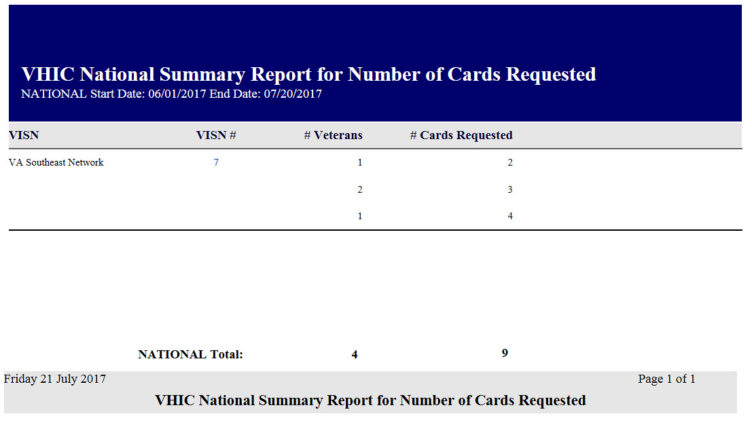
Figure 7-44: VHIC National Summary Report for Number of Cards Requested

The VHIC Detail Report for Number of Cards Requested/Mailed - VISN lists all the Facilities for the selected VISN and contains a hyperlink in the Facility # column. Clicking the hyperlink takes the user to the VHIC Facility Detailed Report for Number of Cards Requested/Mailed report.

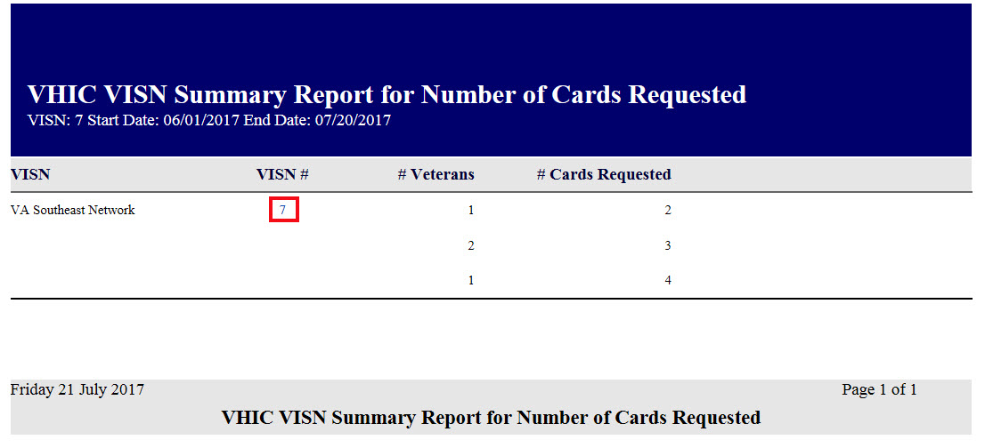
Figure 7-45: VHIC VISN Summary Report for Number of Cards Requested

When the user searches by Facility, the VHIC Detailed Report for Number of Cards Requested/Mailed - Facility lists all the VISNs and contains a hyperlink in the Facility # column. Clicking on the facility number will drill down further to show a breakdown by Veteran.
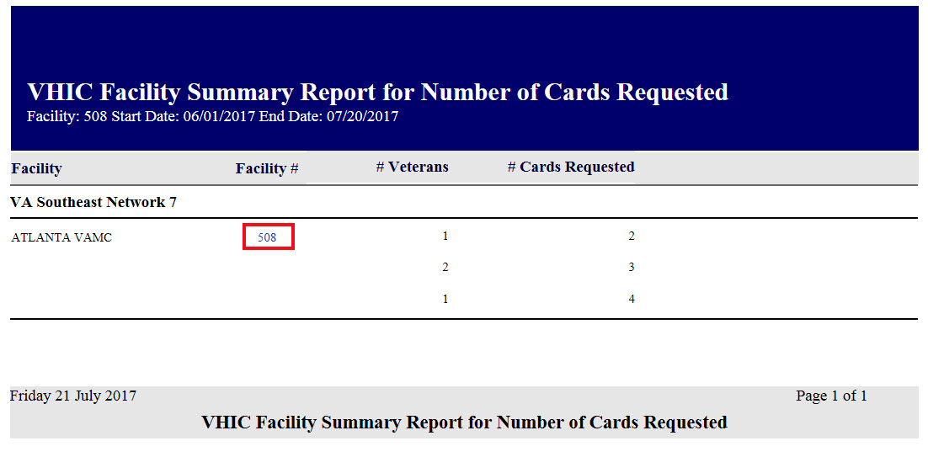
Figure 7-46: VHIC Facility Summary Report for Number of Cards Requested

The VHIC Facility Detailed Report for Number of Cards Requested/Mailed report includes the Veteran’s Name, Member ID (if available), and number of Cards Requested/Mailed.

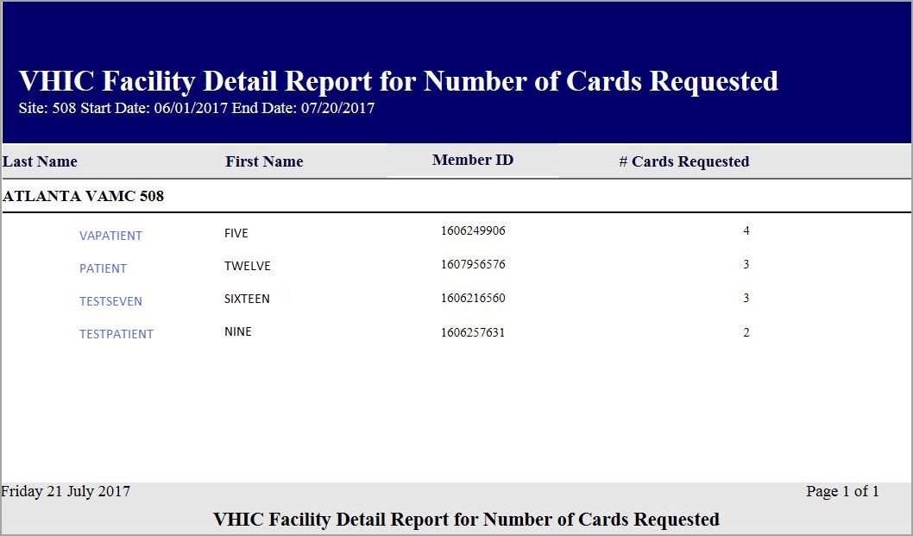
Figure 7-47: VHIC Facility Detail Report for Number of Cards Requested

Card History Report
Table 7: Card History Report at a Glance
At a Glance…
Who can access this report? | Administrator, Supervisor, Associate, Tech Admin (Tier 3), Auditor, Read-Only
Who can access National version? | N/A
Date Range Allowed | N/A
Search Criteria Available | Card ID, Person ID

The Card History Report provides the user with a breakdown of requested cards. To access these reports, enter a Card ID number or a Person ID number of the Veteran.

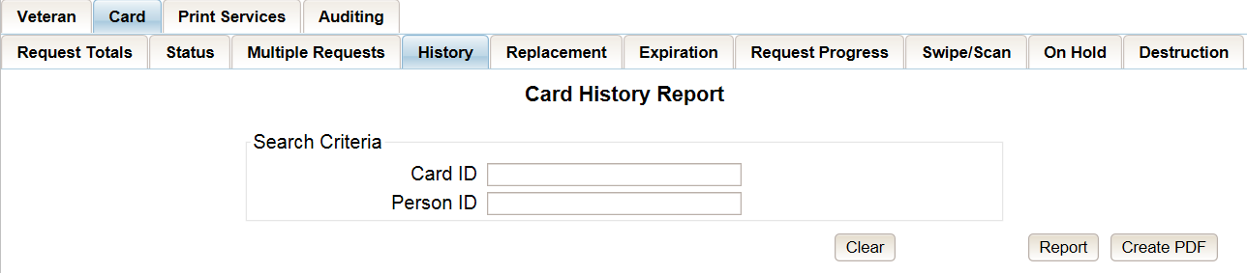
Figure 7-48: Card History Report query screen – Administrators, Tech Administrator (Tier 3), and Auditors

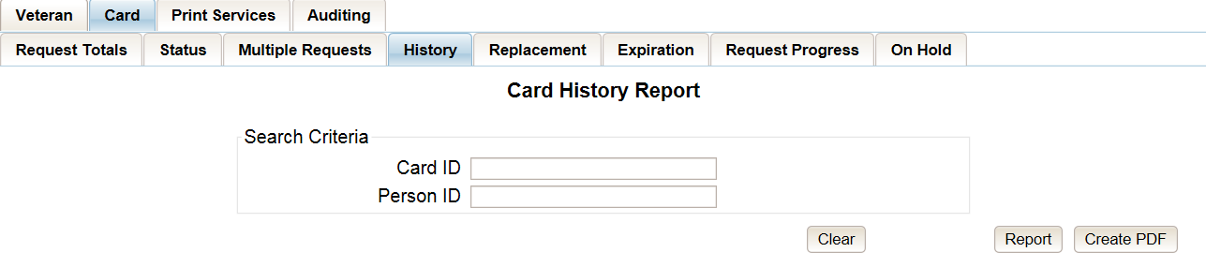
Figure 7-49: Card History Report query screen – Supervisor

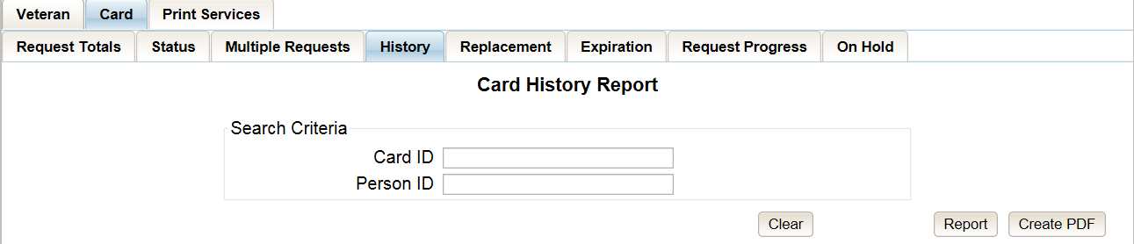
Figure 7-50: Card History Report query screen – Associate

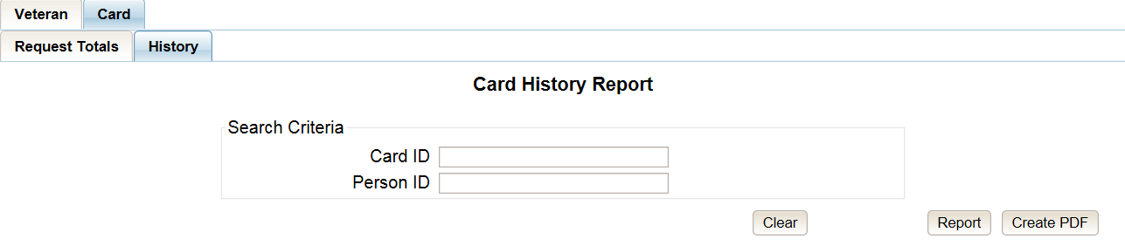
Figure 7-51: Card History Report query screen – Read-Only User

Searching by Card ID (found in the Veteran Detail Report) returns a single result for that specific card number, referred to as the Card History by Card ID Report.

Figure 7-52: VHIC Card History by Card ID Report
Searching by Person ID (found in the Veteran report) returns all of the cards requested for that Veteran, referred to as the Card History by Person ID Report.

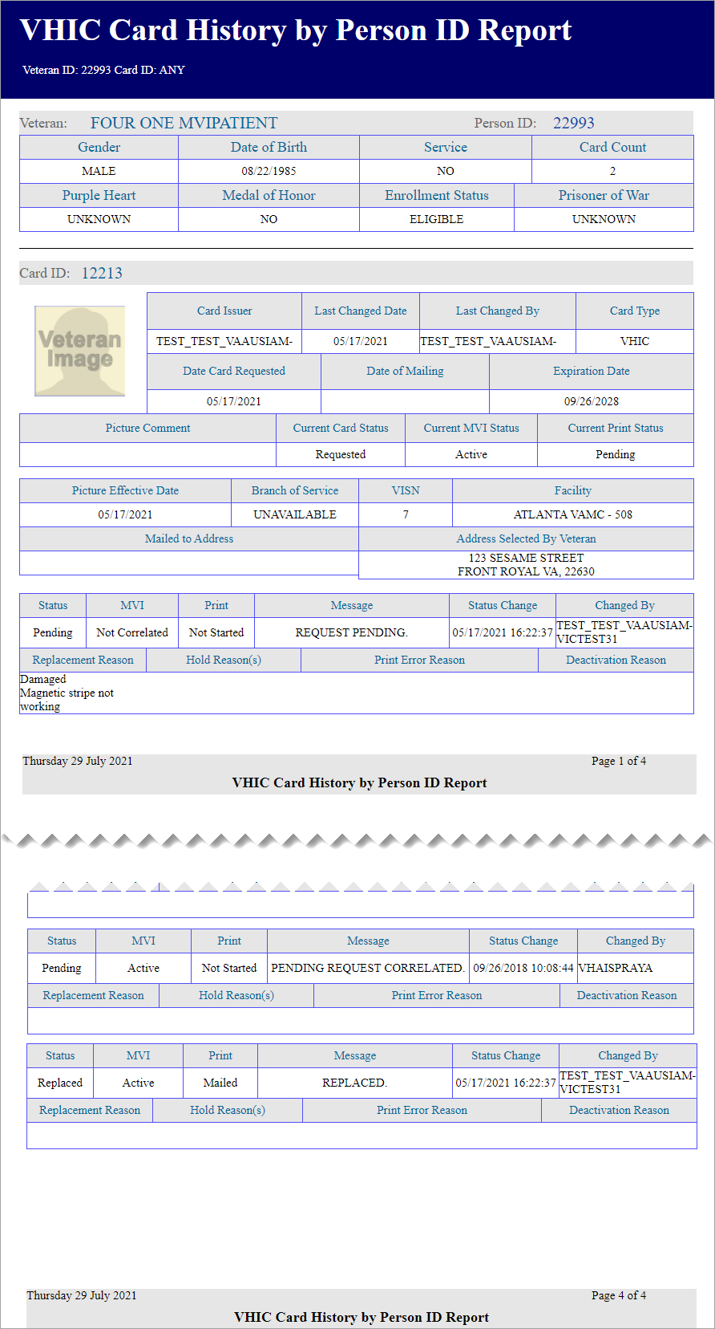
Figure 7-53: Card History by Person ID Report
Both reports, Card History by Card ID and Card History by Person ID, provide the user with the following information tied to that particular card:

- Veteran’s name
- Person ID
- Gender
- Date of Birth
- Service status
- Card Count
- Purple Heart status
- Medal of Honor status
- Enrollment Status
- Prisoner of War status
- Card ID
- Card Issuer
- Last Changed Date
- Last Changed By
- Card Type
- Date Card Requested
- Date of Mailing
- Expiration Date
- Picture Comment
- Current Card Status
- Current MVI Status
- Current Print status
- Picture Effective Date
- Branch of Service
- VISN
- Facility
- Replacement Reason (If any)
- Hold Reason(s) (If any)
- Print Error Reason (If any)
- Deactivation Reason (If any)
A history of the three statuses is also available. This allows reviewers to monitor and verify the various stages the card request has gone through as well as its final status at the time of the report.
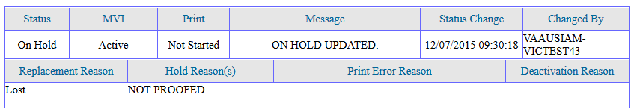
Figure 7-54: Card History Report Status History

Card Replacement Report
Table 8: Card Replacement Report at a Glance
At a Glance…
Who can access this report? | Administrator, Supervisor, Associate, Tech Admin (Tier 3), Auditor
Who can access National version? | Administrator, Tech Admin (Tier 3), Auditor
Date Range Allowed | Administrator, Tech Admin (Tier 3), Auditor – unlimited  Supervisor, Associate – one (1) year or less from date report is being run
Search Criteria Available | VISN, Facility, Start Date, End Date
Each Card Replacement Report gives the user a breakdown, in a tabular format, of the requested replacement cards. The report, sorted by the replacement reasons and by the selected VISN and/or Facility, displays the number of Cards Replaced for each specific reason, and provides a hyperlinked number. Clicking a hyperlink takes the user to reports that are more detailed.
Selecting the [National] checkbox (if available) will return results for all VISNs and Facilities. Selecting either the [VISN] or the [Facility] radio button will update the list of available options accordingly (based on a user’s role).

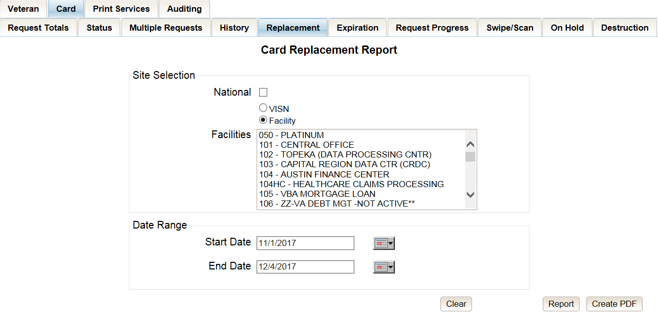
Figure 7-55: VHIC Card Replacement Report query screen – Administrators and Tech Administrators (Tier 3)

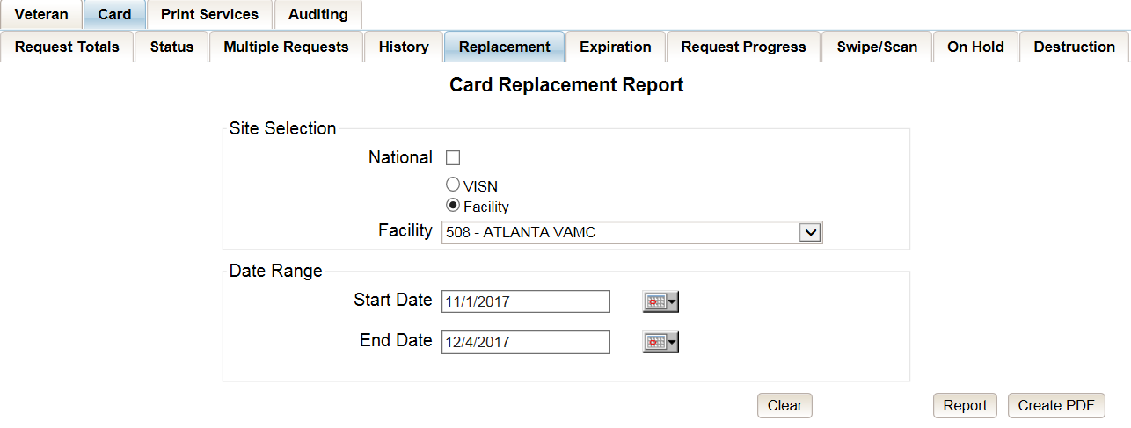
Figure 7-56: VHIC Card Replacement Report query screen – Auditors

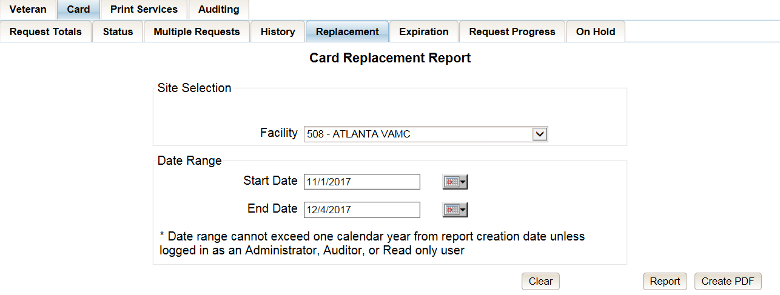
Figure 7-57: Card Replacement Report query screen – Supervisors

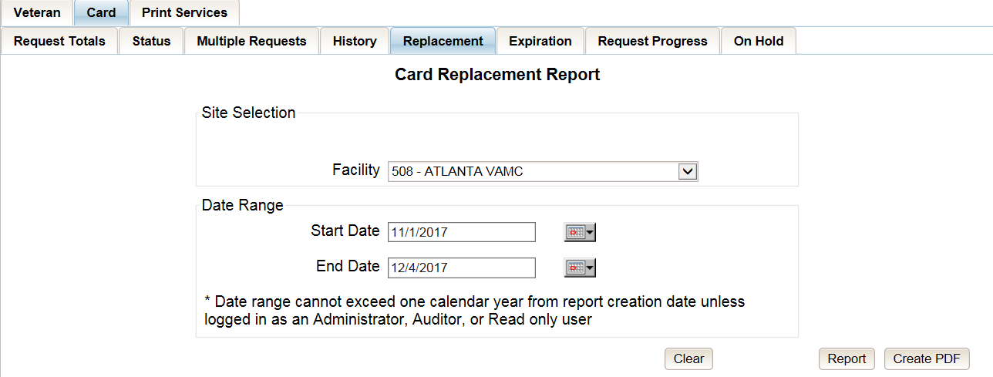
Figure 7-58: VHIC Card Replacement Report query screen – Associates

The VHIC Card Replacement National Report lists the VISNs and contains a hyperlink in the VISN # column. Clicking the hyperlink takes the user to the VHIC Card Replacement VISN Summary Report.
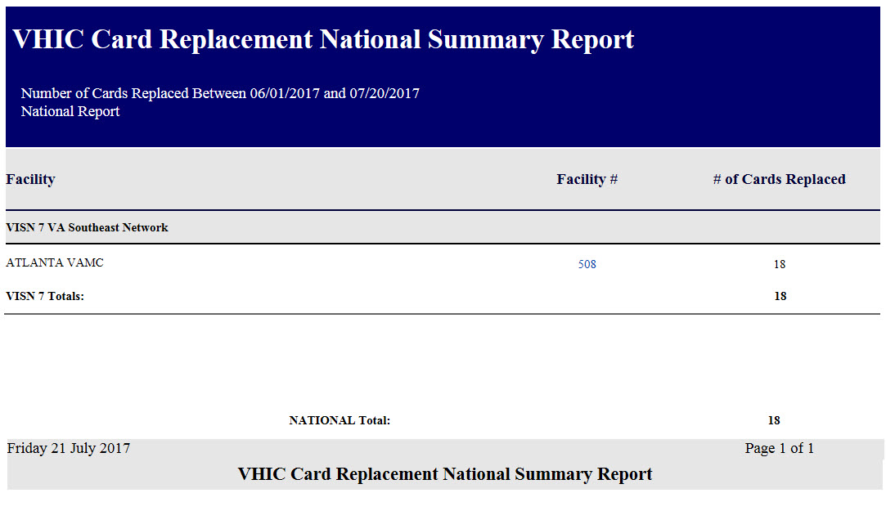
Figure 7-59: VHIC Card Replacement Summary Report – National

The VHIC Card Replacement Facility Report lists the Replacement Reasons and contains a hyperlink in the # of Cards Replaced column. Clicking the hyperlink takes the user to the VHIC Card Replacement Facility Sub-Reason Report.

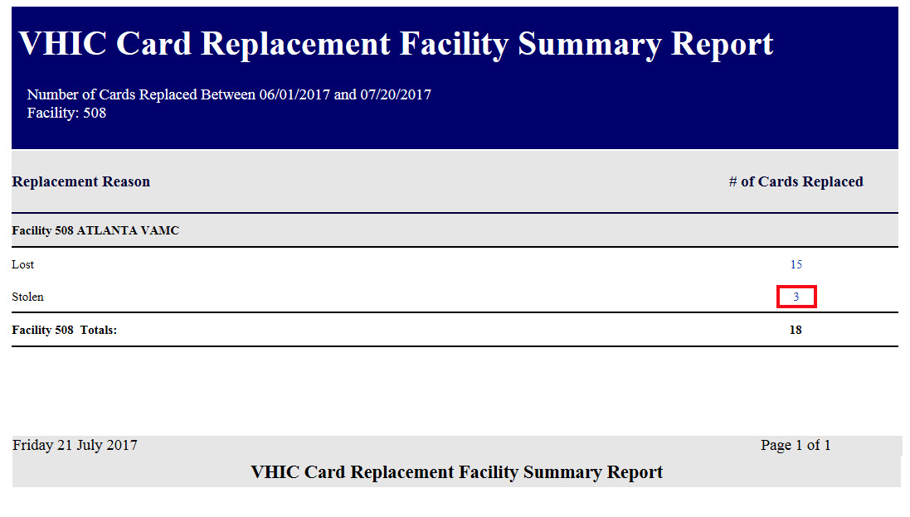
Figure 7-60: VHIC Card Replacement Facility Report – Summary

NOTE: The "No Matching Data" message will show when no records are returned to be consistent with the other summary level reports for this option.

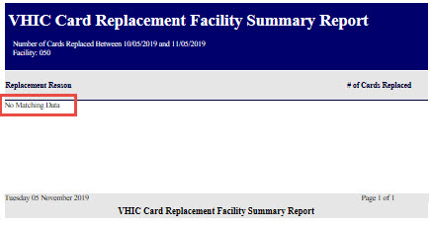
Figure 7-61: No Matching Data Message

The VHIC Card Replacement Facility Sub-Reason Report contains a hyperlink in the # of Cards Replaced column. Clicking the hyperlink opens up a detailed breakdown report by Veteran.

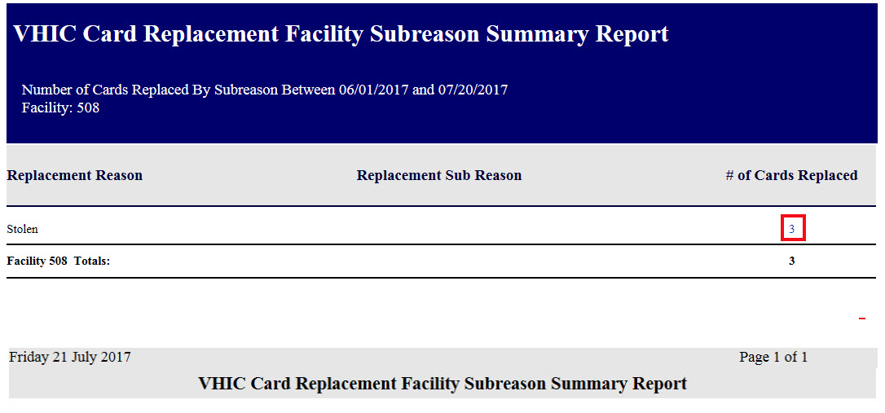
Figure 7-62: VHIC Card Replacement Facility Sub Reason Report – Summary

The VHIC Card Replacement Sub-Reason Detail contains hyperlinks in both the Card Number column and the Last 4 SSN column. Clicking the hyperlink under Card Number will take the user to the Card History Report for that Card ID, and clicking on the hyperlink under the Last 4 SSN takes the user to the Veteran Detail Report for the Veteran selected.

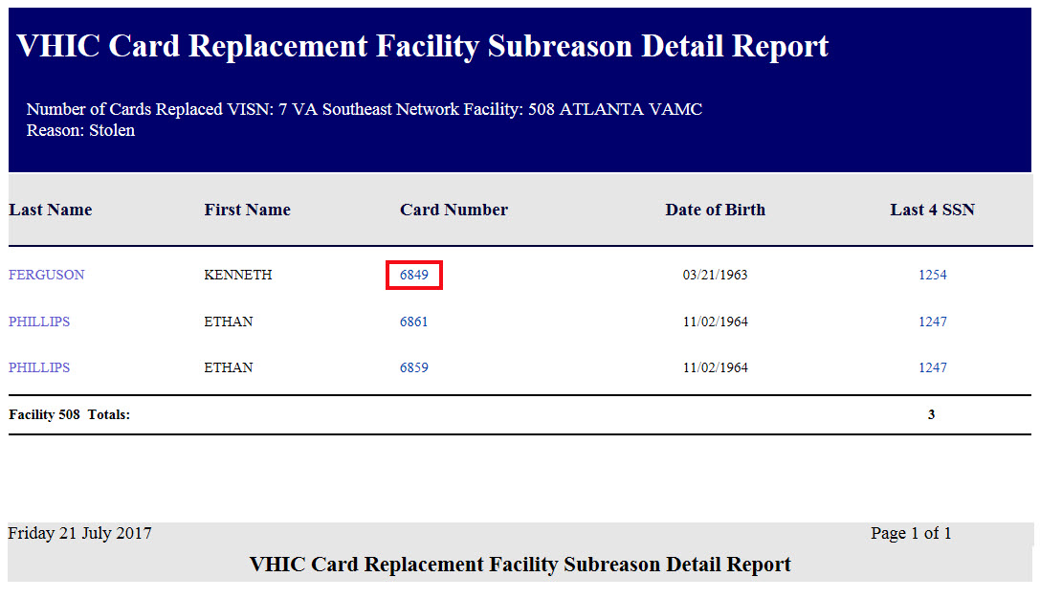
Figure 7-63: VHIC Card Replacement Facility Sub Reason Detail report

Card Expiration Report
Table 9: Card Expiration Report at a Glance
At a Glance…
Who can access this report? | Administrator, Supervisor, Associate, Tech Admin (Tier 3), Auditor
Who can access National version? | Administrator, Tech Admin (Tier 3), Auditor
Date Range Allowed | Administrator, Tech Admin (Tier 3), Auditor – unlimited  Supervisor, Associate – one (1) year or less from date report is being run
Search Criteria Available | VISN, Facility, Start Date, End Date

The Card Expiration Report allows the user to view information pertaining to VHICs that have expired. From the Card Expiration Report screen, the user can query expired cards by National, VISN, or Facility, depending on their role.

NOTE: The user can also find VHICs set to expire by selecting future start and end dates.

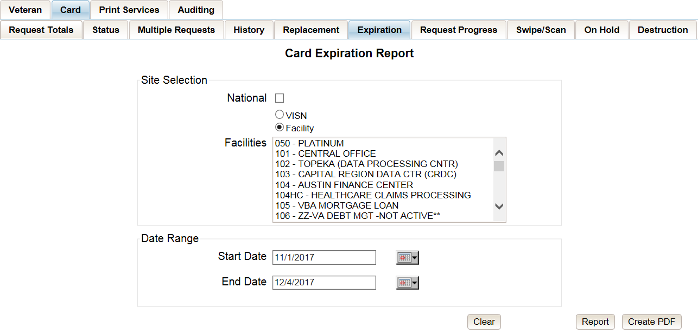
Figure 7-64: Card Expiration Report query screen – Administrators and Tech Administrators (Tier 3)

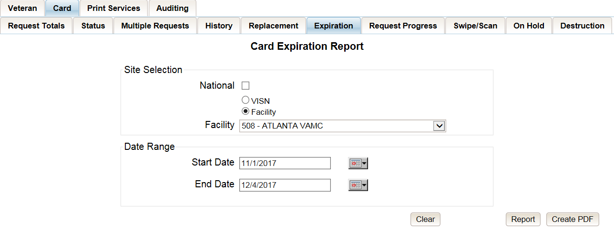
Figure 7-65: Card Expiration Report query screen – Auditors

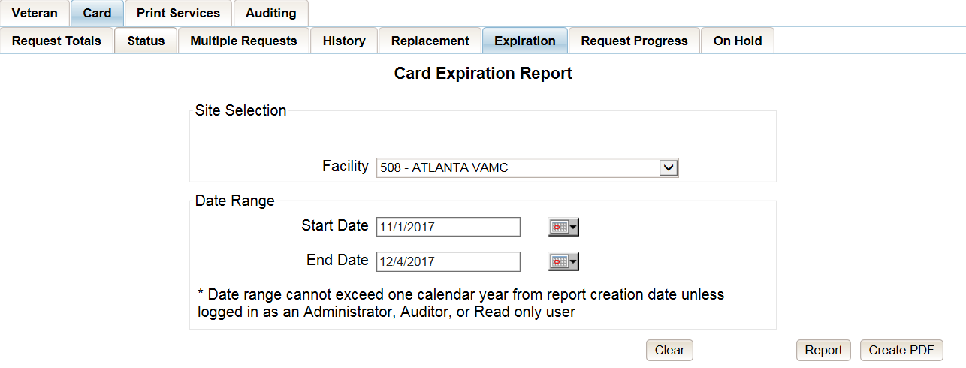
Figure 7-66: Card Expiration Report query screen – Supervisors

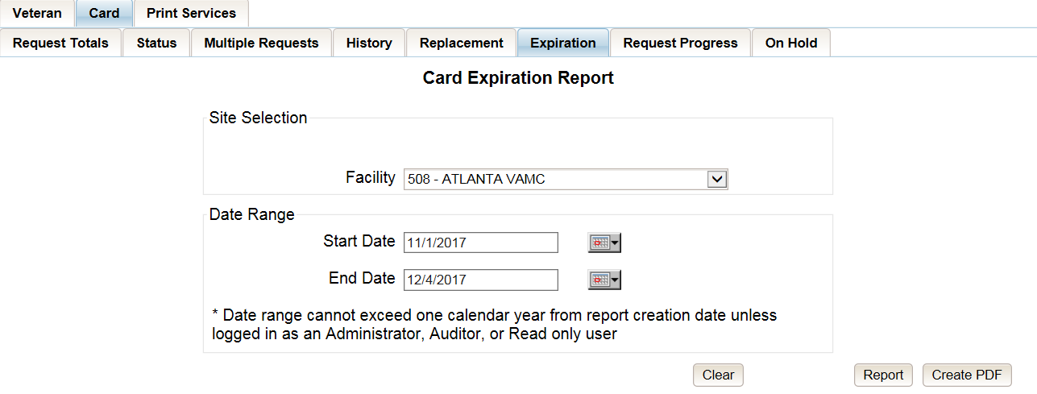
Figure 7-67: Card Expiration Report query screen – Associates
The VHIC Card Expiration Summary Report - National lists the VISNs and Facilities and contains a hyperlink in the VISN Number column. Clicking the hyperlink takes the user to the VHIC Card Replacement Site Report – VISN.

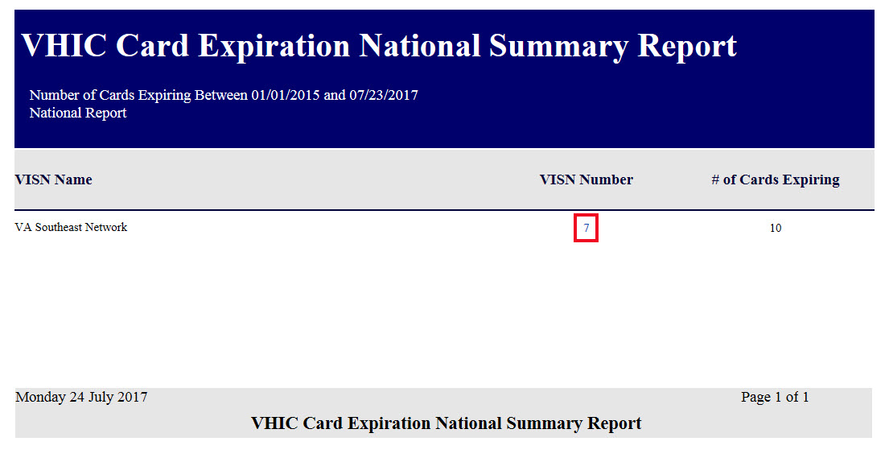
Figure 7-68: VHIC Card Expiration National Summary Report

The VHIC Card Expiration Site Report - VISN contains a hyperlink in the Facility Number column. Clicking the hyperlink opens up a detailed breakdown report by Veteran.

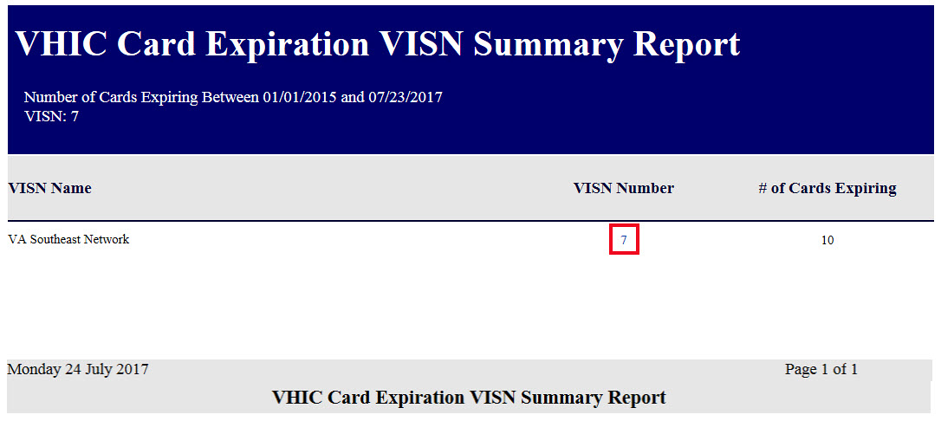
Figure 7-69: VHIC Card Expiration VISN Summary Report

In addition, when searching my Facility on the query screen, the VHIC user will be taken to VHIC Card Expiration Site Report – Facility. The VHIC Card Expiration Site Report - Facility contains a hyperlink in the Facility Number column. Clicking the hyperlink opens up a detailed breakdown report by Veteran.

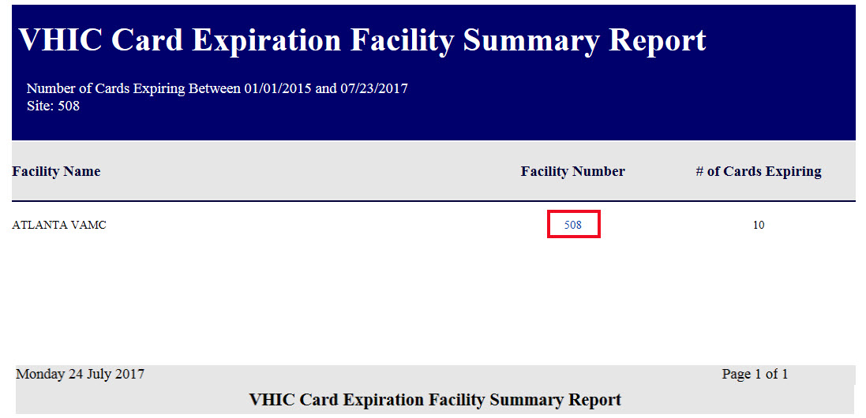
Figure 7-70: VHIC Card Expiration Facility Summary Report

The VHIC Card Expiration Detail Report contains hyperlinks in both the Card Number column and the Last 4 SSN column. Clicking the hyperlink under Card Number will take the user to the Card History Report for that Card ID, and clicking on the hyperlink under the Last 4 SSN takes the user to the Veteran Detail Report for the Veteran selected.

REDACTED
Figure 7-71: VHIC Card Expiration Facility Detail Report

Card Request Progress Report
Table 10: Card Request Progress Report at a Glance
At a Glance…
Who can access this report? | Administrator, Supervisor, Associate, Tech Admin (Tier 3), Auditor
Who can access National version? | Administrator, Tech Admin (Tier 3), Auditor
Date Range Allowed | Administrator, Tech Admin (Tier 3), Auditor – unlimited  Supervisor, Associate – one (1) year or less from date report is being run
Search Criteria Available | VISN, Facility, Start Date, End Date
There are many stages that a VHIC (card) goes through once the user clicks either the [Submit] button or the [Hold] button.
The Card Request Progress report allows the user to see how many cards are currently at each step of the Card Request lifecycle starting from the time the VHIC user clicks on either the [Submit] button or the [Hold] button, all the way through the mailed confirmation for a given VISN, Facility and Nationally, during a set time period.
The card request stages that are displayed on this report are: Pending, Request Submitted, On Hold, Defunct, Sent to Printer, Acknowledged, Rejected, and Confirmed Mailed.
This would allow the user to keep an eye on potential areas of trouble (i.e. Cards On-Hold or timing out and becoming Defunct) and be able to track down what is happening at each stage much easier.

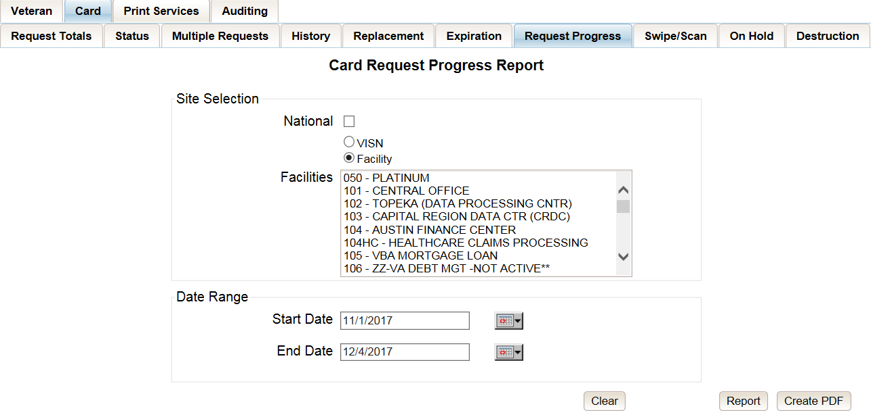
Figure 7-72: Card Request Progress Report query screen - Administrators and Tech Administrators (Tier 3)

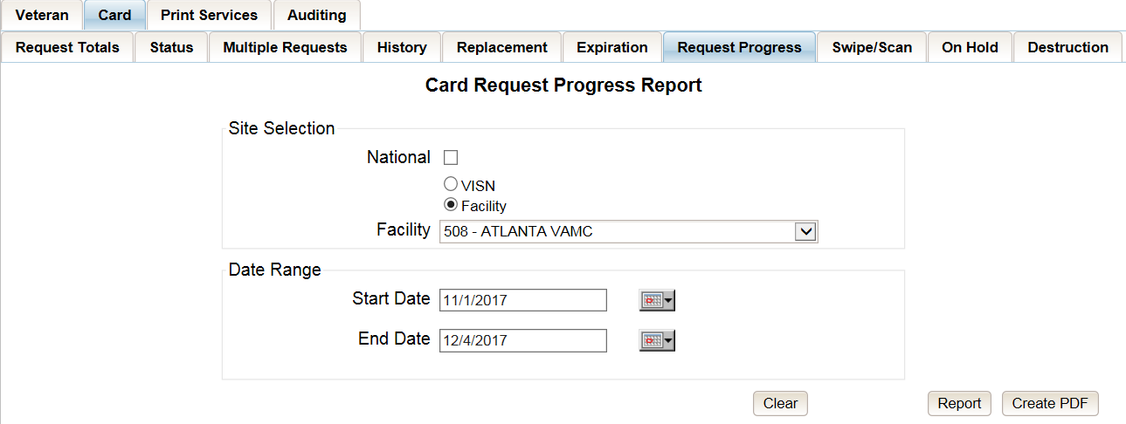
Figure 7-73: Card Request Progress Report query screen – Auditors

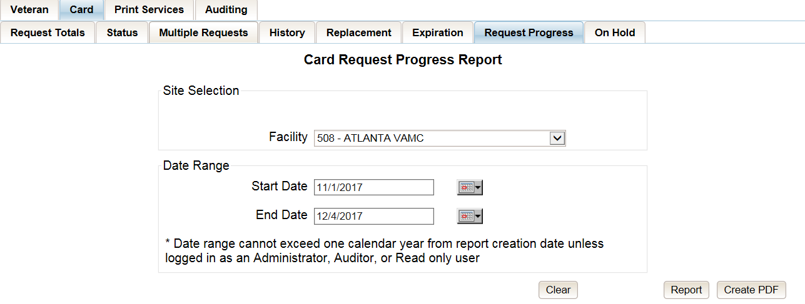
Figure 7-74: Card Request Progress Report query screen – Supervisors

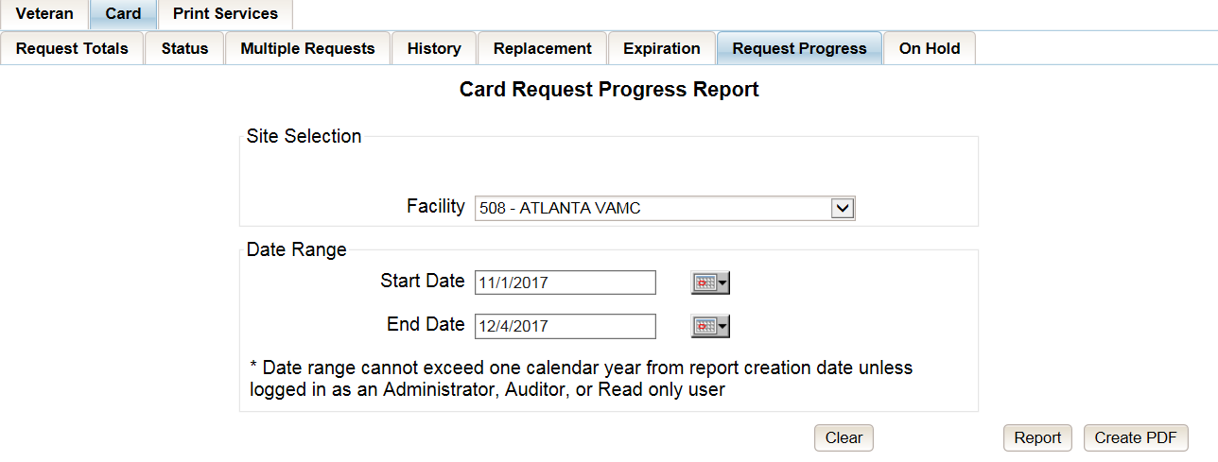
Figure 7-75: Card Request Progress Report query screen – Associates

The VHIC Card Request Progress National Summary Report lists all of the VISNs and contains a hyperlink in the VISN # column. Clicking the hyperlink takes the user to the VHIC Card Request Progress VISN Summary Report.

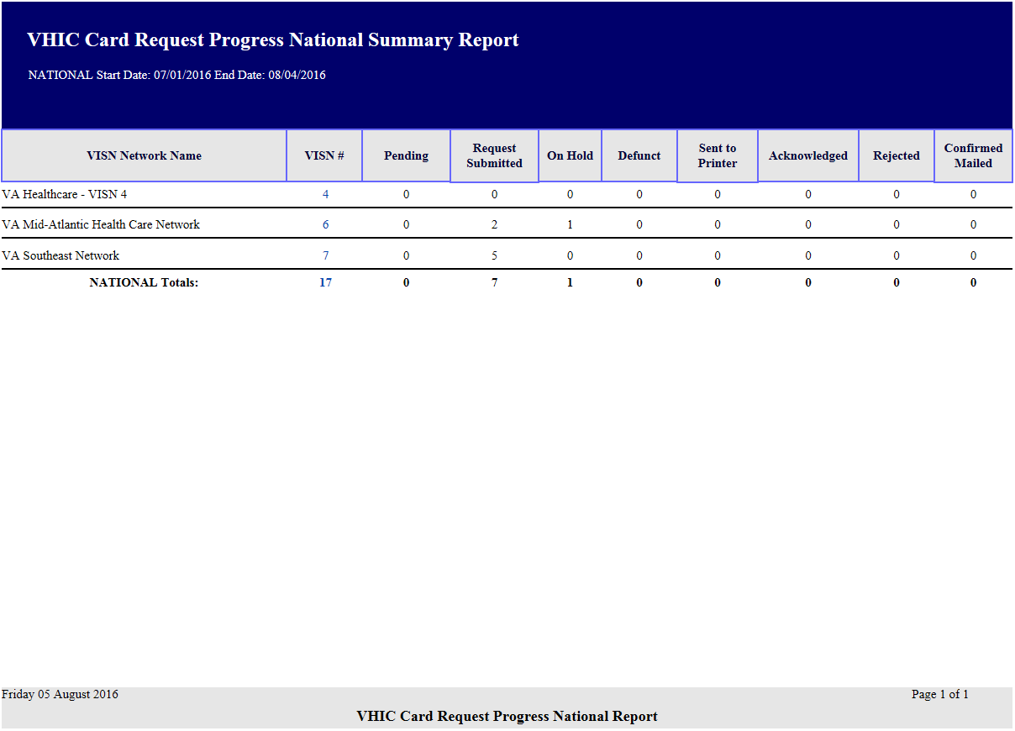
Figure 7-76: VHIC Card Request Progress National Summary Report

The VHIC Card Request Progress VISN Summary Report lists all of the Facilities included in the selected VISN and contains a hyperlink in the Facility # column. Clicking the hyperlink takes the user to the VHIC Card Request Progress Facility Summary Report.

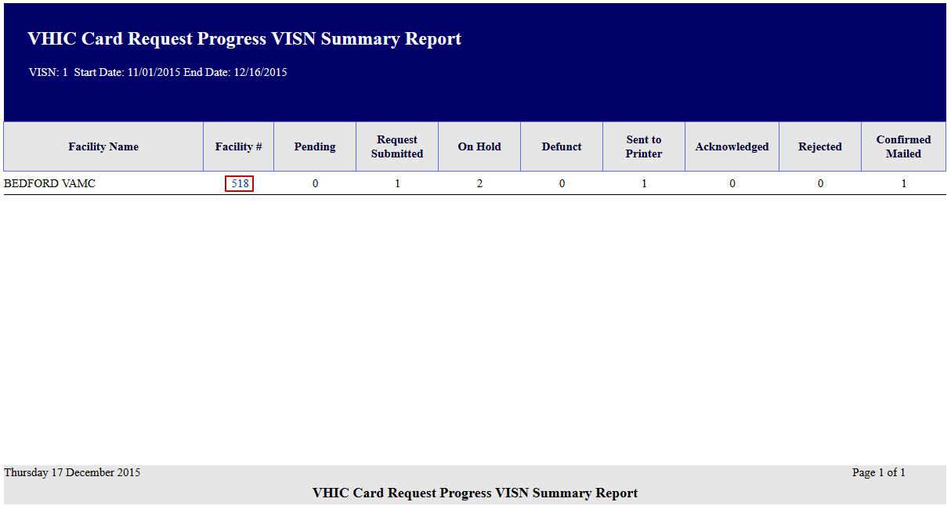
Figure 7-77: VHIC Card Request Progress VISN Summary Report

The VHIC Card Request Progress Facility Summary Report contains a hyperlink on the number displayed for each progress status column. Clicking the hyperlink takes the user to the VHIC Card Request Progress Facility Detail Report for the selected progress status.

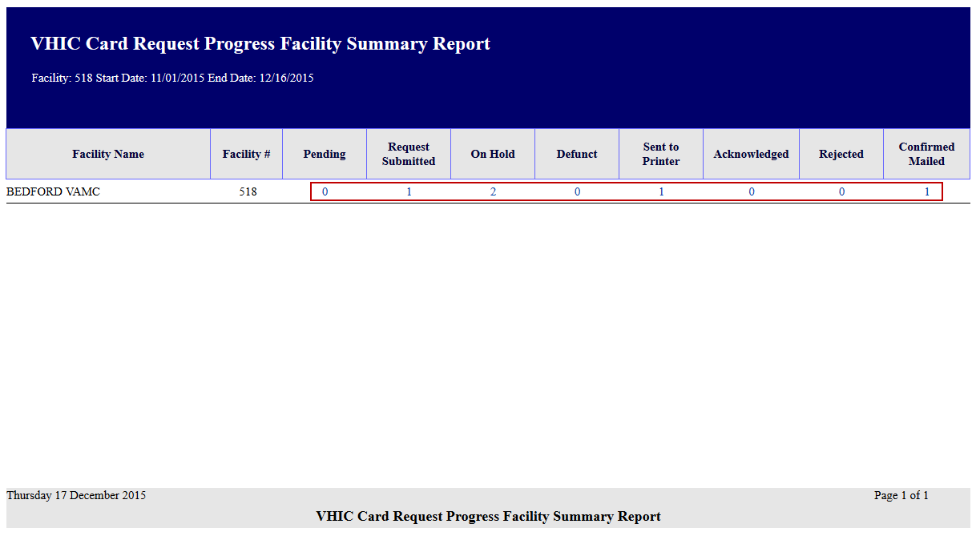
Figure 7-78: VHIC Card Request Progress Facility Summary Report

The VHIC Card Request Progress Facility Detail Report will provide a detailed list of all the cards that have the selected status. The user will be able to see the Status Date, Veteran’s Name, Card ID, and Member ID (if available).

The VHIC Card Request Progress Facility Detail Report contains hyperlinks in both the Card Number column and the Last Name column. Clicking the hyperlink under Card Number will take the user to the Card History Report for that Card ID, and clicking on the hyperlink under the Last Name takes the user to the Veteran Detail Report for the Veteran selected.

REDACTED
Figure 7-79: VHIC Card Request Progress Facility Detail Report

Card Swipe/Scan Report
Table 11: Card Swipe/Scan Report at a Glance
At a Glance…
Who can access this report? | Administrator, Tech Admin (Tier 3), Auditor
Who can access National version? | N/A
Date Range Allowed | N/A
Search Criteria Available | Card ID
The Card Swipe/Scan Report allows the Administrator, Tech Admin (Tier 3) and the Auditor to look up information for a given card ID indicating the location and time where the card has been swiped or scanned .

After entering the Card ID number, select the [Report] button to view the results.

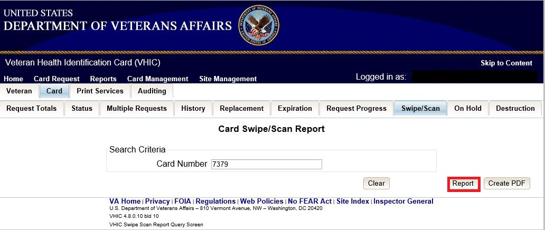
Figure 7-80: VHIC Card Swipe/Scan Report query screen - Administrators, Tech Administrators (Tier 3), and Auditors

The VHIC Card Swipe Scan Report displays the Facility Name, Facility Number, Vista Option (whether the card was Swiped or Scanned), and the Date and Time the VHIC was Swiped or Scanned in the yyyy-MM-dd hhmmss format.
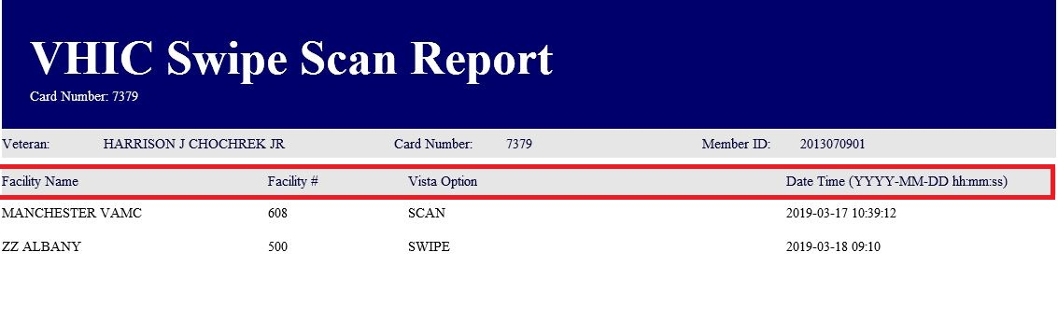
Figure 7-81: VHIC Swipe Scan Report results

After selecting the [Create PDF] button, a pop up window will appear asking if you want to open the PDF or save it to your computer.
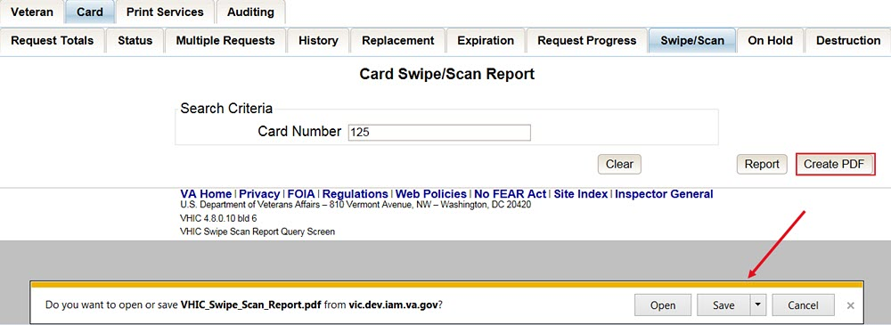
Figure 7-82: Create Swipe Scan PDF

A PDF version of the VHIC Swipe Scan Report results will be generated.
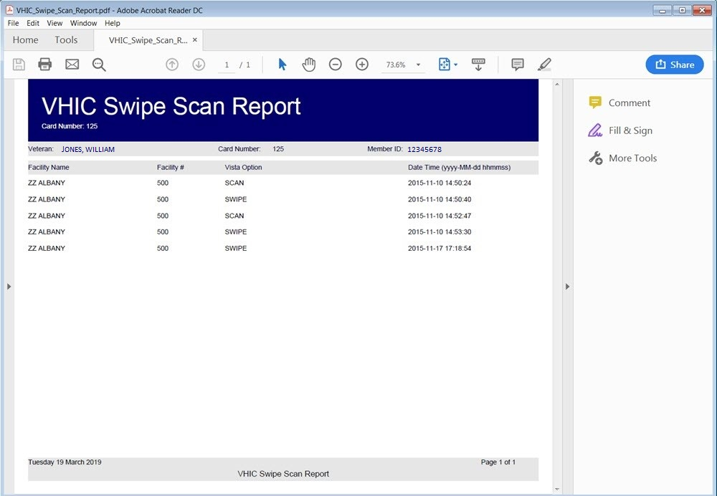
Figure 7-83: VHIC Swipe Scan Report results PDF

Clicking the [Clear] button will reset the query for a new Card Number.
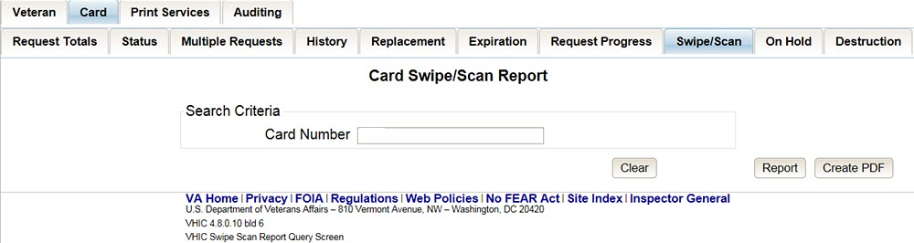
Figure 7-84: Card Swipe/Scan Report

Card On Hold Report
Table 12: On Hold Status Report at a Glance
At a Glance…
Who can access this report? | Administrator, Tech Admin (Tier 3), Supervisor, Associate, Auditor
Who can access National version? | Administrator, Tech Admin (Tier 3), Auditor
Date Range Allowed | Admins, Tech Admin (Tier 3), Auditor – unlimited  Supervisor, Associate – one (1) year or less from date report is being run
Search Criteria Available | VISN, Facility, Start Date, End Date
The On Hold Status Report contains one category: On Hold Status. This report has the usual search criterial options such as National, VISN or Facility, Start Date, and End Date. Along with those, the user must select one of seven On Hold Status options: All, Not Proofed, Eligibility Pending, Enrollment Services Unavailable, Not Correlated, No Photo, No EDIPI, and Bad Data.
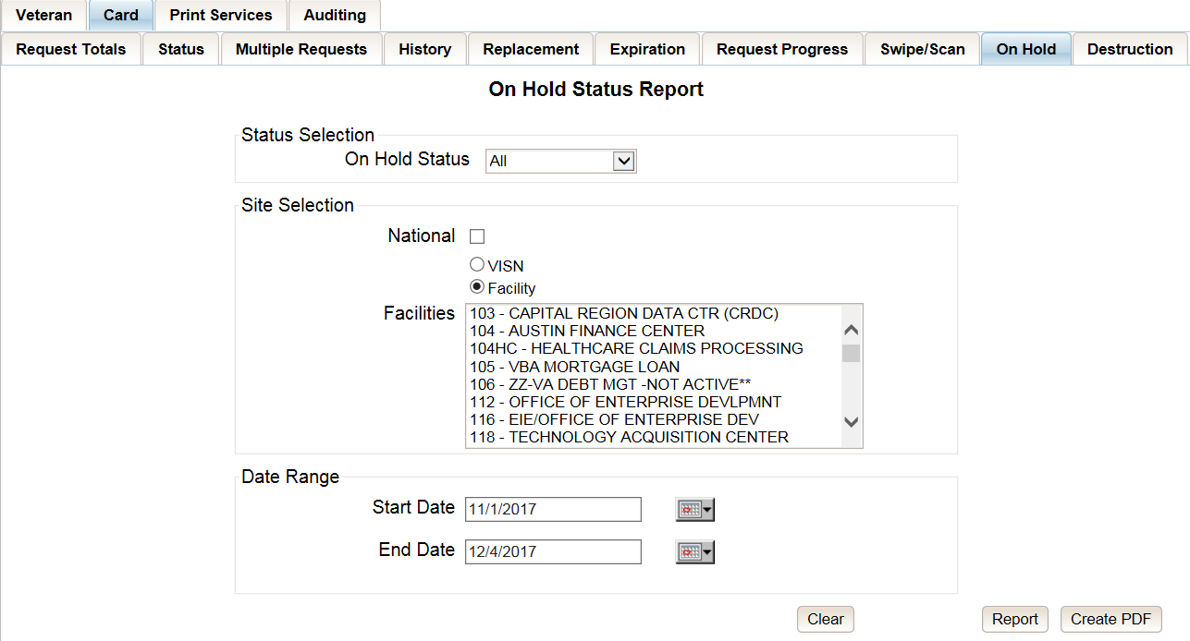
Figure 7-85: On Hold Status Report query screen – Administrator and Tech Administrator (Tier 3)

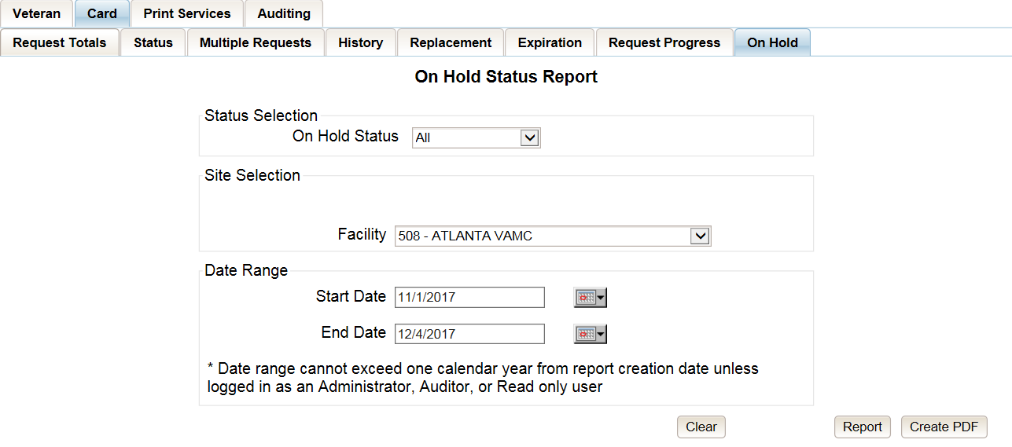
Figure 7-86: On Hold Status Report query screen – Supervisor

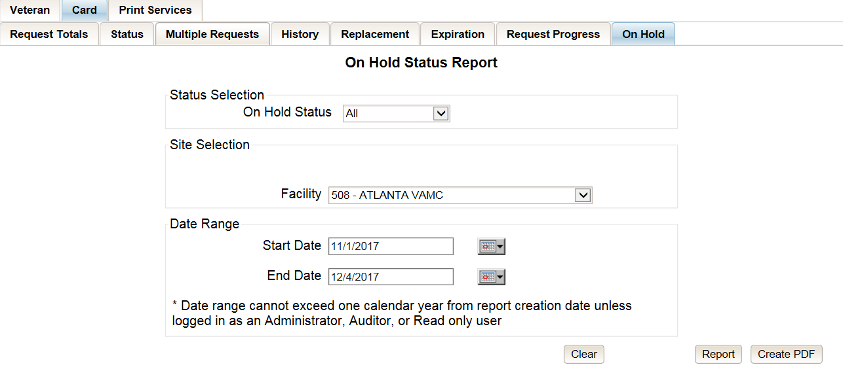
Figure 7-87: On Hold Status Report query screen – Associate

The VHIC On Hold Card Status National Summary Report lists all of the VISNs and contains a hyperlink in the VISN # column. Clicking the hyperlink takes the user to the VHIC On Hold Card Status VISN Summary Report.
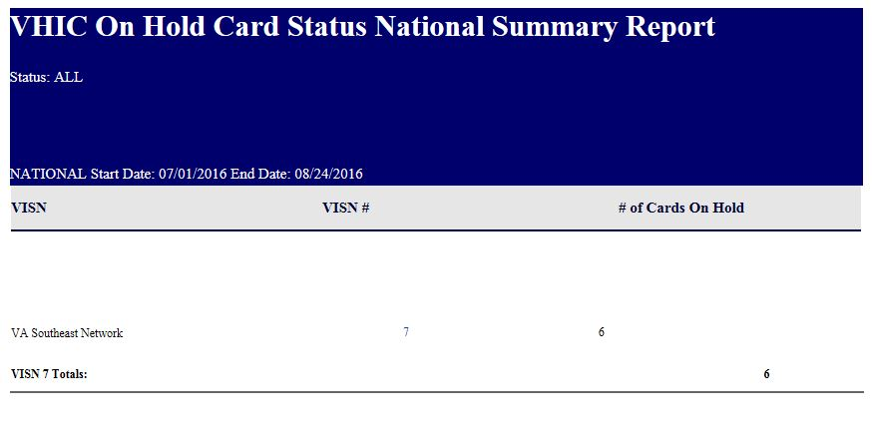
Figure 7-88: VHIC On Hold Card Status National Summary Report

The VHIC On Hold Card Status VISN Summary Report lists all of the Facilities pertaining to the selected VISN and contains a hyperlink in the Facility # column. Clicking the hyperlink takes the user to the VHIC On Hold Card Status Facility Summary Report.
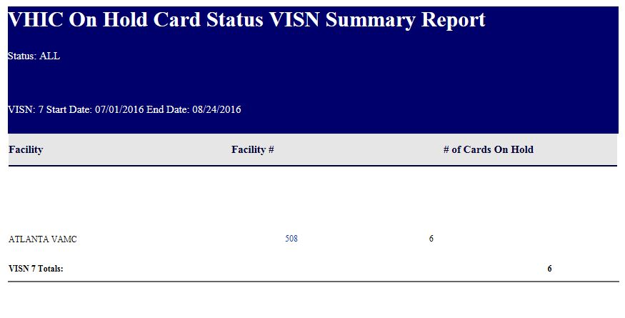
Figure 7-89: VHIC On Hold Card Status VISN Summary Report

The VHIC On Hold Card Status Facility Summary Report displays the total number of cards On Hold for the selected Facility VISN and contains a hyperlink in the Facility # column. Clicking the hyperlink takes the user to the VHIC On Hold Card Status Facility Detail Report.

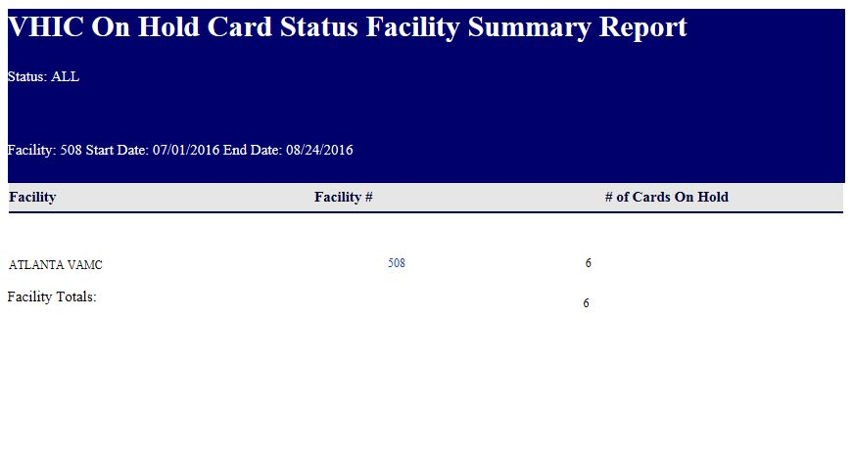
Figure 7-90: VHIC On Hold Card Status Facility Summary Report

The VHIC On Hold Card Status Facility Detail Report contains several columns: Facility Name, Facility #, On Hold Date, On Hold Reason, Card Issuer, Last Name, and Card Id. The purpose of this report is to provide detailed information in regard to cards that are, or have been, placed on hold. There are hyperlinks in the Last Name and Card ID columns.
- Clicking on the hyperlinked Last Name will take the user to the VHIC Veteran Detail Report
- Clicking the hyperlinked Card ID will take the user to the VHIC Card History Report

REDACTED
Figure 7-91: VHIC On Hold Card Status Facility Detail Report
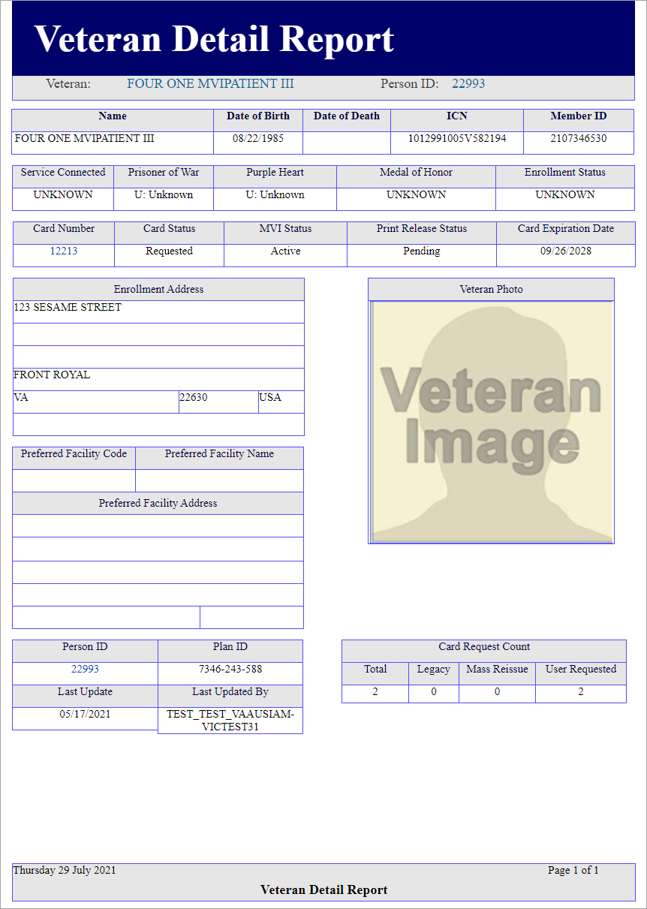
Figure 7-92: VHIC Veteran Detail Report
Figure 7-93: VHIC Card History by Card ID

Card Destruction Report
Table 13: Card Destruction Report at a Glance
At a Glance…
Who can access this report? | Administrator, Tech Admin (Tier 3), Auditor
Who can access National version? | N/A
Date Range Allowed | Admins, Tech Admin (Tier 3), Auditor – unlimited
Search Criteria Available | Pending Destruction, Destroyed, Card Type, Start Date, End Date
The Card Destruction Report contains two categories: Pending Destruction and Destroyed. The user must also a select one of four Card Type options: All, Legacy, Mass Reissuance, and VHIC. As with other searches, the user must specify a Start Date and End Date range for the search.

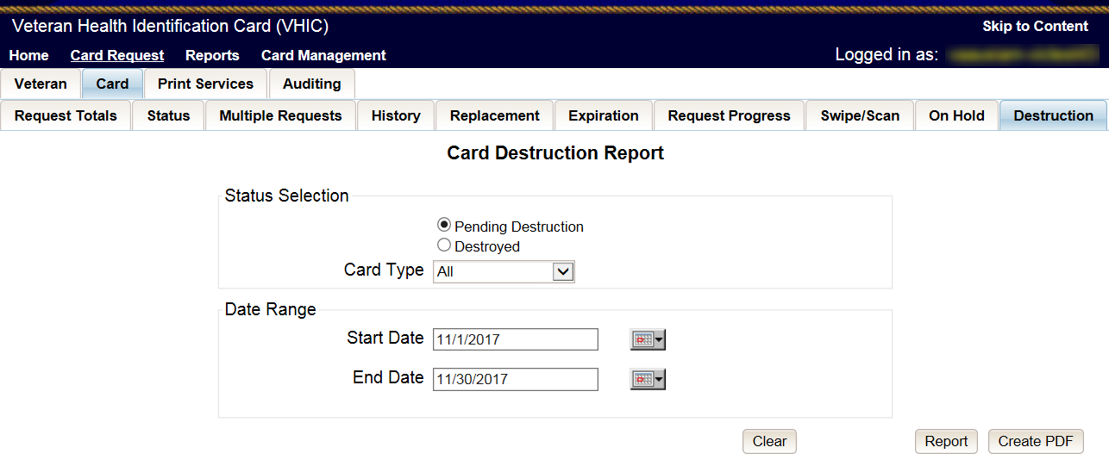
Figure 7-94: Card Destruction Report – Administrators and Tech Administrators (Tier 3)

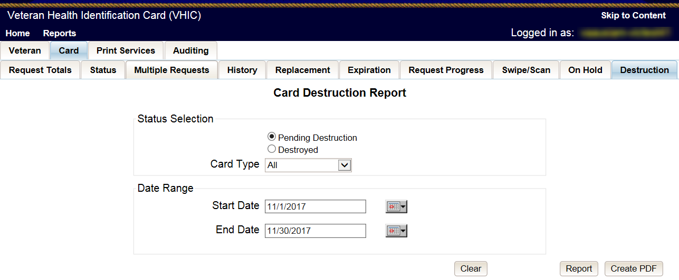
Figure 7-95: Card Destruction Report – Auditors

Choosing Pending Destruction and Card Type All, users receive the VHIC Card Destruction Report – Pending Destruction report. Click the Last Name hyperlink highlighted below.
REDACTED
Figure 7-96: Card Destruction Report – Pending Destruction – Last Name Hyperlink

This returns the Veteran Detail Report.

Figure 7-97: Veteran Detail Report

Click the Card ID hyperlink highlighted below.

REDACTED
Figure 7-98: Card Destruction Report – Pending Destruction – Last Name Hyperlink

The Card ID hyperlink opens the VHIC Card History by Card ID Report.
Figure 7-99: VHIC Card History by Card ID Report
NOTE: Clicking the Person ID hyperlink, in the upper right-hand corner of the VHIC Card History by Card ID Report, opens the Veteran Detail Report.
Choosing Destroyed and Card Type All, the user receives the VHIC Card Destruction Report – Destroyed report. Click the Last Name hyperlink highlighted below.

REDACTED
Figure 7-100: VHIC Card History by Card ID Report

The Last Name hyperlink opens the Veteran Detail Report.
Figure 7-101: Veteran Detail Report

Click the Card ID hyperlink highlighted below.
REDACTED
Figure 7-102: VHIC Card Destruction Report - Destroyed - Card ID Hyperlink

The Card ID hyperlink opens the VHIC Card History by Card ID Report.
Figure 7-103: VHIC Card History by Card ID Report

NOTE: Clicking the Person ID hyperlink, in the upper right-hand corner of the VHIC Card History by Card ID Report, opens the Veteran Detail Report.

Print Services – Processing Report
Table 14: Batch Summary Report at a Glance
At a Glance…
Who can access this report? | Administrator, Supervisor, Tech Admin (Tier 3), Auditor
Who can access National version? | Administrator, Tech Admin (Tier 3), Auditor
Date Range Allowed | Admins, Tech Admin (Tier 3), Auditor – unlimited  Supervisor, Associate – one (1) year or less from date report is being run
Search Criteria Available | VISN, Facility, Start Date, End Date

Clicking [Submit] on step 6 of the Card Request process does not immediately transmit a card request to the print vendor. The card requests from all sites are stored throughout the day, then bundled and transmitted to the print vendor in one batch file. When the print vendor receives the batch file, they send back a confirmation message. The Print Services Reports provide the user with information received from the Print Vendor after sending the batch files.
After processing the card requests in a batch file, the print vendor sends back to VHIC an acknowledgement file for every request specifying success or failure in card printing. The numbers in the report comes from the data updated by the confirmation and acknowledgement files received from the print vendor.
The Print Services Processing Status Summary Report date fields are not auto-populated like most of the other reports. The user must populate them prior to running the report.

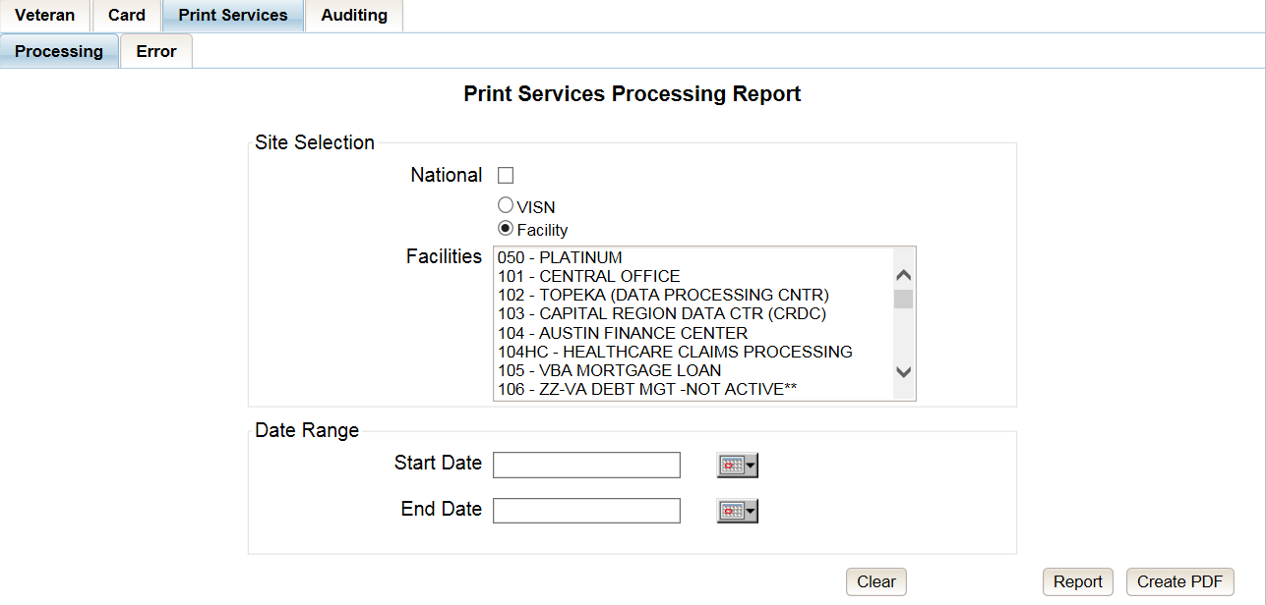
Figure 7-104: VHIC Print Services Processing Status Summary Report – Administrators and Tech Administrators (Tier 3)

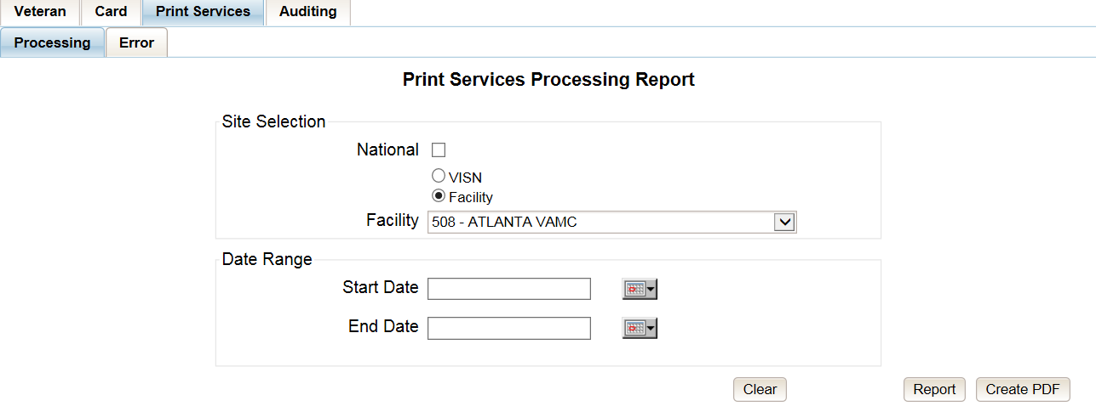
Figure 7-105: VHIC Print Services Processing Status Summary Report – Auditors

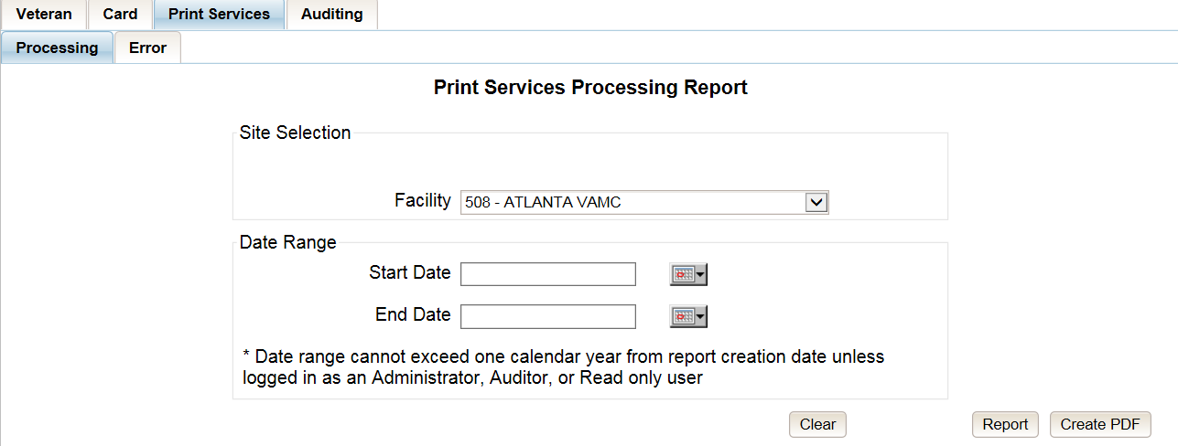
Figure 7-106: VHIC Print Services Processing Status Summary Report – Supervisors

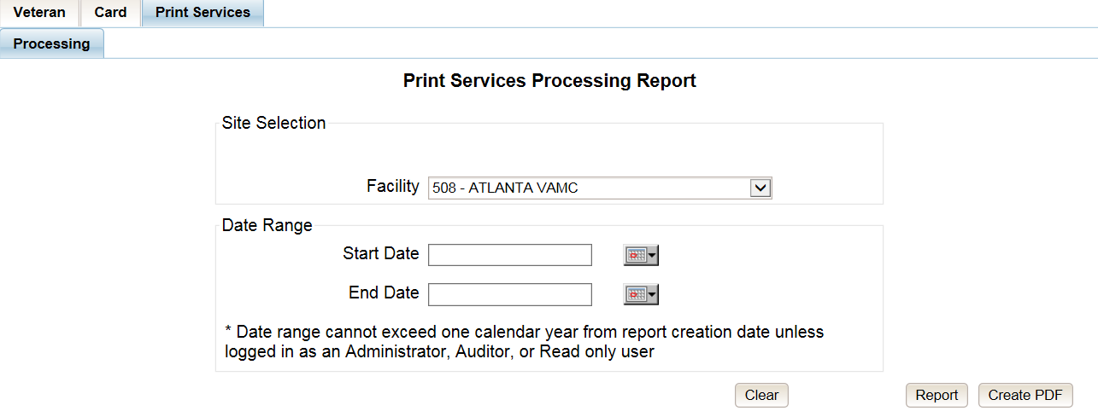
Figure 7-107: VHIC Print Services Processing Status Summary Report query screen – Associates
The VHIC Batch File Processing Status Summary Report provides a high-level count of Accepted, Error, Sent, Mailed, and Rejected card requests. The VHIC Batch File Processing Status National Summary Report has a hyperlink in the VISN number column that will take you to the VHIC Batch File Processing Status Summary Report – VISN.

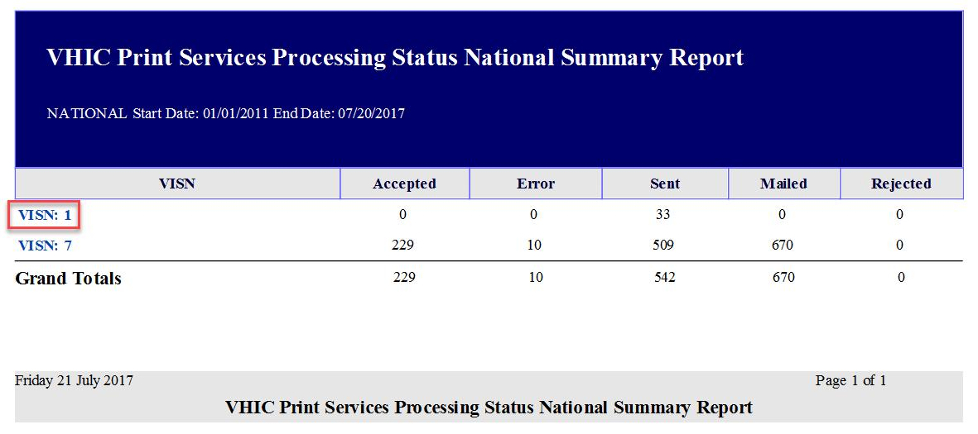
Figure 7-108: VHIC Print Services Processing Status Summary Report

The VHIC Batch File Processing Status Summary Report – VISN has a hyperlink in the Facility Code column that will take you to the VHIC Batch File Processing Status Summary Report – Facility.

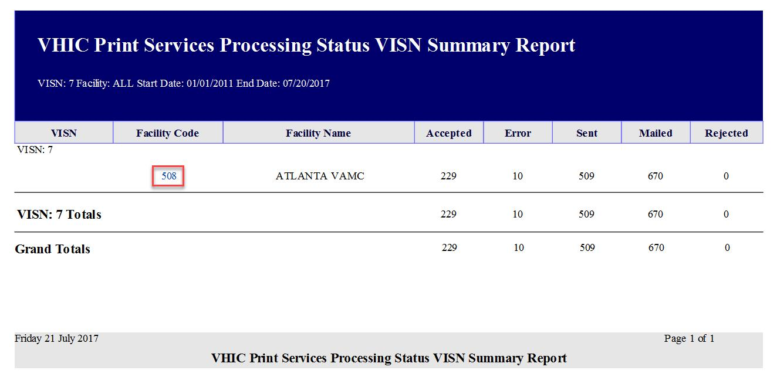
Figure 7-109: VHIC Print Services Processing Status VISN Summary Report

The VHIC Batch File Processing Status Summary Report – Facility has a hyperlink in the Facility Code column that will take you to the VHIC Batch File Processing Status Detail Report.
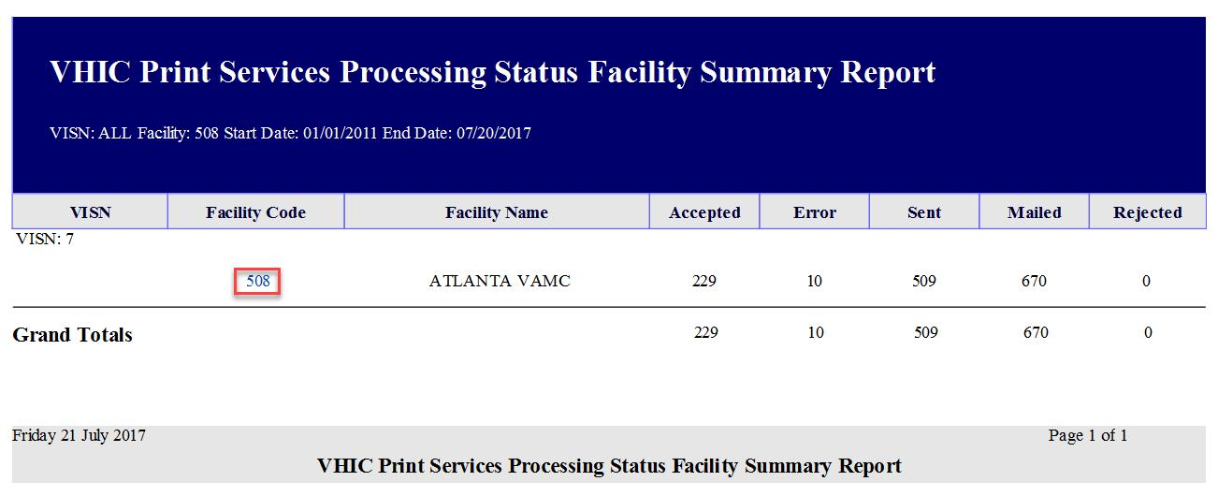
Figure 7-110: VHIC Print Services Processing Status Facility Summary Report
REDACTED
Figure 7-111: VHIC Print Services Processing Status Facility Detail Report

Print Services – Batch Error Report
Table 15: Batch Error Report at a Glance
At a Glance…
Who can access this report? | Administrator, Supervisor, Tech Admin (Tier 3), Auditor
Who can access National version? | Administrator, Tech Admin (Tier 3), Auditor
Date Range Allowed | Admins, Tech Admin (Tier 3), Auditor – unlimited  Supervisor – one (1) year or less from date report is being run
Search Criteria Available | VISN, Facility, Not Acknowledged, Acknowledged Not Confirmed, Pending Not Sent (which includes configurable Number of Days field), Start Date, End Date

The VHIC Print Error Status Summary Report – Sent Not Acknowledged allows the user to find out how many cards have not been acknowledged with an acknowledgement file or cards that have been acknowledged but have received no confirmation of being mailed within a given date range. The user will also be able to see how many cards are still sitting in a Pending state and have not been sent to the print vendor.
The user would be able to select the number of days to configure the query. How many days after being sent to the printer before looking for an Acknowledgement file, how many days after getting the Acknowledgement file before receiving Confirmation of it being mailed, or how many days has the card been sitting at a Pending status but has not been sent to the print vendor.
The user would be able to select between National, VISN, and Facility depending on their role.

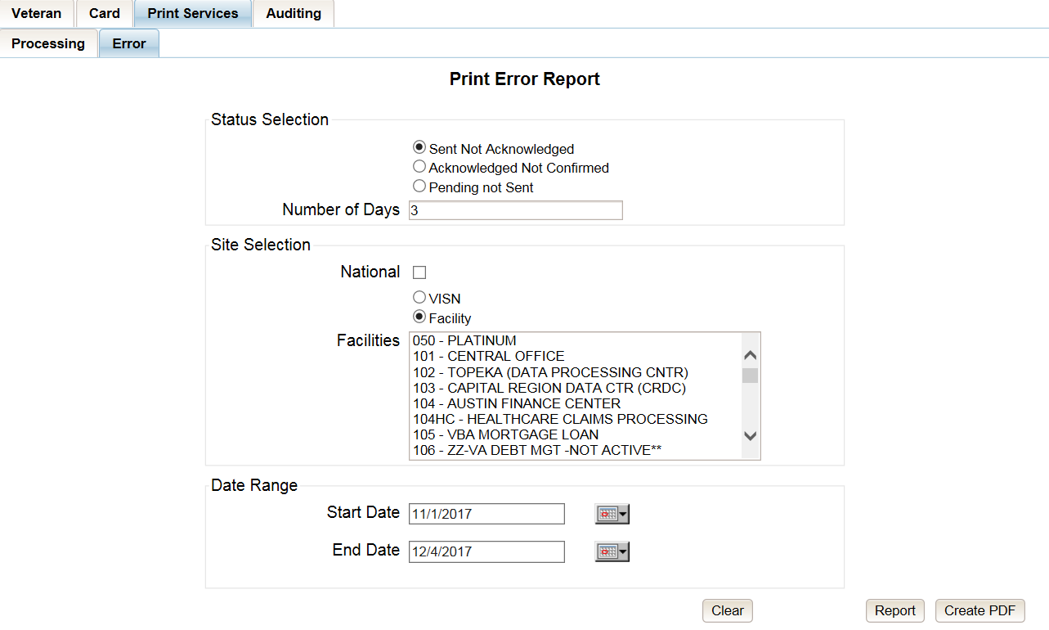
Figure 7-112: Print Services – Print Error Status Report query screen – Administrators and Tech Administrators (Tier 3)

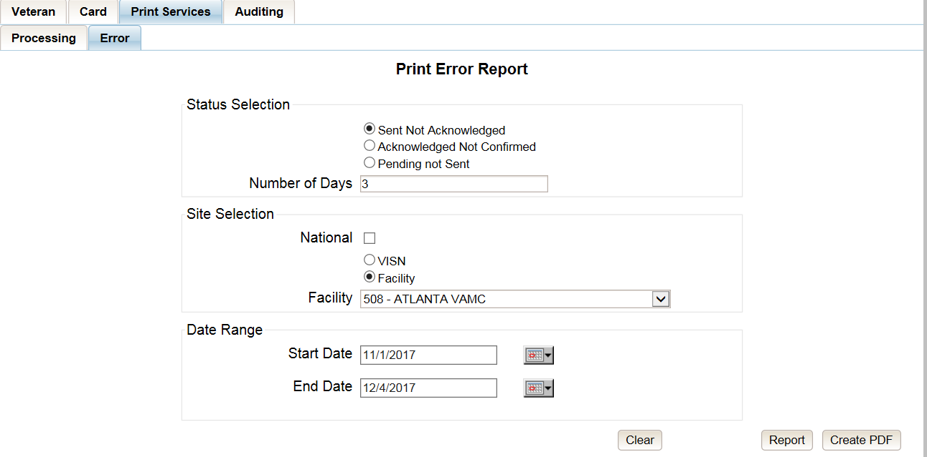
Figure 7-113: Print Services - Print Error Status Report query screen – Auditors

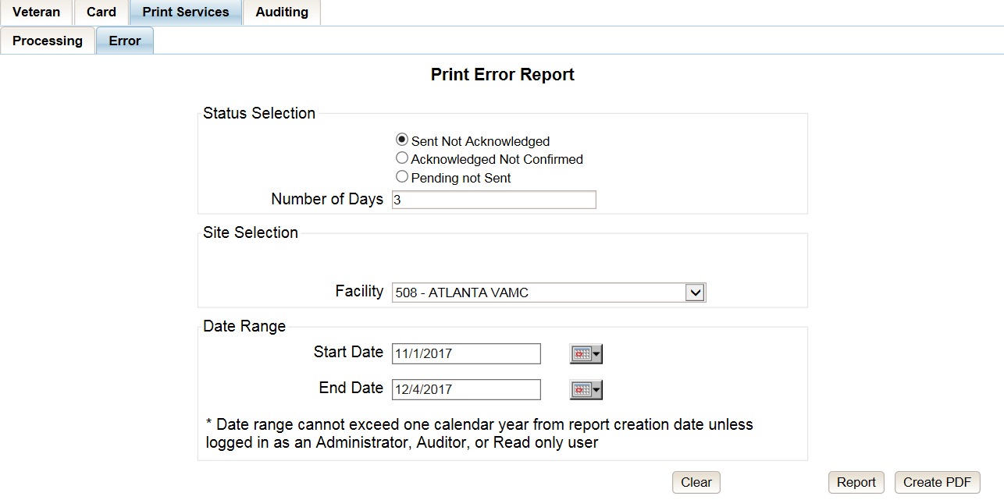
Figure 7-114: Print Services - Print Error Status Report query screen – Supervisors

Sent Not Acknowledged
By selecting the [Not Acknowledged] radio button, the VHIC user will be able to see how many cards have not been acknowledged as received within the entered Number of Days (the default is three (3) days) after being sent to the print vendor during the selected Date Range.

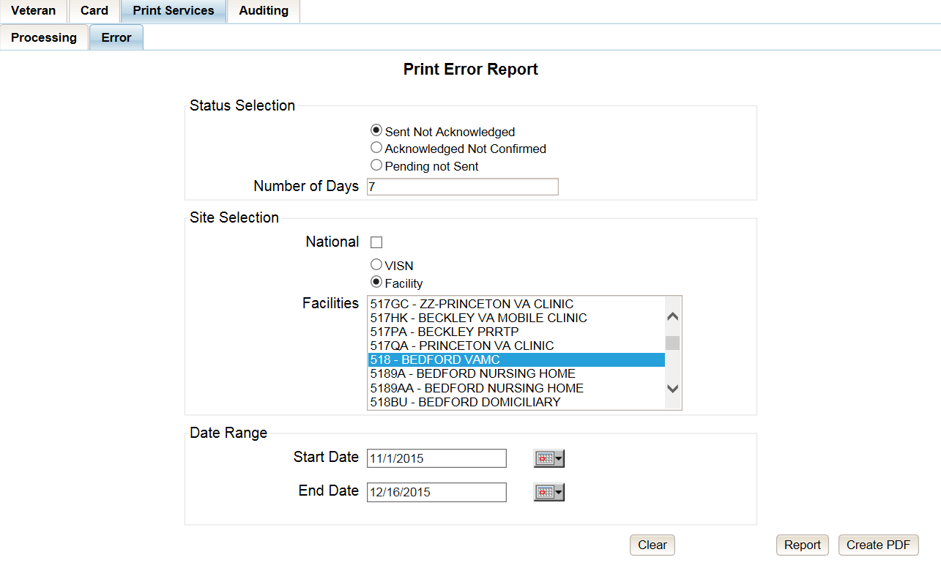
Figure 7-115: VHIC Print Error Status Facility Summary Report – Sent Not Acknowledged

The National Error Summary report lists all of the VISNs and the VISN # is a hyperlink to the VISN Error Summary Report.

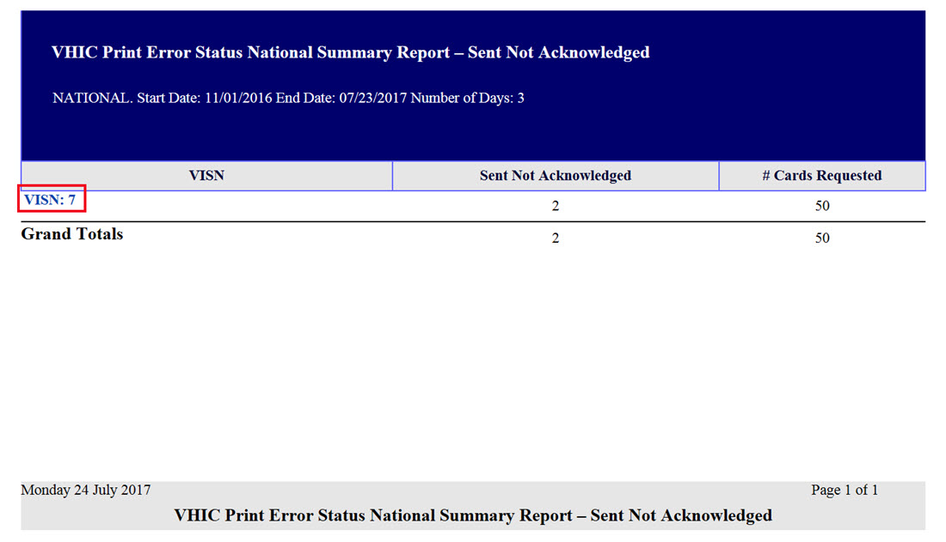
Figure 7-116: VHIC Print Error Status National Summary Report – Sent Not Acknowledged

The VISN Error Summary Report lists all of the Facilities for the selected VISN. The Facility # is a hyperlink to the Facility Error Summary Report.

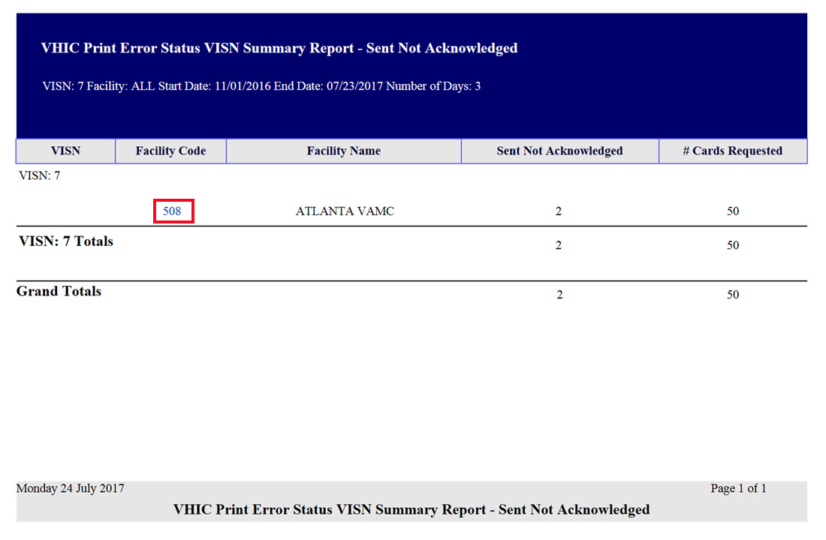
Figure 7-117: VHIC Print Error Status VISN Summary Report – Sent Not Acknowledged

The Facility Error Summary Report shows the totals for the selected Facility. The Facility # is a hyperlink to the Facility Error Detail Report.

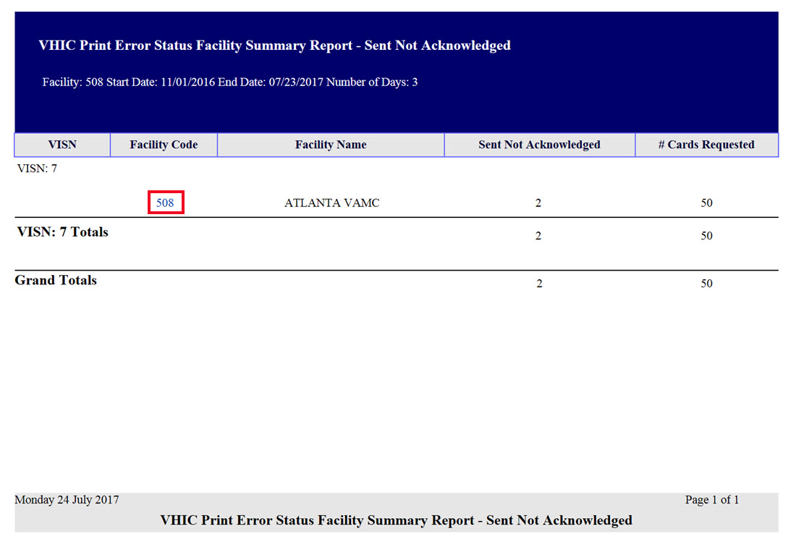
Figure 7-118: VHIC Print Error Status Facility Summary Report – Sent Not Acknowledged

The Facility Error Detail Report would give a list of all of the cards that have NOT been Acknowled by the print vendor and will display the Veteran’s Name, Card ID, and the Card Request File name.

REDACTED
Figure 7-119: VHIC Batch File Processing Error Status Detail Report - Not Acknowledged

Acknowledged Not Confirmed
By selecting the [Acknowledged Not Confirmed] radio button, the VHIC user will be able to see how many cards have been acknowledged as received but have NOT been confirmed as mailed within the entered Number of Days (the default is seven (7) days) after receiving the acknowledgement file from the print vendor during the selected Date Range.

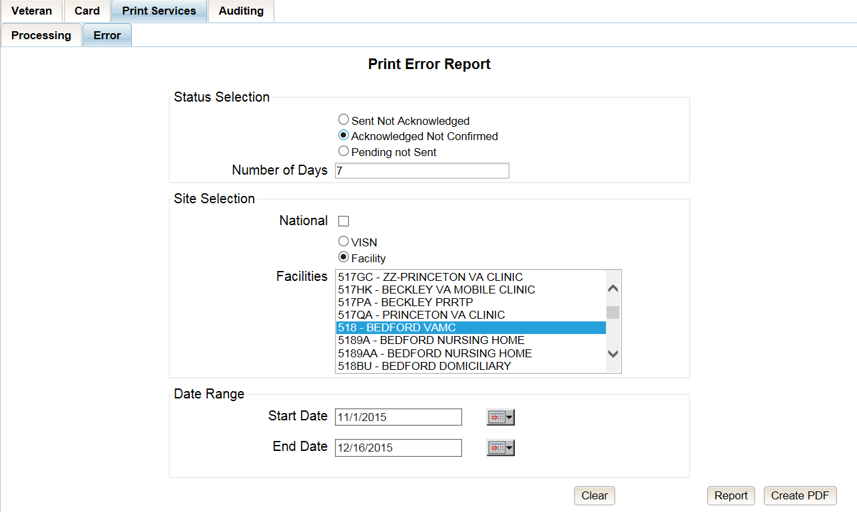
Figure 7-120: VHIC Print Error Status Facility Detail Report – Acknowledged Not Confirmed

The National Error Summary report lists all of the VISNs and the VISN # is a hyperlink to the VISN Error Summary Report.

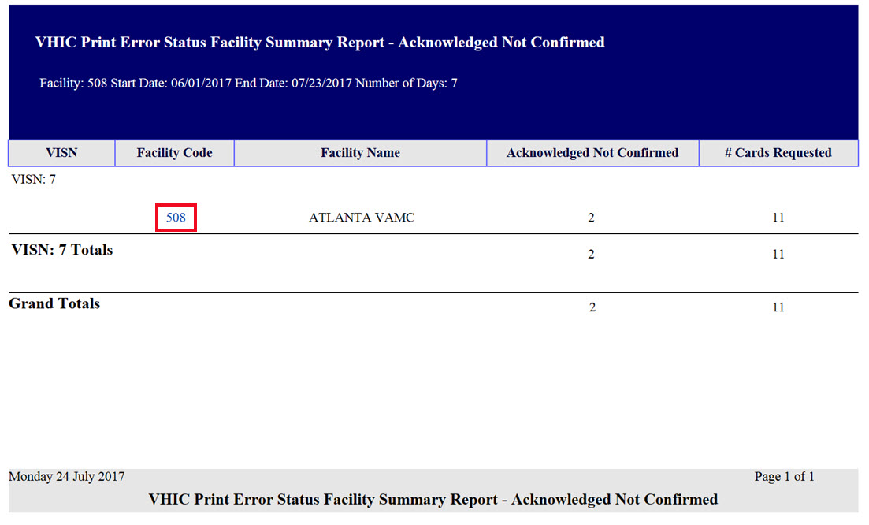
Figure 7-121: VHIC Print Error Status National Summary Report – Acknowledged Not Confirmed

The VISN Error Summary Report lists all of the Facilities for the selected VISN. The Facility # is a hyperlink to the Facility Error Summary Report.

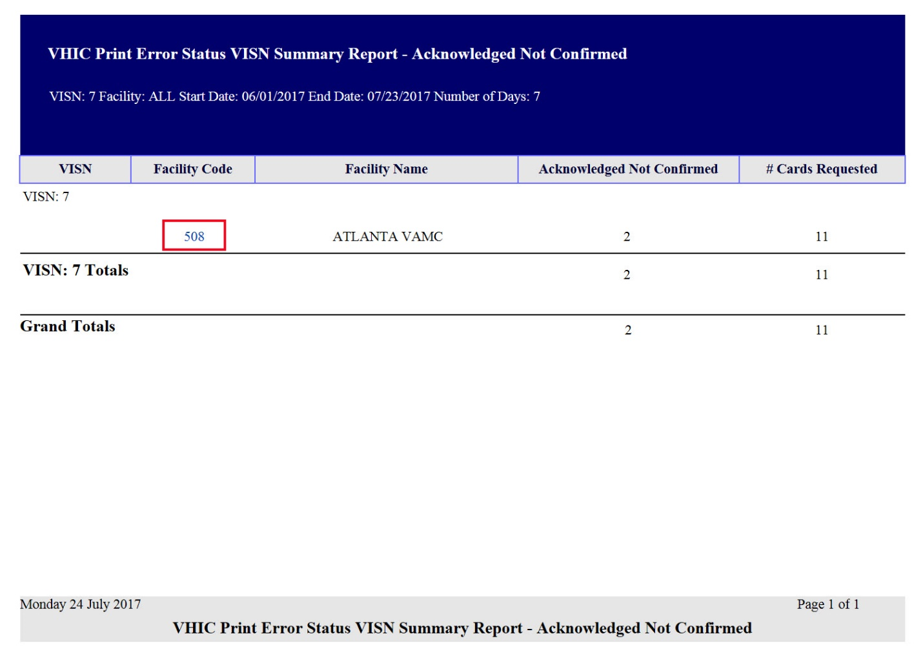
Figure 7-122: VHIC Print Error Status VISN Summary Report – Acknowledged Not Confirmed

The Facility Error Summary report shows the totals for the selected Facility. The Facility # is a hyperlink to the Facility Error Detail Report.

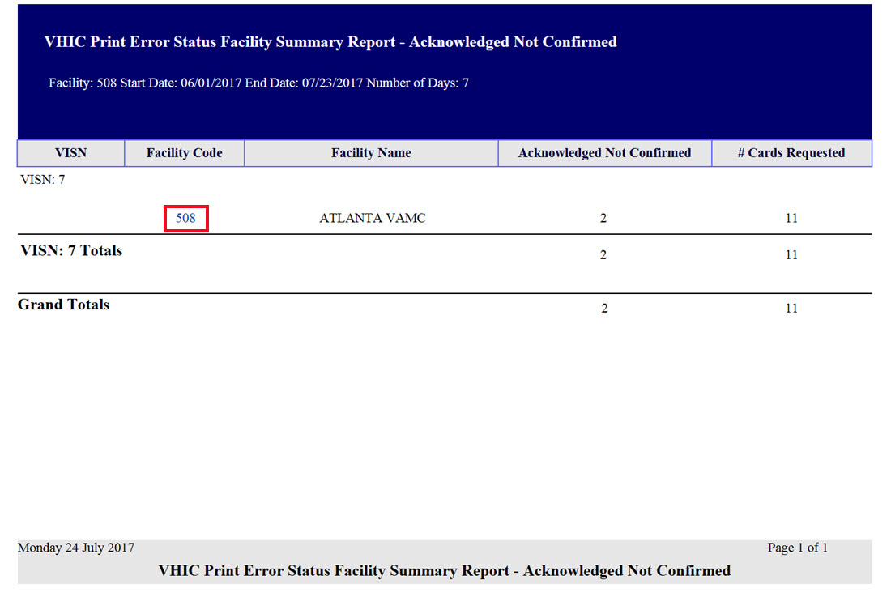
Figure 7-123: VHIC Print Error Status Facility Detail Report – Acknowledged Not Confirmed

The Facility Error Detail Report would give a list of all of the cards that have NOT been confirmed as Mailed by the print vendor and will display the Veteran’s Name, Card ID, and the Acknowledgement File name.

REDACTED
Figure 7-124: VHIC Print Error Status Facility Detail Report – Acknowledged Not Confirmed

Pending Not Sent
By selecting the [Pending Not Sent] radio button, the VHIC user will be able to see how many cards are sitting in the Pending Card Status state and have not been sent to the print vendor within the entered Number of Days (the default is three (3) days) after the card request has been submitted by the VHIC User within the selected Date Range.

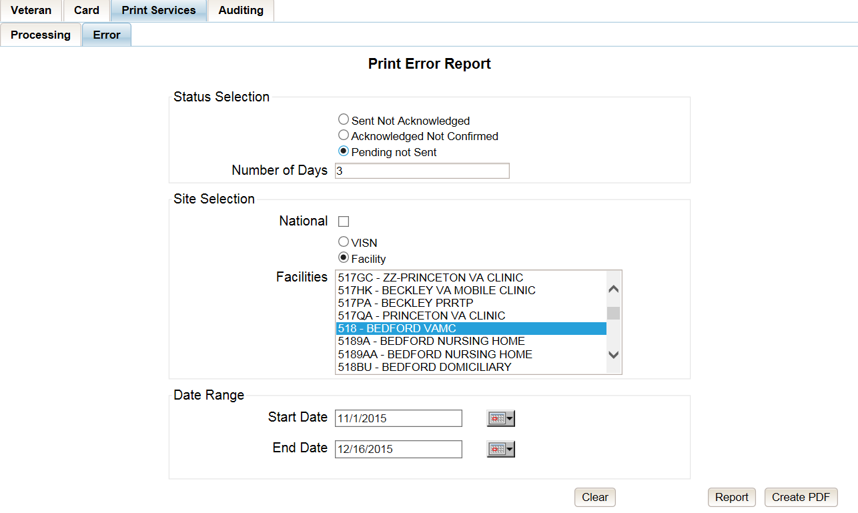
Figure 7-125: VHIC Print Error Status National Summary Report – Pending Not Sent

The National Error Summary Report lists all of the VISNs and the VISN # is a hyperlink to the VISN Error Summary Report.

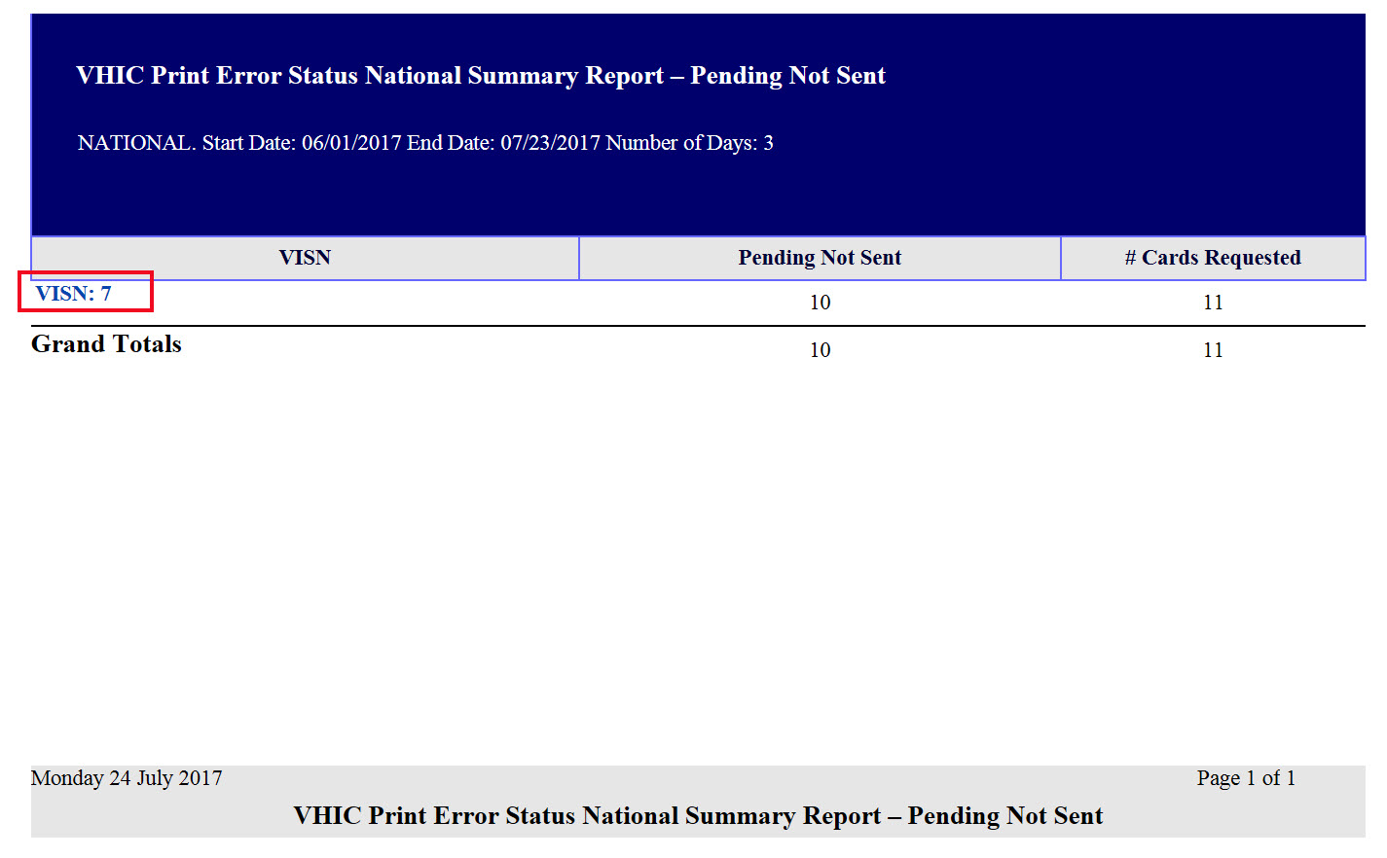
Figure 7-126: VHIC Print Error Status National Summary Report – Pending Not Sent

The VISN Error Summary Report lists all of the Facilities for the selected VISN. The Facility # is a hyperlink to the Facility Error Summary Report.

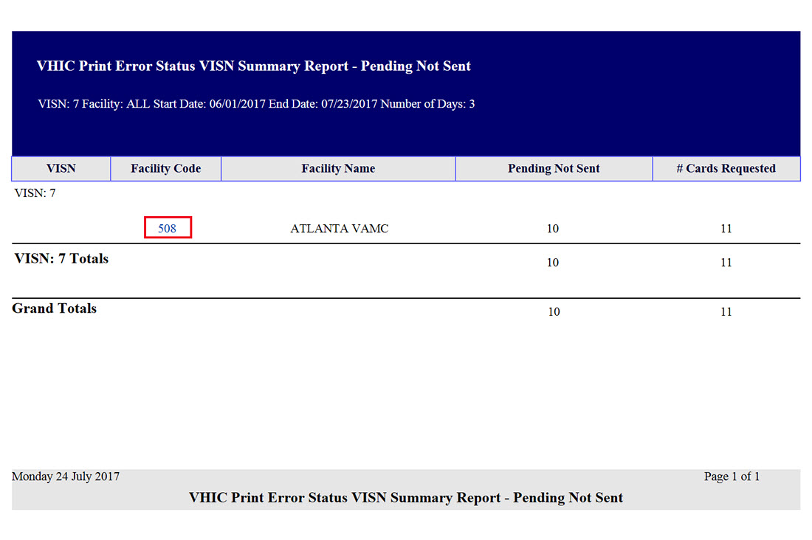
Figure 7-127: VHIC Print Error Status VISN Summary Report – Pending Not Sent

The Facility Error Summary report shows the totals for the selected Facility. The Facility # is a hyperlink to the Facility Error Detail Report.

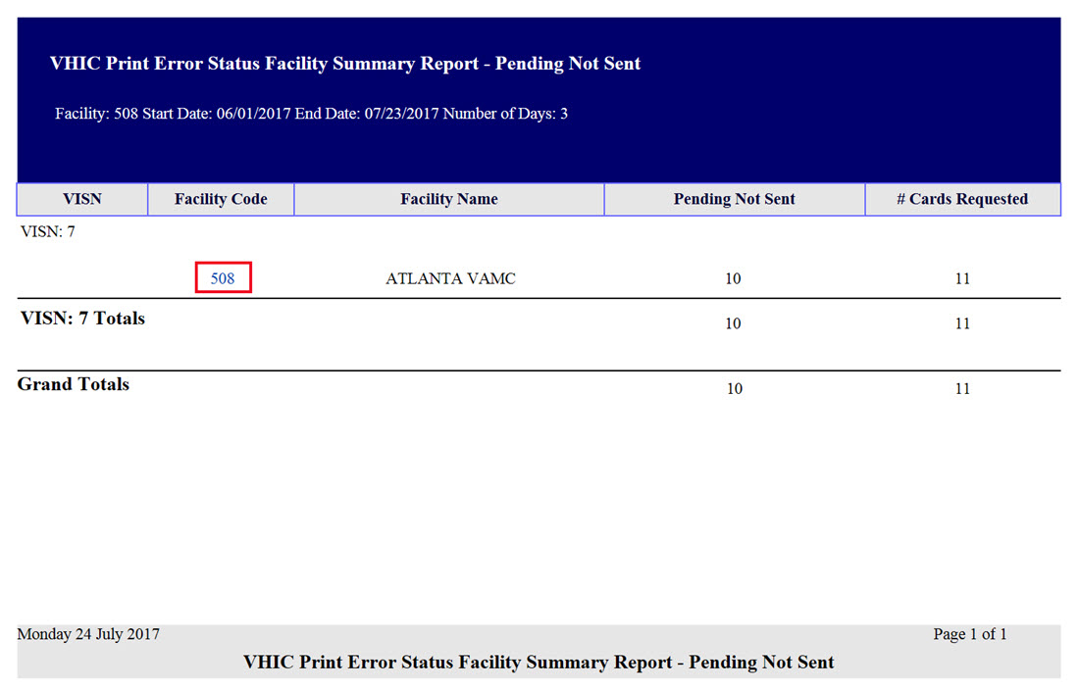
Figure 7-128: VHIC Batch File Processing Error Status Summary Report – Facility

The Facility Error Detail Report gives a list of all of the cards that have NOT been sent to the print vendor will display the Veteran’s Name and Card ID.

REDACTED
Figure 7-129: VHIC Print Error Status Facility Detail Report – Pending Not Sent

Auditing Report
Table 16: Audit Report at a Glance
At a Glance…
Who can access this report? | Administrator, Supervisor, Tech Admin (Tier 3), Auditor
Who can access National version? | N/A
Date Range Allowed | Admins, Tech Admin (Tier 3), Auditor – unlimited  Supervisor – one (1) year or less from date report is being run
Search Criteria Available | Login, Start Date, End Date

The Auditing Report provides a way to track all activity for individual users within the VHIC system. To run this report, the user must enter the login name/ID for the user being audited. The resulting report returns the following fields of information: Date/Time, Audit ID, Action, Person ID, Member ID, Card ID, and Query String. The query string shows all of the information that was entered into various fields and/or submitted by the associate page. Items in the audit report are listed in order of the Date/Time stamp.

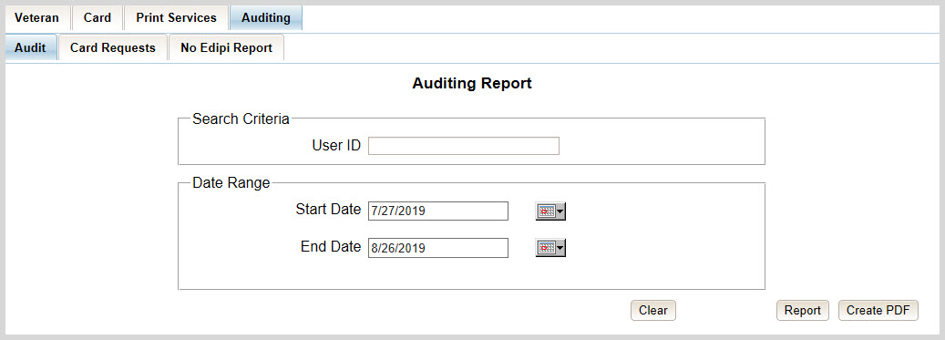
Figure 7-130: Audit Report query screen – Administrators, Tech Administrators (Tier 3), and Auditors

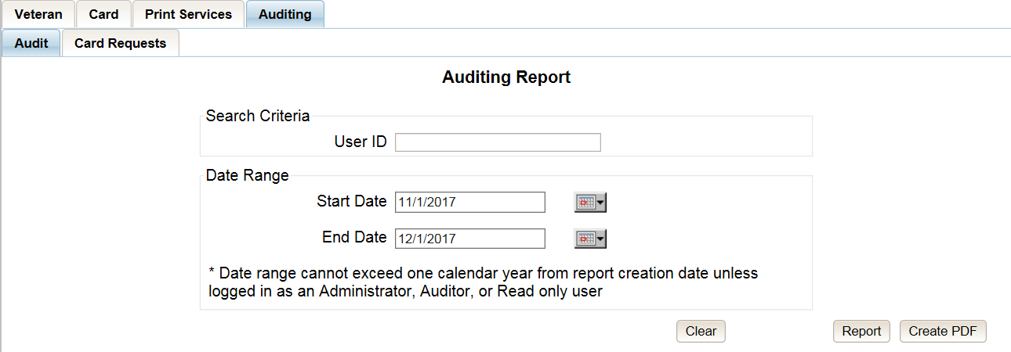
Figure 7-131: Audit Report query screen – Supervisors

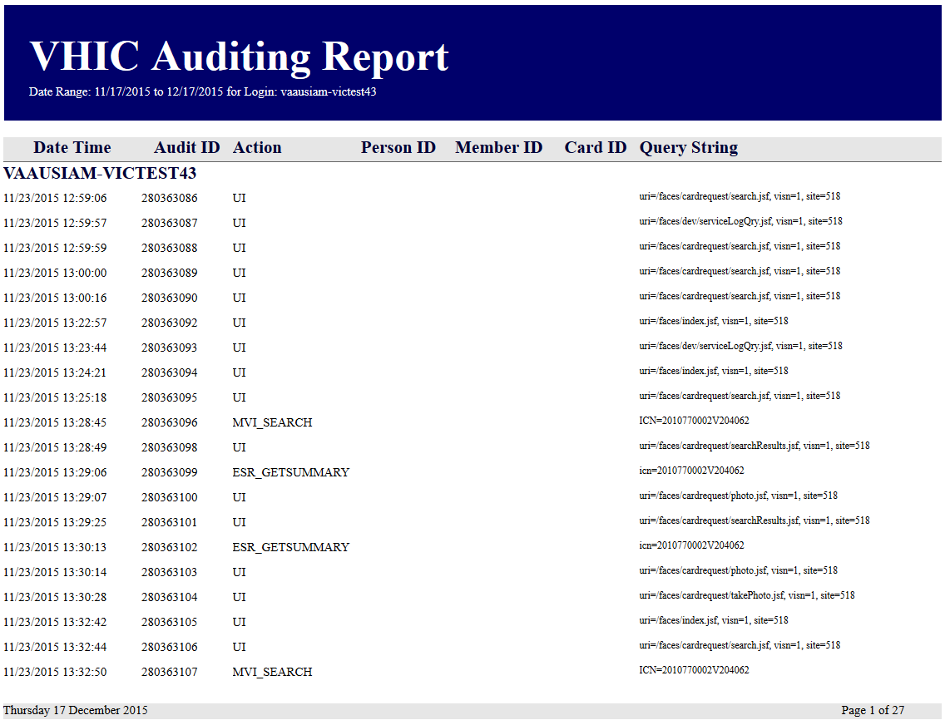
Figure 7-132: VHIC Auditing Report

Card Requests Report
Table 17: Card Request Report at a Glance
At a Glance…
Who can access this report? | Administrator, Supervisor, Tech Admin (Tier 3), Auditor
Who can access National version? | N/A
Date Range Allowed | Admins, Tech Admin (Tier 3) – unlimited  Supervisor – one (1) year or less from date report is being run
Search Criteria Available | Login, Start Date, End Date

The Card Requests Report provides the VHIC card requests by user for the selected VISN and/or Facility. Selecting either the [VISN] or the [Facility] radio button will update the list of available options accordingly (based on a user’s role). Selecting the National checkbox, if available, returns results for all VISNs and Facilities.

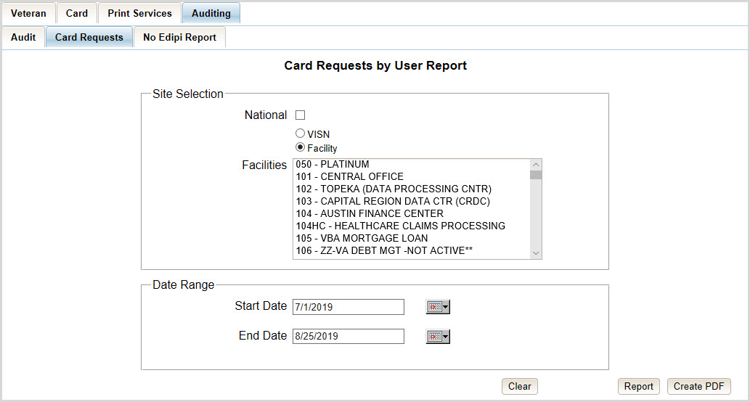
Figure 7-133: Card Requests query screen – Administrators, Tech Administrators (Tier 3), and Auditors

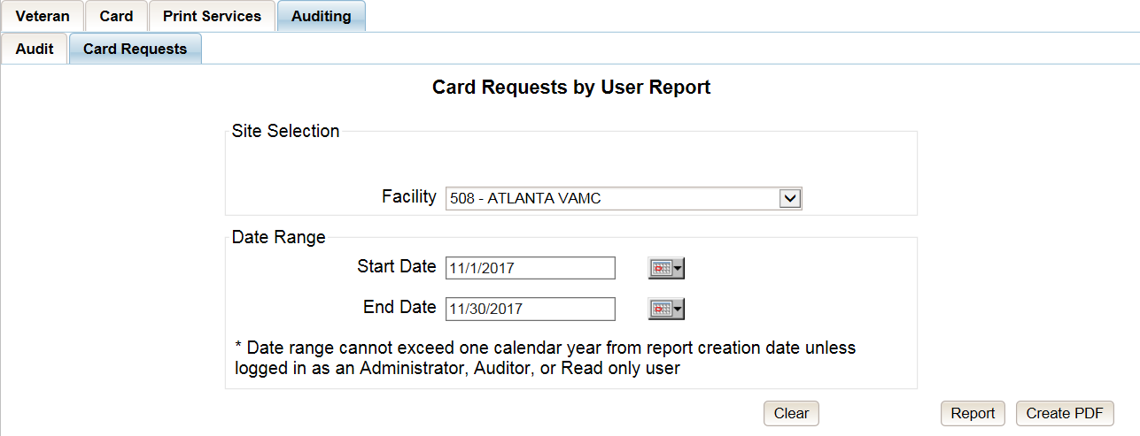
Figure 7-134: Card Requests query screen – Supervisor

The Card Requests Report provides results by user. Each report contains links that open additional reports. The following example illustrates those reports using a Site Selection of [National]. This search returns data under the columns of VISN Name, VISN Number, and # of Card Requests. Click the VISN Number hyperlink to open the next report.

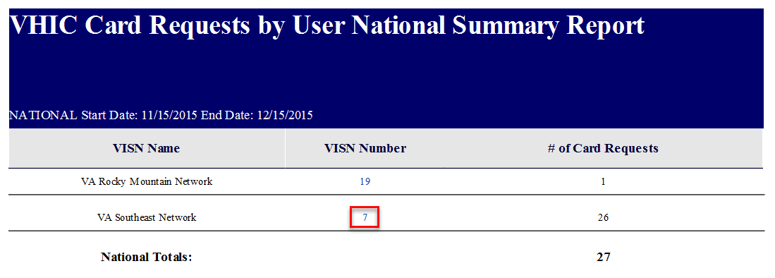
Figure 7-135: VHIC Card Requests by User Summary Report – National

The VHIC Card Requests by User VISN Summary Report opens. This search returns data under the columns of Facility, Facility Number, and # of Card Requests. Click the Facility Number hyperlink to open the next report.
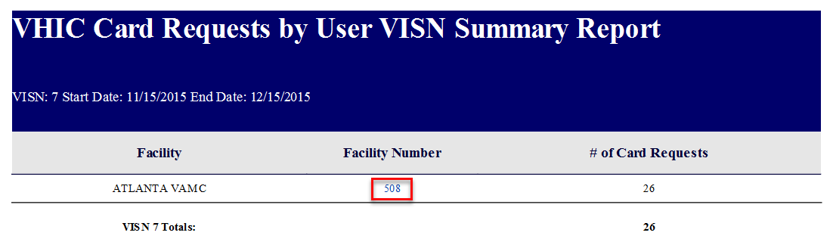
Figure 7-136: VHIC Card Requests by User VISN Summary Report

The VHIC Card Requests by User Facility Summary Report opens. This search returns data under the columns of Facility Name, Facility Number, User ID, and 3 of Card Requests. Click the User ID hyperlink to open the next report.

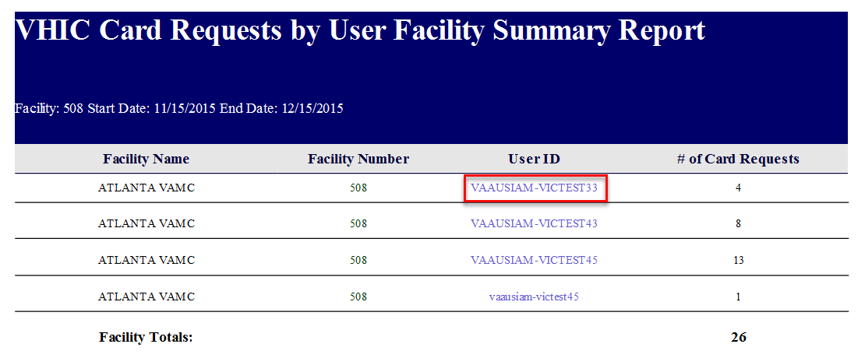
Figure 7-137: VHIC Card Requests by User Facility Summary Report

The VHIC Card Requests by User Detail Report opens. This search returns data under the columns of Facility Name, Facility Number, User ID, Card Status, Last Name and Card ID. Both the Last Name column and the Card ID column offer hyperlinks to additional reports. Click the Last Name hyperlink to open the next report.

REDACTED
Figure 7-138: VHIC Card Requests by User Detail Report – Last Name Hyperlink

The Veteran Detail Report opens. This search returns specific information relating to the last name clicked from the previous report.

REDACTED
Figure 7-139: Veteran Detail Report

The VHIC Card Requests by User Detail Report also contains a hyperlink for Card ID. Click the Card ID hyperlink to open the next report.

REDACTED
Figure 7-140: VHIC Card Requests by User Detail Report – Card ID Hyperlink

The VHIC Card History by Card ID Report opens. This search returns specific information relating to the Card ID clicked from the previous report.
Figure 7-141: VHIC Card History by Card ID Report

No Edipi Report

Table 18. VHIC Cards Printed No Edipi Report at a Glance
At a Glance…
Who can access this report? | Administrator, Supervisor, Tech Admin (Tier 3), Auditor
Who can access National version? | Administrator and Tech Admin (Tier 3)
Date Range Allowed | Admins, Tech Admin (Tier 3) – unlimited  Supervisor – one (1) year or less from date report is being run
Search Criteria Available | Site Selection, Start Date, End Date

The VHIC Cards Printed No Edipi Report provides the number(s) of VHIC cards printed with no Edipi by VISN and/or Facility. Selecting either the [VISN] or the [Facility] radio button will update the list of available options accordingly (based on a user’s role). Selecting the [National] checkbox, if available, returns results for all VISNs and Facilities.

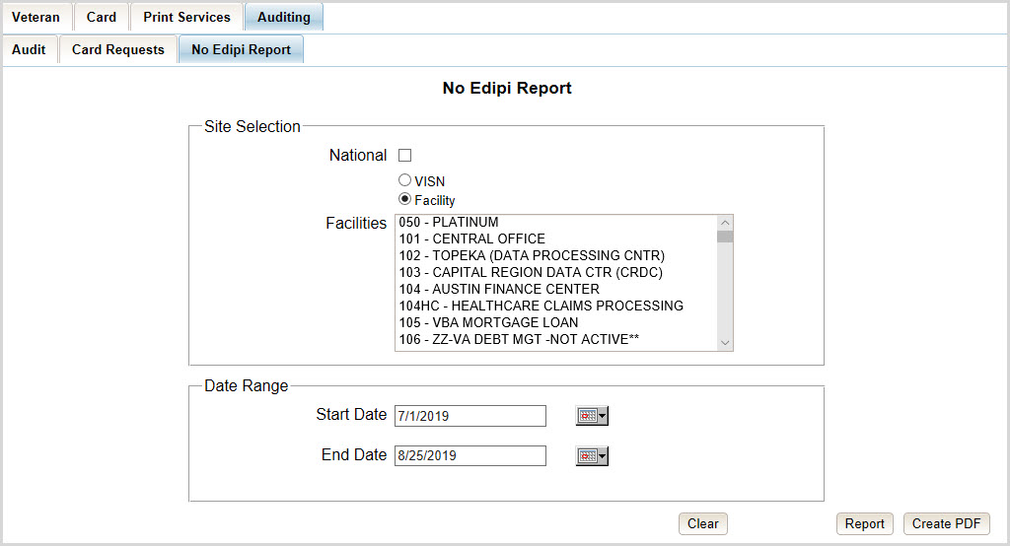
Figure 7-142: VHIC Cards Printed No Edipi Report Query Screen

Once the user selects a site, and inputs a date range, they will click [Report] or [Create PDF]. Selecting the [National] check box will display the VHIC Cards Printed No Edipi National Summary Report displaying the following information:
- VISN Description
- VISN Number
- Number of Cards Total

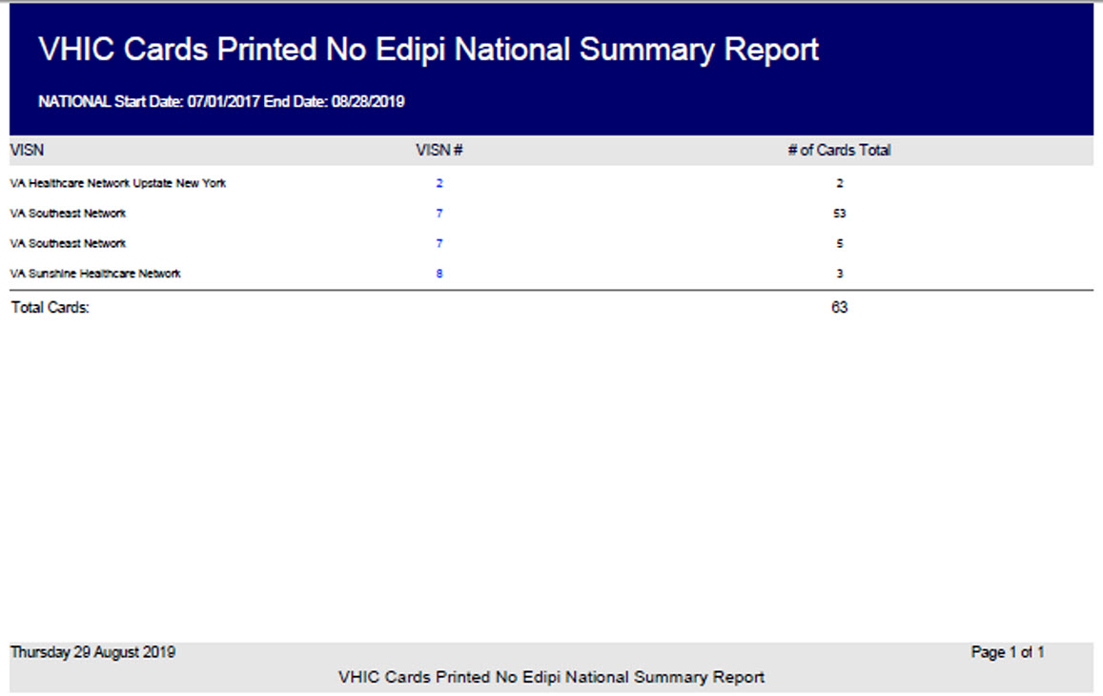
Figure 7-143: VHIC Cards Printed No Edipi National Summary Report Results

Clicking on the VISN number hyperlink will direct you to the VHIC Cards Printed No Edipi VISN Summary Report displaying the following
- VISN
- VISN Number
- Facility
- Facility Number
- Number of Cards Total

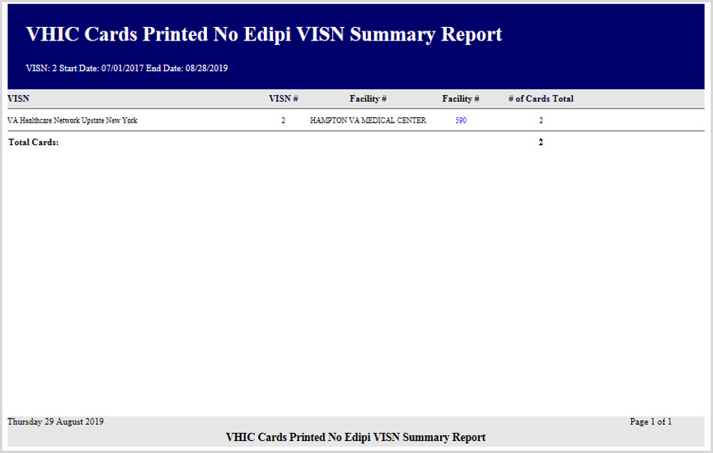
Figure 7-144: VHIC Cards Printed No Edipi VISN Summary Report

Clicking on the Facility number hyperlink will direct you to the VHIC Cards Printed No Edipi Facility Summary Report displaying the following fields:
- VISN - SITE
- Card ID (hyperlink)
- Person ID (hyperlink)
- Name
- Last Changed

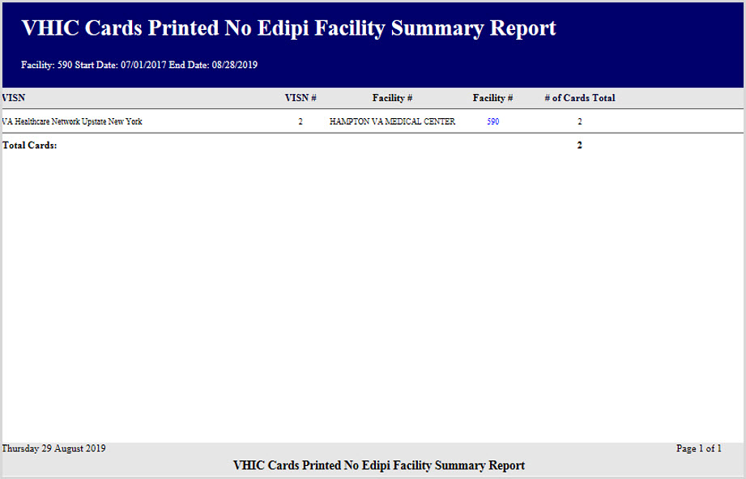
Figure 7-145: VHIC Cards Printed No Edipi Facility Summary Report

Clicking on the Facility number hyperlink will direct you to the VHIC Cards Printed No Edipi VISN Facility Detail Report displaying the following:
- VISN – SITE Description
- Card ID (hyperlink)
- Person ID (hyperlink)
- Veteran Name
- Last Changed

REDACTED
Figure 7-146: VHIC Cards Printed No Edipi VISN Facility Detail Report

The VHIC Cards Printed No Edipi VISN Facility Detail Report contain two hyperlinks Card ID and Person ID.
Clicking on the Card ID hyperlink will direct you to the VHIC Card History by Card ID Report screen.

REDACTED
Figure 7-147: VHIC Card History by Card ID Report screen

Clicking on the Person ID hyperlink will direct you to the VHIC Card History by Person ID Report screen.

REDACTED
Figure 7-148: VHIC Card History by Person ID Report screen

Self-Service Card Request Reports
The VHIC Self-Service Application was created to allow Veterans to request new and replacement VHIC card(s) without having to visit their local facilities offering them convenience and safely limiting exposure to Covid 19. The Self Service Reports allow the VHIC users to monitor card requests submitted through the Self Service Tool.

Table 19. Self Service Activity Report at a Glance
At a Glance…
Who can access this report? | Administrator, Supervisor, Tech Admin (Tier 3), Associate, Auditor, Read-Only
Who can access National version? | Administrator, Tech Admin (Tier 3), Auditor
Date Range Allowed | Admins, Tech Admin (Tier 3), Auditor – unlimited  Supervisor, Associate – one (1) year or less from date report is being run
Search Criteria Available | Start Date, End Date

Self Service Activity Report

The Self Service Activity Report provides the VHIC user a view of the activity submitted by the VHIC Self Service Card Request Tool within a specified date range. Using the calendar dropdowns, the user enters the date range desired and select the option to either view the report by clicking the [Report] button or using the [Create PDF] button to generate a pdf of the results for use.

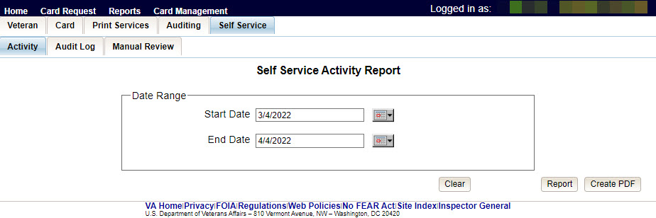
Figure 7-149. Self Service Activity Summary Report

The Report/PDF generated will include the Card Status and number of self-service card requests submitted resulting in that status.

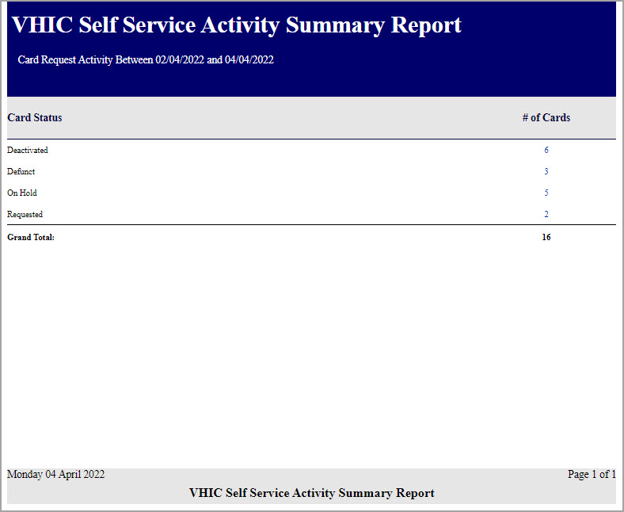
Figure 7-150. VHIC Self Service Activity Summary Report

Selecting the # of Cards hyperlink will take you to the Self Service Activity Detail Report; giving the user the details of the cards with the status selected.
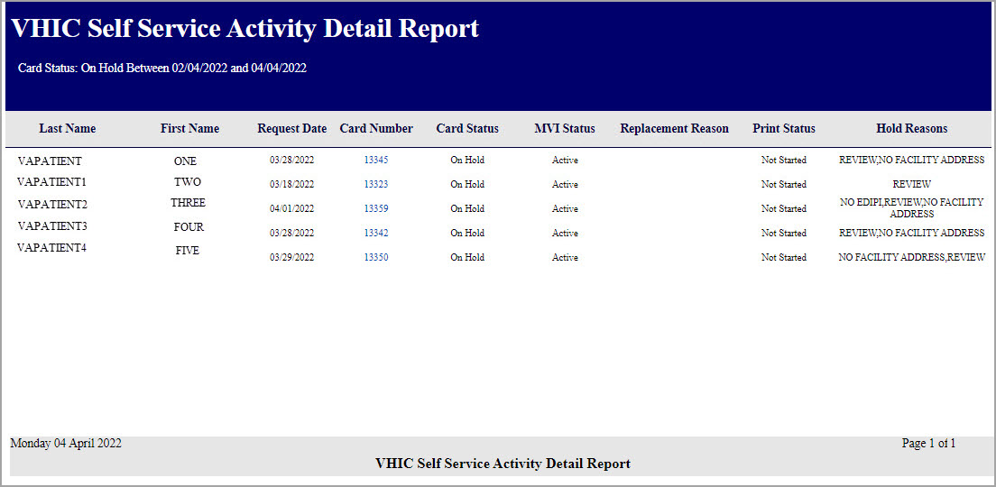
Figure 7-151. VHIC Self Service Activity Detail Report

Selecting the Card Number hyperlink in the Detail report will take the user to the Card History by Card ID Report.

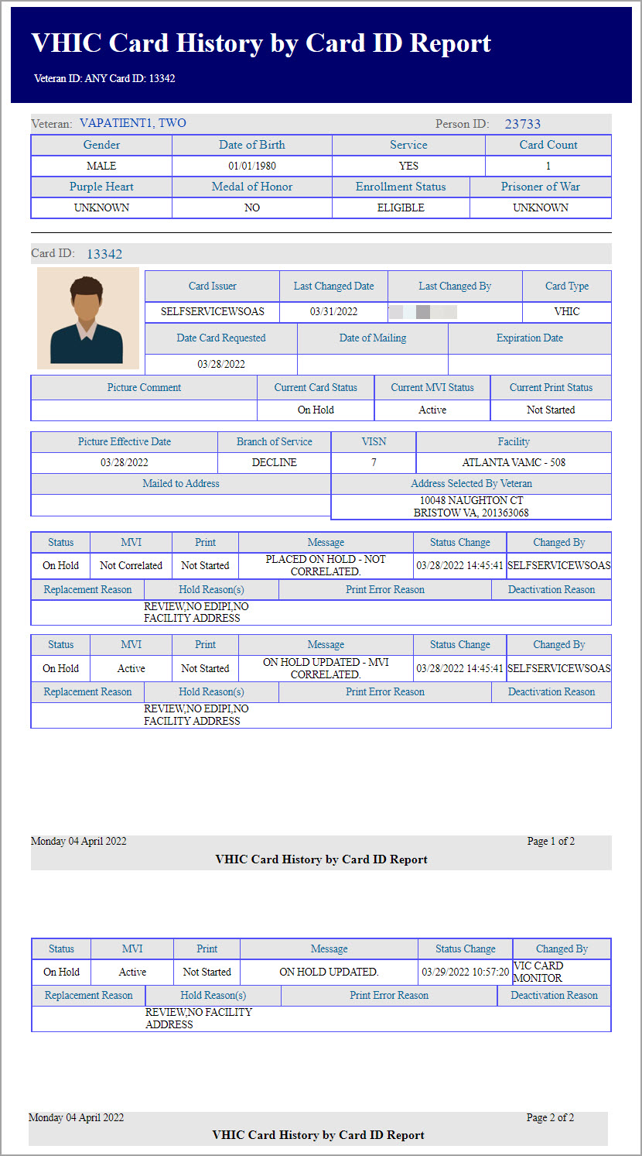
Figure 7-152. VHIC Card History by Card ID Report

Self Service Audit Log
Table 20. Self Service Audit Log at a Glance
At a Glance…
Who can access this report? | Administrator, Supervisor, Tech Admin (Tier 3), Associate, Auditor, Read Only
Who can access National version? | N/A
Date Range Allowed | Admins, Tech Admin (Tier 3), Auditor, Read-Only– unlimited  Supervisor and Associate – one (1) year or less from date report is being run
Search Criteria Available | Login, Start Date, End Date Time of Day

The Self Service Audit Log provides a way to track all activity for the VHIC Self Service Tool. The resulting report returns the following fields of information: Date, Action, System, ICN, Card ID, Status Message, and HTTP Response.. The query string shows all of the information that was entered into various fields and/or submitted by the associate page. Items in the audit report are listed in order of the Date and Time.

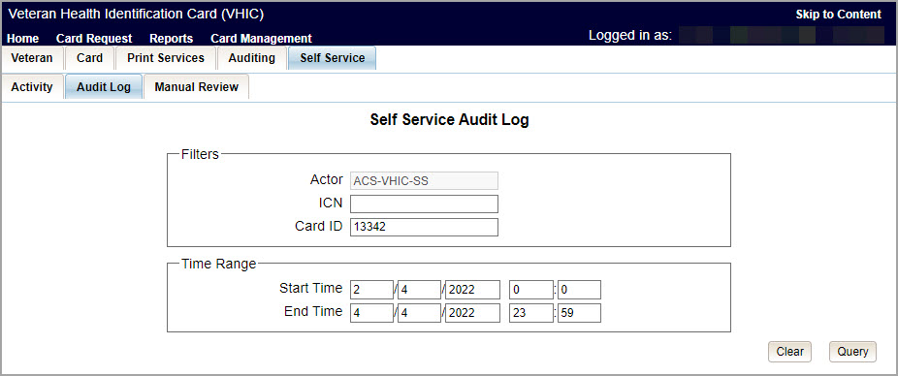
Figure 7-153. Self Service Audit Log Field Entry

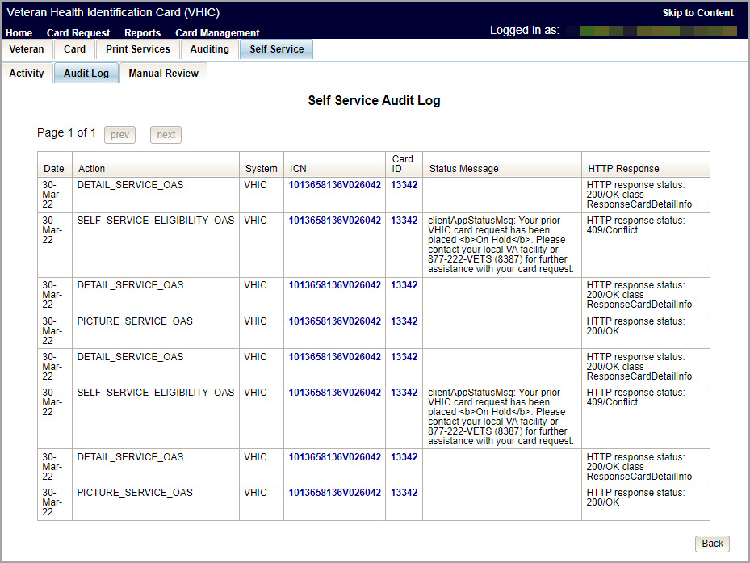
Figure 7-154. Self Service Audit Log Results

The Status Message and HTTP Response will give the User more details regarding the card request submitted by the veteran using the Self Service Tool. ICN (hyperlink) will take the user to the Veteran Detail Report and the Card ID (hyperlink) will take the user to Card History by Card ID Report.

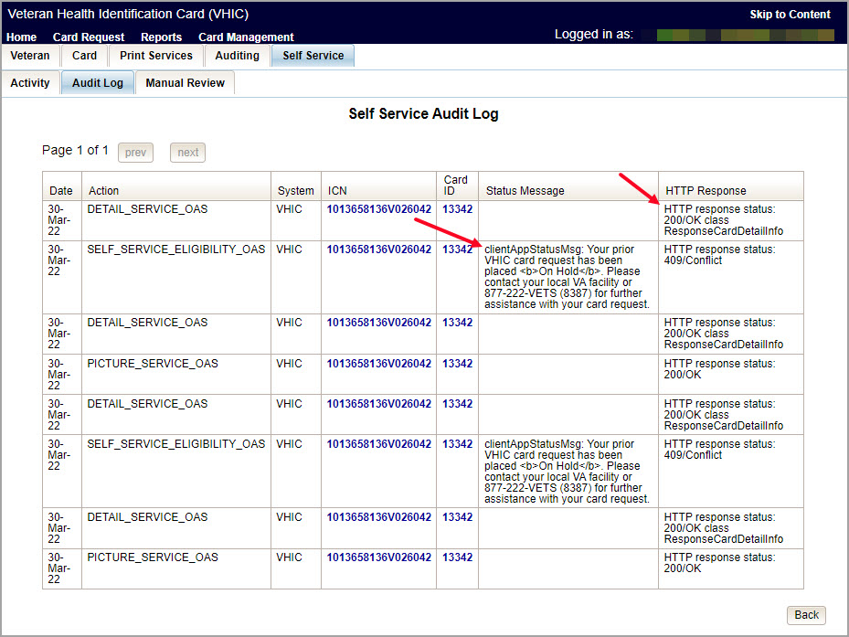
Figure 7-155. Status Messages and HTTP Responses Highlighted

If specific criteria are entered into the Audit Log and the system cannot locate the information a message will appear as in the figure below.
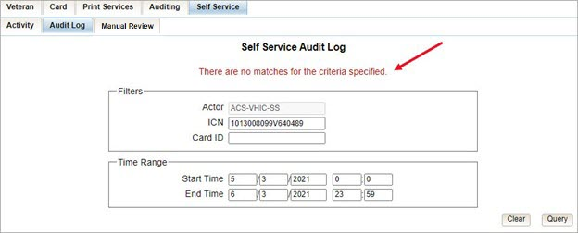
Figure 7-156. Self Service Audit Log No Match Message

Self Service Manual Review Activity Report
Table 21. Self Service Manual Activity Report at a Glance
At a Glance…
Who can access this report? | Administrator, Supervisor, Tech Admin (Tier 3), Associate, Auditor, Read-Only
Who can access National version? | Administrator, Tech Admin (Tier 3), Auditor, Read-Only
Date Range Allowed | Admins, Tech Admin (Tier 3), Auditor, Read-Only – unlimited  Supervisor, Associate – one (1) year or less from date report is being run
Search Criteria Available | Start Date, End Date

The Self Service Manual Review Activity Report indicates the number of card requests submitted through the Self-Service request process and can be sorted by National Requests, VSN Requests, and Facility Requests, though the report is set to Facility by default.
Selecting the National radio button (access permitting) the resulting report returns the following fields of information: VISN, VISN Number, and the Number of Cards submitted.
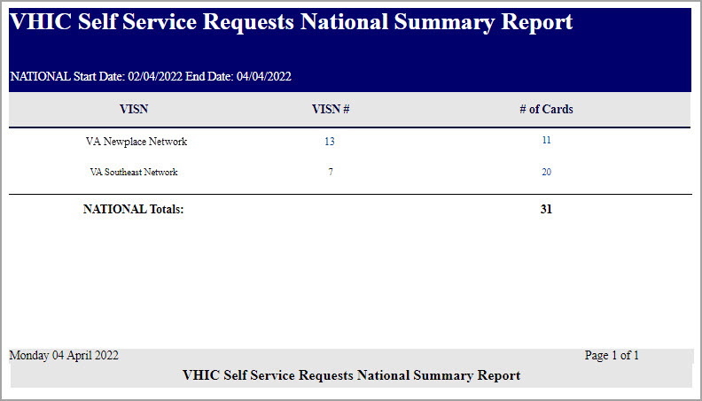
Figure 7-157. VHIC Self Service Requests National Summary Report

The VISN# is a link to the VISN Summary Report providing Facility, Facility Number, and the Number of Cards submitted for review per Facility within that VISN.
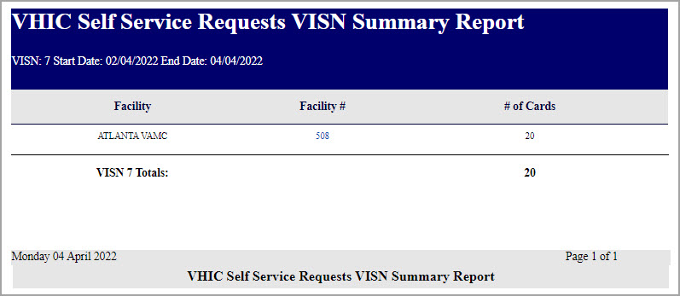
Figure 7-158. VHIC Self Service Requests VISN Summary Report

Selecting the facility number link will take the user to the VHIC Self Service Requests Facility Summary Report providing Facility, Facility Number, and the Number of Cards submitted for review for the specific Facility.
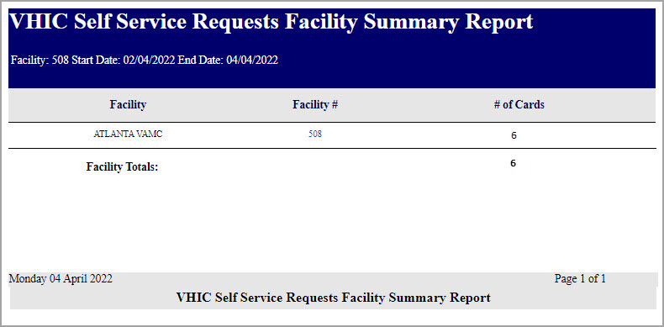
Figure 7-159. Self Service Facility Summary Report

The Facility # link to the Self Service Facility Detail Report displays the following information:
Facility Name, On Hold Reason, On Hold Date, Card Issuer, Last Name, Card ID, Card Status, Patient ICN, Task Status, and what (if any) POC the request has been Assigned To.
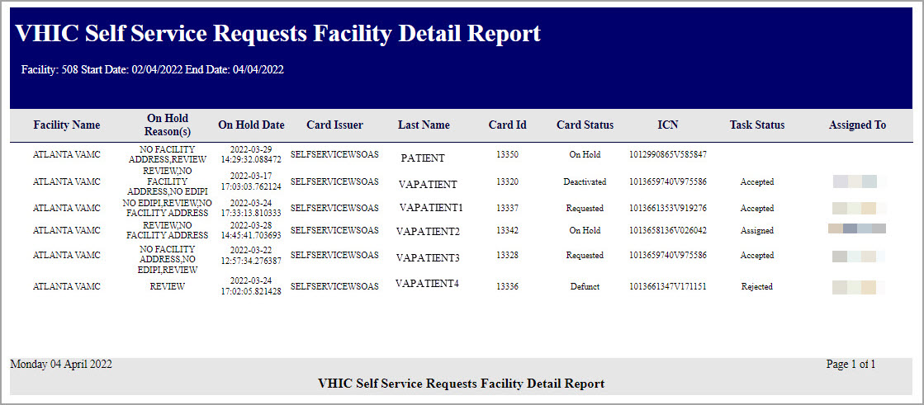
Figure 7-160. Self Service Facility Detail Report

Troubleshooting
For a through set of troubleshooting guidelines, please refer to the Veteran Health Identification Card User Guide - Volume 4 - Troubleshooting document.

