Veteran Health Identification Card (VHIC 4.20)

User Guide
Volume 6 – Self-Service Request Processing

April 2022

Department of Veterans Affairs
Office of Information and Technology (OIT)

Revision History
NOTE: The revision history cycle begins once changes or enhancements are requested after the document has been baselined.
Date | Revision | Description | Author
4/18/2022 | 0.1 | Created to support ACS Self-Service VHIC card requests | REDACTED

Table of Contents

1. Introduction 1
1.1. Purpose 1
1.2. Document Orientation 1
1.2.1. Organization of the Manual 1
1.2.2. Assumptions 2
1.2.3. Disclaimers 2
1.2.3.1. Software Disclaimer 2
1.2.3.2. Documentation Disclaimer 2
1.2.4. Documentation Conventions 2
1.3. Enterprise Service Desk and Organizational Contacts 3
2. Self-Service VHIC Card Request – What is it? 4
3. Getting Started 4
3.1. Single Sign-On Internal (SSOi) 4
3.2. Accessing the VHIC Application 4
3.3. Logging On 5
3.4. System Menu 5
3.5. Accessing the Identity Management Toolkit 5
3.5.1. Accessing the Identity Management Toolkit Directly 5
3.5.1.1. SSOi 5
3.5.2. Accessing Identity Management Toolkit from within the VHIC Application 6
3.5.2.1. Step 1 of the VHIC Application 6
3.5.2.2. Veteran Link in Assigned Self Service Requests for Manual Review List 7
4. VHIC Application Home Page 8
4.1. VHIC System Status Banner 8
4.2. VHIC Self-Service Request Notifications 9
4.3. Viewing Self Service New Card Requests 10
4.3.1. Unassigned Requests 10
4.3.2. Assigned Requests 13
5. Self Service Request Processing 14
5.1. Person Verification Task- Accepted Image 15
5.2. Person Verification Task- Rejected Image 23
6. Troubleshooting 30

Table of Figures
Figure 3-1: SSOi Login Screen 4
Figure 3-2: Identity Management Toolkit SSOi Logon Screen 6
Figure 3-3: Step 1: Enter Search Terms with Identity Management Toolkit hyperlink 7
Figure 3-4. Veteran Link to MPI Toolkit Task 8
Figure 3-5. MPI Toolkit Task 8
Figure 4-1. VHIC System Banner Page Figure 4-2. VHIC Self-Service New Card Request Information 9
Figure 4-3. Unassigned Request Information 11
Figure 4-4. Unassigned Self Service Requests for Manual Review 12
Figure 4-5. Request Information Changed 13
Figure 4-6. Assigned Request Information 13
Figure 4-7. Assigned Self-Service Requests for Manual Review 14
Figure 5-1. Link to Person Verification Task 15
Figure 5-2. Select Task Number 16
Figure 5-3. Task Notes Tab 16
Figure 5-4. Assign Task 17
Figure 5-5. Person Verification Task Details 17
Figure 5-6. Self Service Images Tab 18
Figure 5-7. Review Proofing Documents 18
Figure 5-8. Data Review Tab 19
Figure 5-9. Verification Document Details 20
Figure 5-10. Submit Document Details 21
Figure 5-11. Select OK Button 21
Figure 5-12. Task Competed 22
Figure 5-13. LOA Changed 23
Figure 5-14. Proofing Correlation Added 23
Figure 5-15. Link to Toolkit Task 24
Figure 5-16. . MPI Toolkit Task Number Link 24
Figure 5-17. New Person Verification Task Details 25
Figure 5-18. Task Notes Tab 25
Figure 5-19. Assign Task 25
Figure 5-20. Select Person Verification Tab 26
Figure 5-21. Attached Person Verification Document(s) 26
Figure 5-22. Compare Veteran Images 27
Figure 5-23. Enter Rejection Notes 28
Figure 5-24. Select Reject Image Button 28
Figure 5-25. Reject/Resolve Confirmation Message 29
Figure 5-26. Resolved Task Status 29
Figure 5-27. Level of Assurance Does Not Change 29
Figure 5-28. Request Cancellation Review Issue 30
Figure 5-29. Request Cancellation Email Timed Out 30

Table of Tables
Table 1: Documentation Symbols and Descriptions 3
Table 2: Enterprise Service Desk Contact Information 3

Introduction

Purpose
The purpose of this User Guide is to provide information and a detailed walkthrough of processing a Veteran Health Identification Card request submitted by the veteran through the VA Access Self-Service application.

Document Orientation

Organization of the Manual
This User Guide is divided into six sections to allow you to obtain quickly the information you need.

The first section will provide an overview of what a VHIC is and what the eligibility requirements are, and the various user roles and their accessibility within the VHIC application.

In order to be able to receive a VHIC, a Veteran must meet the following eligibility criteria:
- Be eligible for VA medical benefits
- Be enrolled in the VA Healthcare system
- Be Level 2 proofed at a VA medical facility
- Veteran identity must be recognized in the Master Veteran Index (MVI), which is managed by the Identity and Access Management (IAM) of the VA

NOTE: The level 2 proofing process is a method to verify the identity of Veterans. VA requires Veterans to provide approved identification documents to access Personal Identifiable Information (PII), Personal Health Information (PHI) and request a Veterans Health Identification Card (VHIC).

The second and third sections will explain system requirements and log in instructions
The fourth section review and discuss the information found on the VHIC Menu/Home page.
The fifth section will give the user step-by-step details of how to complete the Identity Proofing process for a Veteran that has submitted a VHIC Card request remotely. The VHIC user must verify the Veteran’s Identity Proofing Level is at Level 2 in the Identity Management Toolkit.

The last section covers some troubleshooting issues and solutions that will help the VHIC user to better able to support the Veteran and ensure that the VHIC requests are processed properly.

Assumptions
This guide has been written with the following assumed experience/skills of the audience:
- User has basic knowledge of the operating system (such as log in, the use of commands, menu options, and navigation tools).
- User has understanding of the roles within VHIC
- User has been provided the appropriate active roles required for the VHIC application.
- User is using Google Chrome or Microsoft Edge to do their job of either Creating a VHIC Card Request, Running Reports, or Managing VHICs depending on user roles.
- User has validated access to the VHIC application.
- User has completed any prerequisite training.

Disclaimers

Software Disclaimer
This software was developed at the Department of Veterans Affairs (VA) by employees of the Federal Government in the course of their official duties. Pursuant to title 17 Section 105 of the United States Code this software is not subject to copyright protection and is in the public domain. VA assumes no responsibility whatsoever for its use by other parties, and makes no guarantees, expressed or implied, about its quality, reliability, or any other characteristic. We would appreciate acknowledgement if the software is used. This software can be redistributed and/or modified freely provided that any derivative works bear some notice that they are derived from it, and any modified versions bear some notice that they have been modified.

Documentation Disclaimer
The appearance of external hyperlink references in this manual does not constitute endorsement by the Department of Veterans Affairs (VA) of this Web site or the information, products, or services contained therein. The VA does not exercise any editorial control over the information you may find at these locations. Such links are provided and are consistent with the stated purpose of the VA.

Documentation Conventions
This manual uses several methods to highlight different aspects of the material.
- Various symbols are used throughout the documentation to alert the reader to special information. The following table gives a description of each of these symbols:

Table 1: Documentation Symbols and Descriptions
Symbol | Description
 | NOTE: Used to inform the reader of general information including references to additional reading material

- Descriptive text is presented in a proportional font (as represented by this font).
- “Screenshots” of computer online displays (i.e., character-based screen captures/dialogs) and are shown in a non-proportional font and enclosed within a box. Also included are Graphical User Interface (GUI) Microsoft Windows images (i.e., dialogs or forms).
- User's responses to online prompts (e.g., manual entry, taps, clicks, etc.) will be [boldface] type and enclosed in brackets.

Enterprise Service Desk and Organizational Contacts
The support contact information documented herein is intended to restore normal service operation as quickly as possible and minimize the adverse impact on business operations, ensuring that the best possible levels of service quality and availability are maintained.

The following table lists the contact information needed by site users for troubleshooting purposes. Support contacts are listed by description of the incident escalation and contact information (phone number and options to select).
Table 2: Enterprise Service Desk Contact Information
Issue | Contact Info
For Provisioning Issues | Contact the Enterprise Service Desk at REDACTED, option 3 (Applications), then option 1.  When contacted by a support specialist, be ready to supply the employee’s full name, VA user ID and email address.
For Proofing Issues | Contact the Enterprise Service Desk at REDACTED, option 3 (Applications), then option 1.  When contacted by a support specialist, be ready to supply the Veterans' full name, full SSN, and DOB.
For All Other VHIC System Issues | Contact the Enterprise Service Desk at REDACTED, option 3 (Applications), then option 1  When contacted by a support specialist, be ready to supply the Veterans' full name, full SSN, and DOB.

Self-Service VHIC Card Request – What is it?
The VHIC Self-Service Application was created to allow Veterans to request VHIC card(s) without having to visit their local facilities offering them convenience and safely limiting exposure to Covid 19. VHIC users will be responsible for monitoring and processing new card requests submitted through the Self-Service Tool. Self-Service New Card Requests require remote veteran proofing the process will be outlined in this user guide.

Getting Started

Single Sign-On Internal (SSOi)
Once users are logged into their VA desktop, they will access VHIC using Google Chrome or Microsoft Edge (IE) by either entering the REDACTED listed above or via the bookmark saved during an earlier session.
Users will be presented with the Single Sign On – internal (SSOi) login screen (shown below).

Here the VHIC user will need to use their PIV card to log into the VHIC application.

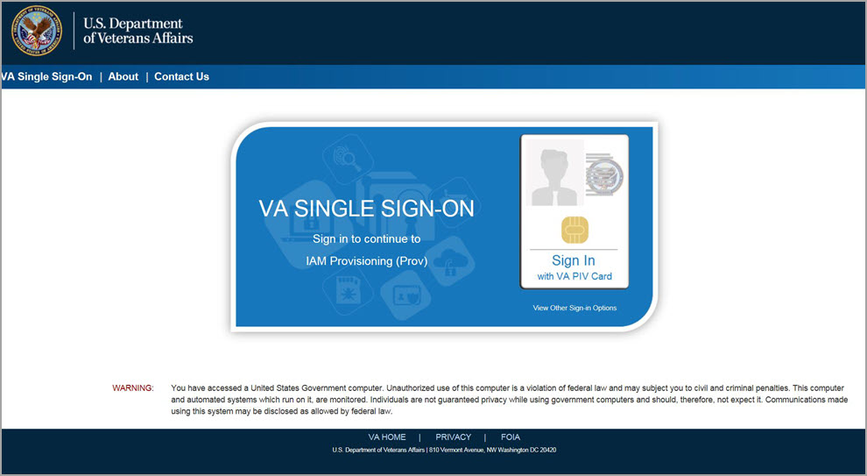
Figure 3-1: SSOi Login Screen

Accessing the VHIC Application
VHIC is a web-based application that users will access via a web browser. The recommended browser is Google Chrome or Microsoft Edge (currently version 11). The VHIC URL is REDACTED and is case sensitive – it must be entered exactly as shown. After successfully logging in to the VHIC application, users should bookmark this site for easy access in the future. Instructions on how to do just that can be found here: REDACTED

The best time to bookmark the site is after the user is in the application itself rather than attempting to bookmark the Login screen.

Logging On
The VHIC application is built to accommodate a specific set of pre-established user roles. During the provisioning process, the VHIC user will have a role assigned to them, which will determine what aspects of the VHIC application are available to them. The roles are listed below. For more information on the areas of access that accompanies each role, please refer to VHIC Roles and Access document.

System Menu
Depending on the VHIC users’ role, they will be presented different Home screens upon logging into the VHIC application.

NOTE: Some features of the VHIC application will not function correctly in IE. You will need to copy the URL link and open in Chrome or Edge.

Accessing the Identity Management Toolkit

Accessing the Identity Management Toolkit Directly
The VHIC user will need to go to the Identity Management Toolkit application to look up the Veteran and verify their proofing level and if needed complete the proofing process. The Identity Management Toolkit can be accessed by using the URL in the next section entitled “SSOi.”

SSOi
SSOi: REDACTED
Figure 3-2: Identity Management Toolkit SSOi Logon Screen

The URLs are case sensitive – they must be entered exactly as shown. After successfully logging into the Identity Management Toolkit application, users should bookmark this site for easy access in the future. Instructions on how to do just that can be found here: REDACTED

The best time to bookmark the site is after the user is in the application itself rather than attempting to bookmark the Login screen.

Accessing Identity Management Toolkit from within the VHIC Application

Step 1 of the VHIC Application
When the VHIC user starts the Card Request process, they will see a message on Step 1: Enter Search Terms. “IMPORTANT: Have you Identity Proofed the Veteran in Identity Management Toolkit? (Click here to open REDACTED in another window)”

The VHIC user can click on the blue words “REDACTED” which is a hyperlink that will take the user to the Identity Management Toolkit application.
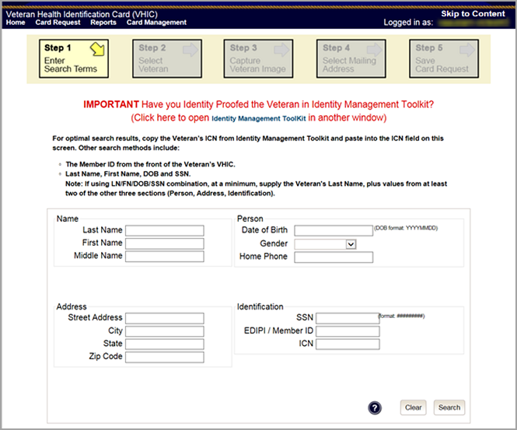
Figure 3-3: Step 1: Enter Search Terms with Identity Management Toolkit hyperlink

Veteran Link in Assigned Self Service Requests for Manual Review List
Selecting the Full Name link from the Assigned Request list will open the Toolkit directly to the 1998 Person Verification [Self-Service] Task.
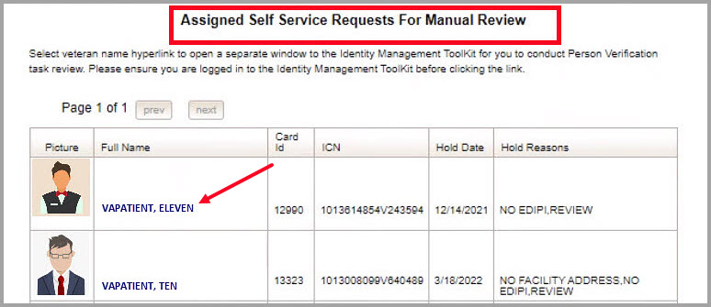
Figure 3-4. Veteran Link to MPI Toolkit Task

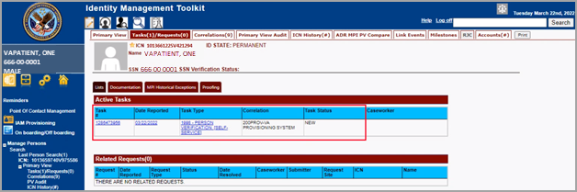
Figure 3-5. MPI Toolkit Task

VHIC Application Home Page

VHIC System Status Banner
The VHIC System will display a Status Banner at the top of the screen to notify users of reported issues with the system and/or during maintenance activities that do not require downtime such as high volume or preferred browser reminder.
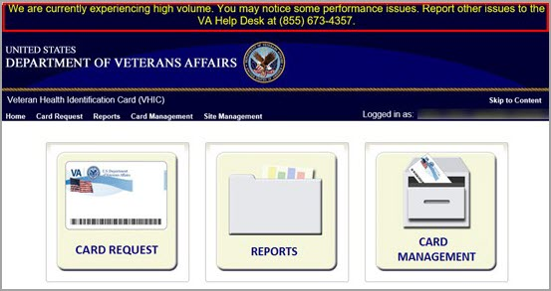
Figure 4-1. VHIC System Banner Page

VHIC Self-Service Request Notifications

When the VHIC User logs into the VHIC Application, they will see Self-Service request information for their facility listed on the Home page. This information includes:
- The number of facility specific requests that have been submitted through the Self-Service Application for that have not been assigned to a proofer for review.
- The number of requests that the user has assigned to them
- The number of requests that are in an on hold status that will expire within seven days.
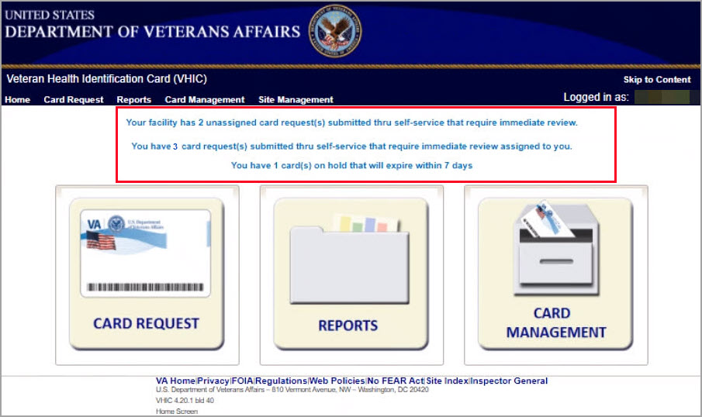
Figure 4-2. VHIC Self-Service New Card Request Information

Viewing Self Service New Card Requests
The Self-Service request information listed on the Home screen serves as a link to review the New Card Requests.

Unassigned Requests
Clicking on the Unassigned Card Request message will direct the user to the list of facility requests that need to be assigned to a Proofer.

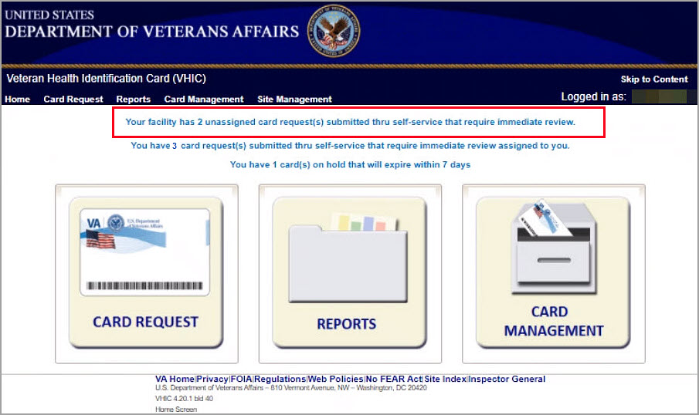
Figure 4-3. Unassigned Request Information

A list of unassigned requests will be displayed offering the following details:
- Photograph currently on file in the system
- Full Name
- Card ID
- ICN
- Hold Date
- Hold Reason(s)
Selecting the Veteran Name Link will assign the request to the user.
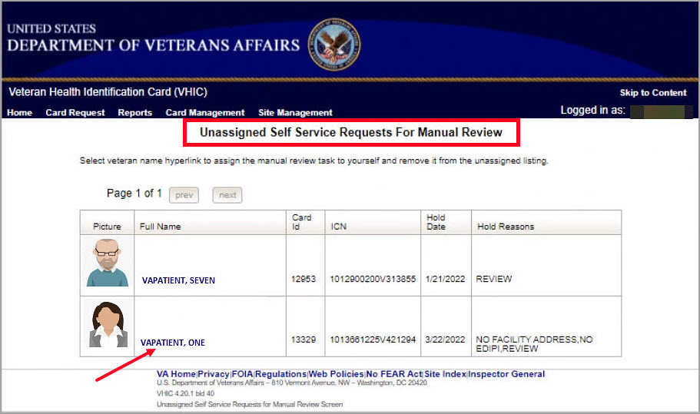
Figure 4-4. Unassigned Self Service Requests for Manual Review

The user will be able to see the updated number of requests in their queue on the home page.
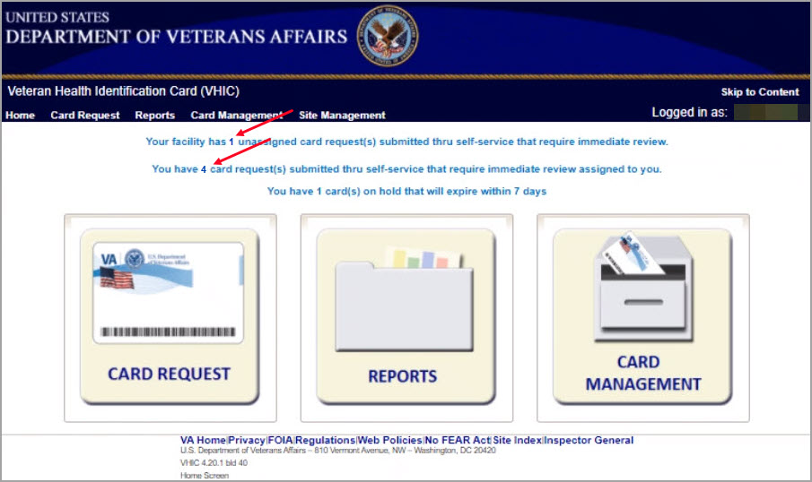
Figure 4-5. Request Information Changed

Assigned Requests
Clicking on the Assigned Card Request message will direct the user to the list of facility requests assigned to them for proofing.
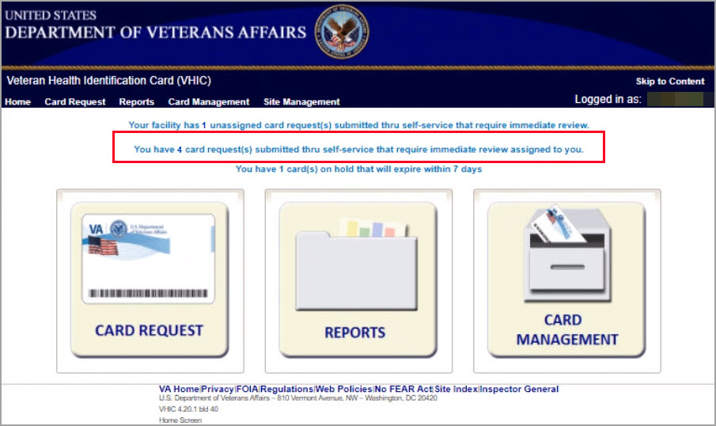
Figure 4-6. Assigned Request Information

The list of assigned requests will be displayed offering the following details:
- Photograph currently on file in the system
- Full Name
- Card ID
- ICN
- Hold Date
- Hold Reason(s)

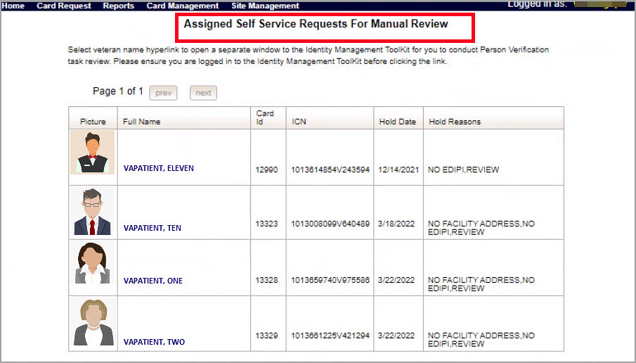
Figure 4-7. Assigned Self-Service Requests for Manual Review

When the user is ready to review the request(s) the Proofer will need to access the Toolkit through one of the methods listed in Section 3.5 Accessing the Identity Management Toolkit. Once Toolkit access has been established, selecting the Veteran Name link will open a new window giving the VHIC user access to the new Proofing Task in the Toolkit.

Self Service Request Processing
A new 1998 Person Verification [Self-Service] Task is created in the Toolkit to proof veterans that have submitted VHIC card requests through the VA Access application. These requests will fall under two categories:
- Accepted Image
- Rejected Image

Person Verification Task- Accepted Image
Selecting the Full Name link from the Assigned Request list will open the 1998 Person Verification [Self-Service] Task.
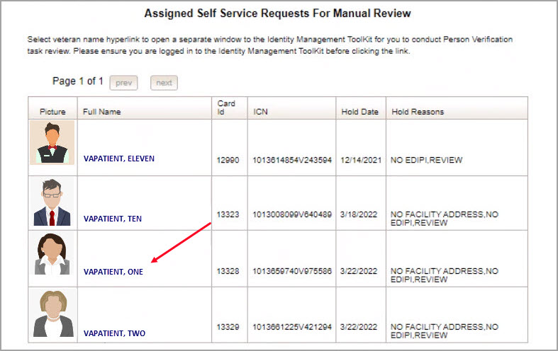
Figure 5-1. Link to Person Verification Task

To process:
- Select the Task Number to open the Task for review.
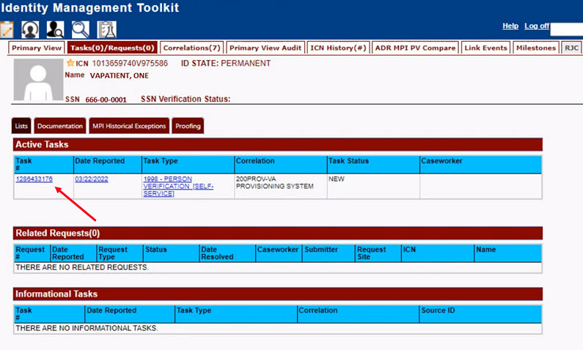
Figure 5-2. Select Task Number

- The Proofer will need to navigate to the Task Notes tab to assign the Task to themselves.
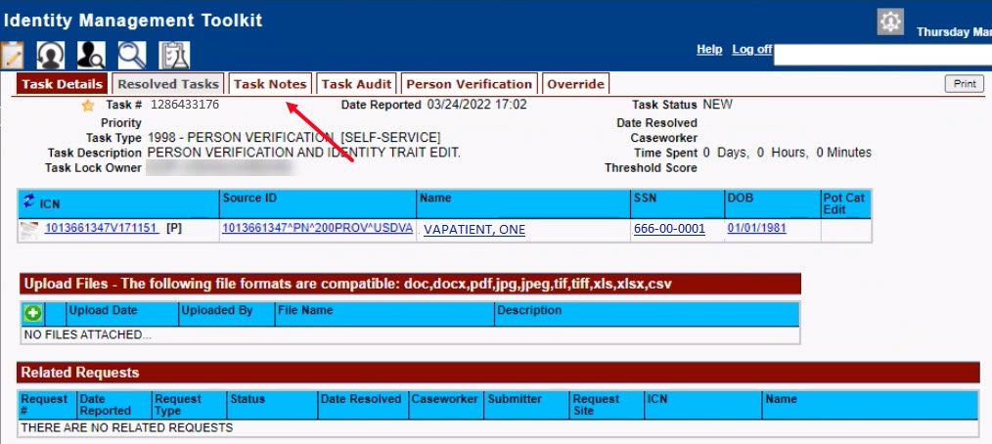
Figure 5-3. Task Notes Tab

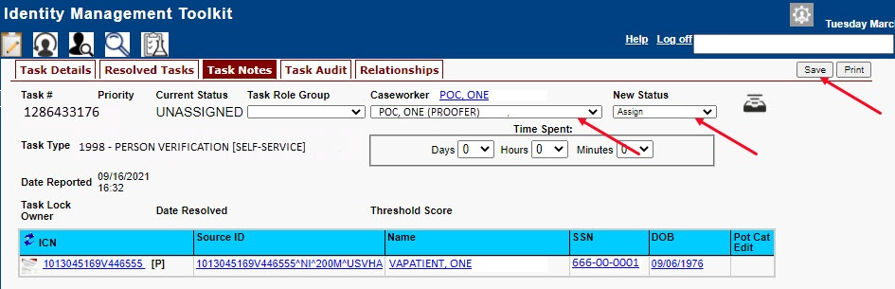
Figure 5-4. Assign Task

- After assigning the Task they will open to Task Details Tab, then Select Person Verification Tab to process the Task
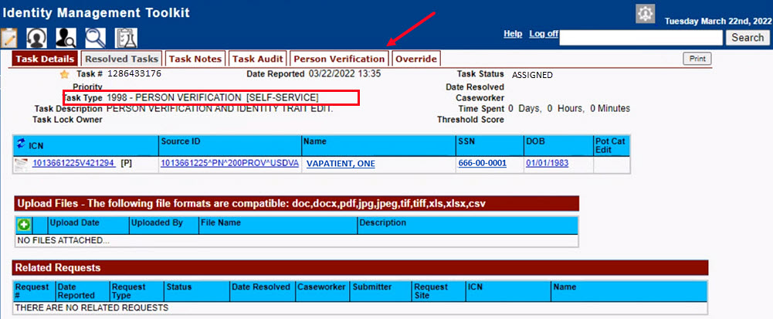
Figure 5-5. Person Verification Task Details

- On the Person Verification Tab, the user will be taken to the Self Service Image Tab, Click Person Verification Document link (s) to open submitted images for review.
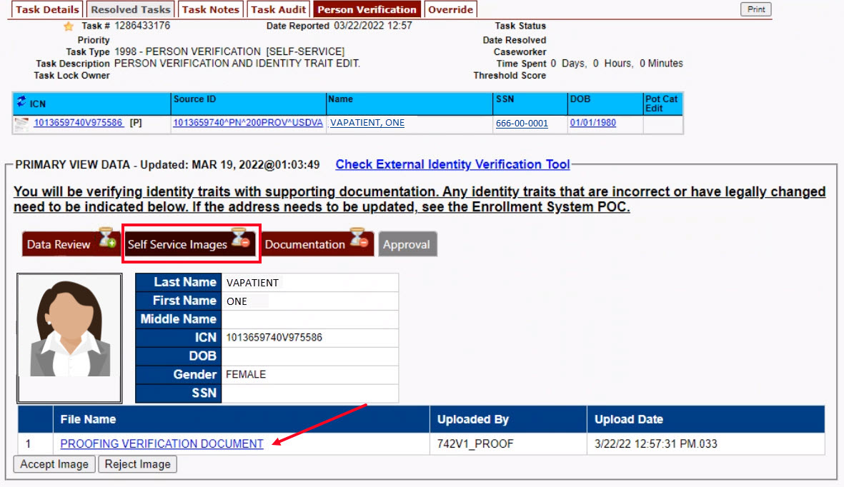
Figure 5-6. Self Service Images Tab

- The documents will open in a separate window. Review Proofing Document(s) and click Accept Image to continue if correct.
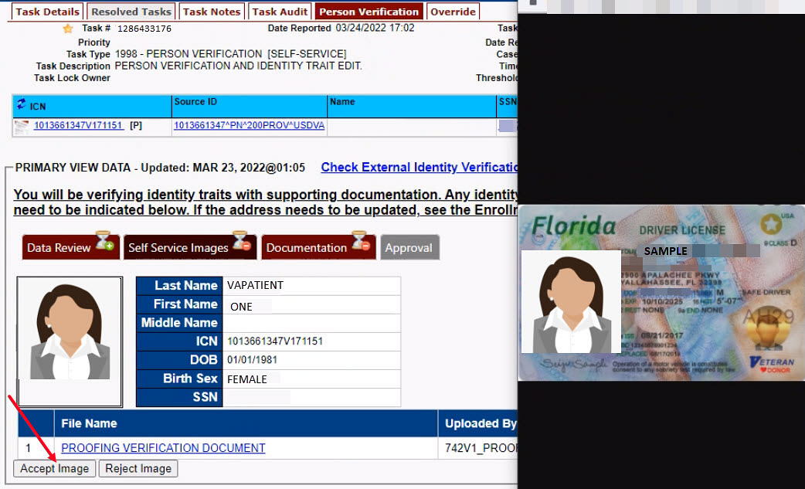
Figure 5-7. Review Proofing Documents

- The Proofer will be directed to the Data Review tab of the Person Verification Tool which will be used to verify the identity traits and/or document changes to the traits. The MPI Value column will contain Primary View data. Verify traits by checking the corresponding check box in the Verify column. The target trait will highlight green.
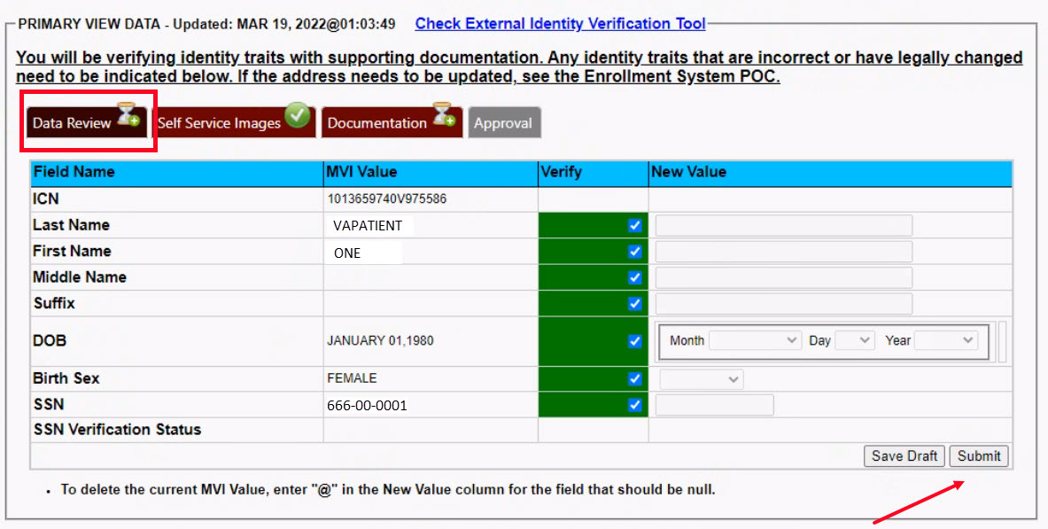
Figure 5-8. Data Review Tab

NOTE:
The Veteran is informed during the Request Process that if a trait needs to be modified (for example, Last Name changes), they must come in to the facility. If the Veteran submits a request under the following conditions:
- Photo submitted is not acceptable
- Verification document uploaded is not acceptable
- Identification traits do not match

The POC will need to make a note under the Task Notes Tab and continue through the Rejection Process page 23

- The verification will move to the Documentation tab where the Proofer enters the Verification Document(s) details normally

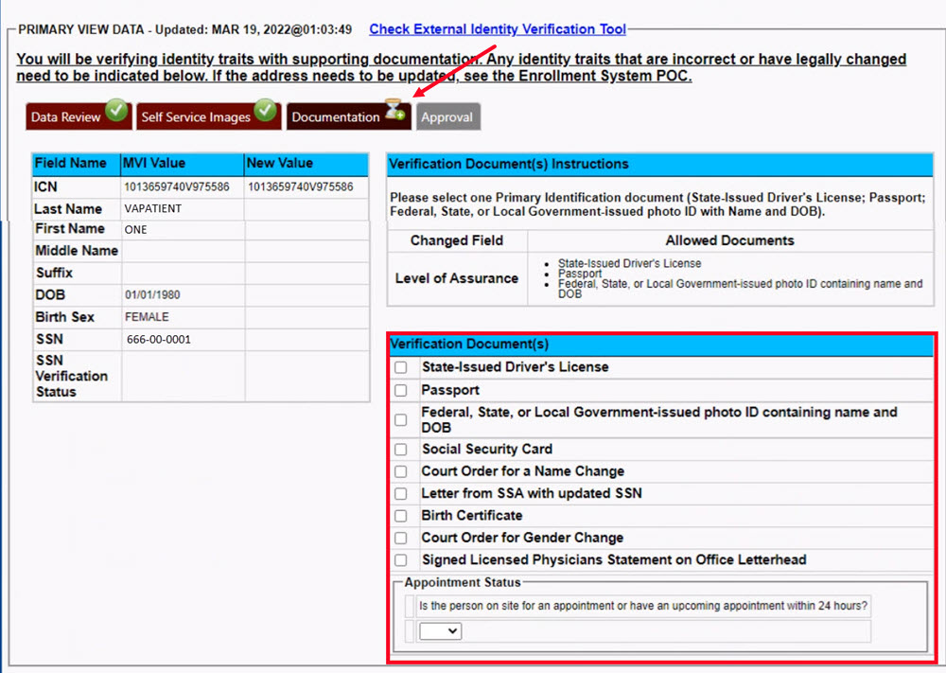
Figure 5-9. Verification Document Details

- After the document information details have been entered, Click Submit.
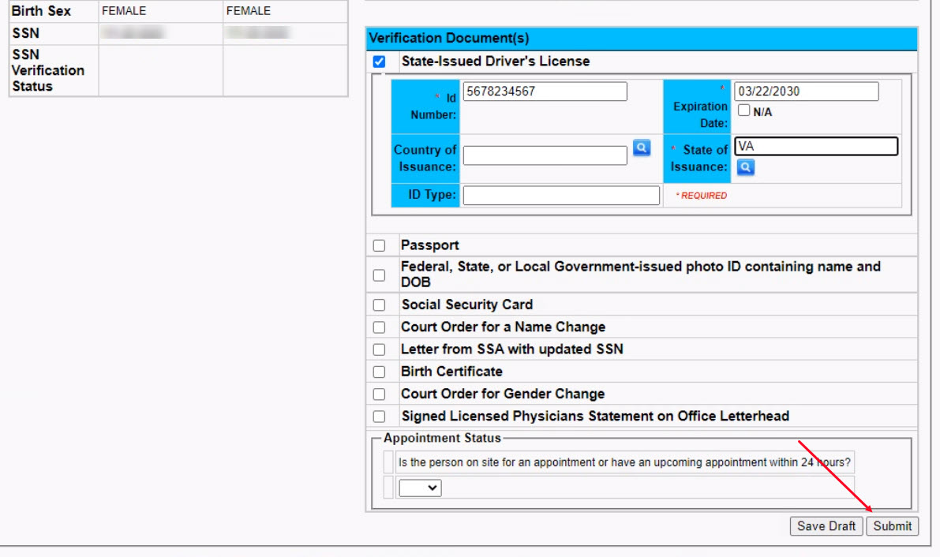
Figure 5-10. Submit Document Details

- Select OK button in the Task Complete pop up box
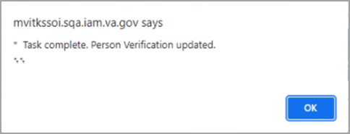
Figure 5-11. Select OK Button

Documentation Requirements Met, Green Check Indicators all marked that Proofing Task Completed
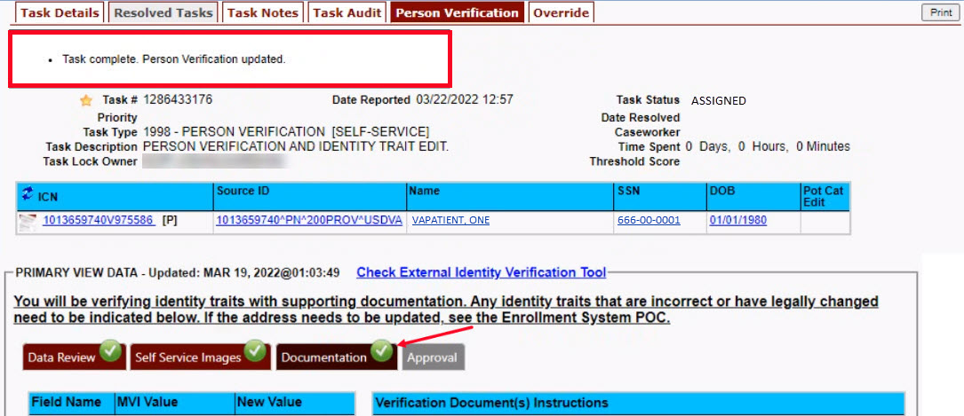
Figure 5-12. Task Competed

- Once the Task is completed, the POC will need to go back to the Task Notes tab and mark it as Resolved.
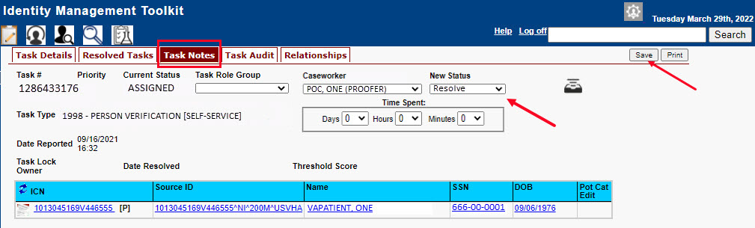

From the Primary View the user can confirm that the LOA Changed to 2
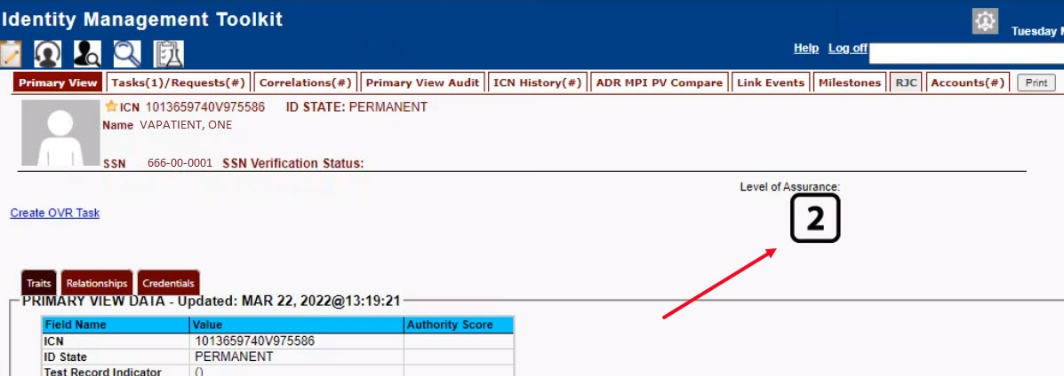
Figure 5-13. LOA Changed

From the Correlations tab the user can confirm that the Proofing Correlation Added
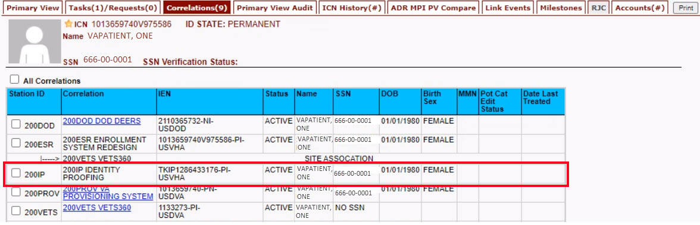
Figure 5-14. Proofing Correlation Added

Person Verification Task- Rejected Image

Selecting the Full Name link from the Assigned Request list will open a window into the MPI Toolkit 1998 Person Verification [Self-Service] Task.
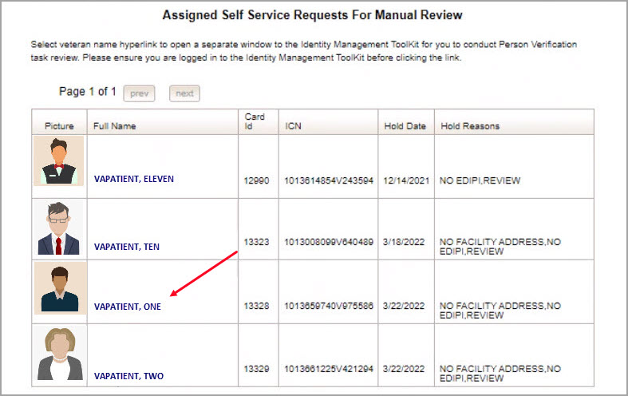
Figure 5-15. Link to Toolkit Task

To review, click on the 1998-Person verification [Self Service] Task hyperlink.
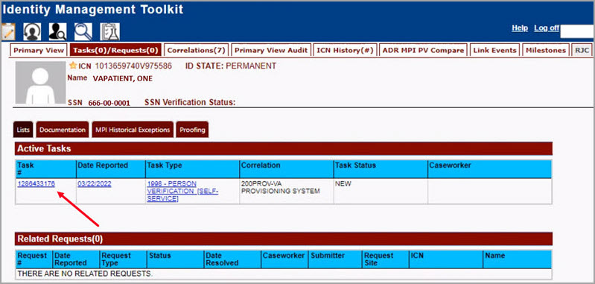
Figure 5-16. MPI Toolkit Task Number Link

Task Details page will open
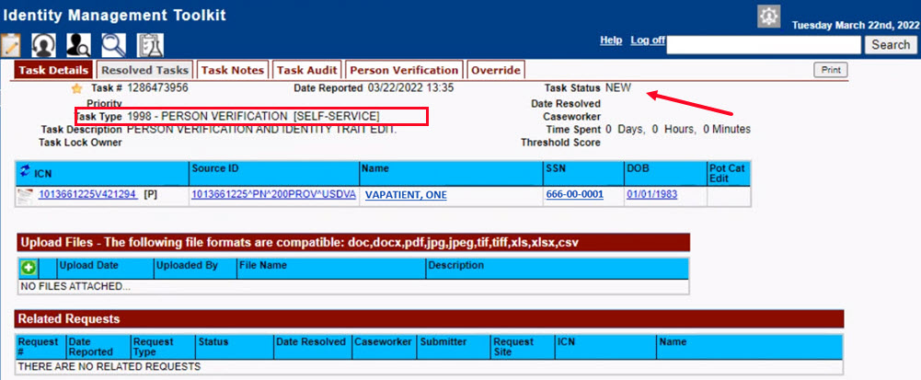
Figure 5-17. New Person Verification Task Details

- The Proofer will need to navigate to the Task Notes tab to assign the Task to themselves.
Figure 5-18. Task Notes Tab

Figure 5-19. Assign Task

- After assigning the Task they will open to Task Details Tab, then Select Person Verification Tab to process the Task

Task Details Screen, the user will need to click on the Person Verification tab to continue the Proofing Task
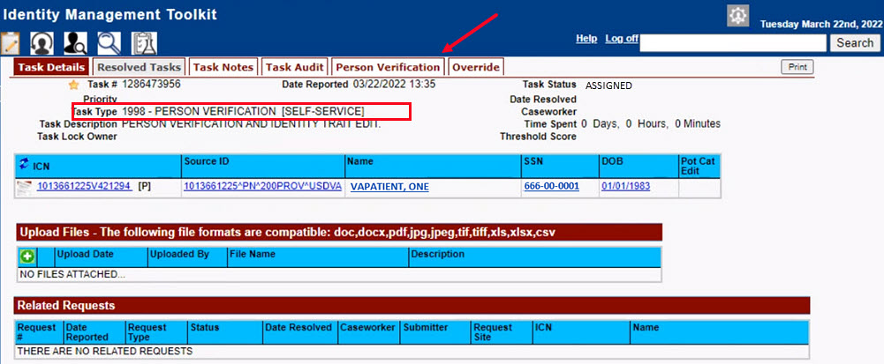
Figure 5-20. Select Person Verification Tab

On the Proofing Verification tab the Self Service Images tab is displayed. Select the Proofing Verification Document link to view and compare the document(s) submitted by the Veteran.
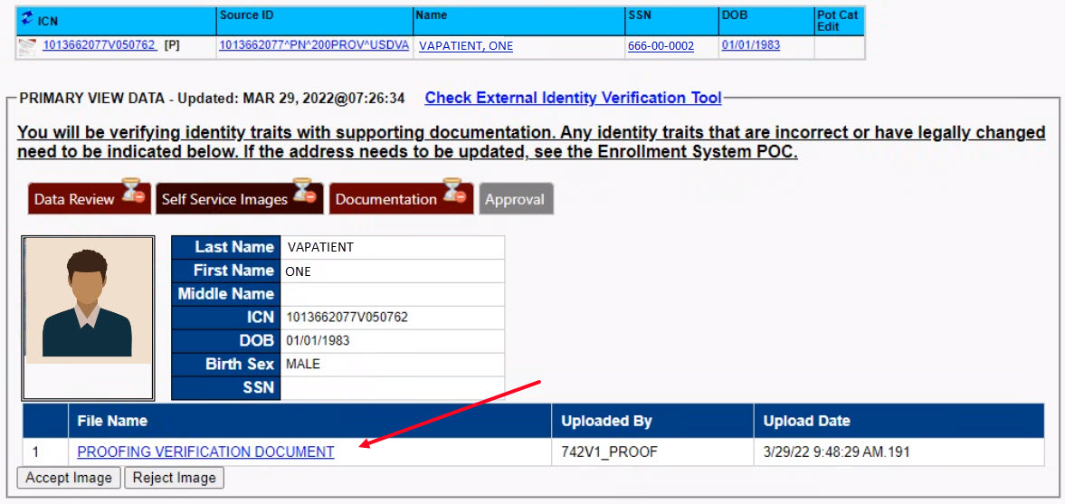
Figure 5-21. Attached Person Verification Document(s)

Upon review, if the images do not match, or if they fall under any other rejection reason, the user will need to close the window and move to the Task Notes tab.
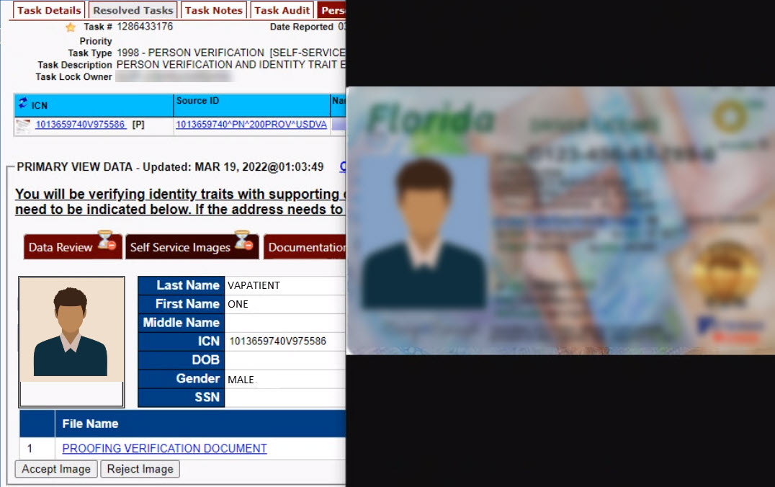
Figure 5-22. Compare Veteran Images

Note: Rejection reasons can include:
- Photo submitted is not acceptable
- Verification document uploaded is not acceptable
- Identification traits do not match

Enter reason for rejection under the Task Notes and return to the Person Verification tab
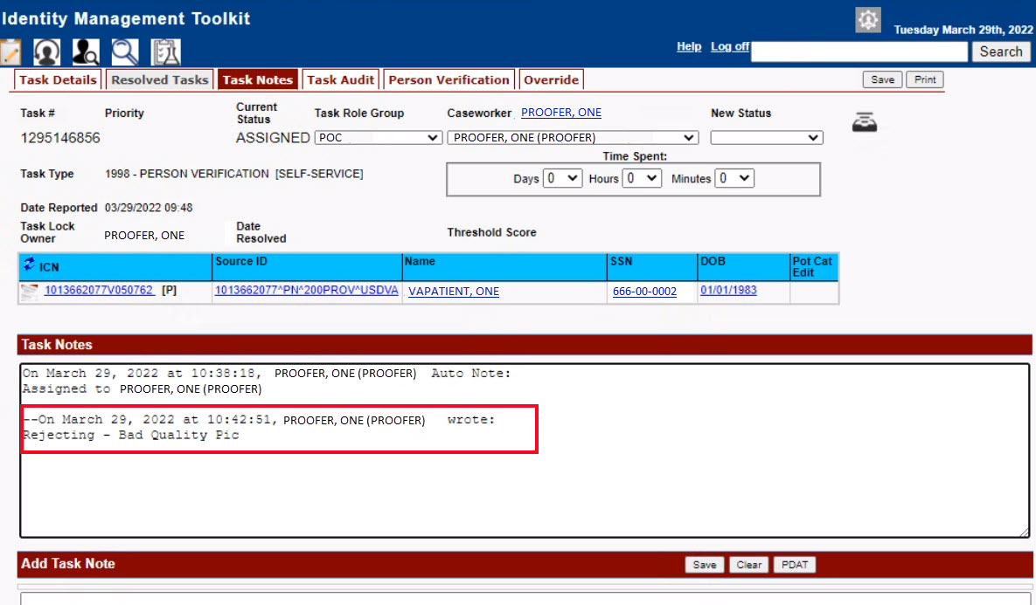
Figure 5-23. Enter Rejection Notes

Under Self Service Images tab, click the Reject Image button
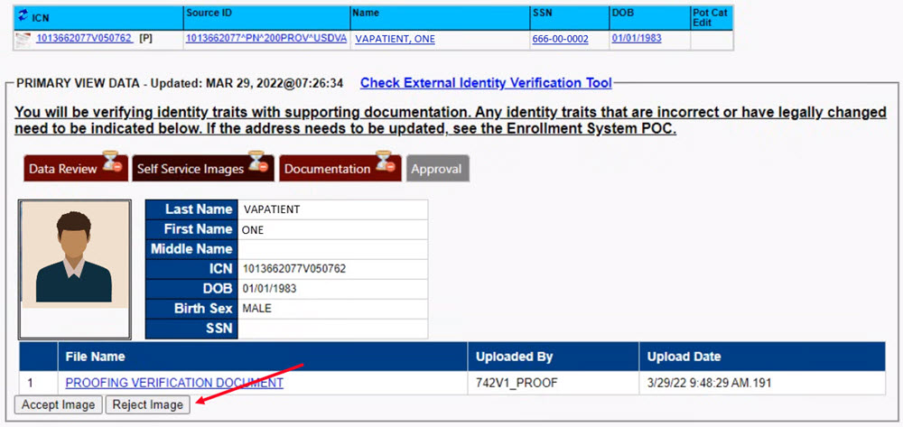
Figure 5-24. Select Reject Image Button

A pop up will appear to confirm the rejection. Select OK to confirm. Confirming the image rejection the Proofing Task will auto-resolve and cancel the request.
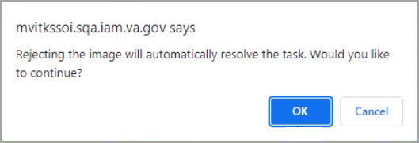
Figure 5-25. Reject/Resolve Confirmation Message

Auto-resolved will go to Task Details tab instead of staying on the Person Verification Tab
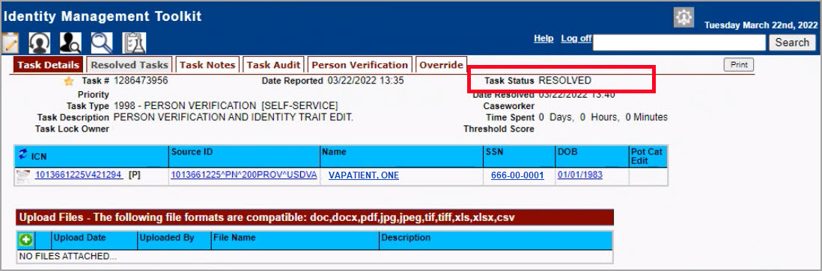
Figure 5-26. Resolved Task Status

The LOA on the Primary View will remain at 1
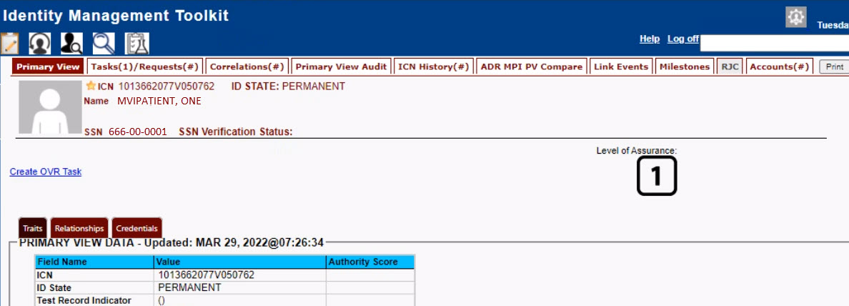
Figure 5-27. Level of Assurance Does Not Change

The Veteran will receive an email indicating that their request was cancelled and direct them to come into their nearest facility to resolve any issues that may keep them from qualifying for a VHIC card. Examples of these emails are:

- The card request was cancelled due to review issues such as a bad photo, unacceptable documents submitted, etc.
REDACTED
Figure 5-28. Request Cancellation Review Issue

- The card request was cancelled due to other reasons such as 30 day timeout.
REDACTED
Figure 5-29. Request Cancellation Email Timed Out

Troubleshooting
For a through set of troubleshooting guidelines, please refer to the Veteran Health Identification Card User Guide - Volume 4 - Troubleshooting document.

