Veteran Health Identification Card (VHIC 4.20)

Roles and Access Guide
April 2022

Department of Veterans Affairs
Office of Information and Technology (OI&T)

Revision History

Date | Revision | Description | Author
04/18/2022 | 2.0 | Revision based on VIP 20 changes | REDACTED
12/19/2020 | 1.0 | Revision based on VIP 15 changes | REDACTED
10/23/19 |  | Document Baseline | REDACTED

Table of Contents

1. Introduction 1
1.1. Purpose 1
1.2. Document Orientation 1
1.2.1. Organization of the Manual 1
1.2.2. Assumptions 1
1.2.3. Disclaimers 1
2. Roles within VHIC 2
2.1. VHIC Associate 2
2.2. VHIC Supervisor 4
2.3. VHIC Administrator 7
2.4. VHIC Technical Administrator (Tier 3) 12
2.5. VHIC Auditor 17
2.6. VHIC Read-Only User 19
2.7. VHIC Card Replacement Enrollment Services Users 20
3. VHIC Roles and Access Quick Reference Table 22

Table of Figures
Figure 1: Associate Reports Menu 3
Figure 2: VHIC Associate and VHIC Supervisor Home screen 5
Figure 3: Supervisor Reports Menu 5
Figure 4: Administrator Reports Menu 8
Figure 5: Administrator Card Management Tab 11
Figure 6: VHIC Technical Administrator (Tier 3) Home screen 12
Figure 7. VHIC Technical Administrator Tier 3 Reports Menu 13
Figure 8. Card Management Menu 16
Figure 9: VHIC Auditor User Home screen 17
Figure 10: VHIC Read-Only User Home screen 20
Figure 11: VHIC ES User Home Page 21

Table of Tables
Table 1. VHIC Roles and Access Table 22

Introduction

Purpose
The purpose of this User Guide is to provide accessibility and user roles with the VHIC application.

Document Orientation

Organization of the Manual
This User Guide is divided into two sections to allow you to obtain quickly the information you need.

The first section will provide a description of the various user roles and their accessibility within the VHIC application. The second section provides a table with this information for quick look up.

Assumptions
This guide has been written with the following assumed experience/skills of the audience:
- User has basic knowledge of the operating system (such as the use of commands, menu options, and navigation tools).
- User has been provided the appropriate active roles required for the VHIC application.
- User is using Google Chrome or Microsoft Edge to do their job of either Creating a VHIC Card Request, Running Reports, or Managing VHICs depending on user roles.
- User has validated access to the VHIC application.
- User has completed any prerequisite training.

Disclaimers

Software Disclaimer
This software was developed at the Department of Veterans Affairs (VA) by employees of the Federal Government in the course of their official duties. Pursuant to title 17 Section 105 of the United States Code this software is not subject to copyright protection and is in the public domain. VA assumes no responsibility whatsoever for its use by other parties, and makes no guarantees, expressed or implied, about its quality, reliability, or any other characteristic. We would appreciate acknowledgement if the software is used. This software can be redistributed and/or modified freely provided that any derivative works bear some notice that they are derived from it, and any modified versions bear some notice that they have been modified.

Documentation Disclaimer
The appearance of external hyperlink references in this manual does not constitute endorsement by the Department of Veterans Affairs (VA) of this Web site or the information, products, or services contained therein. The VA does not exercise any editorial control over the information you may find at these locations. Such links are provided and are consistent with the stated purpose of the VA.

Roles within VHIC
The VHIC application is built to accommodate a specific set of pre-established user roles. During the provisioning process, the VHIC user will have a role assigned to them, which will determine what aspects of the VHIC application are available to them. The following breaks down the specific roles and the areas of access that accompany each role.
If, while utilizing the VHIC application, a user finds they do not have access to items they feel they should have access to or find that they have access to items they should not, based on the definitions listed below, the VHIC user should report this information to their VHIC Supervisor. The VHIC Supervisor should then verify that the proper role has been assigned.

VHIC Associate
The VHIC Associate role shall be assigned to individuals responsible for processing a card request and resolving card request issues. Associates have the ability to create a card request and have access to a limited number of reports.
The VHIC Associate user will be presented with two menu options: Card Request and Reports. They can navigate to each of these application modules by either clicking on one of the links located in the header at the top left of the screen or by clicking on one of the icon buttons in the middle of the screen as seen in Figure 1. Associate Home Page.
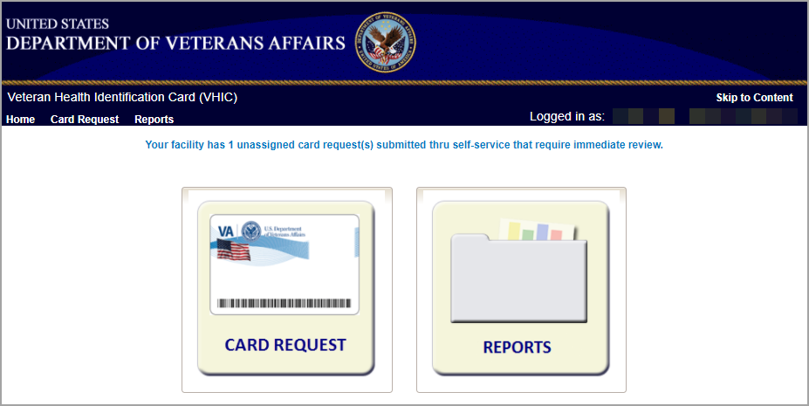
Figure 1. Associate Home Page

Selecting the Card Request option will start the Associate on the Card Request Process. Details regarding the Card Request Process are available in Veteran Health Identification Card User Guide – Volume 1 Card Request.
Selecting the Reports option will take the Associate to the Reports menu.
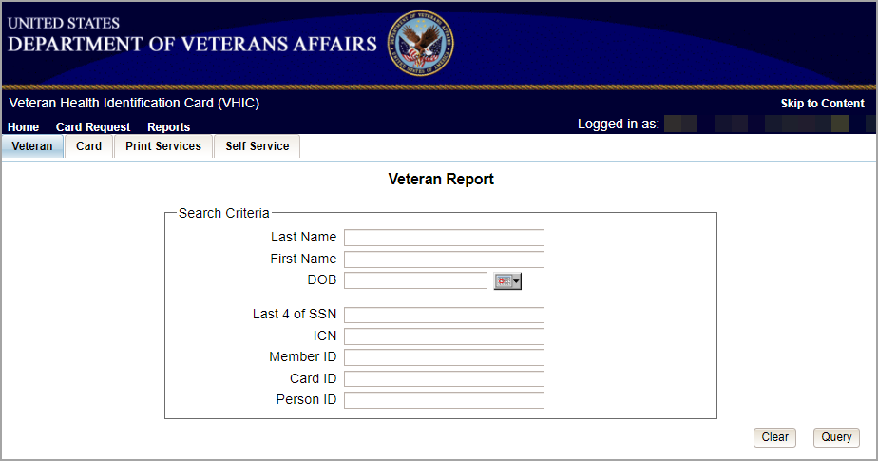
Figure 2: Associate Reports Menu

The reports menu is broken down into three types of reports the Veteran Report, Card Reports, and Print Services Reports. The details and instructions for all the reports can be found in Veteran Health Identification Card (VHIC) User Guide Volume 2 – Reports.
The Associate access grants the user access to the following reports:
Veteran Report
- Individual Veteran Report
Card Request Totals
- Facility Report
Card Status
- Facility Report
Card Status – MVI Status Report
- Facility Report
Card Status – Print Release Status Report
- Facility Report
Multiple Requests (Card – Multiple Requests):
- Cards Requested
- Cards Mailed
  - Facility Report
Card History (Card – History):
- Card ID
- Person ID
Replacement (Card – Replacement):
- Facility Report
Expiration (Card – Expiration):
- Facility Report
Request Progress Report (Card – Request Progress)
- Facility Report
On Hold (Card – On Hold Reason)
- Facility Report
Print Services Processing
- Facility Report
Self Service Activity Report
- Facility Report
Self Service Audit Log
- ICN
- Card ID
Self Service Manual Review Activity Report
- Facility Report

VHIC Supervisor
The VHIC Supervisor shall automatically inherit all access and privileges given to the VHIC Associate. The VHIC Supervisor role is allowed to submit a request for user access to the VHIC application. VHIC Supervisors have the ability to create a card request and have access to most available reports (excluding national versions).
The VHIC Associate user will be presented with two menu options: Card Request and Reports. They can navigate to each of these application modules by either clicking on one of the links located in the header at the top left of the screen or by clicking on one of the icon buttons in the middle of the screen as seen below.
Figure 3: VHIC Associate and VHIC Supervisor Home screen

Selecting the Card Request option will start the Supervisor on the Card Request Process. Details regarding the Card Request Process are available in Veteran Health Identification Card User Guide – Volume 1 Card Request.
Selecting the Reports option will take the Supervisor to the Reports menu.
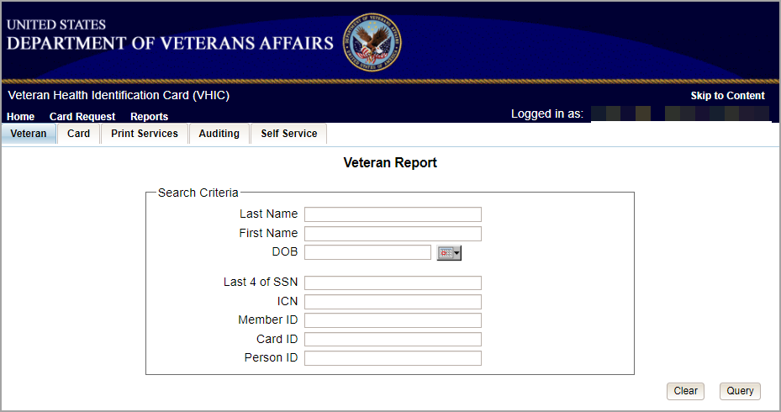
Figure 4: Supervisor Reports Menu

The reports menu is broken down into three types of reports the Veteran Report, Card Reports, and Print Services Reports. The details and instructions for all the reports can be found in Veteran Health Identification Card) User Guide Volume 2 – Reports.
The Supervisor access grants the user access to the following reports:
Veteran Report
- Individual Veteran Report
Card Request Totals
- Facility Report
Card Status
- Facility Report
Card Status – MVI Status Report
- Facility Report
Card Status – Print Release Status Report
- Facility Report
Multiple Requests (Card – Multiple Requests):
- Cards Requested
- Cards Mailed
  - Facility Report
Card History (Card – History):
- Card ID
- Person ID
Replacement (Card – Replacement):
- Facility Report
Expiration (Card – Expiration):
- Facility Report
Request Progress Report (Card – Request Progress)
- Facility Report
On Hold (Card – On Hold Reason)
- Facility Report
Print Services Processing
- Facility Report
Print Error Report
- Facility Report
Auditing Report
- User ID
Card Requests by User Report
- Facility Report
No Edipi Report
- Facility Report
Self Service Activity Report
- Facility Report
Self Service Audit Log
- ICN
- Card ID
Self Service Manual Review Activity Report
- Facility Report

VHIC Administrator
The VHIC Administrator role is reserved for the VHIC Business (HEC) team members responsible for the creation and maintenance of all other VHIC accounts/roles. The VHIC Administrator shall automatically inherit privileges given to the VHIC Supervisor. Administrators have the ability to create a card request, manage cards, and have access to all available reports.
The VHIC Administrator users will be presented with three menu options: Card Request, Reports and Card Management. They can navigate to each of these application modules by either clicking on one of the links located in the header at the top left of the screen or by clicking on one of the icon buttons in the middle of the screen as seen in Figure 5. VHIC Administrator Home Page.
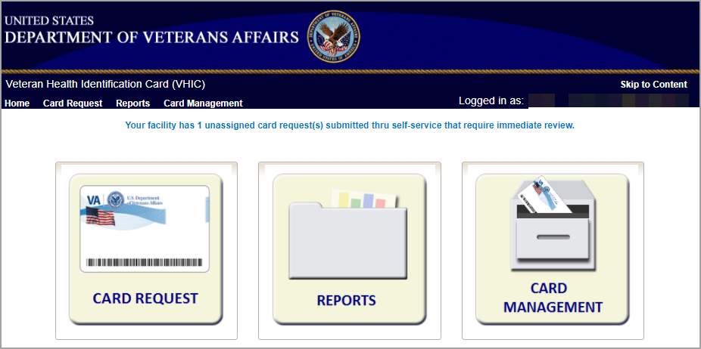
Figure 5. VHIC Administrator Home Page

Selecting the Card Request option will start the Administrator on the Card Request Process. Details regarding the Card Request Process are available in Veteran Health Identification Card User Guide – Volume 1 Card Request.
Selecting the Reports option will take the Administrator to the Reports menu.
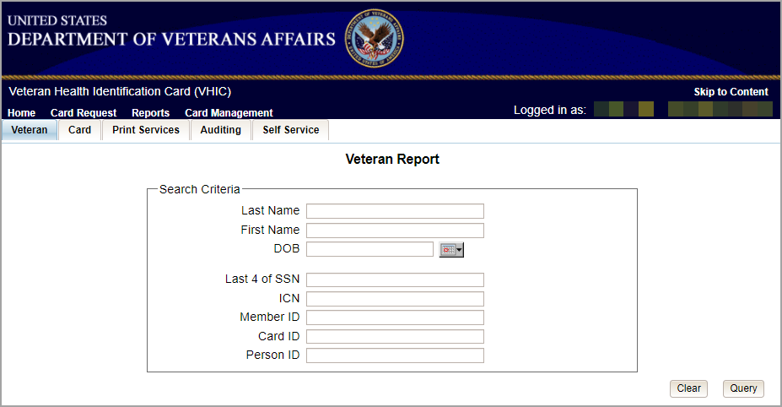
Figure 6: Administrator Reports Menu

The reports menu is broken down into three types of reports the Veteran Report, Card Reports, and Print Services Reports. The details and instructions for all the reports can be found in Veteran Health Identification Card (VHIC) User Guide Volume 2 – Reports.
The Administrator access grants the user access to the following reports:
Veteran Report
- Individual Veteran Report
Card Request Totals
- National Report
- VISN Report
- Facility Report
Card Status
- National Report
- VISN Report
- Facility Report
Card Status – MVI Status Report
- National Report
- VISN Report
- Facility Report
Card Status – Print Release Status Report
- National Report
- VISN Report
- Facility Report
Multiple Requests (Card – Multiple Requests)
- Cards Requested
  - National Report
  - VISN Report
  - Facility Report
- Cards Mailed
  - National Report
  - VISN Report
  - Facility Report
Card History (Card – History)
- Card ID
- Person ID
Replacement (Card – Replacement)
- National Report
- VISN Report
- Facility Report
Expiration (Card – Expiration)
- National Report
- VISN Report
- Facility Report
Request Progress Report (Card – Request Progress)
- National Report
- VISN Report
- Facility Report
Swipe/Scan Report
- Card Number
On Hold (Card – On Hold Reason)
- National Report
- VISN Report
- Facility Report
Destruction (Card – Destruction)
- Pending Destruction
- Destroyed
Print Services Processing
- National Report
- VISN Report
- Facility Report
Print Error Report (Print Services – Error)
- Sent Not Acknowledged
- Acknowledged Not Confirmed
- Pending Not Sent
Auditing Report
- Direct Search
Card Requests by User Report
- National Report
- VISN Report
- Facility Report
No EDIPI Report
- National Report
- VISN Report
- Facility Report
Self Service Activity Report
- Facility Report
Self Service Audit Log
- ICN
- Card ID
Self Service Manual Review Activity Report
- National Report
- VISN Report
- Facility Report

The Administrator role also has access to the Card Management Tab.
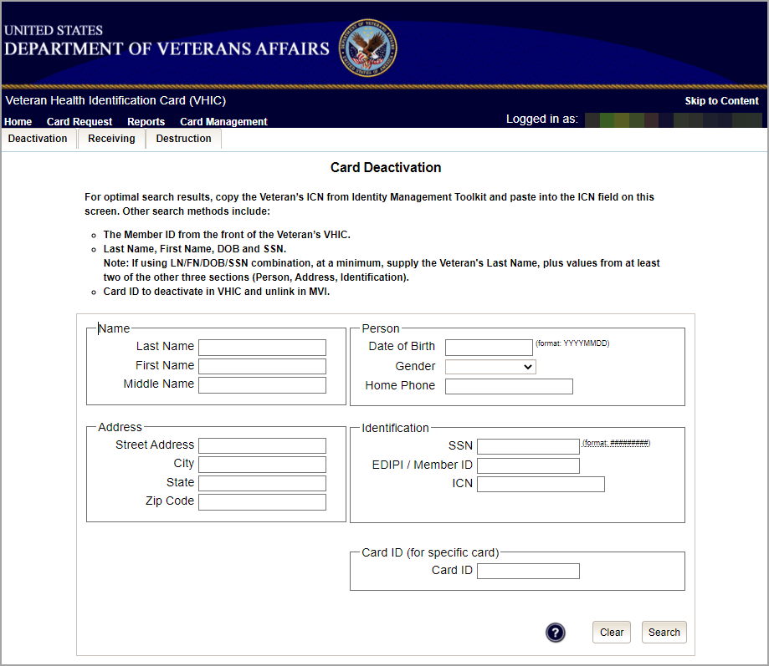
Figure 7: Administrator Card Management Tab

Functionality available to the Administrator include:

Deactivation
- Card Deactivation (Direct Search)
Receiving
- Cards Received (Direct Search)
Destruction
- Card Destruction (By Date Received)

VHIC Technical Administrator (Tier 3)
The VHIC Technical Administrator (Tier 3) automatically inherits all access and privileges given to the VHIC Administrator. Technical Administrators (Tier 3) have the ability to create a card request and have access to all available reports as well as access to the Administration page.
The VHIC Technical Administrator Tier 3 users will be presented with three menu options: Card Request, Reports, Card Management, and Site Management. They can navigate to each of these application modules by either clicking on one of the links located in the header at the top left of the screen or by clicking on one of the icon buttons in the middle of the screen.
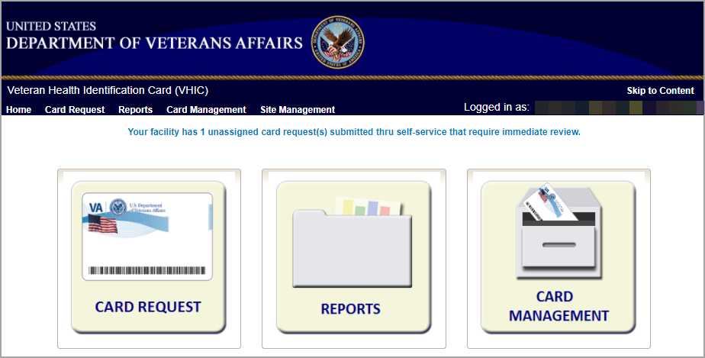
Figure 8: VHIC Technical Administrator (Tier 3) Home screen

Selecting the Card Request option will start the VHIC Technical Administrator Tier 3 on the Card Request Process. Details regarding the Card Request Process are available in Veteran Health Identification Card User Guide – Volume 1 Card Request.
Selecting the Reports option will take the VHIC Technical Administrator Tier 3 to the Reports menu.
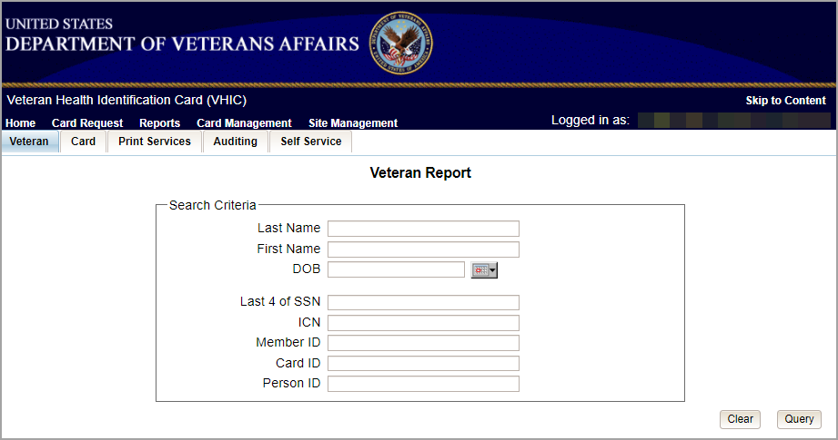
Figure 9. VHIC Technical Administrator Tier 3 Reports Menu

The reports menu is broken down into three types of reports the Veteran Report, Card Reports, and Print Services Reports. The details and instructions for all the reports can be found in Veteran Health Identification Card (VHIC) User Guide Volume 2 – Reports.
The VHIC Technical Administrator Tier 3 access grants the user access to the following reports:
Veteran Report
- Individual Veteran Report
Card Request Totals
- National Report
- VISN Report
- Facility Report
Card Status
- National Report
- VISN Report
- Facility Report
Card Status – MVI Status Report
- National Report
- VISN Report
- Facility Report
Card Status – Print Release Status Report
- National Report
- VISN Report
- Facility Report
Multiple Requests (Card – Multiple Requests)
- Cards Requested
  - National Report
  - VISN Report
  - Facility Report
- Cards Mailed
  - National Report
  - VISN Report
  - Facility Report
Card History (Card – History)
- Card ID
- Person ID
Replacement (Card – Replacement)
- National Report
- VISN Report
- Facility Report
Expiration (Card – Expiration)
- National Report
- VISN Report
- Facility Report
Request Progress Report (Card – Request Progress)
- National Report
- VISN Report
- Facility Report
Swipe/Scan Report
- Card Number
On Hold (Card – On Hold Reason)
- National Report
- VISN Report
- Facility Report
Destruction (Card – Destruction)
- Pending Destruction
- Destroyed
Print Services Processing
- National Report
- VISN Report
- Facility Report
Print Error Report (Print Services – Error)
- Sent Not Acknowledged
- Acknowledged Not Confirmed
- Pending Not Sent
Auditing Report
- Direct Search
Card Requests by User Report
- National Report
- VISN Report
- Facility Report
No EDIPI Report
- National Report
- VISN Report
- Facility Report
Self Service Activity Report
- Facility Report
Self Service Audit Log
- ICN
- Card ID
Self Service Manual Review Activity Report
- National Report
- VISN Report
- Facility Report

The VHIC Technical Administrator Tier 3 role also has access to the Card Management Tab.

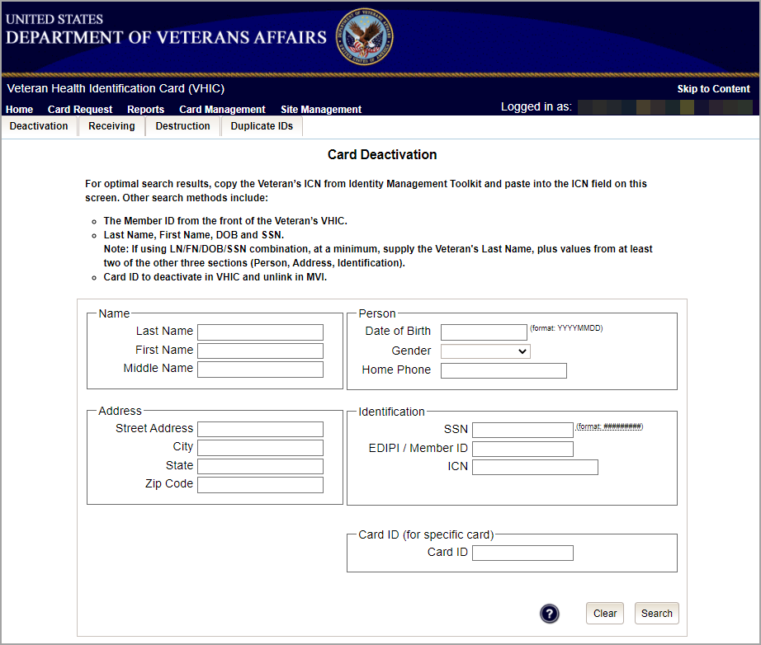
Figure 10. Card Management Menu

Functionality available to the VHIC Technical Administrator Tier 3 include:
Deactivation
- Card Deactivation (Direct Search)
Receiving
- Cards Received (Direct Search)
Destruction
Card Destruction (By Date Received)

VHIC Auditor
The VHIC Auditor role shall be assigned to users with read-only access to the VHIC System. The VHIC Auditor does not have the ability to create a card request but does have access to all available reports.
The VHIC Auditor users will be presented with the Reports menu option. They can navigate to Reports by clicking on the icon button in the middle of the screen as seen below.

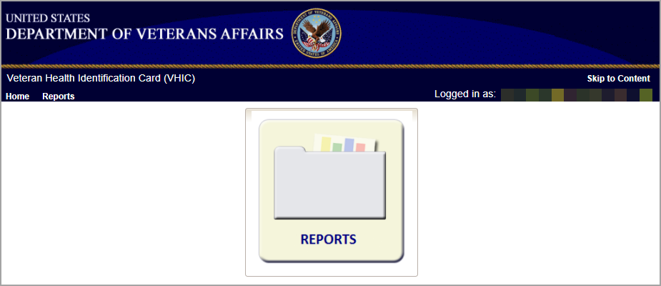
Figure 11: VHIC Auditor User Home screen

Available reports include:
Veteran Report
- Individual Veteran Report
Card Request Totals
- National Report
- VISN Report
- Facility Report
Card Status
- National Report
- VISN Report
- Facility Report
Card Status – MVI Status Report
- National Report
- VISN Report
- Facility Report
Card Status – Print Release Status Report
- National Report
- VISN Report
- Facility Report
Multiple Requests (Card – Multiple Requests)
- Cards Requested
  - National Report
  - VISN Report
  - Facility Report
- Cards Mailed
  - National Report
  - VISN Report
  - Facility Report
Card History (Card – History)
- Card ID
- Person ID
Replacement (Card – Replacement)
- National Report
- VISN Report
- Facility Report
Expiration (Card – Expiration)
- National Report
- VISN Report
- Facility Report
Request Progress Report (Card – Request Progress)
- National Report
- VISN Report
- Facility Report
Swipe/Scan Report
- Card Number
On Hold (Card – On Hold Reason)
- National Report
- VISN Report
- Facility Report
Destruction (Card – Destruction)
- Pending Destruction
- Destroyed
Print Services Processing
- National Report
- VISN Report
- Facility Report
Print Error Report (Print Services – Error)
- Sent Not Acknowledged
- Acknowledged Not Confirmed
- Pending Not Sent
Auditing Report
- Direct Search
Card Requests by User Report
- National Report
- VISN Report
- Facility Report
No EDIPI Report
- National Report
- VISN Report
- Facility Report
Self Service Activity Report
- Facility Report
Self Service Audit Log
- ICN
- Card ID
Self Service Manual Review Activity Report
- National Report
- VISN
- Facility Report

VHIC Read-Only User
The VHIC Read-Only User role shall be assigned to users with read-only access to the VHIC System. The VHIC Read-Only user does not have the ability to create a card request but does have access to a limited number of reports.
The VHIC Read-Only users will be presented with the Reports menu option. They can navigate to Reports by clicking on the icon button in the middle of the screen.

Figure 12: VHIC Read-Only User Home screen

Reports Available to the Read Only User include:

Veteran Report:
- Direct Search
Card History (Card – History):
- Card ID
- Person ID
Card Request Totals (Card – Request Totals):
- VISN
- Facility
Self Service Activity Report
- Facility Report
Self Service Audit Log
- ICN
- Card ID
Self Service Manual Review Activity Report
- VISN
- Facility Report

VHIC Card Replacement Enrollment Services Users
The VHIC Card Replacement User role shall be assigned to Enrollment System (ES) users with limited access to the VHIC System. The VHIC Card Replacement user does not have the ability to create a new card request but does have access to the Card Replacement functionality.
An eligible VHIC Card Replacement Enrollment Services Users will be able to click on a hyperlink in the Enrollment System and be directed to VHIC. After the hyperlink has been selected, a second browser tab will be opened and VHIC Users will be directed to the Home screen assigned to their roles. To the eligible HEC ES users (Card Replacement Role), the Veteran Card Details page serves as their Home page for the application.

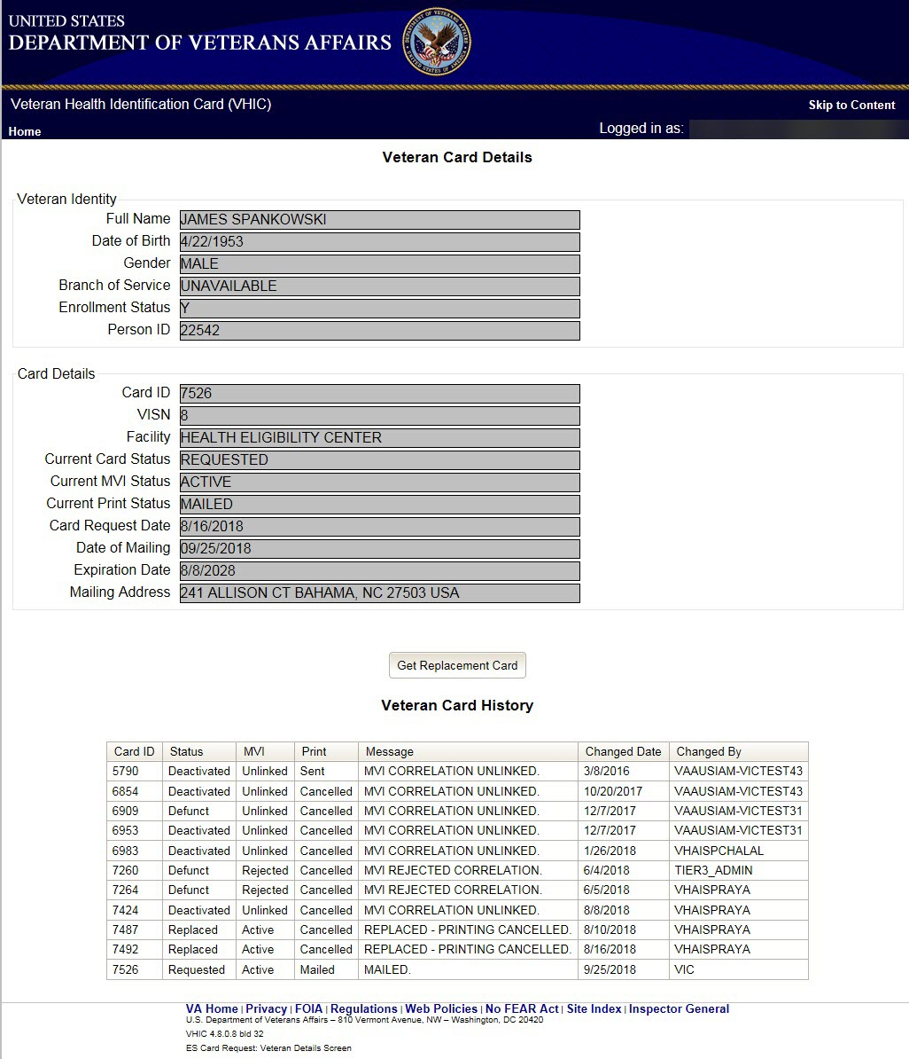
Figure 13: VHIC ES User Home Page

VHIC Roles and Access Quick Reference Table

Table 1. VHIC Roles and Access Table

 | VHIC Roles
Function | Administrator | Technical Administrator  Tier 3 | Supervisor | Associate | Auditor | Read-Only User | Card Replacement User (Enrollment System User)
Card Requests
Request Cards | X | X | X | X |  |  | X
Reports
Veteran Tab
Veteran (Direct Search):
Basic (No National Option) | X | X | X | X | X | X
Card Tab
Card Request Totals (Card – Request Totals):
National | X | X |  |  | X
VISN | X | X |  |  | X | X
Facility | X | X | X | X | X | X
Card Status – Card Status Report (Card – Status):
National:
Replaced | X | X |  |  | X
Deactivated | X | X |  |  | X
Expired | X | X |  |  | X
On Hold | X | X |  |  | X
Pending | X | X |  |  | X
Requested | X | X |  |  | X
Defunct | X | X |  |  | X
Pending Destruction | X | X |  |  | X
Destroyed | X | X |  |  | X
VISN:
Replaced | X | X |  |  | X
Deactivated | X | X |  |  | X
Expired | X | X |  |  | X
On Hold | X | X |  |  | X
Pending | X | X |  |  | X
Requested | X | X |  |  | X
Defunct | X | X |  |  | X
Pending Destruction | X | X |  |  | X
Destroyed | X | X |  |  | X
Facility:
Replaced | X | X | X | X | X
Deactivated | X | X | X | X | X
Expired | X | X | X | X | X
On Hold | X | X | X | X | X
Pending | X | X | X | X | X
Requested | X | X | X | X | X
Defunct | X | X | X | X | X
Pending Destruction | X | X | X | X | X
Destroyed | X | X | X | X | X
Card Status – MVI Status Report (Card – Status):
National:
Active | X | X |  |  | X
Not Correlated | X | X |  |  | X
Rejected | X | X |  |  | X
Unlinked | X | X |  |  | X
VISN:
Active | X | X |  |  | X
Not Correlated | X | X |  |  | X
Rejected | X | X |  |  | X
Unlinked | X | X |  |  | X
Facility:
Active | X | X | X | X | X
Not Correlated | X | X | X | X | X
Rejected | X | X | X | X | X
Unlinked | X | X | X | X | X
Card Status – Print Release Status Report (Card – Status):
National:
Cancelled | X | X |  |  | X
Error | X | X |  |  | X
Mailed | X | X |  |  | X
Not Started | X | X |  |  | X
Pending | X | X |  |  | X
Received | X | X |  |  | X
Rejected | X | X |  |  | X
Sent | X | X |  |  | X
VISN:
Cancelled | X | X |  |  | X
Error | X | X |  |  | X
Mailed | X | X |  |  | X
Not Started | X | X |  |  | X
Pending | X | X |  |  | X
Received | X | X |  |  | X
Rejected | X | X |  |  | X
Sent | X | X |  |  | X
Facility:
Cancelled | X | X | X | X | X
Error | X | X | X | X | X
Mailed | X | X | X | X | X
Not Started | X | X | X | X | X
Pending | X | X | X | X | X
Received | X | X | X | X | X
Rejected | X | X | X | X | X
Sent | X | X | X | X | X
Multiple Requests (Card – Multiple Requests):
Cards Requested:
National | X | X |  |  | X
VISN | X | X |  |  | X
Facility | X | X | X | X | X
Cards Mailed:
National | X | X |  |  | X
VISN | X | X |  |  | X
Facility | X | X | X | X | X
Card History (Card – History):
Card ID | X | X | X | X | X | X
Person ID | X | X | X | X | X | X
Replacement (Card – Replacement):
National | X | X |  |  | X
VISN | X | X |  |  | X
Facility | X | X | X | X | X
Expiration (Card – Expiration):
National | X | X |  |  | X
VISN | X | X |  |  | X
Facility | X | X | X | X | X
Request Progress Report (Card – Request Progress)
National | X | X |  |  | X
VISN | X | X |  |  | X
Facility | X | X | X | X | X
Swipe/Scan (Card- Swipe Scan)
Swipe/Scan (Direct Search) | X | X |  |  | X
On Hold (Card – On Hold Reason)
National:
All | X | X |  |  | X
Bad Data | X | X |  |  | X
Eligibility Pending | X | X |  |  | X
ES Unavailable | X | X |  |  | X
Not Correlated | X | X |  |  | X
Not Proofed | X | X |  |  | X
No Photo | X | X |  |  | X
VISN:
All | X | X |  |  | X
Bad Data | X | X |  |  | X
Eligibility Pending | X | X |  |  | X
ES Unavailable | X | X |  |  | X
Not Correlated | X | X |  |  | X
Not Proofed | X | X |  |  | X
No Photo | X | X |  |  | X
Facility:
All | X | X | X | X | X
Bad Data | X | X | X | X | X
Eligibility Pending | X | X | X | X | X
ES Unavailable | X | X | X | X | X
Not Correlated | X | X | X | X | X
Not Proofed | X | X | X | X | X
No Photo | X | X | X | X | X
Destruction (Card – Destruction)
Pending Destruction
All | X | X |  |  | X
Legacy | X | X |  |  | X
Mass Reissuance | X | X |  |  | X
VHIC | X | X |  |  | X
Destroyed
All | X | X |  |  | X
Legacy | X | X |  |  | X
Mass Reissuance | X | X |  |  | X
VHIC | X | X |  |  | X
Print Services Tab
Processing (Print Services – Processing):
National | X | X |  |  | X
VISN | X | X |  |  | X
Facility | X | X | X | X | X
Print Error Report (Print Services – Error):
Sent Not Acknowledged
National | X | X |  |  | X
VISN | X | X |  |  | X
Facility | X | X | X |  | X
Acknowledged Not Confirmed
National | X | X |  |  | X
VISN | X | X |  |  | X
Facility | X | X | X |  | X
Pending Not Sent
National | X | X |  |  | X
VISN | X | X |  |  | X
Facility | X | X | X |  | X
Auditing:
Auditing Report
Basic (Direct Search) | X | X | X |  | X
Card Requests by User Report
National | X | X |  |  | X
VISN | X | X |  |  | X
Facility | X | X | X |  | X
No EDIPI Report
National | X | X |  |  | X
VISN | X | X |  |  | X
Facility | X | X | X |  | X
Self Service
Activity
Facility | X | X | X | X | X | X
Audit Log
ICN | X | X | X | X | X | X
Card ID | X | X | X | X | X | X
Manual Review
National | X | X |  |  | X
VISN | X | X |  |  | X
Facility | X | X | X | X | X | X
Card Management
Deactivation
Card Deactivation (Direct Search) | X | X
Receiving
Cards Received (Direct Search) | X | X
Destruction
Card Destruction (By Date Received) | X | X

