Veteran Health Identification Card (VHIC 4.21)

User Guide
Volume 5 – Card Replacement User
Enrollment Services

June 2022

Department of Veterans Affairs
Office of Information and Technology (OI&T)

Revision History
NOTE: The revision history cycle begins once changes or enhancements are requested after the document has been baselined.
Date | Revision | Description | Author
06/18/2022 | 6.0 | Updated to reflect changes during VIP 21 | REDACTED
04/18/2022 | 5.2 | No changes in functionality updated date and version number | REDACTED
09/18/2021 | 5.1 | No changes in functionality updated date and version number | REDACTED
06/20/2021 | 5.0 | Updated to reflect functionality changes during VIP 17 | REDACTED
03/20/2021 | 4.1 | Updated to reflect functionality changes during VIP 16 | REDACTED
12/10/2020 | 4.0 | Updated to reflect changes during VIP 15 | REDACTED
06/20/2020 | 3.0 | Updated to reflect changes to application During VIP 13 | REDACTED
02/15/2020 | 2.0 | Updated to reflect changes to application During VIP 11 | REDACTED
10/02/2018 | 1.0 | Initial Draft | REDACTED
11/09/2018 | 1.0 | Re-ran TOCs, ran Spelling and Grammar, fixed content/figure pagination issues in the Word document, and added Alt text to all images. Created Section 508 compliant PDF for uploading, with revised Word document, to RTC Jazz Tools as well as SharePoint. No technical content changed in editing process. Completed editing 11/09/2018 for 11/14/2018 delivery. | REDACTED
09/19/2019 | 2.0 | Updated to reflect changes to application release of version 4.9 | REDACTED
Table of Contents
1. Introduction 4
1.1. Purpose 4
1.2. Document Orientation 4
1.2.1. Organization of the Manual 4
1.2.2. Assumptions 5
1.2.3. Disclaimers 5
1.2.3.1. Software Disclaimer 5
1.2.3.2. Documentation Disclaimer 5
1.2.4. Documentation Conventions 5
1.3. Enterprise Service Desk and Organizational Contacts 6
2. Veteran Health Identification Card – What is it? 7
2.1. Proper Navigation of the VHIC Application 7
2.2. Roles Within VHIC 7
3. Getting Started 8
3.1. Logging On 8
3.2. Enrollment System Link to VHIC 9
3.3. VHIC Home Screen 10
3.3.1. Veteran Card Details Page 11
4. Requesting a Replacement VHIC Card 14
4.1. Card Replacement Eligibility 14
4.2. Requesting a Replacement Card 16
4.2.1. VHIC Card Replacement Request 16
4.2.1.1. Branch of Service 22

Table of Figures
Figure 2:1: Example of what the VHIC looks like 7
Figure 3:1: VHIC ES Hyperlink 9
Figure 3:2: VHIC ES User Home Page 10
Figure 3:3: Veteran Identity Section 11
Figure 3:4: Card Detail Section 12
Figure 3:5: Veteran Card History Section 13
Figure 4:1: Card Not Eligible for Replacement 14
Figure 4:2: Card Eligible for Replacement 15
Figure 4:3: Select the Get Replacement Card Button 16
Figure 4:4: Veteran Identity Confirmation Page 17
Figure 4:5: Select Replacement Reason 18
Figure 4:6: Select Mailing Address 19
Figure 4:7: Select Next Button 21
Figure 4:8: Branch of Service Selection 23
Figure 4:9: Save Card Request 24
Figure 4:10: Card Request Submitted 25
Figure 4:11: Close Browser Window 25
Figure 4:12: Pending Request No EDIPI 26
Figure 4:13: On Hold Request Confirmation Box 26
Figure 4:14: HC IdM Request Confirmation 27
Figure 4:15: Active Request Exists in System Message 28
Figure 4:16: Reason for Hold: No EDIPI 29
Figure 4:17: On Hold Request Confirmation Request 29
Figure 4:18: Saved on Hold 30

Table of Tables
Table 1: Documentation Symbols and Descriptions 6
Table 2: Enterprise Service Desk Contact Information 6

Introduction

Purpose
The purpose of this User Guide is to provide general system information, as well as accessibility and user roles with the VHIC application. This User Guide will provide a detailed walkthrough of creating a Veteran Health Identification Card replacement request using the VHIC application.

Document Orientation

Organization of the Manual
This User Guide is divided into sections to allow you to obtain quickly the information you need.

The first section will provide an overview of what a VHIC is and what the eligibility requirements are, and the various user roles and their accessibility within the VHIC application.

In order to be able to receive a VHIC, a Veteran must meet the following eligibility criteria:
- Be eligible for VA medical benefits
- Be enrolled in the VA Healthcare system
- Be Level 2 proofed at a VA medical facility
- Veteran identity must be recognized in the Master Veteran Index (MVI), which is managed by the Identity and Access Management (IAM) of the VA

NOTE: The Level 2 proofing process is a method to verify the identity of Veterans. VA requires Veterans to provide approved identification documents to access Personal Identifiable Information (PII), Personal Health Information (PHI) and request a Veterans Health Identification Card (VHIC).

The second and third sections will walk the user through the steps needed to access the VHIC application, as well as some general guidelines on using the VHIC application.

The fourth section will give the user step-by-step details of how to complete the Replacement Card Request. Once all of the required information has been provided, the final step in the process will allow a VHIC request to be submitted for processing.

Each day, these card requests are transmitted from the VHIC system to a vendor to print and mail the cards to the Veterans, the preferred facility, or the requesting facility. Typically, the cards are received in 7-10 business days from date of request. To ensure the VHIC is received at the appropriate address, the VHIC Associate must verify that the correct address is used and the Print Vendor verifies that the address is valid. If the U.S. Postal Service cannot deliver the card, it is returned to the requesting facility.

The last section covers some troubleshooting issues and solutions that will help the VHIC user to better able to support the Veteran and ensure that the VHIC requests are processed properly.

Assumptions
This guide has been written with the following assumed experience/skills of the audience:
- User has basic knowledge of the operating system (such as the use of commands, menu options, and navigation tools).
- User has been provided the appropriate active roles required for the VHIC application.
- User is using Google Chrome or Microsoft Edge to do their job of either Creating a VHIC Card Request, Running Reports, or Managing VHICs depending on user roles.
- User has validated access to the VHIC application.
- User has completed any prerequisite training.

Disclaimers

Software Disclaimer
This software was developed at the Department of Veterans Affairs (VA) by employees of the Federal Government in the course of their official duties. Pursuant to title 17 Section 105 of the United States Code this software is not subject to copyright protection and is in the public domain. VA assumes no responsibility whatsoever for its use by other parties, and makes no guarantees, expressed or implied, about its quality, reliability, or any other characteristic. We would appreciate acknowledgement if the software is used. This software can be redistributed and/or modified freely provided that any derivative works bear some notice that they are derived from it, and any modified versions bear some notice that they have been modified.

Documentation Disclaimer
The appearance of external hyperlink references in this manual does not constitute endorsement by the Department of Veterans Affairs (VA) of this Web site or the information, products, or services contained therein. The VA does not exercise any editorial control over the information you may find at these locations. Such links are provided and are consistent with the stated purpose of the VA.

Documentation Conventions
This manual uses several methods to highlight different aspects of the material.
- Various symbols are used throughout the documentation to alert the reader to special information. The following table gives a description of each of these symbols:

Table 1: Documentation Symbols and Descriptions
Symbol | Description
 | NOTE: Used to inform the reader of general information including references to additional reading material

- Descriptive text is presented in a proportional font (as represented by this font).
- “Screenshots” of computer online displays (i.e., character-based screen captures/dialogs) and are shown in a non-proportional font and enclosed within a box. Also included are Graphical User Interface (GUI) Microsoft Windows images (i.e., dialogs or forms).
- User's responses to online prompts (e.g., manual entry, taps, clicks, etc.) will be [boldface] type and enclosed in brackets.

Enterprise Service Desk and Organizational Contacts
The support contact information documented herein is intended to restore normal service operation as quickly as possible and minimize the adverse impact on business operations, ensuring that the best possible levels of service quality and availability are maintained.

The following table lists the contact information needed by site users for troubleshooting purposes. Support contacts are listed by description of the incident escalation and contact information (phone number and options to select).

Table 2: Enterprise Service Desk Contact Information
Issue | Contact Info
For Provisioning Issues | Contact the Enterprise Service Desk at REDACTED, option 3 (Applications), then option 1.  When contacted by a support specialist, be ready to supply the employee’s full name, VA user ID and email address.
For Proofing Issues | Contact the Enterprise Service Desk at REDACTED, option 3 (Applications), then option 1.  When contacted by a support specialist, be ready to supply the Veterans' full name, full SSN, and DOB.
For All Other VHIC System Issues | Contact the Enterprise Service Desk at REDACTED, option 3 (Applications), then option 1  When contacted by a support specialist, be ready to supply the Veterans' full name, full SSN, and DOB.

Veteran Health Identification Card – What is it?
The VHIC serves as an identification mechanism for Veterans that are enrolled in the VA Healthcare system and supports efficiencies at VA medical facilities throughout the United States. Although not required by Veterans to receive medical care at a VA facility, it does enable Veterans to check in for VA appointments more quickly. The VHIC system is a web-based application that VHIC Associates use to issue VHICs to enrolled Veterans.

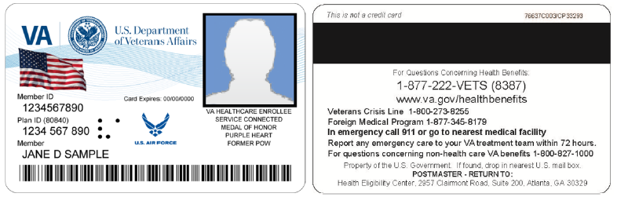
Figure 2:1: Example of what the VHIC looks like

Proper Navigation of the VHIC Application
The correct way to navigate through the VHIC application is to use the buttons that are located at the bottom of each screen instead of using the Browser’s built in Back button. Please do NOT use the Back button at the top of your browser window to navigate back to a previous screen; this will cause errors to occur.

Roles Within VHIC
The VHIC application is built to accommodate a specific set of pre-established user roles. During the provisioning process, the VHIC user will have a role assigned to them, which will determine what aspects of the VHIC application are available to them. The following breaks down the specific roles and the areas of access that accompany each role.

If, while utilizing the VHIC application, a user finds they do not have access to items they feel they should have access to or find that they have access to items they should not, based on the definitions listed below, the VHIC user should report this information to their VHIC Supervisor. The VHIC Supervisor should then verify that the proper role has been assigned.

For a complete list of Roles and Access levels please refer to the VHIC Roles and Access document.

Getting Started

Logging On
The VHIC application is built to accommodate a specific set of pre-established user roles. During the provisioning process, the VHIC user will have a role assigned to them, which will determine what aspects of the VHIC application are available to them. The roles are listed below. For more information on the areas of access that accompanies each role, please refer to the VHIC Roles and Access document.

- VHIC Associate
- VHIC Supervisor
- VHIC Administrator
- VHIC Technical Administrator (Tier 3)
- VHIC Auditor
- VHIC Read-Only User
- VHIC Card Replacement User

Enrollment System Link to VHIC
Once users are logged into the Enrollment System, an eligible user will be able to click on a hyperlink in the Enrollment System and be directed to VHIC. Their VHIC role of Card Replacement User provides access to features in the VHIC application for ES Users use only.
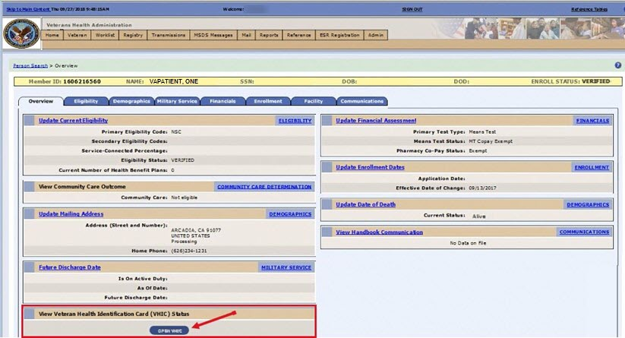
Figure 3:1: VHIC ES Hyperlink

VHIC Home Screen
After the hyperlink has been selected, a second browser tab will be opened and VHIC Users will be directed to the Home screen assigned to their roles. To the eligible HEC ES users (Card Replacement Role), the Veteran Card Details page serves as their Home page for the application.
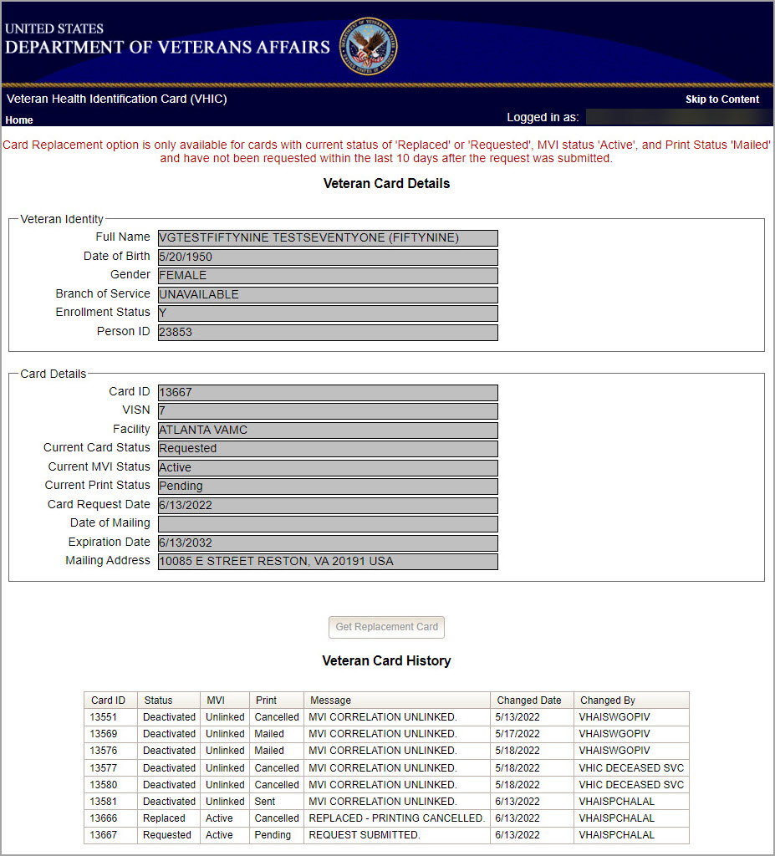
Figure 3:2: VHIC ES User Home Page

Veteran Card Details Page
The Veteran Card Details page provides the latest Card Status information based on the card ID received from the Enrollment System and provides capability to request a replacement VHIC card based on the business rules for card replacement.
The Veteran Card Details page is broken into three sections.
- Veteran Identity Information
This section provides the Veteran Identity Information including:
  - Veteran’s Full Name
  - Date of Birth
  - Gender
  - Branch of Service
  - Enrollment Status
  - Person ID

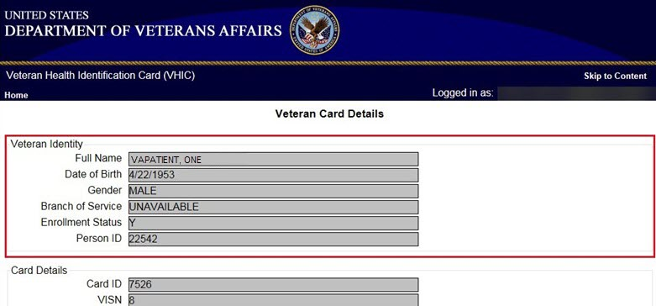
Figure 3:3: Veteran Identity Section

NOTE: If the Veteran has a Preferred Name on file it will appear within parenthesis where the Full Name appears as seen below.
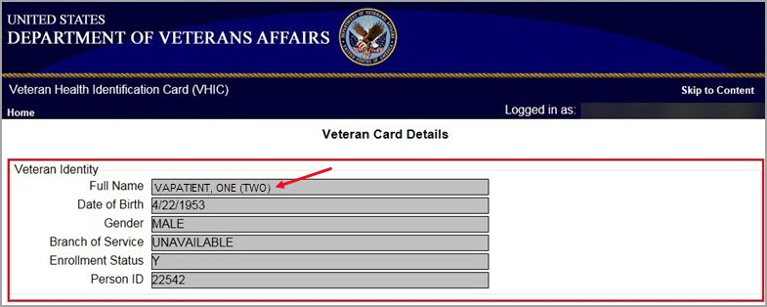
Figure 3:4. Veteran Identity Section with Preferred Name

- Veteran Card Details
This section provides the Veteran Identity Information including:
- Card ID
- VISN
- Facility
- Current Card Status
- Current MVI Status
- Current Print Status
- Card Request Date
- Date of Mailing
- Expiration Date
- Mailing Address

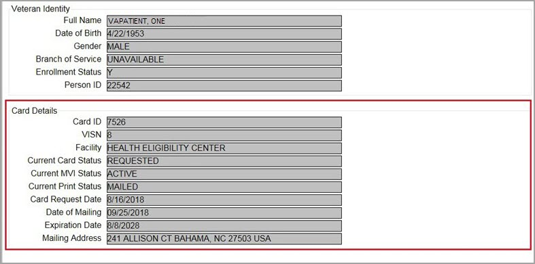
Figure 3:5: Card Detail Section

- Veteran Card History
This section provides the Veteran Card Information including:
- Card ID
- Card Status
- MVI Status
- Print Status
- Print Message
- Card Status
- Change Date
- ID of User that facilitated last Card Status change

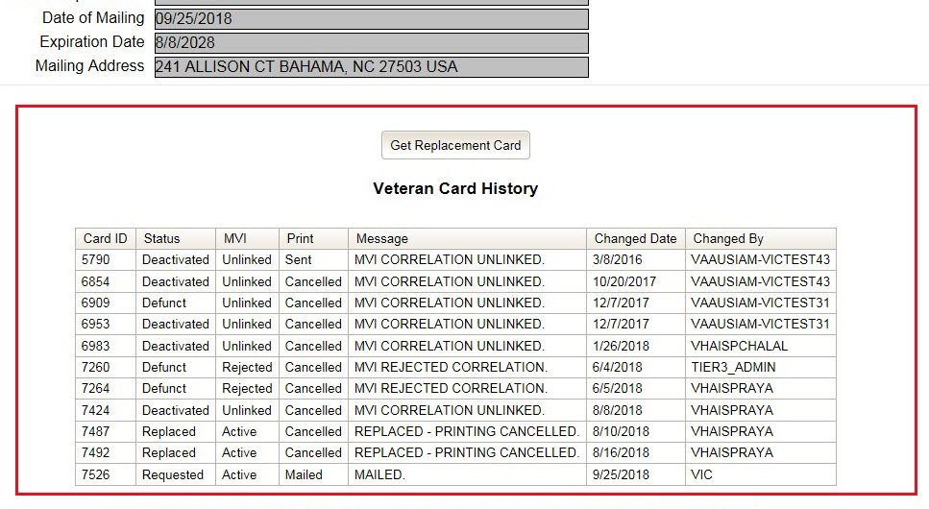
Figure 3:6: Veteran Card History Section

Requesting a Replacement VHIC Card

Card Replacement Eligibility
The Card Replacement option is only available to veterans with an active VHIC card.
A card replacement request may not be made within 10 days of the submission of a previous card request.
If the replacement requirements are not met, the user will see a notification at the top of the page, and the [Get Replacement Card] button will be shown but greyed out and not available.
REDACTED
Figure 4:1: Card Not Eligible for Replacement

If the card is Eligible for Replacement, the [Get Replacement Card] button can be seen and selected. 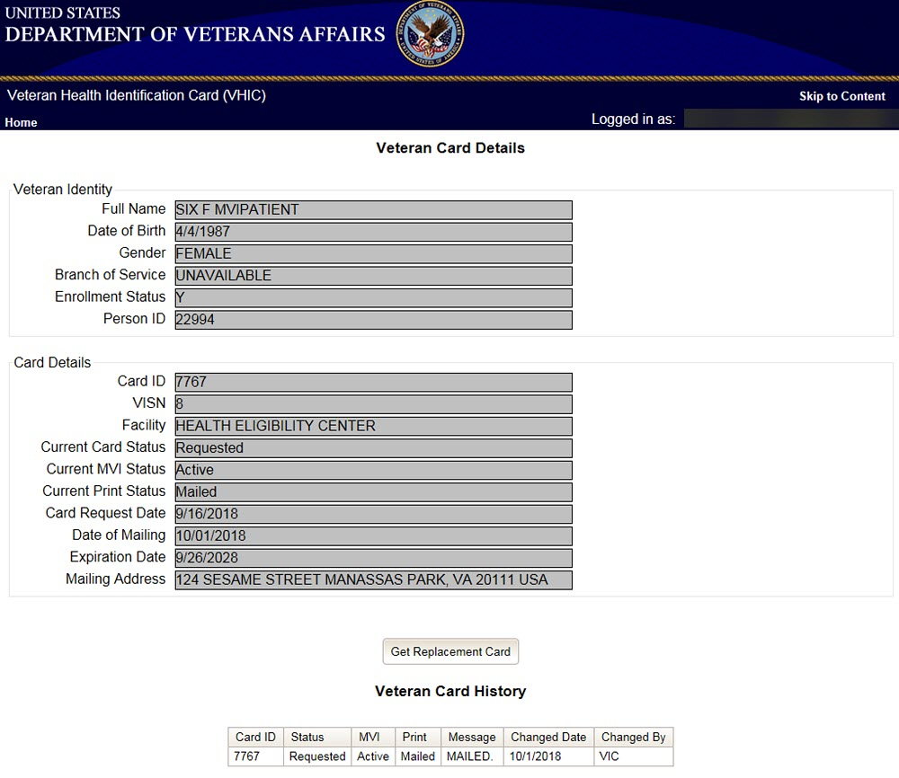
Figure 4:2: Card Eligible for Replacement

Requesting a Replacement Card
This section will give the ES user the step-by-step details of the process to replace a card in VHIC.

VHIC Card Replacement Request
Once you have been transferred from the Enrollment system to the VHIC system, review and verify all information found on the Veteran Card Details Page. When all details have been verified, click on the [Get Replacement Card] button.
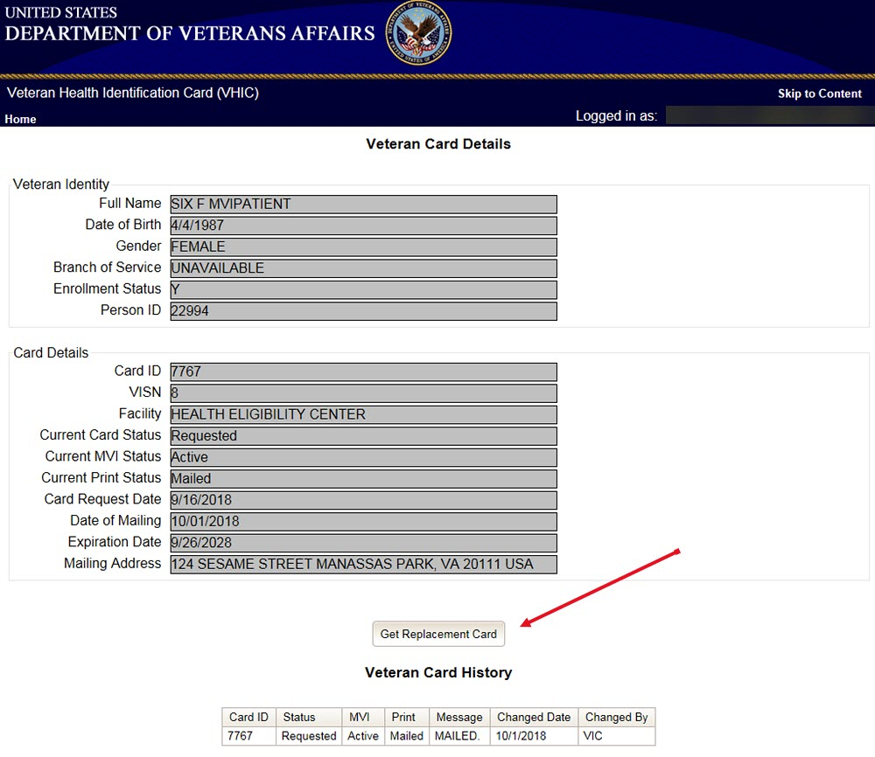
Figure 4:3: Select the Get Replacement Card Button

After clicking the [Get Replacement Card] button, you will be directed to the Veteran Identity Confirmation page. This screen displays the information retrieved from the Master Veteran Index (MVI) and the Enrollment System (ES) for the selected Veteran. The purpose of this screen is to verify the displayed information, select the reason for replacement, and to determine where the Veteran’s card should be mailed.
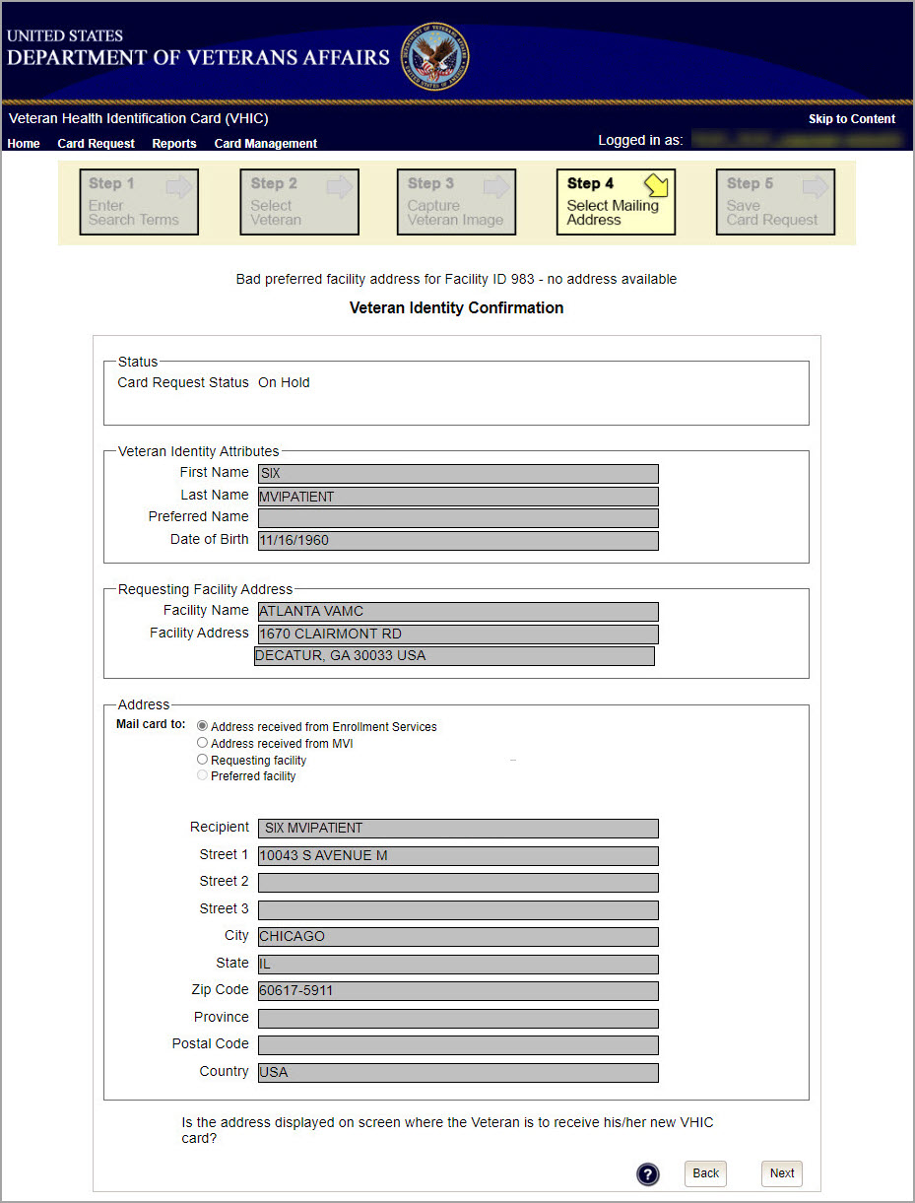
Figure 4:4: Veteran Identity Confirmation Page
NOTE: If the Veteran has a Preferred Name on file it will appear in the Veteran Identity Attribute section as seen below.
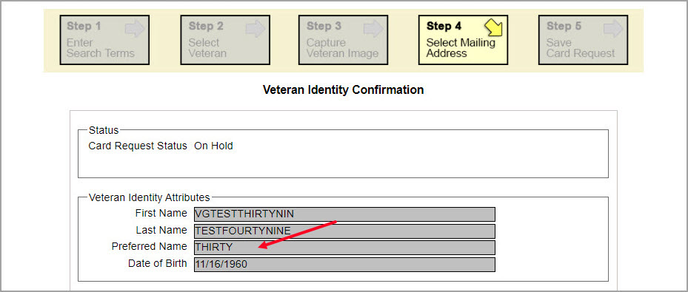
Figure 4:5. Veteran Identity Attributes with Preferred Name

Select the reason for replacement from the drop-down menu. Confirm the Veteran and Facility information and move down to the Address section of the screen to select where the replacement card will be delivered.
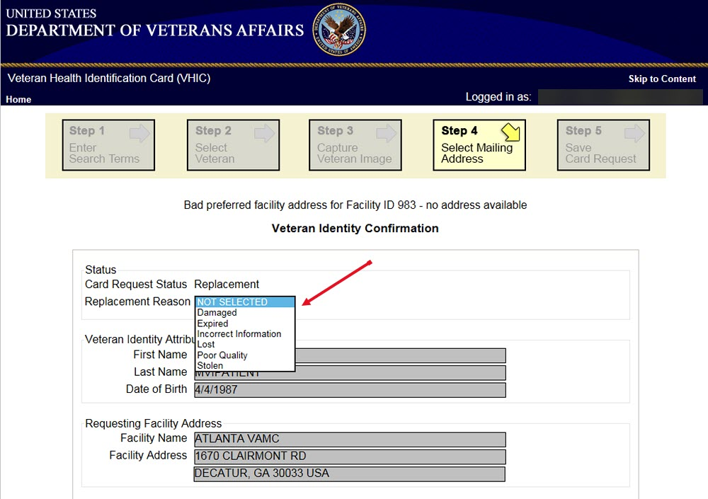
Figure 4:6: Select Replacement Reason
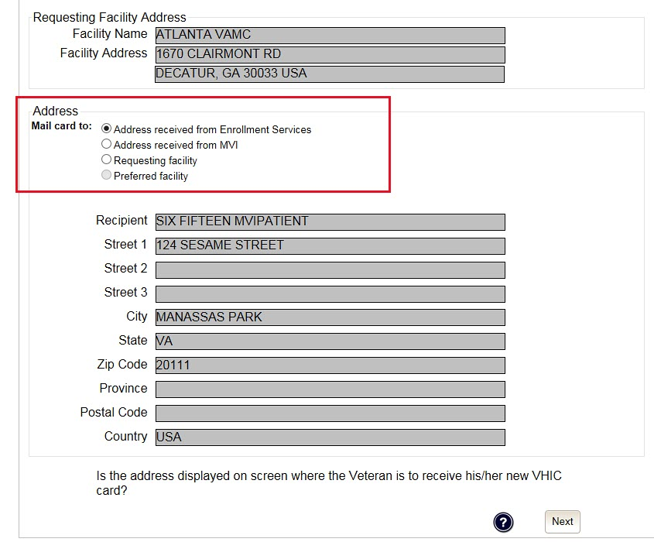
Figure 4:7: Select Mailing Address

This step provides several mailing options for the card:
- Mail to the address received from Enrollment Services
- Mail to the address received from MVI
- Mail to the requesting facility If requesting facility is not known a message will be displayed above for the on-hold condition and the Requesting facility button will be grayed out as seen in Figure 4:8: Select Next Button
- Mail to the preferred facility

NOTE: If Enrollment has flagged the Veteran’s address as bad, a message stating why, as well as additional guidance on how to proceed, will be displayed near the top of the screen. At this point, if the Veteran opts to not update their information with ES, the Associate MUST choose one of the remaining viable address options for mailing the card in order to proceed with the card request process.

NOTE: If MVI has flagged the Veteran’s address as bad, a message stating why, as well as additional guidance on how to proceed, will be displayed near the top of the screen. At this point, if the Veteran opts not to update their information with MVI or ES, the Associate MUST choose one of the remaining viable address options for mailing the card in order to proceed with the card request process. Selecting a radio button will automatically update the address information based on the selection. The process cannot continue until the appropriate radio button has been selected.

NOTE: If no preferred facility information has been received from ES or the preferred facility address is flagged as bad, a message stating why, as well as additional guidance on how to proceed, will be displayed near the top of the screen. The Associate MUST choose one of the remaining viable address options for mailing the card in order to proceed with the card request process. Selecting a radio button will automatically update the address information based on the selection. The process cannot continue until the appropriate radio button has been selected.

Selecting a radio button will automatically update the address information based on the selection. The process cannot continue until the appropriate radio button has been selected.

If the information on the screen is a correct match, select the [Next] button in the lower right hand to move forward.
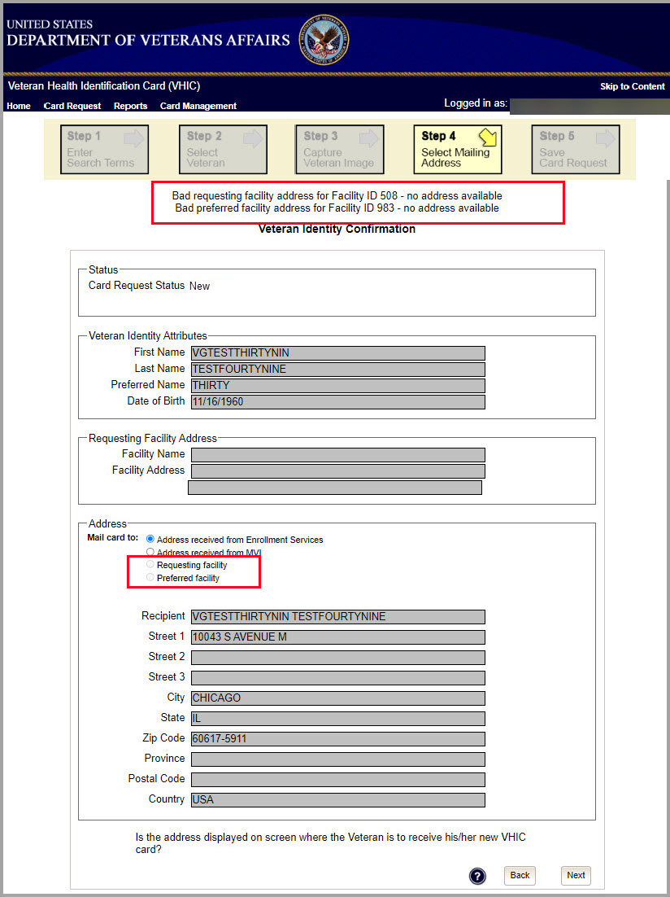
Figure 4:8: Select Next Button

You will be directed to the Save Card Request page (Figure 4:9: Save Card Request) which gives the VHIC user and the Veteran one more opportunity to review all of the information on the screen for accuracy.
This screen contains the following information for review:
- Name as it will appear on card
- Address card will be mailed to (this also contains the name as it will appear in the mailing address)
- Replacement reason (if applicable)
- Reason for hold (if applicable)
- Service connected status
- Medal of Honor status
- Purple Heart status
- Prisoner of War status
- Branch of Service selection
- Date of Birth

Other fields that either will be populated or will populate upon final submission are:
- Card Number (populates upon final submission)
- Member ID
- ICN
- Member Benefit Plan ID
- VISN and Facility where request is being processed

Branch of Service
If available, the Veteran’s Branch of Service options will be displayed on screen. The Veteran should be given the opportunity to select which logo they would prefer to appear on their card or if they would like to decline the logo option altogether (decline is the default option). The appropriate radio button should be selected based upon the Veteran’s preference. Only those branches of service that are listed in the Enrollment System and in which the Veteran has served will be shown. This will need to be chosen before submitting the card request.
NOTE: Only one Branch of Service logo can appear on the card; those with more than one branch will have to select one or decline to show any logo.

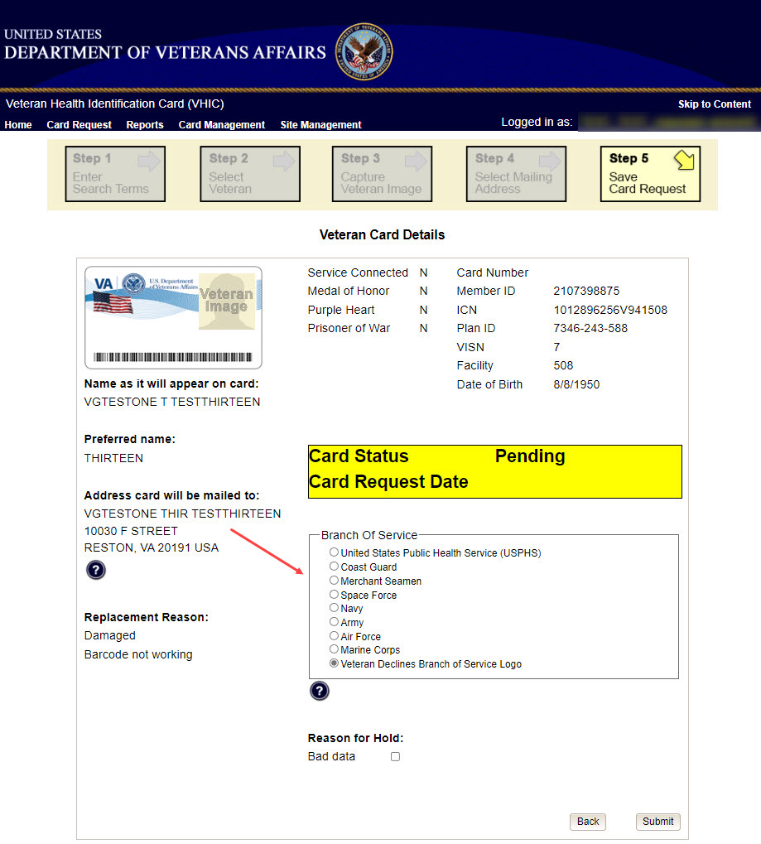
Figure 4:9: Branch of Service Selection

NOTE: If the Veteran has a Preferred Name on file it will appear as seen below. Though Preferred Name appears in the system, it does NOT appear on the VHIC card at this time.
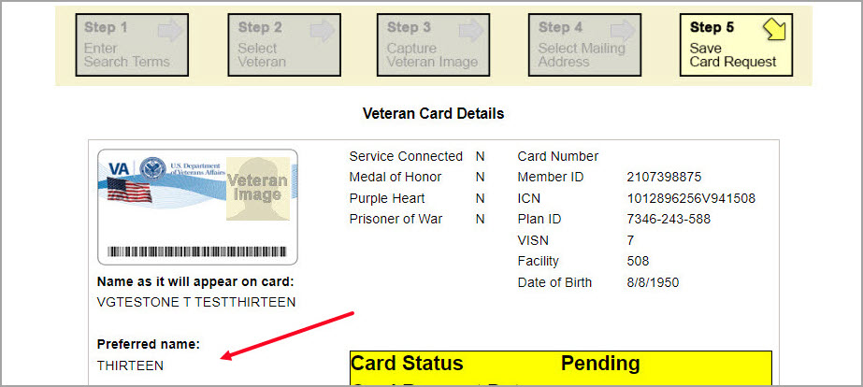
Figure 4:10. Branch of Service Selection Preferred Name Highlighted

After the card and information have been confirmed, click the Submit button at the bottom of the page to advance the request.
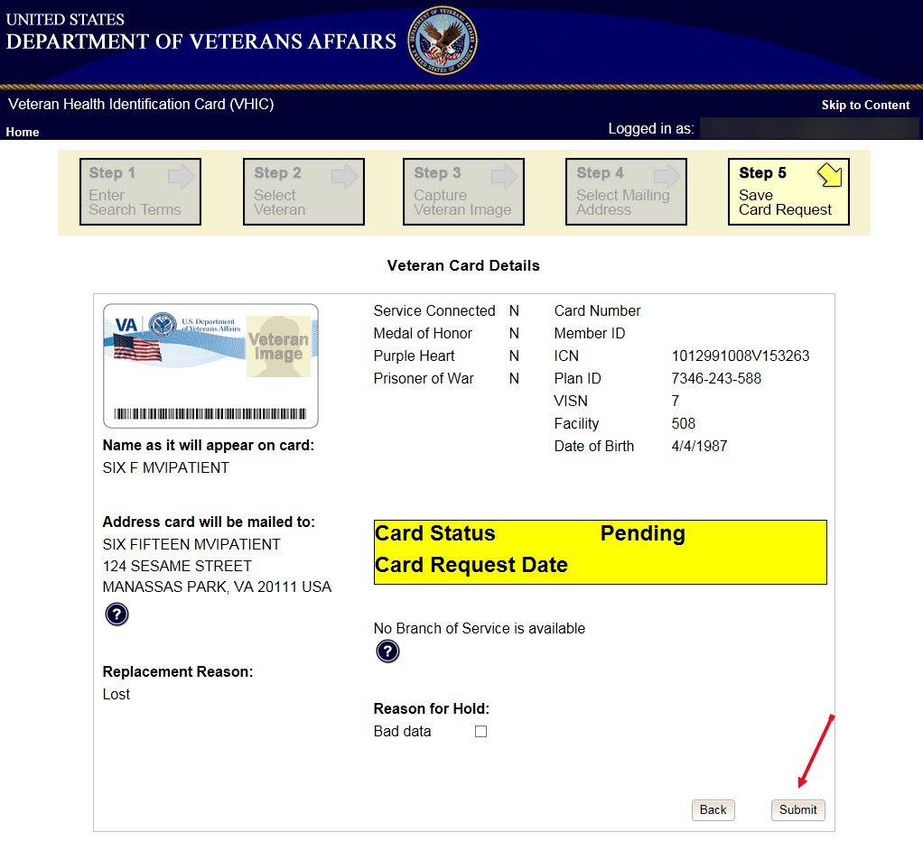
Figure 4:11: Save Card Request

Upon submission, a Card Number will be generated as well as an Expiration Date and Card Request Date. The colored field will change from yellow to green and the corresponding Card Status will change from Pending to Submitted as seen below.
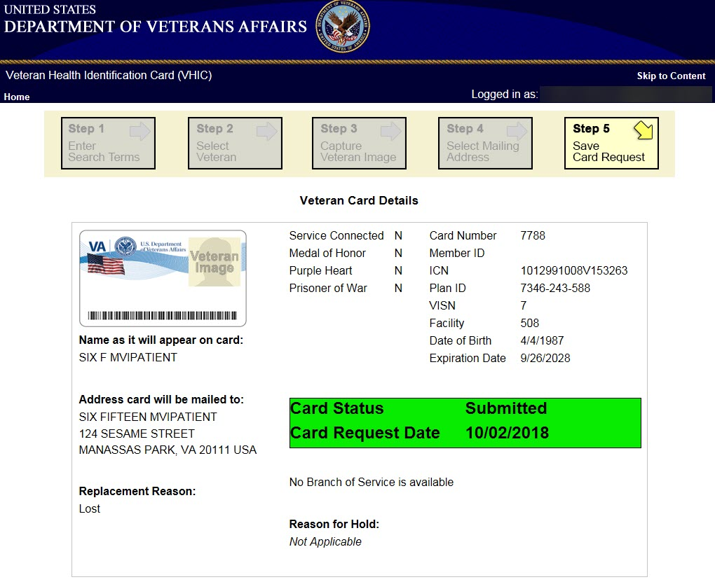
Figure 4:12: Card Request Submitted

This action has been completed. To exit the application, click the [X] button to close this browser window.
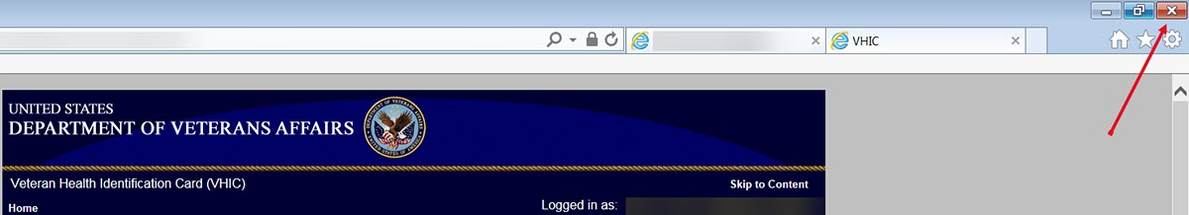
Figure 4:13: Close Browser Window

NOTE: If the veteran does not have an EDIPI number, the card request will be marked as Pending and saved for thirty (30) days and a request will be generated for HC IdM remediation once you select the hold button.

REDACTED
Figure 4:14: Pending Request No EDIPI

A Confirmation message will appear, select the [OK] button.
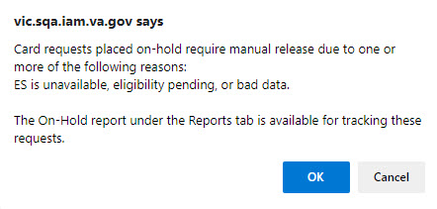
Figure 4:15: On Hold Request Confirmation Box

The request number will be displayed in a message that can be used for tracking purposes in the Tool Kit. Should anything prevent the card hold from resolving in 30 days an email will be generated to the VHIC Team for additional action.
REDACTED
Figure 4:16: HC IdM Request Confirmation

If a second request is generated before the thirty (30) days the user will get a message indicating that a request is open in the system.
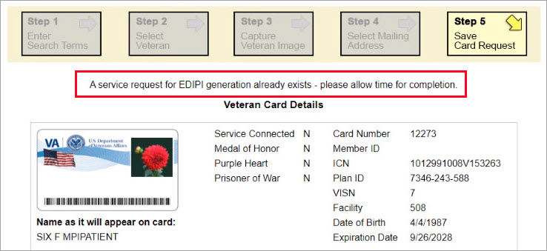
Figure 4:17: Active Request Exists in System Message

NOTE: If the VA received an imprecise Date of Birth, such as Month/year instead of Month/Date/Year. A request needs to be created for HC IdM remediation. Select the Branch of Service (if available) and click on the [Hold] button. This will save the card request for thirty (30) days and generate the remediation request for HC IdM.

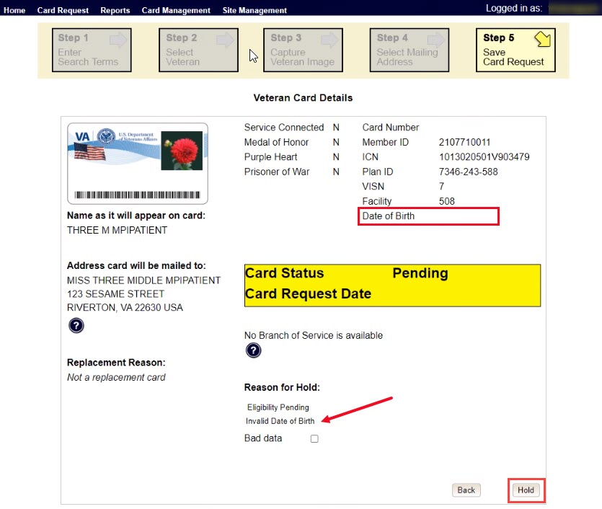
Figure 4:18: Reason for Hold: No EDIPI

A Confirmation request message will appear, select the [OK] button.
Figure 4:19: On Hold Request Confirmation Request

The screen will change showing that the Card Request Status has been updated and saved.
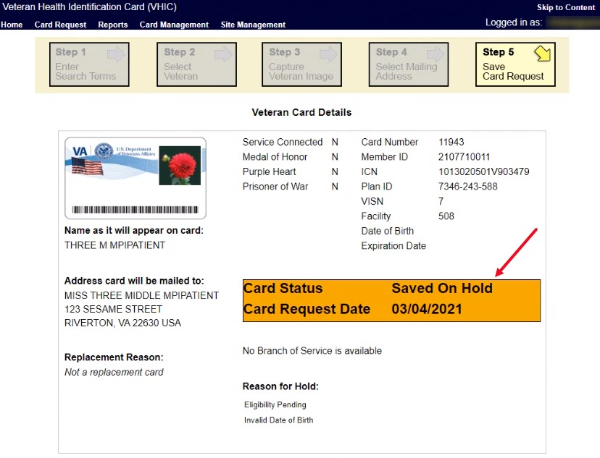
Figure 4:20: Saved on Hold

