Veteran Health Identification Card (VHIC 4.25)

User Guide

Volume 3 - Card Management and
Administrator Only Tasks

June 2023

Department of Veterans Affairs
Office of Information and Technology (OI&T)

Revision History
NOTE: The revision history cycle begins once changes or enhancements are requested after the document has been baselined.
Date | Revision | Description | Author
07/19/2023 | 11 | Worked on redactions. | Department of Veteran Affairs
06/17/2023 | 10 | Updated to reflect changes in functionality during VIP 25, removed duplicate information and information not relevant to Card Management | Department of Veteran Affairs
03/18/2023 | 9 | Updated to reflect changes in functionality during VIP 24 | Department of Veteran Affairs
12/17/2022 | 8.2 | No Changes in functionality updated date and version number | Department of Veteran Affairs
09/18/2022 | 8.1 | No Changes in functionality updated date and version number | Department of Veteran Affairs
06/18.2022 | 8 | Updated to reflect changes from VIP 21 Release | Department of Veteran Affairs
04/18/2022 | 7.4 | No Changes in functionality updated date and version number | Department of Veteran Affairs
09/18/2021 | 7.3 | No Changes in functionality updated date and version number | Department of Veteran Affairs
06/20/2021 | 7.2 | No Changes in functionality updated date and version number | Department of Veteran Affairs
03/20/2021 | 7.1 | No Changes in functionality updated date and version number | Department of Veteran Affairs
12/19/2020 | 7 | Updated for VIP 15 release | Department of Veteran Affairs
06/20/2020 | 6 | Updated to reflect changes to application with VIP 13 | Department of Veteran Affairs
02/15/2020 | 5 | Updated to reflect changes to application with VIP 12 release | Department of Veteran Affairs
11/01/2019 | 4 | Updated to reflect updates to VHIC completed in VIP 10 -Validation for ICN input fields on all search screens and shall add a usage tip | Department of Veteran Affairs
09/04/2019 | 3 | Updated to reflect new functionality for VHIC 4.9 Release (Card Destruction) and updated formatting to comply with OIT Standards | Department of Veteran Affairs
01/21/2018 | 2.1 | Accepted all changes as approved on anomaly logs, re-paginated document, re-ran TOCs, and created Section 508 compliant PDF for uploading, with Word document, to RTC Jazz Tools as well as SharePoint. | Department of Veteran Affairs
01/19/2018 | 2.1 | Re-paginated document. Readied document for creating Section 508 compliant PDF. | Department of Veteran Affairs
01/12/2018 | 2.1 | Applied changes from first anomaly log dated 010418 as well as some additional internal anomalies identified by the VHIC Product Development Team. | Department of Veteran Affairs
12/21/2017 | 2.1 | Updated images to include new “Skip To Content” link. Added Section 8 entitled “Card Destruction.” Updated Appendix entitled “VHIC Roles.”  Checked Alt text for all images and figures. Added Alt text to figures without it. Re-ran TOCs. | Department of Veteran Affairs
08/25/2017 | 2.0 | Checked Alt text for all images and figures. Added Alt text to figures without it. Changed name in footer from “Card Deactivation” to “Card Management.” Re-ran TOCs and fixed content/figure pagination issues in the Word document. Document converted to Section 508 compliant PDF as part of VHIC 4.8. Updated document name to match VA naming conventions by replacing spaces in Word document name with underscores. | Department of Veteran Affairs
08/15/2017 | 2.0 | Updated with content and images for first draft for VHIC 4.8. | Department of Veteran Affairs
08/17/2016 | 1.6 | Completed technical writer review of document. Ran Spelling and Grammar, added Alt text to all images, and re-ran TOCs. Created a footer and page numbering for document Page 1 to match other volumes. Changed cover date from “August 2016” to match footer date of “September 2016” to match other Volumes. | Department of Veteran Affairs
08/04/2016 | 1.6 | Updated content | Department of Veteran Affairs
01/06/2015 | 1.5 | Updated content and Images | Department of Veteran Affairs
07/07/2015 | 1.4 | Updated content and Images | Department of Veteran Affairs
07/07/2015 | 1.3 | Rebuilt to capture content overhaul to VHIC System and divided this guide into three separate parts | Department of Veteran Affairs
05/20/2015 | 1.2 | Updated Content and Images to reflect the Maintenance Releases | Department of Veteran Affairs
01/13/2015 | 1.1 | Updated content and Images | Department of Veteran Affairs
09/18/2014 | 1.0 | Rebuilt to capture content overhaul to VHIC System | Department of Veteran Affairs
Table of Contents
1. Introduction 1
1.1. Purpose 1
1.1.1. Organization of the Manual 1
1.1.2. Assumptions 1
1.1.3. Disclaimers 2
1.1.3.1. Software Disclaimer 2
1.1.3.2. Documentation Disclaimer 2
1.1.4. Documentation Conventions 2
1.2. Enterprise Service Desk and Organizational Contacts 2
2. Accessing the VHIC Application 3
2.1. Browser 3
2.1.1. Browser Incompatibility Issue 3
2.2. Proper Navigation of the VHIC Application 3
2.3. Roles within VHIC 5
3. Getting Started 5
3.1. Logging On 5
3.2. VHIC Administrator and Technical Administrator Tier 3 6
4. Card Management – The Card Deactivation Process 6
4.1. Accessing Card Deactivation 7
4.1.1. Processing Card Deactivation 8
4.1.1.1. Deactivation By Veteran 9
4.1.1.2. Deactivation By Card ID 13
4.2. Verifying Card Deactivation 17
5. Replacing a Deactivated VHIC Card 21
5.1. Request a Replacement Card 21
5.1.1.1. Step 4: Review Verified Identity Attributes 23
5.1.2. Step 5: Save Card Request 25
5.1.2.1. Photograph Verification 25
5.1.2.2. Save Card Request: Replacement 26
6. Card Receiving 26
6.1. Cards Received 27
6.1.1. Accessing Cards Received Screen 27
6.1.2. Step 1: Enter Search Terms 28
6.1.3. Step 2: Card Verification 31
7. Card Destruction 33
7.1. Card Destruction 33
7.1.1. Accessing Card Destruction Screen 33
7.1.2. Step 1: Select Cards for Destruction 35
7.1.3. Select Date of Destruction 36
7.1.4. Card Destruction Status Displayed 37
8. Reports 37
9. Troubleshooting 37

Table of Figures
Figure 1: VHIC Navigation Buttons 3
Figure 2: VHIC Administrator and VHIC Technical Administrator (Tier 3) menu 4
Figure 3: SSOi Login Screen 5
Figure 4: VHIC Administrator and VHIC Technical Administrator (Tier 3) Home screen 6
Figure 5: VHIC Administrator Home screen; click Card Management 8
Figure 6: Card Deactivation Screen 8
Figure 7: Help Icon 9
Figure 8: Card Management Deactivation Home screen. Search for Veteran 10
Figure 9: Enter Search Terms screen - No Match Found error 10
Figure 10: Select Veteran for Card(s) Deactivation 11
Figure 11: Select Deactivation Reason from Dropdown 11
Figure 12: Add Details for Deactivation Reason if “Other” Chosen 12
Figure 13: Select Deactivation and Confirm in Pop Up 12
Figure 14: Cards Deactivated - Cancelled/Declined 13
Figure 15: Card Deactivation Search 14
Figure 16: Select Veteran by Card ID 14
Figure 17: Select Deactivation Reason 15
Figure 18: Confirm Card Deactivation 15
Figure 19: Card Deactivated, Replace Card Button Shown 16
Figure 20: Replacement Card Process Started at Step 3 16
Figure 21: Card Deactivated Person ID Shown 17
Figure 22: Card History Report Query Screen 17
Figure 23: Card History Report - Cancelled/Declined 18
Figure 24. Card History by Person ID Report with Preferred Name 19
Figure 25: Veteran Report Screen 19
Figure 26: Veteran Detail Report Results 20
Figure 27: Card Status (Deactivated) Report 20
Figure 28: Card Status Report (Deactivated) Results 20
Figure 29: Replace Card 21
Figure 30: Step 3 Capture Veteran Image screen 22
Figure 31: Step 3: Confirm Reuse of Photo by clicking the OK button 22
Figure 32: Greyscale Photo Error 23
Figure 33: Replacement Card Step 4 24
Figure 34: Save Card Request review screen 25
Figure 35: Photo Does Not Meet VHIC Standards 25
Figure 36: Replacement Card Request Submitted 26
Figure 37: VHIC Administrator Home screen; click [Card Management] 27
Figure 38: Select Card Receiving Tab 27
Figure 39: Card Received Screen 28
Figure 40: Card Scanned into system, Card ID populates 29
Figure 41: Search by Member ID 30
Figure 42: Search by Veteran Name/SSN 30
Figure 43: Help icon 31
Figure 44: VHIC Card details displayed 31
Figure 45: Card status updated - Pending Destruction 32
Figure 46: Receiving Search Page 32
Figure 47: VHIC Administrator Home screen; click Card Management 33
Figure 48: Select Card Destruction Tab 34
Figure 49: Card Destruction Screen 34
Figure 50: Select Cards by Received Date for Destruction 35
Figure 51: Select Date of Destruction 36
Figure 52: Card Destruction Confirmation Message 36
Figure 53: Card Destruction Status 37

Table of Tables
Table 1: Enterprise Service Desk Contact Information 3
Table 2: Who can deactivate a card? 6
Table 3: Who can receive a card? 26
Table 4. Who can destroy a card? 33

Introduction

Purpose
The purpose of this User Guide is to provide general system information, as well as accessibility and user roles with the VHIC application. This User Guide will also provide the detailed steps on how VHIC Administrators can deactivate all VHICs associated to a selected Veteran.Document Orientation

Organization of the Manual
This User Guide is divided into eight sections, allowing the user to quickly obtain the information needed.
The first section will provide an overview of what a VHIC is and what the eligibility requirements are, and the various user roles and their accessibility within the VHIC application.

The second and third sections will walk the user through the steps needed to access the VHIC application, as well as some general guidelines on using the VHIC application.
The fourth section will provide information for the VHIC Administrator on how to deactivate the VHICs for a specific Veteran. A step-by-step process will navigate the VHIC Administrator through the Card Management screens in the VHIC application. Once all of the required information has been provided, the final step in the Card Management process will confirm that the deactivation of all VHICs associated with a Veteran have been deactivated.
Additional sections cover the logging of VHIC cards received at the HEC for destruction and processing the destruction of these cards.
The last section covers some troubleshooting issues and solutions that will help the VHIC user to better able to support the Veteran and ensure that the VHIC requests are processed properly.

Assumptions
This guide was written with the following assumed experience/skills of the audience:
- User has basic knowledge of the operating system (such as the use of commands, menu options, and navigation tools).
- User has been provided the appropriate active roles required for the VHIC application.
- User is using Google Chrome or Microsoft Edge to do their job of either creating VHIC Card Requests, Running Reports, or Deactivating VHICs depending on user roles.
- User has validated access to the VHIC application.
- User has completed any prerequisite training.

Disclaimers

Software Disclaimer
This software was developed at the Department of Veterans Affairs (VA) by employees of the Federal Government in the course of their official duties. Pursuant to title 17 Section 105 of the United States Code this software is not subject to copyright protection and is in the public domain. VA assumes no responsibility whatsoever for its use by other parties, and makes no guarantees, expressed or implied, about its quality, reliability, or any other characteristic. We would appreciate acknowledgement if the software is used. This software can be redistributed and/or modified freely provided that any derivative works bear some notice that they are derived from it, and any modified versions bear some notice that they have been modified.

Documentation Disclaimer
The appearance of external hyperlink references in this manual does not constitute endorsement by the Department of Veterans Affairs (VA) of this Web site or the information, products, or services contained therein. The VA does not exercise any editorial control over the information you may find at these locations. Such links are provided and are consistent with the stated purpose of the VA.

Documentation Conventions
This manual uses several methods to highlight different aspects of the material.

- Descriptive text is presented in a proportional font (as represented by this font).
- Information of note will be identified with underlined, capitalized, and boldfaced font. Example:
NOTE:
- “Screenshots” of computer online displays (i.e., character-based screen captures/dialogs) and are shown in a non-proportional font and enclosed within a box. Also included are Graphical User Interface (GUI) Microsoft Windows images (i.e., dialogs or forms).
- User's responses to online prompts (e.g., manual entry, taps, clicks, etc.) will be [boldface] type and enclosed in brackets.

Enterprise Service Desk and Organizational Contacts
The support contact information documented herein are intended to restore normal service operation as quickly as possible and minimize the adverse impact on business operations, ensuring that the best possible levels of service quality and availability are maintained.
The following table lists the contact information needed by site users for troubleshooting purposes. Support contacts are listed by description of the incident escalation and contact information (phone number and options to select).

Table 1: Enterprise Service Desk Contact Information
Issue | Contact Info
For Provisioning Issues | Contact the Enterprise Service Desk at REDACTED, option 3 (Applications), then option 1.  When contacted by a support specialist, be ready to supply the employee’s full name, VA user ID and email address.
For Proofing Issues | Contact the Enterprise Service Desk at REDACTED, option 3 (Applications), then option 1.  When contacted by a support specialist, be ready to supply the Veterans' full name, full SSN, and DOB.
For All Other VHIC System Issues | Contact the Enterprise Service Desk at REDACTED, option 3 (Applications), then option 1.  When contacted by a support specialist, be ready to supply the Veterans' full name, full SSN, and DOB.

Accessing the VHIC Application

Browser
VHIC is a web-based application that users will access via a web browser. The recommended browser is Google Chrome or Microsoft Edge . You can access the VHIC website REDACTED. After successfully logging in to the VHIC application, users should bookmark this site for easy access in the future. Instructions on how to do that can be found REDACTED.

The best time to bookmark the site is after the user is in the application itself rather than attempting to bookmark the Login screen.

Browser Incompatibility Issue
In some instances, users may experience image misplacement or misalignment. This is most likely due to the current browser compatibility settings. You will want to ensure that the browser is not set to Compatibility View. This process is explained in the Veteran Health Identification Card User Guide - Volume 4 - Troubleshooting document.

Proper Navigation of the VHIC Application
The correct way to navigate through the VHIC application is to use the [Back] and [Next] buttons that are located at the bottom of each screen instead of using the Browser’s built in Back button. Please do NOT use the [Back] button at the top of your browser window to navigate back to a previous screen; this will cause errors to occur.
Figure 1: VHIC Navigation Buttons

The VHIC user can also navigate to the different features within the VHIC application by clicking on one of the navigation links located in the header near the top left of the screen. The user’s assigned role will determine which links are available as seen below. To see the full home screen, refer to Section 3.3 System Menu.
Figure 2: VHIC Administrator and VHIC Technical Administrator (Tier 3) menu

NOTE: The “Skip To Content” link is a Section 508 compliance feature that skips repetitive navigation links so that page content can be quickly accessed.

Roles within VHIC
If, while utilizing the VHIC application, a user finds they do not have access to items they feel they should have access to or find that they have access to items they should not, based on the definitions listed below, the VHIC user should report this information to their VHIC Supervisor. The VHIC Supervisor should then verify that the proper role has been assigned.

For a detailed list of Roles and corresponding Access levels please refer to the VHIC Roles and Access document.

Getting Started

Logging On
The VHIC application is built to accommodate a specific set of pre-established user roles. During the provisioning process, the VHIC user will have a role assigned to them, which will determine what aspects of the VHIC application are available to them. For more information on the areas of access that accompanies each role, please refer to VHIC Roles and Access document.

Once users are logged into their VA desktop, they will access VHIC using Google Chrome or Microsoft Edge by either entering the URL listed in Section 2.1 or via the bookmark saved during an earlier session.
Users will be presented with the Single Sign On – internal (SSOi) login screen (shown below).
Here the VHIC user will need to use their PIV card to log into the VHIC application.
Figure 3: SSOi Login Screen
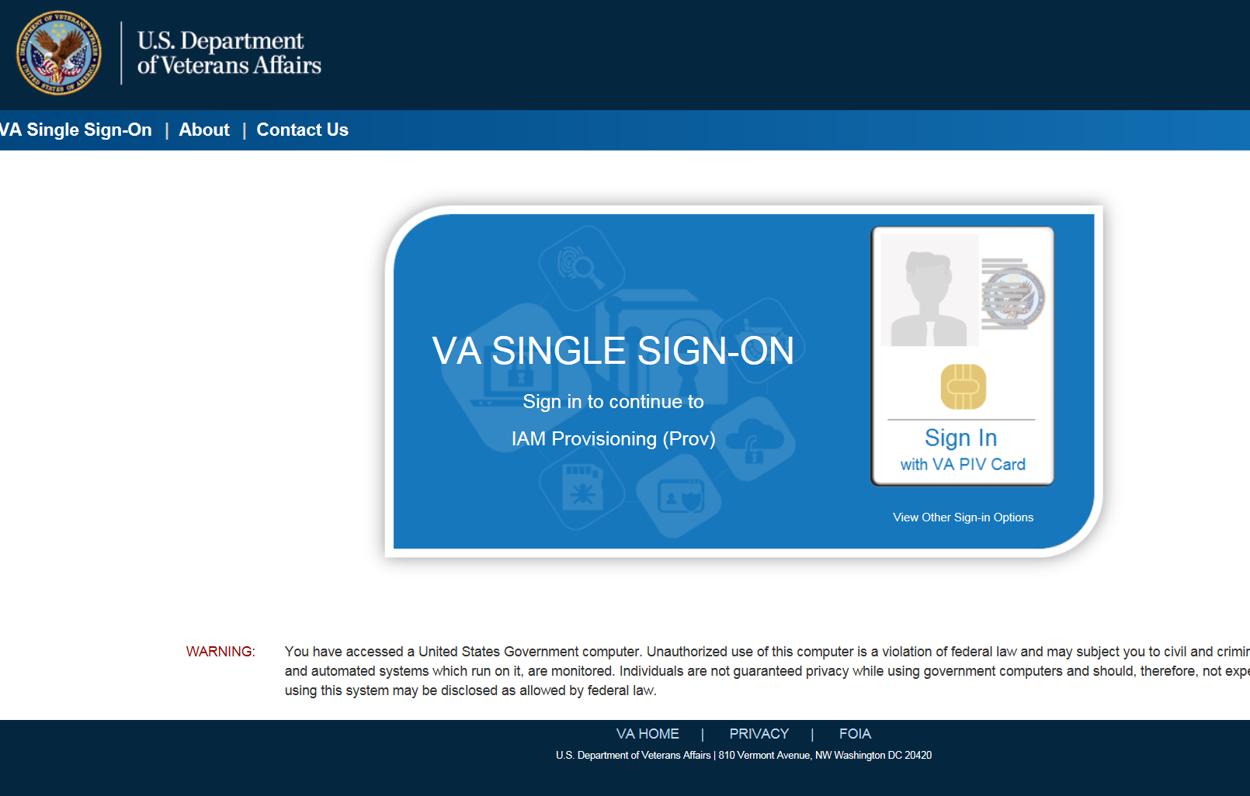

VHIC Administrator and Technical Administrator Tier 3
The VHIC Administrator and VHIC Technical Administrator Tier 3 users will be presented with three menu options: Card Requests, Reports and Card Management. They can navigate to each of these application modules by either clicking on one of the links located in the header at the top left of the screen or by clicking on one of the icon buttons in the middle of the screen.
Figure 4: VHIC Administrator and VHIC Technical Administrator (Tier 3) Home screen
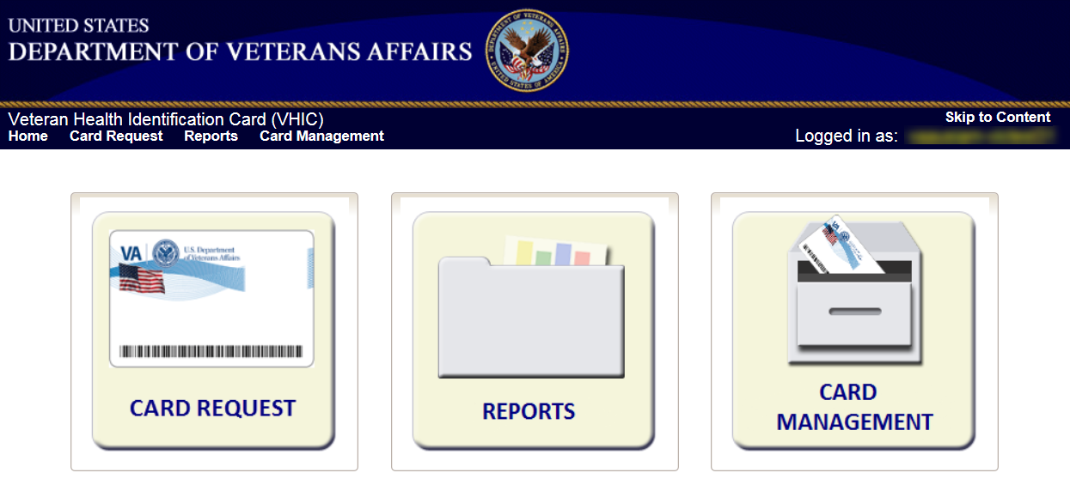

Card Management – The Card Deactivation Process
Table 2: Who can deactivate a card?
At a Glance… | VHIC Roles
Who can deactivate a card? | Administrator, Tech Admin (Tier 3)

This section will walk the VHIC Administrator through the process of deactivating all cards for a Veteran.
The card deactivation process follows numbered steps shown next.
- Enter Search Terms
- Select Veteran
- Select Deactivation Reason
- Confirm Deactivation Request
- Request a Replacement Card (when applicable)
- Verifying Card Deactivation

These steps are fully explained below. We will walk through the steps required to complete a VHIC card deactivation request for each of the available deactivation reasons.:
- Cancelled/Declined
- Damaged
- Deceased
- Identity Theft
- Lost
- Other
- Stolen

The VHIC Administrator will have the option to request a replacement card at the end of the card deactivation process in select instances.
The deactivation reasons that will allow the Administrator to request a new card are:
- Damaged
- Lost
- Stolen

Accessing Card Deactivation
When the VHIC Administrator logs in to the VHIC application, they are presented with three menu options: Card Request, Reports, and Card Management. The Administrator can click either on the links in the header at the top of the screen or on the icon buttons in the middle of the screen.
To begin the Card Deactivation process, the VHIC Administrator would click on either the Card Management link or the Card Management icon button.

Figure 5: VHIC Administrator Home screen; click Card Management
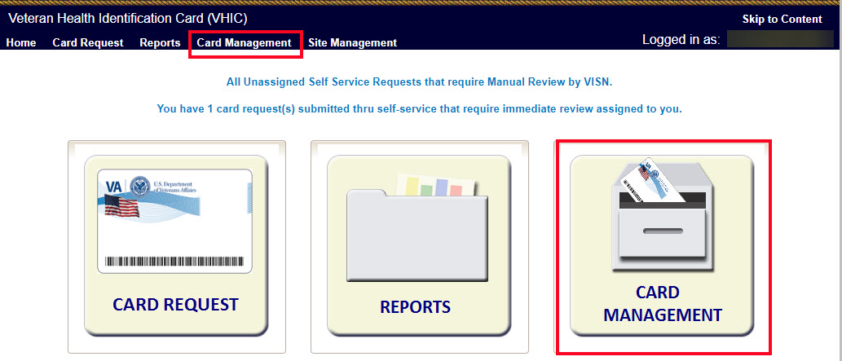

The Card Deactivation screen will show as the default screen following the selection of Card Management.
Figure 6: Card Deactivation Screen
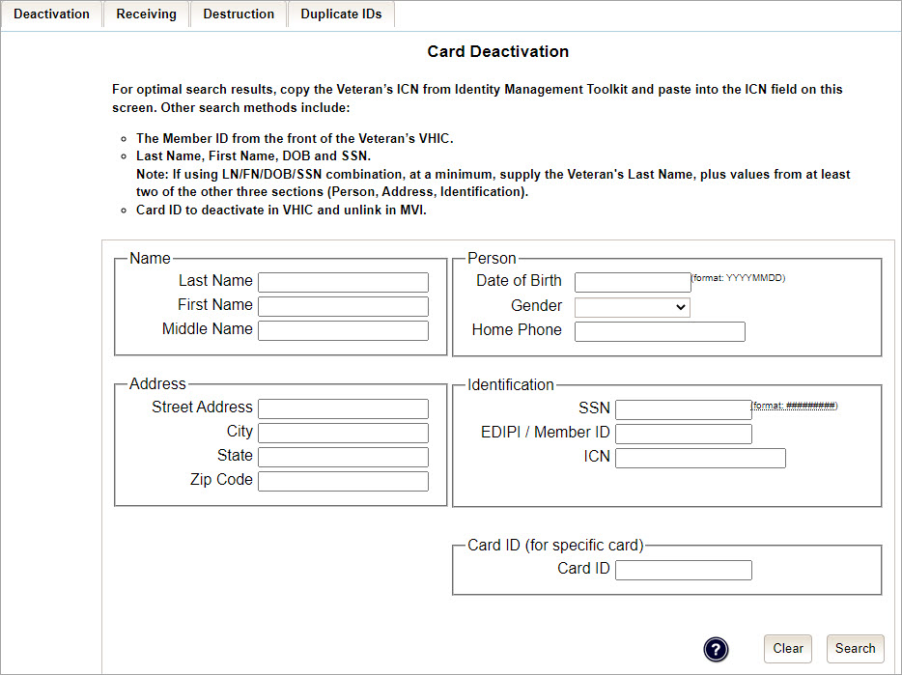

Processing Card Deactivation
There are two modes of processing deactivations:
- By Veteran (meaning all cards will be deactivated for that veteran)
- By Card ID (meaning only the card ID specific will be deactivated).

Deactivation By Veteran
The first step in the process is to find the Veteran in the system. This is accomplished by entering enough search criteria to trigger a match within Master Person Index (MPI). The top of the screen offers guidance regarding the set of traits recommended to ensure the best match is found. These are guidelines and not necessarily the required set of traits that must be entered.
However, for optimal search results, copy the Veteran’s ICN from Toolkit and paste it into the ICN field on this screen.
Other search methods include:
- The Member ID from the front of the Veteran’s VHIC
- Last Name, First Name, DOB and SSN

NOTES:
- If using LN/FN/DOB/SSN combination, at a minimum, supply the Veteran's Last Name, plus values from at least two of the other three sections (Person, Address, and Identification). The more traits entered, the more likely a match will be returned.
Additional guidance is also available on-screen by clicking on the blue circle containing a question mark. This type of help is available throughout the application and will provide additional detail or clarification for that particular step or section.
Figure 7: Help Icon

- Once the search information has been entered into the required fields, click on [Search] to proceed to the next step.
Figure 8: Card Management Deactivation Home screen. Search for Veteran
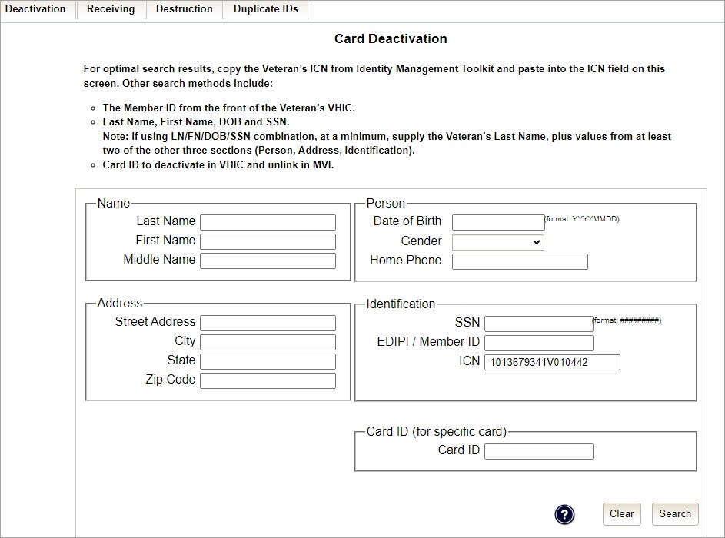

Various error messages can be received throughout the Card Deactivation process such as Invalid ICN, Invalid Veteran ID, etc. If the search yields no results, a message will be displayed above the search fields.
Figure 9: Enter Search Terms screen - No Match Found error
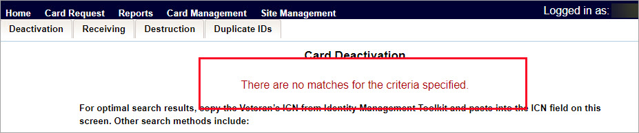

The user can then verify that the information entered is correct or make corrections as needed as well as add more information to increase the likelihood of finding a match.

- Step 2: Select Veteran
If the search was successful and a possible match has been found, the results of that search will be displayed on screen. From the list provided (up to 10 matches may be returned), select the appropriate Veteran by clicking on the Veteran’s name which is hyperlinked.
If the correct Veteran is not in the list, click the [Back] button and verify the traits entered are correct. If the traits are correct, try adding additional information to aid in triggering a match.

Figure 10: Select Veteran for Card(s) Deactivation
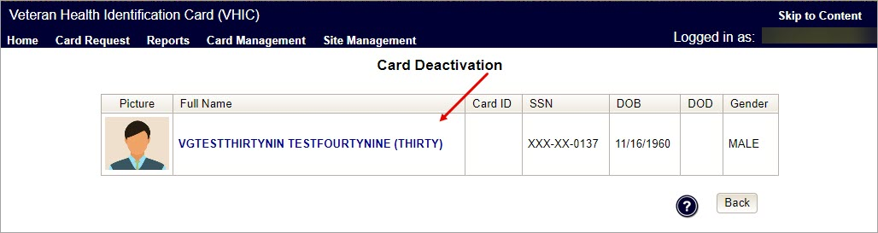

- Select Deactivation Reason
Once the Administrator has selected the correct Veteran, the next step in the process is to select the reason for deactivating all the VHIC card(s) for this Veteran. Choose from one of the several deactivation reasons VHIC provides.
Figure 11: Select Deactivation Reason from Dropdown
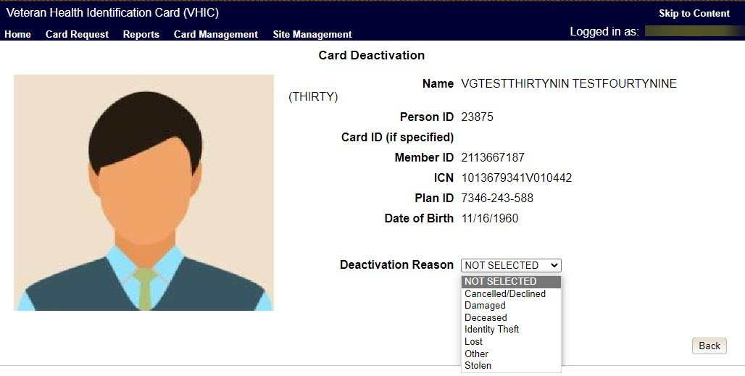

NOTE: If “Other” is selected as the reason for Deactivation the Administrator is required to add details in the space provided.

Figure 12: Add Details for Deactivation Reason if “Other” Chosen
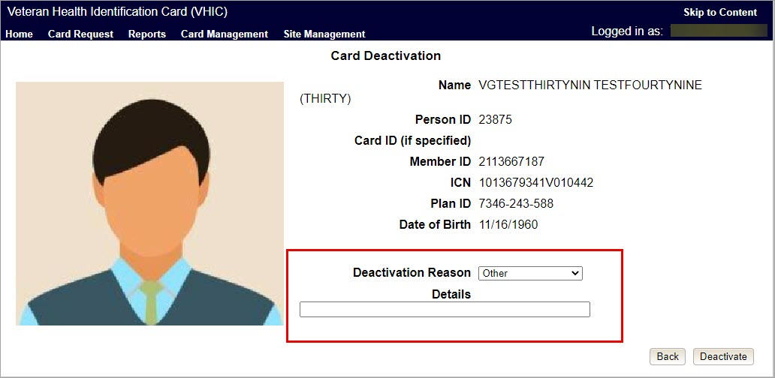

Once the Deactivation Reason is provided the Administrator will click the [Deactivate] button to continue.
- Confirm Deactivation
A pop up will appear asking to confirm the deactivation. Select [OK] to proceed with the Card Deactivation.
Figure 13: Select Deactivation and Confirm in Pop Up
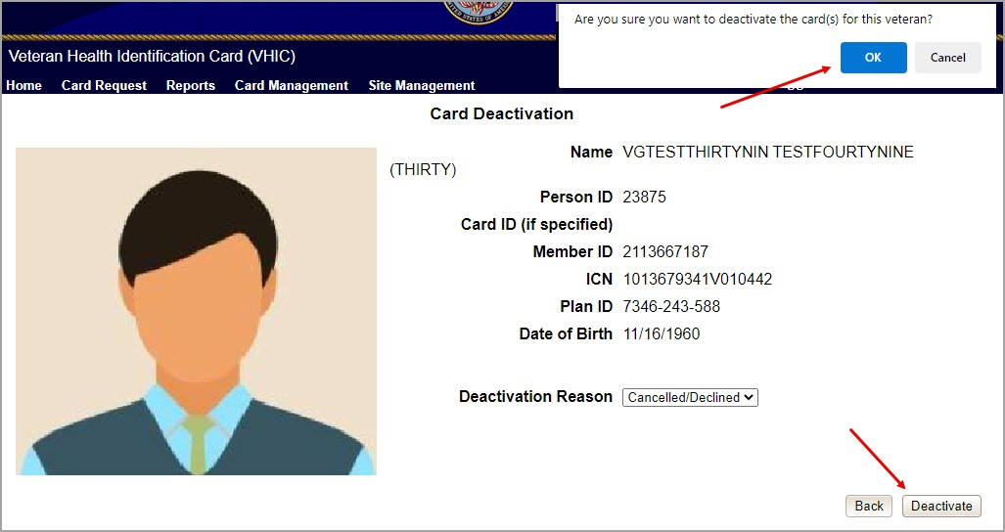

- Deactivation Submitted
The screen below shows that the Card Deactivation was completed successfully.
The selected deactivation reason will be displayed on this screen.

NOTE: Since Cancelled/Declined was the deactivation reason selected, the VHIC Admin is not presented with the option to request a new card for the Veteran.
Figure 14: Cards Deactivated - Cancelled/Declined
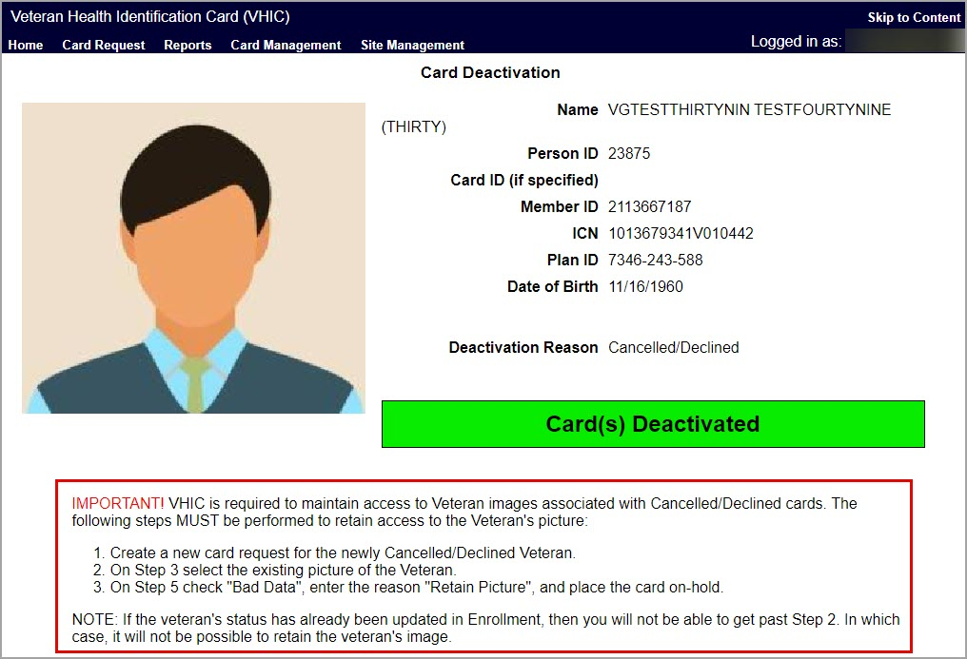

Deactivation By Card ID
Administrators will use Deactivation by Card ID when deactivating a specific card, not all cards.

- The Administrator will use the search by Card Id function to begin the deactivation process.

Figure 15: Card Deactivation Search
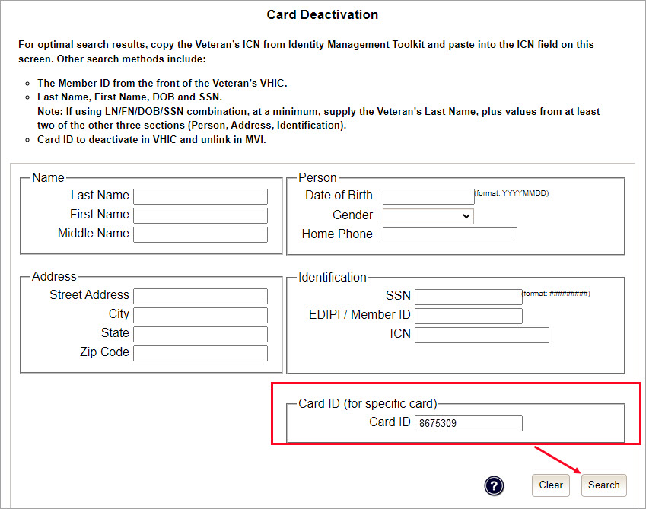

- Verify Card ID number and select the Veteran name link to continue.
Figure 16: Select Veteran by Card ID
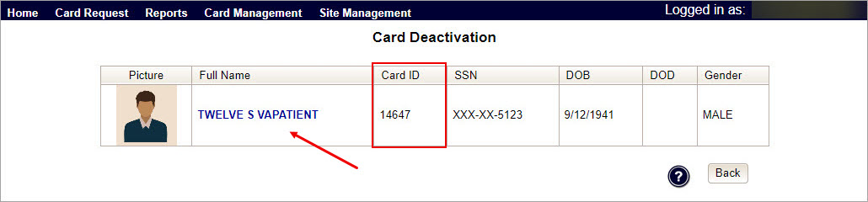

- The Card ID will show in the details to the right of the Veteran photo. Select Deactivation Reason from the dropdown menu.

Figure 17: Select Deactivation Reason
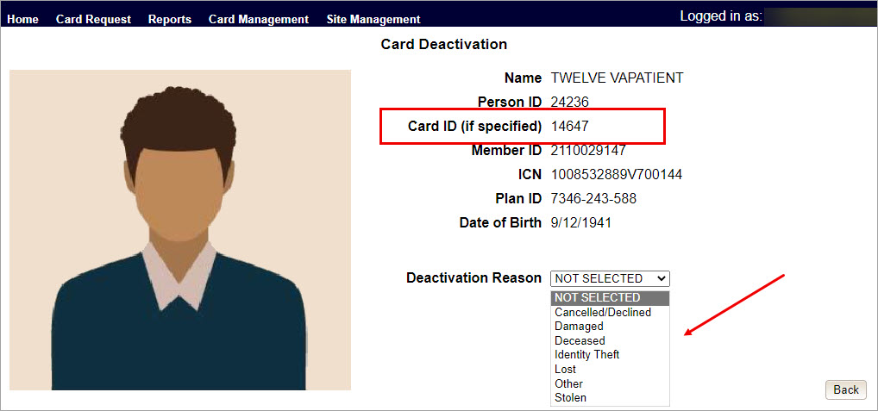

NOTES:
- Selecting Other requires an explanation in the text box that will be provided
- Administrators selecting reasons such as Damaged, Lost, etc., will need to submit a Replacement Card request

- After clicking on the Deactivation button, a pop-up box will appear asking you to confirm the action. Select OK to continue the Deactivation.
Figure 18: Confirm Card Deactivation
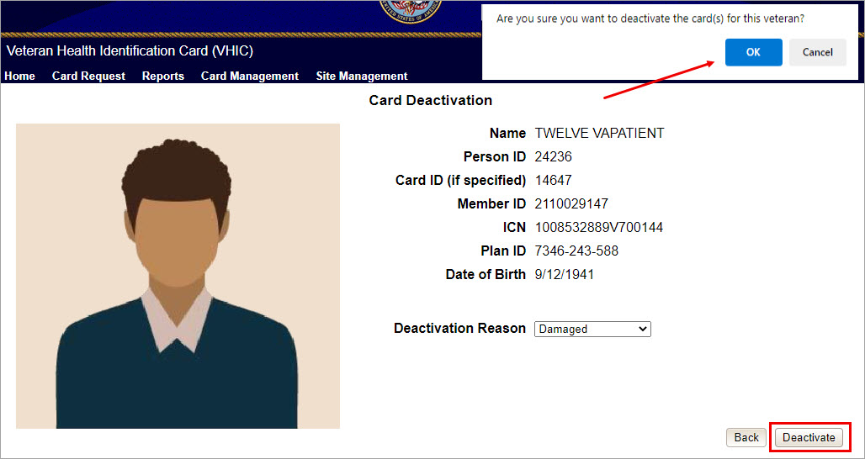

- The Card Id will show, and the Deactivation notification will appear.
Figure 19: Card Deactivated, Replace Card Button Shown
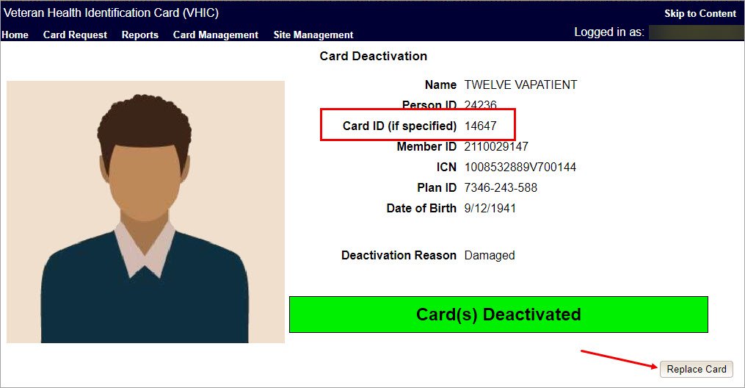

In the example above the Deactivation Reason is “Damaged”. This card will need to be replaced.
- Selecting the Replace Card button at the bottom of the screen will start the Replacement Card process taking the administrator to Step 3.
Figure 20: Replacement Card Process Started at Step 3
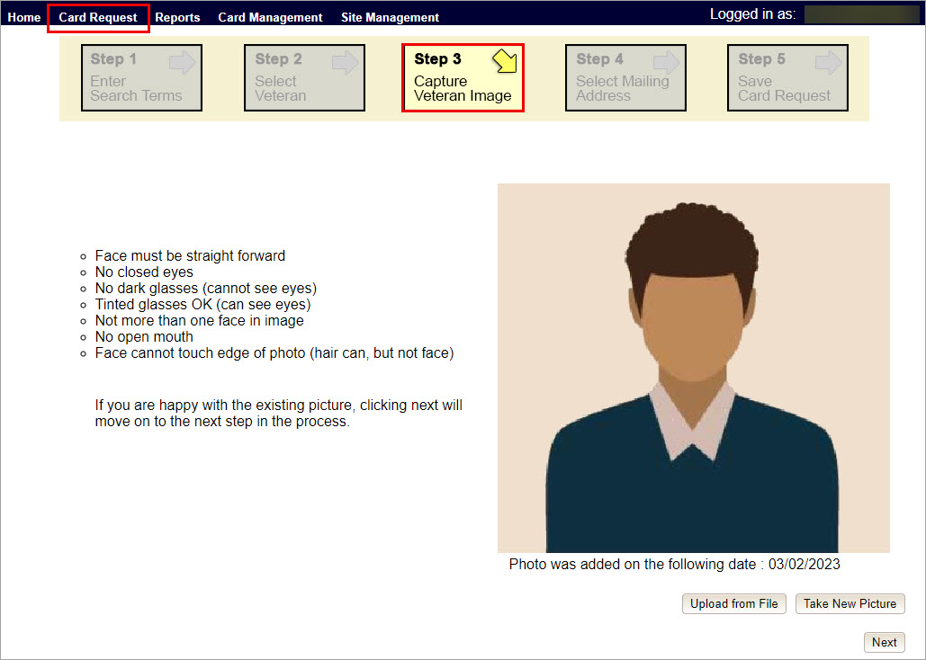

Continue Card Replacement process as in Request a Replacement Card.

Verifying Card Deactivation
The VHIC Administrator can verify that the cards for that Veteran have been deactivated by running different reports. Details regarding these Reports can be found in VHIC User Guide Vol 2 Reports.

- Card History Report by Person ID
To see all of the cards for a Veteran, search by using the Veteran’s Person ID, which was displayed on the last step of the card deactivation process.
Figure 21: Card Deactivated Person ID Shown
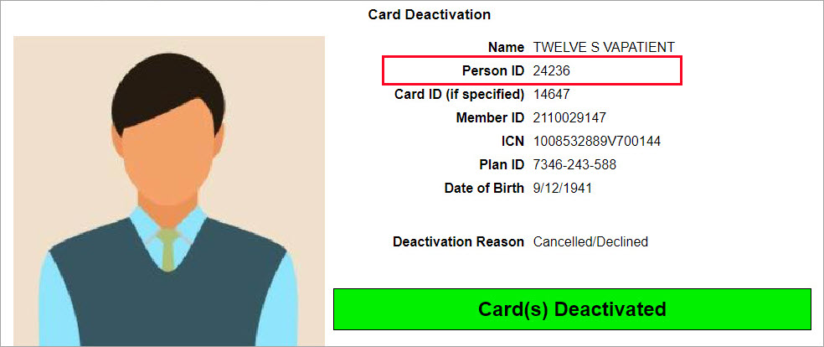

Figure 22: Card History Report Query Screen
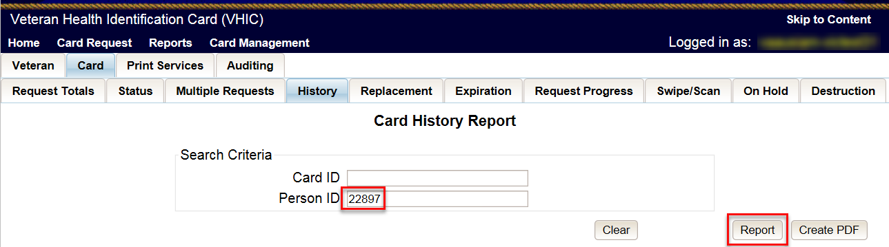

When looking at the Card History report, the Administrator will see that the Current Card Status has been updated to Deactivated and the Current MPI Status has been updated to Unlinked.
The Administrator will also see the messages for Deactivated and MPI Correlation Unlinked in the Message history section.
The Deactivation Reason field will also be populated with the deactivation reason that was selected during the card deactivation process.

Figure 23: Card History Report - Cancelled/Declined
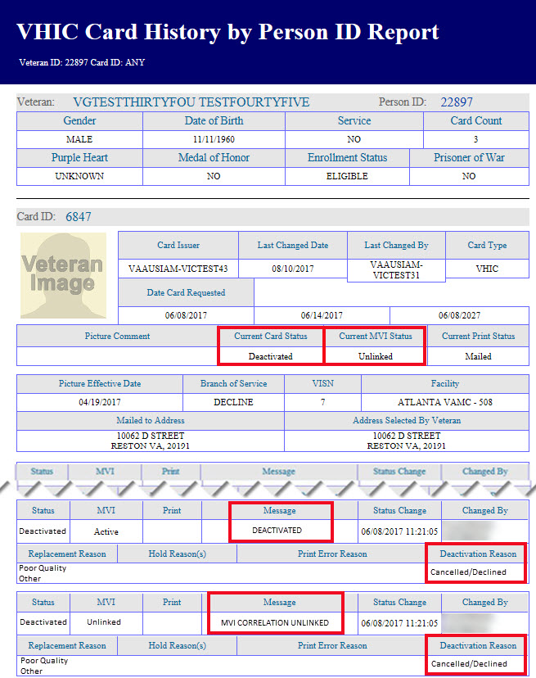

NOTE: If the Veteran has a Preferred Name on file it will appear on the report within parenthesis as seen below.
Figure 24. Card History by Person ID Report with Preferred Name
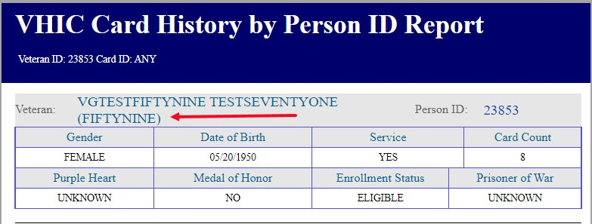

- Veteran Detail Report
Using the Basic Veteran Search will return the Veteran Detail Report. This report offers Veteran Details including VHIC Card information such as Card Number(s), Card Status(es), and MPI Status(es).
Figure 25: Veteran Report Screen
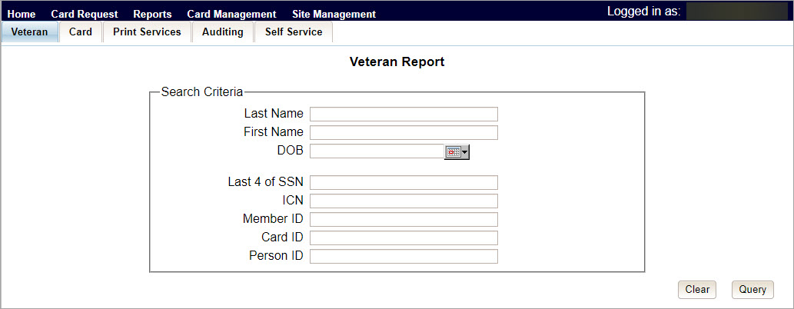

Figure 26: Veteran Detail Report Results
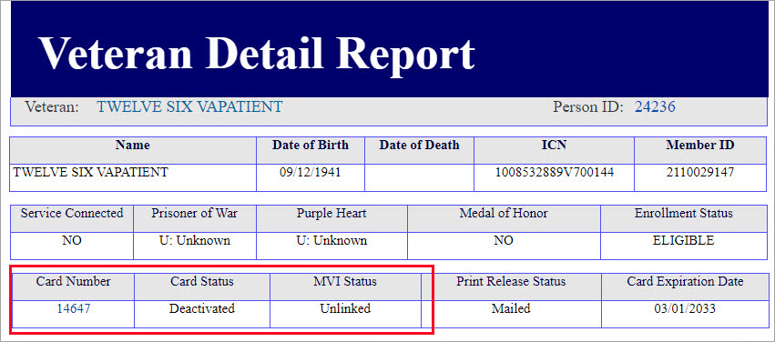

- Card Status Report (Deactivated)
Using the Card Status Report, Administrators can select [Deactivated] along with the date range of the Deactivation(s) will return the number of Deactivated cards along with the information of the cards that were deactivated during that timeframe.
Figure 27: Card Status (Deactivated) Report
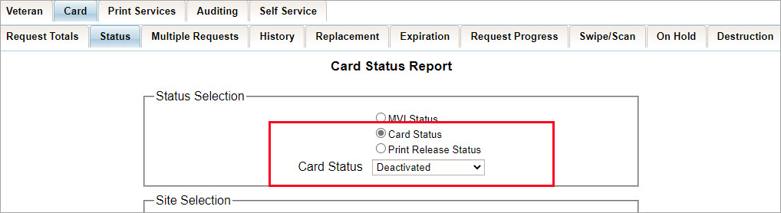

Figure 28: Card Status Report (Deactivated) Results
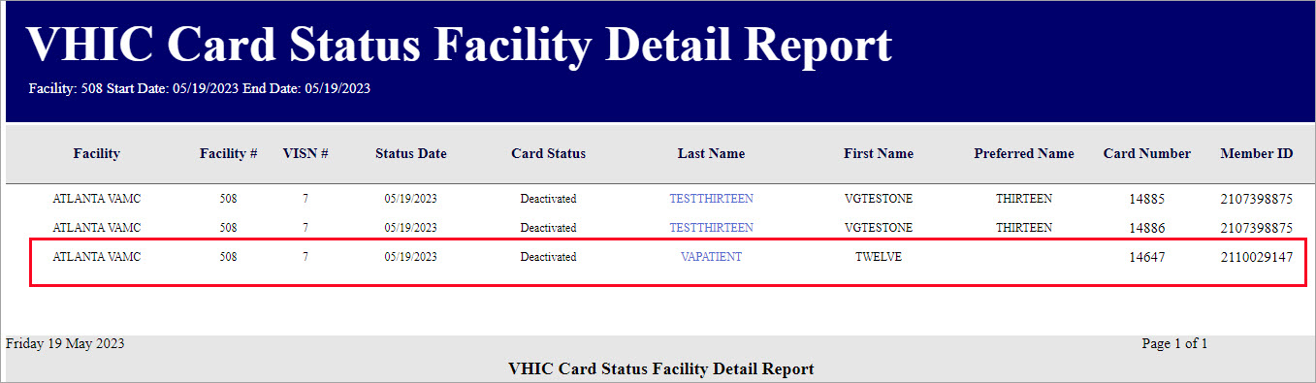

Replacing a Deactivated VHIC Card
For details on the Card Request process see VHIC User Guide Vol 1 Card Requests – All Users.

Request a Replacement Card
The VHIC Administrator will have the option to request a replacement card at the end of the card deactivation process in select instances. Since Stolen was the deactivation reason selected in the below example, the VHIC Admin is presented with the option to request a new card for the Veteran.
To request a replacement card, click the [Replace a Card] button after Card Deactivation.
Figure 29: Replace Card
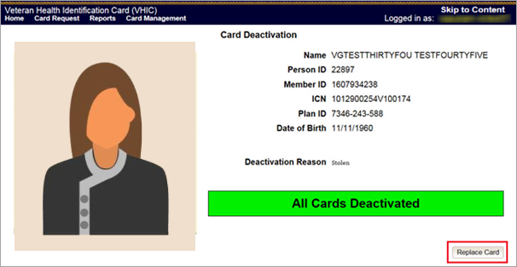

This will take the user to Step 3: Capture Veteran Image of the card request process.
Click [Next] to reuse the existing photo for this Veteran. Then complete the card request process following the current procedures.

Figure 30: Step 3 Capture Veteran Image screen
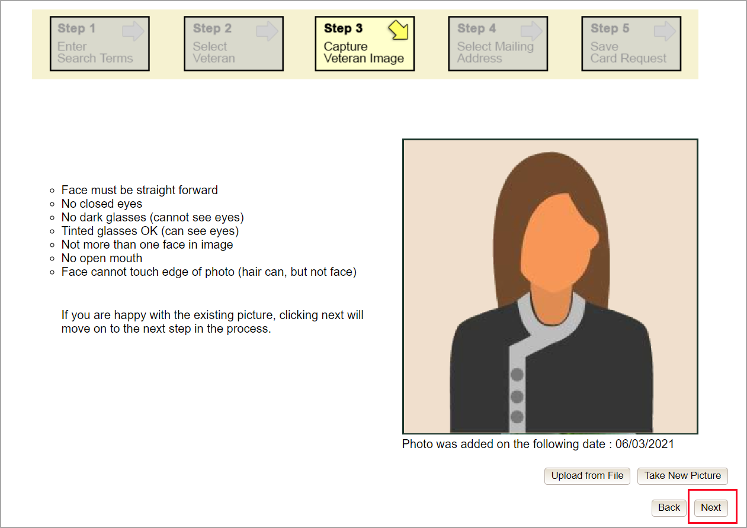

Confirm that you want to use the existing photo by clicking on the [OK] button.
Figure 31: Step 3: Confirm Reuse of Photo by clicking the OK button
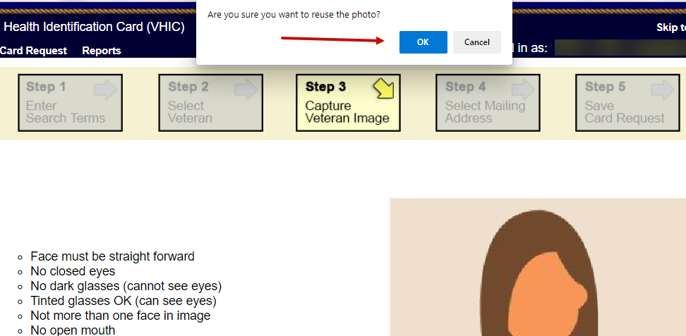

NOTE: Greyscale pictures are not permitted to appear on the VHIC card. Attempts to use a greyscale photo will result in an error and you will need to use the [Back] button to capture or upload a new photo.
Figure 32: Greyscale Photo Error
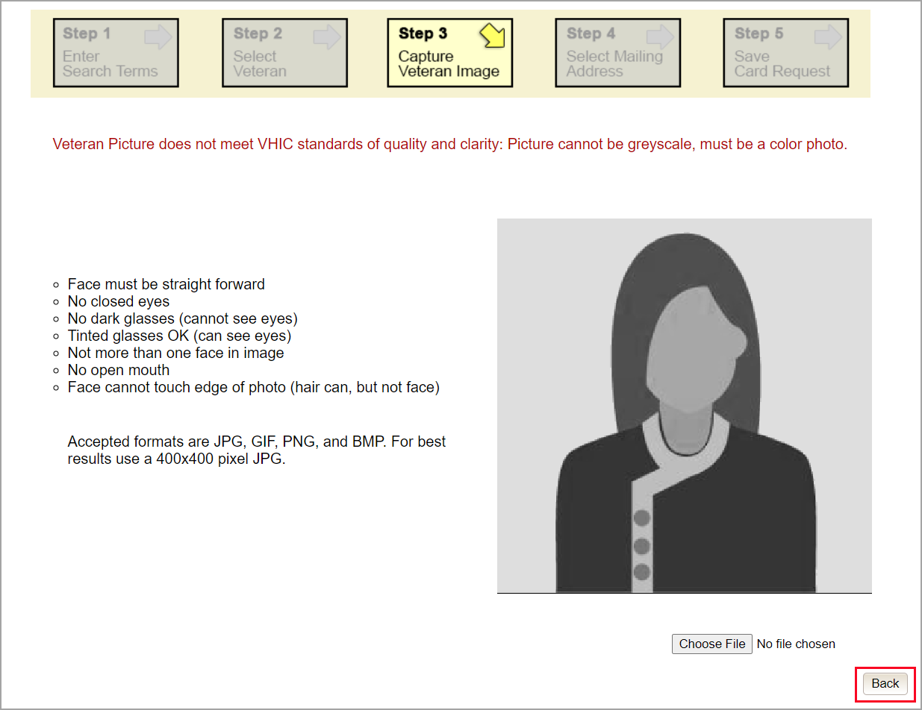

Step 4: Review Verified Identity Attributes
Since the Card Request Status is Replacement, a selection must be made from the drop-down list as to why the card is being replaced. The available options are: Damaged, Expired, Incorrect Information, Lost, Poor Quality, or Stolen.

Figure 33: Replacement Card Step 4
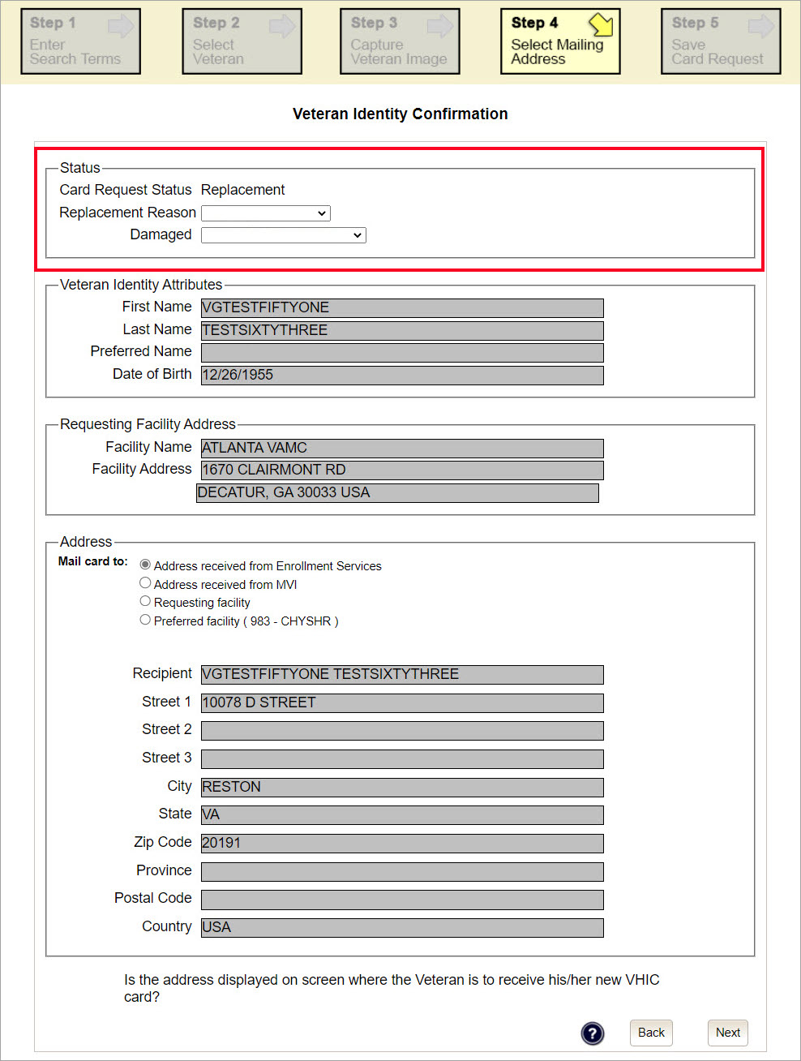

Step 5: Save Card Request
This brings us to Step 5 – Save Card Request. This screen allows the VHIC Admin to verify all of the information shown on the screen as being correct.
If the information on the screen is a correct match, and the Branch of Service is confirmed, select the [Submit] button in the lower right hand to move forward.
Figure 34: Save Card Request review screen
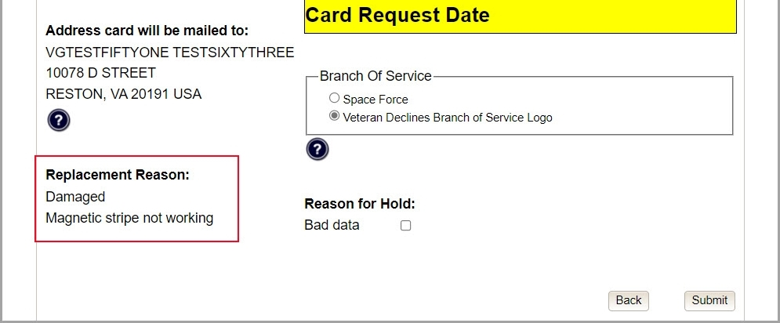

Photograph Verification
As with any Card Request, the Veteran Photo must be verified before the request can be submitted.
Figure 35: Photo Does Not Meet VHIC Standards
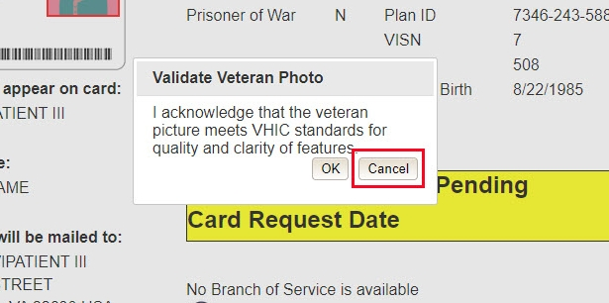

Once veteran photo has been approved the user may continue with the request.

Save Card Request: Replacement
Saving and submitting a replacement card request is essentially the same as submitting a new card request. The only variation will be the replacement reason. The selections made earlier in Step 4 will be reflected on this screen under the Replacement Reason section.
Figure 36: Replacement Card Request Submitted
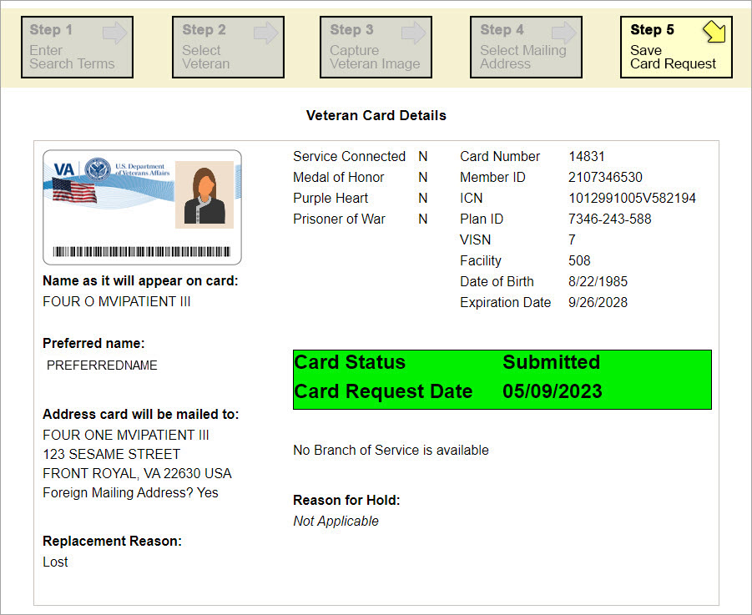

Card Receiving
Table 3: Who can receive a card?
At a Glance… | VHIC Roles
Who can receive a card? | Administrator, Tech Admin (Tier 3)

Per SOP, the proper disposal of Veteran Health Identification Cards (VHICs that are returned to the Health Eligibility Center (HEC) require both receiving and destructions logs which will be maintained for six years from the date of document creation, or last effective date, whichever is later.
This section will walk the VHIC Administrator through the process of logging VHIC cards received at the HEC for destruction and processing the destruction of these cards.

Cards Received

Accessing Cards Received Screen
When the VHIC Administrator logs in to the VHIC application, they are presented with three menu options: Card Request, Reports, and Card Management. The Administrator can click either on the links in the header at the top of the screen or on the icon buttons in the middle of the screen.
To begin the Card Management process, the VHIC Administrator would click on either the Card Management link or the Card Management icon button.
Figure 37: VHIC Administrator Home screen; click [Card Management]
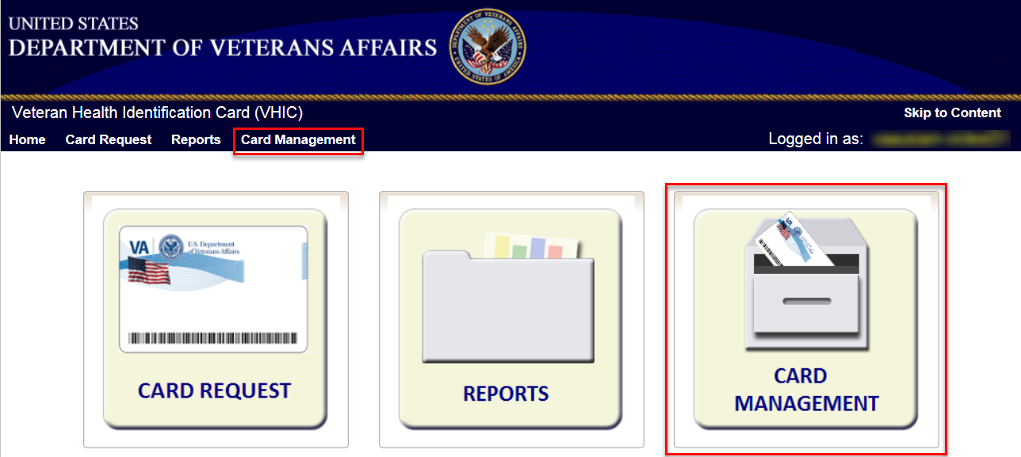

The Card Management button will automatically take you to the Card Deactivation Tab. You will need to select Card Receiving by clicking on the Receiving Tab at the top of the page.
Figure 38: Select Card Receiving Tab
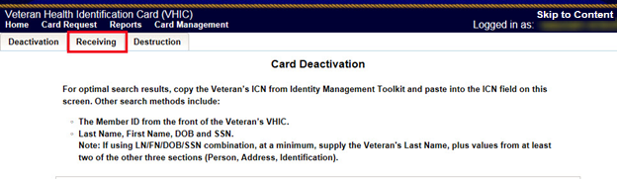

Figure 39: Card Received Screen
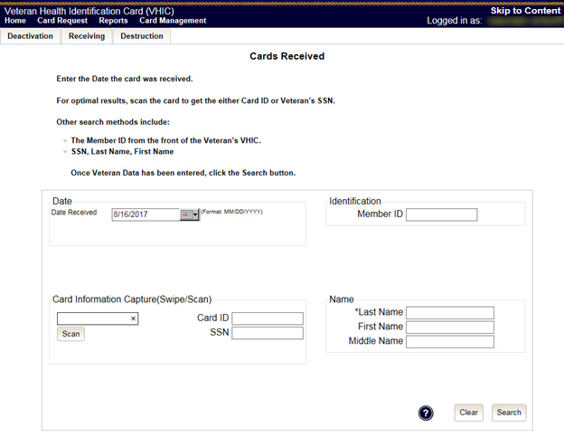

Step 1: Enter Search Terms
The first step in the process is to find the VHIC Card in the system. For optimal results, this is accomplished by scanning the barcode into the system. Once the barcode is captured, click the Scan button, and the Card ID will populate.

Figure 40: Card Scanned into system, Card ID populates
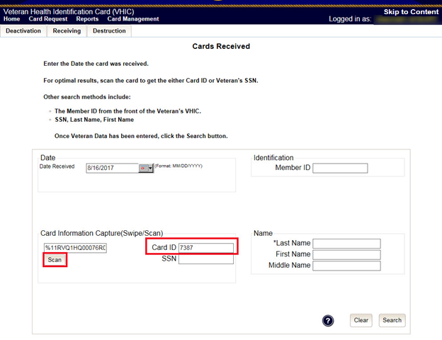

Other search methods include:
- The Member ID from the front of the Veteran’s VHIC
- Last Name, First Name, DOB and SSN

NOTE: If using LN/FN/DOB/SSN combination, at a minimum, supply the Veteran's Last Name, plus values from at least two of the other three sections (Person, Address, and Identification).

Figure 41: Search by Member ID
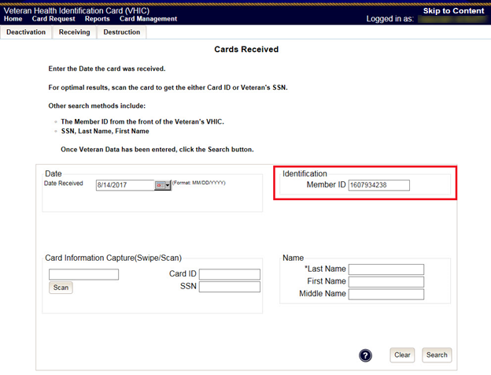

Figure 42: Search by Veteran Name/SSN
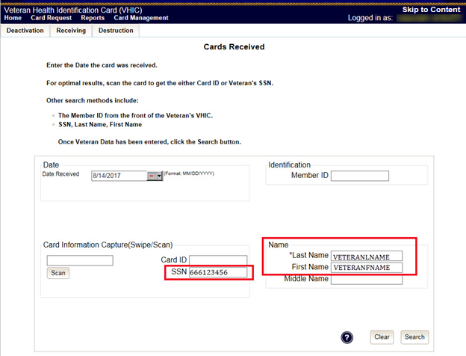

Additional guidance is also available on-screen by clicking on the blue circle containing a question mark.
Figure 43: Help icon

This type of help is available throughout the application and will provide additional detail or clarification for that particular step or section.
Once the information has been entered into the required fields, click on [Search] to proceed to the next step.

Step 2: Card Verification
After search is completed, the system will display the details of the VHIC card scanned. Verify that all information displayed is correct prior to clicking submit.
Figure 44: VHIC Card details displayed
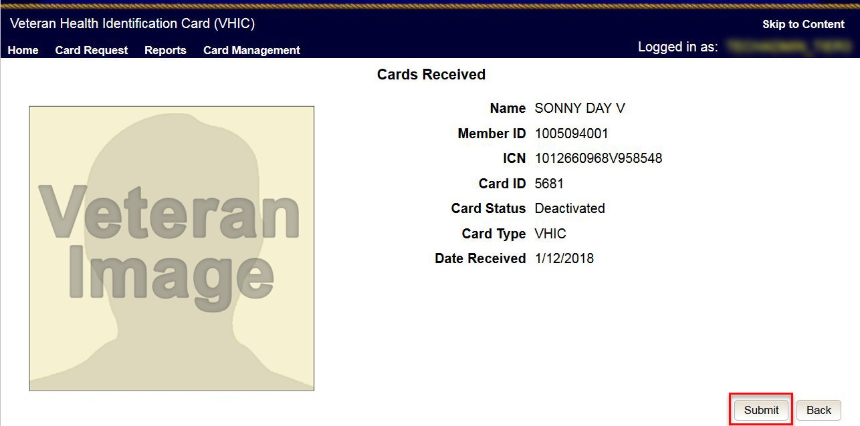

Submitting the card information will update the status of the VHIC card and log it into the system as having been received and pending destruction.
Figure 45: Card status updated - Pending Destruction
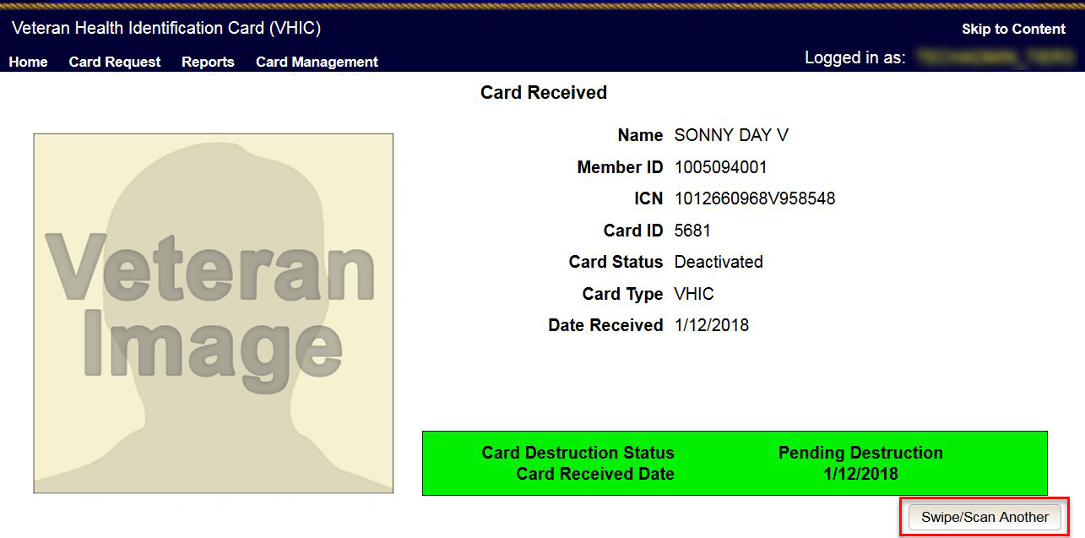

Selecting the Swipe/Scan Another button at the bottom of the screen will bring you back to the Receiving search page.
Figure 46: Receiving Search Page
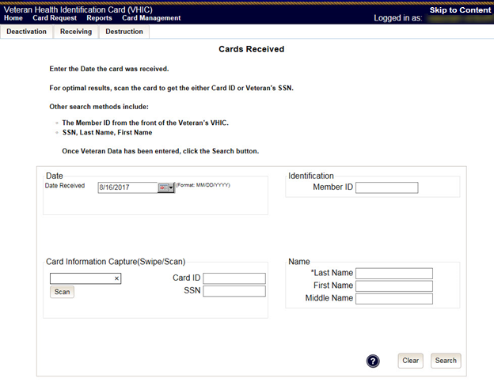

Card Destruction
Table 4. Who can destroy a card?
At a Glance… | VHIC Roles
Who can destroy a card? | Administrator, Tech Admin (Tier 3)

Per SOP, the proper disposal of Veteran Health Identification Cards (VHICs that are returned to the Health Eligibility Center (HEC) require both receiving and destructions logs which will be maintained for six years from the date of document creation, or last effective date, whichever is later.
This section will walk the VHIC Administrator through the process of logging VHIC cards received at the HEC for destruction and processing the destruction of these cards. The system will track all VHIC cards received and destroyed, and the logs can be viewed by running the appropriate reports.

Card Destruction

Accessing Card Destruction Screen
When the VHIC Administrator logs in to the VHIC application, they are presented with three menu options: Card Request, Reports, and Card Management. The Administrator can click either on the links in the header at the top of the screen or on the icon buttons in the middle of the screen.
To begin the Card Management process, the VHIC Administrator would click on either the Card Management link or the Card Management icon button.
Figure 47: VHIC Administrator Home screen; click Card Management
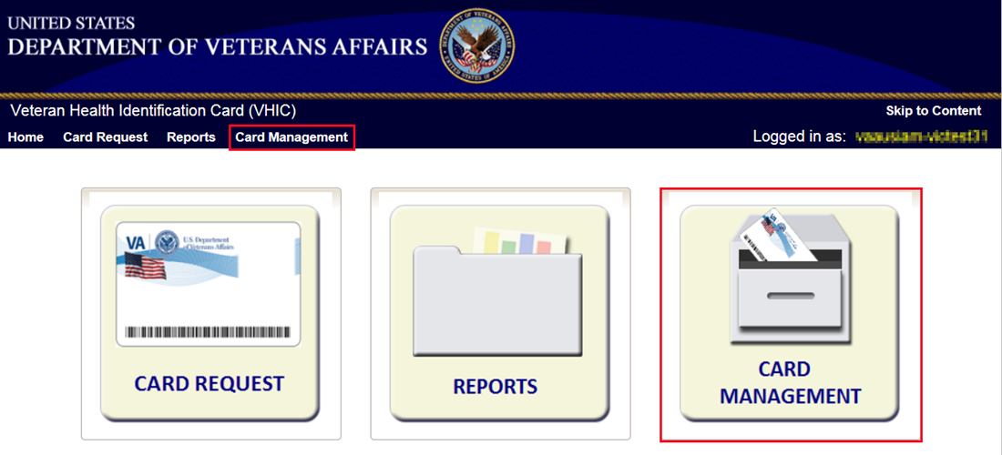

The Card Management button will automatically take you to the Card Deactivation Tab. You will need to select Card Destruction by clicking on the Destruction Tab at the top of the page.
Figure 48: Select Card Destruction Tab
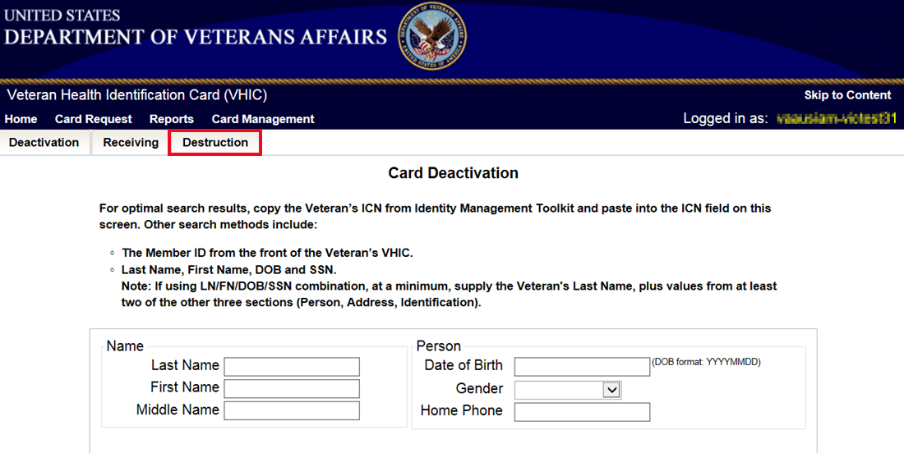

Figure 49: Card Destruction Screen
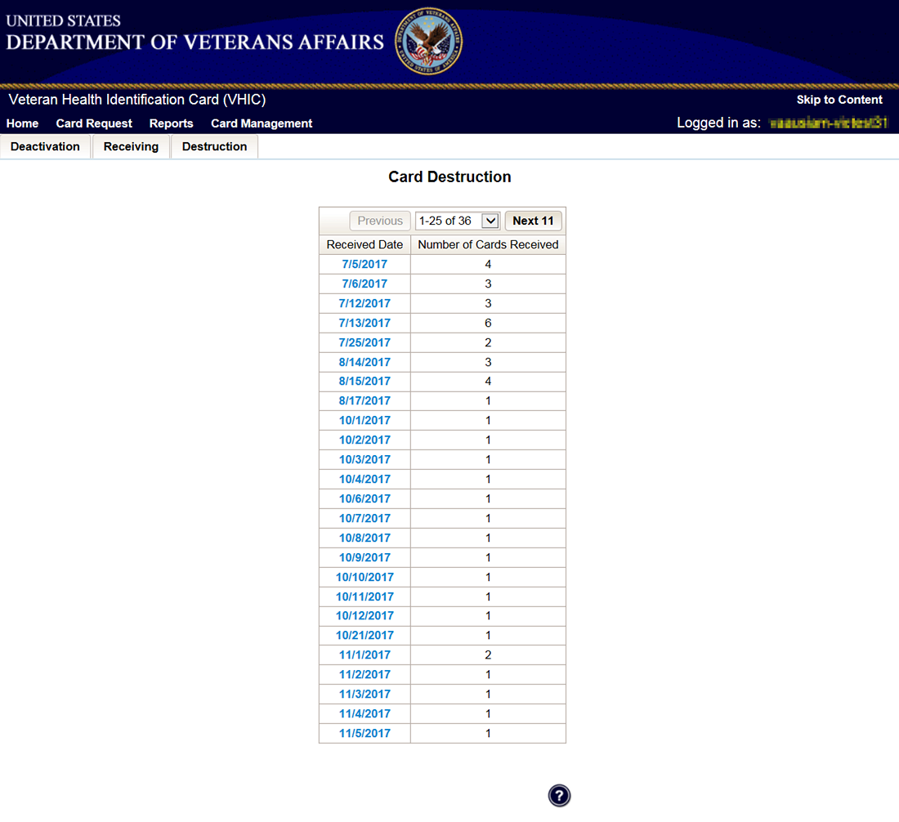

Step 1: Select Cards for Destruction
The Card Destruction screen shows a table of cards received, logged, and ready for destruction. The table indicates the Received Date and Number of Cards Received, allowing for batch destruction as needed. NOTE: To view details of cards received, you will need to run the Card Destruction Report see Veteran Health Identification Card User Guide - Volume 2 – Reports. Select cards for destruction by clicking on the appropriate link found under Received Date.
Figure 50: Select Cards by Received Date for Destruction
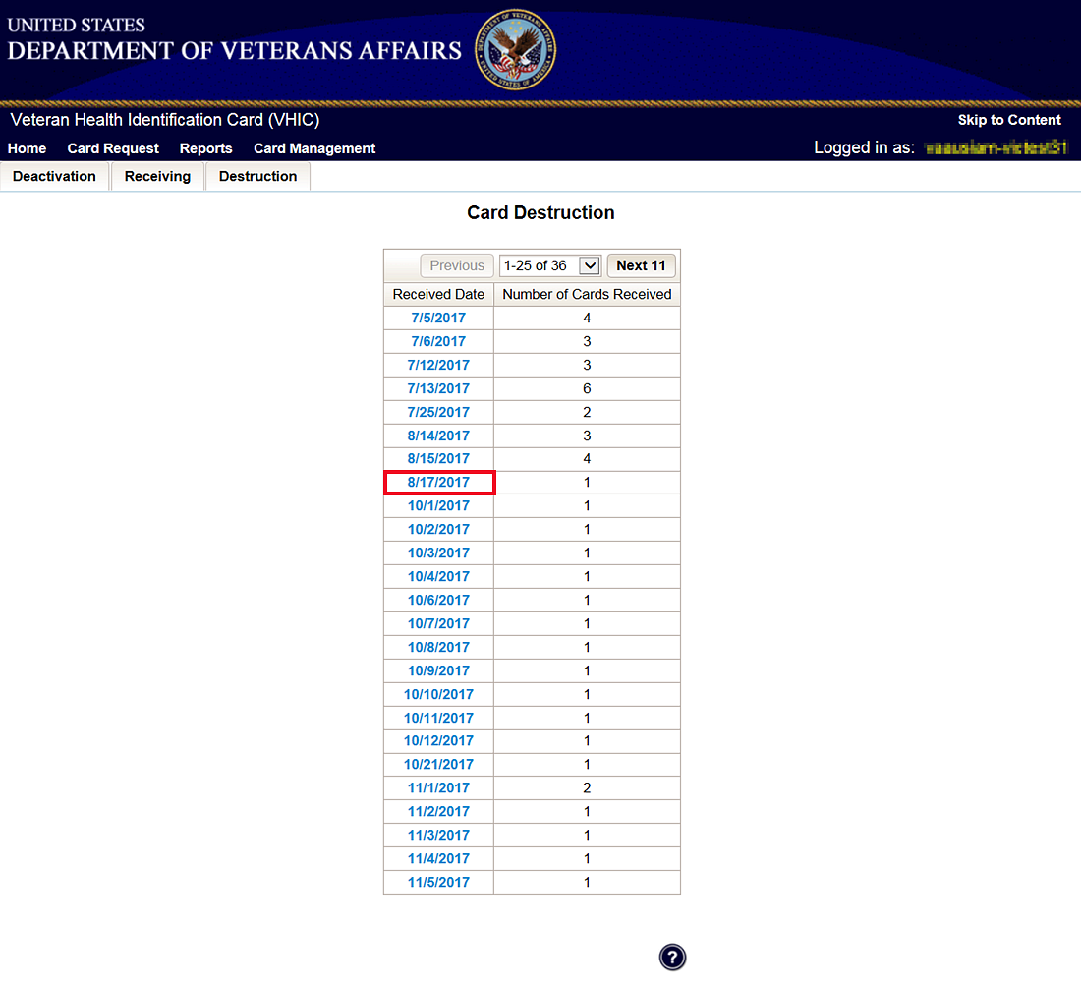

Select Date of Destruction
Once the Received Date has been selected, you will be directed to a new screen for entering the date of destruction. The Date Destroyed will be populated with the current date by default. To provide a different date, you may enter it manually, or select it from the calendar dropdown. You will then click the Submit button.
Figure 51: Select Date of Destruction
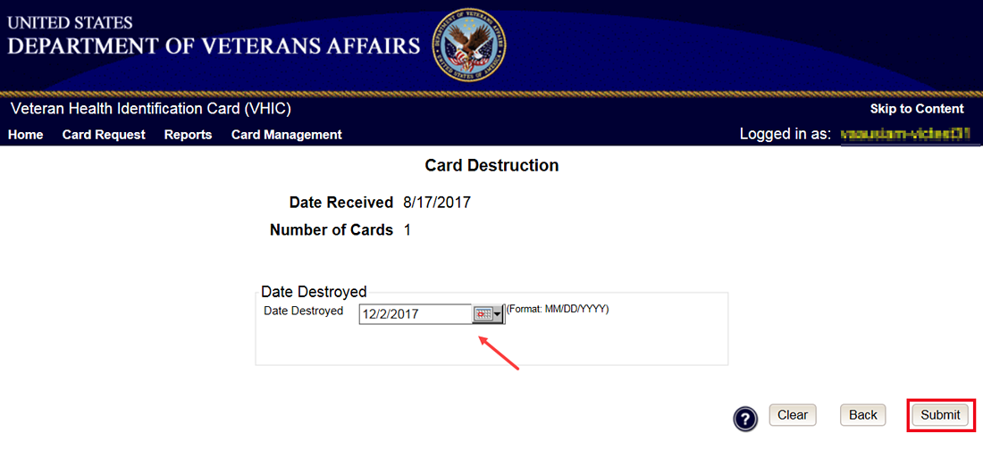

After Clicking submit, a pop-up message will appear to confirm destruction of the selected cards.
Figure 52: Card Destruction Confirmation Message
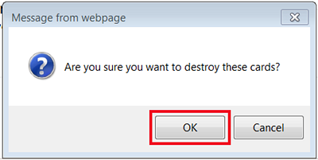

Card Destruction Status Displayed
Submitting the Card Destruction Date will update the status of the VHIC card(s) and log it into the system as having been destroyed. You will have the options of either exiting the Status Screen or clicking the Destroy Another button to return to the main Card Destruction screen.
Figure 53: Card Destruction Status
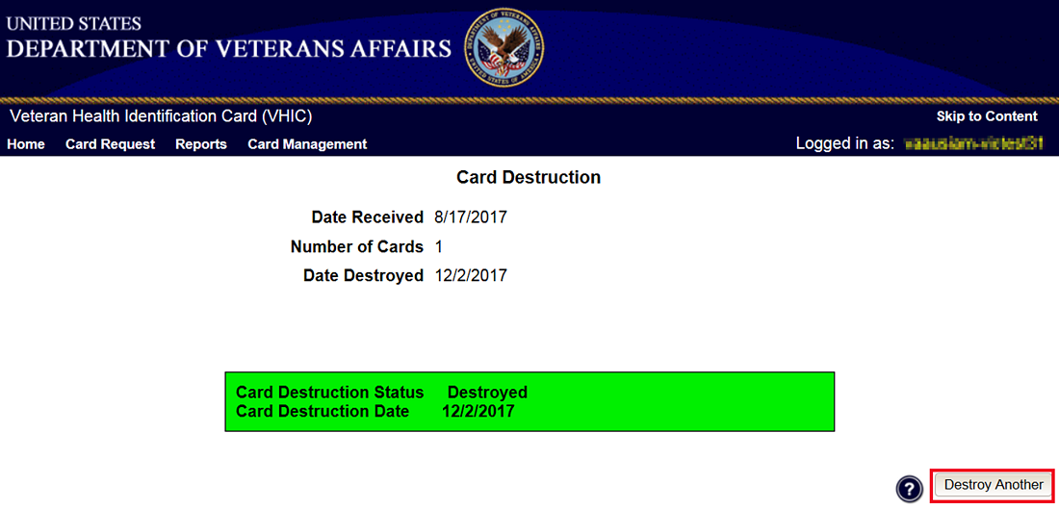

Reports
A comprehensive walkthrough of the different reports available to VHIC users and the types of metrics that can be obtained, as well as an explanation of the user role permissions for accessing the reports are included in the Veteran Health Identification Card User Guide - Volume 2 - Reports document.

Troubleshooting
For a through set of troubleshooting guidelines, please refer to the Veteran Health Identification Card User Guide - Volume 4 - Troubleshooting document.

