Veteran Health Identification Card (VHIC)

Release Notes

VHIC 4.2.0.6

February 2014

Department of Veterans Affairs Office of Enterprise Development

Preface

Purpose of the Release Notes
The Release Notes document describes the enhancements and/or defects addressed in VHIC 4.2.0.6.

Reference Numbering System
This document uses a numbering system to organize its topics into sections and show the reader how these topics relate to each other. For example, section 1.3 means this is the main topic for the third section of Chapter 1. If there were two subsections to this topic, they would be numbered 1.3.1 and 1.3.2.
This numbering system tool allows the reader to more easily follow the logic of sections that contain several subsections.

Contents
- OVERVIEW 4
- DEFECT FIXES WITH REMEDY TICKETS 4
  - INC000000903802 - VETERAN ADDRESS DOES NOT MATCH ESR VISTA AFTER 48 HOURS. 4
  - INC000000903985 - VHIC REQUEST FILE SHOULD BE SENT TO THE CARD PRINT VENDOR DAILY 5
  - INC000000924560 - THE TOTALS REPORTED UNDER VHIC REPORTS DOES NOT SEEM TO BE RIGHT 5
  - INC000000930579 - THE INFORMATION IN VHIC REPORTS IS NOT CORRECT 5
  - INC000000931627 - A SINGLE FACILITY OR THE WHOLE VISN FOR CARD REQUEST, THE SITE LINKS WILL NOT OPEN 5
  - INC000000936582- SITES REPORT AN ERROR STATING THE VETERAN IS NOT ELIGIBLE FOR A VIC 6
  - INC000000944333 - THE STANDARD BAR CODE APPS FOR PHONES ARE ABLE TO PULL THE FULL SOCIAL SECURITY NUMBER OFF OF THE VETERAN ID CARDS 6
- ENHANCEMENTS 6
  - ON-SCREEN GUIDANCE TO SUPPORT THE END-USER WHEN CAPTURING THE VETERAN IMAGE 6
  - IMPROVED ONLINE HELP 7
  - ABILITY TO DESIGNATE THE VETERAN BRANCH OF SERVICE ON THE PHYSICAL CARD . 8 3.4. ADDITIONAL STATUS REPORTS 9
    - Card Status Report 9
    - Cards Printed Without EDIPI 11
    - Card Issued Multiple Times 11
3. RELATED DOCUMENTS 12

Overview
The 4.2 Release of the Veterans Health Identification Card (VHIC) web application addresses a number of issues that were discovered after the national rollout in September 2013 as outlined below:
  - Improved ability to meet industry standards relevant to identification cards
  - Removal of the Social Security Number (SSN) from the card to eliminate identity risk
  - Allow clinical applications to support positive patient identification with the card
  - On-screen guidance for improved photo capture to support the end-user when capturing the Veteran image
  - Improved reliability surrounding the Veteran in-person proofing process
  - Hover-Over help text providing more specific user guidance for the application screens
  - Ability to designate the Veteran Branch of Service on the physical card
  - Addition of the following status reports necessary for supporting local, regional, and VHIC program operations:
- Card Status - Card Status Report
- Card Status - Print Release Status Report
- Cards Printed without EDIPI
- Card Issued Multiple Times - Summary Report
- Card Issued Multiple Times - Detail Report

Defect Fixes with Remedy Tickets

INC000000903802 - Veteran address does not match ESR Vista after 48 hours.

Issue
When a VHIC Associate processed a card request for a Veteran, VHIC may retrieve incorrect information from the Enrollment system by using an inactive correlated identifier found in the Master Veteran Index (MVI).

Solution
When VHIC gets correlated identifiers from MVI, only active (A) records will be included in the response. Including the passive identifiers affects picking the right correlation data out of MVI, affecting address verification through the ESR.

INC000000903985 - VHIC request file should be sent to the Card Print Vendor daily.

Issue
After national rollout in September 2013, the card requests were accumulated, yet halted production of the cards until this release. The card request file was not sent to the Print Vendor.

Solution
The VHIC card request file will be sent to the Print Vendor after VHIC 4.2.0.6 release.

INC000000924560 - The totals reported under VHIC reports does not seem to be right.

Issue
The totals reported under VHIC reports are not accurate.

Solution
Report performance improved and report content/layout updated per Business requirements to include additional information.

INC000000930579 - The information in VHIC reports is not correct.

Issue
Report information is not accurate.

Solution
Report performance improved and report content/layout updated per Business requirements to include additional information.

INC000000931627 - A single facility or the whole VISN for Card Request, the site links will not open.

Issue
When the user selects a single facility or the whole VISN for card request, the site links will not open.

Solution
Report performance improved and report content/layout updated per Business requirements to include additional information.

INC000000936582 - Sites report an error stating the Veteran is not eligible for a VIC.

Issue
The user reports getting an error stating the Veteran is not eligible for a VIC.

Solution
When VHIC gets correlated identifiers from MVI, only active (A) records are included in the response.
Including the passive identifiers affects picking the right correlation data out of MVI, affecting eligibility verification through ESR.

INC000000944333 - The standard bar code apps for phones are able to pull the full SSN off the Veteran ID cards.

Issue
The standard bar code applications for phones are able to pull the full SSN off the Veteran ID cards.

Solution
The SSN is removed from the barcode.

Enhancements
The following section is an overview of the enhancements for VHIC users that have been added in the VHIC 4.2.0.6 release.

On-screen guidance to support the end-user when capturing the Veteran image

Issue
The Veteran photo must meet VA photo requirements.

Solution
On-screen guidance for capturing photo improves the photo quality and lets the user know what photo requirements must be met.

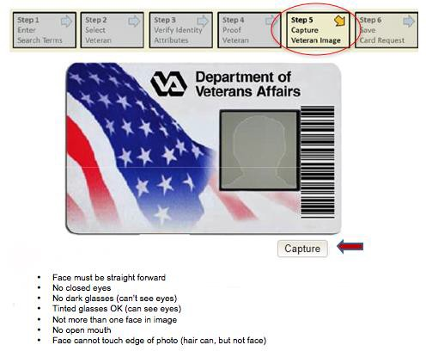

Improved Online Help

Issue
The system shall support improved online and context-sensitive help.

Solution
The VHIC application provides context-sensitive help to assist the user throughout the issuance of the card request.

Please see the context-sensitive help example below.
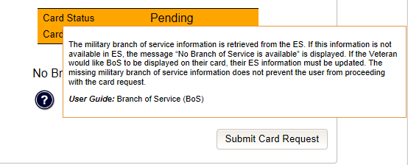

Ability to Designate the Veteran Branch of Service on the Physical Card

Issue
Provide Card Vendor with military branch of service information to be displayed on the face of the VHIC card.

Solution
    - The military branch of service (BOS) information is retrieved from the ESR to be displayed in the VHIC application.
    - If multiple BOSs are available, the VHIC User has to verify with the Veteran which BOS should be displayed on the face of the card.
    - The VHIC application passes the BOS to the Print Vendor.
    - The Veteran has the option to decline displaying the military BOS on the VHIC card.

REDACTED

Additional Status Reports

Issue
Leverage existing report capabilities to support local, regional, and VHIC Program operations.

Solution
The reports listed below are added to measure usage, effectiveness, and other aspects of VHIC application.

Card Status Report
The Card Status - Status Report is provided for four card/card request statuses listed below.

Status | Status Description
Active | The card is active.
Inactive | The card is deactivated.
Processing | The Print Facility is processing the card request.
Request | The card is sent to the print facility.

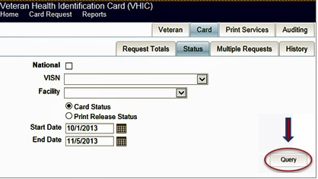
The Card Status - Print Release Status report is provided for the nine card request statuses listed below.

Status Code/Reason Code Description

Release Status | Release Status Description
Cancelled | Request is cancelled
Error | Request error: data integrity
Hold | Request is on-hold
Ineligible | Request ineligible for card; phone and data stored
Mailed | Request processed, card has been mailed
Printing | Card Print Site prints the card
Received | Request has been received by Card Print Site
Rejected | Request rejected by Card Print Site
Sent | Request has been sent to Card Print Site

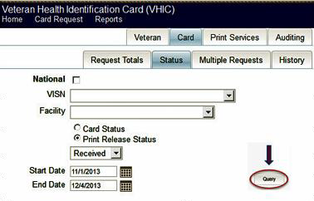

Cards Printed without EDIPI
The Card Printed without EDIPI report shall provide the actual card count of VHIC cards issued to Veterans without an EDIPI populated on the card within the selected date range.
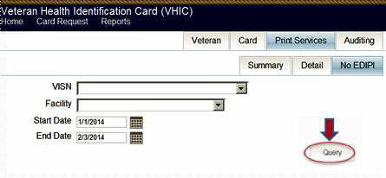

Card Issued Multiple Times
- Summary Report
- Detail Report
This report provides information on cards that have been requested on more than one occasion for the same Veteran. The user can specify the maximum of Card Requests to search for. The results returned will be equal to or greater than the maximum of Card Requests entered.

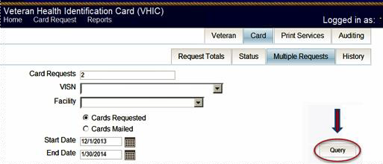Summary Report summarizes information by VISN/Facility. Detailed Report provides detailed Veteran information.

3. Related Documents
The VA software Documentation Library (VDL) website will contain the VHIC 4.2.0.6 Release Notes and the updated VHIC User Guide. This website is usually updated within 1–3 days of the patch release date.

