Voluntary Service System (VSS) Enhancements

VSS*5*3

Release Notes

Department of Veterans Affairs
Office of Information and Technology (OI&T)
Product Development

Version: 1.1
August 2017

Revision History

Date | Version | Description | Author
08/14/2017 | 1.1 | Updates from Project Team | VSS Technical Team
08/09/2017 | 1.0 | VSS 5.3 Release Notes | VSS Technical Team

Table of Contents
1. Introduction 1
2. Purpose 1
3. Audience 1
3.1 How to access VSS*5*3 1
3.2 Documentation 1
4. New Functionality or Functionality Changes 2
4.1 Volunteer Demographic 2
4.2 Notifications Enhancement 2
4.3 Print Volunteer Profile Information 2
4.4 New NAC Organization Reports Sub Menu 2
4.5 Committee Listing Report Enhancements 3
4.6 Merge Branches and Organizations 3
4.7 Meal Ticket Feature 4
4.8 Manage Letter Template Revisions 4
4.9 General Ledger Update 4
4.10 Reports 4

List of Tables
Table 1: Standard Reports 4

Introduction
The Department of Veterans Affairs (VA) Voluntary Service Office (VAVS) operates one of the largest volunteer programs in the Federal Government that supplements staff and resources in all areas of patient care and support. The mission of the VAVS office is to provide a structured volunteer program under the management of VA compensated employees in cooperation with community resources to serve Veterans and their families with dignity and compassion.
The Voluntary Service System (VSS) is an enterprise web application that allows staff to track volunteers and in which capacities they serve along with any organizations they serve on behalf of. VSS tracks all donations received into the VA and how the donated dollars are allocated.
This release will expand upon the functionality released in VSS 5.2. Now, only high priority notifications such as new e-donations or LEIE matches are available upon logon, all other notifications are stored in the new Requirements Notification Screen. Automatically merging organizations to a Target Organization and sibling branches to a Target Branch is added to simplify the maintenance process. If a user needs a paper copy of a volunteer’s information, the new print feature prints everything from the volunteer’s profile. In addition, several new reports are added to the VSS dynamic reporting system.

Purpose
VSS is currently in Production. The last patch implemented was VSS 5.2.
This document covers the newly added features and the changes to the current VSS functionality as implemented in VSS 5.3.

Audience
This document targets users and administrators of VSSE and applies to the changes made between this release and any previous releases for this software.

How to access VSS*5*3
The following new URL’s have been established:
Production Staff: REDACTED
Production PC Kiosk: REDACTED

Documentation
The VSS User Guide will provide summaries and step-by-step instructions for all VSS user screens. The intent of this document is to familiarize users with the functionality released in VSS*5*3.
Additional documents can be found on the VA Software Document Library at: http://www.va.gov/vdl/application.asp?appid=135

New Functionality or Functionality Changes
The following are new enhancements to the VSS 5.3 Release.

Volunteer Demographic
The Volunteer Demographic Screen is enhanced with more customized options for viewing volunteer information. The following options are now available:
- Active Organization – If selected, displays active organizations affiliated with volunteers in alphabetical order.
- Years Volunteering - If selected, displays the number of years the user has volunteered.
- Entry Date – If selected, allows a user to search for volunteers with entry date of all, in this fiscal year, the last two fiscal years, before, after, or between.

Notifications Enhancement
To keep the most important notifications upon login, the Notifications section on the VSS Homepage is updated to only include new e-donations, LEIE Matches, and Kiosk changes. All other notifications are available on the new Requirements Notification Screen and can be accessed by selecting the new Requirement Notifications link or menu option from the Volunteers Menu.

Also, the following new options are available:

- The Show Entries dropdown is available on Notifications and Requirements Notifications Screens that enables users to pick from 10, 20, or 50 entries to view.
- The Excel, PDF, and Print buttons are available to export a .csv file, make a pdf copy, or print any items selected on the screen.

Print Volunteer Profile Information
Now you can print the full Volunteer Profile from VSS to a paper copy. This allows users and staff members to have a printable reference sheet on hand, rather than searching in the VSS application for a specific detail on a volunteer. The new Print button displays at the top of the profile and prints all details on the Volunteer Profile.

New NAC Organization Reports Sub Menu
All national management-related reports are grouped under the new NAC Organization Reports sub menu. From the Administration Reports Menu dropdown list, select the secondary NAC Organization Reports option and the following reports are available under the new submenu:

      - Annual Joint Review
      - Committee Attendance Listing
      - National Official Listing
      - NAC Organization Yearly Comparison
      - Volunteers by NAC Organization on VAVS Committee
      - Volunteer Organization RS Occasional Hours

Committee Listing Report Enhancements
The Committee Listing Report is updated to include the committee attendance members with assignments, regardless if they have no hours logged or visits for the fiscal year selected. If none are recorded, the volunteer will be listed on the report with the hours of 0.00 in Quarterly Hours and Visits Columns. This affects volunteers who have the following service roles assigned:
- Voluntary Service – Advisory MTG Associates
- Voluntary Service – Advisory MTG Deputies
- Voluntary Service – Advisory MTG Honorary
- Voluntary Service – Advisory MTG Representatives

Merge Branches and Organizations
The VSS National Administrator can merge local organizations, such that, all the affiliated local entities (branches), Occasional hours, Regular hours, all volunteers organizations associations, all volunteer “Primary Organization” data, and all the branches now have the National Organization as the parent. Any donor or donations with the local organization will now have the National Organization as the donor or affiliation on the donation. The Merge Local Organizations button is located on the Organization Detail Screen.

The VSS Site Administrators can merge Siblings (Branches) under National or local organizations, such that, all the affiliated local entities (branches), Occasional hours, Regular hours, all volunteers organizations associations, all volunteer “Primary Organization” data, are merged under one branch. Any donor or donations with the branch that was merged will now have the target branch as the donor or affiliation on the donation.

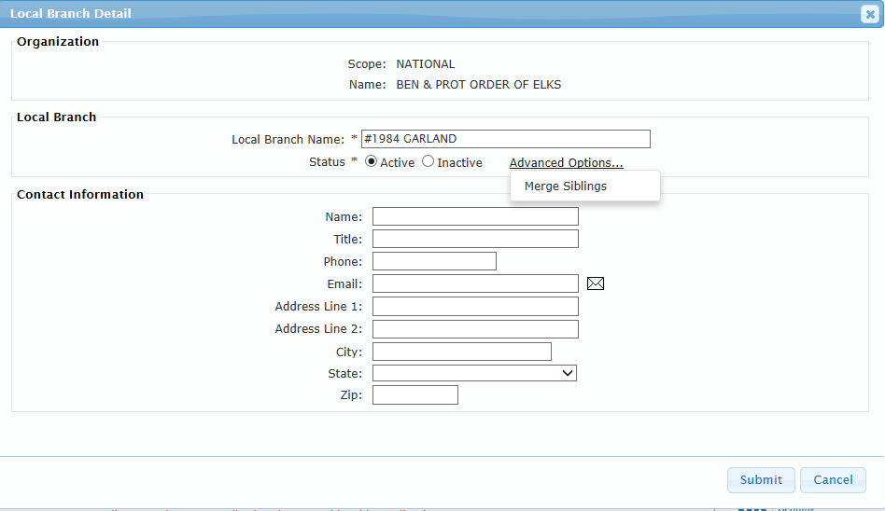

On the Organization Detail Screen, the Merge Siblings option below the Advanced Options link starts the process of merging Siblings branches to one Target Branch.

Meal Ticket Feature
A new layout enables Meal Tickets to be seamlessly printed from a Kiosk. When clicking on the Print Selected button on the Meal Ticket Screen, the new Format Select box gives the user the option to print from a normal or receipt (kiosk) printer. Printing from a kiosk reformats the content and margins on the Meal Ticket to correctly fit the printer size.
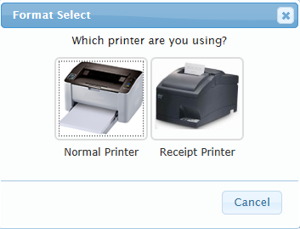
Note: To print Meal Tickets from a receipt printer with the highest quality, the margins may be adjusted to fit the printer format. Detailed procedures are documented in the VSS User Guide.

Manage Letter Template Revisions
The Manage Letter Template Type drop-down is revised for improved readability. The following options now available are:
    - Monetary - Not in Memory Of
    - Monetary - In Memory Of
    - Family Contact (To Donor)
    - Family Contact (To Family)
    - Activity Donation
    - Item Donation

General Ledger Update
Updated with this release, a Daily Ledger for a GPF now contains donations to that ledger. A user can drill down to the individual donation amounts for each date for further specifics.

Reports
The following new and standard reports are available with this release:
Table 1: Standard Reports
Report Name | Description
Annual Joint Review | Users have the ability to create customized Annual Joint Review (AJR) Reports. It is mandatory by Department of Veterans Affairs Voluntary Service (VAVS) for all VA Voluntary Service (VAVS) Organizations (National and Facility) to conduct an Annual Joint Reviews (AJR) with the Voluntary Service Program Manager. The objective is to assess organizations’ participation in the VAVS Program during the preceding year and develop plans and goals for the next year using the Annual Joint Review Report.
Daily Volunteer List | Displays a detailed history of all volunteers’ hours within a date range and the date and time of the entry, as well as the user that made the last change.
NAC Organization Yearly Comparison | Compares the total number of volunteers from each NAC organization by Facility, State, or VISN five years back from the defined date.
National Organization Affiliated Volunteers | Enables users to run a report on the total number of volunteers with the total number of active Volunteers that have logged time and the total number Volunteers that have not logged any time from each National Organization or Facility.  - Displays number of volunteers in each National Organization with active hours.  - Displays numbers of volunteers in each National Organization that are active but dormant (i.e., no hours logged).  - Displays total number of active hours by National Organization.
Volunteer Daily Review | Enables users to run a report on a single volunteer and view a detailed history of the volunteer’s hours. When the parameters screen displays, a user searches for the specific volunteer and defines a date range. The report displays hours the volunteer worked, which facility, the user who entered the time, a date and time stamp, and more.
Volunteers by Service and Facility | Displays services for the selected facility(s) within number of months specified. The information is categorized by regular scheduled volunteers, occasional volunteers, and total volunteers to show the total number of hours by service and role.
Volunteers by Service | Enhanced to display Grand Totals on the Summary only.

