KERNEL AUTHENTICATION & AUTHORIZATION FOR J2EE (KAAJEE)

SECURITY SERVICE PROVIDER INTERFACE (SSPI) VERSION 8.0.748

FOR WEBLOGIC (WL) VERSIONS 12.2 AND HIGHER

ROLLBACK GUIDE

December 2021

Department of Veterans Affairs
Office of Information and Technology
Product Development

Revision History

Documentation Revisions

The following table displays the revision history for this document. Revisions to the documentation are based on patches and new versions released to the field.

Table i. Documentation revision history
Date | Description | Author(s)
12/2021 | Updated software and the installation guide with relation to the KAAJEE SSPI.  Kernel Patch: XU*8.0*748, makes changes the Technical Reference Model (TRM) compliance changes and upgrades/certifications of a KAAJEE SSPI component for the WebLogic 12.2/Java 1.8 and Oracle Relational Database Management System (RDMS), version 19c platform. | REDACTED
11/2021 | Second version of this document. | REDACTED

Table of Contents
KAAJEE SSPI rollback 4

List of Figures
No table of figures entries found.

List of Tables

Table i. Documentation revision history 3

KAAJEE SSPI rollback

- Locate and Run the setWLSEnv.sh script on the application server

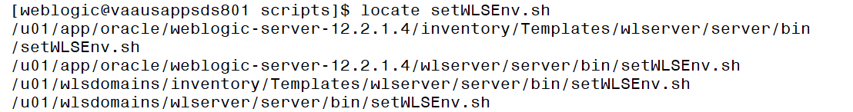

The file is located under the server/bin directory by default (Ex: /u01/app/oracle/weblogic-server-12.2.1.4/wlserver/server/bin/setWLSEnv.sh)

Run the java weblogic.WLST and pass the required properties file to the deleteDSSSPI.py

java weblogic.WLST deleteDSSSPI.py -p createDSSSPI.properties

The script will attempt to remove a datasource as well as the SQLAuthenticationProvider. It will use the same properties file. Upon successful script completion, you will be offered to shutdown an admin server.

- Start the server; Log onto admin console.

- Navigate to the Authentication Directory:
  - Select Security Realms under Domain Structure.
  - Navigate to the Providers tab, as shown below:
- Home > Summary of Security Realms > myrealm > Providers > Authentication tab

- Confirm absence of the KaajeeManageableAuthenticator.

  - When returned to the Authentication page, select and edit the DefaultAuthenticator Authentication Provider. Ensure that Control Flag is 'REQUIRED'.

- Restart the admin server, if any changes to the Authentication Providers has been made.

- Verify all Changes Have Taken Place:

  - Use the WebLogic console software (i.e., WebLogic Server 10.3.6 Console Login) to navigate to the following locations:
    - Home > Summary of Security Realms > myrealm > Users and Groups
(Users tab)
    - Home > Summary of Security Realms > myrealm > Users and Groups
(Groups tab)
  - Confirm absense of application-level users retrieved by the KaajeeManageableAuthenticator

