KERNEL SLOTMASTER

MANAGEMENT GUIDE

Version 8.0

March 1996

Revised January 2005

Department of Veterans Affairs
VistA Health Systems Design & Development (HSD&D)
Infrastructure and Security Services (ISS)

Revision History

Documentation Revisions

The following table displays the revision history for this document. Revisions to the documentation are based on patches and new versions released to the field.

Date | Revision | Description | Author
03/96 | 1.0 | Initial Kernel SlotMaster V. 8.0 software and documentation release | Kernel Development Team, San Francisco OIFO
01/04/05 | 2.0 | Kernel SlotMaster V. 8.0 documentation reformatting/revision.  Reviewed document and edited for the "Data Scrubbing" and the "PDF 508 Compliance" projects.  Data Scrubbing—Changed all patient/user TEST data to conform to HSD&D standards and conventions as indicated below:  - The first three digits (prefix) of any Social Security Numbers (SSN) start with "000" or "666."  - Patient or user names are formatted as follows: KRNPATIENT,[N] or KRNUSER,[N] respectively, where the N is a number written out and incremented with each new entry (e.g., KRNPATIENT, ONE, KRNPATIENT, TWO, etc.).  - Other personal demographic-related data (e.g., addresses, phones, IP addresses, etc.) were also changed to be generic.  PDF 508 Compliance—The final PDF document was recreated and now supports the minimum requirements to be 508 compliant (i.e., accessibility tags, language selection, alternate text for all images/icons, fully functional Web links, successfully passed Adobe Acrobat Quick Check). | REDACTED
Table i: Documentation revision history

Patch Revisions

For the current patch history related to this software, please refer to the Patch Module on FORUM.

Contents

Revision History iii
1. Introduction 1-1
2. System Management 2-1
If You Already Are Using a Version of SlotMaster 2-1
How SlotMaster Works 2-1
SlotMaster Loop 2-2
Slot Loop 2-3
Starting Up SlotMaster 2-4
Force Exiting Slots 2-5
SlotMaster Menu on the Operations Menu 2-5
Switching DHCP to a Non-SlotMaster Service 2-7
Known Problems and Observations 2-7
Direct Mode Utilities 2-8
3. Programmer Tools 3-1
$$CHK^ZSLOT0 function 3-1

Introduction

SlotMaster is a quick login utility for VMS systems. SlotMaster saves user time by letting the user connect directly to an active M partition. This saves users from sitting through VMS process creation and loading an M partition, allowing them to log in to DHCP directly.

SlotMaster also conserves system resources by re-using the same VMS process for new users, rather than creating a new process for each new user.

System Management

If You Already Are Using a Version of SlotMaster

Several versions of the SlotMaster software exist. The version of SlotMaster distributed with Kernel merges in features from several existing SlotMaster versions.

One advantage of switching to Kernel's SlotMaster implementation is that it is integrated with Kernel; no patching of Kernel routines is required to run Kernel's version of SlotMaster. Another advantage is that Kernel's version of SlotMaster is supported within the ISC structure as released software.

There are no major new features in Kernel's version of SlotMaster. The experience you have gained managing your current SlotMaster configuration will be useful when working with Kernel's. One convenience is that only the STARTUP$ZSLOT.COM file needs editing.

Only "DETACH" mode of SlotMaster supported.

How SlotMaster Works

SlotMaster is a combination of DCL command procedures and M routines. It uses a feature available under OpenVMS LAT known as dedicated LAT ports. With dedicated LAT ports, an application can be dedicated to a set of specific LAT devices.

With SlotMaster, the user connects to a service that is a set of dedicated LAT ports that are connected to already running ZSLOT0 DSM jobs waiting to call the Kernel's sign-on. This keeps the user and the system from having to go through process creation and image activation at the time of login to DHCP applications.

SlotMaster Process

The system manager starts up SlotMaster on a given node using the STARTUP$ZSLOT.COM command file. This command file creates a set of custom files and submits them to a VMS queue. These files start up the set of slot processes for the node, plus one instance of a controller process, called SlotMaster, that manages the set of slots. The SlotMaster process scans the set of slots for the current node, restarts processes that have been force-exited or have otherwise disappeared, and collects usage statistics for reference.

Individual Slots

Each slot is started up by running the VMS loginout.exe image, which creates new detached processes. Each slots runs the same DCL command file (ZSLOT_COMMON_SLOT.COM). This command file invokes DSM, and runs the routine ^ZSLOT0. ^ZSLOT0 is passed a LAT device name by ZSLOT_COMMON_SLOT.COM. ^ZSLOT0 opens the LAT device, it then attempts a read (with a ten minute time-out). At this point the slot is ready and waiting for a user to connect to it. When a user connects to the LAT service, pressing <Enter> completes the read for the waiting process on the LAT device; at this point, the user connects to the slot.

Depending on how STARTUP$ZSLOT.COM is setup, the use of $P, USE 0, and access to programmer mode can be supported or not.

For additional information on dedicated LAT ports, consult the Digital Service Network (DSN) databases for OpenVMS and DSM for OpenVMS.

SlotMaster Loop

SlotMaster process
is created by
startup$zslot.com.
Set xxxx to st_port
startup parameter.
Does process _{exist on device} Queue job to start on Increment xxxx _{LTAxxxx? No} device LTAxxxx. by one.
Yes
Is xxxx
greater than
en_port startup
parameter? No
Yes
Store plotting data
for slots.
If slots on node
nearly full, lower
LAT rating.
If LAT rating
lowered for 5 cycles,
raise LAT rating.

Hang for 30
seconds.

Slot Loop

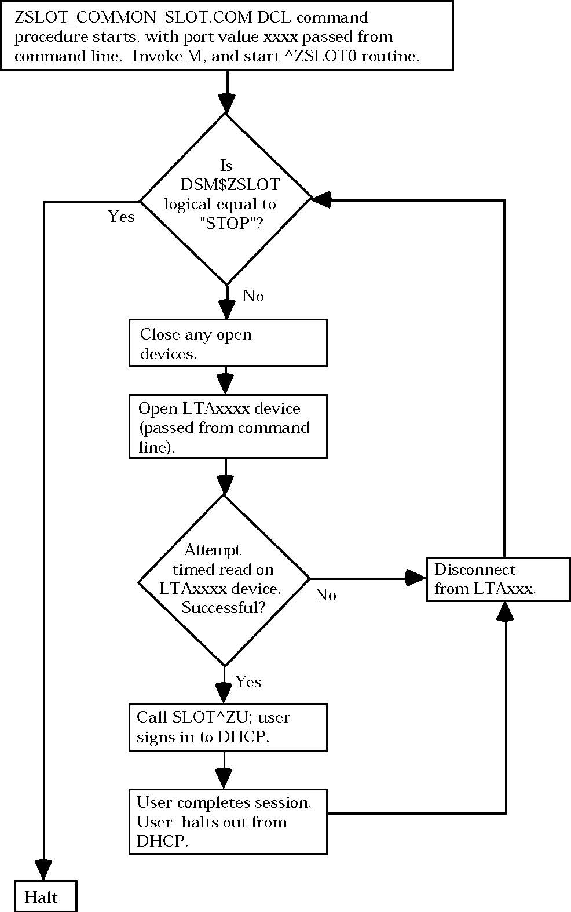

Starting Up SlotMaster

WARNING: You should not start SlotMaster on a node where there are many users already logged in; the node can run out of system resources with too many processes created (current users plus a full complement of slots).

Check that the STARTUP$ZSLOT.COM command file, in its first section, has been edited to define the START_ZSLOT symbol to be 1.

You can start SlotMaster with the default number of jobs specified in the command procedure STARTUP$ZSLOT.COM like this.

$ @DEVICE:[DIRECTORY]startup$zslot.com <Enter>

Or you can create VMS logicals that will be used in place of the default numbers. A good place to create the logicals would be in sys$startup:syslogicals.com a system startup file.

$ node = f$getsyi("nodename")
$ if f$extract(3,3,node) .eqs. "A03"
$ then
$ define/system/executive_mode dsm$zslot_start 3000
$ define/system/executive_mode dsm$zslot_end 3099
$ endif
$ if f$extract(3,3,node) .eqs. "A04"
$ then
$ define/system/executive_mode dsm$zslot_start 4000
$ define/system/executive_mode dsm$zslot_end 4099
$ endif

Or you can use parameter passing to specify the starting and ending points for slots (and thus the number of slots to create):

$ @DEVICE:[DIRECTORY]startup$zslot.com DETACH 7001 7150 <Enter>

In this form the first parameter of "DETACH" is required.

STARTUP$ZSLOT.COM starts SlotMaster up on the node that it is run on only; you must run it separately for every node you want to start SlotMaster up on. This will allow different numbers of slots on each node.

It can take ten to fifteen minutes for all slots to start up.

The startup process builds a batch queue for each node based on the node name. For example, on a node called 661A01, a queue would be created called DSM$SLOT_661A01. These queues are used by SlotMaster at startup and also when restarting slots.

Force Exiting Slots

You can force-exit individual slot processes using the Kill off a user's job [XURESJOB] option just as you force-exit other M processes. The FORCEX routine in the manager's account, is only available if the ALLOW_PROG symbol was set to 1.

SlotMaster Menu on the Operations Menu

Cluster Status (All Nodes)

Lists the status of the SlotMaster processes, and all slots, for all nodes in the configuration that are running SlotMaster.

Node Status (Current Node)

Lists the status of the SlotMaster process and all slots, for the current node.

Port Statistics (port resets)

Displays records from the ^ZZSLOT global for all ports that have had to be restarted by the SlotMaster process.

Reset Port/Inhibit Counters

Lets you clear the port reset statistics stored in the ^ZZSLOT global. You can clear port reset statistics either for the current node only, or for all nodes.

User Statistics (Plot Graph)

Prints out statistics for the usage of SlotMaster slots.

Reset User Counters

Purges data on slot usage from the ^ZZSLOT global.

Maximum Usage Stats

This option report on the maximum slot usage over a time period.

Broadcast a Message (Current Node)

Broadcasts a message to all slot users on the current node.

Stop SlotMaster (Current Node)

Performs two steps for the current node. First, it sets the service to no connect; second, sets the logical DSM$ZSLOT on the current node equal to STOP. This causes, on the current node only, the SlotMaster process and all unused slots to stop. It takes ten to fifteen minutes for all unused slots to stop.

There is code in the command procedures and routines, for both slots and the SlotMaster controller process, that checks for the existence and value of a system wide logical name DSM$ZSLOT. If DSM$ZSLOT is equal to "STOP" then the all slot jobs will terminate.

For slots, this system wide logical is only checked when a user exits the system, or the OPEN/READ command to connect a slot to a user times out.

When you shut down DSM, you should shutdown SlotMaster first; this will make the shutdown of DSM processes more graceful. You can stop slots by using Stop SlotMaster (Current Node) on the SlotMaster Menu (or from ^ZSLOTP) on each node that you want SlotMaster to shut down on. In an emergency you can set the DSM$ZSLOT logical yourself on each node:

$ DEF/SYS/EXEC DSM$ZSLOT STOP <Enter>

Once the logical is set, you should wait several minutes for all processes not tied up by users to quit. It could take as long as fifteen minutes for this to occur, depending on the length of the time-outs for the OPEN and READ commands in the ^ZSLOT0 routine.

Enable User access (create service)

Provided SlotMaster has already been started on the current node, this option recreates the LAT service for slots, by running the ZSLOT_COMMON_SERVICE.COM DCL command file. Use this option in conjunction with the Disable User access (delete service) option to temporarily disable and re-enable access to one node's set of slots.

Disable User access (delete service)

Using Disable User Access (Delete Service) option, you can temporarily disable access to SlotMaster on a given node. This deletes the LAT service for slots on the current node, by running the ZSLOT_COMMON_SERVICE.COM command file. Slots are not shutdown or otherwise affected, however. Use this option in conjunction with the Enable User access (create service) option to temporarily disable and re-enable access to one node's set of slots.

In this way, you can disable and re-enable access to the SlotMaster slots, without having to shut down and restart SlotMaster itself.

Switching DHCP to a Non-SlotMaster Service

SlotMaster redefines the DHCP service (or whatever service you specify in STARTUP$ZSLOT.COM's service_name symbol) to be served by SlotMaster. If you need to switch this service back to a non-SlotMaster service on the current node, you should first shut down SlotMaster on the current node. Then, you should use the LAT Control Program (LATCP) command for the current node to redefine the DHCP service to serve the node (instead of SlotMaster slots) again. The commands to do this are:

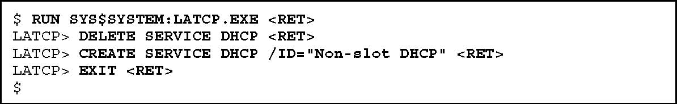

Known Problems and Observations
- On Spawning, when returning from a spawned job always USE IO(0), this is especially a problem if the routine was reading another file and trapped out on the end of file.
- All DCL command files called by slot processes need to have a $SET NOVERIFY as the first line of the procedure (to prevent the text of the command file from being displayed to the slot's user).

Direct Mode Utilities

> D ^ZSLOTP

The ^ZSLOTP direct-mode utility allows you to monitor and control SlotMaster activities. It provides the following choices:

>D ^ZSLOTP

Select SlotMaster Option: ? <Enter>
Answer with SlotMaster Option NUMBER, or NAME

Choose from: ??
1 Cluster Status (all nodes)
2 Node Status (current node)
3 Port Statistics (port resets)
4 Reset Port/Inhibit Counters
5 User Statistics (plot graph)
6 Reset User Counters
7 Maximum Usage Stats
8 Broadcast a Message (current node)
9 Stop SlotMaster (current node)
10 Enable User access (create service)
11 Disable User access (delete service)

Select SlotMaster Option:

Each option is the same as from the SlotMaster Menu.

Programmer Tools

$$CHK^ZSLOT0 function

Usage | S X=$$CHK^ZSLOT0
Input | none
Output | Return value: | 1 if the current process is running in a slot, 0 if the current process is not running in a slot.

Description Use the $$CHK^ZSLOT0 function to determine if the current process is running in a slot. One use of this function is in the entry actions of options, to decide whether disable the option if the option is running in a slot.

Note: The $$CHK^ZSLOT0 function is only available if the site has installed the optional SlotMaster component. If the site has not installed SlotMaster, the ^ZSLOT0 routine (and therefore $$CHK^ZSLOT0) will not be available.

