Veterans Data Integration and Federation Enterprise Platform (VDIF-EP):

InterSystems Application Programming Interface (API) Manager

User Guide
August 2023

Department of Veterans Affairs (VA)
Office of Information and Technology (OIT)

Revision History
Date | Revision | Description | Author
08/09/2023 | 1.1 | Updates:  - Updated Figure 2.  - Updated Figure 3. | VDIF-EP API Manager Development Team
08/03/2023 | 1.0 | Initial Veterans Data Integration and Federation Enterprise Platform (VDIF-EP) InterSystems Application Programming Interface (API) Manager User Guide document. | VDIF-EP API Manager Development Team

Artifact Rationale
Per the Veteran-focused Integrated Process (VIP) Guide, the User’s Guide is required to be completed prior to Critical Decision Point #2 (CD2), with the expectation that it will be updated as needed. A User Guide is a technical communication document intended to give assistance to people using a particular system, such as Veterans Health Information Systems and Technology Architecture (VistA) end-users. It is usually written by a technical writer, although it can also be written by developers, product or project managers, or other technical staff. Most user guides contain both a written guide and the associated images. In the case of computer applications, it is usual to include screenshots of the human-machine interfaces, and hardware manuals often include clear, simplified diagrams. The language used is matched to the intended audience, with jargon kept to a minimum or explained thoroughly. The User Guide is a mandatory, build-level document, and should be updated to reflect the contents of the most recently deployed build. The sections documented herein are required if applicable to your product.

Table of Contents
Revision History ii
List of Figures iv
List of Tables iv
1 Introduction 1
1.1 Purpose 1
2 System Summary 2
3 Getting Started 2
3.1 Logging On 3
3.2 Exit System 3
4 Using the Software 3
4.1 Navigation 3
4.2 Catalog Access 3
4.3 API Specification 5
4.3.1 Specification Access 5
4.3.2 Specification Features 6
4.4 Try API 8
4.4.1 “Try It Out” Feature 8
4.4.2 Data Discovery 11
4.4.2.1 Data Use Cases 14
4.4.2.2 Osteoarthritis 15
4.4.2.3 Hypertension 15
4.4.2.4 Lung Cancer 16
5 Troubleshooting 17
6 Acronyms and Abbreviations 17

List of Figures
Figure 1: API Manager Overview 1
Figure 2: API Manager Developers’ Portal 2
Figure 3: Catalog Link 3
Figure 4: “View API Catalog” Button 4
Figure 5: Title Link 4
Figure 6: API Specification Button 5
Figure 7: API Methods 6
Figure 8: Sample API Method Detail with Get Parameters and Responses 7
Figure 9: “Try it out” Button 8
Figure 10: Cancel Button 8
Figure 11: Parameters—Editing 9
Figure 12: Parameters—Execute 9
Figure 13: Parameters—Execute and Clear 10
Figure 14: Request Format 10
Figure 15: Server Response 11
Figure 16: Example “id” with Value of “7402” 12
Figure 17: FHIR Condition Resource Example 13
Figure 18: FHIR Condition Resource Response 13
Figure 19: Example for Practitioner 7415 14
Figure 20: Example for Organization 7453 14

List of Tables
Table 1: Osteoarthritis Resource References 15
Table 2: Hypertension Resource References 16
Table 3: Lung Cancer Resource References 17
Table 4: Acronyms and Abbreviations 17

Introduction

Purpose
The Veterans Data Integration and Federation Enterprise Platform (VDIF-EP) Application Programming Interface (API) Manager is a commercial-off-the-shelf (COTS) product from InterSystems that provides a way to route API traffic through a centralized gateway, which then forwards requests to the correct target endpoints. It is an application that resides on an InterSystems IRIS for Health data platform. API Manager serves as a gateway between applications (e.g., Fast Healthcare Interoperability Resources [FHIR] R4 a subset of Health Level Seven [HL7]) and the intended API.
NOTE: The process for project teams to request an application be added is currently under development.

Figure 1: API Manager Overview
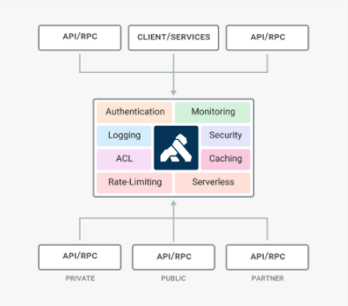

This guide focuses on the Developers’ portal, which displays information necessary for a developer to code against an API and incorporate that API into application code.

System Summary
The VDIF-EP API Manager application is hosted on Amazon Web Service (AWS). The system is only accessible within the VA intranet. The Developers’ portal is intended for internal VA users to discover existing APIs available for use through self-service.

Getting Started
The Developers’ portal (Figure 2) is available to all VA users from the VA intranet.

Figure 2: API Manager Developers’ Portal
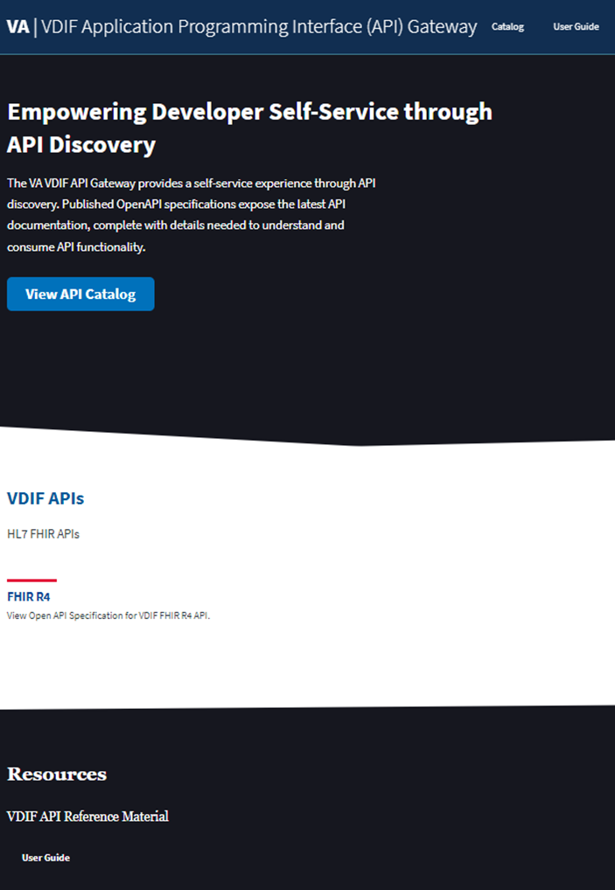

Logging On
To log onto the Developers’ portal, do the following:
- Open a browser (e.g., Microsoft© Edge or Google© Chrome).
- Navigate to the API Manager Developers’ portal.
- Currently, no signon credentials are required, since the API Manager Developers’ portal and catalog screens are not integrated with Single Sign On internal (SSOi).

Exit System
To exit the Developers’ portal, close the browser. Logout is not necessary.

Using the Software

Navigation
Navigation of the Developers’ portal is accomplished by:
- Pressing buttons.
- Selecting links.
- Using built-in browser features, such as a link to go back to the previous page.

Catalog Access
The Developers’ portal Catalog contains a list of all available APIs that are exposed to consumers.
To access the Catalog, navigate from the Developers’ portal main screen to the Catalog by selecting either of the following options:
- “Catalog” link (Figure 3).
- “View API Catalog” button (Figure 4).

The “Catalog” link is located at the top of the Developers’ portal page, to the right of the banner (title), as shown in Figure 3:

Figure 3: Catalog Link

The “View API Catalog” blue button is located under the API gateway description, as shown in Figure 4:

Figure 4: “View API Catalog” Button
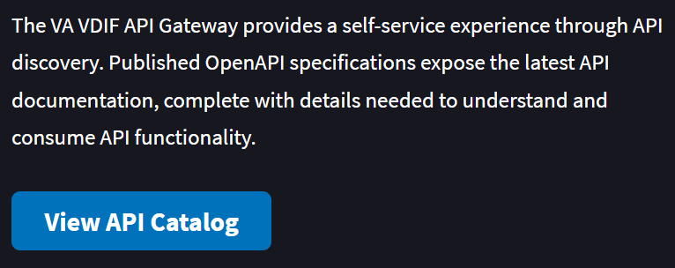

To return to the main Developers’ portal page, select the “VA | VDIF Application Programming Interface (API) Gateway” title link at the top of the screen (Figure 5) or use the browser’s built-in feature to go to a previous page.

Figure 5: Title Link

API Specification
Once the Catalog displays, drill down to view API specifications.

Specification Access
To view an API specification, select the button next to the API name. For example, InterSystems HealthShare FHIR (Figure 6).
NOTE: At this time, there is only one API specification available for viewing (i.e., InterSystems HealthShare FHIR). More API specifications will be available in the future.

Figure 6: API Specification Button
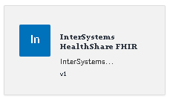

Specification Features
To view details for a specific resource, select the “GET / <method name>” button to expand.

Figure 7: API Methods
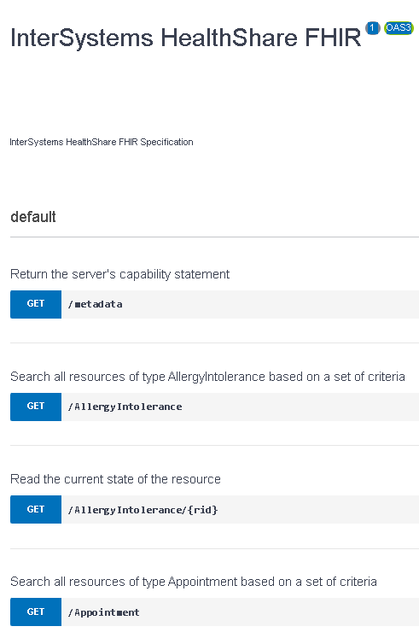

As shown in Figure 8, all supported parameters display, as well as an example response on the right. All details needed to code against an API are displayed. Specifications are written in OpenAPI.

Figure 8: Sample API Method Detail with Get Parameters and Responses
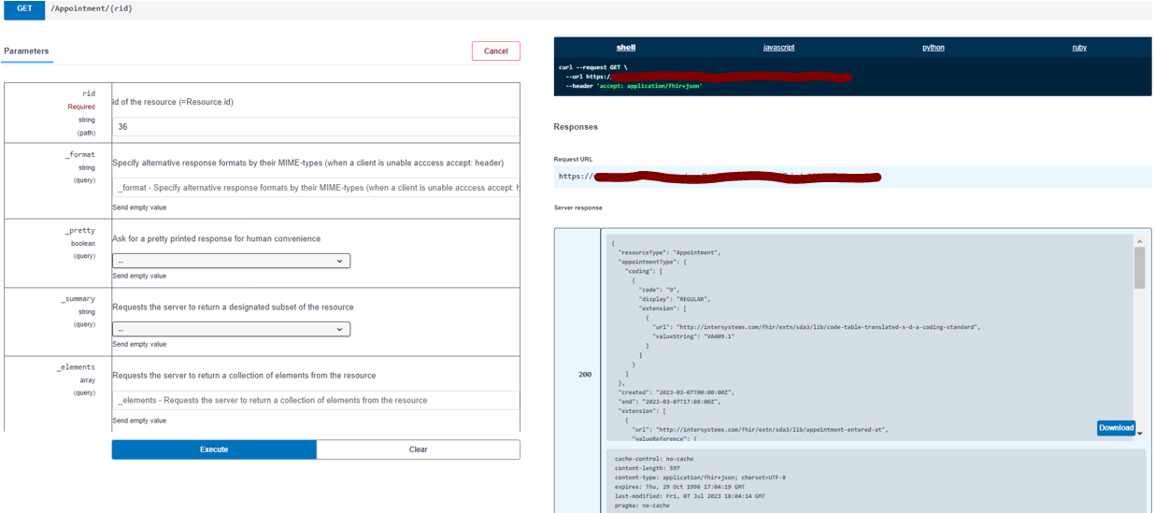

To close the detailed view, select the same button.

Try API

“Try It Out” Feature
To try a request to the API Manager sandbox, select the “Try it out” button (Figure 9). After selection, the button changes to a “Cancel” button (Figure 10), which cancels the feature allowing input into parameter fields.

Figure 9: “Try it out” Button
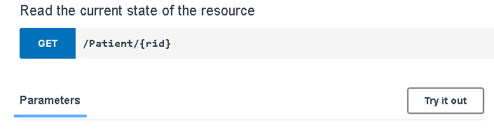

Figure 10: Cancel Button
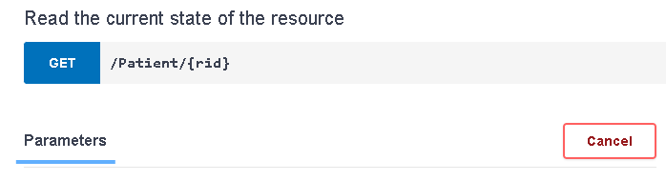

Fill in parameter values to include in the request (Figure 11). The fields are available to edit once the “Try it out” button is selected. If the “Cancel” button is selected, the parameter values are no longer available to edit.

Figure 11: Parameters—Editing
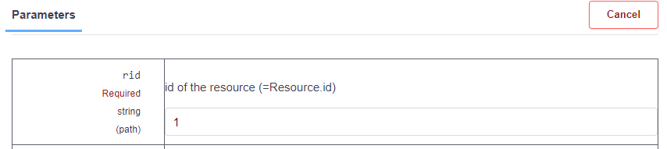

Press the “Execute” button (Figure 12) at the bottom of the parameters to trigger the request message to the sandbox.

Figure 12: Parameters—Execute
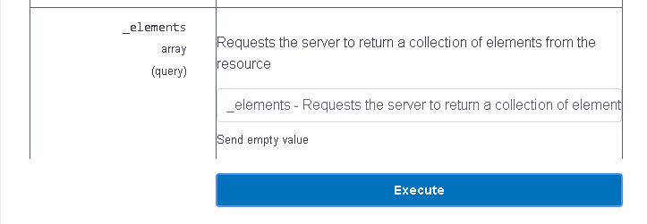

After pressing the “Execute” button (Figure 12), the user has the option to execute an additional request or clear the response (Figure 13).

Figure 13: Parameters—Execute and Clear
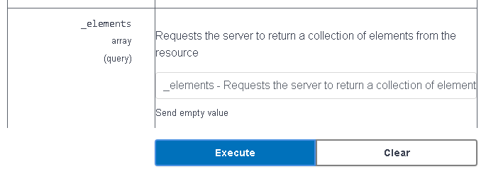

Once a request is executed, the right side of the screen displays details. The request code shows in multiple formats, such as shell or javascript (Figure 14). Select the format to display.

Figure 14: Request Format

The server response also displays and is available for download (Figure 15).

Figure 15: Server Response
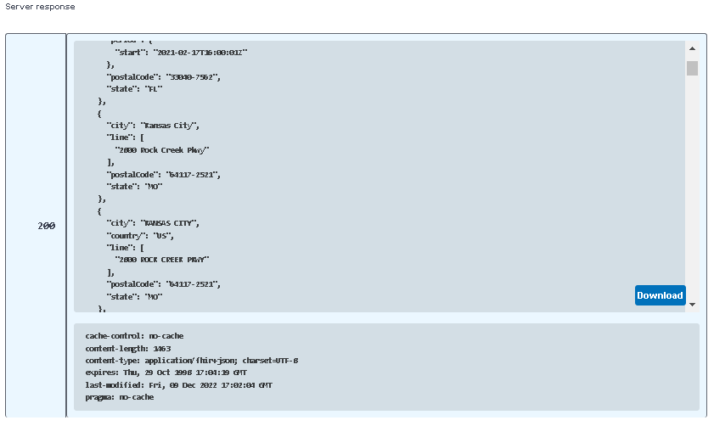

Data Discovery
Data exists so a developer can execute a request against a mapped API and receive a real response from that API.
To discover data examples, first query for all patients:
- Use the “Try It Out” feature.
- Select FHIR R4 Patient resource.
- Execute without specifying any parameters.

Synthea data models were used to model patient data and the data model name is contained in the patient name. Select a patient to explore and note the value of “id”, which is near the end of a patient’s information (Figure 16).

Figure 16: Example “id” with Value of “7402”
"meta": {
"versionId": "1",
"lastUpdated": "2023-05-05T18:52:42Z"
},
"id": "7402"
},
"search": {
"mode": "match"
}
},

Use the patient id to search for associated data. For example, select FHIR R4 Condition resource and put in a value for “patient” to see all entries for that patient.
Figure 17 is an example of the FHIR Condition Resource. FHIR is a standard that is related to the HL7 standard. FHIR connections are called “resources” or “endpoints”. A resource or endpoint is made up of parameters.
Figure 17 shows the details of the condition resource.

Figure 17: FHIR Condition Resource Example
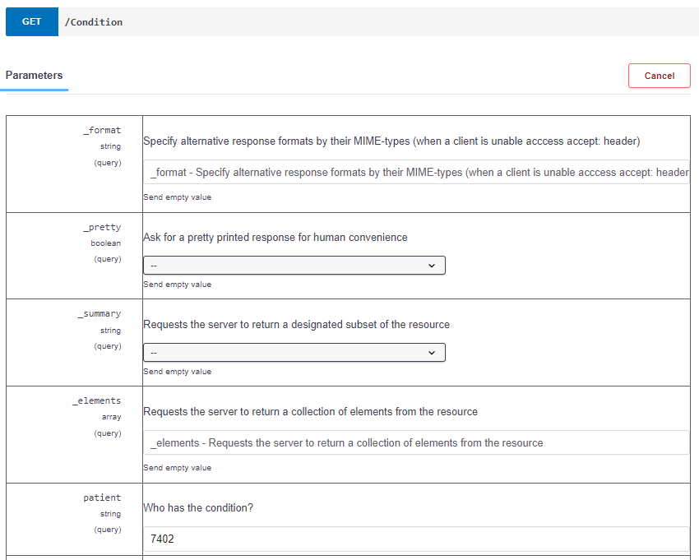

This request returns all conditions for the selected patient. Figure 18 shows the response returned when a request is executed based on the endpoint definition in Figure 17. In this example (Figure 18), nine conditions are returned.

Figure 18: FHIR Condition Resource Response
{
"resourceType": "Bundle",
"id": "3036478a-0947-11ee-8f0d-025e399e25d2",
"type": "searchset",
"timestamp": "2023-06-12T17:33:05Z",
"total": 9,

Some FHIR resources (e.g., Location, Organization, Medication, and Practitioner) are not associated with a specific patient. By inspecting other resource responses, it is possible to discover these resources too.
For example, a practitioner (Figure 19) and an organization (Figure 20) are referenced in one of the Condition resource responses.

Figure 19: Example for Practitioner 7415
"resource": {
"resourceType": "Condition",
"asserter": {
"reference": "Practitioner/7415"
},

Figure 20: Example for Organization 7453
"valueReference": {
"reference": "Organization/7453"
}

NOTE: To search a response for a specific resource reference, click inside of the response box and type <Control>F. In the search pop-up box, type the search word and press Enter.

Data Use Cases
API Manager data models are based on a VA representation of specific Synthea Modules, which outline care for an illness. For example, the following are links to specific models:
- Osteoarthritis
- Hypertension
- Lung Cancer

The condition is contained in the name of the patient that models the condition. For example, the patient diagnosed and treated for hypertension will have a last name of “HYPERTENSION".
In addition, all FHIR R4 resources have data for one patient with “ALL-RESOURCES” in the name.

Osteoarthritis
The patient diagnosed with osteoarthritis has data for the following resources:
- Appointment
- Condition
- Encounter
- MedicationStatement
- ServiceRequest

Table 1 lists the resources that are not directly related to the patient but can be discovered using other resources:
- Location
- Medication
- Organization
- Practitioner

Table 1: Osteoarthritis Resource References
Resource | Referenced By
Location | Appointment
Medication | MedicationStatement
Organization | All resources except Medication, Practitioner
Patient | Appointment, Condition, Encounter, MedicationStatement, ServiceRequest
Practitioner | Encounter, Appointment, Condition, MedicationStatement, ServiceRequest

Hypertension
The patient diagnosed with hypertension has data for the following resources:
- Appointment
- Condition
- Encounter
- MedicationStatement
- Procedure
- ServiceRequest

Table 2 lists the resources that are not directly related to the patient but can be discovered using other resources:
- Location
- Medication
- Organization
- Practitioner

Table 2: Hypertension Resource References
Resource | Referenced By
Location | Appointment
Medication | MedicationStatement
Organization | All resources except Medication, Practitioner
Patient | Appointment, Condition, Encounter, MedicationStatement, Procedure ServiceRequest
Practitioner | Encounter, Appointment, Condition, MedicationStatement, ServiceRequest

Lung Cancer
The patient diagnosed with lung cancer has data for the following resources.
- AllergyIntolerance
- Appointment
- Condition
- DocumentReference
- Encounter
- MedicationStatement
- Procedure
- ServiceRequest

Table 3 lists the resources that are not directly related to the patient but can be discovered using other resources:
- Location
- Medication
- Organization
- Practitioner

Table 3: Lung Cancer Resource References
Resource | Referenced By
Location | Appointment
Medication | MedicationStatement
Organization | All resources except Medication, Practitioner
Patient | AllergyIntolerance, Appointment, Condition, DocumentReference, Encounter, MedicationStatement, Procedure, ServiceRequest
Practitioner | AllergyIntolerance, Appointment, Condition, DocumentReference, Encounter, MedicationStatement, Procedure, ServiceRequest

Troubleshooting
This section is a placeholder for future troubleshooting details as needed.

Acronyms and Abbreviations

Table 4: Acronyms and Abbreviations
Term | Definition
API | Application Programming Interface
AWS | Amazon Web Service
CD2 | Critical Decision Point #2
COTS | Commercial-Off-the-Shelf
FHIR | Fast Healthcare Interoperability Resources
HL7 | Health Level Seven
OIT | Office of Information and Technology
SSOi | Single Sign On internal
VA | Department of Veterans Affairs
VDIF-EP | Veterans Data Integration and Federation Enterprise Platform
VIP | Veteran-focused Integrated Process

For a definition of OpenAPI, see the Wikipedia OpenAPI entry.
Synthea is an open-source, fully synthetic set of electronic health record data developed by the MITRE Corporation that can be used to model a vast array of disease states and populations. For more information, see the https://synthetichealth.github.io/synthea/ site.

