Pharmacy Enterprise Customization System (PECS)

User Guide
Version 6.2
June 2021
Department of Veterans Affairs (VA)
Office of Information and Technology (OIT)
Product Development (PD)

Revision History
Date | Version  Patch No. | Description/Authors
June 2021 | PECS v6.2  PREC*6.2*1 | - Updated PECS version 6.1 references to 6.2 in the Title page and Footers  - Updated formatting of most figures, tables, and styles to reflect more current VA standards  - Updated Title page, Revision History, Table of Contents, List of Figures, List of Tables, and Footers  Liberty ITS
July 2017 | PECS v6.1  PREC*6.1*1 | Updates for 2FA Compliance and IAM SSOi integration for PIV authentication: System Configuration, User Access Levels, & Login. – REDACTED
May 2016 | PECS v6.0  PREC*6.0*1 | Document wide updates: New version, Section 508 compliance, grammar/format. Added SFTP to acronyms. Replaced FTP with SFTP. – REDACTED & REDACTED
Nov 2014 | PECS v5.0  PREC*5.0*1 | Document wide updates: New version, Section 508 compliance, grammar/format. Corrected internal document links. Clarified sentence describing the Pre-Production and Production environments, and Customize Settings. All references to FDB MedKnowledge Framework were reverted to FDB-DIF to correct an inaccuracy; the product name does not change until the 4.x series, not the 3.3 version of the FDB product deployed with PECS v5.0. – REDACTED
July 2014 | PECS v3.0  PREC*3.0*1 | Document wide updates: Section 508 compliance and grammar/format. Changed FDB-DIF to FDB MedKnowledge Framework. Made additional changes per CPS. Made changes per CPS: graphics caption formatting, added links, created new heading for cross-reference purposes: Drug Pair Customization and Modifying Records. – REDACTED
April 2014 | PECS v3.0  PREC*3.0*1 | Document wide updates: grammar/format. Section 508 Compliance updates to Getting Started. Edits to screen shots for Drug Pair Detail Screen for Multiple Customization. – REDACTED
Mar 2014 | PECS v3.0  PREC*3.0*1 | Document wide updates: Section 508 compliance and grammar/format. Added Reverse DDIs.  – REDACTED
Jan 2014 | PECS v3.0  PREC*3.0*1 | Document wide updates: Section 508 compliance. Completed PECS by Tab. Rearranged and rewrote major portions of guide. – REDACTED
Feb 2013 | PECS v3.0  PREC*3.0*1 | Document wide updates: New version, Section 508 compliance, grammar/format. Added FDB Drug Pair content. – REDACTED & REDACTED
Feb 2013 | PECS v2.2  PREC*2.2*1 | Document wide updates: Section 508 compliance and grammar/format. – REDACTED
June 2012 | PECS v2.2  PREC*2.2*1 | Document wide updates: Section 508 compliance and grammar/format. Replaced screen shots for Requestor & Approver home pages. Updated Quick Drug Pair selection. Added screen capture and write-up to contain info about the date from the FDB update to Null Drug Pair section. Updated Release Manager information. Added information about CCR5122 in the Notification of Drug Pairs Needing Action for an Approved Drug-Drug Interaction section. Edited and obtained new screen shots for Multiple DDI records to one FDB.  – REDACTED, REDACTED, & REDACTED
Mar 2012 | PECS v2.1  PREC*2.2*1 | Drafted Drug Pair Notification. Record Locking. Creating Multiple Custom DDIs to One FDB Record and Prevention of Duplicate DP on Single Record. Forward/Reverse Monographs. – REDACTED
Feb 2012 | PECS v2.1  PREC*2.2*1 | Section 508 compliance completed for screen captures. Completed Record Locking. Made a few changes to the text on Edit panels. Created text for Not Editing Single Drug Pair.  REDACTED
Nov 2011 | PECS v2.1  PREC*2.2*1 | Edited information from customer on Action Statuses, and added information on Saved Queries. – REDACTED
April 2011 | PECS v2.1  PREC*2.2*1 | Document wide updates: New version, Section 508 compliance, and grammar/format. Added information on potential Easy Search/PECS Record discrepancy.  REDACTED, REDACTED, REDACTED
Dec 2010 |  | Initial Release.  – REDACTED & REDACTED

Table of Contents
1. Introduction 1
1.1. Purpose 1
1.2. Overview 1
1.3. Project References 2
1.3.1. Information 2
1.3.2. Coordination 3
1.3.3. Help Desk 3
1.4. Organization of the Manual 3
1.5. Acronyms and Abbreviations 4
2. System Summary 5
2.1. System Configuration 6
2.1.1. Deployment Design – PECS 7
2.1.2. Hardware/Software Components 8
2.1.3. Production Environment 8
2.2. Data Flows 9
2.2.1. Process Flow 9
2.2.2. Transaction Flow 11
2.3. User Access Levels 13
2.3.1. Identity Management 13
2.3.2. Role Assignment 13
2.3.3. Role Descriptions for Identify Management 13
3. Customization Information 13
3.1. Drug-Drug Interaction and Professional Monograph 14
3.2. Duplicate Therapy 15
3.3. Dose Range 15
4. Getting Started 15
4.1. Login 16
4.1.1. Logging into PECS 17
4.1.2. Authentication Explanation 17
4.2. Application Organization 18
4.2.1. Welcome and Update Information 19
4.2.2. General Page Structure and Navigation 19
4.2.3. Home Page 20
5. PECS by Tab 20
5.1. Home 20
5.2. Advanced Query/Customization 21
5.3. Easy Search 22
5.4. Drug Pair Lookup 23
5.5. Reports 24
5.6. Contact Us 25
5.7. Custom Updates 26
5.8. Administration 26
5.9. Help 27
6. Using Advanced Query/Customization 28
6.1. Accessing the Advanced Query/Customization Page 28
6.2. Build a Query Panel 29
6.3. Create a Query 30
6.3.1. Query Filters 32
6.3.2. And/Or Usage Examples 33
6.3.3. Query Specifics 33
6.3.4. Add Default DRC Query 34
6.4. Save a Query 35
6.5. Run a Saved Query 35
6.6. Rename a Saved Query 36
6.7. Delete a Saved Query 36
6.8. Query Results 37
6.8.1. Sort Query Results 37
6.8.2. Re-Order Results Columns 38
6.9. Export Query Results 38
6.10. Query Errors 40
6.10.1. Database Timeout (Too Many Results) 40
6.10.2. Inappropriate Value 40
7. Working with Customization Requests 40
7.1. Create a Customization Request 40
7.1.1. Customize a Drug-Drug Interaction Record 41
7.1.2. Customize Other Record Types 41
7.1.3. Create Customization from a Blank Form 42
7.2. Modify Customization Requests 43
7.3. Review Customization Requests 44
7.4. Approve Customization Requests 45
7.5. Reject Customization Requests 46
7.6. Delete Customization Requests 47
7.7. Record Locking Feature 48
7.7.1. Record in Use 48
7.7.2. Record Recently Modified 48
7.7.3. Record Time-Out Lock 48
7.7.4. Record Navigation 49
8. User Roles and Tasks 49
8.1. Requestor 49
8.1.1. Requestor Home Page 50
8.1.2. My Request History: Requestor 50
8.1.3. Additional Tools Available to Requestors 51
8.2. Approver 52
8.2.1. Approver Home Page 54
8.2.2. My Request History: Approver 56
8.2.3. My Assigned Requests for Review 57
8.2.4. My Assigned Requests for Approval 58
8.2.5. My Assigned Requests for Deletion 58
8.2.6. Unassigned Requests 59
8.2.7. All Requests 59
8.2.8. Additional Tools Available to Approvers 59
8.3. Release Manager 60
8.3.1. Release Manager Home Page 60
8.3.2. Custom Update Tab 60
8.3.3. Custom Update Overview 61
8.3.4. Update Files Explained 61
8.3.5. Create a Custom Update 63
8.3.6. Review Custom Update History 63
8.3.7. Additional Tools Available to Release Managers 64
8.4. Administrator 64
8.4.1. Administrator Home Page 65
8.4.2. Administration Tab 65
8.4.3. Customize Settings 65
8.4.4. Change Field Display Order 69
8.4.5. Update User Roles 69
8.4.6. Null Drug Pair Removal Process 72
8.4.7. Editing Contact Us 73
8.4.8. Add a Contact Link 74
8.4.9. Edit a Contact Link 75
8.4.10. Additional Tools Available to Administrators 75
9. Easy Search 75
9.1. Easy Search Drug-Drug Interaction with Professional Monograph and/or Duplicate Therapy Query 75
9.2. Easy Search Interactions for a Single Drug Query 80
9.3. Easy Search Dose Range Query 82
9.4. Potential Easy Search Result and PECS Record Discrepancy 86
10. Drug Pair Lookup 87
10.1. Performing a Drug Pair Lookup Query 88
10.2. Export Query Results 89
11. Detail Pages 91
11.1. Detail Page Overview 91
11.1.1. Informational and Warning Messages 93
11.2. Using Detail Pages 93
11.2.1. Viewing Record Details 93
11.2.2. Edit a Record 94
11.2.3. Print a Record 94
11.2.4. Add Pre-Customization Comments 95
11.2.5. View Associated Record Links 96
11.2.6. History Report 97
11.2.7. Field-Level History Table 98
11.2.8. Export Date 98
11.3. Drug-Drug Interaction Detail 99
11.3.1. Multiple VA Customizations for One FDB Record 100
11.3.2. Create Multiple Customizations from One FDB Record 101
11.3.3. Cannot Add Identical Drug Pairs to Same DDI 101
11.3.4. Reverse Drug-Drug Interactions 102
11.3.5. Working with Drug Pairs within the DDI 103
11.3.6. Fields 104
11.4. Drug Pair Detail 106
11.4.1. Fields and Other Information 107
11.4.2. Finding Drug Pairs 108
11.4.3. FDB Drug Pair Detail Page 109
11.4.4. VA Customized Drug Pair Detail Page 112
11.5. Drug Pair Customization (Non 508-Compliant) Detail 113
11.5.1. Drug Pairs Panel 114
11.5.2. Notification of Drug Pairs Needing Action for an Approved Drug-Drug Interaction 115
11.5.3. Customizing Drug Pairs from the Selection List 118
11.5.4. Review a Drug Pair 121
11.6. Section 508 Compliant Drug Pair Customization Detail 122
11.6.1. Select Drug Pairs to Add to the Above VA Custom Interaction Panel 123
11.7. Professional Monograph Detail 126
11.7.1. Fields 127
11.7.2. Buttons 128
11.7.3. Forward and Reverse Professional Monograph 128
11.8. Duplicate Therapy Detail 130
11.8.1. Fields 131
11.8.2. Buttons 132
11.9. Dose Range Detail 132
11.9.1. Dose Range Concept Types 133
11.9.2. Fields 133
11.9.3. Buttons 137
12. Sample Modification Scenarios 137
12.1. Duplicate Therapy Modification 137
12.1.1. Process Steps 137
12.2. Duplicate Therapy Approval 138
12.2.1. Process Steps 138
12.3. Drug Interaction Research 139
12.3.1. Process Steps for Severity Check, Case 1 139
12.4. Drug Interaction Severity Change 139
12.4.1. Process Steps for Editing Case 1 140
12.5. Drug Interaction Severity Change 141
12.5.1. Process Steps for Editing Case 2 141
12.6. Remove Drug Pair from Interaction 142
12.6.1. Process Steps 142
12.7. Create Professional Monograph 142
12.7.1. Process Steps 143
13. Contact Us 144
14. Reports 145
14.1. Active Customization Reports 146
14.1.1. FDB Custom Dose Range Report 147
14.1.2. FDB Custom Drug-Drug Interaction Report 148
14.1.3. FDB Custom Duplicate Therapy Report 149
14.1.4. FDB Custom Professional Monograph Report 150
14.1.5. Deleted Monograph Customization Report 150
14.1.6. Null Drug Pairs Customization Report 151
14.2. FDB Comparison Reports 152
14.2.1. FDB Comparison Drug-Drug Interaction/Drug Pair Report 154
14.2.2. Structure of the FDB Comparison Report 157
14.2.3. FDB Comparison Duplicate Therapy Report 160
14.2.4. FDB Comparison Dose Range Report 162
15. Online Help 166
15.1. Accessing Online Help 167

List of Tables
Table 1: Acronyms and Abbreviations 4
Table 2: Build a Query Panel Fields 29
Table 3: Query Filters 32
Table 4: And/Or Example 1 33
Table 5: And/Or Example 2 33
Table 6: My Request History Columns 50
Table 7: My Request History Columns 56
Table 8: All Request Columns 59
Table 9: Customize Table Settings Columns 66
Table 10: Interactions for a Single Drug Report Fields 81
Table 11: DDI Fields 104
Table 12: Field Descriptions for Drug Pair Detail 107
Table 13: Drug Pair-related Information 113
Table 14: Drug Pair Fields 114
Table 15: Drug Pair Buttons 114
Table 16: Professional Monograph Fields 127
Table 17: Professional Monograph Buttons 128
Table 18: Forward and Reverse Professional Monograph Pairs 129
Table 19: Duplicate Therapy Detail Fields 131
Table 20: Duplicate Therapy Detail Buttons 132
Table 21: Dose Range Detail Fields 133
Table 22: Dose Range Detail Buttons 137
Table 23: FDB Comparison Drug-Drug Interaction/Drug Pair Report Fields 154
Table 24: FDB Comparison Drug-Drug Interaction/Drug Pair Report Fields 156
Table 25: FDB Interaction ID-Drug Pairs Fields 157
Table 26: FDB Comparison Report Row Fields 158
Table 27: FDB Comparison Report Statuses 158
Table 28: FDB Comparison Duplicate Therapy Report Fields 160
Table 29: FDB Comparison Dose Range Report 162

List of Figures
Figure 1: Logical Deployment Design for the PRE PECS Application 7
Figure 2: PECS High Level Deployment Design 8
Figure 3: Production Environment for PECS 9
Figure 4: PECS Customization Life Cycle 10
Figure 5: Action Statuses 11
Figure 6: Drug-Drug Interaction Relationship 14
Figure 7: IAM Single Sign-On Screen 16
Figure 8: PECS Help Window 17
Figure 9: PECS Help Window 17
Figure 10: PECS Tab Groups Displayed 18
Figure 11: Welcome Text and Update Information 19
Figure 12: PECS Tab Groups with “Go to Main Content” Link 19
Figure 13: Requestor Home Page 20
Figure 14: Advanced Query/Customization Window with Sample Data 21
Figure 15: Initial Easy Search Window 22
Figure 16: Drug-Drug Pair Lookup Window 23
Figure 17: List of Reports 24
Figure 18: Example of Contact Us Data 25
Figure 19: Custom Updates Tab for Release Manager 26
Figure 20: Administrator's Home Page 27
Figure 21: PECS Help Window 27
Figure 22: Advanced Query/Customization Tab 28
Figure 23: Advanced Query/Customization Footer Link 28
Figure 24: PECS Help Window 29
Figure 25: Advanced Query/Customization Build a Query Panel – New Query 29
Figure 26: Build a Query Concept Field 30
Figure 27: Query Data Field 30
Figure 28: Query Criteria Field Selection 31
Figure 29: Query Filter Field 31
Figure 30: Query Value Field 31
Figure 31: Query And/Or Option 31
Figure 32: Query Record Links for Details 32
Figure 33: Bad Query Value Error Message 34
Figure 34: Default Dose Range Query Window, with Default Dose Range Query 34
Figure 35: Results from Building a Dose Range Query with Default DRC Query 34
Figure 36: Running a Saved Query 36
Figure 37: Example Query Results 37
Figure 38: Sort Direction Indicator 37
Figure 39: Dragging a Column to a New Position 38
Figure 40: Re-positioned "Severity Level Code" Column 38
Figure 41: Exporting Query Button 38
Figure 42: Options Dialog Box for Exported Results 38
Figure 43: Exported Query Reporting Fields in the Excel Spreadsheet 39
Figure 44: Query Criteria Tab in the Exported Excel Spreadsheet 39
Figure 45: Export Query Line Limit Message 39
Figure 46: Generic Query Error 40
Figure 47: Open Blank Form Button 42
Figure 48: Record in Use 48
Figure 49: Record Recently Modified 48
Figure 50: Editing Time-Out Warning 48
Figure 51: Navigation Causing Loss of Changes Warning 49
Figure 52: Requestor’s Home Page 50
Figure 53: My Request History 50
Figure 54: Home Tab Summary - Pre-Defined Query 51
Figure 55: Query Results 51
Figure 56: Approver's Home Page 55
Figure 57: My Request History 56
Figure 58: Home Tab Summary - Pre-Defined Query 57
Figure 59: Query Results 57
Figure 60: My Assigned Request for Review Example 57
Figure 61: Approver's List of Requests for Approval 58
Figure 62: Approver's List of Requests for Deletion 58
Figure 63: Approver's List of Unassigned Requests 59
Figure 64: Release Manager's Home Page 60
Figure 65: The Custom Update Tab 60
Figure 66: Custom Update Zip File 62
Figure 67: Custom Update Text File 62
Figure 68: Custom Drug-Drug Interaction Full Update File 63
Figure 69: Newly Created Update Files 63
Figure 70: Existing Custom Updates by Year and Month 64
Figure 71: Administrator's Home Page 65
Figure 72: The Administration Tab 65
Figure 73: The Customize Setting Panel 66
Figure 74: Customize Settings Example (Drug Pairs) 66
Figure 75: Example of Display in Query Column of Radio Button Choices 67
Figure 76: Example of Display in Details Column of Radio Button Choices 68
Figure 77: Example of Include In Reports Column of Radio Button Choices 68
Figure 78: Display Order List 69
Figure 79: Update User Roles Panel 69
Figure 80: User Roles Save Message 70
Figure 81: Update User Roles Option 71
Figure 82: List of User Roles 71
Figure 83: User Roles Save Message 71
Figure 84: Null Drug Pair Removal Button on Administration Tab 72
Figure 85: Null Drug Pair Removal Process Complete 72
Figure 86: Edit Content Option in the Contact Us Tab 73
Figure 87: Contact Us Edit Page 73
Figure 88: Save Button on the Contact Us Edit Page 73
Figure 89: Create Link Button on the Contact Us page 74
Figure 90: URL Field for an Email Address 74
Figure 91: Description Field for an Email Address 74
Figure 92: Target List 74
Figure 93: Completed Link Properties 74
Figure 94: Easy Search Results Page 76
Figure 95: Easy Search Query Selection Drop Down Menu 76
Figure 96: Select Information Type Panel 76
Figure 97: Search and Select Drugs Panel 77
Figure 98: Search Results 77
Figure 99: Easy Search Results for DDI with PM, Drugs Checked 78
Figure 100: DDIs Shown Applicable to Drugs Checked 78
Figure 101: The Professional Monograph Associated with the DDI/PM Easy Search 79
Figure 102: Duplicate Therapy Easy Search Results 79
Figure 103: Select Search Type Drop Down Menu 80
Figure 104: Select Information Types Radio Buttons 80
Figure 105: Search and Select Drugs 80
Figure 106: Excel Report for Drug Pair Interaction 81
Figure 107: Select Search Type Drop Down Menu 82
Figure 108: Drug Information Search Results 83
Figure 109: Dose Route Selection for a Selected Drug 83
Figure 110: Demographic Information 83
Figure 111: Dosing Information 84
Figure 112: Results for a Dose Range Easy Search 84
Figure 113: PECS Unable to Retrieve Dose Information Message 85
Figure 114: Easy Search DDI Record 86
Figure 115: Referenced PECS Record with Name Discrepancy 87
Figure 116: Drug Pair Descriptions and Severity Level Codes 88
Figure 117: Drug Pairs Matching the Query Display 88
Figure 118: Drug Pair Selection List 89
Figure 119: Interaction ID Link 89
Figure 120: VA and FDB Results to Export 89
Figure 121: Internet Explorer Download Screen 90
Figure 122: Drug Pair Tab of the Excel Exported Report 90
Figure 123: Criteria Tab of Excel Spreadsheet 90
Figure 124: Export Query Line Limit Message 91
Figure 125: FDB DDI Record 91
Figure 126: VA Custom DDI 92
Figure 127: Informational and Warning Messages 93
Figure 128: Example of a Detail Page 93
Figure 129: Use the Edit button to Modify Record Details 94
Figure 130: Print Page Button 94
Figure 131: Add Comment Button 95
Figure 132: Enter Comments Dialog Box 95
Figure 133: Example of Pre-Customization Comment History 95
Figure 134: VA Custom Record ID Links 96
Figure 135: VA Custom and FDB Record Links 96
Figure 136: History Button 97
Figure 137: Internet Explorer Download Dialog Box 97
Figure 138: Example of an Excel Report with Changed Data 97
Figure 139: At-a-Glance History Icon 98
Figure 140: On-Screen History Table from Icon 98
Figure 141: Detail Page of VA Customized DDI Top 99
Figure 142: Detail Page of VA Customized DDI Bottom 99
Figure 143: Multiple VA Custom DDIs to One FDB Record 100
Figure 144: FDB ID Record 101
Figure 145: Error for Duplicate Drug Pairs for One DDI 101
Figure 146: Error for Duplicate Drug Pairs in Reverse Order for One DDI 101
Figure 147: FDB DDI with a Customization and a Reverse Customization 102
Figure 148: Choosing the Reverse VA DDI Customization 102
Figure 149: Reverse FDB Interaction ID 103
Figure 150: The Drug Pair Detail Page – VA 106
Figure 151: Drug Pair Detail Page - FDB 106
Figure 152: Example of Informational Messages for Drug Pair Detail 107
Figure 153: Un-Customized FDB Drug Pair 109
Figure 154: FDB Drug-Drug Interaction without Customized Drug Pairs 110
Figure 155: Drug Pair Detail Page (Read Only) 110
Figure 156: FDB Drug Pair Message One 111
Figure 157: FDB Drug Pair Message Two 112
Figure 158: VA Customized Drug Pair 112
Figure 159: Drug Pair Customization Window 113
Figure 160: Drug Pair List Filters 115
Figure 161: Approved DDIs with Pending Drug Pairs on Home Page 116
Figure 162: My Assigned DDIs with Pending Drug Pairs List 116
Figure 163: DDIs with Needed Drug Pairs – Add with Drug Pairs Button 117
Figure 164: Assigned To: Drop-Down 117
Figure 165: Drug Pair Selection List 118
Figure 166: Large Group of Selected Drug Pair for Batch Update 119
Figure 167: Select Drug Pairs Source List 119
Figure 168: Range Selection of Routed Generic Drugs 120
Figure 169: Individual Selection of Routed Generic Drugs 120
Figure 170: Drug Pairs List Selection List 120
Figure 171: Drug Pairs List 120
Figure 172: Drug Pairs Button 121
Figure 173: Edit Button on the Drug Pair Customization Page 121
Figure 174: Drug Panel for Selecting Drug Pairs 121
Figure 175: Assigned To List 122
Figure 176: Buttons Available to Choose From 122
Figure 177: Link to Access 508-Compliant Drug Pair Selection Page 122
Figure 178: Routed Generic Drug List on 508-Compliant Page 123
Figure 179: Corresponding FDB Drug Pairs, 508-Compliant Page Top 124
Figure 180: Corresponding FDB Drug Pairs, 508-Compliant Page Bottom 124
Figure 181: Drug Pair List Filters 125
Figure 182: Professional Monograph Detail Top 126
Figure 183: Professional Monograph Detail Bottom 126
Figure 184: Forward/Reverse DDIs with Professional Monographs, Custom Update File Created by Release Manager 129
Figure 185: Duplicate Therapy Detail 130
Figure 186: Dose Range Detail Top 132
Figure 187: Dose Range Detail Bottom 133
Figure 188: Duplicate Therapy Modification 138
Figure 189: Creating a Professional Monograph 143
Figure 190: Contact Us Example 144
Figure 191: List of Reports 145
Figure 192: Sample Active Customization Report 146
Figure 193: Sample Custom Dose Range Report 147
Figure 194: Sample Custom DDI Report 148
Figure 195: Sample Custom Duplicate Therapy Report 149
Figure 196: Sample Custom Professional Monograph Report 150
Figure 197: Sample Deleted Monograph Report 150
Figure 198: Sample Drug Pairs Customization Report 151
Figure 199: Changed Data in Report 152
Figure 200: FDB Incremental Update Date Samples 153
Figure 201: DDI-DP FDB Comparison Report 155
Figure 202: FDB Interaction ID-Drug Pairs Tab 156
Figure 203: Sample FDB Comparison Report - Duplicate Therapy 157
Figure 204: FDB Incremental Updates 159
Figure 205: Report with No Differences 159
Figure 206: FDB Comparison Duplicate Therapy Report 160
Figure 207: FDB Incremental Update Dates 161
Figure 208: FDB Comparison Dose Range Report 162
Figure 209: PECS Online Help Window 166
Figure 210: The Help Tab 167
Figure 211: The Page Help Link 167
Figure 212: The Show Link 167

Introduction
The Pharmacy Enterprise Customization System (PECS) is a Graphical User Interface (GUI) application that currently allows the VA’s Pharmacy Benefits Management (PBM) pharmacists and Automated Data Processing Application Coordinators (ADPACs) to customize the contents of the following five business concepts:
- Drug-Drug Interaction
- Drug Pair
- Duplicate Therapy
- Dose Range
- Professional Monograph

Purpose
The purpose of this user guide is to provide a general overview of the PECS application, as well as more detailed working information. It also provides reference material and task-based instructions for entering and approving Drug-Drug Interaction, Drug Pair, Duplicate Therapy, Dose Range, or Professional Monograph Customization Requests.

Overview
When a VA provider orders a drug for a patient (either through CPRS [Computerized Patient Record System] or VistA), the Medication Order Check Healthcare Application (MOCHA) performs order checks on that drug, and alerts the provider if the drug they are ordering has any of the following anomalies:
- Causes an interaction with other drugs the patient is taking
- Is in the same Therapeutic Class as other drugs the patient is taking
- Is prescribed in a dose that is incompatible with patient factors such as age, weight and Body Surface Area (BSA)
The drug information used as a basis for these order checks comes from a Commercial Off the Shelf (COTS) product provided by First Databank (FDB) called the Drug Information Framework (FDB-DIF).
Sometimes, the information provided by FDB is not optimal for the VA Providers or the Veteran community they serve. The primary purpose of the Pharmacy Enterprise Customization System (PECS) is to give Pharmacy Benefits Management (PBM) the ability to customize the drug information provided by FDB so the order checks and resulting alerts are based on drug information tailored specifically for the VA.
The major users of PECS are Pharmacy Benefits Management (PBM) personnel and the Automated Data Processing Application Coordinators (ADPACs) who will research and request the customization of FDB data. Once approved by the National Drug File (NDF) committee members, the changes made will affect all of the VA sites throughout the country to where the data is sent and used in the enhanced order check. The order check is used by VA physicians and pharmacists to see if any serious drug conflicts occur with the patients’ existing medication. It will also check for duplication of therapy of other prescribed drugs also taken by the VA patient.
The advantages to the VA for using PECS are as follows:
- All customizations will be performed at the National level to provide consistent order checks between facilities.
- Use of First Databank for drug interaction, duplicate therapy, and dosing data.
- More specificity in drug interaction order checks with the ability to include or exclude dose routes.
- More specificity in duplicate therapy order checks with FDB data.
- Weekly FDB updates with monthly customization updates.
- More frequent customization updates when needed.

Project References
This User Guide relies on the following documents, which can be found here:
http://vaww.REDACTED/projects/pre/PRE_IPT_Rev/PRE_IPT_Rev_PECS/Lists/PECS%20v50%20Review/AllItems.aspx
Note: Due to policy constraints, active links cannot be included in this document. Please copy and paste the URLs into your browser.
- PECS Requirements Specification Document (RSD)
- Pharmacy Reengineering (PRE) Configuration Management Plan (CMP)
- PECS Database Design Document
- PEPS Style Guide
- PECS Project Architecture Document
- PECS Interface Control Document
- PECS Production Operations Manual (POM)

Information
Note: Due to policy constraints, this document cannot support live links. Please copy and paste the links into your browser.
Project contacts for PD PRE PECS project are as follows:
- Office of Information & Technology (OIT) Product Development (PD) Program Manager
- OIT PD Project Manager PECS
- Business Sponsor/Stakeholder
- Business Subject Matter Expert (SME)/Lead Clinical Analyst
The current names of those serving these roles can be found in the organization chart for PD PRE: Be sure to look at the tab for PECS:
http://vaww.REDACTED/projects/pre/OverArching%20Documents/PRE_Organization_Chart_all%20tabs.pdf
These people can be contacted through the Global Address List (GAL).

Coordination
Any coordination activities that must occur will take place between the PBM group and their ADPACs. If something has to be escalated, the ADPACs will have specific procedures for each site.

Help Desk
Each site needs to use the help desk escalation that they normally use. Since each site is different, the only instructions for users are to go their ADPACs and to report issues.
See the Contact Us tab in the PECS Application for guidance.

Organization of the Manual
Introduction
An overview of the PECS system and this User Guide
System Summary
A more detailed description of the PECS system including a non-technical overview of the product design, data flow, and application access
Customization Information
Provides a brief overview of customizations and how they’re created in PECS
Getting Started
Discusses logging into PECS and the organization of the application
PECS by Tab
PECS functions are organized into Tabs. PECS by Tab describes the tabs found in PECS
Using Advanced Query/Customization
Instruction on using Advanced Query/Customization feature
Working with Customization Requests
Instruction on how to create and process customization requests
User Roles and Tasks
Information on PECS User Roles and the functions they perform
Easy Search
Instruction on using the Easy Search feature
Drug Pair Lookup
Instruction on using the Drug Pair Lookup feature
Detail Pages
Description of the Detail Pages
Sample Modification Scenarios
Sample scenarios on why a record would be customized and the steps to make the customization
Contact Us
Information about the Contact Us page
Reports
Information about PECS Reports

Acronyms and Abbreviations
Acronyms and Abbreviations used in this document.
Table 1: Acronyms and Abbreviations
Term | Definition
ADPAC | Automated Data Processing Application Coordinator
AITC | Austin Information Technology Center
API | Application Program Interface
BSA | Body Surface Area
COTS | Commercial Off-the-Shelf
CPRS | Computerized Patient Record System
DATUP | Application that implements the FDB-DIF update business logic using the FDB Updater APIs to process the update file
FDB | First Databank
FDB-DIF | First Databank Drug Information Framework database
FTP | File Transfer Protocol
GCN | Generic Code Number
GUI | Graphical User Interface
J2EE | Java 2 Enterprise Edition
KAAJEE | Kernel Authentication and Authorization for J2EE
NDF | National Drug File
OIT/OI&T | Office of Information and Technology (verify which to use).
PBM | Pharmacy Benefits Management
PD | Product Development
PECS | Pharmacy Enterprise Customization System
PEPS | Pharmacy Enterprise Product System
PRE | Pharmacy Reengineering
RSD | Requirements Specification Document
SFTP | Secure File Transfer Protocol
URL | Uniform Resource Locator
VA | Department of Veterans Affairs
VAMC | VA Medical Center
VistA | Veterans Health Information Systems and Technology Architecture
VPN | Virtual Private Network

System Summary
The Pharmacy Enterprise Customization System (PECS) was born out of the need to support enhanced order checks. A decision was made to replace the home-grown order checking process, implemented in M, with a COTS product (FDB-DIF). However, the VA desired to be able to customize the drug information (such as drug interaction severity, monographs etc.) existing in FDB. PECS will satisfy this need, while adhering to stringent requirements intended to ensure patient safety.
The PECS application is designed with the following functionality:
- Allows customization of FDB data used in the enhanced order checking by National Drug File (NDF) Managers
- Provides access to GUI customization application by facility users to request custom changes
- Provides role based system accessibility
- Provides a report to list all customizations created to date compared against corresponding FDB standard reference data
- Provides a process to allow drug interaction information in VistA to be transferred to the custom tables
- Provides a process via Secure File Transfer Protocol (SFTP) to update from a national database to all local/regional instances of FDB standard and custom tables
PECS is developed to allow easy customization of FDB standard reference tables such as Duplicate Therapy, Dose Range, Drug-Drug Interaction, and Drug-Drug Interaction Professional Monograph, which are used in the enhanced order checking by the MOCHA system.
In more detail, PECS does the following:
- Allows users to customize the FDB standard reference tables used in the enhanced order checking that will be used by the Pharmacy Benefits Management (PBM) group, the Automated Data Processing Application Coordinators (ADPACs), and National Drug File (NDF) managers or designees to enter and update the custom table values.
- Allows users to do the following customizations:
  - A custom drug-drug interaction, and any important attributes for that interaction
  - Drug pairs associated with a custom drug-drug interaction
  - A custom Professional Monograph for a drug-drug interaction, including any important attributes
  - A custom duplication allowance value for a duplicate therapy class
  - Custom values for attributes associated with a custom dose range check table
- Provides a Searching capability for a user to see Drug-Drug Interaction, Duplicate Therapy, or Professional Monograph information separately or together, for chosen drugs.
- Provides the following reports:
  - History of custom changes for each of the five concepts
  - Exportable FDB or Custom Data - Individual query data can be exported from the five FDB-DIF or Custom tables. The available format is Excel
  - FDB Comparison Reports to compare incoming updated FDB data against VA customized data to help determine if the VA customized data needs to be modified
- Provides a process via SFTP to transfer Custom data from a National server to all local/regional instances servers.
- Leverages the existing FDB data loader utility at each site that is used to update the FDB-DIF databases.
Custom table content distribution involves using an automated utility, Data Update (DATUP). The distribution method supports the following data content scenarios:
- Only FDB standard reference table data.
- FDB standard reference table data and Custom table data.
- Only Custom table data.
Custom table content distribution supports both periodic and as-needed releases.

System Configuration
PECS is installed in two environments at the Austin Information Technology Center (AITC) in Austin, TX: Pre-Production and Production. The new PECS build, database changes (updates), security patches, etc., are first applied to PECS Pre-Production and then on successful deployment promoted to PECS Production.

Deployment Design – PECS
Figure 1 shows the overview of the logical deployment design for the PRE PECS Application.
Application Server
The WebLogic Application Server 12.1.3 will host PRE PECS and its business services.
Data Base Server
The Database Server software is Oracle 11g running on Red Hat Linux Enterprise version RHEL6. It will host the Custom Table Staging database and FDB-DIF database.
Failover Server
The Failover Server will host both the BEA WebLogic Application Server and Oracle Database Server to provide redundancy.
IAM SSOi Interface
Identity and Access Management Single Sign On internal service used for PIV authentication.
Figure 1: Logical Deployment Design for the PRE PECS Application
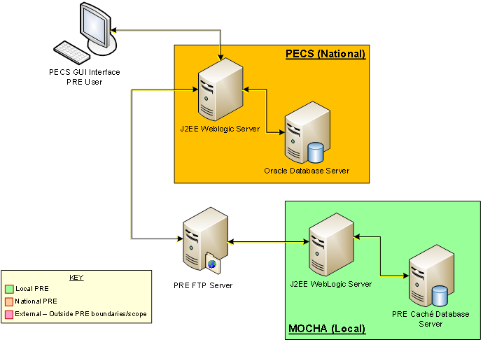

Hardware/Software Components
The Hardware/Software components and deployment architecture of the Pre-Production and Production environments are the same. The PECS Application and database are kept in synchronization for both.
Figure 2: PECS High Level Deployment Design
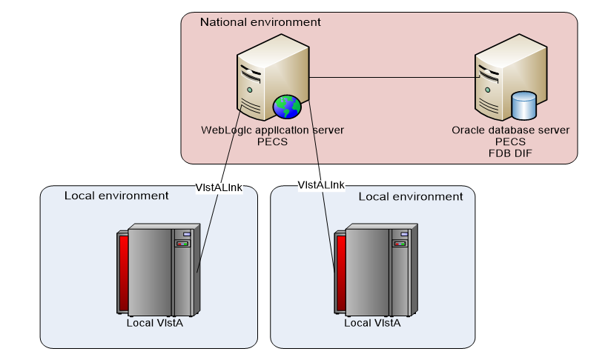

Production Environment
Figure 3 shows the Production environment that will be supported, and the local networks to which they will be attached for Local VA Medical Centers (VAMC), where PECS users are located.

Figure 3: Production Environment for PECS
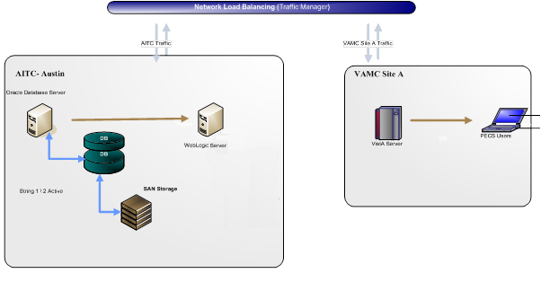

Data Flows

Process Flow
Figure 4 shows the life cycle of a customization change from the Requestor entry to the point the record is ready to be sent to the production FDB Drug Information Framework (DIF) custom table. The updates and changes are made and maintained in a Staging Table. Records are not extracted until the Release Manager submits approved changes. Records are then formatted and placed in a directory where they will be updated to production. The process that updates these records uses software named DATUP.
Figure 4: PECS Customization Life Cycle
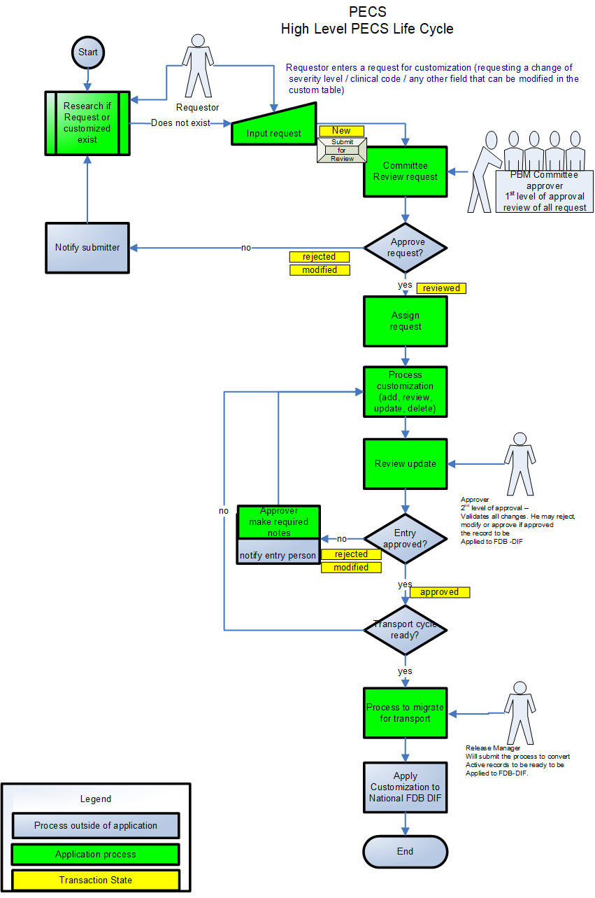

Transaction Flow
Figure 5 depicts the Action Statuses of a record’s transition from creation to approval.
Figure 5: Action Statuses
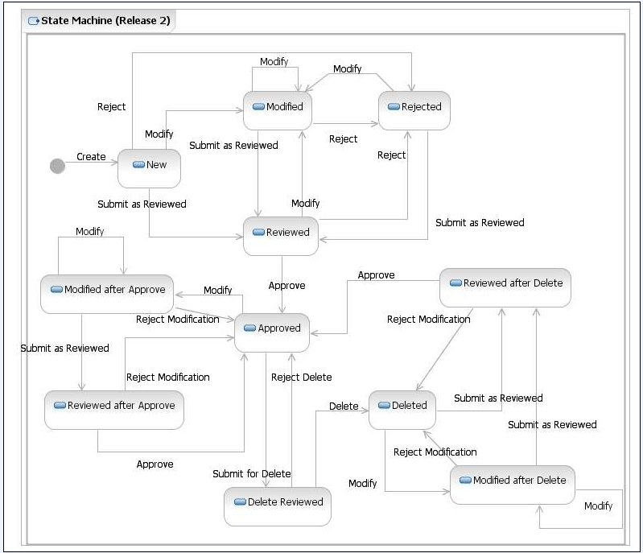
Action Statuses
This list displays the different Action Statuses a VA customized record may go through as it steps through the approval workflow within PECS. Note that only seven of the following eleven states are displayed in the user interface - in other words, some of this information is “behind-the-scenes.” It is included here for informational purposes only.
- New - A new customization request has been created. If a user has the appropriate authority, they may modify the request (Modified) to be completed at a later point. Then, if they have the proper authority, they may submit the request as reviewed (Reviewed).
- Modified - A user can make changes to their own New requests. The record will remain Modified until a user with the proper authority (Approver role) reviews the request and submits the request as Reviewed.
  - Modified After Approve - (displays as Modified) A user with the proper authority has requested a change in the Approved customization that requires another approval process.
  - Modified After Delete - (displays as Modified) A user with the proper authority has requested the deleted record be considered again for Approval with or without modifications. This requires another approval process.
- Reviewed - This is the first stage of approval. A user with the proper authority (Approver role) reviews the new or modified customization request and submits it as Reviewed. The approver may also reject or modify the request. Note that an approver can review their own requests but not approve them.
  - Reviewed After Approve - (displays as Reviewed) Modifications were made to an approved record. A user with the proper authority (Approver role) reviews the request and submits it as Reviewed. The Approver may also reject the request, in which case the record returns to the Approved state, or they may modify it.
  - Reviewed After Delete - (displays as Reviewed) Modifications were made to a deleted record. A user with the proper authority (Approver role) reviews the request and submits it as Reviewed. The Approver may also reject the request, in which case the record returns to Deleted state, or they may modify it.
- Rejected - The customization request is in a Rejected state. At this point the user may make changes, resubmit, or allow the customization to remain in Rejected state. All records that are rejected or not approved will remain in that state and will be available to the user for any future changes.
- Approved - This is the second stage of approval. A user with the proper authority (Approver role) who did not submit the request as Reviewed will review the record and may approve, reject, or modify the request.
- Delete Reviewed - The record remains active but a user with the proper authority (Approver role) has requested deletion of an existing approved customization.
- Deleted - A user in the Approver role who did not submit the request for Deletion may delete the customization. If an Approver confirms the deletion, the record will remain active for potential future modifications.

User Access Levels
The PECS application is accessible only by users signed directly into the VA network, or by users signed into the VA network via approved virtual private network (VPN) software. User authentication into the VA network is a precondition of PECS application access. Application authentication and authorization will be controlled by the VA two factor authentication (2FA) using IAM SSOi. Privileges are granted by PECS Administrators.
In order to log in to the application, each user must have a valid PIV card. At the SSOi login screen, users are prompted to login using their PIV or Windows credentials.

Identity Management
Access to PECS is a two-step process. Authentication is handled through the IAM SSOi service and user role-based authorization is handled within the PECS application. The roles (Requestor, Approver, Release Manager and Administrator) have a set of permissions within PECS that allow them to perform specific tasks. A PECS user can hold multiple roles and would have access to all the functions associated with each role. All VA users have the default Requestor role. The requests for other roles with more privilege must go to the PBM NDF Managers and the roles can be granted through the PECS UI.

Role Assignment
In addition to the PIV authentication, users must be assigned to roles by a PECS Administrator in User Roles. The exception is the Requestor role (the least-privileged access to PECS), which does not require specific assignment by an Administrator. See Update User Roles for additional information.

Role Descriptions for Identify Management
Following is a list of roles available within the application, and a description of what each role can do:
- Requestor: Creates Customization Requests.
- Approver: Creates Customization requests and Reviews and Approves Customization Requests created by other users
- Release Manager: Generates Custom Update Files; Reviews existing Custom Updates.
- Administrator: Grants/Removes User Role privileges; Updates Concepts Settings; Edits content on the Contact us page.

Customization Information
The Customization Information section describes the customizations that can be done through PECS.

Drug-Drug Interaction and Professional Monograph
Figure 6 displays how a Drug-Drug Interaction is tied to Drug Pairs and Professional Monographs: More information on Drug-Drug Interactions, Drug Pairs, and Professional Monographs is provided later in the manual.
Figure 6: Drug-Drug Interaction Relationship
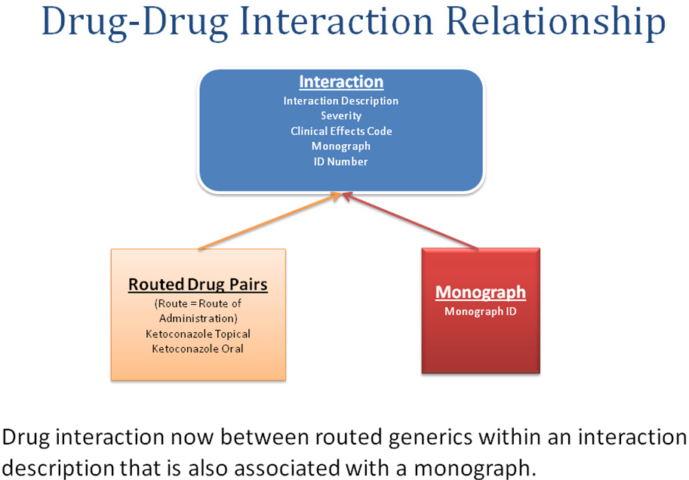
FDB Drug-Drug interaction severity levels:
1 = Contraindicated
2 = Severe
3 = Moderate
9 = Undetermined severity – Alternate therapy
Within the VA system an FDB or VA Custom drug-drug interaction of severity level 1 will return a Critical order check and severity level 2 will return a Significant order check. Severity levels 3 and 9 will not return an order check.
Types of drug-drug interaction customizations include:
- Change in severity level
- Add or remove drug pairs
- Create drug interactions not found in FDB
Note: Due to the millions of possible drug pair combinations, you must be very specific on which two products are involved when reporting problems with the system.

Duplicate Therapy
The Duplicate Therapy concept allows you to specify the maximum number (0, 1, 2, 3, or 4) of duplicate therapy matches that can occur within a therapeutic class without creating an order check. A ‘0’ duplicate allowance means only 1 medication from that therapeutic class can be on the patient profile without getting an order check (zero duplication). If a second drug from that class is added, then the provider gets the order check. If the allowance is ‘1’, two drugs can be on the patient profile at once, the 3rd drug added would get the check (one duplication), etc.
The only type of Duplicate Therapy customization allowed is to increase or lower the duplicate therapy allowance for a therapeutic category.

Dose Range
A Dose Range is the allowable dosage of a drug based on a number of factors such as patient age, weight, and Dose Route. PECS allows you to modify the Dose Ranges included in the FDB-DIF product.
- Dosing is based on the GCN (Generic Code Number) Sequence Number (GCNSEQNO), a number specific to all drug products with the same generic ingredient(s), route of administration, drug strength(s) and dosage form.
- Dosing is age-specific for most products. FDB has dosing for neonatal, infant, adolescent, adult, and geriatric. All ages are by days, for example, 18 years x 365= 6570 days.
- FDB also has indication-specific dosing, and dosing type. Examples of dosing type are loading, maintenance, single, and initial.
- A typical product may have 30 or more dosing records when all variables are taken into consideration.
- The initial implementation of dosing order checks within VistA looks at the maximum single dose and daily dose range order checks using a common indicator.

Getting Started
The Getting Started section provides information that is essential for a user to get started with PECS.

Login
PECS requires the user to login to prevent unauthorized users from accessing the system and to establish identity for their actions within the application. Note that authentication is handled using the IAM SSOi service via PIV authentication. Authorization is handled using a number of roles for users (Requestor, Approver, Release Manager and Administrator) and each role has a set of permissions. All VA users have the default Requestor role. The roles with higher privileges can be granted through the PECS UI by the PBM NDF Managers. To see the list, refer to the Identity Management section.
Figure 7: IAM Single Sign-On Screen
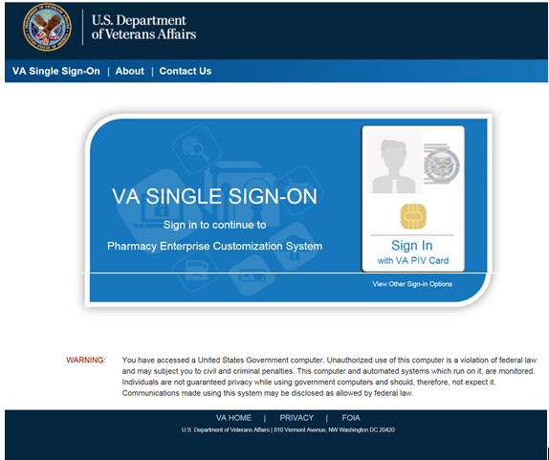

Logging into PECS
To login to PECS:
- On the SSOi Login Screen, choose Sign in using VA PIV Card and enter PIN
Figure 8: PECS Help Window
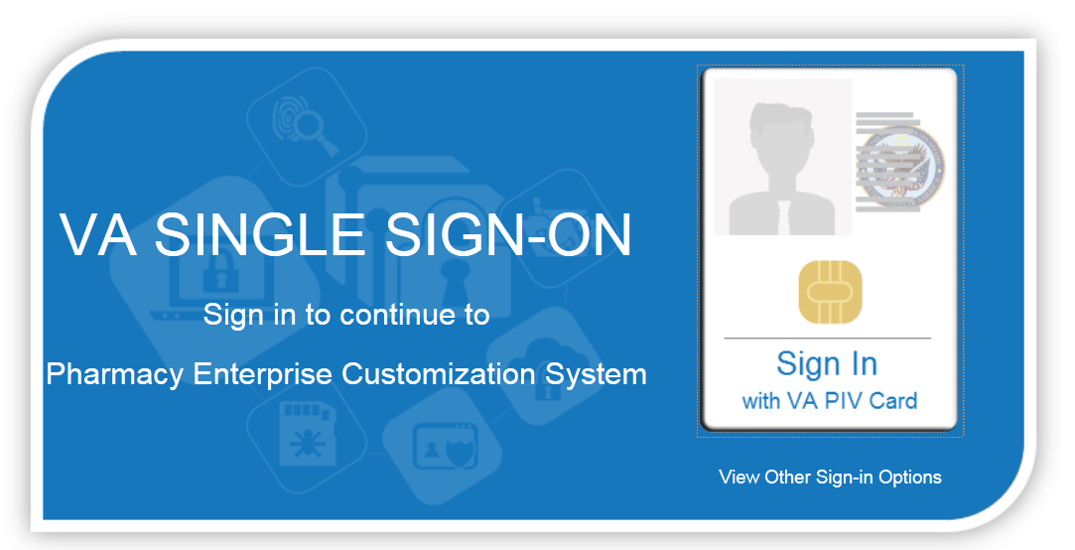
- After entering PIV credentials, PECS displays the Confidentiality Statement. You must agree to this statement to continue. Click Agree.
Figure 9: PECS Help Window
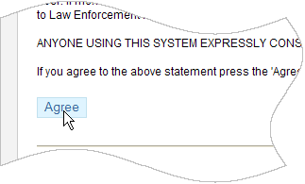

Authentication Explanation
Application authentication is controlled by VA two factor authentication (2FA) with PIV using the IAM SSOi system. On successful login, the system displays the PECS Home page.

Application Organization
PECS is organized into a set of tabs. Only tabs that are relevant to the users role are displayed; for example, a Requestor user will see different tabs than an Approver user.
Figure 10: PECS Tab Groups Displayed
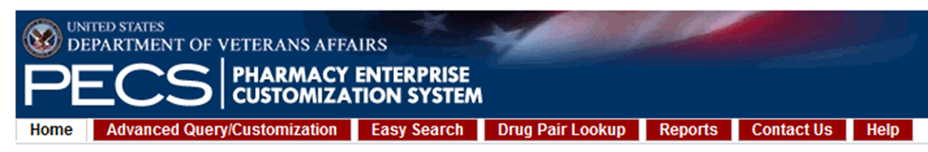
All available tabs in PECS are listed below. Tab availability by user role and function will be discussed in more detail later in the User Guide.
- Home
- Advanced Query / Customization
- Easy Search
- Drug Pair Lookup
- Reports
- Help
- Contact Us
- Custom Updates
- Administration
See PECS by Tab for additional information.

Welcome and Update Information
The Welcome and Update Information section at the top of the Home page displays the current user's account name and the dates of the last FDB-DIF Update and the last Custom Update.
Figure 11: Welcome Text and Update Information
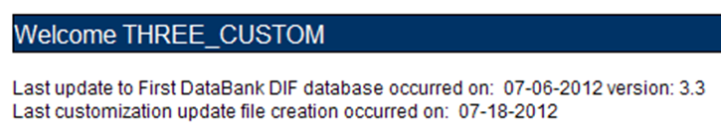
To Those Using Screen-Reading Assistive Technology
The window that displays the PECS tab groups also contains a link at the top, “Go to Main Content.” This link is for screen readers to jump directly to the main content of the selected tab and not read each and every tab every time a tab is selected.
Figure 12: PECS Tab Groups with “Go to Main Content” Link
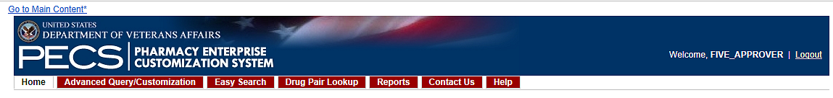

General Page Structure and Navigation
All PECS application pages have certain features that provide information and help navigate the system.
Header
The PECS Header shows the Name of the current user and contains a Logout link for exiting the PECS application.
Tabs
The Tab row is used to access PECS functions.
Content
The tools (such as build a query) or content (such as a customization request) are displayed here.
Footer
The footer contains navigation links; this is a duplicate of the tabs. The application version is also displayed here.

Home Page
The Home Page is the first page that the user sees after logging into PECS, and is organized into panels containing specific information; only panels that are appropriate to the role of the current user are displayed. The Home page provides summary counts of the number of active customization records accessible to the current user. Additionally, it displays when the last update to the First Databank DIF database tables occurred and when the last customization update file was created.

PECS by Tab
Tabs provide the organization for the functions provided by PECS. This section provides an overview of the tabs and their functions. The tabs themselves are explained in more detail later in the user guide.

Home
The Home tab is available to the following type of PECS users:
- Requestor
- Approver
- Release Manager
- Administrator
The PECS Home tab is the first page you see after a successful login, and can be used to return to this page at any time. The appearance of the home tab is role-specific; what appears on the page is different depending on the role associated with your login credentials.
See the Home Page section in Getting Started for additional information, as well as the role-specific home page sections in User Roles and Tasks.
Figure 13: Requestor Home Page
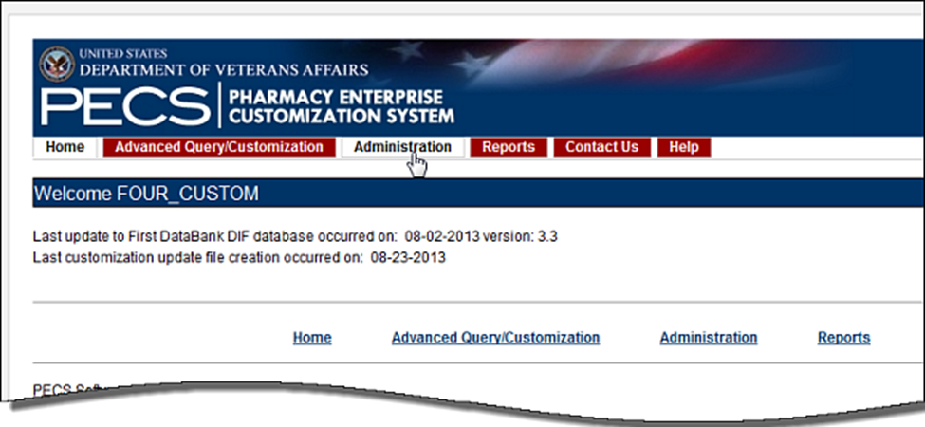

Advanced Query/Customization
The Advanced Query/Customization tab is available to the following type of PECS users:
- Requestor
- Approver
- Release Manager
- Administrator
Searching for records is the one common task for all roles in PECS. It is done from the Advanced Query/Customization tab which is available to all users.
The Query Builder Panel on the Advanced Query/Customization page allows you to retrieve a specified set of records from the VA Custom Tables, the FDB standard tables, or both in order to perform research, make customizations, make customization changes, or export data. You can use it to create a new query, load a query you have previously saved, or load a query saved by another user.
Figure 14: Advanced Query/Customization Window with Sample Data
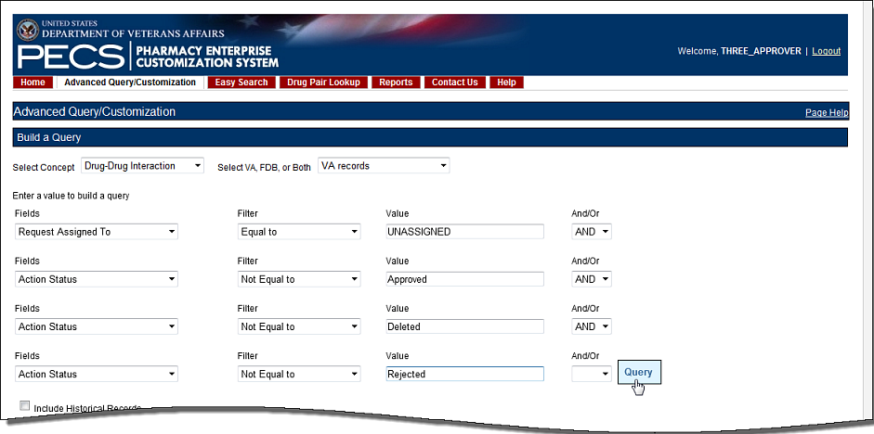
For detailed information on Advanced Query/Customization, see Using Advanced Query/Customization.

Easy Search
The Easy Search tab is available to the following type of PECS users:
- Requestor
- Approver
- Release Manager
- Administrator
Easy Search provides a simple way to display commonly-requested PECS information. Easy Search differs from other methods for finding information in that the results are display-only; the records displayed as a result of an Easy Search query cannot be modified. However, in some cases, a link is provided to an editable version of the resulting records.
Figure 15: Initial Easy Search Window
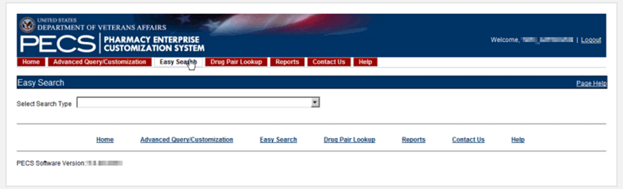
For additional information, see Easy Search for additional information.

Drug Pair Lookup
The Drug Pair Lookup tab is available to the following type of PECS users:
- Requestor
- Approver
- Release Manager
- Administrator
The Drug Pair Lookup tab provides the ability to perform a quick search on the most common elements of a drug pair: Generic Drug Name A, Generic Drug Name B, Interaction, and the Severity Code.
Figure 16: Drug-Drug Pair Lookup Window
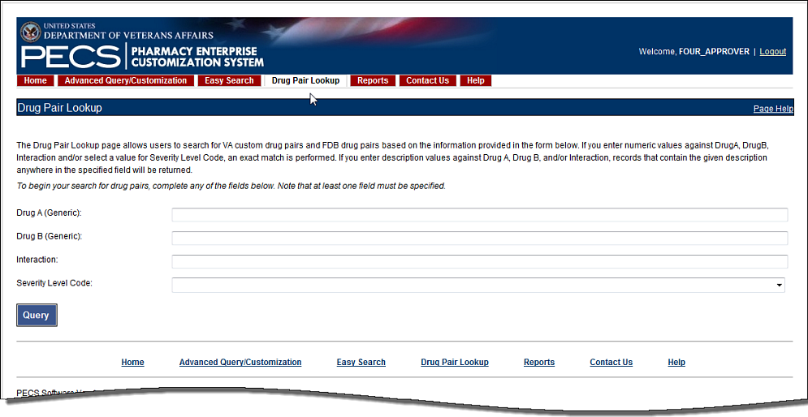
For additional information, see Drug Pair Lookup.

Reports
The Reports tab is available to the following type of PECS users:
- Approver
- Administrator
Note to Assistive Technology Users: Please refer to the documentation included with your screen reader for commands related to reading column and row headers.
The Reports tab displays a list of available reports in PECS.
Figure 17: List of Reports
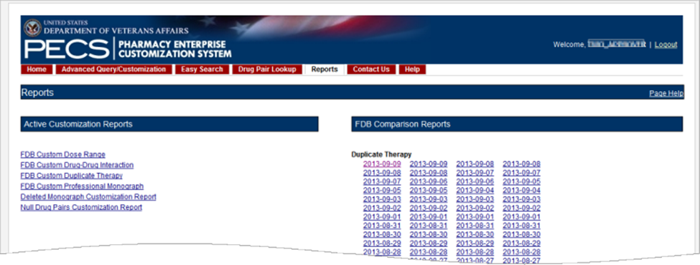
There are two types of Reports:
- Active Customization Reports
- FDB Comparison Reports
Reports are generated in the form of Excel spreadsheets. To run a Report, click the associated link. For additional information, see Reports.

Contact Us
The Contact Us tab is available to the following type of PECS users:
- Requestor
- Approver
- Release Manager
- Administrator
The Contact Us page contains a list of PECS Project Contacts should you need additional information about the PECS product. The content of the Contact Us page is decided by users with the Administrator role. Contact Us may include links that allow you to send that person (or group) an email.
Note: Clicking the link opens your mail application and a new email message to the person specified in the properties of the link. This may produce a warning message. This is normal.
Figure 18: Example of Contact Us Data
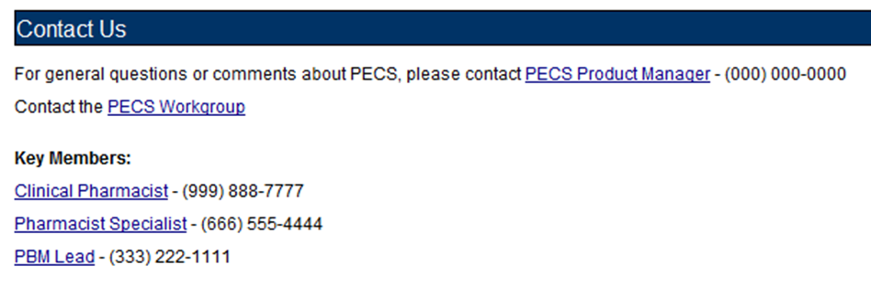
Note that the above example is only an example – it can be changed to display just about anything.
See Contact Us for additional information.

Custom Updates
The Custom Updates tab is available to the following type of PECS users:
- Release Manager
The Custom Updates tab is seen and used by a Release Manager to generate a zip file containing files for each Order Check in the FDB update file format. Both update files are created by clicking the "Create New Update" button.
Figure 19: Custom Updates Tab for Release Manager
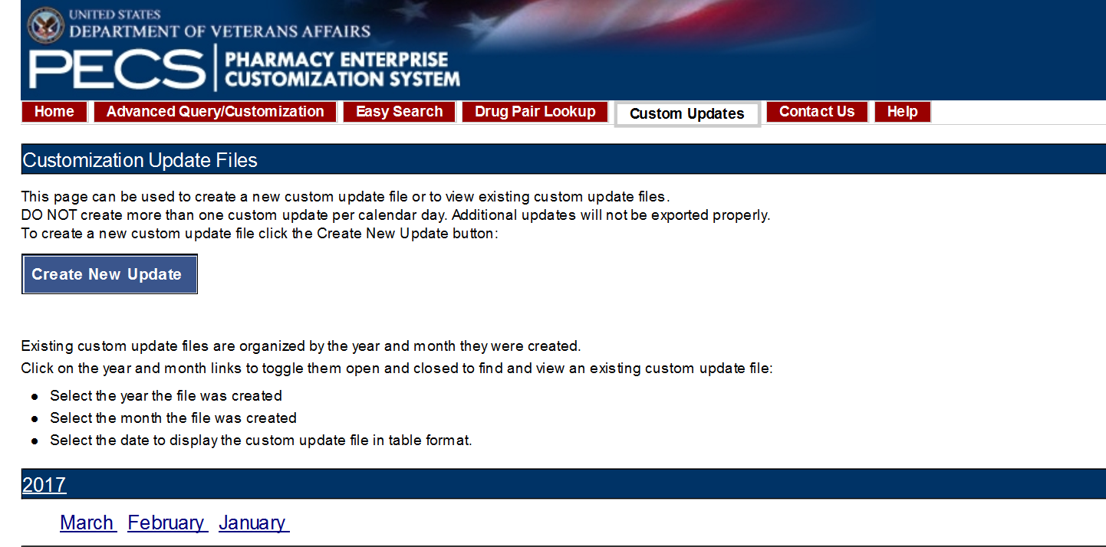

Administration
The Administration tab is available to the following type of PECS users:
- Administrator
The Administration tab is used only by PECS users with Administrator privileges to perform specialized tasks such as modifying certain aspects of the PECS environment, adding or deleting Approver users, and removing Null Drug Pairs.
Figure 20: Administrator's Home Page
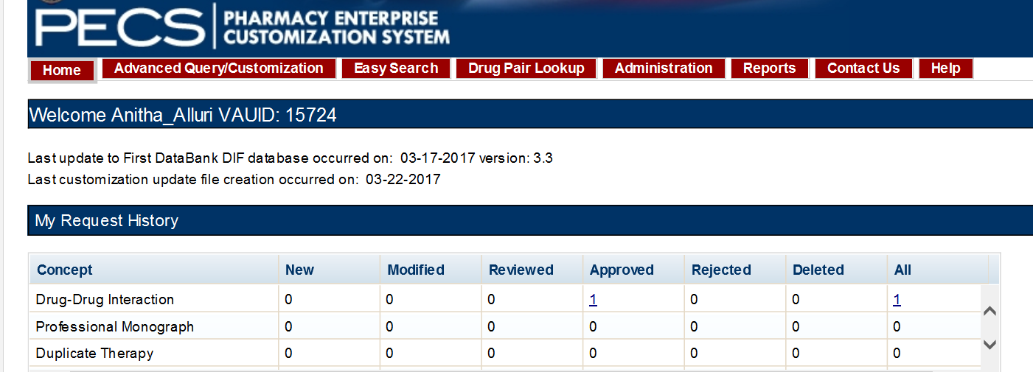
See Administrator for additional information.

Help
The Help tab is available to the following type of PECS users:
- Requestor
- Approver
- Release Manager
- Administrator
The Help tab launches the PECS Online Help System and displays the "front page" of the Help System. To get context-sensitive help, click the Page Help link on the page you need help with.
Figure 21: PECS Help Window
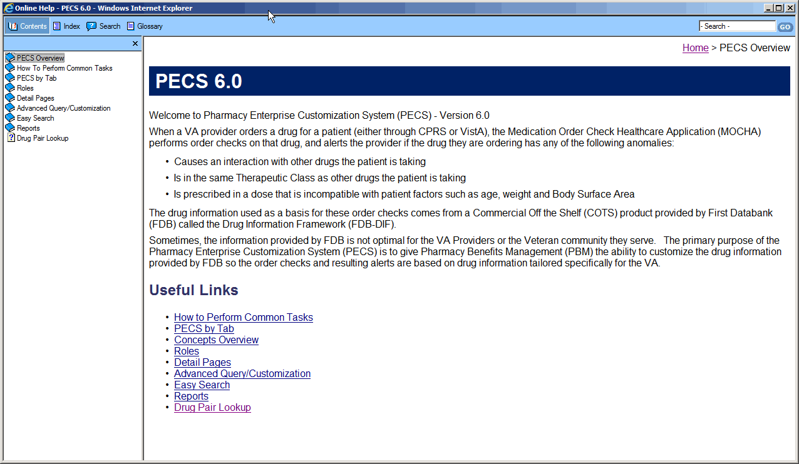
See Online Help for additional information.

Using Advanced Query/Customization
Searching for records is a task common to all PECS roles. Advanced Query/Customization is the most comprehensive way to find PECS records. Advanced Query/Customization can be used to find both VA customizations and FDB records so that they can then be customized.

Accessing the Advanced Query/Customization Page
Use the Query Builder (Build a Query) Panel on the Advanced Query/Customization page to retrieve a specified set of records from either the VA Custom Tables, the FDB standard tables, or both. This allows you to perform research, make customizations, change existing customization, or export data. In the Query Builder Pane, you can create new queries or load previously-saved queries (either yours or a query saved by another user).
There are three ways to display the Advanced Query/Customization page:
- Click the Advanced Query/Customization tab on the navigation bar near the top of the page. This will open a blank query:
Figure 22: Advanced Query/Customization Tab
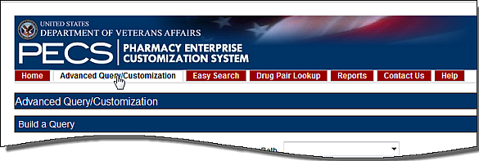
- Click the Advanced Query/Customization link on the footer near the bottom of the page. This will open a blank query:
Figure 23: Advanced Query/Customization Footer Link
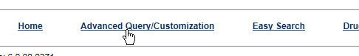
- Click a link from one of the summary tables displayed on the Home tab. This will generate a query appropriate to the context of the link that was clicked. In the example below, a query displaying criteria to display the unassigned Drug-Drug Interaction records will be produced.
Figure 24: PECS Help Window
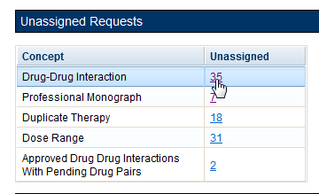

Build a Query Panel
To build a new query first select a Concept (type of record) and the source for the record you want to find. The concepts are Drug-Drug Interaction, Drug Pair, Professional Monograph, Duplicate Therapy, and Dose Range.
Figure 25: Advanced Query/Customization Build a Query Panel – New Query
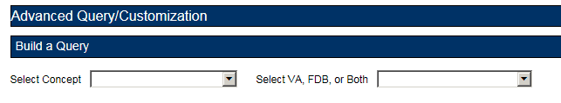
After selecting values for the Select Concept and Select VA, FDB, or Both fields, additional fields display, through which you can create your Query.
Table 2: Build a Query Panel Fields
Field Name | Definition
Fields | Select the field you want to query from the Fields list. The available fields are specific to the selected Concept.
Filter | Select a filter for the field from the Filter list (Contains, Equal To, etc.) See Query Filters for additional information.
Value | Enter search criteria in the Value field. Appropriate values are dictated by what was selected from the Fields list.
And/Or | Use the And/Or field to create complex queries by adding additional search criteria. If the query must meet multiple criteria, use AND; if a value from a list of criteria is acceptable, use OR. AND and OR can be combined when building the query. See And/Or Usage Example for additional information.
Query button | Click Query to run the query you have built or loaded
Add Default DRC Query button | Dose Range Queries Only: Adds two standard criteria (Concept Type = '6' and AGEHIGHINDAYS >= '6570) to the query. You should enter your specific criteria before clicking Add Default DRC Query.
'Include Historical Records' checkbox | Select Include Historical Records to include inactive historical records in the Query results. Historical records can only be viewed not modified. A Historical Record is any previous version of a record.
'Clear Query' button | Click Clear Query to delete the current query; only the Concept Type and record source will remain.
'Query Name' | Enter a name for the current query if you want to save it. The name should be as descriptive as possible so that you (and other users) will understand what results the query will produce.
'Save Query' button | Click Save Query to save the current query for later use. If the Query Name field is blank, this button is inactive.

Create a Query
To create a query:
- On the Advanced Query/Customization tab, select a Concept.
Figure 26: Build a Query Concept Field
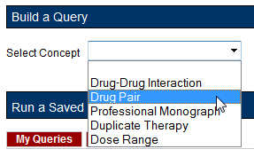
- Select the data you want to view – VA, FDB, or Both.
Figure 27: Query Data Field
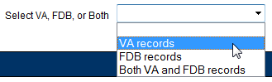
- In the "Enter a value to build a query" area, select the Field you want to use as a query criteria. The available field options will be determined by the Concept you selected earlier.
Figure 28: Query Criteria Field Selection
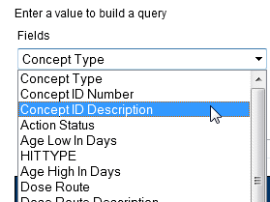
- Select the Filter you want to impose on the Field. See Query Filters for additional information.
Figure 29: Query Filter Field
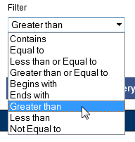
- Enter a Value to use as your query criteria. The Value must be appropriate for the selected Field and Filter or an error message is displayed in the Results panel. See Query Specifics for additional information.
Figure 30: Query Value Field
- To add additional criteria to the query, make a selection from the And/Or list.
Figure 31: Query And/Or Option
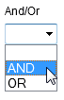
  - AND indicates the results must match the new criteria and all the AND-connected criteria above it.
  - OR indicates that the results must match either the new criteria or the AND-connected criteria above it. See And/Or Usage Example for additional information.
- To include Historical Records in the query, select the Include Historical Records check box.
- When all criteria have been added select the Query button. The results will display in the Results panel appropriate to the query being performed (VA or FDB).
- To see details of the record follow the link in the Select column. The links are either Active (current VA record), Historical (old version of an active VA record), or Open (FDB record).
Figure 32: Query Record Links for Details
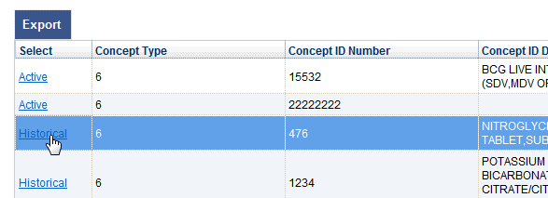

Query Filters
The Advanced Query/Customization query function provides Filters that allow you to control what data is returned by the query. The filters are:
Table 3: Query Filters
Filter Name | Filter Function
Contains | The contents of the Value field appears somewhere in the database row of the Field being queried. Used primarily for fields containing text data. Contains is the default Filter option. Contains = “25” would match 25, 125, and 250, but not 205.
Equal To | The contents of the Value field exactly matches the contents of the database row of the Field being queried. “Equal To” = “25” would match 25, but not 125, 250, or 205.
Less than or Equal to | The contents of the Value field is less than or equal to the contents of the database row of the Field being queried.
Greater than or Equal to | The contents of the Value field is greater than or equal to the contents of the database row of the Field being queried.
Begins with | The contents of the database row of the Field being queried starts with the contents of the Value field.
Ends with | The contents of the database row of the Field being queried ends with the contents of the Value field.
Greater than | The contents of the Value field is greater than the contents database row of the Field being queried.
Less than | The contents of the Value field is less than the contents database row of the Field being queried.
Not equal to | The contents of the Value field does not exactly match the contents of the database row of the Field being queried.

And/Or Usage Examples
To see approved records with an interaction description equal to "anti" or "Lido", build the query as follows:
Table 4: And/Or Example 1
Field | Filter | Value | And/Or
Interaction description | Equals | anti | And
Status | Equals | approved | Or
Interaction description | Equals | Lido | And
Status | Equals | approved
If you build the query below, you will get approved records with an interaction description = "anti", but you will get all records with an interaction description of "Lido", regardless of status.
Table 5: And/Or Example 2
Field | Filter | Value | And/Or
Interaction description | Equals | anti | And
Status | Equals | approved | Or
Interaction description | Equals | Lido

Query Specifics
- Use the YYYY-MM-DD date format for searching date fields within a query
- Date values can only use the following filters
  - Equal to
  - Less than or Equal to
  - Greater than or Equal to
  - Greater than
  - Less than
If a value that is not appropriate for the selected Field and Filter, then an error message is displayed in the Results panel.
Figure 33: Bad Query Value Error Message

Add Default DRC Query
Queries on the Dose Range Concept (DRC) provide a special button that automatically adds predefined query criteria relevant to Dose Range records. These criteria can be used alone or in conjunction with other criteria you provide.
The predefined fields added when using the Add Default DRC Query button are:
- Concept type = 6
- AGEHIGHINDAYS >= (greater than or equal to) 6570 (18 years old)
To add these criteria to your query, click the Add Default DRC Query button.
Figure 34: Default Dose Range Query Window, with Default Dose Range Query
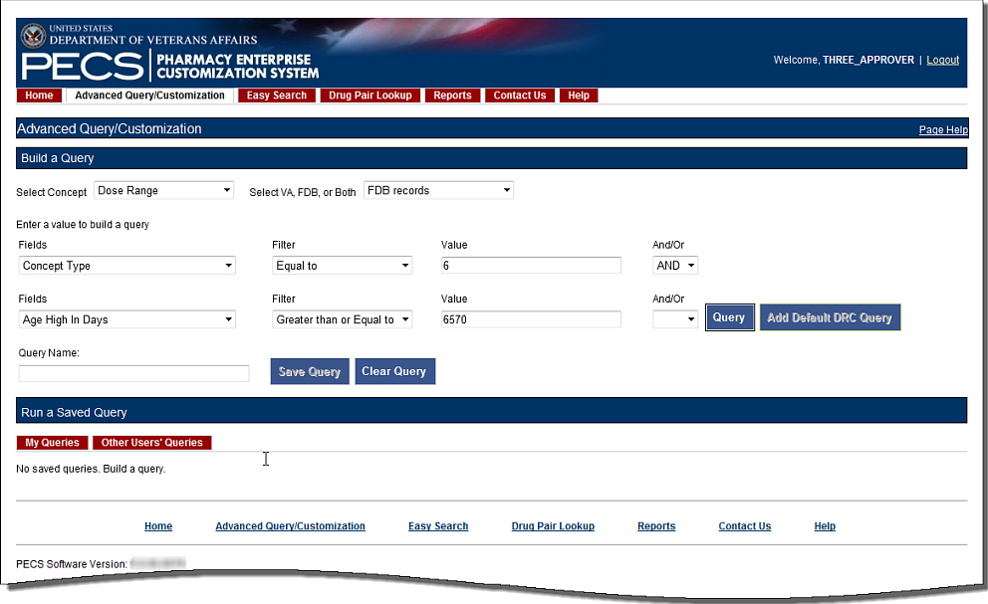
Figure 35: Results from Building a Dose Range Query with Default DRC Query
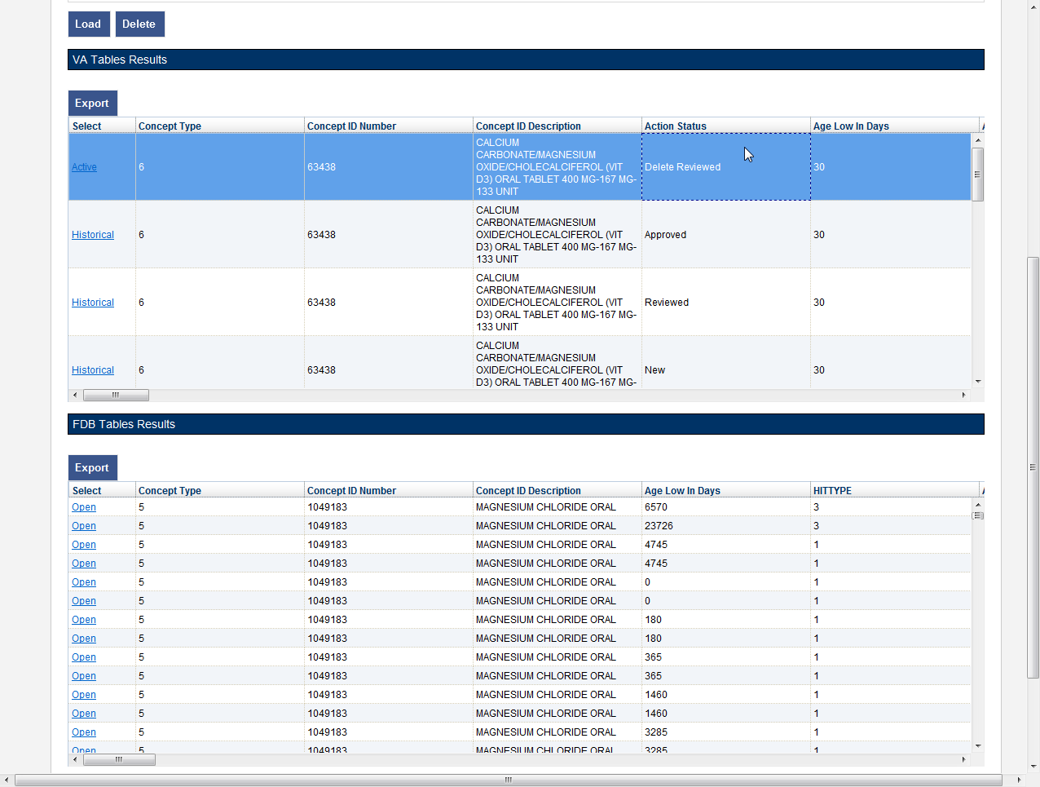

Save a Query
PECS allows you to save a complete query so that you and other PECS users can run a specific query without having to re-build it every time.
Note: The state of the Historical Records check box will not be saved with the query; if desired, it must be re-selected after the query is loaded at run-time.
To save a query:
- Create and run a query in the Build a Query panel. See Build a Query Panel for additional information.
- Enter a name for the query in the Query Name field. The name must contain at least five characters and cannot be longer than 64 characters.
- Click Save Query.

Run a Saved Query
PECS allows you to run a previously saved query with the same Concept and content (VA, FDB, or Both). There are two types of saved queries: My Queries (those that you have saved) or Other Users’ Queries (queries saved by other PECS users).
To run a saved query:
- On the Advanced Query/Customization tab, select a Concept.
- Select what data you want to view: VA, FDB, or Both.
- In the Run a Saved Query sub-panel, select either My Queries or Other Users’ Queries, then select the query you want to run.
- Select the Load button. This will add the components of the saved query to the Build a Query panel.
Figure 36: Running a Saved Query
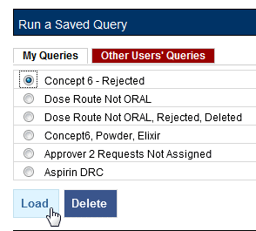
- Select the Query button to run the query. You may also select additional criteria to alter or enhance the saved query.

Rename a Saved Query
A saved query can be renamed by loading it then adding a different name in the Query Name field.
To rename a saved query:
- On the Advanced Query/Customization tab, select a Concept.
- Select what data you want to view-- VA, FDB, or Both.
- In the Run a Saved Query sub-panel, select My Queries, then select the query to be renamed; a saved query created by another user cannot be renamed.
- Enter a new name into the Query Name field.
- Select Save Query. The new query name will appear in the My Queries list in place of the original query.

Delete a Saved Query
You can delete queries you have created and saved. Note that the delete operation is immediate; you will not be warned that the query is about to be deleted and there is no undo option.
To delete a Saved Query:
- On the Advanced Query/Customization tab, select a Concept.
- Select what data you want to view-- VA, FDB, or Both.
- In the Run a Saved Query sub-panel, select My Queries, then select the query to be deleted; a query created by another user cannot be deleted.
- Select the Delete button to delete the query.

Query Results
The results of the query will appear in either one or two panels: VA Table Results or FDB Table Results, depending on the type of records being queried. The results can be re-ordered, sorted by specific criteria, and exported.
Figure 37: Example Query Results
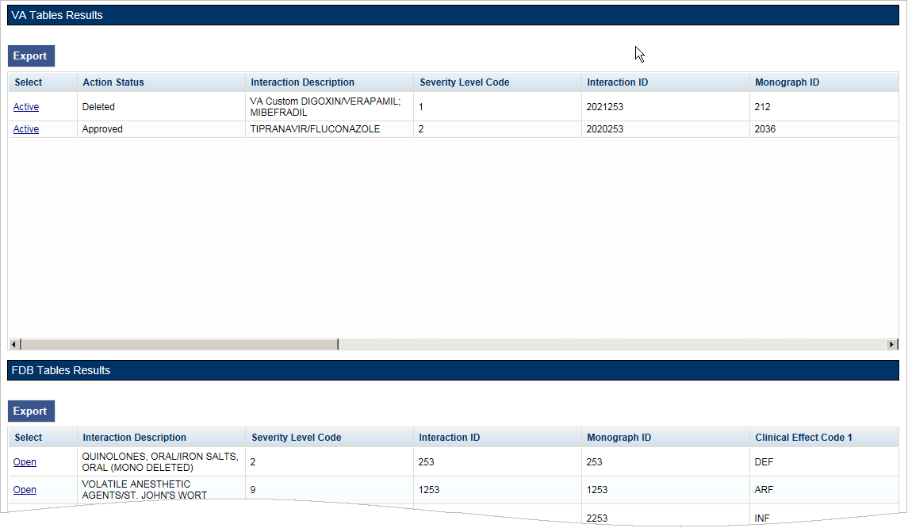

Sort Query Results
You can change the sort order of results of your query by clicking on the column headings in the display grid. Clicking once will display the records in ascending order (A to Z, 1-2-3 etc.) based on the contents of the column of the header selected; clicking a second time display the records in descending order (Z to A, 3-2-1, etc.). A small arrow indicates the direction of the current sort and the primary sort field.
Figure 38: Sort Direction Indicator
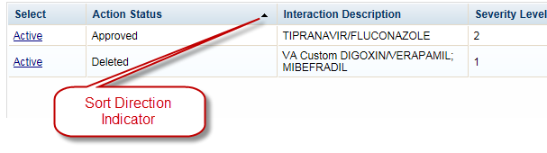
For VA records, the default sort order is by ‘Action Date’, from newest to oldest. This puts the VA Customizations that have been updated most recently at the top of the returned list. By default, FDB records are displayed in the order they appeared in the update file sent by FDB. However, they can be re-sorted by clicking a column header.
Note: Due to technical database restrictions, not all fields can be used to determine the sort order. For example, Concept ID Description on a Dose Range query cannot be used to sort the query results. Clicking these columns will have no result and the current sort order will be retained

Re-Order Results Columns
You can also move the columns in these tables and compare different fields side-by-side. Click the heading and drag and drop it:
Figure 39: Dragging a Column to a New Position
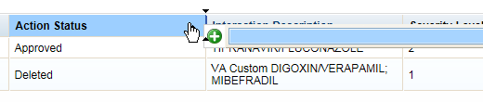
Figure 40: Re-positioned "Severity Level Code" Column
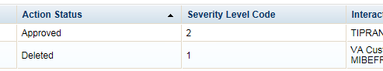

Export Query Results
You can export query results for both VA and FDB records to an Excel spreadsheet.
To export the query results:
- On the appropriate query results panel, select the Export button.
Figure 41: Exporting Query Button
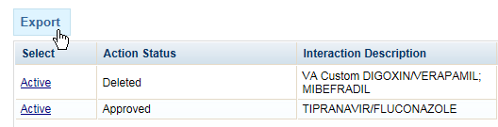
- Select one of the following options from the dialog box:
  - Open
  - Save
  - Cancel
- Select Open to display the exported data in the spreadsheet; select Save to save a copy of the report to your system, or Cancel to abandon the export operation.
Figure 42: Options Dialog Box for Exported Results
- The spreadsheet contains two tabs:
- The [Name of Concept] tab (either VA or FDB) displays the results of the query.
Figure 43: Exported Query Reporting Fields in the Excel Spreadsheet
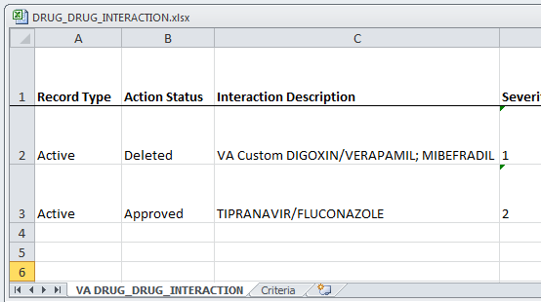
- The Criteria tab displays the criteria used in the query.
Figure 44: Query Criteria Tab in the Exported Excel Spreadsheet
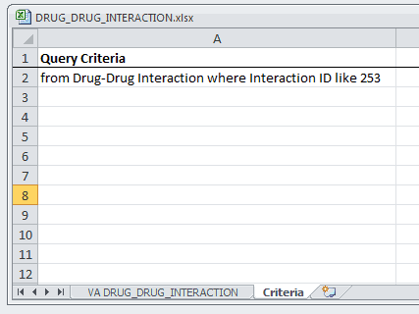
For Drug-Drug Interaction, Drug Pair, Professional Monograph, and Duplicate Therapy records, there is a 1,000,000 line limit for exporting to the spreadsheet; for Dose Range records, the limit is 100,000. If the query returned more than the allowable number of records and the records were submitted for export anyway, the Criteria tab on the report will give the following message: “The number of rows returned in the search (XXXXXX) is greater than the maximum number of rows that can be exported (YYYYYY).”
Figure 45: Export Query Line Limit Message
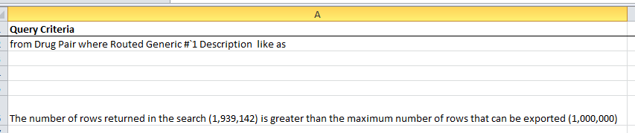

Query Errors
After running a query an error message may appear in the Results panel. This is usually caused by one of the following:
Figure 46: Generic Query Error

Database Timeout (Too Many Results)
The database may timeout if the query produces too many results. If this error happens frequently, try re-writing the queries to be more specific, or add additional criteria that will limit the results when possible.

Inappropriate Value
Entering a value that is not appropriate for the selected Field and Filter will also produce an error message in the Results panel. For example Export Date > “Z” produces an error because “Z” is not a date value.

Working with Customization Requests
As suggested by the name of the application (Pharmacy Enterprise Customization System), customizations are the primary focus of PECS. The process of creating a customization may involve many steps, but the process is relatively simple. In its simplest, “happy path” form, the workflow consists of three steps:
- Customization is Requested
- Request is Reviewed
- Request is Approved

Create a Customization Request
The process for creating a customization request varies with the concept type you are customizing. Customization requests can be made by either Requestor or Approver users.

Customize a Drug-Drug Interaction Record
Customizing a Drug-Drug Interaction record is more complicated than other record types in that Drug Pairs associated with the record must also be selected and customized.
To customize a Drug-Drug Interaction record:
- Find the Drug-Drug Interaction record to be customized in the FDB database using Advanced Query/Customization. See Using Advanced Query/Customization for additional information.
- Select the Open link next to the record to be customized.
- Select the Edit button.
- Make changes to the record. At minimum, text must be added into the Current Action Reason field.
- Select Customize. The system will confirm that the customization request has been entered and will be reviewed, that the Drug Pairs have not been approved, or that no Drug Pairs have been associated.
- Select the Drug Pairs button.
- Associate one or more drug pairs with the customized Drug-Drug Interaction. See Drug Pair Customization (Non 508-Compliant) Detail for additional information.
- All the components are now in place for the Drug-Drug Interaction record for review and approval.

Customize Other Record Types
Customizing Professional Monograph, Duplicate Therapy, and Dose Range records is relatively straight-forward; there are no associated records (as in Drug-Drug Interactions) that must be modified or selected.
To customize a Professional Monograph, Duplicate Therapy, or Dose Range record:
- Find the record to be customized in the FDB database using Advanced Query/Customization. See Using Advanced Query/Customization for additional information.
- Select the Open link next to the record to be customized.
- Select the Edit button.
- Make changes to the record. At minimum, text must be added into the Current Action Reason field.
- Select Customize. The system will confirm that the customization request has been entered and will be reviewed.

Create Customization from a Blank Form
To create a new record use the Open Blank Form button. This method can be used to create new Drug-Drug Interaction, Professional Monograph, and Dose Range records. It cannot be used to create a Duplicate Therapy record.
Figure 47: Open Blank Form Button
To Create a New Record:
- Perform an Advanced Query/Customization Query for the record type (Concept) on both VA and FDB Records you want to create.
- Select the Open Blank Form button at the bottom of the page.
- Complete the form with as much information as possible. Fields marked as Required must be completed before the record can be saved. Some record types (concepts) have other requirements that must be met before the record can be created. See New Record Requirements by Concept Type for additional information.
New Record Requirements by Concept Type
Some records have specific requirements for new records that are not indicated by the Required label.
Drug-Drug Interaction
For a completely new record, the interacting drugs must be separated by a forward slash (/) character.
Professional Monograph
Custom Professional Monographs can be associated with Drug-Drug Interactions once they are Approved.
Dose Range
The Concept Type can only be 6 and the Concept ID Number must correspond to an existing FDB record for Concept Type 6.
Duplicate Therapy
New Duplicate Therapy records cannot be created using this method. A new Duplicate Therapy customization must be made on the Advanced Query/Customization page.
Drug Pairs
New Drug Pair records cannot be created using this method. A new Drug Pair can be added by selecting routed generic drugs associated with a drug-drug interaction.

Modify Customization Requests
Customization requests can be modified at any time. If a required field is changed (other than Current Action Reason), the customization Action Status will change to Modified; non-required fields do not affect Action Status. Requestors can modify customizations they have requested, but cannot modify customizations requested by other users. Approvers can modify any record at any time. Release Managers and Administrator cannot modify customization requests.
Note: Although the Edit button will appear on customization requests for Release Managers and Administrators (and for Requestors viewing requests other than their own), there is no way to save any changes made.
The links on the Home page can be used to locate records for processing. See the User Roles and Tasks and/or Home Page sections for additional information.
To modify a customization request:
Note: See Section 7.7. Record Locking Feature for images and descriptions of the pop-up windows that may be encountered throughout the process of working with Customization Requests.
- Select the Advanced Query/Customization tab.
- Select a Concept to build a Query search using a VA record or FDB record (or both).
- Select/enter a Field, Filter, and Value.
- Run a Query search. The results table will be displayed.
- Select the Active link associated with the record to be modified.
- Select the Edit button.
- Make changes to the record. At minimum, text must be added into the Current Action Reason field.
- Select Modify to save the changes. Select Cancel Edit to abandon the changes and return to the detail page.

Review Customization Requests
Review is the second step to getting a customization Approved. A Review must be performed by an Approver. Approvers cannot Review customization requests they have created and cannot Approve customization requests they have Reviewed.
The links on the Home page can be used to locate records for processing. See the User Roles and Tasks and/or Home Page sections for additional information.
To Review a customization request:
Note: See Section 7.7. Record Locking Feature for images and descriptions of the pop-up windows that may be encountered throughout the process of working with Customization Requests.
- Select the Advanced Query/Customization tab.
- Select a Concept to build a Query search using a VA record or FDB record (or both).
- Select/enter a Field, Filter, and Value.
- Run a Query search. The results table will be displayed.
- Select the Active link associated with the record to be reviewed.
- Select the Edit button.
- Review the customization request to be approved.
- Select Submit as Reviewed to save the changes. Select Cancel Edit to abandon the review and return to the detail page.

Approve Customization Requests
An Approved customization request is considered valid and should be used in making decisions in veteran pharmaceutical care. Approved customization requests are included in the Custom Updates that are distributed to other pharmacy applications, and are used in Order Checks for veteran prescriptions.
Customization requests are Approved by Approvers. Approvers cannot Approve customization requests they Reviewed; they can Approve customization requests they created once they have been Reviewed by another Approver.
The links on the Home page can be used to locate records for processing. See the User Roles and Tasks and/or Home Page sections for additional information.
To Approve a customization request:
Note: See Section 7.7. Record Locking Feature for images and descriptions of the pop-up windows that may be encountered throughout the process of working with Customization Requests.
- Select the Advanced Query/Customization tab.
- Select a Concept to build a Query search using a VA record or FDB record (or both).
- Select/enter a Field, Filter, and Value.
- Run a Query search. The results table will be displayed.
- Select the Active link associated with the record to be approved.
- Select the Edit button.
- Review the customization request to be approved.
- Select Approve to save the changes. Select Cancel Edit to abandon the changes and return to the detail page.

Reject Customization Requests
Customization requests can be Rejected at all points of the Create/Review/Approve process. Customization requests are Rejected because they are thought to be invalid as written by either the Reviewer or Approver. Customization requests can also be Rejected by the user who initiated the customization request if they determine that request is no longer needed. Rejected customization requests can be modified and re-submitted for Review and Approval.
The links on the Home page can be used to locate records for processing. See the User Roles and Tasks and/or Home Page sections for additional information.
To Reject a customization request:
Note: See Section 7.7.Record Locking Feature for images and descriptions of the pop-up windows that may be encountered throughout the process of working with Customization Requests.
- Select the Advanced Query/Customization tab.
- Select a Concept to build a Query search using a VA record or FDB record (or both).
- Select/enter a Field, Filter, and Value.
- Run a Query search. The results table will be displayed.
- Select the Active link associated with the record to be rejected.
- Select the Edit button.
- Review the customization request to be certain it is invalid and cannot continue in the Review/Approval process without modification.
- Select Reject to save the changes. Select Cancel Edit to abandon the Reject process and return to the detail page.

Delete Customization Requests
If an Approved customization is no longer valid, and should not be used in Order Check decisions, it must be deleted. Deleting a customization request will not remove it from the PECS system, but will remove it from MOCHA during the next Custom Update. Deleted records can be edited and re-submitted for Review and Approval.
Deleting an Approved customization request is a two-step process. One user with Approver privileges must request that the record be deleted, and then a second user with Approver privileges must delete the record. At any time during this process, prior to actual deletion, the deletion request can be Rejected.
The links on the Home page can be used to locate records for processing. See the User Roles and Tasks and/or Home Page sections for additional information.
To Delete a Customization Request:
Note: See Section 7.7.Record Locking Feature for images and descriptions of the pop-up windows that may be encountered throughout the process of working with Customization Requests.
- Select the Advanced Query/Customization tab.
- Select a Concept to build a Query search using a VA record or FDB record (or both).
- Select/enter a Field, Filter, and Value.
- Run a Query search. The results table will be displayed.
- Select the Active link associated with the record to be deleted.
- Select the Edit button.
- Review the content. Once satisfied that the customization request should be deleted write a brief explanation in the Current Action Reason field.
- Select the Submit for Delete button.
- A confirmation pop-up will appear. To continue the deletion process, select OK. This will change the Action Status to Delete Reviewed. Select Cancel to return to Edit mode.
Now another Approver can confirm the Delete Reviewed customization request for deletion, and complete the process.
To confirm a Delete Reviewed customization request for deletion:
- Find the record to be deleted using Advanced Query/Customization or from the PECS Home page (in My Requests for Deletion).
- Select the active link associated with the record to be deleted.
- Select Edit.
- Enter a comment for agreeing with the Request for Deletion.
- Select Delete.
- A confirmation pop-up will appear. To continue the deletion process, select OK. This will change the Action Status to Deleted. Select Cancel to return to Edit mode.

Record Locking Feature

Record in Use
Records from all five concept types (Drug-Drug Interaction, Drug Pairs, Professional Monograph, Dose Range, and Duplicate Therapy) can be edited only by a single user at a time. If more than one user attempts to edit the same record at the same time, then the user who entered the record first will have precedence and the subsequent users will receive a message that the record is in-use and cannot be edited at the current time.
Figure 48: Record in Use
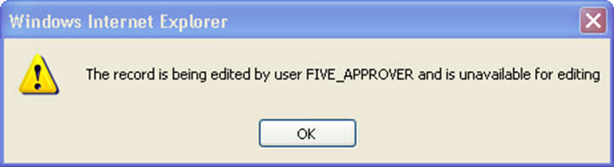

Record Recently Modified
If an opened record has been modified by another user while in use, then PECS will send an alert message warning that the record has been modified and is no longer current. Select OK to load the modified record.
Figure 49: Record Recently Modified
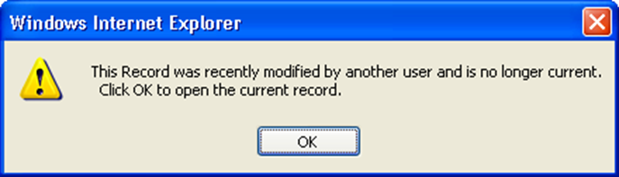

Record Time-Out Lock
To prevent the record from being locked for an extended amount of time the lock will be automatically removed if no edits are made in two consecutive minutes. Select OK to continue editing the record.
Figure 50: Editing Time-Out Warning
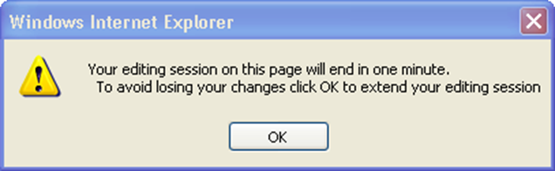

Record Navigation
If a user navigates away from an un-saved record, then a warning dialog box will appear. Select Cancel to continue editing the page or Select OK to return to the read-only display.
Figure 51: Navigation Causing Loss of Changes Warning
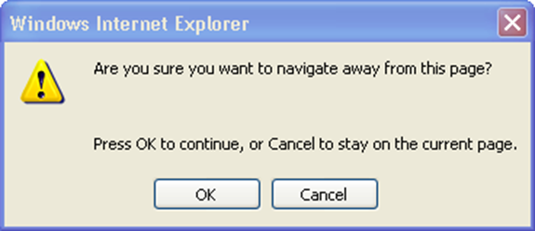

User Roles and Tasks
PECS users have one of four roles within the application, each with specific tasks they perform.
- Requestor
- Approver
- Release Manager
- Administrator

Requestor
The primary task of a PECS Requestor is to create customization requests. The Requestor has limited privileges. They can only view and modify the customization requests that they created. The Requestor Home Page reflects this limited privilege.
A Requestor performs the following tasks related to customization requests:
- Create a Customization Request
- Modify Customization Requests

Requestor Home Page
The Home Page for the Requestor role only displays links to the customization requests made by the current user.
Figure 52: Requestor’s Home Page
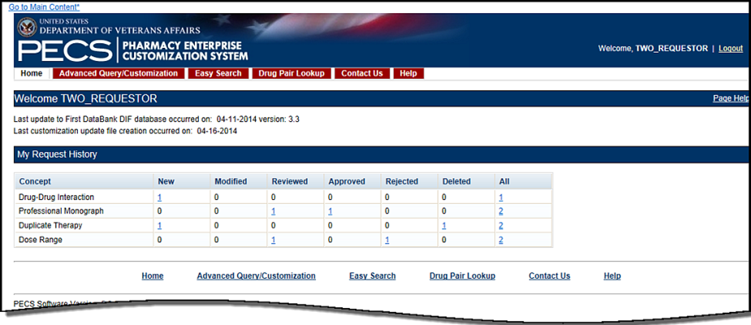
The following information is displayed on the Requestor Home tab:
- My Request History

My Request History: Requestor
My Request History displays customization requests created by the current user. The results are displayed by Action Status of the requests.
Figure 53: My Request History
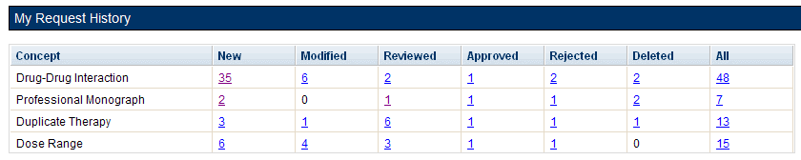
The following table defines the columns found on the My Request History window.
Table 6: My Request History Columns
Column Name | Column Definition
New | The number of active records in the "New" status created by the current user.
Modified | The number of active records in the "Modified" status created by the current user.
Reviewed | The number of active records in the "Reviewed" and "Delete Reviewed" status created by the current user.
Approved | The number of active records in the "Approved" status created by the current user.
Rejected | The number of active records in the "Rejected" status created by the current user.
Deleted | The number of active records in the "Deleted" status created by the current user.
All | The number of all active records in any status, created by the current user.
Following the links within the summary table opens pre-defined queries to provide details of the requests. For example, clicking the New - Professional Monograph link will display a query with the appropriate criteria and the query results: Concept = Professional Monograph, Request Submitted By = <current user>, Action Status = New.
Figure 54: Home Tab Summary - Pre-Defined Query
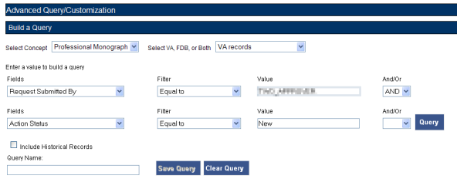
Figure 55: Query Results
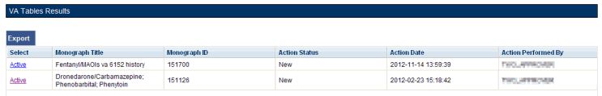

Additional Tools Available to Requestors
In addition to the Home tab, Requestors see the following tabs on their Home page:
- Advanced Query/Customization – See Using Advanced Query/Customization for additional information.
- Easy Search – see Easy Search for additional information.
- Drug Pair Lookup – see Drug Pair Lookup for additional information.
- Contact Us – see Contact Us for additional information.
- Help – see Online Help for additional information.

Approver
The PECS Approver creates and processes customization requests. In addition to being able to request a customization themselves, they can also Review, Modify, Reject, Approve, and Delete customization requests made by other PECS users.
An Approver performs the following tasks related to customization requests:
- Create a Customization Request
- Modify Customization Requests
Customization requests can be modified at any time. If a required field is changed (other than Current Action Reason), the customization Action Status will change to Modified; non-required fields do not affect Action Status. Requestors can modify customizations they have requested, but cannot modify customizations requested by other users. Approvers can modify any record at any time. Release Managers and Administrator cannot modify customization requests.
Note: Although the Edit button will appear on customization requests for Release Managers and Administrators (and for Requestors viewing requests other than their own), there is no way to save any changes made.
The links on the Home page can be used to locate records for processing. See the User Roles and Tasks and/or Home Page sections for additional information.
To modify a customization request:
Note: See Section 7.7. Record Locking Feature for images and descriptions of the pop-up windows that may be encountered throughout the process of working with Customization Requests.
- Select the Advanced Query/Customization tab.
- Select a Concept to build a Query search using a VA record or FDB record (or both).
- Select/enter a Field, Filter, and Value.
- Run a Query search. The results table will be displayed.
- Select the Active link associated with the record to be modified.
- Select the Edit button.
- Make changes to the record. At minimum, text must be added into the Current Action Reason field.
- Select Modify to save the changes. Select Cancel Edit to abandon the changes and return to the detail page.
- Review Customization Requests
Review is the second step to getting a customization Approved. A Review must be performed by an Approver. Approvers cannot Review customization requests they have created and cannot Approve customization requests they have Reviewed.
The links on the Home page can be used to locate records for processing. See the User Roles and Tasks and/or Home Page sections for additional information.
To Review a customization request:
Note: See Section 7.7. Record Locking Feature for images and descriptions of the pop-up windows that may be encountered throughout the process of working with Customization Requests.
- Select the Advanced Query/Customization tab.
- Select a Concept to build a Query search using a VA record or FDB record (or both).
- Select/enter a Field, Filter, and Value.
- Run a Query search. The results table will be displayed.
- Select the Active link associated with the record to be reviewed.
- Select the Edit button.
- Review the customization request to be approved.
- Select Submit as Reviewed to save the changes. Select Cancel Edit to abandon the review and return to the detail page.
- Approve Customization Requests
An Approved customization request is considered valid and should be used in making decisions in veteran pharmaceutical care. Approved customization requests are included in the Custom Updates that are distributed to other pharmacy applications, and are used in Order Checks for veteran prescriptions.
Customization requests are Approved by Approvers. Approvers cannot Approve customization requests they Reviewed; they can Approve customization requests they created once they have been Reviewed by another Approver.
The links on the Home page can be used to locate records for processing. See the User Roles and Tasks and/or Home Page sections for additional information.
To Approve a customization request:
Note: See Section 7.7. Record Locking Feature for images and descriptions of the pop-up windows that may be encountered throughout the process of working with Customization Requests.
- Select the Advanced Query/Customization tab.
- Select a Concept to build a Query search using a VA record or FDB record (or both).
- Select/enter a Field, Filter, and Value.
- Run a Query search. The results table will be displayed.
- Select the Active link associated with the record to be approved.
- Select the Edit button.
- Review the customization request to be approved.
- Select Approve to save the changes. Select Cancel Edit to abandon the changes and return to the detail page.
- Reject Customization Requests
Customization requests can be Rejected at all points of the Create/Review/Approve process. Customization requests are Rejected because they are thought to be invalid as written by either the Reviewer or Approver. Customization requests can also be Rejected by the user who initiated the customization request if they determine that request is no longer needed. Rejected customization requests can be modified and re-submitted for Review and Approval.
The links on the Home page can be used to locate records for processing. See the User Roles and Tasks and/or Home Page sections for additional information.
To Reject a customization request:
Note: See Section 7.7.Record Locking Feature for images and descriptions of the pop-up windows that may be encountered throughout the process of working with Customization Requests.
- Select the Advanced Query/Customization tab.
- Select a Concept to build a Query search using a VA record or FDB record (or both).
- Select/enter a Field, Filter, and Value.
- Run a Query search. The results table will be displayed.
- Select the Active link associated with the record to be rejected.
- Select the Edit button.
- Review the customization request to be certain it is invalid and cannot continue in the Review/Approval process without modification.
- Select Reject to save the changes. Select Cancel Edit to abandon the Reject process and return to the detail page.
- Delete Customization Requests

Approver Home Page
The Home Page for the Approver role displays links to customization requests in many different states:
- Customization requests made by the current user (My Request History: Approver)
- Customization requests made by other users that are assigned to the current user for review (My Assigned Requests for Review)
- Customization requests made by other users that are assigned to the current user for approval (My Assigned Requests for Approval)
- Customization requests made by other users that are assigned to the current user for deletion (
- My Assigned Requests for Deletion)
- Customization requests made by other users that are not currently assigned to an Approver (Unassigned Requests)
- Customization requests made by any user in any state (All Requests)
Figure 56: Approver's Home Page
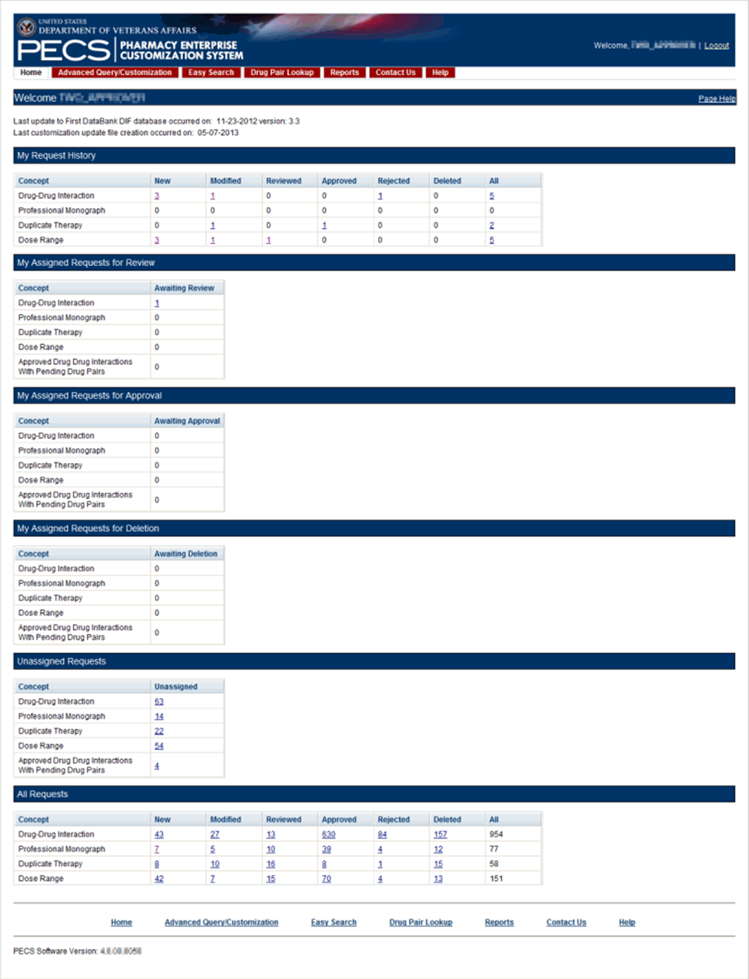

My Request History: Approver
My Request History displays active customization records created by the current user (Requestor and Approver roles only). The results will be broken down into numbers of active records, created by the current user by the following Action Statuses: New, Modified, Reviewed, Approved, Rejected, Deleted and All.
Figure 57: My Request History
The following table defines the columns found on the My Request History window.
Table 7: My Request History Columns
Column Name | Column Definition
New | The number of active records in the "New" status created by the current user.
Modified | The number of active records in the "Modified" status created by the current user.
Reviewed | The number of active records in the "Reviewed" and "Delete Reviewed" status created by the current user.
Approved | The number of active records in the "Approved" status created by the current user.
Rejected | The number of active records in the "Rejected" status created by the current user.
Deleted | The number of active records in the "Deleted" status created by the current user.
All | The number of all active records in any status, created by the current user.
Following the links within the summary table opens pre-defined queries to provide details of the requests. For example, clicking the New - Professional Monograph link will display a query with the appropriate criteria and the query results: Concept = Professional Monograph, Request Submitted By = <current user>, Action Status = New.
Figure 58: Home Tab Summary - Pre-Defined Query
Figure 59: Query Results

My Assigned Requests for Review
My Assigned Requests for Review are active customization records assigned to the current user to be reviewed. The Awaiting Review count is the number of records that are in the "New" or "Modified" status, that have been assigned to the current user for review. To see the records, select the corresponding link.
Figure 60: My Assigned Request for Review Example
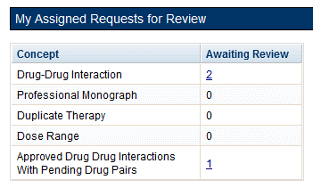

My Assigned Requests for Approval
My Assigned Requests for Approval are active customization records assigned to the current user to be approved. These records have been reviewed by another Approver. To see the records, select the corresponding link.
Figure 61: Approver's List of Requests for Approval
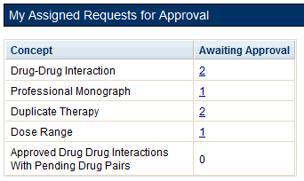

My Assigned Requests for Deletion
My Assigned Requests for Deletion are active customization records assigned to the logged in user to be deleted. The records have been "delete reviewed" by another "Approver" in the system. To see the records, select the corresponding link.
Figure 62: Approver's List of Requests for Deletion
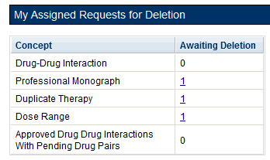

Unassigned Requests
Unassigned Requests are either New, Modified, or Reviewed customization requests that have not been assigned to any user. To see the records, select the corresponding link.
Figure 63: Approver's List of Unassigned Requests
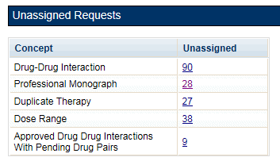

All Requests
All Requests displays all customization requests currently in the system by Action Status. The result detail will display the active records associated with the selected custom table summary.
The categories are:
Table 8: All Request Columns
Column Name | Column Definition
New | The number of active records in the "New" status.
Modified | The number of active records in the "Modified" status.
Reviewed | The number of active records in the "Reviewed" and "Delete Reviewed" status.
Approved | The number of active records in the "Approved" status.
Rejected | The number of active records in the "Rejected" status.
Deleted | The number of active records in the "Deleted" status.
All | The number of all active records in any status.

Additional Tools Available to Approvers
In addition to the Home tab, Approvers see the following tabs on their Home page:
- Advanced Query/Customization – See Using Advanced Query/Customization for additional information.
- Easy Search – see Easy Search for additional information.
- Drug Pair Lookup – see Drug Pair Lookup for additional information.
- Reports – see Reports for additional information.
- Contact Us – see Contact Us for additional information.
- Help – see Online Help for additional information.

Release Manager
The primary task of a PECS Release Manager is to create Custom Updates. Since they are not directly involved in the creation or processing of customization requests, the customization-related panels that appeared on the Requestor and Approver Home Pages do not appear on the Release Manager Home page.
Custom Updates are created at the instruction of the PECS Administrator and/or the National Drug File (NDF) Support Group. Once the Custom Update has been created, the Release Manager should send an Outlook email to the PECS Administrators.

Release Manager Home Page
The Home Page for the Release Manager does not display links associated with customization requests.
Figure 64: Release Manager's Home Page
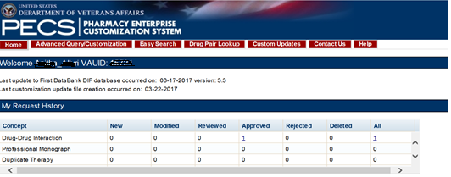

Custom Update Tab
The Custom Update tab contains the Release Manager-specific functions and is available only to PECS Release Managers.
Figure 65: The Custom Update Tab
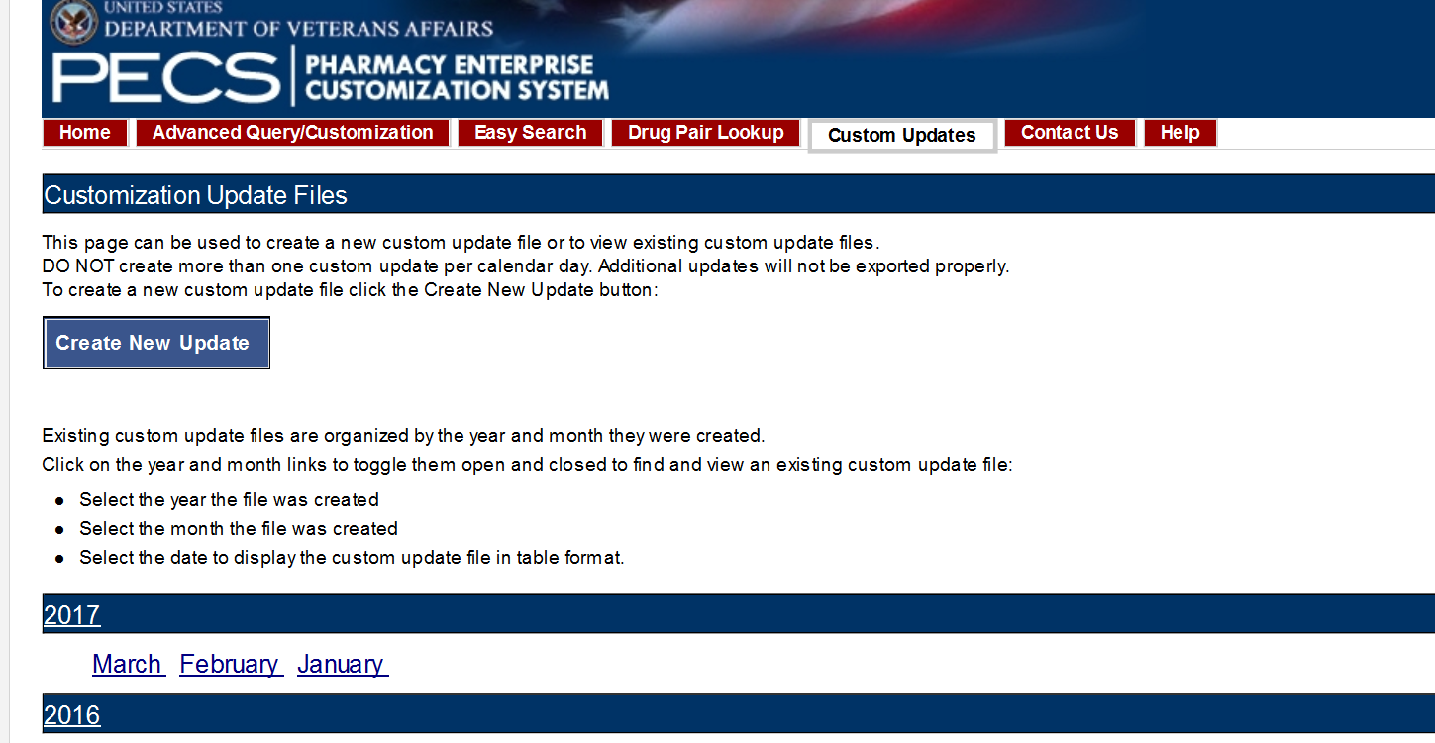

Custom Update Overview
A Custom Update is a set of files that:
- Transmit Approved customization requests to MOCHA (via DATUP) so that the customizations can be used in Order Check decisions.
- Transmit contain Deleted customization requests so that previously approved customizations can be removed from the MOCHA Order Check decision process
- Transmit updates received from FDB

Update Files Explained
A Custom Update produces two files. The Full Custom Update includes the entire FDB data distribution. The Incremental Update file contains updates from FDB to their database, as well as Approved and Deleted customizations from PECS. These updates will be incorporated in the national and regional databases for use in order check decisions (MOCHA).
Custom Update files use the following file naming standard:
CstmUpdFile_{FDB Version}.{PECS Generated Version Number}_{Date/Time Stamp}.zip
For example, the CstmUpdFile_3.2.751_20120503154622.zip has an FDB Version number of "3.2," a PECS-generated Version Number of "751," and was created on May 3, 2012 at 15:46:22 (military time). The contents of the zip file will determine if this is an Incremental or a Full update.
Incremental Update File
The Incremental Update File contains just the updates delivered by FDB and Approved and Deleted customizations from PECS. The custom zip file contains a proddefinition.xml, FDBPRODCONTROL.DAT and several data files that have an extension of UPD.
Figure 66: Custom Update Zip File
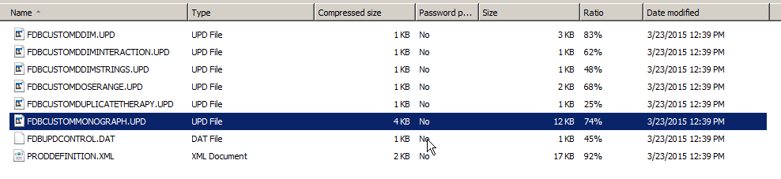
The proddefinition.xml file is a file from FDB that defines the table structures for the FDB tables in an XML format. The FDBUPDCONTROL.DAT file contains control information used by the FDB Data Updater software when determining if this Incremental update should be applied to a database. The UPD files contain data updates for a particular FDB table in the database.
Here is a sample: Note that the “D”, “C”, and “A” in the left column mean Delete, Change, and Add, respectively.
Figure 67: Custom Update Text File
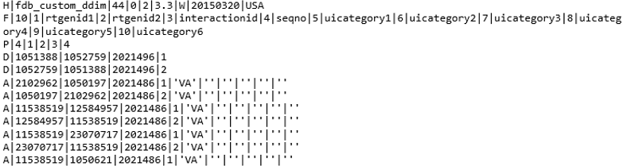
Full Update File
The Full Update File contains the complete FDB distribution. The files are:
- CTVERSION.TXT
- FDBCUSTOMDDIM.TXT
- FDBCUSTOMDDIMINTERACTION.TXT
- FDBCUSTOMDDIMSTRINGS.TXT
- FDBCUSTOMDOSERANGE.TXT
- FDBCUSTOMDUPLICATETHERAPY.TXT
- FDBCUSTOMMONOGRAPH.TXT
- FILECOUNTS.DAT
- PRODDEFINITION.XML
Here is a sample of the full update of Drug-Drug Interactions:
Figure 68: Custom Drug-Drug Interaction Full Update File
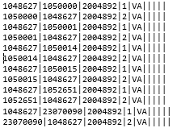

Create a Custom Update
Note: Custom Updates can be only be created by Release Managers
To create a Custom Update:
- Select the Custom Updates tab:
- Select Create New Update:
- After processing, the two new update files will appear in the list.
Figure 69: Newly Created Update Files
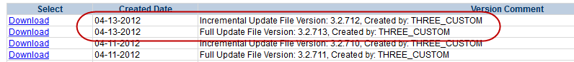
- Verify today’s date in Created Date column. The dates in the Created Date column should match the current date.
- If an error message is received, report it to PECS Administrator. See Contact Us for additional information.

Review Custom Update History
The existing Custom Updates are organized by Year and Month. Select the Year to display the months containing custom updates for that year, then click a month to display the custom updates performed during that month. The custom updates for more than one month can be displayed simultaneously. Selecting a month for a second time will collapse (hide) the custom updates for that month.
Figure 70: Existing Custom Updates by Year and Month
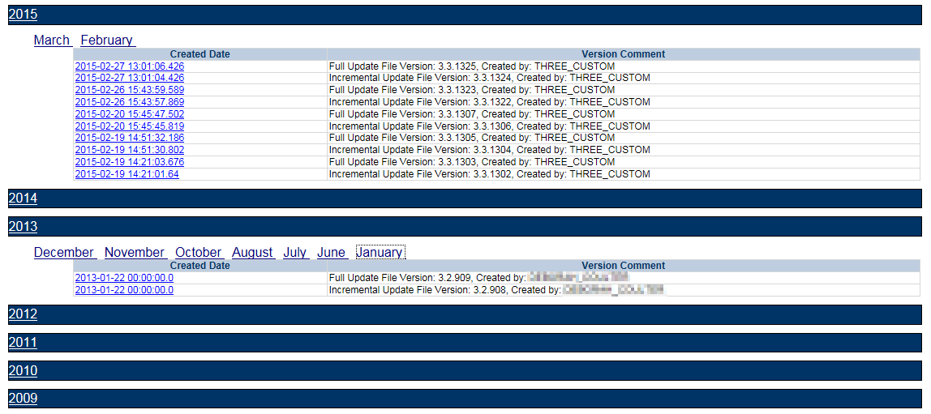

Additional Tools Available to Release Managers
In addition to the Home tab and Custom Updates, Release Managers role see the following tabs on their Home page:
- Advanced Query/Customization – See Using Advanced Query/Customization for additional information.
- Contact Us – See Contact Us for additional information.
- Help – See Online Help for additional information.

Administrator
The PECS Administrator performs limited maintenance on the PECS system through the Administration tab. The administrator can modify the page display for the PECS records (both FDB and VA). Demote existing Approvers, remove Null Drug Pairs, and change what is displayed on the Contact Us page. The Administration tab is displayed only to Administrator users.
Since they are not directly involved in the creation or processing of customization requests, the customization-related panels that appeared on the Requestor and Approver Home Pages do not appear on the Administrator Home page.
The unique tasks performed by an Administrator are:
- Customize Settings
- Change Field Display Order
- Null Drug Pair Removal Process
- Editing Contact Us
Most Administrator functions are performed on the Administration tab. Editing the Contact Us page occurs on the Contact Us page itself.

Administrator Home Page
The Home Page for the Administrator does not display links associated with customization requests.
Figure 71: Administrator's Home Page
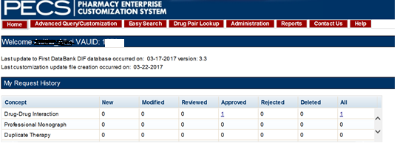

Administration Tab
The Administration tab contains most of the Administrator-specific functions and is available only to PECS Administrators.
Figure 72: The Administration Tab
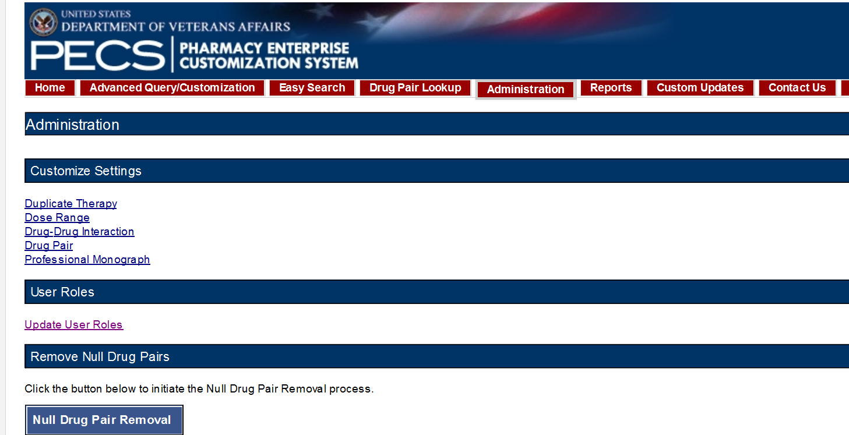

Customize Settings
The Customize Settings panel allows Administrators to change the label name for the Field (Display Name), and whether the field should appear in Queries, Detail Pages, and Reports. It also allows the administrator to change the order of the individual fields that are displayed on their respective pages.
To access Customize Settings:
- Log in as an Administrator.
- Select the Administration tab.
- Select the appropriate concept to change the way data appears in relation to that concept.
Figure 73: The Customize Setting Panel
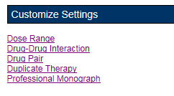
Customize Settings Table Description
There are currently five Customize Settings pages, one for each concept: Drug Pair, Drug-Drug Interaction, Dose Range, Duplicate Therapy and Professional Monograph.
Table 9: Customize Table Settings Columns
Column | Description
Name | Name is the database field name for items displayed for the selected concept. Name cannot be changed; it identifies the field in the database table.
Display Name | Display Name is what appears within PECS for the field defined by the entry in the Name column. The contents of Display Name will appear in query selection, data entry field and reports for the selected table.
Display in Query | Display in Query allows you to set if the field will be displayed in the Advance Query/Customization results tables. Some fields are required and cannot be turned off.
Display in Details | Display in Details allows you to set if the field will be displayed on the Detail page of the selected concept.
Include in Reports | Include in Reports allows you to set if the field will be displayed in any applicable reports.
Display Order | A numeric value designating the order the field will be displayed in.
Warning: Changes made on the Settings page will affect all PECS users. Please proceed cautiously.
Figure 74: Customize Settings Example (Drug Pairs)
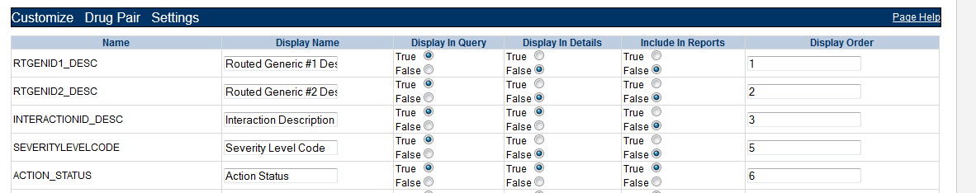
Change Field Display Name
To change how the name of a field is displayed on the page, modify the contents of the Display Name field.
- In the Customize <Concept> List, find the name of the database field to be changed.
- Modify the contents of the field in the Display Name column.
- Repeat the process as necessary.
- Select Save to save the changes, select Cancel to abandon the changes and return to the Settings page.
Note: Cancel is immediate. There is no warning that the changes will be lost.
Add/Remove Field from Query Options
To add (or remove) a field from Query options
- In the Customize <Concept> List, find the name of the database field to be changed.
- In the Display in Query column, select True to display the field in Query options, select False to prevent the field from displaying in Query options.
Note: Display in Query” options are not available for all fields; some fields are explicitly required to be displayed in the Query options while others are forbidden from being displayed. In these cases, the required display option (True or False) will be the only options displayed and cannot be changed.
Figure 75: Example of Display in Query Column of Radio Button Choices
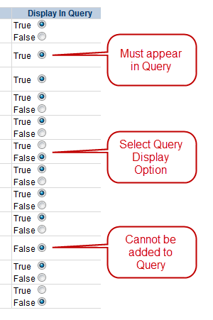
- Repeat the process as necessary.
- Select Save to save the changes, select Cancel to abandon the changes and return to the Settings page.
Note: Cancel is immediate. There is no warning that the changes will be lost.
Add/Remove Field from Detail Pages
To add (or remove) a field from Detail pages
- In the Customize <Concept> List, find the name of the database field you want to change.
- In the Display in Detail column, select True to display the field on the concept Detail page, select False to prevent the field from displaying on the concept Detail page.
Figure 76: Example of Display in Details Column of Radio Button Choices
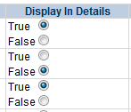
- Repeat the process as necessary.
- Select Save to save the changes, select Cancel to abandon the changes and return to the Settings page.
Note: Cancel is immediate. There is no warning that the changes will be lost.
Add/Remove Field from Reports
To add (or remove) a field from Reports
- In the Customize <Concept> List, find the name of the database field you want to change.
- In the Include in Reports column, select True to display the field on concept-related reports, select False to prevent the field from displaying on the concept-related reports.
Figure 77: Example of Include In Reports Column of Radio Button Choices
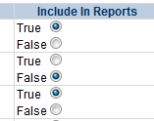
- Repeat the process as necessary.
- Select Save to save the changes, select Cancel to abandon the changes and return to the Settings page.
Note: Cancel is immediate. There is no warning that the changes will be lost.

Change Field Display Order
To change the order that the fields appear in Detail pages and drop-down lists, change the adjacent number in the Display Order field. Note that changing the Display Order is an entirely manual process; each field must be changed individually and the order is not validated in any way. Multiple fields can have the same display order.
When all changes are complete, Select Save, select Cancel to abandon the changes and return to the Settings page.
Figure 78: Display Order List
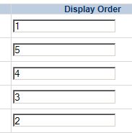

Update User Roles
PECS Administrators can add PECS users and modify the roles of existing users. By default, PECS users are assigned Requestor privileges. Once added, the user privileges can be elevated to Approver, Release Manager, and Administrator by an Administrator through the User Roles page. Privileges can also be removed from a user at any time.
Note: Release Manager or Approvers should immediately be assigned the appropriate roles to avoid giving them access to inappropriate privileges (creating customizations).
Figure 79: Update User Roles Panel
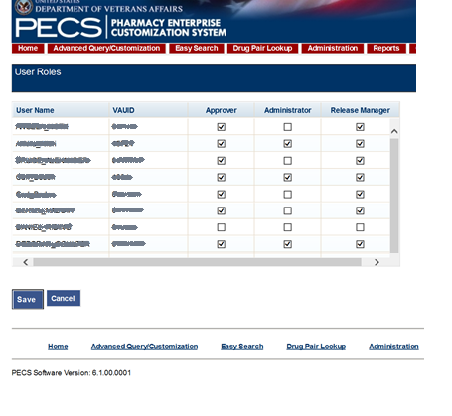

Update User Roles
Administrators can assign roles to PECS users. In order to successfully log in, the user must have a valid PIV card. See Identity Management for additional information.
To assign roles to PECS users
- From the Administration tab, select Update User Roles.
- Manage the user roles by selecting the appropriate role for the User Name.
- Select Save.
- Select OK to save the user, select Cancel to abandon the operation.
Figure 80: User Roles Save Message
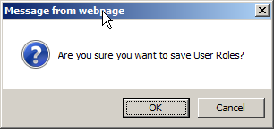

Remove User Roles
To remove a role from a user
- From the Administration tab, select Update User Roles.
Figure 81: Update User Roles Option
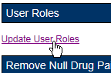
- Clear one or more roles for one or more users from the User Name list.
Figure 82: List of User Roles
- Select Save.
- Select OK to accept changes to the user roles, select Cancel to abandon the operation.
Figure 83: User Roles Save Message

Null Drug Pair Removal Process
The Null Drug Pair Removal changes the status of any VA Drug Pair that contains a null Routed Generic to “Deleted”, and removes the null drug pairs from their associated VA Drug-Drug Interactions. VA Drug Pairs have null Routed Generics because one or both of the Routed Generics that make up the Drug Pair has been deleted by FDB. PECS applies the FDB Routed Generic deletions as part of the weekly FDB-DIF update, so it is recommended that the Null Drug Pair Removal process be run weekly, after the FDB-DIF update completes.
The Administrator may initiate this process at any time by clicking the “Null Drug Pair Removal” button on the following window:
Figure 84: Null Drug Pair Removal Button on Administration Tab
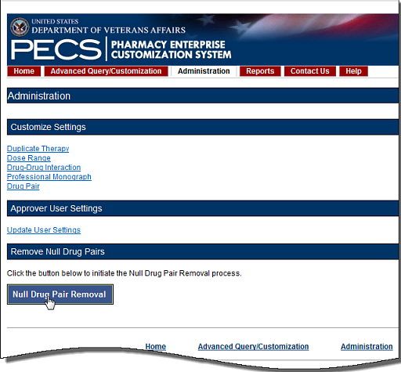
When the process is complete, a message will appear at the top of the page to indicate that the process has completed.
Figure 85: Null Drug Pair Removal Process Complete
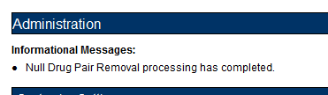
Note: The Null Drug Pairs Customization Report can be used to identify approved VA Drug-Drug Interactions that contain null Drug Pairs. However, the Null Drug Pair Removal Process removes null drug pairs from any VA Drug-Drug Interaction, regardless of status. All VA Custom drug pairs that contain a null routed generic drug are updated as follows: the action status of the drug pair is changed to “Deleted” and the current action reason is “FDB Deleted,” with the value of the FDB issue date when the custom drug pair was deleted. The FDB issue date is the date associated with the FDB update file that includes the deletion.

Editing Contact Us
In addition to viewing, Administrator users can edit the content of the Contact Us page. To edit the Contact Us page:
- Select the Contact Us tab.
- Select the Edit Content link on the right side of the page. This will display a word processor-like editor.
Figure 86: Edit Content Option in the Contact Us Tab
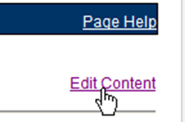
- Add or change the content on the page. To add or edit a link, see the appropriate sections below.
Figure 87: Contact Us Edit Page
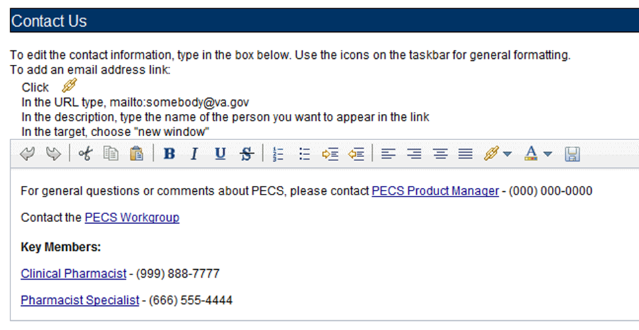
- When the edits are complete, select the Save button.
Figure 88: Save Button on the Contact Us Edit Page
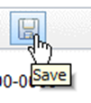

Add a Contact Link
To add a link while editing the Contact Us page:
- Select the Create Link button. This will display the Link Properties dialog box.
Figure 89: Create Link Button on the Contact Us page
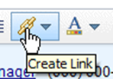
- Enter the mailto URL for the person whose contact information being added into the URL field. A mailto URL is the word "mailto" followed by a colon followed by the appropriate email address. VA email addresses are usually (but not always) firstname.lastname@va.gov. Verify the contact information in the Outlook Global Address List (GAL) for the correct email address. Example: mailto:firstname.lastname@va.gov.
Figure 90: URL Field for an Email Address
- Enter the contact name in the Description field. This is the text the user will actually see on the Contact Us page.
Figure 91: Description Field for an Email Address
- On the Target list, select New Window.
Figure 92: Target List
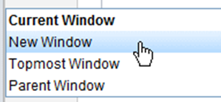
- Select the Set button.
Figure 93: Completed Link Properties
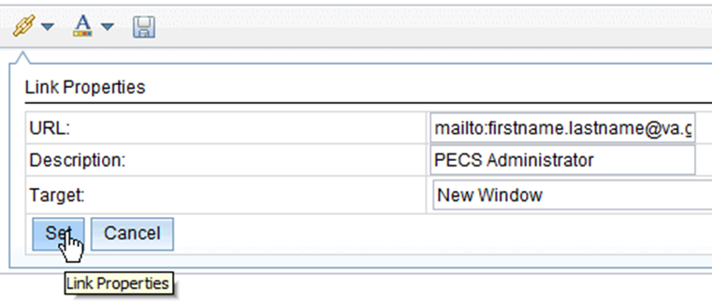

Edit a Contact Link
To modify an existing contact link while editing the Contact Us page:
- Double-click the existing link.
- Make the necessary adjustments in the Link Properties dialog box.
- Select the Set button.

Additional Tools Available to Administrators
In addition to the Home tab and Administration, the Release Manager role sees the following tabs on their Home page:
- Advanced Query/Customization – See Using Advanced Query/Customization for additional information.
- Contact Us – see Contact Us for additional information.
- Help – see Online Help for additional information.

Easy Search
Easy Search provides a simple way to display commonly-requested PECS information. Easy Search differs from other methods for finding information in that the results are display-only. The records displayed as a result of an Easy Search query cannot be modified. However, in some cases, a link is provided to an editable version of the resulting records.
The Easy Search queries are handled slightly differently depending on which type of search performed. There are three types of Easy Search Query:
- Dose Range
- Drug-Drug Interaction with Professional Monograph and/or Duplicate Therapy
- Interactions for a Single Drug

Easy Search Drug-Drug Interaction with Professional Monograph and/or Duplicate Therapy Query
The Drug-Drug Interaction with Professional Monograph and/or Duplicate Therapy query allows the user to easily search for any Drug-Drug Interaction (and associated Professional Monographs) and/or Duplicate Therapy records that may exist within PECS for at least two and up to ten drugs that are selected by the user. This page also allows the user to search for Duplicate Therapy information for any drug they select.
Figure 94: Easy Search Results Page
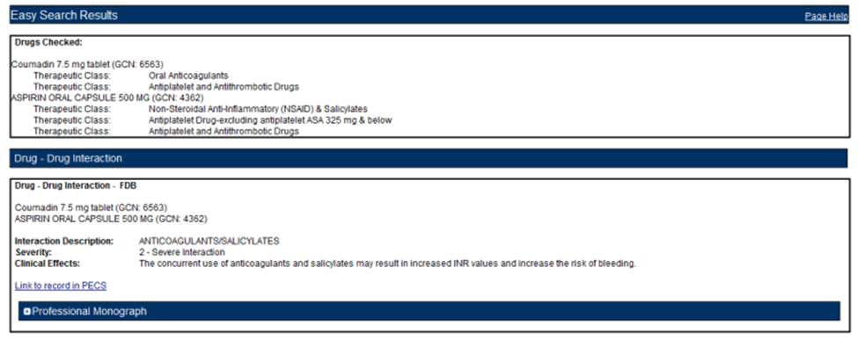
To perform a Drug-Drug Interaction Easy Search Query
- From the Select Search Type drop-down list, select 'Drug-Drug Interaction with Professional Monograph and/or Duplicate Therapy.' After selecting this value, the system will then display the 'Select Information Type', 'Search and Select Drugs', 'Search Results,' and 'Drugs to Check' panels.
Figure 95: Easy Search Query Selection Drop Down Menu
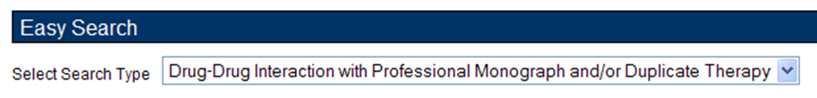
- Choose the appropriate options from the Select Information Type panel:
  - Select Drug-Drug Interaction with Professional Monograph to find Drug-Drug Interactions with the associated Professional Monograph. If the selection is the Drug-Drug Interaction with Professional Monograph checkbox, then the system will display two options: Display Severity Levels 1 (contraindicated) and 2 (severe) and Display All Severity Levels. Select one of these options.
  - Select Duplicate Therapy checkbox to display Duplicate Therapy records (if any) for the selected drugs.
Figure 96: Select Information Type Panel
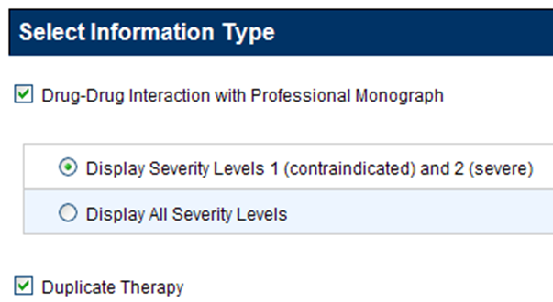
- Enter a partial string or whole drug name into the Drug field and select Search. The system returns all drugs, that is, both routed generic drugs and dispensable drugs that contain the partial string/whole drug name entered.
Figure 97: Search and Select Drugs Panel
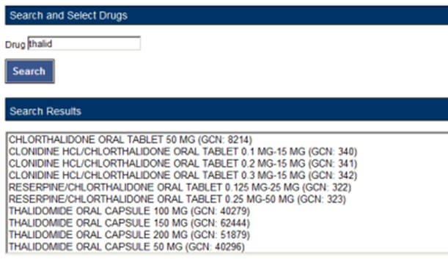
- Select a drug from the Search Results window and select Add to Drugs to Check. The selected drug will appear in the Drugs to Check box.
Figure 98: Search Results
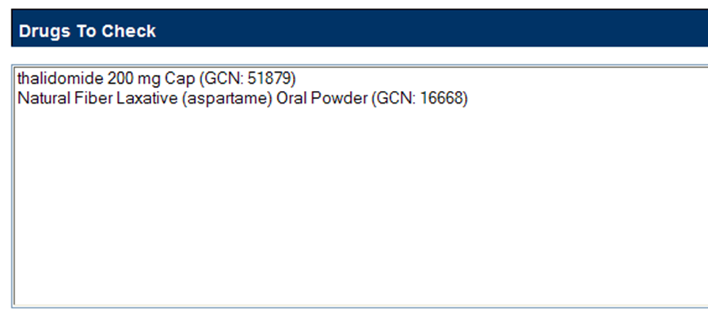
- If necessary, repeat the Search/Select process to add more drugs to the check. For Drug-Drug Interaction queries, select at least two, but up to ten drugs. For Duplicate Therapy, a user can select multiple drugs to find duplicate therapies, or select a single drug to display the associated Therapeutic Class.
- When all drugs have been added, select Submit. The query results will appear on a results page.
Results
The Drug-Drug Interaction with Professional Monograph and/or Duplicate Therapy query will produce the following results based on the selections made in the query.
Drugs Checked
All Drugs that were selected by the User are listed first on the page after ‘Drugs Checked’ and each drug name, the Therapeutic Class(es) that drug belongs to are listed for reference.
Figure 99: Easy Search Results for DDI with PM, Drugs Checked
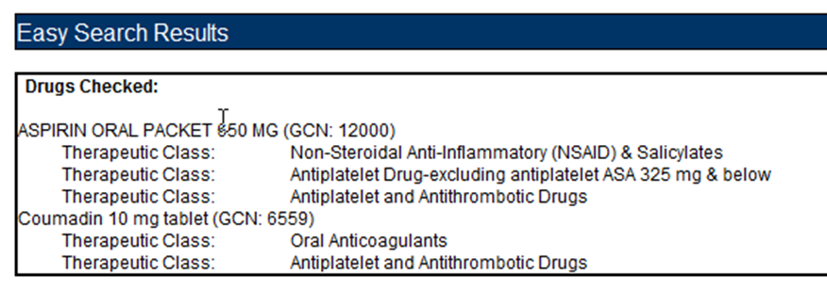
Drug-Drug Interaction
The Easy Search query Drug-Drug Interaction with Professional Monograph information will display any Drug-Drug Interactions that apply to any combination of the drugs searched. select the “Link to record in PECS” link to display the record in the standard PECS application where it can undertake additional processing.
Figure 100: DDIs Shown Applicable to Drugs Checked
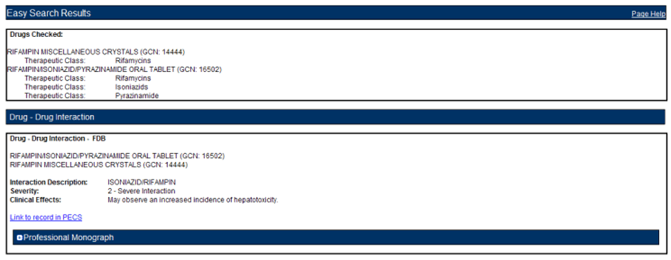
Professional Monograph
Any associated Professional Monographs to those Drug-Drug Interactions will be listed after the Drug-Drug Interaction information. Select the + symbol to expand the Professional Monograph (collapsed by default). If there is no Professional Monograph associated to the Drug-Drug Interaction returned by the Easy Search query, then this option will not expand.
Figure 101: The Professional Monograph Associated with the DDI/PM Easy Search
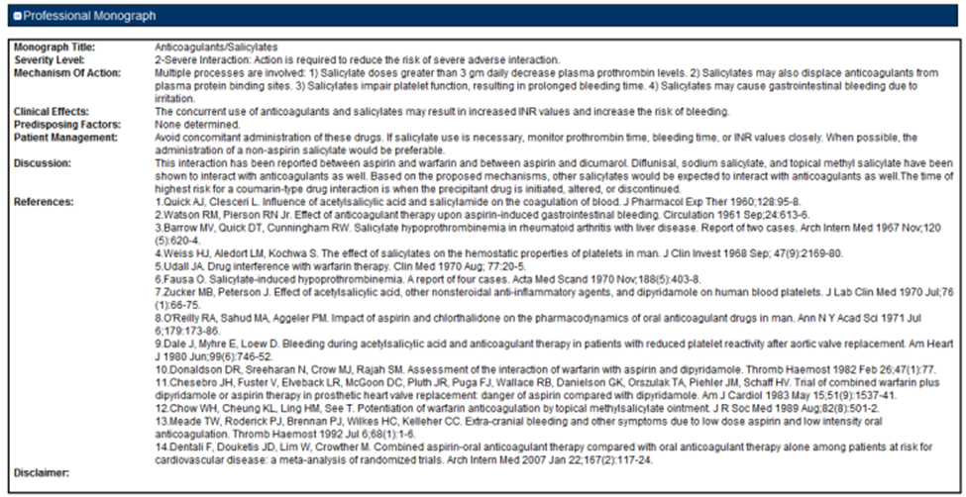
Duplicate Therapy
Duplicate Therapy results the Duplicate Therapy for the drugs selected in the Drugs to Check box. The record contains the Therapeutic Drug Class that the two drugs belong to and Duplicate Allowance numerical value (0,1, 2, 3, or 4) followed by a short message stating these two drugs may represent a duplication in therapy. To view the Duplicate Therapy record in PECS, select “Link to record in PECS.”
Figure 102: Duplicate Therapy Easy Search Results
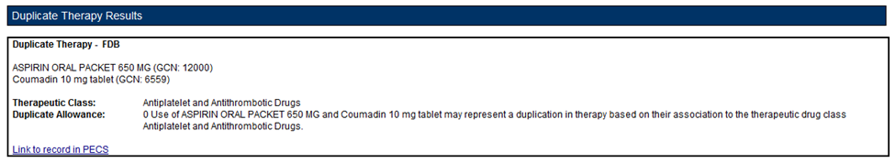

Easy Search Interactions for a Single Drug Query
Interactions for a Single Drug allows the user to generate a report for all the drug pairs that would be returned in VistA for the selected drug. The report displays FDB and Approved VA custom drug pairs with the specified severity level. FDB drug pairs will display only if there is not a corresponding Approved VA customized drug pair.
To perform an Interactions for a Single Drug Query:
- Select "Interactions for a Single Drug" from the Select Search Type drop-down list.
Figure 103: Select Search Type Drop Down Menu
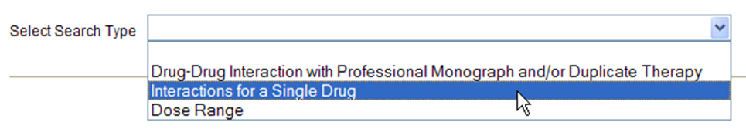
- From the Select Information Type panel, choose the desired Severity Level with the appropriate radio button - Severity Level 1 (contraindicated), Severity Level 2 (severe), or Severity Levels 1 (contraindicated) and 2 (severe).
Figure 104: Select Information Types Radio Buttons
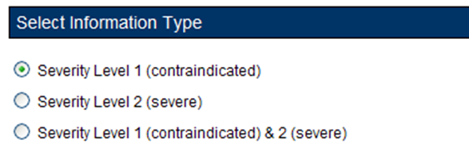
- Enter a partial string or whole drug name into the Drug field and select Search. Items that match the search string are displayed in the Search Results box. The drug list displays the drug name, dose, route of delivery, and the drug’s GCN sequence number. Note that if both a dispensable generic drug and dispensable drug are found that have the same GCN sequence number, only the dispensable drug are displayed on the list. Select an entry from the list.
Figure 105: Search and Select Drugs
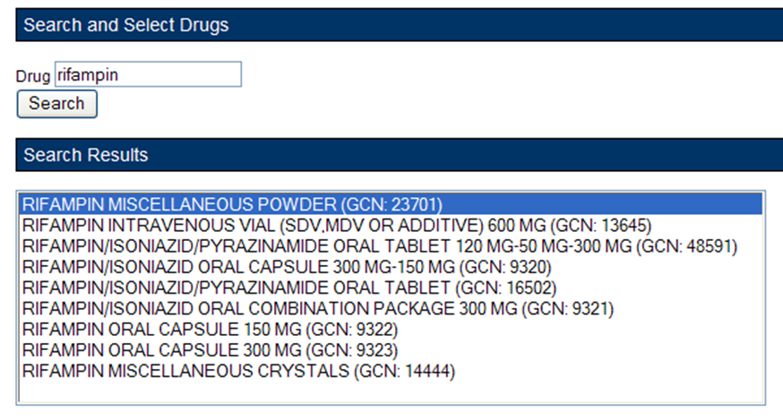
- Select the Generate Report button. The report generates in Excel. It contains the FDB and VA custom drug pairs whose severity level matches the selected severity level and contain a routed generic drug that corresponds to the selected generic dispensable drug or dispensable drug.
Figure 106: Excel Report for Drug Pair Interaction
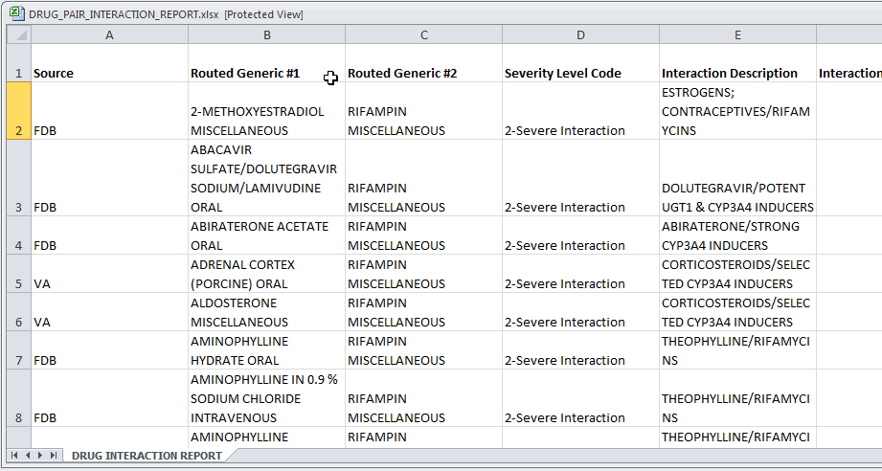
Interactions for a Single Drug Report Details
Table 10: Interactions for a Single Drug Report Fields
Field | Description
Source | Source of the record; either VA or FDB
Routed Generic #1 | A generic drug name, e.g. "Rifampin Oral"
Routed Generic #2 | A generic drug name, e.g. "Rifampin Oral"
Severity Level Code | The severity of the interaction.
Interaction Description | A brief description of the interaction.
Interaction ID | A numerical identifier assigned to the interaction.
Corresponding FDB Interaction ID | VA records only: the interaction as described by First Databank. If there is no corresponding interaction, this field will contain '0'.
Action Date | The date and time of the most recent update to the record.

Easy Search Dose Range Query
The Dose Range query allows the user to easily find the appropriate dosage information for a specific drug based on the patient and dose particulars entered for a selected drug. The results of this query allow the user to ensure the amount being prescribed is an acceptable amount. An Easy Search Dose Range query allows the user to find the acceptable dose range for a drug quickly and easily, and presents the results in an easy to understand format.
To perform an Easy Search Dose Range query:
- From the Select Search Type drop-down list on the Easy Search page, select 'Dose Range.'
Figure 107: Select Search Type Drop Down Menu
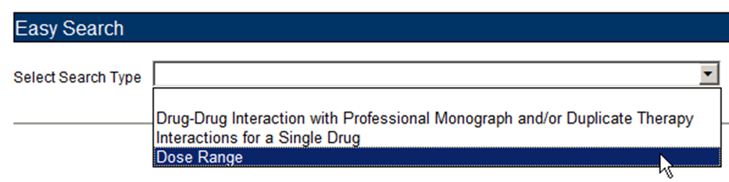
- Enter a partial string or whole drug name into the 'Drug' field. Note that the user can enter multiple partial strings, and the system returns drugs that match on both strings -- the order of the strings and case are ignored.
- Select the Search button. The system returns all drugs, that is, both routed generic drugs and dispensable drugs that contain the partial string/whole drug name entered.
- Select the appropriate drug from the Search Results list. Note that if the drug does not have a defined dose route and/or a defined dose unit, the query cannot be performed and an error message is displayed.
Figure 108: Drug Information Search Results
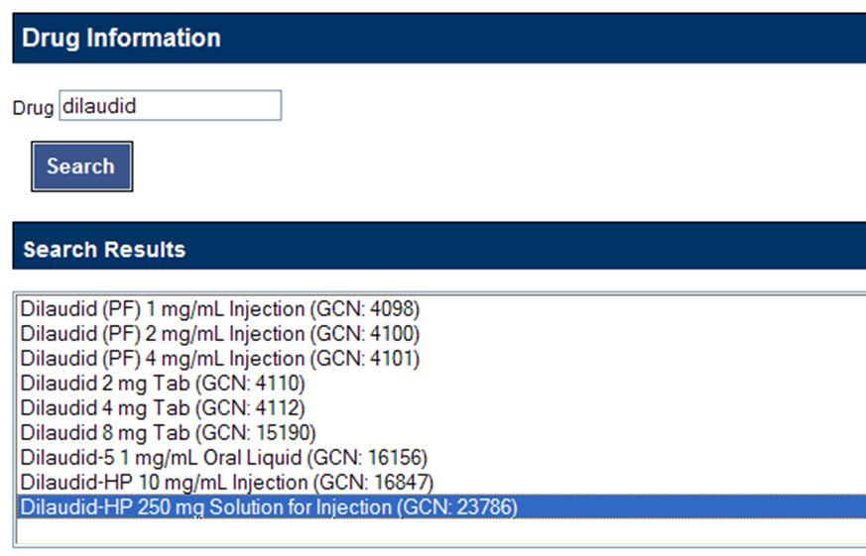
- In the Selected Drug section, select the Dose Type and Dose Route. The available selections will be limited to those appropriate for the selected drug; in some cases, the default values may be the only options available.
Figure 109: Dose Route Selection for a Selected Drug
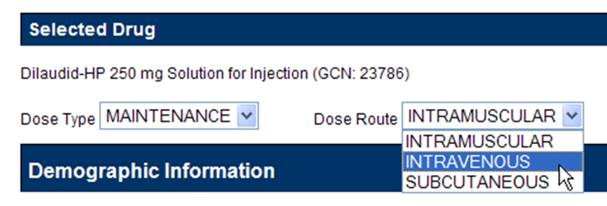
- The Demographic Information section will automatically be populated with standard values. If more appropriate patient information is available, the default values can be replaced. Factors included are:
  - Age (years)
  - Weight (kg or lbs.)
  - Height (cm or in)
Figure 110: Demographic Information
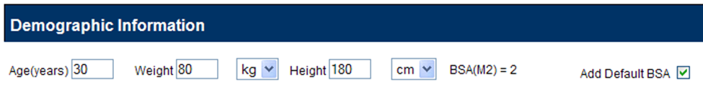
In the Dosing Information section, enter information about the proposed dose. Factors include:
- Single Dose
- Dose Unit
- Dose Rate Unit
- Frequency
Figure 111: Dosing Information
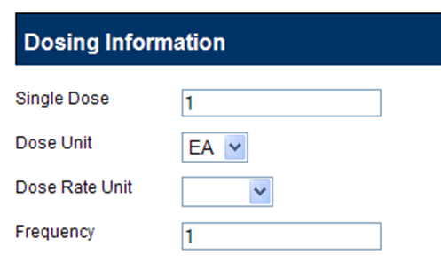
Dose Range Query Results
If available, the Dose Range Results section displays the appropriate dose range for the selected drug. The Dose Range record can be viewed in PECS by clicking “Link to record in PECS”
Note: Due to a limitation in the FDB database, not all PECS Dose Range records can be linked directly from Easy Search Results. If the record cannot be linked, “Link to record in PECS Not Available” will appear at the bottom of Dose Range Results. Use Advanced Query/Customization to find and view the record in PECS.
Figure 112: Results for a Dose Range Easy Search
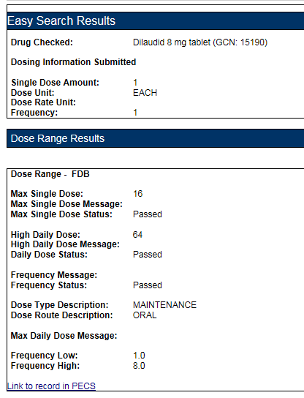
Drug Information
The Easy Search Results section displays the information that was entered into the query.
- Drug Checked
- Drug Information Submitted
  - Single Dose Amount
  - Dose Unit
  - Dose Rate Unit
  - Frequency
Dose Range Information
The Dose Range Results section displays (if available) the appropriate dose range for the selected drug.
- Max Single Dose
- Max Single Dose Message
- Max Single Dose Status
- High Daily Dose
- High Daily Dose Message
- Daily Dose Status
- Frequency Message
- Frequency Status
- Dose Type Description
- Dose Route Description
- Max Daily Dose Message
- Frequency Low
- Frequency High
Note: When PECS can’t retrieve the selected dose type, dose unit, and dose route for a drug, it displays a message in a popup:
Figure 113: PECS Unable to Retrieve Dose Information Message
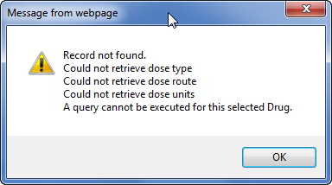

Potential Easy Search Result and PECS Record Discrepancy
The custom detail pages in PECS show the custom record as it exists in PECS. These detail pages are accessed through either the Advanced Query/Customization tab, or by following the “Link to record in PECS” link found on the Easy Search Results screens.
When you use Easy Search to look up Drug-Drug Interactions or Duplicate Therapy, Easy Search uses a different database table than the one used to store the actual PECS record. The Easy Search results page shows only data from custom records in an Approved state that have been exported in a custom update and processed by an external process named DATUP. If a custom record has not gone through this process, you will see the FDB record and there will be a discrepancy.
If a previously approved/exported custom record is updated, then Easy Search will not show the updated data in the results page until the record is approved, exported, and processed by DATUP. Instead, Easy Search will show the custom record results that were last uploaded to DATUP.
Below are examples of discrepancies. Remember that these discrepancies cannot be duplicated and re-displayed after a custom update has been approved and run through DATUP, so do not try to re-create them. They are for informational purposes only, and even shown as an older screen capture of PECS (no Contact Us tab). Example one, is from Easy Search.
Figure 114: Easy Search DDI Record
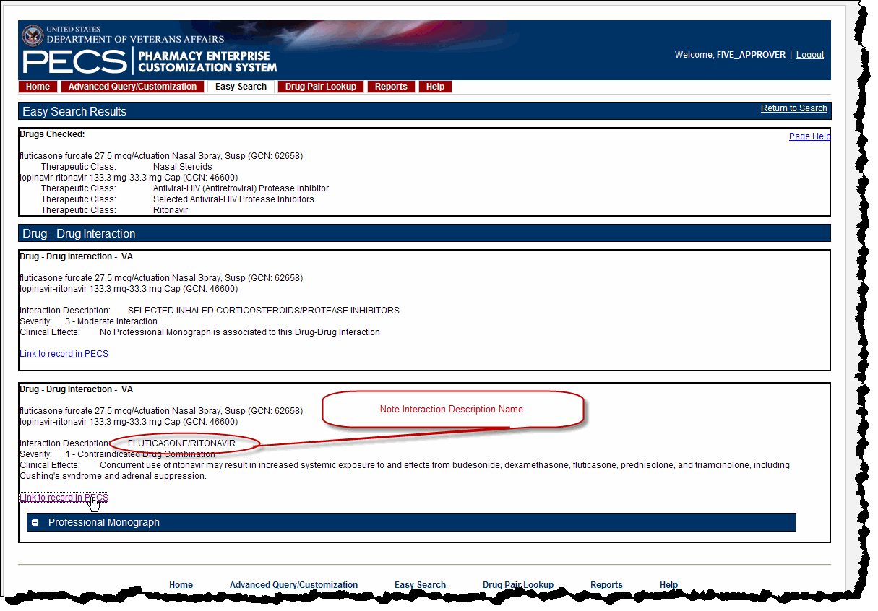
Example two, is shown by clicking the “Link to record in PECS” link as is shown above. This discrepancy means the custom record has not been approved and/or not processed through DATUP. This potential discrepancy applies to Drug-Drug Interaction, Professional Monograph, Duplicate Therapy, and Dose Range concepts.
Figure 115: Referenced PECS Record with Name Discrepancy
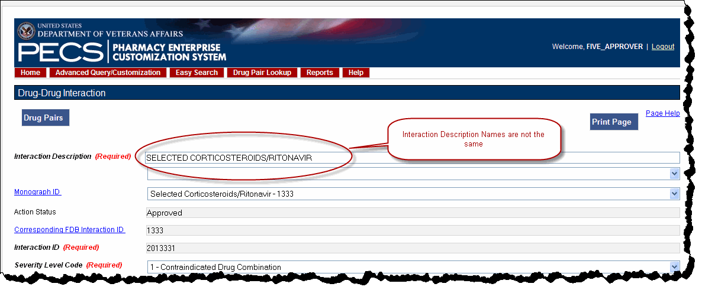

Drug Pair Lookup
A Drug Pair is a combination of drugs known to cause a drug interaction. A drug interaction is a situation in which a substance (usually another drug) affects the activity of a drug when both are administered together. Drug Pair Lookup provides a quick and easy way to search both the FDB and VA databases for these drug pairs.
When performing a Drug Pair Lookup query, enter query criteria in any or all of the four entry fields. The results are displayed under the VA Table Results and FDB Table Results panels. These consist of active customized Drug Pair records from the VA custom database that are available for modification, as well as their related Drug Pair records from the FDB database from which they were customized.
Field names are as follows:
- Drug A (Generic) - The name (or partial name) of one generic drug associated with an interaction.
- Drug B (Generic) - The name (or partial name) of a second generic drug associated with an interaction.
- Interaction - An assigned drug interaction number and description associated with the drug pair. This can be entered in conjunction with the Drug A and Drug B entries or can be used on its own. Enter either all of the Interaction ID, or all or part of the interaction description.
- Severity Level Code - A drop-down list of available severity codes that are allowed for an interaction. This can be used on its own, but is most useful to limit the results produced by the other criteria.

Performing a Drug Pair Lookup Query
To perform a Drug Pair Lookup query:
- Fill the query form with the search criteria; greater detail will yield more relevant results.
Figure 116: Drug Pair Descriptions and Severity Level Codes
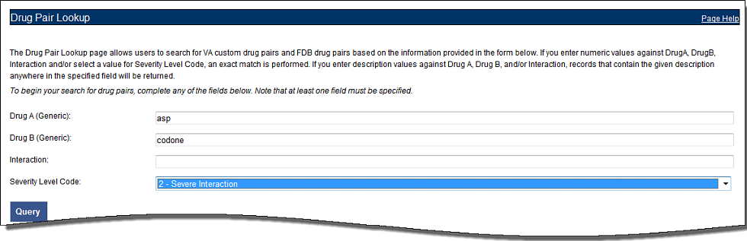
- Select Query.
- Drug Pairs matching the query criteria (both VA and FDB) will display in their respective panels. If the results are unsatisfactory, then the user can adjust the query criteria and select Query again.
Figure 117: Drug Pairs Matching the Query Display
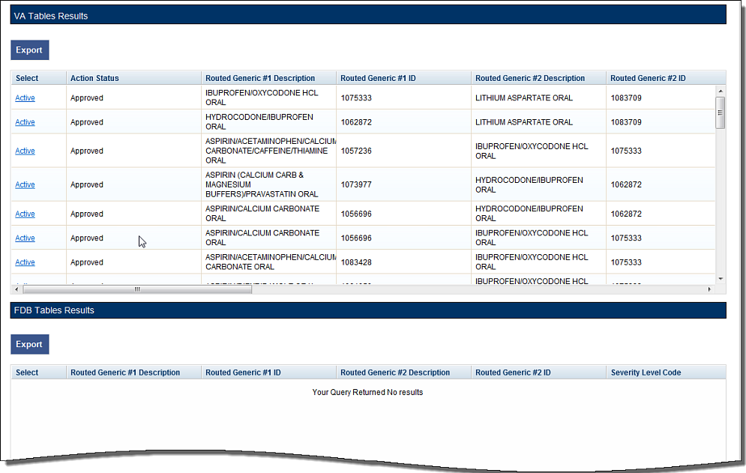
- Select the link in the Select column to view the drug pair record. VA records will display and Active link; FDB records display an Open link.
Figure 118: Drug Pair Selection List
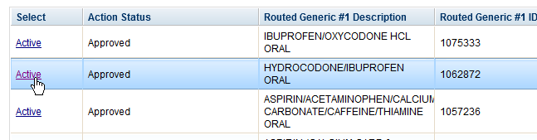
- To further customize the record, select the Interaction ID link to display the Drug-Drug Interaction (and the associated Drug Pairs).
Figure 119: Interaction ID Link
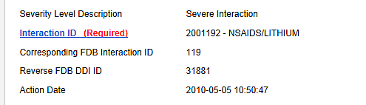

Export Query Results
The user can export the results of a Drug Pair Lookup query to an Excel spreadsheet.
- Perform a Drug Pair Lookup Query.
- Select the Export button associated with the Results list. The Export option is available for both VA and FDB results.
Figure 120: VA and FDB Results to Export
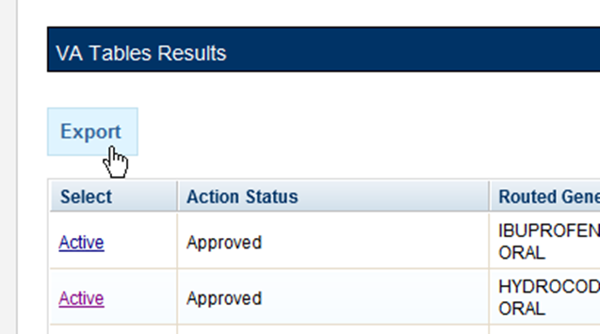
- Select Open to display the Drug Pair Report; select Save to save a copy of the report to your system.
Figure 121: Internet Explorer Download Screen
The spreadsheet contains two tabs:
- The Drug Pair tab (either VA or FDB) displays the results of the query.
Figure 122: Drug Pair Tab of the Excel Exported Report
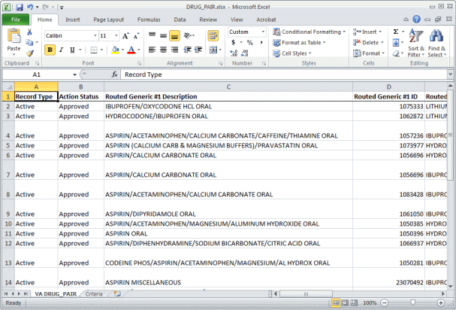
- The Criteria tab displays the criteria used in the query.
Figure 123: Criteria Tab of Excel Spreadsheet
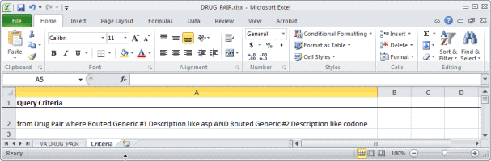
Export Query Line Limit
There is a 1,000,000 line limit for exporting to the spreadsheet. If the query returned more than 1,000,000 records and the records were submitted for export anyway, the Criteria tab on the report gives the following message: “The number of rows returned in the search (XXXXXX) is greater than the maximum number of rows that can be exported (1,000,000).”
Figure 124: Export Query Line Limit Message

Detail Pages
Detail Pages are the display mechanism for PECS records. To display the information contained in the record, and in the case of FDB records, provide a means to customize that record. There are detail pages for each of the five concepts (Drug-Drug Interaction, Drug Pairs, Professional Monograph, Duplicate Therapy, and Dose Range).

Detail Page Overview
Detail Pages display the details of the record appropriate to the concept being viewed for both FDB and VA records. The sections below are taken from a Drug-Drug Interaction records, but the detail page behaviors are consistent among the different Concepts.
FDB Records
Figure 125: FDB DDI Record
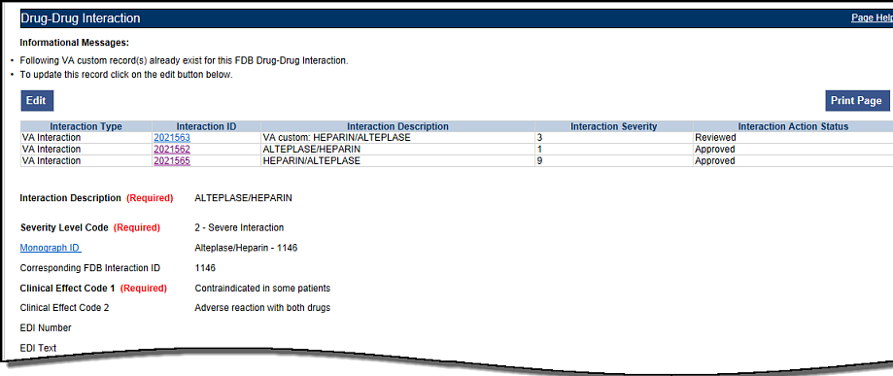
With FDB records, the user can:
- View Record Details
- Customize the FDB Record
- View Associated Record Links
VA Records
Figure 126: VA Custom DDI
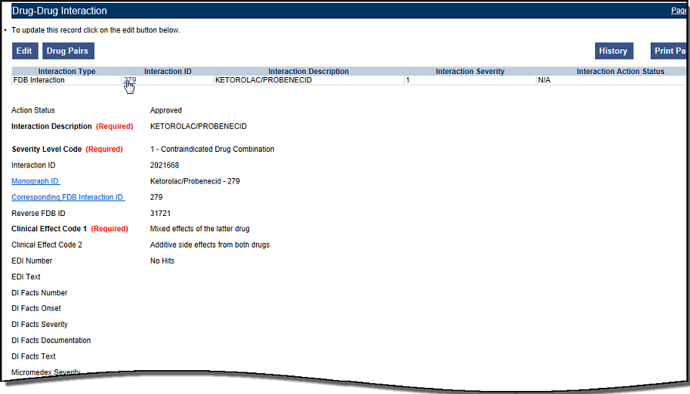
With VA records, the user can:
- View Record Details
- Edit a Record
- Print a Record
- Add Pre-Customization Comments
- View Associated Record Links
- View History Report
- View Field-Level History
- View Export Date

Informational and Warning Messages
Some records have informational and warning messages associated with them. These messages provide information about the record itself not necessarily the contents of the record.
Figure 127: Informational and Warning Messages
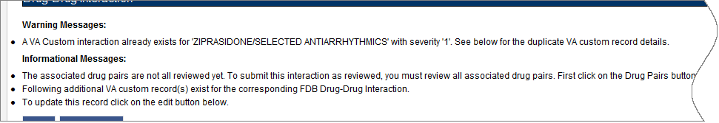

Using Detail Pages
Detail pages provide information about the PECS records. The information on the page is slightly different for each concept, but the basic functions are the same.
Figure 128: Example of a Detail Page
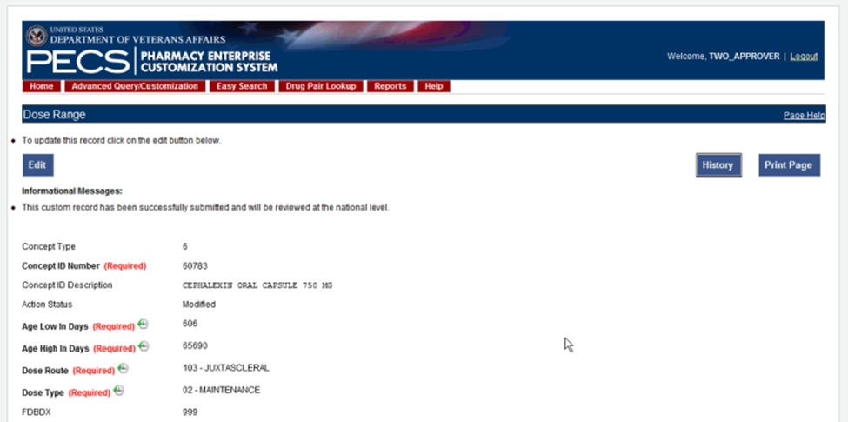

Viewing Record Details
The Home Page for Requestors and Approvers contains links to pre-defined queries that facilitate viewing records. Requestors can use these links to view details of records that they have created.
Approvers can use the links to view details of records they created, records currently assigned to them for some action, unassigned records, and All records.
All users can use Advanced Query/Customization to find and view record details.

Edit a Record
Editing a record is different depending on the type of record it is, and the current state of that record. For example, if viewing an FDB record, editing it produces a customization. If viewing a VA record, editing could mean:
- Changing the record details (modify)
- Reviewing an existing record as part of the approval process
- Approving an existing record
- Rejecting an existing record
- Deleting an existing record
In all cases, select Edit to begin the modification process. See Working with Customization Requests for additional information on the modifications that can performed on a record.
Figure 129: Use the Edit button to Modify Record Details
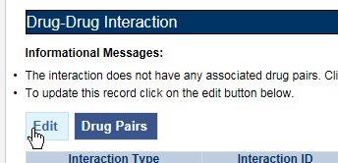
Only Requestor and Approvers can modify a record. Requestors can only modify FDB records (customize) or VA records they have created. Approvers can also modify/customize FDB records and can also modify most VA records with the following exception: they cannot Review a record they created. See Working with Customization Requests for additional information.
Note: If the user is a Release Manager or Administrator but has not been assigned that role by a PECS Administrator, they will have Requestor privileges until their appropriate role is assigned.
In some cases, PECS will display the Edit button and allow the user to view the record in Edit mode. However, any changes made to the record cannot be saved. Use Cancel Edit to return to the detail page in read-only mode.

Print a Record
The Print Page button calls the browser Print function, allowing the user to print the page to any printer they have connected to their system.
Figure 130: Print Page Button

Add Pre-Customization Comments
Approver users can add comments to FDB records that do not have customized VA versions. The comments are visible on the FDB record and contain the text of the comment as well as the date and time it was entered and the PECS User ID of the person who entered it. Once entered, these comments cannot be edited or deleted.
If the FDB record is customized, then the pre-customization comments will become part of the customized record. Once customized, you cannot add additional pre-customization comments to an FDB record.
To add a pre-customization comment:
- Select the Add Comment button:
Figure 131: Add Comment Button
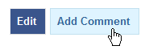
- Enter the comment in the Enter Comments dialog box:
Figure 132: Enter Comments Dialog Box
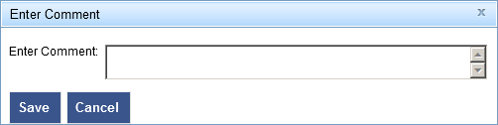
- Select Save to save your changes, or select Cancel to abandon the enter comments process and return to the record. The comments appear in the Pre-Customization Comment History of the record.
Figure 133: Example of Pre-Customization Comment History
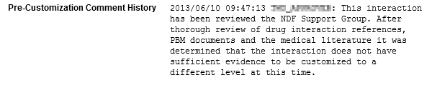

View Associated Record Links
If an FDB record has been customized, then the links to the VA-customized records are provided.
Figure 134: VA Custom Record ID Links
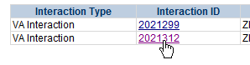
VA records provide links to the original FDB record as well as any additional customizations created from the original FDB record.
Figure 135: VA Custom and FDB Record Links
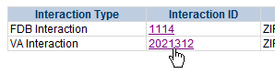

History Report
History Reports detail all the changes made to the current record. Changes to most editable fields will appear in the report as red text with an asterisk (*). Changes to the Current Action Reason are not highlighted (red) in the History Report. It is presented as a Microsoft Excel spreadsheet.
To display a History Report:
- From the Detail page, Select the History button.
Figure 136: History Button
- Select Open to display the History Report. Select Save to save a copy of the report to your system:
Figure 137: Internet Explorer Download Dialog Box
- If you chose to Open the report, then it will be displayed. If you chose Save, then the report can be opened at any time using Excel.
Figure 138: Example of an Excel Report with Changed Data
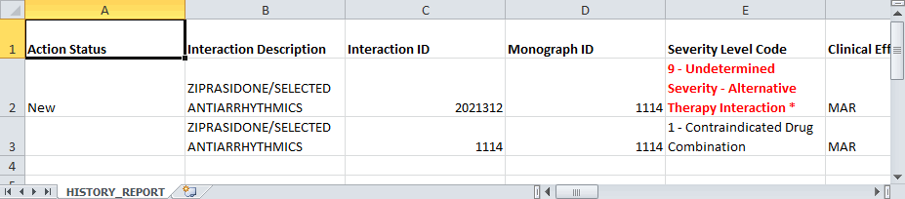

Field-Level History Table
A user can review a list of changes to an individual field by hovering over the History Table icon next to a field that has been changed. Field-level history is retained only while the record is in its current state. The field-level history is reset when the state changes to Approved or Deleted (Modified or Reviewed doesn’t cause a reset). Field-level history is only displayed for Required Fields with the exception of Current Action Reason; field-level history is not retained for Current Action Reason, but it can be viewed on the History Report along with changes to non-required fields.
Figure 139: At-a-Glance History Icon
Figure 140: On-Screen History Table from Icon
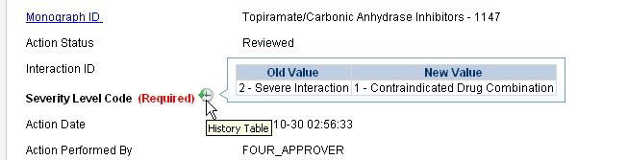

Export Date
The Export Date field appears on the VA Custom Detail Pages and in the Customization Reports. It contains the date and time an Approved or Deleted record was included in the Incremental Update File, so it is only populated on records with Action Status’ equal to Approved or Deleted.
Note: If an Incremental Update File has not been created since the record Action Status was change to Approved or Deleted, then the Export Date will be blank until the next Incremental File is created.
Sometimes an Approved or Deleted record included on an Incremental Update File needs to be changed. Any change to that record will cause the Export Date field to be cleared (blank) in the active record. The only way to determine that the record has been exported is to view the History report or search for the record using Advanced Query/Customization and select Include Historical Records.
If the change to the record causes a change to the Action Status and that modification is later Rejected, then the following happens:
If a “Modified after Approved” (displays as Modified in PECS) record is Rejected:
The Action Status “rolls back” to Approved, and the record will be included in the next Incremental Update File and the Export Date will be updated.
If a “Modified after Delete” (displays as Modified in PECS) record is Rejected:
The Action Status “rolls back” to Deleted. However, records that roll back to a Deleted Action Status are NOT included in the next Incremental Update File, so the Export Date will NOT be updated and will remain blank on the active record.

Drug-Drug Interaction Detail
The Drug-Drug Interaction Detail page allows users to view the details of both FDB and VA Drug-Drug Interaction records. FDB Drug-Drug Interactions can be customized to become VA Drug-Drug Interactions. See Working with Customization Requests for additional information on creating a VA customization request.
Figure 141: Detail Page of VA Customized DDI Top
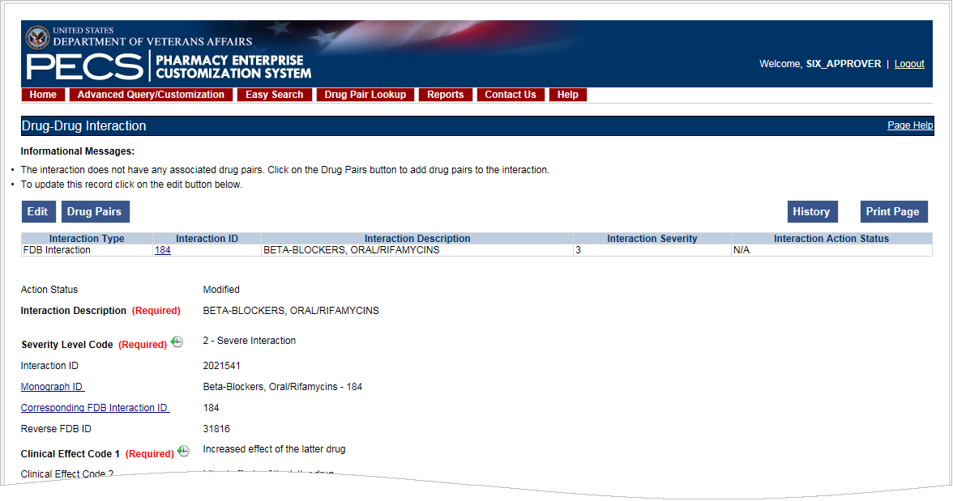
Figure 142: Detail Page of VA Customized DDI Bottom
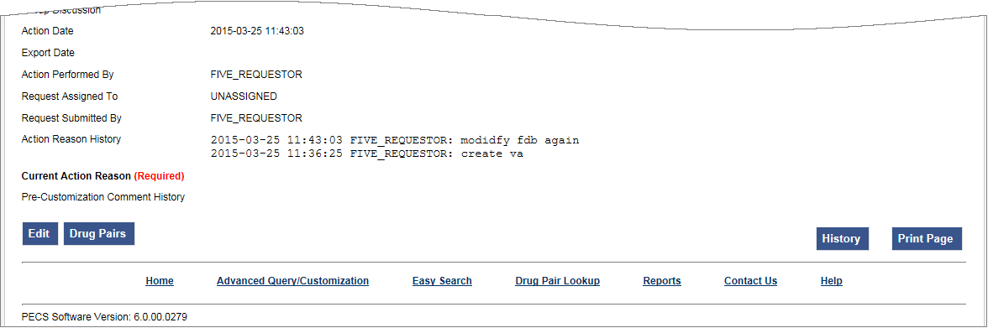

Multiple VA Customizations for One FDB Record
A user can create multiple VA Custom Drug-Drug Interactions (DDIs) from one corresponding FDB Record. If a user opens an FDB DDI record on the Advanced Query/Customization page, then the DDI Detail page will open. If there are any VA custom records for this FDB DDI, then a message is displayed stating that “The following VA custom record(s) already exist for this FDB Drug-Drug Interaction,” and a table and a link to any interactions displays.
Figure 143: Multiple VA Custom DDIs to One FDB Record
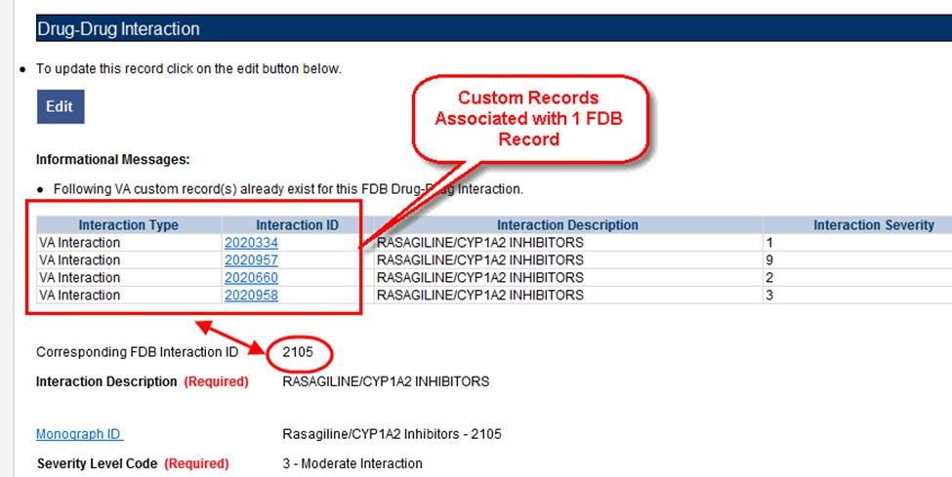
From here, a user can create another custom record. Checks exist in the system so that the same user cannot make duplicate DDIs or another user cannot come in and make the same DDI that another user just made.

Create Multiple Customizations from One FDB Record
Drug-Drug Interactions and Dose Range records can be customized multiple times from a single FDB record.
To create multiple customizations from one FDB record:
- Find and display the FDB record to be customized using Advanced Query/Customization.
- Select Edit.
- Create the custom record by changing something and selecting Customize.
- The new record is created. The record ID is displayed on the Interaction ID field. If there are any duplicates or other discrepancies, then a warning message will be displayed (such as an identical interaction severity):
Figure 144: FDB ID Record
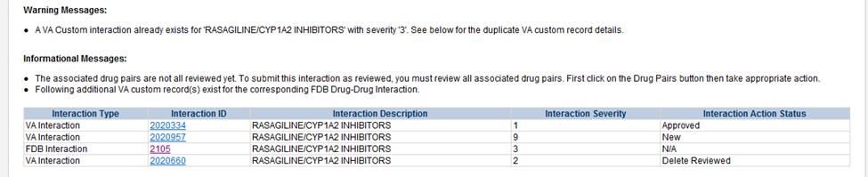
- Repeat the process using the same FDB record as many times as necessary.

Cannot Add Identical Drug Pairs to Same DDI
After one user has created a new DDI or added new drug pairs to an existing DDI, a second user can come in and attempt to add the same drug pairs. A users cannot add a drug pair that currently exists for the selected DDI:
Figure 145: Error for Duplicate Drug Pairs for One DDI
The user will also receive an error if they attempt to customize a drug pair for a DDI in Reverse Order:
Figure 146: Error for Duplicate Drug Pairs in Reverse Order for One DDI
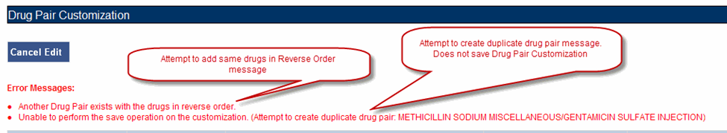

Reverse Drug-Drug Interactions
Multiple Drug-Drug Interaction records may exist for the same drugs listed in reverse order. For example, FDB Interaction ID 1234 is Drug A/Drug B and FDB Interaction ID 30766 is Drug B/Drug A. Information about reverse DDIs is displayed in the table at the top of the detail page. The screen shot below displays FDB record 1637, which has a DDI customization and a reverse DDI customization.
Figure 147: FDB DDI with a Customization and a Reverse Customization
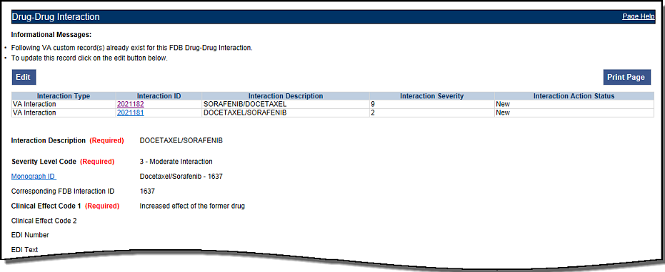
If a user selects the link associated with the reverse DDI, then they will see its detail page (next screen shot):
Figure 148: Choosing the Reverse VA DDI Customization
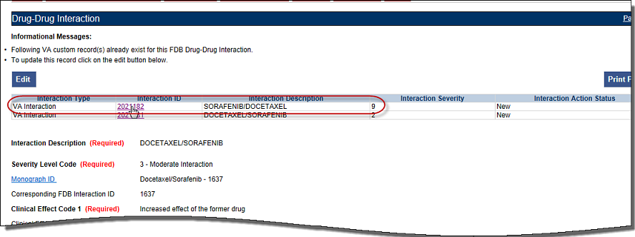
The detail page of the Reverse VA Customization is displayed:
Figure 149: Reverse FDB Interaction ID
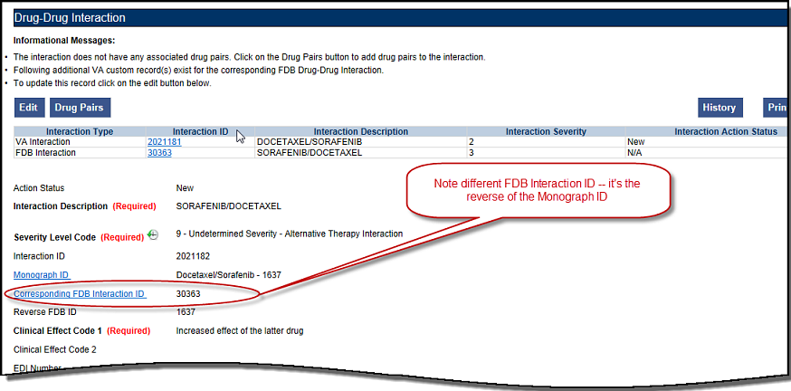
Displaying the Reverse FDB DDI Interaction ID
The Reverse FDB DDI Interaction ID is displayed in the VA custom DDI and DP Detail pages, in the results of DDI and Drug Pair queries and on the FDB Custom DDI Report. The Reverse FDB DDI Interaction ID is defined as the reverse of the FDB DDI ID and is obtained by executing this equation:
32,000 – (minus) FDB Monograph ID.
For example:
- If FDB monograph ID is 2246, then the reverse FDB DDI ID is 29745 (32,000 – 2246 = 29745)
- If FDB monograph ID is 29754, then the reverse FDB DDI ID is 2246 (32,000 – 29754 = 2246)
- If FDB monograph ID is 0, then the reverse FDB Interaction ID is 0 ( i.e., DDI was created from scratch using the Open Blank Form option)
Displaying the reverse FDB DDI Interaction ID in the DDI and DP detail pages, query results, and reports enables the user to find information about reverse DDIs easily.

Working with Drug Pairs within the DDI
Note that a user can work with a drug pair only by starting from the Drug-Drug interaction page, and selecting the Drug Pairs button.
See the Drug Pair Detail for additional information.

Fields
Table 11: DDI Fields
Table Heading Name | Table Heading Description
Monograph ID | The Professional Monograph ID associated with the drug interaction pair.
Action Status | Applicable to VA record only. The point this customization is at, within the VA Approval Workflow.
Corresponding FDB Interaction ID | The system ID of the FDB record from which the VA customization was created.
Interaction ID | The system ID of this VA customization.
Reverse FDB ID | The FDB ID associated with a customized reverse interaction ID.
Severity Level Code | The level of severity for this Drug-Drug Interaction.
Action Date | Applicable to VA record only. The date of the last action taken on the record.
Action Performed By | Applicable to VA record only. The name of the user that performed the last action.
Request Submitted By | Applicable to VA record only. The name of the user that submitted this VA request.
Action Effective Date | Applicable to VA record only. The date of the last action taken on the record.
Request Assigned To | Applicable to VA record only. A drop down list to assign an approver.
Clinical Effect Code 1 | Clinical effect code.
Clinical Effect Code 2 | Clinical effect code
EDI Number | The severity level from the Evaluations of Drug Interactions (EDI) system.
EDI Text | The interaction text found in EDI.
DI Facts Number | Severity number of interaction found in DI Facts.
DI Facts Onset | The onset of the interaction as found in DI facts.
DI Facts Severity | The severity level of the interaction found in DI facts.
DI Facts Documentation | Documentation of the interaction found in the DI Facts.
DI Facts Text | The text of the interaction from DI facts.
Micromedex Severity | The severity found in Micromedex.
Micromedex Onset | The onset of the interaction as found in Micromedex.
Micromedex Substantiation | Level of documentation of the interaction found in the Micromedex.
Micromedex Text | The interaction text found in Micromedex.
Medline Hits | A dropdown list to select whether or not this reference was checked.
Medline Text | Brief description of literature results.
Package Insert | A dropdown list to select whether or not this reference was checked.
Package Insert Text | The interaction text found in the package insert.
PBM Criteria | A dropdown list to select whether or not this reference was checked.
PBM Criteria Text | Text information found in PBM criteria.
AIDS Guidelines | A dropdown list to select whether or not this reference was checked.
AIDS Guidelines Text | Text information from the AIDS guidelines.
Interaction Source | A drop-down list to select source.
Interaction Type | A drop-down list to select type.
Highest Level of Evidence | A drop-down list to select the source of the evidence to support the described drug-drug interaction.
Group Discussion | General comment from meeting.
Action Reason History | Applicable to VA record only. All historical current action reason comments for this record, in one viewable field.
Current Action Reason (optional) | Applicable to VA record only. Free form text that can be used to specify the reason for taking the specific action of creating new, modifying, assigning, rejecting, reviewing, approving, or deleting the customization.
Export Date | For Approved or Deleted records. Indicates the date of the last Custom Update. See Export Date for additional information.
Pre-Customization Comment | Approvers can add comments to un-customized FDB records in this field and select the add comment button to save the comment
Pre-Customization Comment History | Displays all comments that have been added to this record prior to customization

Drug Pair Detail
Drug Pairs are sets of drugs that are associated with a drug-drug interaction. The Drug Pair detail page allows a user to view the details of a drug pair associated with a Drug-Drug Interaction. Unlike other detail pages, there is no way to directly edit a drug pair from a drug pair detail page. Instead, the user must make the modifications through the associated Drug-Drug Interaction. See Drug Pair Customization (Non 508-Compliant) Detail or Section 508 Compliant Drug Pair Customization Detail for additional information.
Figure 150: The Drug Pair Detail Page – VA
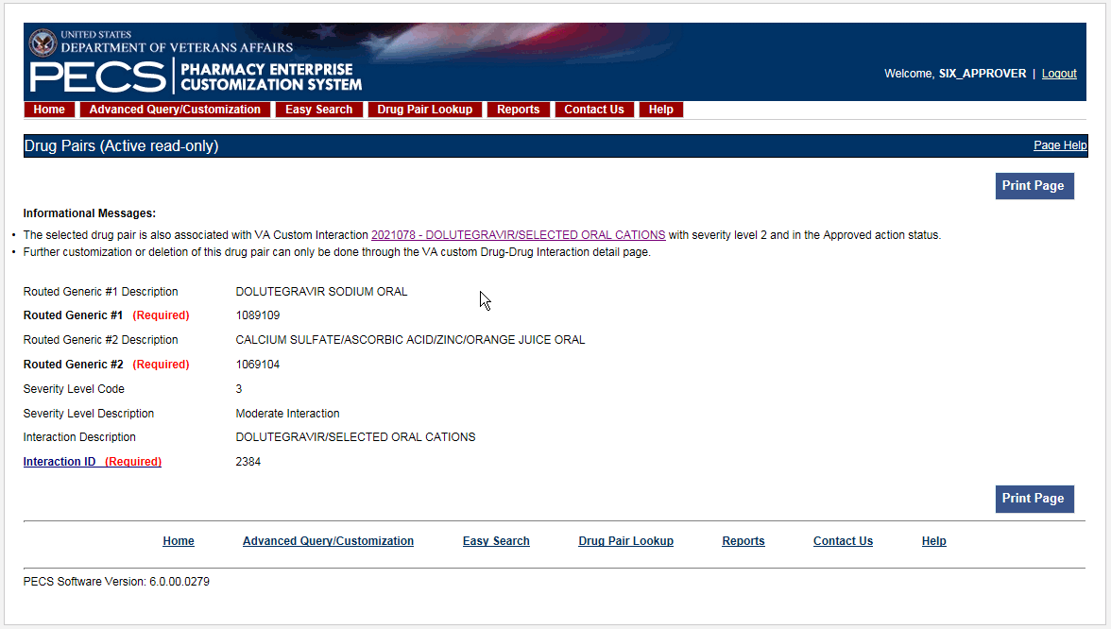
Figure 151: Drug Pair Detail Page - FDB
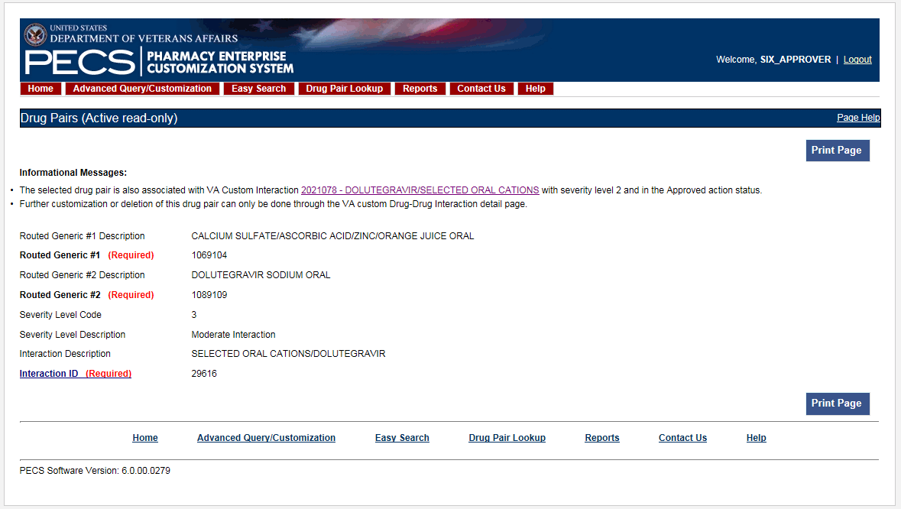

Fields and Other Information
The information presented on a drug pair detail page is also different from other record types.
Informational Messages
Informational messages are critical with drug pairs. They associate the displayed drug pair with any associated Drug-Drug Interaction.
Figure 152: Example of Informational Messages for Drug Pair Detail
Table 12 describes the fields for a Drug Pair record. Not all fields are applicable to all record types (FDB or VA).
Table 12: Field Descriptions for Drug Pair Detail
Field Name | Field Description
Action Status | Applicable to VA record only. It is the status of this customization within the VA Approval Workflow.
Routed Generic #1 | The ID of the first drug in this Drug Pair.
Routed Generic #1 Description | Applicable to FDB record only. The description of the first drug in this Drug Pair.
Routed Generic #2 (required) | The ID of the second drug in this Drug Pair.
Routed Generic #2 Description | The description of the second drug in this Drug Pair.
Severity Level Code | Applicable to FDB record only. The severity level code for this Drug-Drug Interaction.
Severity Level Description | The description of the severity level code for this Drug-Drug Interaction.
Interaction ID | The ID number of the FDB or VA Custom Drug-Drug Interaction associated with the drug pair.
Interaction Description | Applicable to FDB record only. The description of the Interaction ID that the drug pair is associated with.
Corresponding FDB Interaction ID | Applicable to VA records only. It is the Interaction ID of the FDB record from which the VA Drug interaction customization was created.
Reverse FDB ID | Applicable to VA records only. It is the Reverse FDB Drug-Drug Interaction ID, or the Reverse Interaction ID of the DDI FDB record from which the DDI custom record was created. For more information about the Reverse FDB DDI ID, see “Displaying the Reverse FDB DDI Interaction ID”.
Action Performed By | Applicable to VA records only. The name of the user who performed the action.
Request Assigned To | Applicable to VA records only. The name of the PECS user assigned to process the customization request.
Request Submitted by | Applicable to VA records only. The name of the user that submitted this VA request.
Reference Text | Applicable to VA records only. Field for the user to enter any reference text needed to support customization of the drug pair.
Action Reason History | Applicable to VA records only. All historical 'current action reason' comments for this record, in one viewable field.
Current Action Reason | Applicable to VA records only. Free form text that can be used to specify the reason for taking the specific action of creating new, modifying, assigning, rejecting, reviewing, approving, or deleting the customization.
Export Date | Applicable to VA records only. Date that the approved or deleted drug pair record was exported to the incremental update file
Action Date | Applicable to VA records only. The date of the last action taken on the record.

Finding Drug Pairs
Drug pairs are usually found and processed directly from the Drug-Drug Interaction they are associated with. However, a user can search for them directly using either Advanced Query/Customization or Drug Pair Lookup. When searching for drug pairs directly, what is displayed is dependent the record type (VA or FDB) and whether the associated Drug-Drug Interaction has been customized. In all cases, drug pair records cannot be edited directly; the user must work through an associated Drug-Drug Interaction.
- If the results locate a customized VA Drug Pair, then the VA Drug Pair detail page for that Drug Pair is displayed. The detail page contains a link to the associated Drug-Drug Interaction(s).
- If the results locate an FDB drug pair record that has been customized by VA, then the FDB Drug Pair Detail page is displayed. The detail page contains a link to the FDB Drug-Drug Interaction and the customized VA Drug-Drug Interaction created from the FDB Drug-Drug Interaction.
- If the results locate an FDB drug pair record that has NOT been customized by VA, then the associated FDB Drug-Drug Interaction detail page is displayed.
Using Advanced Query/Customization
To find a drug pair using Advanced Query/Customization:
- Select the Advanced Query/Customization tab.
- Select Drug Pair from the Select Concept List and select the appropriate drug pair type from the Select VA, FDB, or Both list.
- Build the query to find the appropriate drug pair and select Query.
- Select the link in the Select column to open the record. The record that is displayed depends on the record type.
See Using Advanced Query/Customization for additional information.
Using Drug Pair Lookup
To find a drug pair using Drug Pair Lookup:
- Select the Drug Pair Lookup tab.
- Build the query to find the appropriate drug pair and select Query.
- Select the link in the Select column to open the record. The record that is displayed depends on the record type.
See Drug Pair Lookup for additional information.

FDB Drug Pair Detail Page
When a user opens an FDB Drug Pair that is not customized, but the associated FDB Drug-Drug Interaction is customized, the FDB Drug Pair Detail Page is displayed. The informational message will contain all VA Custom Drug-Drug Interactions associated with the FDB Drug-Drug Interaction(s) associated with the drug pair. To customize the drug pair, select the appropriate linked interaction in the informational message.
Figure 153: Un-Customized FDB Drug Pair
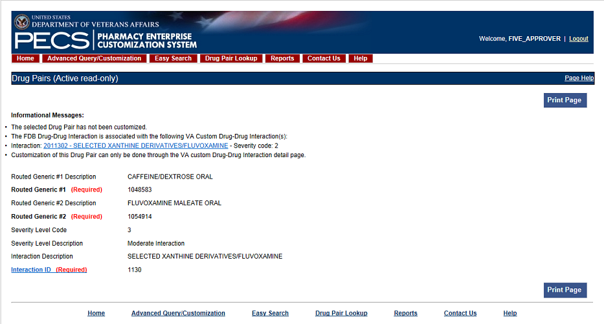
FDB Drug Pair Not Customized, Not Associated with Customized Drug-Drug Interaction
When a user opens an FDB drug pair that has not been customized and is not associated with a customized Drug-Drug Interaction the FDB Drug-Drug Interaction associated with the drug pair is displayed. To customize the FDB Drug-Drug Interaction and the associated drug pairs, select the Interaction ID link.
Figure 154: FDB Drug-Drug Interaction without Customized Drug Pairs
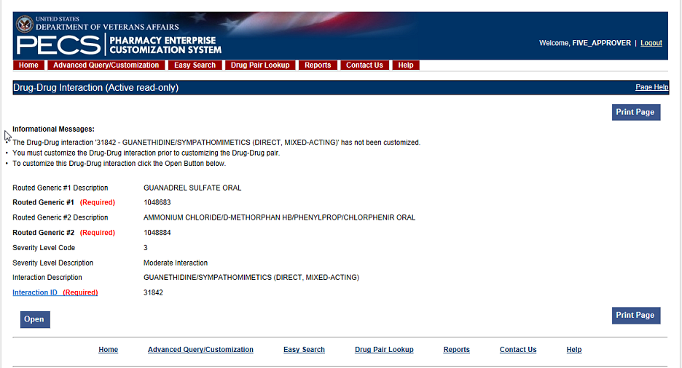
FDB Drug Pair Customized Once
When a user opens an FDB Drug pair that has been customized once they will be presented with the VA customized drug pair and a link to the associated VA Drug-Drug Interaction ID.
Figure 155: Drug Pair Detail Page (Read Only)
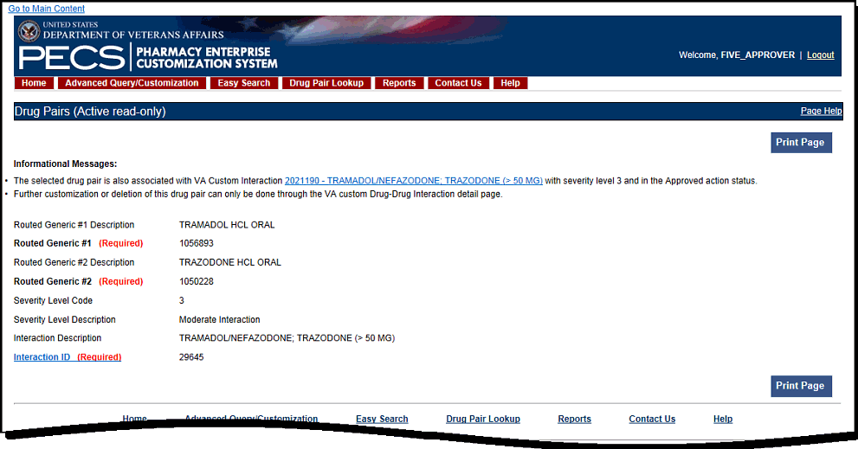
FDB Drug Pair Customized More Than Once
An FDB Drug Pair can be customized more than once. For example, a Drug Pair can be customized for a VA Drug-Drug Interaction and subsequently rejected or deleted. It can then be customized a second time for a different VA DDI. In this case, when the user opens the FDB Drug Pair record, they will not only get information about the FDB drug pair and its associated FDB DDI, but they will see two messages about the drug pair and the custom VA DDIs it is associated with. One message says that the drug pair is rejected, and the other message says that it is in the New Action Status. Two examples follow:
- The following example shows what will display if the user opens an FDB Drug Pair that was customized for and subsequently rejected from DDI 2021210, and then customized a second time for DDI 2021211. Note the informational messages and the links to the FDB and custom VA DDIs:
Figure 156: FDB Drug Pair Message One
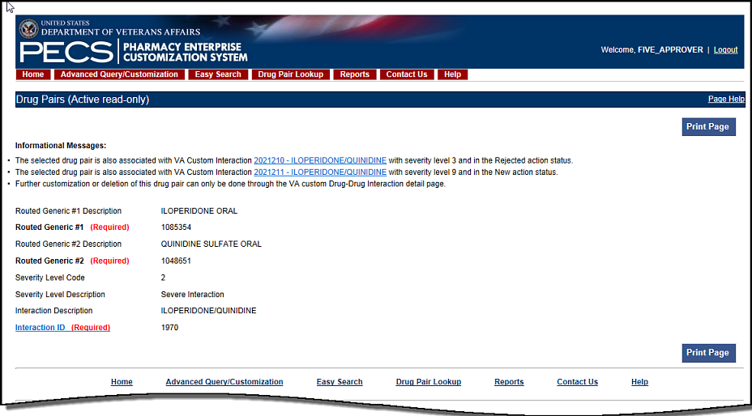
- The following example shows what will display if the user opens an FDB Drug Pair that was customized and subsequently rejected from DDI 2021212, customized a second time and subsequently deleted from DDI 2021213, and customized for DDI 2021214. Note the informational messages and links to all customizations:
Figure 157: FDB Drug Pair Message Two
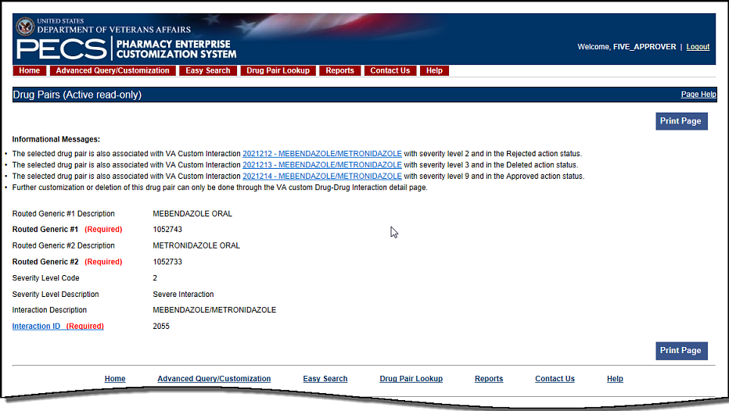

VA Customized Drug Pair Detail Page
When a user opens a VA Customized drug pair, they will be presented with the customized Drug Pair Detail page.
Figure 158: VA Customized Drug Pair
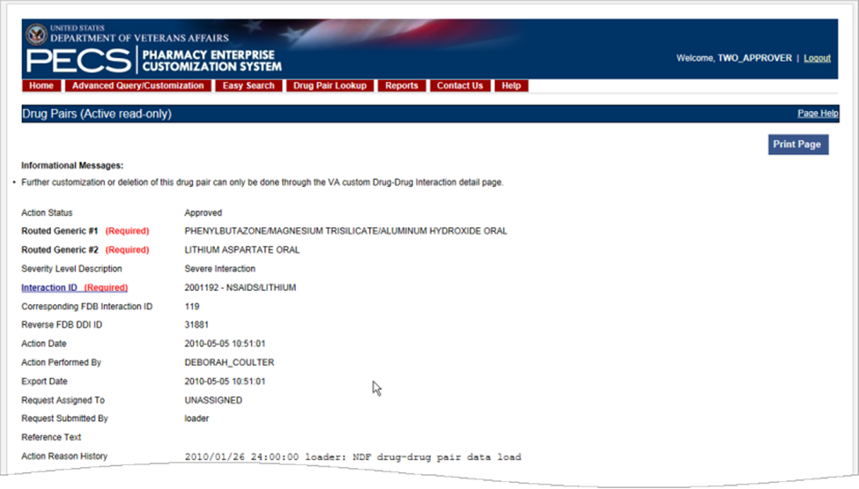

Drug Pair Customization (Non 508-Compliant) Detail
The Drug Pair Customization (Non 508 Compliant) page allows users to create or delete drug pairs associated with the VA Customized Drug-Drug Interaction as well as perform mass VA Workflow updates to all associated Drug Pairs. To reach this page, select the “Drug Pairs” button on a VA customized Drug-Drug Interaction detail page.
Figure 159: Drug Pair Customization Window
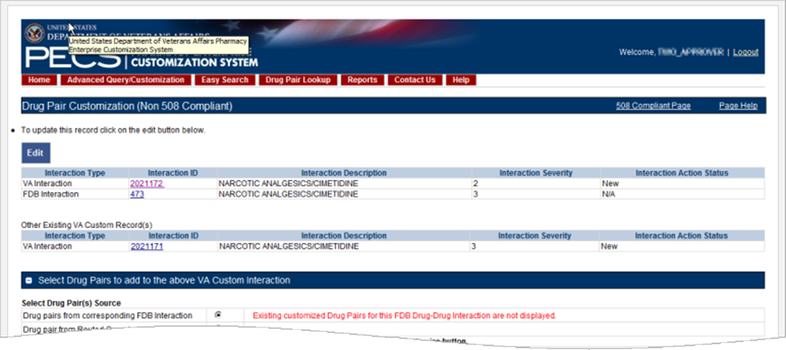
Table 13 displays information related to the drug pair.
Table 13: Drug Pair-related Information
Field Name | Field Description
Interaction Type | The type of interaction displayed, either VA or FDB.
Interaction ID | The numerical reference number assigned to the interaction by the agency referenced in the Interaction Type field.
Interaction Description | The name of the drug pair associated with the interaction.
Interaction Severity | A numerical indicator of the severity of the interaction.
Interaction Action Status | The status of the interaction in the VA Approval Workflow. The Action Status for FDB Records will always be 'N/A,' as it does not go through the VA Approval Workflow
There are two methods to add drug pairs to a drug-drug interaction customization: from existing FDB Drug Pairs (see page ) and from Routed Generics (see page ).
Table 14: Drug Pair Fields
Field Name | Field Description
Reference Text | Field for the user to enter any drug pair reference text needed to support the addition of this/these drug pair(s).
Current Action Reason | Applicable to VA record only. Free form text that can be used to specify the reason for taking the specific action of creating new, modifying, assigning, rejecting, reviewing, approving, or deleting the customization.
Table 15: Drug Pair Buttons
Button Name | Button Description
Customize | Creates the Drug Pair record and associates it to the VA Customized Drug-Drug Interaction.
Cancel Edit | Disregards chosen Drug Pair and any text entered into fields and collapses this panel.

Drug Pairs Panel
The Drug Pairs panel contains all the VA Customized Drug Pairs already associated to the VA Customized Drug-Drug Interaction (noted at the top of the page). The panel contains
- Interaction Description - VA Customized Drug-Drug Interaction Description
- Routed Generic #1 Description - First drug in the drug pair
- Routed Generic #2 Description - Second drug in the drug pair
- Action Status - current status of the Drug Pair
- Request Submitted By - User ID of the PECS user who made the initial customization request
- Action Date - The date of the most recent action
- Action Performed By - User ID of the PECS user who performed the most recent action
- Request Assigned To - User ID of the PECS user who is responsible for reviewing the drug pair information
- Interaction ID - The numerical identifier for the Drug-Drug Interaction
- Severity Level Description - A text description of the interaction severity
- Reference Text - Contents of the Reference Text field
- Severity Level Code - A numerical identifier for the severity of the Drug-Drug Interaction
The checkboxes at the top allow the user to filter what is displayed in the interaction table by Action Status (Historical records are not displayed). They can only process records that are in the same Action Status.
Figure 160: Drug Pair List Filters
The “Get Record Counts” button displays count of all VA customized drug pairs associated with the Drug-Drug Interaction. This helps the user to determine how many drug pairs to select to perform an action against at one time. It is recommended that quantities be limited to 200 drug pairs at a time to prevent negative impacts to system performance.
For more information, see the following:
- Customizing Drug Pairs from the Selection List
- Drug-Drug Interaction Detail

Notification of Drug Pairs Needing Action for an Approved Drug-Drug Interaction
The drug pairs that are associated with a Drug-Drug Interaction (DDI) need to go through the approval/status change process themselves (be approved, rejected, modified, or deleted), separately from the DDI. If the drug pairs are acted upon at the same time as the DDI is acted upon, then there is no problem in an Approver knowing that the drug pair needs to be acted upon. However, drug pairs may be added or modified even after a DDI has been acted upon. The way an Approver will know if they need to act on a drug pair associated with an already-approved DDI is by the row on the home page tables that displays the row “Approved Drug-Drug Interaction with Pending Drug Pairs.”
Figure 161: Approved DDIs with Pending Drug Pairs on Home Page
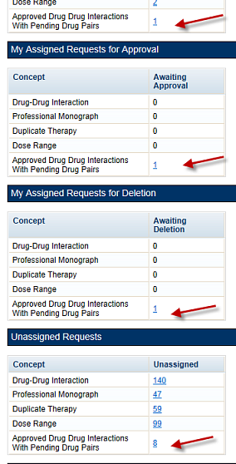
From the screen above, if a user selects the link "My Assigned Drug Pairs Associated with Approved Drug-Drug Interactions" for one of the states listed that has actual counts (not zero), then they are taken to the Advanced Query/Customization page that displays the results for all Drug-Drug Interactions with associated Drug Pairs assigned to the user in that state. Here the user can act on the drug pairs.
Figure 162: My Assigned DDIs with Pending Drug Pairs List
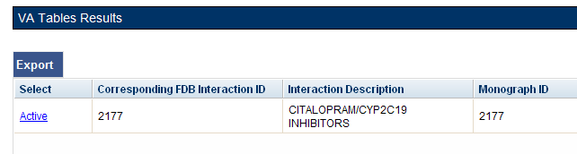
Here is the Interaction window shown after the link is selected from the Advanced Query Page. On the Interaction window the user can act on the drug pairs -- to do so, select the Drug Pairs button:
Figure 163: DDIs with Needed Drug Pairs – Add with Drug Pairs Button
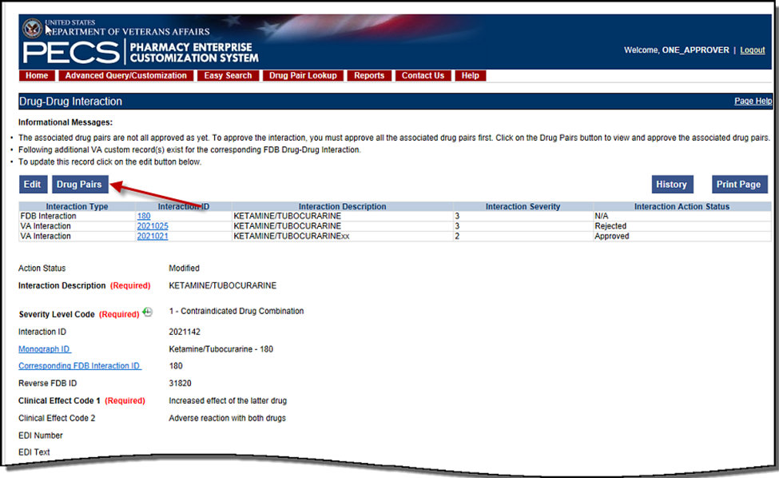
After the user selects the Drug Pairs button, they can go through the process described in Customizing Drug Pairs from the Selection List (after the user clicks the Edit button).
The paragraphs below describe in detail the process for assigning the request to other Approvers for action.
When a user is working with the Drug Pair customization window, there is a drop-down where they can assign the request to a user ID. The default is the Approver who is assigned to the DDI, but that can changed.
Figure 164: Assigned To: Drop-Down
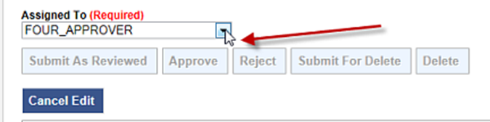
If a user changes the status of the drug pairs to Submit as Reviewed or Submit for Delete, then the drug pairs are automatically reassigned to the "Unassigned" User ID if the user who is assigned to the DDI is the same user who is making the status change. The reassignment happens because the person who submits can’t also do the approval or delete the drug pairs.
Notes: If a user changes the status of the drug pairs to Submit as Reviewed or Submit for Delete, then the drug pairs are automatically reassigned to the “Unassigned” category.
If a user puts a Drug-Drug Interaction (DDI) into the Delete Reviewed status, then the Drug Pairs associated with the DDI must be in either a “Delete Reviewed,” “Rejected” or “Deleted” status.
A routed generic Drug Pair that was deleted and then customized in the reverse order will be listed with those in the New Action Status and displayed in reverse order in the Drug Pairs table on the Drug Pairs Customization page.

Customizing Drug Pairs from the Selection List
PECS allows a user to create multiple drug pairs for an interaction at one time. This same multi-select method allows them to batch process drug pairs for other operations such as Review, Reject, and Delete. The process differs slightly between drug pairs created from a corresponding FDB interaction or using routed generic drugs.
Adding Drug Pairs from Corresponding FDB Interaction
When adding FDB Drug Pairs to an interaction on the Batch Customization page, the user may select single drug pairs, groups of consecutive drug pairs, or a combination of both.
Note: The following instructions are written for the screen that is non-compliant for Section 508. See Section 508 Compliant Drug Pair Customization Detail for instructions on how to use the compliant screen.
To select single drug pairs, simply select the corresponding checkboxes of the drug pairs to be selected.
Figure 165: Drug Pair Selection List
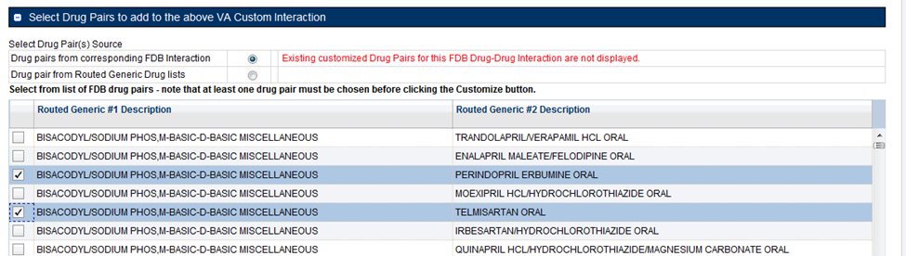
To select groups of consecutive drug pairs, select the first checkbox in the group and then Shift + click (click while holding down the shift key) the last checkbox in the group. All drug pairs between the first and last checkboxes will be selected. If the user wants to add another group to their selection, then select the first checkbox in the second group and Shift + click the last checkbox in the group. Two groups of drug pairs will now be selected. To add other non-consecutive drug pairs, select the corresponding checkbox.
Figure 166: Large Group of Selected Drug Pair for Batch Update
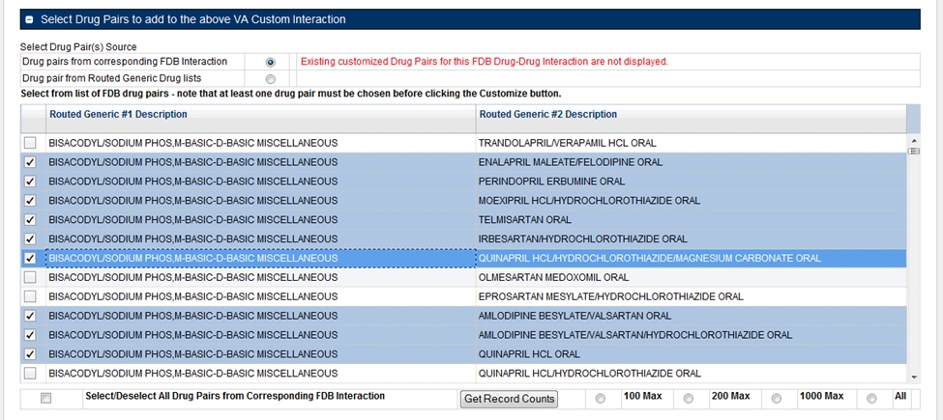
Drug Pairs from Routed Generic Drugs
To select multiple drug pairs from Routed Generic drugs:
- On the Drug Pair Customization window, select Drug pair from Routed Generic Drug lists from the Select Drug Pair(s) Source list.
Figure 167: Select Drug Pairs Source List
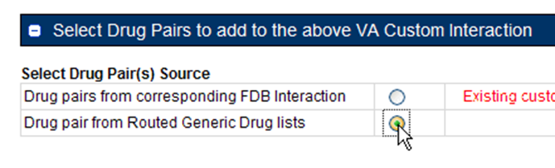
- Select Edit.
- Enter all or part of a routed generic drug name in the Routed Generic 1 field. To display all routed generic drugs, enter *. The list will populate automatically, but the process may take some time based on server load and the specificity of the search term.
- Enter all or part of a routed generic drug name in the Routed Generic 2 field. To display all routed generic drugs, enter *. The list will populate automatically, but the process may take some time based on server load and the specificity of the search term.
- To select a range of routed generic drugs from the results list, select the first item in the range, then Shift + click the last item in the range. Use the scroll bar on the results list if the last item in the range is not immediately visible.
Figure 168: Range Selection of Routed Generic Drugs
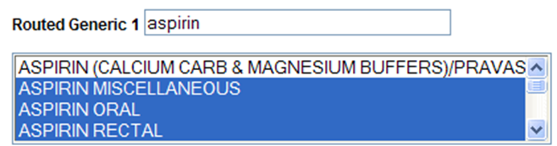
- To select non-consecutive items in the results list, select the first item, then Ctrl + click (click while holding down the Ctrl key) any additional items. Use the scroll bar on the results list if the last item in the range is not immediately visible. This technique can also be used to de-select items within a previously selected range of items.
Figure 169: Individual Selection of Routed Generic Drugs
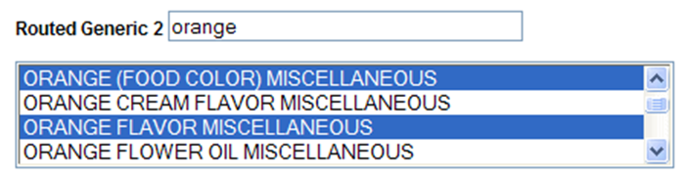
- Select the Customize button. After processing, the new drug pairs will appear in the Drug Pairs list. In this example, six new drug pairs were created: each of the three selected Routed Generic 1 drugs is now paired with the two selected Routed Generic 2 drugs.
Figure 170: Drug Pairs List Selection List
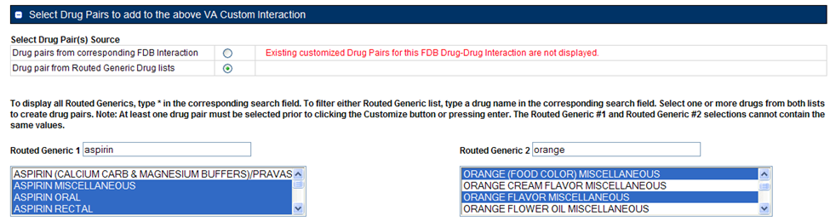
Figure 171: Drug Pairs List
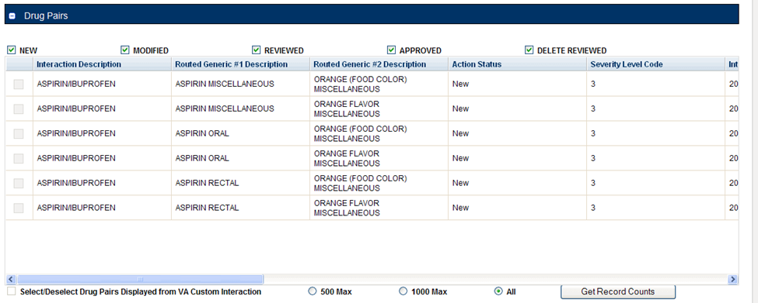
Batch Update Drug Pairs
A user can use the quick selection processes described above to change the actions status of multiple drug pairs at the same time. The Action buttons available are dependent upon the action status of the selected drug pairs. Only mutually appropriate actions will be available.

Review a Drug Pair
An Approver may be assigned to review drug pairs associated with a drug-drug interaction. The options are to either Submit as Reviewed, indicating that the Drug Pair associated with the drug-drug interaction is appropriate, or Reject the Drug Pair as inappropriately associated with the Drug-Drug interaction.
To review a drug pair associated with an interaction customization:
- From the Drug-Drug Interaction record, select Drug Pairs.
Figure 172: Drug Pairs Button
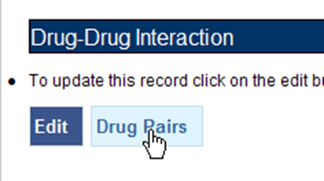
- When the Drug Pair Customization page appears, select Edit.
Figure 173: Edit Button on the Drug Pair Customization Page
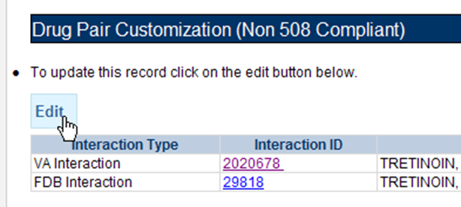
- In the Drug Pairs panel, select one or more drug pairs currently associated with the drug-drug interaction. For information on selecting multiple items within a list, see Customizing Drug Pairs from the Selection List.
Figure 174: Drug Panel for Selecting Drug Pairs
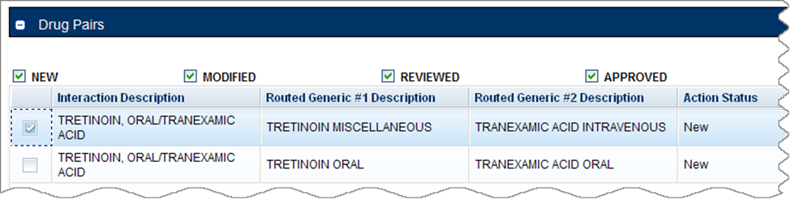
- Using the Assigned To list, select the person to Approve the drug pair association with the selected drug-drug interaction. If unsure who this should be, then select Unassigned.
Figure 175: Assigned To List
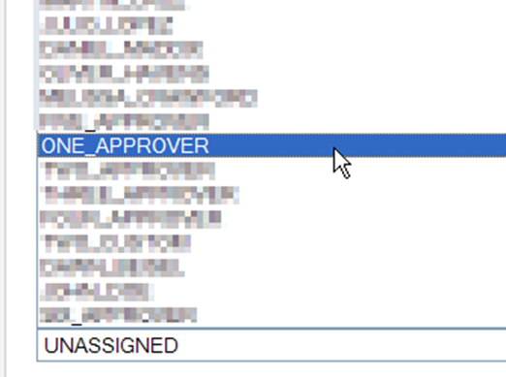
- Select Submit as Reviewed to indicate that the drug pair has been reviewed and confirm that it is correctly associated with the selected drug-drug interaction. Select Reject to indicate that the drug pair is not correctly associated with the selected drug-drug interaction -- this will remove the drug pair from the record. Select Cancel Edit to abandon the current editing session and leave the record unchanged.
Figure 176: Buttons Available to Choose From
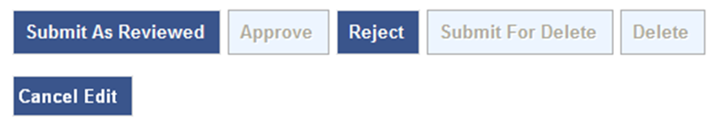
Note: Drug Pair records can be modified after they have been Reviewed.

Section 508 Compliant Drug Pair Customization Detail
Note: These are the instructions for the Section 508 compliant version of the Drug Pair Customization page. For Non-compliant Drug Pair customization, see Drug Pair Customization (Non 508-Compliant) Detail.
To reach the Section 508-Compliant version of the Drug Pair Customization page:
- Select the “Drug Pairs” button on a VA customized Drug-Drug interaction detail page.
- Select the 508-Compliant Page link in the Drug Pair Customization banner.
Figure 177: Link to Access 508-Compliant Drug Pair Selection Page

Select Drug Pairs to Add to the Above VA Custom Interaction Panel
These are instructions on how to select drug pairs on the Section 508 Compliant Drug Pair Customization page.
Add Routed Generic to VA Custom Interaction
If the interaction is customized from a blank form, then there are no FDB drug pairs to choose from. The user will choose drug pairs from Routed Generic drug lists. The user will select the first drug “Routed Generic #1 Description” and then select the second drug “Routed Generic #2 Description” for the Drug Pair they are associating to this VA customized Drug-Drug Interaction. Note that a drug pair must be chosen before selecting the “Customize button”. “Routed Generic #1” and “Routed Generic #2” fields cannot contain the same chosen value. “'Routed Generic #1” and “Routed Generic #2”' must follow the same order as the Interaction Description. The user must be careful to select all routed generics that contain the desired drug as an ingredient. Combination products may not fall alphabetically close to single ingredient products. The Routed Generic drug lists can also be used to add drug pairs to a drug-drug interaction customized from an FDB record if the drug pairs to be added do not exist in the FDB database.
Figure 178: Routed Generic Drug List on 508-Compliant Page
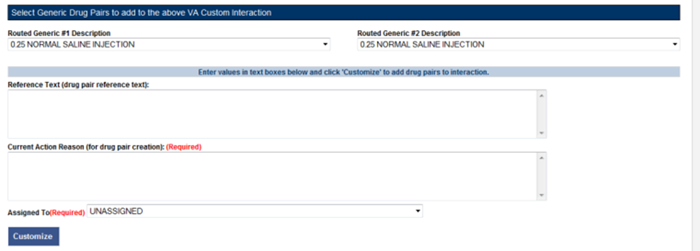
To add a Routed Generic drug pair:
- Select the Edit button.
- In the "Select Generic Drug Pairs to add to the above VA Custom Interaction" panel, select the first drug from the Routed Generic #1 Description list.
- Select the second drug from the Routed Generic #2 Description list.
- Add any available reference text to the Reference Text field. This is not required.
- Add a reason for the current action in the Action Reason field. This is required.
- Select a PECS user to review the action in the Action Reason field.
- Select the Customize button.
Add FDB Drug Pairs to VA Custom Interaction
If the interaction is customized from an FDB record, the user can select any or all of the corresponding FDB drug pairs. Each FDB drug pair consists of Routed Generic #1 and Routed Generic #2. Select the checkbox adjacent to the drug pair or pairs to select it to add to the custom interaction.
Figure 179: Corresponding FDB Drug Pairs, 508-Compliant Page Top
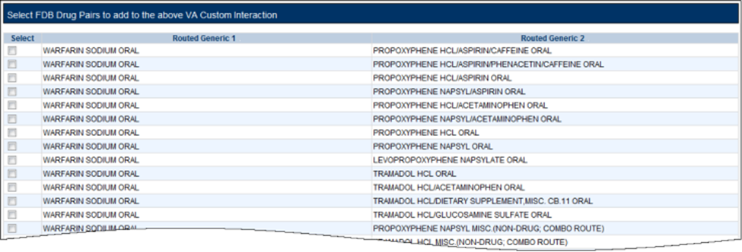
Figure 180: Corresponding FDB Drug Pairs, 508-Compliant Page Bottom
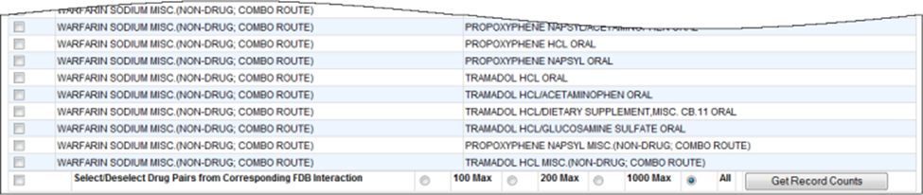
To add a FDB drug pair:
- Select the Edit button.
- In the "Select FDB Drug Pairs to add to the above VA Custom Interaction" panel, select the check box adjacent to the drug pair to be added to the customization. Users can select more than one drug pair. To select all the drug pairs, select the 'Select/Deselect All Drug Pairs Displayed from Corresponding FDB Interaction' check box, and to limit the number selected, select one of the number-specific radio buttons.
- Add any available reference text to the Reference Text field. This is not required.
- Add a reason for the current action in the Action Reason field. This is required.
- Select a PECS user to review the action in the Action Reason field.
- Select the Customize button.
Drug Pairs Panel
The Drug Pairs panel contains all the VA Customized Drug Pairs already associated to the VA Customized Drug-Drug Interaction (noted at the top of the page). The panel contains:
- Interaction Description - VA Customized Drug-Drug Interaction Description
- Routed Generic #1 Description - First drug in the drug pair
- Routed Generic #2 Description - Second drug in the drug pair
- Action Status - current status of the Drug Pair
- Request Submitted By - User ID of the PECS user who made the initial customization request
- Action Date - The date of the most recent action
- Action Performed By - User ID of the PECS user who performed the most recent action
- Request Assigned To - User ID of the PECS user who is responsible for reviewing the drug pair information
- Interaction ID - The numerical identifier for the Drug-Drug Interaction
- Severity Level Description - A text description of the interaction severity
- Reference Text - Contents of the Reference Text field
- Severity Level Code - A numerical identifier for the severity of the Drug-Drug Interaction
The checkboxes at the top allow the user to see what is displayed in the interaction table by Action Status (Historical records are not displayed). The drug pairs must be in the same state before an action can be performed on them.
Figure 181: Drug Pair List Filters
The 'Get Record Counts' button will display the count of all VA customized drug pairs associated with the Drug-Drug Interaction. This helps to determine how many drug pairs require processing. It is recommended that no more than 200 drug pairs are processed at a time to prevent negative impacts to system performance.
To perform a batch update on the drug pairs:
- Use the Action Status checkbox filters to make sure all drug pairs selected are in the same Action Statuses
- Select the amount that will be updated in this one action
- Select all or the individual drug pairs
- Select the allowed Approval Workflow action to be performed (Submit as Reviewed, Approve, Reject, etc.)
Repeat this process for all of the drug pairs until the entire set of drug pairs is in the desired point in the Approval Workflow.

Professional Monograph Detail
A Professional Monograph is a document containing drug interaction information written for healthcare professionals. The Professional Monograph Detail Page allows the user to view the details of a Professional Monograph and customize it for VA use.
FDB monographs are not generally customized, however some Professional Monographs have been created from blank documents at the national level for drug interactions that do not appear in the FDB database.
Figure 182: Professional Monograph Detail Top
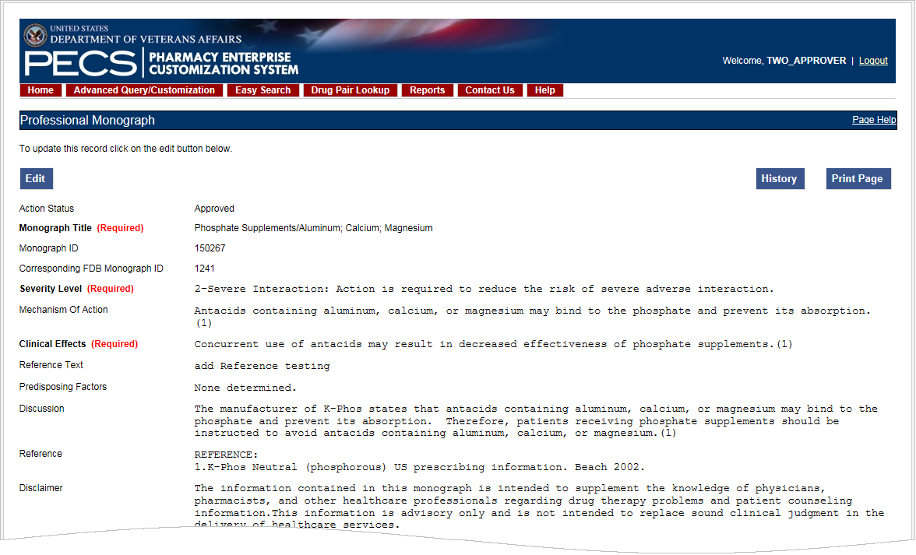
Figure 183: Professional Monograph Detail Bottom
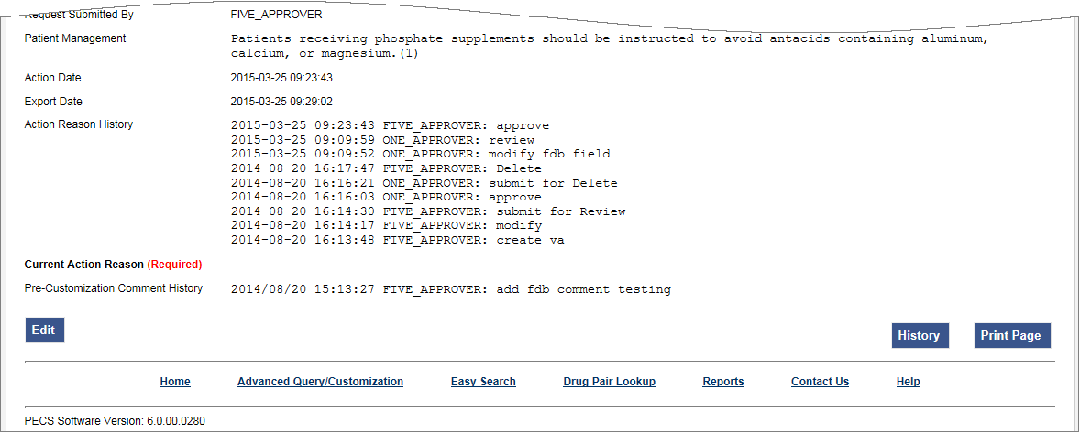

Fields
Fields that cannot be modified are shaded within PECS.
Table 16: Professional Monograph Fields
Field Name | Field Description
Monograph Title | The title Monograph is usually the two drugs that have the interaction.
Monograph ID | The VA-assigned numerical identifier for the Monograph.
Action Status | Applicable to VA record only. The point this customization is at, within the VA Approval Workflow.
Action Date | Applicable to VA record only. The date of the last action taken on the record.
Action Performed by | Applicable to VA record only. The name of the user that performed the last action.
Action Effective Date | Applicable to VA record only. The date of the last action taken on the record.
Corresponding FDB Monograph ID | The First Databank (FDB)-assigned numerical identifier for the Monograph.
Request Assigned To | Applicable to VA record only. Approver the request is assigned to.
Request Submitted By | Applicable to VA record only. The name of the user that submitted this VA request.
Severity Level | The severity level associated with the interaction.
Mechanism Of Action | The specific biochemical interaction through which a drug interaction occurs. For instance, pharmacokinetic drug interactions may include:  - Inhibition of absorption  - Enzyme inhibition increasing the risk of toxicity  - Enzyme inhibitors resulting in reduced drug effect  - Enzyme induction resulting in reduced effect  - Enzyme induction resulting in toxic metabolites  - Altered renal elimination  Pharmacodynamic drug interactions include:  - Additive effects  - Antagonistic pharmacodynamic effects
Clinical Effects (required) | The Clinical effects associated with the interaction.
Predisposing Factors (optional) | The factors or conditions that render an individual vulnerable to a drug interaction?
Patient Management (optional) | Describe the management options available to the provider, for example, Discontinuation of the medication, increased monitoring, laboratory tests, and scheduling the medication at different times
Discussion | Usually case reports or discussion.
Reference | Cited reference information.
Disclaimer | Textual reminder that the information provided is not intended to replace the user's clinical judgment.
Reference Text | Applicable to VA record only. Field for the user to enter any reference text needed to support customization of the Professional Monograph.
Action Reason History | Applicable to VA record only. All historical current action reason comments for this record, in one viewable field.
Current Action Reason | Free form text that can be used to specify the reason for taking the specific action of creating new, modifying, assigning, rejecting, reviewing, approving, or deleting the customization.
Export Date | For Approved or Deleted records. Indicates the date of the last Custom Update. See Export Date for additional information.

Buttons
Table 17: Professional Monograph Buttons
Button Name | Field Description
Print Page | Allows the user to print the page being viewed.
History | Allows the user to open the history of changes report.
Comment | Add a pre-customization comment (FDB Only)

Forward and Reverse Professional Monograph
A single VA Custom Drug-Drug Interaction could be associated with a separate custom Professional Monograph for the forward and reverse interactions. An interaction described as Drug A and Drug B would have a different Custom Monograph from an interaction described as Drug B and Drug A. These different monographs may be necessary because there could be a different Clinical Effect Code between forward and reverse interactions (DrugA+DrugB: Clinical Effect Code = Adverse effects of the former drug; DrugB+DrugA: Clinical Effect Code = Adverse effects of the latter drug).
The following VA Custom Professional Monograph pairs will be associated with each other. This means that when a Monograph is assigned to a VA Custom Drug-Drug Interaction, the corresponding Monograph will be automatically assigned to the reverse Drug-Drug Interaction (DDI1 = DrugA + DrugB; DDI2 = DrugB+DrugA).
Below is a list of the monograph IDs and titles, and the paired Monograph ID and title.
Table 18: Forward and Reverse Professional Monograph Pairs
Monograph ID and Title | Paired Monograph ID and Title
150022 VA Customized: Adverse Effects of Former Drug (Critical) (ARF1) | 150024 VA Customized: Adverse Effects of Latter Drug (Critical) (ARL1)
150023 VA Customized: Adverse Effects of the Former Drug (Significant) (ARF2) | 150025 VA Customized: Adverse Effects of the Latter Drug (Significant) (ARL2)
150030 VA Customized: Decreased Effects (Critical) (DEF1) | 150032 VA Customized: Decreased Effects (Critical) (DEL1)
150031 VA Customized: Decreased Effects (Significant) (DEF2) | 150033 VA Customized: Decreased Effects (Significant) (DEL2)
150034 VA Customized: Increased Effects (Critical) (INF1) | 150036 VA Customized: Increased Effects (Critical) (INL1)
150035 VA Customized: Increased Effects (Significant) (INF2) | 150037 VA Customized: Increased Effects (Significant) (INL2)
150040 VA Customized: Mixed Effects of Former Drug (Critical) (MXF1) | 150103 VA Customized: Mixed Effects of Latter Drug (Critical) (MXL1)
150041 VA Customized: Mixed Effects of the Former Drug (Significant) (MXF2) | 150104 VA Customized: Mixed Effects of the Latter Drug (Significant) (MXL2)
When viewing a Drug-Drug Interaction, the PECS user interface will only display the Professional Monograph associated with the Forward interaction. The associated Reverse Professional Monograph will only be visible in the custom updates file created by the Release Manager.
Figure 184: Forward/Reverse DDIs with Professional Monographs, Custom Update File Created by Release Manager
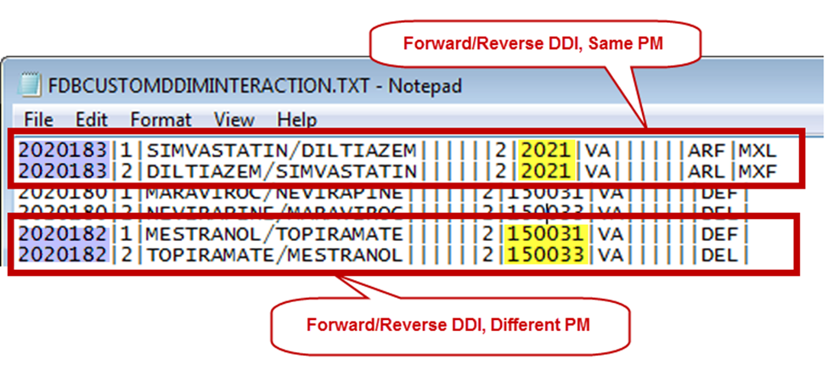

Duplicate Therapy Detail
The Duplicate Therapy Detail page allows the user to view and edit the details of a Duplicate Therapy record. If an FDB record is edited, then the result is a VA Customization Request. For FDB records that have not been customized, the user has the option of adding a comment that will be retained with the record. If the record is later customized, then these pre-customization comments will be displayed with the customized record. Once the FDB record has been customized, a link to the VA customized record will be provided. FDB Duplicate Therapy records can be customized only once. If the record has already been customized, then it displays in Read-only mode, and it will not be customizable again (the Edit button will not display).
Figure 185: Duplicate Therapy Detail
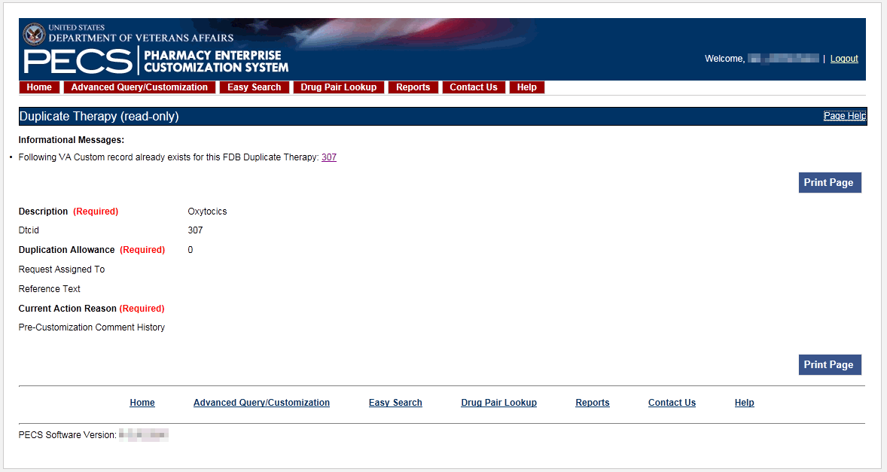

Fields
Table 19: Duplicate Therapy Detail Fields
Field Name | Field Description
DTCID | Duplicate therapy ID assigned by First Databank (FDB).
Custom Dup Allowance | The number of drugs a patient can be prescribed, within a Therapeutic Drug Class, before an alert is generated. A 0 duplicate allowance means only 1 medication from that Therapeutic class can be on the patient profile without getting an order check (zero duplication). If a second drug from that class is added the provider gets the order check. If the allowance is 1, two drugs can be on the patient profile at once, the 3rd drug added would get the check (one duplication), etc.
Description | The name of this Therapeutic Drug Class.
Action Status | Applicable to VA record only. The point this customization is at, within the VA Approval Workflow.
Action Date | Applicable to VA record only. The date of the last action taken on the record.
Export Date | For Approved or Deleted records. Indicates the date of the last Custom Update. See Export Date for additional information.
Action Effective Date | Applicable to VA record only. The date of the last action taken on the record.
Action Performed By | Applicable to VA record only. The name of the user that performed the last action.
Request Assigned To | Applicable to VA record only. A drop down list to assign an approver.
Request Submitted By | Applicable to VA record only. The name of the user that submitted this VA request.
Action Reason History | Applicable to VA record only. All historical current action reason comments for this record, in one viewable field.
Reference text | Field for the user to enter any reference text needed to support customization of the Duplicate Allowance.
Current Action Reason | Applicable to VA record only. Free form text that can be used to specify the reason for taking the specific action of creating new, modifying, assigning, rejecting, reviewing, approving, or deleting the customization.

Buttons
Table 20: Duplicate Therapy Detail Buttons
Button Name | Field Description
Print Page | Allows the user to print the page being viewed.
History | Allows the user to open the history of changes report.
Comment | Un-customized FDB Records Only: Add a Pre-Customization comment to the FDB record.

Dose Range Detail
A Dose Range is the allowable dosage of a drug based on a number of factors such as patient age, weight, and Dose Route. The Dose Range Detail page allows the user to view the details of a Dose Range record. If the FDB record is Concept Type 6 (Generic Dispensable Drug), then it can be customized. For FDB records of concept type other than 6, the only action that can be taken is to add a comment. Once the FDB record has been customized, a link to the VA customized record (or records) will be provided. For VA records, a link to the original FDB record (if one exists) is provided as well as any additional customizations to the same FDB record.
Figure 186: Dose Range Detail Top
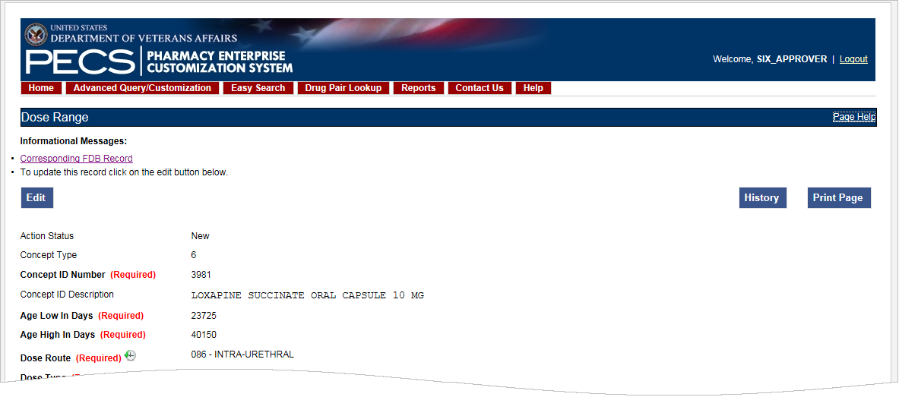
Figure 187: Dose Range Detail Bottom
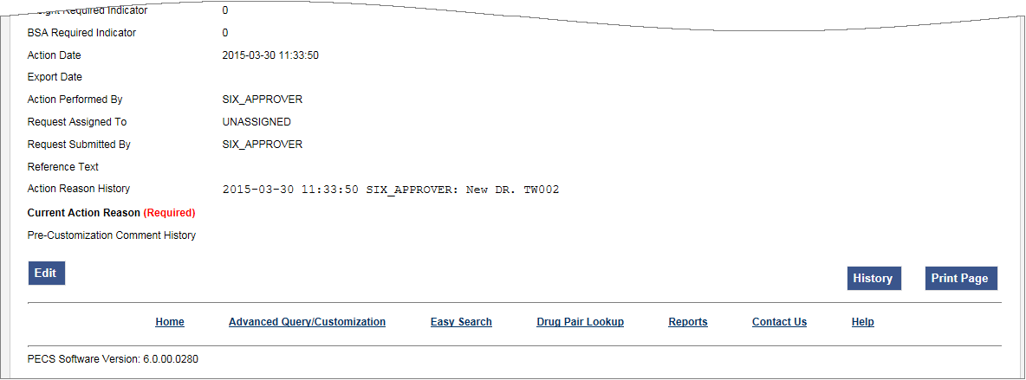

Dose Range Concept Types
FDB Dose Range records can be associated to different drug Concept Types (a type associated in the FDB drug database that PECS uses). However, only Concept Type 6 - Generic Dispensable Drug can be customized. The Concept Types are:
1 -- Drug Name
2 -- Routed Drug
3 -- Dispensable Drug
4 -- Generic Drug Name
5 -- Generic Routed Drug
6 -- Generic Dispensable Drug
7 -- Routed Dosage Form Drug
8 -- Generic Routed Dosage Form Drug
100 -- Packaged Drug
101 -- Manufactured Drug
102 -- Reference Only Item
103 -- Compound
104 -- Ingredient
105 -- Regional Packaged Drug
106 -- Total Parenteral Nutrition Solution

Fields
Table 21: Dose Range Detail Fields
Field | Description
Concept Type | Number identifying the drug's concept type (FDB dose range category)
Concept ID Number | Number identifying the drug (For Concept Type = 6, Concept ID number = GCNSEQ code - an FDB product code)
Concept ID Description | The name of the drug being described.
Action Status | Applicable to VA record only. The point this customization is at, within the VA Approval Workflow.
Age Low in Days | Lowest patient age in days to which dosing information applies
Age High in Days | Highest patient age in days to which dosing information applies
Action Effective Date | Applicable to VA record only. The date of the last action taken on the record.
Dose Route | Dose route
Dose Type | Dose type
FDBDX | A nine-character alphanumeric coding system developed by First DataBank that identifies specific disease states or side effects.
DXID | DXID type code to identify a Medical Condition
Dose Low | Minimum amount to be administered per day
Dose Low Units | Unit of measure for low dose per day
Dose High | Highest amount to be administered per day
Dose High Units | Unit of measure for high dose per day
Dose Form Low | Low dose for a given dose form
Dose Form Low Units | Unit of measure for the dose form
Dose Form High | High dose for a given dose form
Dose Form High Units | Unit of measure for the dose form
Frequency Low | Indicates the low end of a drug's frequency of administration per day
Frequency High | Indicates the high end of a drug's frequency of administration per day
Duration Low | Indicates the lowest recommended duration of therapy (in days)
Duration High | Indicates the highest recommended duration of therapy (in days)
Max Duration | Indicates the maximum recommended duration of therapy (in days)
Max Single Dose | Maximum amount to be administered in a single dose
Max Single Dose Units | Unit of measure for the maximum single dose
Max Single Dose Form | Maximum single dose for a given form
Max Single Dose Form Units | Unit of measure for the dose form
Max Daily Dose | Maximum amount to be administered per day
Max Daily Dose Units | Unit of measure for the maximum daily dose
Max Daily Dose Form | Maximum daily dose for a dose form
Max Daily Dose Form Units | Unit of measure for the dose form
Max Lifetime Dose | Maximum amount to be administered over a patient’s lifetime, if available
Max Life Time Dose Units | Unit of measure for maximum lifetime dose
Max LifeTime Dose Form | Maximum lifetime dose for a given dose form
Max LifeTime Dose Form Units | Unit of measure for the dose form
Dose Rate Low | Minimum amount to be administered per dose rate (hours or minutes)
Dose Rate Low Units | Unit of measure for low dose rate (hours or minutes)
Dose Rate High | Highest amount to be administered per dose rate (hours or minutes)
Dose Rate High Units | Unit of measure for high dose rate (hours or minutes)
Dose Form Rate Low | Low dose for a given dose form rate (hours or minutes)
Dose Form Rate Low Units | Unit of measure for the dose form rate (hours or minutes)
Dose Form Rate High | High dose for a given dose form rate (hours or minutes)
Dose Form Rate High Units | Unit of measure for the dose form rate (hours or minutes)
Max Single Dose Rate | Maximum amount to be administered in a single dose rate (hours or minutes)
Max Single Dose Rate Units | Unit of measure for the maximum single dose rate (hours or minutes)
Max Single Dose Form Rate | Maximum single dose for a given dose form rate (hours or minutes)
Max Single Dose Form Rate Units | Unit of measure for the dose form rate (hours or minutes)
Max Daily Dose Rate | Maximum amount to be administered per dose rate (hours or minutes)
Max Daily Dose Rate Units | Unit of measure for the maximum daily dose rate (hours or minutes)
Max Daily Dose Form Rate | Maximum daily dose for a dose form rate (hours or minutes)
Max Daily Dose Form Rate Units | Unit of measure for the dose form rate (hours or minutes)
Hepatic Impairment IND | Boolean (0/1) indicating whether dosing needs to be adjusted for hepatic impairment
Renal Impairment IND | Boolean (0/1) indicating whether dosing needs to be adjusted for renal impairment
CRCL Threshold | Number indicating lowest creatinine clearance to which dosing applies
CRCL Threshold Units | Unit of measure for the creatinine clearance threshold
Low Elimination Half Life | Indicates the low end of the drug's half-life range
High Elimination Half Life | Indicates the high end of the drug's half-life range
Half Life Units | Unit of time for the half-life range of a drug
Weight Required IND | Boolean (0/1) indicating whether weight is required for dosing
BSA Required IND | Boolean (0/1) indicating whether body surface area is required for dosing
Request Submitted By | Applicable to VA record only. The name of the user that submitted this VA request.
Request Assigned To | Applicable to VA record only. A drop down list to assign an approver.
Action Performed By | Applicable to VA record only. The name of the user that performed the last action.
Action Date | Applicable to VA record only. The date of the last action taken on the record.
Export Date | For Approved or Deleted records. Indicates the date of the last Custom Update. See Export Date for additional information.
Reference Text | Applicable to VA record only. Field for the user to enter any reference text needed to support customization of this Dose Range.
Action Reason History | Applicable to VA record only. All historical 'current action reason' comments for this record, in one viewable field.
Current Action Reason | Applicable to VA record only Free form text that can be used to specify the reason for taking the specific action of creating new, modifying, assigning, rejecting, reviewing, approving, or deleting the customization.

Buttons
Table 22: Dose Range Detail Buttons
Button Name | Field Description
Print Page | Allows the user to print the page being viewed.
History | Allows the user to open the history of changes report.
Comment | Add a Pre-Customization comment (FDB Only).

Sample Modification Scenarios
The following scenarios are examples of the types of modifications a typical user may perform. It is not a step-by-step guide in instructing users how to perform actual modifications. Sample steps are given, but these could differ based on the customizations being modified.

Duplicate Therapy Modification
Sample case: Making a Duplicate Therapy customization for Topical Pine Tar.

Process Steps
Edit duplicate therapy allowance:
- From the Home Page, select the Advanced Query/Customization tab.
- Select “Duplicate Therapy” from the Select a Concept drop-down and select ‘FDB’ from the Select VA, FDB, or Both drop-down
- Build the query as follows: Fields=Description; Filter=contains; Value=Tar.
- Select the Query button.
- Look at the query results at the bottom of the page.
- Select the Open link for the desired class of drug.
- The following is displayed:
Figure 188: Duplicate Therapy Modification
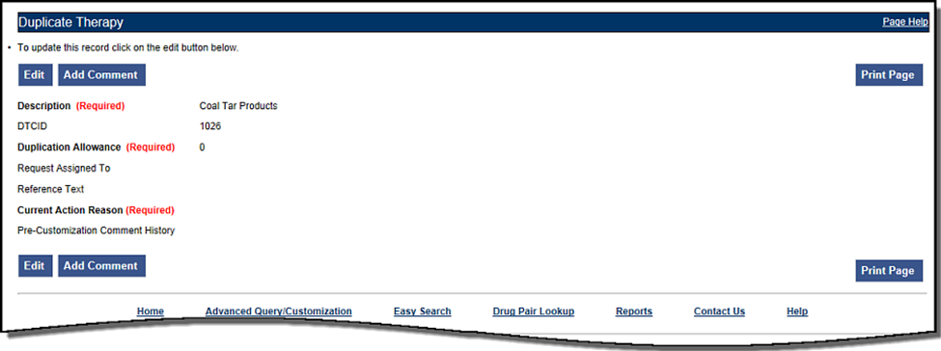
- Select the Edit button to edit the record.
- Select the drop down arrow on Custom Dup Allowance (required) and select another number.
- Enter a Description (required).
- Enter the Current Action Reason (required).
- Add any reference text needed (optional).
- Select the Customize button.

Duplicate Therapy Approval
Sample Case: After the duplication allowance has been edited for the above situation, the user needs to submit the request for approval. Assign this request to FOUR_APPROVER.

Process Steps
- From the Home page, look at My Request History.
- Select the link to the NEW Duplicate Therapy requests.
- Look at the query results at the bottom of the page.
- Select the link for the desired class of drug (Topical Pine Tar).
- Review the information.
- Select the Edit button to edit the record.
- Select the next business reviewer’s name in Request Assigned To (optional) field.
- Indicate the action reason in Current Action Reason (optional) field.
- Select the Submit As Reviewed button.

Drug Interaction Research
Sample Case: The chief of urology has been told by the Pfizer sales rep that the VA has no drug-drug interaction between Sildenafil and Tamsulosin. The chief insists that a significant (severity level 2) interaction be added to the system.

Process Steps for Severity Check, Case 1
Check severity of an existing drug-drug interaction.
- From the Home page, Select the Drug Pair Lookup tab.
- Fill in known information (Drug A: Sildenafil; Drug B: Tamsulosin).
- Select the Query button.
- Review the VA custom records and FDB record.
- Note existing VA custom interaction between Sildenafil and Tamsulosin with severity level 2 and FDB interaction with severity level 3.
- No action needed.

Drug Interaction Severity Change
Sample Case: The FDA recently issued a black box warning stating that Cyclosporine and Tolterodine should never be used together due to risk of renal toxicity. This interaction is considered severity level 3 (moderate) by First Data Bank. Based on the issuance of this black box warning, the NDF support group is recommending the severity level be changed to 1 (critical). Create custom drug-drug pairs for this new VA custom drug-drug interaction.

Process Steps for Editing Case 1
Edit the severity of an existing FDB drug interaction
- From Home page, choose the Advanced Query/Customization tab.
- Select “Drug-Drug Interaction” from the Select a Concept drop-down and select ‘FDB’ from the Select VA, FDB, or Both drop-down.
- Build the Query: Fields=Interaction Description; Filter=contains; Value=Cyclosporine; And/Or=Or.
- Build Query: Column=Interaction Description; Constraints=contains; Value=Tolterodine.
- Select the Query button.
- Look at the query results at the bottom of the page.
- Select the Open link for desired Interaction Description.
- Select the Edit button to edit the record.
- Select the drop down arrow on Severity Level Code (required).
- Select the new desired severity level code (1).
- Indicate the action reason in the free text Current Action Reason (required) field.
- Select the Customize button.
- Select Drug Pairs button.
- Select the Edit button to edit the Drug Pairs.
- If the section is not expanded, select the plus sign on Select Drug Pairs to add to the above VA Custom interaction bar.
- If the radio button is not selected, select the radio button for “Drug Pairs from Corresponding FDB Interaction.”
- Select desired drug pairs to add to the custom interaction.
- Indicate the action reason in the free text Current Action Reason (required) field.
- Select the Customize button.
To Submit as Reviewed:
- From the home page, look at My Request History.
- Select the NEW Drug-Drug Interactions link.
- Look at the query results at the bottom of the page.
- Select the link for the desired interaction description (Tolterodine/Cyclosporine).
- Select the Drug Pairs button.
- Select the Edit button.
- Scroll down to Drug Pairs section, and select the newly added Drug Pair
- Select the Submit as Reviewed button.
- Select the link at the top of the page for the VA interaction
- Select the Edit button.
- Review the information.
- Indicate the Action Reason in the free text Current Action Reason (required) field.
- Select the Submit as Reviewed button.

Drug Interaction Severity Change
Sample Case: Over the past six months, several local VA facilities have reported adverse reactions (ADRs) involving the use of Digoxin and Metoclopramide resulting in Digoxin toxicity requiring hospital admissions for management. This interaction is classified as severity level 3 (moderate) by FDB and therefore does not create an alert in the physician order entry process. The NDF support group has approved the change of the severity level from 3 to 2 (severe) to provide for order alerts and has assigned the task to be completed. Create custom drug-drug pairs for this new VA custom drug-drug interaction. Then submit the new interaction and drug pairs as reviewed.

Process Steps for Editing Case 2
Edit the severity of an existing FDB drug interaction
- From the Home page, choose the Advanced Query/Customization tab.
- Select “Drug-Drug Interaction” from the Select a Concept drop-down and select ‘FDB’ from the Select VA, FDB, or Both drop-down.
- Build the Query: Fields=Interaction Description; Filter=contains; Value=Digoxin; And/Or=And.
- Build the Query: Fields=Interaction Description; Filter=contains; Value=Metoclopramide.
- Select the Query button.
- Look at the query results at the bottom of the page.
- Select the Active link for the desired Interaction Description.
- Select the Edit button.
- Select the drop down arrow on Severity Level Code (required).
- Select the desired new severity level code (2).
- Indicate the action reason in the free text Current Action Reason (required) field.
- Select the Customize button.
- Select Drug Pairs button.
- Select the Edit button.
- If the section is not expanded, select the plus sign on Select Drug Pairs to add to the above VA Custom interaction bar.
- If the radio button is not selected, select the radio button for ‘drug pairs from corresponding FDB interaction.’
- Select the checkbox for ‘Select/Deselect all drug Pairs from corresponding FDB interaction.’
- Indicate the action reason in the free text Current Action Reason (required) box
- Select the Customize button.
- From the Home page, look at My Request History.
- Select the NEW Drug-Drug Interactions link.
- Look at the query results at the bottom of the page.
- Select on the Active link for the desired interaction description (digoxin/metoclopramide).
- Select Drug Pairs button (Drug pairs should be submitted as reviewed prior to submitting the interaction for review)
- Scroll to the Drug Pairs Bar
- Select the Edit button
- Select the checkbox for ‘Select/Deselect All Drug Pairs Displayed from VA Custom Interaction’
- Select the Submit as Reviewed button.
- Select on the VA Interaction ID at top of page to navigate to Drug Interaction Detail page
- Select the Submit as Reviewed button.

Remove Drug Pair from Interaction
Sample Case: The user has been asked to remove the drug pair Sumatriptan Nasal/Tranylcypromine Sulfate Oral from the existing VA custom drug-drug interaction Selected 5HT-1D Agonists/MAO Inhibitors.

Process Steps
Remove or add a drug pair from an existing VA custom drug-drug interaction.
- Choose the Advanced Query/Customization tab.
- Select “Drug-Drug Interaction” from the Select a Concept drop-down and select ‘VA’ from the Select VA, FDB, or Both drop-down.
- Build the Query: Column=Interaction Description; Filter=contains; Value=Selected 5HT.
- Select the Query button.
- Look at the query results at the bottom of the page.
- Select the Active link for the desired Interaction Description.
- Select the Edit button.
- Select the Drug Pairs button.
- Select the Edit button to edit the drug pairs.
- Select the plus sign on ‘Drug Pairs’ bar.
- Select on the checkbox associated with Sumatriptan Nasal and Tranylcypromine Sulfate Oral.
- Select the Submit for Delete button.
- Alert another Approver that the drug pair needs to be deleted.

Create Professional Monograph
Sample Case: Create a new VA custom monograph using the current FDB interaction monograph created for Cyclosporine and Tolterodine as the guide. Modify the FDB monograph severity level from level 3 to level 1 – contraindication.

Process Steps
- Choose the Advanced Query/Customization tab.
- Select “Professional Monograph” from the Select a Concept drop-down and select ‘FDB’ from the Select VA, FDB, or Both drop-down.
- Build the Query: Column=Monograph Title; Filter=contains; Value=cyclosporine.
- Select OR from the And/Or drop-down.
- Build the Query: Column=Monograph Title; Filter=contains; Value=tolterodine.
- Select the Query button.
- Look at the results at the bottom of the page.
- Select the link for the desired monograph title in the FDB table results. The Monograph is displayed, as shown.
Figure 189: Creating a Professional Monograph
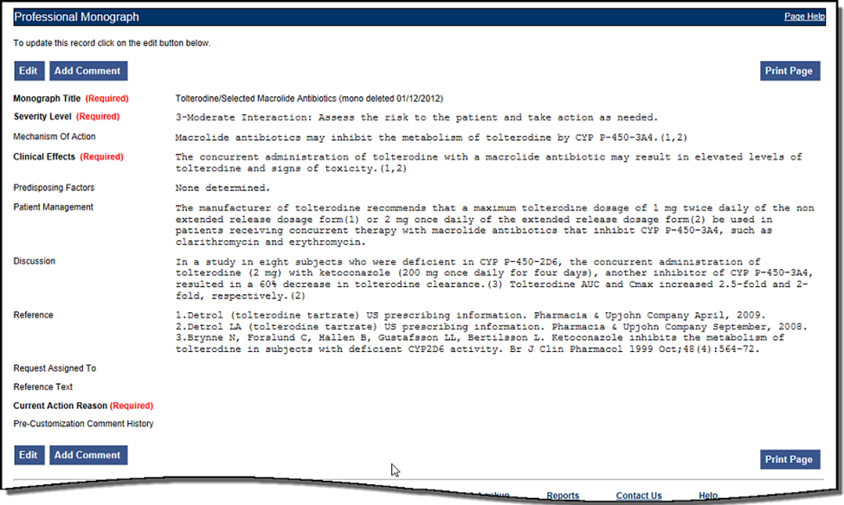
- Select the Edit button to edit the record.
- Change the Severity level to 1 – Critical.
- Indicate the action reason in the free text Current Action Reason (required) field.
- Select the Customize button.

Contact Us
The Contact Us page contains a list of PECS Project Contacts should the user need additional information about the PECS product. The content of the Contact Us page is created and maintained by users with the Administrator role. In many cases, a linked email address will be included. Select the link associated with the name to send that person (or group) an email.
Note: Selecting the link opens the mail application and a new email message to the person specified in the properties of the link. This may produce a warning message. This is normal.
Figure 190: Contact Us Example
PECS Administrators can edit the content of the Contact Us page. See Editing Contact Us for additional information.

Reports
The Reports page displays a list of available reports in PECS. PECS Reports are essentially exported Excel spreadsheets that can be manipulated and formatted as the user sees fit.
Note: The Reports tab is not visible to Requestor or Release Manager users.
Note to Assistive Technology Users: Please refer the documentation included with the screen reader for commands related to reading column and row headers.
To run a report, select the link associated with it. The user will be provided the option of opening the file directly or saving a copy of the file to a location on their workstation (or accessible network location).
Figure 191: List of Reports
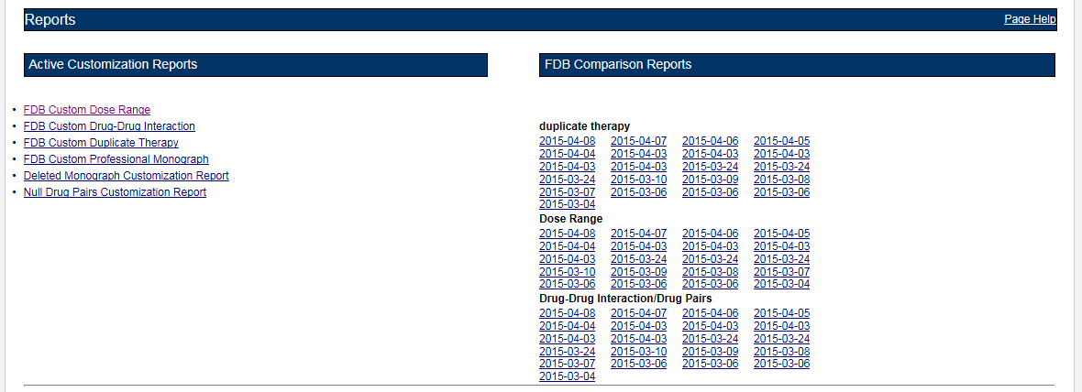
There are two types of Reports:
- Active Customization Reports
- FDB Comparison Reports

Active Customization Reports
The Active Customization Reports are:
- FDB Custom Dose Range Report
- FDB Custom Drug-Drug Interaction Report
- FDB Custom Duplicate Therapy Report
- FDB Custom Professional Monograph Report
- Deleted Monograph Customization Report
- Null Drug Pairs Customization Report
The first four Active Customization Reports, FDB Custom Dose Range, FDB Custom Drug-Drug Interaction, FDB Custom Duplicate Therapy, and FDB Custom Professional Monograph, display concept records in an Approved status along with their corresponding FDB record data. See the sample below.
Figure 192: Sample Active Customization Report
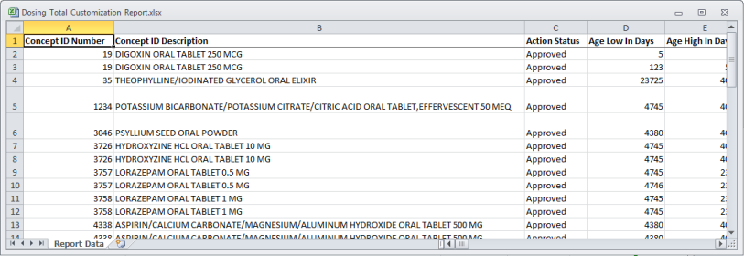
The last two reports on the list, Deleted Monograph Customization Report and Null Drug Pairs Customization Report, look for problems. The Deleted Monograph Customization Report displays DDIs with an associated PM that has been deleted (e.g., the FDB update deleted an FDB PM, and that FDB PM is associated to a custom DDI). The Null Drug Pairs Customization Report displays custom DDIs that have an associated DP in which one or both routed generics is null because an FDB update deleted the routed generic(s).

FDB Custom Dose Range Report
The FDB Custom Dose Range Report contains active VA custom Dose Range records in an Approved status. The default file name is Dosing_Total_Customization_Report.xlsx.
To Run the FDB Custom Dose Range Report:
- Select the Reports tab on the PECS Application Window.
- Select the FDB Custom Dose Range Report link.
- Select Open to view the exported file in Excel; select Save to save a copy of the file to a location on the workstation (or accessible network location). The file name is Dosing_Total_Customization_Report.xlsx.
- If the user selected Open, then the report will automatically appear in the Excel application.
Figure 193: Sample Custom Dose Range Report
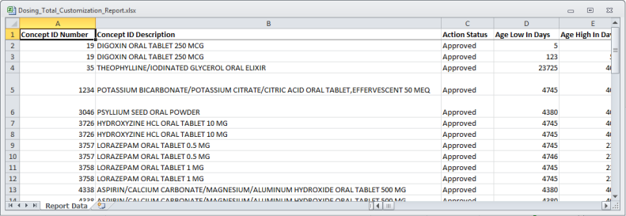

FDB Custom Drug-Drug Interaction Report
The FDB Custom Drug-Drug Interaction Report contains active VA custom Drug-Drug interaction records in an Approved status along with their corresponding FDB record data.
To Run the FDB Custom Drug-Drug Interaction Report:
- Select the Reports tab on the PECS Application Window.
- Select the FDB Custom Drug-Drug Interaction Report link.
- Select Open to view the exported file in Excel; select Save to save a copy of the file to a location on the workstation (or accessible network location). The file name is Ddiminteraction_Total_Customization_Report.xlsx.
- If the user selected Open, the report will automatically appear in the Excel application.
Figure 194: Sample Custom DDI Report
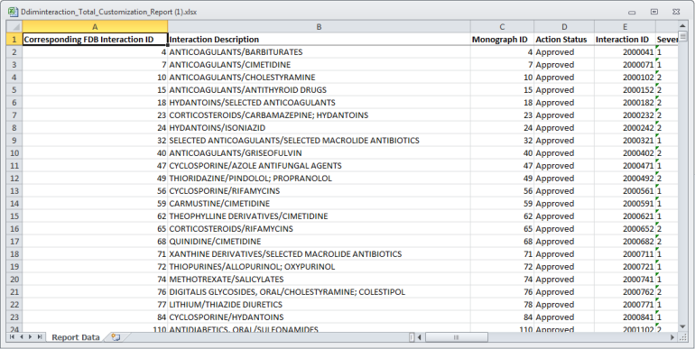

FDB Custom Duplicate Therapy Report
The FDB Custom Duplicate Therapy Report contains active VA custom Duplicate Therapy records in an Approved status along with their corresponding FDB record data.
To run the FDB Custom Duplicate Therapy Report:
- Select the Reports tab on the PECS Application Window.
- Select the FDB Custom Duplicate Therapy Report link.
- Select Open to view the exported file in Excel; select Save to save a copy of the file to a location on the workstation (or accessible network location). By default, the file name is Dtcat_Total_Customization_Report.xlsx.
- If the user selected Open, the report will automatically appear in the Excel application.
Figure 195: Sample Custom Duplicate Therapy Report
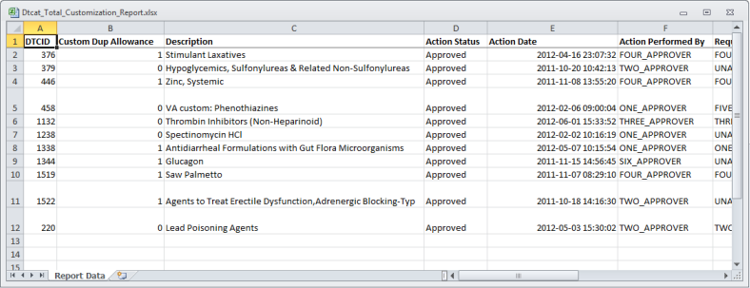

FDB Custom Professional Monograph Report
The FDB Custom Professional Monograph Report contains active VA custom Professional Monograph records in an Approved status along with their corresponding FDB record data.
To run the FDB Custom Professional Monograph Report:
- Click the Reports tab on the PECS Application Window.
- Click the FDB Custom Professional Monograph Report link.
- Select Open to view the exported file in Excel; select Save to save a copy of the file to a location on your workstation (or accessible network location). By default, the file name is Monograph_Total_Customization_Report.xlsx.
- If you selected Open, the report will automatically appear in the Excel application.
Figure 196: Sample Custom Professional Monograph Report
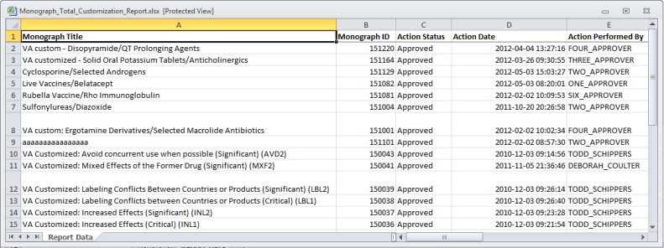

Deleted Monograph Customization Report
The Deleted Monograph Customization Report contains active VA custom Drug-Drug interaction records in an Approved status that are associated with a deleted FDB Professional Monograph.
To run the Deleted Monograph Customization Report:
- Click the Reports tab on the PECS Application Window.
- Click the Deleted Monograph Customization Report link.
- Select Open to view the exported file in Excel; select Save to save a copy of the file to a location on your workstation (or accessible network location). By default, the file name is Deleted_Monograph_Report.xlsx.
- If you selected Open, the report will automatically appear in the Excel application.
Figure 197: Sample Deleted Monograph Report
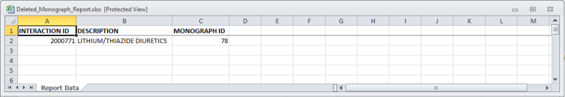

Null Drug Pairs Customization Report
The Null Drug Pairs Customization Report contains approved VA custom Drug-Drug Interactions that contain Drug Pairs with null Routed Generic #1 or Routed Generic #2 fields. The report will not display drug pairs with Deleted status.
If this report contains any entries, then a user in the Administrator role should initiate the Null Drug Pair Removal Process, which deletes Null Drug Pairs listed on the report. After the Null Drug Pair Removal process is complete, the Administrator may want to run the report to verify that these drug pairs have been removed. The null Drug Pairs listed on this report are the ones that will be deleted during the Null Drug Pair Removal process.
To run the Null Drug Pairs Customization Report:
- Select the Reports tab on the PECS Application Window.
- Select the Null Drug Pairs Customization Report link.
- Select Open to view the exported file in Excel; select Save to save a copy of the file to a location on the workstation (or accessible network location). By default, the file name is Deleted_Monograph_Report.xlsx.
- If the user selected Open, the report will automatically appear in the Excel application.
Figure 198: Sample Drug Pairs Customization Report
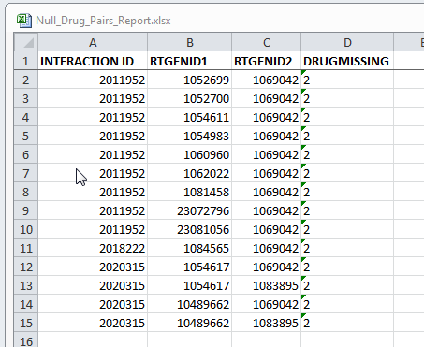
Note: This report can be used to identify approved VA Drug-Drug Interactions that contain null Drug Pairs.
For more information, see the section Null Drug Pair Removal Process under Administrator.

FDB Comparison Reports
The FDB Comparison Reports display the changes to existing data included in the Incremental FDB updates. The reports inform an Approver or Administrator of the latest FDB changes for the Duplicate Therapy, Drug-Drug Interaction, Drug Pair, and Dose Range concepts and provide data that helps the these users decide whether or not to change a custom record. The FDB Comparison Reports help an Approver or Administrator keep PECS customizations in sync with FDB changes.
FDB Comparison Reports display:
- Customized records in all action statuses that have differences between the PECS FDB data and the data in the Incremental FDB Update file.
- Un-customized records that have differences between the PECS FDB data and the data in the Incremental FDB Update file.
- Indications that an FDB record is scheduled to be deleted by DATUP.
- Lists of the drug pairs that will be added or deleted by DATUP.
- A "no data found" message if the Incremental FDB Update file has no changes to the FDB data.
Changed data is marked with an asterisk (*) and colored red. The reports are organized by type and the date of the FDB Incremental Update.
Figure 199: Changed Data in Report
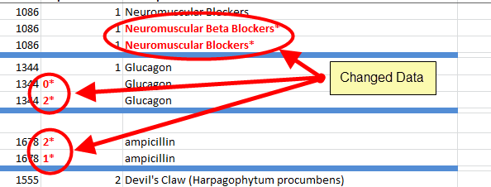
To run an FDB Comparison report, select the appropriate date of an FDB Incremental Update under the appropriate Report Heading:
Figure 200: FDB Incremental Update Date Samples
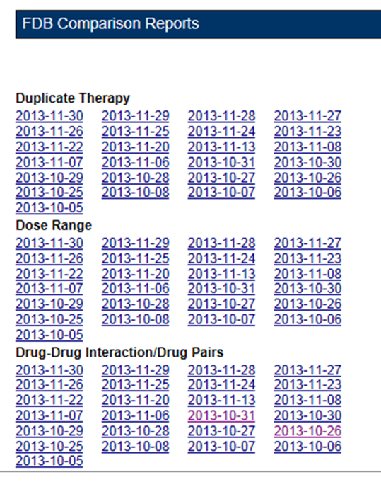

FDB Comparison Drug-Drug Interaction/Drug Pair Report
The FDB Comparison Drug-Drug Interaction/Drug Pairs Report displays the changes to existing Drug-Drug Interactions included in the Incremental FDB updates. All Action Statuses are compared and are included in the report. The following data points are compared between the FDB update and the VA Drug-Drug Interaction records:
- Corresponding FDB Interaction ID
- Interaction Description
- Monograph ID
- Severity Level Code
- Clinical Effect 1
- Clinical Effect 2
- Deleted Drug Pairs
- Added Drug Pairs
The DDI-DP FDB Comparison Report contains two types of spreadsheets:
- The DDI-DP FDB Comparison Report – gives information about the FDB comparisons and the associated VA custom records.
- FDB Interaction ID-DP – gives information about the added or deleted drug pairs for a specific FDB record. Each FDB update record that has added or deleted drug pairs has its own FDB Interaction ID-DP spreadsheet.
The following DDI-specific fields are included in the DDI-FDB Comparison Report spreadsheet:
Table 23: FDB Comparison Drug-Drug Interaction/Drug Pair Report Fields
Field | Description
VA Interaction ID | A VA-assigned numerical identifier for the interaction.
FDB Interaction ID | An FDB-assigned numerical identifier for the interaction.
Interaction Description | A text description of the interaction.
Monograph ID | A numerical identifier for the Professional Monograph associated with the interaction.
Severity Level | A coded severity indicator.
Clinical Effect 1 | A three letter code describing the clinical effect.
Clinical Effect 2 | A three letter code describing the clinical effect.
Drug Pairs | If a DDI has drug pairs scheduled to be added or deleted by DATUP, then there will be a message, "See FDB Interaction ID <FDB Interaction ID number>-DP."  If a DDI record in the incremental FDB update file does not have added or drug pairs, then this column will remain blank.
If the latest FDB update contains added or deleted drug pairs, then these will be displayed on separate tabs titled "FDB Interaction ID <FDB Interaction ID number>-DP".
Each record consists of at least three lines and individual records are by a blank row (blue). There will be more than three lines if there is more than one VA Customization for the described interaction.
Figure 201: DDI-DP FDB Comparison Report
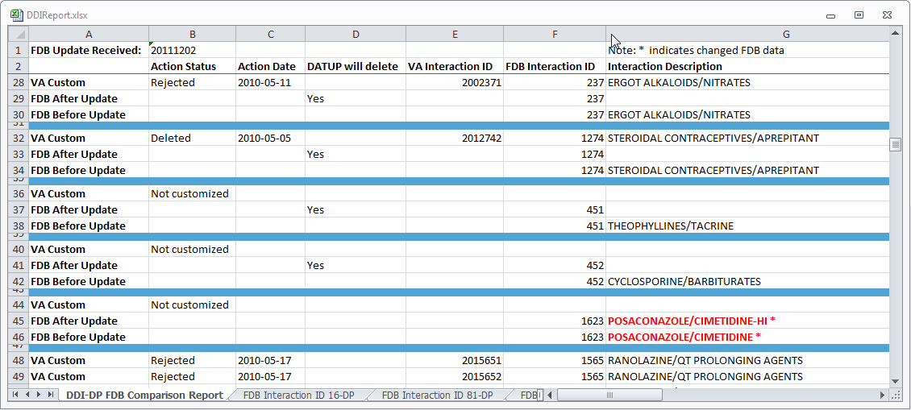
- VA Custom - Custom VA information about the Drug-Drug Interaction record(s). If the DDI has not been customized, the record will state "Not customized".
- Latest FDB - Indicates changes to the Drug-Drug Interaction record that appeared on the incremental FDB update the user selected.
- Previous FDB - Displays the value for the Drug-Drug Interaction record in the incremental FDB update immediately prior to the incremental FDB update the user selected.
The following fields are included in the report:
Table 24: FDB Comparison Drug-Drug Interaction/Drug Pair Report Fields
Field | Description
Action Status | The current state of the record based on the most recent action performed on the associated record.
Action Date | The date the current action (Action Status) was performed.
DATUP will delete | YES in this column Indicates the associated record will be deleted by DATUP.
VA Interaction ID | A VA-assigned numerical identifier for the interaction.
FDB Interaction ID | An FDB-assigned numerical identifier for the interaction.
Interaction Description | A text description of the interaction.
Monograph ID | A numerical identifier for the Professional Monograph associated with the interaction.
Severity Level | A coded severity indicator.
Clinical Effect 1 | A three letter code describing the clinical effect.
Clinical Effect 2 | A three letter code describing the clinical effect.
If the latest FDB update contains added or deleted drug pairs, then these will be displayed on separate tabs titled "FDB Interaction ID <FDB Interaction ID number>-DP".
Figure 202: FDB Interaction ID-Drug Pairs Tab
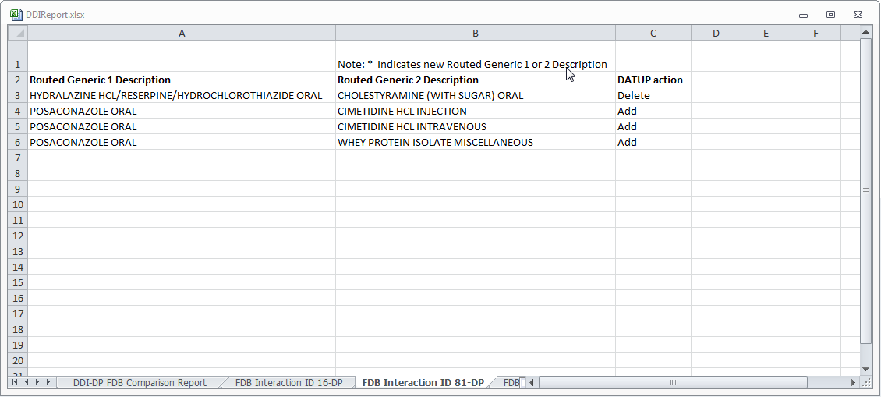
The following fields are included in the report:
Table 25: FDB Interaction ID-Drug Pairs Fields
Field | Description
Routed Generic 1 Description | The Routed Generic Description of Drug 1 in the Drug Pair.
Routed Generic 2 Description | The Routed Generic Description of Drug 2 in the Drug Pair.
DATUP Action | The action that DATUP will perform. Either DATUP will add the drug pair to the PECS database or delete it from PECS.
Note: A DDI record that is not listed on the DDI-DT FDB Comparison Report spreadsheet can still have added or deleted drug pairs listed in the latest incremental FDB update file. In that case, the drug pair information is just listed on an FDB Interaction ID-DP spreadsheet.

Structure of the FDB Comparison Report
Figure 203: Sample FDB Comparison Report - Duplicate Therapy
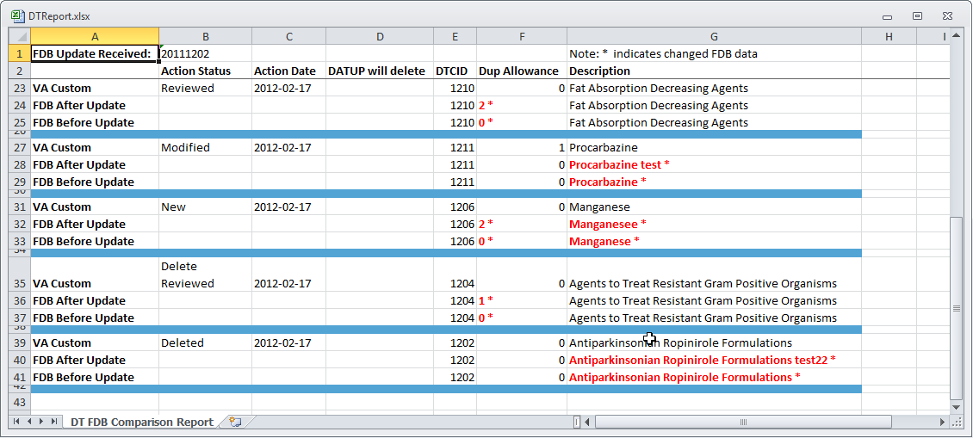
Each FDB Comparison Report lists the "FDB Update Received" date, which is the date listed in the Incremental FDB Update file. Each report lists comparison sets of VA and FDB data. Each comparison set consists of at least three rows separated by a blue line. The three rows are:
Table 26: FDB Comparison Report Row Fields
Row Name | Row Description
VA Custom | Data in the Custom VA record. If the corresponding FDB record has not been customized, then a "Not customized" message will be in the Action Status column and the rest of the row will be blank.
FDB After Update | Data in the Incremental FDB Update File. This data will be in the PECS database shortly after the incremental FDB update is done via DATUP.
FDB Before Update | Data in the PECS FDB record. This data will be replaced by the 'FDB After Update' data. If the FDB After Update and FDB Before Update data of the same type are different, then they are marked with an asterisk (*) and colored red. Records that do not have any differences between the FDB Before Update and FDB After Update data of the same type are not listed in the report.
Each FDB Comparison Report has the following columns:
Table 27: FDB Comparison Report Statuses
Column Name | Column Description
Action Status | The state of the associated VA record based on the most recent action performed. PECS compares FDB data with VA customizations in any Action Status, including Rejected or Deleted.
Action Date | The date the current action (Action Status) was taken.
DATUP will delete | YES in this column Indicates the associated FDB record will be deleted by DATUP. If the column is blank, then the associated FDB record will not be deleted by DATUP.  If the FDB record will be deleted by DATUP, then only the FDB Interaction ID and DATUP will delete columns will be filled out in the FDB After Update row. All the other columns will be blank.
The reports are organized by type and the date of the FDB Incremental Update. Links to the reports are kept for eight weeks on the Reports page. To run an FDB Comparison report, select the appropriate FDB Incremental Update date under the appropriate Report Heading.
Figure 204: FDB Incremental Updates
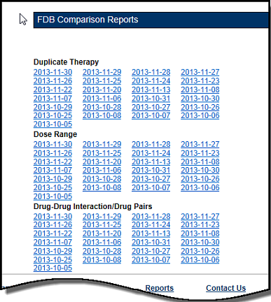
If there are no differences between the FDB After Update and FDB Before Update data of the same type in any of the records, then a "No Data Found" message is printed on the FDB Comparison Report.
Figure 205: Report with No Differences
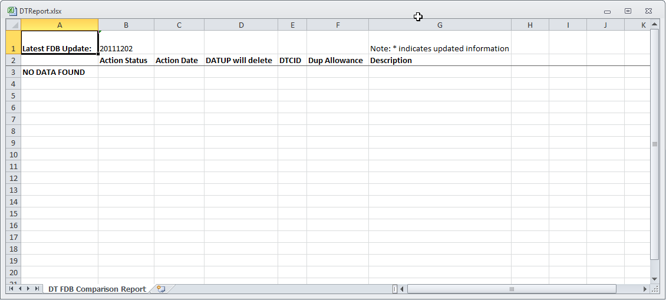

FDB Comparison Duplicate Therapy Report
The Duplicate Therapy FDB Comparison Report displays the differences between the PECS FDB data and the data in the Incremental FDB Update file for the Duplicate Therapy (DT) concept. This report displays the following DT-specific data:
Figure 206: FDB Comparison Duplicate Therapy Report
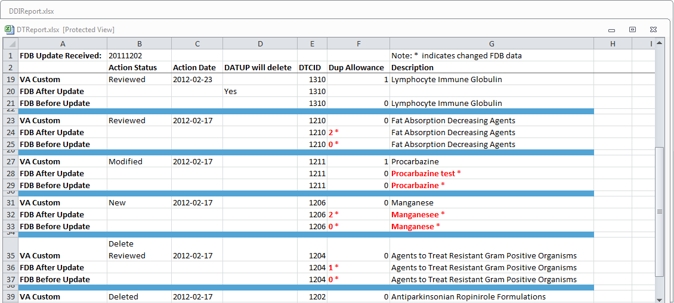
The three lines display the following fields:
Table 28: FDB Comparison Duplicate Therapy Report Fields
Field Name | Field Description
DTCID | Duplicate Therapy Control ID. A numerical identifier for the DT FDB and VA records.
Dup Allowance | Duplicate Allowance. The number of drugs performing the same function before a warning is issued.
Description | A description (name) of the drug that is the basis of the DT record.
To run the Duplicate Therapy FDB Comparison report, click the desired date of an FDB Incremental Update under the appropriate Duplicate Therapy heading.
Figure 207: FDB Incremental Update Dates

FDB Comparison Dose Range Report
The Dose Range FDB Comparison Report displays the differences between the PECS FDB data and the data in the Incremental FDB Update file for the Dose Range (DR) concept.
Figure 208: FDB Comparison Dose Range Report
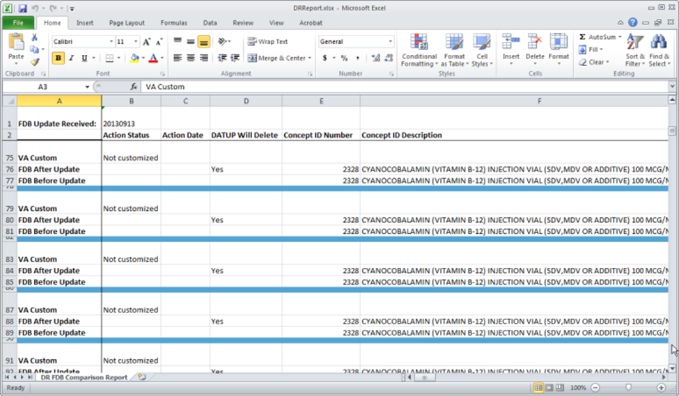
Only records where the Concept Type = 6 will display on the report. If the DR FDB record has not been customized, then it will display on the report if the following conditions were met:
- Data in all of the first seven fields (Concept ID Number, Age Low in Days, Age High in Days, Dose Route ID, Dose Type ID, FDBDX, HITTYPE) is identical in the PECS FDB record and the latest incremental FDB update
- Data in at least one other field is different in the PECS FDB record and the latest incremental FDB update
If a DR FDB record has been customized, then it will display on the report if all the conditions mentioned above have been met and the active VA custom record and the PECS FDB record are cross-referenced. Thus indicating that the active VA custom record was created from the FDB record.
Fields
Table 29: FDB Comparison Dose Range Report
Field Name | Field Description
Concept ID Number | Number identifying the drug. Identifies a specific drug within a given concept type.
Age Low in Days | Lowest patient age in days to which dosing information applies
Age High in Days | Highest patient age in days to which dosing information applies
Dose Route ID | Dose Route Identifier. Refers to the route of administration, which is the site or method by which a drug is administered
Dose Type ID | Dose type identifier
FDBDX | FDBDX type code to identify a Medical Condition
HITTYPE | Signifies whether the dose record came from the Dosage Range Check module or the Minimum/Maximum dosing module. There are 3 possible values: 1 – Dose Range Check; 2 – Dosing Not Established For This Age Range; 3 – Minimum/maximum dosing. HITTYPE is used to determine how to structure the dose alerts.
Concept ID Description | Text description of the Concept ID. Also defined as the drug name. For example, the Concept ID Description is GUAIFENESIN/PHENYLPROPANOLAMINE HCL/ACETAMINOPHEN/CAFFEINE ORAL TABLET and the Concept ID is 713.
DXID | First Databank Medical Lexicon (FML) Disease Identifier
Dose Low | Minimum amount to be administered per day
Dose Low Units | Unit of measure for low dose per day
Dose High | Highest amount to be administered per day
Dose High Units | Unit of measure for high dose per day
Dose Form Low | Low dose for a given dose form
Dose Form Low Units | Unit of measure for the dose form (EA/KG/DAY)
Dose Form High | High dose for a given dose form
Dose Form High Units | Unit of measure for the dose form (EA/KG/DAY)
Frequency Low | Low end of a drug’s frequency of administration per day
Frequency High | High end of a drug’s frequency of administration per day
Duration Low | Lowest recommended duration of therapy (in days)
Duration High | Highest recommended duration of therapy (in days)
Maximum Duration | Maximum recommended duration of therapy (in days)
Maximum Single Dose | Maximum amount to be administered in a single dose
Maximum Single Dose Units | Unit of measure for the maximum single dose
Maximum Single Dose Form | Maximum single dose for a given form
Maximum Single Dose Form Units | Unit of measure for the dose form (EA/KG/DAY)
Maximum Daily Dose | Maximum amount to be administered per day
Maximum Daily Dose Units | Unit of measure for the maximum daily dose
Maximum Daily Dose Form | Maximum daily dose for a dose form
Maximum Daily Dose Form Units | Unit of measure for the dose form (EA/KG/DAY)
Maximum Lifetime Dose | Maximum amount to be administered over a patient’s lifetime, if available
Maximum Lifetime Dose Units | Unit of measure for maximum lifetime dose
Maximum Lifetime Dose Form | Maximum lifetime dose for a given dose form
Maximum Lifetime Dose Form Units | Unit of measure for the dose form (EA/KG/DAY)
Dose Rate Low | Minimum amount to be administered per dose rate (hours or minutes)
Dose Rate Low Units | Unit of measure for low dose rate (hours or minutes)
Dose Rate High | Highest amount to be administered per dose rate (hours or minutes)
Dose Rate High Units | Unit of measure for high dose rate (hours or minutes)
Dose Form Rate Low | Low dose for a given dose form rate (hours or minutes)
Dose Form Rate Low Units | Unit of measure for the dose form rate (hours or minutes)
Dose Form Rate High | High dose for a given dose form rate (hours or minutes)
Dose Form Rate High Units | Unit of measure for the dose form rate (hours or minutes)
Maximum Single Dose Rate | Maximum amount to be administered in a single dose rate (hours or minutes)
Maximum Single Dose Rate Units | Unit of measure for the maximum single dose rate (hours or minutes)
Maximum Single Dose Form Rate | Maximum single dose for a given dose form rate (hours or minutes)
Maximum Single Dose Form Rate Units | Unit of measure for the dose form rate (hours or minutes)
Maximum Daily Dose Form Rate | Maximum daily dose for a dose form rate (hours or minutes)
Maximum Daily Dose Rate | Maximum amount to be administered per dose rate (hours or minutes)
Maximum Daily Dose Form Rate Units | Unit of measure for the dose form rate (hours or minutes)
Maximum Daily Dose Rate Units | Unit of measure for the maximum daily dose rate (hours or minutes)
Max Single NTE Dose | Maximum Not-to-Exceed (NTE) amount to be administered in a single dose
Max Single NTE Dose Unit | Unit of measure for the maximum single NTE dose
Max Single NTE Dose Form | Maximum Unit of measure for the NTE dose form (EA/KG/DAY)
Max Single NTE Dose Form Unit | Maximum Not-to-Exceed amount to be administered in a single dose for a given dose form
Hepatic Impairment Indicator | Indicates that the drug’s dosing information needs to be adjusted for a patient with hepatic impairment. This flag does not differentiate between mild, moderate, and severe hepatic failure.
Renal Impairment Indicator | Indicates whether the dosing information needs to be modified for any degree of renal impairment in the patient.
CRCL Threshold | Lowest Creatinine Clearance (CRCL) to which dosing applies.
CRCL Threshold Units | Unit of measure for the Creatinine Clearance (CRCL) threshold.
Low Elimination Half Life | Low end of the drug’s half-life range
High Elimination Half Life | High end of the drug’s half-life range.
Half Life Units | Unit of time for the half-life range of a drug.
Weight Required Indicator | Indicates whether weight is required for dosing.
BSA | Required Indicator Indicates whether Body Surface Area (BSA) is required for dosing

Online Help
PECS provides an online help system that provides information on using the application.
Figure 209: PECS Online Help Window
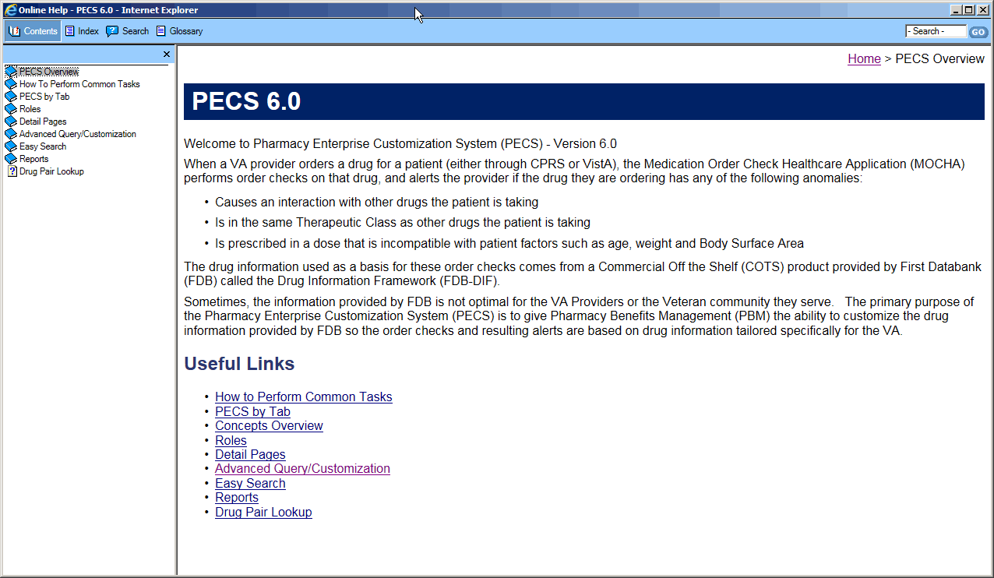

Accessing Online Help
There are two ways to access online help: the Help tab and Page Help link.
- Select the Help tab to open the main Online Help page
Figure 210: The Help Tab
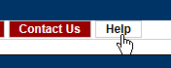
- Select the Page Help link to access help specific to the current page.
Figure 211: The Page Help Link
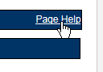
Using the Page Help link will display help page relevant to the current page. Click the Show link to display the Table of Contents.
Figure 212: The Show Link
