Internet Formulary Advisor

Version 1.0

User Manual
December 2022
Department of Veterans Affairs (VA)
Office of Information and Technology (OIT)

Revision History
Date | Revision | Description | Author
December 2022 | 1.0 | Initial version | Liberty IT Solutions

Table of Contents
1. Introduction 1
1.1. Purpose 1
2. System Summary 1
2.1. Navigation 1
2.2. Site Navigation 3
2.3. Sending Feedback 4
2.4. VA Global Header 5
3. Getting Started 6
3.1. Search 6
3.1.1. Search by URL 9
3.1.2. Accessing CFU Documents 9
3.2. Drug Detail Page 10
3.2.1. Related Drugs & Classes Listings 11
3.2.2. Other Drugs in Same Class 12
3.2.3. Other Classes in Same Category 13
4. Acronyms and Abbreviations 14

List of Figures
Figure 2-1. VA Formulary Advisor URL 1
Figure 2-2. Pharmacy Benefits Management Services Site 2
Figure 2-3. Home Page Featuring Search Pane 3
Figure 2-4. Feedback Email Links 4
Figure 2-5. Global Header 5
Figure 2-6. Global Footer 5
Figure 3-1. Search Pane on Home Page 6
Figure 3-2. Search for Drug, Drug Class or Therapeutic Category 7
Figure 3-3. Filter by Drug Class 7
Figure 3-4. Filter by Formulary Status 8
Figure 3-5. Search the VA National Formulary 8
Figure 3-6. Indication for Drugs with CFU 9
Figure 3-7. CFU Information 9
Figure 3-8. Documents & Links Section of Drug Detail Page 10
Figure 3-9. Drug Detail Page 11
Figure 3-10. Other Drug and Classes Button 11
Figure 3-11. Medications in Class List 12
Figure 3-12. Classes Within Category List 13

Introduction
The VA Internet Formulary Advisor is a tool intended for Department of Veterans Affairs (VA) and non-VA personnel to search VA National Formulary information.

Purpose
This User Manual describes the functional characteristics, important features, and navigational elements of the VA Internet Formulary Advisor.

System Summary
The VA Internet Formulary Advisor provides users with the following functions:
- Search publicly accessible information from the VA National Formulary and Community Care Urgent/Emergent Formulary Information quickly and easily
- Search by Drug, Drug Class, and Therapeutic Category
- Filter search results by formulary status
- Check other drugs in the same class or category
- Review Criteria for Use (CFU) documents
The primary benefit of the VA Internet Formulary Advisor is to provide users a more comprehensive and user-friendly search tool.

Navigation
Users have two ways to navigate to the VA Internet Formulary Advisor:
- Enter the following Uniform Resource Locator (URL) into the navigation bar: https://www.va.gov/FormularyAdvisor
Figure 2-1. VA Formulary Advisor URL
- Via the Pharmacy Benefits Management (PBM) Services site on va.gov.
  - Enter the following URL into the navigation bar: https://www.pbm.va.gov
Figure 2-2. Pharmacy Benefits Management Services Site
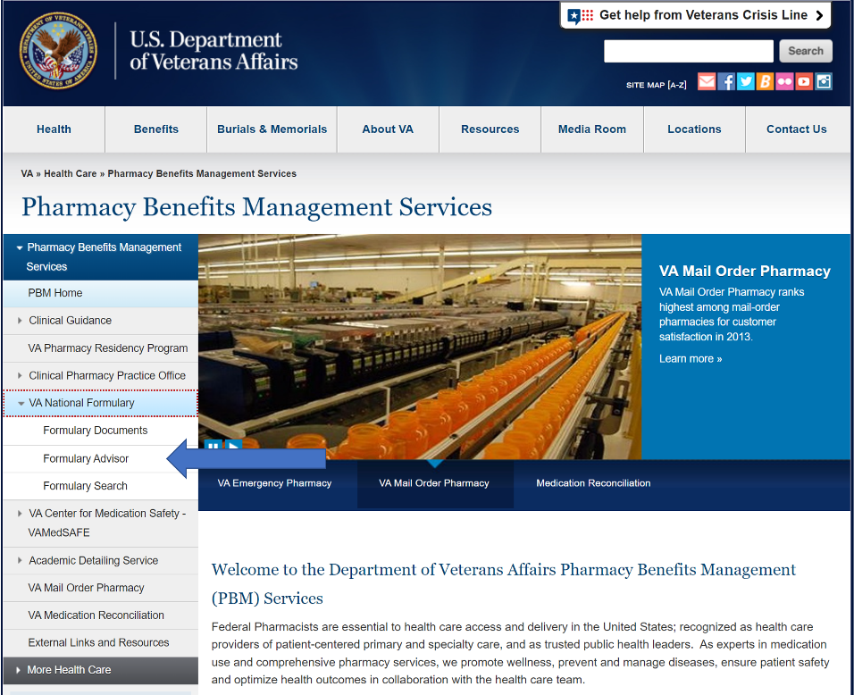

Site Navigation
Once on the site, users are on the home page where the search pane is visible.
Figure 2-3. Home Page Featuring Search Pane
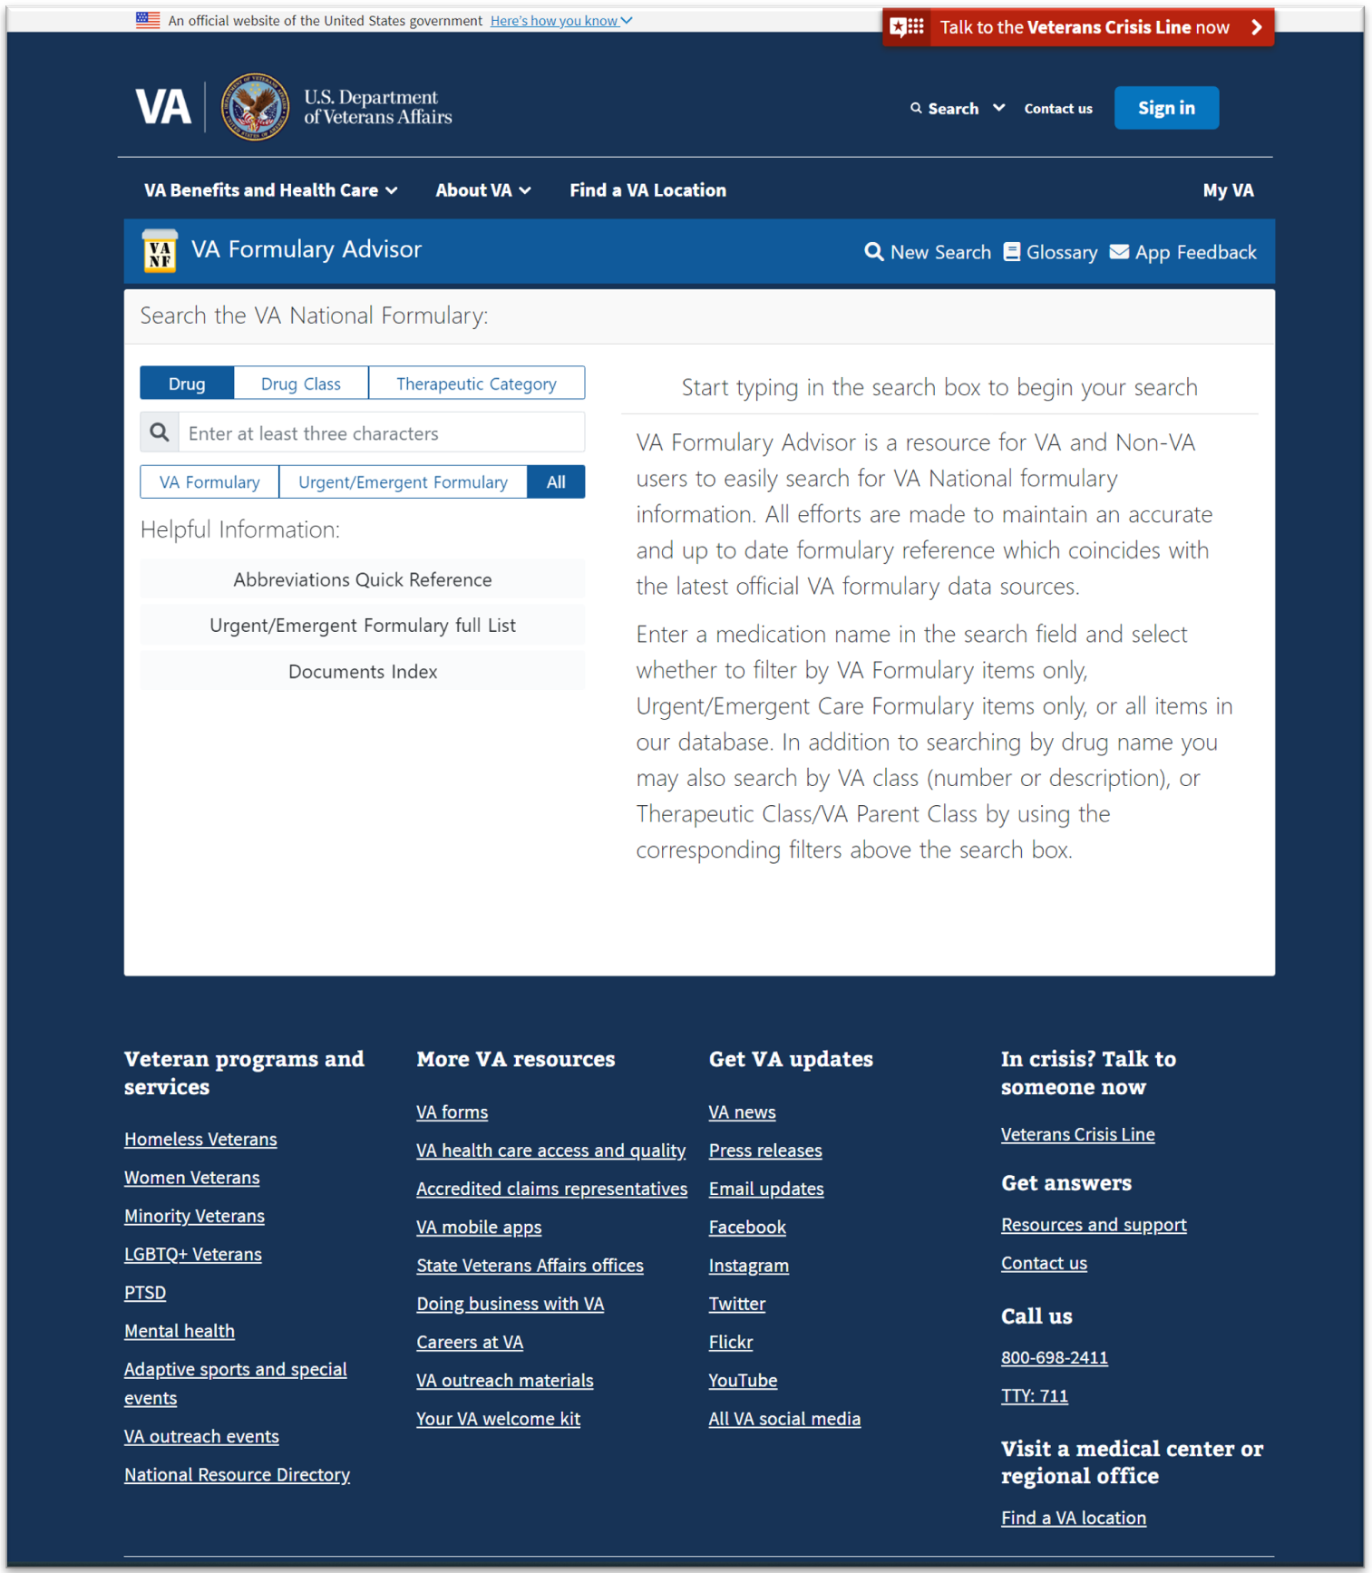
The home page includes the search pane with different filters for each search and an Abbreviations Quick Reference guide for the various icons that may appear in search results.
The top navigation for the page has the following items:
- Home page: Allows users to navigate back to the landing page.
- Glossary: Lists the terms and abbreviations found throughout the site.
- About page: Information about the site. “The VA Formulary Advisor is a resource for VA and Non-VA users to easily search for VA National formulary information. All efforts are made to maintain an accurate and up to date formulary reference which coincides with the latest official VA formulary data sources.”
- Support team email link: This link opens an email message that allows users to email the Veterans Health Administration (VHA) PBM Internet Formulary team.

Sending Feedback
If a user would like to send feedback about the VA Internet Formulary Advisor, they can do so by clicking on the email link in the top navigation bar.
Figure 2-4. Feedback Email Links
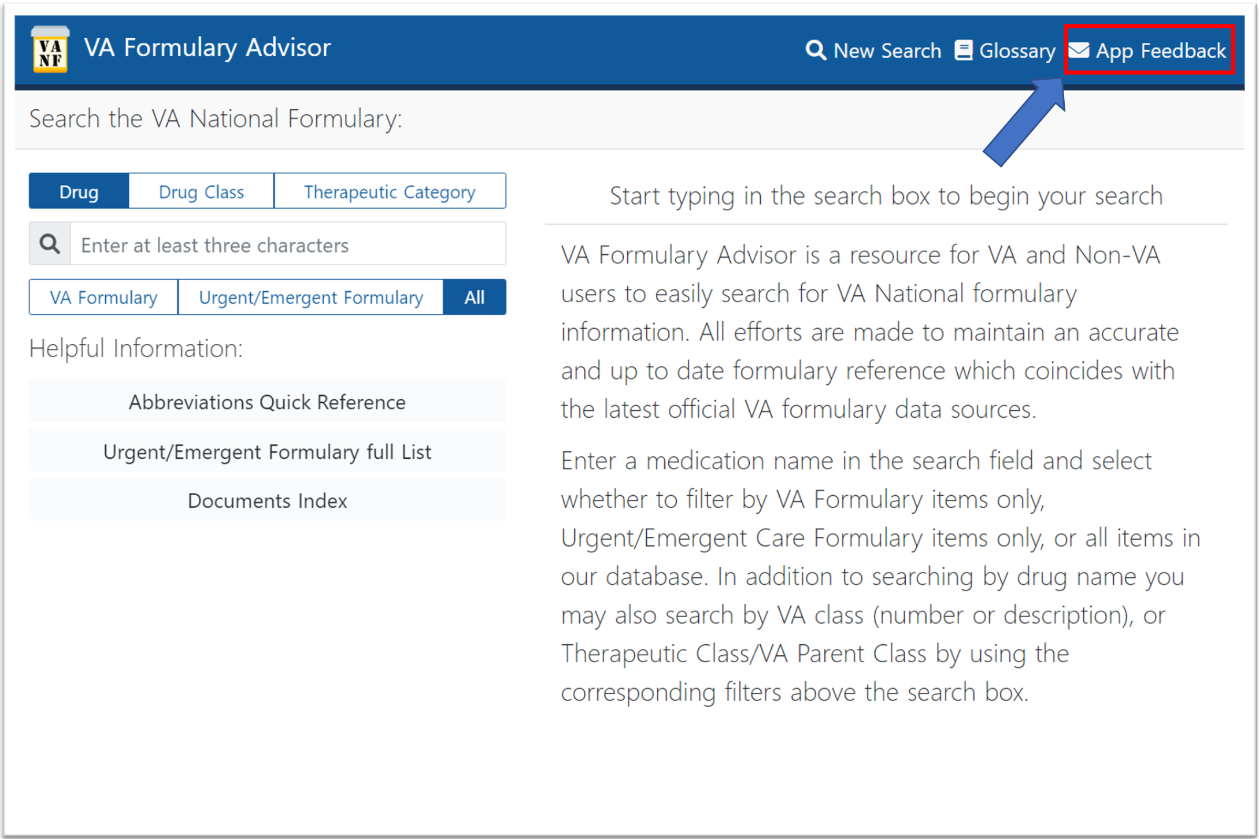

VA Global Header
The VA branded global header and footer is currently managed by the Public Website team. When a change is made to the va.gov headers and footers, these changes will also be made to the Formulary Advisor’s.
Figure 2-5. Global Header
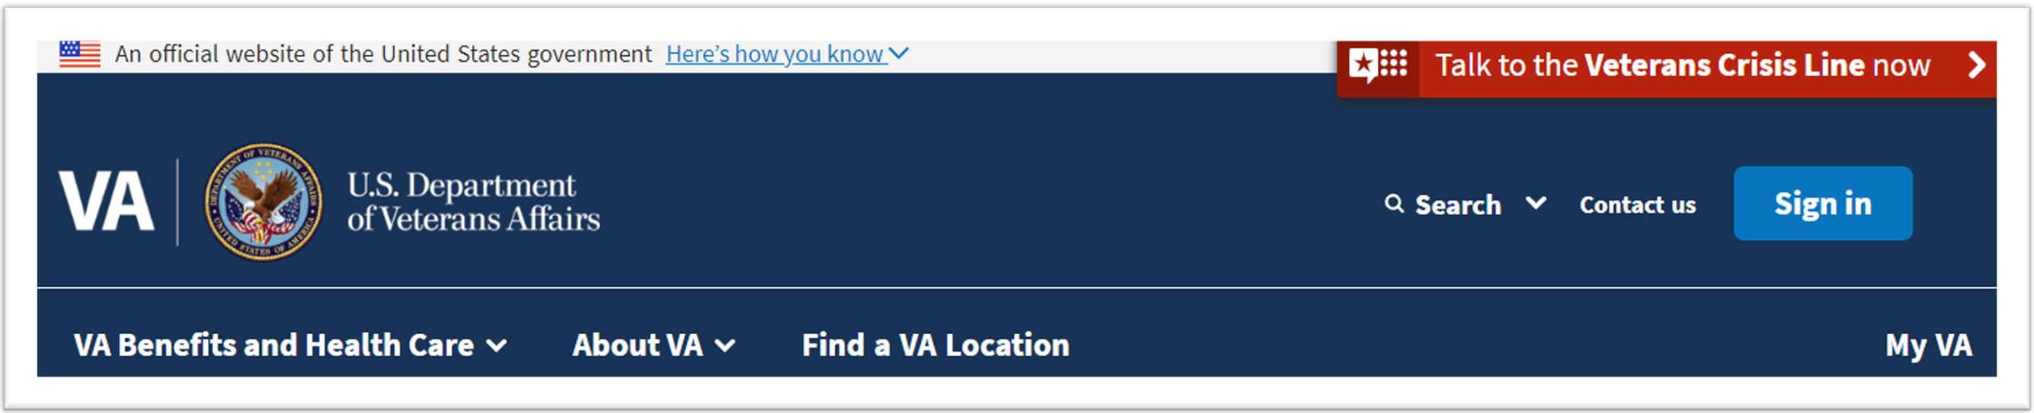
Figure 2-6. Global Footer
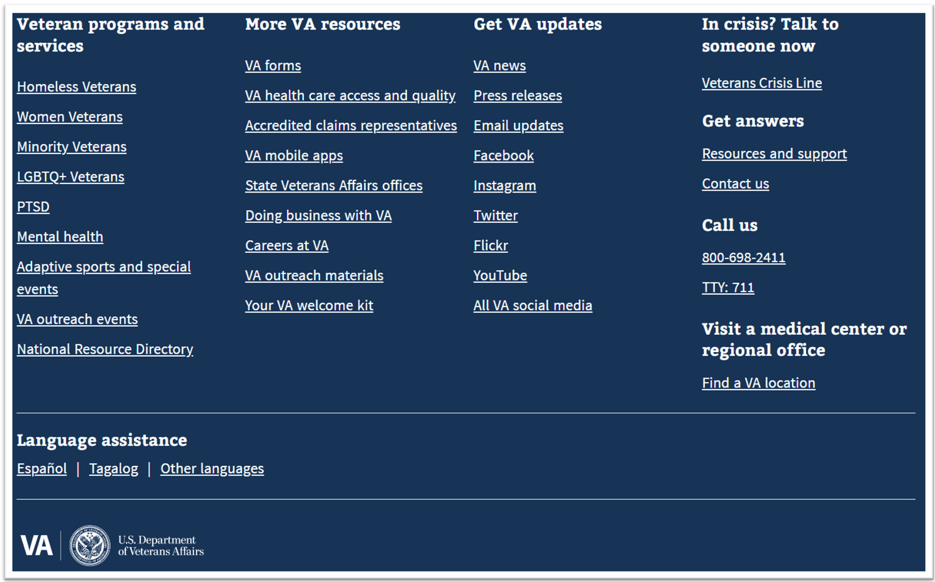
Items found in the header:
- VA Benefits and Health Care dropdown menu: Links to various VA benefit information.
- About VA dropdown menu.
- Find a VA Location link: Allows users to find a nearby VA center.
Items found in the footer:
- Veteran Programs and Services menu: Links for users to find various resources and programs offered by the VA.
- More VA resources menu:
- Get VA Updates: Links to social media, news, press releases, etc.
- Veterans Crisis Line link: Gives uses the resources to connect with the 24/7 crisis care line via web chat, text, or phone call.
- VA Contact information.
- Language assistance.

Getting Started
The following sections provide instructions on conducting searches and accessing CFU documents.

Search
Users can search for various drugs, drug classes and therapeutic categories using the search pane found on the home page.
Figure 3-1. Search Pane on Home Page
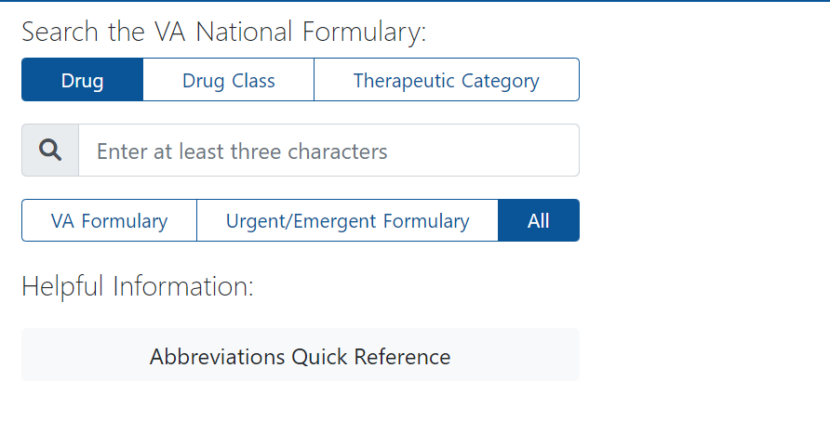
To start a search for a drug, drug class, or therapeutic category, user must enter a minimum of three characters.
Figure 3-2. Search for Drug, Drug Class or Therapeutic Category
If searching by drug class, user needs to enter a minimum of two characters.
Figure 3-3. Filter by Drug Class
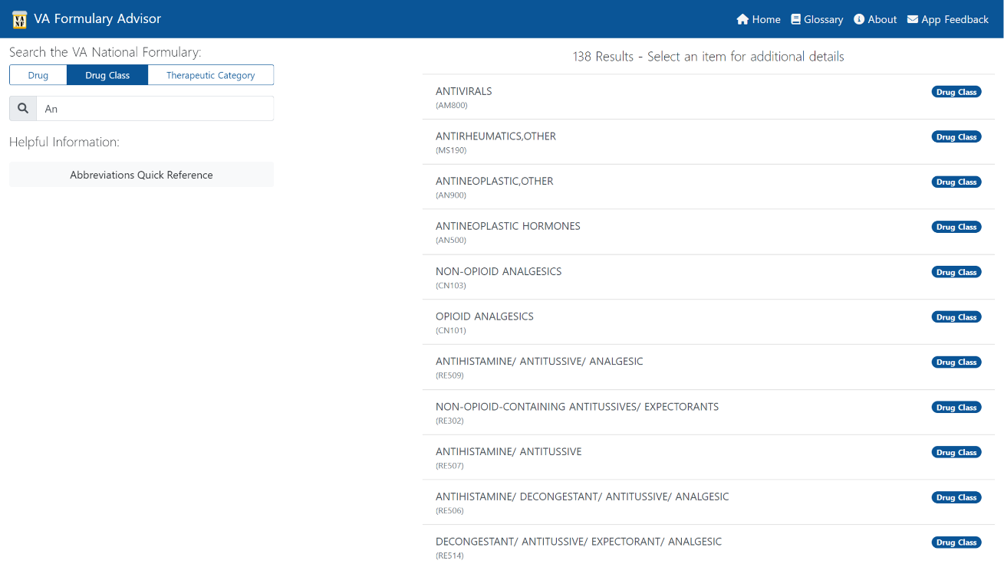
Users can also filter by formulary status: VA Formulary, Urgent/Emergent Formulary, or All items in the national drug file.
Figure 3-4. Filter by Formulary Status
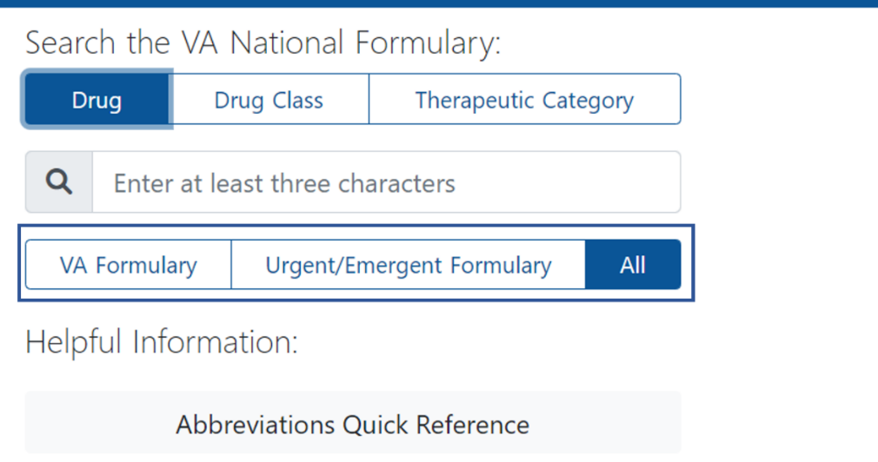
Searches can be entered as comma or space separated. The order in which the terms are entered does not change the search results.
Figure 3-5. Search the VA National Formulary
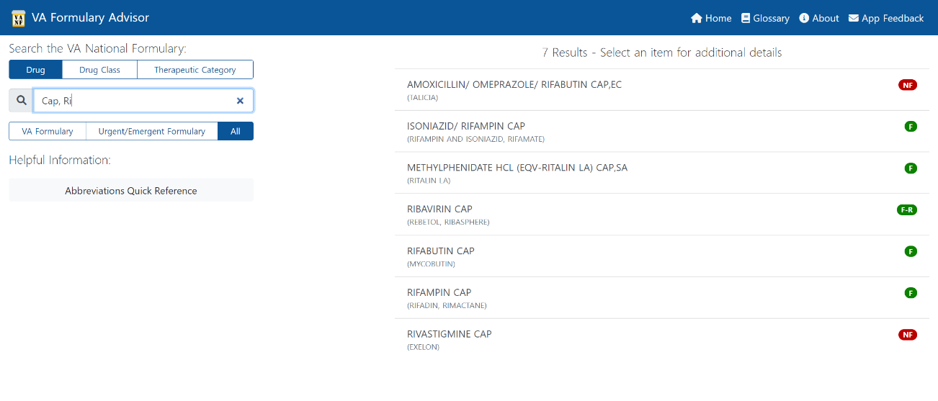
The user sees the following search results as show above in Figure 3-5:
- Generic and Trade Name for the drug search results.
- Colored formulary status and other document indicators.
  - For more information on these icons refer to the Abbreviations Quick Reference.

Search by URL
Users can also search directly by entering search queries in the URL bar.
- www.va.gov/formularyadvisor/search/drugname
or
- www.va.gov/formularyadvisor/?s=drugname

Accessing CFU Documents
Drugs with CFU documentation have an indicator in the search results.
Figure 3-6. Indication for Drugs with CFU
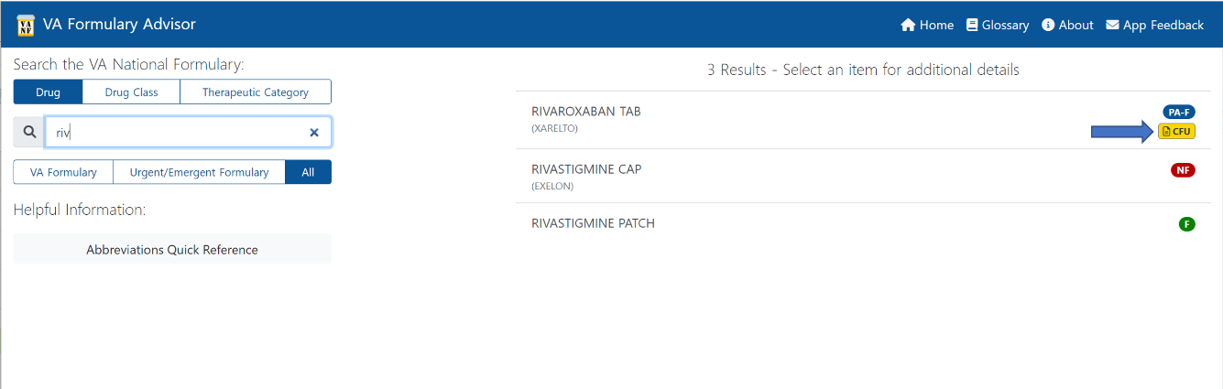
Users can hover over this indicator to see which CFU documents are available. Clicking the link opens the corresponding CFU Portable Document Format (PDF) file.
Figure 3-7. CFU Information
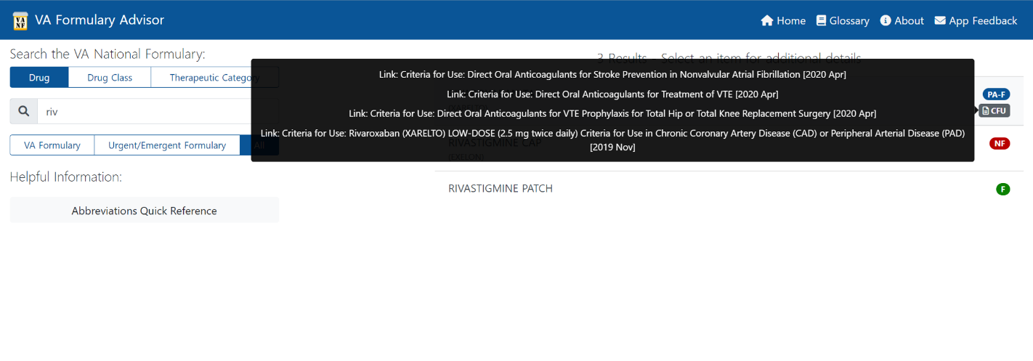
The CFUs can also be accessed through the Documents & Links section on the Drug Detail page.
Figure 3-8. Documents & Links Section of Drug Detail Page
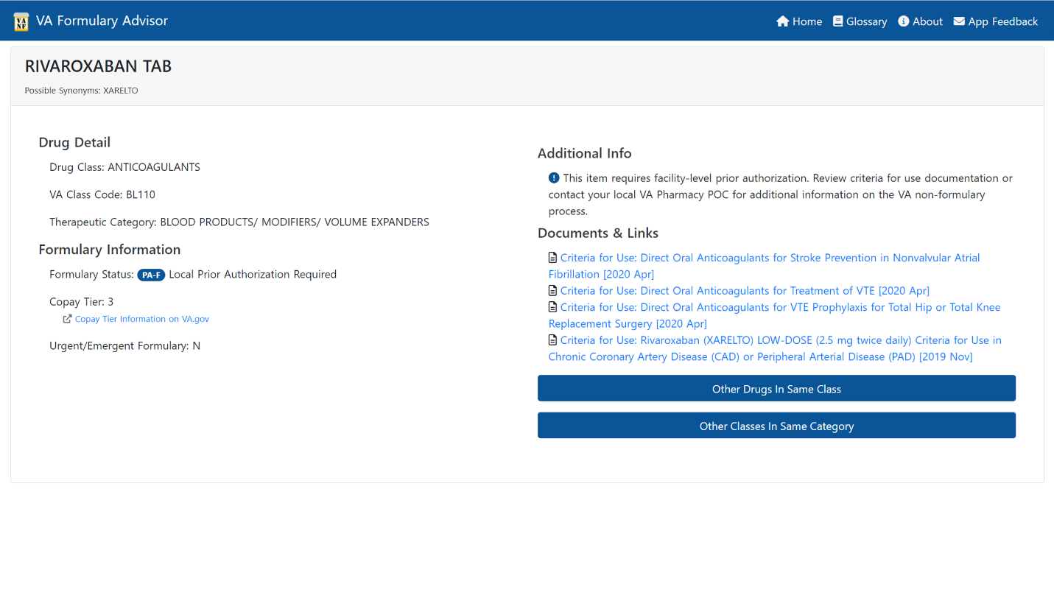

Drug Detail Page
The Drug Detail page provides the following information to users:
- Drug class
- VA Class Code
- Therapeutic Category
- Formulary Status
- Copay Tier
  - Link to the Copay Tier information on va.gov
- If the drug is on the Urgent/Emergent Formulary
- Additional information about the drug
- Any CFU documentation
- Links to show Other Drugs in Same Class and Other Classes in Same Category
Figure 3-9. Drug Detail Page

Related Drugs & Classes Listings
The Drug Detail page includes links that bring up lists within the page of Other Drugs in Same Class and Other Classes In Same Category.
Figure 3-10. Other Drug and Classes Button
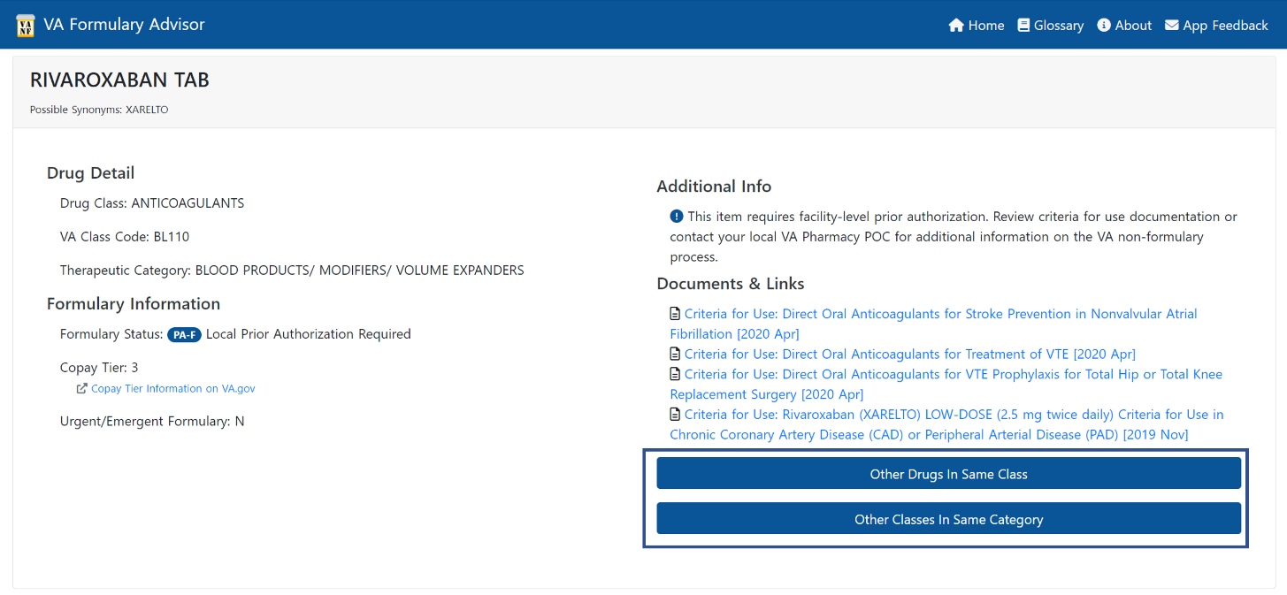

Other Drugs in Same Class
The list results are clickable and take the user to the detail page for those results. These results can also be filtered by VA Formulary, Urgent/Emergent Formulary, or Show All.
Clicking on Other Drugs In Same Class brings up a list of medications in the same class as the drug searched.
Figure 3-11. Medications in Class List
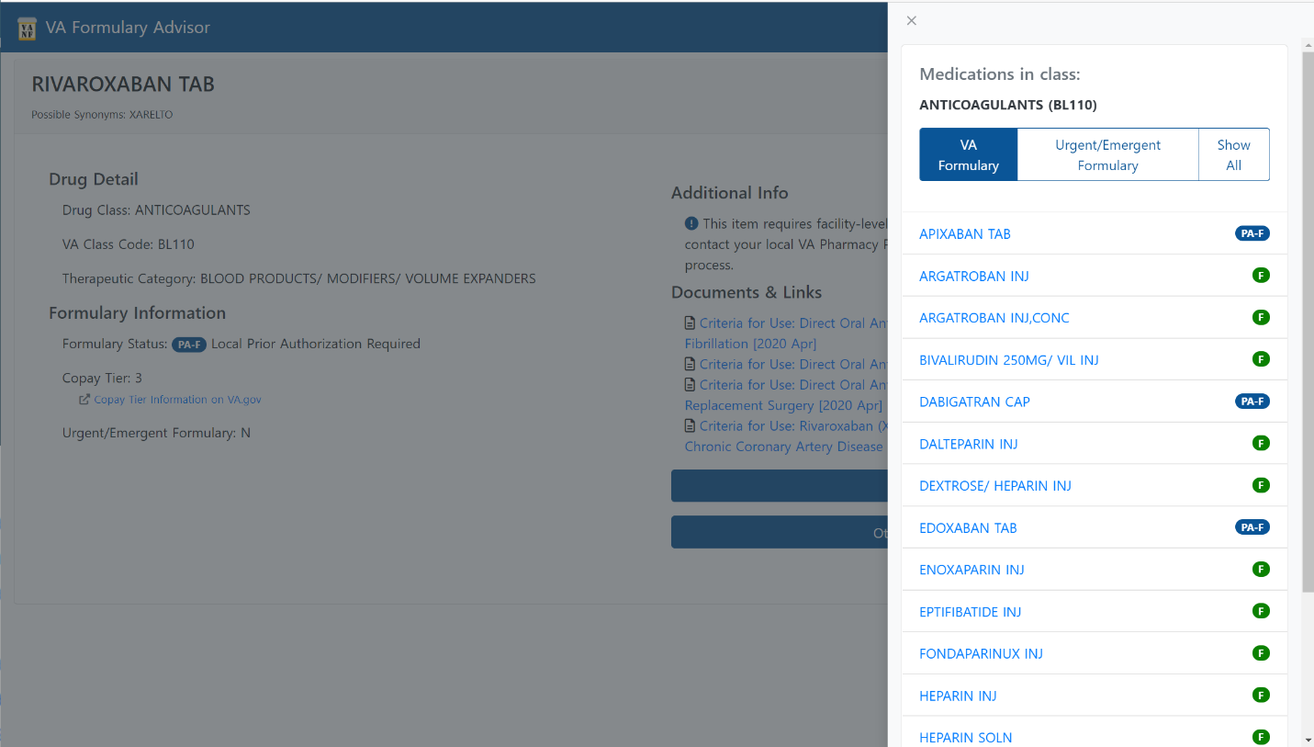

Other Classes in Same Category
Clicking on Other Drugs In Same Category brings up classes within the category of the drug class of the drug just searched.
Figure 3-12. Classes Within Category List
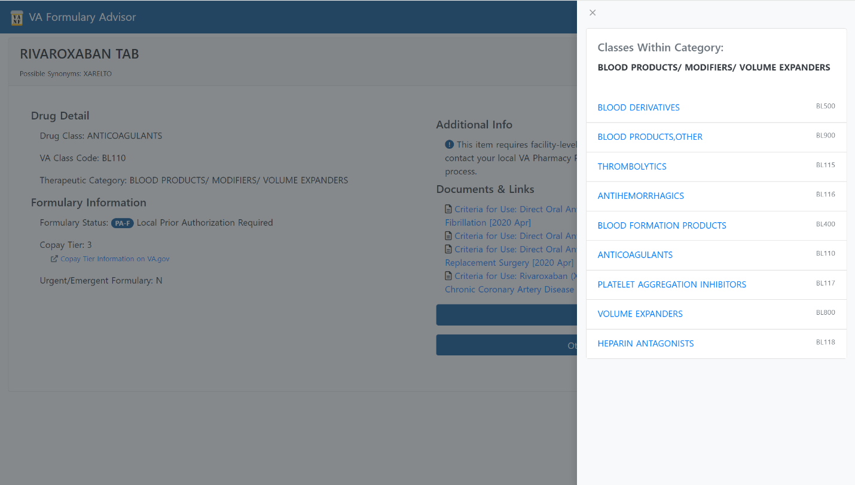

Acronyms and Abbreviations
Term | Meaning
CFU | Criteria for Use
OIT | Office of Information and Technology
PBM | Pharmacy Benefits Management
PDF | Portable Document Format
URL | Uniform Resource Locator (Web address)
VA | Department of Veterans Affairs
VHA | Veterans Health Administration

