Eligibility and Enrollment (E&E)

Veterans Health Administration (VHA) Enrollment System (VES) 6.1

Release Notes
May 2022
Department of Veterans Affairs (VA)
Office of Information and Technology (OIT)

Table of Contents
1 Introduction 1
2 Purpose 2
3 Audience 2
4 This Release 2
4.1 Enhancements and Modifications 2
4.2 Defects and Fixes 6
4.3 Known Issues 6
5 Product Documentation 6

List of Tables
Table 1: VES 6.1 Enhancements and Modifications 2
Table 2: HUD-VASH Secondary Eligibility Assignment 5
Table 3: Defects and Fixes in VES 6.1 6

List of Figures
Figure 1: New HUD-VASH Non-Veteran Eligibility Code 3
Figure 2: HUD-VASH Work Item 4

Introduction
The mission of the VA OIT Development, Security, and Operations is to provide benefits to Veterans and their families. In order to meet this overarching goal, OIT is charged with providing high quality, effective and efficient IT services and Operations and Maintenance (O&M) to persons and organizations that provide point-of-care services to our Veterans.
The VA’s goals for its Veterans and families include:
- Make it easier for Veterans and their families to receive the right benefits and meeting their expectations for quality, timeliness and responsiveness.
- Improve the quality and accessibility of health care, benefits and memorial services while optimizing value.
- Provide world-class health care delivery, by partnering with each Veteran to create a personalized, proactive strategy to optimize health and well-being, while providing state of the art disease management.
- Ensure awareness and understanding of the personalized, proactive and patient-driven health care model through education and monitoring.
- Provide convenient access to information regarding VA health benefits, medical records, health information, expert advice and ongoing support needed to make informed health decisions and successfully implement the Veteran’s personal health plans.
- Receive timely, high quality, personalized, safe, effective and equitable health care, not dependent upon geography, gender, age, culture, race, or sexual orientation.
- Strengthen collaborations with communities and organizations, such as the Department of Defense (DoD), Department of Health and Human Services (DHHS), academic affiliates and other service organizations.
To assist in meeting these goals, the Eligibility and Enrollment (E&E) program will provide enterprise wide enhancements and sustainment for the following systems/applications:
- The VHA Enrollment System (VES) is the authoritative system for VA enrollment and Community Care static eligibility determinations.
- Income Verification Match (IVM)/Enrollment Database (EDB) assists in determining priority grouping for health care eligibility.
- Veterans Information Systems and Technology Architecture (VistA) Registration, Eligibility & Enrollment (REE) shares information with other VistA applications and enables registration and preliminary eligibility determinations and enrollment at VA Medical Centers (VAMC). VES makes the final eligibility determinations.
- The Veteran’s On-Line Application (VOA), now referred to as Health Care Application (HCA), enables Veterans to self-enroll in VA health care and is another entry point for records to be added to VES.
E&E defines VHA Profiles (VHAP) for which a client (Veteran, Service Member, or beneficiary) is eligible and ties them to the authority for care. Key enhancements to be completed include Pending Eligibility Determination, fixes to the VHA Enrollment System, Date of Death, Internal Controls, Workflow, Veterans Financial Assessment, converting of Military Service Data Sharing (MSDS) to Enterprise Military Information Service (eMIS), Manage Relationships, Veteran Contact Service and support for Enrollment System Community Care (ESCC).

Purpose
The purpose of this Release Notes document is to announce the release of the VES 6.1. This release, developed in Java technology, contains E&E development and upgrade efforts. This release includes enhancements and defect fixes to support Enrollment System Modernization (ESM), ESCC and VES Sustainment.

Audience
This document targets users and administrators of VES 6.1 and applies to the changes made between this release and any previous release for this software.

This Release
VES will be upgraded from Version 6.0.1 to Version 6.1 and hosted by Amazon Web Services.
The following sections provide a summary of the enhancements and updates to the existing software and any known issues for VES 6.1.

Enhancements and Modifications
Table 1 shows the enhancements and modifications included in the VES 6.1 release as tracked in Atlassian Jira.
Table 1: VES 6.1 Enhancements and Modifications
Jira Epic # | Summary
VES-14968 | HUD-VASH Program Enhancement (VES)
VES-17487 | New factors with CTB for general Hardship data (VES)
VES-18030 | Update OIT Report Extract for Homeless Program Office
VES-18683 | Share Future Date Hardship Expires on EE Web Service
VES-20513 | VES Auto-lock Accounts Inactive 90+ Days
VES-21185 | Add and Change Letters DB Changes (Phase 1)
VES is enhanced to allow users to easily identify Veterans and non-Veterans who are eligible for the Housing and Urban Development-Veterans Affairs Supportive Housing (HUD-VASH) program.

- A new non-Veteran Eligibility Code, “HUD-VASH”, is added to the Eligibility tab.
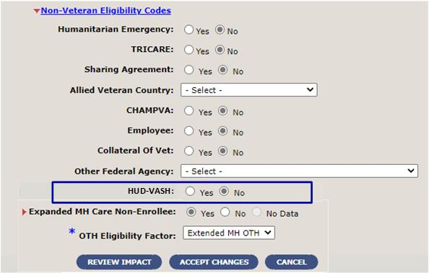
Figure 1: New HUD-VASH Non-Veteran Eligibility Code
- Eligibility tab rules for Ineligible Reasons and Pending Verification / Re-Verification Reasons are updated for HUD-VASH: When the user selects “Yes” for the HUD-VASH Non-Veteran Eligibility Code but the Ineligible Reason or Pending Verification / Re-Verification Code is one that doesn’t qualify for HUD-VASH, VES displays an error message informing the user that HUD-VASH cannot be selected and informs the user of the currently assigned Ineligible Reason or Pending Verification / Re-Verification Reason Code.
- VES assigns the HUD-VASH Secondary Eligibility and VHAP as follows:
  - When the HUD-VASH Non-Veteran Eligibility Code is by default set to “No”, the person’s record will NOT have a Secondary Eligibility of “HUD-VASH” or a VHAP of “HUD-VASH Restricted Care” assigned.
  - When a user sets the HUD-VASH Non-Veteran Eligibility Code to “Yes”:
    - A HUD-VASH qualifying person’s record is saved successfully upon selection of the “Accept Changes” button.
    - VES assigns the Secondary Eligibility of “HUD-VASH” in addition to the Primary and Secondary Eligibilities as determined by the rules for the data conditions of the current record.
    - The new VHAP “HUD-VASH Restricted Care” is assigned in addition to the Core and Carveout VHAPs as determined by the rules for the data conditions of the current record.
  - When a user manually sets the HUD-VASH Non-Veteran Eligibility Code from “Yes” to “No”, a HUD-VASH qualifying person’s record is saved successfully upon selection of the “Accept Changes” button.
    - VES only removes the currently assigned Secondary Eligibility of “HUD-VASH”.
    - VES only removes the currently assigned Carveout VHAP “HUD-VASH Restricted Care”.
- VES is updated to send and receive the HUD-VASH Secondary Eligibility Code and VHAP to and from VistA.
  - When a VistA user removes HUD-VASH from a former servicemember’s record after they have completed the HUD-VASH program, the HUD-VASH assignment is removed from VES for the same person.
  - When VES receives a Secondary Eligibility Code of HUD-VASH from VistA:
    - If the person’s record in VES qualifies for HUD-VASH, the HUD-VASH Secondary Eligibility and the corresponding VHAP are assigned in VES.
    - If the person’s record in VES does not qualify for HUD-VASH, either through a non-qualifying Ineligible Reason Code or non-qualifying Pending Verification / Re-Verification Reason, the HUD-VASH Secondary Eligibility and the corresponding VHAP are NOT assigned in VES and no work item is created. VES will send a Health Level Seven (HL7) ORU/ORF-Z11 message to VistA to remove the HUD-VASH eligibility.
    - If the person’s record in VES is either missing the Ineligible Reason Code or the Pending Verification / Re-Verification Reason and VES is unable to determine if HUD-VASH can be assigned or not, then a work item is created.
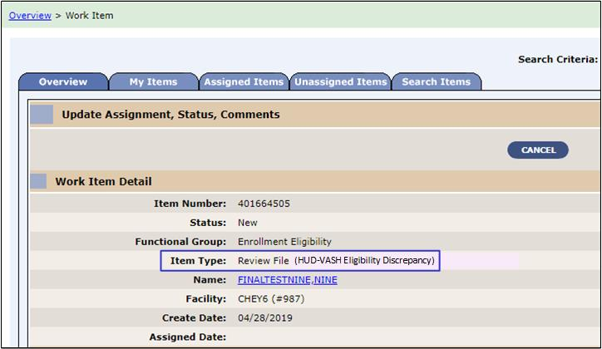
Figure 2: HUD-VASH Work Item
- The “SDS Eligibility_Code” table in the Standard Data Service (SDS) database is updated with the new HUD-VASH Secondary Eligibility Code.

- For record seeding, VES will share the updates shown in Table 2 with VistA sites where the person is known.
Table 2: HUD-VASH Secondary Eligibility Assignment
Record seeding for all records that currently have: | … are updated as follows:
OTH Eligibility Factor, “Extended MH OTH”  Primary Eligibility of “Expanded MH Care Non-Enrollee”  AND  Verification Method text entered only as “HUD-VASH”, “HUDVASH” or “HUD VASH”  When Verification Method is HUD-VASH and additional text, those records are not included  AND  Ineligible Reason Code is not “Bad Conduct General Court Martial”, “Dishonorable Discharge”, or “Fugitive Felon Program (FFP)” | "HUD-VASH" Non-Veteran Eligibility Code set to “Yes” under Eligibility tab  “Expanded MH Care Non-Enrollee” Non-Veteran Eligibility Code set to “No” under Eligibility tab  Eligibility and Enrollment rules recalculated  Secondary Eligibility of “HUD-VASH” assigned in addition to any existing Secondary Eligibilities  Carveout VHAP of “HUD-VASH Restricted Care” assigned in addition to any existing VHAPs
VES is updated to query the Corporate Data Warehouse (CDW) for additional hardship reasons that were added with Consult Toolbox (CTB) 2.0. This will allow VES to have the latest consult factors for a hardship and assign the proper Veterans Choice Eligibility (VCE) value and VHAP. Upon receiving the new consult factors successfully, VES assigns the following to the record:
- VCE - Hardship (H)
- VHAP - Veteran Plan CCP Hardship Determination (CCP H)
VES is updated to include all Ineligible Reason Codes and Military Service Episode Data to the OIT Homeless Program Report Extracts. Updating this functionality will result in Veterans receiving the appropriate eligibility determinations for VA Homeless programs.
VES is updated to include the Community Care (CC) hardship expiration date on the E&E web service so that it can be available to subscribers.
VES, which currently locks inactive accounts after a one-year period, will now lock accounts after 90 days of inactivity to comply with Federal Information Security Management Act (FISMA) requirements. VES will send a reminder email to users 7 days prior to their account being locked.
The VES database is updated to include 5 new letters (Creditable Coverage Letter, Special Eligibility Proof Request, Registration Only Letter, Returned Mail Letter and Caregiver Letter). These letters will not be able to be triggered from VES until a future release.

Defects and Fixes
Table 3 lists the defects and fixes and corresponding Jira issue numbers included in VES 6.1.
Table 3: Defects and Fixes in VES 6.1
Jira Issue # | Summary
VES-19278 | Defect: Enrollment history calls on inbound data work manager transactions are sticking, causing the transactions to delay and be redelivered by the Java Transaction Application Programming Interface (JTA).  Fix: Removed enrollment history calls for rules that don’t need them and modified the rule for “ProcessLetterSendRequest” so that it functions properly.
VES-21618 | Defect: VES is not processing the relationship “Aunt” from Cerner.  Fix: Updated mapping for the inbound relationship value from Cerner so that all relationships are properly processed.
VES-22179 | Defect: After Future Discharge Date (FDD) maturity is reached and the FDD batch job is executed, the VBA Query status remains in “Pending Response”.  Fix: Modified code so that the status of the VBA Query is updated properly instead of remaining in “Pending Response”.

Known Issues
No known or open issues were identified in this release.

Product Documentation
The following documents apply to this release:
- VES 6.1 Release Notes are uploaded to the VA Software Document Library.
- Additional reference documentation related to this release is stored in GitHub.

