Eligibility and Enrollment (E&E)

Veterans Health Administration (VHA) Enrollment System (VES) 6.2

Release Notes
September 2022
Department of Veterans Affairs (VA)
Office of Information and Technology (OIT)

Table of Contents
1 Introduction 1
2 Purpose 2
3 Audience 2
4 This Release 2
4.1 Enhancements and Modifications 2
4.2 Defects and Fixes 8
4.3 Known Issues 8
5 Product Documentation 8

List of Tables
Table 1: VES 6.2 Enhancements and Modifications 2
Table 2: SC% / Ineligible Information Manual Entry Matrix 5
Table 3: VES Sustainment Defects and Fixes in VES 6.2 8

List of Figures
Figure 1: Edit Eligibility Tab – Ineligible Reason Dropdown 3
Figure 2: Overview Tab – Ineligible Reason Field 3
Figure 3: Other Ineligibility Section - Ineligible Reason Field 3
Figure 4: Ineligible Reason - Other 4
Figure 5: Work Item Detail 6
Figure 6: Application Received Date Label Example 7

Introduction
The mission of the VA OIT Development, Security, and Operations is to provide benefits to Veterans and their families. In order to meet this overarching goal, OIT is charged with providing high quality, effective and efficient IT services and Operations and Maintenance (O&M) to persons and organizations that provide point-of-care services to our Veterans.
The VA’s goals for its Veterans and families include:
- Make it easier for Veterans and their families to receive the right benefits and meeting their expectations for quality, timeliness and responsiveness.
- Improve the quality and accessibility of health care, benefits and memorial services while optimizing value.
- Provide world-class health care delivery, by partnering with each Veteran to create a personalized, proactive strategy to optimize health and well-being, while providing state of the art disease management.
- Ensure awareness and understanding of the personalized, proactive and patient-driven health care model through education and monitoring.
- Provide convenient access to information regarding VA health benefits, medical records, health information, expert advice and ongoing support needed to make informed health decisions and successfully implement the Veteran’s personal health plans.
- Receive timely, high quality, personalized, safe, effective and equitable health care, not dependent upon geography, gender, age, culture, race, or sexual orientation.
- Strengthen collaborations with communities and organizations, such as the Department of Defense (DoD), Department of Health and Human Services (DHHS), academic affiliates and other service organizations.
To assist in meeting these goals, the Eligibility and Enrollment (E&E) program will provide enterprise wide enhancements and sustainment for the following systems/applications:
- The VHA Enrollment System (VES) is the authoritative system for VA enrollment and Community Care static eligibility determinations.
- Income Verification Match (IVM)/Enrollment Database (EDB) assists in determining priority grouping for health care eligibility.
- Veterans Information Systems and Technology Architecture (VistA) Registration, Eligibility & Enrollment (REE) shares information with other VistA applications and enables registration and preliminary eligibility determinations and enrollment at VA Medical Centers (VAMC). VES makes the final eligibility determinations.
- The Veteran’s On-Line Application (VOA), now referred to as Health Care Application (HCA), enables Veterans to self-enroll in VA health care and is another entry point for records to be added to VES.
E&E defines VHA Profiles (VHAP) for which a client (Veteran, Service Member, or beneficiary) is eligible and ties them to the authority for care. Key enhancements to be completed include Pending Eligibility Determination, fixes to the VHA Enrollment System, Date of Death, Internal Controls, Workflow, Veterans Financial Assessment, converting of Military Service Data Sharing (MSDS) to Enterprise Military Information Service (eMIS), Manage Relationships, Veteran Contact Service and support for VES Integrated Veteran Care (IVC) Systems Impact (VES/IVC SI).

Purpose
The purpose of this Release Notes document is to announce the release of the VES 6.2. This release, developed in Java technology, contains E&E development and upgrade efforts. This release includes enhancements and defect fixes to support Enrollment System Modernization (ESM), VES/IVC SI and VES Sustainment.

Audience
This document targets users and administrators of VES 6.2 and applies to the changes made between this release and any previous release for this software.

This Release
VES will be upgraded from Version 6.1.1 to Version 6.2 and hosted by Amazon Web Services.
The following sections provide a summary of the enhancements and updates to the existing software and any known issues for VES 6.2.

Enhancements and Modifications
Table 1 shows the enhancements and modifications included in the VES 6.2 release as tracked in Atlassian Jira.
Table 1: VES 6.2 Enhancements and Modifications
Jira Epic # | Summary
VES-12472 | Standardize List of Ineligible Reasons and Add Rules
VES-17490 | Update Rules for Not Eligible Reasons
VES-22133 | Change Application Date Field Label on Enrollment Tab
VES-22326 | HUD-VASH Phase 2: Update "Expanded MH Care" Rule
VES-22398 | Change VHAP Assigned to Clinical Evaluation SRRO
VES-22399 | Change VHAP to Humanitarian for Those Pending Proof of Qualifying Military Service
VES-22400 | Update Functionality for Removing All SC-Rated Disabilities
VES-22401 | Change Rules for Placing Records in Not Eligible
VES-22478 | Update VHAP Descriptions

VES v5.18 added a lookup table containing a list of selectable Ineligible Reason Codes and added the Ineligible Reason Code selection field to the Edit Eligibility screen. The Ineligible Reason free text field was still available and, if blank, would be automatically populated with the value of the Ineligible Reason dropdown. With VES v6.2, the Ineligible Reason field label is changed, and usage of the Ineligible Reason free-text field is discontinued and removed from the user interface. All ineligible records will now have a standardized Ineligible Reason from the dropdown assigned. New business rules are implemented for processing Veterans Benefits Administration (VBA) data, entry of Service Connection (SC) data and VHA Profile (VHAP) assignment based on the value of the Ineligible Reason.
- Under the Edit Eligibility tab, the current “Ineligible Reason” free-text and “Ineligible VARO Decision” fields are removed from the display and the “Ineligible Reason Code” field label is renamed “Ineligible Reason”.
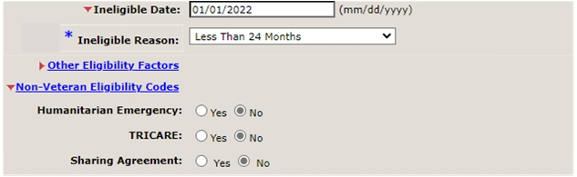
Figure 1: Edit Eligibility Tab – Ineligible Reason Dropdown
- Under the Overview tab, the “Ineligible Reason Code” field is renamed “Ineligible Reason” and the “Ineligible Reason” free-text field is removed.
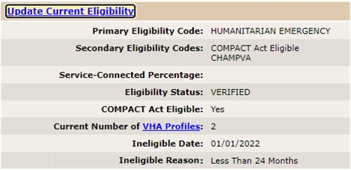
Figure 2: Overview Tab – Ineligible Reason Field
- Under the Eligibility tab -> Other Ineligibility section, the “Ineligible VARO Decision” field is removed and the “Ineligible Reason” value displayed is the standardized ineligible reason assigned for the person.
Figure 3: Other Ineligibility Section - Ineligible Reason Field
- Under the Eligibility History tab -> Other Ineligibility section, the value for the “Ineligible Reason” field maps to the standardized ineligible reason.
- Records will be seeded with the standardized ineligible reasons.
  - For records with free text but no standardized ineligible reason assigned, the respective standardized ineligible reason value will be assigned based on mapping provided by stakeholders.
  - As a temporary solution for records that cannot be auto-assigned one of the currently identified list of eight ineligible reasons, a new ineligible reason of “other” will be used and will display as greyed out for all users who do not have the “Edit Fugitive Felon Program Reason” capability.
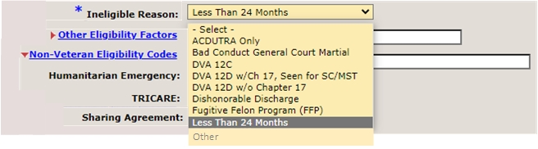
Figure 4: Ineligible Reason - Other
  - Upon completion of the record seeding and cleanup, VES will send all records with a standardized Ineligible Reason to correlated VistA sites via the ZIE segment of a Health Level Seven (HL7) ORU/ORF-Z11 message.
- When a VES user assigns an Ineligible Reason to a record that has one of the six ineligible reasons (Bad Conduct General Court Martial, Dishonorable Discharge, DVA 12D w/o Chapter 17, DVA 12C, Fugitive Felon Program (FFP)) or “ACDUTRA Only”, and the person's record has the Military Sexual Trauma (MST) Indicator set to "Yes", VES will not assign the Secondary Eligibility Code of SPECIAL TX AUTHORITY CARE to the record.
  - Existing records meeting these criteria will be cleaned up to remove the SPECIAL TX AUTHORITY CARE Secondary Eligibility Code.
- When a VES user selects the “Remove All Rated SC Disabilities” button, VES will allow and accept entering an Ineligible Date and Reason without having to accept changes first, and will clear all data from the following fields:
  - Service Connected: %
  - Effective Date of Combined Evaluation
  - Rated SC Disabilities
  - Receiving VA Disability Compensation
  - Total Monthly Check Amount
  - Annual Check Amount
  - Unemployable

- The user interface under the Eligibility tab is updated to enable / disable / display error for manual entries of SC% and Ineligible information based on the below matrix.
Sample Error Message: SC% Zero is not valid for bar-to-benefits records and/or when Veteran Indicator is “No”.
SC % | Vet Indicator | Ineligible Date | Ineligible Reason | Manual Entry of Inel. Date | Manual Entry of Inel. Reason | Manual Entry of SC % = 0 | Manual Entry of SC % > 0 | Display Error upon Accept/Review OR Save Record | Requirement/  Statement
NULL | N | Y | Not Bar-to-benefits |  |  | Disallow |  |  | When SC% is NULL, Vet Indicator is No, Ineligible Date exists with a not bar-to-benefits reason, VES user is not allowed to enter SC% of zero.
NULL | N | Y | Bar-to-benefits |  |  | Disallow |  |  | When SC% is NULL, Vet Indicator is No, Ineligible Date exists with a bar-to-benefits reason, VES user is not allowed to enter SC% of zero.
NULL | N (Change to Y) | Y | Bar-to-benefits |  |  | Disallow |  |  | When SC% is NULL, VES user changes Vet Indicator from No to Yes, Ineligible Date exists with a bar-to-benefits reason, VES user is not allowed to enter SC% of zero.
NULL | N (Change to Y) VI remains Y | Y | Not Bar-to-benefits |  |  | Allow |  | Save Record | When SC% is NULL, VES user changes Vet Indicator from No to Yes, Ineligible Date exists with a not bar-to-benefits reason, VES user is allowed to enter SC% of zero and save the record.
Is = 0 | Y | NULL | NULL | Allow | Bar-to-benefits |  |  | Y | When SC% is zero, Vet Indicator is Yes, Ineligible Date is entered with a bar-to-benefits reason, VES user is not allowed to save the record. An error message will be displayed.
Is = 0 | N | NULL | NULL | Allow | Bar-to-benefits |  |  | Y | When SC% is zero, Vet Indicator is No, Ineligible Date is entered with a bar-to-benefits reason, VES user is not allowed to save the record. An error message will be displayed.
Is = 0 | Y | NULL | NULL | Allow | Not Bar-to-benefits |  |  | Save Record | When SC% is zero, Vet Indicator is Yes, Ineligible Date is entered with a not bar-to-benefits reason, VES user is allowed to save the record.
Is = 0 | N | NULL | NULL | Allow | Not Bar-to-benefits |  |  | Y | When SC% is zero, Vet Indicator is No, Ineligible Date is entered with a not bar-to-benefits reason, VES user is not allowed to save the record. An error message will be displayed.
Table 2: SC% / Ineligible Information Manual Entry Matrix

- When an Ineligible Date is assigned to a record and an update is received from VBA, any SC data received is ignored and a work item is created.
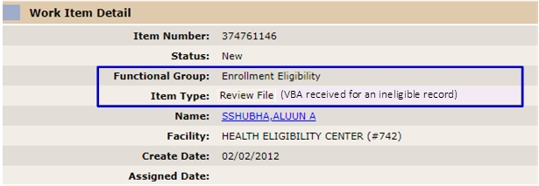
Figure 5: Work Item Detail
- When a VES user clears the Ineligible Date and Ineligible Reason of “Fugitive Felon Program (FFP)” and saves the record, VES will clear the Ineligible Date and Ineligible Reason and initiate an automatic VBA query request.
- A new Clinical Evaluation eligibility for MST clinical reminder to be triggered in Computerized Patient Record System (CPRS) is added to VES and will be shared with VistA on the ZEL segment of the HL7 ORU/ORF-Z11 message.
- The descriptions of the following VHAPs are updated:
  - Veteran Restricted Med Benefits
  - Non Veteran Other Restricted Med Benefits
  - Ineligible
  - Restricted Examination Only
  - Humanitarian
  - Applicant in Process
- VHAP assignments are updated and VES shares the records with VistA:
  - When a record's Eligibility Status is “Pending” with Pending Reason "Pending Proof of Qualifying Military Service", and the Enrollment Status is either "Pending: Eligibility Status is Unverified" or "Closed Application", VES assigns the Humanitarian VHAP to the record.
- The rules for placing records in “Not Eligible” are updated:
  - When a VES user tries to enter an Ineligible Date and Ineligible Reason for a record with Eligibility Status of “Pending Verification/Re-verification”, VES displays an error message indicating that an Ineligible record must always be Verified and does not save the changes.
  - When a VES user tries to modify the Eligibility Status to “Pending Verification/Re-verification” on a record that has the Ineligible Date and Ineligible Reason populated, VES displays an error message indicating that the Ineligible record must always be Verified and does not save the changes.
  - When a VOA/HCA update is received on a record that has the Ineligible Date and Ineligible Reason populated, VES rejects the update, creates a work item, and does not set the record to pending or execute any downstream queries or recalculations.
  - With the VES 6.2 rule that all Ineligible records should be in Verified status, the rules that set eligibility status to Pending Verification based on evaluation of military service information from a VOA update or existing data within the Administrative Data Repository (ADR) will not be executed.
- When a user accepts changes on the Eligibility tab for a record with the Self-Reported Registration Only Reason of “Clinical Evaluation”, Veteran Indicator set to “No” and an Ineligible Date assigned, VES will not display an error message and will save the record.
As a continuation of the Housing and Urban Development-Veterans Affairs Supportive Housing (HUD-VASH) workflow introduced to VES in version 6.1, with version 6.2 VES will also be updated to prevent the VES user from assigning the Primary Eligibility Code of "Expanded MH Care Non-Enrollee" to a person who is not eligible.
- When a VES user attempts to save a record with Primary Eligibility of “Expanded MH Care Non-Enrollee”, and that record also has an Ineligible Date, or if the user attempts to assign Expanded OTH factor to an ineligible record, VES will display an error message informing the user that the Primary Eligibility of “Expanded MH Care Non-Enrollee” is not valid when the Ineligible Date is populated, and not save the record.
- “Expanded MH Care Non-Enrollee” Primary Eligibility Code will be removed from ineligible records and Eligibility and Enrollment rules will be recalculated.
- VES will no longer accept an MH OTH Factor received from VistA if there is an Ineligible Date on the VES record.
With version 6.2, all instances of the label "Application Date" are updated to display "Application Received Date" on the VES user interface.
- Enrollment Screen
- Enrollment History Screen
- Overview Screen
- Eligibility Screen
- Eligibility History Screen
- Edit Current Eligibility Screen
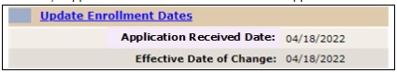
Figure 6: Application Received Date Label Example

Defects and Fixes
Table 3 lists the VES Sustainment defects and fixes and corresponding Jira issue numbers included in VES 6.2.
Table 3: VES Sustainment Defects and Fixes in VES 6.2
Jira Issue # | Summary
VES-17790 | Defect: The VBA query response is improperly handled.  Fix: When a solicited message response is returned with no data on file, the call to the VBA rule is prevented in order to prevent the calculation based on previous verified and pending verification status. The status and reason will be updated, and the flow will be ended.
VES-21146 | Defect: VES modifies IVM test status and Priority Group after eligibility update.  Fix: Restricted financial changes when eligibility is updated.
VES-23615 | Defect: Remove references to “HL7_ARCHIVE_TRANSACTION_LOG”.  Fix: Permanently removed all references to the archive table.
VES-24421 | Defect: There is a null pointer exception on the 10-10EZ PDF import for VOA.  Fix: Added null checks during generation of the 10-10EZ PDF.

Known Issues
No known or open issues were identified in this release.

Product Documentation
The following documents apply to this release:
- VES 6.2 Release Notes are uploaded to the VA Software Document Library.
- Additional reference documentation related to this release is stored in GitHub.

