Eligibility and Enrollment (E&E)

Veterans Health Administration (VHA) Enrollment System (VES) 6.3

Release Notes
December 2022
Department of Veterans Affairs (VA)
Office of Information and Technology (OIT)

Table of Contents
1 Introduction 1
2 Purpose 2
3 Audience 2
4 This Release 2
4.1 Enhancements and Modifications 2
4.2 Defects and Fixes 9
4.3 Known Issues 10
5 Product Documentation 10

List of Tables
Table 1: VES 6.3 Enhancements and Modifications 2
Table 2: Additional 10-10EZ & 10-10EZR Fields 3
Table 3: Defects and Fixes in VES 6.3 9

List of Figures
Figure 1: Overview Tab / View Community Care Outcome Panel 3
Figure 2: Eligibility Tab / Community Care Panel 3
Figure 3: Community Care Determination Tab / Community Care Outcome Panel 4
Figure 4: Community Care Determination History Tab / Community Care Outcome Panel 4
Figure 5: Presumptive Psychosis Screening Radio Buttons / Category Dropdown 5
Figure 6: Eligibility Screen 6
Figure 7: Eligibility History Screen 7
Figure 8: Clinical Determination Screen 8
Figure 9: Clinical Determination History Screen 8

Introduction
The mission of the VA OIT Development, Security, and Operations is to provide benefits to Veterans and their families. In order to meet this overarching goal, OIT is charged with providing high quality, effective and efficient IT services and Operations and Maintenance (O&M) to persons and organizations that provide point-of-care services to our Veterans.
The VA’s goals for its Veterans and families include:
- Make it easier for Veterans and their families to receive the right benefits and meeting their expectations for quality, timeliness and responsiveness.
- Improve the quality and accessibility of health care, benefits and memorial services while optimizing value.
- Provide world-class health care delivery, by partnering with each Veteran to create a personalized, proactive strategy to optimize health and well-being, while providing state of the art disease management.
- Ensure awareness and understanding of the personalized, proactive and patient-driven health care model through education and monitoring.
- Provide convenient access to information regarding VA health benefits, medical records, health information, expert advice and ongoing support needed to make informed health decisions and successfully implement the Veteran’s personal health plans.
- Receive timely, high quality, personalized, safe, effective and equitable health care, not dependent upon geography, gender, age, culture, race, or sexual orientation.
- Strengthen collaborations with communities and organizations, such as the Department of Defense (DoD), Department of Health and Human Services (DHHS), academic affiliates and other service organizations.
To assist in meeting these goals, the Eligibility and Enrollment (E&E) program will provide enterprise wide enhancements and sustainment for the following systems/applications:
- The VHA Enrollment System (VES) is the authoritative system for VA enrollment and Community Care static eligibility determinations.
- Income Verification Match (IVM)/Enrollment Database (EDB) assists in determining priority grouping for health care eligibility.
- Veterans Information Systems and Technology Architecture (VistA) Registration, Eligibility & Enrollment (REE) shares information with other VistA applications and enables registration and preliminary eligibility determinations and enrollment at VA Medical Centers (VAMC). VES makes the final eligibility determinations.
- The Veteran’s On-Line Application (VOA), now referred to as Health Care Application (HCA), enables Veterans to self-enroll in VA health care and is another entry point for records to be added to VES.
E&E defines VHA Profiles (VHAP) for which a client (Veteran, Service Member, or beneficiary) is eligible and ties them to the authority for care.

Purpose
The purpose of this Release Notes document is to announce the release of the VES 6.3. This release, developed in Java technology, contains E&E development and upgrade efforts. This release includes enhancements and defect fixes to support Enrollment System Modernization (ESM), VES/IVC SI and VES Sustainment.

Audience
This document targets users and administrators of VES 6.3 and applies to the changes made between this release and any previous release for this software.

This Release
VES will be upgraded from Version 6.2.2.06001 to Version 6.3 and hosted by Amazon Web Services.
The following sections provide a summary of the enhancements and updates to the existing software and any known issues for VES 6.3.

Enhancements and Modifications
Table 1 shows the enhancements and modifications included in the VES 6.3 release as tracked in Atlassian Jira.
Table 1: VES 6.3 Enhancements and Modifications
Jira Epic # | Summary
VES-3566 | Update VES 10-10EZ and 10-10EZR to Reflect 2022 Form
VES-13814 | Add SIGI to VOA Service for Online Application Submissions (VES)
VES-15805 | Add VCE Effective Date to VES GUI
VES-22402 | Presumptive Psychosis Secondary Eligibility (VES)
VES is updated to accept, store and display information received from VOA using the July 2022 version of 10-10EZ and 10-10EZR forms, under Enrollment and Financial tabs.

- The VOA Web Service is modified to receive and store the information shown in Table 2 in the Administrative Data Repository (ADR) in addition to the current list of fields and response values.
Table 2: Additional 10-10EZ & 10-10EZR Fields
Section | Field | Response(s) - New Values Only | 10-10EZ | 10-10EZR
I | SELF-IDENTIFIED GENDER IDENTITY | - TRANSGENDER MALE  - TRANSGENDER FEMALE  - OTHER  - DOES NOT WISH TO DISCLOSE  - NON-BINARY | X | X
I | ARE YOU AN INDIAN? | - YES  - NO | X | X
- VES will display the applicant’s SELF-IDENTIFIED GENDER IDENTITY (SIGI) as validated and received from MPI (Demographics / Identity Traits).
- VES will display the applicant’s choice of YES or NO as received on 10-10EZ or 10-10EZR form as response to the question ARE YOU AN INDIAN? (Demographics / Personal).
VES is updated to display the CC Determination Date (the date when the Community Care eligibility (VCE) became effective) next to its associated VCE on the following screens:
- Overview Tab / View Community Care Outcome Panel
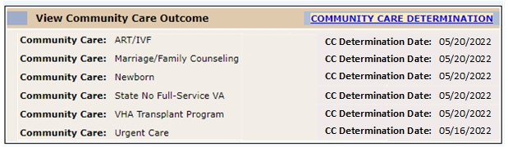
Figure 1: Overview Tab / View Community Care Outcome Panel
- Eligibility Tab / Community Care Panel
Figure 2: Eligibility Tab / Community Care Panel

- Community Care Determination Tab / Community Care Outcome Panel
Figure 3: Community Care Determination Tab / Community Care Outcome Panel
- Community Care Determination History Tab / Community Care Outcome Panel
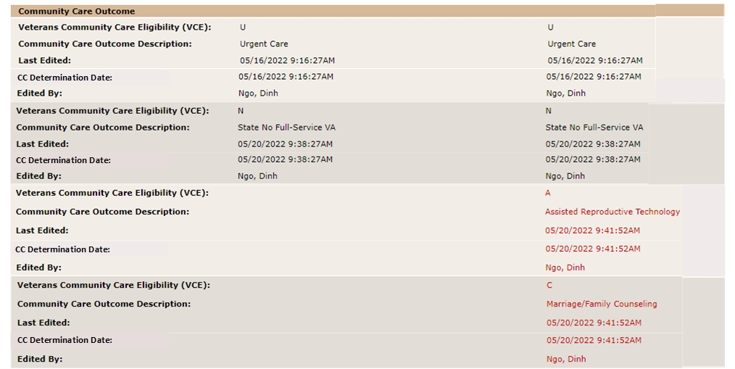
Figure 4: Community Care Determination History Tab / Community Care Outcome Panel

VES is enhanced with the introduction of workflows to select Presumptive Psychosis Screening for qualifying persons and automatic assignment of the Secondary Eligibility Code of "Presumptive Psychosis Eligible" for persons that are screened positive.
- VES users with Edit Eligibility capability can request for Presumptive Psychosis (PP) Screening and assign a category. The screening request can be successfully made only if the person qualifies for “Clinical Evaluation” Secondary Eligibility Code.
- A new “Clinical Evaluations” tree is displayed under the Edit Current Eligibility Screen, and the “Presumptive Psychosis Screening” field is displayed under the group with “Yes” and “No” radio button options.
- If the user selects “Yes” for Presumptive Psychosis Screening, VES displays the “Presumptive Psychosis Screening Category” dropdown.
  - One and only one Presumptive Psychosis Category selection is required when “Yes” is selected; if left unselected, VES will display the error message: “A category selection is required when Presumptive Psychosis screening is being requested.”
  - Records with the Secondary Eligibility of “Clinical Evaluation” assigned will be saved when the user accepts changes after selecting Presumptive Psychosis Screening = Yes and selecting the Presumptive Psychosis Category.
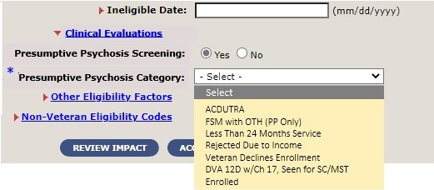
Figure 5: Presumptive Psychosis Screening Radio Buttons / Category Dropdown
- Presumptive Psychosis screening request category and timestamp are shared between VES and VistA via Health Level 7 (HL7) messaging.

- The Eligibility screen is updated:
  - A new panel, “Clinical Evaluations”, is displayed below the Secondary Eligibility Codes panel, with Presumptive Psychosis Screening Category displayed when a user has requested screening and assigned a category.
  - When the screening option is set to “No”, “No Data Available” will display under the Clinical Evaluations panel.
  - The panel label “Other Eligibility Factors” is replaced by a new label, “Clinical Determinations”.
  - When VES receives positive screening information, “Presumptive Psychosis” will display under the Clinical Determinations panel.
  - Note: Clinical Determination will not be received until Computerized Patient Record System (CPRS) functionality is updated to allow a clinician to populate the new Presumptive Psychosis Determination field in a manner similar to the way current CPRS functionality allows a clinician to update the Military Sexual Trauma (MST) Status.
Figure 6: Eligibility Screen

- The Eligibility History screen is updated:
  - A new panel “Clinical Evaluations” is displayed below the “Secondary Eligibility Codes” panel, with Presumptive Psychosis Screening Category, Request Timestamp, Request Update Date (Timestamp) and PP Screening Request displayed.
    - When a user requests for screening and assigns a category, PP Screening Request displays "Yes", and the selected Category and Request Date are displayed.
    - When the screening is updated to “No”, the indicator displays "No" and the Screening Category and Request Date display blank.
    - The Screening Request Update Date displays the date when the indicator is set to "Yes" or "No".
  - The panel label “Other Eligibility Factors” is replaced by a new label, “Clinical Determinations”.
  - When VES receives positive screening information, “Presumptive Psychosis” will display under the Clinical Determinations panel.
  - Screening request and removal history is displayed.
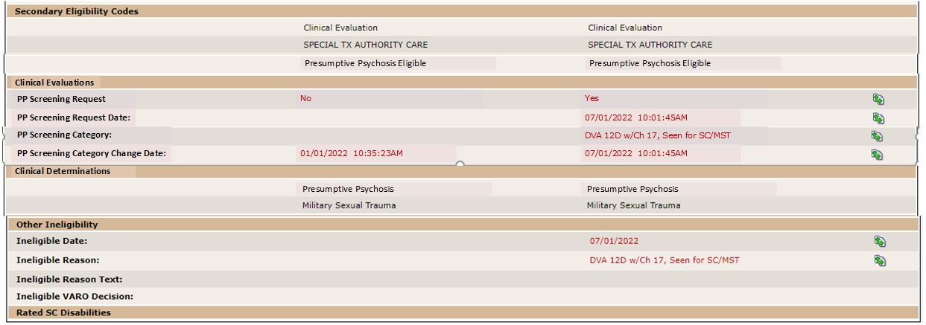
Figure 7: Eligibility History Screen

- The Clinical Determination screen is updated:
  - A new panel, “Presumptive Psychosis”, is displayed below the Military Sexual Trauma panel.
  - “PP Status Indicator”, “Status Date”, and “Facility Making Determination” labels are displayed under the new panel.
  - Display of Status Date and Facility Making Determination values follows the same logic as MST.
  - “PP Status Indicator” values: Screened, Reports PP (Y), Screened does not report PP (N), Screened Declines to answer (D) or Unknown, not screened (U).
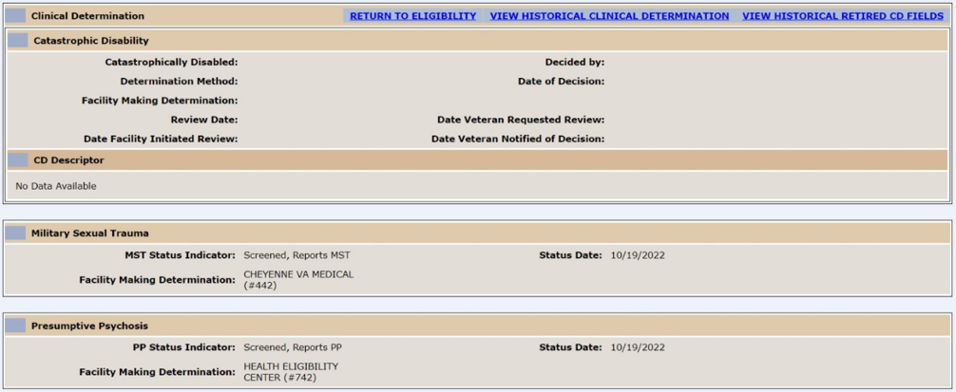
Figure 8: Clinical Determination Screen
- The Clinical Determination History screen is updated:
  - A new panel, “Presumptive Psychosis”, is displayed below the Military Sexual Trauma panel.
  - All field labels displayed are the same as under the MST panel (except for the indicator, which is displayed as “PP Status Indicator”); values follow the same logic as MST.
  - “PP Status Indicator” values as received: Screened, Reports PP (Y), Screened does not report PP (N), Screened Declines to answer (D) or Unknown, not screened (U).
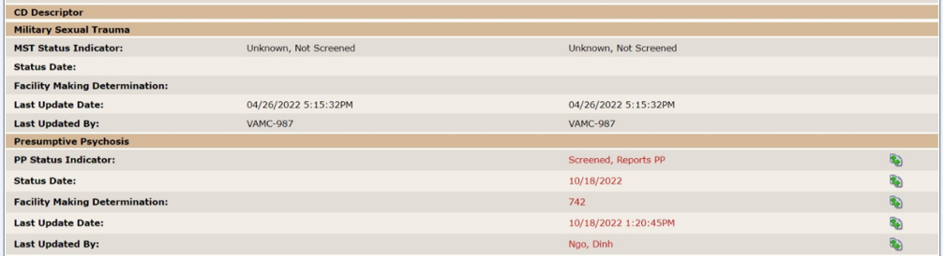
Figure 9: Clinical Determination History Screen

- VES will set the Presumptive Psychosis indicator for all current and future records with SC Code 9410 to positive (“Screened, Reports PP (Y)”).
- VES will nullify the Presumptive Psychosis indicator when SC Code 9410 is removed.
- The Secondary Eligibility Code “Presumptive Psychosis Eligible” is:
  - Assigned to all records that have the PP indicator set to positive by the clinician (Screened, Reports PP (Y)), except for those with bar-to-benefits ineligible reasons; VES sends the eligibility code to VistA.
  - Removed when the PP indicator is set to anything other than positive; VES shares the removal of the code with VistA.
  - Removed from all records that have the PP indicator set to positive by the clinician when the ineligible reason assigned is bar-to-benefits; VES shares the removal of the code with VistA.
- The “Presumptive” VHAP is:
  - Assigned to a record and shared with VistA when the Secondary Eligibility Code of “Presumptive Psychosis Eligible” is assigned.
  - Removed from a record, and shared with VistA, when the Secondary Eligibility Code of “Presumptive Psychosis Eligible” is removed.
- Other VHAP updates in VES include:
  - The user interface and Web Help descriptions of the “Presumptive” VHAP are updated.
  - New Carveout VHAP, “Clinical Evaluation” is assigned to records with the Secondary Eligibility Code of "Clinical Evaluation", and the assignment is shared with VistA.

Defects and Fixes
Table 3 lists the defects and fixes and corresponding Jira issue numbers included in VES 6.3.
Table 3: Defects and Fixes in VES 6.3
Jira Issue # | Summary
VES-23818 | Defect: Section 508: The name, role, state or value of user interface elements in the product cannot be understood (programmatically determined).  Fix: Updated the user interface elements so that they can be understood (programmatically determined).
VES-23927 | Defect: Electronic Health Record Modernization (EHRM) outbound is not getting triggered from the Primary View date of death flow.  Fix: Updated so that when Date of Death is entered in Master Person Index (MPI) or in VES , VES end-dates the VHAPs and triggers an EHRM outbound message to VA Profile.
VES-24269 | Defect: When Caregiver status is revoked, staff cannot manually remove the collateral eligibility because the button group remains greyed out.  Fix: Updated VES to enable the radio button once all the Caregiver records become inactive.
VES-25518 | Defect: An update is needed to the COMPACT Override Indicator error message.  Fix: Message is updated to: "One of the following scenarios must be true (Veteran Indicator is Yes, Eligibility is Verified, and Do You Wish To Enroll is No) Or (Veteran indicator is No, Enrollment Status is Not Applicable, and Do You Wish To Enroll is No Data) when the COMPACT Act (Override) is set to Yes".
VES-25806 | Defect: The VCE recalculation job updating the wrong “person_id”.  Fix: Updated the recalculation flag of deactivated records.
VES-26191 | Defect: The query “gmtThreshold_getByYearFipsAndMSACode” is not sorting the results from highest to lowest and will just take the first value returned.  Fix: Updated query to sort so that the first value returned is always the highest one.

Known Issues
No known or open issues were identified in this release.

Product Documentation
The following documents apply to this release:
- VES 6.3 Release Notes are uploaded to the VA Software Document Library.
- Additional reference documentation related to this release is stored in GitHub.

