Enrollment System Modernization (ESM) Phase 2

Enrollment System (ES) 5.10

Release Notes
February 2020
Department of Veterans Affairs
Office of Information and Technology (OIT)

Table of Contents
1 Introduction 1
2 Purpose 2
3 Audience 2
4 This Release 2
4.1 Enhancements and Modifications 2
4.2 Defects and Fixes 11
4.3 Known Issues 12
5 Product Documentation 12

List of Tables
Table 1: ES 5.10 ESM Enhancements and Modifications 2
Table 2: ES 5.10 EHRM Enhancements and Modifications 10
Table 3: ES 5.10 ODM Enhancements and Modifications 10
Table 4: Defects and Fixes in ES 5.10 11
List of Figures
Figure 1: View Hardship Details Hyperlink 3
Figure 2: Hardship Overview Screen - No Current Hardship On File 3
Figure 3: Hardship Overview Screen - Current Hardship On File 3
Figure 4: Delete Hardship 4
Figure 5: Edit Hardship Details Screen 4
Figure 6: Financials Tab 5
Figure 7: HCA Farewell Message 6
Figure 8: VMBP Label Change: Reference Page 6
Figure 9: VMBP Label Change: Person Search / Eligibility / VHA Profile Page 7
Figure 10: VMBP Label Change: Person Search / Eligibility / VHA Profile Change History Page 7
Figure 11: VMBP Label Change: Person Search / Eligibility Page 7
Figure 12: VHA Profiles Link on Update Current Eligibility Panel 8
Figure 13: Return to Eligibility Hyperlink on VHA Profiles Screen 8
Figure 14: Initial and Subsequent 90-Day Periods of Care 9
Figure 15: 15-Day Backdating and Forward-Dating for Subsequent 90-Day Periods of Care 9

Introduction
The mission of the Department of Veterans Affairs (VA) Office of Information and Technology (OIT), Enterprise Program Management Office (EPMO) is to provide benefits to Veterans and their families. To meet this overarching goal, OIT is charged with providing high quality, effective, and efficient IT services and Operations and Maintenance (O&M) to persons and organizations that provide point-of-care services to our Veterans.
The VA’s goals for its Veterans and families include:
- Make it easier for Veterans and their families to receive the right benefits, and meet their expectations for quality, timeliness, and responsiveness.
- Improve the quality and accessibility of health care, benefits, and memorial services while optimizing value.
- Provide world-class health care delivery by partnering with each Veteran to create a personalized, proactive strategy to optimize health and well-being, while providing state-of-the-art disease management.
- Ensure awareness and understanding of the personalized, proactive, and patient-driven health care model through education and monitoring.
- Provide convenient access to information regarding VA health benefits, medical records, health information, expert advice, and ongoing support needed to make informed health decisions and successfully implement the Veteran’s personal health plans.
- Receive timely, high quality, personalized, safe, effective, and equitable health care, not dependent upon geography, gender, age, culture, race, or sexual orientation.
- Strengthen collaborations with communities and organizations, such as the Department of Defense (DoD), Department of Health and Human Services (DHHS), academic affiliates, and other service organizations.
To assist in meeting these goals, the Enterprise Health Benefits Determination (EHBD) program provides enterprise-wide enhancements and sustainment for the following systems/applications:
- The Enrollment System (ES) is the authoritative system for VA enrollment determination.
- Income Verification Match (IVM)/Enrollment Database (EDB) assists in determining priority grouping for health care eligibility.
- Veterans Information Systems and Technology Architecture (VistA) Registration, Eligibility & Enrollment (REE) shares information with other VistA applications and enables registration and preliminary eligibility determinations and enrollment at VA Medical Centers (VAMC). ES makes the final eligibility determinations.
- The Veteran’s On-Line Application (VOA), now referred to as Health Care Application (HCA), enables Veterans to self-enroll in VA health care and is another entry point for records to be added to ES.
Enrollment System Modernization (ESM) defines VHA Profiles (VHAP) for which a client (Veteran, service member, or beneficiary) is eligible and ties them to the authority for care. Key enhancements to be completed include pending eligibility determination, fixes to the Enrollment System, date of death, internal controls, workflow, Veterans Financial Assessment, converting of Military Service Data Sharing (MSDS) to Enterprise Military Information Service (eMIS), Manage Relationships, Veteran Contact Service, and support for Enrollment System Community Care (ESCC).

Purpose
The purpose of this Release Notes document is to announce the release of the ES 5.10. This release, developed in Java technology, contains ESM Phase 2 development and upgrade efforts, including enhancements and defect fixes to support ESCC, Suicide High-Risk Patient Enhancements (SHRPE), Electronic Health Record Modernization (EHRM), and ES Sustainment.

Audience
This document targets users and administrators of ES 5.10 and applies to the changes made between this release and any previous release for this software.

This Release
ES will be upgraded from Version 5.9.1 to Version 5.10 and hosted at the Austin Information Technology Center (AITC).
The following sections provide a summary of the enhancements and updates to the existing software and any known issues for ES 5.10.

Enhancements and Modifications
Enrollment System Modernization (ESM)
Table 1 shows the ESM enhancements and modifications included in the ES 5.10 release as tracked in Rational Team Concert (RTC) Requirements Management (RM).
Table 1: ES 5.10 ESM Enhancements and Modifications
RTC  RM # | Summary
1085902 | VMBP: Hardship
1051868 | ESCC Quality
1145494 | Reroute Anonymous HCA Applications
1154759 | Send Address Override Key to VA Profile
1158673 | Assign Medical Benefit Plan to Individuals with no Veteran Eligibility Code
1158674 | Overview Link to VMBP Listing
1159224 | VMBP Names Changed
1161819 | SHRPE: New "Expanded Mental Health" Eligibility Functionality and OTH Periods
1162279 | Enhance Demographic BIO for HIE
1162280 | VMBP Category: Add new and update existing manual plans
1164623 | Clarification of "future" subsequent 90-day periods
1164624 | “Authorization Received Date" - A future date is not allowed

ES is enhanced to allow entry of financial hardships so that Veterans will be placed in the appropriate enrollment priority and VHAP.
Three new capabilities – “Add Hardship”, "Edit Hardship", and "Delete Hardship" – are added to ES. The system allows only users with the appropriate capabilities to add, edit, or delete hardships.
Hardship information is added to the ES User Interface (UI):
- A hyperlink titled “View Hardship Details” is added to the Hardship section of the Person Search Financials screen. Clicking the “View Hardship Details” hyperlink directs the user to a new screen titled “Hardship Overview”.
Figure 1: View Hardship Details Hyperlink
  - If there is no current hardship on file, the system displays the blank hardship fields, the “Cancel” button, and the “Grant Hardship” button.
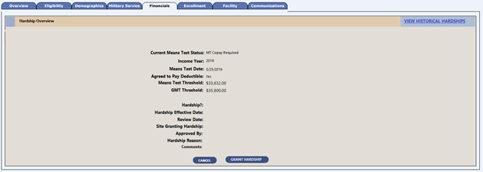
Figure 2: Hardship Overview Screen - No Current Hardship On File
  - If a current hardship is on file, the system displays the current hardship details within the hardship fields, the “Cancel” button, the “Delete Hardship” button, and the “Edit Hardship” button.
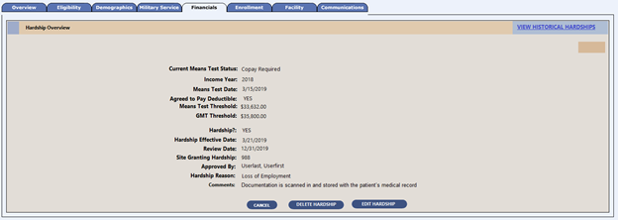
Figure 3: Hardship Overview Screen - Current Hardship On File
- Selecting the “Delete Hardship” button displays a free text field on the Person Search Financials Hardship Overview screen with the title: “Reason for Hardship Deletion” along with an “Accept Changes” and “Cancel” button.
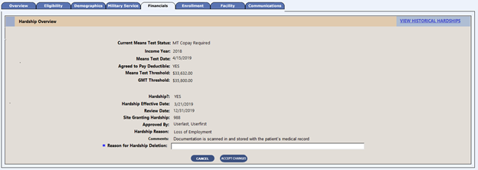
Figure 4: Delete Hardship
- A new screen, “Edit Hardship Details”, is added and is displayed when a user clicks the “Grant Hardship” or "Edit Hardship" button from the Person Search Financials Hardship Overview screen.
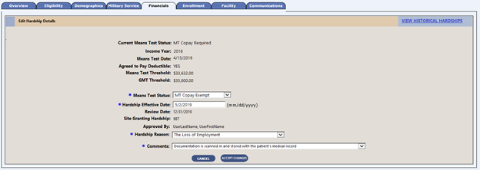
Figure 5: Edit Hardship Details Screen

- The Financials tab is updated to include ES-entered hardships. The system deletes the hardship when the associated income test is deleted, disables the “Add Income Test” button when there is a current hardship, and grays out the “Married Last Calendar Year”, “Disclose Financial Income”, and “Agree to Pay Deductible” radio buttons on the Person Search Financials Edit Financial Details screen when a hardship is entered in ES.
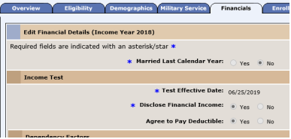
Figure 6: Financials Tab
ES is enhanced to send hardship updates to VistA by triggering an updated Z10 message to correlated VistA site(s) upon hardship entry completion.
ES will generate a daily report for the Office of Community Care (OCC) so that it is notified when a job or routine fails in the processes of determining, communicating, and tracking CC eligibility. The report will be generated in the morning and will include the data for the day before. This report will be created out of Oracle and displayed as part of a daily email. The report includes:
- Daily counts of Veteran records that were slated to be sent to VistA for VHAP changes and failed.
- Daily counts of how many Veterans with “State with No Full-Service Medical Facility (N)” did not meet the business rules and need to be investigated.
- Daily counts of how many Veterans with “Urgent Care (U)” did not meet the business rules and need to be investigated.
- Daily counts of the number of records processed for Title 38 care received from Corporate Date Warehouse (CDW) and the number of records ES assigned “Grandfather (G)” status.
- Daily counts to show the difference between the number of records ES sent to Planning Systems Support Group (PSSG) and the number of records returned.
When online Health Care Applications (HCAs) are transmitted to the Enrollment System, (if HCAs have incorrect information or information that cannot be verified), the Enrollment System determines the HCAs to be “anonymous”; however, rather than failing HCAs because they are “anonymous”, the anonymous HCAs are rerouted to the Workload Reporting and Productivity (WRAP) system so the anonymous HCAs can be reviewed and processed manually in order to validate the incorrect or missing information.
Note: Anonymous HCAs are treated the same as mailed-in applications once rerouted to WRAP.
Important: The WRAP functionality will be delivered in ES 5.10 but turned off in Production until WRAP is ready.
If the Veteran provides an email address, the initial email confirmation will continue to be sent to the Veteran after the online HCA is saved and submitted. The same confirmation email will be used for both anonymous and authenticated online HCAs. Concurrently, the farewell message will continue to display on the Farewell screen after the online HCA is saved and submitted. The same farewell message will be used for both anonymous and authenticated online HCAs.
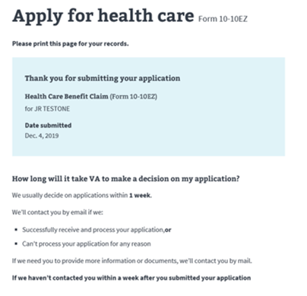
Figure 7: HCA Farewell Message
ES is enhanced to allow users to update a Veteran’s address on the Address screen when the address is “invalid” according to the Universal Addressing Module (UAM) but the Veteran has indicated that it is a valid address. The address is stored to VA Profile without further UAM validation.
In order to support the Electronic Health Record (EHR) in Cerner's Millennium application, all VMBP labels are updated to display “VHA Profile” or “VHA Profiles”.
- The Reference page title and all VMBP labels within are updated to display “VHA Profile”.
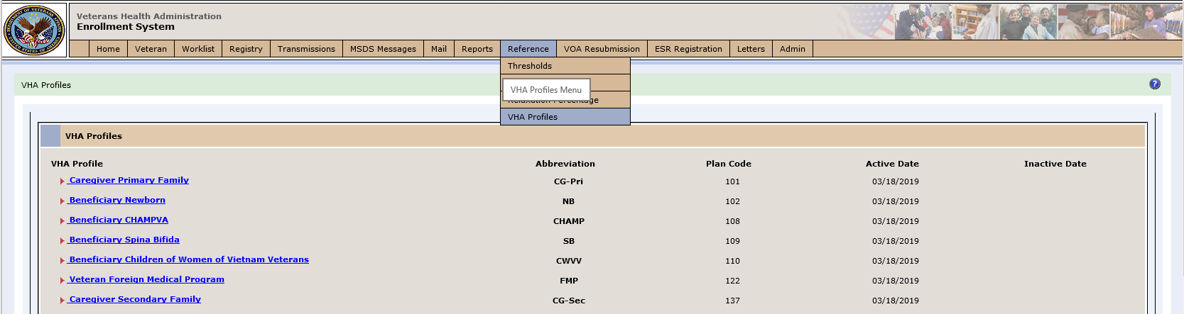
Figure 8: VMBP Label Change: Reference Page

- The Person Search Eligibility VMBP page title and all labels within are updated to display “VHA Profile”.
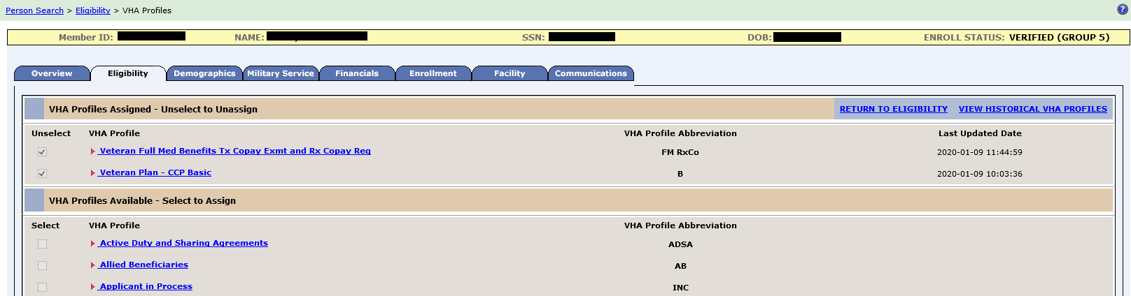
Figure 9: VMBP Label Change: Person Search / Eligibility / VHA Profile Page
- The Person Search Eligibility VMBP Change History page title and all labels within are updated to display “VHA Profile”.
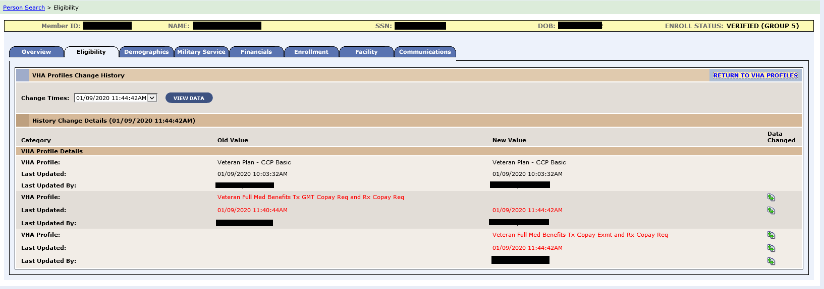
Figure 10: VMBP Label Change: Person Search / Eligibility / VHA Profile Change History Page
- The Person Search Eligibility page title and all labels within are updated to display “VHA Profile”.
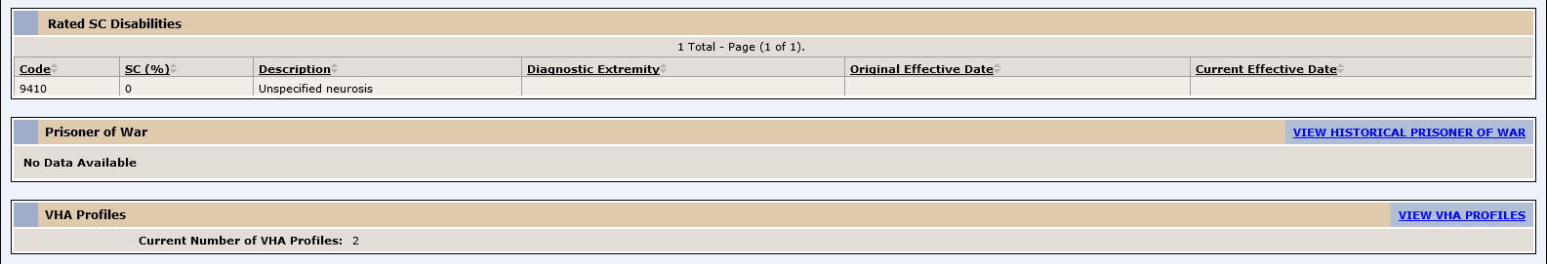
Figure 11: VMBP Label Change: Person Search / Eligibility Page

ES is enhanced to shorten VHAP names to allow the profiles to be successfully sent to the Cerner system, provide an easier way for ES users to access VHAP details, and add a new profile for employee records.
- VHAP names are changed so that they don’t contain special characters or exceed 60 characters total per Cerner limitations.
- ES users can access the list of VHAP with a single click from the Overview Update Current Eligibility panel.
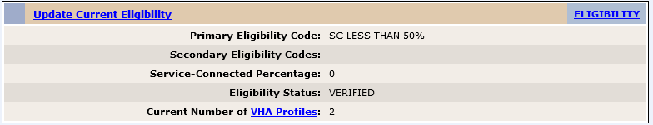
Figure 12: VHA Profiles Link on Update Current Eligibility Panel
- ES is updated to display a “Return to Eligibility” hyperlink on the Person Search Eligibility VHA Profiles screen. Upon clicking, the hyperlink directs the user to the Person Search Eligibility screen.
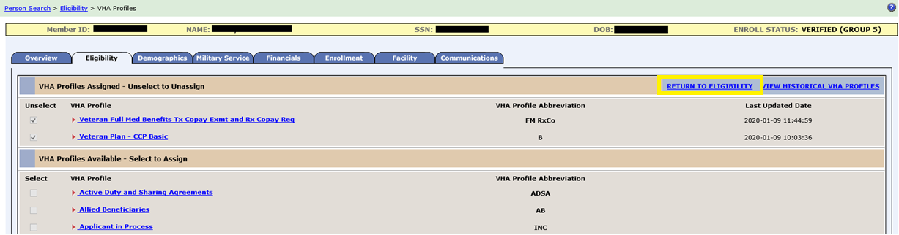
Figure 13: Return to Eligibility Hyperlink on VHA Profiles Screen
- ES is enhanced to allow users to assign a VHAP to individuals who have no Veteran eligibility code and who have either a primary or secondary code of Employee.
  - The “Employee Only” profile is displayed on the Person Search Eligibility VHA Profiles page with a non-grayed out checkbox and is manually assignable to records by users with the appropriate capability.
  - The “Employee Only” profile is considered a Carveout/Supplemental profile that can be assigned in addition to other profiles.
ES is updated to gray out and disable all profile checkboxes when a record has a Deceased enrollment status. Upon a date of death being entered in or received by ES, the system unassigns and moves to history all manually assigned profiles.

ES is updated to include the following Suicide High Risk Patient Enhancements (SHRPE) for Emergent MH OTH:
- ES calculates the initial and subsequent 90-day periods of care.
  - The initial 90-day period of care in any 365-day period has a total of 91 days.
  - Any additional 90-day periods of care within a 365-day period have a total of 90 days.
REDACTED
Figure 14: Initial and Subsequent 90-Day Periods of Care
- Only today’s date (current date) or a past date is allowed for the “Authorization Received Date”.
- A 15-day backdating and forward-dating rule for subsequent 90-day periods of care is added.
  - If the current 90-day period is ACTIVE, then the Start Date of the subsequent 90-day period is limited to the “current period’s End Date+1” (the next consecutive day after the current period ends) through forward-dating up to 15 days.
  - If the current 90-day period is EXPIRED, then the Start Date of the subsequent 90-day period is limited to backdating and forward-dating up to 15 days from the current date.
REDACTED
Figure 15: 15-Day Backdating and Forward-Dating for Subsequent 90-Day Periods of Care
The Health Information Exchange (HIE) initiative requires ES to now share several demographic data fields. ES is enhanced to create and send a message to the VA Profile Micro Service when applicable demographics data (Race, Religion, Ethnicity, and Marital Status) have been updated or deleted in Administrative Database Repository (ADR).

Table 2 shows the EHRM enhancements and modifications included in the ES 5.10 release as tracked in RTC RM.
Table 2: ES 5.10 EHRM Enhancements and Modifications
RTC  RM # | Summary
1147835 | VA Individual Service Connected Ratings SmartApp
Within Cerner Millennium, there is not a way for clinicians to view an individual’s service connected (SC) disability rating data. This information is critical for clinicians to access within the course of patient encounters and orders. ES is enhanced to provide a view of an individual’s SC disability rating data to clinicians using Cerner Millennium.
- ES receives and validates ratings requests from Cerner. Upon receipt of the message, ES performs basic format validation to assure that it is in a recognized structure by ES and performs authentication of the message.
- ES calls the VA Profile Ratings Service, receives a response, and evaluates the outcome based on that reply.
- ES constructs a view from the VA Profile response message.
  - If the VA Profile response message succeeds, ES constructs a view (formatted as an HTML page following Cerner style guidelines) from the VA Profile response message, renders the HTML view, and sends a reply code indicating “success”.
  - If the VA Profile response message fails, ES constructs the view (formatted as an HTML page following Cerner style guidelines) from existing ADR ratings data. The view contains a message indicating that the data being displayed is from ES and the reason it could not be retrieved from VA Profile.
Operational Decision Manager (ODM)
Table 3 shows the ODM enhancements and modifications included in the ES 5.10 release as tracked in RTC RM.
Table 3: ES 5.10 ODM Enhancements and Modifications
RTC  RM # | Summary
1057405 | Change Request #881133: Integrate Determine Eligibility Rules
1090581 | Integrate Manage Communications Log Rules
1090582 | Integrate Process Mail Responses Rules
1090610 | Integrate Calculate Period Of Service Rules
1090612 | Integrate Conflict Experience Validation Rules
1163287 | Integrate Determine CL-V Rules
Under ODM, the 71 iLOG rule sets were transferred from iLOG to ODM. A Mediation Framework was established to allow the system administrators to switch between the iLOG and ODM rules sets as the rules sets are integrated into the ES application. Once the migration is fully completed to ODM, the rules will not be switched back to iLOG unless there is a systemic issue with ODM. ES 5.10 supports integration of the Determine Eligibility, Manage Communications Log, Process Mail Responses, Calculate Period of Service, Conflict Experience Validation, and Camp Lejeune Veterans (CL-V) rule sets.

Defects and Fixes
Table 4 lists the defects and fixes and corresponding RTC Change and Configuration Management (CM) numbers included in ES 5.10 (RM# 1165388: ES 5.10 Maintain the Enrollment System - Maintain the Enrollment System - ESM Defect Fixes in Build 9 ver 5.10.0).
Table 4: Defects and Fixes in ES 5.10
RTC  CM # | Summary
1120309 | Defect: Cerner Notification: The push notification does not contain the “Eligibility Report Date” for Special Authorities Bio.  Fix: Updated code to add Special Factors report dates to the Enrollment & Eligibility (E&E) Service.
1127129 | Defect: Cerner Notification: ES is not updating the "Nose and Throat" indicator.  Fix: Updated the rules to conduct a null check for verification date on the Nose Throat Radium (NTR) indicator from Cerner.
1147553 | Defect: Cerner Notification: There are discrepancies in the Diagnosis & Catastrophic Disability descriptors between the E&E summary and the Cerner Outbound Bio.  Fix: Updated code to reconcile the inbound and outbound descriptors.
1151082 | Defect: Search Screen: Searching using Member ID and other traits (social security number (SSN), first and last names, birth sex, and date of birth (DOB)) displays a red banner with a hidden error message.  Fix: Added exclusive Member ID message.
1159993 | Defect: Cerner Notification: Medicaid last updated date is mapped to updated date on inbound mapper.  Fix: Updated code to read the Medicaid last updated date from the “medicaidlastupdated” field instead of the audit field.
1160669 | Defect: Section 508: Headings and labels do not describe the topics or purpose of the content to which they belong. (Demographics, Associates)  Fix: Changed delete check box count label to name.
1160678 | Defect: Section 508: Labels and instructions are not provided when content requires user input. (Add Associate)  Fix: Associate page role is changed to remove “required” from the label name.
1172132 | Defect: Calculate Period of Service: When a new record is generated, manual updates are lost.  Fix: Manual changes were added back in; ODM version will be used in future.
1176663 | Defect: VA Profile Contact Information: VA Profile inbound process service returns a null pointer exception.  Fix: The null pointer occurs when there is no CHANGE_EFFECTIVE_DATE on the phone or email and there is a delete request coming in from VA Profile. Fixed code to look at the record modified date if the CHANGE_EFFECTIVE_DATE is not present on file for email or phone.
1180972 | Defect: ES is excluding addresses with country code PHL from geocoding requests. Residential address in PHL should also be included in the geocoding request.  Fix: The PHL country code is not excluded from geocoding; however, the state and zip code check is skipped.
1182332 | Defect: The EHRM outbound message retries on validation errors from VA Profile.  Fix: Updated code to not retry when the HTTP status is 400 BAD_REQUEST.

Known Issues
No known issues were identified in this release.

Product Documentation
The following documents apply to this release:
- ES 5.10 Release Notes are uploaded to the VA Software Document Library (VDL).
- Additional reference documentation related to this release is stored in RTC.

