Enrollment System Modernization (ESM) Phase 3

Enrollment System (ES) 5.12

Release Notes
June 2020
Department of Veterans Affairs
Office of Information and Technology (OIT)

Table of Contents
1 Introduction 1
2 Purpose 2
3 Audience 2
4 This Release 2
4.1 Enhancements and Modifications 2
4.2 Defects and Fixes 19
4.3 Known Issues 19
5 Product Documentation 20

List of Tables
Table 1: ES 5.12 Caregiver Enhancements and Modifications 2
Table 2: ES 5.12 ESM Enhancements and Modifications 5
Table 3: ES 5.12 EHRM Enhancements and Modifications 12
Table 4: ES 5.12 ODM Enhancements and Modifications 18
Table 5: Defects and Fixes in ES 5.12 19
List of Figures
Figure 1: New Caregiver Grid Display 4
Figure 2: Associate Change History - Foreign Address Fields 6
Figure 3: Expire Hardship Button 7
Figure 4: Hardship Expiration Date Field 7
Figure 5: Error Message 8
Figure 6: Updated Hardship Overview Screen 9
Figure 7: Expire Hardship Button Clicked 9
Figure 8: Reason for Hardship Expiration (Person Search > Financials > Hardship Overview) 10
Figure 9: Hardship History Screen 10
Figure 10: Hardship Expiration Date Field 10
Figure 11: Hardship Granted Status 11
Figure 12: Veteran Indicator 13
Figure 13: Registration Only Section of Eligibility Screen 14
Figure 14: Edit Current Eligibility Screen 15
Figure 15: User Agreement Text 17
Figure 16: User Account Screen 17
Figure 17: Modify User Account Screen 18

Introduction
The mission of the Department of Veterans Affairs (VA) Office of Information and Technology (OIT), Enterprise Program Management Office (EPMO) is to provide benefits to Veterans and their families. To meet this overarching goal, OIT is charged with providing high quality, effective, and efficient IT services and Operations and Maintenance (O&M) to persons and organizations that provide point-of-care services to our Veterans.
The VA’s goals for its Veterans and families include:
- Make it easier for Veterans and their families to receive the right benefits, and meet their expectations for quality, timeliness, and responsiveness.
- Improve the quality and accessibility of health care, benefits, and memorial services while optimizing value.
- Provide world-class health care delivery by partnering with each Veteran to create a personalized, proactive strategy to optimize health and well-being, while providing state-of-the-art disease management.
- Ensure awareness and understanding of the personalized, proactive, and patient-driven health care model through education and monitoring.
- Provide convenient access to information regarding VA health benefits, medical records, health information, expert advice, and ongoing support needed to make informed health decisions and successfully implement the Veteran’s personal health plans.
- Receive timely, high quality, personalized, safe, effective, and equitable health care, not dependent upon geography, gender, age, culture, race, or sexual orientation.
- Strengthen collaborations with communities and organizations, such as the Department of Defense (DoD), Department of Health and Human Services (DHHS), academic affiliates, and other service organizations.
To assist in meeting these goals, the Enterprise Health Benefits Determination (EHBD) program provides enterprise-wide enhancements and sustainment for the following systems/applications:
- The Enrollment System (ES) is the authoritative system for VA enrollment determination.
- Income Verification Match (IVM)/Enrollment Database (EDB) assists in determining priority grouping for health care eligibility.
- Veterans Information Systems and Technology Architecture (VistA) Registration, Eligibility & Enrollment (REE) shares information with other VistA applications and enables registration and preliminary eligibility determinations and enrollment at VA Medical Centers (VAMC). ES makes the final eligibility determinations.
- The Veteran’s On-Line Application (VOA), now referred to as Health Care Application (HCA), enables Veterans to self-enroll in VA health care and is another entry point for records to be added to ES.
Enrollment System Modernization (ESM) defines VHA Profiles (VHAP) for which a client (Veteran, service member, or beneficiary) is eligible and ties them to the authority for care. Key enhancements to be completed include pending eligibility determination, fixes to the Enrollment System, date of death, internal controls, workflow, Veterans Financial Assessment, converting of Military Service Data Sharing (MSDS) to Enterprise Military Information Service (eMIS), Manage Relationships, Veteran Contact Service, and support for Enrollment System Community Care (ESCC).

Purpose
The purpose of this Release Notes document is to announce the release of the ES 5.12. This release, developed in Java technology, contains ESM Phase 3 development and upgrade efforts, including enhancements and defect fixes to support Caregiver, Electronic Health Record Modernization (EHRM), and ES Sustainment.

Audience
This document targets users and administrators of ES 5.12 and applies to the changes made between this release and any previous release for this software.

This Release
ES will be upgraded from Version 5.10.1 to Version 5.12 and hosted at the Austin Information Technology Center (AITC).
The following sections provide a summary of the enhancements and updates to the existing software and any known issues for ES 5.12.

Enhancements and Modifications
Caregiver
Table 2 shows the Caregiver enhancements and modifications included in the ES 5.12 release as tracked in Rational Team Concert (RTC) Requirements Management (RM).
Table 1: ES 5.12 Caregiver Enhancements and Modifications
RTC  RM # | Summary
1168288 | Create status for Caregivers
1168289 | Notify ES staff of Caregiver approved status
1168291 | Receive Caregiver information from Identity and Access Management (IAM) to ES
1168292 | Push Caregiver VHAPs from ES or VistA to other systems
1168294 | Notify ES/VistA of Caregiver status change in Caregiver Record Management Application (CARMA) to “Benefit End”
1168295 | ES To send information to VA Profile for Cerner to receive
1168296 | Create ES medical plan for In-Process Caregivers
1168297 | Assign the appropriate VHAP to the Caregiver
Under the scope of the VA Maintaining Systems and Strengthening Integrated Outside Networks (MISSION) Act, expanded VA benefits are provided to approved Primary Family Caregivers and Secondary Family Caregivers authorized for the Program of Comprehensive Assistance for Family Caregivers (PCAFC). In addition to the PCAFC, the Program of General Caregiver Support Services (PGCSS) similarly has expanded benefits under the Caregivers and Veterans Omnibus Health Services Act of 2010. Three types of VA Caregivers exist. Each one is specific to one of the programs and has its own VHA Profile (VHAP) and unique VA benefits. The three Caregiver types are:
- Primary Family Caregiver (PCAFC)
- Secondary Family Caregiver (PCAFC)
- General Caregiver (PGCSS)
In order to accurately capture the Caregivers and provide the appropriate VHAP, ES has expanded the Collateral of Vet eligibility code to identify the Caregiver Subtype, assign the appropriate VHAP, and share the Caregiver information with other systems, including VA Profile and VistA REE.
- ES receives the following new required Caregiver fields from CARMA (via MPI):
  - Caregiver Subtype
  - Caregiver Status
  - Caregiver Effective Date
  - Caregiver Inactive Date – only received when status is “Denied” or “Revoked”
  - Sponsor ICN
  - Sponsor SSN
  - Sponsor Name
- A Caregiver will have their own record in ES and the Caregiver’s Veteran sponsor will be displayed in their record. The Caregiver record will contain one or more of the following statuses:
  - In Process: The Caregiver will appear in this status until they are approved or denied for the Caregiver program. They will be in this status when the health record is made. They will be conducting the evaluations with CSC/Field staff.
  - Denied: The Caregiver applied to participate in the Caregiver program but was denied based on the evaluations conducted by the CSCs. This status will trigger the termination of their “Caregiver In Process” VHAP.
  - Approved: The Caregiver has been approved after completing the training and evaluations in CPRS. They are marked as approved in CARMA and can complete their registration process with ES/VistA.
  - Revoked: A Caregiver who has previously been approved for the Caregiver program is determined to require removal from the Caregiver program for a reason decided upon by the CSC staff.
  - Benefit End: A Caregiver who was revoked (possibly with a future benefit end date) has reached their benefit end date. CARMA sends this status to trigger the termination of their Caregiver VHAP.

- ES will continue to display “Collateral of Vet” as a Non-Veteran Eligibility Code with Yes/No radio buttons on the Edit Current Eligibility screen. ES accepts and displays the new data and status change data received from Master Person Index (MPI) for all new and existing Caregiver instances in a read-only Caregiver grid.
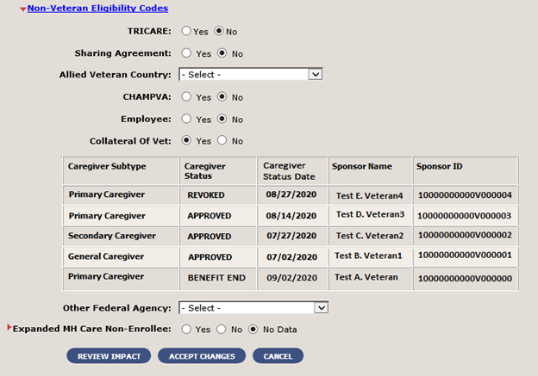
Figure 1: New Caregiver Grid Display
- A new carveout VHAP called “Caregiver In Process” is available in ES: Caregiver In Process is an individual who is undergoing evaluation for enrollment in Program of Comprehensive Assistance for Family Caregivers or Program of General Caregiver Support Services.
  - If deemed ineligible, their profile will be changed from “Caregiver In Process” to “Humanitarian”.
- ES shares Caregiver data (not including the new Caregiver data fields) with other systems using the E&E Web Service and with Cerner Millennium by sending the data to VA Profile.
- ES and VistA REE use Health Level 7 (HL7) messaging to ensure both applications stay in sync.
  - Note: The messages are triggered to/from VistA REE and ES on all applicable Caregiver registration data, eligibility code, and VHAP changes.

Table 2 shows the ESM enhancements and modifications included in the ES 5.12 release as tracked in Rational Team Concert (RTC) Requirements Management (RM).
Table 2: ES 5.12 ESM Enhancements and Modifications
RTC  RM # | Summary
1089667 | ES dynamic list to add site of change and source of change in ES from partners with VA Profile
1154785 | 50% service connected (SC) or above shall be seen and assigned appropriate VHAP
1164636 | Store foreign addresses for associates in ES
1164637 | Send and receive foreign addresses for associates in ES
1167287 | VHAP: Expire hardships when means test is no longer required
1169833 | Provide view of VA Profile transactions in the ES user interface (UI)
1169838 | Change to value (consult factor) that identifies hardship approval consults
1173645 | Updates to existing VHAPs
1173646 | Humanitarian and Ineligible VHAP
1173647 | Dental VHAPs (manual)
N/A | ESCC production defects
ES is enhanced to allow the entry of foreign addresses for associates and transmission of foreign addresses for associates to VistA.
- Upon selecting the “Add” or “Update” button on the Person Search > Demographics > Associates > Add Associate (or Update Associate) screens, the system will not display the error message: “Non-US address is not allowed” when a country other than United States is selected.
  - The "Only US addresses are currently allowed" note is removed.

- Under the Person Search > Demographics > Associates > Associate Change History page, the Postal Code, Province, and Country fields are displayed under the County field.
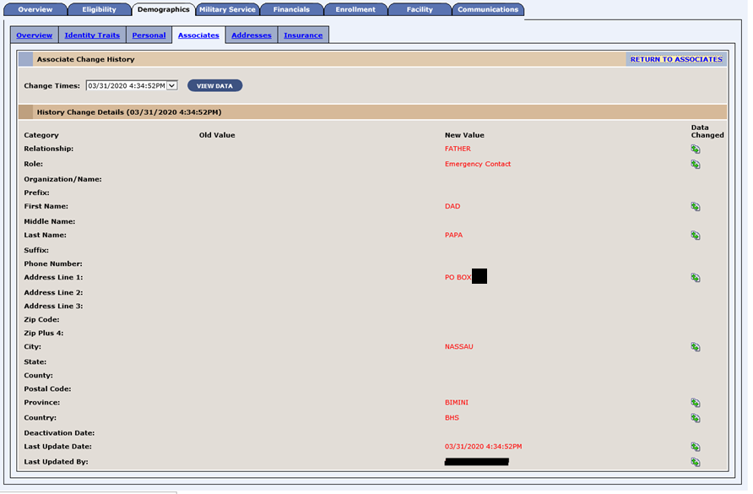
Figure 2: Associate Change History - Foreign Address Fields
- Upon saving a foreign address for an associate in ES, the system triggers a Z05 message to each correlated VistA site which contains the Country, Province, and Postal Code. Upon receiving a Z07 message from VistA, which includes a foreign address for an associate, ES stores the address, including Country, Province, and Postal Code, for the new or existing associate.

ES is enhanced to automatically expire financial hardships when a Veteran’s record is no longer eligible, and at the end of each year display the expiration date and view that the expiration date is sent to VistA. The ES user can view the hardship expiration date that is sent to VistA by going to the Facility > All HL7 Messages > Z10 Message (where the hardship was expired).
- The system will only allow users with the “Expire Hardship” capability to click on the “Expire Hardship” button on the (Person Search > Financials > Hardship Overview) screen. The expire hardship button will be disabled for users who do not have the “Expire Hardship” capability.
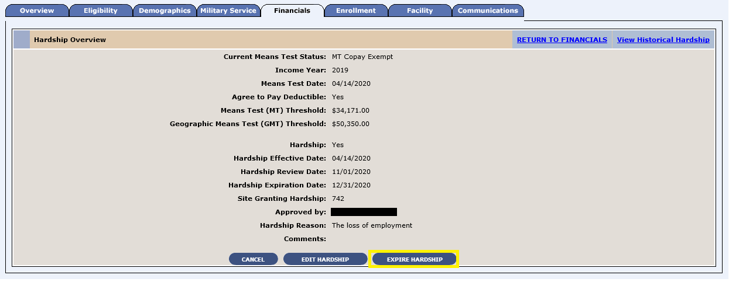
Figure 3: Expire Hardship Button
- The system displays a new “Hardship Expiration Date” field on the Person Search > Financials > Edit Hardship Details screen. The field is a label and defaults to 12/31 of the current year when granting or editing a hardship.
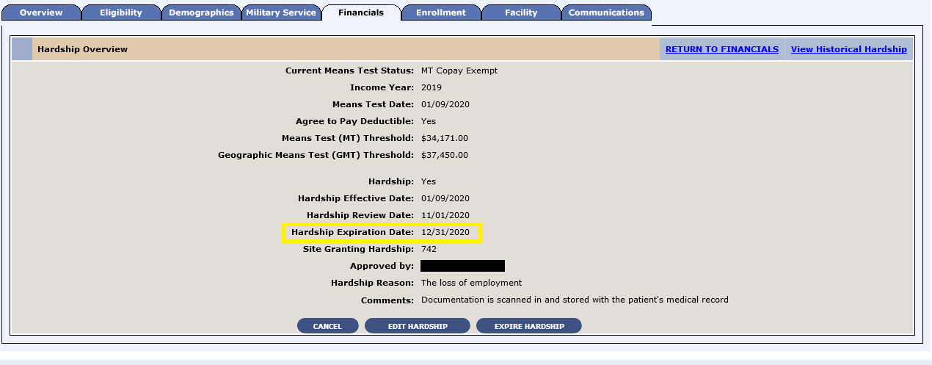
Figure 4: Hardship Expiration Date Field

- The system is updated to display an error message when the “Grant Hardship” button is clicked, and the current means test status is “Pending Adjudication”. Upon clicking the “Grant Hardship” button, the following validations will be updated to remove “Pending Adjudication” as a valid option:
  - If the current means test status of the record is not “MT Copay Required” or “GMT Copay Required”, the following error message is displayed:
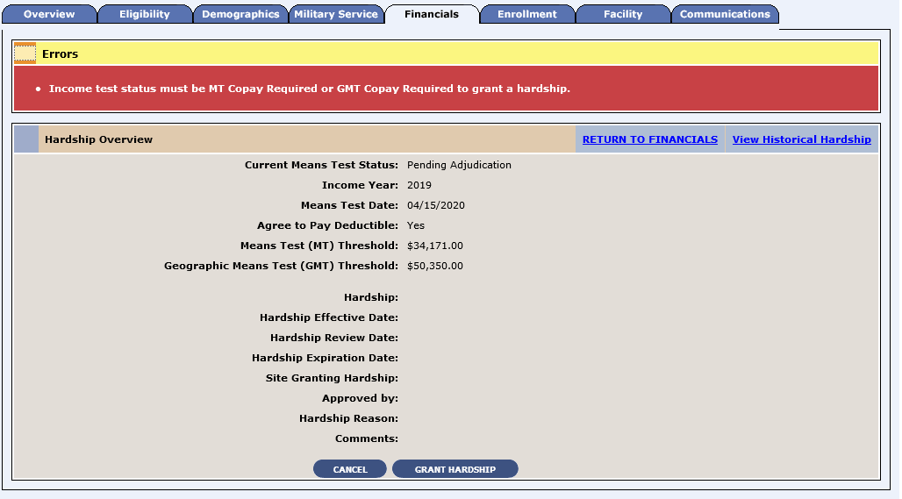
Figure 5: Error Message
- ES is updated to no longer display the “Delete Hardship” button on the Person Search > Financials > Hardship Overview screen.
  - Note: The system will no longer allow the deletion of hardships and will only allow the expiration of a hardship.

- Updated Person Search > Financials > Hardship Overview screen:
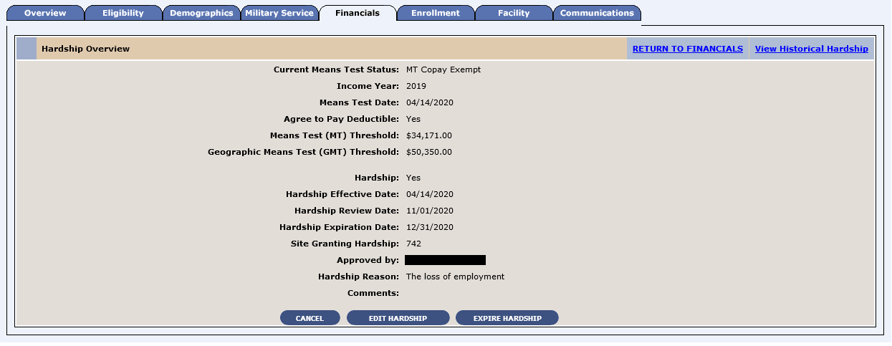
Figure 6: Updated Hardship Overview Screen
- Figure 7 shows the Person Search > Financials > Hardship Overview screen when the Expire Hardship button is clicked.
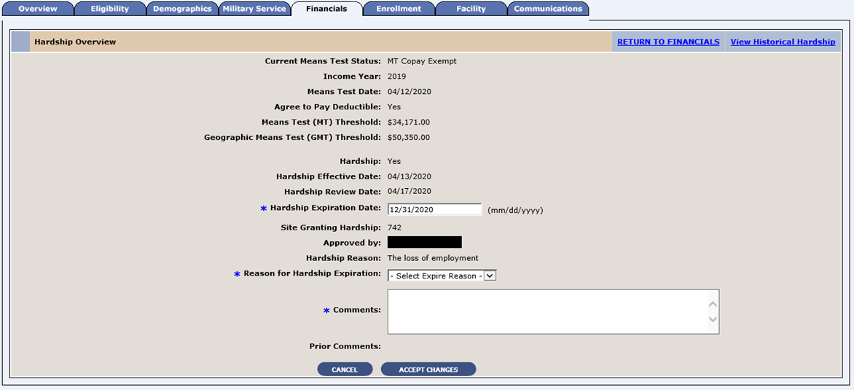
Figure 7: Expire Hardship Button Clicked
- The system will not display the “Grant Hardship”, “Edit Hardship”, or “Expire Hardship” buttons when an existing hardship is expired.

- The “Reason for Hardship Expiration” field is displayed below the “Hardship Reason”.
  - Note: In order to edit/remove the hardship, the user will need to enter a new means test.
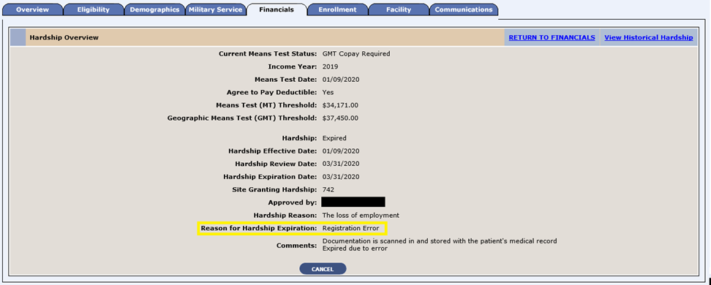
Figure 8: Reason for Hardship Expiration (Person Search > Financials > Hardship Overview)
- The system displays the new “Hardship Expiration Date” and “Reason for Hardship Expiration” fields on the Person Search > Financials > Hardship Overview > Hardship History screen.
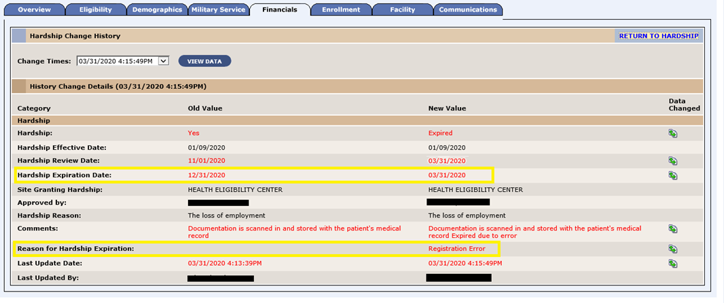
Figure 9: Hardship History Screen
- The system displays a new “Hardship Expiration Date” field on the Person Search > Financials > Hardship screen.
Figure 10: Hardship Expiration Date Field
- The system displays the hardship granted status within the Financials section of the Person Search > Overview screen
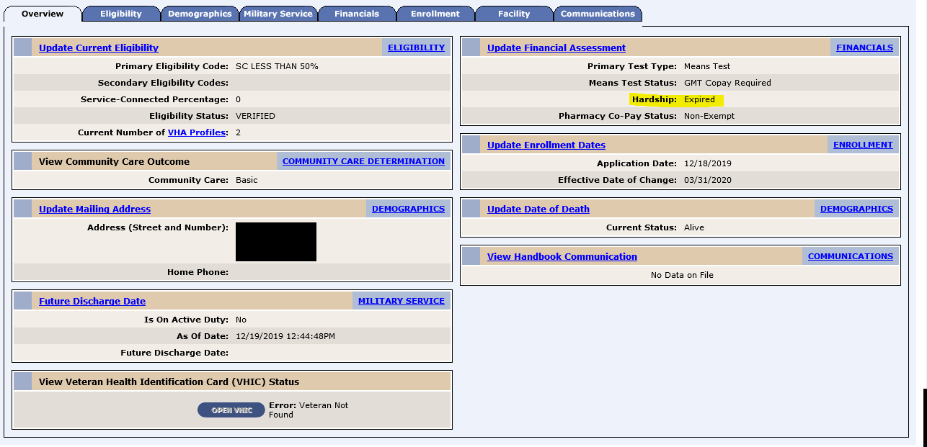
Figure 11: Hardship Granted Status
- The system will expire an active hardship upon a user successfully clicking the “Expire Hardship” and then “Accept Changes” button on the Person Search > Financials > Hardship Overview screen.
- Annual Hardship Expiration
  - On 1/1 of each year, the system will run a batch process to expire all hardships with a hardship expiration date in the past.
- Upon expiring a hardship by any method, ES will:
  - Recalculate the means test status based on current income information
  - Recalculate the eligibility and enrollment based on the attributes/eligibility factors/information in the record
  - Recalculate the VHA Profile (VHAP)
- Existing Hardship Expiration
  - All records meeting the conditions below will be updated to have a hardship expiration date of 12/31/2020
    - Record has a hardship in place
    - The hardship is applied to the current means test
    - Record is not in a deceased enrollment status
- Upon granting a hardship, ES defaults the “Hardship Review Date” to be 60 days prior to the hardship expiration date. If there are less than or equal to 60 days until the expiration date, the “Hardship Review Date” is set to the current date.
- ES and VistA REE will use HL7 messaging to ensure the hardship expiration date in both applications stays in sync.
ES is enhanced to recognize approval indication on hardship consults and set either a 6-month or 12-month expiration so the approval can be connected to the Veteran’s record.
ES is enhanced to include updated VHAP names, abbreviations, and descriptions; three new manual dental profiles; and one new automated ineligible profile with automated rules. The rules for the Humanitarian profile are updated to not include ineligible statuses.
In order to properly identify new partners onboarded to VA Profile, ES is enhanced with a dynamic list to add site of change and source of change information from partners with VA Profile.
Table 3 shows the EHRM enhancements and modifications included in the ES 5.12 release as tracked in RTC RM.
Table 3: ES 5.12 EHRM Enhancements and Modifications
RTC  RM # | Summary
1085900 | VHAP: Reporting per VHAP
1154762 | Option to select Registration Only vs. Full Enrollment in ES
1154764 | HCA Applications
1154765 | Flag the Compensation and Pension Record Interchange (CAPRI) records as Registration Only
1154766 | Flag the North Chicago records as Registration Only
1154767 | Registration Only to Enrollment
1154768 | ES - Military information is not required (only optional)
1154770 | ES - Provide a reason for Veteran's registration with VHA
1154772 | ES - Capture and store reason for Veteran's registration with VHA
1154774 | ES - Capture and store the source of application/modality about Veteran's Registration
1154776 | ES - Capture and store the Veteran's registration date
1154778 | HL7 Messages: Add a person from VistA; modify existing person from VistA; Z11 from ES to VistA
1154779 | ES - Means and Rx copay test not required
1154781 | ES - Historical registration records
1154783 | Share with Enrollment and Eligibility (E&E)
1154786 | Update the Help and “How do I” files
1165073 | Create an error message and directions on how to request access to ES if I am not an ES user
1165075 | ES will no longer require the user to check the "Accept Agreement" upon log in
1165078 | ES changes to displaying warning message to the ES user
1165079 | ES will no longer require the signature agreement codes once per year
N/A | Support to Cerner notification end-to-end testing
N/A | Support to Cerner PowerChart Rating end-to-end testing
N/A | Support to Caregiver (ES -> VA Profile --> Cerner)
N/A | System parameters to control messages
The long-term goal of the Health Eligibility Center (HEC) within Member Services with regards to VHA Enrollment is to separate (i.e., decouple) the Registration for access to VA healthcare from VA Enrollment. To this end, ES is enhanced to set the foundation for decoupling of the Registration event from the Enrollment event by implementing the ability to create and maintain a “Registration Only” record. Registration and Enrollment records in ES and VistA REE systems existing at the time of production implementation will not be back filled with the new Registration data.
- When adding a record to ES, the user is required to choose YES or NO for the Veteran Indicator.
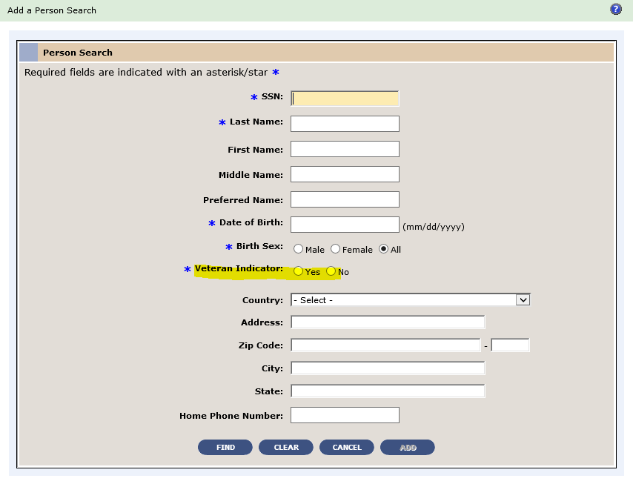
Figure 12: Veteran Indicator
  - If the Veteran Indicator is YES, then ES will display the following new fields (in addition to all existing fields):
    - On the Eligibility screen, new “Do You Wish to Enroll” field in ES with options for YES, NO, and NO DATA (default is NO DATA).
    - If the answer is YES, then ES presents as usual.
    - If the answer is NO, then ES displays a new additional field “Self-Reported Registration Only Reason”.
  - If the Veteran Indicator is NO, then:
    - “Do You Wish to Enroll” is defaulted to NO.
    - On the Eligibility screen, the new “Self-Reported Registration Only Reason” field is displayed.
    - Follow the process to finish the registration of the non-Veteran.
    - The system will save the new Registration details upon clicking “Save in Process”.
- ES displays the new Registration Only Fields on a new Registration panel on the Eligibility screen as follows:
  - Do You Wish To Enroll
  - Self-Reported Registration Reason
    - Populated when the response to “Do You Wish To Enroll” is NO.
  - Registration Only Date
    - Populated at all times.
    - If the record is created in ES, then the Registration Only date field is set to the current date by the system (the date when the user completed the Registration).
    - If the record (previously not known to ES) is received from VistA, then the date is accepted from VistA.
  - Source of Registration
    - Populated when the response to “Do You Wish To Enroll” is NO.
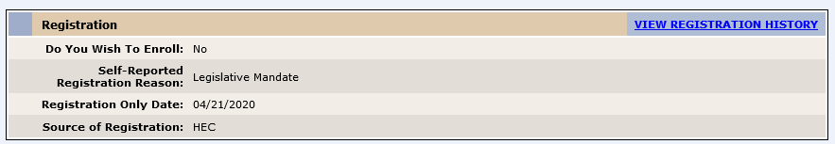
Figure 13: Registration Only Section of Eligibility Screen

- ES displays a drop-down list of self-reported Registration Only reasons from which the user may select ONLY ONE.
  - The following three reasons are assigned automatically and are NOT displayed to users in the drop-down:
    - North Chicago Active Duty
    - Unanswered
    - Caregiver
  - The system does not allow the user to change the reason once submitted unless they have elevated access privileges. Users with elevated access privileges may select from ALL the reasons.
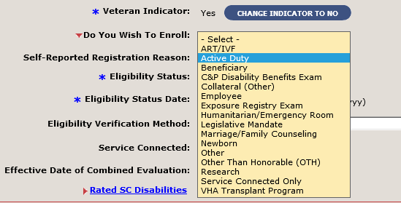
Figure 14: Edit Current Eligibility Screen
- ES does not allow the user to set the Cancelled/Declined Indicator to YES when the Enrollment Status = Registration Only or when the “Do You Wish To Enroll” value is NO.
- ES sets the source of Registration value.
- ES does not accept financials for Registration Only Records. If the user provides financial details, upon clicking “Complete Registration” ES presents the error “Financial Information cannot be entered for Registration Only Records”.
- ES does not require, but does allow, the user to enter military service information. The Enrollment Status will remain Registration Only regardless of the outcome of the military service information process unless the user enters a Future Discharge Date (FDD) on the Military Service tab.
- ES will continue to apply the existing validations at Complete Registration and will display the following new error messages for Registration Only fields:
- Veteran Indicator: When the Registration data is saved and the ES User has not indicated a YES or NO value for the Veteran Indicator field, the data is not saved, and the following error message is displayed:
A Yes or No value for the Veteran indicator is required.
- Enroll Question: When the Registration data is saved and the ES User has not indicated a YES or NO value for the “Do You Wish To Enroll” field and the Registration is for a new person (i.e., person not previously known to ES), the data is not saved and the following error message is displayed:
A Yes or No indication for the intent to enroll is required.
- Self-Reported Registration Only Reason: When the New Registration fields are saved and the ES User has not indicated a Registration reason and the Registration is for a new person (i.e., person not previously known to ES), the data is not saved, and the following error message is displayed:
Self-Reported Registration Reason must be selected.
- Future Discharge Date: If the user enters a Future Discharge Date, ES will display the error message:
The Future Discharge Date is only applicable to Veterans who intend to enroll upon discharge. The response to ‘Do You Wish To Enroll’ should be set to Yes; Or remove the Future Discharge Date.
- ES will assign a VHA Profile for Registration Only records as follows:
  - A new rule will be added for Restricted Examination Only (REO):
  - If the Self-Reported Registration Only reason is: Exposure Registry Exam or C&P - Disability Benefits Exam or Research AND Enrollment Status is Registration Only, then ES will assign the REO VHAP.
  - The Restricted Medical Benefit (RM) VHAP will be updated to include the Enrollment Status of Registration Only.
  - The Humanitarian (HM) VHAP will be updated to include the Enrollment Status of Registration Only.
  - The Other Restricted Medical Benefits (ORM) VHAP will be updated to include the Enrollment Status of Registration Only.
- When a Registration is completed, the Registration data will be available for subscribers of the E&E Web Service and Registration data will be communicated to VistA via HL7 Messaging.

ES is enhanced to eliminate the initial User Agreement page that is displayed upon initial login and eliminate the need for the user to enter a user agreement code. The current user agreement text will be displayed in a popup window after successful login.
- ES logs the user into the application and no longer displays the page that requires the user to click the “Accept Agreement” checkbox. Instead, upon login, ES displays the user’s requested ES application page and then displays a modal popup message box with the user agreement text, and “OK” and “Cancel” buttons.
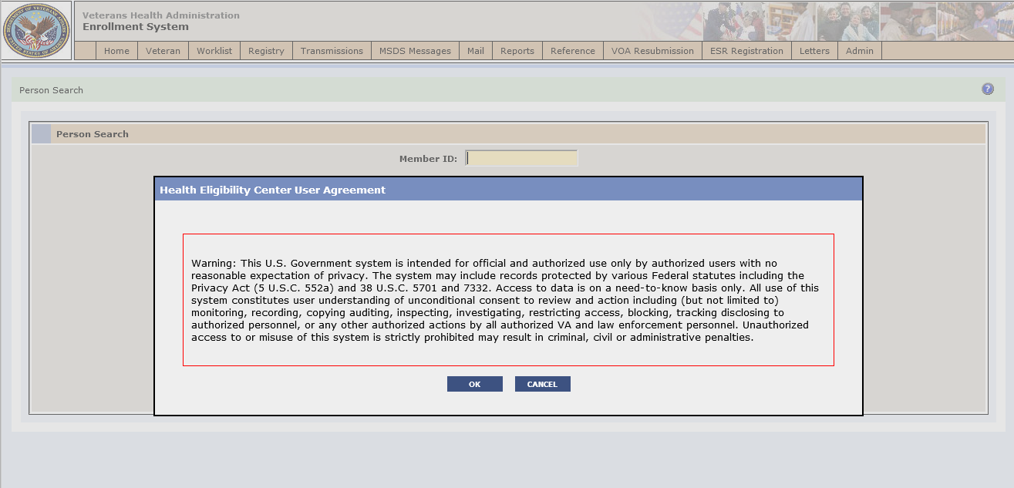
Figure 15: User Agreement Text
- In addition, ES will no longer generate and store a User Agreement Code when a new Enrollment System user is created.
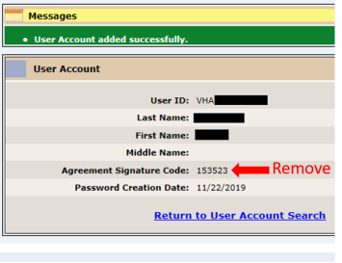
Figure 16: User Account Screen
- ES will no longer display the Agreement Signature Code label and value on the Add User Account feedback screen or the Modify User Account screen.
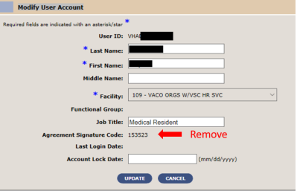
Figure 17: Modify User Account Screen
ES is enhanced to provide detail and summary reports on Veterans who are included in each VHAP for the Preferred Facilities selected.
- The VHA Profile Summary Report provides information on the total number of Veterans who are included in each VHAP for the Preferred Facilities selected.
- The VHA Profile Detail Report shows Veteran information for each VHA Profile for their Preferred Facilities.
- The VHA Profile Reports can be run on demand or scheduled. They are listed on the Report List and Scheduled Reports tabs:
  - VHA Profile Summary Report ID: ES-VHAP1
  - VHA Profile Detail Report ID: ES-VHAP2
- All standard reporting functions such as View (both formats supported: output of CSV and PDF), Delete, and Archive function as the current reports function.
Operational Decision Manager (ODM)
Table 4 shows the ODM enhancements and modifications included in the ES 5.12 release as tracked in RTC RM.
Table 4: ES 5.12 ODM Enhancements and Modifications
RTC  RM # | Summary
1090581 | Integrate Manage Communications Log Rules
1090584 | Integrate Load Registry Files Rules
1090585 | Integrate Manage Registry Rules
1090586 | Integrate Registry Document Validation Rules
1090589 | Integrate Registry Validation Rules
1090591 | Integrate Letter Mailing Validation Rules
1090607 | Integrate Process Financial Information Rules
1090611 | Integrate Combat Episode Validation Rules
1090614 | Integrate MSE Validation Rules
Under ODM, the 71 iLOG rule sets were transferred from iLOG to ODM. A Mediation Framework was established to allow the system administrators to switch between the iLOG and ODM rule sets as the rule sets are integrated into the ES application. Once the migration is fully completed to ODM, the rules will not be switched back to iLOG unless there is a systemic issue with ODM. ES 5.12 supports integration of the rule sets listed above in Table 4.

Defects and Fixes
Table 5 lists the defects and fixes and corresponding RTC Change and Configuration Management (CM) numbers included in ES 5.12 (RM# 1177195: ES 5.12 Maintain the Enrollment System).
Table 5: Defects and Fixes in ES 5.12
RTC  CM # | Summary
1196281 | Defect: Legacy hardship Veterans Choice Eligibility (VCE) expiration should be based on most recent legacy hardship.  Fix: Updated legacy hardship expiration and history screen to base legacy hardship expiration on most recent legacy hardship.
1200494 | Defect: State No Full-Service VA VCE change should not be dependent on geocoding.  Fix: Added rule that when an enrolled Veteran’s residential address is modified, VCE calculations will be performed by the system if any of the following is true:  - The Veteran’s current residential address is in a State with no full-service VA facility (N State) and the new residential address is not in an N State.  - The Veteran’s current residential address is not in an N State and the new residential address is in an N State.

Known Issues
No known issues were identified in this release.

Product Documentation
The following documents apply to this release:
- ES 5.12 Release Notes are uploaded to the VA Software Document Library (VDL).
- Additional reference documentation related to this release is stored in RTC.

