Enrollment System Modernization (ESM) Phase 3

Enrollment System (ES) 5.13

Release Notes
September 2020
Department of Veterans Affairs
Office of Information and Technology (OIT)

Table of Contents
1 Introduction 1
2 Purpose 2
3 Audience 2
4 This Release 2
4.1 Enhancements and Modifications 2
4.2 Sustainment Defects and Fixes 9
4.3 Known Issues 13
5 Product Documentation 14

List of Tables
Table 1: ES 5.13 ESM Enhancements and Modifications 2
Table 2: ES 5.13 EHRM Enhancements and Modifications 3
Table 3: Sustainment Defects and Fixes in ES 5.13 9
List of Figures
Figure 1: Financials Edit Financial Details Disabled Fields 3
Figure 2: Hardship Expiration Letter on Available for Mailing Tab 4
Figure 3: COLLATERAL OF VET. 5
Figure 4: Community Care Program Grid 6
Figure 5: Current Eligibility Screen 7
Figure 6: Warning: Unable to Access Own Person Record 8
Figure 7: Warning: Sensitive Record (No Permission to View) 8
Figure 8: Warning: Sensitive Record (Permission Granted) 9

Introduction
The mission of the Department of Veterans Affairs (VA) Office of Information and Technology (OIT), Enterprise Program Management Office (EPMO) is to provide benefits to Veterans and their families. To meet this overarching goal, OIT is charged with providing high quality, effective, and efficient IT services and Operations and Maintenance (O&M) to persons and organizations that provide point-of-care services to our Veterans.
The VA’s goals for its Veterans and families include:
- Make it easier for Veterans and their families to receive the right benefits, and meet their expectations for quality, timeliness, and responsiveness.
- Improve the quality and accessibility of health care, benefits, and memorial services while optimizing value.
- Provide world-class health care delivery by partnering with each Veteran to create a personalized, proactive strategy to optimize health and well-being, while providing state-of-the-art disease management.
- Ensure awareness and understanding of the personalized, proactive, and patient-driven health care model through education and monitoring.
- Provide convenient access to information regarding VA health benefits, medical records, health information, expert advice, and ongoing support needed to make informed health decisions and successfully implement the Veteran’s personal health plans.
- Receive timely, high quality, personalized, safe, effective, and equitable health care, not dependent upon geography, gender, age, culture, race, or sexual orientation.
- Strengthen collaborations with communities and organizations, such as the Department of Defense (DoD), Department of Health and Human Services (DHHS), academic affiliates, and other service organizations.
To assist in meeting these goals, the Enterprise Health Benefits Determination (EHBD) program provides enterprise-wide enhancements and sustainment for the following systems/applications:
- The Enrollment System (ES) is the authoritative system for VA enrollment determination.
- Income Verification Match (IVM)/Enrollment Database (EDB) assists in determining priority grouping for health care eligibility.
- Veterans Information Systems and Technology Architecture (VistA) Registration, Eligibility & Enrollment (REE) shares information with other VistA applications and enables registration and preliminary eligibility determinations and enrollment at VA Medical Centers (VAMC). ES makes the final eligibility determinations.
- The Veteran’s On-Line Application (VOA), now referred to as Health Care Application (HCA), enables Veterans to self-enroll in VA health care and is another entry point for records to be added to ES.
Enrollment System Modernization (ESM) defines VHA Profiles (VHAP) for which a client (Veteran, service member, or beneficiary) is eligible and ties them to the authority for care. Key enhancements to be completed include pending eligibility determination, fixes to the Enrollment System, date of death, internal controls, workflow, Veterans Financial Assessment, converting of Military Service Data Sharing (MSDS) to Enterprise Military Information Service (eMIS), Manage Relationships, Veteran Contact Service, and support for Enrollment System Community Care (ESCC).

Purpose
The purpose of this Release Notes document is to announce the release of the ES 5.13. This release, developed in Java technology, contains ESM Phase 3 development and upgrade efforts, including enhancements and defect fixes to support ESCC, Electronic Health Record Modernization (EHRM), and ES Sustainment.

Audience
This document targets users and administrators of ES 5.13 and applies to the changes made between this release and any previous release for this software.

This Release
ES will be upgraded from Version 5.12 to Version 5.13 and hosted at the Austin Information Technology Center (AITC).
The following sections provide a summary of the enhancements and updates to the existing software and any known issues for ES 5.13.

Enhancements and Modifications
Table 1 shows the ESM enhancements and modifications included in the ES 5.13 release as tracked in Atlassian Jira.
Table 1: ES 5.13 ESM Enhancements and Modifications
Jira Epic # | Summary
VES-3557 | Replace WebHINQ Query in ES with VA Profile Service
VES-3564 | Provide New ES Service to Process VBA Data from VA Profile Service
VES-3567 | Populate Originating Source in ES with VAMC ID
VES-4758 | ES Means Test Pending Adjudication - Notification Change
ES has replaced Web Hospital Inquiry (WebHINQ) with the new VA Profile Service. When a data push from the Veterans Benefits Administration (VBA) occurs, all data – including all rated disabilities and all evaluation history – will be populated in the message from VA Profile.
ES now populates the original site and source for VA Profile. All contact information exceptions will be assigned to the VA Medical Center (VAMC) that made the error to resolve the errors. This provides the required provenance for accountability, reporting, and needed education activities to further improve VA contact information, including all Veteran address types, all Veteran phone number types, and all Veteran email address types.

Three fields in the Assets section of the Edit Financial Details screen are disabled:
- Cash and Bank Account Balance
- Land, Buildings Less Mortgage and Liens
- Other Property or Assets
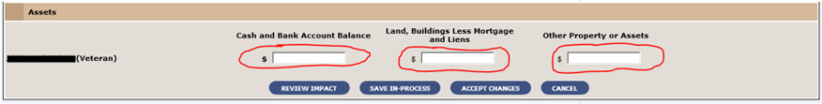
Figure 1: Financials Edit Financial Details Disabled Fields
Removing user entry for the three asset fields will prevent the supplemental adjudication question from being presented. The supplemental adjudication question is no longer required as part of the financial assessment process (Means Test, Income Test) used to assign a Veteran's enrollment priority group, copay responsibilities, and other benefits.
Table 2 shows the EHRM enhancements and modifications included in the ES 5.13 release as tracked in Jira.
Table 2: ES 5.13 EHRM Enhancements and Modifications
Jira Epic # | Summary
VES-2361 | Eliminate Saving of Handbook Files Received from CMS
VES-2362 | Remove the Links to View Handbook Files
VES-2413 | ES Decoupling Support
VES-2414 | Generate and Send Hardship Expiration Letters
VES-2415 | E&E Web Service: Updated VCEs
VES-2421 | Identify Existing Collaterals Shared with CCN and Collateral of Veteran Details
VES-2423 | View the ES Collateral of Veteran Eligibility and Collateral Program Transactions are in Sync
VES-2427 | Edit Subcategory "Collateral Program"
VES-2428 | Automate Collateral of Veteran VHAPs
VES-2429 | View the Collateral of Veteran Eligibility Transaction Details on the ES User Interface
VES-2512 | Switch Candidate Address Service Endpoint to the v2 Endpoint
VES-2513 | Create a Link within Rev Cycle for the Enrollment System
VES-2514 | Update Existing VHAP Names, Abbreviations, and Descriptions so that VA and Cerner Systems are in Sync with the Latest Information
VES-2636 | Generate Hardship Expiration Letter in ES
VES-4066 | Person & Sensitive Records Access
VES-4199 | Add new VHAP Carveout "Collateral of Veteran Other"
VES-4223 | Assignment of Veterans Community Care Eligibility (VCE) for Certain Collateral Programs
VES-5679 | Database Changes for New VHAPs and VCEs
VES-5680 | iLog Rule Changes and Java Methods
VES-5681 | Override Rules for New VCEs
VES-5682 | CCN/TPA Functionality Changes
VES-5683 | Unit Test VCEs in Web Service
VES-5684 | Perform Clean Up in ES
VES-6708 | Update ES to Not Display Additional Popup Message at Login
ES will no longer create or retain any copies of the PDF files of the Veteran’s Handbook. Links to view the handbook are removed from the user interface.
ES 5.12 replaced the landing page that contained the user security and privacy disclaimer with a popup screen containing the disclaimer. However, since ES inherits the system use notification/warning banner from the VA Enterprise Identity and Access Management (IAM) Single Sign-On Internal (SSOi) infrastructure when a user initially establishes a session, ES 5.13 is updated to no longer display the disclaimer popup message window when a user successfully logs into the application.
In ES 5.12, the system was modified to expire financial hardships at the end of the year. ES 5.13 is updated to provide a new letter that will inform Veterans up to 60 days in advance that their hardship is expiring so that they can submit a new means test.
The new hardship expiration letter is displayed under the Person Search > Communication Log "Available for Mailing" and "Previously Mailed" tabs.
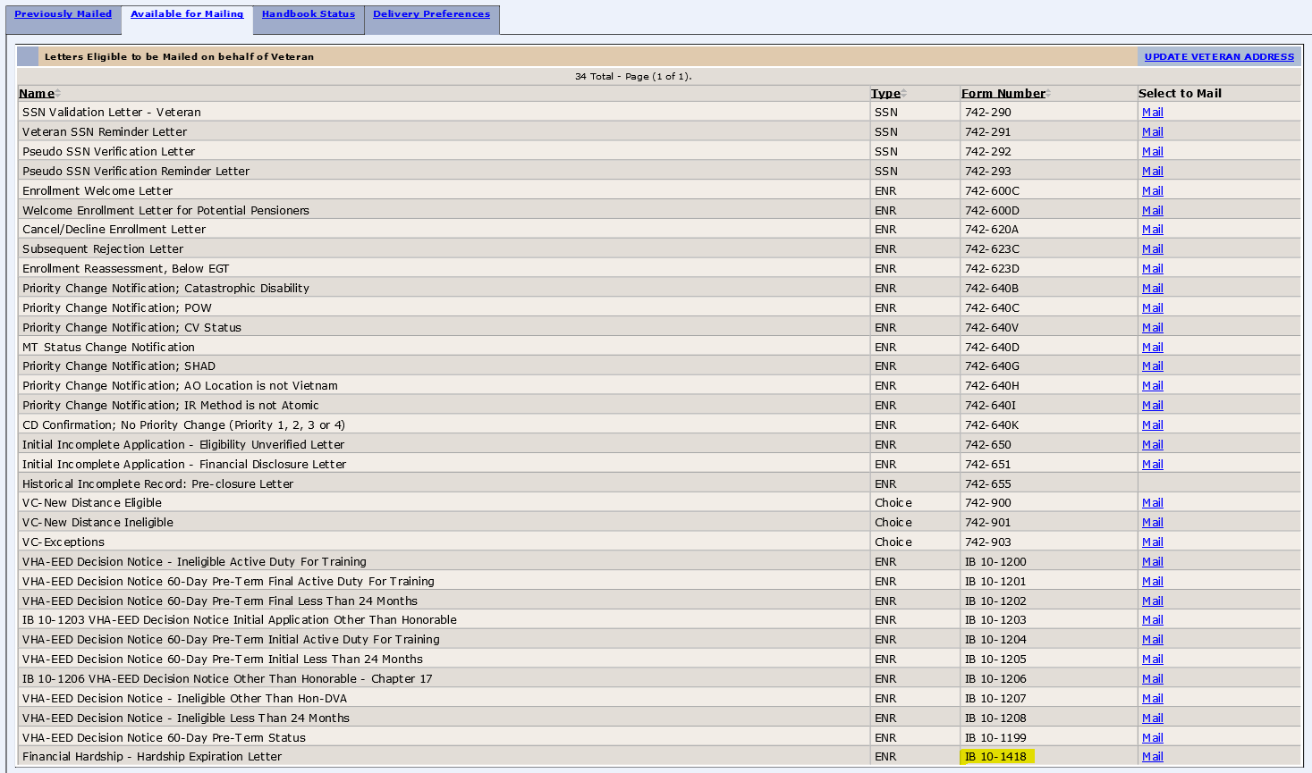
Figure 2: Hardship Expiration Letter on Available for Mailing Tab

ES is updated to store and display one renamed and four new “Carveout” VHAPs.
- Active Duty and Tricare Sharing Agreement - renamed
- VA DoD Direct Resource Sharing Agreements - new
- State Veteran Home – new
- Employee Veteran - new
- OWCP (Office of Workers Compensation Program) – new
ES is updated to support the Community Care Program (CCP):
- Add new Collateral of Veteran Other VHAP
- Create Community Care Program (CCP) for Collaterals functionality
- Automate some Collateral VHAPs
- Add new functionality to support not enrolled covered Veterans
- Share CCPs with VistA
- Share new VHAPs
- Share new Veterans Community Care Eligibility (VCE) codes
ES is updated to store and display the new “Carveout” Collateral of Veteran Other VHAP. Collateral of Veteran Other identifies collateral populations not identified in other specific VHA Profiles – A person, related to or associated with a Veteran (spouse, family member, or significant other) receiving care from the Department of Veterans Affairs (VA). The person is seen by a professional member of the VA health care facility's (HCF's) staff either within the facility or at a site away from the facility for reasons relating to the Veteran's clinical care.
This VHAP will be assigned to Collaterals for the VHA Transplant Program, Marriage/Family Counseling, and Collaterals that are not assigned to a Caregiver Program.
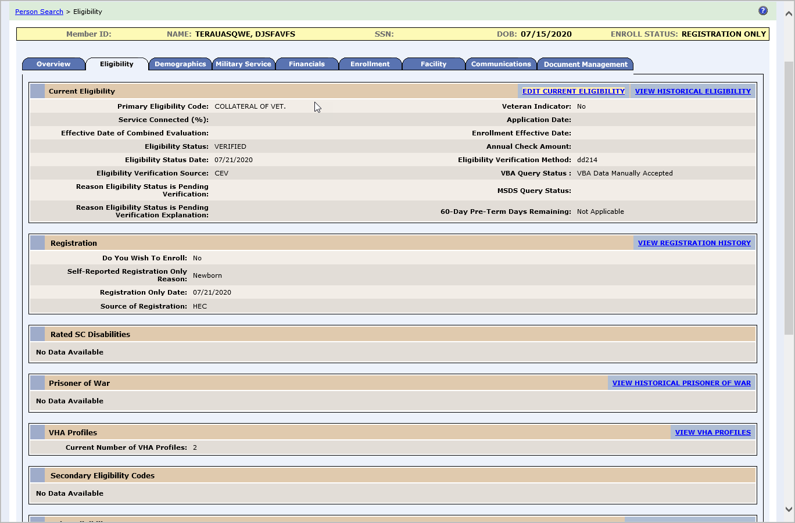
Figure 3: COLLATERAL OF VET.

A new CCP grid with dropdowns is added to Edit Current Eligibility > Non-Veteran Eligibility Codes > Collateral of Vet for the ES user to select or remove the appropriate CCP.
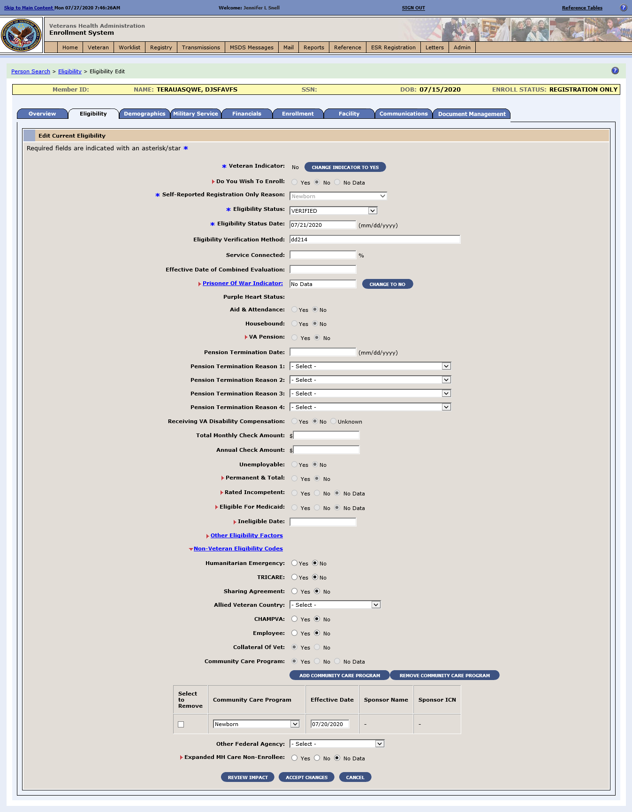
Figure 4: Community Care Program Grid
Four new Community Care Outcomes were created and will display in View Community Care Outcome and Community Care Determination: ART/IVF, Marriage/Family Counseling, Newborn, and VHA Transplant Program.

A new identifier is added to the Current Eligibility Screen to show the ES user that a Community Care Program record is associated with a Collateral.
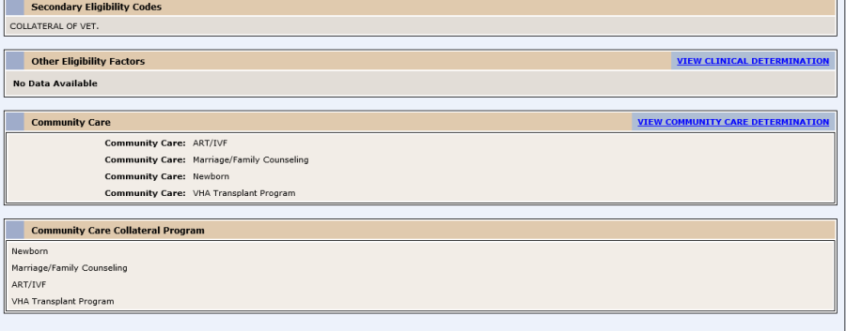
Figure 5: Current Eligibility Screen
The VHAP History will flow into the existing View VHA Historical Profiles Screen and the VCE will flow into the existing Community Care Determination History Page. ES automatically assigns a VHAP and a VCE to the CCP.
To support the VA Maintaining Internal Systems and Strengthening Integrated Outside Networks (MISSION) Act, ES is enhanced to now reflect not enrolled covered Veterans as Community Care eligible.
ES is enhanced to automate the determination of Entitled Care and Restricted Care Community Care Outcomes based on rules.
Two new CCP VHAPs are created, stored, displayed, and automated to support not enrolled covered Veterans:
  - Veteran Plan CCP Entitled Care: Assigned to Veterans who are not enrolled and have the following eligibility: Service Connected (SC) 50% to 100%.
  - Veteran Plan CCP Restricted Care: Assigned to Veterans who are not enrolled and have the following eligibility:
    - SC 0% to 40%
    - SC 0% (non-compensable)
    - Military Sexual Trauma (MST) Non-Veteran (Active Duty)
    - Emergent Mental Health (MH) Other-Than-Honorable (OTH) or Extended MH OTH
Note: This population can be seen for their Service Connected (SC) conditions only (and/or MST if MST is indicated or MH care per OTH regulations).
ES and VistA will share Community Care Collaterals and associated VHAPs via messaging. All new VCE data are communicated from ES to the Community Care Network (CCN) vendor. New VCE data are available for the Enrollment & Eligibility (E&E) web service Community Care subscribers; new VHAP data are available for E&E web service subscribers.

ES is updated to instantiate an ES application session in response to a Cerner Revenue Cycle user clicking a link from within that application. ES will automatically log the user into the application and direct the user to the summary page for the Veteran received in the call from Revenue Cycle.
ES is updated to perform a single service call for address validation instead of two service calls and to change the processing of the response to account for a change to the response message content.
ES is updated to limit a user’s access to their own record, receive sensitive records notifications, and log person record access data.
ES displays a pop-up warning message if a user attempts to access his/her own record on the Person Search screen or the Add a Person screen.
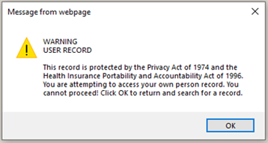
Figure 6: Warning: Unable to Access Own Person Record
ES displays a pop-up warning message when a user without the new "View Sensitive Records" capability attempts to access a sensitive record on the Person Search screen or the Add a Person Screen.
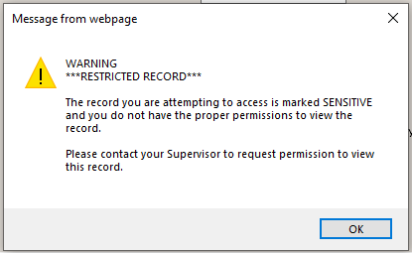
Figure 7: Warning: Sensitive Record (No Permission to View)

ES notifies users that DO have the new “View Sensitive Record” capability with a pop-up view sensitive record warning message if he/she is about to access a sensitive record from the Person Search screen or the Add a Person screen.
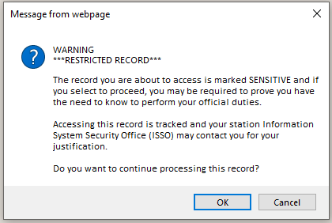
Figure 8: Warning: Sensitive Record (Permission Granted)
ES will log who accessed every person record, including sensitive records, from the Person Search screen or the Add a Person screen.

Sustainment Defects and Fixes
Table 3 lists the sustainment defects and fixes and corresponding Jira bug numbers included in ES 5.13.
Table 3: Sustainment Defects and Fixes in ES 5.13
Jira Bug # | Summary
VES-529 | Defect: Browser Compatibility: Chrome and Edge - Military Service Tab - When a Veteran record with a military episode and Camp Lejeune Eligibility is pulled up in ES, it does not show the expanded view of the Camp Lejeune Eligibility section.  Fix: Updated code to show the expanded view including all the fields on the Camp Lejeune Eligibility section of the Military Service tab.
VES-541 | Defect: Browser Compatibility - Chrome only - On the Person Search screen, Military Service Number and Claim Folder Number fields under the Additional Search Criteria section are misaligned.  Fix: Updated code to properly align the Military Service Number and Claim Folder fields under the Additional Search Criteria section.
VES-544 | Defect: Browser Compatibility: Chrome and Edge - On the “Edit Current Eligibility” screen for AAP scenario, the description does not populate for the code added under Rated SC Disabilities.  Fix: Updated code to display all descriptions in AAP.
VES-545 | Defect: Browser Compatibility: Chrome and Edge - Eligibility Tab - When a Veteran record with military episode and Camp Lejeune Eligibility is pulled up in ES, it does not show the expanded view of the Camp Lejeune Eligibility section.  Fix: Updated code to show the expanded view including all the fields on the Camp Lejeune Eligibility section of the Eligibility tab.
VES-553 | Defect: Browser Compatibility: Report Filter by Status feature does not work on Chrome but works on IE.  Fix: Updated code to enable the Report Filter by Status feature on both browsers.
VES-554 | Defect: Browser Compatibility: Chrome - Military Service Screen: Military Service Episodes – HEC section: fields are misaligned.  Fix: Updated code to properly align the Military Service Screen: Military Service Episodes – HEC section fields.
VES-555 | Defect: Entry of future date of birth is being allowed during Add A Person (AAP).  Fix: Implemented validation rule to AAP: “Date of Birth Cannot Be in the Future”.
VES-580 | Defect: Section 508: Field label is not included in incorrect format error messages on the Completed Reports screen.  Fix: Updated code to include field label on the incorrect format error message on the Completed Reports screen.
VES-586 | Defect: The Z05 message is failing for long city names from HCA.  Fix: Added logic to the HCA inbound message to validate the city if the name has more than 15 characters.
VES-600 | Defect: Section 508: Some active controls that generate an error are neither read with error nor marked as error (Demographics/ Personal).  Fix: Updated code so that if Preferred Facility is not selected, an error is displayed and the field is highlighted.
VES-604 | Defect: The Programmable Logic Controller (PLC) letter response file fails to complete.  Fix: Updated batch process to rename the file to .DONE so that the process completes.
VES-606 | Defect: Errors occur when saving and opening VOA file attachments from Edit Eligibility.  Fix: Updated code to enable VOA file attachments to be saved directly as PDFs and opened.
VES-632 | Defect: The date of birth validation message for Purple Heart is displayed when it is not expected to be displayed.  Fix: Modified Check Birth Date / Received Date code for Purple Heart so that the validation message is not displayed when the Document Received Date field is updated with the current date.
VES-906 | Defect: Browser Compatibility: Chrome and Edge - When Member ID with a trailing space is pasted in the Member ID field or a 29-character ICN is pasted in the ICN field on the Person Search page, the focus jumps to a blank field adjacent to the respective fields.  Fix: Updated code to prevent focus from jumping to the blank fields when a Member ID with a trailing space or a 29-character ICN is entered.
VES-907 | Defect: The 10-10EZ PDF from either the Financials tab or the VOA version on the Enrollment tab is failing to generate.  Fix: Updated code to properly load the 10-10EZ PDF from all instances.
VES-915 | Defect: Browser Compatibility: Chrome Only - The row and the page counters at the top of the table on the Facilities header are displayed to the left, when they should be displayed in the middle.  Fix: Updated code to properly display the row and page counters at the top of the table on the Facilities header.
VES-916 | Defect: Browser Compatibility: Chrome Only - Worklist Tab – The “Search Criteria” and “Search Value” fields above the “My Items” tab are displayed on the left side of the screen (no impact to functionality).  Fix: Updated code to display the “Search Criteria” and “Search Value” fields above the “My Items” tab on the Worklist Tab on the right side of the screen.
VES-917 | Defect: Browser Compatibility - Chrome and Edge – On the “My Items” subtab of the “Worklist” tab, the “Assign” button is placed away from the “Assign Selected Items to” dropdown.  Fix: Updated code to place the “Assign” button next to the “Assign Selected Items to” dropdown menu on the “My Items” subtab of the “Worklist” tab.
VES-1297 | Defect: If a user attempts to retransmit an ORU-Z11 message, the retransmit attempt fails with the following error message: “Unable to retransmit message due to error: Failed to resend a message: Failed to build outbound ORUZ11-S message due to an exception”.  Fix: Updated code to enable retransmission of the ORU-Z11 message.
VES-1304 | Defect: The “623A Notify Applicant Priority Below EGT Letter” is not being sent.  Fix: Changed the “order-by” in the COM_MAILING_STATUS_DETAIL table.
VES-1849 | Defect: Fortify: Resolve all 1214 code warnings.  Fix: Executed separate scan to resolve all files with the same filename in different folders.
VES-1850 | Defect: A user is unable to update the “State” on the Personal screen as the field is not visible after initially adding the address.  Fix: Updated “updateCountryFields” code so that the “State” field is visible on the Personal screen.
VES-1891 | Defect: Fortify: Unreleased Resource: Streams - 14 issues  Some allocated system resources fail to be released.  Fix: Analysis found that the allocated resources will be released even if an exception occurs.
VES-1892 | Defect: Fortify: Log Forging – 1 issue  Unvalidated user input could allow forging or injection of malicious content into the log.  Fix: Created a set of legitimate log entries that correspond to different events that must be logged, and only allow logging of entries from this set (always use server-controlled values rather than user-supplied data).
VES-1893 | Defect: Fortify: Key Management: Empty Encryption Key - 1 issue  Empty encryption keys can compromise security.  Fix: Updated code so that encryption keys are never empty and are obfuscated and managed in an external source.
VES-1894 | Defect: Fortify: Dynamic Code Evaluation: Unsafe Deserialization - 1 issue  Deserializing user-controlled object streams at runtime can allow attackers to execute arbitrary code on the server, abuse application logic, and/or lead to denial of service.  Fix: Analysis found that the identified class is performing deserializing file input stream on given class that is available from application classpath; the current class file is retrieved from the secured and trusted ES server classpath.
VES-1895 | Defect: Fortify: SQL Injection: Hibernate - 10 issues  An SQL query build using input potentially coming from an untrusted source is being invoked.  Fix: Updated code to mitigate SQA injection risk.
VES-1936 | Defect: Fortify: Null Dereference - 1 issue  Dereferencing a null pointer can crash the program.  Fix: The local variable that could be null was checked not null.
VES-1937 | Defect: Fortify: Dynamic Code Evaluation: Unsafe XStream Deserialization – 1 issue  The XStream library provides the developer with an easy way to transmit objects, serializing them to XML documents. However, XStream deserialization might enable an attacker to run arbitrary Java code on the server.  Fix: Use whitelist rather than blacklist approach so that any class allowed in the whitelist is audited to make sure it is safe to deserialize.
VES-1960 | Defect: WASA: A2 - Broken Authentication and Session Management  Fix: Updated the Cross-Site Scripting (XSS) filter.
VES-1961 | Defect: WASA: A5 - Security Misconfiguration  Fix: Enabled Cross Site Request Forgery (CSRF) Guard, updated build files and fixed Java Server Pages (JSPs).
VES-4603 | Defect: Fortify: Path Manipulation - 2 issues  Attackers are able to control a file system path argument, which allows them to access or modify otherwise protected files.  Fix: Updated code to ensure that the user has no control over the path that is provided to the input stream.
VES-4604 | Defect: Fortify: Server-Side Request Forgery - 6 issues  If data is retrieved from an external system, then it must be validated.  Fix: Updated code to check if provided IDs are in the expected format and match that of one of the documents associated with the current record.
VES-4605 | Defect: Fortify: Log Forging - 10 issues  Unvalidated user input to the log could enable forging of log entries or injection of malicious content into the log.  Fix: Updated code to prevent unvalidated user input to the log.
VES-4606 | Defect: Fortify: Null Dereference - 4 issues  Dereferencing a null pointer can crash the system.  Fix: Updated code to remove null dereferences.
VES-4607 | Defect: Fortify: Unreleased Resource: Streams - 6 issues  Some allocated system resources are failing to be released.  Fix: Updated code to allow release of the allocated system resources.
VES-4608 | Defect: Fortify: Unreleased Resource: Files  Allowed files are sometimes failing to be released.  Fix: Updated code to release the allowed files.
VES-4609 | Defect: Fortify: Portability Flaw: Locale Dependent Comparison  Fix: Analysis found that there is no longer a flaw in ContactInformationInputParameter.java.
VES-4610 | Defect: Fortify: Dynamic Code Evaluation: Unsafe Deserialization  Fix: Removed “Sys” statement to enable safe deserialization.
VES-4611 | Defect: Fortify: Unresolved Scan Issues: ES_HECMS_ui_web_admin  Fix: Resolved all scan issues in file ES_HECMS_ui_web_admin.
VES-4612 | Defect: Fortify: Unreleased Resource: Sockets: ES_WS_Webserv  Fix: Updated code to release the Sockets: ES_WS_Webserv resource.
VES-4613 | Defect: Fortify: Unresolved Scan Issues: ES_WS_Webserv  Fix: Resolved all scan issues in file ES_WS_Webserv.
VES-5553 | Defect: Access Controls - Elevated Privileges  The ability to edit a user profile is currently requiring administrator capability instead of just the single “edit user profile” capability.  Fix: Implementation corrected so that the ability to edit a user profile requires only the existing “edit user profile” capability.
VES-5752 | Defect: Section 508: Some fields on Schedule Reports screens are not read as “Required” by Job Access With Speech (JAWS).  Fix: Fixed the Generate Report, Day to Generate Report, and Time to Generate Report fields to be read as “Required” by JAWS.
VES-5897 | Defect: Fortify: Privacy Violation - 52 issues  Confidential information is being mishandled.  Fix: Analysis found that the confidential information is being handled properly; the reported class is using a Business Entity class and not the “CCNFileData” class as reported.
VES-5898 | Defect: Fortify: Privacy Violation: Heap Inspection – 30 issues  Sensitive data is being stored in such a way that it cannot be reliably purged from memory.  Fix: Analysis found that the instances identified are sensitive data. They are Enum values which are set to private variables.
VES-5899 | Defect: Fortify: Race Condition: Singleton Member Field – 3 issues  Certain classes are singletons, so the member fields are shared between users; the result is that one user could see another user's data.  Fix: Analysis found that the reported classes are not singleton classes; this rule does not apply to its members being shared between users.
VES-6767 | Defect: Changing a preferred facility to a new station that has never been assigned before does not create a new assignment date; it is inheriting the facility assignment date from the previously assigned record.  Fix: Updated code to set the assignment date to the system date when a new preferred facility is added.
VES-6912 | Defect: Fortify: Unvalidated input into JavaScript Object Notation (JSON) could allow an attacker to inject arbitrary elements or attributes into the JSON entity.  Fix: Analysis found that JSON is created by ES; attributes are generated from the Java classes within ES, not from user input.

Known Issues
No known issues were identified in this release.

Product Documentation
The following documents apply to this release:
- ES 5.13 Release Notes are uploaded to the VA Software Document Library (VDL).
- Additional reference documentation related to this release is stored in Rational Team Concert (RTC).

