Enrollment System Modernization (ESM) Phase 3

Enrollment System (ES) 5.14.1

Release Notes
December 2020
Department of Veterans Affairs
Office of Information and Technology (OIT)

Table of Contents
1 Introduction 1
2 Purpose 2
3 Audience 2
4 This Release 2
4.1 Enhancements and Modifications 2
4.2 Defects and Fixes 3
4.3 Known Issues 4
5 Product Documentation 4

List of Tables
Table 1: ES 5.14.1 ES Sustainment Enhancements and Modifications 2
Table 2: Defects and Fixes in ES 5.14.1 3
List of Figures
Figure 1: Department of Homeland Security Value in Other Federal Agency Dropdown 3
Figure 2: DHS Value on ZPD Segment 3

Introduction
The mission of the Department of Veterans Affairs (VA) Office of Information and Technology (OIT), Enterprise Program Management Office (EPMO) is to provide benefits to Veterans and their families. To meet this overarching goal, OIT is charged with providing high quality, effective, and efficient IT services and Operations and Maintenance (O&M) to persons and organizations that provide point-of-care services to our Veterans.
The VA’s goals for its Veterans and families include:
- Make it easier for Veterans and their families to receive the right benefits, and meet their expectations for quality, timeliness, and responsiveness.
- Improve the quality and accessibility of health care, benefits, and memorial services while optimizing value.
- Provide world-class health care delivery by partnering with each Veteran to create a personalized, proactive strategy to optimize health and well-being, while providing state-of-the-art disease management.
- Ensure awareness and understanding of the personalized, proactive, and patient-driven health care model through education and monitoring.
- Provide convenient access to information regarding VA health benefits, medical records, health information, expert advice, and ongoing support needed to make informed health decisions and successfully implement the Veteran’s personal health plans.
- Receive timely, high quality, personalized, safe, effective, and equitable health care, not dependent upon geography, gender, age, culture, race, or sexual orientation.
- Strengthen collaborations with communities and organizations, such as the Department of Defense (DoD), Department of Health and Human Services (DHHS), academic affiliates, and other service organizations.
To assist in meeting these goals, the Enterprise Health Benefits Determination (EHBD) program provides enterprise-wide enhancements and sustainment for the following systems/applications:
- The Enrollment System (ES) is the authoritative system for VA enrollment determination.
- Income Verification Match (IVM)/Enrollment Database (EDB) assists in determining priority grouping for health care eligibility.
- Veterans Information Systems and Technology Architecture (VistA) Registration, Eligibility & Enrollment (REE) shares information with other VistA applications and enables registration and preliminary eligibility determinations and enrollment at VA Medical Centers (VAMC). ES makes the final eligibility determinations.
- The Veteran’s On-Line Application (VOA), now referred to as Health Care Application (HCA), enables Veterans to self-enroll in VA health care and is another entry point for records to be added to ES.
Enrollment System Modernization (ESM) defines VHA Profiles (VHAP) for which a client (Veteran, service member, or beneficiary) is eligible and ties them to the authority for care. Key enhancements to be completed include pending eligibility determination, fixes to the Enrollment System, date of death, internal controls, workflow, Veterans Financial Assessment, converting of Military Service Data Sharing (MSDS) to Enterprise Military Information Service (eMIS), Manage Relationships, Veteran Contact Service, and support for Enrollment System Community Care (ESCC).

Purpose
The purpose of this Release Notes document is to announce the release of the ES 5.14.1. This release, developed in Java technology, contains ESM Phase 3 enhancements and defect fixes to support ESCC, Electronic Health Record Modernization (EHRM), and ES Sustainment.

Audience
This document targets users and administrators of ES 5.14.1 and applies to the changes made between this release and any previous release for this software.

This Release
ES will be upgraded from Version 5.14 to Version 5.14.1 and hosted at the Austin Information Technology Center (AITC).
The following sections provide a summary of the enhancements and defect fixes to the existing software and any known issues for ES 5.14.1.

Enhancements and Modifications
Table 1 shows the ES Sustainment enhancements and modifications included in the ES 5.14.1 release as tracked in Atlassian Jira.
Table 1: ES 5.14.1 ES Sustainment Enhancements and Modifications
Jira Epic # | Summary
VES-10133 | Internal Revenue Service (IRS) annual updates
VES-10917 | Add Ability to Identify and Allow Department of Homeland Security (DHS) Employees to Receive COVID-19 Vaccine from VA (ES)
In addition to including the IRS annual updates, ES 5.14.1 also includes enhancements that identify and allow DHS employees to receive the COVID-19 vaccine from VA.

- A new value of "Department of Homeland Security" is added to the “Other Federal Agency” field within the Person Search > Eligibility > Eligibility Edit screen. (Note: VistA will install a supporting patch at all sites prior to ES assigning the new "Other Federal Agency" name of “Department of Homeland Security”.)
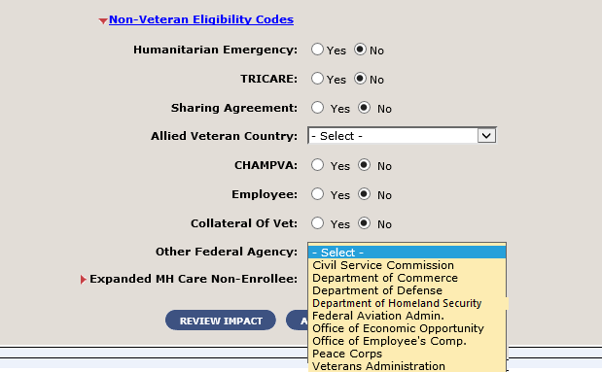
Figure 1: Department of Homeland Security Value in Other Federal Agency Dropdown
- For messaging with VistA, a new value of "DHS" is added to the VA-Specific Patient Information (ZPD) Segment when "Department of Homeland Security" is selected as the “Other Federal Agency”.
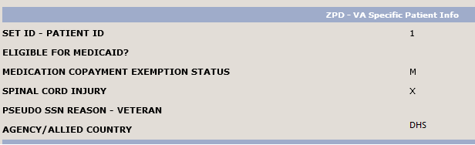
Figure 2: DHS Value on ZPD Segment

Defects and Fixes
Table 2 lists the defects and fixes and corresponding Jira issue numbers included in ES 5.14.1.
Table 2: Defects and Fixes in ES 5.14.1
Jira Issue # | Summary
VES-10348 | Defect: Cerner Rating App null pointer exception.  Fix: Modified comparator to handle the null pointer exception.
VES-10361 | Defect: Catastrophic Disability Review Date is not mapped in the Cerner interface.  Fix: Set inbound update from Cerner to account for missing review date on the Catastrophic Disability when it is added by Cerner.
VES-10636 | Defect: Home, Cell, and Work phone types are not displayed on Add/Edit Address page if old phone types are present in the database.  Fix: Modified code for Add Address and Addresses Overview so that phone types are properly displayed.

Known Issues
No known issues were identified in this release.

Product Documentation
The following documents apply to this release:
- ES 5.14.1 Release Notes are uploaded to the VA Software Document Library (VDL).
- Additional reference documentation related to this release is stored in GitHub.

