Enrollment System Modernization (ESM) Phase 3

Enrollment System (ES) 5.14

Release Notes



November 2020

Department of Veterans Affairs

Office of Information and Technology (OIT)

Table of Contents

1 Introduction 1

2 Purpose 2

3 Audience 2

4 This Release 2

4.1 Enhancements and Modifications 2

4.2 ES Production Defects and Fixes 9

4.3 ES Sustainment Defects and Fixes 11

4.4 Known Issues 13

5 Product Documentation 14

**List of Tables**

Table 1: ES 5.14 ESM Enhancements and Modifications 2

Table 2: ES 5.14 EHRM Enhancements and Modifications 5

Table 3: Production Defects and Fixes in ES 5.14 9

Table 4: Sustainment Defects and Fixes in ES 5.14 11

**List of Figures**

Figure 1: IVD Document Type - Upload and Search Document Tabs 3

Figure 2: Deprecated Record Banner 4

Figure 3: Financial Summary 5

Figure 4: Review Impact Screen 5

Figure 5: Edit Registration Option 6

Figure 6: Self-Reported Registration Only Reason 6

Figure 7: Confirmation Popup 7

Figure 8: Phone Types Dropdown 8

Figure 9: Adding New Phone Record 8

Figure 10: Phone Type on Overview Tab 9

# Introduction

The mission of the Department of Veterans Affairs (VA) Office of Information and Technology (OIT), Enterprise Program Management Office (EPMO) is to provide benefits to Veterans and their families. To meet this overarching goal, OIT is charged with providing high quality, effective, and efficient IT services and Operations and Maintenance (O&M) to persons and organizations that provide point-of-care services to our Veterans.

The VA’s goals for its Veterans and families include:

* Make it easier for Veterans and their families to receive the right benefits, and meet their expectations for quality, timeliness, and responsiveness.
* Improve the quality and accessibility of health care, benefits, and memorial services while optimizing value.
* Provide world-class health care delivery by partnering with each Veteran to create a personalized, proactive strategy to optimize health and well-being, while providing state-of-the-art disease management.
* Ensure awareness and understanding of the personalized, proactive, and patient-driven health care model through education and monitoring.
* Provide convenient access to information regarding VA health benefits, medical records, health information, expert advice, and ongoing support needed to make informed health decisions and successfully implement the Veteran’s personal health plans.
* Receive timely, high quality, personalized, safe, effective, and equitable health care, not dependent upon geography, gender, age, culture, race, or sexual orientation.
* Strengthen collaborations with communities and organizations, such as the Department of Defense (DoD), Department of Health and Human Services (DHHS), academic affiliates, and other service organizations.

To assist in meeting these goals, the Enterprise Health Benefits Determination (EHBD) program provides enterprise-wide enhancements and sustainment for the following systems/applications:

* The Enrollment System (ES) is the authoritative system for VA enrollment determination.
* Income Verification Match (IVM)/Enrollment Database (EDB) assists in determining priority grouping for health care eligibility.
* Veterans Information Systems and Technology Architecture (VistA) Registration, Eligibility & Enrollment (REE) shares information with other VistA applications and enables registration and preliminary eligibility determinations and enrollment at VA Medical Centers (VAMC). ES makes the final eligibility determinations.
* The Veteran’s On-Line Application (VOA), now referred to as Health Care Application (HCA), enables Veterans to self-enroll in VA health care and is another entry point for records to be added to ES.

Enrollment System Modernization (ESM) defines VHA Profiles (VHAP) for which a client (Veteran, service member, or beneficiary) is eligible and ties them to the authority for care. Key enhancements to be completed include pending eligibility determination, fixes to the Enrollment System, date of death, internal controls, workflow, Veterans Financial Assessment, converting of Military Service Data Sharing (MSDS) to Enterprise Military Information Service (eMIS), Manage Relationships, Veteran Contact Service, and support for Enrollment System Community Care (ESCC).

# Purpose

The purpose of this Release Notes document is to announce the release of the ES 5.14. This release, developed in Java technology, contains ESM Phase 3 development and upgrade efforts. This release includes enhancements and defect fixes to support ESCC, Electronic Health Record Modernization (EHRM), and ES Sustainment.

# Audience

This document targets users and administrators of ES 5.14 and applies to the changes made between this release and any previous release for this software.

# This Release

ES will be upgraded from Version 5.13 to Version 5.14 and hosted at the Austin Information Technology Center (AITC).

The following sections provide a summary of the enhancements and updates to the existing software and any known issues for ES 5.14.

## Enhancements and Modifications

Table 1 shows the ESM enhancements and modifications included in the ES 5.14 release as tracked in Atlassian Jira.

Table 1: ES 5.14 ESM Enhancements and Modifications

| **Jira Epic #** | **Summary** |
| --- | --- |
| VES-7269 | ES IVD Document Management Updates |
| VES-7270 | ES Deactivated Records Notification |
| VES-7528 | Blue Water Navy Verification (Enhancement Analysis and Design Only) |
| VES-7677 | Phase 2 - Means Test Pending Adjudication (Net Worth UI Update) |
| VES-9474 | ES 5.14 Design, Engineering, and Architecture (DE&A) Compliance Evidence (The DE&A epic has been completed and in compliance for the ES 5.14 release.) |

ES is enhanced to include a new document type of Income Verification Division (IVD) within the Document Management functionality. Currently, there is no document management system to manage Income Verification correspondence received from Veterans. As a result, Income Verification staff at the Health Eligibility Center (HEC) are physically handling 400k-500k+ paper documents annually. Implementation of this enhancement will reduce storage and resource costs, reduce delays in adjudicating cases and support timely notifications to Veterans. This enhancement also provides an audit trail and allows for timely responses to Congressional inquiries.

* A new capability "IVD Document Management" is added to the Enrollment System and a new   
  IVD-related Document Type of "IVD" is added in the available types drop-down.
* ES allows the selection of an IVD Document Type on the Upload and Search tabs of the Document Management Screen if the user has the "IVD Document Management" capability.

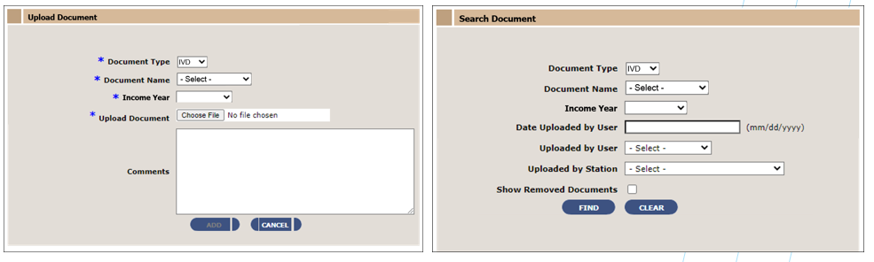

Figure 1: IVD Document Type - Upload and Search Document Tabs

* When a user clicks the document name hyperlink on the "View Documents" panel on the Overview, Search, and Upload screens, an audit record is created and populated with the user's ID, user station, and the date/time the document was viewed.

Sets of deactivated records exist in the ES Administrative Data Repository (ADR) database. ES currently does not alert users that the record presented at the end of a search is deactivated. This enhancement will alert the user that the record is deactivated and will provide a hyperlink to the active record.

* If an ES user searches an ICN in the Person Search Screen, and the record is deactivated, ES displays a banner warning message on the Person Search Overview Screen with a link to the ICN of the active record.
* This will provide ES user opportunity to make updates to the beneficiary's active record.
* If an ES user searches an ICN in the Person Search Screen, and the record is deactivated, ES displays a banner warning message on the Person Search Overview Screen with a link to the ICN of the active record.
* If an ES user searches an ICN in the Person Search Screen, and the record is deprecated, ES displays a banner warning message on the Person Search Overview Screen with a link to the ICN of the active record.

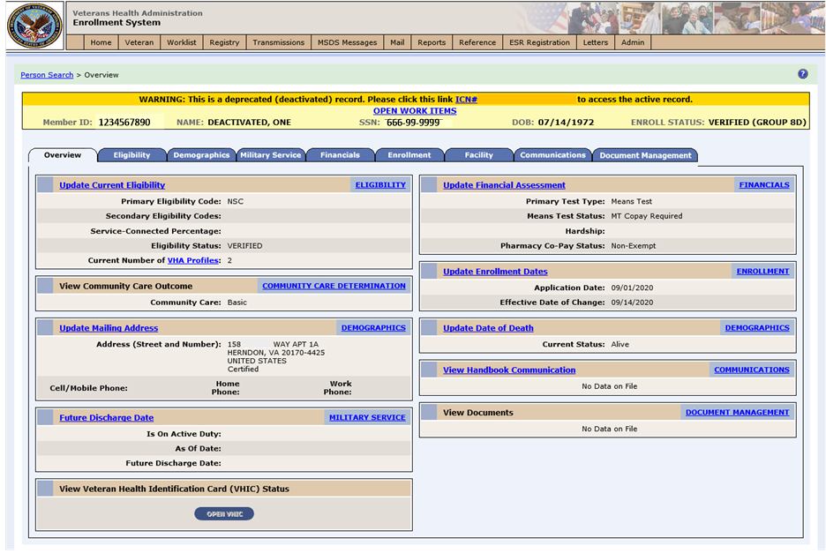

Figure 2: Deprecated Record Banner

In ES 5.13, ES was enhanced to disable the three Asset fields (“Cash and Bank Account Balance”, “Land, Buildings Less Mortgage and Liens”, and “Other Property or Assets”) in the Assets section of the Edit Financials Information screen. Removing user entry for the three Assets fields prevented the supplemental adjudication question from being presented, as it is no longer required as part of the financial assessment process. With ES 5.14, the system is enhanced to also disable the Assets fields on the Edit Financial Details screen.

* The "Net Worth" field in the "Financial Summary" section is no longer displayed.

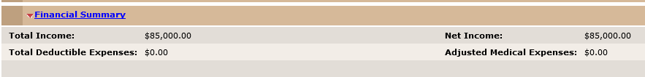

Figure 3: Financial Summary

* The "Net Worth" and "Total Income + Net Worth" fields are removed from the Review Impact screens:

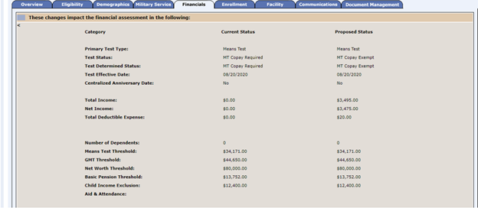

Figure 4: Review Impact Screen

Table 2 shows the EHRM enhancements and modifications included in the ES 5.14 release as tracked in Jira.

Table 2: ES 5.14 EHRM Enhancements and Modifications

| **Jira Epic #** | **Summary** |
| --- | --- |
| VES-2644 | Populate Originating Source in ES with VAMC ID (ES) - Send Blank Source System User |
| VES-7057 | Separate Registration (Decoupling) Updates - ES |
| VES-7250 | Disable Temporary Address Functionality in ES |
| VES-7323 | Phase 1 - ES to Add ERI Values to E&E Service |
| VES-7358 | Update Phone Type Dropdown in ES |
| VES-7474 | Update ES Description of Veteran Plan CCP Restricted Care VHAP |
| VES-9455 | ES CC Hardship Information from Cerner |

ES is enhanced to provide identification of the originating source system for all contact information changes. This change will allow all contact information exceptions to be assigned to the VAMC that made the error to resolve the errors. This provides the required provenance for accountability, reporting, and needed education activities to further improve VA contact information for our VA customers.

ES and VistA were updated in the 5.12 and 5.13 releases to allow Veterans a choice of either "Enrolling" with the Veterans Health Administration (VHA) or completing a "Registration" only. The initial requirement only allowed the Veteran to change this answer from No → Yes, but not from Yes → No if a mistake was made. Also, the Enrollment System currently sets Non-Veteran records with a date of death to a "Not Applicable" enrollment status instead of the expected "Deceased" enrollment status.

* ES is enhanced to allow users to change the answer of the "Do You Wish To Enroll" question from Yes to No in case a mistake is made during the initial registration.
* A new capability titled "Edit Registration Option" is added to ES. Only users with this capability are able to change the answer of the “Do You Wish To Enroll” question form Yes to No.
* ES is enhanced to set Non-Veteran records to an enrollment status of Deceased when a date of death is entered or received.
* When a record is in an enrollment status of Cancelled/Declined, the system allows users with the "Edit Registration Option" capability to change the answer of "Do You Wish To Enroll" from   
  Yes → No, but does not allow the user to set the value to "No Data“. The “No Data” option is disabled once “Do You Wish To Enroll” has been initially set to either “Yes” or “No”.

Edit Registration Option

Figure 5: Edit Registration Option

* Once a user changes the answer of "Do You Wish To Enroll" from Yes → No, ES requires the user to enter the "Self-Reported Registration Only Reason“.

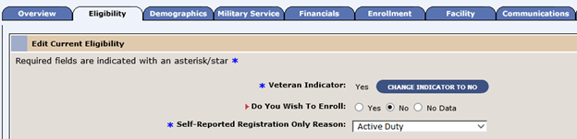

Figure 6: Self-Reported Registration Only Reason

* ES displays a new confirmation popup when a user sets the "Do You Wish To Enroll" question to Yes.
* The confirmation popup is displayed for all new records (Blank → Yes) and for existing   
  records (No → Yes).

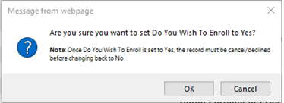

Figure 7: Confirmation Popup

* ES displays a new canceled/declined reason of "Erroneous Enrollment due to Clerical Error“.
  + The new cancelled/declined reason is only selectable by users with the "Edit Registration Option" capability. Users without the capability will see the new reason as grayed out and disabled
* ES will not send the cancelled/declined letter (742-620A - Cancel/Decline Enrollment Letter) when a canceled/declined reason of "Erroneous Enrollment due to Clerical Error" is entered.
* The existing “Reason Cancel/Declined Not Processed” label on the Person Search > Enrollment page is updated to display “Reason Canceled/Declined Not Processed”.
* ES is updated to store the "Source of Registration" when the answer to "Do You Wish To Enroll" is set to Yes.
  + This applies to new records in the system and to existing records when the “Do You Wish To Enroll” question changes from No → Yes.
  + **Example**: If a record is changed in ES from "Do You Wish To Enroll" No → Yes:
    - The "Source of Registration" field remains
  + **Example:** If a new record is entered in ES and "Do You Wish To Enroll" is set directly to Yes:
    - The "Source of Registration" field is set to HEC
* The "Source of Registration" field will remain populated when enrolling in ES on a point-forward basis.
* When adding a date of death to a non-Veteran record, ES sets the enrollment status to "Deceased“.
* ES will complete a cleanup job that will identify all non-Veteran records with a date of death and update them to an enrollment status of "Deceased“.
  + As part of the cleanup job, a message will be sent to all correlated VistA sites for each record.
  + As part of the cleanup job, any VHAPs assigned to the impacted records will be removed.
  + No additional 683A - Compassion letters will be triggered as part of the cleanup job.

VA Profile has not implemented Temporary Address as no other Line of Business (LOB) in VA uses a Temporary Address. Cerner implementation does not support the use of Temporary Address; only addresses for Permanent Mailing Address and Residential Address flow from VistA to ES and ES to VA Profile to Cerner. If a Temporary Address is used at a Cerner-enabled site, mail could be misdirected to that address and not the Permanent Mailing Address or Residential Address. The functionality for ES to eliminate the use of Temporary Address was developed and will be made available in a future release after the functionality is implemented in VistA.

ES currently supports twelve phone type options and is changing to support the same values in the Phone Type dropdown list as interfacing partners enterprise wide.

* ES has reduced the number of options in the dropdown list displayed on the Demographics Addresses tab to match valid values in the Cerner application as of the date of this release.
* ES limits the Phone Type dropdown list to the following selectable options:
  + Home
  + Cell/Mobile
  + Work
  + Temporary (Temporary phone numbers will continue to display until this functionality is removed from VistA and the ES system parameter is set to "N“)

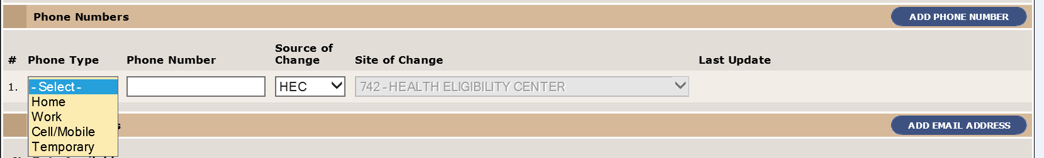

Figure 8: Phone Types Dropdown

* The system will only enable phone types that have not already been saved when attempting to add a new phone record.
* ES displays existing phone type entries having Phone Type "Business" with Phone Type "Work" via a change to the label.
* Entries having obsolete phone types are not removed; however, as of the date of this release, they will no longer display.

Add new phone record

Figure 9: Adding New Phone Record

* ES displays on the Overview tab in the “Update Mailing Address” panel Cell/Mobile Phone, Home Phone, and Work Phone labels.

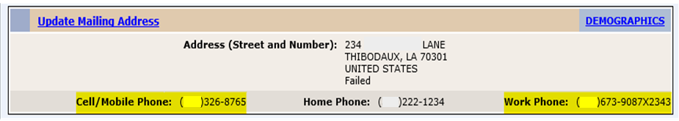

Figure 10: Phone Type on Overview Tab

ES is enhanced to include Emergency Response Indicators (ERIs) and associated data in the Enrollment and Eligibility (E&E) Web Service. VA Profile requires ERI values and historical information from the authoritative source (ES), so that individuals receiving VA care due to a public health crisis can be properly identified.

ES is enhanced to store and display an updated description for the Veteran Plan CCP Restricted Care VHAP.

ES has been updated to capture Community Care hardships that are entered from Cerner Millennium so that the Veteran Hardship Veterans Choice Eligibility (VCE) can be updated and reflected in ES, as well as shared with downstream applications and partners.

## ES Production Defects and Fixes

Table 3 lists the production defects and fixes and corresponding Jira issue numbers included in ES 5.14.

Table 3: Production Defects and Fixes in ES 5.14

| **Jira Issue #** | **Summary** |
| --- | --- |
| VES-603 | **Defect**: Deleting the Mobile (Cell) Phone in VistA does not delete the Mobile (Cell) phone in VA Profile.  **Fix**: Updated code so that when a Cell Phone is deleted in VistA, the Cell Phone is also deleted in VA Profile. |
| VES-1358 | **Defect**: Duplicates are sent in the Community Care Network (CCN) daily file.  **Fix**: Modified the CCN batch process to send current data so that duplicate entries are no longer created. |
| VES-1534 | **Defect**: The count of VHA Profiles under the “New Value” column on the View Historical Eligibility Screen is incorrect after the Veteran indicator was changed to “No” and an Ineligible Date was entered.  **Fix**: Updated the screen to no longer display VHA Profiles and the count. |
| VES-2298 | **Defect**: Section 508: Associate Foreign Address.  **Fix**: Analysis found that the Section 508 issues reported were only occurring with the Automatic Reader in Job Access With Speech (JAWS); no coding changes needed. |
| VES-6116 | **Defect**: Deleting the Home Phone in VistA does not also delete the Home Phone in ES (if ES has multiple phones).  **Fix**: Analysis found that ES works as expected based on when the delete phone number comes from VistA; ES will not delete the phone number but will send the update to VA Profile. Upon receiving back the delete response from VA Profile, ES will delete the phone number. |
| VES-6704 | **Defect**: A JavaScript Error is occurring on the Agreement modal load in Staging.  **Fix**: Updated JavaScript to correct the error. |
| VES-6974 | **Defect**: ES is displaying both Code and Description for “Site of Change”.  **Fix**: Updated code so that when the Code and Description are the same for “Site of Change”, only the Code is returned. |
| VES-8166 | **Defect**: Notification was not sent to VA Profile when there was an update in SW Asia condition.  **Fix**: Added comparison code to check for updates in SW Asia condition so that the proper notification will be sent to VA Profile. |
| VES-8167 | **Defect**: Open work items were created in ES for a Newborn Non-Veteran record with the message "Military Service Data (MSDS Query Blocked - Identity Traits Missing)".  **Fix**: Removed the MSDS validation query for Social Security Number (SSN) required records. |
| VES-9141 | **Defect**: New VCEs for Collaterals and Covered Veterans need to be added to the VCE counts section of the ESCC Email Report.  **Fix**: Added the new VCEs to the ESCC Email Report. |
| VES-9169 | **Defect**: Database/User Interface displays “VIET NAM” instead of “VIETNAM” in the Country dropdown.  **Fix**: Updated Country dropdown to correctly display “VIETNAM”. |
| VES-9361 | **Defect**: Removing and adding the same Community Care Plan (CCP) with the same Effective Date in VistA is causing the ZCE segments to be out of sync with ES.  **Fix**: Updated code so that the latest dates match and are in sync between ES and VistA. |
| VES-9399 | **Defect**: The CCN Daily count reported in the ESCC Email Report is incorrect when the CCN batch process is still in process.  **Fix**: Modified the stored procedure code so that if a count is not present, a text "CCN batch process not complete yet" is reported. |
| VES-9413 | **Defect**: Updating the Mobile (Cell) Phone in VistA is displaying a date/time related error in VA Profile.  **Fix**: Analysis found that this was a time zone issue between test accounts; no code change needed. |
| VES-9859 | **Defect**: IVD Document Management: No validation error message is being displayed when a user performs an invalid date search.  **Fix**: Updated code to display an error message when the user performs an invalid date search. |
| VES-9949 | **Defect**: ESCC Quality Email Report: “VMBP” needs to be updated to “VHAP”.  **Fix**: Changed all instances of “VMBP” in the ESCC Quality Email Report to “VHAP”. |

## ES Sustainment Defects and Fixes

Table 4 lists the sustainment defects and fixes and corresponding Jira issue numbers included in ES 5.14.

Table 4: Sustainment Defects and Fixes in ES 5.14

| **Jira Issue #** | **Summary** |
| --- | --- |
| VES-546 | **Defect**: Browser Compatibility – Chrome and Edge – Truncated text on various buttons in ES screens.  **Fix**: Updated code and formatting so that the button text no longer truncates. |
| VES-588 | **Defect**: A null pointer exception was found in ES version 5.8.  **Fix**: Updated messaging code to correct the null value. |
| VES-590 | **Defect**: ES did not trigger IVM migration upon change from Priority Group 8G to 8D.  **Fix**: Updated code to trigger IVM migration if a record moves from Priority Group 8G to any Enrolled Group. |
| VES-598 | **Defect**: VBA push to ES updates new eligibility date even though the eligibility status is not changed.  **Fix**: Updated rules to check current eligibility status. |
| VES-601 | **Defect**: Net Income is not calculating for Copay Tests received from VistA.  **Fix**: Updated code so that Net Income and Threshold data displays in ES. |
| VES-618 | **Defect**: ES does not deactivate the temporary address when “No” is answered to the VistA prompt to delete.  **Fix**: Added rules for Temporary Address to the Operational Decision Manager (ODM) deploy list so that Temporary Addresses are synchronized. |
| VES-622 | **Defect**: ES is transmitting two outbound messages to the same site for the same Veteran (using a deprecated data file number (DFN)).  **Fix**: Updated code so that ES properly filters out deprecated DFNs from MVI correlation profiles. |
| VES-647 | **Defect**: Person Merge fails if the Veteran has Camp Lejeune eligibility.  **Fix**: Updated code and comments on Camp Lejeune so that the merge no longer fails and the user interface displays the merge page if there are comments. |
| VES-1366 | **Defect**: State Codes AA, AE, AP do not allow Box number for a Residential Address.  **Fix**: Updated code to exclude State Codes AA, AE, and AP from the rule blocking entry of Box numbers in Residential Address. |
| VES-1394 | **Defect**: Inbound addresses pushed from VA Profile are being added to empty/locked enrollment records.  **Fix**: Updated code to discard address updates for any record with no enrollment determination. |
| VES-4126 | **Defect**: Browser Compatibility: VHIC button is not greyed out in Chrome.  **Fix**: Updated style sheet so that the VHIC button is greyed out in Chrome and Edge browsers. |
| VES-6698 | **Defect**: 5.13.0 Fortify: Null Dereference.  **Fix**: Modified rules and code to no longer dereference a null pointer. |
| VES-6699 | **Defect**: 5.13.0 Fortify: Log Forging.  **Fix**: Updated code to correct the log forging issue. |
| VES-6700 | **Defect**: 5.13.0 Fortify: Unreleased Resource: Streams.  **Fix**: Updated code to release the resource. |
| VES-7055 | **Defect**: ES is producing outbound Health Level 7 (HL7) messages to 200CRNR because that station was added as a type of VAMC; the messages are piling up in HealthConnect.  **Fix**: Updated ES to filter out 200CRNR from the outbound builder since there is no VistA station to receive these messages. |
| VES-7081 | **Defect**: 5.13.0 Fortify: Password Management - 16 issues.  **Fix**: Analysis found that the affected configuration file is no longer used in Production. No code changes were necessary. |
| VES-7144 | **Defect**: When the VCE recalculation job updates a record that has both a traits change and a VCE change, it intermittently creates two separate entries to send to the CCN with different VCE statuses for the same person in the same file.  **Fix**: Modified the CCN batch process to send current data so that duplicate entries are no longer created. |
| VES-7155 | **Defect**: Veteran Medical Benefit Plan (VMBP)/VCE jobs are creating brand new enrollment records in an invalid status for the surviving side of a duplicate/linked/merged record when the deprecated person is the one flagged for recalculation.  **Fix**: Modified code so that ES will abandon the update if the record has no enrollment record yet. |
| VES-8259 | **Defect**: Phone fields are being intermittently populated as false in the contact information adapter outbound to VA Profile. ES does not store these fields and always should be setting them as null instead of any Boolean value.  **Fix**: Investigation found that there are not any phone entries with a value that directly came from ES. MPI identity transactions are updating the ES phone fields in the VA Profile phone table. No code changes were necessary. |
| VES-9197 | **Defect**: 5.14.0 Fortify: JSON Injection - 1 Issue - Unvalidated input is being written into JavaScript Object Notation (JSON). This call could allow an attacker to inject arbitrary elements or attributes into the JSON entity.  **Fix**: Investigation found that the JSON attributes are generated from the Java classes within ES, not derived from user input. No code changes were necessary. |
| VES-9199 | **Defect**: 5.14.0 Fortify: Privacy Violation – 3 issues.  **Fix**: Investigation found that the server hosting the application is configured and operated securely according to VA hosting facility policy and that the log files in question are protected from unauthorized read and/or write access. No code changes were necessary. |
| VES-9202 | **Defect**: 5.14.0 Fortify: Privacy Violation - 8 issues.  **Fix**: Investigation found that the classes reported (CleanUpPendingAdjudicationProcess.java and CCNServiceLogServiceImpl.java) are not using the CCNFileData as reported. No code changes were necessary. |
| VES-9204 | **Defect**: 5.14.0 Fortify: Race Condition: Singleton Member Field - 7 issues  **Fix**: Analysis found that the reported class is not a Singleton class so the rule does not apply to its members being shared between users. No code changes were necessary. |
| VES-9273 | **Defect**: 5.14.0 Fortify: Weak Extensible Markup Language (XML) Schema: Unbounded Occurrences - 50 issues.  **Fix**: Analysis found that ES inherits the schema and is not allowed to change it. In addition, any affected messages first pass through HealthConnect, which has validation rules that it follows before submitting to ES; therefore, the messages would fail in HealthConnect before reaching ES. |
| VES-9379 | **Defect**: Section 508: Focusable components in the content do not receive focus in an order that preserves meaning and operability.  **Fix**: Updated code so that JAWS reads the fields correctly. |
| VES-9496 | **Defect**: E&E Service: Schema validation is failing for an Income Verification Match (IVM) request.  **Fix**: Fixed the XML tags so that the IVM retrieve request is successful. |
| VES-9578 | **Defect**: The “Send IVMUpdates” request in the E&E Service is throwing a Jakarta XML Binding (JAXB) unmarshalling exception error.  **Fix**: Fixed an incorrect annotation in the “SendIVMUpdatesRequest.java” code that was causing the error. |
| VES-9581 | **Defect**: E&E Service time stamp is different in new schema than in old schema.  **Fix**: Updated the format of the new schema to match the old service. |
| VES-9715 | **Defect**: E&E Service missing policy effective date tag in new schema.  **Fix**: Updated the format of the new schema to match the old service. |
| VES-9932 | **Defect**: Bidirectional Text (BIDI): Priority Group is not updated in ES on IVM conversion; Income Effective Date is removed in ES.  **Fix**: Added logic to parse incoming XML dates using alternate date formats. |
| VES-9959 | **Defect**: E&E Service: “SendIVMUpdates” tag name in new service response is not matching the old service.  **Fix**: Analysis found that IVM Bidirectional will work with either the old or the new tag name as long as the "<acknowledgement>" and "<invocationDate>" child elements match; no code changes needed. |
| VES-9962 | **Defect**: E&E Service: Extra tag is displaying in the “retrieveIVMCandidates” response in the new service.  **Fix**: Analysis found that the extra tag will not break the IVM Bidirectional; no code change needed. |
| VES-10175 | **Defect**: Military service changes are being sent to VA Profile when the record is not actually changed; this causes unnecessary messaging and creation of duplicate work items in Cerner Millennium.  **Fix**: Modified logic to compare only the military service eligibility object for changes and not the entire collection. |

## Known Issues

No known issues were identified in this release.

# Product Documentation

The following documents apply to this release:

* ES 5.14 Release Notes are uploaded to the [VA Software Document Library](http://www.va.gov/vdl/) (VDL).
* Additional reference documentation related to this release is stored in GitHub.