Enrollment System Modernization (ESM) Phase 3

Enrollment System (ES) 5.15

Release Notes
February 2021
Department of Veterans Affairs
Office of Information and Technology (OIT)

Table of Contents
1 Introduction 1
2 Purpose 2
3 Audience 2
4 This Release 2
4.1 Enhancements and Modifications 2
4.2 ES Production Defects and Fixes 7
4.3 ES Sustainment Defects and Fixes 8
4.4 Known Issues 11
5 Product Documentation 11

List of Tables
Table 1: ES 5.15 ESM Enhancements and Modifications 2
Table 2: ES 5.15 EHRM Enhancements and Modifications 6
Table 3: ES 5.15 ODM Enhancements and Modifications 7
Table 4: Production Defects and Fixes in ES 5.15 7
Table 5: Sustainment Defects and Fixes in ES 5.15 8
Table 6: Open Defects in the ES 5.15 Release 11
List of Figures
Figure 1: History Link on Community Care Program Collateral 2
Figure 2: Community Care Program Collateral History Page 3
Figure 3: New Labels and Button Titles on Eligibility Edit Screen 3
Figure 4: Blue Water Navy Dropdown on Edit Current Eligibility Screen 4
Figure 5: Blue Water Navy Dropdown on Military Service Screen 5
Figure 6: Blue Water Navy Pending 7131 Dropdown on Edit Current Eligibility Screen 5
Figure 7: Admin/System Parameters: Enable Blue Water Navy 6
Figure 8: System Parameters Menu Option on Administrator Menu 6
Figure 9: Export Button – Example (Demographics > Addresses tab) 7

Introduction
The mission of the Department of Veterans Affairs (VA) Office of Information and Technology (OIT), Enterprise Program Management Office (EPMO) is to provide benefits to Veterans and their families. To meet this overarching goal, OIT is charged with providing high quality, effective, and efficient IT services and Operations and Maintenance (O&M) to persons and organizations that provide point-of-care services to our Veterans.
The VA’s goals for its Veterans and families include:
- Make it easier for Veterans and their families to receive the right benefits, and meet their expectations for quality, timeliness, and responsiveness.
- Improve the quality and accessibility of health care, benefits, and memorial services while optimizing value.
- Provide world-class health care delivery by partnering with each Veteran to create a personalized, proactive strategy to optimize health and well-being, while providing state-of-the-art disease management.
- Ensure awareness and understanding of the personalized, proactive, and patient-driven health care model through education and monitoring.
- Provide convenient access to information regarding VA health benefits, medical records, health information, expert advice, and ongoing support needed to make informed health decisions and successfully implement the Veteran’s personal health plans.
- Receive timely, high quality, personalized, safe, effective, and equitable health care, not dependent upon geography, gender, age, culture, race, or sexual orientation.
- Strengthen collaborations with communities and organizations, such as the Department of Defense (DoD), Department of Health and Human Services (DHHS), academic affiliates, and other service organizations.
To assist in meeting these goals, the Enterprise Health Benefits Determination (EHBD) program provides enterprise-wide enhancements and sustainment for the following systems/applications:
- The Enrollment System (ES) is the authoritative system for VA enrollment determination.
- Income Verification Match (IVM)/Enrollment Database (EDB) assists in determining priority grouping for health care eligibility.
- Veterans Information Systems and Technology Architecture (VistA) Registration, Eligibility & Enrollment (REE) shares information with other VistA applications and enables registration and preliminary eligibility determinations and enrollment at VA Medical Centers (VAMC). ES makes the final eligibility determinations.
- The Veteran’s On-Line Application (VOA), now referred to as Health Care Application (HCA), enables Veterans to self-enroll in VA health care and is another entry point for records to be added to ES.
Enrollment System Modernization (ESM) defines VHA Profiles (VHAP) for which a client (Veteran, service member, or beneficiary) is eligible and ties them to the authority for care. Key enhancements to be completed include pending eligibility determination, fixes to the Enrollment System, date of death, internal controls, workflow, Veterans Financial Assessment, converting of Military Service Data Sharing (MSDS) to Enterprise Military Information Service (eMIS), Manage Relationships, Veteran Contact Service, and support for Enrollment System Community Care (ESCC).

Purpose
The purpose of this Release Notes document is to announce the release of the ES 5.15. This release, developed in Java technology, contains ESM Phase 3 development and upgrade efforts. This release includes enhancements and defect fixes to support ESCC, Electronic Health Record Modernization (EHRM), and ES Sustainment.

Audience
This document targets users and administrators of ES 5.15 and applies to the changes made between this release and any previous release for this software.

This Release
ES will be upgraded from Version 5.14.2 to Version 5.15 and hosted at the Austin Information Technology Center (AITC).
The following sections provide a summary of the enhancements and updates to the existing software and any known issues for ES 5.15.

Enhancements and Modifications
Table 1 shows the ESM enhancements and modifications included in the ES 5.15 release as tracked in Atlassian Jira.
Table 1: ES 5.15 ESM Enhancements and Modifications
Jira Epic # | Summary
VES-8396 | Populate Stop Communications to Cease 1095B Communication
VES-9435 | Phase II CCP Collateral History Screen Updates
VES-9464 | Blue Water Navy Verification - Complete Development (ES)
ES is enhanced to ensure mailings are stopped for deceased Veterans by setting the Stop Communications indicator when a Date of Death is entered. The tax-related 1095B form and the Affordable Care Act (ACA) letter are exceptions – these communications will be mailed to deceased Veterans at the beginning of a calendar year if the Date of Death was the previous year, and then are stopped for the years following.
ES 5.13 was updated to begin capturing historical data for Collateral of Veteran changes. ES 5.15 is updated to display this historical data on the Person Search > Eligibility screens.
- A new history link is added to the Community Care Program Collateral section on the Person Search > Eligibility screen:
Figure 1: History Link on Community Care Program Collateral
- A new history page is displayed upon clicking the "View Community Care Program Collateral History" link:
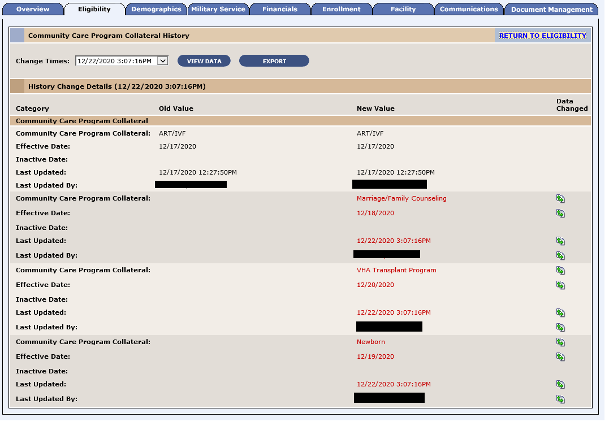
Figure 2: Community Care Program Collateral History Page
- The existing labels and button titles on the Person Search > Eligibility > Eligibility Edit screen are updated:
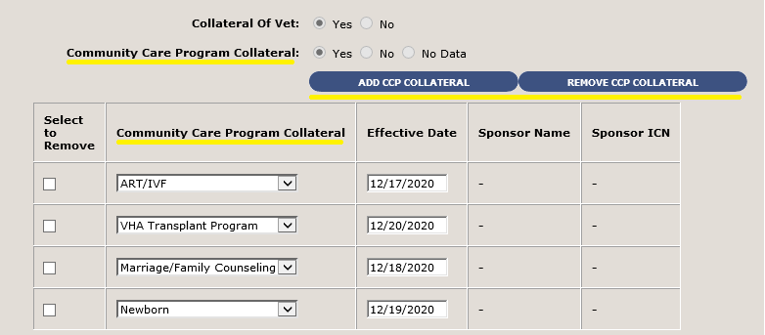
Figure 3: New Labels and Button Titles on Eligibility Edit Screen
ES is updated to introduce a new Agent Orange Exposure Location called Blue Water Navy (BWN). Processing rules will be the same for BWN as they are today for Viet Nam. A new reason for pending eligibility status is implemented to indicate verification of eligibility is awaiting receipt of a Blue Water Navy 7131 form.
- The Edit Current Eligibility screen "Agent Orange Exposure Location" field is updated to include "Blue Water Navy" in the drop-down list:
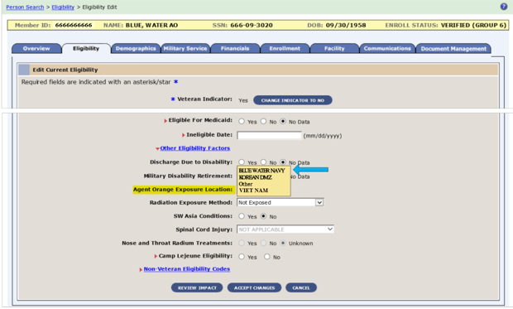
Figure 4: Blue Water Navy Dropdown on Edit Current Eligibility Screen

- The Military Service Screen "Agent Orange Exposure Location" field is updated to include "BLUE WATER NAVY" in the drop-down list:
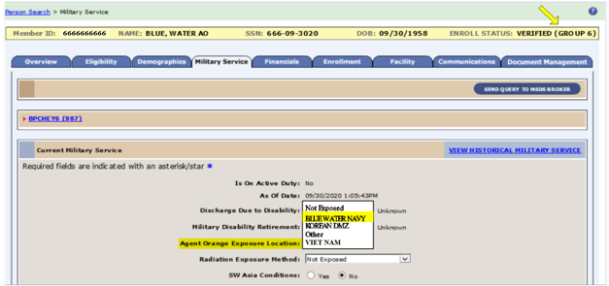
Figure 5: Blue Water Navy Dropdown on Military Service Screen
- The Edit Current Eligibility screen "Reason Eligibility Status is Pending Verification" field is updated to include "Blue Water Navy Pending 7131" in the drop-down list.
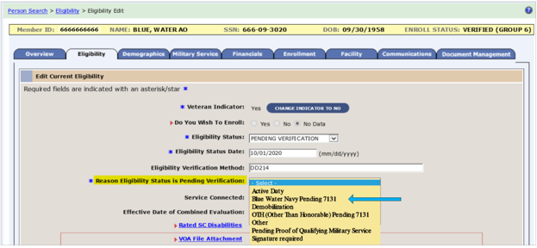
Figure 6: Blue Water Navy Pending 7131 Dropdown on Edit Current Eligibility Screen
- Messaging with VistA is updated to include "B" for Blue Water Navy as a valid value.

- ES has implemented a new system parameter, “Enable Blue Water Navy,” to enable administrators to select the new Blue Water Navy options. The parameter has a default value of "N".
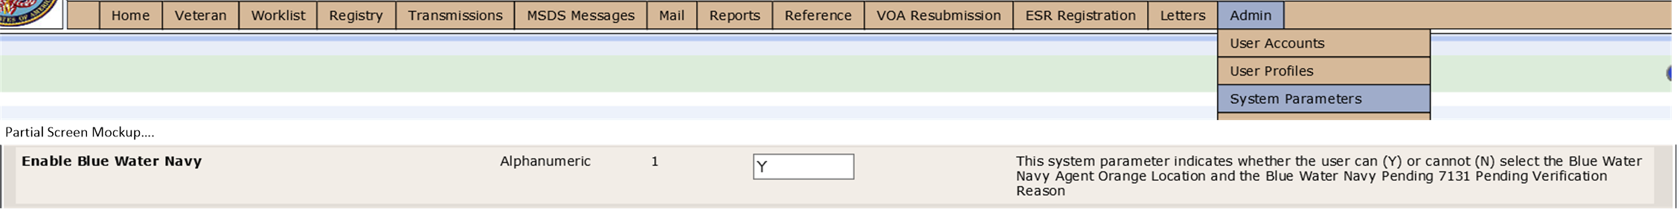
Figure 7: Admin/System Parameters: Enable Blue Water Navy
Table 2 shows the EHRM enhancements and modifications included in the ES 5.15 release as tracked in Jira.
Table 2: ES 5.15 EHRM Enhancements and Modifications
Jira Epic # | Summary
VES-8395 | Configurable List of Other Health Insurance (OHI) for Suppression
VES-9421 | Add Export History Button
Currently, ES receives unverified Other Health Insurance (OHI) information from the Community Care Network (CCN) contractor. ES transmits this insurance information to VistA and Cerner for processing by the Insurance Verification staff. ES is enhanced to allow for the identification and suppression of specific incoming OHI information from transmitting to the VistA Insurance Buffer. This change will improve the workflow process and decrease inefficiencies.
- A new System Parameter is enabled to allow an ES System Administrator with the appropriate capabilities to add, edit, and remove a value to the following entry: CCN OHI INSCO SUPPRESSION LIST.
- This is a list showing all the incoming CCN Insurance Companies that will be suppressed from ES. ES will not store any OHI data for any of the insurance companies in this list.
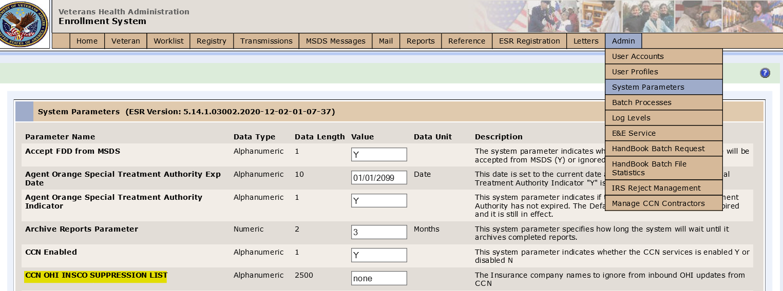
Figure 8: System Parameters Menu Option on Administrator Menu

ES is enhanced to allow users to export a person's change details by adding an "EXPORT" button next to the "VIEW DATA" button on “View History” for the following screens:
- Eligibility History
- Demographics > Personal History
- Demographics > Associates History
- Community Care Program Collateral History
- Military Service History
- Financials History
- Enrollment History
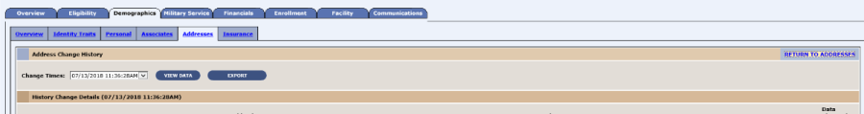
Figure 9: Export Button – Example (Demographics > Addresses tab)
Operational Decision Manager (ODM)
Table 3 shows the ODM enhancements and modifications included in the ES 5.15 release as tracked in Jira.
Table 3: ES 5.15 ODM Enhancements and Modifications
Jira Epic # | Summary
VES-9093 | Integrate Process Financial Information Rules
VES-10112 | Integrate Handle Undeliverable Mail Rules
Under ODM, the 71 iLOG rule sets were transferred from iLOG to ODM. A Mediation Framework was established to allow the system administrators to switch between the iLOG and ODM rules sets as the rules sets are integrated into the ES application. Once the migration is fully completed to ODM, the rules will not be switched back to iLOG unless there is a systemic issue with ODM. ES 5.15 supports integration of the Process Financial Information and Handle Undeliverable Mail rule sets.

ES Production Defects and Fixes
Table 4 lists the production defects and fixes and corresponding Jira issue numbers included in ES 5.15.
Table 4: Production Defects and Fixes in ES 5.15
Jira Issue # | Summary
VES-642 | Defect: Adding/updating “Rated Incompetent” should trigger a Z05 (existing Production behavior).  Fix: Updated code to properly trigger the Z05.
VES-9874 | Defect: Document Management: Null pointer exception is thrown when accessing Document Management screens.  Fix: Updated the document management screens to present an error message in the event that the Data Access Service (DAS) is down at the time they are accessed.
VES-10228 | Defect: A record goes into locked status during Add a Person (AAP).  Fix: Updated code so that during AAP, the Overview page will be displayed and a user will be able to continue AAP.
VES-10301 | Defect: System parameter modification and removal is needed.  Fix: Updated “Temporary Address Enabled” system parameter to “Temporary Mailing Address Enabled” and removed Registration Date system parameter.
VES-10688 | Defect: Prevent Hardship Request and Generate Hardship batch job scrolling issue.  Fix: Modified code to retrieve all records from the database instead of performing an incremental retrieve.
VES-10798 | Defect: Expire Hardships batch process needs to be scheduled to run on January 1.  Fix: Scheduled the batch process to run on January 1.

ES Sustainment Defects and Fixes
Table 5 lists the sustainment defects and fixes and corresponding Jira issue numbers included in ES 5.15.
Table 5: Sustainment Defects and Fixes in ES 5.15
Jira Issue # | Summary
VES-542 | Defect: Browser Compatibility: Chrome & Edge – On the Add/Edit Address > Demographics > Addresses screen, the address field names do not appear as greyed out.  Fix: Updated code to grey out inputs on the Addresses screen.
VES-556 | Defect: Browser Compatibility: Internet Explorer (IE) and Chrome – Issue between IE and Chrome on Hardship screen.  Fix: Updated code so that Hardship comments match for IE and Chrome.
VES-565 | Defect: Browser Compatibility: Edge and Chrome (not IE) – An error is thrown when adding a new phone number on the Address screen.  Fix: Fixed error message in Edge and Chrome when adding a phone number on the Address screen.
VES-566 | Defect: Browser Compatibility: Edge and Chrome error message "0: Unable to get property 'value' of undefined or null reference".  Fix: Fixed JavaScript errors and truncated buttons on the affected pages.
VES-644 | Defect: Cleanup legacy batch processes (obsolete jobs) .  Fix: Legacy batch processes that are no longer needed were removed from the system.
VES-1305 | Defect: The “ACA 800” letter was sent when Stop Communications was set.  Fix: Updated letter rules to properly generate and cease generation of letters.
VES-1306 | Defect: Health Eligibility Center (HEC) reject reason is not always displaying for letters in “Reject at HEC” status.  Fix: Resolved by fixing an issue with “PREVIOUS_ENROLLMENT_STATUS_NOT_REJECTED_BELOW_EGT”.
VES-1358 | Defect: Duplicates are sent in CCN daily file.  Fix: Modified the query that acquires the list of CCN file data to retrieve one record per person.
VES-4173 | Defect: An application error occurs when the Eligibility link is clicked from the breadcrumb.  Fix: Updated the breadcrumb properties to resolve the issue.
VES-8122 | Defect: Site Verified Eligibility is not updating correctly.  Fix: Updated messaging to accept “Verified” status on a new Veteran.
VES-9200 | Defect: 5.14.0 Fortify: Log Forging - 2 issues.  Fix: Added “CommonNamehelper,Encode” to the log statement in order to resolve the log forging issues.
VES-9201 | Defect: 5.14.0 Fortify: Null Dereference - 3 issues.  Fix: No code changes were required for these issues; justification has been provided to the software analysis team in the ES 5.15 submission.
VES-9203 | Defect: 5.14.0 Fortify: Portability Flaw: Locale Dependent Comparison – 2 issues.  Fix: No code changes were required for these issues; justification has been provided to the software analysis team in the ES 5.15 submission.
VES-9346 | Defect: ES is sending a Pseudo Social Security Number (SSN) in the add correlation.  Fix: Updated code to send a null SSN instead of stripping off the “P” for Pseudo SSN.
VES-9549 | Defect: Loss of Veterans Choice Eligibility (VCE) Hardship, N State and Urgent Care with Manual Override.  Fix: Updated ILOG rules so that no data is lost when recalculating the VCE.
VES-9745 | Defect: Application error on View Transmission Details on Third-Party Administrator (TPA) Message log if there is wait-time data in the database.  Fix: Removed wait-time from the TPA hibernate configuration as it is not part of the TPA file.
VES-9786 | Defect: VCE date shows record modified date from VCE eligibility table for CCN and TPA transmission log.  Fix: Updated code to use record created date for VCE effective date for CCN/TPA.
VES-9953 | Defect: Add check for “addPreferredTreatingFacility” (APTF) Social Security Number (SSN) site validation during “proxy_vista” .  Fix: Updated code to add exception catch for SSN site validation during APTF and to present a message on the user interface to inform the user of the specific error.
VES-10079 | Defect: Hardship VCE expiration should be based on most recent hardship consult.  Fix: Updated code to base hardship expiration date on the consult with the latest expiration date.
VES-10149 | Defect: Section 508: In the timeout modal, the name and role of the close button cannot be understood.  Fix: Updated code to remove close link element.
VES-10797 | Defect: OHI files are not received from Region 4.  Fix: OHI filename saved to the Administrative Data Repository (ADR) so that the filename will be read while retrieving the OHI file attachment and can be viewed in “CCN Transmissions” in the ES user interface.
VES-11083 | Defect: Invalid Bad Address Indicator (BAI) exists in the CCN eligibility file.  Fix: Added check for BAI reason and set the BAI to character code to resolve the issue.
VES-11084 | Defect: Names are missing in the CCN eligibility file.  Fix: Updated CCN batch to check for null name fields and look them up in the ADR before writing the record to the CCN file.
VES-12043 | Defect: ES is defaulting the “temporary address active” field to “true” regardless of temporary address status.  Fix: Set the temporary address indicator based on the end date setting.
VES-12078 | Defect: Patients cannot be added by using HCA/VOA request with SOAP UI in Stage 1A.  Fix: Resolved by the latest Extensible Markup Language (XML) from the pre-production account.
VES-12079 | Defect: Fortify: On line 768 of HistoryDAOImpl.java, execute() uses Hibernate to execute a dynamic SQL statement built with input coming from an untrusted source.  Fix: Analysis found that this is a false positive; no code changes are required.
VES-12080 | Defect: Fortify: Privacy violation from SystemParameterServiceImpl.java:1008.  Fix: Analysis found that although Fortify detected this as a privacy violation. no confidential information is included in the code; no code changes are required.
VES-12081 | Defect: Fortify: The method preProcessIncomeTestDateAndSource() in FinancialInfoRuleServiceImpl.java can crash the program by dereferencing a null pointer on line 348.  Fix: Analysis found that this is a false positive result; no code changes are required.
VES-12082 | Defect: Fortify: The method getKeyPosition() in HistoryAction.java can crash the program by dereferencing a null pointer on line 817.  Fix: Modified HistoryAction.java to resolve the issue.
VES-12083 | Defect: Fortify: The method processMessage() in VET360InboundProcessService.java can crash the program by dereferencing a null pointer on line 197.  Fix: Analysis found that this is a false positive result; no code changes are required.
VES-12084 | Defect: Fortify: The call to equals() on line 776 causes portability problems because it has different locales which may lead to unexpected output.  Fix: Analysis found that no code changes are required; since the default is “English,” there is no need for locale in the code.
VES-12085 | Defect: Fortify: The method hasCombatVeteranChanged() in PersonSubmittedAdvice.java mishandles confidential information.  Fix: Analysis found that this is an incorrect finding; the method is using a different class than that reported.
VES-12086 | Defect: Fortify: The function resourceLookup() in FileUtils.java sometimes fails to release a file handle allocated by JarFile() on line 179.  Fix: Updated FileUtils.java to resolve the issue.
VES-12087 | Defect: Fortify: Attackers can control the file system path argument to FileOutputStream() at Financials1010EZApplication.java.  Fix: Analysis found that this is a false finding; no code changes are required.
VES-12386 | Defect: Expire Hardships job does not update VAMC tests.  Fix: Updated code to exclude execution of financial validation for Expire Hardships batch process.

Known Issues
Table 6 lists identified defects that remain open in this release.
Table 6: Open Defects in the ES 5.15 Release
Jira Issue # | Summary
VES-12193 | Financials Change History page does not reflect Means Test status change.
VES-12605 | Spouse's employment (Occupation) information is not being removed in ES when Spouse's Employment Status is set to Unknown/ Not Employed in VistA.

Product Documentation
The following documents apply to this release:
- ES 5.15 Release Notes are uploaded to the VA Software Document Library (VDL).
- Additional reference documentation related to this release is stored in GitHub.

