Enrollment System Modernization (ESM) Phase 3

Enrollment System (ES) 5.16

Release Notes
May 2021
Department of Veterans Affairs
Office of Information and Technology (OIT)

Table of Contents
1 Introduction 1
2 Purpose 2
3 Audience 2
4 This Release 2
4.1 Enhancements and Modifications 2
4.2 Defects and Fixes 12
4.3 Known Issues 14
5 Product Documentation 14

List of Tables
Table 1: ES 5.16 ESM Enhancements and Modifications 2
Table 2: ES 5.16 EHRM Enhancements and Modifications 10
Table 3: ES 5.16 ODM Enhancements and Modifications 12
Table 4: Production Defects and Fixes in ES 5.16 12
Table 5: Sustainment Defects and Fixes in ES 5.16 13
List of Figures
Figure 1: CCN Message Log With New Comments Column 3
Figure 2: New Add Comment Screen 3
Figure 3: Eligibility -> Edit Current Eligibility: Ineligible Date Field Enabled 4
Figure 4: Updated Query Button on Military Service Tab 5
Figure 5: Updated Query Confirmation Page 5
Figure 6: Updated Query Confirmation Message 5
Figure 7: Eligibility -> Community Care Determination Page Redesign 7
Figure 8: Community Care Determination History Page Redesign 8
Figure 9: "New Value" Column Blank Fields 9
Figure 10: Geocode Transmit History Page Blank Fields 10
Figure 11: Save to Mailing Address? Checkbox 11
Figure 12: Save to Residential Address? Warning Message 11

Introduction
The mission of the Department of Veterans Affairs (VA) Office of Information and Technology (OIT), Enterprise Program Management Office (EPMO) is to provide benefits to Veterans and their families. To meet this overarching goal, OIT is charged with providing high quality, effective, and efficient IT services and Operations and Maintenance (O&M) to persons and organizations that provide point-of-care services to our Veterans.
The VA’s goals for its Veterans and families include:
- Make it easier for Veterans and their families to receive the right benefits, and meet their expectations for quality, timeliness, and responsiveness.
- Improve the quality and accessibility of health care, benefits, and memorial services while optimizing value.
- Provide world-class health care delivery by partnering with each Veteran to create a personalized, proactive strategy to optimize health and well-being, while providing state-of-the-art disease management.
- Ensure awareness and understanding of the personalized, proactive, and patient-driven health care model through education and monitoring.
- Provide convenient access to information regarding VA health benefits, medical records, health information, expert advice, and ongoing support needed to make informed health decisions and successfully implement the Veteran’s personal health plans.
- Receive timely, high quality, personalized, safe, effective, and equitable health care, not dependent upon geography, gender, age, culture, race, or sexual orientation.
- Strengthen collaborations with communities and organizations, such as the Department of Defense (DoD), Department of Health and Human Services (DHHS), academic affiliates, and other service organizations.
To assist in meeting these goals, the Enterprise Health Benefits Determination (EHBD) program provides enterprise-wide enhancements and sustainment for the following systems/applications:
- The Enrollment System (ES) is the authoritative system for VA enrollment and Community Care static eligibility determinations.
- Income Verification Match (IVM)/Enrollment Database (EDB) assists in determining priority grouping for health care eligibility.
- Veterans Information Systems and Technology Architecture (VistA) Registration, Eligibility & Enrollment (REE) shares information with other VistA applications and enables registration and preliminary eligibility determinations and enrollment at VA Medical Centers (VAMC). ES makes the final eligibility determinations.
- The Veteran’s On-Line Application (VOA), now referred to as Health Care Application (HCA), enables Veterans to self-enroll in VA health care and is another entry point for records to be added to ES.
Enrollment System Modernization (ESM) defines VHA Profiles (VHAP) for which a client (Veteran, service member, or beneficiary) is eligible and ties them to the authority for care. Key enhancements to be completed include pending eligibility determination, fixes to the Enrollment System, date of death, internal controls, workflow, Veterans Financial Assessment, converting of Military Service Data Sharing (MSDS) to Enterprise Military Information Service (eMIS), Manage Relationships, Veteran Contact Service, and support for Enrollment System Community Care (ESCC).

Purpose
The purpose of this Release Notes document is to announce the release of the ES 5.16. This release, developed in Java technology, contains ESM Phase 3 development and upgrade efforts. This release includes enhancements and defect fixes to support ESCC, Electronic Health Record Modernization (EHRM), and ES Sustainment.

Audience
This document targets users and administrators of ES 5.16 and applies to the changes made between this release and any previous release for this software.

This Release
ES will be upgraded from Version 5.15.2 to Version 5.16 and hosted at the Austin Information Technology Center (AITC).
*************************************************************************************
Please note that since VA support for Internet Explorer (IE) will be phased out by August 2021, we recommend using either the Chrome or Edge browser to access the context-sensitive ES Online Help starting with ES version 5.16. Alternatively, users may either:
- Access the general ES Online Help at the following URL in IE: https://vaww.esr.aac.va.gov/esr/webhelp/esr_help_project.htm#t=online_help%2Fenrollment_system.html, or
- Access the ES User Guide on the VA Software Document Library: https://www.va.gov/vdl/
*************************************************************************************
The following sections provide a summary of the enhancements and updates to the existing software and any known issues for ES 5.16.

Enhancements and Modifications
Table 1 shows the ESM enhancements and modifications included in the ES 5.16 release as tracked in Atlassian Jira.
Table 1: ES 5.16 ESM Enhancements and Modifications
Jira Epic # | Summary
VES-8221 | ES Add Comment Field CCN Message Log
VES-8330 | ES to Assign the Not Eligible Enrollment Status Ahead of Registration Only
VES-8336 | Replace WebHINQ Query in ES with VA Profile Service Integration
VES-11930 | ES Stop PSSG Process for Distance Data based on Choice Rules
ES is updated to include a comment field in the Community Care Network (CCN) message log so that administrators and specified users can view that an error has been resolved and/or dispositioned.
- A new "Edit CCN Log User Comments" capability controls whether a user can enter and/or edit a comment on the CCN message log.
- ES includes include a "Comments" column on each row of the CCN message log results regardless of message status.
- For users with the new "Edit CCN Log User Comments" capability, an "Add/Edit" link is displayed on each row.
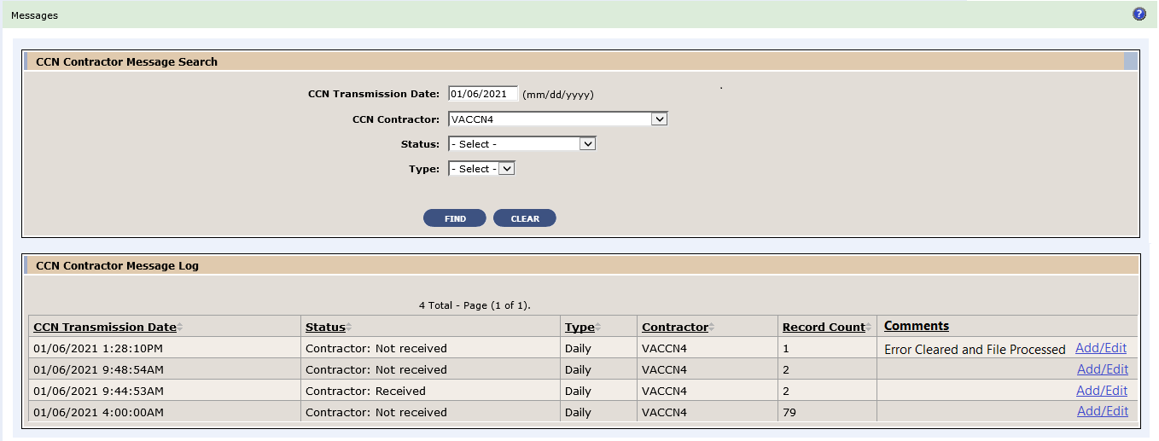
Figure 1: CCN Message Log With New Comments Column
- Upon clicking the "Add/Edit" link, a screen is displayed that allows the user to add a new comment or edit any existing comments.
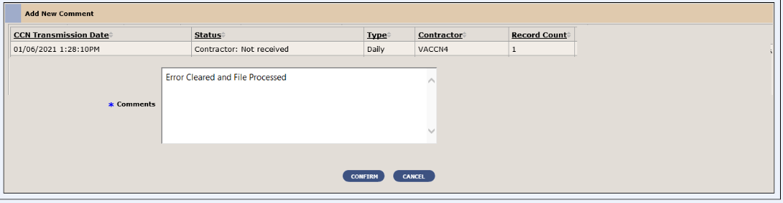
Figure 2: New Add Comment Screen

The Enrollment System and VistA currently assign the "Not Eligible; Ineligible Date" status after the "REGISTRATION ONLY" status which does not properly reflect the enrollment status for ineligible Non-Veterans. With ES 5.16, the system is updated to override the enrollment statuses of “Not Applicable” and “REGISTRATION ONLY” with “Not Eligible; Ineligible Date” when ineligibility fields are populated. ES will assign the Enrollment Status field the value of "Not Eligible; Ineligible Date" regardless of the answer to Do You Wish to Enroll? whenever an ineligible date and reason are populated.
- The system is modified to enable the Ineligible Date, Ineligible Reason, and Ineligible VARO Decision fields to be populated when the enrollment status is “REGISTRATION ONLY”.
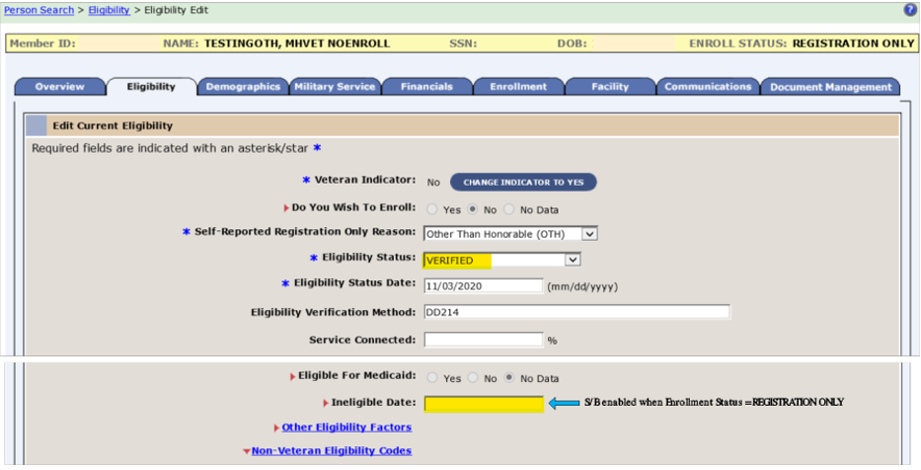
Figure 3: Eligibility -> Edit Current Eligibility: Ineligible Date Field Enabled
- ES is modified to disable the Ineligible Date field(s) during the Add A Person (AAP) process; this will prevent users from entering ineligibility information without completing the record.
- ES is modified to update Determine VHA Profile rules Decision 50, Non-Veteran Other Restricted Med Benefits for ineligible Veterans to include the Enrollment Status of "Not Eligible; Ineligible Date" when a record has mental health care (MH Care) and an ineligible date.
*************************************************************************************
NOTE: To ensure that the correct Enrollment Status is reflected in patient records, it is recommended to only enter/update the Ineligible Date and Reason in ES until DG*5.3*1045 is installed in the VistA production environment.
*************************************************************************************

ES is updated to no longer execute the WebHINQ batch job that processes VBA data sent to ES from eGate, which is unsupported and needs to be decommissioned. Instead, when requesting VBA data for a Veteran, ES will queue requests to query the VA Profile Services for that Veteran.
- The button to query the MSDS Broker on the Military Service tab is updated to “Query VBA and MSDS Data”.
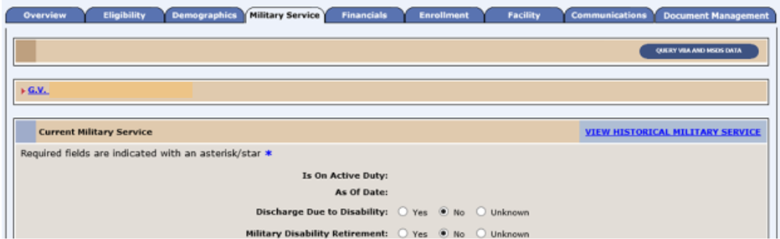
Figure 4: Updated Query Button on Military Service Tab
- The confirmation page title is changed to "Query VBA and MSDS Data" and the screen heading is changed to "Query VBA and MSDS Data Message Confirmation.
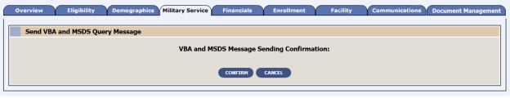
Figure 5: Updated Query Confirmation Page
- If the user selects "Confirm", ES will queue a request to query the VA Profile Service and MSDS for that Veteran, direct the user back to the originating screen, and display the updated confirmation message "The Query VBA and MSDS Data Message has successfully been added to the queue of messages to be sent."
Figure 6: Updated Query Confirmation Message

The ES eligibility rules under the "Grandfather" provision of the MISSION Act of 2018 (VA Maintaining Systems and Strengthening Integrated Outside Networks Act) are modified to no longer consider distance data for Veterans who were included in the initial Community Care Grandfathered population and live in one of the five lowest populated density states (AK, MT, ND, SD, WY). These Veterans will be assigned Grandfather eligibility (VCE G) without sending their record to the Geographer Support Services Center (GSSC) (formally known as Planning Systems Support Group (PSSG)) going forward; however, ES will continue to share their Community Care eligibility information with downstream systems/processes. In addition, this enhancement will support the VHA Support Service Center (VSSC) effort to sunset the monthly Veterans Access Choice and Accountability Act of 2014 (VACAA) Report.
- ES is modified to relax Grandfather eligibility (VCE-G) rules to no longer evaluate mileage for Veterans included in the initial Grandfathered population (those who were eligible for and assigned a Grandfathered VCE pursuant to the MISSION Act on June 6, 2019). Newly enrolled Veterans who live in one of the five lowest population density states do not qualify for a Community Care outcome that includes Grandfathered.
- ES is modified to relax State with No Full-Service Medical Facility eligibility (VCE-N) rules to remove White River Junction VAMC and mileage criteria for Veterans residing in New Hampshire.
- ES is modified to recalculate the Community Care outcome when a Veteran included in the initial Grandfathered population changes their Residential Address.
  - From a low population density state to a state that is not a low population density state (remove Grandfathered outcome), or
  - From a state that is not in low population density state to a low population density state (regain Grandfathered outcome).
- ES is modified to exclude Veterans who were included in the initial Grandfathered population when sharing records with GSSC for the purpose of determining distance data based on Choice rules.

- The Community Care Determination page is modified:
  - Each sub-panel displays horizontally from left to right margins.
  - The header displays the “VIEW GEOCODE TRANSMIT HISTORY” link
  - Veteran Information headers display the links “SEND TO CONTRACTORS”, “View Data Sent to CCN Contractors”, and “View Data Sent to TPA.”
- The field label “Residential Address at the time of Drive Distance Determination” is shortened to “Residential Address”.
- The Community Care Outcome panel is modified to align and display the Override arrows, labels, and radio buttons on the same line for each.
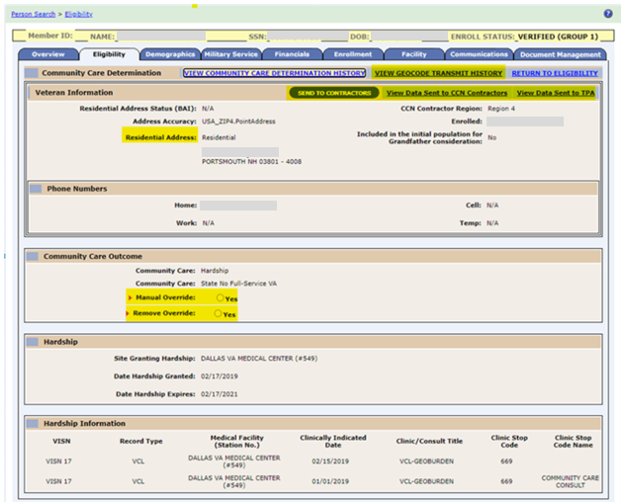
Figure 7: Eligibility -> Community Care Determination Page Redesign

- ES is modified to display only the relevant header rows when the geocoding date is after ES release 5.16 and both previous and current values are blank.
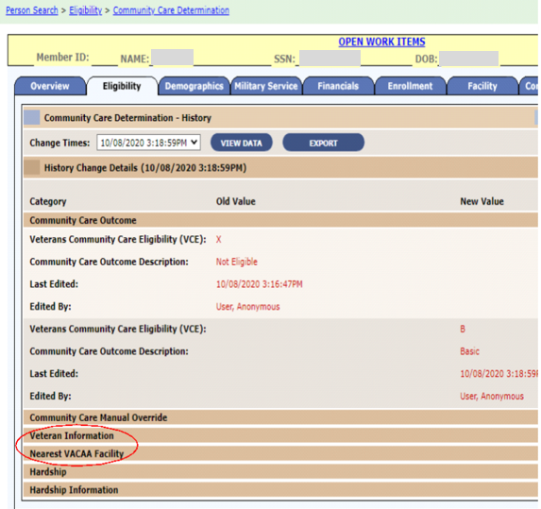
Figure 8: Community Care Determination History Page Redesign

- ES is modified to display blanks in the “New Value” column in all fields for previously Grandfathered Veterans when geocoding date is after ES release 5.16 and an old value exists on the History Change Details record in one or both of the following sections:
  - Veteran Information
  - Nearest VAAAC Facility
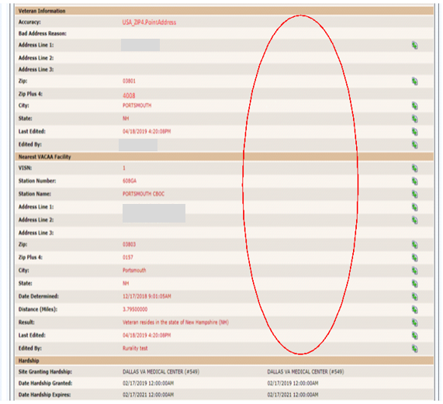
Figure 9: "New Value" Column Blank Fields

- ES is modified to display blanks in the Geocoding Result and Driving Distance columns on the Eligibility -> Geocode Transmit History page when geocoding date is after ES release 5.16.
  - Both these columns will continue to have data in the Administrative Data Repository (ADR) database.
  - The PSSG ETL process will continue to detect changes in driving distance and trigger VCE recalculations. This will not affect the eligibility outcome.
  - The ETL process will also continue to generate record counts that are part of ESCC Quality email, which is no longer required.
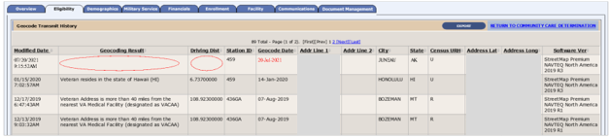
Figure 10: Geocode Transmit History Page Blank Fields
- The ESCC Quality Report is modified to remove the following sections:
  - Discrepancy between Residential Address and Geocoding
  - PSSG
  - Reconciliation Process for Title-38 Care Received for Grandfather VCE (CDW)
Table 2 shows the EHRM enhancements and modifications included in the ES 5.16 release as tracked in Jira.
Table 2: ES 5.16 EHRM Enhancements and Modifications
Jira Epic # | Summary
VES-9274 | ES - Address Same as Function
VES-10507 | Remove the "Permanent" Label on Mailing Address (ES)
VES-11886 | Implement US Space Force as additional Military Branch (ES)

Currently, when an ES user adds an address during the Add A Person functionality, the system forces the user to enter one address at a time although the Mailing Address (MA) and the Residential Address (RA) are usually the same address. With this release, ES is updated so that the ES user will be able enter either MA or RA and be able to click a button or check a box to automatically update the other address.
- A new checkbox with the label "Save to Mailing Address?" is added to the address entry screen when adding or updating a Residential Address.
- A new checkbox with label "Save to Residential Address?" is added to the address entry screen when adding or updating a Mailing Address.
- When the address screen is initially rendered, the checkbox is unchecked.
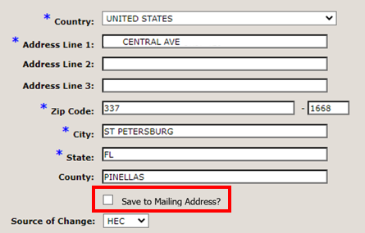
Figure 11: Save to Mailing Address? Checkbox
- A physical address (i.e., no P.O. Box or General Delivery) must be entered for the Mailing Address when the “Save to Residential Address?” indicator is selected, or a warning message is displayed.
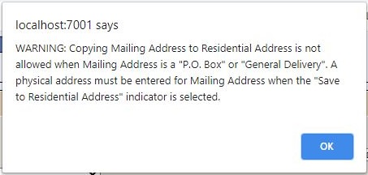
Figure 12: Save to Residential Address? Warning Message
- When a user is attempting to complete a registration, ES will verify that a Residential Address has been entered and, if not, display the error "Residential Address is required".
ES is updated to change the label “Permanent Mailing Address” to “Mailing Address” wherever it appears.
ES is updated to add a new Service Branch for “Space Force” to capture military service information for those in the new military service branch of US Space Force.
- ES interfaces now recognize Space Force when sending and receiving messages.
- ES users are able to add/edit/delete a military service episode with a Service Branch of Space Force per existing rules.
Operational Decision Manager (ODM)
Table 3 shows the ODM enhancements and modifications included in the ES 5.16 release as tracked in Jira.
Table 3: ES 5.16 ODM Enhancements and Modifications
Jira Epic # | Summary
VES-9092 | Integrate Process IVM Financials Rules
Under ODM, the 71 iLOG rule sets were transferred from iLOG to ODM. A Mediation Framework was established to allow the system administrators to switch between the iLOG and ODM rules sets as the rules sets are integrated into the ES application. Once the migration is fully completed to ODM, the rules will not be switched back to iLOG unless there is a systemic issue with ODM. ES 5.16 supports integration of the Process IVM Financials rule set.

Defects and Fixes
Table 5 lists the production defects and fixes and corresponding Jira issue numbers included in ES 5.16.
Table 4: Production Defects and Fixes in ES 5.16
Jira Issue # | Summary
VES-12455 | Defect: An error message is displayed when selecting any POW camp in the Prisoner of War section on the Person Search > Eligibility > Eligibility Edit page.  Fix: Updated backend JavaScript to correct the error.
VES-12666 | Defect: VHAP should be recalculated when “RxCopay” expires after 365 days.  Fix: Added a daily batch job that will recalculate the VHAP for records with expired Rx tests.
VES-12676 | Defect: At the Cerner site, service-connected disabilities are displaying in a single line and are difficult to read.  Fix: Updated code to properly display rated disabilities.
VES-12677 | Defect: “StackOverflow” errors occur on model properties recursion.  Fix: Updated model properties for “DocumentAudit” to prevent stack overflow.
VES-13970 | Defect: The “AssociationValidation” rule is throwing an exception in the rules log.  Fix: Updated code to avoid log errors for association validation rule.
Table 5 lists the sustainment defects and fixes and corresponding Jira issue numbers included in ES 5.16.
Table 5: Sustainment Defects and Fixes in ES 5.16
Jira Issue # | Summary
VES-9560 | Defect: Repeated DGEN bulletins for ineligible records.  Fix: Modified code to check on Veteran indicator.
VES-10145 | Defect: Section 508: Information, structure, and relationships conveyed through presentation cannot be understood (programmatically determined).  Fix: Modified code in the affected screens to move the focus from “Skip to Main Content” to the first item/field of the page.
VES-10146 | Defect: Section 508: When input errors are automatically detected, the item that is in error is not identified and described to the user in text.  Fix: Modified code on the affected screens to add audio indication when a user tries to type in more than the maximum allowed characters and the characters do not appear on the screen.
VES-10148 | Defect: Section 508: The name, role, state or value of user interface elements in the product cannot be understood (programmatically determined).  Fix: Modified code so that assistive technology will read name, state, role, and value when an expandable section is expanded or collapsed.
VES-10205 | Defect: Home Phone # is getting stored in the Address table when the phone number is entered from the Search/Add screen.  Fix: Commented out code to keep the phone number from being added to the address table.
VES-12079 | Defect: Fortify: On line 768 of HistoryDAOImpl.java, execute() uses hibernate to execute a dynamic SQL statement built with input coming from an untrusted source.  Fix: Analysis found that this finding is a false positive; no code changes are required.
VES-12084 | Defect: Fortify: Null Dereference and Portability Flaw: Locale Dependent Comparison.  Fix: Made minor changes in the code to resolve the null dereference and portability problems.
VES-12234 | Defect: Clean-up old Enrollment and Eligibility (E&E) Service code.  Fix: Cleaned up the “HECMS-websrv” project to remove the old E&E Service code.
VES-12259 | Defect: Identical duplicate rows are inserted into the Enrollment Application Table when a user starts the Add A Person process.  Fix: Updated code to no longer create duplicate entries in the database..
VES-12337 | Defect: The CCN daily batch process is experiencing latency issues.  Fix: Updated CCN daily batch process to include all acquired data from the query.
VES-12904 | Defect: The Programmable Logic Controller (PLC) letter extract is missing required fields.  Fix: Modified the retrieval of the Initial Pending Notification (IPN) date method for closure letters.
VES-13402 | Defect: “PersonTraits” needs to be excluded from hibernate optimistic locking checks as the updates are asynchronous.  Fix: Updated code to remove versioning from the “PersonTraits” hibernate mapping file.
VES-13836 | Defect: Automation: Uncaught reference error: “addAlertText” is not defined on adding a person using Python automation tool.  Fix: Added “addAlertText” function to the “ESR-Script.js” JavaScript and removed that function from Java Server Pages (JSP).
VES-14152 | Defect: A feedback loop is occurring on inbound Health Benefit updates.  Fix: Updated code to prevent Add a Person creation and feedback loop through inbound EHRM updates.
VES-14419 | Defect: ES is not correctly evaluating the existence of the Patient Identity (PI) active correlation upon completing registration in the proxy add step to VistA.  Fix: Added PI check to the match criteria for “correlation exists”.

Known Issues
No known or open issues were identified in this release.

Product Documentation
The following documents apply to this release:
- ES 5.16 Release Notes are uploaded to the VA Software Document Library (VDL).
- Additional reference documentation related to this release is stored in GitHub.

