Enrollment System Modernization (ESM) Phase 4

Enrollment System (ES) 5.17

Release Notes
August 2021
Department of Veterans Affairs
Office of Information and Technology (OIT)

Table of Contents
1 Introduction 1
2 Purpose 2
3 Audience 2
4 This Release 2
4.1 Enhancements and Modifications 2
4.2 Defects and Fixes 4
4.3 Known Issues 6
5 Product Documentation 6

List of Tables
Table 1: ES 5.17 ESM Enhancements and Modifications 2
Table 2: IVD Document List Changes 3
Table 3: ES 5.17 ODM Enhancements and Modifications 4
Table 4: Production Defects and Fixes in ES 5.17 4
Table 5: Sustainment Defects and Fixes in ES 5.17 4
List of Figures
Figure 1: Reason Eligibility Status is Pending Verification Dropdown 3

Introduction
The mission of the Department of Veterans Affairs (VA) Office of Information and Technology (OIT), Enterprise Program Management Office (EPMO) is to provide benefits to Veterans and their families. To meet this overarching goal, OIT is charged with providing high quality, effective, and efficient IT services and Operations and Maintenance (O&M) to persons and organizations that provide point-of-care services to our Veterans.
The VA’s goals for its Veterans and families include:
- Make it easier for Veterans and their families to receive the right benefits, and meet their expectations for quality, timeliness, and responsiveness.
- Improve the quality and accessibility of health care, benefits, and memorial services while optimizing value.
- Provide world-class health care delivery by partnering with each Veteran to create a personalized, proactive strategy to optimize health and well-being, while providing state-of-the-art disease management.
- Ensure awareness and understanding of the personalized, proactive, and patient-driven health care model through education and monitoring.
- Provide convenient access to information regarding VA health benefits, medical records, health information, expert advice, and ongoing support needed to make informed health decisions and successfully implement the Veteran’s personal health plans.
- Receive timely, high quality, personalized, safe, effective, and equitable health care, not dependent upon geography, gender, age, culture, race, or sexual orientation.
- Strengthen collaborations with communities and organizations, such as the Department of Defense (DoD), Department of Health and Human Services (DHHS), academic affiliates, and other service organizations.
To assist in meeting these goals, the Enterprise Health Benefits Determination (EHBD) program provides enterprise-wide enhancements and sustainment for the following systems/applications:
- The Enrollment System (ES) is the authoritative system for VA enrollment and Community Care static eligibility determinations.
- Income Verification Match (IVM)/Enrollment Database (EDB) assists in determining priority grouping for health care eligibility.
- Veterans Information Systems and Technology Architecture (VistA) Registration, Eligibility & Enrollment (REE) shares information with other VistA applications and enables registration and preliminary eligibility determinations and enrollment at VA Medical Centers (VAMC). ES makes the final eligibility determinations.
- The Veteran’s On-Line Application (VOA), now referred to as Health Care Application (HCA), enables Veterans to self-enroll in VA health care and is another entry point for records to be added to ES.
Enrollment System Modernization (ESM) defines VHA Profiles (VHAP) for which a client (Veteran, service member, or beneficiary) is eligible and ties them to the authority for care. Key enhancements to be completed include pending eligibility determination, fixes to the Enrollment System, date of death, internal controls, workflow, Veterans Financial Assessment, converting of Military Service Data Sharing (MSDS) to Enterprise Military Information Service (eMIS), Manage Relationships, Veteran Contact Service, and support for Enrollment System Community Care (ESCC).

Purpose
The purpose of this Release Notes document is to announce the release of the ES 5.17. This release, developed in Java technology, contains ESM Phase 4 development and upgrade efforts. This release includes enhancements and defect fixes to support ESCC and ES Sustainment.

Audience
This document targets users and administrators of ES 5.17 and applies to the changes made between this release and any previous release for this software.

This Release
ES will be upgraded from Version 5.16 to Version 5.17 and hosted at the Austin Information Technology Center (AITC).
The following sections provide a summary of the enhancements and updates to the existing software and any known issues for ES 5.17.

Enhancements and Modifications
Table 1 shows the ESM enhancements and modifications included in the ES 5.17 release as tracked in Atlassian Jira.
Table 1: ES 5.17 ESM Enhancements and Modifications
Jira Epic # | Summary
VES-7499 | Populate Originating Source in ES with VAMC ID (ES) - HL7 Changes
VES-12891 | Hiding of Selected IVD Document Names
VES-13193 | Update OTH Pending Verification Reason in ES
ES 5.17 implements Health Level 7 (HL7) messaging updates in order to properly receive source system user name and DUZ (user number) from VistA.
- ES receives the user's name and DUZ for all contact information segments on the HL7 messages received from VistA and saves the User Name and DUZ in the Administrative Data Repository (ADR).
- When reviewing the history for changes to contact information within the ES user interface, “Originating Source System”, “Last Updated by User”, and “Source System User” remain as is.

Income Verification Division (IVD) users can upload income-related documents for a Veteran using the Enrollment System's Document Management functionality. The IVD has determined that the list of available Document Names is too broad. Therefore, some document names are eliminated from the upload screen but are retained for historical purposes.
Table 2: IVD Document List Changes
Selectable Document Names | Removed Document Names
The following Document Names remain on the selection list for IVD Document Type on the Document Management Upload Documents screen:  - Federal Income Tax Forms with schedules and attachments  - W2  - 1099/All  - Appeals/All  - HEC 200-1A  - HEC 220-1/2  - Declaration of Representative  - Misc. Documents | The following Document Names are removed from the selection list for IVD Document Type on the Document Management Upload Documents screen:  - 1098/All  - Gambling Receipts/All  - Medical Receipts/All  - Education Receipts/All  - Burial/Funeral Receipts/All  - Real Estate Documents/All  - Royalty Statements  - Dependent Information/All  - Proof of Marriage/All  - Proof of Divorce/Separation  - Power of Attorney  - Congressionals
The dropdown for the “Reason Eligibility Status is Pending Verification” field on the Edit Eligibility screen had a value in the dropdown list of "OTH (Other Than Honorable) Pending 7131". This value is changed to "OTH (Other Than Honorable) Pending 20-0986".
- This field is also displayed as view-only on the Eligibility Summary View screen.
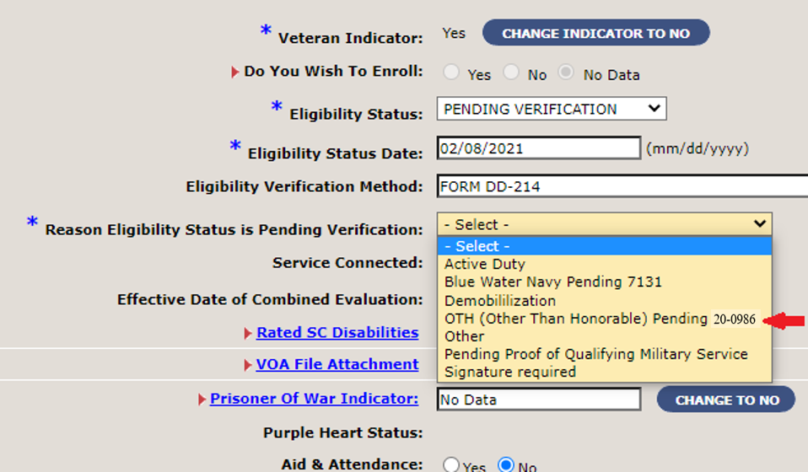
Figure 1: Reason Eligibility Status is Pending Verification Dropdown

Operational Decision Manager (ODM)
Table 3 shows the ODM enhancements and modifications included in the ES 5.17 release as tracked in Jira.
Table 3: ES 5.17 ODM Enhancements and Modifications
Jira Epic # | Summary
VES-10110 | Integrate Process Letter Send Request Rules
VES-10215 | Integrate Consistency Checks Rules
VES-10216 | Integrate Trigger Automatic Letter Rules
Under ODM, the 71 iLOG rule sets were transferred from iLOG to ODM. A Mediation Framework was established to allow the system administrators to switch between the iLOG and ODM rules sets as the rules sets are integrated into the ES application. Once the migration is fully completed to ODM, the rules will not be switched back to iLOG unless there is a systemic issue with ODM. ES 5.17 supports integration of the Process Letter Send Request, Consistency Checks, and Trigger Automatic Letter rules sets.

Defects and Fixes
Table 4 lists the production defects and fixes and corresponding Jira issue numbers included in ES 5.17.
Table 4: Production Defects and Fixes in ES 5.17
Jira Issue # | Summary
VES-15031 | Defect: ESCC Quality Report for State No Full-Service VA needs to be modified.  Fix: ES is modified to relax State with No Full-Service Medical Facility eligibility (VCE N) rules to remove White River Junction VA Medical Center (VAMC) and mileage criteria for Veterans residing in New Hampshire.
VES-15034 | Defect: The Manual Override section in the ESCC Quality Report reports a cumulative total count of override records.  Fix: Modified the Manual Override section in the ESCC Quality Report to only report overrides created on the processing date.
Table 5 lists the sustainment defects and fixes and corresponding Jira issue numbers included in ES 5.17.
Table 5: Sustainment Defects and Fixes in ES 5.17
Jira Issue # | Summary
VES-2961 | Defect: AC-10 Concurrent Sessions - Security Control Violation.  Fix: Updated code to track user and session identifiers so that concurrent sessions can be invalidated and removed as necessary.
VES-6025 | Defect: The response from Veterans Benefits Administration (VBA) and eMIS queries when a Z07 message is being processed causes a database constraint error and fails to update the message.  Fix: Updated code so that the Z11 messages trigger with no error in the logs.
VES-9560 | Defect: ES is sending repeated DGEN email bulletins to sites when the record is in an ineligible status.  Fix: Updated code to add a check on Veteran indicator and previous enrollment status state so that duplicate bulletins are not sent.
VES-9802 | Defect: Push from VA Profile creates duplicate site of change in the site of change table.  Fix: Removed caching in “SiteOfChange.hbm” to avoid duplicate entries into the table.
VES-10683 | Defect: ES is sending non-primary station in the proxy add.  Fix: Corrected code logic to look for the primary facility.
VES-11879 | Defect: Duplicate barcodes on AAC letters causing incorrect mail status.  Fix: Updated code to match the Social Security Number (SSN) from the mailed file with the SSN in “com_mailing”.
VES-11892 | Defect: Duplicate calls to Master Veteran Index (MVI) are occurring during searches from the ES user interface.  Fix: Updated code to prevent more than one set of calls to MVI during search actions.
VES-12193 | Defect: Financials Change History page does not reflect the change for the Means Test (MT) status.  Fix: Fixed the Financial Assessment sub-section to reflect the updated MT status.
VES-13539 | Defect: E&E service invalid schema restriction on enumeration: Source and Registration Only reasons.  Fix: Added the value of “OTHER” to the restriction on the field to avoid the schema validation failure.
VES-14106 | Defect: Section 508 - Edge: “Military Service / Future Discharge Date (FDD) / Other Explanation” focus moves to the end of the text window after each entry(letter) in the text box.  Fix: Fixed code so that the focus from the text window does not move until the user completes entering the text.
VES-14549 | Defect: Fortify – The method addNewPersonScreen() in SearchAction.java can crash the program by dereferencing a null-pointer on line 492.  Fix: Updated code to resolve the dereferenced null-pointer.
VES-14550 | Defect: Fortify – The method performPostQueryProcessing() in PersonSearchValueListAdapter.java can crash the program by dereferencing a null-pointer on line 87.  Fix: Updated code to resolve the dereferenced null-pointer.
VES-14662 | Defect: Pending letters reject for missing gender.  Fix: Removed validation of gender from the common validation package.
VES-14679 | Defect: 60-day expired banner remains on enrolled record.  Fix: Added a check on the enrollment status before displaying banner.
VES-14937 | Defect: Period of Service (POS) is not being calculated correctly for VistA records even after the Military Service Data Sharing (MSDS) response is received.  Fix: Fixed code so that ES correctly calculates POS after the MSDS response is received.
VES-15055 | Defect: “Uncaught Reference” error displays in the Console after adding an address in the Add a Person (AAP) screen.  Fix: Modified code so that the “Uncaught Reference” error no longer displays.
VES-15103 | Defect: The “AACLetter” export job is creating new enrollment records.  Fix: Analysis found that the letter trigger should remain as is; no code changes necessary.
VES-15334 | Defect: Updates to the Minimum Essential Coverage (MEC) period table are not being made.  Fix: DBA reviewed/updated the existing stored procedure to handle the MEC period table update.

Known Issues
No known or open issues were identified in this release.

Product Documentation
The following documents apply to this release:
- ES 5.17 Release Notes are uploaded to the VA Software Document Library (VDL).
- Additional reference documentation related to this release is stored in GitHub.

