Enrollment System Modernization (ESM) Phase 4

Enrollment System (ES) 5.18

Release Notes
October 2021
Department of Veterans Affairs
Office of Information and Technology (OIT)

Table of Contents
1 Introduction 1
2 Purpose 2
3 Audience 2
4 This Release 2
4.1 Enhancements and Modifications 2
4.2 Defects and Fixes 4
4.3 Known Issues 4
5 Product Documentation 4

List of Tables
Table 1: ES 5.18 ESM Enhancements and Modifications 2
List of Figures
Figure 1: Ineligible Reason Code Dropdown 3
Figure 2: Ineligible Date and Reason Fields 3

Introduction
The mission of the Department of Veterans Affairs (VA) Office of Information and Technology (OIT), Enterprise Program Management Office (EPMO) is to provide benefits to Veterans and their families. To meet this overarching goal, OIT is charged with providing high quality, effective, and efficient IT services and Operations and Maintenance (O&M) to persons and organizations that provide point-of-care services to our Veterans.
The VA’s goals for its Veterans and families include:
- Make it easier for Veterans and their families to receive the right benefits, and meet their expectations for quality, timeliness, and responsiveness.
- Improve the quality and accessibility of health care, benefits, and memorial services while optimizing value.
- Provide world-class health care delivery by partnering with each Veteran to create a personalized, proactive strategy to optimize health and well-being, while providing state-of-the-art disease management.
- Ensure awareness and understanding of the personalized, proactive, and patient-driven health care model through education and monitoring.
- Provide convenient access to information regarding VA health benefits, medical records, health information, expert advice, and ongoing support needed to make informed health decisions and successfully implement the Veteran’s personal health plans.
- Receive timely, high quality, personalized, safe, effective, and equitable health care, not dependent upon geography, gender, age, culture, race, or sexual orientation.
- Strengthen collaborations with communities and organizations, such as the Department of Defense (DoD), Department of Health and Human Services (DHHS), academic affiliates, and other service organizations.
To assist in meeting these goals, the Enterprise Health Benefits Determination (EHBD) program provides enterprise-wide enhancements and sustainment for the following systems/applications:
- The Enrollment System (ES) is the authoritative system for VA enrollment and Community Care static eligibility determinations.
- Income Verification Match (IVM)/Enrollment Database (EDB) assists in determining priority grouping for health care eligibility.
- Veterans Information Systems and Technology Architecture (VistA) Registration, Eligibility & Enrollment (REE) shares information with other VistA applications and enables registration and preliminary eligibility determinations and enrollment at VA Medical Centers (VAMC). ES makes the final eligibility determinations.
- The Veteran’s On-Line Application (VOA), now referred to as Health Care Application (HCA), enables Veterans to self-enroll in VA health care and is another entry point for records to be added to ES.
Enrollment System Modernization (ESM) defines VHA Profiles (VHAP) for which a client (Veteran, service member, or beneficiary) is eligible and ties them to the authority for care. Key enhancements to be completed include pending eligibility determination, fixes to the Enrollment System, date of death, internal controls, workflow, Veterans Financial Assessment, converting of Military Service Data Sharing (MSDS) to Enterprise Military Information Service (eMIS), Manage Relationships, Veteran Contact Service, and support for Enrollment System Community Care (ESCC).

Purpose
The purpose of this Release Notes document is to announce the release of the ES 5.18. This release, developed in Java technology, contains ESM Phase 4 development and upgrade efforts. This release includes enhancements to support ESCC and ES Sustainment.

Audience
This document targets users and administrators of ES 5.18 and applies to the changes made between this release and any previous release for this software.

This Release
ES will be upgraded from Version 5.17 to Version 5.18 and hosted at the Austin Information Technology Center (AITC).
The following sections provide a summary of the enhancements and updates to the existing software and any known issues for ES 5.18.

Enhancements and Modifications
Table 1 shows the ESM enhancements and modifications included in the ES 5.18 release as tracked in Atlassian Jira.
Table 1: ES 5.18 ESM Enhancements and Modifications
Jira Epic # | Summary
VES-14972 | Veterans Comprehensive Prevention, Access to Care, and Treatment Act of 2020 or the Veterans COMPACT (ES)
VES-15077 | Megabus Military Sexual Trauma (MST) (SEC. 5301) (ES)
New functionality is added to ES 5.18 to assist in establishing administrative processes to support Public Law No. 116-214, Veterans Comprehensive Prevention, Access to Care, and Treatment Act of 2020 or the Veterans COMPACT Act of 2020 (December 5, 2020). The new functionality includes the addition of a new eligibility factor and changes to rules to assign existing Veterans Community Care Eligibility (VCE) Status Codes and VHAPs.
Note: ES will not be sending the new COMPACT ACT ELIGIBLE eligibility code or new COMPACT Act Eligible VHAP to a VistA site until all sites have installed patch DG*5.3*1061, which includes this functionality. The patch will be released first with a short compliance period before ES 5.18 is deployed.
- A new secondary eligibility of “COMPACT Act Eligible” (Code 24) is added along with rules to properly assign the eligibility code.
- The Long Descriptions of select VHAPs are updated to reference COMPACT Act Eligibility.
- A new VHAP, “Dishonorable VA” (DVA) is added for records that have a bar-to-benefits Ineligible Reason selected.
- A new capability, “Edit Fugitive Felon Program Reason” is added to ES and can be assigned to users who are allowed to add or remove a Fugitive Felon Program (FFP) from a person on the Edit Eligibility screen.
- A new lookup table containing a list of selectable Ineligible Reason Codes is added to ES and a new Ineligible Reason Code selection field is added to the Edit Eligibility screen.
Note: The ineligible reason free text field is still available and, if blank, will be automatically populated with the value of the ineligible reason dropdown.
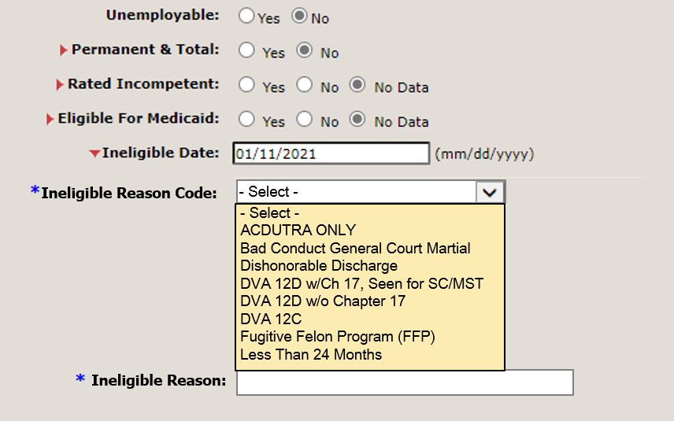
Figure 1: Ineligible Reason Code Dropdown
- Ineligible Date, Ineligible Reason Text, and Ineligible Reason Code values are added to the Person Overview screen for records that have an Ineligible Date on file.
Figure 2: Ineligible Date and Reason Fields

New functionality is added to ES 5.18 to assist in establishing administrative processes to support Section 5301 of the Johnny Isakson and David P. Roe, M.D. Veterans Health Care and Benefits Improvement Act of 2020 (Megabus Act).
- A new Secondary Eligibility, “SPECIAL TX AUTHORITY CARE”, is added to ES. The Eligibility Code is assigned automatically when the MST Indicator = Yes.
- The Long Descriptions of select VHAPS are updated to reference Megabus – MST Eligibility: Restricted Examination Only (REO) and Humanitarian (HM).
- The new Eligibility Code for SPECIAL TX AUTHORITY CARE is shared with VistA via existing messaging processes.

Defects and Fixes
No defects and fixes are included in this release.

Known Issues
No known or open issues were identified in this release.

Product Documentation
The following documents apply to this release:
- ES 5.18 Release Notes are uploaded to the VA Software Document Library (VDL).
- Additional reference documentation related to this release is stored in GitHub.

