Enrollment System 5.18

User Guide-Quick Start
October 2021
Department of Veterans Affairs
Office of Information and Technology (OIT)

Revision History
Date | Revision | Description | Author
10/16/2021 | 36.0 | ES V5.18 added the following:  - Installation, Maintenance, & Monitoring heading update, p. 2  - COMPACT ACT description, p. 11  - COMPACT Act updates on the Overview screen, pgs. 12-13  - COMPACT ACT: Dishonorable VA or FFP (302) VHAP, p. 14  - COMPACT Act Core VHAP updates, pgs. 16-27  - Veteran Full Med Benefits Tx and Rx Copay Exmt (213)  - Veteran Full Med Benefits Tx Copay Exmt and Rx Copay Req (214)  - Veteran Full Med Benefits Tx Copay Req and Rx Copay Exmt 6 (215)  - Veteran Full Med Benefits Tx Copay Req and Rx Copay Exmt 7 (216)  - Veteran Full Med Benefits Tx Copay Req and Rx Copay Exmt 8 (217)  - Veteran Full Med Benefits Tx and Rx Copay Req 6 (218)  - Veteran Full Med Benefits Tx and Rx Copay Req 8 (219)  - Veteran Full Med Benefits Tx GMT Copay Req and Rx Copay Exmt (220)  - Veteran Full Med Benefits Tx GMT Copay Req and Rx Copay Req (221)  - Veteran Restricted Med Benefits (222)  - Non Veteran Other Restricted Med Benefits (223)  - Restricted Examination Only (224)  - Applicant in Process (226)  - Ineligible (290)  - Removed "a Pending Adjudication” from the following:  - Veteran Full Med Benefits Tx Copay Req and Rx Copay Exmt 6 (215)  - Veteran Full Med Benefits Tx Copay Req and Rx Copay Exmt 8 (217)  - COMPACT Act: Community Care Program (CCP) VHAP update, pgs. 28-29  - Veteran Plan CCP Restricted Care (300)  - COMPACT Act: Ineligible Reason Code, pgs. 30-31  - Secondary Eligibility Determination of "COMPACT Act Eligible" rules, pgs 32-34  - Secondary Eligibility Code Updates, p. 35  - Megabus Act description, p. 36  - Megabus MST: SPECIAL TX AUTHORITY CARE, p. 37  - CCN Regions Map update, pgs. 38-39  - Paginating and Filtering User Profiles, p. 40  - Carveout VHAP description update, p. 41  - CCP VHAP description update, p. 42  - Core VHAP description update, p. 43 | TeamLibertyTW
Artifact Rationale
Per the Veteran-focused Integrated Process (VIP) Guide, the User Guide-Quick Start is required to be completed prior to Critical Decision Point #2 (CD2), with the expectation that it will be updated as needed. A User Guide-Quick Start is a technical communication document intended to give assistance to people using a particular system, such as the Enrollment System (ES). It is usually written by a technical writer, although it can also be written by programmers, product or project managers, or other technical staff. Most quick start guides contain both a written guide and the associated images. In the case of computer applications, it is usual to include screenshots of the human-machine interfaces, and hardware manuals often include clear, simplified diagrams. The language used is matched to the intended audience, with jargon kept to a minimum or explained thoroughly. The User Guide-Quick Start is a mandatory, build-level document, and should be updated to reflect the contents of the most recently deployed build. The sections documented herein are required if applicable to your product.
Table of Contents
1. Introduction 1
1.1. Purpose 1
1.2. Overview 1
1.2.1. Release Updates and Enhancements 1
1.2.2. Organization of the Manual 1
1.2.3. Assumptions 2
1.2.4. Installation, Maintenance, & Monitoring 2
1.2.5. Documentation Conventions 2
1.2.6. Project References 2
1.3. National Service Desk and Other Contacts 3
2. System Summary 3
2.1. System Configuration 3
2.2. Data Flows 3
2.3. User Access Levels 3
2.4. ESM Application Information System Contingency Plan 3
2.5. ESM Project Artifacts SharePoint Site 3
2.6. Browser & Operating System Compatibility 4
3. Getting Started 4
3.1. Enrollment System (ES) Layout 4
3.2. ES Online Help 6
3.3. 508 Compliance & Accessibility 8
3.3.1. Accessibility Software 9
3.4. Standard Data Service (SDS) Lookup Tables 9
3.5. Exiting ES 10
3.6. Caveats and Exceptions 10
4. Significant Additions and Updates to ES Version 5.18 10
4.1. COMPACT Act Description 10
4.2. COMPACT Act on the Overview screen 12
4.3. COMPACT Act: Dishonorable VA or FFP VHAP (302) 14
4.4. COMPACT Act: Core VHAP Updates 15
4.5. COMPACT Act: Community Care Program (CCP) Restricted Care (300) VHAP updates 28
4.6. COMPACT Act: Ineligible Reason Code 30
4.7. COMPACT Act: Secondary Eligibility Determination of "COMPACT Act Eligible" rules 32
4.8. COMPACT Act: Secondary Eligibility Code Updates 35
4.9. Megabus Act Description 36
4.10. Megabus MST: SPECIAL TX AUTHORITY CARE 37
4.11. CCN Regions Map Update 38
4.12. Paginating and Filtering User Profiles 40
4.13. Carveout VHAP Description Update 41
4.14. CCP VHAP Description Update 42
4.15. Core VHAP Description Update 43
5. Troubleshooting 44

Table of Figures
Figure 1: Menu Bar 4
Figure 2: Summary with a Sensitive Record 4
Figure 3: Person Search Tabs 5
Figure 4: Summary and Main Screen on ES 5
Figure 5: Sorting Columns 5
Figure 6: System Help and Screen Help 6
Figure 7: SDS Lookup Table 10

List of Tables
Table 1: Support Contact Information 3
Table 2: Accessibility Software 9

Introduction
The Enrollment System (ES) is the primary Veterans Affairs (VA) system used to manage VA health benefits.
ES allows staff at the Health Eligibility Center (HEC), located in Atlanta, Georgia, to work more efficiently and determine patient eligibility in a timelier manner. Messaging with the VAMC (Department of Veterans Affairs Medical Center) allows for the adding and updating of beneficiary records to the enterprise enrollment system to be shared with the field.
ES is one component of the "system of systems" needed to implement the HealtheVet REE (Registration, Eligibility & Enrollment) environment.
ES’s two main functions are:
- Expert System (Messaging) provides a seamless bi-directional interface with external Veterans Health Administration (VHA) and non-VHA systems for data exchange of Veterans’ information.
- Workflow (Case Management) that provides authorized VHA case representatives at the HEC and VAMC with a web interface to easily track, maintain, and manage cases associated with Veteran benefits. HEC and VAMC staff utilize ES to manage these "cases" to completion so that verified Eligibility & Enrollment can be determined.

Purpose
The purpose of this user guide is to familiarize users with important features and navigational elements of the ES application.

Overview
President George W. Bush established a task force for returning Global War on Terror (GWOT) heroes who resulted in enhancements that improved delivery of Federal services and benefits to GWOT service members and Veterans. Among recommendations associated with task force was to focus on enhancing delivery of services and information to GWOT service members and Veterans within existing authority and resource levels.

Release Updates and Enhancements
Click the link to view current and past ES release updates and enhancements on the online help.

Organization of the Manual
This User Guide-Quick Start guide contains the following:
- Introduction
- System Summary
- Getting Started
- Significant Additions and Updates to ES Version
- Troubleshooting

Assumptions
This quick start was written with the following assumed experience/skills of the audience:
- User has basic knowledge of ES (such as the use of commands, menu options, and navigation tools).
- User has been provided the appropriate active roles, menus, and security keys required for ES.
- User is using ES to do their job.
- User has validated access to ES.
- User has completed any prerequisite training.

Installation, Maintenance, & Monitoring
Installation, maintenance, and monitoring of ES updates are performed at the Austin Information Technology Center (AITC) on the third Saturday of each month.

Software Disclaimer
This software was developed at the Department of Veterans Affairs (VA) by employees of the federal government in the course of their official duties. Pursuant to title 17 Section 105 of the United States Code this software is not subject to copyright protection and is in the public domain. VA assumes no responsibility whatsoever for its use by other parties, and makes no guarantees, expressed or implied, about its quality, reliability, or any other characteristic. We would appreciate acknowledgement if the software is used. This software can be redistributed and/or modified freely if any derivative works bear some notice that they are derived from it, and any modified versions bear some notice that they have been modified.

Documentation Disclaimer
The appearance of external hyperlink references in this manual does not constitute endorsement by VA of this Web site or the information, products, or services contained therein. The VA does not exercise any editorial control over the information you may find at these locations. Such links are provided and are consistent with the stated purpose of the VA.

Documentation Conventions
This Quick Start uses several methods to highlight different aspects of the material.
- Various symbols are used throughout the documentation to alert the reader to special information. The following table gives a description of each of these symbols:

Project References
Refer to the following Enrollment System references:
- ES 5.17 Release Notes
- ES 5.17 Online Help

National Service Desk and Other Contacts
Table 1: Support Contact Information
Name | Org | Contact Info
OIT National Service Desk | OIT | - Agent Live Chat: Click the "Chat with us now" button in the lower right corner of the yourIT Service portal to launch Abel the Chatbot and type “chat with agent”  - Self-Service: Create Incident  - Phone: 855-673-4357  - TTY (hearing-impaired only): 844-224-6186
VistA Patch Maintenance | OIT | Use the yourIT Service portal – A ServiceNOW (SNOW) ticket is entered and the ticket assigned to the “NTL SUP Admin Team”.

System Summary
Users require group membership to access SharePoint and Teams’ links. To request access, contact the E&E Program Management Office (PMO) or use the request access option at the SharePoint site and specify group membership.

System Configuration
Please refer the Enrollment Health Benefits Determination (EHBD) Technical and Architectural Roadmaps on the ES SharePoint here.

Data Flows
Please refer to the Production Operations Manual (POM) on the ES SharePoint here.

User Access Levels
See the Buttons/Admin section where User Accounts, Profiles, Roles and Capability Sets explain the different user access levels of the ES.

ESM Application Information System Contingency Plan
Please refer to the Enrollment System Modernization (ESM) Application Information System Contingency Plan on the ES SharePoint here.

ESM Project Artifacts SharePoint Site
Click the following link to access the ESM Project Artifacts SharePoint site.

Browser & Operating System Compatibility
ES is functional through Windows using Chrome or Edge.
Internet Explorer (IE) and Firefox are not supported browsers. Users who have permission to have Firefox should not be using it to access ES.

Getting Started

Enrollment System (ES) Layout
ES displays a beneficiary's record data. The "Menu Bar" and the "Person Search Tabs" provide access to various screens for viewing, updating, adding, and deleting information on ES.

Menu Bar
Menu Bar is where utility buttons for ES are located. From the Menu Bar, users view Worklists, perform Veteran Merges, perform Health Level 7 (HL7), Community Care Network (CCN), Third-Party Administrator (TPA) and Military Service Data Sharing (MSDS) Message Searches, Load Registries, do an Undeliverable Mail Search, Generate/View Reports, Reference Thresholds/Enrollment Group Threshold (EGT) Settings, view Veterans Online Application (VOA) Re-submissions, Search and Add a New Person, and perform general Administrative functions such as enable or disable Veterans Community Care Eligibility (VCE) parameters.

Figure 1: Menu Bar

Summary
The Summary displays the beneficiary's Name, social security number (SSN), date of birth (DOB), date of death (DOD), Enrollment Status, Member ID (if available), and any other important information such as Open Work Items, Pending Merges, Sensitive Records, etc..

Sensitive Record information, if disclosed to the individual, may have serious adverse effects on the individual's mental or physical health. Such information may require explanation or interpretation by an intermediary or assistance in the information's acceptance and assimilation in order to preclude adverse impacts on the individual's mental or physical health.

Figure 2: Summary with a Sensitive Record

Person Search Tabs
Person Search Tabs are the area of the screen where the user may access the various kinds of information on record for the beneficiary to aid in determining his or her eligibility for enrollment in the VA healthcare system.

Figure 3: Person Search Tabs
The terms Veteran, beneficiary, patient, and applicant are used interchangeably throughout ES. While not all applicants are Veterans or patients, not all applicants are beneficiaries either. Whether they are a Veteran, patient or beneficiary is determined AFTER the application for benefits is received and processed.

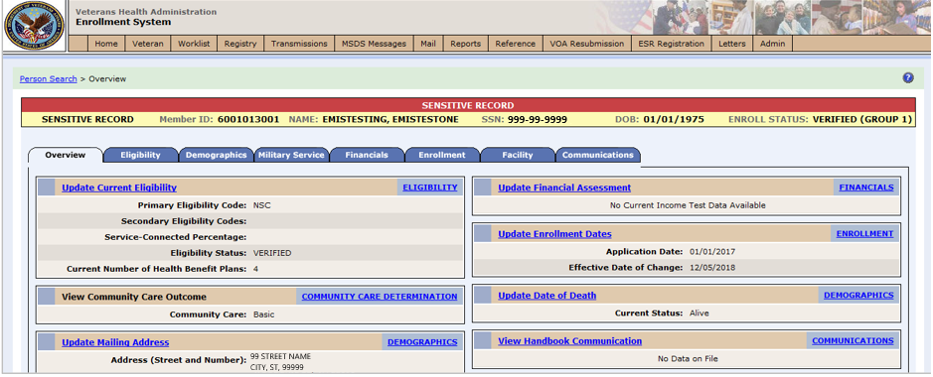
Figure 4: Summary and Main Screen on ES

Sorting Columns
For screens that contain listed data, ascending and descending sorting may be performed for any category by clicking on the category name or on the symbol . Re-clicking the category name or symbol re-sorts the previous sort.

Figure 5: Sorting Columns
ES Online Help is an Online Help system built in Adobe RoboHelp, an authoring and publishing tool. The ES Online Help delivers an output to ES users when clicking the context-sensitive help buttons, System Help or Screen Help.

ES Online Help
In ES, you can obtain information about windows or dialogs clicking the context-sensitive help button available ES in the upper right-hand corner of the “System Help” and “Screen Help”.

System Help:
System Help is the top upper-right context-sensitive help button .

Screen Help:
Screen Help is the lower upper-right context-sensitive help button .
If you roll over the Help icons in ES, screen tips will appear distinguishing between “System Help” and “Screen Help”.

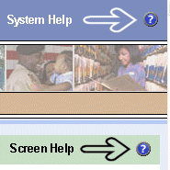
Figure 6: System Help and Screen Help
(an online Table of Contents (TOC) is a summary of your project with topics arranged by category)

ES Online Help Tool Bar
To the left of the ES Online Help, above the table of contents pane, a tool bar contains Contents, Index, Search and Glossary links.

Table of Contents:
Contents displays an expanded table of contents.
- Collapse / Expand (, )
- Topics () are categories of information in the ES Online Help. Clicking, you can view the contents of topic in the main screen located to the right.

Index:
Index displays a multi-level list of keywords and keyword phrases. These terms are associated with topics in the ES Online Help and the keywords are intended to direct you to specific topics within the ES Online Help. Click the keyword to launch a topic from the TOC to the main screen. If the keyword is used with more than one topic, a list of topics displays under the keyword or keyword phrase in which the keyword or keyword phrase appears.

Search:
Search provides a way to explore the content of the ES Online Help and find matches to ES-defined words. Unlike Index that lists author-defined keywords such as terms, synonyms, and cross-references, Search lists words used within the content of topics. To find a topic in which the word appears, click the letter link to display the words that begin with the letter being searched for. Words that appear once are in bold. Words that appear in multiple topics are listed with numbers. Click on a number to display the topic in the right-hand pane in which the word appears.

Glossary:
Glossary provides a list of terms and definitions related to the subject-matter in ES. Click a letter in the top pane and see corresponding definitions that begin with the letter clicked in the lower pane.

The Enrollment System Help text uses Adobe RoboHelp’s 2017 WebHelp as its output and is 508-compliant. The Online Help opens in your web browser as a new window.

Other buttons and functions
Hide/Show the left pane
Provides a larger viewing area of the open topic and hides the left pane.
- Click the Hide link in the upper left side of the right pane to hide the left pane.
- Click the Show link in the upper left side of the pane to show the left pane.

Browser Toolbar
Since there is not a browser toolbar at the top of the ES Online Help window, right-click within ES Online Help window and select either Back or Forward to go back and forward through the history of visited topics, print a topic, or perform other tasks available within the Windows context-sensitive commands.

The Forward command is only available if the Back command has been used first. At that point the Forward command becomes available.

The TOC on the left side of the ES Online Help can also be used to navigate throughout the ES Online Help.

WebHelp Build Date
Click the Systems Parameters topic to view the WebHelp Build Date. The build date is next to the topic title.

Adjusting the main screen and TOC size
Adjust the width and height of the main screen window by dragging the edges of the window in or out.
Adjust the width of the table of contents pane by pointing to the right edge of the left pane until the mouse pointer turns into a line with arrows on each end: Drag the pane to the right or left with the left mouse button held down.

Navigating Help Topics

The following navigational techniques generally refer to the Online Help, where indicated, and not the written documentation:

Links (Online Help)
* symbol indicates a required field in the Online Help.
symbol indicates a required field in the user guide.
symbol is displayed when a submitted field has an error.
symbol ("data changed") is displayed when a type of data has changed on the History, Veteran Merge, and user-related confirmation windows.
Indicates a note or item of special interest.

508 Compliance & Accessibility
With every release, the Department of Veterans Affairs strives to improve accessibility in the Enrollment System through the World Wide Web Consortium (W3C)’s Web Content Accessibility Guidelines (WCAG) 2.0, Levels A and AA.
It's important to mention that because Adobe RoboHelp displays a leveled hierarchy of contents through expanded and collapsed icons. Enrollment System users must click the collapsed icon to display contentsfor that section and re-click the expanded icon to close the contents of that section.

Accessibility Software
The table below lists accessibility software used to assist disabled users with the Enrollment System.
Table 2: Accessibility Software
Accessibility Software | Description | Keyboard Shortcuts
Jaws (Job Access with Speech) | Assists blind and visually impaired Veterans with reading screens on ES either with a text-to-speech output or a Braille display. | JAWS Keystrokes
Window-Eyes | Reads specific text on an ES screen to a disabled Veteran. | Window-Eyes Manual
MAGic | Magnifies ES screens to varying levels and assists Veterans with screen reading. | MAGic Keystrokes
ZoomText Magnifier / Reader | Magnifies ES screens to varying levels and assists Veterans with screen reading. | ZoomText Tutorial
Dragon Naturally Speaking | Through dictating ES functions, assists disabled Veterans with ES document downloads  and exports. | Dragon NaturallySpeaking User Documentation

If you have questions or comments regarding Adobe RoboHelp 2017 accessibility, please contact the Adobe Accessibility Team and provide feedback on their feedback form. For further information on Adobe accessibility, please refer to the following link:
https://www.adobe.com/accessibility/508standards.html

Standard Data Service (SDS) Lookup Tables
The SDS is a repository of enterprise-level reference tables. The SDS Lookup Tables contain information needed to define requirements and research the E&E process. The SDS Lookup Tables page enables a user to view information about a specific table (for example, table name, code, description, active status, date when a code became inactive). ES uses SDS tables in several of its applications.
Users access the SDS Lookup Tables screen by clicking the Reference Tables link at the top right of any ES screen.
To display the SDS Lookup Tables:
- Click the Reference Tables link and the SDS Lookup Tables page displays. SDS table and SDS History table names are listed in alphabetical order in the Navigation Bar.
- Select an SDS table name from the navigation bar. The right panel displays the first five columns in the selected table and the Table Name contains a link for downloading the whole table as an Excel spreadsheet. The Excel spreadsheet will display all the columns in the table.

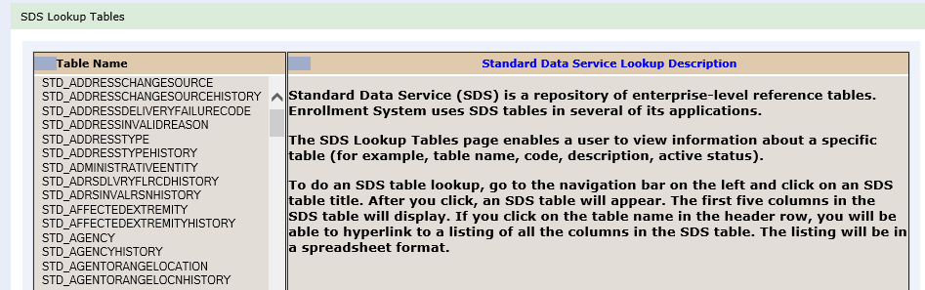
Figure 7: SDS Lookup Table
No data found for the selected table displays if there is no data in an SDS Lookup Table.

Exiting ES
To exit ES, click on the Sign Out link at the top of any page.

Caveats and Exceptions
None.

Significant Additions and Updates to ES Version 5.18

Please refer to 5.18 additions in below.

COMPACT Act Description
Confirm the following online help updates.

Step | Action
1 | Click the Person Search Tabs book on the table of contents on the online help.
2 | Click the Eligibility book.
3 | Click the COMPACT Act topic (at the bottom of the Eligibility book).
4 | Confirm the description is correct and accurate.  Veterans Comprehensive Prevention, Access to Care, and Treatment Act of 2020, better known as the Veterans COMPACT Act of 2020, supports administrative processes for Public Law No. 116-214.  COMPACT Act improves Department of Veterans Affairs transition assistance, suicide prevention for Veterans, and care and services for women Veterans. The COMPACT Act was signed into law on December 5th, 2020.  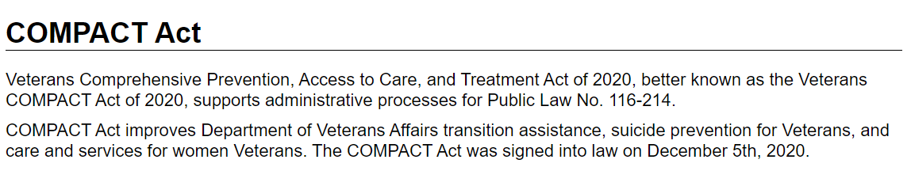

COMPACT Act on the Overview screen
Confirm the following online help updates.

Step | Action
1 | Click the Person Search Tabs book on the table of contents on the online help.
2 | Click the Overview book.
3 | Scroll down to the "Update Current Eligiblity" field defintion.
4 | Confirm the text and tables within each collapse/expand link is accurate.  - COMPACT Act eligibility  - ineligible date  - ineligible reason text  - ineligible reason code  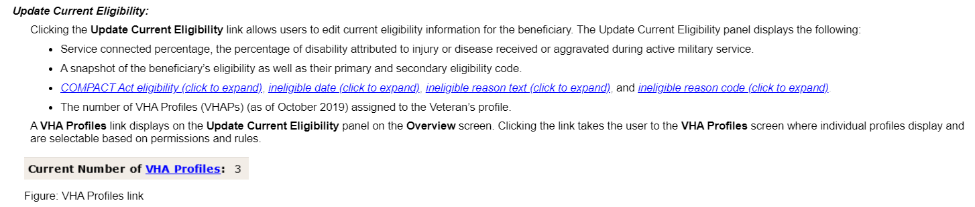  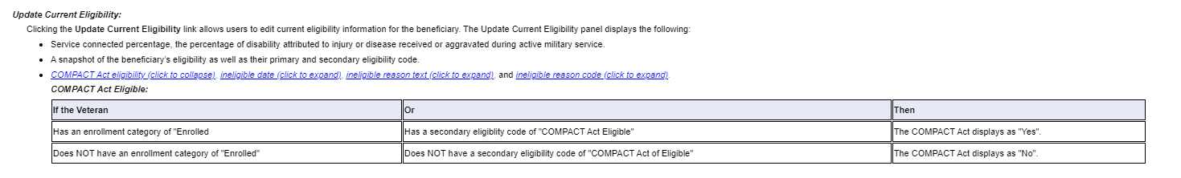  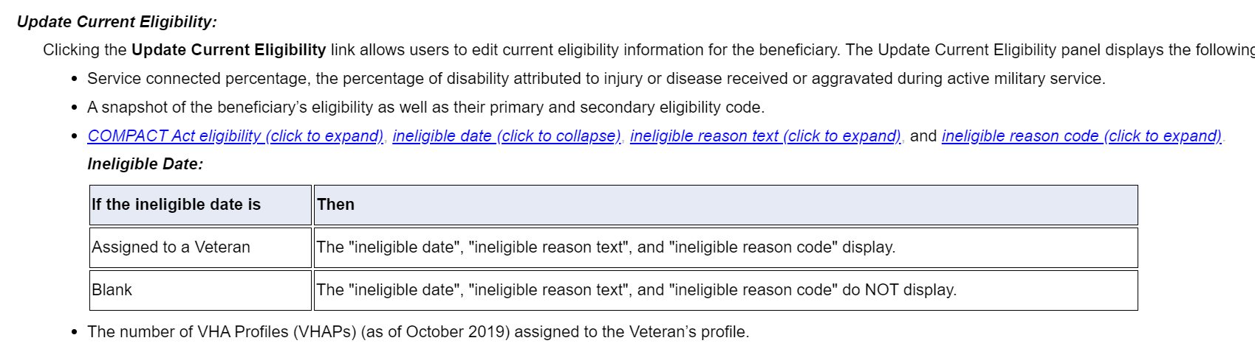  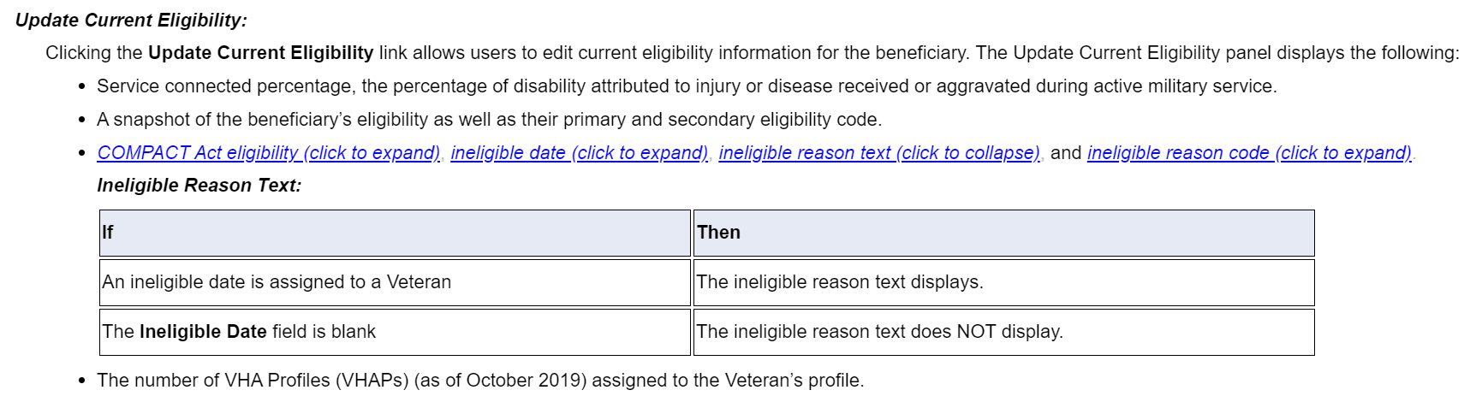  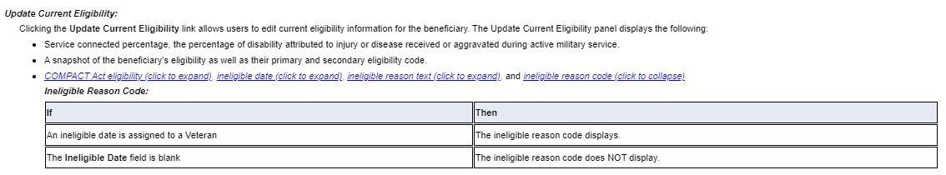

COMPACT Act: Dishonorable VA or FFP VHAP (302)
Confirm the following online help updates.

Step | Action
1 | Click the Menu Bar book on the table of contents on the online help.
2 | Click the References book.
3 | Click the Core VHAPs topic.
4 | Confirm the following text was added for the following new core VHAP. “Dishonorable VA or FFP”.  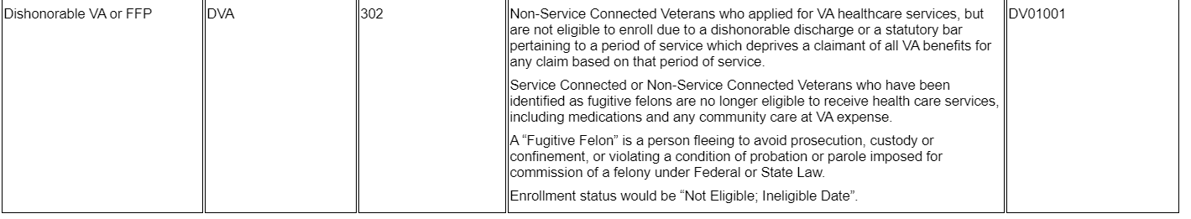

COMPACT Act: Core VHAP Updates
Confirm the following online help updates.

Step | Action
1 | Click the Menu Bar book on the table of contents on the online help.
2 | Click the References book.
3 | Click the VHA Profiles book.
4 | Click the Core VHAPs topic.
5 | Confirm the following text was added:  “For eligible individuals, under Veterans Comprehensive Prevention, Access to Care, and Treatment Act of 2020 (COMPACT), Section 201, VA will furnish, reimburse, pay for emergent suicide care, make referrals, as appropriate, for care following the period of emergent suicide care. Eligible individuals are ones who served in the active military service, regardless of length of service, and who were discharged, excluding anyone who received a dishonorable discharge or was discharged or dismissed by reason.”  …to the following core VHAPs:  - Veteran Full Med Benefits Tx and Rx Copay Exmt (213)  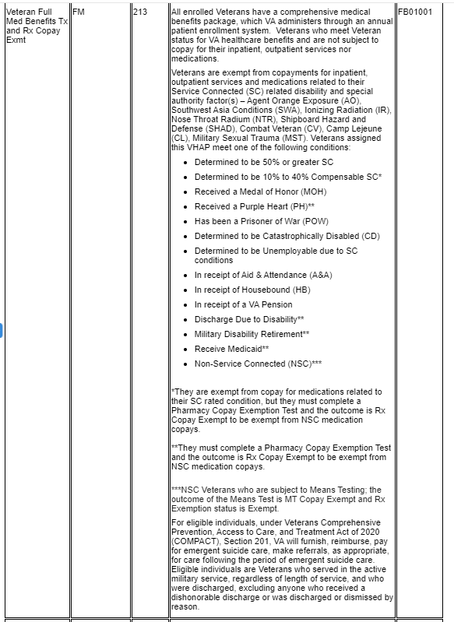  - Veteran Full Med Benefits Tx Copay Exmt and Rx Copay Req (214)  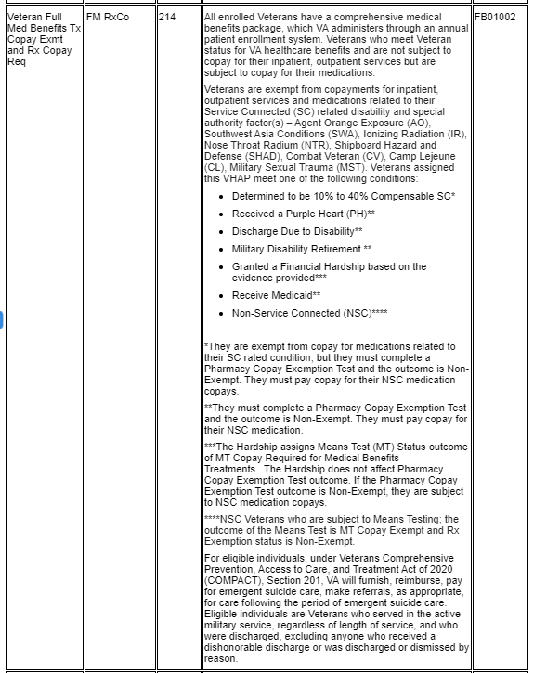  - Veteran Full Med Benefits Tx Copay Req and Rx Copay Exmt 6 (215)  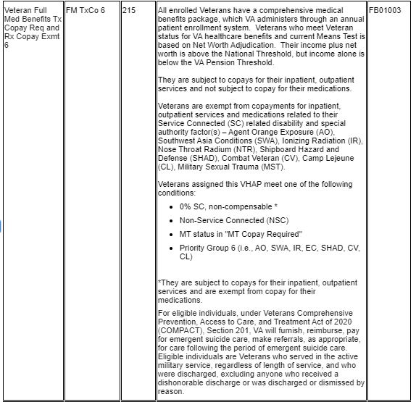  - Veteran Full Med Benefits Tx Copay Req and Rx Copay Exmt 7 (216)  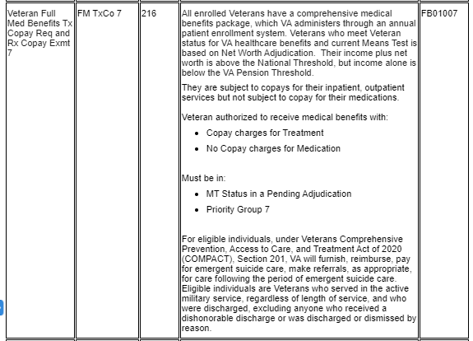  - Veteran Full Med Benefits Tx Copay Req and Rx Copay Exmt 8 (217).  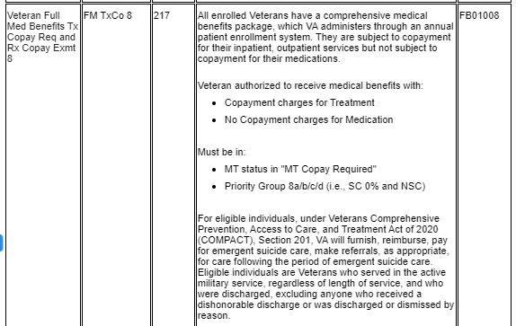  - Veteran Full Med Benefits Tx and Rx Copay Req 6 (218)  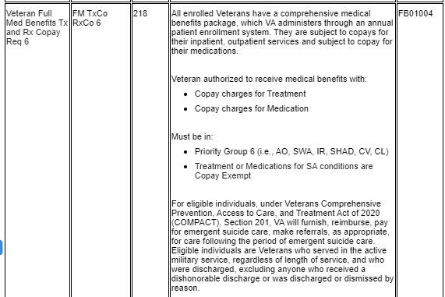  - Veteran Full Med Benefits Tx and Rx Copay Req 8 (219)  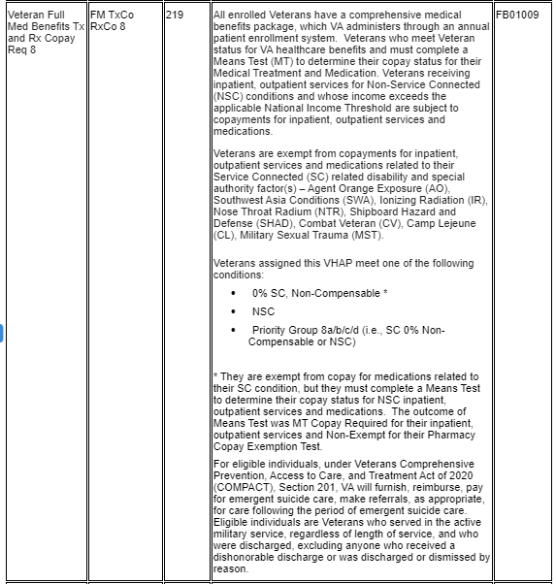  - Veteran Full Med Benefits Tx GMT Copay Req and Rx Copay Exmt (220)  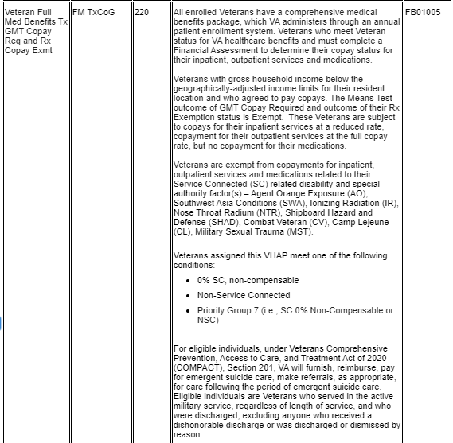  - Veteran Full Med Benefits Tx GMT Copay Req and Rx Copay Req (221)  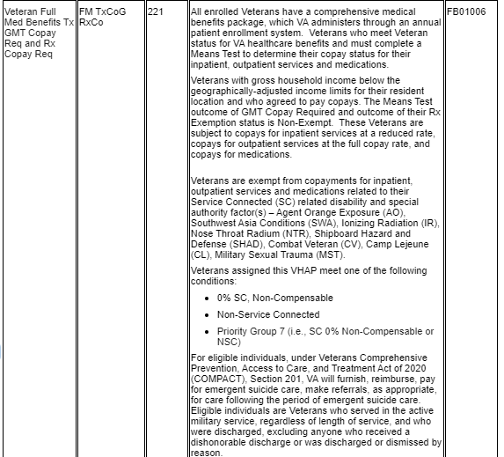  - Veteran Restricted Med Benefits (222)  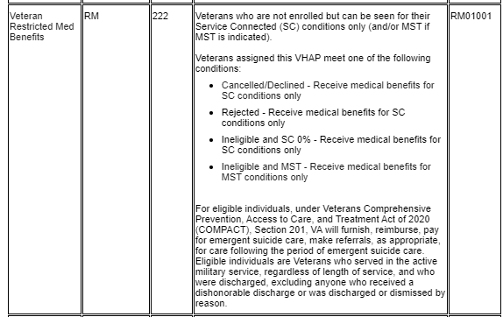  - Non Veteran Other Restricted Med Benefits (223)  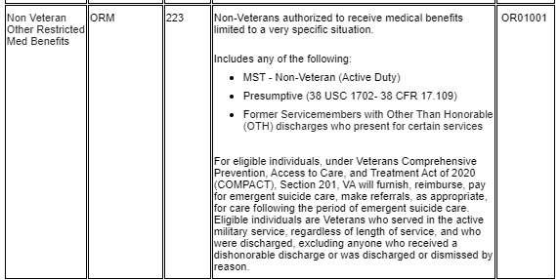  - Restricted Examination Only (224)  Added the following text to core VHAP 224:  "For eligible individuals, under Veterans Comprehensive Prevention, Access to Care, and Treatment Act of 2020 (COMPACT), Section 201, VA will furnish, reimburse, pay for emergent suicide care, make referrals, as appropriate, for care following the period of emergent suicide care. Eligible individuals are Veterans who served in the active military service, regardless of length of service, and who were discharged, excluding anyone who received a dishonorable discharge or was discharged or dismissed by reason or while serving in the Armed Forces, was the victim of a physical assault of a sexual nature, a battery of a sexual nature, or sexual harassment."  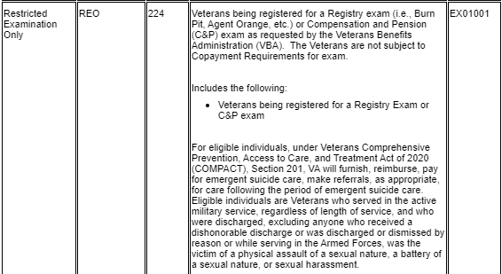  - Applicant in Process (226)  Added the following text to core VHAP 226:  "For eligible individuals, under Veterans Comprehensive Prevention, Access to Care, and Treatment Act of 2020 (COMPACT), Section 201, VA will furnish, reimburse, pay for emergent suicide care, make referrals, as appropriate, for care following the period of emergent suicide care. Eligible individuals are Veterans who served in the active military service, regardless of length of service, and who were discharged, excluding anyone who received a dishonorable discharge or was discharged or dismissed by reason or while serving in the Armed Forces, was the victim of a physical assault of a sexual nature, a battery of a sexual nature, or sexual harassment."  \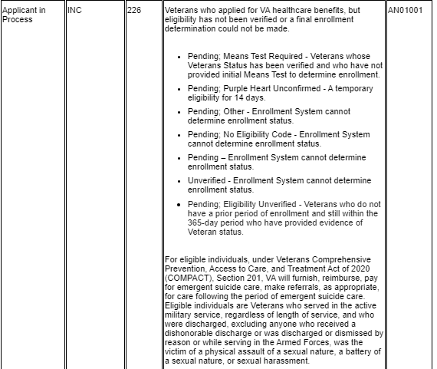  - Ineligible (290)  Added the following text to core VHAP 290:  "For eligible individuals, under Veterans Comprehensive Prevention, Access to Care, and Treatment Act of 2020 (COMPACT), Section 201, VA will furnish, reimburse, pay for emergent suicide care, make referrals, as appropriate, for care following the period of emergent suicide care. Eligible individuals are Veterans who served in the active military service, regardless of length of service, and who were discharged, excluding anyone who received a dishonorable discharge or was discharged or dismissed by reason or while serving in the Armed Forces, was the victim of a physical assault of a sexual nature, a battery of a sexual nature, or sexual harassment."  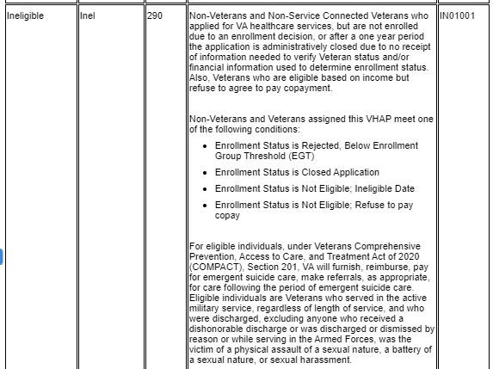
6 | Confirm the following text was removed from core VHAP "215":  Removed "a Pending Adjudication” (third bullet):  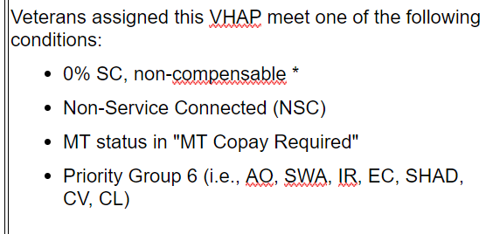
7 | Confirm the following text was removed from core VHAP "217":  Removed "a Pending Adjudication” (from first bullet):  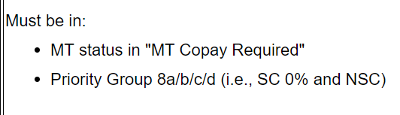

COMPACT Act: Community Care Program (CCP) Restricted Care (300) VHAP updates
Confirm the following online help updates.

Step | Action
1 | Click the Menu Bar book on the table of contents on the online help.
2 | Click the References book.
3 | Click the VHA Profiles book.
4 | Click the CCP VHAPs topic.
5 | Confirm the following text was added to “Veteran Plan CCP Restricted Care” (300) VHAP:  The VHAP Veteran Plan CCP Restricted Care is assigned to:  Not enrolled covered Veterans: Veterans who are NOT enrolled and non-Veterans who have the following eligibility:  - SC 0% to 40%; SC 0% (non-compensable)  - Was discharged or released from active military service for a disability incurred or aggravated in the line of duty for a 12-month period following discharge or release  - Military Sexual Trauma (MST) Non-Veteran (Active Duty)  - Emergent Mental Health (MH) Other-Than-Honorable (OTH) or Extended MH OTH  COMPACT Act 2020 eligible Veterans: Veterans who served in the active military service, regardless of length of service, and who were discharged, excluding anyone who received a dishonorable discharge or was discharged or dismissed by reason; are not enrolled in the health care system established by section 1705 of this title; and served in the Armed Forces for a period of more than 100 cumulative days: and was deployed in a theater of combat operations, or while serving in the Armed Forces, was the victim of a physical assault of a sexual nature, a battery of a sexual nature, or sexual harassment.  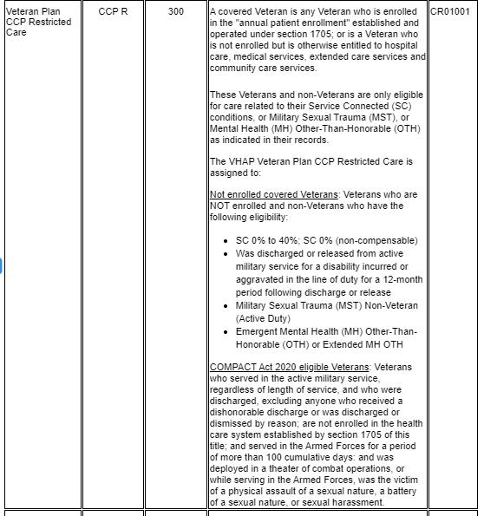

COMPACT Act: Ineligible Reason Code
Confirm the following online help updates.

Step | Action
1 | Click the Person Search Tabs book on the table of contents on the online help.
2 | Click the Eligibility book.
3 | Click the Current Eligibility book.
4 | Scroll down to the Ineligible Reason Code (Required) field.
Confirm the definition text and the rules under this field are correct.
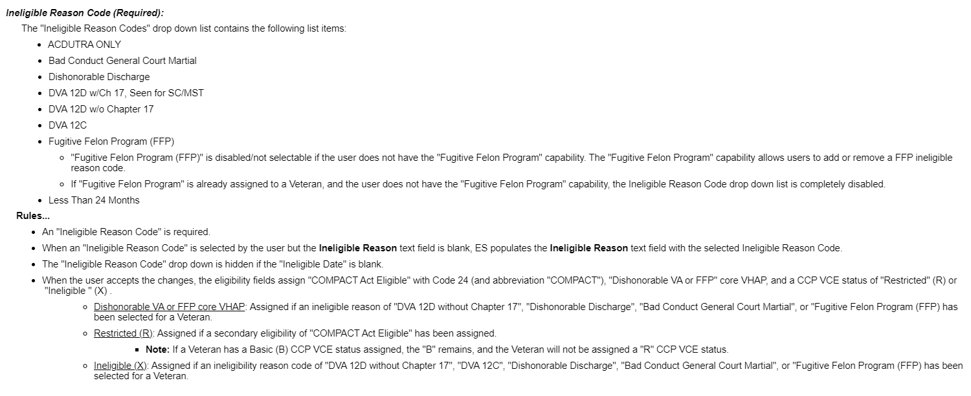

5 | Navigate to the table of contents (on the left of the system help).
6 | Click the Edit Current Eligibility (Add a Person) topic.
7 | Scroll down to the Ineligible Reason Code (Required) field
8 | Confirm the definition text and the rules under this field are correct.  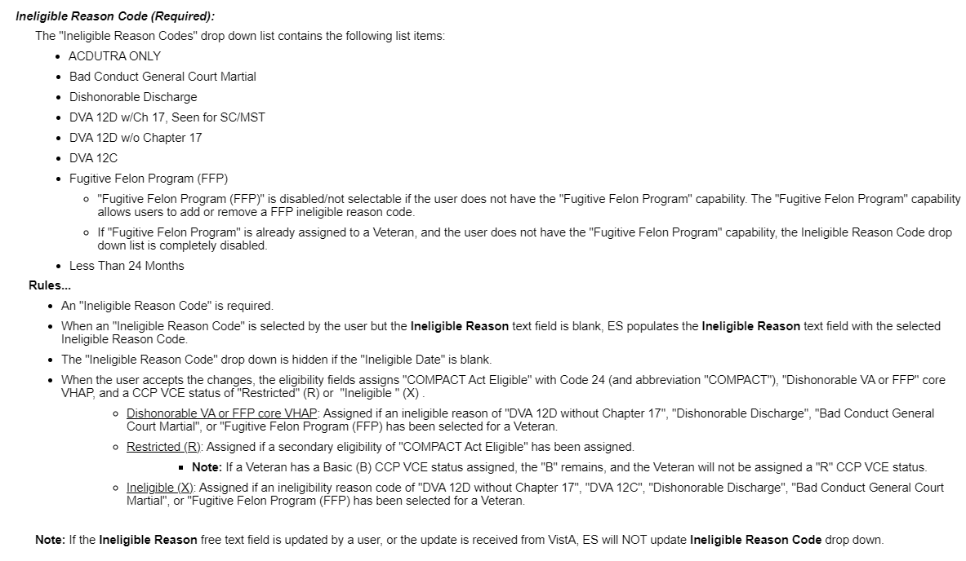

COMPACT Act: Secondary Eligibility Determination of "COMPACT Act Eligible" rules
Confirm the following online help updates.

Step | Action
1 | Click the Person Search Tabs book on the table of contents on the online help.
2 | Click the Eligibility book.
3 | Click the Current Eligiblity book.
4 | Click the Edit Current Eligiblity topic.
5 | Scroll down to the Ineligible Reason Code (Required): field.
6 | Scroll down to the Secondary Eligibility Determination of “COMPACT Act” Eligible rules.
7 | Confirm the rules are correct and accurate.  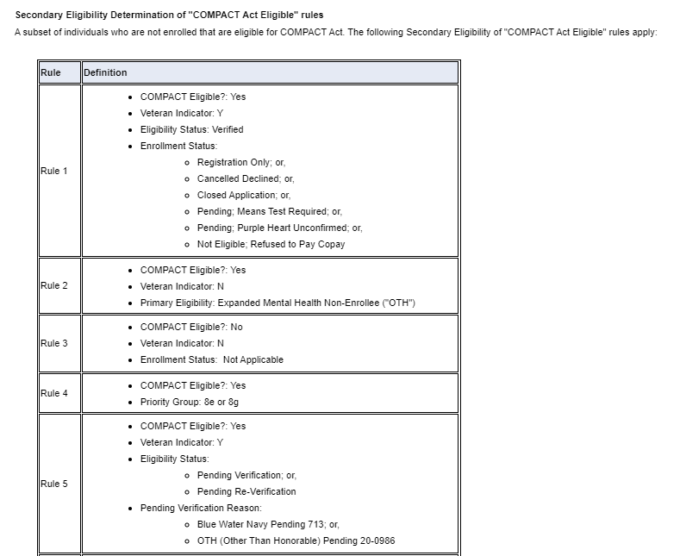  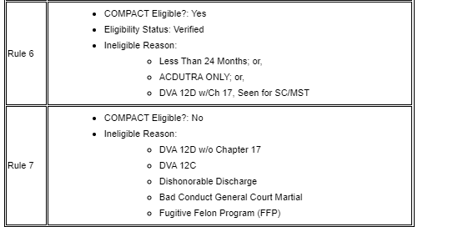
8 | Click the Person Search Tabs book on the table of contents on the online help.
9 | Click the Eligibility book.
10 | Click the Current Eligiblity book.
11 | Click the Edit Current Eligiblity (Add a Person) topic.
12 | Scroll down to the Ineligible Reason Code (Required): field.
13 | Scroll down to the Secondary Eligibility Determination of “COMPACT Act” Eligible rules.
14 | Confirm the rules are correct and accurate.

COMPACT Act: Secondary Eligibility Code Updates
Confirm the following online help updates.

Step | Action
1 | Click the Person Search Tabs book on the table of contents on the online help.
2 | Click the Eligibility book.
3 | Click the Secondary Eligibility Codes book.
4 | Click the Secondary Eligibility Codes topic.
5 | Scroll down to the Veteran Eligiblity Codes: list.
7 | Confirm “COMPACT Act Eligible” and “Special TX Authority Care” are added to the list, and correct.  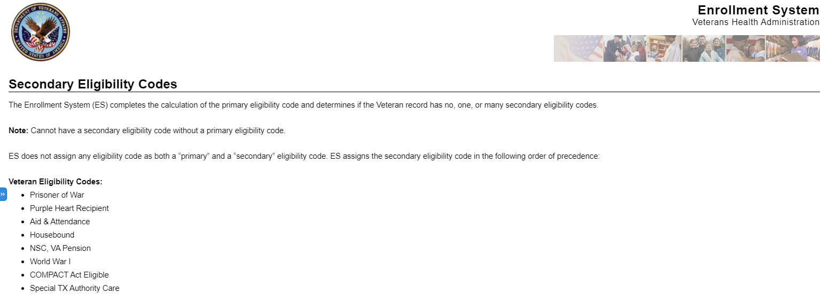

Megabus Act Description
Confirm the following online help updates.

Step | Action
1 | Click the Person Search Tabs book on the table of contents on the online help.
2 | Click the Eligibility book.
3 | Click the Megabus Act topic (at the bottom of the Eligibility book).
4 | Confirm the Megabus Act decription is correct and accurate.  The Megabus Act (aka Section 5301 of the Johnny Isakson and David P. Roe, M.D. Veterans Health Care and Benefits Improvement Act of 2020) offers Military Service Trauma (MST) related health care services to Veterans and former Service Members with an “Other Than Honorable (OTH)” discharge.  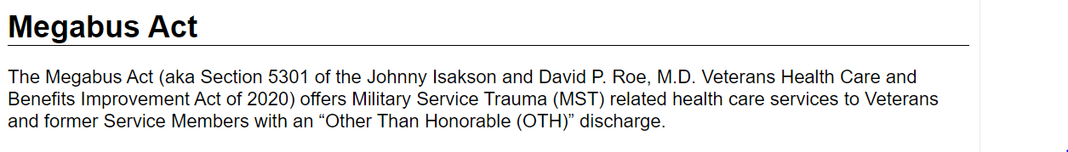

Megabus MST: SPECIAL TX AUTHORITY CARE
Confirm the following online help updates.

Step | Action
1 | Click the Person Search Tabs book on the table of contents on the online help.
2 | Click the Eligibility book.
3 | Click the Other Eligibility Factors book.
4 | Scroll down to the SPECIAL TX AUTHORITY CARE field.
5 | Confirm the text definition, if/then table, and note within this definition is correct and accurate.  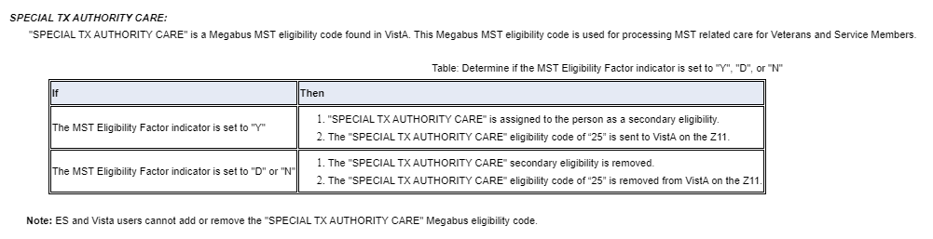

CCN Regions Map Update
Confirm the following online help updates.

Step | Action
1 | Click the Person Search Tabs book on the table of contents on the online help.
2 | Click the Eligibility book.
3 | Click the Community Care book.
4 | Click the CCN Message Log topic.
5 | Scroll down to the Manage Demographic Contact Information (Manage State/Regions) section.
6 | Confirm the FIVE updated regions and the updated map screen shot.  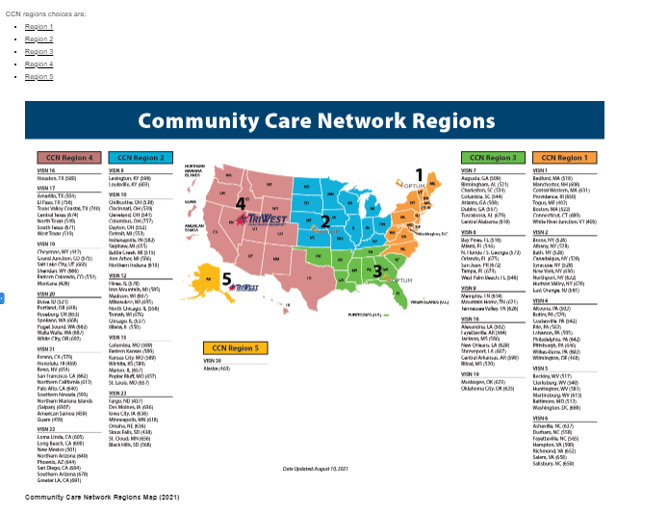
7 | Navigate to the table of contents (on the left of the system help).
8 | Click the Community Care Determination topic (still under the Community Care book)
9 | Scroll down to the "CCN Contractor Region" field definition.
10 | Confirm the FIVE updated regions and the updated map screen shot.  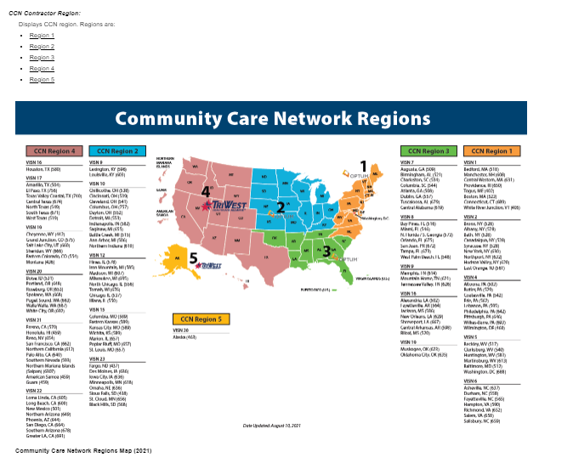

Paginating and Filtering User Profiles
Confirm the following online help updates.

Step | Action
1 | Click the Menu Bar book on the table of contents on the online help.
2 | Click the Admin book.
3 | Click the User Profiles book.
4 | Click the second User Profiles book.
5 | Click the View User Profiles topic.
6 | Scroll down to the “Paginating and Filtering User Profiles” section
7 | Confirm the following text added for paginating and filtering user profiles is correct and accurate:  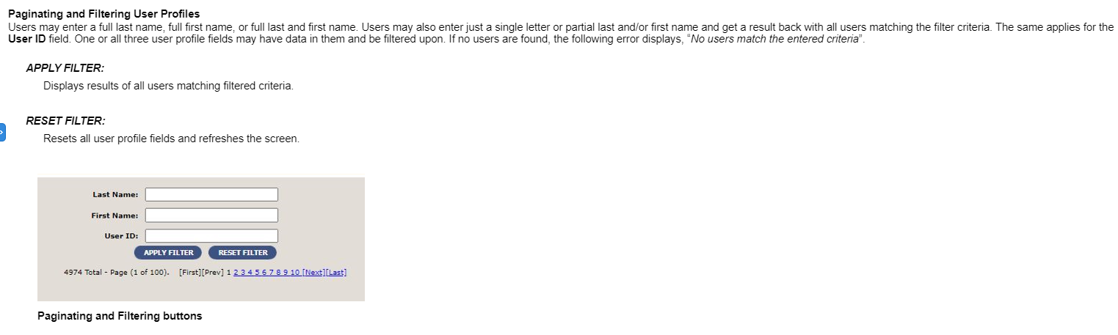

Carveout VHAP Description Update
Confirm the following online help updates.

Step | Action
1 | Click the Menu Bar book on the table of contents on the online help.
2 | Click the References book.
3 | Click the VHA Profiles book.
4 | Click the Carveout VHAP topic.
5 | Confirm the following text added to the Carveout VHAP topic is correct and accurate:  Carveout VHA Profiles (VHAPs) are optional and may or may not be assigned together or separately to a Veteran's core VHAP.  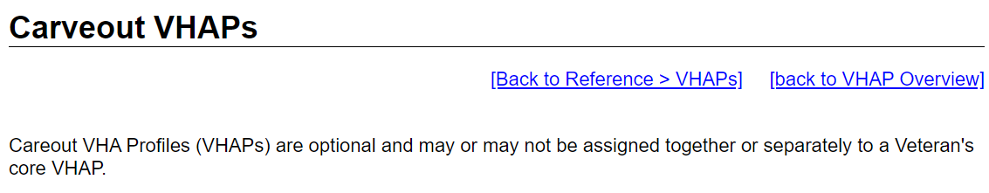

CCP VHAP Description Update
Confirm the following online help updates.

Step | Action
1 | Click the Menu Bar book on the table of contents on the online help.
2 | Click the References book.
3 | Click the VHA Profiles book.
4 | Click the CCP VHAP topic.
5 | Confirm the following text added to the CCP VHAP topic is correct and accurate:  Community Care Program (CCP) VHA Profiles (VHAPs) are categorized as a carveout and are optional, and may or may not be assigned together or separately to a Veteran's core VHAP.  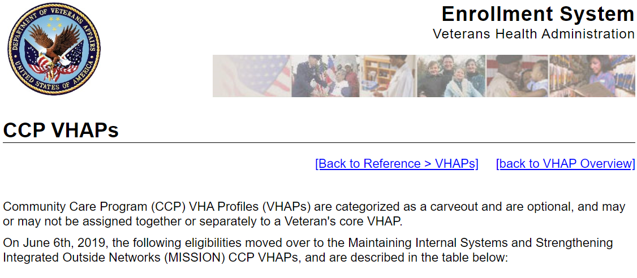

Core VHAP Description Update
Confirm the following online help updates.

Step | Action
1 | Click the Menu Bar book on the table of contents on the online help.
2 | Click the References book.
3 | Click the VHA Profiles book.
4 | Click the Core VHAP topic.
5 | Confirm the following text added to the Core VHAP topic is correct and accurate:  Core VHA Profiles (VHAPs) describe the eligible benefits and copay responsibilities of a Beneficiary.A record can only have one core VHAP at a time. Because a record can only have one core VHAP at a time, a record will be placed in the best core VHAP available to the Beneficiary.  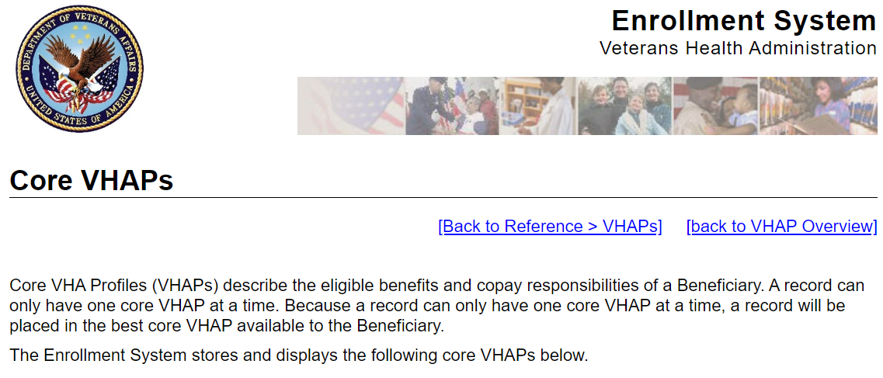

Troubleshooting
Please refer to the Troubleshooting section of the Production Operations Manual (POM) on the ES SharePoint.

