Enrollment System Modernization (ESM) Phase 4

Enrollment System (ES) 5.19

Release Notes
December 2021
Department of Veterans Affairs (VA)
Office of Information and Technology (OIT)

Table of Contents
1 Introduction 1
2 Purpose 2
3 Audience 2
4 This Release 2
4.1 Enhancements and Modifications 2
4.2 Defects and Fixes 5
4.3 Known Issues 8
5 Product Documentation 8

List of Tables
Table 1: ES 5.19 ESM Enhancements and Modifications 2
Table 2: ES 5.19 ODM Enhancements and Modifications 5
Table 3: Production Defects and Fixes in ES 5.19 5
Table 4: Sustainment Defects and Fixes in ES 5.19 5
List of Figures
Figure 1: Main Overview Tab 3
Figure 2: Demographics / Overview Tab 3
Figure 3: Demographics / Personal Tab 4
Figure 4: Demographics / Personal Tab / Personal Change History Page 4

Introduction
The mission of the VA OIT Enterprise Program Management Office is to provide benefits to Veterans and their families. To meet this overarching goal, OIT is charged with providing high quality, effective and efficient IT services and Operations and Maintenance (O&M) to persons and organizations that provide point-of-care services to our Veterans.
The VA’s goals for its Veterans and families include:
- Make it easier for Veterans and their families to receive the right benefits and meet their expectations for quality, timeliness and responsiveness.
- Improve the quality and accessibility of health care, benefits and memorial services while optimizing value.
- Provide world-class health care delivery by partnering with each Veteran to create a personalized, proactive strategy to optimize health and well-being, while providing state-of-the-art disease management.
- Ensure awareness and understanding of the personalized, proactive and patient-driven health care model through education and monitoring.
- Provide convenient access to information regarding VA health benefits, medical records, health information, expert advice and ongoing support needed to make informed health decisions and successfully implement the Veteran’s personal health plans.
- Receive timely, high quality, personalized, safe, effective and equitable health care, not dependent upon geography, gender, age, culture, race, or sexual orientation.
- Strengthen collaborations with communities and organizations, such as the Department of Defense (DoD), Department of Health and Human Services (DHHS), academic affiliates and other service organizations.
To assist in meeting these goals, the Enterprise Health Benefits Determination program provides enterprise-wide enhancements and sustainment for the following systems/applications:
- ES is the authoritative system for VA enrollment and Community Care static eligibility determinations.
- Income Verification Match/Enrollment Database assists in determining priority grouping for health care eligibility.
- Veterans Information Systems and Technology Architecture (VistA) Registration, Eligibility & Enrollment shares information with other VistA applications and enables registration and preliminary eligibility determinations and enrollment at VA Medical Centers (VAMC). ES makes the final eligibility determinations.
- The Veteran’s On-Line Application (VOA), now referred to as Health Care Application (HCA), enables Veterans to self-enroll in VA health care and is another entry point for records to be added to ES.
ESM defines VHA Profiles (VHAP) for which a client (Veteran, service member, or beneficiary) is eligible and ties them to the authority for care. Key enhancements to be completed include pending eligibility determination, fixes to ES, date of death, internal controls, workflow, Veterans Financial Assessment, converting of Military Service Data Sharing (MSDS) to Enterprise Military Information Service, Manage Relationships, Veteran Contact Service and support for Enrollment System Community Care (ESCC).

Purpose
The purpose of this Release Notes document is to announce the release of the ES 5.19. This release, developed in Java technology, contains ESM Phase 4 development and upgrade efforts. This release includes enhancements and defect fixes to support ESCC and ES Sustainment.

Audience
This document targets users and administrators of ES 5.19 and applies to the changes made between this release and any previous release for this software.

This Release
ES will be upgraded from Version 5.18.0.06002 to Version 5.19 and hosted at the Austin Information Technology Center.
The following sections provide a summary of the enhancements and updates to the existing software and any known issues for ES 5.19.

Enhancements and Modifications
Table 1 shows the ESM enhancements and modifications included in the ES 5.19 release as tracked in Atlassian Jira.
Table 1: ES 5.19 ESM Enhancements and Modifications
Jira Epic # | Summary
VES-3564 | Provide New ES Service to Process VBA Data from VA Profile Service
VES-14976 | Megabus Bill 3002 Indian Copay (ES)
ES 5.19 is enhanced to receive real-time updates of Veterans Benefits Administration (VBA) data from the new VA Profile VBA Data Service in place of the current batch job that calls Web Hospital Inquiry (WebHINQ).
ES is updated to comply with the legislative changes enacted in the Johnny Isakson and David P. Roe, M.D. Veterans' Health Care and Benefits Improvement Act of 2020 (Public Law 116–315), hereafter referred to as the Megabus Act. This bill includes a provision in Section 3002, "Prohibition on collection of a health care copayment by the Secretary of Veterans Affairs from a veteran who is a member of an Indian tribe."
With ES 5.19, modifications are made to ES to capture the self-identified Indian status, which will prevent the collection of payment for health care services obtained through the VA from Veteran patients that identify as an Indian based on the definition provided in Section 3002 of the Megabus Act.

- The main Overview tab is modified as follows:
  - The header label on the Demographics panel is changed from “Update Date of Death” to “Update Personal Demographics.
  - The Update Personal Demographics panel is modified to include the following fields: Indian, Attestation Date, Start Date, End Date and Reversal Reason.
    - Note: ES only displays the End Date and Reversal Reason field for reversals. They will be hidden when not populated.
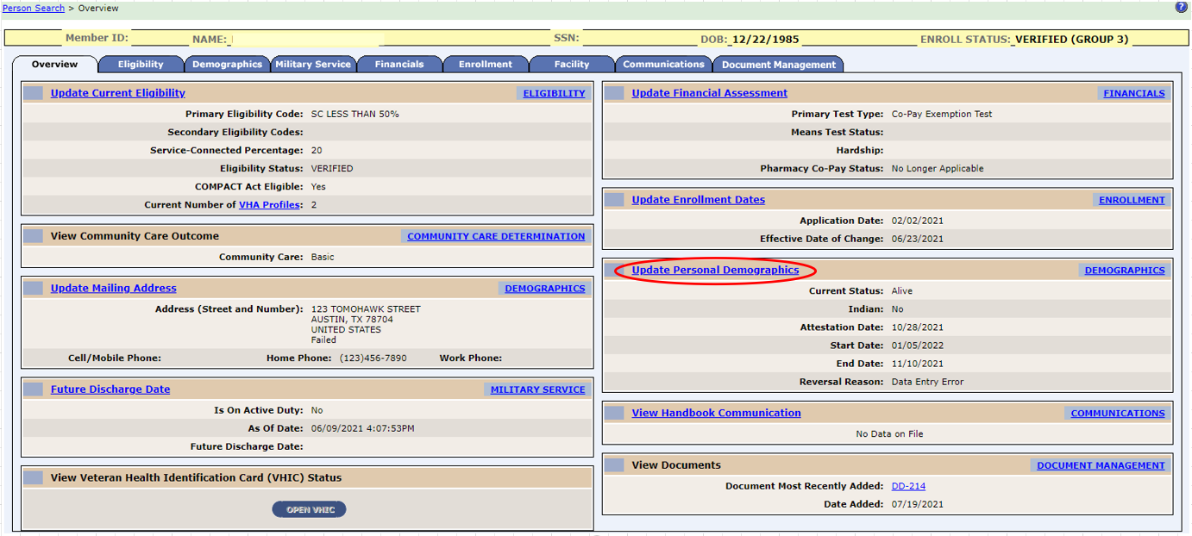
Figure 1: Main Overview Tab
- The Demographics / Overview tab is modified as follows:
  - The Update Associates and Update Insurance panels are moved to the right margin.
  - The Update Personal panel is moved to the left margin and is modified to include the following fields: Indian, Attestation Date, Start Date, End Date and Reversal Reason.
    - Note: ES only displays the End Date and Reversal Reason field for reversals. They will be hidden when not populated.
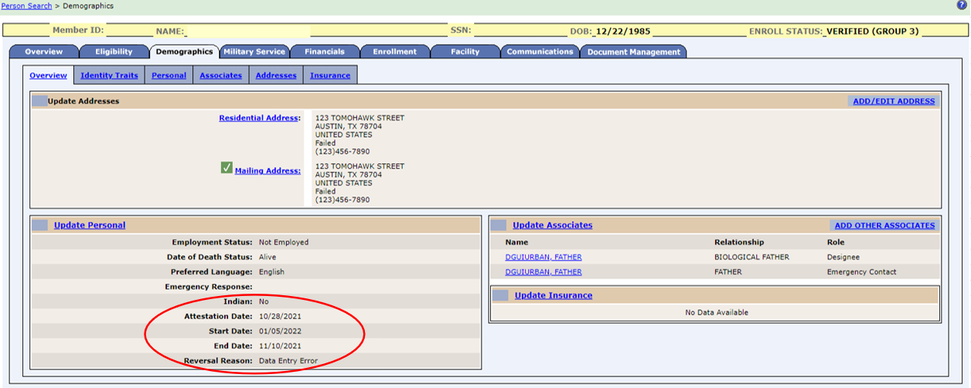
Figure 2: Demographics / Overview Tab
- The Demographics / Personal tab is modified to include the following fields: Indian, Attestation Date, Start Date, End Date and Reversal Reason.
  - Note: ES hides the Start Date, End Date, and Reversal Reason until the Indian field is set to "Yes" and Enrollment Status = "Verified".
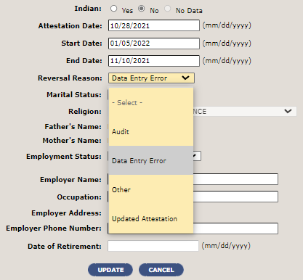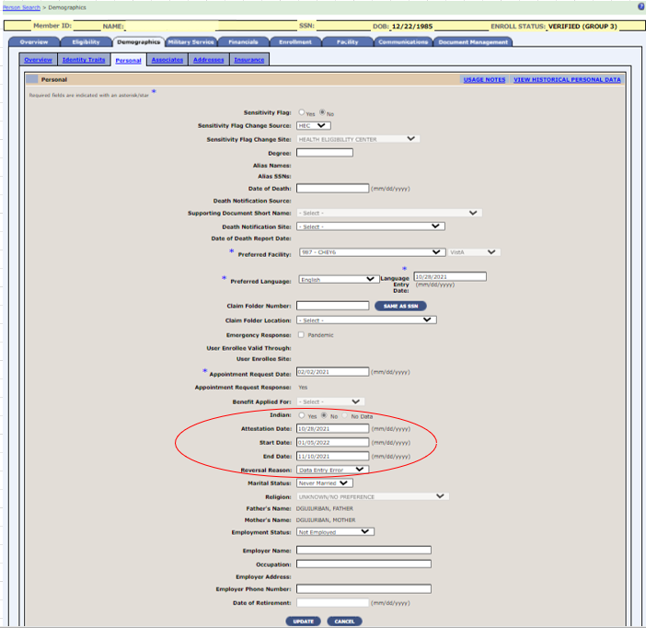
Figure 3: Demographics / Personal Tab
- The Demographics / Personal tab / Personal Change History page is modified to include the following fields: Indian, Attestation Date, Start Date, End Date and Reversal Reason.
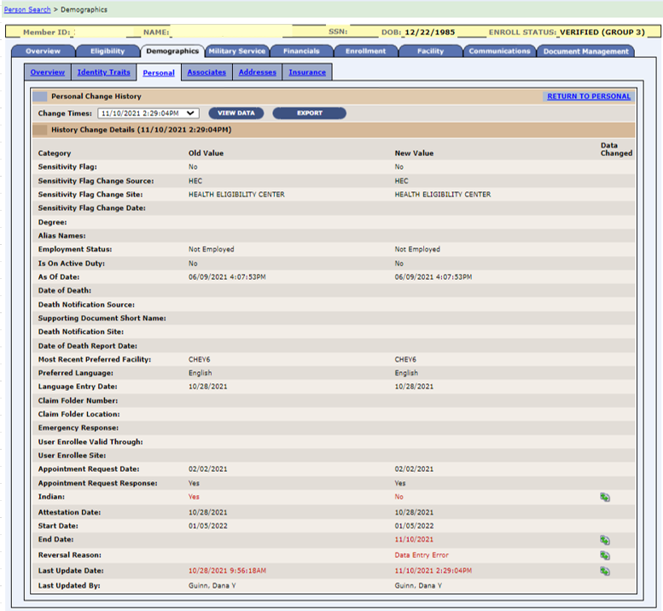
Figure 4: Demographics / Personal Tab / Personal Change History Page
- The rules for assigning the Veteran Full Med Benefits TX and Rx Copay Exmt (FM) VHAP are modified to include enrolled Veterans who attest to being an Indian, and the Online Help for the VHAP long description is modified accordingly.
- The Veteran Handbook triggers are updated to include changes to the Indian status, and the print file is updated to include the Indian field.
- ES is updated to share Indian information with HCA and VistA.
- The Eligibility & Enrollment Service is modified to include the following Indian status fields when they change: Indian, Attestation Date, Start Date and End Date.
- ES will calculate the VHAP Effective Date for the Indian population as either the enrollment date or the legislative effective date of 1/5/2022, whichever is greater.
Table 1 shows the Operational Decision Manager (ODM) enhancements and modifications included in the ES 5.19 release as tracked in Atlassian Jira.
Table 2: ES 5.19 ODM Enhancements and Modifications
Jira Epic # | Summary
VES-9090 | Integrate Trigger Message Rules
VES-10111 | Integrate Process Special Factors Rules
Under ODM, the 71 iLOG rule sets were transferred from iLOG to ODM. A Mediation Framework was established to allow the system administrators to switch between the iLOG and ODM rule sets as the rule sets are integrated into the ES application. Once the migration is fully completed to ODM, the rules will not be switched back to iLOG unless there is a systemic issue with ODM. ES 5.19 supports integration of the Trigger Message and Process Special Factors rules sets.

Defects and Fixes
Table 3 lists the production defects and fixes and corresponding Jira issue numbers included in ES 5.19.
Table 3: Production Defects and Fixes in ES 5.19
Jira Issue # | Summary
VES-17777 | Defect: A minor update to the description of the Applicant in Process VHAP is needed.  Fix: VHAP description is updated as follows: “Pending; Eligibility Unverified - Veterans who do not have a prior period of enrollment and still within the 365-day period who have not provided evidence of Veteran status.”
Table 4 lists the sustainment defects and fixes and corresponding Jira issue numbers included in ES 5.19.
Table 4: Sustainment Defects and Fixes in ES 5.19
Jira Issue # | Summary
VES-599 | Defect: A null pointer exception occurs on the phrase “CommsLogServiceImpl.processPendingApplicationRequests”.  Fix: Investigation found that this issue is no longer occurring since 9/27/2020; no code changes are necessary.
VES-609 | Defect: Handbook Batch File Statistics screen displays an error.  Fix: Updated code to no longer display the generic error page.
VES-624 | Defect: ES is throwing “Date can’t be past” error message for “Date to Generate Report” while scheduling Pending Application Report.  Fix: Analysis found that the system is behaving as expected; no code changes necessary.
VES-640 | Defect: Temporary phone number from VistA is not displayed in ES.  Fix: Updated ES and messaging code so that the temporary phone number is properly stored and displayed.
VES-4631 | Defect: Section 508 Browser Compatibility: In Chrome and Edge under Reports, the Day to Generate Report field displays off to the left.  Fix: .Updated code to correctly display the fields on the Reports screens.
VES-6938 | Defect: Section 508 Browser Compatibility: In Chrome and Edge under Veteran - Veteran Merge, the columns are not sized for the screen.  Fix: Updated code to correctly size data in the columns so that they fit on the screen.
VES-6939 | Defect: Section 508 Browser Compatibility: In Chrome and Edge Under Report List, Date Range and Site List display off to the left.  Fix: Updated code to correctly display the fields on the Reports List screens.
VES-6940 | Defect: Section 508 Browser Compatibility: In Chrome and Edge under VOA Submission, Work List tab, the fields display off to the left.  Fix: Updated code to correctly display the fields on the VOA Submission screens.
VES-8445 | Defect: VOA applications are failing due to a constraint violation.  Fix: Updated code to fix the duplicate constraint error that was occurring in the Person Traits table.
VES-11864 | Defect: The “View User Profiles” screen is not paginated, requiring the load and display of the entire user population onto a single page.  Fix: Updated code to paginate for 50 users per page and to include filters for: User ID, First Name, Last Name.
VES-12105 | Defect: Bar code generates a “not found” message under Mail/Undeliverable Mail Search.  Fix: Resolved the error by re-ordering the sequence IDs in the Mailing Status Detail table by creation date.
VES-12752 | Defect: Contact information sent to VA Profile contains date/time inconsistencies.  Fix: Updated code to account for the time zone of the sending facility.
VES-13447 | Defect: Financials should be recalculated to update enrollment status when the service connected percentage (SC%) is removed.  Fix: Updated code to always run financials before the Enrollment & Eligibility assessment.
VES-13829 | Defect: ES is removing the “Unemployable” indicator from VistA.  Fix: Updated code so that ES no longer sends back to VistA the “Delete” signal for the “Unemployable” field.
VES-13833 | Defect: Community Care Network (CCN) retransmit fails after 7 days of last transmission.  Fix: Changed code to look at record modified date instead of record created date.
VES-13886 | Defect: Section 508: Military Service – Focus is not moving to Medal of Honor (MOH).  Fix: Updated focus to properly move to the MOH field.
VES-14160 | Defect: There is an unhandled validation exception on financials input.  Fix: Added validation to Financial Test Date field.
VES-14546 | Defect: Browser Compatibility: Chrome and Edge – Text is truncated on the Delete Income Test button.  Fix: Updated code so that all buttons display complete text.
VES-14508 | Defect: ES should be using Source Date instead of Effective Start Date in the date compare.  Fix: Changed the date compare to use Source Date instead of Effective Start Date.
VES-15161 | Defect: Z05 failing for long city name from VA Profile.  Fix: Updated code to get the shortened city name if the incoming city name from VA Profile has more than 15 characters.
VES-16189 | Defect: The VBA Query Response is not updating.  Fix: Updated code to ignore unknown disability codes sent from VBA.
VES-16275 | Defect: Fortify: Access Control: Database (11 issues).  Fix: Users are allowed to view all records; no code changes necessary.
VES-16276 | Defect: Fortify: Dynamic Code Evaluation: Unsafe Deserialization (6 issues).  Fix: Code is invoking “SerializationUtils.clone” method to perform deep cloning assuming all objects are serializable; there is no deserialization invoked here; no code changes necessary.
VES-16277 | Defect: Fortify: Formula Injection (27 issues).  Fix: Analysis found that the reported issue is with code that writes to a PDF file, not a spreadsheet; no code changes necessary.
VES-16278 | Defect: Fortify: Null Dereference (1 issue).  Fix: Analysis found that the action is only taken when the incoming date value is not null at line 439; no code changes necessary.
VES-16279 | Defect: Fortify: Path Manipulation (24 issues).  Fix: Analysis found that the input value read from the database is an integer value; no code changes necessary.
VES-16280 | Defect: Fortify: Privacy Violation (2,768 issues).  Fix: Analysis found that the reported class is not using the CCN File Data class as reported; no code changes necessary.
VES-16281 | Defect: Fortify: Privacy Violation: Heap Inspection (24 issues).  Fix: Analysis found that no sensitive information is stored as notified by Fortify; no code changes necessary.
VES-16282 | Defect: Fortify: Server-Side Request Forgery (20 issues).  Fix: Analysis found that the identifier used to construct the URL is checked and validated before a network connection is made; no code changes necessary.
VES-17565 | Defect: ES should not publish Health Level 7 messages to sites that are not operational.  Fix: The error message that gets sent is modified to remove the entity key value.
VES-17656 | Defect: Income year 2019 means test is getting deleted in VistA.  Fix: Once the processing is complete, the incoming action is modified so the appropriate action will be sent to VistA.
VES-17657 | Defect: Member ID is not displayed after trait search.  Fix: Corrected the proxy for the identity management endpoint so that the Member ID displays correctly after trait search.
VES-17790 | Defect: The VBA query response is improperly handled.  Fix: Updated VBA rule that automatically modified eligibility status.
VES-18094 | Defect: ES VBA Push Service is not removing ratings data when an empty bio is received from VA Profile.  Fix: Modified the existing rule to remove ratings data if the incoming ratings data from VBA is null.
VES-18410 | Defect: Internal Revenue Service (IRS) – System throws application error when resubmitting Affordable Care Act (ACA) correction.  Fix: Updated code so that resubmission occurs without error.
VES-18419 | Defect: Unable to retrieve existing records due to birthplace null pointer issue.  Fix: Updated code to add null protection when parsing birthplace address.

Known Issues
No known or open issues were identified in this release.

Product Documentation
The following documents apply to this release:
- ES 5.19 Release Notes are uploaded to the VA Software Document Library.
- Additional reference documentation related to this release is stored in GitHub.

