Enrollment System Modernization (ESM) Phase 2

Enrollment System (ES) 5.7

Release Notes
August 2019
Department of Veterans Affairs
Office of Information and Technology (OIT)

Table of Contents
1 Introduction 1
2 Purpose 2
3 Audience 2
4 This Release 2
4.1 Enhancements and Modifications 2
4.2 Defects and Fixes 9
4.3 Known Issues 13
5 Product Documentation 13

List of Tables
Table 1: ES 5.7 ESM Enhancements and Modifications 2
Table 2: ES 5.7 ESCC Enhancements and Modifications 3
Table 3: ES 5.7 ODM Enhancements and Modifications 7
Table 4: Defects and Fixes in ES 5.7 9
Table 5: Open Defects in the ES 5.7 Release 13
List of Figures
Figure 1: Email Address 3
Figure 2: Community Care Determination Screen - View Geocode Transmit History Hyperlink 4
Figure 3: Geocode Transmit History Screen 5
Figure 4: Geocode Transmit History Export File 5

Introduction
The mission of the Department of Veterans Affairs (VA) Office of Information and Technology (OIT), Enterprise Program Management Office (EPMO) is to provide benefits to Veterans and their families. To meet this overarching goal, OIT is charged with providing high quality, effective, and efficient IT services and Operations and Maintenance (O&M) to persons and organizations that provide point-of-care services to our Veterans.
The VA’s goals for its Veterans and families include:
- Make it easier for Veterans and their families to receive the right benefits, and meet their expectations for quality, timeliness, and responsiveness.
- Improve the quality and accessibility of health care, benefits, and memorial services while optimizing value.
- Provide world-class health care delivery by partnering with each Veteran to create a personalized, proactive strategy to optimize health and well-being, while providing state-of-the-art disease management.
- Ensure awareness and understanding of the personalized, proactive, and patient-driven health care model through education and monitoring.
- Provide convenient access to information regarding VA health benefits, medical records, health information, expert advice, and ongoing support needed to make informed health decisions and successfully implement the Veteran’s personal health plans.
- Receive timely, high quality, personalized, safe, effective, and equitable health care, not dependent upon geography, gender, age, culture, race, or sexual orientation.
- Strengthen collaborations with communities and organizations, such as the Department of Defense (DoD), Department of Health and Human Services (DHHS), academic affiliates, and other service organizations.
To assist in meeting these goals, the Enterprise Health Benefits Determination (EHBD) program provides enterprise-wide enhancements and sustainment for the following systems/applications:
- The Enrollment System (ES) assists Veterans to enroll for VA healthcare benefits and is the core application that feeds other VA systems with Enrollment and Eligibility (E&E) data.
- Income Verification Match (IVM) assists in determining priority grouping for healthcare eligibility.
- Veterans Information Systems and Technology Architecture (VistA) Registration, Eligibility & Enrollment (REE) shares information with other VistA applications and enables registration and eligibility determinations and enrollment at VA Medical Centers (VAMC).
- Veteran’s On-Line Application (VOA) is re-purposed for the online Veterans Health Benefits Handbook (VHB). VHB provides each enrolled Veteran on-demand online access to a personalized and dynamic health benefits-related Handbook.
Enrollment System Modernization (ESM) defines Health Benefit Plans (HBP) for which a client (Veteran, Service Member, or beneficiary) is eligible and ties them to the authority for care. Key enhancements to be completed include Pending Eligibility Determination, fixes to the Enrollment System, Date of Death, Internal Controls, Workflow, Veterans Financial Assessment, converting of Military Service Data Sharing (MSDS) to Enterprise Military Information Service (eMIS), Manage Relationships, Veteran Contact Service, and support for Enrollment System Community Care (ESCC).

Purpose
The purpose of this Release Notes document is to announce the release of the ES 5.7. This release, developed in Java technology, contains Enrollment System Modernization (ESM) Phase 2 development and upgrade efforts, including enhancements and defect fixes to support Enrollment System Community Care (ESCC) and ES Sustainment.

Audience
This document targets users and administrators of ES 5.7 and applies to the changes made between this release and any previous release for this software.

This Release
ES will be upgraded from Version 5.6.1 to Version 5.7 and hosted at the Austin Information Technology Center (AITC).
The following sections provide a summary of the enhancements and updates to the existing software and any known issues for ES 5.7.

Enhancements and Modifications
ESM
Table 1 shows the ESM enhancements and modifications included in the ES 5.7 release as tracked in Rational Team Concert (RTC) Requirements Management (RM).
Table 1: ES 5.7 ESM Enhancements and Modifications
RTC  RM # | Summary
1085529 | ES Only Share Personal Emails
NOTE: Changes to the Enrollment System interface have been completed for Veteran Medical Benefit Plans (VMBPs) during the August, 5.7 release, however VMBP functionality will not be available until October, 5.8 release. Those include: Execute rules for determining VMBP for Veterans, Assign VMBP to Veteran Profile, Determine eligibility changes, Perform Rx Copay Test, Assign VMBP to Non-Veteran Profile, Share VMBP info with other lines of business, Determine eligibility changes for Non-Veterans, View definition of VMBP and Sync help text with updated VMBP .
ES has been modified so that the system will only support a single personal email address. This personal email address will be the only email address that ES shares with VistA. ES will no longer support the entry of a business email address. Additionally, ES will no longer share business email address with VistA.

Business email addresses that were entered prior to ES release 5.7 will continue to be displayed, but they will be grayed out and cannot be updated. Users will be limited to deletion of the business email address only.
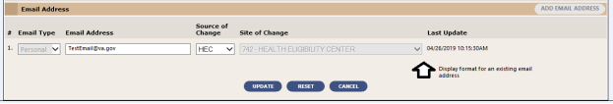
Figure 1: Email Address
ESCC
Table 2 shows the ESCC enhancements and modifications included in the ES 5.7 release as tracked in RTC RM.
Table 2: ES 5.7 ESCC Enhancements and Modifications
RTC  RM # | Summary
895421 | Receive Requests for Updated CC Eligibility, Demographic Information from Community Care Network (CCN) Contractor
895422 | Send Updated CC Eligibility, Demographic Information to CCN Contractor Upon Request (Solicited)
1054425 | CR 881143: Send Email Notification When ES Other Health Insurance (OHI) from CCN
1058177 | CR 887028: Add a New Link "Geocode Transmit History" to the CC Determination Screen
1058179 | CR 887028: Add a New Screen "Geocode Transmit History"

ES has been modified to include a new “View Geocode Transmit History” hyperlink on the “Community Care Determination” page. Once selected, the user is navigated to a new “Geocode Transmit History” page. The “Geocode Transmit History” screen is populated with all the historical data from Planning Systems Support Group (PSSG). If there is no Geocode Transmit History data present for the Veteran, a green banner is presented at the top of the “Community Care Determination” screen stating, “No Geocode Transmit History Data available for this Veteran” and the “View Geocode Transmit History” hyperlink is disabled.
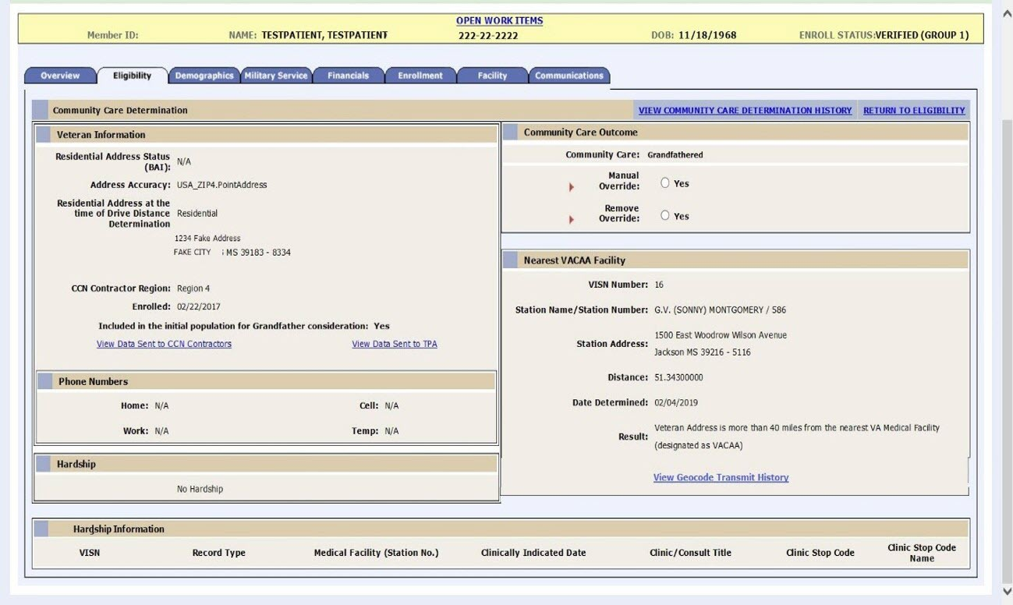
Figure 2: Community Care Determination Screen - View Geocode Transmit History Hyperlink

The “Geocode Transmit History” page allows users to export the Geocode Transmit History data in .csv file format. Once exported, users can load the export file in Excel or any application that can read .csv file formatted files.
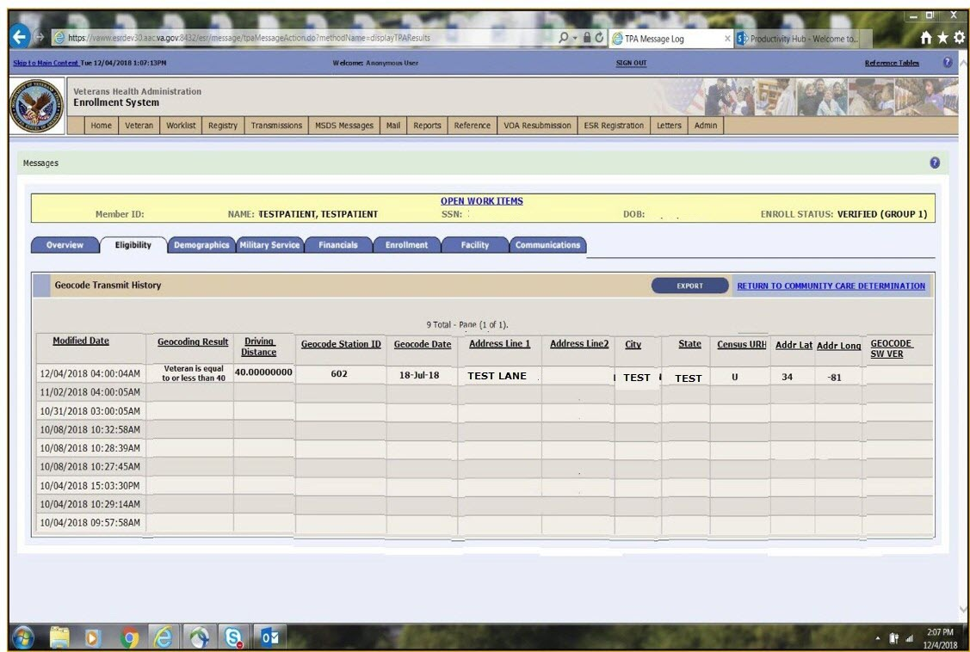
Figure 3: Geocode Transmit History Screen
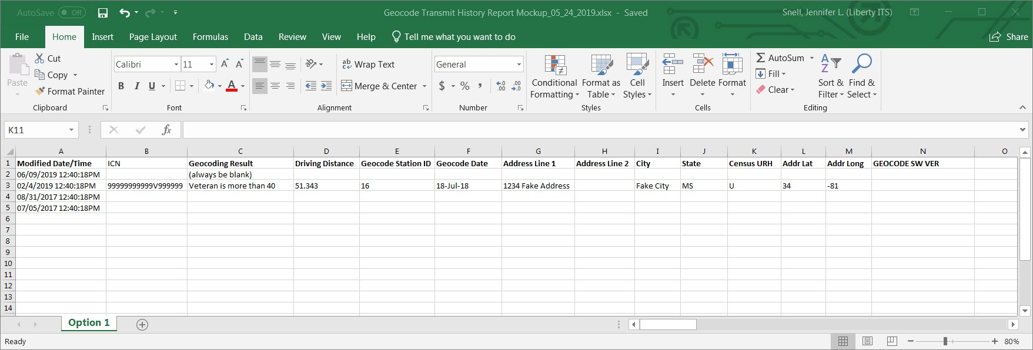
Figure 4: Geocode Transmit History Export File
The success message that ES displays when a user clicks the “Send to Contractors” button to share Veteran data with Third Party Administrator (TPA) and CCN contractors now reads as, “Person data marked to send to TPA and CCN Contractors.” This is a confirmation message to the ES user stating that the demographic data has been sent to the TPA and CCN Contractors.
ES is modified so that it will generate an email to the VA OCC CORs whenever an OHI file is received from a CCN Contractor. When OHI is received and processed from a CCN contractor, the notification email will go to the respective region. For example, Region 1 COR Team will only get notifications for Region 1.
Staff members that are on the email distribution list (Mail Groups) can view the summary level of OHI information sent to ES and they can verify that the email notification was sent when OHI was received from any of the CCN contractors. “CCN OHI Report” is added in the Subject line of the email. The body of the email will include the following embedded content: CCN Contractor Name; File Name; # of Records Sent by CCN Contractor; # of Records Received by ES; # of records Processed by ES; and the # of Records Rejected by ES due to Validation Errors. ES will generate a single notification per OHI file received.

ESCC enhancements and modifications also include the following:
- Support MISSION Act defects in production
- Support CCN testing
- Support CCN defects from testing
- Development environment code clean up
- Extract, Transform, and Load (ETL) logging and reporting
Operational Decision Manager (ODM)
Table 3 shows the ODM enhancements and modifications included in the ES 5.7 release as tracked in RTC RM.
Table 3: ES 5.7 ODM Enhancements and Modifications
RTC  RM # | Summary
1057412 | CR 881133: Integrate Report Other Eligibilities Rules
1076441 | CR 933157: Integrate Enrollment Validation Rules
1076444 | CR: 933157 Integrate Beneficiary Travel Rules
1076449 | CR 933157: Integrate Determine Income Test from Eligibility Rules
1076452 | CR 933157: Integrate Financials Validation Rules
1076453 | CR 933157: Integrate Process Fee Basis Rules
1090609 | Integrate Process SSA Verification Response Rules
1090615 | Integrate POW Validation Rules
1090616 | Integrate Process POW Rules

Under ODM, the 71 iLOG rule sets were transferred from iLOG to ODM. A Mediation Framework was established to allow the System Administrators to switch between the iLOG and ODM rules sets as the rules sets are integrated into the ES application. Once the migration is fully completed to ODM, the rules will not be switched back to iLOG unless there is a systemic issue with ODM. ES 5.7 integrates the rule sets that support the Person Eligibility, Enrollment, Financial, and Military Service functionalities.

Updates also include rule retirement for the following:
- Integrate Beneficiary Travel Rules
- Integrate Calculate Financial Decisions Rules
- PatientVistSummary
- ProcessPersonSignature
- NonVeteran

Defects and Fixes
Table 4 lists the defects and fixes and corresponding Rational Team Concert (RTC) Change and Configuration Management (CM) numbers included in ES 5.7 (RM# 1107756: ES 5.7 Maintain the Enrollment System).
Table 4: Defects and Fixes in ES 5.7
RTC  CM # | Summary
681161 | Defect: A Section 508 defect was reported where the Jaws Reader Voice tool was not always reading out errors to the user for some required fields if the required field was not being completed correctly in Add a Person.  Fix: Changed code so that each required field has an ActionMessage that will individually mark the respective field with error and the Jaws Reader Voice tool reads out the error to the end user for all required fields marked with an error if they are not completed correctly.
716753 | Defect: INC0207738 - A defect was reported where ES users were unable to enter a new Copay Test as part of a Veteran’s Financial Assessment.  Fix: Updated back-end code to apply Veteran Financial Assessment (VFA) rules to Means Test only. ES users are now able to enter a new Copay Test as part of the Veteran’s Financial Assessment.
951065 | Defect: A Section 508 defect was reported for users requiring assistive technologies where required fields were not always displaying an error condition to the user if the required field was not being completed correctly on the “Demographics/Identity Traits” pages.  Fix: Added an else-block to check if the Date of Birth is left null. The code was modified to mark individual fields with error on the “Demographics/Identity Traits” pages. Also, the Jaws Reader Voice tool reads out the error to the end user.
951071 | Defect: A Section 508 defect was reported for users requiring assistive technologies where required fields were not always displaying an error condition to the user if the required field was not being completed correctly on the “Demographics/Personal” pages.  Fix: Added code to put focus on error message banner when applicable. Modified code to get required fields to be individually marked when there is an error on the “Demographics/Personal” pages, and the Jaws Reader Voice tool reads out the error to the end use.
951076 | Defect: A Section 508 defect was reported for users requiring assistive technologies where required fields were not always displaying an error condition to the user if the required field was not being completed correctly on the “Search Items Tab – Create Date Range To:” page  Fix: The property for this field is improperly labeled. It was changed to "createDateTo", this way it matches the Action Form and generate the error. Also, the Jaws Reader Voice tool reads out the error to the end user.
963122 | Defect: A defect was reported where the HBP names for Wait-time and Mileage or Hardship and Wait-Time was being truncated in the Detail Report when multiple HBP entries were being added.  Fix: Updated the height of the HBP field in the report to accommodate multiple HBP entries and updated the names of the Health Benefit Plans in the code. The HBP for post MISSON Act now displays one HBP for the corresponding Veterans Choice Eligibility (VCE).
984135 | Defect: A defect was reported where the “Send to Contractors” button was not being displayed on the Community Care Determination screen if the Community Care Eligibility is Ineligible (X). The expected functionality is that when the enroll status is Deceased, Not Eligible, or Cancelled/Declined, the VCE Community Care Eligibility is Ineligible (X) and the send to Contractor button should be available in the Community Care Determination Page.  Fix: This issue is now resolved and when the Community Care eligibility code is Ineligible (X) in the Community Care Determination screen, the “Send to Contractor” button is displayed.
984183 | Defect: A defect was reported where the CCN Contractor Message Search page is not displaying the correct result for Selected CCN Contractor Search field.  Fix: This issue was resolved by including the Contractor field as a search filter.
985996 | Defect: A defect was reported regarding the errant creation of the ORU Z05 message when users selected the Add email>>>Update option. This defect affected newly created records or records that already had an email associated with the record.  Fix: This issue is now resolved and the ORU Z05 message is no longer created in these scenarios.
986816 | Defect: A defect was reported regarding the cancelled/declined enrollment workflows due to the implementation of the VA MISSION Act (MA). For affected Veterans, their eligibility for Community Care was not being calculated correctly. For a record that was Enrolled, then Cancelled/Declined, and then set back to Enrolled, it should be treated as a new application for CC determination.  Fix: Initial Grandfather (G) eligible record must also have Enrollment Date After MA Enactment Date. Enrolled persons recalculation for CHOICE requires Enrollment Date After MA Enactment Date in addition to requirement of "was ever G". The Enrollment Date is After MA Enactment Date only if the Enrollment Date is not null and is after June 5, 2018. A null Enrollment Date is considered before MA Enactment Date.
986817 | Defect: A defect was reported where the VCE code and descriptions were being displayed in the Community Care Determination Manual Override New Outcomes field.  Fix: Removed VCE codes from CCD Manual Override New Outcome labels and only the VCE description is now displayed in the Override New Outcomes field.
986896 | Defect: A defect was reported where the Temporary Mailing Address displays in the Third-Party Administrator (TPA) and CCN log but not in the Export spreadsheet.  Fix: Updated header column to correctly display the Permanent/Temporary Mailing Address in the Export spreadsheet.
987253 | Defect: A defect was reported where the CCN and TPA export files were not displaying the column headers/labels correctly in the Export file. The Enrollment Effective Date, Province Foreign Address, and Postal Code for Foreign Address labels were incorrect  Fix: Updated the column labels with the correct values “Enrollment Effective Date”, “Province Foreign Address”, and “Postal Code for Foreign Address”; in addition, the record with the greatest number of VCEs is now being used to generate the column headers for the Export file. This change was made for both the CCN and the TPA files.
988514 | Defect: A defect was reported in the TPA Message Log Export spreadsheet where Social Security Numbers (SSN)s that started with a zero were not being displayed correctly.  Fix: This issue was resolved and only the last four digits of the SSN are displayed in the TPA Message Log Export spreadsheet.
988523 | Defect: A defect was reported in the CCN Contractor Message Log screen where the “RETURN TO COMMUNITY CARE DETERMINATION” hyperlink was missing.  Fix: The CCN Contract Message Log has been updated to show the RETURN TO COMMUNITY CARE DETERMINATION link next to the Export button.
994063 | Defect: A defect was reported when an email and/or phone number is deleted in VistA, ES was not deleting the email and/or phone number for the record in Vet360.  Fix: This issue has been resolved. When an email and/or phone number is deleted in VistA, ES now send the deletion message to Vet360 so the Vet360 record will reflect the deletion(s).
997063 | Defect: A defect was reported where the confidential address was being shared with the CCN.  Fix: Confidential address is no longer shared with CCN. Only the Residential Address, Permanent Mailing Address or Temporary Mailing Address is shared with CCN.
998576 | Defect: A defect was reported in the Appointment Request screen when the Appointment Request value was changed from a Yes to a No, the Appointment Request Date was being populated with the system date that the Appointment Request was changed to No instead of showing a blank date field.  Fix: When an Appointment Request is changed from Yes to No, the Appointment Request Date now displays as blank.
998758 | Defect: A defect was reported where the New Hardship Determination was not being displayed in red text in the Community Care (CC) Determination History page when the clinically indicated date was removed  Fix: When the clinically indicated date is now removed, the CC Determination History page displays the New Hardship Determination in red text.
999788 | Defect: A defect was reported where the Purple Heart status was not updating correctly in ES. When a Purple Heart is initially marked as rejected, but then later updated to accepted, ES was not accepting the change and left the Purple Heart status as rejected.  Fix: Removed Purple Heart rules from ODM parameter and the status can now be updated correctly.
1001388 | Defect: A defect was reported where VET360 was not sending the personal email to the CCN contractors via the VET360 interface.  Fix: Fixed code in VET360InboundProcessService.updateEmails; email was not added to the incoming person. When the incoming person was sent via the VET360 interface, since the email was missing in the person object it couldn't process it.
1001810 | Defect: A defect was reported where ES was throwing an application error when users tried to perform a Person Un-Merge.  Fix: Changed the obtain call to use IdMWebservice call and user can now perform the Person Un-Merge in ES.
1005908 | Defect: A defect was reported for incoming changes from VET360 for addresses, phones and emails which updates the address, email or phone database tables. The geocoding required flag was not being set for any change in address, for this reason not deliverable addresses and address updates were not being geocoded.  Fix: The geocoding required flag is set for any change in address, resulting on address updates now populating with the geocoding. Incoming VET360 updated addresses are now geocoded.
1007551 | Defect: A defect was reported with the address validation tool where city names that are greater than 15 characters would throw the “City cannot be greater than 13 characters” error message and prevent the user from adding/updating the address.  Fix: When accepting the address returned from the validation service, if the city name has more than 15 characters, then the short city name is substituted. In addition, new validation was added to avoid users saving a validated address that includes a city name greater than 15 characters.
1009725 | Defect: A defect was reported when retransmitting CCN records. The retransmittal message was not including the Priority Group and Enrollment Date values.  Fix: Added code to include Priority Group and Enrollment Date to the CCN Service Log record.
1022891 | Defect: A defect was reported where the Means Test status was being displayed on the banner for the Financials Overview screen.  Fix: The Means Test status is no longer displayed in the Financial Overview Screen banner.
1055069 | Defect: A defect was reported where CC Basic plans are getting assigned to Non-Veterans with one of the Non-Veteran Eligibility Codes Enroll status=NOT APPLICABLE  Fix: Change in iLOG rule for “not applicable enrollment status” to flow through DetermineVCE rules.
1057055 | Defect: A defect was reported in Production where the TPA file is failing to transmit through DAS.  Fix: This defect was resolved by adding a configuration (directory) parameter for TPA files, adding an error handling logic to handle the file not found errors, and adding additional debug statements.
1062529 | Defect: A defect was reported where the Community Care Manual Override option was still available after the Veteran’s enrollment status was changed to Cancelled/Declined and the VCE was not being recalculated.  Fix: Corrected manual override, which was comparing incorrect variable. When the enrollment status is changed to Cancelled/Declined, the Manual Override button is now removed and the VCE is recalculated correctly.
1063879 | Defect: A defect was reported in the Enrollment and Eligibility (E&E) Webservice schema where the data was not matching the healthBenefitPlan.planName data.  Fix: Corrected schema element for healthBenefitPlan.planName. The E&E Webservice schema now matches healthBenefitPlan.planName data.
1065737 | Defect: A defect was reported in production where ES inadvertently deleting the Date of Death (DOD) caused by an inherent delay from the time DOD is updated in MVI and the time ESR gets the notification.  Fix: This was fixed by ES syncing the Date of Death upon the retrieval from MVI and prior to sending any 1302 update.

Known Issues
Table 5 lists identified defects that remain open in this release.
Table 5: Open Defects in the ES 5.7 Release
RTC  CM # | Summary
N/A | No new defects were introduced by this ES 5.7 release.

Product Documentation
The following documents apply to this release:
- ES 5.7 Release Notes are uploaded to the VA Software Document Library (VDL).
- Additional reference documentation related to this release is stored in RTC.

