Enrollment System Modernization (ESM) Phase 2

Enrollment System (ES) 5.8

Release Notes
October 2019
Department of Veterans Affairs
Office of Information and Technology (OIT)

Table of Contents
1 Introduction 3
2 Purpose 4
3 Audience 4
4 This Release 4
4.1 Enhancements and Modifications 4
4.2 Defects and Fixes 8
4.3 Known Issues 10
5 Product Documentation 10

List of Tables
Table 1: ES 5.8 ESM Enhancements and Modifications 4
Table 2: ES 5.8 ODM Enhancements and Modifications 8
Table 3: Defects and Fixes in ES 5.8 8
Table 4: Open Defects in the ES 5.8 Release 10

List of Figures
Figure 1: Reference Tab – VMBP 5
Figure 2: Reference Page – VMBP 6
Figure 3: Veteran Medical Benefit Plan Abbreviation Column 6
Figure 4: Dropdown Text - Plan Description 7
Figure 5: Current Number of Veteran Medical Benefit Plans Display 7
Figure 6: ZHP Segment - Veteran Medical Benefit Plan 7

Introduction
The mission of the Department of Veterans Affairs (VA) Office of Information and Technology (OIT), Enterprise Program Management Office (EPMO) is to provide benefits to Veterans and their families. To meet this overarching goal, OIT is charged with providing high quality, effective, and efficient IT services and Operations and Maintenance (O&M) to persons and organizations that provide point-of-care services to our Veterans.
The VA’s goals for its Veterans and families include:
- Make it easier for Veterans and their families to receive the right benefits, and meet their expectations for quality, timeliness, and responsiveness.
- Improve the quality and accessibility of health care, benefits, and memorial services while optimizing value.
- Provide world-class health care delivery by partnering with each Veteran to create a personalized, proactive strategy to optimize health and well-being, while providing state-of-the-art disease management.
- Ensure awareness and understanding of the personalized, proactive, and patient-driven health care model through education and monitoring.
- Provide convenient access to information regarding VA health benefits, medical records, health information, expert advice, and ongoing support needed to make informed health decisions and successfully implement the Veteran’s personal health plans.
- Receive timely, high quality, personalized, safe, effective, and equitable health care, not dependent upon geography, gender, age, culture, race, or sexual orientation.
- Strengthen collaborations with communities and organizations, such as the Department of Defense (DoD), Department of Health and Human Services (DHHS), academic affiliates, and other service organizations.
To assist in meeting these goals, the Enterprise Health Benefits Determination (EHBD) program provides enterprise-wide enhancements and sustainment for the following systems/applications:
- The Enrollment System (ES) assists Veterans to enroll for VA healthcare benefits and is the core application that feeds other VA systems with Enrollment and Eligibility (E&E) data.
- Income Verification Match (IVM) assists in determining priority grouping for healthcare eligibility.
- Veterans Information Systems and Technology Architecture (VistA) Registration, Eligibility & Enrollment (REE) shares information with other VistA applications and enables registration and eligibility determinations and enrollment at VA Medical Centers (VAMC).
- Veteran’s On-Line Application (VOA) is re-purposed for the online Veterans Health Benefits Handbook (VHB). VHB provides each enrolled Veteran on-demand online access to a personalized and dynamic health benefits-related Handbook.
Enrollment System Modernization (ESM) defines Health Benefit Plans (HBP) for which a client (Veteran, Service Member, or beneficiary) is eligible and ties them to the authority for care. Key enhancements to be completed include Pending Eligibility Determination, fixes to the Enrollment System, Date of Death, Internal Controls, Workflow, Veterans Financial Assessment, converting of Military Service Data Sharing (MSDS) to Enterprise Military Information Service (eMIS), Manage Relationships, Veteran Contact Service, and support for Enrollment System Community Care (ESCC).

Purpose
The purpose of this Release Notes document is to announce the release of the ES 5.8. This release, developed in Java technology, contains Enrollment System Modernization (ESM) Phase 2 development and upgrade efforts, including enhancements and defect fixes to support ES Sustainment.

Audience
This document targets users and administrators of ES 5.8 and applies to the changes made between this release and any previous release for this software.

This Release
ES will be upgraded from Version 5.7 to Version 5.8 and hosted at the Austin Information Technology Center (AITC).
The following sections provide a summary of the enhancements and updates to the existing software and any known issues for ES 5.8.

Enhancements and Modifications
Enrollment System Modernization (ESM)
Table 1 shows the ESM enhancements and modifications included in the ES 5.8 release as tracked in Rational Team Concert (RTC) Requirements Management (RM).
Table 1: ES 5.8 ESM Enhancements and Modifications
RTC  RM # | Summary
1085527 | CR: 951089 ES Notify to Cerner
1085528 | CR: 951089 Receive Notification from Cerner
1085885 | VMBP: Execute rules for determining VMBP for Veterans
1085887 | VMBP: Perform Rx Copay Test
1085888 | VMBP: Assign VMBP to Veteran Profile
1085889 | VMBP: Assign VMBP to Non-Veteran Profile
1085890 | VMBP: Add VMBP info to web service
1085891 | VMBP: Share VMBP info with other lines of business
1085893 | VMBP: View definition of VMBP
1085894 | VMBP: Determine eligibility changes
1085895 | VMBP: Determine eligibility changes Non-Veterans
1085901 | VMBP: Sync help text with updated VMBP
ES is enhanced to send eligibility, enrollment, and registration changes to VET360 and receive updates through VET360 for changes made to beneficiary records in Cerner Millennium.
ES is enhanced to display, assign, and share Veteran Medical Benefit Plans (VMBPs). ES will continue sending Veteran Medical Benefit Plan data to VistA sites using the existing framework. Nineteen new Core and Supplemental VMBPs are added to ES with an abbreviated name, plan code, and description for each plan.
- Core: A record can only have a single core plan and will be automatically assigned the best core plan for which the record is eligible.
- Supplemental: A record can have zero, one, or multiple supplemental plans and will be automatically assigned all supplemental plans for which the record qualifies.
The ES User Interface (UI) has been modified so that all instances of the Health Benefit Plans (HBPs) will now be labeled as Veteran Medical Benefit Plans (VMBPs).
The Menu option on the Admin Page “Admin -> Health Benefit Plans” has been removed and a new option for the VMPBs has been added to the Reference tab at: “Reference -> Veteran Medical Benefit Plans”.
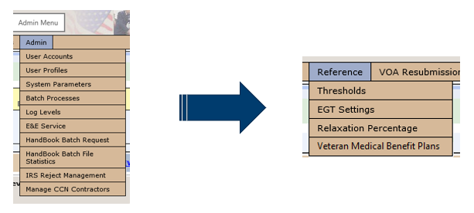
Figure 1: Reference Tab – VMBP

The new “Reference -> Veteran Medical Benefit Plans” page displays a list of all Veteran Medical Benefit Plans along with a brief description (when the plan name is clicked; full descriptions are available in the ES 5.8 User Guide), abbreviation plan code, active date, and inactive date (where appropriate).
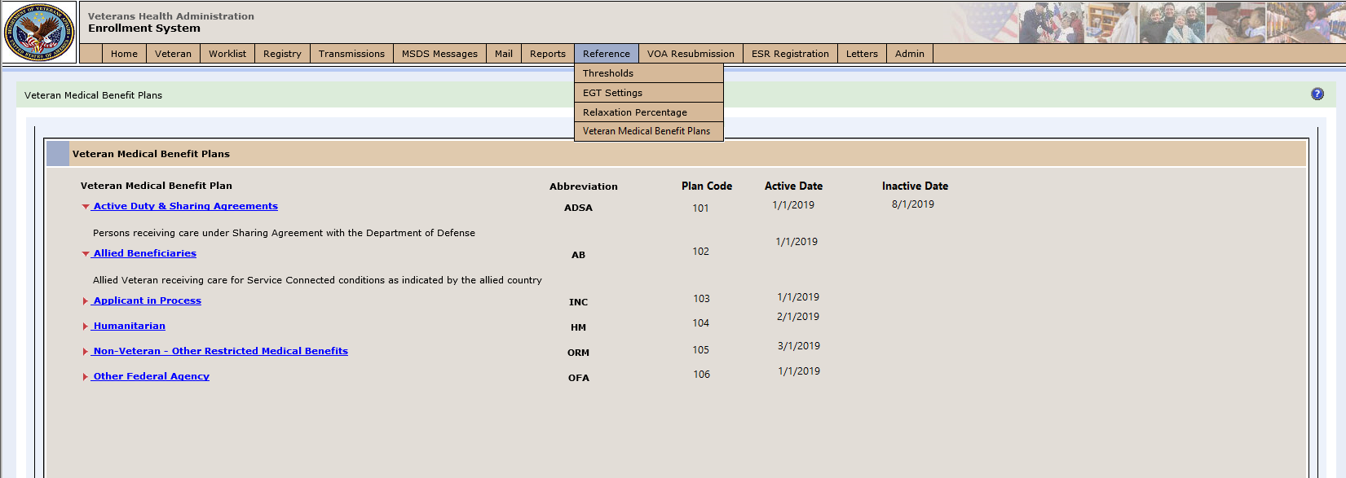
Figure 2: Reference Page – VMBP
The hyperlink on the “Person Search > Eligibility > Health Benefit Plans” page is updated to “View Veteran Medical Benefit Plans” and the panel name is updated to “Veteran Medical Benefit Plans”.
The section titles are updated to: “Veteran Medical Benefit Plans Assigned - Unselect to Unassign” and "Veteran Medical Benefit Plans Available - Select to Assign”
The “Person Search > Eligibility > Health Benefit Plans” page is updated to include a new column titled “Veteran Medical Benefit Plan Abbreviation”.
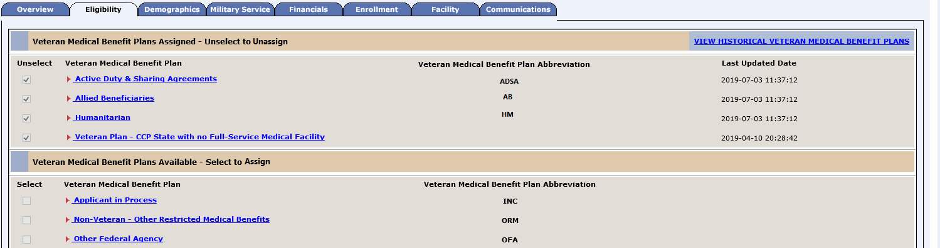
Figure 3: Veteran Medical Benefit Plan Abbreviation Column

Each plan on the “Person Search > Eligibility > Health Benefit Plans” page is enhanced to show a dropdown text containing a brief description for each plan (full descriptions are available in the ES 5.8 User Guide).
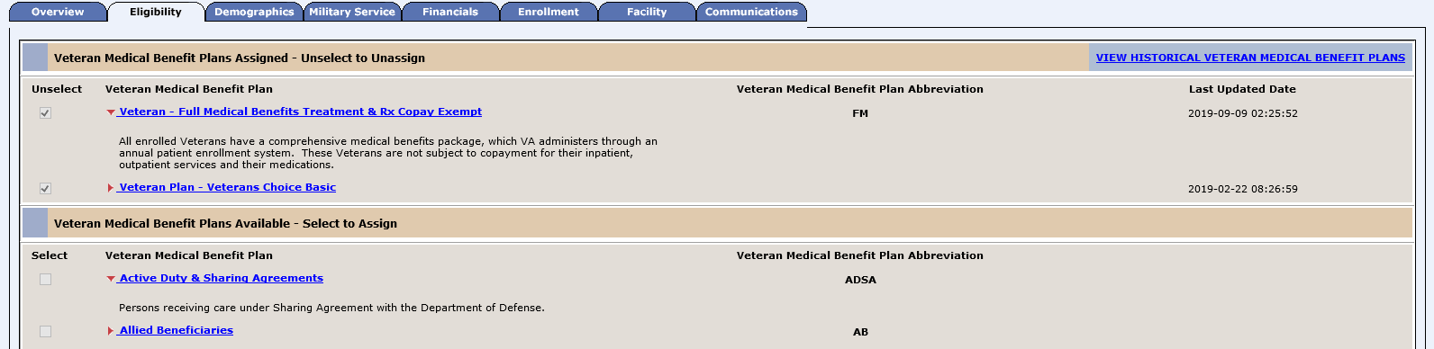
Figure 4: Dropdown Text - Plan Description
The Eligibility section of the “Person Search > Overview” screen is updated to display the “Current Number of Veteran Medical Benefit Plans”.
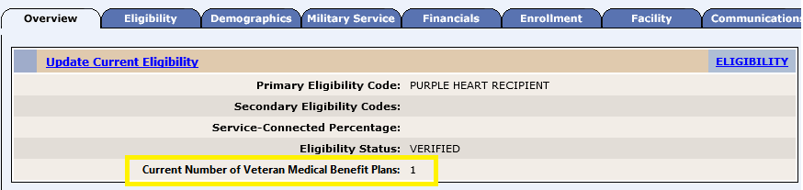
Figure 5: Current Number of Veteran Medical Benefit Plans Display
Users can view that plan assignments were sent to VistA sites by selecting the “Facility” tab and then the “View All” or “View Site” HL7 Messages option. After selecting an ORUZ11 message, the parsed view will display a ZHP segment with plan code for each plan assigned. The titles are updated to read Veteran Medical Benefit Plan instead of Health Benefit Plan.
Figure 6: ZHP Segment - Veteran Medical Benefit Plan
ES will automatically assign a Veteran Medical Benefit Plan, based on eligibility rules, to new and existing records within the system. Veteran Medical Benefit Plans will be assigned to new records upon completing the Add a Person (AAP) process. Veteran Medical Benefit Plans will be assigned to existing records by an automated batch process when ES 5.8 is deployed.
- The batch process will begin with the deployment of ES 5.8 and will assign new Core and Supplemental VMBPs to existing records at a rate of approximately 5,000 per hour. This will take a period of time (Potentially multiple months) to complete.
- Note: During this time period, it should not cause concern if a record is located and is not yet assigned a Core VMBP.
ES will automatically assign and/or unassign VMBPs based on system updates from the authoritative sources and updates by staff. The assigning and unassigning of Core Veteran Medical Benefit Plans will not impact the assigning and/or unassigning of Community Care plans.
The Veteran Medical Benefit Plan on file for each record will be included as an available field within the E&E webservice. Object names within the E&E service requests will remain “healthBenefitPlans”.
ES calculates the RX copay exemption status result, based on the income information entered by a HEC user, to determine if the Veteran has a prescription copay, and uses the result in determining the Veteran Medical Benefit Plan and to assign and unassign Veteran Medical Benefit Plans based on eligibility rules.
Operational Decision Manager (ODM)
Table 2 shows the ODM enhancements and modifications included in the ES 5.8 release as tracked in RTC RM.
Table 2: ES 5.8 ODM Enhancements and Modifications
RTC  RM # | Summary
1090580 | Integrate Process Health Benefit Profile Rules
Under ODM, the 71 iLOG rule sets were transferred from iLOG to ODM. A Mediation Framework was established to allow the System Administrators to switch between the iLOG and ODM rules sets as the rules sets are integrated into the ES application. Once the migration is fully completed to ODM, the rules will not be switched back to iLOG unless there is a systemic issue with ODM. ES 5.8 integrates the rule sets that support the Process Health Benefit Profile functionalities.

Defects and Fixes
Table 3 lists the defects and fixes and corresponding Rational Team Concert (RTC) Change and Configuration Management (CM) numbers included in ES 5.8 (RM# 1144831: ES 5.8.0 Maintain the Enrollment System).
Table 3: Defects and Fixes in ES 5.8
RTC  CM # | Summary
521867 | Defect: Army Post Office/Fleet Post Office (APO/FPO) addresses cause ORU Z05 messages to fail in VistA. If an address does not have a county code, VistA will send an error back to the ES application.  Fix: Updated refactoring method to send a county code for APO/FPO/Diplomatic Post Office (DPO) addresses.
525193 | Defect: A defect was reported where the Enrollment System Redesign (ESR) alters the Mother’s Maiden Name (MMN) field in a new registration.  Fix: Corrected parsing of the MMN field so the information wouldn’t run together.
778045 | Defect: While entering confidential address, a defect was discovered where the ES won’t save or display the confidential phone number. The confidential phone number was not being added to the phone list because the confidential phone number did not contain a change date.  Fix: Added a change date set to the confidential phone number of the transmission date when the incoming Z07 message was received.
866364 | Defect: Section 508 – Report EE22 table data is not well placed for a screen reader user.  Fix: Removed blank table cells and rearranged the table so that the Veterans Integrated Service Networks (VISN) name and Facility name read on the same line.
866376 | Defect: Section 508 – Report EED23 table data is not well placed for a screen reader user.  Fix: Removed blank table cells and rearranged the table so that the VISN name and Facility name read on the same line.
871698 | Defect: The rated disability name lookup never returns a value. When the user enters their disability code, the description box displays “looking up description...” and never goes past this screen. Due to this, the user cannot verify that they are entering the correct disability code.  Fix: Changed the implementation of the handle RDHttp Response method of the ESR-Script.js to handle the encoded data return from the RatedDisabilityLookupAction class.
1085747 | Defect: If a Confidential Address comes in on an in incoming message with a future Start Date and there is no Confidential Address on file, a Null Pointer Exception (NPE) occurs on the Process Address Rule.  Fix: Added a Null Check to the Rule.
1104367 | Defect: ManageContactInformation Rule execution is failing for zip code 00662.  Fix: The ADR team created a new County_Type from the STD_County table by eliminating duplicate rows. The combination of CountyNumber and State_ID should be unique. The Hibernating mapping file is updated to refer to a new view.
1111747 | Defect: Logs are filling up due to hibernate flush errors.  Fix: Removed the Phone object mapping from the CIPhone object and mapped phone_id instead.
1115687 | Defect: Prescriptions were mis-mailed in August 2019 caused by a batch delete on the corporate side where ES mistakenly updated the addresses to end-dated values from VET360.  Fix: Added check to ignore address updates from VET360 where effective end date is set in VET360InboundProcessService.

Known Issues
Table 4 lists identified defects that remain open in this release.
Table 4: Open Defects in the ES 5.8 Release
RTC  CM # | Summary
1120309 | CERNER Notification: Push Notification does not contain “Eligibility Report Date” for Special Authorities Bio.
1124642 | CERNER Notification: Receiving “Failed to persist a person” error when sending a Notification with Insurance bio UPDATE.
1125991 | Suicide High-Risk Patient Enhancements (SHRPE): Requirements Specification Document (RSD) defect on 15-day rule on a new period.
1129844 | CERNER Notification: Catastrophic Disability is not getting deleted when the DELETE comes from CERNER.
1132442 | CERNER Notification: Environmental Indicator is not getting updated when there is a change in Shipping Hazard and Defense (SHAD) status.

Product Documentation
The following documents apply to this release:
- ES 5.8 Release Notes are uploaded to the VA Software Document Library (VDL).
- Additional reference documentation related to this release is stored in RTC.

