Community Care Veterans Billing Statement (CCVBS)

User Guide (UG)
August 2023
Department of Veterans Affairs (VA)
Office of Information and Technology (OIT)

Revision History
Date | Revision | Description | Author
8/9/23 | 1.8 | Updated for second decommission banner message | CCVBS Contractor Team
5/24/23 | 1.7 | Updated for first decommission banner message | CCVBS Contractor Team
5/9/23 | 1.6 | Updated for 3.0.4 version | CCVBS Contractor Team
1/6/2023 | 1.5 | Updated dates | CCVBS Contractor Team
11/15/2022 | 1.4 | Updated for 3.0.0 release | CCVBS Contractor Team
3/27/2022 | 1.3 | Updated for 2.3.0 release | CCVBS Contractor Team
8/20/2021 | 1.2 | Updated formatting | CCVBS Contractor Team
8/1/2021 | 1.1 | Updated for 2.1.0 release | CCVBS Contractor Team
6/11/2021 | 1.0 | Initial draft of UG | CCVBS Contractor Team

Artifact Rationale
Per the Veteran-focused Integrated Process (VIP) Guide, the User’s Guide is required to be completed prior to Critical Decision Point #2 (CD2), with the expectation that it will be updated as needed. A User Guide is a technical communication document intended to give assistance to people using a particular system, such as VistA end users. It is usually written by a technical writer, although it can also be written by programmers, product or project managers, or other technical staff. Most user guides contain both a written guide and the associated images. In the case of computer applications, it is usual to include screenshots of the human-machine interfaces, and hardware manuals often include clear, simplified diagrams. The language used is matched to the intended audience, with jargon kept to a minimum or explained thoroughly. The User Guide is a mandatory, build-level document, and should be updated to reflect the contents of the most recently deployed build. The sections documented herein are required if applicable to your product.

Table of Contents
Revision History ii
Artifact Rationale ii
Table of Contents iii
Table of Figures v
1. Introduction 1
1.1. Purpose 1
1.2. Document Orientation 1
1.2.1. Organization of the Manual 1
1.2.2. Assumptions 2
1.2.3. Coordination 2
1.2.4. Disclaimers 2
1.2.5. Documentation Conventions 3
1.2.6. References and Resources 3
1.3. National Service Desk and Organizational Contacts 3
2. System Summary 4
2.1. System Configuration 4
2.2. Data Flows 4
2.3. User Access Levels 5
2.4. Continuity of Operation 5
3. Getting Started 5
3.1. Logging On 5
3.1.1. External Users 5
3.1.2. Internal Users 5
3.2. System Menu 6
3.3. Changing User ID and Password 6
3.3.1. External Users 6
3.3.2. Internal Users 6
3.4. Exit System 6
3.5. Caveats and Exceptions 6
4. Using the Software 7
4.1. Veteran Patient Search Page 7
4.2. Veteran Patient Statement Page 9
4.2.1. Viewing Statements 10
4.3. Errors and Contact Us 12
5. Troubleshooting 14
5.1. Special Instructions for Error Correction 14
6. Acronyms and Abbreviations 15
7. Appendix 15
8. Index 15

Table of Figures
Figure 1: Alert/Caution Symbol 3
Figure 2: GUI Data Flow Diagram 4
Figure 3: VA SSOi 5
Figure 4: Log Out Button 6
Figure 5: Search Page 8
Figure 6: Search Results 9
Figure 7: Home Statement Page 10
Figure 8: No Statements Available Notification 10
Figure 9: Example View Statement Window (Printable PDF) 11
Figure 10: Example Screen Reader Accessible Window (HTML 508 Compliant Page) 12
Figure 11: Error Page 13
Figure 12: Contact Us Form 13

Introduction
NEW FOR EXTERNAL USERS:
Veteran Patient Statement moves to VA.gov on August 14th, 2023
On August 14th, external users will need to get their statement from the Manage Your VA Debt portal on VA.gov. If you sign in through the original process, we’ll take you to the VA.gov portal and you may need to sign in again. You can also use this portal to check your copay and any benefit overpayment balances, learn about payment or relief options, and request help.

Purpose
The purpose of the CCVBS UG is to familiarize users of the CCVBS application, also known just as Veterans Billing Statements (VBS), with the important features and navigational elements of the system. Some of these features and elements include:
- Facilitating users with access to billing statements
- Allowing users to review or print statements
- Directing users to areas regarding payment and understanding statements
- Operating a search for patients and associated statements (internal users only)

Document Orientation
The CCVBS UG is organized to reflect the way most users will navigate the CCVBS application Graphical User Interface (GUI). It provides an overview of the system and teaches how to use and access the application. It familiarizes users with important features and navigational elements, as well as logging on and exiting the system. The document ends with troubleshooting and recovery procedures.

Organization of the Manual
This user guide was written for veterans using the CCVBS application GUI. The CCVBS UG consists of five sections: Introduction, System Summary, Getting Started, Using the Software, and Troubleshooting. The sections are described as follows:
- Introduction – Explains the purpose and high-level organization of the entire document
- System Summary – Provides the purpose of VBS and a general description of the system written in non-technical terminology
- Getting Started – Provides instructions on logging in, navigating the home page, and exiting the system
- Using the Software – Describes the options on the home page and instructions for using the software
- Troubleshooting – Anticipates any problems, issues, or items that a user may need assistance with and provides comprehensive guidance

Assumptions
This UG is written with the following CCVBS user assumptions regarding experience, skills, access, and knowledge:
- Users have basic knowledge of operating an internet browser such as Microsoft Edge or Internet Explorer.
- External users must be registered with VA Identity and Access Management (IAM) access: either a DS Logon, ID.me user ID and password, or a My HealtheVet (MHV) Level 2 access or above.
- Internal Users must have a valid Personal Identification Verification (PIV) and be provisioned with IAM SSOi.

Coordination
The CCVBS application coordinates with the follow organizations:
- VHA’s Health Resource Center (HRC) – Veteran statement help desk
- Consolidated Copayment Processing Center (CCPC) – Data storage and data retrieval from the center
- VA IAM – Controls security and logon for SSOi
- Master Patient Index (MPI) – index for patient information and identifiers
- Debt Resolution – Debt information access
Please refer to Section 1.2.6 and Section 2 for further details.

Disclaimers
The following are disclaimers for VA user documentation.

Software Disclaimer
Freedom of Information Act (FOIA): This software was developed at the VA by employees of the Federal Government in the course of their official duties. Pursuant to title 17 Section 105 of the United States Code this software is not subject to copyright protection and is in the public domain. VA assumes no responsibility whatsoever for its use by other parties, and makes no guarantees, expressed or implied, about its quality, reliability, or any other characteristic. We would appreciate acknowledgement if the software is used. This software can be redistributed and/or modified freely if any derivative works bear some notice that they are derived from it, and any modified versions bear some notice that they have been modified.

Documentation Disclaimer
The appearance of external hyperlink references in this manual does not constitute endorsement by the VA of this Web site or the information, products, or services contained therein. The VA does not exercise any editorial control over the information you may find at these locations. Such links are provided and are consistent with the stated purpose of the VA.

Documentation Conventions
Conventions for this document include:
- Boldface font is used to differentiate fields, buttons, links, and important items to note.
- Italic font is used when referencing VA document resources, and sections/subsections within this document
- Standard use of version control (Revision History)
- Standard use of document footers
- Standard use of tables
- Alert/Caution Symbol: Used to caution the reader to take special notice of critical information.
Figure 1: Alert/Caution Symbol

References and Resources
General information about the application, statements, and payments can be found on the AccessVA Veteran Patient Statement information page.
An Understanding Your VA Patient Statement guide is found near the bottom of the Statement home page once logged into the CCVBS application.
A link to payment location and information is located at the top of the CCVBS home page at Pay.gov.

National Service Desk and Organizational Contacts
For further information, the HRC may be contacted Monday through Friday 8am to 8pm EST at 1.866.400.1238.
For technical issues regarding the website itself, please refer to the Contact Us link located at the top of the home page or on the error page when it appears.

System Summary
The CCVBS application is hosted in the Veteran Affairs Enterprise Cloud (VAEC) Amazon Web Services (AWS) GovCloud, accessible to internal users through a specified browser URL given to the HRC, and a valid PIV with requested access through IAM. This is a web-based system that allows users to search, access, and view debt notifications electronically through a GUI. This provides the user and the Debt Management Center (DMC) workforce with the capability to access accurate data regarding the veteran and to obtain status updates on the debt. Internal users will have access to the Veteran Patient Search page, referred to as the Search page, which allows the user to search for and select specific Veterans and view associated statements. For logging into the application, internal users will use IAM SSOi.

System Configuration
The components for the system will reside entirely in the VAEC AWS GovCloud. The CCPC mainframe application will transfer the statement data via Secured File Transfer Protocol (SFTP) to the CCVBS application. A background statement processing service will retrieve that data, parse it, and send the statement data to a statement data service component, which will store it in a Dynamo DB database repository. Data will also be sent (or retrieved) from the Debt Resolution Team to the system’s API. The CCVBS will call out to the MPI to match patient information for internal patient searches. Please refer to the Data Flow Diagram figure in Section 2.2.

Data Flows
The internal user access the system through IAM SSOi PIV authentication. Once verified, the user is taken to the Search page, where they may operate a search for a patient, which calls out the to the MPI. Then they are directed to the patient results, and once a patient is selected, they may view the statement data as received from CCPC.
On the technical backend, unseen by the normal GUI interface users, the Debt Resolution team may access information via the API.
The following figure illustrates the GUI process:
Figure 2: GUI Data Flow Diagram
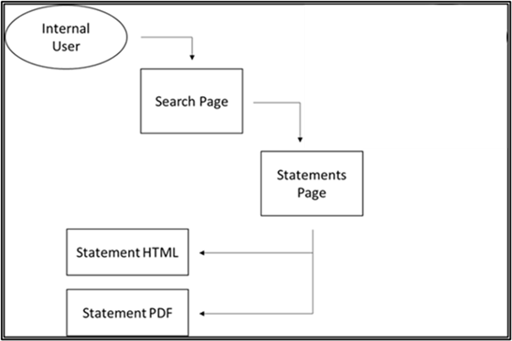

User Access Levels
This system can be accessed internally by anyone with a valid PIV who has also requested access to the system through IAM. Users will have full access to the system functions. The primary internal users are expected to be the HRC.

Continuity of Operation
Backup and restore procedures are managed by VAEC AWS. System recovery is handled by the development/sustainment team. More information on system backup and restore procedures as well as system recovery procedures can be found in the CCVBS Productions Operations Manual (POM).

Getting Started
This section provides a general walkthrough of the system from initiation through exit. The logical arrangement of the following sections enables users to understand the sequence and flow of the system. Where applicable, screen samples are included to depict examples of steps taken.

Logging On

External Users
Please see notice above in the Introduction as this is being decommissioned and transitioned.

Internal Users
Internal users (VA Departments) will use the VA IAM Single Sign-On Internal (SSOi) for authentication and log on through the web browser URL. The CCVBS application will integrate with the IAM SSOi authentication solution for internal facing users. Users may login by using a Personal Identification Verification (PIV) Card and PIN.
The internal user will paste the URL in the web browser. Once entered, the user will be directed to SSOi page where the user will use their PIV authentication. When the user clicks the sign in, it will ask for the user’s PIN. Once authenticated, the user will be directed to the Search page.
Figure 3: VA SSOi

System Menu
After successful log on, the internal user is directed to the Search page. From there a search may be operated for a patient and, once the desired result is selected, the user is re-directed to the Statement page to view the patient statements. On the Statement page, the desired billing statement may be chosen from a list of available statements in a pull-down field. The list only includes the last eighteen months of billable transactions for the internal user, arranged by facility and by date. Once the applicable viewing button is selected by the user, the chosen statement will appear in a separate window that resembles that appearance of the standard CCPC-mailed statements. The user can also choose to download or print the statement as a Portable Document Format (PDF). The perforated section at the bottom of the printable statement can be sent back with payment in the mail.

Changing User ID and Password

External Users
Please see notice above in the Introduction as this is being decommissioned and transitioned.

Internal Users
There are no passwords as all identification and credentials are provided through the PIV card. IAM handles the SSOi log on and verifications.

Exit System
To exit the application, both the internal user may navigate to the Log Out button in the top right of the application pages.
Figure 4: Log Out Button
After selecting the button, the internal user is logged out of the application. A page will be displayed stating they are logged out of the CCVBS application but still signed onto SSOi. The user may then choose to sign out of SSOi by clicking the Logout button on the page.

Caveats and Exceptions
Not applicable for this UG.

Using the Software
The CCVBS application allows users to review and/or print veteran patient statements. The application consists of the statement page with the list of statements and viewing buttons. Internal user have the ability to search for and select patients to see related statements. Links for a statement guide and to be redirected to a payments area are provided.
To log in or out of the system, please refer to Section 3.1 and Section 3.4.

Veteran Patient Search Page
When an internal user logs onto to they system, they will land on the Search page. The Search page allows a patient search by either traits or EDIPI. A Log Out button is located at the top of the page.
A search by traits contains the following fields: Last Name, First Name, SSN, and DOB. The Last Name field and two other traits are required for a search. Once information is entered, the user may click the Search MPI button to conduct a patient search or the Reset button to reset the search fields. If not all required fields are filled out or there is invalid information entered, an error notification will appear when the user attempts to search.
A search by EDIPI contains the EDIPI field as the only field and is required. Once the information is entered, the user may click the Search MPI for EDIPI button to conduct a patient search or the Reset button to reset the search fields. If not all required fields are filled out or an invalid number is entered, an error notification will appear when the user attempts to search.
Figure 5: Search Page
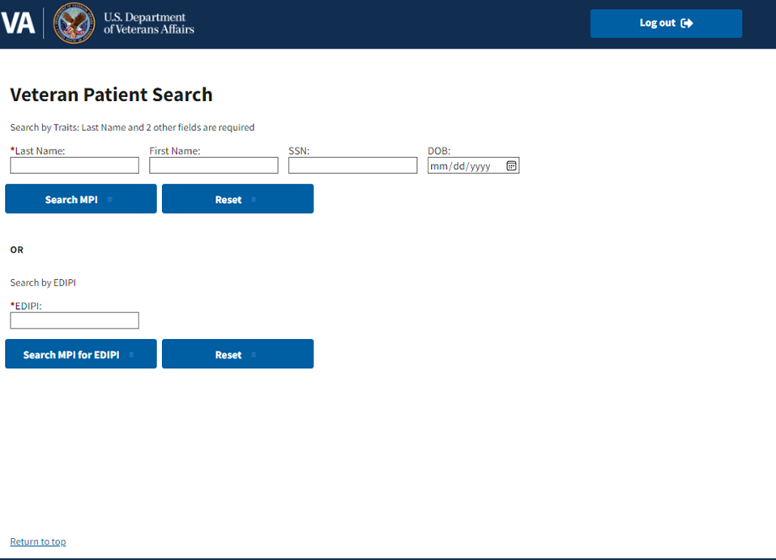
Once valid information is entered in all required fields and a search is conducted, the search results will appear on a the results page displaying all the search results. If search results are greater than 10 patients, a notification will be displayed instead stating there were too many search results and to please go back to alter the search criteria. Once the desired patient is selected, the user may click the Choose Patient button and will be directed to the Statement page to view statements related to that patient. If no choice is desired, the user may click the Back button to be redirected back to the Search page. If no patient matches the entered information, a notification stating no matching results will be displayed.
Figure 6: Search Results
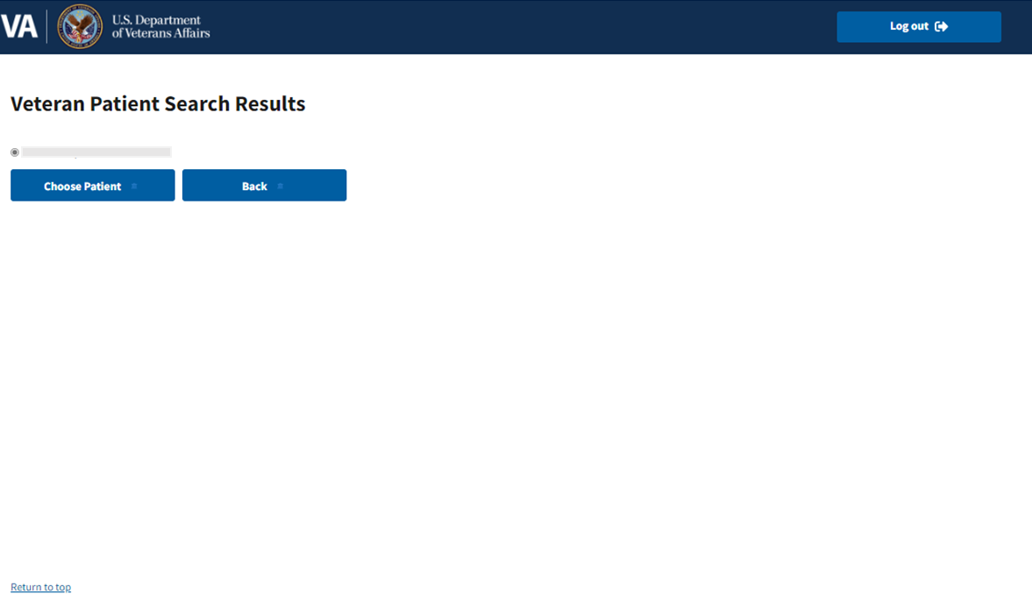

Veteran Patient Statement Page
The Statement page contains Veteran statements and viewing options. At the very top of the page is a disclaimer stating this is an official website of the United States Government with a drop-down menu link on Here’s How You Know that provides more information. The Log Out button is located on the top right of the page. As the page continues, a statement about available statement resources is displayed as well as a statement with a link to report any technical issues with the site.
The Veteran Patient Statement section of the page displays several items. On the left of the section is a box with the list of statements by date and facility. On the right are the View Statement button and Screen Reader Accessible button, both of which allow the user to open and view statements. The bottom of the section contains a link to view an Understanding Your VA Patient Statement guide as well as an alert regarding information on public computers. Near the top left of the section is a payment link, which directs the user to payment locations and information. The top of the section also displays brief instructions for viewing statements.
Figure 7: Home Statement Page
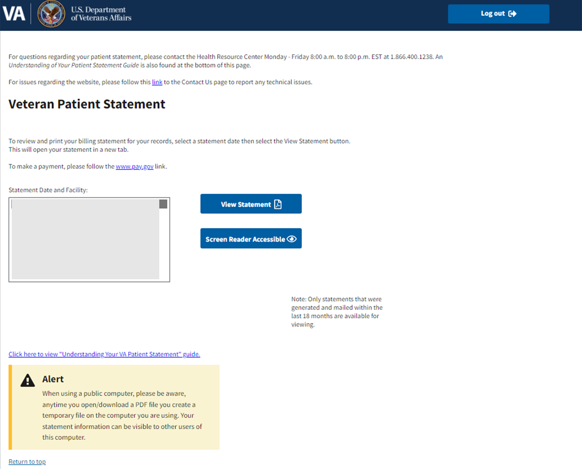

Viewing Statements
The Statement page contains a list of statements that may be selected by the user to view. If there are no statements available, a notification may appear under the Statement Date and Facility stating that no statements are available. In addition, the viewing buttons will not be displayed on the screen.
Figure 8: No Statements Available Notification
If statements are available, the user has two options to select and view the desired statement: the View Statement button or the Screen Reader Accessible button. Both statements will be the same but viewed differently. The View Statement button opens the statement as a PDF while the Screen Reader Accessible button opens the statement in 508 compliant plain HTML page.
Note: Only statements generated and mailed within the last eighteen months are available for viewing for the internal user.

View Statement Button
Under that Statement Date and Facility Box, the user may select the desired statement, then click the View Statement button on the right. The View Statement button opens a new browser tab and displays the statement inside the browser window as a PDF document ready for printing.
Figure 9: Example View Statement Window (Printable PDF)
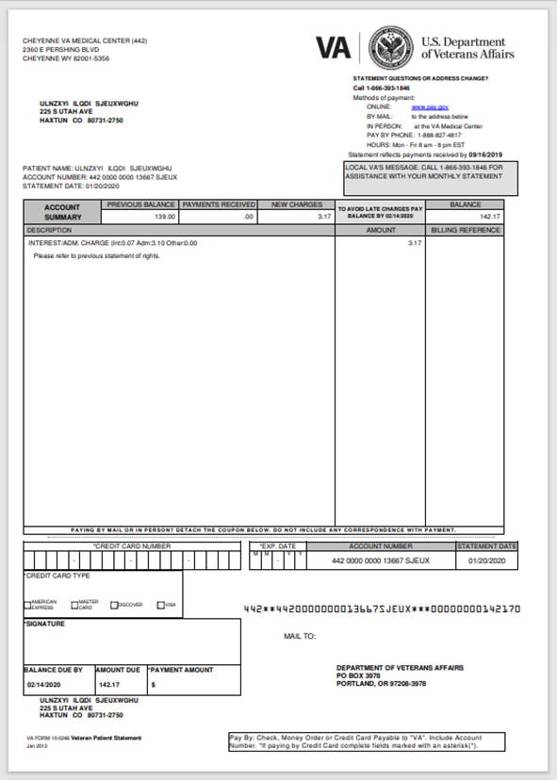

Screen Reader Accessible Button
Under that Statement Date and Facility Box, the user may select the desired statement, then click the Screen Reader Accessible button on the right. The Screen Reader Accessible button opens a new browser tab and displays the statement in a plain HTML and 508 compliant window.
Figure 10: Example Screen Reader Accessible Window (HTML 508 Compliant Page)
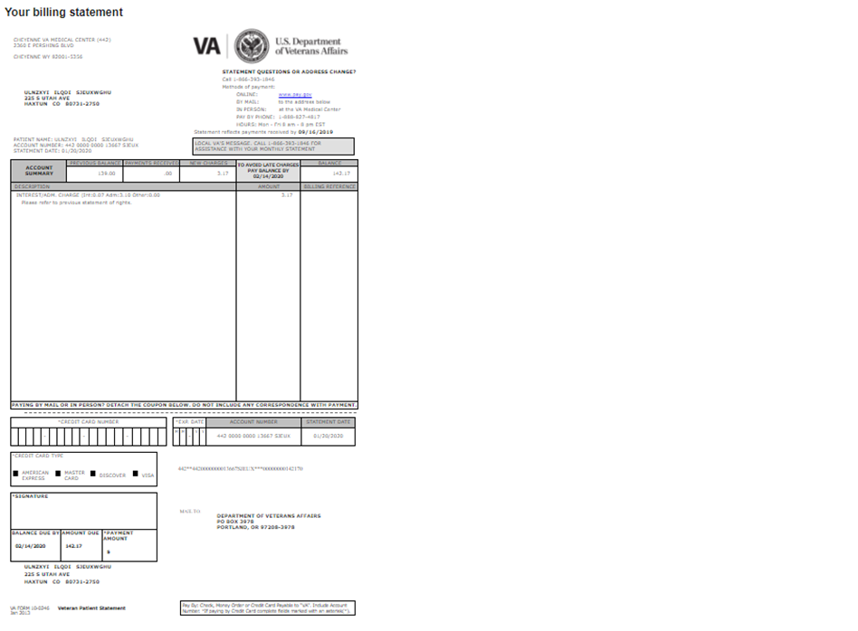

Errors and Contact Us
If at any time the system detects an error, the user will be re-directed to an error page stating the page cannot be found. The error page offers a contact link to report the issue if desired.
Figure 11: Error Page
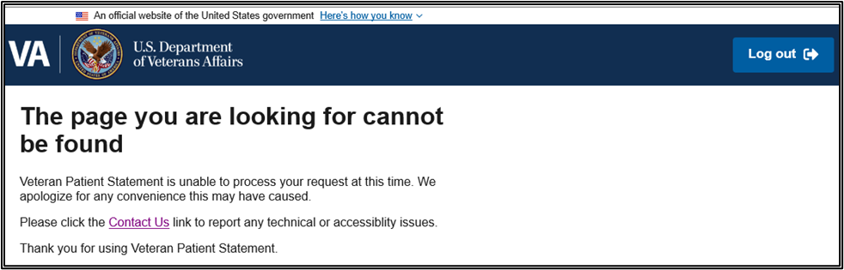
To report the issue, the user may click the Contact Us link on the error page. This link is also located on the top of the home page. This opens a new page with a contact form for the user to fill out.
Figure 12: Contact Us Form
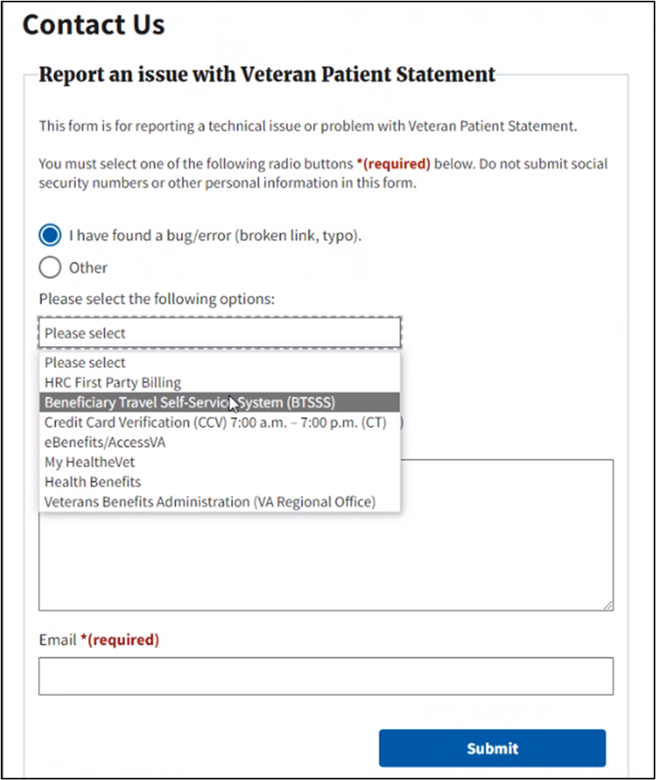
The contact form contains multiple fields for the user to fill out in order to report an issue. One of two radio buttons that may be chosen: one stating I have found a bug/error and one stating Other. Below the buttons is a dropdown with options to select the area the issue pertains to. Next is an Issue Description field where the user may fill out a box describe the issue. This box has a thousand character maximum allowed. Lastly is the Email field where the user may place the desired contact email. When completed, the user may select the Submit button at the bottom of the form. Required information is marked with an asterisk (*). Once submitted, a submission confirmation appears on the page letting the user know the form was successfully submitted.
After successful submission, the user will be contacted by the relevant support team regarding the issue.

Troubleshooting
Please refer to Section 1.3.

Special Instructions for Error Correction
The following are errors the user may encounter in the application interface:
- Error page – may appear if the system detects an error at any time (please refer to Section 4). A link to a contact page is provided.
- Other error codes – may appear if system is having authentication issues, technical difficulties, or other such errors.

Acronyms and Abbreviations
The following are common acronyms and abbreviations associated with the CCVBS application:
Table 1: Glossary
Term | Definition
CCVBS | Veterans Billing Statement
VA | Department of Veterans Affairs
OIT | Office of Information and Technology
UG | User Guide
GUI | Graphical User Interface
AWS | Amazon Web Services
VAEC | VA Enterprise Cloud
DMC | Debt Management Center
IAM | Identity and Access Management
POM | Production Operations Manual
SSOe | Single Sign-On External
HRC | Health Resource Center
MHV | My HealtheVet
CCPC | Consolidated Copayment Processing Center
SDD | System Design Document

Appendix
Not applicable for this UG.

Index
Not applicable for this UG.

