**VistA Audit Solution (VAS) 1.0**

Technical Manual



**February 2023**

Department of Veterans Affairs

Office of Information and Technology (OI&T)

Revision History

**NOTE:** The revision history cycle begins once changes or enhancements are requested after the document has been baselined.

| Date | Revision | Description | Author |
| --- | --- | --- | --- |
| 02/15/2023 | 1.7 | Minor updates to document | VAS Support Team |
| 10/04/2022 | 1.6 | Minor updates to format | VAS Support Team |
| 3/25/2022 | 1.5 | Added diagrams to Section 2.1.2 | VAS Support Team |
| 1/20/2022 | 1.4 | Updates to Section 1, 1.3.2, 2, 2.1.1, 2.2.1, 6, 12, 12.2, Appendix A, and format | VAS Support Team |
| 8/12/2021 | 1.3 | Added Redis installation procedure in Section 2.2 | VAS Team |
| 7/21/2021 | 1.2 | Updates to format and Section 13 | VAS Team |
| 7/14/2021 | 1.1 | Updates to Section 1.2, 1.3, and 2 - 12 | VAS Team |
| 5/25/2021 | 1.0 | Initial Draft | VAS Team |

**Table of Contents**

1 Introduction 1

1.1 Purpose 1

1.2 System Overview 1

1.3 Document Orientation 1

2 Implementation and Maintenance 2

2.1 System Requirements 3

2.2 System Setup and Configuration 8

3 Files 8

4 Routines 8

5 Exported Options 8

6 Mail Groups, Alerts, and Bulletins 9

7 Public Interfaces 9

7.1 Integration Control Registrations 9

7.2 Application Programming Interfaces 9

7.3 Remote Procedure Calls 9

7.4 HL7 Messaging 9

7.5 Web Services 9

8 Standards and Conventions Exemptions 9

8.1 Internal Relationships 9

8.2 Software-wide Variables 9

9 Security 10

9.1 Security Menus and Options 10

9.2 Security Keys and Roles 10

9.3 File Security 10

9.4 Electronic Signatures 10

9.5 Secure Data Transmission 10

10 Archiving 10

11 Non-Standard Cross-References 10

12 Troubleshooting 10

12.1 Special Instructions for Error Correction 10

12.2 National Service Desk and Organizational Contacts 10

**Table of Figures**

Figure 1 VAS Architecture 3

Figure 2 VAS Global Address Listing 3

Figure 3 VAS Physical Architecture (AWS) as of March 24, 2022 5

Figure 4 VAS Physical Architecture (On Prem) as of March 24, 2022 6

Figure 5 VAS Data Flow Diagram (Logical) as of March 24, 2022 7

Figure 6 VAS Support Team Email Group 9

# Introduction

The Veterans Information System and Technology Architecture (VistA) Audit Solution (VAS) is a real-time web-based interface.

It provides a nationwide Health Insurance Portability and Accountability Act (HIPAA) compliant Audit Tracking Solution with the ability to track and report on access logs for patient's Personally Identifiable Information (PII)/Protected Health Information (PHI) data across all VistA instances. VAS users are Privacy Officers, Information Systems Security Officers (ISSO), and their authorized representatives who need the ability to view the log of Creation, Retrieval, Updating, and Deletion (CRUD) operations on patient information ***to respond to Freedom of Information Act (FOIA), HIPAA, employee and Inspector General (IG) requests***. This data originates from VistA and flows through in-memory database servers to be stored in the Veterans Affairs Enterprise Cloud (VAEC) Amazon Web Services (AWS). VAS web-based User Interface (UI) will access and display the data stored in AWS.

Authorized VAS users may view the patient data that was accessed and modified as well as the individual that performed the actions.

## Purpose

The purpose of the VAS Technical Manual is to familiarize authorized users and support staff with the important features and navigational elements of the product.

## System Overview

The VAS UI is a web-based application that may be accessed using either Google Chrome or Microsoft Edge.

VAS provides the ability to search for audit records generated from any VistA instance.

The VAS UI provides the following functionalities and features:

* Patient data accessed and modified (within VistA) is available for reviewing in the VAS UI by authorized users
* Authorized VAS users may view and identify the actions made by VistA users for targeted audit records to include the individual (and date/time) that performed the actions

Additional functions include:

* Search for patient record selection utilizing patient identifying information including full name, date of birth, and social security number
* Selection of user from the VistA environment that has accessed the chosen patient record
* Review and navigation of metadata records
* Selection and view of selected audit record fields

## Document Orientation

The intended audience for the VAS Technical Manual is anyone that is supporting the VAS UI system.

### Disclaimers

#### Software Disclaimer

This software was developed at the Department of Veterans Affairs (VA) by employees of the Federal Government in the course of their official duties. Pursuant to title 17 Section 105 of the United States Code this software is not subject to copyright protection and is in the public domain. VA assumes no responsibility whatsoever for its use by other parties, and makes no guarantees, expressed or implied, about its quality, reliability, or any other characteristic. This software can be redistributed and/or modified freely provided that any derivative works bear some notice that they are derived from it, and any modified versions bear some notice that they have been modified.

#### Documentation Disclaimer

The appearance of external hyperlink references in this manual does not constitute endorsement by the Department of Veterans Affairs (VA) of this website or the information, products, or services contained therein. The VA does not exercise any editorial control over the information you may find at these locations. Such links are provided and are consistent with the stated purpose of the VA.

### References

* VAS 1.0 User Guide
* VAS 1.0 Technical Manual
* VAS 1.0 Release Notes
* WEBS*1*1 Patch Description
* DG*5.3*964 Patch Description
* DG*5.3*964 DIBRG (Deployment, Installation, Backout, Rollback Guide)
* DG*5.3*964 Release Notes
* PIMS Technical Manual
* PIMS ADT Module User Manual – Security Officer Menu

# Implementation and Maintenance

VAS is a web-based application available on Google Chrome and Microsoft Edge for the VA.

Diagram of VAS architecture

Figure 1 VAS Architecture

For information contact the REDACTED team using the email group available in the VA Global Address List (GAL).

REDACTED

Figure 2 VAS Global Address Listing

## System Requirements

The VAS Solution requires the installation of the DG*5.3*964 patch in each VistA environment.

The Austin Information Technology Center (AITC) and Philadelphia Information Technology Center (PITC) Data Centers are utilized for VAS.

The VAS is also using the VAEC AWS GovCloud which contains Redshift for indexing and querying of data and S3 Bucket for long-term data storage.

### Hardware Requirements

Hardware requirements for VAS 1.0 are as follows:

|  |  |  |
| --- | --- | --- |
| **Resource** | **Quantity** | **Name and Type** |
| REDACTED | REDACTED | REDACTED |
| REDACTED | REDACTED | REDACTED |

### Software Requirements

Software requirements for VAS 1.0 are as follows:

* Google Chrome or Microsoft Edge web browsers – used to display VAS UI
* Docker Container – VAS docker containers to be stored in the new GitHub Docker repository for VAS so that they are not publicly available outside of the VA network
  + Subscriber Microservice – Node JS Microservice
  + Metadata Microservice – Node JS Microservice
  + Redshift Microservice – Java Microservice
* Amazon Redshift – used as a database to index audit records to retrieve using UI
* Amazon ElastiCache – used to access patient records from Redshift using index
* REDACTED

REDACTED

Figure 3 VAS Physical Architecture (AWS) as of March 24, 2022

REDACTED

Figure 4 VAS Physical Architecture (On Prem) as of March 24, 2022

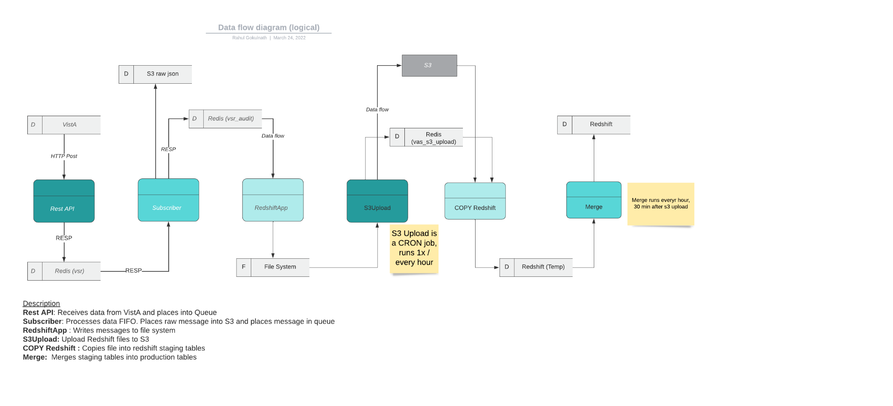

Figure 5 VAS Data Flow Diagram (Logical) as of March 24, 2022

### Database Requirements

Database Requirements for VAS 1.0 are as follows:

* Amazon Redshift – Amazon Data Warehouse database used to index metadata tags for retrieval of audit records from UI
* Amazon S3 Bucket – utilized as long-term storage of the audit records within the AWS GovCloud servers
* Amazon ElastiCache – used to access patient records from Redshift using index

### Cloud Services

* Amazon Redshift – Amazon Data Warehouse database used to index metadata tags for retrieval of audit records from UI
* Amazon S3 Bucket – utilized as long-term storage of the audit records within the AWS GovCloud servers
* Amazon ElastiCache – used to access patient records from Redshift using index
* AWS Elastic Compute Cloud (EC2) – secure and resizable compute capacity to support virtually any workload
* Amazon Virtual Private Cloud (VPC) – a service that lets you build and launch AWS resources in a logically isolated network in the AWS GovCloud
* Amazon CloudWatch – used for monitoring and provides observability on AWS resources and applications on AWS and on-premises
* AWS CloudTrail – tracker of users’ activities and API usage thereby enabling governance, compliance, and operation auditing

## System Setup and Configuration

### 2.2.1 Redis Enterprise Installation Procedure

* Download the installation package of the Redis Enterprise software from any of the supported platforms on Redis Labs
  + Prepare to install on Linux
    - Disable Linux swap on all nodes by running the below commands
      * sudo swapoff -a
      * sudo sed -i.bak '/ swap / s/^(.*)$/#1/g' /etc/fstab
* Install Redis software on Linux
* Extract the .tar installation file and make sure to be in the right directory. Run command: tar vxf <tarfile name>
* Finally, to install Redis Enterprise software,
  + - Execute: sudo ./install.sh -y
* Setup a three-node cluster on Redis Enterprise user interface
  + By navigating to REDACTED for example REDACTED where REDACTED is the server IP in which Redis software has been installed
  + Join other nodes to cluster after creating the cluster on master node
* Create Redis Database VASDB on the UI and configure endpoints and replication on the cluster

# Files

* Docker files: subscriber-microservice, redshift-microservice, metadata-microservice
* UI distribution folder

# Routines

No routines

# Exported Options

Not applicable

# Mail Groups, Alerts, and Bulletins

For additional support and information contact the REDACTED team using the email group available in the VA Global Address List (GAL).

REDACTED

Figure 6 REDACTED Team Email Group

# Public Interfaces

None

## Integration Control Registrations

Not applicable

## Application Programming Interfaces

None

## Remote Procedure Calls

None

## HL7 Messaging

None

## Web Services

None

# Standards and Conventions Exemptions

## Internal Relationships

Each microservice has a dependency on each other. The Subscriber microservice sends messages to the Redshift microservice via the queue. The Redshift microservices reads the messages and inserts them into the Redshift database.

## Software-wide Variables

Not Applicable

# Security

## Security Menus and Options

Not Applicable

## Security Keys and Roles

Only authorized users with active PIV cards and Active Directory (AD) group membership are allowed to access the VAS UI

## File Security

There are no files stored in the system

## Electronic Signatures

Not applicable

## Secure Data Transmission

Not applicable

# Archiving

Data is archived automatically into the S3 file system

# Non-Standard Cross-References

None

# Troubleshooting

FAQs

* What if I don’t see the data I expect?
  + Times for data to arrive and process will vary based on network conditions. Please submit an email to the VAS Support team (see Section 6) if data is not visible after 24 hours.
* What if I can’t access the VAS UI?
  + Please submit an email to the VAS Support team (see Section 6) for assistance.

## Special Instructions for Error Correction

None

## National Service Desk and Organizational Contacts

Contact the VAS team by submitting an email to the REDACTED email group (see Section 6).

###### Appendix A: Acronyms

| **Acronyms** | **Definition** |
| --- | --- |
| AD | Active Directory |
| AITC | Austin Information Technology Center |
| API | Application Programming Interface |
| AWS | Amazon Web Services |
| CRUD | Creation, Retrieval, Updating, and Deletion |
| DIBRG | Deployment, Installation, Back-Out and Rollback Guide |
| FOIA | Freedom of Information Act |
| HIPAA | Health Insurance Portability and Accountability Act |
| IG | Inspector General |
| IOC | Initial Operating Capability |
| ISSO | Information System Security Officer |
| IT | Information Technology |
| MUMPS | Massachusetts General Hospital Utility Multi-Programming System |
| OIT | Office of Information Technology |
| PHI | Protected Health Information |
| PII | Personally Identifiable Information |
| PIMS | Patient Information Management System |
| PITC | Philadelphia Information Technology Center |
| PIV | Personal Identitfication Verification |
| PO | Privacy Officer |
| SQA | Software Quality Assurance |
| TAR | Test Analysis Report |
| UAT | User Acceptance Testing |
| UI | User Interface |
| VA | Department of Veterans Affairs |
| VAS | VistA Audit Solution |
| VAEC | Veterans Affairs Enterprise Cloud |
| VAMC | VA Medical Center |
| VDL | VA Software Document Library |
| VHA | Veterans Health Administration |
| VistA | Veterans Information System and Technology Architecture |