OFFICE OF
INFORMATION
AND TECHNOLOGY

VistA Audit Solution (VAS)
User Guide
Version 1.0
February 2023

FOR INTERNAL USE ONLY

  - Revision History
Date | Version | Description | Author
02/15/2023 | 1.0 | Initial creation of the User Guide for VistA Audit Solutions project | Booz Allen Hamilton

  - Table of Contents
1 Introduction 1
1.1 VistA Audit Solution (VAS) 1
1.2 Purpose 1
1.3 Document Disclaimer 1
2 System Summary 2
3 Getting Started 2
3.1 Access to VAS UI 2
3.2 Steps to Access 2
4 Understanding the Functionality 3
4.1 Search for Patient 3
4.2 Full Search 3
4.3 Partial Search 6
4.4 Selecting a User 8
4.5 Search Metadata Records 10
4.6 Navigate Metadata Records 11
4.7 Select/View Audit Record 13
5 Logout/Close/Exit VAS UI 16
5.1 Logout 16
5.2 Close/Exit 16
6 VistA VAS Functions 16
6.1 VAS Functions in VistA 16
6.2 Menu for VAS Audit 16
6.3 Display VAS Parameters 17
6.4 Modify VAS Parameters 18
6.5 Mail Messages to DG VAS MONITOR 20
7 Troubleshooting 23
7.1 VAS is Unresponsive 23
7.2 Contact VAS Team 23
Appendix A: Acronyms and Abbreviations 25

  - List of Figures
Figure 1: PIN Prompt 2
Figure 2: VAS UI Patient Search Portal 3
Figure 3: Patient Search 4
Figure 4: Full Search Button 4
Figure 5: Full Search 4
Figure 6: Search for Patient Button 5
Figure 7: Full Search - Single Patient Result 5
Figure 8: Full Search - No Patient Results 6
Figure 9: Patient Search 6
Figure 10: Partial Search Button 6
Figure 11: Partial Search Window 7
Figure 12: Partial Search - Single Patient Results 7
Figure 13: Partial Search - Multiple Patient Results 8
Figure 14: Partial Search - No Patient Results 8
Figure 15: Single Patient Result 9
Figure 16: User Name Drop-Down Menu 9
Figure 17: Metadata Records View 10
Figure 18: Searching Metadata 10
Figure 19: Metadata Record Navigation 11
Figure 20: Change Rows Per Page 12
Figure 21: Sorting Field Changed Column 12
Figure 22: Information Icon for Marital Status 13
Figure 23: Selected Metadata Record 14
Figure 24: Audit Record 15
Figure 25: Logout Button for VAS 16
Figure 26: Exit VAS UI 16
Figure 27: Close Browser 16
Figure 28: VA Global Address List 24

Introduction

VistA Audit Solution (VAS)
The Veterans Information System and Technology Architecture (VistA) Audit Solutions (VAS) was designed as a real-time web-based interface. VAS provides a nationwide Health Insurance Portability and Accountability Act (HIPAA) compliant Audit Tracking Solution with the ability to track and report on access logs for patients’ Personally Identifiable Information (PII)/Protected Health Information (PHI) data across all VistA instances. VAS users are Privacy Officers, Information Systems Security Officers (ISSO), and their authorized representatives who need the ability to view the log of Creation, Retrieval, Updating, and Deletion (CRUD) operations on patient information to respond to Freedom of Information Act (FOIA), HIPAA, employee and Inspector General (IG) requests. This data originates from VistA and flows through in-memory database servers to be stored in the Veterans Affairs Enterprise Cloud (VAEC) Amazon Web Services (AWS). VAS web-based User Interface (UI) will access and display the data stored in AWS.
Authorized VAS users may view the patient data that was accessed and modified, as well as the individual that performed the actions.

Purpose
The purpose of the VAS User Guide v1.0 is to familiarize authorized users in the usage of the VAS UI.

Document Disclaimer
The appearance of external hyperlink references in this manual does not constitute endorsement by the Department of Veterans Affairs (VA) of this Web site or the information, products, or services contained therein. The VA does not exercise any editorial control over the information you may find at these locations. Such links are provided and are consistent with the stated purpose of the VA.
This document (including any enclosures, attachments, and hyperlinks) has been prepared for the exclusive use and benefit of the U.S. Department of Veterans Affairs VistA Audit Solution (VAS) and solely for the purpose for which it is provided. Unless provided express prior written consent, no part of this document should be reproduced, distributed, or communicated to any third party.
VAS endeavors to supply accurate information in this report; however, errors and omissions may occur.

System Summary
The VAS UI portal is hosted in VAEC AWS GovCloud. The system is only accessible within the VA intranet to authorized users such as Privacy Officers, Information Systems Security Officers and FOIA Officers to perform consent management tasks.

Getting Started

Access to VAS UI
This section describes the steps for accessing and understanding the VAS UI Portal functionalities.
For users to gain access to the VAS UI, users will need the following:
- VAS UI Uniform Resource Locator (URL)
- Active Personal Identification Verification (PIV) card with Personal Identification Number (PIN)
- Google Chrome or Microsoft Edge
- To be Whitelisted

Steps to Access
Take the following steps to access VAS UI via Single Sign-On Integration (SSOi) with an active PIV card.
Note: Users will only use their PIV card to access.
- Navigate to the VAS UI by entering the URL (https://vsr.va.gov/) into a browser (Chrome or Edge).
- When prompted, enter the PIN associated with the PIV card and click OK.
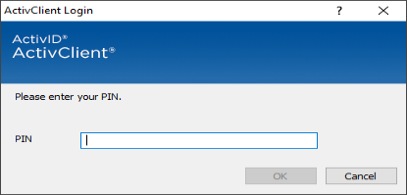
Figure 1: PIN Prompt
- VAS UI has been accessed when the screen providing Patient Search information displays.
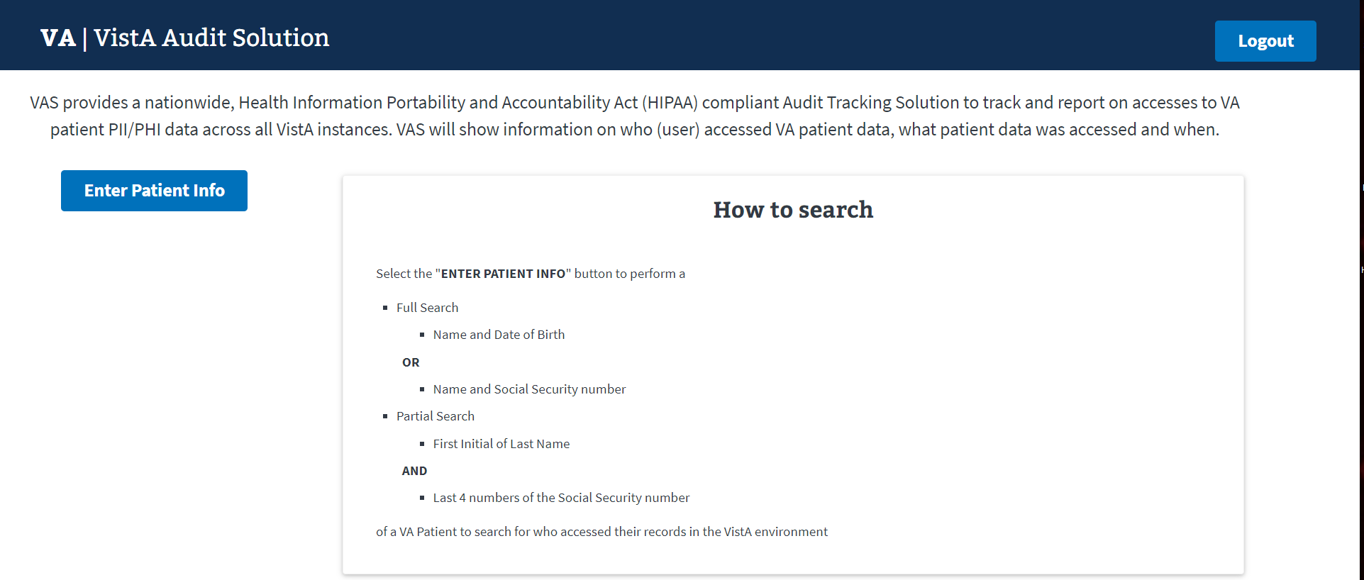
Figure 2: VAS UI Patient Search Portal

Understanding the Functionality
The VAS UI portal provides the following functionalities:
- Patient data accessed and modified (within VistA) is available for viewing.
- Viewing and identifying the actions made by the VistA user(s) for targeted audit records, including the individual that performed the actions.

Search for Patient
The Patient Search screen allows the user to perform a Full or Partial search for the Patient record.

Full Search
To conduct a Full Search in the VAS UI, users need to have:
- Access to the VAS UI
- The Patient’s full name (Last,First Middle)
  - There is no space between “Last””,””First”. If a space is entered, no record will be found. Example: REDACTED
  - Middle Name or Initial is not required
- The Patient’s DOB (MM/DD/YYYY); or
- The Patient’s SSN (no spaces or dashes included)

Steps for Full Search
- Select the Enter Patient Info button on the left of the screen.
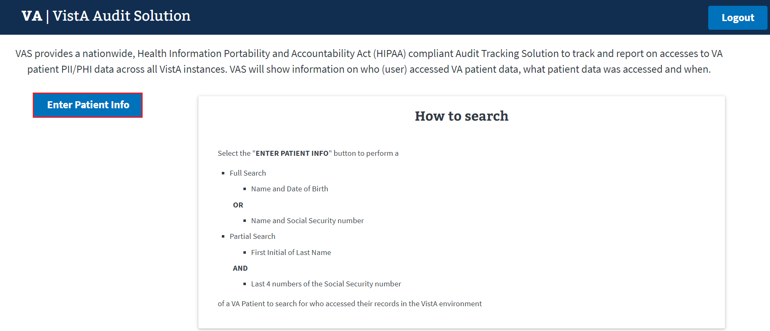
Figure 3: Patient Search
- Select the FULL SEARCH button.
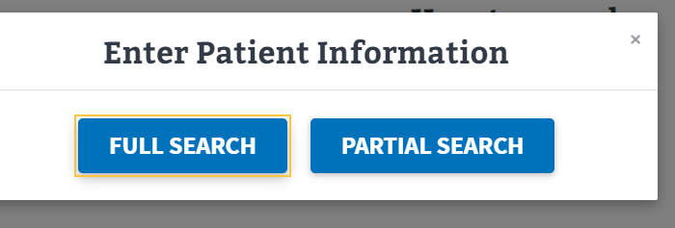
Figure 4: Full Search Button
The FULL SEARCH window displays as seen below:
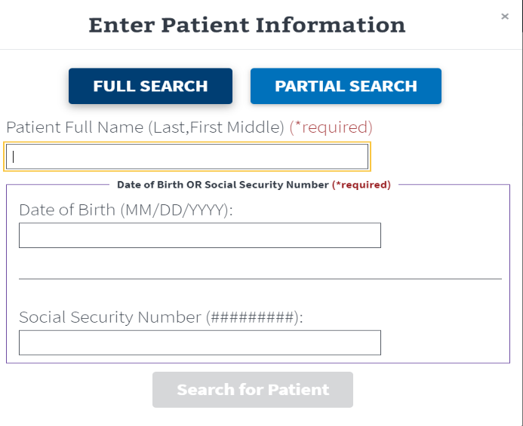
Figure 5: Full Search
- Enter Patient Full Name (Last,First Middle) *required field
  - There is no space between “Last,First.” If a space is entered, no record will be found
  - Middle Name or Initial is not required
- Enter Date of Birth OR Social Security Number *required field.
  - The Search for Patient button will be enabled once all required fields are entered
  - The Search for Patient button will remain disabled if the search criteria is entered incorrectly
- Click the Search for Patient button.
Figure 6: Search for Patient Button

Single Patient Results – Full Search
The patient search information will display on the left side of the screen when the results are for a single record.
The upper center of the screen provides a summary of the number of users that have looked at/accessed the selected patients’ records in VistA.
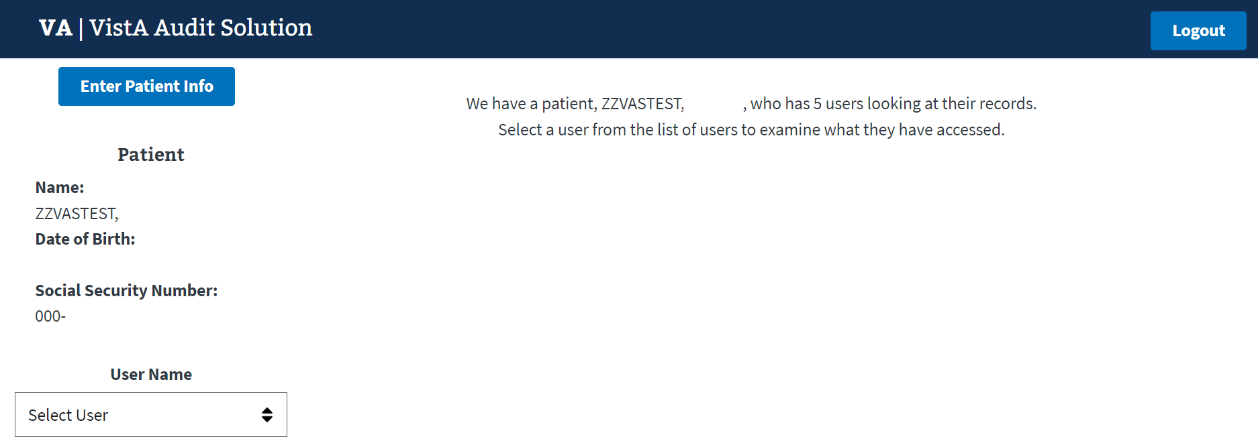
Figure 7: Full Search - Single Patient Result

No Patient Results – Full Search
The screen will display a message stating that no patients were found when the search criteria entered could not locate a record. The user should verify that they correctly entered the search data when performing the Full Search function.
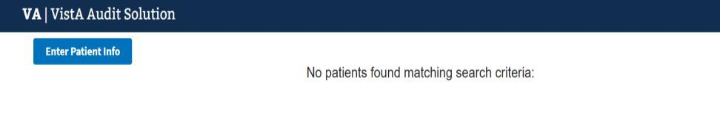
Figure 8: Full Search - No Patient Results

Partial Search
To conduct a Partial Search in VAS UI, user needs to have:
- Access to the VAS UI
- The first initial of the Patient’s Last Name
- Last 4 digits of the Patient’s SSN

Steps for Partial Search
- Select the Enter Patient Info button on left of screen.
Figure 9: Patient Search
- Click the PARTIAL SEARCH button.
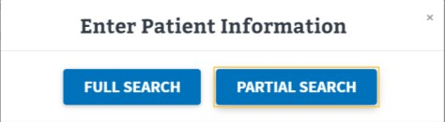
Figure 10: Partial Search Button
- The Partial Search window displays as seen below.
  - Enter the Patient’s First Initial of Last Name. *required field
  - Enter the Last 4 digits of the Patient’s SSN. *required field
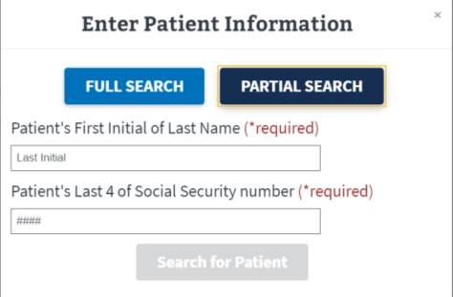
Figure 11: Partial Search Window
- Once the required fields have been entered, the Search for Patient button will be enabled.
  - The Search for Patient button will remain disabled if the search criteria is entered incorrectly.
- Click Search for Patient.

Single Patient Results – Partial Search
The patient search information will display on the left side of the screen when the results are for a single record.
The upper center of the screen provides a summary of the number of users that have looked at
the selected patients’ records.
Figure 12: Partial Search - Single Patient Results

Multiple Patient Results – Partial Search
When multiple results are returned, click the Select Patient button for the desired Patient’s record.
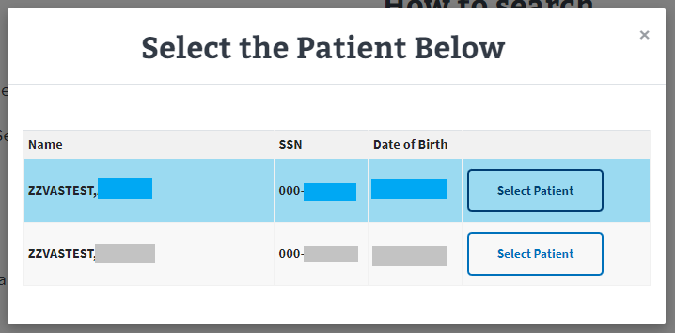
Figure 13: Partial Search - Multiple Patient Results

No Patient Results – Partial Search
The screen will display a message stating that no patients were found when the search criteria entered could not locate a record for the Partial Search.
- The screen will display the partial search criteria entered as seen below:
REDACTED
Figure 14: Partial Search - No Patient Results

Selecting a User
Once a patient record is chosen from a Full or Partial Search, the VAS user must select a User from the User Name drop-down menu. This list contains the individuals within the VistA environment that have accessed the patient’s record.

Steps to Select a User
- Click the drop-down arrow for the User Name menu.
  - Note the summary text indicates there are 5 users who viewed this patient’s records.
Figure 15: Single Patient Result
The User Name drop-down menu will contain the names of the users who have accessed the Patient’s records.
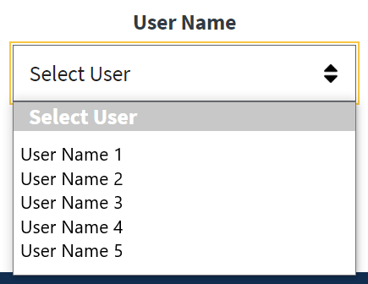
Figure 16: User Name Drop-Down Menu
- Click on the desired User Name.

Metadata Records
Once the User Name is selected the corresponding Metadata Records for the Patient record accessed by the user are displayed in groups of 10 lines (default).
- Each line includes:
  - Field Changed – the field that has been updated for the record, when appropriate
  - Request Type – the type of action taken to the record
    - Create: New Registration record created.
    - Inquiry: Registration record has been viewed.
    - Update: Field within the record that has been updated. Includes actions to add new data, change data and delete data.
  - Date – the Date and Time the action was taken within VistA
  - Site data accessed from – the VistA site where the data was accessed
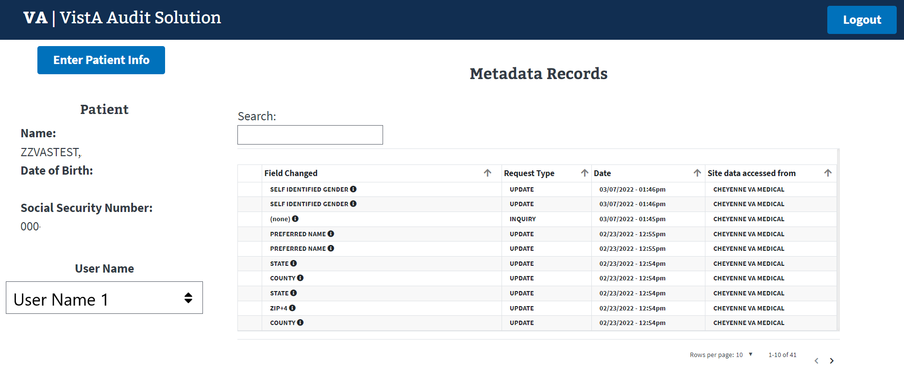
Figure 17: Metadata Records View

Search Metadata Records
- The User has the ability to filter the results of the Field Changed field.
  - All Metadata records for a Patient/User are searched with criteria entered, not just the rows displayed on the screen.
  - The example below is a search with the criteria of ‘na’ entered and all results being displayed.
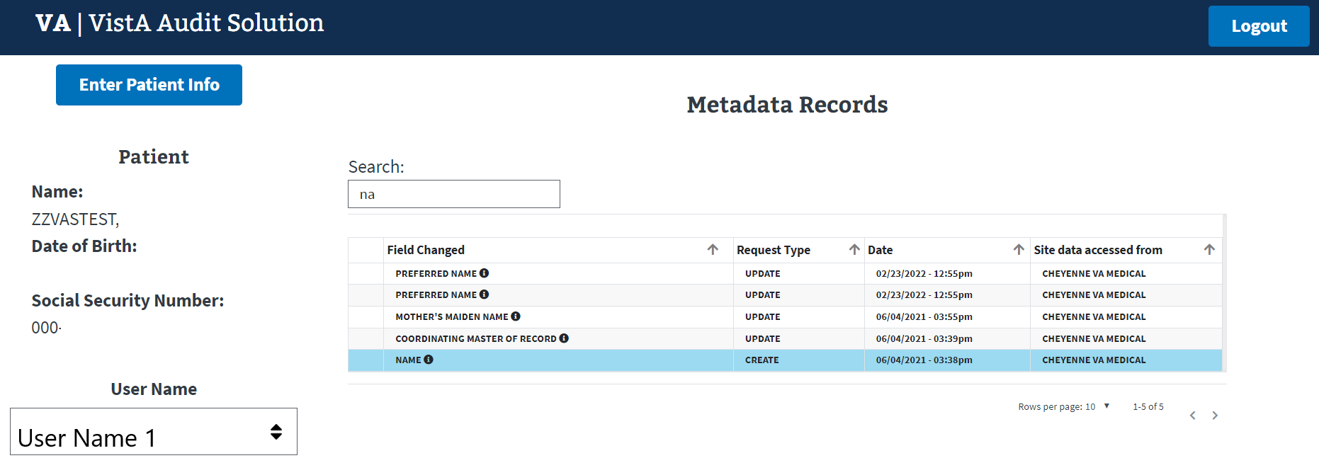
Figure 18: Searching Metadata

Navigate Metadata Records
VAS contains functionality that allows the user to navigate through the data provided in several ways.

Page Forward/Backward
In cases where the metadata records exceed 10 rows (default page size), the user can use the forward ( > ) and backward ( < ) arrows located in the bottom right corner to navigate back and forth through the lines of records.
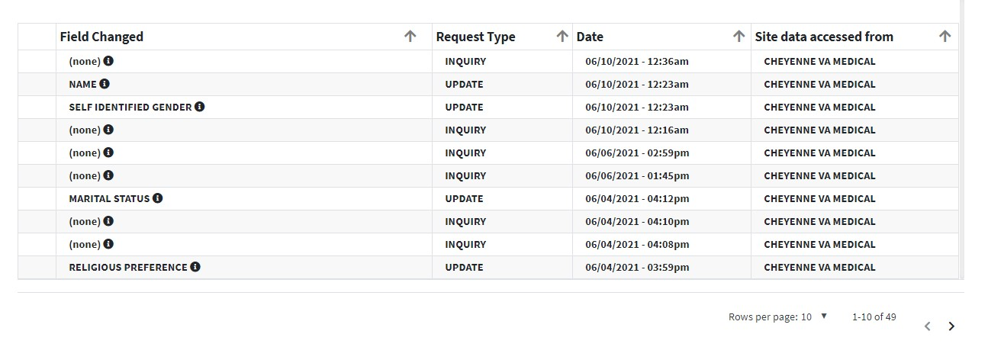
Figure 19: Metadata Record Navigation

Rows Per Page
The default page size for the display of rows of Metadata records is 10 per page. The user may increase this to 25, 50, or 100 rows per page.
- Click on the Rows per page dropdown in the bottom right corner of the screen.
- Select the number of rows desired.
  - The Rows per page will return to the default of 10 per page once another Patient is selected.
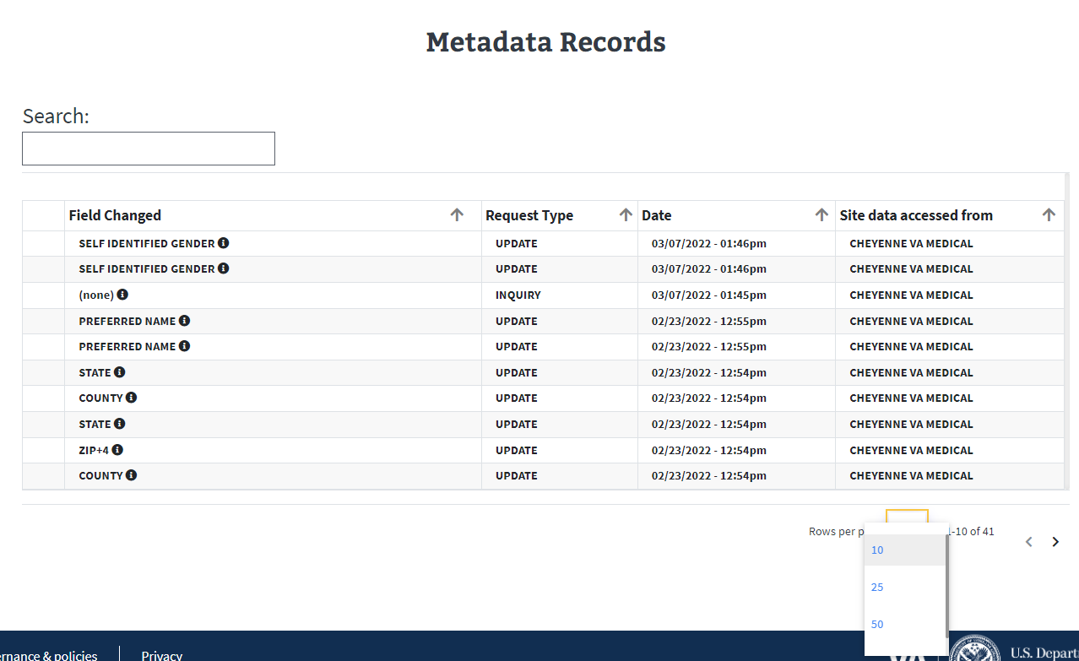
Figure 20: Change Rows Per Page

Ascending/Descending Sort
Each of the column headings for the Metadata Records may be sorted in Ascending or Descending order. The Column Headings are Field Changes, Request Type, Date, and Site data accessed from.
Sort Order:
- Ascending Order: Smallest to largest; A to Z or 0 to 9
- Descending Order: Largest to smallest; Z to A or 9 to 0
The screen below displays an example of a listing of Metadata Records where the Field Changed column is displayed in descending order.
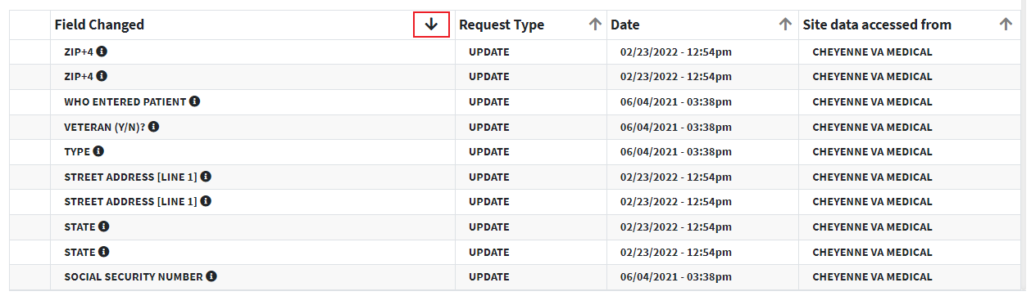
Figure 21: Sorting Field Changed Column

Select/View Audit Record
Viewing data from selected audit records provides information about the VistA user who accessed the record, the updates and inquiries made, as well as the date and time these actions were performed. The major functions for Select/View of Audit Records are:
- View the description, from the VistA Data Dictionary, of the Field Changed
- View Audit Record details regarding the actions taken in VistA for the Patient Record

Field Changed Description
When clicking on the Information icon () located beside the Field Changed name, the description from the VistA Data Dictionary displays the information about the field. Not all fields have a description available.
The following screen provides the description for the MARITAL STATUS field.
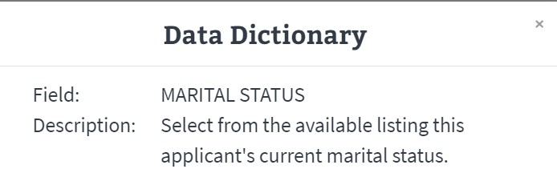
Figure 22: Information Icon for Marital Status

Audit Record Fields
When a Metadata Record is selected by the VAS User they are able to:
- Click on the row to select the Audit Record to be viewed
  - The Audit Record screen will pop up
Each Audit Record contains the fields below. The fields are populated with data specific to the selected record.
- Date/Time: Date and Time that the field was accessed by the chosen VistA site User.
- Site/Station #: VistA Site and Station ID where the record resides, and action was taken.
- Patient Name: Patient Name for record selected.
- Patient MVI/DFN:
  - Master Veteran Index (MVI) is the authoritative source for person identity data. Maintains identity data for persons across VA systems, a unique universal identifier for each person.
  - Data File Number (DFN) is the Internal Entry Number (IEN) in the PATIENT file (#2).
- User Name: The Name of the VistA user that took the action at the VA site for the Patient record.
- User Title/DUZ/UID:
  - User Title is the position title for the VistA user.
  - DUZ is the user number that refers to the Internal Entry Number (IEN) of the logged-on user for the local VistA system.
  - Unique User ID (UID) is the unique identifier for the VistA user by Security ID. This field is also known as the SECID for VA Single Sign-On (SSOi).
- Year/Week #: Displays the calendar year and week number that the Audit Record action occurred.
- Request Type: The type of request that was done for the selected record. Request types include Create, Update, and Inquiry.
- Field Name: The name of the field for the action taken in VistA.
- Old Value: The value in the Patient field prior to the update action. If there was no old value, the field will be populated with <no previous value>.
- New Value: The value that the VistA user updated or added to field in the Patient file.
- Menu Option Used: Name of the menu utilized by the VistA user to Create, Update, or Inquire for the selected record.
The row highlighted below (Field Changed = PREFERRED NAME) was selected to view.
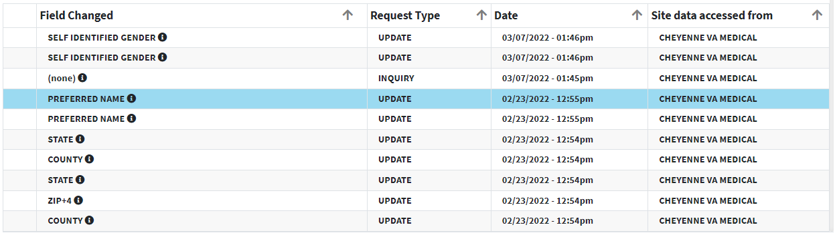
Figure 23: Selected Metadata Record
The selected Audit Record is displayed.
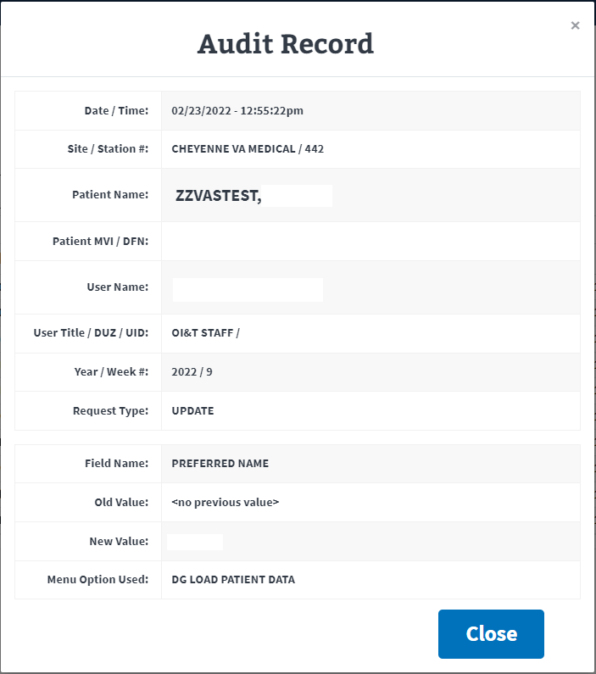
Figure 24: Audit Record

Logout/Close/Exit VAS UI

Logout
Clicking the Logout button in the top right corner of the VAS UI page will log the user out of VAS. The user will be brought to the VA Single Sign-On logout page and a message will read You have been logged out of Vista Audit Solution (VAS).
Figure 25: Logout Button for VAS

Close/Exit
Closing the UI browser will exit the user from the VAS application. Below are a few ways this may be accomplished.
- In Chrome or Edge, the keyboard shortcut, Alt + F4, will quickly close the active window and all open windows.
- Click the ‘X’ located on the right side of the VistA Audit Solution tab. This will close the browser.
Figure 26: Exit VAS UI
- To close all tabs in Chrome or Edge, click the ‘X’ located in the far upper right corner.
Figure 27: Close Browser

VistA VAS Functions

VAS Functions in VistA
A new menu, options and parameters are introduced in VistA with the installation of the DG*5.3*964 patch for VAS.

Menu for VAS Audit
This menu contains options to view and modify the settings for the VistA Audit Solution (VAS) functions for processing and sending targeted audit records from the VistA instance to an external archive. The menu is included in the existing Security Officer Menu and access requires the assignment of the DG Security Officer key.
Select Security Officer Menu <TEST ACCOUNT> Option:

Display User Access to Patient Record Enter/Edit Patient Security Level
Purge Non-sensitive Patients from Security Log Purge Record of User Access from Security Log
EXP ISO Sensitive Records Report-Export
Print Security Log by Date Range and/or Patient FMT ISO Sensitive Records Report-Formatted Report SL1 Security Log Print by User/Date
SL2 Security Log Print by User/Date (Excel) USER User Access Log Print
VistA Audit Solution (VAS) options ...
**> Locked with DG SECURITY OFFICER

The new files, fields and parameter definitions brought in with the DG*5.3*964 patch are available for display and modification to the users that are provided with access to the menu.
Select VistA Audit Solution (VAS) options <TEST ACCOUNT> Option:

Display VAS Parameters Modify VAS Parameters

Display VAS Parameters
The ‘Display VAS Parameters’ option provides the user with a view of the settings and current status.
Display VAS Parameters

DG VAS WEB SERVER: <redacted>.va.gov
STATUS: Don't generate or send data

DG VAS BATCH SIZE: 1000
DG VAS MAX WRITE ATTEMPTS: 60 DG VAS DEBUG FLAG: 0
DG VAS MONITOR: DG VAS MONITOR

DG VAS MAX QUEUE ENTRIES: 60000 DG VAS DAYS TO KEEP EXCEPTIONS: 3

NAME: DG VAS EXPORT
QUEUED TO RUN AT WHAT TIME: DEC 07, 2021@15:24
RESCHEDULING FREQUENCY: 300S SPECIAL QUEUEING: Startup Persistent TASK ID: 696046 USER TO RUN TASK: POSTMASTER

Modify VAS Parameters
This option provides the user with the ability to view and modify the parameters and settings for the VAS functions for processing and sending the targeted audit records to the external archive. The parameters for VAS are established with the initial installation of the DG*5.3*964 patch. For most VistA sites it is uncommon to have to update or edit the parameters.
Modify VAS Parameters

VAS STATUS: Don't generate or send data// Status: Don't generate or send data

----- Setting BATCH SIZE for System: <redacted>.VA.GOV -----
Value: 1000//

Setting DG VAS DEBUGGING FLAG for System: <redacted>.VA.GOV Value: 0//

Setting DG VAS MONITOR GROUP for System: <redacted>.VA.GOV Value: DG VAS MONITOR//

Setting MAX ENTRIES IN DG VAS QUEUE (#46.3) for System: <redacted>.VA.GOV Value: 60000//

Setting WRITE ATTEMPTS BEFORE SENDING MAIL for System: <redacted>.VA.GOV Value: 60//
Setting DAYS TO KEEP EXCEPTIONS for System: <redacted>.VA.GOV Value: 3//

VAS STATUS
This field is for setting the VAS audit process to be started, stopped or paused for the generation and exporting of targeted audit records to the external archive. The three settings available are displayed below. When the DG*5.3*964 patch is installed, this field is defaulted to ‘0’ (Don’t generate or send data).
VAS STATUS: Don't generate or send data// ?

Choose from:
- Don't generate or send data
- Generate and send data
- Generate data, don't send VAS STATUS: Don't generate or send data//

BATCH SIZE
This parameter (DG VAS BATCH SIZE) contains the default number of entries and the maximum number of entries that are set into a batch of records to send to the VAS representational state transfer application programming interface (REST API). When the number of pending records in the DG VAS QUEUE file is less than the value of the DG VAS BATCH SIZE parameter, a partial batch is sent containing the remaining entries in the queue. The value may be 1 – 9,999. The default at patch installation is 1000.
---- Setting BATCH SIZE for System: <redacted>.VA.GOV -----
Value: 1000// ?

Value: 1000//

VAS DEBUGGING FLAG
Provides the user with the ability to request a log file displaying the local variables at the time the debugging process is running. The information is captured and provided in a mail message that is sent to the members of the DG VAS MONITOR at the VistA site. The DG VAS DEBUGGING FLAG is inactive when a ‘0’ is in the field and it is active when a ‘1’ is entered. Once the debugging process is completed, the flag will automatically reset back to ‘0’ and remain that way until a user requests that the process be run by entering a ‘1’.
Setting DG VAS DEBUGGING FLAG for System: <redacted>.VA.GOV Value: 0// ?

Value: 0//

See Section 6.5 for examples of messages created and sent to the DG VAS MONITOR at the local site.

DG VAS MONITOR
Members of the DG VAS MONITOR mail group will receive generated messages that contain various system status information for VAS. Group membership may include individuals with the roles of Privacy Officer and/or Information Systems Security Officers and their authorized representatives. See Section 6.5 for examples of messages created and sent to the DG VAS MONITOR mail group at the local site.
Setting DG VAS MONITOR GROUP for System: <redacted>.VA.GOV Value: DG VAS MONITOR//?

Value: DG VAS MONITOR//

MAX ENTRIES IN DG VAS QUEUE
This parameter contains the maximum number of entries that are allowed to be stored in the ^DGAUDIT global which houses the data for the DG VAS QUEUE File (#46.3). The value may be 0 – 60000 and at patch installation defaults to 60000.
The DG VAS EXPORT option runs as a background task and checks on whether the maximum number of entries has been exceeded. If the maximum is exceeded the oldest entries are deleted until the maximum is no longer surpassed.
Setting MAX ENTRIES IN DG VAS QUEUE (#46.3) for System: <redacted>.VA.GOV Value: 60000// ?

Value: 60000//

WRITE ATTEMPTS BEFORE SENDING MAIL
The maximum number of consecutive attempts to write, or POST, a batch of records to the DG VAS WEB SERVICE without receiving a response is contained in this parameter. The count of the write errors is incremented until the maximum is met, after which a mail message is generated and sent to the mail group in the DG VAS MONITOR GROUP parameter. Audit records in a batch for which no response is received remain in the queue and will be retried until a response is received from the DG VAS WEB SERVICE.
The value for this parameter may range from 1 – 999 and is defaulted to 100 at patch installation.
Setting WRITE ATTEMPTS BEFORE SENDING MAIL for System: <redacted>.VA.GOV Value: 100// ?

Value: 100//

DG VAS DAYS TO KEEP EXCEPTIONS
This parameter contains the number of days to hold on to exceptions before they are purged. The value may range from 0 – 90 days. The default is 3 days when the patch is installed.
Setting DAYS TO KEEP EXCEPTIONS for System: <redacted>.VA.GOV Value: 3// ?

Value: 3//

Mail Messages to DG VAS MONITOR
The REDACTED mail group is introduced with patch DG*5.3*964. Members of the group will receive messages generated that contain various system status information for VAS. Group membership may include individuals with the roles of Privacy Officer and/or Information Systems Security Officers (ISSO) and their authorized representatives.

VAS AUDIT ERROR MESSAGE FROM STATION (XXXX)
The messages generated with the VAS AUDIT ERROR MESSAGE FROM STATION (station) in the Subject Line may contain specific, different errors. Below are several examples of these type of messages with specific information for different errors.
Subj: VAS AUDIT ERROR MESSAGE FROM STATION (Test) [#311040] 12/03/21@12:53
8 lines
From: REDACTED In 'IN' basket. Page 1 *New*

Date/Time: DEC 03, 2021@12:53:03
Error from DG VAS WEB SERVER: <redacted>.va.gov on port: 80 Result of POST command:
ERROR #6159: Although Https property is enabled no SSLConfiguration is specified so unable to make an HTTPS connection to '<redacted>.va.gov:443'. The ^DGAUDIT global contains 21 entries.

Enter message action (in IN basket): Ignore//

Subj: VAS AUDIT ERROR MESSAGE FROM STATION (Test) [#310500] 11/30/21@14:17
7 lines
From: REDACTED In 'IN' basket. Page 1 *New*

Date/Time: 3211130.1417 Result of POST command:
One or more records in batch 3211130.14170005 were rejected.
See ^XTMP("DGAUDIT_EXCEPTION;3211130.14170005" for more information. The ^DGAUDIT global contains 964 entries.
The maximum number of entries before automatic deletion is 1000.

Enter message action (in IN basket): Ignore//

Subj: VAS AUDIT ERROR MESSAGE FROM STATION (Test) [#310970] 12/03/21@08:44
7 lines
From: REDACTED In 'IN' basket. Page 1 *New*

Date/Time: DEC 03, 2021@08:44:43
Error from VAS server: <redacted>.va.gov on port: 80 Result of POST command:
ERROR #6059: Unable to open TCP/IP socket to server <redacted>.va.gov:80 The ^DGAUDIT global contains 13 entries.

Enter message action (in IN basket): Ignore//

NEWAUDEX^DGAUDIT1
The following examples are partial mail messages sent when the Debugging Flag is activated. A log of the local variables at the time the Debugging process is running is provided.
Subj: NEWAUDEX^DGAUDIT1 sent from <redacted> - 500 [#309193] 10/25/21@10:30
100 lines
From: redacted In 'IN' basket. Page 1

Name: <redacted> Station#: 500
Domain: <redacted>.VA.GOV Date/Time: OCT 25, 2021@10:30:41 By: POSTMASTER

%=%
%H=66042,37841
%I=
%L=44
%ZTIME=5706062160
%ZTPFLG=
%objlasterror=0 tO|TCP|80|53363/stage-redis- 7cbb66c6381882eb.<redacted>.com:80DOSO"e^zClose+2^%Net.TelnetStream.1^2d^%OnClose+1^%I O.I.Stream.
1^1 d^%Destruct+1^%IO.I.Stream.1^1d^REDISOPN+11^DGAUDIT^3e^EXPORT+25^DGAUDIT^6d
^EXPORT+10^DGAUDIT^2d^R+2^XQ1^1d^RUN+4^%ZTMS3^1d^4+10^%ZTMS3^1d^PROCESS+9^%ZTMS

Type <Enter> to continue or '^' to exit:

Subj: NEWAUDEX0^DGAUDIT1 sent from <redacted> - 500 [#310445] 11/29/21@15:57
85 lines
From: redacted In 'IN' basket. Page 1 *New*

Name: <redacted> Station#: 500
Domain: <redacted>.VA.GOV Date/Time: NOV 29, 2021@15:57:01 By: POSTMASTER

%=%
%H=66077,57421
%I=
%L=44
%ZTIME=5709110221
%ZTPFLG= AUDGREF=^DIA CNTREC=0 DGABORT=0 DGAUDKPX=2

Type <Enter> to continue or '^' to exit:

Troubleshooting

VAS is Unresponsive
Unresponsive behavior can occur with a session timeout or loss of network connectivity. Input entered prior to a loss of connectivity or timeout will not be saved or recoverable. Refreshing the page may keep you on the same page if a timeout occurs, but you may be re- prompted for the PIN for your PIV.
Session timeout will occur when PIV cache is expired on the browser. The PIV dialog will be shown and require PIN entry.

Contact VAS Team
For additional support and information contact the REDACTED team using the email group available in the VA Global Address List (GAL) as displayed below.
REDACTED
Figure 28: VA Global Address List

Appendix A: Acronyms and Abbreviations
Term | Definition
API | Application Programming Interface
AWS | Amazon Web Services
CRUD | Creation, Retrieval, Updating, and Deletion
DFN | Data File Number
DG | Registration package
FOIA | Freedom of Information Act
GAL | Global Address List
HIPAA | Health Insurance Portability and Accountability Act
IEN | Internal Entry Number
IG | Inspector General
ISSO | Information Systems Security Officer
MVI | Master Veteran Index
OIT | Office of Information and Technology
PHI | Protected Health Information
PII | Personally Identifiable Information
PIN | Personal Identification Number
PIV | Personal Identification Verification
REST | Representational State Transfer
SSOi | Single Sign-On Integration
UI | User Interface
UID | Unique User ID
URL | Uniform Resource Locator
VA | Department of Veterans Affairs
VAS | VistA Audit Solutions
VAEC | Veterans Affairs Enterprise Cloud
VAMC | Veterans Administration Medical Center
VistA | Veterans Information System and Technology Architecture

